

2012 Reliability Needs Assessment


New York Independent System Operator

DRAFT Report

June 20, 2012

Caution and Disclaimer
The contents of these materials are for information purposes and are provided “as is” without representation or warranty of any kind, including without limitation, accuracy, completeness or fitness for any particular purposes. The New York Independent System Operator assumes no responsibility to the reader or any other party for the consequences of any errors or omissions. The NYISO may revise these materials at any time in its sole discretion without notice to the reader.

Table of Contents
1. Introduction 6
2. Summary of Prior CRPs 8
3. RNA Base Case Assumptions, Drivers and Methodology 12
3.1. Annual Energy and Summer Peak Demand Forecasts 13
3.2. Forecast of Special Case Resources 18
3.3. Resource Additions 18
3.4. Local Transmission Plans 19
3.5. Resource Retirements 22
3.6. Base Case Peak Load and Resource Margins 22
3.7. Methodology for the Determination of Needs 24
4. Reliability Needs Assessment 27
4.1. Overview 27
4.2. Reliability Needs for Base Case 27
4.2.1. Transmission Security Assessment 27
4.2.2. Short Circuit Assessment 30
4.2.3 Transmission and Resource Adequacy Assessment 31
4.2.4 System Stability Assessment 35
4.2.5 Reliability Needs Summary 35
4.3 Scenarios 35
5. Impacts of Environmental Program Initiatives 37
5.1 Environmental Regulations 37
5.1.1 Selection of Major Environmental Program Initiatives 39
5.1.2 Reliability Impact Assessment Methodology 41
6. Observations and Recommendations 48
7. Historic Congestion 48
Appendix A - Reliability Needs Assessment Glossary A-1
Appendix B - The Reliability Planning Process B-1
Appendix C - Load and Energy Forecast 2013-2022 C-1
Appendix D - Transmission System Assessment D-1

Table of Tables
Table 2-1: Current Status of Tracked Market-Based Solutions & TOs’ Plans in the 2008 CRP* 9
*2009 and 2010 CRPs did not generate any tracked projects 9
Table 2-2: Proposed New Generation per 2012 Gold Book 10
Table 2-3: Class Year 2011 and 2012 New Generation Projects 11
Table 3-1(a): 2012 RNA Forecast and Scenarios 15
Table 3-1(b): Comparison of 2010 & 2012 RNA Base Case Forecasts 16
Table 3-3: Unit Additions 18
Table 3-4: Firm Transmission Plans included in 2012 RNA Base Case (from 2012 Gold Book) 20
Table 3-5: Retired and Proposed Units Retirements 22
Table 3-6: NYCA Peak Load and Resource Margins 2013 through 2022 24
Table 3-7: 2010 RNA to 2012 RNA Load and Capacity Comparison 24
Table 4-1: 2012 RNA Over-duty Breaker Summary Table 31
Table 4-2: Transmission System Thermal Transfer Limits for Key Interfaces in MW 32
Table 4-3: Transmission System Voltage Transfer Limits for Key Interfaces in MW 32
Table 4-4: Transmission System Base Case Transfer Limits for Key Interfaces in MW 32
Table 5-1: New York Sate Emission Allocations under the Cross State Air Pollution Rule 46
Table 5-2: Summary of Impact Assessment 47
Table C-1: Summary of Econometric & Electric System Growth Rates – Actual & Forecast C-1
Table C-2: Historic Energy and Seasonal Peak Demand - Actual and Weather-Normalized C-2
Table C-3: Annual Energy and Summer Peak Demand - Actual & Forecast C-3
Table C-4: Regional Economic Growth Rates of Key Economic Indicators C-7
Table C-5: Annual Energy by Zone – Actual & Forecast (GWh) C-10
Table C-6: Summer Coincident Peak Demand by Zone – Actual & Forecast (MW) C-11
Table C-7: Winter Coincident Peak Demand by Zone – Actual & Forecast (MW) C-12
Table D-1: Emergency Thermal Transfer Limits D-1
Table D-2: 2012 RNA Fault Current Analysis Summary Table D-4
Table D-3: IBA for 2012 RNA Study D-7

Table of Figures

Figure 3-1(a): 2012 Base Case Forecast and Scenarios – Annual Energy 17
Figure 3-1(b): 2012 Base Case Forecast and Scenarios – Summer Peak Demand 17
Figure 5-1: New York Power Plant Emissions 1999-2011 37
Figure 5-2: New York Power Plant Heat Rates 1999-2011 38
Figure 5-3: MATS NYCA Gas/Oil Capacity 44
Figure B-1: NYISO Reliability Planning Process B-4
Figure B-2: Economic Planning Process B-5
Figure C-1: Annual Employment Growth Rates Error! Bookmark not defined.
Figure C-2: Annual Change in Population by Region Error! Bookmark not defined.
Figure C-3: Annual Growth Rates of Income, Real Domestic Output and Employment Error! Bookmark not defined.
Figure C-4: Zonal Energy Forecast Growth Rates - 2012 to 2022 Error! Bookmark not defined.
Figure C-5: Zonal Summer Peak Demand Forecast Growth Rates - 2012 to 2022 Error! Bookmark not defined.
Figure D-1: Development of the 2012 MARS Topology D-2
Figure D-2: 2012 PJM-SENY MARS Model D-3

Executive Summary
To be added…...

Introduction
The Reliability Needs Assessment (RNA) is developed by the NYISO in conjunction with Market Participants and all interested parties as its first step in the Comprehensive System Planning Process (CSPP). It is the foundation study used in the development of the NYISO’s Comprehensive Reliability Plan (CRP). The RNA is performed to evaluate electric system reliability, for both transmission security and resource adequacy, over a ten year study period. If the RNA identifies any violation of Reliability Criteria for Bulk Power Transmission Facilities (BPTF) the NYISO will report a Reliability Need, quantified by an amount of compensatory megawatts (MW) and/or megavars (MVAr). In addition, the NYISO will request market-based and alternative regulated proposals from interested parties to address the identified Reliability Needs, and designate one or more Responsible Transmission Owners to develop a regulated backstop solution to address each identified need. . This document reports the 2012 RNA findings for the Study Period 2013-2022.
Continued reliability of the bulk power system during the Study Period depends on a combination of additional resources provided by independent developers, in response to market forces, and by the electric utility companies which are obligated to provide reliable and adequate service to their customers. To maintain the system’s long-term reliability, those resources must be readily available or in development to meet future needs. Just as important as the electric system plan is the process of planning itself. Electric system planning is an ongoing process of evaluating, monitoring and updating as conditions warrant. Along with addressing reliability, the CSPP is also designed to provide information that is both informative and of value to the New York wholesale electricity marketplace.
Proposed solutions that are submitted in response to an indentified Reliability Need are evaluated in the CRP report and must satisfy Reliability Criteria, including resource adequacy. However, the solutions submitted to the NYISO for evaluation in the CRP do not have to be in the same amounts of compensatory MW/MVAr or the locations reported in the RNA. There are various combinations of resources and transmission upgrades that could meet the needs identified in the RNA. The reconfiguration of transmission facilities and/or modifications to operating protocols identified in the solution phase could result in changes and/or modifications of the needs identified in the RNA.
This report begins with an overview of the CSPP. The 2010 Comprehensive Reliability Plan (CRP) and prior reliability plans are then summarized. The report continues with a summary of the 2012 RNA Base Case assumptions and methodology and reports the RNA findings for 2013 - 2022. Detailed analyses, data and results underlying the modeling assumptions are contained in the Appendices.
In addition to assessing the Base Case conditions, the RNA analyzes certain scenarios to test the robustness of the system and the conditions under which needs would arise. Attention is given to risks that may give rise to Reliability Needs, including unusually high peak loads and plant retirement notifications.
The NYISO will prepare and issue its 2012 CRP based upon this 2012 RNA report. The NYISO will continue to monitor the progress of the market-based solutions submitted in earlier CRPs and projects that have met the NYISO’s Base Case inclusion rules for this RNA. In addition, the NYISO will continue to monitor the various assumptions that are reflected or impact the RNA Base Case to assess whether these projects are progressing as expected and whether any delays or changes in system conditions are likely to adversely impact system reliability. These base case assumptions include, but are not limited to, the measured progress towards achieving the State energy efficiency program standards, the impact(s) of ongoing developments in State and Federal environmental regulatory programs on existing power plants, the status of plant re-licensing efforts, and the development of transmission owner projects identified in the Local Transmission Plans (LTPs).
For informational purposes, this RNA report also provides the marketplace with the latest historical information available for the past five years of congestion via a link to the NYISO’s website. The 2012 CRP will be the foundation for the 2013 Congestion Assessment and Resource Integration Study (CARIS). A more detailed evaluation of system congestion is presented in the CARIS. The NYISO completed its second CARIS economic planning assessment of future congestion in March 2012.

Summary of Prior CRPs
This is the sixth RNA since the NYISO’s planning process was approved by FERC in December 2004. The first three RNA reports identified Reliability Needs and the first three CRPs (2005-2007) evaluated the market-based and regulated backstop solutions submitted in response to those identified needs. The 2005 CRP was approved by the NYISO Board of Directors in August 2006, and identified 3,105 MW of resource additions needed through the 10-year Study Period ending in 2015. Market solutions totaled 1200 MW, with the balance provided by updated Transmission Owners’ (TOs) plans. The second CRP was approved by the NYISO Board of Directors in September 2007 and identified 1800 MW of resource additions needed over the 10-year Study Period ending in 2016. Proposed market solutions totaled 3007 MW, in addition to updated Transmission Owners’ (TOs) plans. The third CRP was approved by the NYISO Board of Directors in July 2008, and identified 2350 MW of resource additions needed through the 10-year Study period ending in 2017. Market solutions totaling 3,380 MW were submitted to meet these needs. The NYISO did not trigger any regulated backstop solutions to meet previously identified Reliability Needs.
The 2009 CRP, approved by the NYISO Board of Directors in January 2009, and the 2010 CRP, approved by the NYISO Board of Directors in January 2011, indicated that the system was reliable and no solutions were necessary in response to their respective 2009 and 2010 RNAs. Therefore, market solutions were not requested. The primary reasons that no needs were identified in the 2009 and 2010 RNAs, as compared to the 2008 RNA, were: 1) an increase in generation and transmission facilities, 2) a decrease in the energy forecast due to the Energy Efficiency Portfolio Standard Order (EEPS), and 3) an increase in Special Case Resources (SCRs). Although the 2009 and 2010 CRPs did not identify any needs, as a risk mitigation measure, the NYISO has continued to monitor the market-based solutions submitted for the 2008 CRP.
Table 2-1 presents the market solutions and TOs’ plans that were submitted in response to previous requests for solutions and were included in the 2008 CRP. The table also indicates that 1815 MW of solutions are either in-service or are still being reported to the NYISO as moving forward with the development of their projects.
It should be noted that there are a number of other projects in the NYISO interconnection study queue which are also moving forward through the interconnection process, but have not been offered as market solutions in this process. Some of these additional generation resources have either accepted their cost allocation as part of a Class Year Facilities Study process or are currently included in the 2011 or 2012 Class Year Facilities Studies. These projects are listed in Tables 2-2 and 2-3. Tables 2-1, 2-2, 3-3, and 3-4 report the projects that meet the RNA Base Case inclusion rules. The listings of other Class Year Projects can be found along with other non-modeled transmission and non-modeled generator re-rating projects in the 2012 Gold Book at http://www.nyiso.com/public/webdocs/services/planning/planning_data_reference_documents/2012_GoldBook.pdf.

Table 2-1: Current Status of Tracked Market-Based Solutions & TOs’ Plans in the 2008 CRP*
Project Type
NYISO
Queue #
Submitted
MW
Zone
Original In-
Service Date
Current Status
Included in
2012 RNA
Base Case
Gas Turbine
NRG Astoria Re-
Powering
201 and
224
CRP 2005, CRP 2007,
CRP 2008
520
J
Jun - 2010
New Target June 2014
No
Empire Generation
Project
69
CRP 2008
635
F
Q1 2010
Placed in Service
September 2010
Yes
Back-to-Back
HVDC, AC Line
HTP
206
CRP 2007, CRP 2008
and was an alternative
regulated proposal in
CRP 2005

660
PJM - J
Q2 2011
PJM Queue O66
New Target Q2 2013
Article VII approved under construction
Yes
ConEd M29 Project
153
CRP 2005
N/A
J
May - 2011
Placed in Service
February 2011
Yes
Resource Proposals
Transmission Proposals
TOs' Plans
*2009 and 2010 CRPs did not generate any tracked projects

Table 2-2: Proposed New Generation per 2012 Gold Book

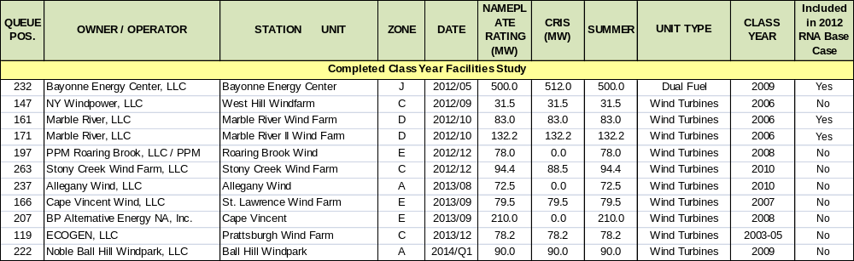

Table 2-3: Class Year 2011 and 2012 New Generation Projects

QUEUE
POS.
OWNER / OPERATOR
STATION UNIT
ZONE
DATE
NAMEPL
ATE
RATING
(MW)
CRIS
(MW)
SUMMER
Included in
2012 RNA
Base Case
349
Taylor Biomass Energy, LLC
Taylor Biomass
G
2012/Q4
22.5
TBD
19.0
Solid Waste
No
198
New Grange Wind Farm, LLC
Arkwright Summit Wind Farm
A
2013/09
79.8
TBD
79.8
Wind Turbines
No
169
Alabama Ledge Wind Farm, LLC
Alabama Ledge Wind Farm
B
2013/10
79.8
TBD
79.8
Wind Turbines
No
201
NRG Energy
Berrians GT
J
2014/06
200.0
TBD
200.0
Combined Cycle
No
224
NRG Energy, Inc.
Berrians GT II
J
2014/06
90.0
TBD
50.0
Combined Cycle
No
310
Cricket Valley Energy Center, LLC
Cricket Valley Energy Center
G
2015/09
1136.0
TBD
1019.9
Combined Cycle
No
251
CPV Valley, LLC
CPV Valley Energy Center
G
2016/05
690.6
TBD
677.6
Combined Cycle
No
189
PPM Energy, Inc.
Clayton Wind
E
2013/10
126.0
TBD
126.0
Wind Turbines
No
322
Rolling Upland Wind Farm, LLC
Rolling Upland Wind
E
2014/12
59.4
TBD
59.4
Wind Turbines
No
266
NRG Energy, Inc.
Berrians GT III
J
2016/06
290.0
TBD
250.0
Combined Cycle
No
284
Broome Energy Resources, LLC
Nanticoke Landfill
C
2012/12
1.6
0.0
1.6
Methane
No
264
RG&E
Seth Green
B
2013/Q1
2.8
0.0
2.8
Hydro
No
338
RG&E
Brown's Race II
B
2013/Q1
8.3
0.0
8.3
Hydro
No
204A
Duer's Patent Project, LLC
Beekmantown Windfarm
D
2013/06
19.5
19.5
19.5
Wind Turbines
No
180A
Green Power
Cody Road
C
2013/Q4
10.0
10.0
10.0
Wind Turbines
No
UNIT TYPE
Class 2011 Generation Projects
Class 2012 Generation Projects Candidates
Other Non Class Year Generation Projects

RNA Base Case Assumptions, Drivers and Methodology
The NYISO has established procedures and a schedule for the collection and submission of data and for the preparation of the models used in the RNA. The NYISO’s CSPP procedures are designed to allow its planning activities to be performed in an open and transparent manner and to be aligned and coordinated with the related activities of the NERC, NPCC, and NYSRC. The assumptions underlying the RNA were reviewed at the Transmission Planning Advisory Subcommittee (TPAS) and the Electric System Planning Working Group (ESPWG). The Study Period analyzed in the 2012 RNA is the 10-year period from 2013 through 2022 for both the Base Case and Scenarios.
The RNA Base Case consists of the first Five Year Base Case and the system representations for the second five years of the Study Period as required by Attachment Y of the tariff. All studies and analyses in the RNA Base Case reference a common energy forecast, which is the Baseline Forecast from the NYISO 2012 Load and Capacity Data Report, also known as the “Gold Book”. The Baseline Forecast is an econometric forecast with an adjustment for statewide energy efficiency programs. This forecast is the 2012 RNA Base Case forecast.
The Five Year Base Case was developed in accordance with ISO Procedures using projections for the installation and retirement of generation resources and transmission facilities that were developed in conjunction with Market Participants and Transmission Owners. These are included in the Base Case beginning with the FERC 715 filing and consistent with base case inclusion screening process provided in the CRPP Manual. Further, resources that choose to participate in markets outside of New York are modeled as contracts, thus removing their available capacity for meeting resource adequacy requirements in New York.
The NYISO developed the system representation for the second five years of the Study Period by starting with the first Five Year Base Case plus:
- The most recent data from the 2012 Gold Book
- The most recent versions of NYISO reliability analyses and assessments provided for or published by NERC, NPCC, NYSRC, and neighboring control areas
- Information reported by neighboring control areas such as power flow data, forecasted energy, significant new or modified generation and transmission facilities, and anticipated system conditions that the NYISO determines may impact the bulk power transmission facilities (BPTF)
- Market Participant input, and
- Changes in the MW and MVAr components of the load model made to maintain a constant power factor.

The 2012 RNA 2013 – 2022 Base Case model of the New York bulk power system includes the following new and proposed facilities and forecasts in the Gold Book:
- TO projects on non-bulk power facilities included in the FERC 715 Cases
- LTPs identified in the 2012 Gold Book as firm plans and meeting Base Case inclusion rules
- Facilities that have accepted their Attachment S cost allocations and are in service or under construction as of April 1, 2012
- Facilities that have obtained a NYS PSC Certificate (or other regulatory approvals and SEQRA review) and an approved System Reliability Impact Study (“SRIS”) and an executed contract with a credit-worthy entity
- Transmission upgrades related to any projects and facilities that are included in the RNA Base Case, as defined above
- Facility re-ratings and uprates
- Noticed retirements
- The forecasted level of Special Case Resources for Summer 2012 (SCR)
Tables 3-3 and 3-4 show those new projects which meet the screening requirements for inclusion.
The NYISO develops reliability scenarios for the first five years and second five years of the Study Period pursuant to Section 31.2.2.5 of Attachment Y of the OATT. The NYISO also conducts sensitivity analyses pursuant to Section 31.2.2.6 of Attachment Y to determine whether Reliability Needs previously identified can be mitigated through alternate system configurations or operational modes.

Annual Energy and Summer Peak Demand Forecasts
There are three primary load forecasts modeled in the 2012 RNA. The first forecast is an econometric forecast of annual energy and peak demand. The second forecast, which is used for the 2012 RNA Base Case, includes a reduction to the econometric forecast reflecting a portion of the savings goal of the statewide energy efficiency initiative, including the programs authorized by the New York State Public Service Commission (NYSPSC) Energy Efficiency Portfolio Standard (EEPS). The third forecast was prepared for the low load scenario as reflected by a 15 percent energy efficiency achievement by 2015, which represents full achievement of the statewide energy goal by 2015. Additional information on the Base Case load forecast and underlying economic data is contained in Appendix C.
The NYISO has been a party to the NYSPSC EEPS proceeding from its inception and is a member of the Evaluation Advisory Group which is responsible for advising the NYDPS on the methods to be used to track program participation and measure the program costs, benefits, and impacts on electric energy usage. In conjunction with the input from market participants at the ESPWG, the NYISO developed energy forecasts for the potential impact of the EEPS over the 10-year planning period. The following factors were considered in developing the 2012 RNA Base Case forecast:
- NYSPSC-approved spending levels for the programs under its jurisdiction, including the Systems Benefit Charge and utility-specific programs
- Expectation of the fulfillment of the investor-owned EEPS program goals by 2018, and continued spending for NYSERDA programs through 2022
- Expected realization rates, participation rates and timing of planned energy efficiency programs
- Degree to which energy efficiency is already included in the NYISO’s econometric energy forecast
- Impacts of new appliance efficiency standards, and building codes and standards
- Specific energy efficiency plans proposed by LIPA, NYPA and Consolidated Edison Company of New York, Inc. (Con Edison)
- The actual rates of implementation of EEPS, based on data received from Department of Public Service staff.
Table 3-1(a) below summarizes the 2012 RNA econometric forecast, the 2012 RNA Base Case forecast and the 2012 RNA 15 x 15 scenario forecast. Table 3-1(b) shows a comparison of the Base Case forecasts and energy efficiency program impacts contained in the 2010 RNA and the 2012 RNA. The 2012 RNA 15x15 scenario forecast is based on achievement of the full EEPS goal of 26,880 GWh by 2015, as deducted from the 2015 forecast prepared in 2008, after allowances for certain energy efficiency programs already put in place by state utilities. The NYISO set this 2015 forecast level at 157,380 GWh in prior RNAs.
The 2012 projection of these energy efficiency program impacts was discussed with all market participants during multiple meetings of the Electric System Planning Working Group (ESPWG) during the first quarter of 2012. The ESPWG accepted the projection of impacts used in the 2012 RNA Base Case forecast in accordance with procedures established for the RNA.
Figures 3-1 (a) and 3-1 (b) present actual and weather-normalized historical data and forecasts of annual energy and summer peak demand for the 2012 RNA.
Table 3-1(a): 2012 RNA Forecast and Scenarios
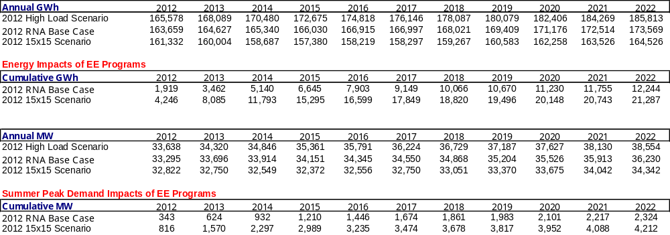
Table 3-1(b): Comparison of 2010 & 2012 RNA Base Case Forecasts
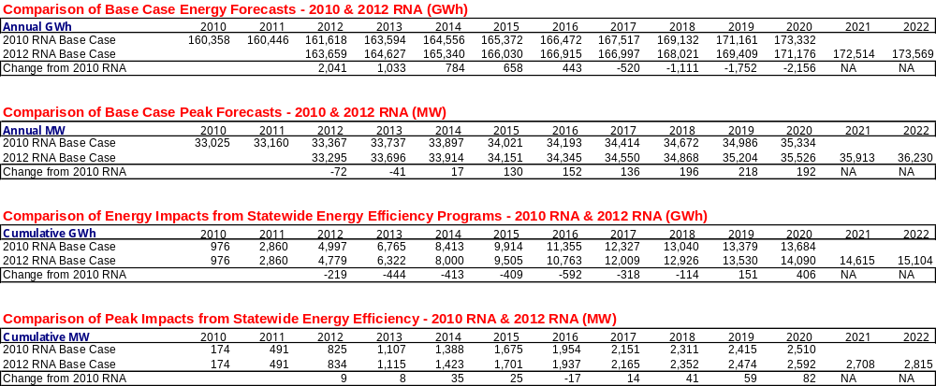
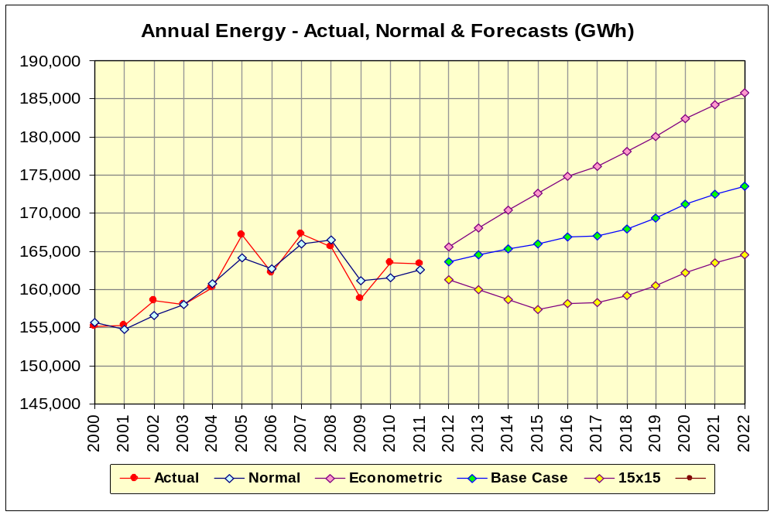
Figure 3-1(a): 2012 Base Case Forecast and Scenarios – Annual Energy

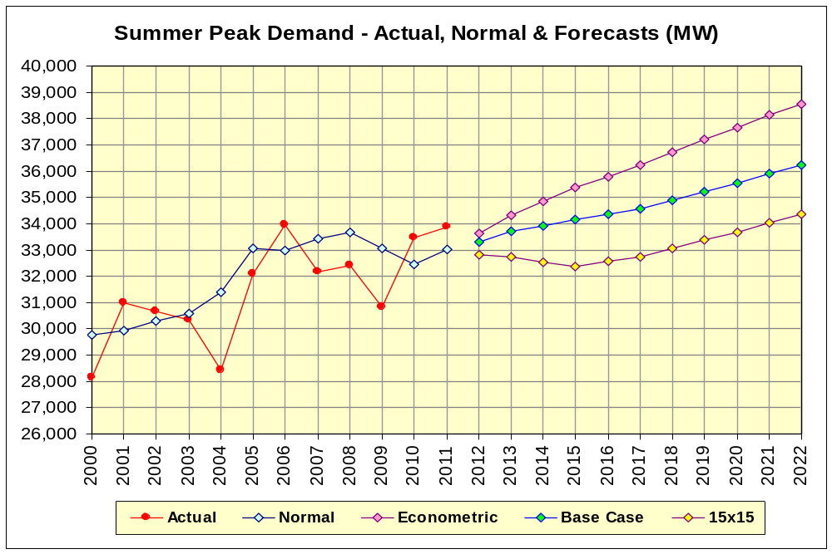
Figure 3-1(b): 2012 Base Case Forecast and Scenarios – Summer Peak Demand

Forecast of Special Case Resources
The 2012 RNA special case resource levels are based on the 2012 Gold Book value of 2165 MW. Unlike the 2010 RNA, the 2012 RNA models the same projected SCR resources of 2165 MW for each of the ten years 2013 – 2022. The MARS program calculates the SCR values for each hour based on the ratio of hourly load to peak load.

Resource Additions
Table 3-3 presents the unit additions and uprates represented in the RNA Base Case.
Table 3-3: Unit Additions
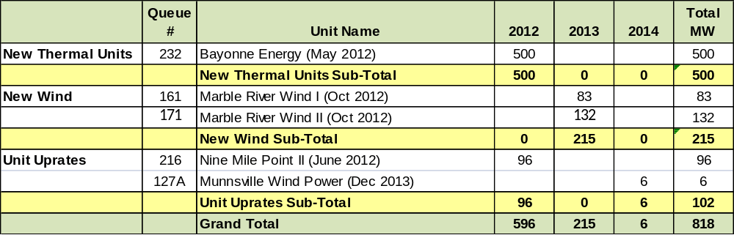

Note: MW values represent the lesser of Capacity Resource Integration Service (CRIS) and Dependable Maximum Net Capability (DMNC) values.

Local Transmission Plans
As part of the LTPP, Transmission Owners presented their Local Transmission Plans (LTPs) to the NYISO and Stakeholders in the fall of 2011. The NYISO reviewed the LTPs and included them in the 2012 Gold Book. Table 3-4 presents the list of 2012 Gold Book firm transmission plans that were included in the RNA Base Case.

Table 3-4: Firm Transmission Plans included in 2012 RNA Base Case (from 2012 Gold Book)
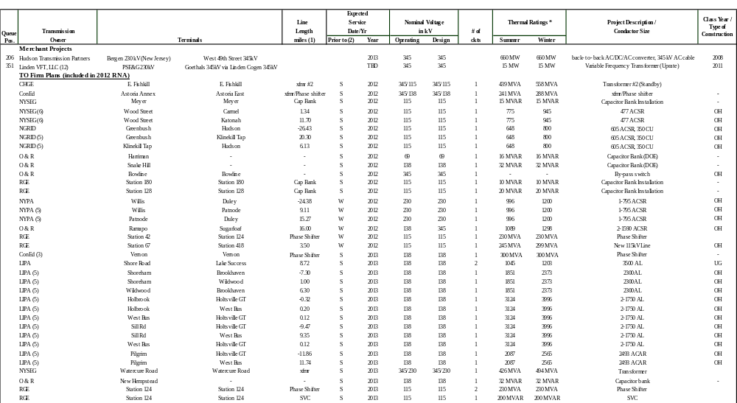

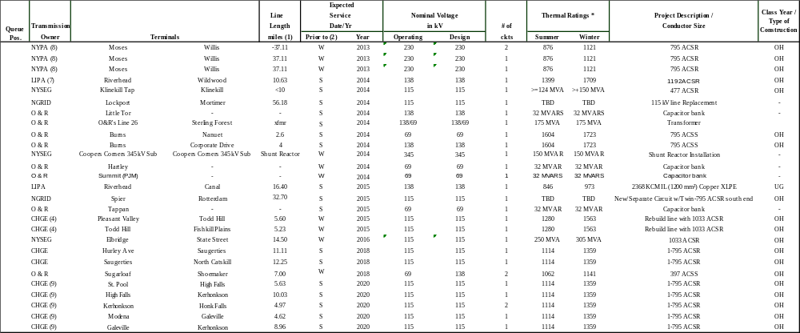

Resource Retirements
Table 3-5 below presents the retired and proposed unit retirements which were represented in the 2012 RNA Base Case. The MW values represent the lesser of CRIS and DMNC values.
Table 3-5: Retired and Proposed Units Retirements

Unit
Retired
Units
Proposed
Retirements
Barrett 07
0
Beebee GT
15
Binghamton Cogen
41
Ravenswood GT 3-4
32
Astoria 2*
177
Astoria 4*
376
Gowanus 1*
134
Gowanus 4*
134
Far Rockaway ST 04*
107
Glenwood ST 04*
115
Glenwood ST 05*
109
Astoria GT 10*
18
Astoria GT 11*
16
Dunkirk 1*
75
Dunkirk 2*
75
Dunkirk 3*
185
Dunkirk 4*
185
Total MW
265
1527**

1792
2012
* Units provided notice of mothballing.
** Capacity values do not add exactly due to rounding.

Base Case Peak Load and Resource Margins
The announced unit retirements as of April 15, 2012 along with the new resource additions that met the base case inclusion rules, when combined with the existing generation in the 2012 Gold Book, resulted in the 2012 RNA Base Case Peak Load and Resource Margins found in Table 3-6 below.
Table 3-6: NYCA Peak Load and Resource Margins 2013 through 2022
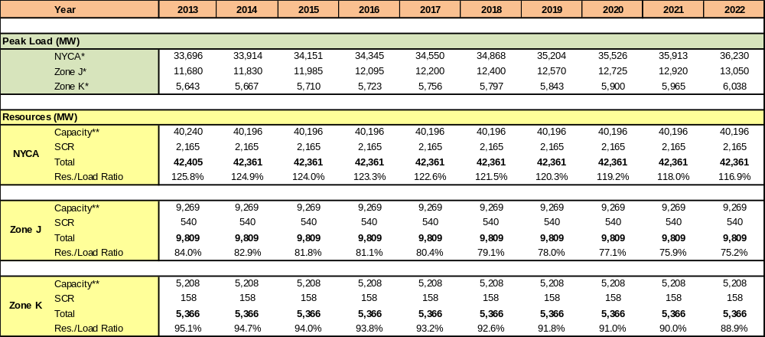

* NYCA load values represent Baseline Coincident Summer Peak Demand. Zones J & K load values represent Summer Non-Coincident Peak Demand.
** NYCA Capacity values include resources electrically internal to NY, Additions, Reratings, Retirements, and Net Purchases and Sales. Zones J and K Capacity values do not include Net Purchases and Sales. Capacity values include the lesser of CRIS and DMNC values

Table 3-7 below presents the comparison between the 2010 RNA and 2012 RNA in NYCA Peak Load forecast, SCRs, capacity and retirements. For 2020, the 2012 RNA Peak Load forecast increased by 192 MW, while the overall NYCA capacity and SCRs decreased by 1,043 MW and 86 MW respectively.

Table 3-7: 2010 RNA to 2012 RNA Load and Capacity Comparison
2010 RNA
2012 RNA
2012 RNA
Horizon
Year 2020
Year 2020
Year 2020
Delta MW
Horizon
Year 2022
Load
35,334
35,526
192
36,230
SCR
2,251
2,165
-86
2,165
Capacity without SCRs
41,239
40,196
-1,043
40,196

Methodology for the Determination of Needs
Reliability Needs are defined by the OATT in terms of total deficiencies relative to Reliability Criteria determined from the assessments of the BPTFs performed for this RNA. There are two different steps to analyzing the reliability of the BPTFs. The first is to evaluate the security of the transmission system; the second is to evaluate the adequacy of the system, subject to the security constraints. The NYISO’s planning procedures include both security and adequacy assessments. The transmission adequacy and the resource adequacy assessments are performed together.
Security is the ability of the power system to withstand sudden disturbances and/or the unanticipated loss of system elements and continue to supply and deliver electricity. Compliance with security criteria is assessed deterministically. Security is a deterministic concept, with potential disturbances being treated with equal likelihood in the assessment. These disturbances (single contingency and multiple contingencies) are explicitly defined in the reliability rules as design criteria contingencies. The impacts when applying these design criteria contingencies are assessed to ensure no thermal loading, voltage or stability violations will arise. These design criteria contingencies are sometimes referred to as N-1 or N-1-1. In addition, the NYISO performs a short circuit analysis to determine that the system can clear faulted facilities reliably under short circuit conditions. The NYISO “Guideline for Fault Current Assessment” is used in this study.
Resource adequacy is the ability of the electric systems to supply and deliver the total quantity of electricity demanded at any given time taking into account scheduled and unscheduled outages of system elements. Resource adequacy considers the transmission systems, generation resources, and other capacity resources, such as demand response. Resource adequacy assessments are performed on a probabilistic basis to capture the randomness of system element outages. A system is adequate if the probability of having sufficient transmission and generation to meet expected demand is equal to or less than the system’s standard, which is expressed as a Loss of Load Expectation (LOLE). The New York State bulk power system is planned to meet a LOLE that, at any given point in time, is less than or equal to an involuntary load disconnection that is not more frequent than once in every 10 years, or 0.1 events per year. This requirement forms the basis of New York’s Installed Reserve Margin (IRM) requirement.
If Reliability Needs are identified, the amount of compensatory MW required for the New York Control Area (NYCA), in appropriate locations to resolve the need (by load zone), are reported. Compensatory MW amounts are determined by adding generic 250 MW generating units to zones to address the zone-specific needs. The compensatory MW amounts and locations are based on a review of binding transmission constraints and zonal LOLE in an iterative process to determine when Reliability Criteria are satisfied. These additions are used to estimate the amount of resources generally needed to satisfy Reliability Needs. The compensatory MW additions are not intended to represent specific proposed solutions. Resource needs could potentially be met by other combinations of resources in other areas including generation, transmission and demand response measures. Due to the differing natures of supply and demand-side resources and transmission constraints, the amounts and locations of resources necessary to match the level of compensatory MW needs identified will vary. Resource needs could be met in part by transmission system reconfigurations that increase transfer limits, or by changes in operating protocols. Operating protocols could include such actions as using dynamic ratings for certain facilities, operating exceptions, or special protection systems.

Reliability Needs Assessment

Overview
Reliability is defined and measured through the use of the concepts of security and adequacy. Security is assessed through a power flow analysis that checks for Transmission Security design criteria violations. Transmission Adequacy and Resource Adequacy are assessed with the use of General Electric’s Multi Area Reliability Simulation (MARS) software package. This is done through the application of interface transfer limits and a probabilistic simulation of the outages of capacity and transmission resources.

Reliability Needs for Base Case
Below are the principal findings of the 2012 RNA for the 2013-2022 Study Period including: transmission security assessment; short circuit assessment; resource and transmission adequacy assessment; system stability assessments; and scenario analyses.

Transmission Security Assessment

A Reliability Needs Assessment requires analysis of the security of the Bulk Power Transmission Facilities (BPTFs). The NYISO performed AC contingency analysis of the BPTFs to test for thermal and voltage violations under pre- and post- contingency conditions (per NERC Standards TPL-001, -002, and -003, NPCC Directory #1, and NYSRC Reliability Rules) using Siemens PTI PSS®E, PSS®MUST and PowerGEM TARA programs. More extensive analysis was performed for critical contingency evaluation and transfer limit evaluation using the power-voltage (P-V) curve approach as described in NYISO Transmission Planning Guideline #2-0 using the Siemens PTI PSS®E (Rev. 32) software package. The impact of the status of critical generators on transfer limits was also quantified. To assist in its assessment, the NYISO also reviewed many previously completed transmission security assessments.

Preliminary transmission security assessments found that certain BPTF contingency outages in Zone A prevented the power flow from solving and other contingencies produced thermal and voltage violations on BPTF and non-BPTF in that zone. In order to complete the transmission security analyses for the RNA Base Case, generic generation facilities were added to the power flow model in Zone A. With the generic generation facilities modeled, no BPTF violations were found in Zone A. National Grid has finished studying transmission security implications due to the Dunkirk Generating Plant mothballing however, National Grid has not completed its examination of all potential solutions that would address the mothballing of Dunkirk. The results from this examination are not expected before this RNA is completed.

Methodology
The NYISO performed the transmission security testing required for the RNA Base Case throughout the study period (2013 – 2022). The testing included the ability of the BPTF to meet transmission design criteria following the design criteria contingency (N-1). The same contingency analysis was also performed with critical facility outages (N-1-1). N-1 testing was performed as part of base case review, thermal and voltage criteria testing, and the identification of critical facilities and critical contingencies.
As part of the N-1-1 analysis, individual N-1 cases were created by removing a critical generator, transmission circuit, transformer, series or shunt compensating device, or HVdc pole from the base. Using the automated process, a set of corrective actions was developed with the objective of eliminating violations in the post-contingency cases for each N-1 case, such that when design contingencies (NERC Category B or C contingencies) were tested on the N-1 case, there would be no post-contingency thermal or voltage violations on the BPTF.
Next, N-1-1 contingency analysis was performed by modeling critical facility outages followed by testing of NPCC and NYSRC Design Criteria contingencies (consistent with NERC Categories B and C) while monitoring applicable limits of the New York State BPTF. All results assume that all necessary existing generation resources have been called upon to mitigate potential violations.
Results
The transmission security analysis identified thermal violations in four locations on the BPTF for which sufficient corrective actions could not be identified: RG&E Station 80 345 kV (Zone B); RG&E Pannell 345 kV (Zone B); National Grid Clay 115 kV (Zone C); National Grid Leeds – Pleasant Valley 345 kV corridor (Zones F & G); (Zone G-H-I analysis to be completed).

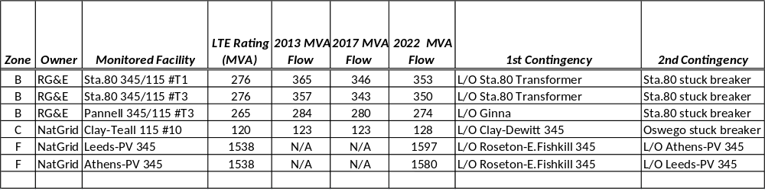

RG&E’s Station 80 includes four 345 kV transmission connections and four 345/115 kV transformers that serve the Rochester area. Starting in 2013, the T1 345/115 kV transformer would be loaded at 132% of its long term emergency (LTE) rating for loss of the T5 transformer followed by a stuck breaker that results in the loss of transformers T2 and T3. Similarly, the T3 345/115 kV transformer would be loaded at 129% of its LTE rating starting in 2013 for loss of the T1 transformer followed by a stuck breaker that results in the loss of transformers T2 and T5. The overloads on T1 and T3 are caused by the loss of three sources (i.e., transformers) to the 115 kV system.
RG&E’s Pannell station includes four 345 kV transmission connections and three 345/115 kV transformers that serve the Rochester area. Similar to the violations identified at Station 80, starting in 2013 the Pannell T3 transformer would be loaded at 107% of its LTE rating for loss of the Ginna generating unit followed by a stuck breaker at Station 80 that results in the loss of Station 80 transformers T2 and T5. The overload of the Pannell T3 transformer is caused by the loss of three sources (i.e., generator and two transformers) to the 115 kV system.
National Grid’s Clay 115 kV station includes eight 115 kV transmission connections and two 345/115 kV transformers that serve the Oswego and Syracuse areas. Starting in 2013, the Clay-Teall #10 115 kV line would be loaded at 103% of its LTE rating for loss of Clay-Dewitt 345 kV followed by a stuck breaker at Oswego 345 kV that results in the loss of Oswego-Elbridge-Lafayette 345 kV line (including Elbridge 345/115 kV transformer) and Oswego T7 345/115 kV transformer. This overload is due to power flowing from north to south on the 115 kV system after the loss of the two north-to-south 345 kV paths in that area.
National Grid’s Leeds – Pleasant Valley 345 kV corridor includes two 345 kV lines from north to south: Leeds – Pleasant Valley and Leeds – Athens – Pleasant Valley. Starting in 2022, each of these lines would be over LTE ratings for two combinations of N-1-1 contingencies. The most severe contingency pair would cause the Leeds – Pleasant Valley 345 kV line to be loaded at 104% of it LTE rating for loss of the Roseton – East Fishkill 345 kV line followed by the loss of the Athens – Pleasant Valley 345 kV line. Similarly, the Athens – Pleasant Valley 345 kV line would be loaded at 103% of it LTE rating for loss of the Roseton – East Fishkill 345 kV line followed by the loss of the Leeds – Pleasant Valley 345 kV line. These overloads are due to a lack of transmission capability and/or generation in the Lower Hudson Valley and New York City areas.
(Transmission Security analysis to be completed for Zones G, H, I.)

For all other N-1-1 contingency combinations that were evaluated, corrective actions were identified for each N-1 outage condition such that there were no other post-contingency thermal or voltage violations on the BPTF.

Short Circuit Assessment
Performance of a transmission security assessment includes the calculation of short circuit current to ascertain whether the circuit breakers in the system would be subject to fault levels in excess of their rated interrupting capability. The analysis was performed for the year 2017 reflecting the study conditions outlined in Sections 3.4, 3.5 and 3.6. The calculated fault levels would be constant over the second five years because no new generation or transmission is modeled in the RNA for second five years, and the methodology for fault duty calculation is not sensitive to load growth. The detailed results are presented in Appendix D of this report.
Based on the study results, there are three stations owned by National Grid which could experience over-duty breakers. Table 4-1 summarizes over-duty breakers at each station. National Grid reports that plans to make the necessary facility upgrades are in place. For Scriba 345 kV, breaker replacements will be completed by the end of 2012. For Porter 115 kV, breaker replacements will be completed in 2015. For Porter 230 kV, the breaker replacements will be completed in 2016.

Table 4-1: 2012 RNA Over-duty Breaker Summary Table
Station | kV | Number of Over-duty Breaker(s) | Breaker ID
Scriba | 345 | 8 | R90,R100,R200,R210,R250,R915,R935,R945
Porter | 230 | 9 | R110,R120,R15,R170,R25,R320,R825,R835,R845
Porter | 115 | 10 | R10,R130,R20,R30,R40,R50,R60,R70,R80, R90

Transmission and Resource Adequacy Assessment
The 2012 RNA Base Case Peak Load forecast was utilized in the analysis to determine transmission system transfer limits. Tables 4-2, 4-3 and 4-4 below provide the thermal and voltage transfer limits for the major NYCA interfaces.

Table 4-2: Transmission System Thermal Transfer Limits for Key Interfaces in MW

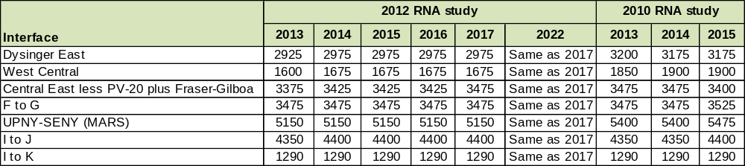

Table 4-3: Transmission System Voltage Transfer Limits for Key Interfaces in MW
Interface
2013
2014
2015
2016
2017
2022
2013
2014
2015
Dysinger East
2725
2900
2875
2900
2875
Same as 2017
2725
2725
2875
West Central
1500
1575
1575
1550
1575
Same as 2017
1475
1475
1575
Central East less PV-20 plus Fraser-Gilboa
3250
3350
3350
3350
3350
Same as 2017
3375
3350
3350
UPNY-ConEd
5150
5210
5210
5210
5210
Same as 2017
5475
5475
5605
I to J & K
5210
5160
5160
5160
5160
Same as 2017
5290
5290
5470
2012 RNA study
2010 RNA study

Table 4-4: Transmission System Base Case Transfer Limits for Key Interfaces in MW

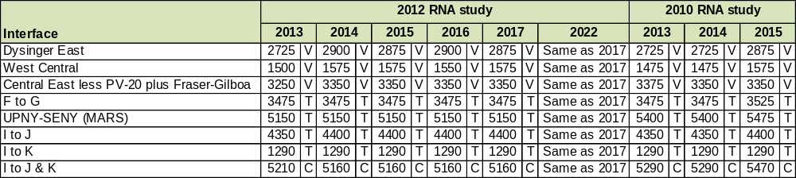
Note: T=Thermal, V=Voltage, C=Combined

The results of the 2012 RNA Base Case studies show that the LOLE for the NYCA does not exceed 0.1 until the year 2020 and the LOLE continues to increase through 2022. The LOLE results for the entire 10-year RNA Base Case are presented in Table 4-5. As noted below that table, all results are rounded to two decimal places. Study results of less than 0.001 are represented by a single zero, rather than 0.000.

Table 4-5: NYCA LOLE for the 2012 RNA Study Base Case*

 | 2013 | 2014 | 2015 | 2016 | 2017 | 2018 | 2019 | 2020 | 2021 | 2022
Area A | 0 | 0 | 0 | 0 | 0 | 0 | 0 | 0 | 0 | 0
Area B | 0 | 0 | 0 | 0 | 0 | 0 | 0 | 0 | 0 | 0.01
Area C | 0 | 0 | 0 | 0 | 0 | 0 | 0 | 0 | 0 | 0
Area D | 0 | 0 | 0 | 0 | 0 | 0 | 0 | 0 | 0 | 0
Area E | 0 | 0 | 0.00 | 0.00 | 0.00 | 0.00 | 0.00 | 0.00 | 0.00 | 0.00
Area F | 0 | 0 | 0 | 0 | 0 | 0 | 0 | 0 | 0 | 0
Area G | 0.00 | 0.00 | 0.00 | 0.00 | 0.00 | 0.01 | 0.01 | 0.01 | 0.02 | 0.03
Area H | 0 | 0 | 0 | 0 | 0 | 0 | 0 | 0 | 0.00 | 0.00
Area I | 0.01 | 0.01 | 0.02 | 0.02 | 0.03 | 0.04 | 0.06 | 0.10 | 0.16 | 0.22
Area J | 0.01 | 0.01 | 0.02 | 0.02 | 0.03 | 0.04 | 0.07 | 0.10 | 0.16 | 0.23
Area K | 0.00 | 0.00 | 0.01 | 0.01 | 0.01 | 0.02 | 0.03 | 0.05 | 0.10 | 0.15
NYCA | 0.01 | 0.01 | 0.02 | 0.02 | 0.03 | 0.05 | 0.07 | 0.11 | 0.17 | 0.24

*Note: “0” represents an LOLE less than 0.001. An LOLE value of 0.00 represents a rounded value such as .001 through .004..
In order to avoid over-dependence on emergency assistance from external areas, the external areas’ emergency operating procedures are not modeled. Capacity of the external systems is further adjusted so that the interconnected LOLE value of the Areas (Ontario, New England, Hydro Quebec, and PJM) is not less than 0.10 and not greater than 0.15 and then the load and generation are frozen in the remaining years. The External Area LOLE values for the Base Case are illustrated in Table 4-5. The MOD-MW capacity modifications required to establish these LOLE values can be found in Appendix D.

Table 4-6: External Area LOLE for the 2012 RNA Study Base Case
Area/Year | 2013 | 2014 | 2015 | 2016 | 2017 | 2018 | 2019 | 2020 | 2021 | 2022
NE | .14 | .14 | .14 | .14 | .15 | .15 | .16 | .17 | .18 | .19
ONT | .12 | .13 | .13 | .13 | .13 | .13 | .14 | .14 | .15 | .15
HQ | .13 | .13 | .13 | .13 | .13 | .13 | .13 | .13 | .13 | .13
PJM | .11 | .11. | .11 | .12 | .12 | .13 | .14 | .15 | .16 | .17

Table 4-7 illustrates the NYCA LOLEs from the 2010 RNA Study.

Table 4-7: NYCA LOLE from the 2010 RNA Study Base Case
Area/Year | 2013 | 2014 | 2015 | 2016 | 2017 | 2018 | 2019 | 2020
NYCA | 0.00 | 0.00 | 0.00 | 0.00 | 0.00 | 0.00 | 0.01 | 0.01

4.2.4 System Stability Assessment
The 2010 NYISO Comprehensive Area Transmission Review (CATR), which was completed in June 2011, is the most recent CATR. An Interim Review was performed in 2011 and will be performed in 2012. The 2010 CATR was performed for the study year 2015 and included the required RNA stability assessments. The CATR found that the planned New York State BPTFs are in conformance with the applicable North American Electric Reliability Corporation (NERC) Reliability Standards, NPCC Transmission Design Criteria and NYSRC Reliability Rules.
The stability analyses were conducted to evaluate the stability performance of the New York State BPTF as required in the NPCC and the NYSRC reliability criteria and rules. The BPTF, as defined in this review, includes all of the facilities designated by the NYISO to be part of the bulk power system as defined by the NPCC; additional non-BPS facilities are also included in the BPTF. The stability simulations show no stability issues for summer peak load or light load conditions.

4.2.5 Reliability Needs Summary

(this section of the report will appear in future draft)

Scenarios
Scenarios are variations on the RNA Base Case to assess the impact of possible changes in key study assumptions which, if they occurred, could change whether there could be Reliability Criteria violations on the NYCA system during the study period. The following scenarios were evaluated as part of the RNA:
  - High Load (Econometric) Forecast
  - Low Load ( full 15 x 15 achievement) Forecast
  - Indian Point Plant Retirement
  - Zonal Capacity at Risk
  - All Coal Generation Retirement

(this section of the report will appear in future draft)

5. Impacts of Environmental Program Initiatives

Environmental Regulations

New York has a long history in the active development of environmental policies and regulations that govern the permitting, construction and operation of power generation and transmission facilities. Currently New York’s standards for permitting new generating facilities are among the most stringent in the nation. The combination of tighter environmental standards, coupled with competitive markets administered by the NYISO since 1999, has resulted in the retirement of older plants equaling approximately 4000 MW of capacity, and the addition of over 9,300 MW of new efficient generating capacity. In turn, these changes have led to marked reduction of power plant emissions and a significant improvement in the efficiency of the generation fleet. Figures 5-1 and 5-2 show New York State power plant emissions and heat rates from 1999 through 2011.

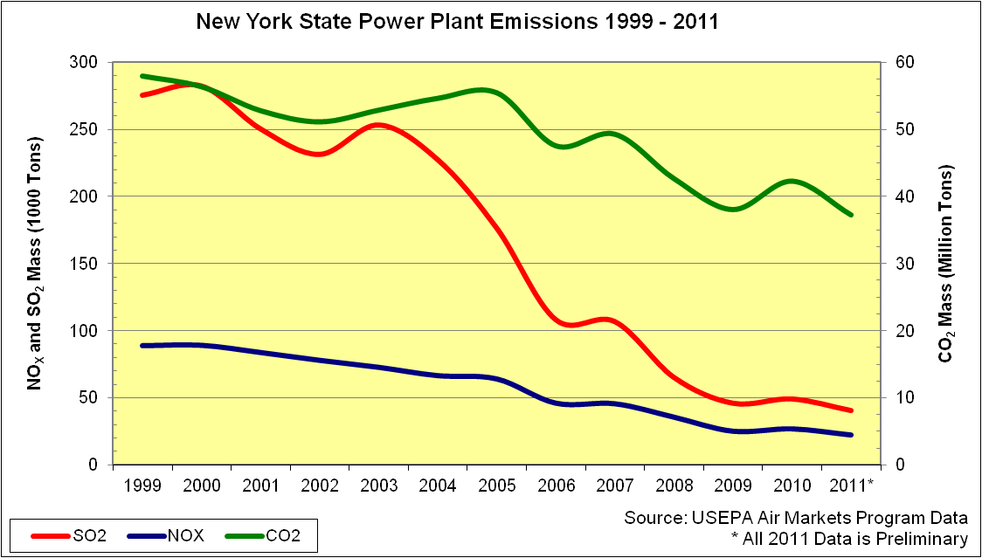
Figure 5-1: New York Power Plant Emissions 1999-2011

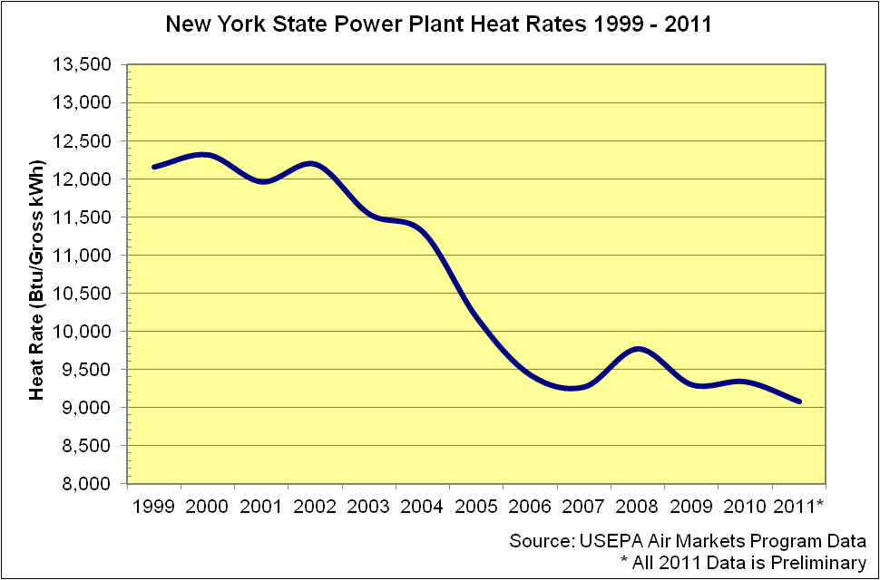
Figure 5-2: New York Power Plant Heat Rates 1999-2011

Notwithstanding the progress towards achieving New York’s clean energy and environmental goals, various environmental initiatives are either in place or pending that will affect the operation of the existing fleet. Environmental initiatives that may affect generation resources may be driven by either or both of the State and Federal programs. Since the prior RNA, the USEPA has promulgated several regulations that will affect most of the thermal fleet of generators in NYCA. Similarly, NYSDEC has undertaken the development of several regulations that will apply to most of the thermal fleet in New York.

One of the purposes of the RNA is to identify possible future outcomes that could lead to insufficient resources in the NYS Power System to satisfy applicable Reliability Criteria. Such a situation may result from the previously unplanned retirement of a significant amount of capacity provided by existing resources. The purpose of the development of this “Environmental Scenario” is to gain insight into the population of resources that are likely to be faced with major capital investment decisions in order to achieve compliance with several evolving environmental program initiatives. The premise of this analysis is that the risk of previously unplanned retirements is related to two factors: first, the capital investment decisions resource owners need to make in order to achieve compliance with the new regulatory program requirements, and second, the recent change in the relative attractiveness of gas versus coal has challenged the viability of some former baseload units. The goal of this analysis is to identify when and where these risks could occur on the New York Power System.

This analysis estimates levels of capacity that will need to undertake retrofits to achieve compliance with the selected suite of environmental initiatives. The identification and timing of these potential risks will help to inform the NYISO and State policy makers of the potential impacts to system reliability caused by the newly adopted and/or proposed environmental regulations. Of equal importance, the results will also provide useful information about future opportunities to developers of new clean efficient generation resources or aggregators of special case resources.

Selection of Major Environmental Program Initiatives
Five environmental initiatives are sufficiently broad in application and have requirements that potentially may require retrofitting environmental control technologies to an extent that generator owners will likely need to address the retirement versus retrofit question. These environmental initiatives are: (i) NYSDEC’s Reasonably Available Control Technology for Oxides of Nitrogen (NOx RACT);, (ii) Best Available Retrofit Technology (BART) to address regional haze; (iii) Best Technology Available (BTA) for cooling water intake structures;,(iv) the USEPA’s Mercury and Air Toxics Standards (MATS), and (v) the Cross State Air Pollution Rule (CSAPR) addressing interstate transport of criteria air pollutants.

Reasonably Available Control Technology for Oxides of Nitrogen (NOx RACT)

NYS DEC finalized new regulations for the control of emissions of nitrogen oxides (NOx) from fossil fueled power plants (Part 227-2). The regulations establish presumptive emission limits for each type of fossil fueled generator and each fuel used in an electric generator in New York that has a capacity greater than 25MW. Compliance options include averaging emissions with lower emitting units, fuel switching, and installing emission reduction equipment such as low NOx burners or combustors, selective catalytic reduction units, or retirement. Generators were required to file permit applications and a RACT analysis with NYSDEC by January 1, 2012. Compliance with approved plans is required by July 1, 2014.

Best Available Retrofit Technology (BART)

NYS DEC recently promulgated a new regulation Part 249, Requirements for the Applicability, Analysis, and Installation of Best Available Retrofit Technology (BART) Controls. The regulation applies to fossil fueled electric generating units built between August 7, 1962 and August 7, 1977 and is necessary for New York State to comply with provisions of the federal Clean Air Act that are designed to improve visibility in National Parks. The regulation requires an analysis to determine the impact of an affected unit’s emissions on visibility in national parks. If the impacts are greater than a prescribed minimum, then emission reductions must be made at the affected unit. Emissions control of sulfur dioxide (SO2), nitrogen oxides (NOx) and particulate matter (PM) may be necessary. Compliance Plans were filed with NYSDEC in October 2011. The compliance deadline is January 2014. USEPA recently announced that several of the submitted plans required additional reductions.

Mercury Air Toxics Standard (MATS)

USEPA announced the final rule in December, 2011. (The proposed rule had been known as the Maximum Achievable Control Technology –MACT Rule for Hazardous Air Pollutants.(HAPS)) The rule establishes limits for acid gases, Hydrogen Chloride (HCl), Hydrogen Fluoride (HF), Mercury (Hg), and Particulate Matter. Alternative limits were also established. MATS limits will apply to coal and/or oil-fired generators. The compliance date is March 2015. NYSDEC may provide an additional year to comply if necessary. Further, reliability critical units can qualify for another year to achieve compliance if retrofitting emissions control technology is required or if the reliability improvement project will take an additional year to comply.

In addition, NYS DEC has promulgated Part 246: Mercury Reduction Program for Coal-Fired Electric Utility Steam Generating Units, which establishes emission limitations that are currently in effect in New York to reduce mercury emissions. Phase II of this regulation requires additional reductions for coal fired boilers in 2015. The Phase II emission limitations are more stringent than the USEPA MATS limits.

Best Technology Available (BTA)

NYS DEC has finalized its policy document “Best Technology Available (BTA) for Cooling Water Intake Structures.” The policy applies to plants with design intake capacity greater than 20 million gallons/day and prescribes reductions in fish mortality. The proposed policy establishes performance goals for new and existing cooling water intake structures. The performance goals call for the use of wet, closed-cycle cooling systems at existing generating facilities. The policy provides some limited relief for plants with historical capacity factors less than 15%. The policy is applied at the time that the State Pollution Discharge Elimination System Permit is renewed which is theoretically a five year period.

Once the NYSDEC has made a determination of what constitutes BTA for a facility, the Department will consider the cost of the technology to determine if the costs are “wholly disproportionate” to the environmental benefits to be gained with BTA.

Cross State Air Pollution Rule (CSAPR)
The USEPA finalized the rule in December. The rule is designed to reduce emissions of SO2, Annual NOx and Ozone Season NOx from fossil fueled power plants in 28 central and eastern states. The regulation is implemented through the use of emission allowances and limited trading programs. The regulation establishes emission budgets for each affected state. The emission budget is then divided on a pro-rata basis determined by historic heat input for existing facilities. There are set asides to provide allowances to new fossil generators. The use of emission allowances is expected to increase offering prices for generation from affected facilities. The final rule was placed under a stay by a federal District Court. But for the action of the courts, the rule would be in effect currently with another reduction in the SO2 cap scheduled for 2014. While this rule is currently the subject of litigation, we have chosen to include it in our analysis. CSAPR is USEPA’s revision of the Clean Air Interstate Rule (CAIR) which was vacated by the US Supreme Court. In doing so, the Court ordered that CAIR remain in effect until such time as replacement rule is implemented. In December when the District Court stayed the CSAPR rule, it ordered that CAIR be reinstated. CAIR as promulgated requires significant reductions in allowable emissions scheduled for 2015. Because the federal Clean Air Act provides for reductions in interstate air pollutant transport, it is reasonable to assume that a national interstate program will be in effect for limiting emissions of SO2 and NOx via a cap and trade program in the early part of the ten-year planning horizon. The CSAPR rule will be used to evaluate the potential impacts of that program.

Reliability Impact Assessment Methodology
Several of the evolving environmental initiatives described above have sufficient definition of potential requirements, are generally widespread in effect, and are expected to require compliance actions in the earlier portion of the planning period. Some of these programs either individually or taken together could require substantial additional capital investment. The programs are estimated to impact 31,710 MW of capacity in the NYCA or 81% of the installed generating capacity listed in the 2012 NYISO Gold Book and used to meet the electricity needs of New York consumers.

Each of the four programs has been examined to estimate the amount and location of capacity that will need to retrofit environmental control technology to comply with the new regulation.

NOx RACT Impact Assessment
The NYISO retained GE to conduct a detailed study about the types and costs of control technology necessary to comply with the proposed regulation. The study found that “[a] total of 72 units or 9515 MW of capacity was identified as needing some type of control mechanism or equipment modification to comply with the proposed standard.” Capital costs of compliance were estimated to be approximately in the range of $100-300 million. The study concluded that the costs to comply with this regulation would reduce operating margin for affected generators but taken alone would not generally lead to situations where those margins would become negative.
Generators were required to file permit applications and a RACT analysis with NYSDEC by January 1, 2012. Compliance with approved plans is required by July 1, 2014. The available plans have been reviewed. Several generators have requested that their submittals be considered Competitive Business Information. NYSDEC has denied these requests. The resolution of this issue may extend beyond the time of this study.
Reviewing the plans that are public, it is seen that approximately 27,000 MW of capacity is subject to this rule of which generating units of approximately 6000 MW of capacity are involved in emission reduction projects. Some of these projects are underway and the balance should be able to be accomplished prior to the July 2014 compliance date.

BART Impact Assessment
The results of the visibility analysis are used to determine the emission reductions that may be necessary for SO2, NOx, and PM. USEPA has established a presumptive set of emission limits for 8600 MW of affected units. Appendix E contains a detailed listing of affected units, the majority of which are located in SENY. The majority of these units are large oil fired units that have gas as an alternate fuel. Many of these units do not have state of the art emission control systems.

The NOx control measures for BART generally were consistent with the results of the NOx RACT study. NYS DEC has established a reasonableness test of $5000/ton reduced. This NYS DEC estimate is based on the NYS DEC definition of “Potential to Emit.” Capital expenditures for this program would be of the same order of magnitude as the NOx RACT program.

BART compliance plans were filed with NYSDEC in October 2011. NYSDEC has reviewed these plans and is in the process of issuing amended Title V stationary source permits. USEPA must also review and approve these plans. It has announced that several of the proposed plans will need to be revised to be more consistent with the presumptive limits.

Historic emissions and inventories of installed emission control equipment of have been reviewed to estimate the level of additional emission reductions required. Most of the affected capacity can with optimum operation of existing environmental control equipment and/or fuel switching, comply with the emission limits. Several small units have chosen to retire representing a capacity loss of less than 50 MW. Other plants will achieve the required emission reductions through the use of cleaner fuels, while others are undertaking retrofit projects. Approximately 1800 MW of capacity may be required to undertake a major emissions reduction project or switch to cleaner fuels.

MATS Impact Assessment
USEPA announced the final rule for MATS for fossil fired electric generators in December. The regulations apply to coal and oil fueled electric generators greater than 25 MW. Units with 10,300 MW of capacity in NY will be affected by this regulation.
USEPA established a subcategory for limited use oil-fired generators. Units that maintain a capacity factor on oil that is less than 8% will be more lightly regulated. As shown in Figure 5-3, no oil fired EGUs exceeded the 8% Capacity Factor, while firing oil in 2009 and 2010. While these units will remain subject to MATS, it is not expected that significant emission control retrofit projects will be required at these units.
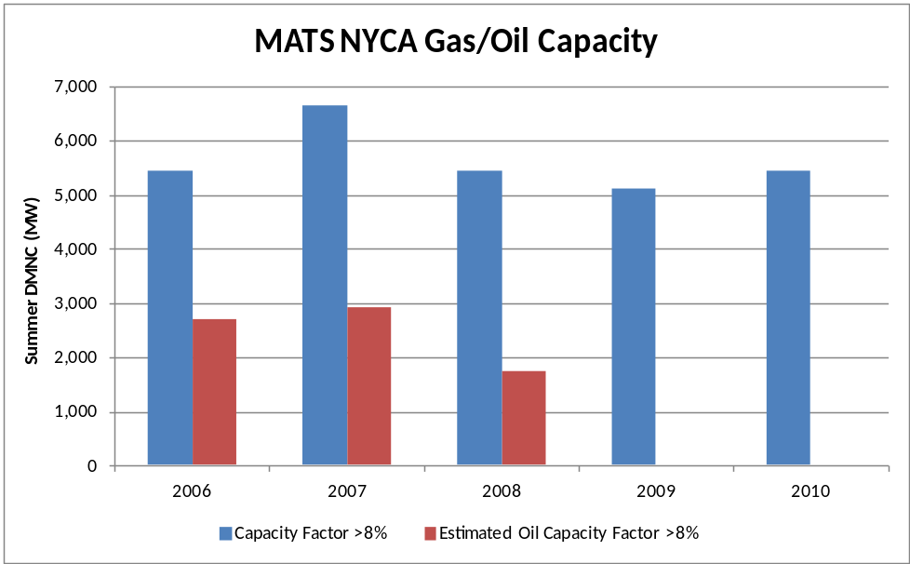
Figure 5-3: MATS NYCA Gas/Oil Capacity

The coal fired generators subject to MATS are also subject to NYS DEC Part 246 Phase 2 regulations for limitations on mercury emission. These regulations are more stringent than USEPA’s MATS. The review of potential impacts for coal units focused on emissions of particulate matter (PM) and acid gases in the form of HCL. Alternative emission limits are also provided for Non-Hg Metals and SO2. Historic emissions and inventories of installed emission control equipment have been reviewed to estimate the level of additional emission reductions required. With optimum operation of existing environmental control equipment and/or fuel switching, most of the affected coal capacity can comply with the emission limits.

BTA Impact Assessment
NYS DEC’s BTA policy will require the use of closed cycle cooling systems at plants that currently have open cycle cooling systems with some limited relief for sites that cannot physically accommodate cooling towers, generators with historical capacity factors below 15%, and where the expense of a closed cooling water system is “wholly disproportionate” compared to the environmental benefits to be gained. Several sites have gained limited relief.

NYS DEC has made twelve BTA determinations of which two determinations required the use of closed cycle cooling systems. Although the number of impacted MWs is unknown, for study purposes the NYISO shows a range from 4000 MW to 7000 MW. This program will require capital investments that are one to two orders of magnitude greater than the cumulative costs for the other environmental initiatives examined. Consequently, the BTA program has the greatest potential to lead to previously unplanned retirements.

CSAPR Impact Assessment

The CSAPR rule applies to most of the fossil fueled fleet with nameplate capacity greater than 25 MW. The rule will require the use of allowances in numbers equivalent to actual emissions for SO2, Annual NOx, and for Ozone Season NOx. The budget for each of the states in the program has been established by USEPA through the use of long range transport models to identify sources and sinks for impact of emissions on areas in other states. The budget of allowances for each of the three categories is distributed on a pro-rata basis developed on historic heat input at affected units. A small set-aside is established for new units and recently retired units to continue to receive allowances for a limited time period. The rule calls for a two phase reduction of SO2 while the limits for Annual NOx and Ozone Season NOx are fixed. The program limits the amount of allowances that can be obtained through trading with generator owners in other states. The total of the budget plus traded allowances is known as the “Assurance Level.” Should a state’s emissions exceed the Assurance Level then two additional allowances would need to be surrendered for the excess emissions. This penalty would be prorated across all emitters.
Historic emissions and inventories of installed emission control equipment have been reviewed to estimate the level of additional emission reductions required. As detailed in Table 5-1 below, with optimum operation of existing environmental control equipment and/or fuel switching, New York State should be able to operate within the Assurance Level.

Table 5-1: New York Sate Emission Allocations under the Cross State Air Pollution Rule
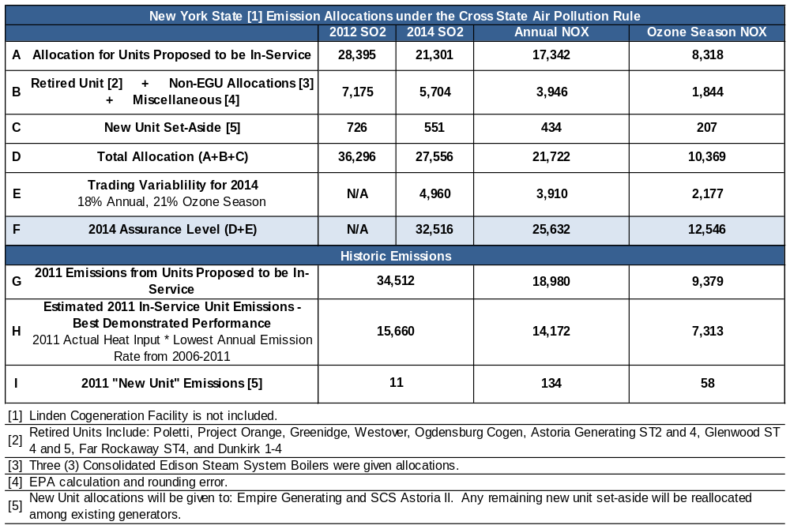

Summary of Impact Assessment

Table 5-2: Summary of Impact Assessment
Program | Description | Goal | Status | Compliance Deadline | Approximate Capacity Affected | Potential Retrofits
NOx RACT  Reasonably Available Control Technology for Oxides of Nitrogen | Limits emissions of nitrogen oxides (NOx) from fossil-fueled power plants by establishing presumptive limits for each type of fossil fueled generator and fuel used. | To reduce emissions from the affected generators by 50%, from 58,000 Tons per Year (TPY) to 29,000 TPY | In effect | July 2014 | 26,700 MW  (238 Units) | 6,000 MW  (23 Units)
BART  Best Available Retrofit Technology | Requires an analysis to determine the impact of certain affected unit’s emissions. If the impacts are greater than a prescribed minimum, then emission reductions must be made at the affected unit. | To limit emissions that may impact visibility in national parks. Emissions control of sulfur dioxide (SO2), nitrogen oxides (NOx) and particulate matter (PM) may be necessary. | In effect | January 2014 | 8,600 MW  (19 Units) | 1,800 MW  (5 Units)
MATS  Mercury and Air Toxics Standard | Establishes limits for Hazardous Air Pollutants (HAP). Will apply to coal and oil-fired generators. | To limit emissions, under the federal Clean Air Act, of certain substances classified as hazardous air pollutants. | In effect | March 2015 | 10,300 MW  (28 Units) | 400 MW  (2 Units)
BTA  Best Technology Available for Cooling Water Intake Structures | Would apply to power plants with design intake capacity greater than 20 million gallons/day and prescribes reductions in fish mortality. | To establish performance goals for new and existing cooling water intake structures, and the use of wet, closed-cycle cooling systems. | In effect | Upon Permit Renewal | 16,900 MW  (39 Units) | 4,400 to  7,300 MW
CSAPR  Cross State Air Pollution Rule | Limits Emissions of SO2 and NOx From Power Plants Greater Than 25 MW in 28 Eastern States through the use of emission allowances with limited trading. | Attain and maintain air quality consistent with Nation Ambient Air Quality Standards. | Implementation is stayed while the rule is in litigation | Jan. 2012 and Jan. 2014 | 25,000 MW  (156 Units) | 2,400 MW  (11 Units)

Observations and Recommendations

Historic Congestion
Appendix A of Attachment Y of the NYISO OATT states: “As part of its Comprehensive System Planning Process, the NYISO will prepare summaries and detailed analysis of historic congestion across the New York Transmission System. This will include analysis to identify the significant causes of historic congestion in an effort to help Market Participants and other stakeholders distinguish persistent and addressable congestion from congestion that results from onetime events or transient adjustments in operating procedures that may or may not recur. This information will assist Market Participants and other stakeholders to make appropriately informed decisions.” The detailed analysis of historic congestion can be found on the NYISO Web site.

Appendices A-D

- Reliability Needs Assessment Glossary

Term | Definition
10-year Study Period: | 10-year period starting with the year after the study is dated and projecting forward 10 years. For example, the 2012 RNA covers the 10-year Study Period of 2013 through 2022.
Adequacy: | Encompassing both generation and transmission, adequacy refers to the ability of the bulk power system to supply the aggregate requirements of consumers at all times, accounting for scheduled and unscheduled outages of system components.
Alternative Regulated Responses: | Regulated solutions submitted by a TO or other developer in response to a solicitation by the NYISO, if the NYISO determines that it has not received adequate market-based solutions to satisfy the Reliability Need.
Annual Transmission Reliability Assessment (ATRA): | An assessment, conducted by the NYISO staff in cooperation with Market Participants, to determine the System Upgrade Facilities required for each generation and merchant transmission project included in the Assessment to interconnect to the New York State Transmission System in compliance with Applicable Reliability Requirements and the NYISO Minimum Interconnection Standard.
Annual Transmission Review (ATR): | The NYISO, in its role as Planning Coordinator, is responsible for providing an annual report to the NPCC Compliance Committee in regard to its Area Transmission Review in accordance with the NPCC Reliability Compliance and Enforcement Program and in conformance with the NPCC Design and Operation of the Bulk Power System (Directory #1).
Best Available Retrofit Technology (BART): | NYS DEC regulation, required for compliance with the federal Clean Air Act, applying to fossil fueled electric generating units built between August 7, 1962 and August 7, 1977. Emissions control of SO₂, NOx and PM may be necessary for compliance. Compliance deadline is January 2014.
Best Technology Available (BTA): | Proposed NYS DEC policy establishing performance goals for new and existing electricity generating plants for Cooling Water Intake Structures. The policy would apply to plants with design intake capacity greater than 20 million gallons/day and prescribes reductions in fish mortality. The performance goals call for the use of wet, closed-cycle cooling systems at existing generating plants.
Bulk Power Transmission Facility (BPTF): | Transmission facilities that are system elements of the bulk power system which is the interconnected electrical system within northeastern North America comprised of system elements on which faults or disturbances can have a significant adverse impact outside of the local area.
Capability Period: | The Summer Capability Period lasts six months, from May 1 through October 31. The Winter Capability Period runs from November 1 through April 30 of the following year.
Capacity: | The capability to generate or transmit electrical power, or the ability to reduce demand at the direction of the NYISO.
Capacity Resource Integration Service (CRIS): | CRIS is the service provided by NYISO to interconnect the Developer’s Large Generating Facility or Merchant Transmission Facility to the New York State Transmission System in accordance with the NYISO Deliverability Interconnection Standard, to enable the New York State Transmission System to deliver electric capacity from the Large Generating Facility or Merchant Transmission Facility,  pursuant to the terms of the NYISO OATT.
Class Year: | The group of generation and merchant transmission projects included in any particular Annual Transmission Reliability Assessment [ATRA], in accordance with the criteria specified for including such projects in the assessment.
Clean Air Interstate Rule (CAIR): | Rule proposed by the U.S. EPA to reduce Interstate Transport of Fine Particulate Matter (PM) and Ozone. CAIR provides a federal framework to limit the emission of SO₂ and CO₂.
Comprehensive Reliability Planning Process (CRPP): | The biennial process that includes evaluation of resource adequacy and transmission system security of the state’s bulk electricity grid over a 10-year period and evaluates solutions to meet those needs. The CRPP consists of two studies: the RNA, which identifies potential problems, and the CRP, which evaluates specific solutions to those problems.
Comprehensive Reliability Plan (CRP): | A biennial study undertaken by the NYISO that evaluates projects offered to meet New York’s future electric power needs, as identified in the Reliability Needs Assessment (RNA). The CRP may trigger electric utilities to pursue regulated solutions to meet Reliability Needs if market-based solutions will not be available by the need date. It is the second step in the Comprehensive Reliability Planning Process (CRPP).
Comprehensive System Planning Process (CSPP): | A transmission system planning process that is comprised of three components: 1) Local transmission planning; 2) Compilation of local plans into the Comprehensive Reliability Planning Process (CRPP), which includes developing a Comprehensive Reliability Plan (CRP); 3) Channeling the CRP data into the Congestion Assessment and Resource Integration Study (CARIS)
Congestion Assessment and Resource Integration Study (CARIS): | The third component of the Comprehensive System Planning Process (CSPP). The CARIS is based on the Comprehensive Reliability Plan (CRP).
Congestion: | Congestion on the transmission system results from physical limits on how much power transmission equipment can carry without exceeding thermal, voltage and/or stability limits determined to maintain system reliability. If a lower cost generator cannot transmit its available power to a customer because of a physical transmission constraint, the cost of dispatching a more expensive generator is the congestion cost.
Contingencies: | Contingencies are individual electrical system events (including disturbances and equipment failures) that are likely to happen.
Dependable Maximum Net  Capability  (DMNC): | The sustained maximum net output of a generator, as demonstrated by the performance of a test or through actual operation, averaged over a continuous time period as defined in the ISO Procedures. The DMNC test determines the amount of Installed Capacity used to calculate the Unforced Capacity that the Resource is permitted to supply to the NYCA.
Electric System Planning Work Group (ESPWG): | A NYISO governance working group for Market Participants designated to fulfill the planning functions assigned to it. The ESPWG is a working group that provides a forum for stakeholders and Market Participants to provide input into the NYISO’s Comprehensive System Planning Process (CSPP), the NYISO’s response to FERC reliability-related Orders and other directives, other system planning activities, policies regarding cost allocation and recovery for regulated reliability and/or economic projects, and related matters.
Energy Efficiency Portfolio Standard (EEPS): | A statewide program ordered by the NYSPSC in response to the Governor’s call to reduce New Yorkers' electricity usage by 15% of 2007 forecast levels by the year 2015, with comparable results in natural gas conservation.
Federal Energy Regulatory Commission (FERC): | The federal energy regulatory agency within the U.S. Department of Energy that approves the NYISO’s tariffs and regulates its operation of the bulk electricity grid, wholesale power markets, and planning and interconnection processes.
FERC 715: | Annual report that is required by transmitting utilities operating grid facilities that are rated at or above 100 kilovolts. The report consists of transmission systems maps, a detailed description of transmission planning Reliability Criteria, detailed descriptions of transmission planning assessment practices, and detailed evaluation of anticipated system performance as measured against Reliability Criteria.
Five Year Base Case: | The model representing the New York State power system over the first five years of the Study Period.
Forced Outage: | An unanticipated loss of capacity, due to the breakdown of a power plant or transmission line. It can also mean the intentional shutdown of a generating unit or transmission line for emergency reasons.
Gap Solution: | A solution to a Reliability Need that is designed to be temporary and to strive to be compatible with permanent market-based proposals. A permanent regulated solution, if appropriate, may proceed in parallel with a Gap Solution.
Gold Book: | Annual NYISO publication of its Load and Capacity Data Report.
Market Monitoring Unit: | A consulting or other professional services firm, or other similar  entity, retained by the NYISO Board pursuant to Market Service Tariff Section 30.4, Attachment O - Market Monitoring Plan.
Installed Capacity (ICAP): | A generator or load facility that complies with the requirements in the Reliability Rules and is capable of supplying and/or reducing the demand for energy in the NYCA for the purpose of ensuring that sufficient energy and capacity are available to meet the Reliability Rules.
Installed Reserve Margin (IRM): | The amount of installed electric generation capacity above 100% of the forecasted peak electric consumption that is required to meet New York State Reliability Council (NYSRC) resource adequacy criteria. Most studies in recent years have indicated a need for a 15-20% reserve margin for adequate reliability in New York.
Interconnection Queue: | A queue of transmission and generation projects (greater than 20 MW) that have submitted an Interconnection Request to the NYISO to be interconnected to the state’s bulk electricity grid. All projects must undergo three studies – a Feasibility Study (unless parties agree to forgo it), a System Reliability Impact Study (SRIS) and a Facilities Study – before interconnecting to the grid.
Load Pocket: | Areas that have a limited ability to import generation resources from outside their areas in order to meet reliability requirements.
Local Transmission Plan (LTP): | The Local Transmission Owner Plan resulting from the LTPP.
Local Transmission Owner Planning Process (LTPP): | The first step in the Comprehensive System Planning Process (CSPP), under which transmission owners in New York’s electricity markets provide their local transmission plans for consideration and comment by interested parties.
Loss of load expectation (LOLE): | LOLE establishes the amount of generation and demand-side resources needed - subject to the level of the availability of those resources, load uncertainty, available transmission system transfer capability and emergency operating procedures - to minimize the probability of an involuntary loss of firm electric load on the bulk electricity grid. The state’s bulk electricity grid is designed to meet an LOLE that is not greater than one occurrence of an involuntary load disconnection in 10 years, expressed mathematically as 0.1 days per year.
Lower Hudson Valley: | The southeastern section of New York, comprising New York Control Area Load Zones G (lower portion), H and I. Greene, Ulster, Orange, Dutchess, Putnam, Rockland and Westchester counties are located in those Load Zones.
Market-Based Solutions: | Investor-proposed projects that are driven by market needs to meet future reliability requirements of the bulk electricity grid as outlined in the RNA. Those solutions can include generation, transmission and Demand Response Programs.
Market Participant: | An entity, excluding the NYISO, that produces, transmits sells, and/or purchases for resale capacity, energy and ancillary services in the wholesale market. Market Participants include: customers under the NYISO’s tariffs, power exchanges, TOs, primary holders, load serving entities, generating companies and other suppliers, and entities buying or selling transmission congestion contracts.
Mercury and Air Toxics Standards (MATS): | In December, 2011 USEPA announced the final rule (previously known as the MACT rule). The rule applies to oil and coal fired generators and establishes limits for HAPs, acid gases, Mercury (Hg), and Particulate Matter (PM). Compliance is required by March 2015.
National Ambient Air Quality Standards (NAAQS): | Limits, set by the EPA, on pollutants considered harmful to public health and the environment.
New York Control Area (NYCA): | The area under the electrical control of the NYISO. It includes the entire state of New York, and is divided into 11 zones.
New York State Department of Environmental Conservation (NYSDEC): | The agency that implements New York State environmental conservation law, with some programs also governed by federal law.
New York Independent System Operator (NYISO): | Formed in 1997 and commencing operations in 1999, the NYISO is a not-for-profit organization that manages New York’s bulk electricity grid – an 11,016-mile network of high voltage lines that carry electricity throughout the state. The NYISO also oversees the state’s wholesale electricity markets. The organization is governed by an independent Board of Directors and a governance structure made up of committees with Market Participants and stakeholders as members.
New York State Department of Public Service (DPS): | The New York State Department of Public Service, as defined in the New York Public Service Law, which serves as the staff for the New York State Public Service Commission.
New York State Public Service Commission (NYSPSC): | The New York State Public Service Commission, as defined in the New York Public Service Law.
New York State Energy Research and Development Authority (NYSERDA): | A corporation created under the New York State Public Authorities law and funded by the System Benefits Charge (SBC) and other sources. Among other responsibilities, NYSERDA is charged with conducting a multifaceted energy and environmental research and development program to meet New York State's diverse economic needs, and administering state System Benefits Charge, Renewable Portfolio Standard, and Energy Efficiency Portfolio Standard programs.
New York State Reliability Council (NYSRC) | A not-for-profit entity that develops, maintains, and, from time-to-time, updates the Reliability Rules which shall be complied with by the New York Independent System Operator ("NYISO") and all entities engaging in electric transmission, ancillary services, energy and power transactions on the New York State Power System.
North American Electric Reliability Corporation (NERC): | A not-for-profit organization that develops and enforces reliability standards; assesses reliability annually via 10-year and seasonal forecasts; monitors the bulk power system; and educates, trains, and certifies industry personnel. NERC is subject to oversight by the FERC and governmental authorities in Canada.
Northeast Power Coordinating Council (NPCC): | A not-for-profit corporation responsible for promoting and improving the reliability of the international, interconnected bulk power system in Northeastern North America.
Open Access Transmission Tariff (OATT): | Document of Rates, Terms and Conditions, regulated by the FERC, under which the NYISO provides transmission service. The OATT is a dynamic document to which revisions are made on a collaborative basis by the NYISO, New York’s Electricity Market Stakeholders, and the FERC.
Order 890: | Adopted by FERC in February 2007, Order 890 is a change to FERC’s 1996 transmission open access regulations (established in Orders 888 and 889). Order 890 is intended to provide for more effective competition, transparency and planning in wholesale electricity markets and transmission grid operations, as well as to strengthen the Open Access Transmission Tariff (OATT) with regard to non-discriminatory transmission service. Order 890 requires Transmission Providers – including the NYISO – to have a formal planning process that provides for a coordinated transmission planning process, including reliability and economic planning studies.
Outage: | Removal of generating capacity or transmission line from service either forced or scheduled.
Peak Demand: | The maximum instantaneous power demand averaged over any designated interval of time, which is measured in megawatts (MW). Peak demand, also known as peak load, is usually measured hourly.
Reasonably Available Control Technology for Oxides of Nitrogen (NOx RACT): | Revised regulations recently promulgated by NYSDEC for the control of emissions of nitrogen oxides (NOx) from fossil fueled power plants. The regulations establish presumptive emission limits for each type of fossil fueled generator and fuel used as an electric generator in NY. The NOx RACT limits are part of the State Implementation Plan for achieving compliance with the National Ambient Air Quality Standard (NAAQS) for ozone.
Reactive Power Resources: | Facilities such as generators, high voltage transmission lines, synchronous condensers, capacitor banks, and static VAr compensators that provide reactive power. Reactive power is the portion of electric power that establishes and sustains the electric and magnetic fields of alternating-current equipment. Reactive power is usually expressed as kilovolt-amperes reactive (kVAr) or megavolt-ampere reactive (MVAr).
Regional Greenhouse Gas Initiative (RGGI): | A cooperative effort by nine Northeast and Mid-Atlantic states (not including New Jersey or Pennsylvania) to limit greenhouse gas emissions using a market-based cap-and-trade approach.
Regulated Backstop Solutions: | Proposals required of certain TOs to meet Reliability Needs as outlined in the RNA. Those solutions can include generation, transmission or Demand Response. Non-Transmission Owner developers may also submit regulated solutions. The NYISO may call for a Gap Solution if neither market-based nor regulated backstop solutions meet Reliability Needs in a timely manner. To the extent possible, the Gap Solution should be temporary and strive to ensure that market-based solutions will not be economically harmed. The NYISO is responsible for evaluating all solutions to determine if they will meet identified Reliability Needs in a timely manner.
Reliability Criteria: | The electric power system planning and operating policies, standards, criteria, guidelines, procedures, and rules promulgated by the North American Electric Reliability Corporation (NERC), Northeast Power Coordinating Council (NPCC), and the New York State Reliability Council (NYSRC), as they may be amended from time to time.
Reliability Need: | A condition identified by the NYISO in the RNA as a violation or potential violation of Reliability Criteria.
Reliability Needs Assessment (RNA): | A bi-annual report that evaluates resource adequacy and transmission system security over a 10-year planning horizon, and identifies future needs of the New York electric grid. It is the first step in the NYISO’s CSPP.
Renewable Portfolio Standard (RPS): | Proceeding commenced by order of the NYSPSC in 2004 which established goal to increase renewable energy used in New York State to 25% (or approximately 3,700 MW) by 2013.
Responsible Transmission Owner (Responsible TO): | The Transmission Owner(s) or TOs designated by the NYISO, pursuant to the NYISO CSPP, to prepare a proposal for a regulated solution to a Reliability Need or to proceed with a regulated solution to a Reliability Need. The Responsible TO will normally be the Transmission Owner in whose Transmission District the NYISO identifies a Reliability Need.
Security: | The ability of the power system to withstand the loss of one or more elements without involuntarily disconnecting firm load.
Southeastern New York (SENY): | The portion of the NYCA comprised of the transmission districts of Con Edison and LIPA (Zones H, I, J and K).
Special Case Resources (SCR): | A NYISO Demand Response program designed to reduce power usage by businesses and large power users qualified to participate in the NYISO’s ICAP market. Companies that sign up as SCRs are paid in advance for agreeing to cut power upon NYISO request.
State Environmental Quality Review Act (SEQRA) | NYS law requiring the sponsoring or approving governmental body to identify and mitigate the significant environmental impacts of the activity/project it is proposing or permitting.
State Implementation Plan (SIP): | A plan, submitted by each State to the EPA, for meeting specific requirements of the Clean Air Act, including the requirement to attain and maintain the National Ambient Air Quality Standards (NAAQS).
Study Period: | The 10-year time period evaluated in the RNA.
System Reliability Impact Study (“SRIS”) | A study, conducted by the NYISO in accordance with Applicable Reliability Standards, to evaluate the impact of a proposed interconnection on the reliability of the New York State Transmission System.
System Benefits Charge (SBC): | An amount of money, charged to ratepayers on their electric bills, which is administered and allocated by NYSERDA towards energy-efficiency programs, research and development initiatives, low-income energy programs, and environmental disclosure activities.
Transfer Capability: | The amount of electricity that can flow on a transmission line at any given instant, respecting facility ratings and reliability rules.
Transmission Constraints: | Limitations on the ability of a transmission facility to transfer electricity during normal or emergency system conditions.
Transmission Owner (TO): | A public utility or authority that owns transmission facilities and provides Transmission Service under the NYISO’s tariffs
Transmission Planning Advisory Subcommittee (TPAS): | An identified group of Market Participants that advises the NYISO Operating Committee and provides support to the NYISO Staff in regard to transmission planning matters including transmission system reliability, expansion, and interconnection
Unforced Capacity Delivery Rights (UDR): | Unforced capacity delivery rights are rights that may be granted to controllable lines to deliver generating capacity from locations outside the NYCA to localities within NYCA.
Upstate New York (UPNY): | The NYCA north of Con Edison's transmission district
Weather Normalized: | Adjustments made to neutralize the impact of weather when making energy and peak demand forecasts. Using historical weather data, energy analysts can account for the influence of extreme weather conditions and adjust actual energy use and peak demand to estimate what would have happened if the hottest day or the coldest day had been the typical, or “normal,” weather conditions. “Normal” is usually calculated by taking the average of the previous 30 years of weather data.
Zone: | One of the eleven regions in the NYCA connected to each other by identified transmission interfaces and designated as Load Zones A-K.

- The Reliability Planning Process
This section presents an overview of the NYISO’s reliability planning process followed by a summary of the 2005, 2007, 2008, 2009 and 2010 CRPs and their current status. A detailed discussion of the reliability planning process, including applicable Reliability Criteria, is contained in NYISO Manual 26 entitled: “Comprehensive Reliability Planning Process Manual,” which is posted on the NYISO’s website.
The NYISO’s reliability planning process, also known as Comprehensive Reliability Planning Process (CRPP) is an integral part of the NYISO’s overall Comprehensive System Planning Process (CSPP). The CSPP planning process is comprised of the Local Transmission Planning Process (LTPP), the Comprehensive Reliability Planning Process (CRPP), and the Congestion Assessment and Resource Integration Study (CARIS). Each CSPP cycle begins with the LTPP. As part of the LTPP, local Transmission Owners perform transmission studies for their BPTFs in their transmission areas according to all applicable criteria. Links to the Transmission Owner’s LTPs can be found on the NYISO’s website . The LTPP provides inputs for the NYISO’s reliability planning process. During the CRPP process, the NYISO conducts the Reliability Needs Assessment (RNA) and Comprehensive Reliability Plan (CRP). The RNA evaluates the adequacy and security of the bulk power system over a 10-year Study Period. In identifying resource adequacy needs, the NYISO identifies the amount of resources in megawatts (known as “compensatory megawatts”) and the locations in which they are needed to meet those needs. After the RNA is complete, the NYISO requests and evaluates first market-based solutions, then regulated backstop solutions and alternative regulated responses that address the identified Reliability Needs. This step results in the development of the NYISO’s Comprehensive Reliability Plan (CRP) for the 10-year Study Period. The CRPP provides inputs for the NYISO’s economic planning process known as CARIS. CARIS Phase 1 examines congestion on the New York bulk power system and the costs and benefits of alternatives to alleviate that congestion. During CARIS Phase 2, the NYISO will evaluate specific transmission project proposals for regulated cost recovery.
The NYISO’s reliability planning process is a long-range assessment of both resource adequacy and transmission reliability of the New York bulk power system conducted over five-year and 10-year planning horizons. There are two different aspects to analyzing the bulk power system’s reliability in the RNA: adequacy and security. Adequacy is a planning and probabilistic concept. A system is adequate if the probability of having sufficient transmission and generation to meet expected demand is equal to or less than the system’s standard, which is expressed as a loss of load expectation (LOLE). The New York State bulk power system is planned to meet an LOLE that, at any given point in time, is less than or equal to an involuntary load disconnection that is not more frequent than once in every 10 years, or 0.1 days per year. This requirement forms the basis of New York’s installed reserve margin (IRM) resource adequacy requirement.
Security is an operating and deterministic concept. This means that possible events are identified as having significant adverse reliability consequences, and the system is planned and operated so that the system can continue to serve load even if these events occur. Security requirements are sometimes referred to as N-1 or N-1-1. N is the number of system components; an N-1 requirement means that the system can withstand single disturbance events (e.g., generator, bus section, transmission circuit, breaker failure, double-circuit tower) without violating thermal, voltage and stability limits or before affecting service to consumers. An N-1-1 requirement means that the Reliability Criteria apply after any critical element such as a generator, a transmission circuit, a transformer, series or shunt compensating device, or a high voltage direct current (HVDC) pole has already been lost. Generation and power flows can be adjusted by the use of 10-minute operating reserve, phase angle regulator control and HVDC control and a second single disturbance is analyzed.
The CRPP is anchored in the market-based philosophy of the NYISO and its Market Participants, which posits that market solutions should be the preferred choice to meet the identified Reliability Needs reported in the RNA. In the CRP, the reliability of the bulk power system is assessed and solutions to Reliability Needs evaluated in accordance with existing Reliability Criteria of the North American Electric Reliability Corporation (NERC), the Northeast Power Coordinating Council, Inc. (NPCC), and the New York State Reliability Council (NYSRC) as they may change from time to time. These criteria and a description of the nature of long-term bulk power system planning are described in detail in the applicable planning manual, and are briefly summarized below. In the event that market-based solutions do not materialize to meet a Reliability Need in a timely manner, the NYISO designates the Responsible TO or Responsible TOs to proceed with a regulated backstop solution in order to maintain system reliability. Market Participants can offer and promote alternative regulated responses which, if determined by NYISO to help satisfy the identified Reliability Needs and by regulators to be more desirable, may displace some or all of the Responsible TOs regulated backstop solutions. Under the CRPP, the NYISO also has an affirmative obligation to report historic congestion across the transmission system. In addition, the draft RNA is provided to the Market Monitoring Unit for review and consideration of whether market rules changes are necessary to address an identified failure, if any, in one of the NYISO’s competitive markets. If market failure is identified as the reason for the lack of market-based solutions, the NYISO will explore appropriate changes in its market rules with its stakeholders and Independent Market Advisor. The CRPP does not substitute for the planning that each TO conducts to maintain the reliability of its own bulk and non-bulk power systems.
The NYISO does not license or construct projects to respond to identified Reliability Needs reported in the RNA. The ultimate approval of those projects lies with regulatory agencies such as the FERC, the NYS PSC, environmental permitting agencies, and local governments. The NYISO monitors the progress and continued viability of proposed market and regulated projects to meet identified needs, and reports its findings in annual plans. Figure B-1 below summarizes the CRPP and Figure B-2 summarizes the CARIS which collectively comprise the CSPP process.
The 2012 CRP will form the basis for the next cycle of the NYISO’s economic planning process. That process will examine congestion on the New York bulk power system and the costs and benefits of alternatives to alleviate that congestion.

NYISO Reliability Planning Process
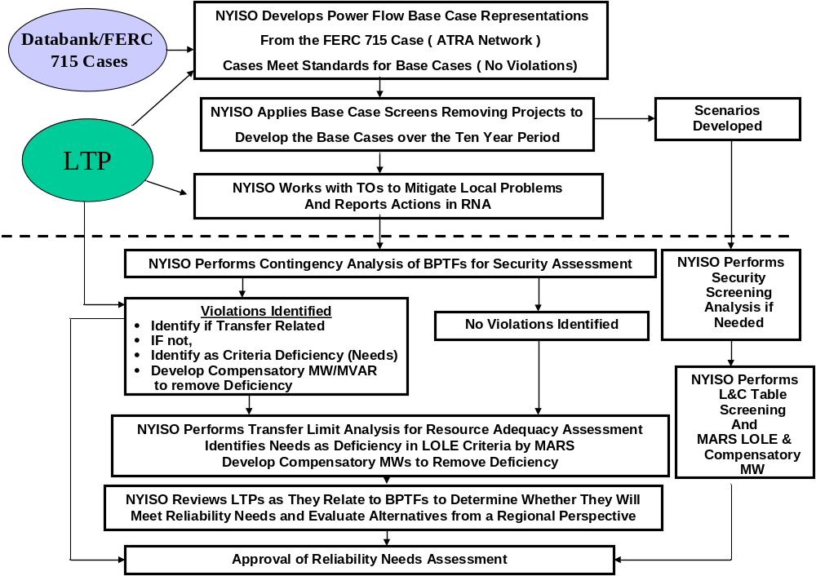
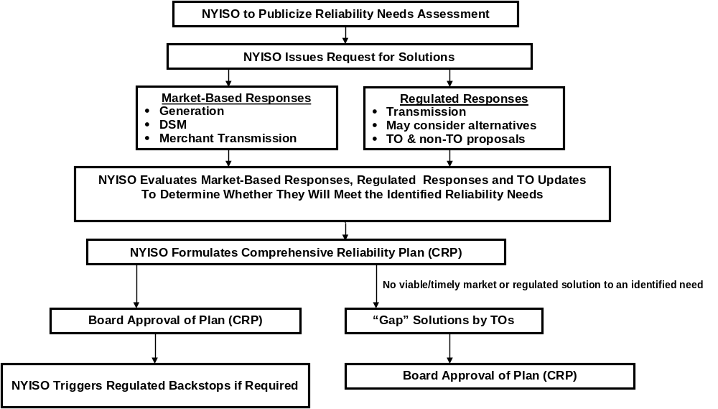
Figure B-1: NYISO Reliability Planning Process

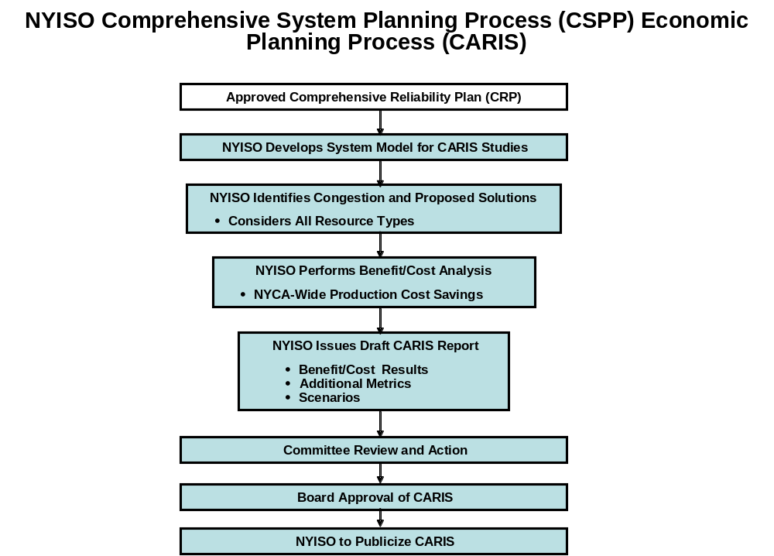
Figure B-2: Economic Planning Process

- Load and Energy Forecast 2013-2022
- Summary
In order to perform the 2012 RNA, a forecast of summer and winter peak demands and annual energy requirements was produced for the years 2013 - 2022. The electricity forecast is based on projections of New York’s economy performed by Moody's Analytics in January 2012. The forecast includes detailed projections of employment, output, income and other factors for twenty three regions in New York State. This appendix provides a summary of the electric energy and peak demand forecasts and the key economic input variables used to produce the forecasts. Table C-1 provides a summary of key economic and electric system growth rates from 2001 to 2022.
In June 2008, the Public Service Commission of New York issued its Order regarding the Energy Efficiency Portfolio Standard. This proceeding set forth a statewide goal of a cumulative energy reduction of about 26,900 GWh. The NYISO estimates the peak demand impacts to be about 5500 MW. This goal is expected to be achieved by contributions from a number of state agencies, power authorities and utilities, as well as from federal codes and building standards. The NYISO included fifty-six percent of the goal by the year 2022 in the 2012 RNA Base Case, including achievements obtained during the years 2009 through 2011.
Table C-1: Summary of Econometric & Electric System Growth Rates – Actual & Forecast
Economic Indicators | Average Annual Growth
Economic Indicators | 2001-2006 | 2006-2011 | 2012-2017 | 2017-2022
Total Employment | 0.44% | 0.04% | 1.82% | 0.58%
Gross State Product | 2.83% | 0.85% | 2.73% | 2.25%
Population | 0.18% | 0.21% | 0.30% | 0.27%
Total Real Income | 3.19% | 0.10% | 2.75% | 1.91%
Weather Normalized Summer Peak | 2.06% | 0.02% | 0.74% | 0.95%
Weather Normalized Annual Energy | 1.00% | 0.00% | 0.40% | 0.77%
Employment Trends | Shares of Total Employment
Employment Trends | 2006 | 2011 | 2017 | 2022
Business, Services & Retail | 53.6% | 53.3% | 53.3% | 53.0%
Health, Education, Government | 35.5% | 37.4% | 37.8% | 38.3%
Manufacturing, Agriculture & Construction | 10.9% | 9.2% | 9.0% | 8.7%

- Historic Overview
The New York Control Area (NYCA) is a summer peaking system and its summer peak has grown faster than annual energy and winter peak over this period. Both summer and winter peaks show considerable year-to-year variability due to the influence of peak-producing weather conditions for the seasonal peaks. Annual energy is influenced by weather conditions over an entire year, which is much less variable than peak-producing conditions.
Table C-2 shows the New York Control Area’s (NYCA) historic seasonal peaks and annual energy growth since 2001. The table provides both actual results and weather-normalized results, together with annual average growth rates for each table entry. The growth rates are averaged over the period 2001 to 2011.
Table C-2: Historic Energy and Seasonal Peak Demand - Actual and Weather-Normalized
 |  | Annual Energy - GWh |  |  | Summer Peak - MW |  |  | Winter Peak - MW
Year |  | Actual | Weather Normalized |  | Actual | Weather Normalized |  | Years | Actual | Weather Normalized
2001 |  | 155,241 | 154,780 |  | 30,982 | 30,000 |  | 2001-02 | 22,798 | NA
2002 |  | 158,508 | 156,613 |  | 30,664 | 30,302 |  | 2002-03 | 24,454 | 24,294
2003 |  | 158,012 | 158,030 |  | 30,333 | 30,576 |  | 2003-04 | 25,262 | 24,849
2004 |  | 160,211 | 160,772 |  | 28,433 | 31,401 |  | 2004-05 | 25,541 | 25,006
2005 |  | 167,208 | 164,139 |  | 32,075 | 33,068 |  | 2005-06 | 24,947 | 24,770
2006 |  | 162,238 | 162,703 |  | 33,939 | 32,992 |  | 2006-07 | 25,057 | 25,030
2007 |  | 167,341 | 166,047 |  | 32,169 | 33,444 |  | 2007-08 | 25,021 | 25,490
2008 |  | 165,612 | 166,471 |  | 32,432 | 33,670 |  | 2008-09 | 24,673 | 25,016
2009 |  | 158,780 | 161,234 |  | 30,844 | 33,063 |  | 2009-10 | 24,074 | 24,537
2010 |  | 163,505 | 161,570 |  | 33,452 | 32,458 |  | 2010-11 | 24,652 | 24,452
2011 |  | 163,330 | 162,672 |  | 33,865 | 33,019 |  | 2011-12 | 23,901 | 24,630
 |  | 0.51% | 0.50% |  | 0.89% | 0.96% |  |  | 0.47% | 0.15%

- Forecast Overview
Table C-3 shows historic and forecast growth rates of annual energy for the different regions in New York. The Upstate region includes Zones A – I. The NYCA's two locality zones, Zones J (New York City) and K (Long Island) are shown individually.
Table C-3: Annual Energy and Summer Peak Demand - Actual & Forecast
 |  | Annual Energy - GWh |  |  |  |  | Summer Coincident Peak - MW
Year |  | Upstate Region | New York City | Long Island | NYCA |  | Upstate Region | New York City | Long Island | NYCA
2001 |  | 84,241 | 50,277 | 20,723 | 155,241 |  | 15,146 | 10,602 | 4,900 | 30,648
2002 |  | 85,608 | 51,356 | 21,544 | 158,508 |  | 15,271 | 10,321 | 5,072 | 30,664
2003 |  | 85,223 | 50,829 | 21,960 | 158,012 |  | 15,100 | 10,240 | 4,993 | 30,333
2004 |  | 85,935 | 52,073 | 22,203 | 160,211 |  | 14,271 | 9,742 | 4,420 | 28,433
2005 |  | 90,253 | 54,007 | 22,948 | 167,208 |  | 16,029 | 10,810 | 5,236 | 32,075
2006 |  | 86,957 | 53,096 | 22,185 | 162,238 |  | 17,054 | 11,300 | 5,585 | 33,939
2007 |  | 89,843 | 54,750 | 22,748 | 167,341 |  | 15,824 | 10,970 | 5,375 | 32,169
2008 |  | 88,316 | 54,835 | 22,461 | 165,612 |  | 16,222 | 10,979 | 5,231 | 32,432
2009 |  | 83,788 | 53,100 | 21,892 | 158,780 |  | 15,415 | 10,366 | 5,063 | 30,844
2010 |  | 85,469 | 55,114 | 22,922 | 163,505 |  | 16,407 | 11,213 | 5,832 | 33,452
2011 |  | 86,566 | 54,060 | 22,704 | 163,330 |  | 16,557 | 11,373 | 5,935 | 33,865
2012 |  | 86,991 | 53,663 | 23,005 | 163,659 |  | 16,355 | 11,500 | 5,440 | 33,295
2013 |  | 87,194 | 54,094 | 23,339 | 164,627 |  | 16,461 | 11,680 | 5,555 | 33,696
2014 |  | 87,167 | 54,753 | 23,420 | 165,340 |  | 16,505 | 11,830 | 5,579 | 33,914
2015 |  | 87,174 | 55,234 | 23,622 | 166,030 |  | 16,544 | 11,985 | 5,622 | 34,151
2016 |  | 87,385 | 55,756 | 23,774 | 166,915 |  | 16,616 | 12,095 | 5,634 | 34,345
2017 |  | 87,439 | 55,725 | 23,833 | 166,997 |  | 16,684 | 12,200 | 5,666 | 34,550
2018 |  | 87,676 | 56,306 | 24,039 | 168,021 |  | 16,762 | 12,400 | 5,706 | 34,868
2019 |  | 88,053 | 57,096 | 24,260 | 169,409 |  | 16,882 | 12,570 | 5,752 | 35,204
2020 |  | 88,483 | 58,086 | 24,607 | 171,176 |  | 16,993 | 12,725 | 5,808 | 35,526
2021 |  | 88,887 | 58,772 | 24,855 | 172,514 |  | 17,121 | 12,920 | 5,872 | 35,913
2022 |  | 89,234 | 59,118 | 25,217 | 173,569 |  | 17,236 | 13,050 | 5,944 | 36,230
2001-11 |  | 0.3% | 0.7% | 0.9% | 0.5% |  | 0.9% | 0.7% | 1.9% | 1.0%
2012-22 |  | 0.3% | 1.0% | 0.9% | 0.6% |  | 0.5% | 1.3% | 0.9% | 0.8%
2001-06 |  | 0.6% | 1.1% | 1.4% | 0.9% |  | 2.4% | 1.3% | 2.7% | 2.1%
2006-11 |  | -0.1% | 0.4% | 0.5% | 0.1% |  | -0.6% | 0.1% | 1.2% | 0.0%
2012-17 |  | 0.1% | 0.8% | 0.7% | 0.4% |  | 0.4% | 1.2% | 0.8% | 0.7%
2017-22 |  | 0.4% | 1.2% | 1.1% | 0.8% |  | 0.7% | 1.4% | 1.0% | 1.0%

- Trends Affecting Electricity in New York
  - 2012 Employment Forecast
The 2012 employment forecast projects modest growth through 2013, higher growth through 2016, then reduced growth rates through 2022.

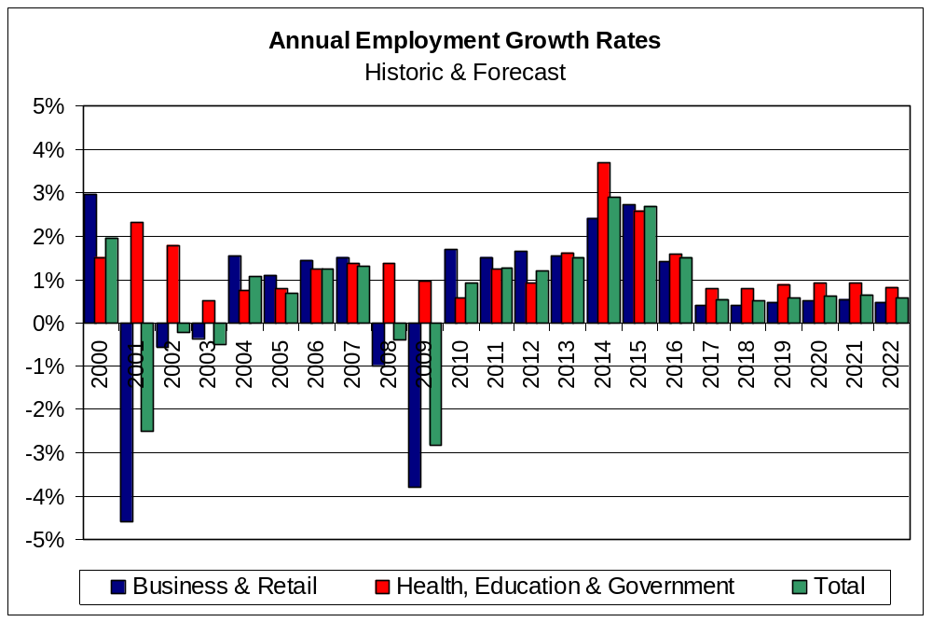 Figure C-1: Annual Employment Growth Rates
  - 2012 Population Forecast
The 2012 population forecast projects slower population growth in every region of the state than during the period from 2000 to 2010. While all growth rates remain positive throughout the forecast horizon, population growth from 2013 onward is slower than in the period from 2009 to 2012.
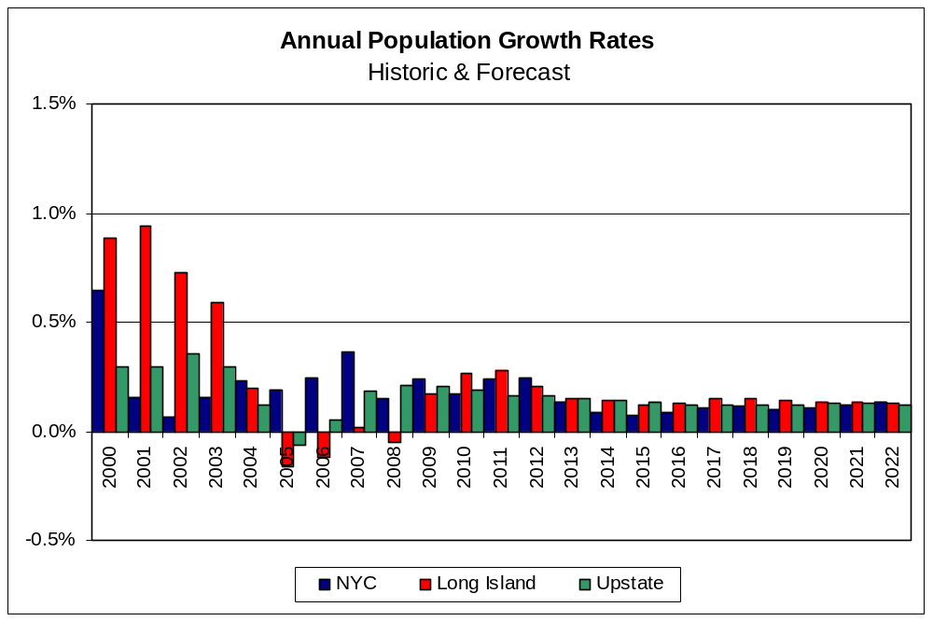 Figure C-2: Annual Change in Population by Region

  - 2012 Forecasts of Real Output, Real Income, Employment
Three key economic trends in the state are measured by real gross domestic output, total income, and employment. Real gross domestic output measures the prosperity of business, while real income and employment are indicative of the prosperity of households and wage-earners. The period from 2004 to 2007 showed significant growth in all these metrics. The recession caused them to decline substantially through 2009, and to only begin to recover in 2010.
The 2012 forecast projects real economic output growth in the range of 2% through 2022. Real income growth has a similar pattern to output. Employment turns positive but is only growing at a rate of about 0.3%. All indices are characterized by faster growth in the near term followed by slower growth in the long term.
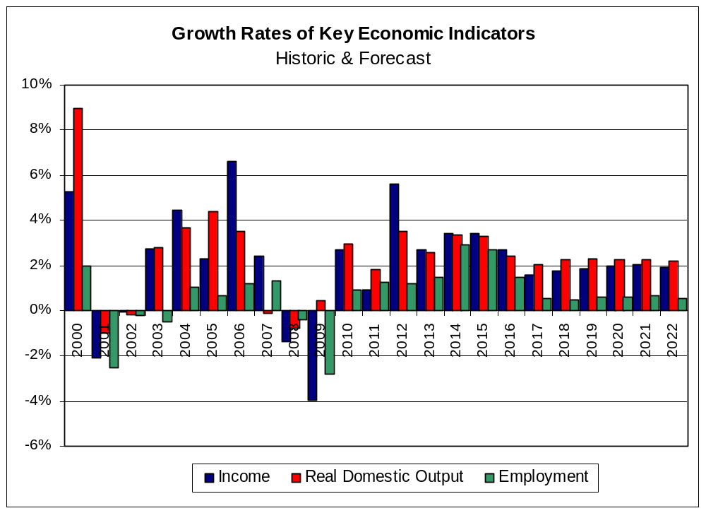
Figure C-3: Annual Growth Rates of Income, Real Domestic Output and Employment

  - Regional Economic Trends
Table C-4 provides a summary of historic and forecast growth rates of economic and demographic data for the state and for the Upstate and Downstate regions. Economic drivers for Long Island and New York City are somewhat higher than for the Upstate region, typical of forecast trends in prior Reliability Needs Assessments.
Table C-4: Regional Economic Growth Rates of Key Economic Indicators
New York State |  |  |  | New York City
 | Average Annual Growth |  |  |  | Average Annual Growth
Economic Indicators | 2001-2011 | 2012-2022 |  | Economic Indicators | 2001-2011 | 2012-2022
Total Employment | 0.2% | 1.2% |  | Total Employment | 0.3% | 1.3%
Gross Product | 1.8% | 2.5% |  | Gross Product | 1.8% | 2.9%
Population | 0.2% | 0.3% |  | Population | 0.2% | 0.3%
Real Income | 1.6% | 2.3% |  | Real Income | 1.8% | 3.1%
Upstate Regions |  |  |  | Long Island
 | Average Annual Growth |  |  |  | Average Annual Growth
Economic Indicators | 2001-2011 | 2012-2022 |  | Economic Indicators | 2001-2011 | 2012-2022
Total Employment | 0.3% | 1.1% |  | Total Employment | 0.0% | 1.1%
Gross Product | 1.8% | 1.8% |  | Gross Product | 2.2% | 2.5%
Population | 0.2% | 0.3% |  | Population | 0.2% | 0.3%
Real Income | 1.5% | 1.2% |  | Real Income | 1.4% | 2.8%
- Forecast Methodology
The NYISO methodology for producing the long term forecasts for the Reliability Needs Assessment consists of the following steps.
Econometric forecasts were developed for zonal energy using monthly data from 2000 through 2011. For each zone, the NYISO estimated an ensemble of econometric models using population, households, economic output, employment, cooling degree days and heating degree days. Each member of the ensemble was evaluated and compared to historic data. The zonal model chosen for the forecast was the one which best represented recent history and the regional growth for that zone. The NYISO also received and evaluated forecasts from Con Edison and LIPA, which were used in combination with the forecasts we developed for Zones H, I, J and K.
The summer & winter non-coincident and coincident peak forecasts for Zones H, I, J and K were derived from the forecasts submitted to the NYISO by Con Edison and LIPA. For the remaining zones, the NYISO derived the summer and winter coincident peak demands from the zonal energy forecasts by using average zonal weather-normalized load factors from 2000 through 2011. The 2012 summer peak forecast was matched to coincide with the 2012 ICAP forecast.
  - Energy Conservation
The Energy Efficiency Portfolio Standard (EEPS) is an initiative of the Governor of New York and implemented by the state's Public Service Commission. The goal of the initiative is to reduce electric energy usage by 15 percent from 2007 forecasted energy usage levels in the year 2015 (the 15x15 initiative), which translates into a goal of 26,880 GWh savings by 2015.
The NYS PSC directed a series of working groups composed of all interested parties to the proceeding to obtain information needed to further elaborate the goal. The NYS PSC issued an Order in June 2008, directing NYSERDA and the state's investor owned utilities to develop conservation plans in accordance with the EEPS goal. The NYS PSC also identified goals that it expected would be implemented by LIPA and NYPA.
The NYISO has been a party to the EEPS proceeding from its inception. As part of the development of the 2012 RNA forecast, the NYISO developed an adjustment to the 2012 econometric model that incorporated a portion of the EEPS goal. This was based upon discussion with market participants in the Electric System Planning Working Group. The NYISO considered the following factors in developing the 2012 RNA Base Case:
- NYS PSC-approved spending levels for the programs under its jurisdiction, including the Systems Benefit Charge and utility-specific programs
- Expectation of the fulfillment of the investor-owned EEPS program goals by 2018, and continued spending for NYSERDA programs through 2022
- Expected realization rates, participation rates and timing of planned energy efficiency programs
- Degree to which energy efficiency is already included in the NYISO’s econometric energy forecast
- Impacts of new appliance efficiency standards, and building codes and standards
- Specific energy efficiency plans proposed by LIPA, NYPA and Consolidated Edison Company of New York, Inc. (Con Edison)
- The actual rates of implementation of EEPS based on data received from Department of Public Service staff
The resulting adjusted econometric forecast included approximately 56% of the entire EEPS goal by the year 2022. Once the statewide energy and demand impacts were developed, zonal level forecasts were produced for the econometric forecast and for the Base Case.

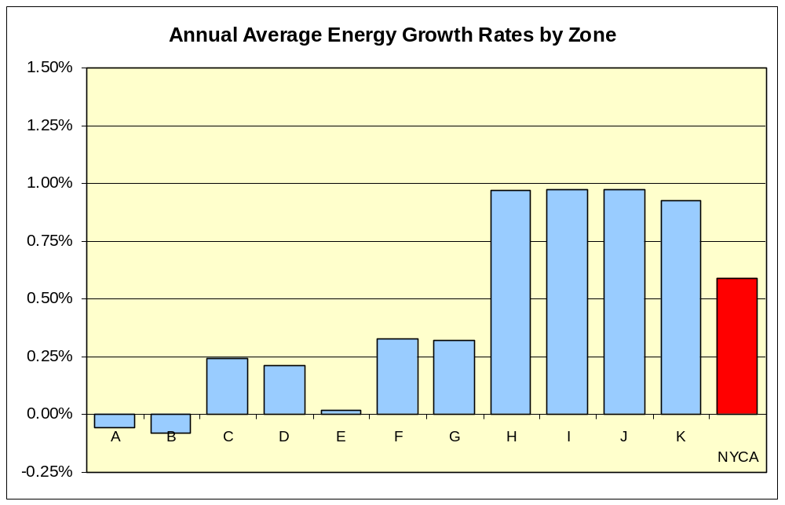
Figure C-4: Zonal Energy Forecast Growth Rates - 2012 to 2022

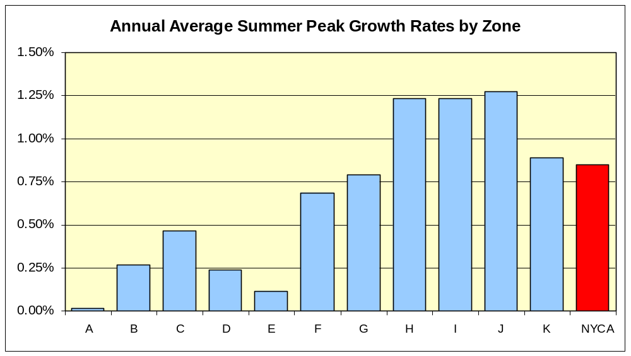
Figure C-5: Zonal Summer Peak Demand Forecast Growth Rates - 2012 to 2022
Table C-5: Annual Energy by Zone – Actual & Forecast (GWh)
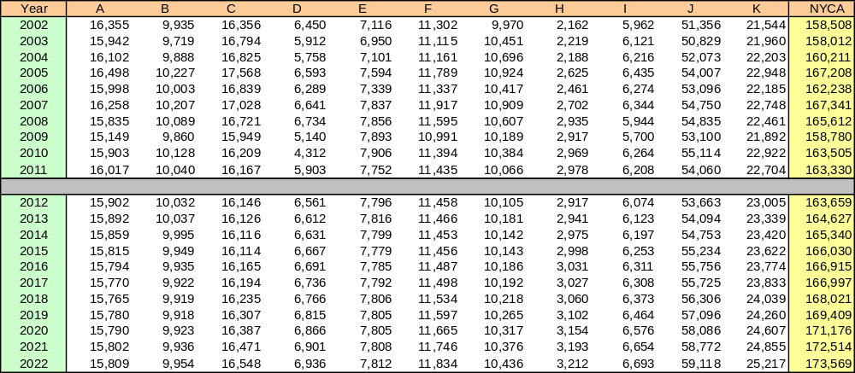

Table C-6: Summer Coincident Peak Demand by Zone – Actual & Forecast (MW)
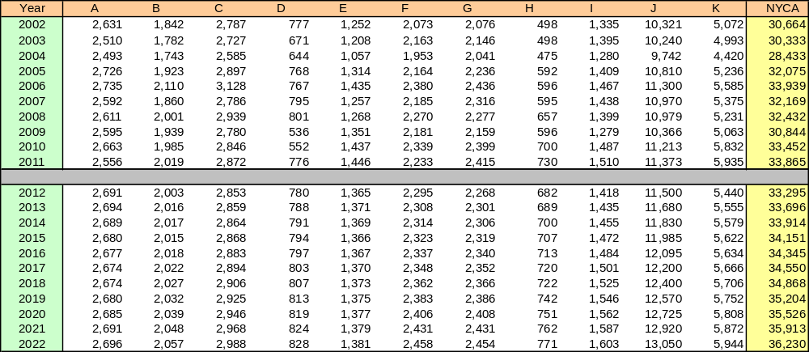

Table C-7: Winter Coincident Peak Demand by Zone – Actual & Forecast (MW)
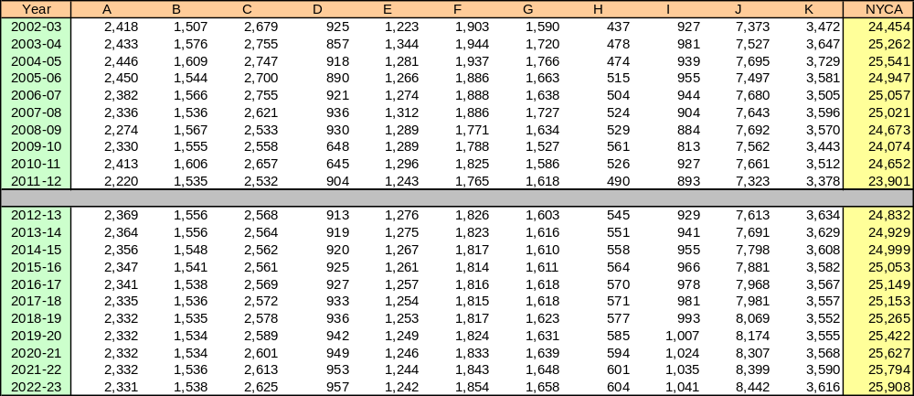

- Transmission System Assessment
(to be provided)
D-1 Development of RNA Base Case System Cases

(to be provided)

D-2 Emergency Thermal Transfer Limit Analysis

(to be provided)

Table D-1: Emergency Thermal Transfer Limits
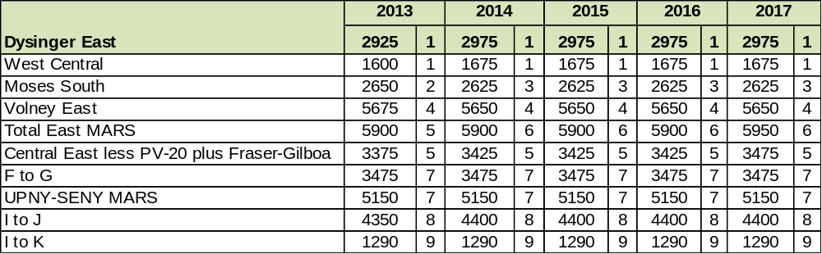

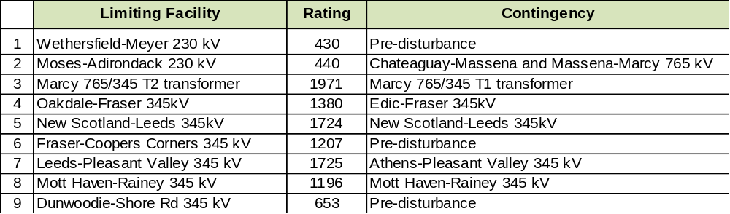
D-3 Development of the MARS Topology

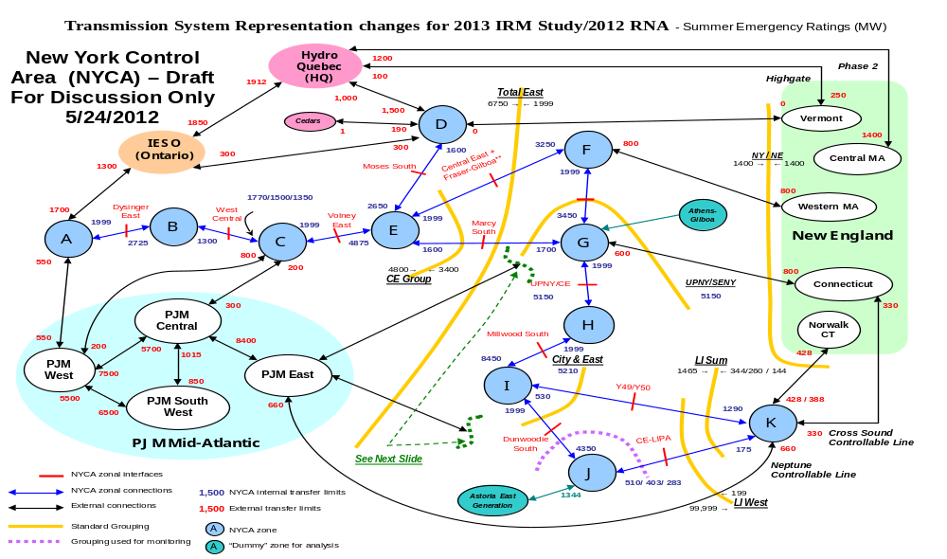

Figure D-1: Development of the 2012 MARS Topology
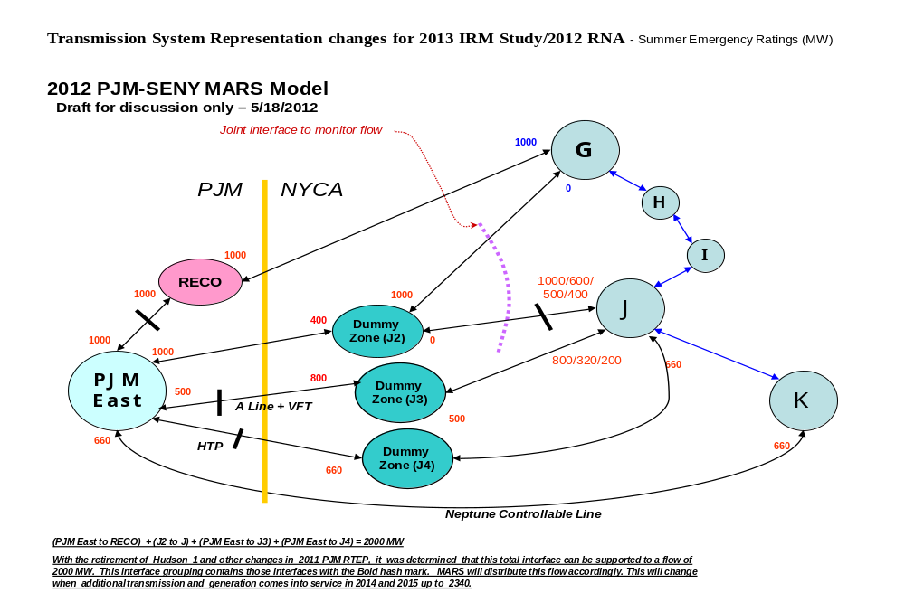

Figure D-2: 2012 PJM-SENY MARS Model
D-4 Short Circuit Assessment
Table D-3 provides the results of NYISO’s short circuit screening test. Individual Breaker Assessment (IBA) is required for any breakers whose rating is exceeded by the maximum fault current. Results of the IBA performed by the NYISO or the Transmission Owner are shown in Table D-4.

Table D-2: 2012 RNA Fault Current Analysis Summary Table
Substation | Nominal | Lowest Rated | Maximum | IBA
Name | kV | Circuit Breaker | Phase Current | Required
 |  | (kA) | (kA) | (Y/N)
Marcy | 765 | 63 | 9.7 | N
Massena | 765 | 63 | 7.8 | N
Academy | 345 | 63 | 32.4 | N
AES Somerset | 345 | 32 | 17.9 | N
Alps | 345 | 40 | 17.5 | N
AstoriaAnnex | 345 | 63 | 45.1 | N
Athens | 345 | 48.8 | 34.1 | N
Bowline 1 | 345 | 40 | 26.9 | N
Bowline 2 | 345 | 40 | 26.7 | N
Buchanan N. | 345 | 63 | 28.8 | N
Buchanan S. | 345 | 40 | 38.5 | N
Clay | 345 | 49 | 32.9 | N
Coopers Corners | 345 | 32 | 15.6 | N
Dewitt | 345 | 40 | 18.9 | N
Dunwoodie | 345 | 63 | 50.4 | N
East Fishkill | 345 | 63 | 39.4 | N
East Garden City | 345 | 63 | 25.3 | N
Edic | 345 | 40 | 32.2 | N
Elbridge | 345 | 40 | 16.1 | N
Farragut | 345 | 63 | 57.7 | N
Fitzpatrick | 345 | 37 | 41.4 | Y
Fraser | 345 | 29.6 | 17.3 | N
Fresh Kills | 345 | 63 | 26.6 | N
Gilboa | 345 | 40 | 25.3 | N
Goethals N. | 345 | 63 | 26.4 | N
Goethals S. | 345 | 63 | 27.3 | N
Gowanus N. | 345 | 63 | 27.7 | N
Gowanus S. | 345 | 63 | 27.7 | N
Hurley Avenue | 345 | 40 | 17.2 | N
Independence | 345 | 41.9 | 38.5 | N
Ladentown | 345 | 63 | 38.9 | N
Lafayette | 345 | 40 | 17.9 | N
Leeds | 345 | 36.6 | 34.7 | N
Marcy | 345 | 63 | 31.4 | N
Middletown Tap | 345 | 63 | 17.1 | N
Millwood | 345 | 63 | 44.6 | N
Mott Haven | 345 | 63 | 48.5 | N
New Scotland | 345 | 32.4 | 31.4 | N
Niagara | 345 | 63 | 34 | N
Nine Mile Point 1 | 345 | 50 | 43.5 | N
Oakdale | 345 | 29.6 | 12.2 | N
Oswego | 345 | 40.6 | 32.5 | N
Pleasant Valley | 345 | 63 | 41.2 | N
Pleasantville | 345 | 63 | 21.9 | N
Rainey | 345 | 63 | 54.7 | N
Ramapo | 345 | 63 | 42.2 | N
Reynolds Road | 345 | 40 | 14.8 | N
Rock Tavern | 345 | 50 | 26.4 | N
Roseton | 345 | 63 | 34.7 | N
Scriba | 345 | 38.4 | 46.9 | Y
Shore Road | 345 | 63 | 27.7 | N
South Mahwah- B | 345 | 40 | 33.5 | N
South Mahwah-A | 345 | 40 | 33.1 | N
Sprain Brook | 345 | 63 | 51.7 | N
Station 122 | 345 | 32 | 16.8 | N
Station 80 | 345 | 32 | 16.9 | N
Stolle Road | 345 | 32 | 3.9 | N
Volney | 345 | 44.8 | 36.6 | N
Watercure | 345 | 29.6 | 8.2 | N
West 49th Street | 345 | 63 | 49.8 | N
West Haverstraw | 345 | none | 28.2 | n/a
Adirondack | 230 | 25 | 9.6 | N
Chases Lake | 230 | 40 | 9.1 | N
Dunkirk | 230 | 28 | 15.2 | N
Gardenville | 230 | 31.8 | 22.7 | N
Hillside | 230 | 28.6 | 12.2 | N
Huntley | 230 | 30.6 | 27.1 | N
Meyer | 230 | 28.6 | 6.6 | N
Niagara | 230 | 63 | 57.3 | N
Oakdale | 230 | none | 6.2 | n/a
Packard | 230 | 47.1 | 43.9 | N
Porter | 230 | 18 | 19.5 | Y
Robinson Road | 230 | 34.4 | 14.5 | N
Rotterdam | 230 | 23.5 | 12.7 | N
South Ripley | 230 | 39.9 | 9.1 | N
St. Lawrence | 230 | 37 | 33.2 | N
Stolle Road | 230 | 28.6 | 13.9 | N
Watercure | 230 | 26.4 | 12.2 | N
Willis | 230 | 37 | 12.2 | N
Astoria East | 138 | 63 | 48.4 | N
Astoria West | 138 | 45 | 45.3 | Y
Barrett | 138 | 59.2 | 48.3 | N
Brookhaven | 138 | 35.4 | 26.5 | N
Buchanan | 138 | 40 | 15.8 | N
Corona | 138 | 63 | 48.1 | N
Dunwoodie No. | 138 | 40 | 34.2 | N
Dunwoodie So. | 138 | 40 | 30.5 | N
East 13th | 138 | 63 | 47 | N
East 75t ST | 138 | 63 | 10.9 | N
East 179th | 138 | 63 | 48.3 | N
East Garden City | 138 | 80 | 70.9 | N
Eastview | 138 | 63 | 36.7 | N
Fox Hills | 138 | 40 | 31.7 | N
Freeport | 138 | 63 | 34.4 | N
Fresh Kills | 138 | 40 | 35.7 | N
Greenwood | 138 | 63 | 44.2 | N
HG | 138 | 63 | 41.7 | N
Holbrook | 138 | 52.2 | 48.2 | N
Hudson E | 138 | 63 | 38.1 | N
Jamaica | 138 | 63 | 46.7 | N
Lake Success | 138 | 57.8 | 38.4 | N
Millwood W | 138 | 20 | 19.3 | N
Motthaven | 138 | 50 | 13.3 | N
Newbridge Road | 138 | 80 | 72 | N
Northport | 138 | 56.2 | 59.9 | Y
Pilgrim | 138 | 63 | 59.3 | N
Port Jefferson | 138 | 63 | 32.2 | N
Queensbridge | 138 | 63 | 43.5 | N
Riverhead | 138 | 63 | 17.8 | N
Ruland | 138 | 63 | 45.2 | N
SB TR N7 | 138 | 63 | 26.8 | N
SB TR S6 | 138 | 63 | 28.9 | N
Sherman Creek | 138 | 63 | 45.3 | N
Shore Road | 138 | 57.8 | 47.8 | N
Shoreham | 138 | 52.2 | 25.4 | N
Tremont | 138 | 63 | 42.5 | N
Valley Stream | 138 | 57.8 | 52.1 | N
Vernon East | 138 | 63 | 42.7 | N
Vernon West | 138 | 63 | 34.5 | N
Clay | 115 | 44.8 | 36.4 | N
Porter | 115 | 37.9 | 41.2 | Y
E River | 69 | 50 | 49.7 | N

Tables D-3 provides the results of NYISO’s IBA for Farragut 345kV, Fitzpatrick 345kV, Astoria West 138kV, Northport 138 kV, and National Grid’s IBA for Porter 115kV, Porter 230 kV, and Scriba 345kV.
.
Table D-3: IBA for 2012 RNA Study

ASTORIA WEST 138 KV
Breaker ID | Rating (kA) | 1LG (kA) | 2LG (kA) | 3LG (kA) | Overduty
G1N | 45 | 42.81 | 41.11 | 37.84 | N
G2N | 45 | 42.81 | 41.11 | 37.84 | N

FITZPATRICK 345 kV
Breaker ID | Rating (kA) | 1LG (kA) | 2LG (kA) | 3LG (kA) | Overduty
10042 | 37 | 34.06 | 34.39 | 32.52 | N

NORTHPORT 138 kV

Breaker ID | Rating (kA) | 1LG (kA) | 2LG (kA) | 3LG (kA) | Overduty
1310 | 56.2 | 50.074 | 50.309 | 51.515 | N
1320 | 56.2 | 50.051 | 50.314 | 51.53 | N
1450 | 56.2 | 50.98 | 50.002 | 48.552 | N
1460 | 56.2 | 30.745 | 29.545 | 26.863 | N
1470 | 56.2 | 32.377 | 32.142. | 31.681 | N

PORTER 115 kV

Breaker ID | Rating (kA) | Phase Current (kA) | Overduty
R10 LN1 | 43.0 | 44.7 | Y
R100 TB3 | 43.0 | 37.2 | N
R115 TB1 | 63.0 | 44.8 | N
R125 TB2 | 63.0 | 44.8 | N
R130 LN13 | 43.0 | 45.0 | Y
R20 LN2 | 43.0 | 44.7 | Y
R200 TB4 | 43.0 | 35.9 | N
R30 LN3 | 43.0 | 44.5 | Y
R40 LN4 | 43.0 | 44.4 | Y
R50 LN5 | 43.0 | 44.4 | Y
R60 LN6 | 43.0 | 45.0 | Y
R70 LN7 | 43.0 | 44.2 | Y
R80 LN8 | 43.0 | 44.6 | Y
R8105 BUSTIE | 47.7 | 42.6 | N
R90 LN9 | 43.0 | 45.0 | Y

PORTER 230 kV
Breaker ID | Rating (kA) | Phase Current (kA) | Overduty
R110 B-11 | 23.9 | 26.4 | Y
R120 B-12 | 23.9 | 26.4 | Y
R15 B-TB1 | 23.9 | 26.4 | Y
R170 B-17 | 23.9 | 26.4 | Y
R25 B-TB2 | 23.9 | 26.4 | Y
R300 B-30 | 40.0 | 22.0 | N
R310 B-31 | 40.0 | 22.0 | N
R320 B-30 | 23.9 | 26.4 | Y
R825 31-TB2 | 23.9 | 25.2 | Y
R835 12-TB1 | 23.9 | 25.4 | Y
R845 11-17 | 23.9 | 25.2 | Y

SCRIBA 345 kV
Breaker ID | Rating (kA) | Phase Current (kA) | Overduty
R100 B-10 | 50.0 | 56.0 | Y
R200 B-20 | 50.0 | 56.0 | Y
R210 B-21 | 50.0 | 56.0 | Y
R230 B-23 | 63.0 | 56.0 | N
R250 B-25 | 50.0 | 56.0 | Y
R90 B-9 | 50.0 | 56.0 | Y
R915 9-20 | 50.0 | 54.7 | Y
R925 B-23 | 63.0 | 56.0 | N
R935 10-21 | 50.0 | 53.9 | Y
R945 B-25 | 50.0 | 56.0 | Y

Any generating units that, pursuant to the PSC Orders in Case 05-E-0889, have provided a notice of Retirement, Mothball, protective layup, etc., by the study lock-down date, will be assumed to not be available for the period of the RNA study beginning once the applicable PSC notice period runs.
Compared to the 2010 RNA, the 2012 RNA models a small increase in the NYCA peak loads and a small decrease in the energy usage. The magnitude of the generation retirements modeled in the 2012 RNA outweigh the capacity of a single new transmission intertie. There is a small decrease in the 2012 RNA of projected MW of SCR registrations.
In the 2010 RNA, the 2010 Gold Book projected SCR MWs for 2011 were assigned to 2020 and then scaled back to 2011 based on the projected peak load ratios.
Consolidated Edison presented an update to their LTP in February 2012 to accommodate the announced mothballing of Astoria Units 2 & 4. LTPs can be found at http://www.nyiso.com/public/markets_operations/services/planning/process/ltpp/index.jsp
RNA Study results are rounded to two decimal places. A result of exactly 0.01, for example, would correspond to one event in one hundred years.
http://www.nyiso.com/public/markets_operations/services/planning/documents/index.jspdocs=nyiso-historic-congestion-costs/congested-elements-reports
The first CRP was entitled the “2005 Comprehensive Reliability Plan,” while the second CRP, released the following year, was entitled the “2007 Comprehensive Reliability Plan.” A year was skipped in the naming convention because the title of the first CRP, which covered the Study Period 2006-2015, designated the year the study assumptions were derived, or 2005, but for the second CRP a different year designation convention was adopted, which identified the first year of the Study Period. The latter naming convention continues to be applied to the 2008, 2009 and 2010 CRP documents. However, the original naming convention is used for the 2012 CRP and subsequent CRP documents. Thus, the study period for the 2012 RNA is 2013 – 2022.
http://www.nyiso.com/public/webdocs/documents/manuals/planning/CRPPManual120707.pdf.
http://www.nyiso.com/public/markets_operations/services/planning/process/ltpp/index.jsp
The procedures for reviewing alternative regulated solutions for a reliability need are currently being discussed in NYPSC Case 07-E-1507.

