

2011 Congestion Assessment and Resource Integration Study

CARIS – Phase 1

Appendices B-H

DRAFT REPORT

January 25, 2012

Caution and Disclaimer
The contents of these materials are for information purposes and are provided “as is” without representation or warranty of any kind, including without limitation, accuracy, completeness or fitness for any particular purposes. The New York Independent System Operator (NYISO) assumes no responsibility to the reader or any other party for the consequences of any errors or omissions. The NYISO may revise these materials at any time in its sole discretion without notice to the reader.

Appendix B – Congestion Assessment and Resource Integration Study (CARIS) Process

CARIS consists of two phases: Phase 1, the Study Phase, and Phase 2, the Project Phase. This process is described below and explained in full detail in the Initial CARIS Manual found in Appendix F.

B.1. Phase 1 – Study Phase
Phase 1 of the CARIS is depicted in the following diagram:

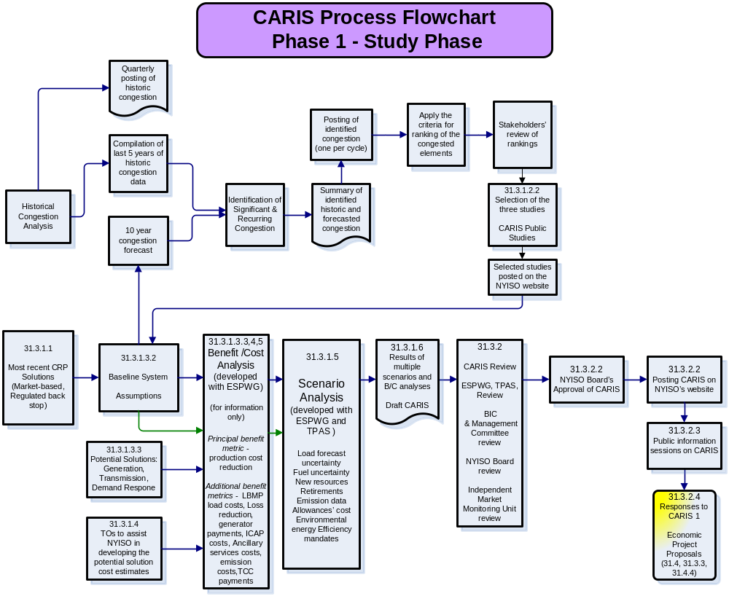
Figure B-: Phase 1 or Study Phase of the CARIS Process

B.2. Phase 2 – Projects Phase
Phase 2 of the CARIS is depicted in the following diagram:

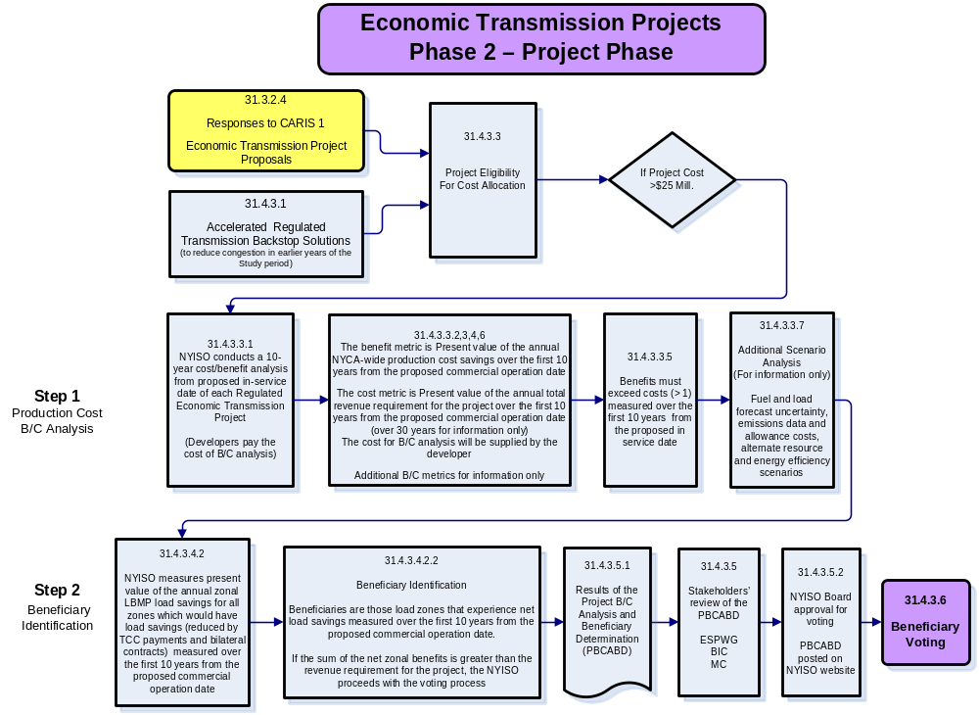
Figure B-: Phase 2 – Project Phase of the CARIS process

Voting, Cost Allocation, and Cost Recovery
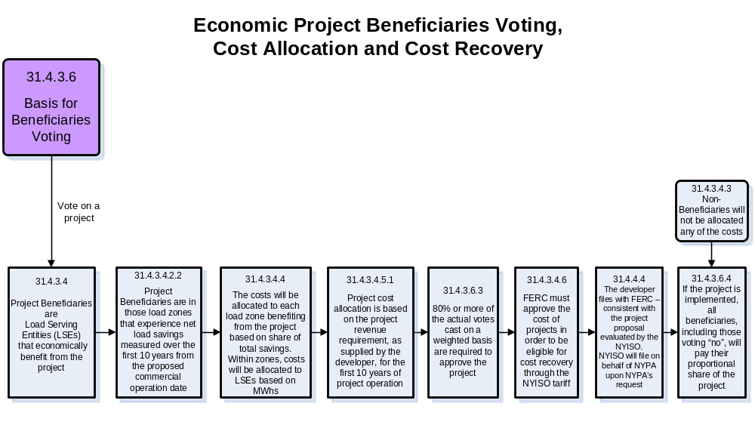
Figure B-: Voting, Cost Allocation, and Cost Recovery of the CARIS process

Appendix C – Baseline System Assumptions and Methodology

C.1. CARIS Model - Base Case Modeling Assumptions for 2011-2020
Implementing the CARIS requires understanding and utilizing a significant amount of data. As stated in Section 31.3.1.1 of Attachment Y, “The CARIS for economic planning will align with the reliability planning process. Each CARIS will use a ten-year planning horizon consistent with the reliability planning horizon. Each CARIS will be based on the most recently concluded and approved CRP. The base case for each CARIS will assume a reliable system for the ten-year planning horizon based upon the CRP.”
The data utilized in the base case simulations for 2011 CARIS Phase 1 is largely derived from the 2010 CRP, 2011 Gold Book and CARIS Assumptions Matrix, Table C-1, shown below. Major components of the data include base load flow data, unit heat rates, unit capacities, fuel prices, transmission constraint modeling, load forecasts, load shape, both simulated and actual and scheduled interchange values, O&M cost, and emission costs. The assumptions matrix was developed in conjunction with NYISO stakeholders at ESPWG.
Table C-: 2009 and 2011 CARIS Base Case Assumptions Matrix Comparison
Parameter | Assumptions from  2009 CARIS Phase 1 | Modeling for 2011CARIS Base Cases
Peak Load | Based on CRP Peak Forecast  Use 2009 Base Case Energy Forecast | Based on 2011 Gold Book
Load Shape Model  Energy Forecast | 2002 load shape is an appropriate representation for this analysis. For base year, use 2002 Load Shape. Adjusted for Energy Forecast if needed., Evaluate alternative in future | Same
Load Uncertainty Model | Base Level Forecast will be used. Other load uncertainty levels not evaluated. | Same
Generating Unit Capacities | Any changes in CRP capacities through time to be represented in CARIS. | Updated to 2011 Gold Book
New Units | As per the CRP and scaled back according to procedure (Tariff Attachment Y: Section 31.3.1.3.2) | Updated as per 2011 Gold Book  (Application of inclusion rules and procedures)
Wind Resource Modeling | Typical shape for location as per MARS and wind studies. | Updated as per 2011 Gold Book and latest Wind Study as appropriate
Non-NYPA Hydro Capacity Modeling | Pondage  Run of River (Hourly) | Updated as per 2011 Gold Book
Special Case Resources | N/A | N/A for model
EDRP Resources | Need to define costs associated, firm modifiers vs. price responsive. | N/A for model
External Capacity – Purchases and Wheel-Throughs | N/A | Modeled based on experience with market operations
Retirements | As per the CRP. | Updated as per 2011 Gold Book  (Application of inclusion rules)
Planned Outages | As per the CRP. | Scheduled to levelize reserves
Outage Scheduling | As per the maintenance schedules in long term adequacy studies. | Same
Gas Turbines Ambient Derate | Reflected only in summer/winter ratings. | Same
Environmental Modeling  Externalities  Allowances | Any impacts assumed in CRP carried forward.  Limits on emissions done through allowances, not hard limits.  Allowance cost from Chicago Climate Futures Exchange. | Same, updated
Commitment and Dispatch Options  Operating Reserves | Each Balancing Authority Commits separately  Hurdle Rates are employed for commitment and dispatch.  Operating Reserves as per NYCA requirements. | Each Balancing Authority commits to serve its own load, firm transactions, and potential transfers  Hurdle rates – flat  Same
Fuel Price Forecast | NYISO to calibrate monthly forecast based on public information and historical data. | Same but with weekly forecasts
Cost Curve Development | Allowances from Chicago Climate Futures Exchange,  Heat Rate development under discussion. Unit specific heat rates are confidential and not disclosed. | Same
Heat Rates  NYCA  External Systems | Developed from vendor supplied data and fuel input data matched with MWh data for NYCA. | Same
Local Reliability Rules | List and develop appropriate nomograms. Fuel burn restrictions, operating restrictions and exceptions, commitment/dispatch limits | Same
Energy Storage  Gilboa PSH  Lewiston PSH | Gilboa and Lewiston scheduled against NYCA. | Scheduling checked to conform to historical operations
Transmission System Model
Power Flow Cases | As per CRP. | Same
Interface Limits  Monitored/contingency pairs  Nomograms  Joint, Grouping  Unit Sensitive Voltage | Based on historical congestion, planning study results, NERC book of flowgates, PROBE/SCUC list of active/potential constraints, Special Protections Systems including Athens SPS in 2009 and 2010.  Transfer limit analysis done in RNA/CRP for critical interfaces. External system limits from input from neighboring systems. | Same plus the use of operational limits
New Transmission Capability | As per CRP. | Updated as per 2011 Gold Book  (Application of base case inclusion rules)
Internal Controllable Lines (PARs,DC,VFT) | Optimized in simulation. | Same
Neighboring Systems
Outside World Area Models  Fuel Forecast | Power flow data from CRP, “production” data developed by NYISO with vendor and neighbor input.  Linked with NYCA forecast | Same
External Capacity  And  Load Forecast | Neighboring systems modeled consistent with reserve margins in the RNA/CRP analysis.  Neighboring systems data reviewed and held at required reserve margin. | Same
System representation in Simulation | HQ modeled as fixed hourly schedule, synchronized with all other external injections.  Full Representation/Participation  - NYISO  - NE-ISO  - IESO  - PJM Classic & AP,AEP,CE,DLCO, DAY, VP)  Proxy Bus Injection:  HQ-NYISO, HQ-NE-ISO, NB-NEISO, HQ - IESO  Transmission Only/Zeroed Out:  MECS,FE,SPP, MAR, NIPS,OVEC,TVA, FRCC,SERC,ERCOT,WECC | Same
External Controllable Lines (PARs,DC,VFT, Radial lines) | A,B,C and J,K “wheel”  Both sets set at 600 min, 1200 max, imbalance monitored  Ramapo +/- 1000 MW  Norwalk +/- 100 MW  L33,34 - +/- 300 MW  PV20 – 130, 0 MW  Neptune and CSC as per CRP firm X 24 hrs, economy remainder | Modified to reflect updated protocols, tariff, and market operation,

Detailed descriptions of key data used in the 2011 CARIS are listed below. The data was developed based on the NYISO’s Tariff requirements and procedures and in collaboration with stakeholders at ESPWG.

1. Base Case Load Forecast
CARIS Base Case load forecasts, from the 2011 Gold Book, are presented in Table C-2 and Table C-3. Table C-2 presents the Annual Zonal Energy in Gigawatt-hours and Table C-3 presents summer peak demand in MW.
Table C-2: Annual Zonal Energy (GWh)
Zone | 2011 | 2012 | 2013 | 2014 | 2015 | 2016 | 2017 | 2018 | 2019 | 2020
West | 15,440 | 15,376 | 15,283 | 15,238 | 15,148 | 15,058 | 14,961 | 14,845 | 14,788 | 14,720
Genesee | 9,963 | 9,994 | 10,017 | 10,020 | 10,034 | 10,065 | 10,111 | 10,156 | 10,225 | 10,295
Central | 16,396 | 16,443 | 16,418 | 16,478 | 16,466 | 16,397 | 16,333 | 16,273 | 16,260 | 16,264
North | 5,510 | 6,297 | 6,363 | 6,399 | 6,453 | 6,488 | 6,544 | 6,580 | 6,632 | 6,685
Mohawk Valley | 7,773 | 7,762 | 7,790 | 7,787 | 7,781 | 7,777 | 7,770 | 7,759 | 7,776 | 7,795
Capital | 11,275 | 11,318 | 11,333 | 11,332 | 11,330 | 11,334 | 11,300 | 11,283 | 11,333 | 11,381
Hudson Valley | 10,478 | 10,574 | 10,624 | 10,667 | 10,694 | 10,725 | 10,733 | 10,746 | 10,806 | 10,870
Millwood | 2,962 | 2,995 | 2,999 | 3,008 | 3,016 | 3,036 | 3,043 | 3,069 | 3,094 | 3,132
Dunwoodie | 6,145 | 6,197 | 6,182 | 6,188 | 6,184 | 6,197 | 6,203 | 6,265 | 6,329 | 6,411
NY City | 54,283 | 54,746 | 54,617 | 54,669 | 54,632 | 54,747 | 54,800 | 55,350 | 55,908 | 56,637
Long Island | 22,562 | 22,819 | 22,970 | 23,062 | 23,187 | 23,495 | 23,681 | 23,912 | 24,159 | 24,505
NYCA Total | 162,787 | 164,521 | 164,596 | 164,848 | 164,925 | 165,319 | 165,479 | 166,238 | 167,310 | 168,695

Table C-3: Summer Peak Demand by Zone (MW)
Zone | 2011 | 2012 | 2013 | 2014 | 2015 | 2016 | 2017 | 2018 | 2019 | 2020
West | 2,550 | 2,554 | 2,550 | 2,549 | 2,525 | 2,495 | 2,476 | 2,458 | 2,451 | 2,443
Genesee | 1,947 | 1,970 | 1,987 | 1,998 | 2,002 | 2,005 | 2,017 | 2,030 | 2,047 | 2,064
Central | 2,795 | 2,825 | 2,834 | 2,855 | 2,849 | 2,831 | 2,820 | 2,814 | 2,817 | 2,822
North | 648 | 742 | 752 | 757 | 763 | 766 | 773 | 777 | 783 | 790
Mohawk Valley | 1,308 | 1,312 | 1,321 | 1,322 | 1,318 | 1,310 | 1,305 | 1,302 | 1,305 | 1,309
Capital | 2,173 | 2,201 | 2,222 | 2,234 | 2,233 | 2,230 | 2,227 | 2,230 | 2,248 | 2,264
Hudson Valley | 2,256 | 2,290 | 2,321 | 2,345 | 2,357 | 2,366 | 2,375 | 2,387 | 2,408 | 2,428
Millwood | 702 | 711 | 722 | 729 | 732 | 736 | 744 | 750 | 756 | 763
Dunwoodie | 1,464 | 1,472 | 1,484 | 1,492 | 1,497 | 1,497 | 1,509 | 1,521 | 1,538 | 1,554
NY City | 11,505 | 11,635 | 11,720 | 11,785 | 11,830 | 11,880 | 12,015 | 12,200 | 12,405 | 12,585
Long Island | 5,364 | 5,470 | 5,520 | 5,543 | 5,572 | 5,633 | 5,655 | 5,721 | 5,775 | 5,845
NYCA Total | 32,712 | 33,182 | 33,433 | 33,609 | 33,678 | 33,749 | 33,916 | 34,190 | 34,533 | 34,867

2. Power Flow Data
The CARIS uses the network topology, system impedance and transmission line ratings as set forth in the assumption matrix.

3. Transmission Model
New York Control Area Model
Figure C-1 below displays the bulk power system for NYCA, which generally consists of facilities 230 kV and above, but also includes certain 138 kV facilities and a small number of 115 kV facilities. The balance of the facilities 138 kV and below are considered non-bulk or sub-transmission facilities for purposes of this study. The figure also displays key transmission interfaces for New York.
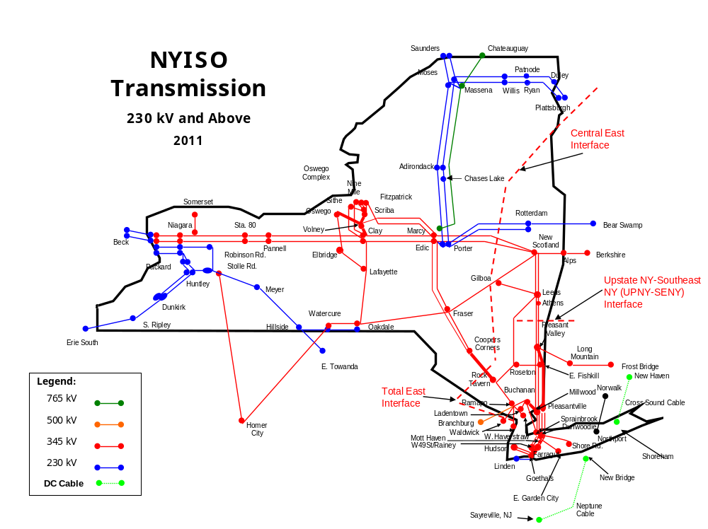
Figure C-1: NYISO 230 kV and above Transmission Map

New York Control Area Changes, Upgrades and Resource Additions
System changes modeled for 2011 and beyond are as follows:
a. M29 – 345 kV cable from an existing station in Yonkers, NY to a new substation in NYC, with normal, LTE and STE ratings of 521 MW, 748 MW and 1195 MW respectively. The M29 facility commences commercial operation in February 2011;
b. Astoria Energy II – 576 MW commences commercial operation in Juneii011;
c. Steel Winds II – 1.5 MW (summer rating) commences commercial operation iin August 2011;
d. Greenidge 4 – 106 MW retired 3/18/2011;
e. Westover 8 – 81.2 MW retired 3/18/2011;
f. Seneca Energy Ontario - 5.6 MW uprate, commences commercial operation in November 2011;
g. Bayonne Energy Center – new 500 MW GT generator in Bayonne NJ, commences commercial operation in May 2012;
h. Hudson Transmission Partners (HTP) 660 MW Merchant Transmission Facility, commences commercial operation in 2013 (not shown in 2011 map above);
i. Munnsville Wind Power 0.6 MW rating increase commences commercial operation in December 2013;
j. Nine Mile Pt2 – 115 MW uprate commences commercial operation in June 2012 and 53 MW uprate commences commercial operation in June 2014; and
k. For study purposes, Athens Special Protection System (SPS) is assumed to no longer be in service starting January 2011.
External Area Model
The external areas immediately adjacent to the NYCA are actively modeled, except for Hydro Quebec (HQ). Those areas include ISO-NE, IESO, and PJM (PJM Classic, AP, AEP, CE, DLCO, DAY and VP). Since HQ is asynchronously tied to the bulk system, proxy buses representing the direct ties from HQ to NYISO and HQ to ISO-NE are modeled. The HQ to NYISO capacity modeled is 1300 MW. External areas surrounding the above areas are only modeled to capture the impact of loop flows.
Six generating plants were also added to the base case in PJM. These additions totaled thirteen generating units with a summer rated capacity of 2621 MWs. Table C-4 lists the new units with associated data.
Table C-4: Generating Units Added to PJM
Unit Name | Summer Capacity | Type/Fuel | Installation Date | Company Name
Fort Martin | 585 | Coal | March 2011 | AP
Peach Bottom | 550 | CC - NG | July 2011 | PECO
Bremo Tenaska | 625 | CC - NG | April 2011 | Dominion VP
Clinch River | 534 | Coal | March 2012 | Dominion VP
Kearny 1 | 36.4 | LM6000-NG | June 2012 | PSE&G
Kearny 2 | 36.4 | LM6000-NG | June 2012 | PSE&G
Kearny 3 | 36.4 | LM6000-NG | June 2012 | PSE&G
Kearny 4 | 36.4 | LM6000-NG | June 2012 | PSE&G
Kearny 5 | 36.4 | LM6000-NG | June 2013 | PSE&G
Kearny 6 | 36.4 | LM6000-NG | June 2013 | PSE&G
Hunlock Creek 3 | 30 | CT - NG | June 2011 | UGI Utilities
Hunlock Creek 1 | 39.3 | CT - NG | June 2011 | UGI Utilities
Hunlock Creek 2 | 39.3 | CT – NG | June 2011 | UGI Utilities

Hurdle Rates and Interchange Models
Hurdle rates set the conditions in which economic interchange can be transacted between neighboring markets/control areas. They represent a minimum savings level that needs to be achieved before energy will flow across the interface. Hurdle rates help ensure that the production-cost simulation is reasonably consistent with the historical pattern of internal NYCA generation and imports. Hurdle rates are used to allow the simulation model to reflect inter-regional energy market transaction costs.
Two independent hurdle rates are used in the CARIS, one for the commitment of generation and a separate one for the dispatch of generation. Both commitment and dispatch hurdle rates are held constant throughout the 2011-2020 study period as discussed with NYISO stakeholders at ESPWG. The hurdle rate values produce results consistent with NYCA historic total import levels.
Only energy transactions associated with granted Unforced Capacity Deliverability Rights (UDRs) or firm withdrawal rights on controllable tie-lines were specifically modeled, namely on the NYISO controllable tie-lines (Neptune, Cross Sound Cable (CSC), Linden VFT, and HTP). The reverse flow was not modeled on controllable lines with UDRs. The flow on the CSC line was modeled to allow up to 330 MW from ISO-NE to Long Island. The flow on the Linden VFT was modeled to allow up to 300 MW of flow from PJM to NYISO. The Neptune and HTP flows were modeled to allow up to 660 MW of flow from PJM into Long Island and New York City respectively.
The hourly interchange flow for each interface connecting the NYISO with neighboring control areas was priced at the LMP of its corresponding proxy bus. The summation of all 8,760 hours determined the annual cost of the energy for each interface. Table C-5 lists the proxy bus location for each interface.

Table C-5: Interchange LMP Proxy Bus
Interface | Proxy bus
PJM | Keystone
Ontario | Bruce
Quebec | Chateauguay and Cedars
Neptune | Raritan River
New England | Sandy Pd
Cross Sound Cable | New Haven Harbor
HTP | Bergen
VFT | Linden 138 kV

4. Production Cost Model
Production cost models require input data to develop cost curves for the resources that the model will commit and dispatch to serve the load subject to the constraints given in the model.
This section discusses how the “production cost input data” is developed. The incremental cost of generation is the product of the incremental heat rate multiplied by the sum of fuel cost, emissions cost, and variable operation and maintenance expenses.
Heat Rates
Fuel costs represent the largest variable expense for fossil fueled generating units. Cost curves are the product of fuel prices and incremental heat rates. Individual unit heat rates are commercially sensitive confidential information and thus are not widely available from generator owners. Unit heat rate input data was updated based on the U.S. Environmental Protection Agency’s (EPA) Clean Air Market Data and, where available, unit production data from the U.S. Energy Information Administration (USEIA).
Consideration was given to using this approach across all of the units in the simulation. However, the relatively smaller impact of heat rate inaccuracies for non-NYCA units and the magnitude of the effort to correct heat rates for all units in the simulation led to the conclusion that vendor-supplied heat rate information could be used for all non-NYCA units.
CARIS simulation models employ power points which represent minimum, intermediary, and maximum power levels where generating units can be simulated to operate on a sustained basis. Each power point is tied to a point on the heat rate curve allowing incremental heat rates to be determined for each unit. The power points and incremental heat rates are developed on a Summer/Winter basis.

Heat Rates of marginal units in all zones display the expected seasonal patterns with summer months having the highest values. Also, there is a progression by which the monthly averages are the lowest in Zone A. The further east a zone is located in the NYCA, the higher is the implied heat rate. The relative magnitudes of differences across zones are consistent with the differences in the generation fuel-mixes.

5. Fuel Forecast
Table C-6 shows the regional bases expressed as a multiple of the U.S. national average annual price for each fuel. Figures C-2 through C-5 illustrate forecasted fuel price prices for external areas from which weekly fuel price forecasts were developed.
Table C-6: External Areas Fuel Forecast Regional Multiplier
 | PJM- East | PJM- West | ISONE | IESO
Fuel Oil #2 | 0.970 | 1.070 | 0.960 | 1.100
Fuel Oil #6 | 0.970 | 1.070 | 0.960 | 1.100
Natural Gas | 1.158 | 1.012 | 1.168 | 1.028
Coal | 1.430 | 1.050 | 1.500 | 1.200

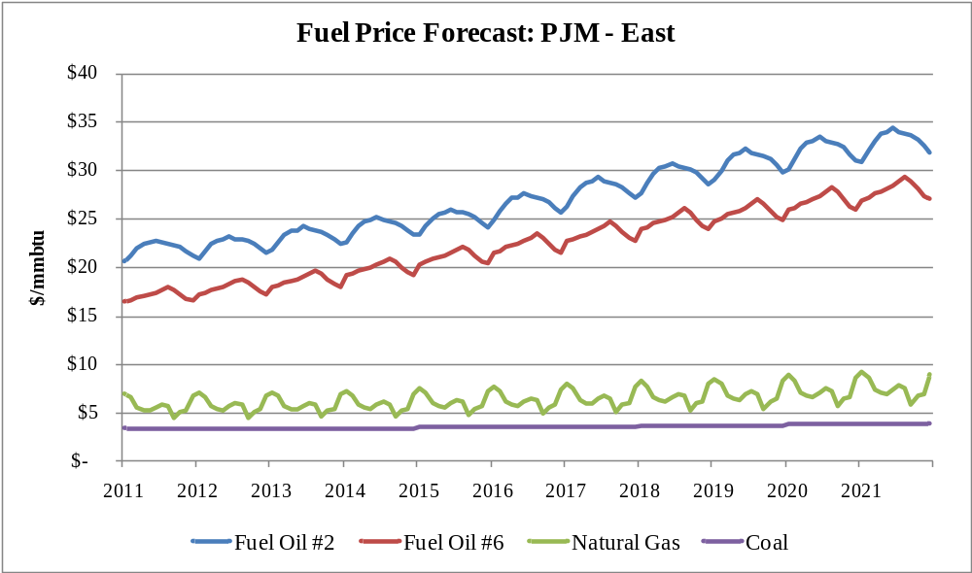
Figure C-2: Forecasted Fuel prices for PJM East (nominal $)

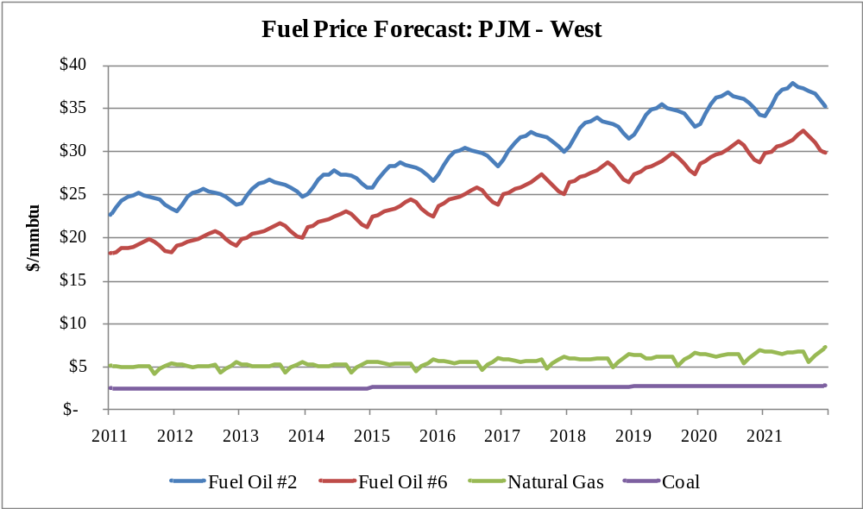
Figure C-3: Forecasted Fuel prices for PJM West (nominal $)

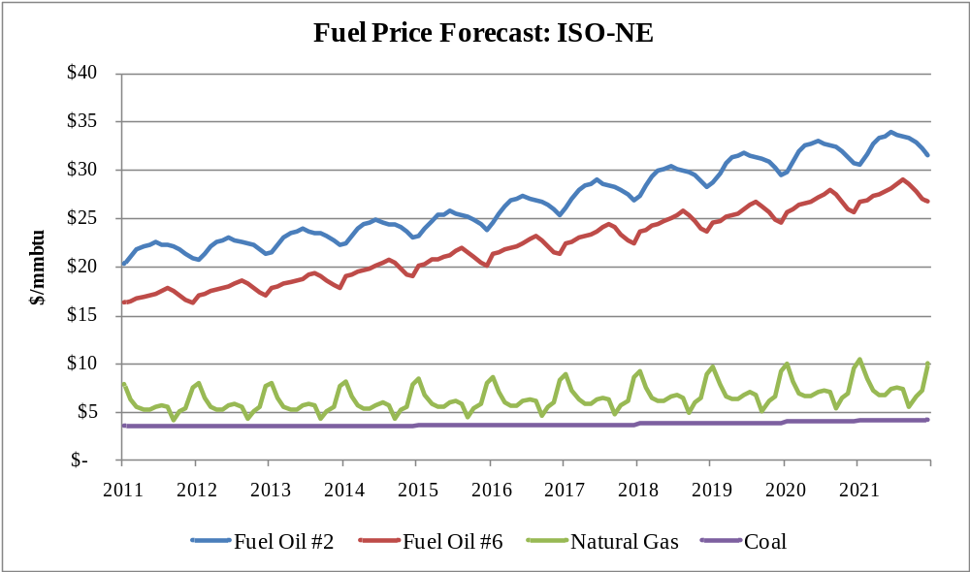
Figure C-4: Forecasted Fuel prices for ISO-NE (nominal $)

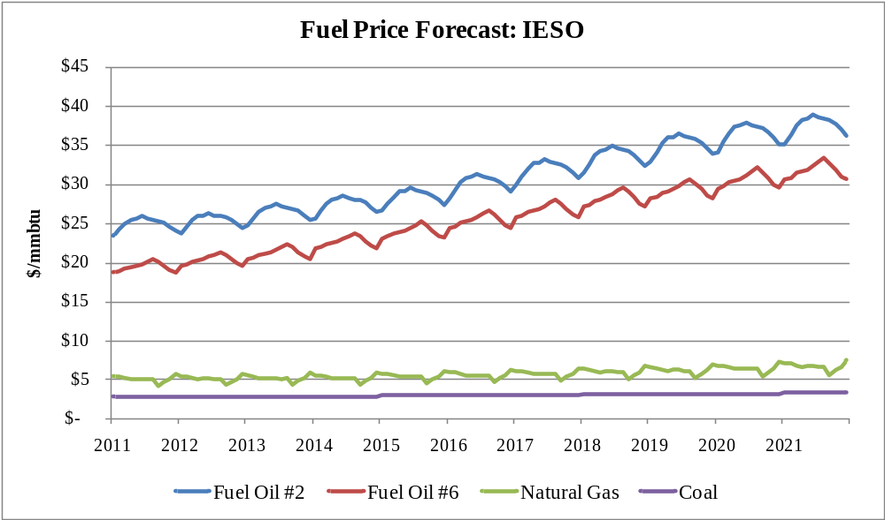
Figure C-5: Forecasted Fuel prices for IESO (nominal $)

Fuel Switching
Fuel switching capability is widespread within NYCA. In the NYCA, 38% of the 2011 generating capacity, or 14,275 MW, has the ability to burn either oil or gas. The production-cost simulation model selects the economic fuel based on weekly production costs for units with dual-fuel capability. Historic relative fuel prices for 2006 -2011are illustrated in Figure C-6.

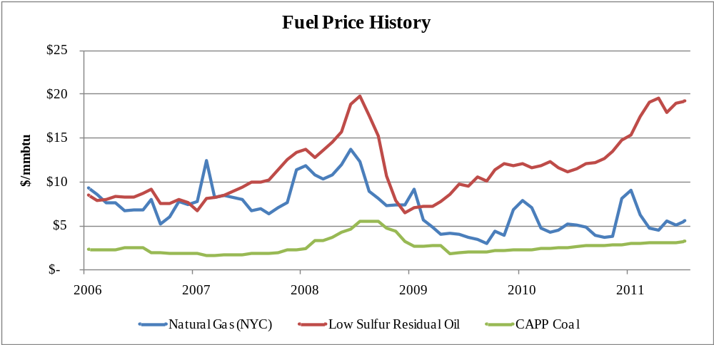
Figure C-6: Historical Natural Gas, Low-Sulfur Residual Oil and Coal (nominal $)
The production-cost simulation model selects the economic fuel based on weekly production costs for units with dual-fuel capability.
The New York State Reliability Council (NYSRC) establishes rules for the reliable operation of the New York Bulk Power System. Two of those rules guard against the loss of electric load because of the loss of gas supply. Rule I-R3 states “The New York State bulk power system shall be operated so that the loss of a single gas facility does not result in the loss of electric load within the New York City zone.” Rule I-R5 similarly states “The New York State bulk power system shall be operated so that the loss of a single gas facility will not result in the uncontrolled loss of electricity within the Long Island zone.” To satisfy these criteria, annual studies are performed that update the configurations of the electricity and gas systems and simulate the loss of critical gas supply facilities. The loss of a gas facility may lead to the loss of some generating units. This loss becomes critical because it may result in voltage collapse when load levels are high enough. Therefore, criteria are established whereby certain units that are capable of doing so are required to switch to minimum oil burn levels so that in the event of the worst single gas system contingency these units stay on-line at minimum generation levels and support system voltage. Some new combined cycle gas turbine units in these zones have the ability to “auto-swap” from gas-burn to oil-burn with a limited loss of output that can be quickly recovered. As the generator fleet in these zones has experienced a shift to increased use of combined cycle units with auto-swap capability, the amount of oil used in steam units to satisfy minimum oil burn criteria has decreased. In order to simulate the use of oil in steam units to satisfy these reliability criteria, both Ravenswood ST3 and Northport ST4 are modeled to burn oil for the first 3 dispatch points during the Summer Capability Period (736 MW and 249 MW respectively). During the winter and above the 3rd power point they are allowed to switch economically.

Generation Maintenance

Modeling modifications were made to large units in NY to reflect updated outage rates and scheduled maintenance. The MAPS scheduling process was employed to achieve a levelized amount of reserves throughout the year in NY. Other than these changes, the process used to model maintenance was consistent with the 2009 process, which is described below.

Levels (MW) of generation unavailability were developed based on historic 2007 and 2008 generation unavailability reported in FERC Form 714, which reports 2 types of monthly unavailability: Planned (maintenance outages) and Unplanned (forced outages). Each generating unit was then assigned an unavailability period for each outage type. Planned or maintenance outage durations are based on established maintenance durations by generating unit technology (i.e. nuclear refueling, steam unit major overhauls, gas turbine inspection). Unplanned or forced outage durations were determined for each generating units based on its most recent 5-year average forced outage rate (EFORd).

Both unavailability periods were then scheduled throughout a calendar year in such a way that the level of unavailability (MW) for each type of outage at the hour of the monthly peak is consistent with the 2007 and 2008 monthly levels of unavailability. The outage duration periods were fixed for each of the study years 2009 through 2018.
5. Generic Solution Cost Matrix
The NYISO defines generic solutions to alleviate congestion for each resource type (generation, transmission, and demand response), as required by the Tariff, Attachment Y, Section 31.3.1.3.3. The costs of each solution must be estimated to report B/C ratios in CARIS Phase 1 for each generic solution. The NYISO, in consultation with its stakeholders, estimates a high, mid and low cost for each solution type in CARIS Phase 1. This establishes a broader range of costs in order to provided more useful information to developers and other interested parties. The Generic Solution Cost Matrix should not be utilized for purposes outside of the CARIS generic solution process. No assessment was made concerning the actual feasibility of any generic solution proposed. These estimates should not be assumed as reflective or predictive of actual projects or imply that specific facilities can necessarily be built for these generic solution estimates.
Each high, mid and low cost estimate for the generic solutions was accomplished by using the appropriate generic solutioncost matrix methodology. This methodology was based on utilizing typical MW block size generic solutions, a standard set of assumptions and order of magnitude costs for each resource type. The order of magnitude cost estimates took into account the cost differences between geographical areas within New York. Three sets of costs were developed that are reflective of the differences in labor, land and permitting costs in each area.
Transmission cost estimates are based on information provided by Transmission Owners, which accounted for considerations such as zonal-specific construction parameters (e.g.,. spatial limitations in downstate zones). As part of this process the 2009 CARIS Phase 1 cost estimates were reviewed and updated by the Transmission Owners. The low cost estimate for the upstate geographic area remained the same as used in the 2009 CARIS Phase 1. The updated costs used in this 2011 CARIS Phase 1were presented to NYISO stakeholders for discussion at ESPWG.
information provided by Transmission Owne as zonal-specific construction parameters x.

Generation costs estimates were based on available NYISO consultant estimates for developing new combined cycle units in Zones F and J. The combined cycle generator plant costs for Zone G (exclusive of interconnection costs) were estimated to be the average of the generation costs for Upstate and Downstate.
The demand response resource type costs were based on New York utility EEPS filings for their Demand Side Management programs. This customer installed cost approach provides the improved methodology suggested in the 2009 CARIS report.
Generic solutions cost matrix and assumptions for all three types of solutions are presented in Table C-7 through Table C-10 below.
Table C-7: Transmission Cost Matrix
Base Case Modeling Assumptions for 2011-2020 CARIS Phase 1
Generic Transmission Cost Matrix
Order of Magnitude Unit Prices
(Estimates should not be assumed reflective or predictive of actual project costs)
 |  | Transmission |  |  |  | Substation
Cost Range | Zone | Line System Voltage (kV) | Block Capacity (MVA) | Construction Type | Transmission Cost ($M/Mile) | Line Terminal Addition per Substation ($M) | System Upgrade Facilities ($M)
High | Zone A-G | 345 | 1000 | Overhead | $7.3 | $9 | $9
Mid | Zone A-G | 345 | 1000 | Overhead | $5 | $6 | $6
Low | Zone A-G | 345 | 1000 | Overhead | $2 | $3 | $3
High | Zone H-J | 345 | 600 | Undergrd | $30 | $30 | $30
Mid | Zone H-J | 345 | 600 | Undergrd | $27 | $25 | $20
Low | Zone H-J | 345 | 600 | Undergrd | $24 | $20 | $10
High | Zone K | 138 | 500 | Undergrd | $20 | $20 | $25
Mid | Zone K | 138 | 500 | Undergrd | $15 | $12 | $15
Low | Zone K | 138 | 500 | Undergrd | $10 | $4 | $5
Assumptions:
1. Estimates herein should not be utilized for purposes outside of the CARIS process. Also, these estimates should not be assumed as reflective or predictive of actual projects or imply that facilities can necessarily be built for these generic solution order of magnitude estimates. Estimate ranges were identified after Transmission Owner input and discussions at the ESPWG.
2. Lines constructed within Zones A through G will be comprised of single circuit AC overhead construction.
3. Lines constructed within Zones H through K will be comprised of AC underground cable construction.
4. The transmission line will be interconnected into an existing 345kV substation for Zones A-J and 138kV for Zone K.
5. The cost for lines that cross between Zones G and Zones H or I will be pro-rated as overhead or underground based on the mileage of the line included within each Zone.
6. The line can be permitted and constructed utilizing the shortest distance between the two selected substations.
7. The existing substation selected as the interconnection point consists of open air construction and has sufficient space within the fenced yard for adding a new breaker and a half bay for the new line terminal. If the selected substation is Gas-Insulated, a factor of 4 times will be applied to the base substation terminal costs.
8. The control house at the existing substations selected as the interconnection point has sufficient space for installing the new protection and communication equipment for the new line terminal.
9. Estimates include costs for material, construction labor, engineering labor, permits, testing and commissioning. The estimates do not include Allowance of Funds During Construction (AFDC).
10. The cost per mile includes a range to account for the variable land and permitting costs associated with a project such as utilizing an existing ROW, expanding an existing ROW or obtaining new ROW.
11. The substation line terminal costs include a range to account for necessary protection and communication equipment.
12. System Upgrade Facilities costs include a range to account for line terminal relay upgrades and replacement of overdutied breakers.
13. If upon a cursory review of the location for the potential solution identifies unusual complexities, a contingency factor will be applied to the costs included in the matrix. These complexities may include but are not limited to right of way restrictions, terrain and/or permitting difficulties, etc. Field inspections will not be completed as part of the cursory review.

Table C-8: Generation Cost Matrix
Base Case Modeling Assumptions for 2011-2020 CARIS Phase 1
Generic Generation Cost Matrix
Order of Magnitude Unit Costs
(Estimates should not be assumed reflective or predictive of actual project costs)
 | Cost Range | Plant Location | Plant Block Size Capacity (MW) | Plant Cost per Block Size* ($M)
 | High | Zone A-F | 500 | $850
 | Mid | Zone A-F | 500 | $696
 | Low | Zone A-F | 500 | $543
 | High | Zone G | 500 | $994
 | Mid | Zone G | 500 | $811
 | Low | Zone G | 500 | $628
 | High | Zone H-J | 500 | $1,139
 | Mid | Zone H-J | 500 | $926
 | Low | Zone H-J | 500 | $712
* Costs are based on a 547 MW block size.
Assumptions:
1. Estimates herein should not be utilized for purposes outside of the CARIS process. Also, these estimates should not be assumed as reflective or predictive of actual projects or imply that facilities can necessarily be built for these generic solution order of magnitude estimates. Estimate ranges were identified based upon NYISO filings at FERC and Consultant estimates.
2. It is assumed that the plant will be gas combined cycle type. Configured as a 2 x 2 x1 7FA.05 block with selective catalytic reduction (SCRs), total generation 500MW.
3. The plant cost includes real estate and permitting.
4. The plant cost includes generator step-up transformer and generator substation yard including associated protection and communication equipment.
5. The plant will be interconnected into an existing 345kV substation for Zones A-J and 138kV for Zone K.
6. The generator lead will be rated 345kV, 1673A, 1000MVA for Zones A-J and 138kV, 2092A, 500MVA for Long Island. The generator lead will be built with overhead construction for Zones A-G and underground construction for Zones H-K.
7. It is assumed that the existing substation selected as the interconnection point consists of open-air construction and has sufficient space within the fenced yard for adding a new breaker and a half bay for the new line terminal. If the selected substation is gas-insulated, a factor of 4 times will be applied to the base substation terminal costs.
8. It is assumed that the plant will require a 10in dia. gas line extension to bring a 450 psig gas supply to the plant and a single gas regulator station per block along with gas conditioning, startup gas heaters and metering. It is assumed that an adequate gas supply is available.
9. It is assumed that the existing substation selected as the interconnection point and outgoing transmission lines has adequate rating to interconnect new generation.
10. It is assumed that the control house at the existing substation selected as the interconnection point has sufficient space for installing the new protection and communication equipment for the new line terminal.
11. It is assumed that the generator lead and gas line can be permitted and constructed utilizing the shortest distance.
12. It is assumed that the ROW is generally unobstructed and significant relocation of underground interferences is not required and that rock excavation is not required.
13. It is assumed that the ROW does not require mitigation of environmentally sensitive areas.
14. Estimates include costs for material, construction labor, engineering labor, permits, testing and commissioning. The estimates do not include Allowance of Funds During Construction (AFDC)
15. The plant cost includes a range to account for the variable land and permitting costs associated with a project.
16. The cost per mile includes a range to account for the variable land and permitting costs associated with a project such as utilizing an existing ROW, expanding an existing ROW or obtaining new ROW.
17. The substation line terminal costs include a range to account for necessary protection and communication equipment.
18. System Upgrade Facilities costs include a range to account for line terminal relay upgrades and replacement of overdutied breakers.
19. The transmission and gas transmission unit cost will be applied during the study as necessary dependent on the location of the congestion location to be studied.
20. If upon a cursory review of the location for the generic solution identifies unusual complexities, a contingency factor will be applied to the costs included in the matrix. These complexities may include but are not limited to right of way restrictions, terrain and/or permitting difficulties, etc. Field inspections will not be completed as part of the cursory review.

Table C-9: Generator Cost per Unit - 2010 Price Level
GENERATOR COST PER UNIT - 2010 Demand Curve Reset Cost Estimates ($M)
Zone | Size | Combined Cycle | EPC Costs | Non-EPC Costs | Total | Unit Cost $/kW
UPSTATE (Capital-F) | 547 MW | 2 X 2 X 1 7FA.05 | $613 | $149 | $762 | $1,393
Zone G | 547 MW | 2 X 2 X 1 7FA.05 | $719 | $169 | $888 | $1,623
DOWNSTATE (NYC-J) | 547 MW | 2 X 2 X 1 7FA.05 | $825 | $188 | $1,013 | $1,853

Table C-10: Demand Response Cost Matrix
Base Case Modeling Assumptions for 2011-2020 CARIS Phase 1
Generic Demand Response Cost Matrix
Order of Magnitude Unit Costs
(Estimates should not be assumed reflective or predictive of actual project costs)
Cost Range | Zone | Demand Response Quantity (MW) | Portfolio Type | Total Portfolio Cost ($M)
High | Zone A-G | 100 | Energy Efficiency | 280
Mid | Zone A-G | 100 | Energy Efficiency | 225
Low | Zone A-G | 100 | Energy Efficiency | 170
High | Zone A-G | 100 | Demand Response | 56
Mid | Zone A-G | 100 | Demand Response | 45
Low | Zone A-G | 100 | Demand Response | 33
High | Zone H-J | 100 | Energy Efficiency | 350
Mid | Zone H-J | 100 | Energy Efficiency | 280
Low | Zone H-J | 100 | Energy Efficiency | 210
High | Zone H-J | 100 | Demand Response | 68
Mid | Zone H-J | 100 | Demand Response | 55
Low | Zone H-J | 100 | Demand Response | 41
High | Zone K | 100 | Energy Efficiency | 285
Mid | Zone K | 100 | Energy Efficiency | 228
Low | Zone K | 100 | Energy Efficiency | 170
High | Zone K | 100 | Demand Response | 86
Mid | Zone K | 100 | Demand Response | 70
Low | Zone K | 100 | Demand Response | 52
Assumptions:
1. Estimates herein should not be utilized for purposes outside of the CARIS process. Also, these estimates should not be assumed as reflective or predictive of actual projects or imply that facilities can necessarily be built for these generic solution order of magnitude estimates.
2. Costs are based on representative NY Utilities' Demand Side Management filings and PSC scorecards.
3. Expected peak demand impact was used to scale the present value of the total portfolio budget to produce 100MW peak reduction.
4. Costs from each portfolio are based on 10 years of peak demand reduction.
5. The “Mid” range is derived from the utility filings. The “High” and “Low” are plus and minus 25%, respectively.
6. Due to a lack of demand response filing data for Upstate, it is assumed that the Upstate costs will be 75% of the Downstate costs. This is representative of the cost difference that exists between the Energy Efficiency programs for the two areas.

Appendix D – Overview of CARIS Modeling

D.1. Model Overview (MAPS, PROBE)
Production cost simulation software is the primary analytical tool utilized in the CARIS process. The software performs a security constrained economic dispatch and calculates the minimum hourly production cost of supply resources to meet the load.

MAPS – General Electric’s Market Analysis and Portfolio Simulation
In conducting the 2011 CARIS analysis the NYISO utilized GE MAPS as the production cost simulation software. MAPS software mimics the operation of the NYISO Day-Ahead electricity market by simulating security constrained unit commitment (SCUC) and economic dispatch of the generation and by monitoring transmission system flows under both normal and contingency conditions. This enables calculation of hourly production costs accounting for the constraints imposed by the transmission system on the economic dispatch of generation. MAPS features the following:
- Detailed representation of the large scale transmission network. The transmission system is modeled in terms of individual transmission lines, interfaces (group of lines), phase-angle regulators (PARs), and HVDC lines. MAPS software models voltage and stability considerations through operating nomograms that define how voltage and stability limits can change hourly as a function of loads, generation, and flows elsewhere on the system.
- Detailed generation modeling for thermal, hydro, pumped storage, wind, solar, and other renewables. Generation system data capabilities include multi-step cost curves based on heat rates, emission costs, fuel costs, and unit cycling capabilities. The generation units, along with chronological hourly load profiles, are assigned to individual buses on the system. Hourly load profiles are adjusted to meet peak and energy forecasts, which are inputs entered into the model on a monthly or annual basis. Information on hourly loads at each bus in the system is required to calculate electrical flows on the transmission system. This parameter is specified by assigning one or a combination of several hourly load profiles to each load bus.

PROBE -– PoRtfolio Ownership and Bid Evaluation
PROBE software, developed by PowerGEM LLC, is the day-ahead market simulation tool which has been utilized by the NYISO as an analysis tool to conduct the NYISO’s historic congestion analysis. The results of the historic congestion analysis, expressed as a change in production cost, along with additional metrics such as generator payments, load payments and congestion payments, have been reported on a quarterly basis on the NYISO’s website since 2003.
Similar to MAPS, PROBE software emulates the Day-Ahead Market (DAM) SCUC operation by using a Linear Programming-based optimization engine. Unlike MAPS however, PROBE uses actual submitted generator parameters, hourly bids and network status, including transmission outages, used by the NYISO to clear the day-ahead market. In addition, PROBE conducts an unconstrained simulation by removing all transmission constraints (other constraints such as generator ramp rates and minimum run times are still enforced). Unit commitment and dispatch are then recalculated for this unconstrained scenario without any changes in bids from those actually submitted. The constrained and unconstrained results are compared to derive the change in bid production costs, load payments and generation payments. All calculations represent all market segments such as the energy, start-up, and ancillary services bids for generators, import/export bids, virtual bids (virtuals), and fixed and price-capped demand bids.
In contrast to other planning-type software products, PROBE is designed to reproduce the day-ahead market clearing calculation as closely as possible. To accomplish this, PROBE was customized to model the NYISO’s SCUC operation, including, but not limited to, rules on co-optimization of energy and ancillary services, market mitigation, and marginal losses.
The major difference between MAPS results and PROBE results is that MAPS does not simulate: (a) virtual bidding; (b) transmission outages; (c) fixed load and price-capped load; (d) production costs based on mitigated bids; (e) Bid Production Cost Guarantee (BPCG) payments; and (f) co-optimization with ancillary services.

D.2. Modeling Validation
Database Verification
To verify the 2011 CARIS database, the NYISO conducted a data and modeling verification process in conjunction with GE. First, the NYISO Planning Staff reviewed all input data and program parameters. After Staff completed its review, modifications and any necessary corrections, the base cases were sent to GE for further verification.
The following topics were examined as part of data verification:
- Forecasts of load data for NYISO zones and external areas (externals);
- Transmission Losses, Spinning Reserves and Thermal Unit Commitment Options
- Transmission interface transfer limits, contingencies and nomograms;
- Commitment and dispatch hurdle Rates;
- Generator incremental heat rates and emissions rates;
- Modeling of combined cycle units;
- Fuel price forecasts;
- Modeling of pumped storage and hydro units; and,
- Accuracy of generator size, type and location
GE reviewed all the warnings created by the programs to ensure that the results were not affected. Discrepancies noted by GE were corrected by NYISO as necessary. After the development of the scenarios, similar data verification was performed by the NYISO Staff and any changes made were reviewed by GE. All of these changes were accomplished before the finalization of the 2011 CARIS base case.

Appendix E –Detailed Results of 2011 CARIS Phase 1

E.1. Congestion Assessment – Historic and Projected
One of the features of a Locational Based Marginal Price (LBMP) market is the ability to identify grid locations that are difficult to serve with economic generation due to transmission bottlenecks (constraints) and quantify the cost of this congestion. The NYISO calculates and publishes LBMP’s with three components:
- Energy component – marginal electricity cost without the adjusted cost of congestion and losses;
- Congestion component – the cost of out-of merit generation dispatch relative to an assumed unconstrained reference point at Marcy substation; and
- Losses component – the cost for supplying the losses from the accessible marginal generators to a specific point on the grid.

E.1.1. Historic Congestion Assessment
The NYISO reports historic congestion results on its website on a quarterly basis. The cost of congestion reported is the sum of the day ahead market LBMP congestion component multiplied by the amount of load being affected (positively or negatively) by congestion (later referred to as “congestion payments”). While this congestion cost is relatively simple to calculate, this value is generally regarded as an over-simplified and deceiving congestion impact metric because:
- This calculation does not incorporate the effect of any potential market responses from supply and demand when congestion is removed; and
- The congestion cost is relative to an assumed uncongested reference point. If this reference point is moved, the congestion cost is shifted to the LBMP energy component. The congestion versus energy cost calculation becomes arbitrary depending on the reference point chosen.
To better measure the true cost of transmission congestion, the NYISO developed analytical tools and protocols. The fundamental idea is to calculate what the day-ahead hourly clearing prices would be if there were no transmission constraints, using the same data and calculation approach as the NYISO SCUC. The congestion cost is the difference between the actual SCUC transmission constrained LBMP’s, loads, and bids, and the same calculation with all transmission constraints ignored. Annual cost is the sum of daily costs.
The reported numbers are the result of a simulation of the NYCA market using the hourly bids and network status actually used by NYISO to clear the day-ahead market. The simulation performs a security constrained unit commitment for the market “as it was”, then removes all transmission constraints. Other constraints such as desired net interchange (DNI), generator ramp rates and minimum run times are still enforced. Unit commitment and dispatch are then recalculated for this unconstrained scenario without any changes to the bids actually submitted. The constrained and unconstrained results are compared to derive the cost of congestion. The calculations represent all market segments (e.g., fixed load, virtual load and generation, imports and exports), and actual hour-by-hour network status. The unconstrained case fixes the amount of virtual load and generation at their original MW levels.
Historic Congestion Metrics
To explore the impact of congestion, four congestion metrics were developed: Bid Production Cost metric; Congestion Payment metric; Generator Payment metric; and Load Payment metric. All metrics report the difference between a constrained and an unconstrained value.
1. Change in Bid Production Cost (BPC) – This is the primary congestion impact metric set forth by the Operating Committee. The calculation compares the change in total production cost, based on mitigated bids, with and without transmission constraints limiting the unit commitment and dispatch. This metric measures the economic inefficiency introduced by the existence of transmission bottlenecks, and is considered the societal cost of transmission congestion. A positive number indicates that transmission congestion increased the total cost to produce the electricity supply in the NYCA.

Production cost always decrease when constraints are removed. The objective of SCUC is to minimize bid production cost; LBMPs are the result of the commitment and dispatch that result from achieving this objective under generation unit and transmission constrained conditions. Since SCUC does not directly attempt to minimize LBMPs, relieving all or some of the constraints may or may not decrease the market based electricity cost to load. In the LBMP markets, the load in a location pays the marginal price of the supply at that location, not the bid price of the generator. The result of relieving constraints in an LBMP market depends on how much load is affected, where the load is, and the response of supply and demand as those constraints are relieved.

2. Change in Congestion Payments – This calculation, which represents the sum of the LBMP congestion component multiplied by the load affected, does not account for the change in the energy component of the LBMP as constraints are removed. With no simulation truly required to arrive at this congestion impact metric, the congestion cost in an unconstrained market is 0. This is considered to be the accounting cost of congestion.

Congestion payments can be hedged with TCCs. The difference between the total congestion payment and the congestion payment associated with TCCs is the unhedged congestion payment reported in the NYISO’s quarterly historic congestion analysis reports. For the historic analysis, it was assumed that all TCCs are owned by load and are available for hedging the congestion payments. A positive number indicate that congestion increases the cost paid by load.

3. Change in Generation Payments – In addition to the LBMP payments to generation (or other supply sources such as virtual generation, or imports), generators are also paid a BPCG and for Ancillary Services. BPCG compensates generators that are committed for reliability despite the fact their bids are greater than the LBMP at the generator location. This phenomenon can happen if ramp rates, minimum run times or other limits force unit operation, which minimizes overall production cost, even including BPCG payments. A positive number means generation payments went up due to congestion.

4. Change in Load Payments – This metric is the opposite side of the generation payments calculation. The calculation uses simulation to include the local energy cost response when transmission constraints are removed. Whereas the change in production cost measures efficiency, this metric determines how much more New York load actually pays due to congestion and the market design. This is considered the bill impact. The load payment congestion impact includes the effect of all market segments that can change when transmission constraints are relieved. These segments are:

- LBMP Components – The LBMP congestion component will equal zero when there are no transmission constraints, and the unconstrained generation will sell more energy at a price that is higher on the generator’s incremental cost curve. The unconstrained generator bid price will be lower than the bid price of the out of merit generator dispatched in the transmission limited case. The result is a likely increase in the LBMP energy component as the LBMP congestion component decreases. The LBMP loss component will also change depending on the location and prices of the generation unbottled when constraints are relieved. Ancillary service costs (e.g., reserves) also affect LBMPs, as generators trade-off between selling ancillary services or energy.

- Load payments due to congestion are hedged with TCCs based on the assumption that all TCCs were credited to load. The TCC auction cost is not accounted for since it is part of the Transmission Service Charge (TSC).

- TCC shortfall – In the event of a TCC shortfall (or surplus), the load pays for the imbalance. As transmission constraints are relieved, the imbalance changes. While the shortfall may be compensated for elsewhere in the TSC, from a congestion impact perspective this is considered a load cost. Although the NYISO OATT describes details of the allocation of shortfall by transmission owner, for purposes of this analysis the shortfall is stated for the NYCA only.
- Rate Schedule 1 imbalances – In accordance with the NYISO OATT, imbalances of energy payments and loss payments are a component of the OATT-defined Rate Schedule 1 payments. Relieving or eliminating transmission constraints affects these payments, and is thus considered a congestion impact in this analysis. Like shortfall, this analysis states the Rate Schedule 1 effect for the NYCA only.

A positive number indicates that congestion increased the load payments.

Historic Congestion Results

The historic congestion analysis results for a constrained system (base case) are presented in Tables E-1 through E-3.

Table E-1: Historic Congestion Demand$ Payments (2006-2010) by Zone (nominal $M)
Zone | 2006 | 2007 | 2008 | 2009 | 2010
West | 1 | (14) | (25) | (14) | (1)
Genesee | 2 | (14) | (9) | 4 | 6
Central | 4 | 9 | 18 | 8 | 11
North | 0 | 0 | (2) | (3) | (1)
Mohawk Valley | 2 | 5 | 10 | 4 | 5
Capital | 27 | 74 | 143 | 53 | 62
Hudson Valley | 54 | 87 | 176 | 57 | 73
Millwood | 27 | 31 | 78 | 16 | 23
Dunwoodie | 44 | 56 | 124 | 41 | 49
NY City | 673 | 700 | 1403 | 503 | 560
Long Island | 708 | 518 | 624 | 274 | 350
NYCA Total | 1,542 | 1,508 | 2,613 | 977 | 1,141
Reported values do not deduct TCC hedges.
NYCA totals represent the sum of absolute values.
DAM data include Virtual Bidding & Transmission planned outages.

Table E-2: Historic Generator Payments (2006-2010) by Zone (nominal $M)
Zone | 2006 | 2007 | 2008 | 2009 | 2010
West | 1,530 | 1,630 | 1,701 | 835 | 1,035
Genesee | 418 | 491 | 476 | 273 | 334
Central | 1,612 | 1,753 | 1,825 | 1,062 | 1,280
North | 633 | 659 | 779 | 393 | 406
Mohawk Valley | 230 | 206 | 234 | 107 | 110
Capital | 704 | 883 | 1,175 | 593 | 788
Hudson Valley | 533 | 571 | 532 | 214 | 207
Millwood | 1,145 | 1,252 | 1,725 | 773 | 887
Dunwoodie | 56 | 39 | 39 | 28 | 11
NY City | 1,895 | 2,072 | 2,405 | 1,125 | 1,369
Long Island | 1,485 | 1,282 | 1,286 | 516 | 782
NYCA Total | 10,241 | 10,840 | 12,178 | 5,919 | 7,209
DAM data include Virtual bidding & Transmission planned outages.
Reported values are exclusive of BPCG and Ancillary services.

Table E-3: Historic Load Payments (2006-2010) by Zone (nominal $M)
Zone | 2006 | 2007 | 2008 | 2009 | 2010
West | 1,061 | 511 | 629 | 511 | 629
Genesee | 754 | 435 | 520 | 435 | 520
Central | 1,060 | 569 | 726 | 569 | 726
North | 474 | 193 | 183 | 193 | 183
Mohawk Valley | 469 | 256 | 313 | 256 | 313
Capital | 1,008 | 508 | 578 | 508 | 578
Hudson Valley | 1,114 | 496 | 630 | 496 | 630
Millwood | 385 | 132 | 168 | 132 | 168
Dunwoodie | 706 | 315 | 375 | 315 | 375
NYCity | 5,919 | 2,753 | 3,305 | 2,753 | 3,305
Long Island | 2,535 | 1,231 | 1,577 | 1,231 | 1,577
NYCA Total | 15,485 | 7,397 | 9,005 | 7,397 | 9,005
DAM data include Virtual bidding & Transmission planned outages.

E.1.2. Projected Congestion Assessment

CARIS Metrics
In conducting the CARIS analysis, seven metrics are used. The primary metric is the production cost metric. Other additional metrics that are included in this report are load payments, generator payments, emissions, TCCs, losses, and the ICAP metric. All benefit metrics are determined by measuring the difference (change) between the CARIS base case system value and a system value when the generic solution is added. The discount rate of 7.36% used for the present value analysis is the current weighted average cost of capital for the NYTOs.

1. NYCA Production Cost Metric
NYCA production cost is the total generation cost of producing power to serve NYCA load. The total cost includes the following components:
- Fuel cost (fuel consumption mmBtu multiplied by fuel cost $/mmBtu);
- Variable O&M cost (VOM adder $/MWh);
- Emission cost (emission allowance price multiplied by total allowance);
- Start-up Costs (number of starts multiplied by start-up cost); and
- NYCA Imports and Exports evaluated at the solution case proxy bus LBMP values.

2. Demand$ Congestion Payment
The congestion value (Demand$) is calculated as the congestion component of the LBMP paid by NYCA load (sum of the total zonal loads). It is defined as the shadow price of each constrained element multiplied by the load affected and calculated as follows:
Demand$ Congestion by constraint for all areas and all hours = (Shadow Price x (Zone Generation Shift Factor (GSF) x Zone Load)).
Total Demand$ Congestion = Sum of all constraints’ Demand$ Congestion.

3. Generator Payment Metric
Generator payment represents zonal LBMP based payment to generators located in a zone. The hourly payment to each generator is determined as the hourly generator MW dispatch multiplied by the generator’s LBMP or spot price. The annual generator payment is then the sum of all 8,760 hourly generator payments.
Annual generator LBMP payment = sum of all hours (generator LBMP x generator MW dispatch).
Zonal generator payment = sum of generator payment located in a zone.

4. LBMP Load Payment Metric
The LBMP Load Payment metric is the hourly load-weighted average LBMP price for each zone multiplied by the zonal load. The annual load payment is then the sum of all 8,760 hourly load payments.
Annual Zonal LBMP payment = sum of all hours (zonal LBMP x zonal load).
Zonal LBMP = zonal average load-weighted LMP.
Note: actual consumer payments will be net of any TCC hedges or bilateral contracts.

5. TCC metric (Congestion Rent)
The TCC payment metric is determined by calculating congestion rents. Hourly congestion rent for a constrained facility is defined as the active power flow (MW) on the constrained facility multiplied by its shadow price. Shadow price is defined as the incremental production cost saving if the constrained element flow limit is increased by one MW. Shadow prices on constrained elements are non-zero during hours of congestion.
Congested rent value by constraint = summation for all hours (constrained element MW x Shadow Price $/MW).
Total congestion rent = Summation for all congestion rent values for all system constraints.

6. ICAP Metric

Revisions to Attachment Y of the OATT after the completion of the 2009 CARIS Report have resulted in new procedures for calculation of the ICAP Metrics. The procedures used in this 2011 CARIS Report are described below.

When a generator, transmission line, or demand response/energy efficiency project is built to relieve transmission congestion, the general consequence is a reduction in system production costs. A secondary effect that one of these projects may cause is to reduce the Installed Capacity (ICAP) costs for the entire NY control area. This appendix section serves to describe the methodology and present the detailed results for the quantification of ICAP savings achieved by three types of generic congestion solutions in the CARIS process.

Calculations used to determine ICAP savings are described in NYISO OATT Attachment Y Section 31.3.1.3.5.6. Information regarding the determination of the currently published NYISO ICAP demand curve is beyond the scope of this document and can be found in the NYISO Installed Capacity Manual.

The NYISO has three separate capacity zones: New York City (NYC), Long Island (LI), and NYCA. The demand curves are used to set the clearing price for existing generation capacity in the capacity market auctions. Locational capacity requirements are inherent within each demand curve so as to meet reliability criteria.

The NYISO OATT describes two savings calculation variants for estimating the range of the potential ICAP cost savings associated with CARIS project solutions. Both of these methods utilize the most recent ICAP demand curves, escalated to the study year for each locality studied. To escalate each of the three demand curves, a single escalation percentage is chosen and applied to the ICAP Based Reference Points and ICAP Based Maximum Clearing Price, which define the demand curve. For the 2011 CARIS cycle an escalation percentage of 1.7% was chosen consistent with the current demand curves. It is necessary to perform 10 years of escalation, one for each study year, in order to perform savings calculations for each year. The points on the demand curves set for each study year are based upon the load and capacity for each locality. The set of projected demand curves for the 10 year study period serve as the basis for both ICAP savings calculations. Before calculating these potential savings under these two methods, the MW impact of the potential solution is determined as described in the next paragraph.

The MW impact is indicative of reduced installed capacity requirement made possible by the congestion mitigation solutions. The megawatt impact, will be computed based on a methodology that: (1) determines the base system loss of load expectation (“LOLE”) for the applicable horizon year (2020); (2) adds the proposed economic project; and (3) calculates the LOLE for the system with the addition of the proposed economic project. If the system LOLE is lower than that of the base system, the procedure is to reduce generation in all New York Control Area (“NYCA”) zones proportionally (i.e., based on proportion of zonal capacity to total NYCA capacity) until the base system LOLE (2020 LOLE of 0.004) is achieved. That amount of reduced generation capacity is the megawatt impact.

The two variants for savings calculations can be better defined and understood by looking at the ICAP Demand Curve diagram below, Figure E-1.
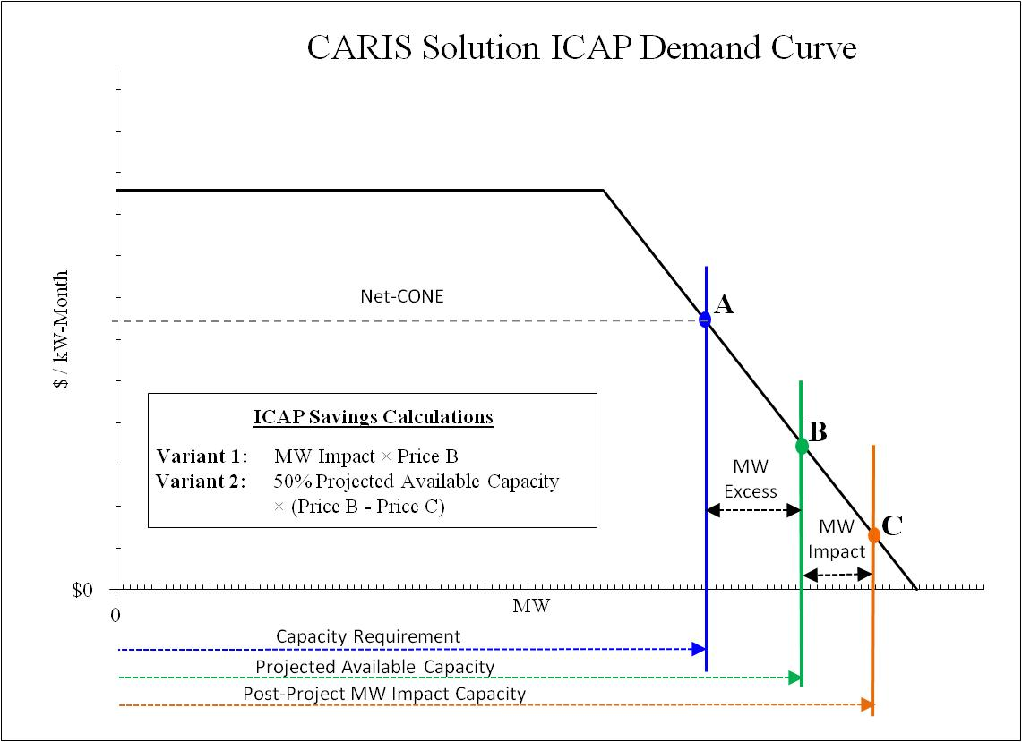
Figure 1: ICAP Savings Calculation Diagram

Figure E-1: CARIS ICAP Demand Curve

Variant #1 of the ICAP savings calculation can now be determined by simply multiplying the MW Impact values in the table above with the pre-project capacity price of the demand curve for the corresponding study year. The MW Impact values are also used to calculate the post-project capacity price for Variant #2, which is then subtracted from the pre-project price and multiplied by 50% of the projected available capacity for the three capacity zones in that year. The results of these calculations for all 10 years of the CARIS study are contained in the Tables E-4 and E-5 below.

The two ICAP cost variants are indicative of a range of the potential benefits to load resulting from the implementation of a CARIS solution. The metrics are not precise determinants of future capacity prices and are calculated for the purpose of providing additional information. Calculation of the ICAP metric begins with the evaluation of a MW impact.

Table E-4: ICAP Costs Savings - Variant 1
CARIS I 2011 ICAP Variant #1 Savings Calculations (2011 Present Value M$)
Study | Solution | Capacity Zone | 2011 | 2012 | 2013 | 2014 | 2015 | 2016 | 2017 | 2018 | 2019 | 2020 | 10-Year Total
Study #1  Central East-New Scotland-Pleasant Valley | Transmission | ROS: | 1 | 0 | 0 | 2 | 2 | 3 | 4 | 6 | 8 | 10 | 37
Study #1  Central East-New Scotland-Pleasant Valley | Transmission | NYC: | 9 | 3 | 0 | 1 | 1 | 1 | 2 | 4 | 6 | 7 | 33
Study #1  Central East-New Scotland-Pleasant Valley | Transmission | LI: | 0 | 1 | 1 | 1 | 1 | 2 | 2 | 2 | 3 | 3 | 16
Study #1  Central East-New Scotland-Pleasant Valley | Transmission | Total: | 10 | 3 | 1 | 4 | 5 | 6 | 8 | 12 | 16 | 20 | 86
Study #1  Central East-New Scotland-Pleasant Valley | Generation | ROS: | 3 | 0 | 0 | 3 | 4 | 5 | 8 | 11 | 15 | 18 | 68
Study #1  Central East-New Scotland-Pleasant Valley | Generation | NYC: | 16 | 5 | 0 | 1 | 1 | 2 | 4 | 8 | 10 | 13 | 60
Study #1  Central East-New Scotland-Pleasant Valley | Generation | LI: | 1 | 1 | 2 | 2 | 3 | 4 | 4 | 4 | 5 | 5 | 31
Study #1  Central East-New Scotland-Pleasant Valley | Generation | Total: | 19 | 6 | 2 | 7 | 8 | 11 | 16 | 23 | 30 | 36 | 160
Study #1  Central East-New Scotland-Pleasant Valley | DR/EE (F & G) | ROS: | 1 | 0 | 0 | 1 | 1 | 1 | 2 | 3 | 4 | 5 | 18
Study #1  Central East-New Scotland-Pleasant Valley | DR/EE (F & G) | NYC: | 4 | 1 | 0 | 0 | 0 | 1 | 1 | 2 | 3 | 3 | 16
Study #1  Central East-New Scotland-Pleasant Valley | DR/EE (F & G) | LI: | 0 | 0 | 1 | 1 | 1 | 1 | 1 | 1 | 1 | 1 | 8
Study #1  Central East-New Scotland-Pleasant Valley | DR/EE (F & G) | Total: | 5 | 2 | 1 | 2 | 2 | 3 | 4 | 6 | 8 | 10 | 43
Study #2  New Scotland-Pleasant Valley | Transmission | ROS: | 1 | 0 | 0 | 2 | 2 | 3 | 4 | 6 | 8 | 10 | 37
Study #2  New Scotland-Pleasant Valley | Transmission | NYC: | 9 | 3 | 0 | 1 | 1 | 1 | 2 | 4 | 6 | 7 | 33
Study #2  New Scotland-Pleasant Valley | Transmission | LI: | 0 | 1 | 1 | 1 | 1 | 2 | 2 | 2 | 3 | 3 | 16
Study #2  New Scotland-Pleasant Valley | Transmission | Total: | 10 | 3 | 1 | 4 | 5 | 6 | 8 | 12 | 16 | 20 | 86
Study #2  New Scotland-Pleasant Valley | Generation | ROS: | 3 | 0 | 0 | 3 | 4 | 5 | 8 | 11 | 15 | 18 | 68
Study #2  New Scotland-Pleasant Valley | Generation | NYC: | 16 | 5 | 0 | 1 | 1 | 2 | 4 | 8 | 10 | 13 | 60
Study #2  New Scotland-Pleasant Valley | Generation | LI: | 1 | 1 | 2 | 2 | 3 | 4 | 4 | 4 | 5 | 5 | 31
Study #2  New Scotland-Pleasant Valley | Generation | Total: | 19 | 6 | 2 | 7 | 8 | 11 | 16 | 23 | 30 | 36 | 160
Study #2  New Scotland-Pleasant Valley | DR/EE (G & I) | ROS: | 1 | 0 | 0 | 1 | 2 | 2 | 3 | 5 | 6 | 8 | 29
Study #2  New Scotland-Pleasant Valley | DR/EE (G & I) | NYC: | 7 | 2 | 0 | 0 | 1 | 1 | 2 | 3 | 4 | 5 | 26
Study #2  New Scotland-Pleasant Valley | DR/EE (G & I) | LI: | 0 | 1 | 1 | 1 | 1 | 1 | 2 | 2 | 2 | 2 | 13
Study #2  New Scotland-Pleasant Valley | DR/EE (G & I) | Total: | 8 | 3 | 1 | 3 | 4 | 5 | 7 | 10 | 13 | 15 | 67
Study #3  Leeds-Pleasant Valley | Transmission | ROS: | 1 | 0 | 0 | 2 | 2 | 3 | 4 | 6 | 8 | 10 | 37
Study #3  Leeds-Pleasant Valley | Transmission | NYC: | 9 | 3 | 0 | 1 | 1 | 1 | 2 | 4 | 6 | 7 | 33
Study #3  Leeds-Pleasant Valley | Transmission | LI: | 0 | 1 | 1 | 1 | 1 | 2 | 2 | 2 | 3 | 3 | 16
Study #3  Leeds-Pleasant Valley | Transmission | Total: | 10 | 3 | 1 | 4 | 5 | 6 | 8 | 12 | 16 | 20 | 86
Study #3  Leeds-Pleasant Valley | Generation | ROS: | 3 | 0 | 0 | 3 | 4 | 5 | 8 | 11 | 15 | 18 | 68
Study #3  Leeds-Pleasant Valley | Generation | NYC: | 16 | 5 | 0 | 1 | 1 | 2 | 4 | 8 | 10 | 13 | 60
Study #3  Leeds-Pleasant Valley | Generation | LI: | 1 | 1 | 2 | 2 | 3 | 4 | 4 | 4 | 5 | 5 | 31
Study #3  Leeds-Pleasant Valley | Generation | Total: | 19 | 6 | 2 | 7 | 8 | 11 | 16 | 23 | 30 | 36 | 160
Study #3  Leeds-Pleasant Valley | DR/EE (G & I) | ROS: | 1 | 0 | 0 | 1 | 2 | 2 | 3 | 5 | 6 | 8 | 29
Study #3  Leeds-Pleasant Valley | DR/EE (G & I) | NYC: | 7 | 2 | 0 | 0 | 1 | 1 | 2 | 3 | 4 | 5 | 26
Study #3  Leeds-Pleasant Valley | DR/EE (G & I) | LI: | 0 | 1 | 1 | 1 | 1 | 1 | 2 | 2 | 2 | 2 | 13
Study #3  Leeds-Pleasant Valley | DR/EE (G & I) | Total: | 8 | 3 | 1 | 3 | 4 | 5 | 7 | 10 | 13 | 15 | 67

Table E-5: ICAP Costs Savings - Variant 2

CARIS I 2011 ICAP Variant #2 Savings Calculations (2011 Present Value M$)
Study | Solution | Capacity Zone | 2011 | 2012 | 2013 | 2014 | 2015 | 2016 | 2017 | 2018 | 2019 | 2020 | 10-Year Total
Study #1  Central East-New Scotland-Pleasant Valley | Transmission | ROS: | 37 | 1 | 3 | 48 | 62 | 75 | 81 | 76 | 71 | 67 | 522
Study #1  Central East-New Scotland-Pleasant Valley | Transmission | NYC: | 82 | 81 | 1 | 18 | 24 | 35 | 61 | 57 | 53 | 50 | 464
Study #1  Central East-New Scotland-Pleasant Valley | Transmission | LI: | 9 | 21 | 27 | 26 | 24 | 23 | 21 | 20 | 19 | 18 | 208
Study #1  Central East-New Scotland-Pleasant Valley | Transmission | Total: | 129 | 103 | 32 | 92 | 110 | 133 | 164 | 153 | 143 | 134 | 1,193
Study #1  Central East-New Scotland-Pleasant Valley | Generation | ROS: | 37 | 1 | 3 | 48 | 62 | 75 | 107 | 141 | 132 | 124 | 731
Study #1  Central East-New Scotland-Pleasant Valley | Generation | NYC: | 153 | 84 | 1 | 18 | 24 | 35 | 80 | 106 | 99 | 93 | 694
Study #1  Central East-New Scotland-Pleasant Valley | Generation | LI: | 9 | 21 | 35 | 40 | 45 | 42 | 40 | 37 | 35 | 33 | 337
Study #1  Central East-New Scotland-Pleasant Valley | Generation | Total: | 199 | 107 | 40 | 106 | 131 | 152 | 226 | 285 | 266 | 249 | 1,762
Study #1  Central East-New Scotland-Pleasant Valley | DR/EE (F & G) | ROS: | 37 | 1 | 3 | 48 | 45 | 43 | 40 | 38 | 36 | 33 | 326
Study #1  Central East-New Scotland-Pleasant Valley | DR/EE (F & G) | NYC: | 41 | 40 | 1 | 18 | 17 | 23 | 31 | 29 | 27 | 25 | 253
Study #1  Central East-New Scotland-Pleasant Valley | DR/EE (F & G) | LI: | 9 | 15 | 14 | 13 | 12 | 11 | 11 | 10 | 9 | 9 | 112
Study #1  Central East-New Scotland-Pleasant Valley | DR/EE (F & G) | Total: | 88 | 56 | 18 | 79 | 75 | 77 | 82 | 77 | 72 | 67 | 691
Study #2  New Scotland-Pleasant Valley | Transmission | ROS: | 37 | 1 | 3 | 48 | 62 | 75 | 81 | 76 | 71 | 67 | 522
Study #2  New Scotland-Pleasant Valley | Transmission | NYC: | 82 | 81 | 1 | 18 | 24 | 35 | 61 | 57 | 53 | 50 | 464
Study #2  New Scotland-Pleasant Valley | Transmission | LI: | 9 | 21 | 27 | 26 | 24 | 23 | 21 | 20 | 19 | 18 | 208
Study #2  New Scotland-Pleasant Valley | Transmission | Total: | 129 | 103 | 32 | 92 | 110 | 133 | 164 | 153 | 143 | 134 | 1,193
Study #2  New Scotland-Pleasant Valley | Generation | ROS: | 37 | 1 | 3 | 48 | 62 | 75 | 107 | 141 | 132 | 124 | 731
Study #2  New Scotland-Pleasant Valley | Generation | NYC: | 153 | 84 | 1 | 18 | 24 | 35 | 80 | 106 | 99 | 93 | 694
Study #2  New Scotland-Pleasant Valley | Generation | LI: | 9 | 21 | 35 | 40 | 45 | 42 | 40 | 37 | 35 | 33 | 337
Study #2  New Scotland-Pleasant Valley | Generation | Total: | 199 | 107 | 40 | 106 | 131 | 152 | 226 | 285 | 266 | 249 | 1,762
Study #2  New Scotland-Pleasant Valley | DR/EE (G & I) | ROS: | 37 | 1 | 3 | 48 | 62 | 67 | 63 | 60 | 56 | 53 | 451
Study #2  New Scotland-Pleasant Valley | DR/EE (G & I) | NYC: | 65 | 63 | 1 | 18 | 24 | 33 | 48 | 45 | 42 | 39 | 378
Study #2  New Scotland-Pleasant Valley | DR/EE (G & I) | LI: | 9 | 21 | 21 | 20 | 19 | 18 | 17 | 16 | 15 | 14 | 170
Study #2  New Scotland-Pleasant Valley | DR/EE (G & I) | Total: | 111 | 86 | 26 | 86 | 105 | 118 | 129 | 120 | 113 | 106 | 999
Study #3  Leeds-Pleasant Valley | Transmission | ROS: | 37 | 1 | 3 | 48 | 62 | 75 | 81 | 76 | 71 | 67 | 522
Study #3  Leeds-Pleasant Valley | Transmission | NYC: | 82 | 81 | 1 | 18 | 24 | 35 | 61 | 57 | 53 | 50 | 464
Study #3  Leeds-Pleasant Valley | Transmission | LI: | 9 | 21 | 27 | 26 | 24 | 23 | 21 | 20 | 19 | 18 | 208
Study #3  Leeds-Pleasant Valley | Transmission | Total: | 129 | 103 | 32 | 92 | 110 | 133 | 164 | 153 | 143 | 134 | 1,193
Study #3  Leeds-Pleasant Valley | Generation | ROS: | 37 | 1 | 3 | 48 | 62 | 75 | 107 | 141 | 132 | 124 | 731
Study #3  Leeds-Pleasant Valley | Generation | NYC: | 153 | 84 | 1 | 18 | 24 | 35 | 80 | 106 | 99 | 93 | 694
Study #3  Leeds-Pleasant Valley | Generation | LI: | 9 | 21 | 35 | 40 | 45 | 42 | 40 | 37 | 35 | 33 | 337
Study #3  Leeds-Pleasant Valley | Generation | Total: | 199 | 107 | 40 | 106 | 131 | 152 | 226 | 285 | 266 | 249 | 1,762
Study #3  Leeds-Pleasant Valley | DR/EE (G & I) | ROS: | 37 | 1 | 3 | 48 | 62 | 67 | 63 | 60 | 56 | 53 | 451
Study #3  Leeds-Pleasant Valley | DR/EE (G & I) | NYC: | 65 | 63 | 1 | 18 | 24 | 33 | 48 | 45 | 42 | 39 | 378
Study #3  Leeds-Pleasant Valley | DR/EE (G & I) | LI: | 9 | 21 | 21 | 20 | 19 | 18 | 17 | 16 | 15 | 14 | 170
Study #3  Leeds-Pleasant Valley | DR/EE (G & I) | Total: | 111 | 86 | 26 | 86 | 105 | 118 | 129 | 120 | 113 | 106 | 999

The base case that was used for LOLE calculations was the 2010 NYISO Reliability Needs Assessment (RNA) base case. Updates were made to match with the capacity resources contained in the production cost simulation base case. A series of project cases was created to simulate transmission, generation, and demand response/energy efficiency projects. To simulate the three transmission project cases, the following changes to interface transfer limits were made, as indicated in Table E-6.

Table E-6: MARS Interface Modifications for ICAP Calculations
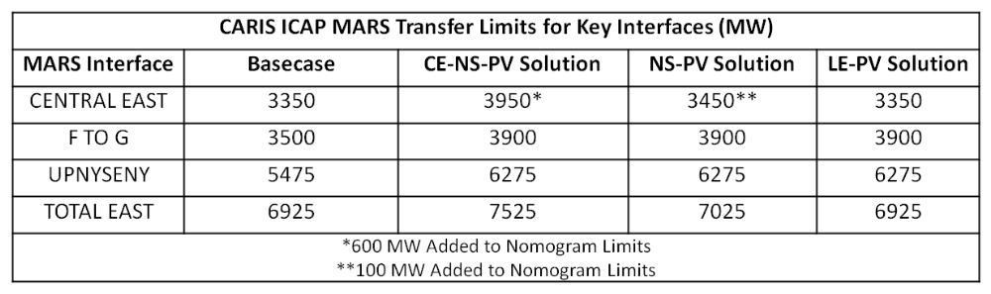

To simulate the generation project case, 1000 MW of capacity was added to Zone G. The demand response and energy efficiency project cases were created by adding 100 MW of SCR generation and 100 MW load modifiers to Zones F & G or G & I, depending upon the study.

After the base case and project case LOLE values were determined, capacity was removed from each NYISO zone in the each project case, based on the zonal total capacity ratio, until the base case LOLE was reached. The resultant amount of capacity removed is equivalent to the MW Impact of that project case. The MW Impact results for each of the project cases, for the 2020 study year are presented in Table E-7.

Table E-7: ICAP MW Impact
Study | Solutions | 2020 MW Impact (MW)
Study | Solutions | ROS | NYC | LI | Total
Study 1: Central East-New Scotland-Pleasant Valley | Transmission | 443 | 161 | 96 | 700
Study 1: Central East-New Scotland-Pleasant Valley | Generation | 824 | 299 | 177 | 1300
Study 1: Central East-New Scotland-Pleasant Valley | Demand Response | 222 | 80 | 48 | 350
Study 2: New Scotland-Pleasant Valley | Transmission | 443 | 161 | 96 | 700
Study 2: New Scotland-Pleasant Valley | Generation | 824 | 299 | 177 | 1300
Study 2: New Scotland-Pleasant Valley | Demand Response | 348 | 126 | 75 | 550
Study 3:Leeds-Pleasant Valley | Transmission | 443 | 161 | 96 | 700
Study 3:Leeds-Pleasant Valley | Generation | 824 | 299 | 177 | 1300
Study 3:Leeds-Pleasant Valley | Demand Response | 348 | 126 | 75 | 550

CARIS Base Case Metrics Results
When comparing historic PROBE values of congestion and other metrics with the projected CARIS values, it is important to note that there are significant differences in assumptions used by these tools. MAPS, unlike PROBE, did not simulate the following: (a) virtual bidding; (b) transmission outages; (c) fixed load and price-capped load; (d) production costs based on mitigated bids;(e) BPCG payments; and (f) co-optimization with ancillary services.
The detailed projected CARIS base case results are presented in Tables E-8 through E-21. Table E-8 below presents the summation of the NYCA zonal base case results for the ten-year study period (except for NYCA-wide production costs and except for system-wide TCC Payments-Congestion Rents).
Table E-8: Projected CARIS Base Case Results 2011-2020 (nominal $M)
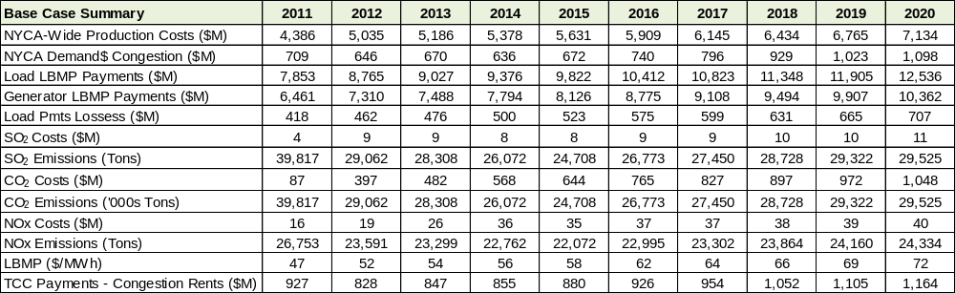

Table E-9: Projected Production Costs (2011-2020) by Zone (nominal $M)
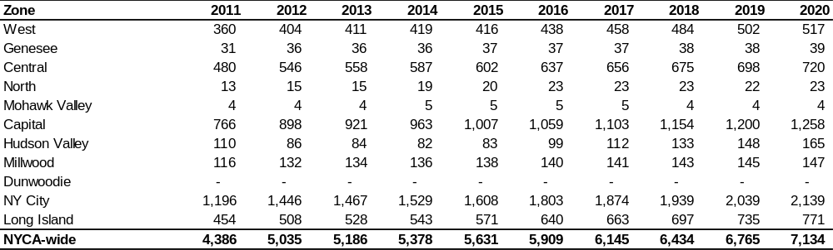

Table E-10: Projected Load Payments (2011-2020) by Zone (nominal $M)
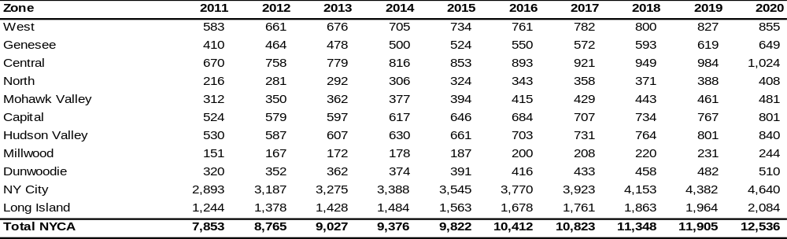
Table E-11: Projected Generator Payments (2011-2020) by Zone (nominal $M)
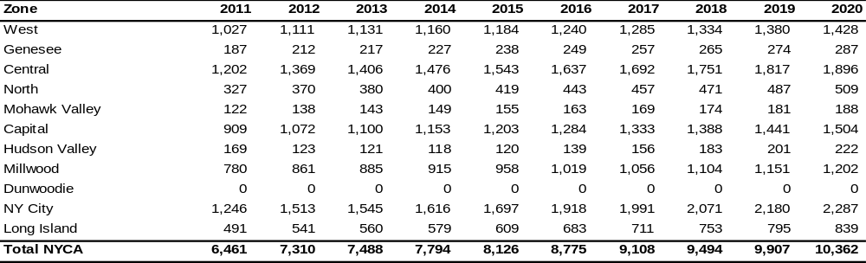

Table E-12: Projected Generator GWh
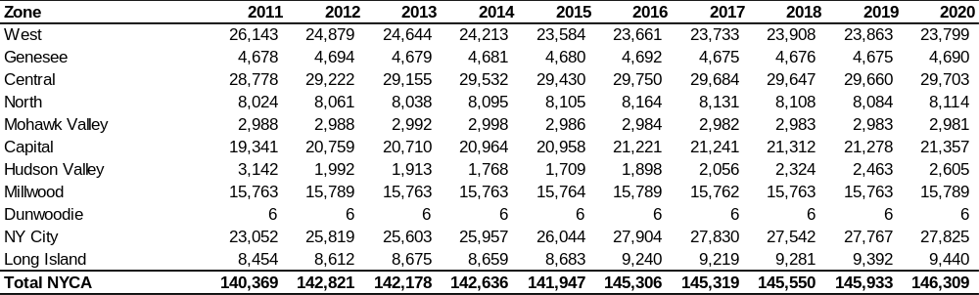

Table E-13: Projected Loss Payments (2011-2020) by Zone (nominal $M)
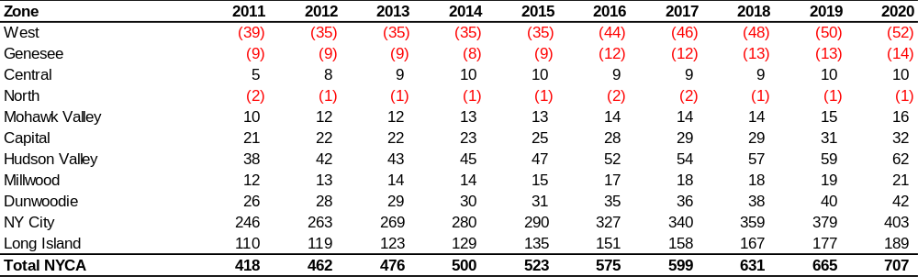
Table E-14: Projected SO₂ Emission Costs (2011-2020) by Zone (nominal $M)
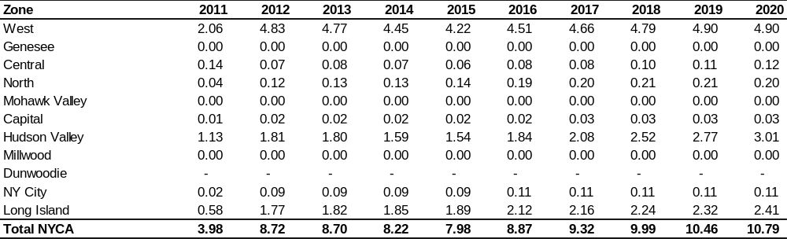

Table E-15: Projected SO₂ Emission Tons (2011-2020) by Zone
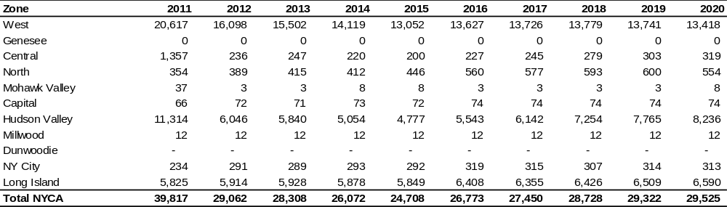

Table E-16: Projected CO₂ Emission Costs (2011-2020) by Zone (nominal $M)
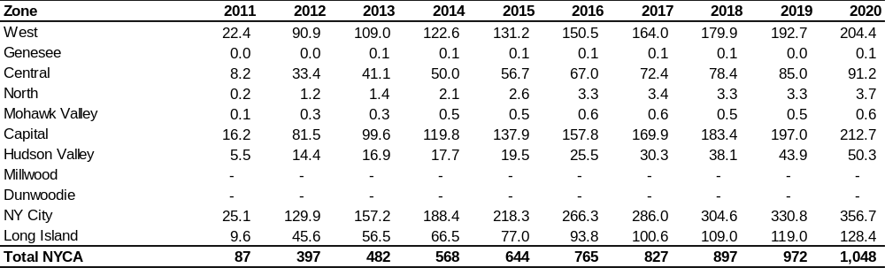

Table E-17: Projected CO₂ Emission ‘000’s Tons (2011-2020) by Zone
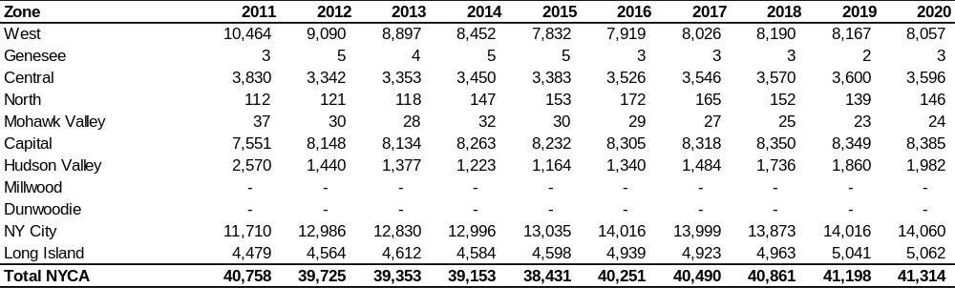

Table E-18: Projected NOx Emission Costs 2011-2020) by Zone (nominal $M)
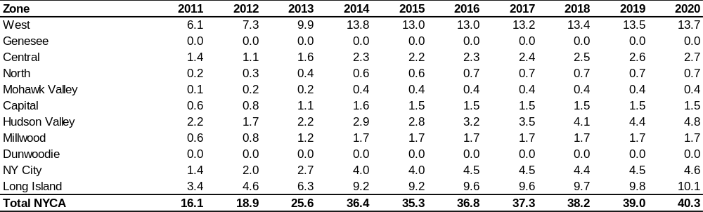

Table E-19: Projected NOx in Tons (2011-2020) by Zone
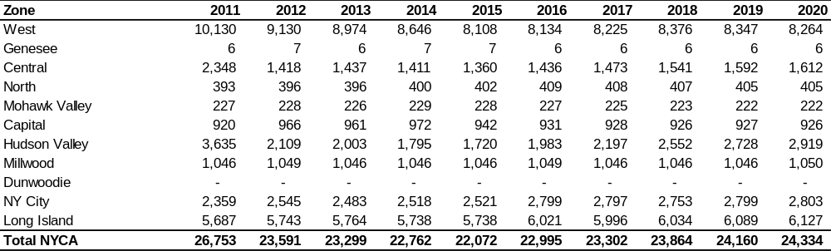

Table E-20: Projected TCC Payments (nominal $M)
 | 2011 | 2012 | 2013 | 2014 | 2015 | 2016 | 2017 | 2018 | 2019 | 2020
Total Congestion Rents | 927 | 828 | 847 | 855 | 880 | 926 | 954 | 1,052 | 1,105 | 1,164

Note: TCC payments in Phase 1 are calculated as congestion rents.

Table E-21: Projected Zonal LBMP $/MWh (2011-2020) by Zone
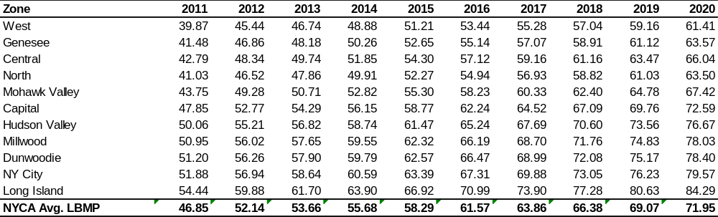

E.2. Selection of Three Studies
The process for selecting the three CARIS studies occurs in two steps, as described below.

In Step 1, both historic (5 years) and projected (10 years) congested elements for the fifteen- year period are ranked in ascending order based on the calculated present value of Demand$ Congestion. Initially, the top five positive and top two negative congested elements are identified for further consideration. This initial list is then revised to include any orphaned elements (elements for which there is no historic congestion data) if their projected congestion is higher than other elements’ projected congestion. If the projected congestion for a specific element is declining in the future years (thus indicating a diminishing return), then that element is removed from the list and is no longer considered for further analysis. The remaining top congested elements (up to five) are then further considered as primary elements for inclusion in Step 2.

In Step 2, the top congested elements from Step 1 are relieved independently to determine if any needs to be grouped with other elements that show significant congestion when a primary element is relieved. The top congested elements are relieved by increasing their limit to 9999 MW for a mid and horizon year. In addition, the impedance of the circuit is reduced to reflect the impact of a new parallel circuit. The primary constraint will be assessed for grouping with a new element if the new element is electrically adjacent to the primary element and in the top five of congested elements based on Demand$ Congestion. If the new element meets these criteria, the process is repeated with the new element’s limit also increased to 9999 to identify any additional electrically adjacent elements that become significantly congested. The elements are grouped if the production cost savings are increased by 50% or more. If, after the initial grouping the production cost savings is not more than $3 million, the primary element is eliminated from the list. If more than three grouped elements meet all the criteria, the three with the most production cost savings are selected as the three studies. The production cost savings based on modifying an existing element’s limit will be different than that achieved when applying a transmission solution since an impedance value for a line is not being introduced.

Table E-22 shows the Demand$ congestion for the base case and the relaxation cases for year 2015 and 2020.

Table E-22: Demand$ Congestion Results for Relaxation of Top Congested Elements

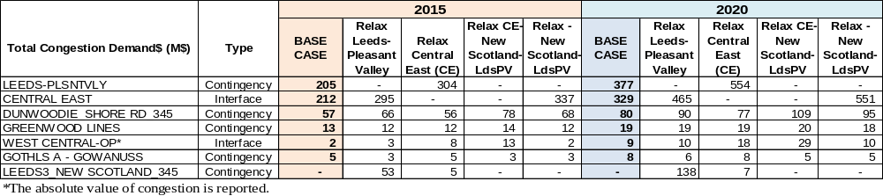

Table E-23 shows the change in production cost when the top elements are relieved. Central East-New Scotland-Pleasant Valley, New Scotland-Pleasant Valley, and Leeds-Pleasant Valley have the highest production cost savings, and are therefore selected as the three studies.

Table E-23: Production Cost Savings (nominal $M) Due to Relaxation of Primary Elements

Elements | 2015 | 2020
CE-NS-PV | 49.5 | 71.5
NS-PV | 20.4 | 31.4
LEEDS-PLSNTVLY | 17.7 | 26.5
DUNWOODIE_SHORE RD_345 | 10.2 | 5.6
CENTRAL EAST | 15.1 | 13.8
GREENWOOD LINES | 3.2 | 5.5
GOTHLS A - GOWANUSS | 3.3 | 3.5
WEST CENTRAL-OP | 0.5 | 0.1

E.3. Generic Solutions

Modeling Modifications

The NYISO developed generic solutions for each of the three studies. The generic solutions are each added to the base case in order to determine the impact on congestion for the grouped elements in each study. It is assumed that each of the generic solutions is installed in the first study year (2011). This assumption allows for the calculation of the full ten-year production cost and additional metrics resulting from the generic solution. The transfer limits were adjusted as necessary in the generic solution cases.

For each study, one block of transmission (>1000MW), two blocks of generation (1000MW), and two blocks of demand response (400MW) were implemented after considering whether a majority of the congestion on the grouped elements being studied could be relieved and whether diminishing returns could be realized from implementing additional blocks.

Disclaimers:
- Other solutions may exist which will better alleviate the congestion on the studied elements.
- No engineering, physical feasibility study, routing study or siting study has been completed for the generic solutions. Therefore, it is unknown if the generic solutions can be physically constructed as proposed.

Study1: Central East-New Scotland-Pleasant Valley

Table E-24 below presents the change in the number of congested hours by constraints after the generic solution has been applied. Negative values indicate a reduction in congested hours. Detailed results for all CARIS metrics, representing the change between the base case values and the values after the three generic solutions have been applied, are presented in Attachment H.
Table E-24: Change in Number of Congested Hours
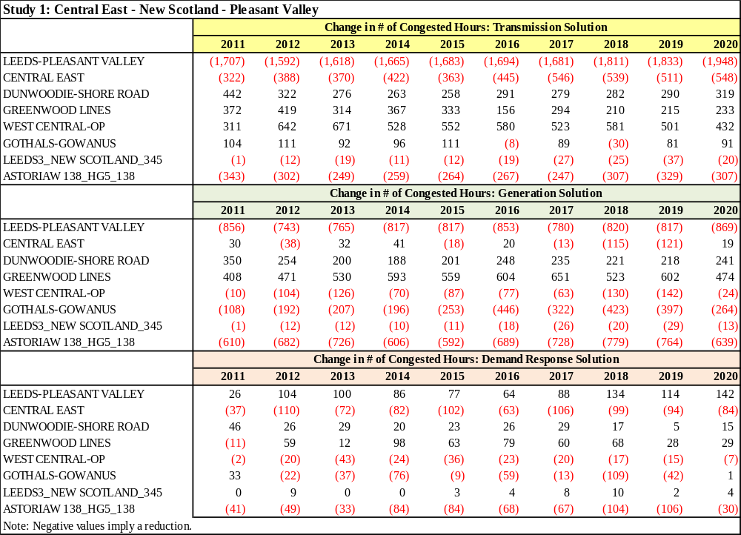

Study 2: New Scotland-Pleasant Valley

Table E-25 below presents the change in the number of congested hours by constraints after the generic solution has been applied. Negative values indicate a reduction in congested hours. Detailed results for all CARIS metrics, representing the change between the base case values and the values after the three generic solutions have been applied, are presented in Attachment H.
Table E-25: Change in Number of Congested Hours
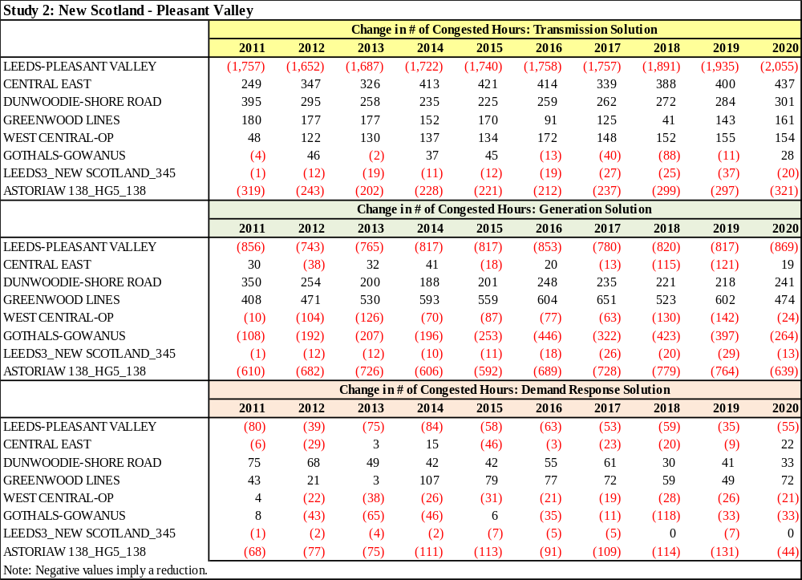

Study 3: Leeds - Pleasant Valley
Table E-26 below presents the change in the number of congested hours by constraint after the generic solution has been applied. Negative values indicate a reduction in congested hours. Detailed results for all CARIS metrics, representing the change between the base case values and the values after the three generic solutions have been applied, are presented in Attachment H.

Table E-26: Change in Number of Congested Hours
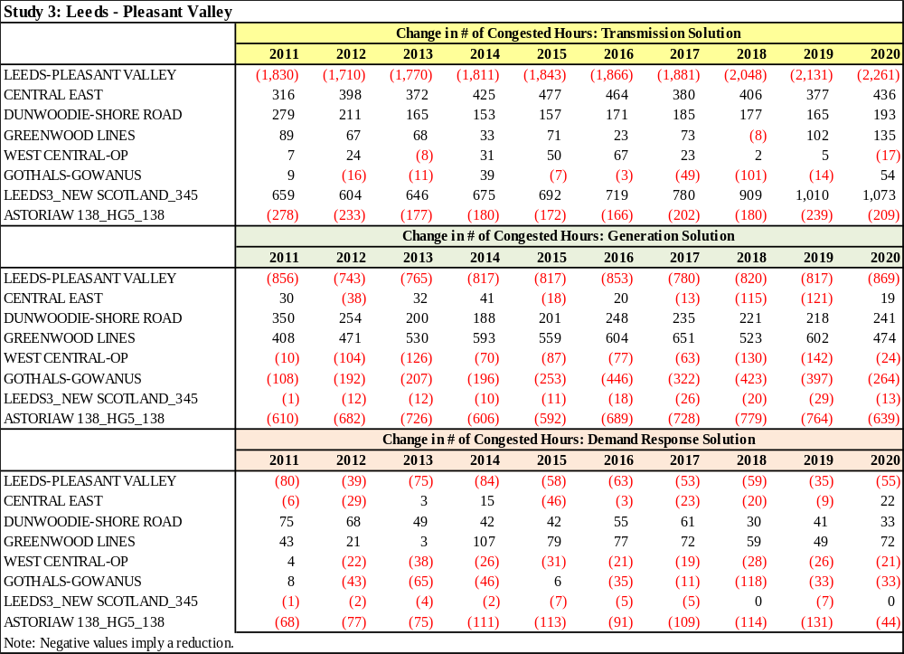

E.4. Benefit/Cost Analysis
Disclaimers

- No verification was conducted to determine if the generic solution can be built within the generic cost estimate ranges.
- The generic solutions analysis is performed to provide a rough estimate of the benefit to cost opportunity based upon the assumptions contained in this report.
- The NYISO makes no representations regarding the adequacy or accuracy of the benefit/cost ratios.

Tables E-27 through E-30 present generic solutions overnight installation costs associated with each study. On-going operation and maintenance costs are not included.

Table E-27: Generic Solution Costs for Each Study ($M)
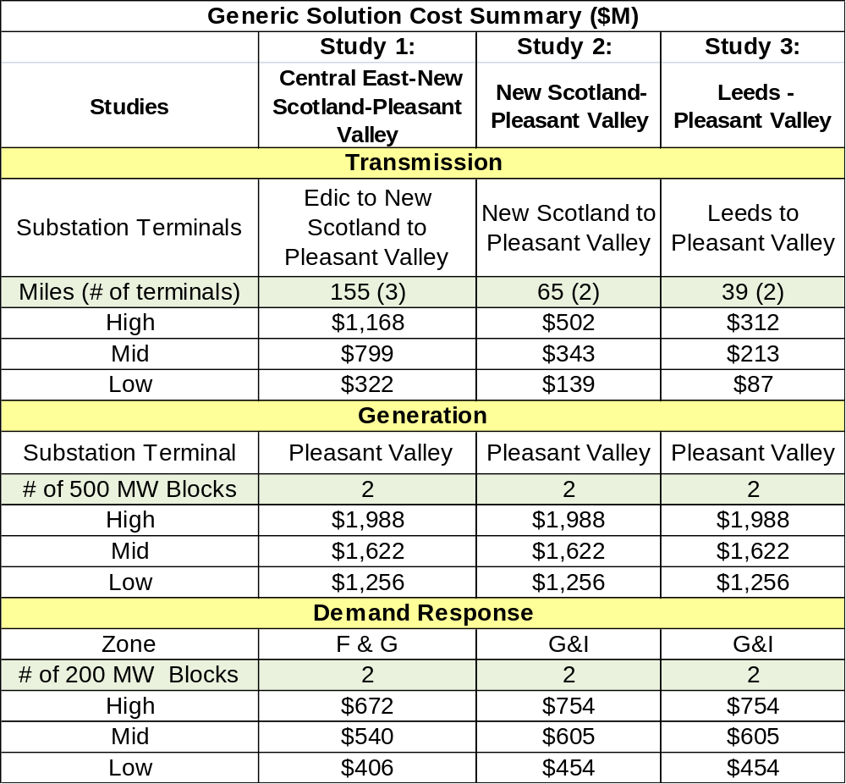

Table E-28: Generic Solutions for Study 1: Central East to New Scotland to Pleasant Valley
Generic Solution
Study 1: Central East-New Scotland-Pleasant Valley
(Estimates should not be assumed reflective or predictive of actual project costs)
Transmission Solution: Edic to New Scotland to Pleasant Valley
Cost Range | Quantity | Unit Pricing ($M) | Total ($M)
High
Transmission Line (Miles) | 155 | $7.3 | $1,131.5
Substation Line Terminal | 3 | $9 | $27.0
System Upgrade | 1 | $9 | $9.0
Total High Transmission Solution Cost |  |  | $1,168
Mid
Transmission Line (Miles) | 155 | $5 | $775.0
Substation Line Terminal | 3 | $6 | $18.0
System Upgrade | 1 | $6 | $6.0
Total Mid Transmission Solution Cost |  |  | $799
Low
Transmission Line (Miles) | 155 | $2 | $310.0
Substation Line Terminal | 3 | $3 | $9.0
System Upgrade | 1 | $3 | $3.0
Total Low Transmission Solution Cost |  |  | $322
Generation Solution: Pleasant Valley
Cost Range | Quantity | Unit Pricing ($M) | Total ($M)
High
Plant in Zone G (500 MW Blocks) | 2 | $994 | $1,988
Total High Generation Solution Cost |  |  | $1,988
Mid
Plant in Zone G (500 MW Blocks) | 2 | $811 | $1,622
Total Mid Generation Solution Cost |  |  | $1,622
Low
Plant in Zone G (500 MW Blocks) | 2 | $628 | $1,256
Total Low Generation Solution Cost |  |  | $1,256
Demand Response Solution: Zone F & G
Cost Range | Quantity | Unit Pricing ($M) | Total ($M)
High
Energy Efficiency (100 MW Blocks) | 2 | $280 | $560
Demand Response (100 MW Blocks) | 2 | $56 | $112
Total High Demand Response Solution Costs |  |  | $672
Mid
Energy Efficiency (100 MW Blocks) | 2 | $225 | $450
Demand Response (100 MW Blocks) | 2 | $45 | $90
Total Mid Demand Response Solution Costs |  |  | $540
Low
Energy Efficiency (100 MW Blocks) | 2 | $170 | $340
Demand Response (100 MW Blocks) | 2 | $33 | $66
Total Low Demand Response Solution Costs |  |  | $406

Table E-29: Generic Solutions for Study 2: New Scotland- Pleasant Valley
Generic Solution
Study 2: New Scotland-Pleasant Valley
(Estimates should not be assumed reflective or predictive of actual project costs)
Transmission Solution: New Scotland to Pleasant Valley
Cost Range | Quantity | Unit Pricing ($M) | Total ($M)
High
Transmission Line (Miles) | 65 | $7.3 | $474.5
Substation Line Terminal | 2 | $9 | $18.0
System Upgrade | 1 | $9 | $9.0
Total High Transmission Solution Cost |  |  | $502
Mid
Transmission Line (Miles) | 65 | $5 | $325.0
Substation Line Terminal | 2 | $6 | $12.0
System Upgrade | 1 | $6 | $6.0
Total Mid Transmission Solution Cost |  |  | $343
Low
Transmission Line (Miles) | 65 | $2 | $130.0
Substation Line Terminal | 2 | $3 | $6.0
System Upgrade | 1 | $3 | $3.0
Total Low Transmission Solution Cost |  |  | $139
Generation Solution: Pleasant Valley
Cost Range | Quantity | Unit Pricing ($M) | Total ($M)
High
Plant in Zone G (500 MW Blocks) | 2 | $994 | $1,988
Total High Generation Solution Cost |  |  | $1,988
Mid
Plant in Zone G (500 MW Blocks) | 2 | $811 | $1,622
Total Mid Generation Solution Cost |  |  | $1,622
Low
Plant in Zone G (500 MW Blocks) | 2 | $628 | $1,256
Total Low Generation Solution Cost |  |  | $1,256
Generic Demand Response Solution: Zone G and I
Cost Range | Quantity | Unit Pricing ($M) | Total ($M)
High
Energy Efficiency in Zone G (100 MW Blocks) | 1 | $280 | $280
Demand Response in Zone G (100 MW Blocks) | 1 | $56 | $56
Energy Efficiency in Zone I (100 MW Blocks) | 1 | $350 | $350
Demand Response in Zone I (100 MW Blocks) | 1 | $68 | $68
Total High Demand Response Solution Costs |  |  | $754
Mid
Energy Efficiency (100 MW Blocks) | 1 | $225 | $225
Demand Response (100 MW Blocks) | 1 | $45 | $45
Energy Efficiency in Zone I (100 MW Blocks) | 1 | $280 | $280
Demand Response in Zone I (100 MW Blocks) | 1 | $55 | $55
Total Mid Demand Response Solution Costs |  |  | $605
Low
Energy Efficiency (100 MW Blocks) | 1 | $170 | $170
Demand Response (100 MW Blocks) | 1 | $33 | $33
Energy Efficiency in Zone I (100 MW Blocks) | 1 | $210 | $210
Demand Response in Zone I (100 MW Blocks) | 1 | $41 | $41
Total Low Demand Response Solution Costs |  |  | $454

Table E-30: Generic Solutions for Study 3: Leeds-Pleasant Valley
Generic Solution
Study 3: Leeds - Pleasant Valley
(Estimates should not be assumed reflective or predictive of actual project costs)
Transmission Solution: Leeds - Pleasant Valley
Cost Range | Quantity | Unit Pricing ($M) | Total ($M)
High
Transmission Line (Miles) | 39 | $7.3 | $284.7
Substation Line Terminal | 2 | $9 | $18.0
System Upgrade | 1 | $9 | $9.0
Total High Transmission Solution Cost |  |  | $312
Mid
Transmission Line (Miles) | 39 | $5 | $195.0
Substation Line Terminal | 2 | $6 | $12.0
System Upgrade | 1 | $6 | $6.0
Total Mid Transmission Solution Cost |  |  | $213
Low
Transmission Line (Miles) | 39 | $2 | $78.0
Substation Line Terminal | 2 | $3 | $6.0
System Upgrade | 1 | $3 | $3.0
Total Low Transmission Solution Cost |  |  | $87
Generation Solution: Pleasant Valley
Cost Range | Quantity | Unit Pricing ($M) | Total ($M)
High
Plant in Zone G (500 MW Blocks) | 2 | $994 | $1,988
Total High Generation Solution Cost |  |  | $1,988
Mid
Plant in Zone G (500 MW Blocks) | 2 | $811 | $1,622
Total Mid Generation Solution Cost |  |  | $1,622
Low
Plant in Zone G (500 MW Blocks) | 2 | $628 | $1,256
Total Low Generation Solution Cost |  |  | $1,256
Demand Response Solution: Zone G & I
Cost Range | Quantity | Unit Pricing ($M) | Total ($M)
High
Energy Efficiency (100 MW Blocks) | 1 | $280 | $280
Demand Response (100 MW Blocks) | 1 | $56 | $56
Energy Efficiency in Zone I (100 MW Blocks) | 1 | $350 | $350
Demand Response in Zone I (100 MW Blocks) | 1 | $68 | $68
Total High Demand Response Solution Costs |  |  | $754
Mid
Energy Efficiency (100 MW Blocks) | 1 | $225 | $225
Demand Response (100 MW Blocks) | 1 | $45 | $45
Energy Efficiency in Zone I (100 MW Blocks) | 1 | $280 | $280
Demand Response in Zone I (100 MW Blocks) | 1 | $55 | $55
Total High Demand Response Solution Costs |  |  | $605
Low
Energy Efficiency (100 MW Blocks) | 1 | $170 | $170
Demand Response (100 MW Blocks) | 1 | $33 | $33
Energy Efficiency in Zone I (100 MW Blocks) | 1 | $210 | $210
Demand Response in Zone I (100 MW Blocks) | 1 | $41 | $41
Total High Demand Response Solution Costs |  |  | $454

Appendix F – Initial CARIS Manual (link)
http://www.nyiso.com/public/webdocs/services/planning/initial_caris_manual_bic_approved/Initial_CARIS_Manual.pdf

The NYISO’s existing CRPP manual and existing Initial CARIS manual are currently being integrated into a single Comprehensive System Planning Process (CSPP) Manual.

Appendix G - 2010 RNA and CRP Reports (link)
The 2010 RNA and CRP reports can be found through the following links:

http://www.nyiso.com/public/webdocs/services/planning/reliability_assessments/2010_Reliability_Needs_Assessment_Final_Report_September_2010.pdf

http://www.nyiso.com/public/webdocs/services/planning/reliability_assessments/CRP_2010_FINAL_REPORT_January_11__2011.pdf

Appendix H - Generic Solution Results – Additional Details
Tables below present the CARIS metrics results for each of the three studies. The CARIS metrics are calculated as the change between the base case values and the change case values after each of the respective generic solutions have been added to the base case. The values are expressed in nominal $M and are calculated as Solution minus base case. Negative values are shown in red and with brackets (except for tables showing percentage changes) and represent a reduction in costs/payments.

H.1. Study 1: Central East - New Scotland - Pleasant Valley (CE-NS-PV)
Generic Transmission Solution

Projected Changes in Production Cost ($M) – CE-NS-PV: Transmission Solution
Area | 2011 |  | 2012 |  | 2013 |  | 2014 |  |  | 2015 |  | 2016 |  | 2017 |  | 2018 |  | 2019 |  | 2020
West | 9 |  | 14 |  | 14 |  | 17 |  |  | 27 |  | 25 |  | 20 |  | 23 |  | 23 |  | 28
Genesee | 0 |  | 0 |  | 0 |  | 1 |  |  | 0 |  | 0 |  | 1 |  | 1 |  | 1 |  | 1
Central | 33 |  | 32 |  | 31 |  | 28 |  |  | 32 |  | 36 |  | 40 |  | 44 |  | 47 |  | 56
North | 6 |  | 8 |  | 9 |  | 8 |  |  | 8 |  | 12 |  | 15 |  | 15 |  | 17 |  | 16
Mohawk Valley | 2 |  | 1 |  | 1 |  | 1 |  |  | 1 |  | 1 |  | 1 |  | 1 |  | 1 |  | 1
Capital | 4 |  | 4 |  | 5 |  | 7 |  |  | 7 |  | 6 |  | 9 |  | 9 |  | 11 |  | 11
Hudson Valley | (16) |  | (22) |  | (20) |  | (22) |  |  | (22) |  | (23) |  | (27) |  | (36) |  | (40) |  | (38)
Millwood | 0 |  | 0 |  | 0 |  | 0 |  |  | 0 |  | 0 |  | (0) |  | 0 |  | 0 |  | 0
Dunwoodie | 0 |  | 0 |  | 0 |  | 0 |  |  | 0 |  | 0 |  | 0 |  | 0 |  | 0 |  | 0
NY City | (101) |  | (109) |  | (101) |  | (96) |  |  | (103) |  | (103) |  | (119) |  | (117) |  | (132) |  | (158)
Long Island | (19) |  | (14) |  | (13) |  | (10) |  |  | (11) |  | (13) |  | (14) |  | (12) |  | (17) |  | (14)
NYCA Total | (80) |  | (86) |  | (74) |  | (68) |  |  | (61) |  | (59) |  | (74) |  | (72) |  | (88) |  | (97)
NYCA-wide | (47) |  | (44) |  | (43) |  | (43) |  |  | (45) |  | (47) |  | (51) |  | (53) |  | (62) |  | (66)
Projected Changes in Load LBMP Payment ($M) – CE-NS-PV: Transmission Solution
Area | 2011 |  | 2012 |  | 2013 |  | 2014 |  |  | 2015 |  | 2016 |  | 2017 |  | 2018 |  | 2019 |  | 2020
West | 26 |  | 20 |  | 19 |  | 20 |  |  | 17 |  | 21 |  | 23 |  | 24 |  | 27 |  | 31
Genesee | 19 |  | 16 |  | 15 |  | 17 |  |  | 15 |  | 18 |  | 19 |  | 21 |  | 24 |  | 28
Central | 32 |  | 28 |  | 27 |  | 28 |  |  | 26 |  | 32 |  | 36 |  | 38 |  | 44 |  | 49
North | 12 |  | 13 |  | 13 |  | 13 |  |  | 13 |  | 15 |  | 17 |  | 18 |  | 21 |  | 23
Mohawk Valley | 15 |  | 13 |  | 13 |  | 14 |  |  | 13 |  | 15 |  | 17 |  | 18 |  | 21 |  | 23
Capital | 11 |  | 9 |  | 8 |  | 9 |  |  | 9 |  | 11 |  | 13 |  | 13 |  | 16 |  | 19
Hudson Valley | (8) |  | (8) |  | (10) |  | (7) |  |  | (10) |  | (8) |  | (8) |  | (11) |  | (11) |  | (10)
Millwood | (4) |  | (4) |  | (5) |  | (4) |  |  | (4) |  | (4) |  | (4) |  | (6) |  | (6) |  | (6)
Dunwoodie | (9) |  | (8) |  | (9) |  | (8) |  |  | (9) |  | (9) |  | (8) |  | (12) |  | (12) |  | (12)
NY City | (61) |  | (57) |  | (68) |  | (58) |  |  | (70) |  | (68) |  | (64) |  | (93) |  | (92) |  | (90)
Long Island | (8) |  | (8) |  | (11) |  | (7) |  |  | (11) |  | (9) |  | (8) |  | (18) |  | (17) |  | (14)
NYCA Total | 25 |  | 13 |  | (7) |  | 17 |  |  | (10) |  | 13 |  | 35 |  | (7) |  | 16 |  | 41
Projected Changes in Generator LBMP Payment ($M) - CE-NS-PV: Transmission Solution
Area | 2011 |  | 2012 |  | 2013 |  | 2014 |  | 2015 |  |  | 2016 |  | 2017 |  | 2018 |  | 2019 |  | 2020
West | 59 |  | 51 |  | 49 |  | 53 |  | 58 |  |  | 60 |  | 61 |  | 64 |  | 70 |  | 79
Genesee | 9 |  | 8 |  | 7 |  | 8 |  | 7 |  |  | 8 |  | 9 |  | 10 |  | 11 |  | 13
Central | 89 |  | 83 |  | 80 |  | 87 |  | 86 |  |  | 104 |  | 115 |  | 122 |  | 136 |  | 153
North | 24 |  | 24 |  | 24 |  | 25 |  | 24 |  |  | 30 |  | 35 |  | 37 |  | 42 |  | 43
Mohawk Valley | 10 |  | 8 |  | 8 |  | 8 |  | 7 |  |  | 9 |  | 9 |  | 10 |  | 12 |  | 13
Capital | 40 |  | 34 |  | 35 |  | 37 |  | 38 |  |  | 43 |  | 50 |  | 53 |  | 63 |  | 70
Hudson Valley | (22) |  | (26) |  | (25) |  | (25) |  | (25) |  |  | (27) |  | (32) |  | (43) |  | (46) |  | (44)
Millwood | (15) |  | (15) |  | (16) |  | (14) |  | (18) |  |  | (16) |  | (15) |  | (21) |  | (21) |  | (21)
Dunwoodie | (0) |  | (0) |  | (0) |  | (0) |  | (0) |  |  | (0) |  | (0) |  | (0) |  | (0) |  | (0)
NY City | (113) |  | (128) |  | (128) |  | (117) |  | (130) |  |  | (129) |  | (142) |  | (154) |  | (166) |  | (186)
Long Island | (22) |  | (18) |  | (18) |  | (13) |  | (17) |  |  | (18) |  | (19) |  | (23) |  | (26) |  | (22)
NYCA Total | 58 |  | 21 |  | 16 |  | 48 |  | 30 |  |  | 65 |  | 71 |  | 55 |  | 74 |  | 97
Projected Changes in Congestion Demand ($M) - CE-NS-PV: Transmission Solution
Area |  | 2011 |  | 2012 |  | 2013 |  | 2014 |  |  | 2015 |  | 2016 |  | 2017 |  | 2018 |  | 2019 |  | 2020
West |  | (1) |  | 3 |  | 3 |  | 4 |  |  | 4 |  | 6 |  | 7 |  | 8 |  | 11 |  | 11
Genesee |  | (1) |  | 1 |  | 2 |  | 1 |  |  | 2 |  | 3 |  | 4 |  | 5 |  | 6 |  | 5
Central |  | (1) |  | (1) |  | (1) |  | (2) |  |  | (2) |  | (2) |  | (2) |  | (2) |  | (3) |  | (3)
North |  | (2) |  | (3) |  | (3) |  | (3) |  |  | (3) |  | (3) |  | (3) |  | (3) |  | (3) |  | (4)
Mohawk Valley |  | (1) |  | (1) |  | (1) |  | (1) |  |  | (1) |  | (1) |  | (1) |  | (2) |  | (2) |  | (2)
Capital |  | (13) |  | (12) |  | (12) |  | (13) |  |  | (12) |  | (14) |  | (14) |  | (17) |  | (19) |  | (20)
Hudson Valley |  | (30) |  | (27) |  | (28) |  | (27) |  |  | (27) |  | (30) |  | (32) |  | (38) |  | (43) |  | (46)
Millwood |  | (11) |  | (10) |  | (10) |  | (10) |  |  | (10) |  | (11) |  | (12) |  | (14) |  | (15) |  | (17)
Dunwoodie |  | (22) |  | (19) |  | (20) |  | (19) |  |  | (19) |  | (22) |  | (23) |  | (27) |  | (31) |  | (33)
NY City |  | (174) |  | (154) |  | (159) |  | (155) |  |  | (159) |  | (178) |  | (188) |  | (230) |  | (255) |  | (276)
Long Island |  | (57) |  | (50) |  | (50) |  | (48) |  |  | (49) |  | (57) |  | (62) |  | (77) |  | (86) |  | (93)
NYCA Total |  | (313) |  | (274) |  | (280) |  | (272) |  |  | (276) |  | (308) |  | (327) |  | (397) |  | (440) |  | (476)
Projected Changes in CO2 Cost ($M) - CE-NS-PV: Transmission Solution
Area |  | 2011 |  | 2012 |  | 2013 |  | 2014 |  |  | 2015 |  | 2016 |  | 2017 |  | 2018 |  | 2019 |  | 2020
West |  | 0.5 |  | 2.9 |  | 3.4 |  | 4.8 |  |  | 8.7 |  | 8.7 |  | 7.2 |  | 8.5 |  | 8.9 |  | 10.8
Genesee |  | 0.0 |  | 0.0 |  | 0.0 |  | 0.1 |  |  | 0.1 |  | 0.1 |  | 0.1 |  | 0.1 |  | 0.1 |  | 0.1
Central |  | 1.0 |  | 3.7 |  | 4.0 |  | 4.1 |  |  | 5.1 |  | 6.6 |  | 7.6 |  | 8.9 |  | 9.9 |  | 12.5
North |  | 0.1 |  | 0.8 |  | 1.0 |  | 1.0 |  |  | 1.1 |  | 1.8 |  | 2.3 |  | 2.5 |  | 2.9 |  | 2.7
Mohawk Valley |  | 0.1 |  | 0.1 |  | 0.1 |  | 0.1 |  |  | 0.1 |  | 0.2 |  | 0.2 |  | 0.3 |  | 0.3 |  | 0.3
Capital |  | 0.1 |  | 0.3 |  | 0.5 |  | 0.8 |  |  | 1.0 |  | 0.9 |  | 1.5 |  | 1.5 |  | 1.9 |  | 1.9
Hudson Valley |  | (0.5) |  | (3.1) |  | (3.5) |  | (4.0) |  |  | (4.2) |  | (5.0) |  | (5.8) |  | (8.6) |  | (10.0) |  | (9.4)
Millwood |  | 0.0 |  | 0.0 |  | 0.0 |  | 0.0 |  |  | 0.0 |  | 0.0 |  | 0.0 |  | 0.0 |  | 0.0 |  | 0.0
Dunwoodie |  | 0.0 |  | 0.0 |  | 0.0 |  | 0.0 |  |  | 0.0 |  | 0.0 |  | 0.0 |  | 0.0 |  | 0.0 |  | 0.0
NY City |  | (2.0) |  | (9.4) |  | (10.4) |  | (11.4) |  |  | (13.3) |  | (14.5) |  | (17.6) |  | (17.7) |  | (20.5) |  | (25.4)
Long Island |  | (0.4) |  | (1.3) |  | (1.4) |  | (1.2) |  |  | (1.5) |  | (1.9) |  | (2.1) |  | (1.9) |  | (2.7) |  | (2.3)
NYCA Total |  | (1.1) |  | (5.9) |  | (6.3) |  | (5.7) |  |  | (2.9) |  | (3.0) |  | (6.6) |  | (6.5) |  | (9.4) |  | (8.8)
Projected Changes in CO2 Emissions (%) - CE-NS-PV: Transmission Solution
Area |  | 2011 |  | 2012 |  | 2013 |  | 2014 |  |  | 2015 |  | 2016 |  | 2017 |  | 2018 |  | 2019 |  | 2020
West |  | 2.2% |  | 3.2% |  | 3.1% |  | 3.9% |  |  | 6.7% |  | 5.8% |  | 4.4% |  | 4.7% |  | 4.6% |  | 5.3%
Genesee |  | 102.3% |  | 63.8% |  | 70.2% |  | 94.9% |  |  | 89.7% |  | 109.1% |  | 165.3% |  | 158.2% |  | 182.9% |  | 157.6%
Central |  | 12.6% |  | 11.1% |  | 9.7% |  | 8.2% |  |  | 9.0% |  | 9.8% |  | 10.5% |  | 11.4% |  | 11.7% |  | 13.6%
North |  | 57.0% |  | 63.0% |  | 66.1% |  | 48.6% |  |  | 44.3% |  | 55.7% |  | 68.7% |  | 74.9% |  | 87.1% |  | 74.2%
Mohawk Valley |  | 103.7% |  | 36.3% |  | 30.7% |  | 25.7% |  |  | 26.6% |  | 34.6% |  | 37.8% |  | 48.9% |  | 47.6% |  | 46.8%
Capital |  | 0.5% |  | 0.4% |  | 0.5% |  | 0.7% |  |  | 0.7% |  | 0.6% |  | 0.9% |  | 0.8% |  | 1.0% |  | 0.9%
Hudson Valley |  | -9.9% |  | -21.5% |  | -20.6% |  | -22.6% |  |  | -21.7% |  | -19.4% |  | -19.2% |  | -22.5% |  | -22.7% |  | -18.7%
Millwood |  | - |  | - |  | - |  | - |  |  | - |  | - |  | - |  | - |  | - |  | -
Dunwoodie |  | - |  | - |  | - |  | - |  |  | - |  | - |  | - |  | - |  | - |  | -
NY City |  | -8.0% |  | -7.2% |  | -6.6% |  | -6.1% |  |  | -6.1% |  | -5.5% |  | -6.2% |  | -5.8% |  | -6.2% |  | -7.1%
Long Island |  | -4.1% |  | -2.8% |  | -2.5% |  | -1.8% |  |  | -2.0% |  | -2.0% |  | -2.1% |  | -1.8% |  | -2.3% |  | -1.8%
NYCA Total |  | -1.3% |  | -1.5% |  | -1.3% |  | -1.0% |  |  | -0.5% |  | -0.4% |  | -0.8% |  | -0.7% |  | -1.0% |  | -0.8%
Projected Changes in SO2 Cost ($M) - CE-NS-PV: Transmission Solution
Area |  | 2011 |  | 2012 |  | 2013 |  | 2014 |  |  | 2015 |  | 2016 |  | 2017 |  | 2018 |  | 2019 |  | 2020
West |  | 0.06 |  | 0.27 |  | 0.25 |  | 0.29 |  |  | 0.33 |  | 0.33 |  | 0.34 |  | 0.37 |  | 0.38 |  | 0.44
Genesee |  | 0.00 |  | 0.00 |  | 0.00 |  | 0.00 |  |  | 0.00 |  | 0.00 |  | 0.00 |  | 0.00 |  | 0.00 |  | 0.00
Central |  | 0.02 |  | 0.03 |  | 0.02 |  | 0.02 |  |  | 0.02 |  | 0.02 |  | 0.03 |  | 0.03 |  | 0.03 |  | 0.05
North |  | 0.01 |  | 0.04 |  | 0.04 |  | 0.04 |  |  | 0.04 |  | 0.06 |  | 0.07 |  | 0.07 |  | 0.07 |  | 0.07
Mohawk Valley |  | 0.01 |  | 0.00 |  | 0.00 |  | 0.00 |  |  | 0.00 |  | 0.00 |  | 0.00 |  | 0.01 |  | 0.00 |  | 0.00
Capital |  | 0.00 |  | 0.00 |  | 0.00 |  | 0.00 |  |  | 0.00 |  | 0.00 |  | 0.00 |  | 0.00 |  | 0.00 |  | 0.00
Hudson Valley |  | (0.08) |  | (0.33) |  | (0.32) |  | (0.30) |  |  | (0.27) |  | (0.28) |  | (0.31) |  | (0.47) |  | (0.53) |  | (0.45)
Millwood |  | 0.00 |  | 0.00 |  | 0.00 |  | 0.00 |  |  | 0.00 |  | 0.00 |  | 0.00 |  | 0.00 |  | 0.00 |  | 0.00
Dunwoodie |  | 0.00 |  | 0.00 |  | 0.00 |  | 0.00 |  |  | 0.00 |  | 0.00 |  | 0.00 |  | 0.00 |  | 0.00 |  | 0.00
NY City |  | (0.00) |  | (0.01) |  | (0.01) |  | (0.01) |  |  | (0.01) |  | (0.01) |  | (0.01) |  | (0.01) |  | (0.01) |  | (0.01)
Long Island |  | (0.02) |  | (0.05) |  | (0.04) |  | (0.04) |  |  | (0.03) |  | (0.05) |  | (0.05) |  | (0.02) |  | (0.05) |  | (0.02)
NYCA Total |  | 0.00 |  | (0.05) |  | (0.06) |  | 0.01 |  |  | 0.07 |  | 0.08 |  | 0.07 |  | (0.02) |  | (0.10) |  | 0.06
Projected Changes in SO2 Emissions (%) - CE-NS-PV: Transmission Solution
Area |  | 2011 |  | 2012 |  | 2013 |  | 2014 |  |  | 2015 |  | 2016 |  | 2017 |  | 2018 |  | 2019 |  | 2020
West |  | 3.0% |  | 5.6% |  | 5.2% |  | 6.6% |  |  | 7.7% |  | 7.4% |  | 7.2% |  | 7.8% |  | 7.7% |  | 8.9%
Genesee |  | 8.4% |  | 7.4% |  | 7.4% |  | 11.1% |  |  | 9.6% |  | 8.6% |  | 10.6% |  | 10.2% |  | 10.2% |  | 11.5%
Central |  | 18.3% |  | 37.2% |  | 21.7% |  | 23.8% |  |  | 25.6% |  | 31.1% |  | 32.5% |  | 33.7% |  | 32.2% |  | 38.9%
North |  | 38.1% |  | 37.5% |  | 35.1% |  | 30.3% |  |  | 28.3% |  | 31.3% |  | 35.7% |  | 31.9% |  | 34.9% |  | 32.1%
Mohawk Valley |  | 274.6% |  | 146.0% |  | 3.3% |  | 58.1% |  |  | 76.8% |  | 277.3% |  | 279.3% |  | 446.1% |  | 382.8% |  | 135.5%
Capital |  | 1.4% |  | 1.3% |  | 1.1% |  | 1.4% |  |  | 1.4% |  | 1.1% |  | 1.6% |  | 1.5% |  | 1.7% |  | 1.7%
Hudson Valley |  | -7.4% |  | -18.2% |  | -17.7% |  | -18.9% |  |  | -17.6% |  | -15.3% |  | -14.8% |  | -18.5% |  | -19.3% |  | -15.0%
Millwood |  | 0.0% |  | 0.0% |  | 0.0% |  | 0.0% |  |  | 0.0% |  | 0.0% |  | 0.0% |  | 0.0% |  | 0.0% |  | 0.0%
Dunwoodie |  | - |  | - |  | - |  | - |  |  | - |  | - |  | - |  | - |  | - |  | -
NY City |  | -10.0% |  | -9.7% |  | -9.4% |  | -8.5% |  |  | -8.5% |  | -7.9% |  | -9.0% |  | -9.5% |  | -10.6% |  | -12.0%
Long Island |  | -3.6% |  | -2.8% |  | -2.3% |  | -1.9% |  |  | -1.8% |  | -2.3% |  | -2.3% |  | -1.1% |  | -2.0% |  | -1.0%
NYCA Total |  | 0.1% |  | -0.5% |  | -0.7% |  | 0.1% |  |  | 0.9% |  | 0.9% |  | 0.7% |  | -0.2% |  | -1.0% |  | 0.6%
Projected Changes in NOx Cost ($M) - CE-NS-PV: Transmission Solution
Area |  | 2011 |  | 2012 |  | 2013 |  | 2014 |  |  | 2015 |  | 2016 |  | 2017 |  | 2018 |  | 2019 |  | 2020
West |  | 0.1 |  | 0.2 |  | 0.2 |  | 0.4 |  |  | 0.7 |  | 0.6 |  | 0.5 |  | 0.5 |  | 0.5 |  | 0.6
Genesee |  | 0.0 |  | 0.0 |  | 0.0 |  | 0.0 |  |  | 0.0 |  | 0.0 |  | 0.0 |  | 0.0 |  | 0.0 |  | 0.0
Central |  | 0.2 |  | 0.2 |  | 0.2 |  | 0.2 |  |  | 0.2 |  | 0.3 |  | 0.3 |  | 0.4 |  | 0.4 |  | 0.5
North |  | 0.0 |  | 0.0 |  | 0.0 |  | 0.0 |  |  | 0.0 |  | 0.0 |  | 0.0 |  | 0.0 |  | 0.0 |  | 0.0
Mohawk Valley |  | 0.0 |  | 0.0 |  | 0.0 |  | 0.0 |  |  | 0.0 |  | 0.0 |  | 0.0 |  | 0.0 |  | 0.0 |  | 0.0
Capital |  | 0.0 |  | 0.0 |  | 0.0 |  | 0.0 |  |  | 0.0 |  | 0.0 |  | 0.0 |  | 0.0 |  | 0.0 |  | 0.0
Hudson Valley |  | (0.3) |  | (0.4) |  | (0.5) |  | (0.7) |  |  | (0.6) |  | (0.7) |  | (0.8) |  | (1.0) |  | (1.1) |  | (1.0)
Millwood |  | 0.0 |  | 0.0 |  | 0.0 |  | 0.0 |  |  | 0.0 |  | 0.0 |  | 0.0 |  | 0.0 |  | 0.0 |  | 0.0
Dunwoodie |  | 0.0 |  | 0.0 |  | 0.0 |  | 0.0 |  |  | 0.0 |  | 0.0 |  | 0.0 |  | 0.0 |  | 0.0 |  | 0.0
NY City |  | (0.1) |  | (0.2) |  | (0.2) |  | (0.3) |  |  | (0.3) |  | (0.3) |  | (0.3) |  | (0.3) |  | (0.4) |  | (0.4)
Long Island |  | (0.1) |  | (0.1) |  | (0.1) |  | (0.1) |  |  | (0.1) |  | (0.1) |  | (0.1) |  | (0.1) |  | (0.1) |  | (0.1)
NYCA Total |  | (0.1) |  | (0.3) |  | (0.3) |  | (0.4) |  |  | (0.0) |  | (0.1) |  | (0.4) |  | (0.5) |  | (0.6) |  | (0.3)
Projected Changes in NOx Emissions (%) - CE-NS-PV: Transmission Solution
Area |  | 2011 |  | 2012 |  | 2013 |  | 2014 |  |  | 2015 |  | 2016 |  | 2017 |  | 2018 |  | 2019 |  | 2020
West |  | 1.9% |  | 2.5% |  | 2.4% |  | 3.0% |  |  | 5.5% |  | 4.7% |  | 3.4% |  | 3.7% |  | 3.7% |  | 4.2%
Genesee |  | 24.3% |  | 17.4% |  | 13.7% |  | 19.7% |  |  | 18.4% |  | 15.7% |  | 18.4% |  | 18.5% |  | 16.2% |  | 21.9%
Central |  | 14.6% |  | 14.3% |  | 10.4% |  | 9.9% |  |  | 10.5% |  | 12.3% |  | 13.3% |  | 14.9% |  | 15.0% |  | 19.0%
North |  | 3.5% |  | 3.9% |  | 4.0% |  | 3.6% |  |  | 3.4% |  | 4.8% |  | 5.6% |  | 5.5% |  | 6.0% |  | 5.3%
Mohawk Valley |  | 6.0% |  | 3.9% |  | 3.5% |  | 2.8% |  |  | 2.5% |  | 3.1% |  | 3.2% |  | 3.4% |  | 3.2% |  | 3.3%
Capital |  | 1.2% |  | 1.2% |  | 1.2% |  | 1.0% |  |  | 1.4% |  | 1.5% |  | 1.9% |  | 2.1% |  | 2.2% |  | 2.5%
Hudson Valley |  | -11.6% |  | -23.0% |  | -22.0% |  | -24.0% |  |  | -23.2% |  | -21.6% |  | -21.4% |  | -24.6% |  | -24.3% |  | -20.8%
Millwood |  | 0.0% |  | 0.0% |  | 0.0% |  | 0.0% |  |  | 0.0% |  | 0.0% |  | 0.0% |  | 0.0% |  | 0.0% |  | 0.0%
Dunwoodie |  | - |  | - |  | - |  | - |  |  | - |  | - |  | - |  | - |  | - |  | -
NY City |  | -10.0% |  | -8.8% |  | -7.8% |  | -7.0% |  |  | -7.0% |  | -6.8% |  | -7.7% |  | -6.7% |  | -8.6% |  | -8.9%
Long Island |  | -2.3% |  | -1.6% |  | -1.5% |  | -1.1% |  |  | -1.1% |  | -1.3% |  | -1.3% |  | -1.1% |  | -1.4% |  | -0.9%
NYCA Total |  | -0.8% |  | -1.4% |  | -1.3% |  | -1.0% |  |  | -0.1% |  | -0.4% |  | -1.0% |  | -1.2% |  | -1.6% |  | -0.9%
Projected LBMP $/MWh - CE-NS-PV: Transmission Solution
Area |  | 2011 |  | 2012 |  | 2013 |  | 2014 |  |  | 2015 |  | 2016 |  | 2017 |  | 2018 |  | 2019 |  | 2020
West |  | 41.43 |  | 46.69 |  | 47.94 |  | 50.12 |  |  | 52.30 |  | 54.73 |  | 56.83 |  | 58.59 |  | 60.90 |  | 63.39
Genesee |  | 43.18 |  | 48.27 |  | 49.53 |  | 51.71 |  |  | 53.95 |  | 56.65 |  | 58.85 |  | 60.69 |  | 63.19 |  | 65.95
Central |  | 44.57 |  | 49.90 |  | 51.29 |  | 53.45 |  |  | 55.79 |  | 58.94 |  | 61.26 |  | 63.39 |  | 66.04 |  | 68.88
North |  | 43.23 |  | 48.55 |  | 49.90 |  | 52.02 |  |  | 54.29 |  | 57.29 |  | 59.57 |  | 61.63 |  | 64.21 |  | 67.01
Mohawk Valley |  | 45.62 |  | 50.94 |  | 52.35 |  | 54.54 |  |  | 56.92 |  | 60.19 |  | 62.57 |  | 64.76 |  | 67.48 |  | 70.42
Capital |  | 48.62 |  | 53.42 |  | 54.86 |  | 56.74 |  |  | 59.37 |  | 63.04 |  | 65.53 |  | 68.05 |  | 70.92 |  | 73.94
Hudson Valley |  | 49.45 |  | 54.58 |  | 56.06 |  | 58.13 |  |  | 60.71 |  | 64.58 |  | 67.19 |  | 69.78 |  | 72.77 |  | 75.92
Millwood |  | 49.90 |  | 54.98 |  | 56.47 |  | 58.54 |  |  | 61.14 |  | 65.08 |  | 67.72 |  | 70.36 |  | 73.40 |  | 76.61
Dunwoodie |  | 50.13 |  | 55.21 |  | 56.69 |  | 58.77 |  |  | 61.37 |  | 65.34 |  | 67.98 |  | 70.66 |  | 73.72 |  | 76.95
NY City |  | 51.00 |  | 56.12 |  | 57.63 |  | 59.71 |  |  | 62.34 |  | 66.30 |  | 68.96 |  | 71.77 |  | 74.95 |  | 78.32
Long Island |  | 54.21 |  | 59.61 |  | 61.35 |  | 63.67 |  |  | 66.57 |  | 70.72 |  | 73.69 |  | 76.78 |  | 80.17 |  | 83.91
NYCA Average |  | 47.39 |  | 52.57 |  | 54.01 |  | 56.13 |  |  | 58.61 |  | 62.08 |  | 64.56 |  | 66.95 |  | 69.80 |  | 72.85
Projected Changes in Generator GWh - CE-NS-PV: Transmission Solution
Area |  | 2011 |  | 2012 |  | 2013 |  | 2014 |  |  | 2015 |  | 2016 |  | 2017 |  | 2018 |  | 2019 |  | 2020
West |  | 237 |  | 305 |  | 293 |  | 347 |  |  | 542 |  | 477 |  | 371 |  | 405 |  | 397 |  | 442
Genesee |  | 6 |  | 6 |  | 6 |  | 9 |  |  | 7 |  | 7 |  | 8 |  | 7 |  | 7 |  | 9
Central |  | 762 |  | 622 |  | 601 |  | 509 |  |  | 560 |  | 617 |  | 659 |  | 694 |  | 718 |  | 814
North |  | 126 |  | 149 |  | 153 |  | 141 |  |  | 133 |  | 188 |  | 222 |  | 222 |  | 237 |  | 212
Mohawk Valley |  | 41 |  | 17 |  | 15 |  | 13 |  |  | 12 |  | 15 |  | 16 |  | 17 |  | 16 |  | 17
Capital |  | 36 |  | 36 |  | 79 |  | 138 |  |  | 141 |  | 92 |  | 145 |  | 138 |  | 184 |  | 173
Hudson Valley |  | (323) |  | (377) |  | (341) |  | (341) |  |  | (318) |  | (332) |  | (366) |  | (487) |  | (517) |  | (465)
Millwood |  | 0 |  | 0 |  | 0 |  | 0 |  |  | 0 |  | 0 |  | (1) |  | 0 |  | 0 |  | 1
Dunwoodie |  | 0 |  | 0 |  | 0 |  | 0 |  |  | 0 |  | 0 |  | 0 |  | 0 |  | 0 |  | 0
NY City |  | (1,617) |  | (1,713) |  | (1,562) |  | (1,434) |  |  | (1,445) |  | (1,360) |  | (1,502) |  | (1,392) |  | (1,487) |  | (1,710)
Long Island |  | (258) |  | (186) |  | (169) |  | (124) |  |  | (136) |  | (146) |  | (145) |  | (127) |  | (162) |  | (128)
NYCA Total |  | (989) |  | (1,140) |  | (926) |  | (744) |  |  | (504) |  | (441) |  | (591) |  | (523) |  | (606) |  | (635)
Projected Changes in Loss Payment ($M) - CE-NS-PV: Transmission Solution
Area |  | 2011 |  | 2012 |  | 2013 |  | 2014 |  |  | 2015 |  | 2016 |  | 2017 |  | 2018 |  | 2019 |  | 2020
West |  | (6) |  | (6) |  | (6) |  | (6) |  |  | (6) |  | (7) |  | (7) |  | (7) |  | (8) |  | (8)
Genesee |  | (2) |  | (2) |  | (2) |  | (2) |  |  | (3) |  | (3) |  | (3) |  | (3) |  | (3) |  | (3)
Central |  | (2) |  | (2) |  | (2) |  | (2) |  |  | (2) |  | (3) |  | (3) |  | (3) |  | (3) |  | (3)
North |  | (1) |  | (1) |  | (1) |  | (1) |  |  | (1) |  | (1) |  | (1) |  | (1) |  | (1) |  | (1)
Mohawk Valley |  | (0) |  | (0) |  | (0) |  | (0) |  |  | (0) |  | (0) |  | (0) |  | (0) |  | (0) |  | (0)
Capital |  | (1) |  | (1) |  | (1) |  | (1) |  |  | (1) |  | (1) |  | (1) |  | (1) |  | (1) |  | (1)
Hudson Valley |  | (3) |  | (3) |  | (4) |  | (4) |  |  | (4) |  | (4) |  | (5) |  | (4) |  | (4) |  | (4)
Millwood |  | (1) |  | (1) |  | (1) |  | (1) |  |  | (1) |  | (1) |  | (1) |  | (2) |  | (2) |  | (2)
Dunwoodie |  | (2) |  | (2) |  | (2) |  | (2) |  |  | (3) |  | (3) |  | (3) |  | (3) |  | (3) |  | (3)
NY City |  | (15) |  | (17) |  | (20) |  | (19) |  |  | (21) |  | (23) |  | (22) |  | (24) |  | (24) |  | (23)
Long Island |  | (5) |  | (6) |  | (8) |  | (7) |  |  | (8) |  | (9) |  | (9) |  | (10) |  | (10) |  | (9)
NYCA Total |  | (38) |  | (43) |  | (47) |  | (47) |  |  | (50) |  | (55) |  | (55) |  | (58) |  | (59) |  | (59)

Generic Generation Solution

Projected Changes in Production Cost ($M) - CE-NS-PV: Generation Solution
Area | 2011 | 2012 | 2013 | 2014 | 2015 | 2016 | 2017 | 2018 | 2019 | 2020
West | (0) | 0 | (2) | (6) | (5) | (9) | (6) | (15) | (14) | (5)
Genesee | (0) | (0) | (0) | 0 | 0 | 0 | 0 | 0 | 0 | 0
Central | (3) | (1) | 0 | (4) | (3) | (8) | (8) | (9) | (13) | (16)
North | (1) | (1) | (2) | (2) | (3) | (4) | (3) | (4) | (3) | (3)
Mohawk Valley | 0 | (0) | (0) | (0) | (0) | (0) | (0) | (0) | (0) | (0)
Capital | (20) | (19) | (17) | (19) | (19) | (17) | (13) | (10) | (9) | (6)
Hudson Valley | 201 | 247 | 258 | 274 | 290 | 321 | 330 | 344 | 357 | 371
Millwood | 0 | 0 | 0 | 0 | 0 | 0 | 0 | 0 | 0 | 0
Dunwoodie | 0 | 0 | 0 | 0 | 0 | 0 | 0 | 0 | 0 | 0
NY City | (110) | (140) | (135) | (125) | (137) | (156) | (176) | (183) | (185) | (207)
Long Island | (18) | (15) | (15) | (14) | (16) | (18) | (16) | (13) | (20) | (17)
NYCA Total | 48 | 72 | 88 | 104 | 106 | 109 | 107 | 110 | 112 | 116
NYCA-wide | (27) | (36) | (35) | (39) | (43) | (54) | (57) | (59) | (66) | (72)
Projected Changes in Load LBMP Payment ($M) -CE-NS-PV: Generation Solution
Area | 2011 | 2012 | 2013 | 2014 | 2015 | 2016 | 2017 | 2018 | 2019 | 2020
West | 3 | 4 | 2 | 2 | 2 | 1 | 0 | 4 | 6 | 5
Genesee | 2 | 3 | 1 | 1 | 1 | (0) | (0) | 2 | 3 | 3
Central | 3 | 3 | 0 | 0 | (0) | (2) | (2) | 2 | 3 | 3
North | 1 | 1 | 0 | (0) | (0) | (1) | (1) | 0 | 1 | 1
Mohawk Valley | 1 | 1 | (0) | (0) | (1) | (2) | (1) | 0 | 1 | 1
Capital | (1) | (2) | (3) | (4) | (2) | (4) | (5) | (3) | (3) | (1)
Hudson Valley | (12) | (12) | (14) | (14) | (14) | (17) | (17) | (19) | (17) | (19)
Millwood | (4) | (4) | (5) | (5) | (5) | (6) | (6) | (7) | (6) | (7)
Dunwoodie | (10) | (9) | (10) | (10) | (10) | (12) | (12) | (14) | (13) | (14)
NY City | (72) | (68) | (73) | (78) | (74) | (93) | (93) | (108) | (100) | (109)
Long Island | (13) | (13) | (13) | (12) | (9) | (14) | (14) | (21) | (13) | (17)
NYCA Total | (103) | (97) | (115) | (121) | (112) | (151) | (150) | (163) | (139) | (156)
Projected Changes in Generator LBMP Payment ($M) -CE-NS-PV: Generation Solution
Area | 2011 | 2012 | 2013 | 2014 | 2015 | 2016 | 2017 | 2018 | 2019 | 2020
West | 6 | 7 | 2 | (2) | (1) | (8) | (5) | (7) | (4) | 3
Genesee | 1 | 1 | 0 | 0 | 0 | (1) | (0) | 1 | 2 | 1
Central | (0) | 4 | 0 | (5) | (6) | (14) | (14) | (10) | (11) | (13)
North | 0 | 1 | (2) | (1) | (3) | (5) | (4) | (3) | (2) | (2)
Mohawk Valley | 1 | 1 | 0 | 0 | (0) | (0) | (0) | 0 | 1 | 1
Capital | (15) | (18) | (17) | (19) | (17) | (19) | (15) | (8) | (4) | 4
Hudson Valley | 215 | 274 | 286 | 304 | 323 | 361 | 371 | 386 | 404 | 420
Millwood | (19) | (19) | (20) | (21) | (20) | (26) | (26) | (28) | (28) | (30)
Dunwoodie | (0) | (0) | (0) | (0) | (0) | (0) | (0) | (0) | (0) | (0)
NY City | (133) | (164) | (165) | (156) | (165) | (195) | (214) | (227) | (223) | (246)
Long Island | (25) | (21) | (20) | (19) | (20) | (24) | (23) | (26) | (26) | (27)
NYCA Total | 30 | 65 | 64 | 80 | 90 | 70 | 70 | 79 | 109 | 110
Projected Changes in Congestion Demand ($M) - CE-NS-PV: Generation Solution
Area | 2011 | 2012 | 2013 | 2014 | 2015 | 2016 | 2017 | 2018 | 2019 | 2020
West | 0 | (0) | (1) | (0) | (1) | (1) | (1) | (1) | (2) | (2)
Genesee | 0 | (0) | 0 | 0 | 0 | (0) | (0) | (0) | (1) | (0)
Central | (0) | (1) | (0) | (0) | (0) | (0) | (0) | (0) | (0) | (0)
North | (0) | (0) | (0) | (0) | (0) | (0) | (0) | (0) | (0) | (0)
Mohawk Valley | (1) | (1) | (1) | (1) | (1) | (1) | (1) | (1) | (1) | (1)
Capital | (3) | (6) | (4) | (4) | (3) | (3) | (4) | (5) | (5) | (3)
Hudson Valley | (14) | (15) | (14) | (14) | (13) | (15) | (15) | (20) | (19) | (21)
Millwood | (5) | (5) | (5) | (5) | (5) | (6) | (6) | (7) | (7) | (8)
Dunwoodie | (11) | (11) | (10) | (10) | (10) | (11) | (11) | (15) | (14) | (16)
NY City | (84) | (85) | (77) | (81) | (76) | (87) | (89) | (119) | (116) | (125)
Long Island | (19) | (20) | (14) | (12) | (10) | (11) | (12) | (26) | (19) | (24)
NYCA Total | (137) | (144) | (126) | (127) | (118) | (136) | (139) | (195) | (185) | (199)
Projected Changes in CO2 Cost ($M) -CE-NS-PV: Generation Solution
Area | 2011 | 2012 | 2013 | 2014 | 2015 | 2016 | 2017 | 2018 | 2019 | 2020
West | 0.0 | (0.0) | (0.5) | (1.7) | (1.9) | (3.4) | (2.4) | (6.0) | (6.0) | (2.4)
Genesee | (0.0) | (0.0) | (0.0) | 0.0 | 0.0 | 0.0 | 0.0 | 0.0 | 0.0 | 0.0
Central | (0.2) | (0.2) | (0.0) | (0.6) | (0.5) | (1.3) | (1.6) | (1.9) | (2.9) | (3.7)
North | (0.0) | (0.1) | (0.2) | (0.2) | (0.4) | (0.5) | (0.5) | (0.6) | (0.6) | (0.6)
Mohawk Valley | 0.0 | (0.0) | (0.0) | (0.0) | (0.0) | (0.0) | (0.0) | (0.0) | (0.0) | (0.0)
Capital | (0.4) | (1.8) | (1.9) | (2.4) | (2.8) | (2.7) | (2.1) | (1.7) | (1.5) | (1.1)
Hudson Valley | 3.7 | 21.4 | 26.7 | 32.8 | 38.6 | 46.1 | 48.8 | 51.4 | 54.5 | 58.7
Millwood | 0.0 | 0.0 | 0.0 | 0.0 | 0.0 | 0.0 | 0.0 | 0.0 | 0.0 | 0.0
Dunwoodie | 0.0 | 0.0 | 0.0 | 0.0 | 0.0 | 0.0 | 0.0 | 0.0 | 0.0 | 0.0
NY City | (2.3) | (12.7) | (14.6) | (15.4) | (18.6) | (23.3) | (27.5) | (29.3) | (30.2) | (34.8)
Long Island | (0.4) | (1.4) | (1.6) | (1.8) | (2.2) | (2.7) | (2.4) | (2.2) | (3.3) | (3.0)
NYCA Total | 0 | 5 | 8 | 11 | 12 | 12 | 12 | 10 | 10 | 13
Projected Changes in CO2 Emissions (%) - CE-NS-PV: Generation Solution
Area | 2011 | 2012 | 2013 | 2014 | 2015 | 2016 | 2017 | 2018 | 2019 | 2020
West | 0.0% | 0.0% | -0.5% | -1.4% | -1.5% | -2.3% | -1.4% | -3.3% | -3.1% | -1.2%
Genesee | -2.1% | -12.2% | -17.9% | 6.5% | 13.2% | 17.1% | 21.6% | 18.1% | 36.3% | 30.3%
Central | -2.6% | -0.5% | -0.1% | -1.3% | -0.9% | -1.9% | -2.2% | -2.4% | -3.4% | -4.0%
North | -8.3% | -8.3% | -16.4% | -9.1% | -15.7% | -16.5% | -15.9% | -18.2% | -17.1% | -15.0%
Mohawk Valley | 8.0% | -4.5% | -4.1% | -4.3% | -5.0% | -6.4% | -5.9% | -4.7% | -3.0% | -4.1%
Capital | -2.7% | -2.2% | -1.9% | -2.0% | -2.0% | -1.7% | -1.2% | -0.9% | -0.8% | -0.5%
Hudson Valley | 66.8% | 148.3% | 158.4% | 185.2% | 198.0% | 180.8% | 161.1% | 134.8% | 124.2% | 116.7%
Millwood | - | - | - | - | - | - | - | - | - | -
Dunwoodie | - | - | - | - | - | - | - | - | - | -
NY City | -9.2% | -9.8% | -9.3% | -8.2% | -8.5% | -8.7% | -9.6% | -9.6% | -9.1% | -9.7%
Long Island | -4.1% | -3.0% | -2.8% | -2.6% | -2.9% | -2.8% | -2.4% | -2.0% | -2.7% | -2.3%
NYCA Total | 0.4% | 1.3% | 1.6% | 1.9% | 1.9% | 1.6% | 1.5% | 1.1% | 1.0% | 1.3%
Projected Changes in SO2 Cost ($M) – CE-NS-PV: Generation Solution
Area | 2011 | 2012 | 2013 | 2014 | 2015 | 2016 | 2017 | 2018 | 2019 | 2020
West | 0.0 | (0.0) | (0.0) | (0.1) | (0.1) | (0.2) | (0.1) | (0.1) | (0.1) | (0.1)
Genesee | (0.0) | (0.0) | (0.0) | 0.0 | 0.0 | 0.0 | 0.0 | 0.0 | 0.0 | 0.0
Central | (0.0) | (0.0) | (0.0) | (0.0) | (0.0) | (0.0) | (0.0) | (0.0) | (0.0) | (0.0)
North | (0.0) | (0.0) | (0.0) | (0.0) | (0.0) | (0.0) | (0.0) | (0.0) | (0.0) | (0.0)
Mohawk Valley | 0.0 | (0.0) | (0.0) | 0.0 | (0.0) | (0.0) | (0.0) | (0.0) | (0.0) | 0.0
Capital | (0.0) | (0.0) | (0.0) | (0.0) | (0.0) | (0.0) | (0.0) | (0.0) | (0.0) | (0.0)
Hudson Valley | (0.2) | (0.3) | (0.3) | (0.3) | (0.3) | (0.4) | (0.4) | (0.6) | (0.7) | (0.6)
Millwood | 0.0 | 0.0 | 0.0 | 0.0 | 0.0 | 0.0 | 0.0 | 0.0 | 0.0 | 0.0
Dunwoodie | 0.0 | 0.0 | 0.0 | 0.0 | 0.0 | 0.0 | 0.0 | 0.0 | 0.0 | 0.0
NY City | (0.0) | (0.0) | (0.0) | (0.0) | (0.0) | (0.0) | (0.0) | (0.0) | (0.0) | (0.0)
Long Island | (0.0) | (0.1) | (0.1) | (0.1) | (0.1) | (0.1) | (0.1) | (0.0) | (0.1) | (0.0)
NYCA Total | (0.2) | (0.4) | (0.4) | (0.5) | (0.5) | (0.7) | (0.6) | (0.8) | (0.9) | (0.8)
Projected Changes in SO2 Emissions (%) – CE-NS-PV: Generation Solution
Area | 2011 | 2012 | 2013 | 2014 | 2015 | 2016 | 2017 | 2018 | 2019 | 2020
West | 0.0% | 0.0% | -0.8% | -2.5% | -2.1% | -4.2% | -2.6% | -2.4% | -2.6% | -1.9%
Genesee | -0.3% | -1.4% | -1.7% | 0.4% | 0.9% | 0.9% | 1.0% | 0.8% | 1.5% | 1.9%
Central | -4.0% | -3.7% | -2.4% | -4.8% | -2.8% | -3.5% | -5.7% | -8.1% | -9.0% | -10.5%
North | -10.1% | -11.2% | -17.6% | -12.1% | -11.8% | -14.1% | -13.3% | -14.9% | -11.9% | -13.7%
Mohawk Valley | 38.9% | -0.9% | -0.8% | 0.2% | -3.4% | -1.5% | -1.5% | -1.3% | -1.0% | 0.1%
Capital | -3.4% | -3.3% | -2.9% | -3.1% | -2.8% | -2.6% | -1.9% | -1.5% | -1.3% | -0.8%
Hudson Valley | -15.9% | -18.4% | -17.1% | -18.7% | -17.6% | -21.4% | -19.9% | -22.8% | -24.0% | -21.5%
Millwood | 0.0% | 0.0% | 0.0% | 0.0% | 0.0% | 0.0% | 0.0% | 0.0% | 0.0% | 0.0%
Dunwoodie | - | - | - | - | - | - | - | - | - | -
NY City | -11.2% | -13.6% | -13.0% | -11.0% | -11.4% | -12.4% | -13.8% | -14.8% | -15.2% | -15.5%
Long Island | -3.8% | -3.1% | -3.2% | -3.1% | -3.2% | -3.2% | -2.3% | -1.5% | -3.2% | -1.6%
NYCA Total | -5.3% | -4.8% | -5.1% | -6.0% | -5.7% | -7.8% | -6.8% | -7.8% | -8.8% | -7.8%
Projected Changes in NOx Cost ($M) – CE-NS-PV: Generation Solution
Area | 2011 | 2012 | 2013 | 2014 | 2015 | 2016 | 2017 | 2018 | 2019 | 2020
West | 0.0 | 0.0 | (0.0) | (0.1) | (0.1) | (0.2) | (0.1) | (0.4) | (0.3) | (0.1)
Genesee | 0.0 | (0.0) | (0.0) | 0.0 | 0.0 | 0.0 | 0.0 | 0.0 | 0.0 | 0.0
Central | (0.1) | (0.0) | (0.0) | (0.0) | (0.0) | (0.1) | (0.1) | (0.1) | (0.1) | (0.1)
North | (0.0) | (0.0) | (0.0) | (0.0) | (0.0) | (0.0) | (0.0) | (0.0) | (0.0) | (0.0)
Mohawk Valley | (0.0) | (0.0) | (0.0) | (0.0) | (0.0) | (0.0) | (0.0) | (0.0) | (0.0) | (0.0)
Capital | (0.0) | (0.0) | (0.0) | (0.0) | (0.0) | (0.0) | (0.0) | (0.0) | (0.0) | (0.0)
Hudson Valley | (0.3) | (0.2) | (0.2) | (0.3) | (0.2) | (0.4) | (0.4) | (0.6) | (0.7) | (0.8)
Millwood | 0.0 | 0.0 | 0.0 | 0.0 | 0.0 | 0.0 | 0.0 | 0.0 | 0.0 | 0.0
Dunwoodie | 0.0 | 0.0 | 0.0 | 0.0 | 0.0 | 0.0 | 0.0 | 0.0 | 0.0 | 0.0
NY City | (0.2) | (0.3) | (0.3) | (0.4) | (0.4) | (0.5) | (0.6) | (0.5) | (0.6) | (0.6)
Long Island | (0.1) | (0.1) | (0.1) | (0.2) | (0.2) | (0.2) | (0.1) | (0.1) | (0.2) | (0.1)
NYCA Total | (1) | (1) | (1) | (1) | (1) | (1) | (1) | (2) | (2) | (2)
Projected Changes in NOx Emissions (%) - CE-NS-PV: Generation Solution
Area | 2011 | 2012 | 2013 | 2014 | 2015 | 2016 | 2017 | 2018 | 2019 | 2020
West | 0.0% | 0.0% | -0.3% | -0.9% | -1.1% | -1.5% | -1.0% | -2.8% | -2.6% | -0.8%
Genesee | 0.1% | -1.7% | -2.6% | 0.7% | 1.6% | 1.5% | 1.6% | 1.4% | 2.5% | 3.4%
Central | -4.8% | -2.0% | -1.3% | -2.1% | -1.6% | -2.2% | -2.9% | -3.9% | -4.5% | -5.3%
North | -0.6% | -0.7% | -1.3% | -0.9% | -1.3% | -1.6% | -1.5% | -1.7% | -1.4% | -1.4%
Mohawk Valley | -0.1% | -0.5% | -0.4% | -0.4% | -0.5% | -0.6% | -0.5% | -0.3% | -0.2% | -0.3%
Capital | -1.2% | -1.2% | -1.0% | -1.3% | -1.4% | -1.8% | -1.4% | -1.0% | -1.0% | -0.5%
Hudson Valley | -13.1% | -11.3% | -8.9% | -9.6% | -7.5% | -11.3% | -11.9% | -15.2% | -16.8% | -15.6%
Millwood | 0.0% | 0.0% | 0.0% | 0.0% | 0.0% | 0.0% | 0.0% | 0.0% | 0.0% | 0.0%
Dunwoodie | - | - | - | - | - | - | - | - | - | -
NY City | -13.0% | -12.7% | -12.1% | -10.8% | -10.9% | -11.1% | -12.7% | -12.4% | -12.6% | -12.4%
Long Island | -2.4% | -1.8% | -1.8% | -1.7% | -1.8% | -1.8% | -1.4% | -1.2% | -1.8% | -1.3%
NYCA Total | -3.9% | -3.0% | -2.8% | -2.9% | -2.9% | -3.6% | -3.6% | -4.7% | -5.1% | -4.3%
Projected LBMP $/MWh - CE-NS-PV: Generation Solution
Area | 2011 | 2012 | 2013 | 2014 | 2015 | 2016 | 2017 | 2018 | 2019 | 2020
West | 40.03 | 45.65 | 46.83 | 48.94 | 51.30 | 53.40 | 55.24 | 57.25 | 59.45 | 61.65
Genesee | 41.61 | 47.03 | 48.21 | 50.26 | 52.65 | 55.00 | 56.94 | 59.05 | 61.33 | 63.69
Central | 42.91 | 48.47 | 49.70 | 51.79 | 54.24 | 56.89 | 58.95 | 61.20 | 63.55 | 66.11
North | 41.15 | 46.70 | 47.87 | 49.89 | 52.24 | 54.74 | 56.76 | 58.89 | 61.13 | 63.57
Mohawk Valley | 43.81 | 49.36 | 50.61 | 52.70 | 55.18 | 57.93 | 60.05 | 62.35 | 64.76 | 67.38
Capital | 47.77 | 52.51 | 53.96 | 55.77 | 58.51 | 61.76 | 64.04 | 66.70 | 69.42 | 72.36
Hudson Valley | 49.11 | 54.20 | 55.70 | 57.59 | 60.35 | 63.81 | 66.27 | 69.11 | 72.11 | 75.14
Millwood | 49.75 | 54.79 | 56.31 | 58.17 | 60.97 | 64.50 | 67.02 | 69.94 | 73.04 | 76.13
Dunwoodie | 49.99 | 55.03 | 56.56 | 58.41 | 61.23 | 64.79 | 67.32 | 70.25 | 73.38 | 76.49
NY City | 50.85 | 55.94 | 57.52 | 59.37 | 62.24 | 65.84 | 68.43 | 71.45 | 74.68 | 77.92
Long Island | 54.05 | 59.46 | 61.26 | 63.49 | 66.63 | 70.54 | 73.47 | 76.64 | 80.20 | 83.76
NYCA Avg. | 46.46 | 51.74 | 53.14 | 55.13 | 57.78 | 60.84 | 63.14 | 65.71 | 68.46 | 71.29
Projected Changes in Generator GWh - CE-NS-PV: Generation Solution
Area | 2011 | 2012 | 2013 | 2014 | 2015 | 2016 | 2017 | 2018 | 2019 | 2020
West | 6 | 2 | (34) | (105) | (108) | (162) | (107) | (269) | (248) | (82)
Genesee | (0) | (1) | (1) | 0 | 1 | 1 | 2 | 1 | 1 | 2
Central | (101) | (16) | 7 | (73) | (57) | (136) | (144) | (142) | (212) | (246)
North | (18) | (20) | (39) | (26) | (47) | (56) | (52) | (55) | (47) | (43)
Mohawk Valley | 1 | (2) | (2) | (3) | (3) | (4) | (3) | (2) | (1) | (2)
Capital | (456) | (398) | (341) | (345) | (342) | (295) | (190) | (142) | (83) | (31)
Hudson Valley | 4,303 | 5,052 | 5,120 | 5,293 | 5,351 | 5,709 | 5,649 | 5,646 | 5,637 | 5,622
Millwood | 0 | 0 | 0 | 0 | 0 | 0 | 1 | 0 | 0 | 1
Dunwoodie | 0 | 0 | 0 | 0 | 0 | 0 | 0 | 0 | 0 | 0
NY City | (1,891) | (2,299) | (2,172) | (1,952) | (2,029) | (2,209) | (2,421) | (2,393) | (2,311) | (2,446)
Long Island | (265) | (206) | (202) | (188) | (201) | (210) | (177) | (150) | (205) | (171)
NYCA Total | 1,578 | 2,111 | 2,336 | 2,602 | 2,566 | 2,637 | 2,560 | 2,494 | 2,531 | 2,603
Projected Changes in Loss Payment ($M) - CE-NS-PV: Generation Solution
Area | 2011 | 2012 | 2013 | 2014 | 2015 | 2016 | 2017 | 2018 | 2019 | 2020
West | 0 | 1 | 1 | 2 | 2 | 2 | 2 | 2 | 2 | 2
Genesee | 0 | 0 | 0 | 1 | 1 | 1 | 1 | 1 | 1 | 1
Central | 0 | 0 | 0 | 0 | 0 | 0 | 0 | 1 | 1 | 1
North | 0 | 0 | 0 | 0 | 0 | 0 | 0 | 0 | 0 | 0
Mohawk Valley | 0 | 0 | 0 | 0 | 0 | 0 | 0 | 0 | 0 | 0
Capital | 0 | 0 | 0 | 0 | 0 | 0 | 0 | 0 | 0 | (0)
Hudson Valley | (0) | (0) | (1) | (1) | (1) | (1) | (1) | (1) | (1) | (0)
Millwood | (0) | (0) | (0) | (0) | (0) | (0) | (0) | (0) | (0) | (0)
Dunwoodie | (0) | 0 | (0) | (0) | (0) | (0) | (0) | (0) | (0) | (0)
NY City | 1 | 3 | 2 | 1 | 1 | 0 | 1 | 1 | 2 | 3
Long Island | 1 | 1 | 0 | 0 | 0 | (0) | 0 | 0 | 1 | 1
NYCA Total | 3 | 6 | 4 | 3 | 4 | 2 | 3 | 4 | 5 | 6

Generic DR/EE Solution
Projected Changes in Production Cost ($M) - CE-NS-PV: DR/EE Solution
Area | 2011 | 2012 | 2013 | 2014 | 2015 | 2016 | 2017 | 2018 | 2019 | 2020
West | (0) | (1) | (1) | (2) | (4) | (2) | (1) | (1) | (3) | (2)
Genesee | (0) | (0) | (0) | (0) | (0) | (0) | (0) | (0) | (0) | (0)
Central | (3) | (3) | (3) | (1) | (2) | (2) | (3) | (3) | (6) | (5)
North | (0) | (1) | (1) | (1) | (1) | (1) | (1) | (2) | (2) | (1)
Mohawk Valley | (0) | (0) | (0) | (0) | (0) | (0) | (0) | (0) | (0) | (0)
Capital | (9) | (7) | (7) | (5) | (6) | (6) | (5) | (5) | (5) | (4)
Hudson Valley | (2) | (2) | (2) | (3) | (2) | (2) | (2) | (4) | (3) | (4)
Millwood | 0 | 0 | 0 | 0 | 0 | 0 | 0 | 0 | 0 | 0
Dunwoodie | 0 | 0 | 0 | 0 | 0 | 0 | 0 | 0 | 0 | 0
NY City | (14) | (15) | (13) | (17) | (16) | (17) | (20) | (16) | (11) | (20)
Long Island | (1) | (2) | (1) | (1) | (3) | (3) | (3) | (2) | (3) | (3)
NYCA Total | (30) | (30) | (28) | (30) | (34) | (32) | (35) | (34) | (33) | (39)
NYCA- wide | (50) | (54) | (54) | (57) | (61) | (63) | (67) | (67) | (71) | (75)
Projected Changes in Load LBMP Payment ($M) - CE-NS-PV: DR/EE Solution
Area | 2011 | 2012 | 2013 | 2014 | 2015 | 2016 | 2017 | 2018 | 2019 | 2020
West | (0) | (1) | (2) | (0) | (1) | (2) | (2) | (2) | (1) | (1)
Genesee | (0) | (1) | (2) | (0) | (0) | (2) | (2) | (2) | (1) | (1)
Central | (1) | (1) | (3) | (1) | (1) | (3) | (3) | (3) | (2) | (2)
North | (0) | (0) | (1) | (0) | (0) | (1) | (1) | (1) | (1) | (1)
Mohawk Valley | (0) | (0) | (1) | (0) | (1) | (1) | (1) | (1) | (1) | (1)
Capital | (28) | (32) | (33) | (33) | (34) | (37) | (39) | (40) | (42) | (43)
Hudson Valley | (26) | (29) | (31) | (30) | (32) | (35) | (36) | (37) | (38) | (39)
Millwood | (0) | (0) | (1) | (0) | (1) | (1) | (1) | (1) | (1) | (1)
Dunwoodie | (1) | (1) | (2) | (1) | (1) | (2) | (2) | (2) | (1) | (1)
NY City | (7) | (8) | (15) | (5) | (8) | (16) | (13) | (16) | (8) | (8)
Long Island | (1) | (3) | (5) | 0 | (1) | (4) | (3) | (5) | (0) | (1)
NYCA Total | (66) | (76) | (95) | (71) | (79) | (104) | (101) | (109) | (96) | (99)
Projected Changes in Generator LBMP Payment ($M) - CE-NS-PV: DR/EE Solution
Area | 2011 | 2012 | 2013 | 2014 | 2015 | 2016 | 2017 | 2018 | 2019 | 2020
West | (1) | (2) | (4) | (3) | (5) | (5) | (4) | (5) | (5) | (5)
Genesee | (0) | (0) | (1) | (0) | (0) | (1) | (1) | (1) | (1) | (1)
Central | (4) | (5) | (8) | (4) | (5) | (8) | (8) | (9) | (8) | (9)
North | (1) | (1) | (2) | (1) | (2) | (3) | (2) | (3) | (2) | (2)
Mohawk Valley | (0) | (0) | (1) | (0) | (0) | (1) | (0) | (0) | (0) | (0)
Capital | (13) | (15) | (16) | (11) | (12) | (15) | (14) | (15) | (16) | (13)
Hudson Valley | (3) | (3) | (3) | (4) | (2) | (3) | (3) | (6) | (4) | (5)
Millwood | (2) | (2) | (4) | (1) | (2) | (4) | (3) | (4) | (2) | (2)
Dunwoodie | (0) | (0) | (0) | (0) | (0) | (0) | (0) | (0) | (0) | (0)
NY City | (15) | (18) | (21) | (18) | (19) | (24) | (26) | (24) | (15) | (24)
Long Island | (2) | (3) | (4) | (1) | (3) | (5) | (4) | (4) | (2) | (3)
NYCA Total | (41) | (50) | (64) | (42) | (51) | (67) | (66) | (71) | (56) | (64)
Projected Changes in Congestion Demand ($M) - CE-NS-PV: DR/EE Solution
Area | 2011 | 2012 | 2013 | 2014 | 2015 | 2016 | 2017 | 2018 | 2019 | 2020
West | (0) | 0 | 0 | 0 | 0 | (0) | 0 | 0 | 0 | (0)
Genesee | (0) | (0) | 0 | (0) | 0 | (0) | 0 | 0 | 0 | 0
Central | (0) | (0) | (0) | (0) | (0) | (0) | (0) | (0) | (1) | (0)
North | (0) | (0) | (0) | (0) | (0) | (0) | (0) | (0) | (0) | (0)
Mohawk Valley | (0) | (0) | (0) | (0) | (0) | (0) | (0) | (0) | (0) | (0)
Capital | (4) | (5) | (4) | (4) | (4) | (4) | (5) | (5) | (6) | (6)
Hudson Valley | (4) | (4) | (4) | (3) | (3) | (4) | (4) | (5) | (4) | (4)
Millwood | (0) | (0) | (0) | (0) | (0) | (0) | (0) | (0) | (0) | (0)
Dunwoodie | (1) | (1) | (1) | (0) | (1) | (1) | (0) | (1) | 0 | (0)
NY City | (5) | (5) | (4) | (3) | (4) | (5) | (3) | (6) | 1 | (0)
Long Island | (1) | (1) | (0) | 1 | (0) | 1 | 1 | (1) | 4 | 2
NYCA Total | (15) | (16) | (14) | (9) | (13) | (14) | (11) | (18) | (7) | (9)
Projected Changes in CO2 Cost ($M) - CE-NS-PV: DR/EE Solution
Area | 2011 | 2012 | 2013 | 2014 | 2015 | 2016 | 2017 | 2018 | 2019 | 2020
West | (0.0) | (0.1) | (0.1) | (0.7) | (1.2) | (0.7) | (0.3) | (0.5) | (1.0) | (1.0)
Genesee | (0.0) | (0.0) | (0.0) | (0.0) | (0.0) | (0.0) | (0.0) | (0.0) | (0.0) | (0.0)
Central | (0.1) | (0.4) | (0.5) | (0.2) | (0.5) | (0.4) | (0.6) | (0.8) | (1.3) | (1.0)
North | (0.0) | (0.1) | (0.1) | (0.1) | (0.2) | (0.2) | (0.2) | (0.3) | (0.3) | (0.2)
Mohawk Valley | (0.0) | (0.0) | (0.0) | (0.0) | (0.0) | (0.0) | (0.0) | (0.0) | (0.0) | (0.0)
Capital | (0.2) | (0.6) | (0.7) | (0.6) | (0.9) | (0.9) | (0.8) | (0.8) | (0.8) | (0.6)
Hudson Valley | (0.1) | (0.3) | (0.4) | (0.6) | (0.4) | (0.5) | (0.3) | (1.2) | (1.0) | (1.2)
Millwood | 0.0 | 0.0 | 0.0 | 0.0 | 0.0 | 0.0 | 0.0 | 0.0 | 0.0 | 0.0
Dunwoodie | 0.0 | 0.0 | 0.0 | 0.0 | 0.0 | 0.0 | 0.0 | 0.0 | 0.0 | 0.0
NY City | (0.3) | (1.3) | (1.4) | (2.1) | (2.2) | (2.4) | (3.1) | (2.6) | (1.7) | (3.3)
Long Island | (0.0) | (0.1) | (0.1) | (0.1) | (0.4) | (0.4) | (0.4) | (0.3) | (0.5) | (0.5)
NYCA Total | (1) | (3) | (3) | (4) | (6) | (6) | (6) | (6) | (7) | (8)
Projected Changes in CO2 Emissions (%) - CE-NS-PV: DR/EE Solution
Area | 2011 | 2012 | 2013 | 2014 | 2015 | 2016 | 2017 | 2018 | 2019 | 2020
West | -0.1% | -0.1% | -0.1% | -0.5% | -0.9% | -0.5% | -0.2% | -0.3% | -0.5% | -0.5%
Genesee | -6.4% | -15.3% | -7.2% | -5.1% | -4.1% | -4.6% | -18.2% | -28.4% | -26.7% | -11.1%
Central | -1.5% | -1.3% | -1.3% | -0.3% | -0.8% | -0.6% | -0.9% | -1.0% | -1.5% | -1.1%
North | -4.5% | -7.4% | -8.7% | -3.7% | -7.9% | -6.6% | -5.4% | -7.8% | -7.9% | -6.5%
Mohawk Valley | -6.4% | -2.9% | -3.3% | -2.5% | -3.3% | -2.6% | -2.7% | -2.6% | -3.3% | -2.1%
Capital | -1.2% | -0.8% | -0.7% | -0.5% | -0.6% | -0.6% | -0.5% | -0.4% | -0.4% | -0.3%
Hudson Valley | -1.3% | -1.8% | -2.5% | -3.6% | -2.2% | -2.0% | -1.1% | -3.1% | -2.3% | -2.4%
Millwood | 0.0% | 0.0% | 0.0% | 0.0% | 0.0% | 0.0% | 0.0% | 0.0% | 0.0% | 0.0%
Dunwoodie | - | - | - | - | - | - | - | - | - | -
NY City | -1.1% | -1.0% | -0.9% | -1.1% | -1.0% | -0.9% | -1.1% | -0.9% | -0.5% | -0.9%
Long Island | -0.3% | -0.3% | -0.2% | -0.1% | -0.5% | -0.5% | -0.4% | -0.2% | -0.4% | -0.4%
NYCA Total | -0.8% | -0.8% | -0.7% | -0.8% | -0.9% | -0.7% | -0.7% | -0.7% | -0.7% | -0.7%
Projected Changes in SO2 Cost ($M) - CE-NS-PV: DR/EE Solution
Area | 2011 | 2012 | 2013 | 2014 | 2015 | 2016 | 2017 | 2018 | 2019 | 2020
West | (0.00) | (0.00) | (0.01) | (0.04) | (0.05) | (0.04) | (0.01) | (0.02) | (0.05) | (0.03)
Genesee | (0.00) | (0.00) | (0.00) | (0.00) | (0.00) | (0.00) | (0.00) | (0.00) | (0.00) | (0.00)
Central | (0.00) | (0.00) | (0.00) | 0.00 | (0.00) | (0.00) | (0.00) | (0.01) | (0.00) | (0.00)
North | (0.00) | (0.01) | (0.01) | (0.00) | (0.00) | (0.01) | (0.01) | (0.01) | (0.01) | (0.01)
Mohawk Valley | (0.00) | (0.00) | (0.00) | (0.00) | (0.00) | (0.00) | (0.00) | (0.00) | (0.00) | (0.00)
Capital | (0.00) | (0.00) | (0.00) | (0.00) | (0.00) | (0.00) | (0.00) | (0.00) | (0.00) | (0.00)
Hudson Valley | (0.01) | (0.02) | (0.04) | (0.06) | (0.03) | (0.04) | (0.02) | (0.07) | (0.06) | (0.07)
Millwood | 0.00 | 0.00 | 0.00 | 0.00 | 0.00 | 0.00 | 0.00 | 0.00 | 0.00 | 0.00
Dunwoodie | 0.00 | 0.00 | 0.00 | 0.00 | 0.00 | 0.00 | 0.00 | 0.00 | 0.00 | 0.00
NY City | (0.00) | (0.00) | (0.00) | (0.00) | (0.00) | (0.00) | (0.00) | (0.00) | (0.00) | (0.00)
Long Island | (0.00) | (0.00) | 0.00 | (0.01) | (0.01) | (0.01) | (0.01) | (0.00) | (0.01) | (0.01)
NYCA Total | (0.02) | (0.04) | (0.06) | (0.11) | (0.10) | (0.10) | (0.05) | (0.12) | (0.14) | (0.12)
Projected Changes in SO2 Emissions (%) - CE-NS-PV: DR/EE Solution
Area | 2011 | 2012 | 2013 | 2014 | 2015 | 2016 | 2017 | 2018 | 2019 | 2020
West | -0.1% | -0.1% | -0.2% | -1.0% | -1.1% | -0.8% | -0.3% | -0.5% | -1.0% | -0.7%
Genesee | -0.6% | -1.6% | -0.8% | -0.6% | -0.5% | -0.4% | -1.2% | -1.7% | -1.4% | -0.7%
Central | -1.4% | -4.9% | -6.2% | 0.3% | -5.2% | -2.9% | -3.5% | -5.4% | -4.5% | -2.7%
North | -2.9% | -4.9% | -6.5% | -3.5% | -2.9% | -4.4% | -3.1% | -5.6% | -5.0% | -2.8%
Mohawk Valley | -15.5% | -0.3% | -0.3% | -0.1% | -0.5% | -0.4% | -0.3% | -0.3% | -0.4% | -0.1%
Capital | -1.5% | -1.2% | -1.1% | -0.8% | -1.0% | -0.9% | -0.9% | -0.7% | -0.7% | -0.5%
Hudson Valley | -1.1% | -1.4% | -2.3% | -3.5% | -2.1% | -2.2% | -1.0% | -2.9% | -2.3% | -2.3%
Millwood | 0.0% | 0.0% | 0.0% | 0.0% | 0.0% | 0.0% | 0.0% | 0.0% | 0.0% | 0.0%
Dunwoodie | - | - | - | - | - | - | - | - | - | -
NY City | -1.4% | -1.2% | -1.3% | -1.5% | -1.2% | -1.9% | -1.5% | -1.5% | -1.3% | -1.4%
Long Island | 0.0% | -0.2% | 0.0% | -0.3% | -0.5% | -0.5% | -0.4% | -0.1% | -0.3% | -0.4%
NYCA Total | -0.5% | -0.5% | -0.7% | -1.4% | -1.2% | -1.1% | -0.6% | -1.2% | -1.3% | -1.1%
Projected Changes in NOx Cost ($M) - CE-NS-PV: DR/EE Solution
Area | 2011 | 2012 | 2013 | 2014 | 2015 | 2016 | 2017 | 2018 | 2019 | 2020
West | (0.0) | (0.0) | (0.0) | (0.1) | (0.1) | (0.0) | (0.0) | (0.0) | (0.0) | (0.1)
Genesee | (0.0) | (0.0) | (0.0) | (0.0) | (0.0) | (0.0) | (0.0) | (0.0) | (0.0) | (0.0)
Central | (0.0) | (0.0) | (0.0) | (0.0) | (0.0) | (0.0) | (0.0) | (0.1) | (0.1) | (0.0)
North | (0.0) | (0.0) | (0.0) | (0.0) | (0.0) | (0.0) | (0.0) | (0.0) | (0.0) | (0.0)
Mohawk Valley | (0.0) | (0.0) | (0.0) | (0.0) | (0.0) | (0.0) | (0.0) | (0.0) | (0.0) | (0.0)
Capital | (0.0) | (0.0) | (0.0) | (0.0) | (0.0) | (0.0) | (0.0) | (0.0) | (0.0) | (0.0)
Hudson Valley | (0.0) | (0.0) | (0.1) | (0.1) | (0.1) | (0.1) | (0.0) | (0.1) | (0.1) | (0.1)
Millwood | 0.0 | 0.0 | 0.0 | 0.0 | 0.0 | 0.0 | 0.0 | 0.0 | 0.0 | 0.0
Dunwoodie | 0.0 | 0.0 | 0.0 | 0.0 | 0.0 | 0.0 | 0.0 | 0.0 | 0.0 | 0.0
NY City | (0.0) | (0.0) | (0.0) | (0.1) | (0.0) | (0.0) | (0.1) | (0.0) | (0.0) | (0.1)
Long Island | (0.0) | (0.0) | (0.0) | (0.0) | (0.0) | (0.0) | (0.0) | (0.0) | (0.0) | (0.0)
NYCA Total | (0.1) | (0.1) | (0.2) | (0.2) | (0.3) | (0.2) | (0.2) | (0.3) | (0.3) | (0.3)
Projected Changes in NOx Emissions (%) - CE-NS-PV: DR/EE Solution
Area | 2011 | 2012 | 2013 | 2014 | 2015 | 2016 | 2017 | 2018 | 2019 | 2020
West | -0.1% | -0.1% | -0.1% | -0.4% | -0.7% | -0.3% | -0.2% | -0.2% | -0.4% | -0.4%
Genesee | -0.7% | -2.5% | -1.2% | -1.2% | -1.1% | -0.6% | -1.8% | -2.7% | -2.1% | -0.9%
Central | -2.5% | -2.1% | -2.5% | -0.2% | -1.8% | -1.2% | -1.4% | -2.1% | -2.1% | -1.3%
North | -0.3% | -0.5% | -0.6% | -0.3% | -0.5% | -0.6% | -0.5% | -0.7% | -0.6% | -0.4%
Mohawk Valley | -0.4% | -0.3% | -0.4% | -0.3% | -0.4% | -0.3% | -0.3% | -0.2% | -0.3% | -0.2%
Capital | -0.9% | -0.8% | -0.6% | -0.6% | -0.8% | -0.9% | -1.0% | -0.9% | -0.9% | -0.8%
Hudson Valley | -1.4% | -2.0% | -2.8% | -3.5% | -2.4% | -1.9% | -1.2% | -3.2% | -2.3% | -2.6%
Millwood | 0.0% | 0.0% | 0.0% | 0.0% | 0.0% | 0.0% | 0.0% | 0.0% | 0.0% | 0.0%
Dunwoodie | - | - | - | - | - | - | - | - | - | -
NY City | -1.4% | -1.6% | -1.1% | -1.5% | -1.2% | -0.8% | -1.2% | -0.7% | -1.1% | -1.3%
Long Island | -0.1% | -0.2% | -0.1% | -0.1% | -0.3% | -0.3% | -0.3% | -0.2% | -0.3% | -0.2%
NYCA Total | -0.6% | -0.6% | -0.6% | -0.7% | -0.8% | -0.6% | -0.5% | -0.7% | -0.8% | -0.8%
Projected LBMP $/MWh - CE-NS-PV: DR/EE Solution
Area | 2011 | 2012 | 2013 | 2014 | 2015 | 2016 | 2017 | 2018 | 2019 | 2020
West | 39.85 | 45.40 | 46.63 | 48.86 | 51.17 | 53.31 | 55.14 | 56.92 | 59.07 | 61.32
Genesee | 41.45 | 46.81 | 48.05 | 50.22 | 52.60 | 55.00 | 56.92 | 58.76 | 61.01 | 63.46
Central | 42.76 | 48.27 | 49.59 | 51.80 | 54.23 | 56.95 | 58.99 | 61.00 | 63.33 | 65.90
North | 41.01 | 46.49 | 47.74 | 49.88 | 52.23 | 54.80 | 56.80 | 58.70 | 60.93 | 63.40
Mohawk Valley | 43.71 | 49.21 | 50.55 | 52.77 | 55.23 | 58.06 | 60.16 | 62.24 | 64.63 | 67.28
Capital | 47.59 | 52.38 | 53.85 | 55.82 | 58.43 | 61.79 | 64.04 | 66.57 | 69.23 | 72.07
Hudson Valley | 49.92 | 55.02 | 56.54 | 58.60 | 61.28 | 64.95 | 67.41 | 70.31 | 73.34 | 76.44
Millwood | 50.83 | 55.86 | 57.40 | 59.43 | 62.16 | 65.94 | 68.46 | 71.51 | 74.66 | 77.86
Dunwoodie | 51.09 | 56.11 | 57.66 | 59.69 | 62.42 | 66.22 | 68.76 | 71.84 | 75.02 | 78.24
NY City | 51.78 | 56.81 | 58.42 | 60.50 | 63.26 | 67.07 | 69.67 | 72.82 | 76.08 | 79.43
Long Island | 54.39 | 59.78 | 61.55 | 63.90 | 66.86 | 70.87 | 73.81 | 77.13 | 80.61 | 84.25
NYCA Average | 46.76 | 52.01 | 53.45 | 55.59 | 58.17 | 61.36 | 63.65 | 66.17 | 68.90 | 71.79
Projected Changes in Generator GWh - CE-NS-PV: DR/EE Solution
Area | 2011 | 2012 | 2013 | 2014 | 2015 | 2016 | 2017 | 2018 | 2019 | 2020
West | (10) | (11) | (11) | (44) | (74) | (36) | (18) | (24) | (41) | (38)
Genesee | (0) | (1) | (1) | (1) | (0) | (0) | (1) | (1) | (1) | (0)
Central | (75) | (71) | (64) | (28) | (40) | (34) | (51) | (49) | (89) | (67)
North | (10) | (18) | (20) | (11) | (23) | (22) | (18) | (23) | (22) | (18)
Mohawk Valley | (3) | (1) | (2) | (1) | (2) | (1) | (1) | (1) | (1) | (1)
Capital | (185) | (152) | (145) | (82) | (108) | (101) | (61) | (80) | (69) | (33)
Hudson Valley | (40) | (32) | (40) | (51) | (28) | (28) | (20) | (61) | (49) | (55)
Millwood | 0 | (0) | (0) | (0) | (0) | (0) | (0) | (0) | 0 | 1
Dunwoodie | 0 | 0 | 0 | (0) | 0 | 0 | 0 | (0) | (0) | 0
NY City | (242) | (248) | (216) | (267) | (236) | (226) | (287) | (218) | (133) | (243)
Long Island | (20) | (22) | (14) | (10) | (29) | (33) | (29) | (19) | (27) | (26)
NYCA Total | (584) | (556) | (513) | (494) | (540) | (482) | (486) | (476) | (432) | (481)
Projected Changes in Loss Payment ($M) - CE-NS-PV: DR/EE Solution
Area | 2011 | 2012 | 2013 | 2014 | 2015 | 2016 | 2017 | 2018 | 2019 | 2020
West | 0 | 0 | 1 | 1 | 1 | 1 | 1 | 1 | 1 | 1
Genesee | 0 | 0 | 0 | 0 | 0 | 0 | 0 | 0 | 0 | 0
Central | 0 | 0 | 0 | 0 | 0 | 0 | 0 | 0 | 0 | 0
North | 0 | 0 | 0 | 0 | 0 | 0 | 0 | 0 | 0 | 0
Mohawk Valley | 0 | 0 | (0) | (0) | 0 | (0) | (0) | (0) | (0) | (0)
Capital | (2) | (2) | (2) | (2) | (2) | (2) | (3) | (3) | (3) | (3)
Hudson Valley | (2) | (2) | (2) | (2) | (2) | (3) | (3) | (3) | (3) | (3)
Millwood | 0 | 0 | (0) | 0 | 0 | (0) | 0 | (0) | (0) | 0
Dunwoodie | 0 | 0 | (0) | 0 | 0 | (0) | 0 | 0 | 0 | 0
NY City | 1 | 1 | (0) | 1 | 1 | 0 | 0 | 0 | 0 | 1
Long Island | 0 | 0 | (0) | 0 | 0 | 0 | 0 | 0 | 0 | 0
NYCA Total | (2) | (2) | (4) | (2) | (2) | (4) | (3) | (4) | (4) | (4)

H.2. Study 2: New Scotland-Pleasant Valley (NS-PV)

Generic Transmission Solution

Projected Changes in Production Cost ($M) – NS-PV: Transmission Solution
Area | 2011 |  | 2012 | 2013 |  | 2014 |  | 2015 |  | 2016 |  | 2017 |  | 2018 |  | 2019 |  | 2020
West | 6 |  | 8 | 8 |  | 9 |  | 16 |  | 15 |  | 12 |  | 11 |  | 12 |  | 15
Genesee | 0 |  | 0 | 0 |  | 1 |  | 0 |  | 0 |  | 0 |  | 0 |  | 1 |  | 1
Central | 8 |  | 8 | 6 |  | 5 |  | 7 |  | 8 |  | 12 |  | 13 |  | 14 |  | 17
North | 5 |  | 6 | 5 |  | 5 |  | 4 |  | 7 |  | 8 |  | 9 |  | 9 |  | 9
Mohawk Valley | 2 |  | 1 | 1 |  | 1 |  | 1 |  | 1 |  | 1 |  | 1 |  | 1 |  | 1
Capital | 23 |  | 18 | 19 |  | 20 |  | 19 |  | 18 |  | 20 |  | 20 |  | 21 |  | 24
Hudson Valley | (12) |  | (19) | (16) |  | (17) |  | (16) |  | (20) |  | (23) |  | (29) |  | (31) |  | (33)
Millwood | 0 |  | 0 | 0 |  | 0 |  | 0 |  | 0 |  | 0 |  | 0 |  | 0 |  | (0)
Dunwoodie | 0 |  | 0 | 0 |  | 0 |  | 0 |  | 0 |  | 0 |  | 0 |  | 0 |  | 0
NY City | (74) |  | (80) | (66) |  | (69) |  | (74) |  | (73) |  | (81) |  | (89) |  | (101) |  | (123)
Long Island | (17) |  | (12) | (13) |  | (9) |  | (11) |  | (14) |  | (14) |  | (12) |  | (16) |  | (12)
Total NYCA | (58) |  | (69) | (56) |  | (54) |  | (53) |  | (57) |  | (64) |  | (76) |  | (90) |  | (101)
NYCA-wide | (28) |  | (26) | (25) |  | (25) |  | (27) |  | (28) |  | (30) |  | (31) |  | (37) |  | (40)
Projected Changes in Load LBMP Payment ($M) – NS-PV: Transmission Solution
Area | 2011 |  | 2012 | 2013 |  | 2014 |  | 2015 |  | 2016 |  | 2017 |  | 2018 |  | 2019 |  | 2020
West | 18 |  | 14 | 13 |  | 13 |  | 12 |  | 12 |  | 13 |  | 15 |  | 17 |  | 18
Genesee | 13 |  | 11 | 10 |  | 10 |  | 10 |  | 9 |  | 11 |  | 12 |  | 14 |  | 16
Central | 21 |  | 17 | 16 |  | 16 |  | 16 |  | 16 |  | 17 |  | 20 |  | 23 |  | 26
North | 6 |  | 6 | 5 |  | 6 |  | 5 |  | 5 |  | 6 |  | 7 |  | 8 |  | 9
Mohawk Valley | 9 |  | 7 | 7 |  | 7 |  | 7 |  | 7 |  | 7 |  | 8 |  | 10 |  | 11
Capital | 19 |  | 19 | 19 |  | 18 |  | 19 |  | 21 |  | 22 |  | 25 |  | 29 |  | 32
Hudson Valley | (5) |  | (4) | (5) |  | (4) |  | (5) |  | (5) |  | (6) |  | (7) |  | (7) |  | (6)
Millwood | (3) |  | (3) | (3) |  | (3) |  | (3) |  | (3) |  | (4) |  | (4) |  | (5) |  | (5)
Dunwoodie | (7) |  | (6) | (6) |  | (6) |  | (6) |  | (7) |  | (8) |  | (9) |  | (10) |  | (10)
NY City | (52) |  | (41) | (46) |  | (42) |  | (46) |  | (53) |  | (56) |  | (73) |  | (74) |  | (72)
Long Island | (8) |  | (6) | (6) |  | (5) |  | (6) |  | (8) |  | (9) |  | (15) |  | (15) |  | (13)
NYCA Total | 11 |  | 13 | 4 |  | 10 |  | 3 |  | (6) |  | (6) |  | (21) |  | (10) |  | 6
Projected Changes in Generator LBMP Payment ($M) – NS-PV: Transmission Solution
Area | 2011 |  | 2012 | 2013 |  | 2014 |  | 2015 |  | 2016 |  | 2017 |  | 2018 |  | 2019 |  | 2020
West | 41 |  | 34 | 32 |  | 33 |  | 37 |  | 35 |  | 34 |  | 37 |  | 42 |  | 45
Genesee | 6 |  | 5 | 5 |  | 5 |  | 4 |  | 4 |  | 5 |  | 6 |  | 6 |  | 7
Central | 46 |  | 41 | 36 |  | 41 |  | 39 |  | 42 |  | 48 |  | 53 |  | 61 |  | 68
North | 15 |  | 14 | 13 |  | 13 |  | 12 |  | 14 |  | 16 |  | 18 |  | 19 |  | 21
Mohawk Valley | 6 |  | 4 | 4 |  | 4 |  | 3 |  | 4 |  | 4 |  | 5 |  | 5 |  | 6
Capital | 73 |  | 65 | 68 |  | 66 |  | 69 |  | 71 |  | 76 |  | 85 |  | 94 |  | 104
Hudson Valley | (16) |  | (22) | (18) |  | (19) |  | (18) |  | (23) |  | (26) |  | (34) |  | (36) |  | (38)
Millwood | (13) |  | (10) | (11) |  | (10) |  | (12) |  | (13) |  | (13) |  | (16) |  | (17) |  | (17)
Dunwoodie | (0) |  | (0) | (0) |  | (0) |  | (0) |  | (0) |  | (0) |  | (0) |  | (0) |  | (0)
NY City | (86) |  | (92) | (85) |  | (83) |  | (91) |  | (94) |  | (103) |  | (118) |  | (129) |  | (146)
Long Island | (22) |  | (16) | (16) |  | (11) |  | (14) |  | (18) |  | (19) |  | (22) |  | (26) |  | (21)
NYCA Total | 50 |  | 23 | 27 |  | 38 |  | 30 |  | 23 |  | 22 |  | 11 |  | 20 |  | 29
Projected Changes in Congestion Demand ($M) – NS-PV: Transmission Solution
Area |  | 2011 | 2012 |  | 2013 |  | 2014 |  | 2015 |  | 2016 |  | 2017 |  | 2018 |  | 2019 |  | 2020
West |  | 1 | 0 |  | (1) |  | (1) |  | (1) |  | (1) |  | (1) |  | (1) |  | (1) |  | 0
Genesee |  | 0 | 1 |  | 0 |  | 0 |  | 0 |  | (0) |  | (0) |  | (0) |  | (0) |  | (0)
Central |  | 1 | 1 |  | 1 |  | 1 |  | 1 |  | 1 |  | 1 |  | 2 |  | 2 |  | 2
North |  | (0) | (0) |  | (1) |  | (1) |  | (1) |  | (1) |  | (1) |  | (1) |  | (1) |  | (1)
Mohawk Valley |  | (1) | (0) |  | (0) |  | (0) |  | (0) |  | (0) |  | (0) |  | (0) |  | (0) |  | (0)
Capital |  | 1 | 5 |  | 6 |  | 4 |  | 6 |  | 7 |  | 7 |  | 9 |  | 10 |  | 11
Hudson Valley |  | (20) | (16) |  | (15) |  | (15) |  | (15) |  | (16) |  | (17) |  | (21) |  | (23) |  | (25)
Millwood |  | (8) | (6) |  | (6) |  | (6) |  | (6) |  | (6) |  | (7) |  | (8) |  | (9) |  | (10)
Dunwoodie |  | (16) | (13) |  | (13) |  | (12) |  | (13) |  | (13) |  | (14) |  | (17) |  | (19) |  | (21)
NY City |  | (128) | (100) |  | (99) |  | (99) |  | (101) |  | (106) |  | (115) |  | (143) |  | (157) |  | (169)
Long Island |  | (42) | (33) |  | (30) |  | (30) |  | (30) |  | (32) |  | (36) |  | (47) |  | (52) |  | (56)
NYCA Total |  | (213) | (162) |  | (156) |  | (159) |  | (159) |  | (166) |  | (182) |  | (228) |  | (251) |  | (269)
Projected Changes in CO2 Cost ($M) – NS-PV: Transmission Solution
Area |  | 2011 | 2012 |  | 2013 |  | 2014 |  | 2015 |  | 2016 |  | 2017 |  | 2018 |  | 2019 |  | 2020
West |  | 0.3 | 1.5 |  | 1.7 |  | 2.5 |  | 5.0 |  | 5.3 |  | 3.9 |  | 3.7 |  | 4.6 |  | 5.7
Genesee |  | 0.0 | 0.0 |  | 0.0 |  | 0.1 |  | 0.1 |  | 0.1 |  | 0.1 |  | 0.1 |  | 0.1 |  | 0.1
Central |  | 0.3 | 1.4 |  | 1.1 |  | 1.1 |  | 1.6 |  | 1.9 |  | 2.9 |  | 3.3 |  | 3.7 |  | 4.2
North |  | 0.1 | 0.5 |  | 0.6 |  | 0.7 |  | 0.7 |  | 1.1 |  | 1.3 |  | 1.5 |  | 1.6 |  | 1.6
Mohawk Valley |  | 0.1 | 0.1 |  | 0.1 |  | 0.1 |  | 0.1 |  | 0.1 |  | 0.1 |  | 0.2 |  | 0.1 |  | 0.2
Capital |  | 0.5 | 1.6 |  | 2.1 |  | 2.5 |  | 2.6 |  | 2.7 |  | 3.1 |  | 3.2 |  | 3.5 |  | 3.9
Hudson Valley |  | (0.3) | (2.4) |  | (2.4) |  | (2.8) |  | (2.7) |  | (3.9) |  | (4.4) |  | (6.4) |  | (6.9) |  | (7.9)
Millwood |  | 0.0 | 0.0 |  | 0.0 |  | 0.0 |  | 0.0 |  | 0.0 |  | 0.0 |  | 0.0 |  | 0.0 |  | 0.0
Dunwoodie |  | 0.0 | 0.0 |  | 0.0 |  | 0.0 |  | 0.0 |  | 0.0 |  | 0.0 |  | 0.0 |  | 0.0 |  | 0.0
NY City |  | (1.5) | (7.1) |  | (6.9) |  | (8.4) |  | (9.8) |  | (10.5) |  | (11.9) |  | (13.7) |  | (15.8) |  | (19.8)
Long Island |  | (0.4) | (1.1) |  | (1.4) |  | (1.1) |  | (1.5) |  | (2.1) |  | (2.1) |  | (1.8) |  | (2.6) |  | (2.0)
NYCA Total |  | (1) | (5) |  | (5) |  | (5) |  | (4) |  | (5) |  | (7) |  | (10) |  | (12) |  | (14)
Projected Changes in CO2 Emissions (%) – NS-PV: Transmission Solution
Area |  | 2011 | 2012 |  | 2013 |  | 2014 |  | 2015 |  | 2016 |  | 2017 |  | 2018 |  | 2019 |  | 2020
West |  | 1.3% | 1.7% |  | 1.6% |  | 2.1% |  | 3.8% |  | 3.5% |  | 2.4% |  | 2.1% |  | 2.4% |  | 2.8%
Genesee |  | 111.4% | 61.2% |  | 63.0% |  | 90.6% |  | 84.1% |  | 96.5% |  | 132.1% |  | 141.7% |  | 181.8% |  | 158.4%
Central |  | 4.1% | 4.1% |  | 2.7% |  | 2.3% |  | 2.8% |  | 2.8% |  | 3.9% |  | 4.2% |  | 4.3% |  | 4.6%
North |  | 45.7% | 45.3% |  | 43.1% |  | 31.7% |  | 25.5% |  | 34.3% |  | 39.3% |  | 44.1% |  | 48.1% |  | 43.5%
Mohawk Valley |  | 85.7% | 27.5% |  | 23.3% |  | 15.9% |  | 14.8% |  | 23.1% |  | 25.7% |  | 37.9% |  | 27.5% |  | 41.3%
Capital |  | 3.0% | 2.0% |  | 2.1% |  | 2.1% |  | 1.9% |  | 1.7% |  | 1.8% |  | 1.7% |  | 1.8% |  | 1.8%
Hudson Valley |  | -5.7% | -16.9% |  | -14.1% |  | -15.7% |  | -13.8% |  | -15.2% |  | -14.5% |  | -16.9% |  | -15.8% |  | -15.8%
Millwood |  | 0.0% | 0.0% |  | 0.0% |  | 0.0% |  | 0.0% |  | 0.0% |  | 0.0% |  | 0.0% |  | 0.0% |  | 0.0%
Dunwoodie |  | - | - |  | - |  | - |  | - |  | - |  | - |  | - |  | - |  | -
NY City |  | -5.9% | -5.4% |  | -4.4% |  | -4.4% |  | -4.5% |  | -3.9% |  | -4.2% |  | -4.5% |  | -4.8% |  | -5.6%
Long Island |  | -3.7% | -2.3% |  | -2.5% |  | -1.6% |  | -1.9% |  | -2.2% |  | -2.1% |  | -1.7% |  | -2.2% |  | -1.6%
NYCA Total |  | -1.0% | -1.4% |  | -1.0% |  | -0.9% |  | -0.6% |  | -0.7% |  | -0.9% |  | -1.1% |  | -1.2% |  | -1.3%
Projected Changes in SO2 Cost ($M) – NS-PV: Transmission Solution
Area |  | 2011 | 2012 |  | 2013 |  | 2014 |  | 2015 |  | 2016 |  | 2017 |  | 2018 |  | 2019 |  | 2020
West |  | 0.03 | 0.13 |  | 0.12 |  | 0.15 |  | 0.19 |  | 0.17 |  | 0.18 |  | 0.17 |  | 0.20 |  | 0.23
Genesee |  | 0.00 | 0.00 |  | 0.00 |  | 0.00 |  | 0.00 |  | 0.00 |  | 0.00 |  | 0.00 |  | 0.00 |  | 0.00
Central |  | 0.00 | 0.02 |  | 0.01 |  | 0.01 |  | 0.01 |  | 0.01 |  | 0.02 |  | 0.02 |  | 0.02 |  | 0.02
North |  | 0.01 | 0.03 |  | 0.03 |  | 0.03 |  | 0.02 |  | 0.03 |  | 0.04 |  | 0.04 |  | 0.04 |  | 0.04
Mohawk Valley |  | 0.01 | 0.00 |  | 0.00 |  | 0.00 |  | (0.00) |  | 0.00 |  | 0.00 |  | 0.00 |  | 0.00 |  | 0.01
Capital |  | 0.00 | 0.00 |  | 0.00 |  | 0.00 |  | 0.00 |  | 0.00 |  | 0.00 |  | 0.00 |  | 0.00 |  | 0.00
Hudson Valley |  | (0.03) | (0.24) |  | (0.19) |  | (0.18) |  | (0.15) |  | (0.20) |  | (0.20) |  | (0.32) |  | (0.32) |  | (0.37)
Millwood |  | 0.00 | 0.00 |  | 0.00 |  | 0.00 |  | 0.00 |  | 0.00 |  | 0.00 |  | 0.00 |  | 0.00 |  | 0.00
Dunwoodie |  | 0.00 | 0.00 |  | 0.00 |  | 0.00 |  | 0.00 |  | 0.00 |  | 0.00 |  | 0.00 |  | 0.00 |  | 0.00
NY City |  | (0.00) | (0.01) |  | (0.01) |  | (0.01) |  | (0.01) |  | (0.01) |  | (0.01) |  | (0.01) |  | (0.01) |  | (0.01)
Long Island |  | (0.02) | (0.04) |  | (0.05) |  | (0.03) |  | (0.03) |  | (0.06) |  | (0.05) |  | (0.02) |  | (0.04) |  | (0.01)
NYCA Total |  | 0.00 | (0.10) |  | (0.08) |  | (0.03) |  | 0.04 |  | (0.05) |  | (0.01) |  | (0.12) |  | (0.10) |  | (0.10)
Projected Changes in SO2 Emissions (%) – NS-PV: Transmission Solution
Area |  | 2011 | 2012 |  | 2013 |  | 2014 |  | 2015 |  | 2016 |  | 2017 |  | 2018 |  | 2019 |  | 2020
West |  | 1.6% | 2.7% |  | 2.5% |  | 3.3% |  | 4.5% |  | 3.7% |  | 3.9% |  | 3.5% |  | 4.0% |  | 4.7%
Genesee |  | 9.0% | 7.0% |  | 6.7% |  | 10.5% |  | 8.8% |  | 7.5% |  | 8.4% |  | 9.0% |  | 9.7% |  | 11.1%
Central |  | 3.6% | 24.0% |  | 13.7% |  | 13.1% |  | 14.7% |  | 13.7% |  | 20.6% |  | 19.5% |  | 18.3% |  | 15.3%
North |  | 30.3% | 28.0% |  | 23.2% |  | 21.6% |  | 17.1% |  | 17.4% |  | 22.5% |  | 17.8% |  | 20.8% |  | 19.3%
Mohawk Valley |  | 225.4% | 144.4% |  | 1.9% |  | 1.1% |  | -0.2% |  | 139.1% |  | 139.9% |  | 431.8% |  | 143.0% |  | 190.7%
Capital |  | 5.4% | 4.0% |  | 3.8% |  | 3.8% |  | 3.6% |  | 3.3% |  | 3.5% |  | 3.5% |  | 3.6% |  | 3.8%
Hudson Valley |  | -3.0% | -13.1% |  | -10.6% |  | -11.5% |  | -9.6% |  | -10.7% |  | -9.7% |  | -12.7% |  | -11.5% |  | -12.2%
Millwood |  | 0.0% | 0.0% |  | 0.0% |  | 0.0% |  | 0.0% |  | 0.0% |  | 0.0% |  | 0.0% |  | 0.0% |  | 0.0%
Dunwoodie |  | - | - |  | - |  | - |  | - |  | - |  | - |  | - |  | - |  | -
NY City |  | -7.9% | -8.1% |  | -6.5% |  | -6.3% |  | -6.4% |  | -6.0% |  | -6.3% |  | -7.4% |  | -8.5% |  | -9.4%
Long Island |  | -3.1% | -2.1% |  | -2.6% |  | -1.5% |  | -1.6% |  | -3.0% |  | -2.3% |  | -0.9% |  | -1.7% |  | -0.6%
NYCA Total |  | 0.1% | -1.2% |  | -1.0% |  | -0.4% |  | 0.5% |  | -0.6% |  | -0.1% |  | -1.2% |  | -1.0% |  | -0.9%
Projected Changes in NOx Cost ($M) – NS-PV: Transmission Solution
Area |  | 2011 | 2012 |  | 2013 |  | 2014 |  | 2015 |  | 2016 |  | 2017 |  | 2018 |  | 2019 |  | 2020
West |  | 0.1 | 0.1 |  | 0.1 |  | 0.2 |  | 0.4 |  | 0.4 |  | 0.2 |  | 0.2 |  | 0.2 |  | 0.3
Genesee |  | 0.0 | 0.0 |  | 0.0 |  | 0.0 |  | 0.0 |  | 0.0 |  | 0.0 |  | 0.0 |  | 0.0 |  | 0.0
Central |  | 0.1 | 0.1 |  | 0.1 |  | 0.1 |  | 0.1 |  | 0.1 |  | 0.2 |  | 0.2 |  | 0.2 |  | 0.2
North |  | 0.0 | 0.0 |  | 0.0 |  | 0.0 |  | 0.0 |  | 0.0 |  | 0.0 |  | 0.0 |  | 0.0 |  | 0.0
Mohawk Valley |  | 0.0 | 0.0 |  | 0.0 |  | 0.0 |  | 0.0 |  | 0.0 |  | 0.0 |  | 0.0 |  | 0.0 |  | 0.0
Capital |  | 0.0 | 0.0 |  | 0.0 |  | 0.0 |  | 0.0 |  | 0.0 |  | 0.1 |  | 0.1 |  | 0.1 |  | 0.1
Hudson Valley |  | (0.2) | (0.3) |  | (0.3) |  | (0.5) |  | (0.4) |  | (0.6) |  | (0.6) |  | (0.8) |  | (0.8) |  | (0.9)
Millwood |  | 0.0 | 0.0 |  | 0.0 |  | 0.0 |  | 0.0 |  | 0.0 |  | 0.0 |  | 0.0 |  | 0.0 |  | 0.0
Dunwoodie |  | 0.0 | 0.0 |  | 0.0 |  | 0.0 |  | 0.0 |  | 0.0 |  | 0.0 |  | 0.0 |  | 0.0 |  | 0.0
NY City |  | (0.1) | (0.1) |  | (0.2) |  | (0.2) |  | (0.2) |  | (0.2) |  | (0.3) |  | (0.2) |  | (0.3) |  | (0.4)
Long Island |  | (0.1) | (0.1) |  | (0.1) |  | (0.1) |  | (0.1) |  | (0.1) |  | (0.1) |  | (0.1) |  | (0.1) |  | (0.1)
NYCA Total |  | (0.1) | (0.3) |  | (0.3) |  | (0.4) |  | (0.2) |  | (0.3) |  | (0.5) |  | (0.6) |  | (0.7) |  | (0.7)
Projected Changes in NOx Emissions (%) – NS-PV: Transmission Solution
Area |  | 2011 | 2012 |  | 2013 |  | 2014 |  | 2015 |  | 2016 |  | 2017 |  | 2018 |  | 2019 |  | 2020
West |  | 1.1% | 1.3% |  | 1.3% |  | 1.6% |  | 3.1% |  | 2.9% |  | 1.8% |  | 1.6% |  | 1.8% |  | 2.2%
Genesee |  | 24.7% | 16.6% |  | 12.8% |  | 19.0% |  | 16.4% |  | 13.7% |  | 14.9% |  | 15.9% |  | 15.8% |  | 21.8%
Central |  | 7.4% | 8.4% |  | 5.2% |  | 5.0% |  | 5.4% |  | 5.1% |  | 7.5% |  | 7.7% |  | 7.7% |  | 7.7%
North |  | 2.8% | 2.9% |  | 2.6% |  | 2.4% |  | 2.0% |  | 2.8% |  | 3.3% |  | 3.2% |  | 3.4% |  | 3.1%
Mohawk Valley |  | 5.1% | 2.9% |  | 2.7% |  | 2.1% |  | 1.8% |  | 2.3% |  | 2.4% |  | 2.5% |  | 2.2% |  | 2.5%
Capital |  | 3.4% | 2.9% |  | 2.9% |  | 2.6% |  | 2.9% |  | 3.2% |  | 3.4% |  | 3.8% |  | 3.9% |  | 4.3%
Hudson Valley |  | -7.5% | -19.1% |  | -15.9% |  | -17.5% |  | -16.1% |  | -17.6% |  | -17.3% |  | -19.2% |  | -18.1% |  | -18.0%
Millwood |  | 0.0% | 0.0% |  | 0.0% |  | 0.0% |  | 0.0% |  | 0.0% |  | 0.0% |  | 0.0% |  | 0.0% |  | 0.0%
Dunwoodie |  | - | - |  | - |  | - |  | - |  | - |  | - |  | - |  | - |  | -
NY City |  | -7.3% | -6.5% |  | -6.0% |  | -5.2% |  | -5.3% |  | -5.0% |  | -5.7% |  | -5.5% |  | -6.9% |  | -7.6%
Long Island |  | -2.0% | -1.2% |  | -1.5% |  | -1.0% |  | -1.1% |  | -1.4% |  | -1.3% |  | -1.0% |  | -1.3% |  | -0.8%
NYCA Total |  | -0.8% | -1.5% |  | -1.4% |  | -1.1% |  | -0.5% |  | -0.9% |  | -1.3% |  | -1.7% |  | -1.8% |  | -1.7%
Projected LBMP $/MWh – NS-PV: Transmission Solution
Area |  | 2011 | 2012 |  | 2013 |  | 2014 |  | 2015 |  | 2016 |  | 2017 |  | 2018 |  | 2019 |  | 2020
West |  | 40.93 | 46.29 |  | 47.54 |  | 49.66 |  | 51.95 |  | 54.14 |  | 56.08 |  | 57.97 |  | 60.22 |  | 62.55
Genesee |  | 42.59 | 47.76 |  | 49.01 |  | 51.10 |  | 53.45 |  | 55.89 |  | 57.93 |  | 59.90 |  | 62.25 |  | 64.86
Central |  | 43.95 | 49.29 |  | 50.63 |  | 52.75 |  | 55.17 |  | 58.00 |  | 60.12 |  | 62.29 |  | 64.76 |  | 67.51
North |  | 42.19 | 47.46 |  | 48.73 |  | 50.84 |  | 53.15 |  | 55.78 |  | 57.86 |  | 59.90 |  | 62.24 |  | 64.89
Mohawk Valley |  | 44.86 | 50.19 |  | 51.55 |  | 53.70 |  | 56.14 |  | 59.07 |  | 61.25 |  | 63.47 |  | 65.99 |  | 68.81
Capital |  | 49.22 | 54.19 |  | 55.73 |  | 57.46 |  | 60.21 |  | 63.82 |  | 66.21 |  | 69.06 |  | 71.97 |  | 75.06
Hudson Valley |  | 49.69 | 54.95 |  | 56.48 |  | 58.43 |  | 61.12 |  | 64.86 |  | 67.31 |  | 70.16 |  | 73.12 |  | 76.28
Millwood |  | 50.15 | 55.36 |  | 56.91 |  | 58.86 |  | 61.57 |  | 65.37 |  | 67.86 |  | 70.76 |  | 73.78 |  | 76.98
Dunwoodie |  | 50.37 | 55.58 |  | 57.13 |  | 59.08 |  | 61.80 |  | 65.62 |  | 68.13 |  | 71.05 |  | 74.08 |  | 77.30
NY City |  | 51.20 | 56.43 |  | 58.01 |  | 59.96 |  | 62.73 |  | 66.58 |  | 69.14 |  | 72.13 |  | 75.27 |  | 78.65
Long Island |  | 54.27 | 59.73 |  | 61.55 |  | 63.74 |  | 66.75 |  | 70.81 |  | 73.69 |  | 76.90 |  | 80.27 |  | 83.96
NYCA Average |  | 47.22 | 52.48 |  | 53.94 |  | 55.96 |  | 58.55 |  | 61.81 |  | 64.14 |  | 66.69 |  | 69.45 |  | 72.44
Projected Changes in Generator GWh – NS-PV: Transmission Solution
Area |  | 2011 | 2012 |  | 2013 |  | 2014 |  | 2015 |  | 2016 |  | 2017 |  | 2018 |  | 2019 |  | 2020
West |  | 146 | 164 |  | 156 |  | 186 |  | 308 |  | 291 |  | 199 |  | 180 |  | 205 |  | 232
Genesee |  | 7 | 5 |  | 5 |  | 8 |  | 7 |  | 6 |  | 7 |  | 7 |  | 7 |  | 8
Central |  | 202 | 168 |  | 123 |  | 104 |  | 140 |  | 148 |  | 199 |  | 211 |  | 220 |  | 254
North |  | 101 | 107 |  | 100 |  | 92 |  | 77 |  | 115 |  | 128 |  | 131 |  | 131 |  | 124
Mohawk Valley |  | 34 | 13 |  | 11 |  | 9 |  | 8 |  | 10 |  | 11 |  | 13 |  | 10 |  | 13
Capital |  | 481 | 329 |  | 366 |  | 381 |  | 345 |  | 299 |  | 318 |  | 291 |  | 304 |  | 315
Hudson Valley |  | (211) | (311) |  | (249) |  | (252) |  | (217) |  | (273) |  | (292) |  | (379) |  | (387) |  | (401)
Millwood |  | 0 | 0 |  | 0 |  | 0 |  | 0 |  | 0 |  | 1 |  | 0 |  | 0 |  | (2)
Dunwoodie |  | 0 | 0 |  | 0 |  | 0 |  | 0 |  | 0 |  | 0 |  | 0 |  | 0 |  | 0
NY City |  | (1,150) | (1,206) |  | (975) |  | (990) |  | (1,009) |  | (946) |  | (983) |  | (1,028) |  | (1,107) |  | (1,289)
Long Island |  | (234) | (151) |  | (167) |  | (109) |  | (128) |  | (157) |  | (147) |  | (118) |  | (156) |  | (109)
NYCA Total |  | (624) | (881) |  | (630) |  | (571) |  | (468) |  | (506) |  | (558) |  | (693) |  | (772) |  | (856)
Projected Changes in Loss Payment: ($M) – NS-PV Transmission Solution
Area |  | 2011 | 2012 |  | 2013 |  | 2014 |  | 2015 |  | 2016 |  | 2017 |  | 2018 |  | 2019 |  | 2020
West |  | (3) | (3) |  | (3) |  | (3) |  | (3) |  | (4) |  | (4) |  | (4) |  | (4) |  | (4)
Genesee |  | (1) | (1) |  | (1) |  | (1) |  | (1) |  | (2) |  | (1) |  | (2) |  | (2) |  | (2)
Central |  | (1) | (1) |  | (1) |  | (1) |  | (1) |  | (1) |  | (1) |  | (1) |  | (1) |  | (1)
North |  | (0) | (1) |  | (1) |  | (1) |  | (1) |  | (1) |  | (1) |  | (1) |  | (1) |  | (1)
Mohawk Valley |  | 0 | 0 |  | 0 |  | 0 |  | 0 |  | 0 |  | 0 |  | 0 |  | 0 |  | 0
Capital |  | 1 | 1 |  | 1 |  | 1 |  | 1 |  | 1 |  | 1 |  | 2 |  | 2 |  | 2
Hudson Valley |  | (1) | (2) |  | (2) |  | (2) |  | (2) |  | (2) |  | (2) |  | (2) |  | (2) |  | (2)
Millwood |  | (0) | (1) |  | (1) |  | (1) |  | (1) |  | (1) |  | (1) |  | (1) |  | (1) |  | (1)
Dunwoodie |  | (1) | (1) |  | (1) |  | (1) |  | (1) |  | (1) |  | (1) |  | (1) |  | (1) |  | (1)
NY City |  | (6) | (8) |  | (10) |  | (9) |  | (9) |  | (11) |  | (11) |  | (11) |  | (10) |  | (9)
Long Island |  | (1) | (2) |  | (3) |  | (3) |  | (3) |  | (4) |  | (4) |  | (4) |  | (4) |  | (3)
NYCA Total |  | (14) | (18) |  | (21) |  | (20) |  | (21) |  | (25) |  | (24) |  | (24) |  | (24) |  | (23)

Generic Generation Solution
Projected Changes in Production Cost ($M) - NS-PV: Generation Solution
Area | 2011 | 2012 | 2013 | 2014 | 2015 | 2016 | 2017 | 2018 | 2019 | 2020
West | (0) | 0 | (2) | (6) | (5) | (9) | (6) | (15) | (14) | (5)
Genesee | (0) | (0) | (0) | 0 | 0 | 0 | 0 | 0 | 0 | 0
Central | (3) | (1) | 0 | (4) | (3) | (8) | (8) | (9) | (13) | (16)
North | (1) | (1) | (2) | (2) | (3) | (4) | (3) | (4) | (3) | (3)
Mohawk Valley | 0 | (0) | (0) | (0) | (0) | (0) | (0) | (0) | (0) | (0)
Capital | (20) | (19) | (17) | (19) | (19) | (17) | (13) | (10) | (9) | (6)
Hudson Valley | 201 | 247 | 258 | 274 | 290 | 321 | 330 | 344 | 357 | 371
Millwood | 0 | 0 | 0 | 0 | 0 | 0 | 0 | 0 | 0 | 0
Dunwoodie | 0 | 0 | 0 | 0 | 0 | 0 | 0 | 0 | 0 | 0
NY City | (110) | (140) | (135) | (125) | (137) | (156) | (176) | (183) | (185) | (207)
Long Island | (18) | (15) | (15) | (14) | (16) | (18) | (16) | (13) | (20) | (17)
NYCA Total | 48 | 72 | 88 | 104 | 106 | 109 | 107 | 110 | 112 | 116
NYCA-wide | (27) | (36) | (35) | (39) | (43) | (54) | (57) | (59) | (66) | (72)
Projected Changes in Load LBMP Payment ($M) -NS-PV: Generation Solution
Area | 2011 | 2012 | 2013 | 2014 | 2015 | 2016 | 2017 | 2018 | 2019 | 2020
West | 3 | 4 | 2 | 2 | 2 | 1 | 0 | 4 | 6 | 5
Genesee | 2 | 3 | 1 | 1 | 1 | (0) | (0) | 2 | 3 | 3
Central | 3 | 3 | 0 | 0 | (0) | (2) | (2) | 2 | 3 | 3
North | 1 | 1 | 0 | (0) | (0) | (1) | (1) | 0 | 1 | 1
Mohawk Valley | 1 | 1 | (0) | (0) | (1) | (2) | (1) | 0 | 1 | 1
Capital | (1) | (2) | (3) | (4) | (2) | (4) | (5) | (3) | (3) | (1)
Hudson Valley | (12) | (12) | (14) | (14) | (14) | (17) | (17) | (19) | (17) | (19)
Millwood | (4) | (4) | (5) | (5) | (5) | (6) | (6) | (7) | (6) | (7)
Dunwoodie | (10) | (9) | (10) | (10) | (10) | (12) | (12) | (14) | (13) | (14)
NY City | (72) | (68) | (73) | (78) | (74) | (93) | (93) | (108) | (100) | (109)
Long Island | (13) | (13) | (13) | (12) | (9) | (14) | (14) | (21) | (13) | (17)
NYCA Total | (103) | (97) | (115) | (121) | (112) | (151) | (150) | (163) | (139) | (156)
Projected Changes in Generator LBMP Payment ($M) -NS-PV: Generation Solution
Area | 2011 | 2012 | 2013 | 2014 | 2015 | 2016 | 2017 | 2018 | 2019 | 2020
West | 6 | 7 | 2 | (2) | (1) | (8) | (5) | (7) | (4) | 3
Genesee | 1 | 1 | 0 | 0 | 0 | (1) | (0) | 1 | 2 | 1
Central | (0) | 4 | 0 | (5) | (6) | (14) | (14) | (10) | (11) | (13)
North | 0 | 1 | (2) | (1) | (3) | (5) | (4) | (3) | (2) | (2)
Mohawk Valley | 1 | 1 | 0 | 0 | (0) | (0) | (0) | 0 | 1 | 1
Capital | (15) | (18) | (17) | (19) | (17) | (19) | (15) | (8) | (4) | 4
Hudson Valley | 215 | 274 | 286 | 304 | 323 | 361 | 371 | 386 | 404 | 420
Millwood | (19) | (19) | (20) | (21) | (20) | (26) | (26) | (28) | (28) | (30)
Dunwoodie | (0) | (0) | (0) | (0) | (0) | (0) | (0) | (0) | (0) | (0)
NY City | (133) | (164) | (165) | (156) | (165) | (195) | (214) | (227) | (223) | (246)
Long Island | (25) | (21) | (20) | (19) | (20) | (24) | (23) | (26) | (26) | (27)
NYCA Total | 30 | 65 | 64 | 80 | 90 | 70 | 70 | 79 | 109 | 110
Projected Changes in Congestion Demand ($M) - NS-PV: Generation Solution
Area | 2011 | 2012 | 2013 | 2014 | 2015 | 2016 | 2017 | 2018 | 2019 | 2020
West | 0 | (0) | (1) | (0) | (1) | (1) | (1) | (1) | (2) | (2)
Genesee | 0 | (0) | 0 | 0 | 0 | (0) | (0) | (0) | (1) | (0)
Central | (0) | (1) | (0) | (0) | (0) | (0) | (0) | (0) | (0) | (0)
North | (0) | (0) | (0) | (0) | (0) | (0) | (0) | (0) | (0) | (0)
Mohawk Valley | (1) | (1) | (1) | (1) | (1) | (1) | (1) | (1) | (1) | (1)
Capital | (3) | (6) | (4) | (4) | (3) | (3) | (4) | (5) | (5) | (3)
Hudson Valley | (14) | (15) | (14) | (14) | (13) | (15) | (15) | (20) | (19) | (21)
Millwood | (5) | (5) | (5) | (5) | (5) | (6) | (6) | (7) | (7) | (8)
Dunwoodie | (11) | (11) | (10) | (10) | (10) | (11) | (11) | (15) | (14) | (16)
NY City | (84) | (85) | (77) | (81) | (76) | (87) | (89) | (119) | (116) | (125)
Long Island | (19) | (20) | (14) | (12) | (10) | (11) | (12) | (26) | (19) | (24)
NYCA Total | (137) | (144) | (126) | (127) | (118) | (136) | (139) | (195) | (185) | (199)
Projected Changes in CO2 Cost ($M) -NS-PV: Generation Solution
Area | 2011 | 2012 | 2013 | 2014 | 2015 | 2016 | 2017 | 2018 | 2019 | 2020
West | 0.0 | (0.0) | (0.5) | (1.7) | (1.9) | (3.4) | (2.4) | (6.0) | (6.0) | (2.4)
Genesee | (0.0) | (0.0) | (0.0) | 0.0 | 0.0 | 0.0 | 0.0 | 0.0 | 0.0 | 0.0
Central | (0.2) | (0.2) | (0.0) | (0.6) | (0.5) | (1.3) | (1.6) | (1.9) | (2.9) | (3.7)
North | (0.0) | (0.1) | (0.2) | (0.2) | (0.4) | (0.5) | (0.5) | (0.6) | (0.6) | (0.6)
Mohawk Valley | 0.0 | (0.0) | (0.0) | (0.0) | (0.0) | (0.0) | (0.0) | (0.0) | (0.0) | (0.0)
Capital | (0.4) | (1.8) | (1.9) | (2.4) | (2.8) | (2.7) | (2.1) | (1.7) | (1.5) | (1.1)
Hudson Valley | 3.7 | 21.4 | 26.7 | 32.8 | 38.6 | 46.1 | 48.8 | 51.4 | 54.5 | 58.7
Millwood | 0.0 | 0.0 | 0.0 | 0.0 | 0.0 | 0.0 | 0.0 | 0.0 | 0.0 | 0.0
Dunwoodie | 0.0 | 0.0 | 0.0 | 0.0 | 0.0 | 0.0 | 0.0 | 0.0 | 0.0 | 0.0
NY City | (2.3) | (12.7) | (14.6) | (15.4) | (18.6) | (23.3) | (27.5) | (29.3) | (30.2) | (34.8)
Long Island | (0.4) | (1.4) | (1.6) | (1.8) | (2.2) | (2.7) | (2.4) | (2.2) | (3.3) | (3.0)
NYCA Total | 0 | 5 | 8 | 11 | 12 | 12 | 12 | 10 | 10 | 13
Projected Changes in CO2 Emissions (%) - NS-PV: Generation Solution
Area | 2011 | 2012 | 2013 | 2014 | 2015 | 2016 | 2017 | 2018 | 2019 | 2020
West | 0.0% | 0.0% | -0.5% | -1.4% | -1.5% | -2.3% | -1.4% | -3.3% | -3.1% | -1.2%
Genesee | -2.1% | -12.2% | -17.9% | 6.5% | 13.2% | 17.1% | 21.6% | 18.1% | 36.3% | 30.3%
Central | -2.6% | -0.5% | -0.1% | -1.3% | -0.9% | -1.9% | -2.2% | -2.4% | -3.4% | -4.0%
North | -8.3% | -8.3% | -16.4% | -9.1% | -15.7% | -16.5% | -15.9% | -18.2% | -17.1% | -15.0%
Mohawk Valley | 8.0% | -4.5% | -4.1% | -4.3% | -5.0% | -6.4% | -5.9% | -4.7% | -3.0% | -4.1%
Capital | -2.7% | -2.2% | -1.9% | -2.0% | -2.0% | -1.7% | -1.2% | -0.9% | -0.8% | -0.5%
Hudson Valley | 66.8% | 148.3% | 158.4% | 185.2% | 198.0% | 180.8% | 161.1% | 134.8% | 124.2% | 116.7%
Millwood | - | - | - | - | - | - | - | - | - | -
Dunwoodie | - | - | - | - | - | - | - | - | - | -
NY City | -9.2% | -9.8% | -9.3% | -8.2% | -8.5% | -8.7% | -9.6% | -9.6% | -9.1% | -9.7%
Long Island | -4.1% | -3.0% | -2.8% | -2.6% | -2.9% | -2.8% | -2.4% | -2.0% | -2.7% | -2.3%
NYCA Total | 0.4% | 1.3% | 1.6% | 1.9% | 1.9% | 1.6% | 1.5% | 1.1% | 1.0% | 1.3%
Projected Changes in SO2 Cost ($M) – NS-PV: Generation Solution
Area | 2011 | 2012 | 2013 | 2014 | 2015 | 2016 | 2017 | 2018 | 2019 | 2020
West | 0.0 | (0.0) | (0.0) | (0.1) | (0.1) | (0.2) | (0.1) | (0.1) | (0.1) | (0.1)
Genesee | (0.0) | (0.0) | (0.0) | 0.0 | 0.0 | 0.0 | 0.0 | 0.0 | 0.0 | 0.0
Central | (0.0) | (0.0) | (0.0) | (0.0) | (0.0) | (0.0) | (0.0) | (0.0) | (0.0) | (0.0)
North | (0.0) | (0.0) | (0.0) | (0.0) | (0.0) | (0.0) | (0.0) | (0.0) | (0.0) | (0.0)
Mohawk Valley | 0.0 | (0.0) | (0.0) | 0.0 | (0.0) | (0.0) | (0.0) | (0.0) | (0.0) | 0.0
Capital | (0.0) | (0.0) | (0.0) | (0.0) | (0.0) | (0.0) | (0.0) | (0.0) | (0.0) | (0.0)
Hudson Valley | (0.2) | (0.3) | (0.3) | (0.3) | (0.3) | (0.4) | (0.4) | (0.6) | (0.7) | (0.6)
Millwood | 0.0 | 0.0 | 0.0 | 0.0 | 0.0 | 0.0 | 0.0 | 0.0 | 0.0 | 0.0
Dunwoodie | 0.0 | 0.0 | 0.0 | 0.0 | 0.0 | 0.0 | 0.0 | 0.0 | 0.0 | 0.0
NY City | (0.0) | (0.0) | (0.0) | (0.0) | (0.0) | (0.0) | (0.0) | (0.0) | (0.0) | (0.0)
Long Island | (0.0) | (0.1) | (0.1) | (0.1) | (0.1) | (0.1) | (0.1) | (0.0) | (0.1) | (0.0)
NYCA Total | (0.2) | (0.4) | (0.4) | (0.5) | (0.5) | (0.7) | (0.6) | (0.8) | (0.9) | (0.8)
Projected Changes in SO2 Emissions (%) – NS-PV: Generation Solution
Area | 2011 | 2012 | 2013 | 2014 | 2015 | 2016 | 2017 | 2018 | 2019 | 2020
West | 0.0% | 0.0% | -0.8% | -2.5% | -2.1% | -4.2% | -2.6% | -2.4% | -2.6% | -1.9%
Genesee | -0.3% | -1.4% | -1.7% | 0.4% | 0.9% | 0.9% | 1.0% | 0.8% | 1.5% | 1.9%
Central | -4.0% | -3.7% | -2.4% | -4.8% | -2.8% | -3.5% | -5.7% | -8.1% | -9.0% | -10.5%
North | -10.1% | -11.2% | -17.6% | -12.1% | -11.8% | -14.1% | -13.3% | -14.9% | -11.9% | -13.7%
Mohawk Valley | 38.9% | -0.9% | -0.8% | 0.2% | -3.4% | -1.5% | -1.5% | -1.3% | -1.0% | 0.1%
Capital | -3.4% | -3.3% | -2.9% | -3.1% | -2.8% | -2.6% | -1.9% | -1.5% | -1.3% | -0.8%
Hudson Valley | -15.9% | -18.4% | -17.1% | -18.7% | -17.6% | -21.4% | -19.9% | -22.8% | -24.0% | -21.5%
Millwood | 0.0% | 0.0% | 0.0% | 0.0% | 0.0% | 0.0% | 0.0% | 0.0% | 0.0% | 0.0%
Dunwoodie | - | - | - | - | - | - | - | - | - | -
NY City | -11.2% | -13.6% | -13.0% | -11.0% | -11.4% | -12.4% | -13.8% | -14.8% | -15.2% | -15.5%
Long Island | -3.8% | -3.1% | -3.2% | -3.1% | -3.2% | -3.2% | -2.3% | -1.5% | -3.2% | -1.6%
NYCA Total | -5.3% | -4.8% | -5.1% | -6.0% | -5.7% | -7.8% | -6.8% | -7.8% | -8.8% | -7.8%
Projected Changes in NOx Cost ($M) – NS-PV: Generation Solution
Area | 2011 | 2012 | 2013 | 2014 | 2015 | 2016 | 2017 | 2018 | 2019 | 2020
West | 0.0 | 0.0 | (0.0) | (0.1) | (0.1) | (0.2) | (0.1) | (0.4) | (0.3) | (0.1)
Genesee | 0.0 | (0.0) | (0.0) | 0.0 | 0.0 | 0.0 | 0.0 | 0.0 | 0.0 | 0.0
Central | (0.1) | (0.0) | (0.0) | (0.0) | (0.0) | (0.1) | (0.1) | (0.1) | (0.1) | (0.1)
North | (0.0) | (0.0) | (0.0) | (0.0) | (0.0) | (0.0) | (0.0) | (0.0) | (0.0) | (0.0)
Mohawk Valley | (0.0) | (0.0) | (0.0) | (0.0) | (0.0) | (0.0) | (0.0) | (0.0) | (0.0) | (0.0)
Capital | (0.0) | (0.0) | (0.0) | (0.0) | (0.0) | (0.0) | (0.0) | (0.0) | (0.0) | (0.0)
Hudson Valley | (0.3) | (0.2) | (0.2) | (0.3) | (0.2) | (0.4) | (0.4) | (0.6) | (0.7) | (0.8)
Millwood | 0.0 | 0.0 | 0.0 | 0.0 | 0.0 | 0.0 | 0.0 | 0.0 | 0.0 | 0.0
Dunwoodie | 0.0 | 0.0 | 0.0 | 0.0 | 0.0 | 0.0 | 0.0 | 0.0 | 0.0 | 0.0
NY City | (0.2) | (0.3) | (0.3) | (0.4) | (0.4) | (0.5) | (0.6) | (0.5) | (0.6) | (0.6)
Long Island | (0.1) | (0.1) | (0.1) | (0.2) | (0.2) | (0.2) | (0.1) | (0.1) | (0.2) | (0.1)
NYCA Total | (1) | (1) | (1) | (1) | (1) | (1) | (1) | (2) | (2) | (2)
Projected Changes in NOx Emissions (%) - NS-PV: Generation Solution
Area | 2011 | 2012 | 2013 | 2014 | 2015 | 2016 | 2017 | 2018 | 2019 | 2020
West | 0.0% | 0.0% | -0.3% | -0.9% | -1.1% | -1.5% | -1.0% | -2.8% | -2.6% | -0.8%
Genesee | 0.1% | -1.7% | -2.6% | 0.7% | 1.6% | 1.5% | 1.6% | 1.4% | 2.5% | 3.4%
Central | -4.8% | -2.0% | -1.3% | -2.1% | -1.6% | -2.2% | -2.9% | -3.9% | -4.5% | -5.3%
North | -0.6% | -0.7% | -1.3% | -0.9% | -1.3% | -1.6% | -1.5% | -1.7% | -1.4% | -1.4%
Mohawk Valley | -0.1% | -0.5% | -0.4% | -0.4% | -0.5% | -0.6% | -0.5% | -0.3% | -0.2% | -0.3%
Capital | -1.2% | -1.2% | -1.0% | -1.3% | -1.4% | -1.8% | -1.4% | -1.0% | -1.0% | -0.5%
Hudson Valley | -13.1% | -11.3% | -8.9% | -9.6% | -7.5% | -11.3% | -11.9% | -15.2% | -16.8% | -15.6%
Millwood | 0.0% | 0.0% | 0.0% | 0.0% | 0.0% | 0.0% | 0.0% | 0.0% | 0.0% | 0.0%
Dunwoodie | - | - | - | - | - | - | - | - | - | -
NY City | -13.0% | -12.7% | -12.1% | -10.8% | -10.9% | -11.1% | -12.7% | -12.4% | -12.6% | -12.4%
Long Island | -2.4% | -1.8% | -1.8% | -1.7% | -1.8% | -1.8% | -1.4% | -1.2% | -1.8% | -1.3%
NYCA Total | -3.9% | -3.0% | -2.8% | -2.9% | -2.9% | -3.6% | -3.6% | -4.7% | -5.1% | -4.3%
Projected LBMP $/MWh - NS-PV: Generation Solution
Area | 2011 | 2012 | 2013 | 2014 | 2015 | 2016 | 2017 | 2018 | 2019 | 2020
West | 40.03 | 45.65 | 46.83 | 48.94 | 51.30 | 53.40 | 55.24 | 57.25 | 59.45 | 61.65
Genesee | 41.61 | 47.03 | 48.21 | 50.26 | 52.65 | 55.00 | 56.94 | 59.05 | 61.33 | 63.69
Central | 42.91 | 48.47 | 49.70 | 51.79 | 54.24 | 56.89 | 58.95 | 61.20 | 63.55 | 66.11
North | 41.15 | 46.70 | 47.87 | 49.89 | 52.24 | 54.74 | 56.76 | 58.89 | 61.13 | 63.57
Mohawk Valley | 43.81 | 49.36 | 50.61 | 52.70 | 55.18 | 57.93 | 60.05 | 62.35 | 64.76 | 67.38
Capital | 47.77 | 52.51 | 53.96 | 55.77 | 58.51 | 61.76 | 64.04 | 66.70 | 69.42 | 72.36
Hudson Valley | 49.11 | 54.20 | 55.70 | 57.59 | 60.35 | 63.81 | 66.27 | 69.11 | 72.11 | 75.14
Millwood | 49.75 | 54.79 | 56.31 | 58.17 | 60.97 | 64.50 | 67.02 | 69.94 | 73.04 | 76.13
Dunwoodie | 49.99 | 55.03 | 56.56 | 58.41 | 61.23 | 64.79 | 67.32 | 70.25 | 73.38 | 76.49
NY City | 50.85 | 55.94 | 57.52 | 59.37 | 62.24 | 65.84 | 68.43 | 71.45 | 74.68 | 77.92
Long Island | 54.05 | 59.46 | 61.26 | 63.49 | 66.63 | 70.54 | 73.47 | 76.64 | 80.20 | 83.76
NYCA Avg. | 46.46 | 51.74 | 53.14 | 55.13 | 57.78 | 60.84 | 63.14 | 65.71 | 68.46 | 71.29
Projected Changes in Generator GWh - NS-PV: Generation Solution
Area | 2011 | 2012 | 2013 | 2014 | 2015 | 2016 | 2017 | 2018 | 2019 | 2020
West | 6 | 2 | (34) | (105) | (108) | (162) | (107) | (269) | (248) | (82)
Genesee | (0) | (1) | (1) | 0 | 1 | 1 | 2 | 1 | 1 | 2
Central | (101) | (16) | 7 | (73) | (57) | (136) | (144) | (142) | (212) | (246)
North | (18) | (20) | (39) | (26) | (47) | (56) | (52) | (55) | (47) | (43)
Mohawk Valley | 1 | (2) | (2) | (3) | (3) | (4) | (3) | (2) | (1) | (2)
Capital | (456) | (398) | (341) | (345) | (342) | (295) | (190) | (142) | (83) | (31)
Hudson Valley | 4,303 | 5,052 | 5,120 | 5,293 | 5,351 | 5,709 | 5,649 | 5,646 | 5,637 | 5,622
Millwood | 0 | 0 | 0 | 0 | 0 | 0 | 1 | 0 | 0 | 1
Dunwoodie | 0 | 0 | 0 | 0 | 0 | 0 | 0 | 0 | 0 | 0
NY City | (1,891) | (2,299) | (2,172) | (1,952) | (2,029) | (2,209) | (2,421) | (2,393) | (2,311) | (2,446)
Long Island | (265) | (206) | (202) | (188) | (201) | (210) | (177) | (150) | (205) | (171)
NYCA Total | 1,578 | 2,111 | 2,336 | 2,602 | 2,566 | 2,637 | 2,560 | 2,494 | 2,531 | 2,603
Projected Changes in Loss Payment ($M) - NS-PV: Generation Solution
Area | 2011 | 2012 | 2013 | 2014 | 2015 | 2016 | 2017 | 2018 | 2019 | 2020
West | 0 | 1 | 1 | 2 | 2 | 2 | 2 | 2 | 2 | 2
Genesee | 0 | 0 | 0 | 1 | 1 | 1 | 1 | 1 | 1 | 1
Central | 0 | 0 | 0 | 0 | 0 | 0 | 0 | 1 | 1 | 1
North | 0 | 0 | 0 | 0 | 0 | 0 | 0 | 0 | 0 | 0
Mohawk Valley | 0 | 0 | 0 | 0 | 0 | 0 | 0 | 0 | 0 | 0
Capital | 0 | 0 | 0 | 0 | 0 | 0 | 0 | 0 | 0 | (0)
Hudson Valley | (0) | (0) | (1) | (1) | (1) | (1) | (1) | (1) | (1) | (0)
Millwood | (0) | (0) | (0) | (0) | (0) | (0) | (0) | (0) | (0) | (0)
Dunwoodie | (0) | 0 | (0) | (0) | (0) | (0) | (0) | (0) | (0) | (0)
NY City | 1 | 3 | 2 | 1 | 1 | 0 | 1 | 1 | 2 | 3
Long Island | 1 | 1 | 0 | 0 | 0 | (0) | 0 | 0 | 1 | 1
NYCA Total | 3 | 6 | 4 | 3 | 4 | 2 | 3 | 4 | 5 | 6

Generic DR/EE Solution
Projected Changes in Production Cost ($M) – NS-PV: DR/EE Solution
Area | 2011 | 2012 | 2013 | 2014 | 2015 | 2016 | 2017 | 2018 | 2019 | 2020
West | 0 | 0 | (0) | (1) | (3) | (1) | 0 | (0) | (2) | (1)
Genesee | (0) | (0) | 0 | 0 | 0 | 0 | 0 | (0) | (0) | 0
Central | (3) | (2) | (2) | (1) | (1) | (1) | (2) | (0) | (4) | (3)
North | (0) | (0) | (1) | (0) | (1) | (0) | (0) | (1) | (1) | (0)
Mohawk Valley | 0 | (0) | (0) | (0) | (0) | (0) | (0) | (0) | (0) | (0)
Capital | (4) | (3) | (2) | (2) | (2) | (2) | (2) | (2) | (2) | 1
Hudson Valley | (3) | (3) | (3) | (4) | (4) | (4) | (3) | (7) | (5) | (5)
Millwood | 0 | 0 | 0 | 0 | 0 | 0 | 0 | (0) | 0 | 0
Dunwoodie | 0 | 0 | 0 | 0 | 0 | 0 | 0 | 0 | 0 | 0
NY City | (20) | (22) | (20) | (22) | (21) | (23) | (25) | (26) | (21) | (31)
Long Island | (3) | (3) | (2) | (2) | (4) | (4) | (4) | (3) | (4) | (4)
NYCA Total | (33) | (34) | (31) | (32) | (35) | (34) | (37) | (38) | (38) | (43)
NYCA-wide | (49) | (53) | (52) | (56) | (59) | (62) | (65) | (65) | (69) | (74)
Projected Changes in Load LBMP Payment ($M) – NS-PV: DR/EE Solution
Area | 2011 | 2012 | 2013 | 2014 | 2015 | 2016 | 2017 | 2018 | 2019 | 2020
West | 0 | 1 | (0) | (0) | 1 | (1) | (0) | (1) | 0 | 1
Genesee | 0 | 0 | (0) | (0) | 1 | (1) | (0) | (1) | 0 | 0
Central | 0 | 1 | (0) | (0) | 1 | (2) | (0) | (1) | 0 | (0)
North | 0 | 0 | (0) | (0) | 0 | (0) | (0) | (0) | 0 | (0)
Mohawk Valley | (0) | 0 | (0) | (0) | 0 | (1) | (0) | (1) | 0 | (0)
Capital | (0) | (1) | (1) | (1) | (0) | (2) | (1) | (2) | (1) | (1)
Hudson Valley | (28) | (30) | (30) | (31) | (32) | (35) | (36) | (38) | (38) | (40)
Millwood | (1) | (1) | (1) | (1) | (1) | (1) | (1) | (2) | (1) | (1)
Dunwoodie | (25) | (27) | (28) | (28) | (29) | (32) | (33) | (35) | (35) | (38)
NY City | (15) | (15) | (13) | (13) | (11) | (22) | (17) | (25) | (16) | (22)
Long Island | (3) | (4) | (4) | (3) | (3) | (6) | (3) | (8) | (2) | (6)
NYCA Total | (73) | (77) | (77) | (77) | (72) | (103) | (93) | (113) | (92) | (107)
Projected Changes in Generator LBMP Payment ($M) – NS-PV: DR/EE Solution
Area | 2011 | 2012 | 2013 | 2014 | 2015 | 2016 | 2017 | 2018 | 2019 | 2020
West | 1 | 1 | (1) | (1) | (1) | (2) | 0 | (1) | (1) | (0)
Genesee | 0 | 0 | 0 | (0) | 0 | (0) | (0) | (0) | 0 | 0
Central | (3) | (1) | (2) | (2) | (1) | (4) | (4) | (3) | (4) | (3)
North | (0) | (0) | (1) | (0) | (0) | (1) | (1) | (1) | (0) | (0)
Mohawk Valley | 0 | 0 | (0) | (0) | 0 | (0) | (0) | (0) | 0 | (0)
Capital | (3) | (3) | (3) | (2) | (1) | (5) | (1) | (3) | (2) | 2
Hudson Valley | (5) | (4) | (4) | (5) | (4) | (5) | (5) | (9) | (6) | (7)
Millwood | (4) | (4) | (4) | (3) | (3) | (5) | (4) | (6) | (4) | (5)
Dunwoodie | (0) | (0) | (0) | (0) | (0) | (0) | (0) | (0) | (0) | (0)
NY City | (25) | (28) | (27) | (26) | (26) | (33) | (33) | (38) | (27) | (41)
Long Island | (5) | (6) | (4) | (4) | (5) | (7) | (6) | (7) | (5) | (7)
NYCA Total | (44) | (45) | (45) | (43) | (40) | (62) | (54) | (69) | (48) | (62)
Projected Changes in Congestion Demand ($M) – NS-PV: DR/EE Solution
Area | 2011 | 2012 | 2013 | 2014 | 2015 | 2016 | 2017 | 2018 | 2019 | 2020
West | 0 | 0 | (0) | 0 | (0) | (0) | 0 | (0) | (0) | (1)
Genesee | 0 | (0) | (0) | 0 | (0) | 0 | (0) | (0) | (0) | (0)
Central | (0) | (0) | (0) | (0) | (0) | (0) | (0) | (0) | (0) | 0
North | (0) | (0) | (0) | (0) | (0) | (0) | (0) | (0) | (0) | (0)
Mohawk Valley | (0) | (0) | (0) | (0) | (0) | (0) | (0) | (0) | (0) | (0)
Capital | (1) | (1) | (0) | (1) | (1) | (1) | (1) | (1) | (1) | (1)
Hudson Valley | (5) | (5) | (4) | (4) | (5) | (5) | (5) | (7) | (6) | (7)
Millwood | (1) | (1) | (1) | (1) | (1) | (1) | (1) | (1) | (1) | (1)
Dunwoodie | (5) | (5) | (4) | (4) | (4) | (5) | (5) | (6) | (6) | (7)
NY City | (15) | (17) | (11) | (11) | (14) | (15) | (16) | (21) | (17) | (21)
Long Island | (3) | (5) | (3) | (2) | (4) | (3) | (3) | (6) | (3) | (5)
NYCA Total | (30) | (35) | (24) | (22) | (28) | (31) | (32) | (42) | (34) | (43)
Projected Changes in CO2 Cost ($M) – NS-PV: DR/EE Solution
Area | 2011 | 2012 | 2013 | 2014 | 2015 | 2016 | 2017 | 2018 | 2019 | 2020
West | 0.0 | 0.0 | (0.0) | (0.3) | (1.0) | (0.3) | 0.1 | (0.1) | (0.6) | (0.4)
Genesee | (0.0) | (0.0) | 0.0 | 0.0 | 0.0 | 0.0 | 0.0 | (0.0) | (0.0) | 0.0
Central | (0.1) | (0.3) | (0.3) | (0.1) | (0.2) | (0.2) | (0.5) | 0.0 | (0.9) | (0.7)
North | (0.0) | (0.0) | (0.1) | (0.0) | (0.1) | (0.0) | (0.1) | (0.1) | (0.1) | (0.0)
Mohawk Valley | 0.0 | (0.0) | (0.0) | (0.0) | (0.0) | (0.0) | (0.0) | (0.0) | (0.0) | (0.0)
Capital | (0.1) | (0.3) | (0.2) | (0.2) | (0.3) | (0.3) | (0.3) | (0.3) | (0.3) | 0.1
Hudson Valley | (0.1) | (0.4) | (0.6) | (0.8) | (0.8) | (0.9) | (0.8) | (1.9) | (1.5) | (1.3)
Millwood | 0.0 | 0.0 | 0.0 | 0.0 | 0.0 | 0.0 | 0.0 | 0.0 | 0.0 | 0.0
Dunwoodie | 0.0 | 0.0 | 0.0 | 0.0 | 0.0 | 0.0 | 0.0 | 0.0 | 0.0 | 0.0
NY City | (0.4) | (2.0) | (2.2) | (2.7) | (2.8) | (3.3) | (3.8) | (4.1) | (3.1) | (5.1)
Long Island | (0.1) | (0.3) | (0.2) | (0.3) | (0.5) | (0.6) | (0.6) | (0.4) | (0.6) | (0.6)
NYCA Total | (1) | (3) | (4) | (4) | (6) | (6) | (6) | (7) | (7) | (8)
Projected Changes in CO2 Emissions (% ) – NS-PV: DR/EE Solution
Area | 2011 | 2012 | 2013 | 2014 | 2015 | 2016 | 2017 | 2018 | 2019 | 2020
West | 0.0% | 0.0% | 0.0% | -0.3% | -0.8% | -0.2% | 0.0% | 0.0% | -0.3% | -0.2%
Genesee | -3.5% | -12.1% | 4.7% | 3.7% | 5.3% | 8.7% | 0.6% | -14.5% | -3.0% | 7.8%
Central | -1.1% | -0.8% | -0.6% | -0.2% | -0.4% | -0.3% | -0.6% | 0.0% | -1.1% | -0.8%
North | -1.3% | -2.7% | -4.5% | -1.8% | -3.8% | -0.6% | -1.9% | -3.4% | -2.7% | -0.5%
Mohawk Valley | 6.9% | -1.7% | -1.5% | -1.2% | -1.3% | -0.4% | -1.0% | -0.8% | -1.4% | -0.3%
Capital | -0.5% | -0.4% | -0.2% | -0.2% | -0.2% | -0.2% | -0.2% | -0.1% | -0.2% | 0.1%
Hudson Valley | -1.8% | -2.7% | -3.4% | -4.5% | -4.0% | -3.5% | -2.7% | -5.0% | -3.3% | -2.6%
Millwood | 0.0% | 0.0% | 0.0% | 0.0% | 0.0% | 0.0% | 0.0% | 0.0% | 0.0% | 0.0%
Dunwoodie | - | - | - | - | - | - | - | - | - | -
NY City | -1.7% | -1.5% | -1.4% | -1.4% | -1.3% | -1.2% | -1.3% | -1.3% | -0.9% | -1.4%
Long Island | -0.7% | -0.6% | -0.4% | -0.4% | -0.6% | -0.6% | -0.6% | -0.4% | -0.5% | -0.5%
NYCA Total | -0.9% | -0.8% | -0.7% | -0.8% | -0.9% | -0.7% | -0.7% | -0.8% | -0.7% | -0.8%
Projected Changes in SO2 Cost ($M) – NS-PV: DR/EE Solution
Area | 2011 | 2012 | 2013 | 2014 | 2015 | 2016 | 2017 | 2018 | 2019 | 2020
West | 0.00 | 0.01 | (0.00) | (0.02) | (0.03) | (0.02) | 0.01 | 0.00 | (0.03) | (0.01)
Genesee | (0.00) | (0.00) | 0.00 | 0.00 | 0.00 | 0.00 | 0.00 | (0.00) | (0.00) | 0.00
Central | (0.00) | (0.00) | (0.00) | 0.00 | (0.00) | (0.00) | (0.00) | 0.00 | (0.00) | (0.00)
North | (0.00) | (0.00) | (0.00) | (0.00) | (0.00) | (0.00) | (0.00) | (0.01) | (0.00) | (0.00)
Mohawk Valley | 0.00 | (0.00) | (0.00) | (0.00) | (0.00) | (0.00) | (0.00) | (0.00) | (0.00) | 0.00
Capital | (0.00) | (0.00) | (0.00) | (0.00) | (0.00) | (0.00) | (0.00) | (0.00) | (0.00) | 0.00
Hudson Valley | (0.02) | (0.04) | (0.05) | (0.07) | (0.06) | (0.06) | (0.05) | (0.12) | (0.09) | (0.07)
Millwood | 0.00 | 0.00 | 0.00 | 0.00 | 0.00 | 0.00 | 0.00 | 0.00 | 0.00 | 0.00
Dunwoodie | 0.00 | 0.00 | 0.00 | 0.00 | 0.00 | 0.00 | 0.00 | 0.00 | 0.00 | 0.00
NY City | (0.00) | (0.00) | (0.00) | (0.00) | (0.00) | (0.00) | (0.00) | (0.00) | (0.00) | (0.00)
Long Island | (0.00) | (0.01) | (0.01) | (0.01) | (0.01) | (0.01) | (0.01) | (0.00) | (0.01) | (0.01)
NYCA Total | (0.02) | (0.04) | (0.07) | (0.11) | (0.11) | (0.10) | (0.06) | (0.13) | (0.14) | (0.10)
Projected Changes in SO2 Emissions (%) – NS-PV: DR/EE Solution
Area | 2011 | 2012 | 2013 | 2014 | 2015 | 2016 | 2017 | 2018 | 2019 | 2020
West | 0.1% | 0.1% | -0.1% | -0.5% | -0.8% | -0.6% | 0.2% | 0.0% | -0.6% | -0.3%
Genesee | -0.3% | -1.2% | 0.4% | 0.3% | 0.4% | 0.6% | 0.0% | -0.9% | -0.2% | 0.5%
Central | -0.9% | -3.1% | -2.3% | 0.5% | -2.3% | -1.0% | -2.6% | 1.6% | -3.7% | -1.8%
North | -0.6% | -1.8% | -3.8% | -0.6% | -1.3% | -2.1% | -1.8% | -3.2% | -1.0% | -0.6%
Mohawk Valley | 29.5% | -0.2% | -0.2% | -0.1% | -0.1% | -0.2% | -0.1% | -0.1% | -0.2% | 0.5%
Capital | -0.6% | -0.5% | -0.3% | -0.3% | -0.3% | -0.4% | -0.3% | -0.2% | -0.3% | 0.1%
Hudson Valley | -1.4% | -2.0% | -3.0% | -4.4% | -3.6% | -3.3% | -2.3% | -4.8% | -3.2% | -2.3%
Millwood | 0.0% | 0.0% | 0.0% | 0.0% | 0.0% | 0.0% | 0.0% | 0.0% | 0.0% | 0.0%
Dunwoodie | - | - | - | - | - | - | - | - | - | -
NY City | -2.0% | -1.9% | -1.9% | -1.9% | -1.5% | -2.2% | -2.4% | -2.2% | -2.4% | -2.0%
Long Island | -0.3% | -0.4% | -0.3% | -0.6% | -0.7% | -0.6% | -0.6% | -0.1% | -0.3% | -0.4%
NYCA Total | -0.4% | -0.5% | -0.8% | -1.3% | -1.3% | -1.2% | -0.7% | -1.3% | -1.3% | -0.9%
Projected Changes in NOx Cost ($M) – NS-PV: DR/EE Solution
Area | 2011 | 2012 | 2013 | 2014 | 2015 | 2016 | 2017 | 2018 | 2019 | 2020
West | 0.00 | 0.00 | (0.00) | (0.02) | (0.08) | (0.02) | 0.00 | (0.01) | (0.03) | (0.02)
Genesee | (0.00) | (0.00) | 0.00 | 0.00 | 0.00 | 0.00 | (0.00) | (0.00) | (0.00) | 0.00
Central | (0.02) | (0.01) | (0.02) | (0.00) | (0.02) | (0.01) | (0.02) | 0.01 | (0.04) | (0.02)
North | (0.00) | (0.00) | (0.00) | (0.00) | (0.00) | (0.00) | (0.00) | (0.00) | (0.00) | (0.00)
Mohawk Valley | (0.00) | (0.00) | (0.00) | (0.00) | (0.00) | (0.00) | (0.00) | (0.00) | (0.00) | (0.00)
Capital | (0.00) | (0.00) | (0.00) | (0.00) | (0.00) | (0.01) | (0.00) | (0.00) | (0.00) | (0.00)
Hudson Valley | (0.04) | (0.05) | (0.08) | (0.13) | (0.12) | (0.11) | (0.10) | (0.22) | (0.13) | (0.14)
Millwood | 0.00 | 0.00 | 0.00 | 0.00 | 0.00 | 0.00 | 0.00 | 0.00 | 0.00 | 0.00
Dunwoodie | 0.00 | 0.00 | 0.00 | 0.00 | 0.00 | 0.00 | 0.00 | 0.00 | 0.00 | 0.00
NY City | (0.03) | (0.04) | (0.05) | (0.08) | (0.06) | (0.07) | (0.07) | (0.07) | (0.09) | (0.08)
Long Island | (0.01) | (0.01) | (0.02) | (0.03) | (0.04) | (0.04) | (0.04) | (0.02) | (0.03) | (0.03)
NYCA Total | (0.10) | (0.13) | (0.17) | (0.27) | (0.33) | (0.25) | (0.24) | (0.31) | (0.33) | (0.29)
Projected Changes in NOx Emissions (%) – NS-PV: DR/EE Solution
Area | 2011 | 2012 | 2013 | 2014 | 2015 | 2016 | 2017 | 2018 | 2019 | 2020
West | 0.0% | 0.0% | 0.0% | -0.2% | -0.6% | -0.1% | 0.0% | -0.1% | -0.2% | -0.1%
Genesee | -0.1% | -1.9% | 0.6% | 0.4% | 0.6% | 0.9% | 0.0% | -1.4% | -0.2% | 0.8%
Central | -1.4% | -1.3% | -1.1% | 0.0% | -0.9% | -0.4% | -1.0% | 0.5% | -1.7% | -0.9%
North | -0.1% | -0.2% | -0.3% | -0.1% | -0.2% | -0.1% | -0.2% | -0.3% | -0.2% | 0.0%
Mohawk Valley | 0.0% | -0.2% | -0.2% | -0.1% | -0.1% | 0.0% | -0.1% | -0.1% | -0.1% | 0.0%
Capital | -0.3% | -0.3% | -0.1% | -0.2% | -0.2% | -0.3% | -0.3% | -0.2% | -0.3% | 0.0%
Hudson Valley | -1.9% | -3.2% | -3.7% | -4.6% | -4.2% | -3.6% | -2.9% | -5.3% | -3.0% | -2.8%
Millwood | 0.0% | 0.0% | 0.0% | 0.0% | 0.0% | 0.0% | 0.0% | 0.0% | 0.0% | 0.0%
Dunwoodie | - | - | - | - | - | - | - | - | - | -
NY City | -1.9% | -2.1% | -2.0% | -1.9% | -1.6% | -1.5% | -1.6% | -1.5% | -1.9% | -1.7%
Long Island | -0.4% | -0.3% | -0.2% | -0.3% | -0.4% | -0.4% | -0.4% | -0.2% | -0.3% | -0.3%
NYCA Total | -0.6% | -0.7% | -0.7% | -0.7% | -0.9% | -0.7% | -0.6% | -0.8% | -0.8% | -0.7%
Projected LBMP $/MWh – NS-PV: DR/EE Solution
Area | 2011 | 2012 | 2013 | 2014 | 2015 | 2016 | 2017 | 2018 | 2019 | 2020
West | 39.88 | 45.47 | 46.74 | 48.87 | 51.28 | 53.37 | 55.24 | 57.00 | 59.17 | 61.44
Genesee | 41.49 | 46.89 | 48.17 | 50.25 | 52.71 | 55.06 | 57.03 | 58.85 | 61.13 | 63.57
Central | 42.80 | 48.36 | 49.72 | 51.83 | 54.35 | 57.02 | 59.11 | 61.09 | 63.47 | 66.02
North | 41.03 | 46.55 | 47.84 | 49.89 | 52.33 | 54.86 | 56.89 | 58.76 | 61.03 | 63.48
Mohawk Valley | 43.74 | 49.29 | 50.67 | 52.79 | 55.34 | 58.13 | 60.27 | 62.32 | 64.76 | 67.38
Capital | 47.81 | 52.71 | 54.23 | 56.07 | 58.75 | 62.06 | 64.42 | 66.95 | 69.67 | 72.52
Hudson Valley | 49.85 | 54.99 | 56.60 | 58.54 | 61.29 | 64.92 | 67.40 | 70.25 | 73.31 | 76.36
Millwood | 50.72 | 55.78 | 57.42 | 59.34 | 62.13 | 65.86 | 68.39 | 71.38 | 74.56 | 77.69
Dunwoodie | 50.95 | 56.00 | 57.64 | 59.56 | 62.35 | 66.11 | 68.66 | 71.67 | 74.87 | 78.03
NY City | 51.67 | 56.72 | 58.45 | 60.40 | 63.22 | 67.00 | 69.60 | 72.70 | 75.98 | 79.26
Long Island | 54.35 | 59.74 | 61.58 | 63.83 | 66.84 | 70.82 | 73.79 | 77.06 | 80.55 | 84.14
NYCA Average | 46.75 | 52.04 | 53.55 | 55.58 | 58.24 | 61.38 | 63.71 | 66.19 | 68.95 | 71.81
Projected Changes in Generator GWh – NS-PV: DR/EE Solution
Area | 2011 | 2012 | 2013 | 2014 | 2015 | 2016 | 2017 | 2018 | 2019 | 2020
West | 4 | 1 | (3) | (20) | (58) | (15) | 3 | (4) | (24) | (16)
Genesee | (0) | (1) | 0 | 0 | 0 | 0 | 1 | (1) | (0) | 1
Central | (60) | (40) | (33) | (20) | (21) | (20) | (35) | (9) | (62) | (46)
North | (3) | (6) | (11) | (5) | (11) | (2) | (6) | (10) | (7) | (1)
Mohawk Valley | 2 | (1) | (1) | (1) | (1) | (0) | (0) | (0) | (1) | (0)
Capital | (79) | (72) | (52) | (27) | (26) | (26) | (1) | (21) | (18) | 30
Hudson Valley | (57) | (50) | (55) | (62) | (55) | (54) | (48) | (98) | (71) | (60)
Millwood | 0 | (0) | (0) | (0) | (0) | 0 | 1 | (1) | (0) | 1
Dunwoodie | 0 | 0 | 0 | (0) | 0 | 0 | 0 | (0) | (0) | 0
NY City | (344) | (352) | (328) | (327) | (299) | (303) | (335) | (326) | (230) | (352)
Long Island | (46) | (42) | (29) | (32) | (40) | (43) | (43) | (28) | (36) | (36)
NYCA Total | (583) | (563) | (511) | (494) | (511) | (463) | (465) | (499) | (450) | (480)
Projected Changes in Loss Payment ($M) – NS-PV: DR/EE Solution
Area | 2011 | 2012 | 2013 | 2014 | 2015 | 2016 | 2017 | 2018 | 2019 | 2020
West | 0.0 | 0.1 | 0.2 | 0.2 | 0.3 | 0.3 | 0.2 | 0.2 | 0.2 | 0.2
Genesee | 0.0 | 0.0 | 0.1 | 0.1 | 0.1 | 0.1 | 0.1 | 0.1 | 0.1 | 0.1
Central | 0.0 | 0.1 | 0.0 | 0.0 | 0.1 | 0.0 | 0.1 | 0.0 | 0.1 | 0.1
North | (0.0) | 0.0 | 0.0 | 0.0 | 0.1 | 0.0 | 0.0 | 0.1 | 0.0 | 0.0
Mohawk Valley | (0.0) | 0.0 | (0.0) | (0.0) | (0.0) | (0.0) | (0.0) | (0.0) | 0.0 | (0.0)
Capital | 0.1 | 0.1 | 0.0 | 0.0 | 0.0 | 0.0 | 0.0 | 0.0 | 0.0 | 0.0
Hudson Valley | (2.1) | (2.2) | (2.4) | (2.4) | (2.5) | (2.8) | (2.8) | (2.9) | (3.0) | (3.1)
Millwood | (0.1) | (0.0) | (0.1) | (0.1) | (0.1) | (0.1) | (0.1) | (0.1) | (0.1) | (0.1)
Dunwoodie | (2.1) | (2.2) | (2.3) | (2.4) | (2.5) | (2.8) | (2.8) | (2.9) | (3.0) | (3.2)
NY City | (0.5) | (0.3) | (1.0) | (0.5) | (0.6) | (1.1) | (0.6) | (0.9) | (0.8) | (0.6)
Long Island | (0.1) | (0.0) | (0.4) | (0.2) | (0.2) | (0.4) | (0.2) | (0.4) | (0.2) | (0.2)
NYCA Total | (5) | (4) | (6) | (5) | (5) | (7) | (6) | (7) | (7) | (7)

H.3. Study 3: Leeds – Pleasant Valley (L-PV)

Generic Transmission Solution

Projected Changes in Production Cost ($M) – L-PV: Transmission Solution
Area | 2011 | 2012 | 2013 | 2014 | 2015 | 2016 | 2017 | 2018 | 2019 | 2020
West | 4 | 5 | 5 | 6 | 13 | 11 | 8 | 7 | 9 | 10
Genesee | 0 | 0 | 0 | 0 | 0 | 0 | 0 | 0 | 0 | 0
Central | 7 | 8 | 7 | 7 | 8 | 9 | 10 | 10 | 13 | 16
North | 4 | 5 | 5 | 5 | 4 | 6 | 7 | 7 | 7 | 6
Mohawk Valley | 1 | 1 | 1 | 0 | 0 | 0 | 0 | 0 | 0 | 0
Capital | 19 | 14 | 14 | 13 | 13 | 11 | 13 | 13 | 14 | 16
Hudson Valley | (8) | (14) | (12) | (12) | (11) | (13) | (15) | (22) | (22) | (23)
Millwood | 0 | 0 | 0 | 0 | 0 | 0 | 0 | (0) | (0) | 0
Dunwoodie | 0 | 0 | 0 | 0 | 0 | 0 | 0 | 0 | 0 | 0
NY City | (56) | (54) | (52) | (55) | (56) | (56) | (67) | (62) | (78) | (89)
Long Island | (13) | (9) | (9) | (5) | (8) | (11) | (11) | (9) | (11) | (9)
NYCA Total | (41) | (44) | (42) | (40) | (38) | (42) | (55) | (54) | (67) | (70)
NYCA-wide | (22) | (18) | (18) | (19) | (21) | (21) | (23) | (22) | (28) | (30)
Projected Changes in Load LBMP Payment ($M) – L-PV: Transmission Solution
Area | 2011 | 2012 | 2013 | 2014 | 2015 | 2016 | 2017 | 2018 | 2019 | 2020
West | 14 | 10 | 9 | 9 | 9 | 9 | 11 | 10 | 13 | 12
Genesee | 10 | 7 | 7 | 7 | 7 | 7 | 9 | 8 | 10 | 10
Central | 16 | 12 | 10 | 12 | 12 | 12 | 14 | 13 | 16 | 16
North | 4 | 3 | 3 | 3 | 3 | 3 | 4 | 3 | 4 | 4
Mohawk Valley | 7 | 5 | 4 | 5 | 5 | 5 | 6 | 5 | 6 | 6
Capital | 19 | 16 | 16 | 15 | 16 | 17 | 19 | 20 | 22 | 24
Hudson Valley | 1 | (1) | (1) | (1) | (1) | (1) | 0 | (2) | 0 | (1)
Millwood | (1) | (2) | (2) | (2) | (2) | (2) | (2) | (3) | (2) | (3)
Dunwoodie | (3) | (4) | (4) | (4) | (4) | (4) | (4) | (6) | (5) | (7)
NY City | (21) | (29) | (31) | (27) | (29) | (31) | (26) | (48) | (42) | (47)
Long Island | 2 | (5) | (4) | (2) | (2) | (3) | (2) | (10) | (6) | (10)
NYCA Total | 47 | 11 | 7 | 16 | 14 | 11 | 29 | (10) | 16 | 5
Projected Changes in Generator LBMP Payment ($M) – L-PV: Transmission Solution
Area | 2011 | 2012 | 2013 | 2014 | 2015 | 2016 | 2017 | 2018 | 2019 | 2020
West | 29 | 23 | 21 | 24 | 29 | 27 | 27 | 25 | 31 | 30
Genesee | 5 | 3 | 3 | 3 | 3 | 3 | 4 | 4 | 4 | 4
Central | 35 | 29 | 26 | 31 | 28 | 31 | 36 | 34 | 43 | 44
North | 11 | 9 | 9 | 9 | 8 | 10 | 12 | 12 | 13 | 12
Mohawk Valley | 4 | 2 | 2 | 2 | 2 | 2 | 3 | 2 | 3 | 3
Capital | 75 | 61 | 63 | 60 | 64 | 65 | 73 | 79 | 90 | 97
Hudson Valley | (9) | (16) | (14) | (13) | (11) | (14) | (16) | (25) | (24) | (25)
Millwood | (6) | (7) | (7) | (6) | (8) | (8) | (6) | (11) | (9) | (11)
Dunwoodie | (0) | (0) | (0) | (0) | (0) | (0) | (0) | (0) | (0) | (0)
NY City | (57) | (65) | (64) | (63) | (65) | (67) | (74) | (81) | (90) | (103)
Long Island | (13) | (13) | (12) | (7) | (9) | (12) | (12) | (16) | (15) | (16)
NYCA Total | 73 | 27 | 27 | 40 | 42 | 38 | 45 | 22 | 46 | 34
Projected Changes in Congestion Demand ($M) - L-PV: Transmission Solution
Area | 2011 | 2012 | 2013 | 2014 | 2015 | 2016 | 2017 | 2018 | 2019 | 2020
West | 2 | 1 | 0 | 0 | (0) | (1) | (1) | (2) | (3) | (4)
Genesee | 1 | 1 | 1 | 1 | 1 | 1 | 0 | (1) | (2) | (2)
Central | 2 | 2 | 2 | 2 | 2 | 3 | 3 | 3 | 4 | 4
North | (0) | (0) | (0) | (0) | (0) | (0) | (0) | (0) | (0) | (0)
Mohawk Valley | 0 | 0 | 0 | 0 | 0 | 0 | 0 | 1 | 1 | 1
Capital | 8 | 8 | 9 | 7 | 8 | 9 | 10 | 11 | 12 | 14
Hudson Valley | (9) | (9) | (7) | (8) | (8) | (8) | (8) | (10) | (10) | (11)
Millwood | (4) | (4) | (4) | (4) | (4) | (4) | (4) | (5) | (5) | (6)
Dunwoodie | (10) | (9) | (8) | (8) | (8) | (8) | (9) | (11) | (11) | (12)
NY City | (74) | (66) | (61) | (63) | (66) | (66) | (70) | (87) | (93) | (98)
Long Island | (23) | (21) | (18) | (18) | (18) | (18) | (22) | (28) | (29) | (33)
NYCA Total | (106) | (96) | (85) | (91) | (93) | (93) | (102) | (129) | (138) | (146)
Projected Changes in CO2 Cost ($M) - L-PV: Transmission Solution
Area | 2011 | 2012 | 2013 | 2014 | 2015 | 2016 | 2017 | 2018 | 2019 | 2020
West | 0.2 | 1.0 | 1.1 | 1.8 | 4.2 | 4.1 | 2.8 | 2.4 | 3.3 | 3.7
Genesee | 0.0 | 0.0 | 0.0 | 0.1 | 0.0 | 0.1 | 0.0 | 0.0 | 0.1 | 0.1
Central | 0.3 | 1.1 | 1.1 | 1.4 | 1.5 | 2.0 | 2.2 | 2.4 | 3.2 | 3.9
North | 0.1 | 0.5 | 0.5 | 0.6 | 0.5 | 0.9 | 1.1 | 1.2 | 1.2 | 1.1
Mohawk Valley | 0.0 | 0.1 | 0.1 | 0.1 | 0.1 | 0.1 | 0.1 | 0.1 | 0.1 | 0.1
Capital | 0.4 | 1.2 | 1.5 | 1.6 | 1.7 | 1.6 | 1.9 | 2.1 | 2.3 | 2.7
Hudson Valley | (0.2) | (1.9) | (2.0) | (2.0) | (1.7) | (2.5) | (3.1) | (5.3) | (5.3) | (5.3)
Millwood | 0.0 | 0.0 | 0.0 | 0.0 | 0.0 | 0.0 | 0.0 | 0.0 | 0.0 | 0.0
Dunwoodie | 0.0 | 0.0 | 0.0 | 0.0 | 0.0 | 0.0 | 0.0 | 0.0 | 0.0 | 0.0
NY City | (1.1) | (4.6) | (5.4) | (6.6) | (7.3) | (8.0) | (10.0) | (9.4) | (12.1) | (14.2)
Long Island | (0.3) | (0.9) | (1.0) | (0.6) | (1.1) | (1.7) | (1.7) | (1.4) | (1.7) | (1.5)
NYCA Total | (1) | (4) | (4) | (4) | (2) | (4) | (7) | (8) | (9) | (9)
Projected Changes in CO2 Emissions (%) - L-PV: Transmission Solution
Area | 2011 | 2012 | 2013 | 2014 | 2015 | 2016 | 2017 | 2018 | 2019 | 2020
West | 0.7% | 1.1% | 1.0% | 1.4% | 3.2% | 2.7% | 1.7% | 1.3% | 1.7% | 1.8%
Genesee | 74.2% | 48.0% | 71.3% | 72.3% | 61.3% | 85.8% | 88.1% | 87.8% | 150.9% | 102.5%
Central | 3.7% | 3.4% | 2.6% | 2.8% | 2.7% | 3.0% | 3.0% | 3.0% | 3.8% | 4.3%
North | 38.2% | 37.3% | 37.6% | 28.1% | 21.2% | 28.4% | 33.1% | 36.4% | 36.3% | 30.6%
Mohawk Valley | 57.7% | 17.6% | 17.4% | 11.9% | 10.0% | 12.4% | 13.7% | 14.8% | 12.9% | 12.4%
Capital | 2.4% | 1.5% | 1.5% | 1.4% | 1.2% | 1.0% | 1.1% | 1.1% | 1.2% | 1.3%
Hudson Valley | -3.7% | -13.1% | -11.6% | -11.3% | -8.8% | -10.0% | -10.3% | -13.9% | -12.1% | -10.6%
Millwood | 0.0% | 0.0% | 0.0% | 0.0% | 0.0% | 0.0% | 0.0% | 0.0% | 0.0% | 0.0%
Dunwoodie | - | - | - | - | - | - | - | - | - | -
NY City | -4.5% | -3.6% | -3.4% | -3.5% | -3.4% | -3.0% | -3.5% | -3.1% | -3.7% | -4.0%
Long Island | -2.9% | -1.9% | -1.8% | -0.9% | -1.5% | -1.8% | -1.7% | -1.2% | -1.5% | -1.2%
NYCA Total | -0.7% | -0.9% | -0.8% | -0.7% | -0.3% | -0.5% | -0.8% | -0.9% | -0.9% | -0.9%
Projected Changes in SO2 Cost ($M) - L-PV: Transmission Solution
Area | 2011 | 2012 | 2013 | 2014 | 2015 | 2016 | 2017 | 2018 | 2019 | 2020
West | 0.02 | 0.08 | 0.08 | 0.11 | 0.16 | 0.11 | 0.14 | 0.12 | 0.15 | 0.15
Genesee | 0.00 | 0.00 | 0.00 | 0.00 | 0.00 | 0.00 | 0.00 | 0.00 | 0.00 | 0.00
Central | 0.00 | 0.01 | 0.01 | 0.01 | 0.01 | 0.01 | 0.01 | 0.01 | 0.02 | 0.02
North | 0.01 | 0.03 | 0.02 | 0.02 | 0.02 | 0.02 | 0.04 | 0.03 | 0.04 | 0.03
Mohawk Valley | 0.01 | 0.00 | 0.00 | 0.00 | (0.00) | 0.00 | 0.00 | 0.00 | 0.00 | 0.00
Capital | 0.00 | 0.00 | 0.00 | 0.00 | 0.00 | 0.00 | 0.00 | 0.00 | 0.00 | 0.00
Hudson Valley | (0.02) | (0.20) | (0.17) | (0.14) | (0.09) | (0.14) | (0.16) | (0.30) | (0.27) | (0.25)
Millwood | 0.00 | 0.00 | 0.00 | 0.00 | 0.00 | 0.00 | 0.00 | 0.00 | 0.00 | 0.00
Dunwoodie | 0.00 | 0.00 | 0.00 | 0.00 | 0.00 | 0.00 | 0.00 | 0.00 | 0.00 | 0.00
NY City | (0.00) | (0.00) | (0.00) | (0.00) | (0.00) | (0.00) | (0.01) | (0.01) | (0.01) | (0.01)
Long Island | (0.01) | (0.03) | (0.03) | (0.02) | (0.02) | (0.05) | (0.05) | (0.01) | (0.03) | (0.02)
NYCA Total | (0.00) | (0.11) | (0.09) | (0.02) | 0.07 | (0.04) | (0.02) | (0.16) | (0.10) | (0.07)
Projected Changes in SO2 Emissions (%) - L-PV : Transmission Solution
Area | 2011 | 2012 | 2013 | 2014 | 2015 | 2016 | 2017 | 2018 | 2019 | 2020
West | 0.8% | 1.7% | 1.6% | 2.5% | 3.7% | 2.5% | 3.0% | 2.4% | 3.0% | 3.2%
Genesee | 6.2% | 5.4% | 7.1% | 8.5% | 6.4% | 6.6% | 5.7% | 5.7% | 7.9% | 7.3%
Central | 3.4% | 19.2% | 11.4% | 15.4% | 12.8% | 14.4% | 14.6% | 12.1% | 14.9% | 14.6%
North | 26.3% | 22.5% | 19.4% | 17.2% | 13.3% | 12.5% | 18.4% | 14.7% | 17.6% | 12.9%
Mohawk Valley | 149.1% | 1.5% | 1.4% | 0.5% | -0.6% | 1.2% | 1.4% | 1.4% | 1.2% | 1.0%
Capital | 3.7% | 2.7% | 2.4% | 2.2% | 1.9% | 1.6% | 1.8% | 1.8% | 1.8% | 2.1%
Hudson Valley | -2.0% | -10.8% | -9.2% | -8.6% | -6.0% | -7.4% | -7.6% | -11.8% | -9.8% | -8.2%
Millwood | 0.0% | 0.0% | 0.0% | 0.0% | 0.0% | 0.0% | 0.0% | 0.0% | 0.0% | 0.0%
Dunwoodie | - | - | - | - | - | - | - | - | - | -
NY City | -6.1% | -5.3% | -5.2% | -4.7% | -4.8% | -4.6% | -5.6% | -5.5% | -7.3% | -6.2%
Long Island | -2.3% | -1.9% | -1.8% | -1.0% | -1.2% | -2.3% | -2.1% | -0.6% | -1.2% | -0.6%
NYCA Total | 0.0% | -1.3% | -1.0% | -0.2% | 0.8% | -0.5% | -0.2% | -1.6% | -1.0% | -0.6%
Projected Changes in NOx Cost ($M) - L-PV: Transmission Solution
Area | 2011 | 2012 | 2013 | 2014 | 2015 | 2016 | 2017 | 2018 | 2019 | 2020
West | 0.0 | 0.1 | 0.1 | 0.1 | 0.3 | 0.3 | 0.2 | 0.1 | 0.2 | 0.2
Genesee | 0.0 | 0.0 | 0.0 | 0.0 | 0.0 | 0.0 | 0.0 | 0.0 | 0.0 | 0.0
Central | 0.1 | 0.1 | 0.1 | 0.1 | 0.1 | 0.1 | 0.1 | 0.1 | 0.2 | 0.2
North | 0.0 | 0.0 | 0.0 | 0.0 | 0.0 | 0.0 | 0.0 | 0.0 | 0.0 | 0.0
Mohawk Valley | 0.0 | 0.0 | 0.0 | 0.0 | 0.0 | 0.0 | 0.0 | 0.0 | 0.0 | 0.0
Capital | 0.0 | 0.0 | 0.0 | 0.0 | 0.0 | 0.0 | 0.0 | 0.0 | 0.0 | 0.0
Hudson Valley | (0.1) | (0.2) | (0.3) | (0.3) | (0.3) | (0.4) | (0.4) | (0.6) | (0.6) | (0.6)
Millwood | 0.0 | 0.0 | 0.0 | 0.0 | 0.0 | 0.0 | 0.0 | 0.0 | 0.0 | 0.0
Dunwoodie | 0.0 | 0.0 | 0.0 | 0.0 | 0.0 | 0.0 | 0.0 | 0.0 | 0.0 | 0.0
NY City | (0.1) | (0.1) | (0.1) | (0.2) | (0.2) | (0.2) | (0.2) | (0.2) | (0.2) | (0.2)
Long Island | (0.1) | (0.0) | (0.1) | (0.1) | (0.1) | (0.1) | (0.1) | (0.1) | (0.1) | (0.1)
NYCA Total | (0.1) | (0.2) | (0.3) | (0.2) | (0.0) | (0.2) | (0.4) | (0.5) | (0.5) | (0.5)
Projected Changes in NOx Emissions (%) - L-PV: Transmission Solution
Area | 2011 | 2012 | 2013 | 2014 | 2015 | 2016 | 2017 | 2018 | 2019 | 2020
West | 0.6% | 0.9% | 0.8% | 1.1% | 2.6% | 2.3% | 1.2% | 0.9% | 1.3% | 1.3%
Genesee | 15.9% | 12.0% | 11.7% | 14.9% | 11.5% | 10.5% | 8.8% | 8.7% | 12.3% | 13.8%
Central | 5.9% | 6.6% | 4.3% | 5.7% | 4.8% | 5.3% | 5.4% | 5.0% | 6.3% | 6.9%
North | 2.3% | 2.3% | 2.3% | 2.1% | 1.6% | 2.3% | 2.8% | 2.6% | 2.6% | 2.2%
Mohawk Valley | 3.5% | 2.2% | 2.0% | 1.5% | 1.2% | 1.5% | 1.5% | 1.5% | 1.2% | 1.2%
Capital | 2.6% | 2.2% | 2.1% | 1.8% | 2.0% | 2.1% | 2.3% | 2.5% | 2.6% | 2.9%
Hudson Valley | -4.8% | -14.1% | -12.6% | -12.1% | -9.7% | -11.5% | -11.9% | -15.2% | -13.3% | -12.1%
Millwood | 0.0% | 0.0% | 0.0% | 0.0% | 0.0% | 0.0% | 0.0% | 0.0% | 0.0% | 0.0%
Dunwoodie | - | - | - | - | - | - | - | - | - | -
NY City | -5.4% | -4.7% | -4.5% | -4.3% | -3.9% | -3.9% | -4.2% | -3.8% | -5.0% | -5.2%
Long Island | -1.6% | -1.0% | -1.0% | -0.5% | -0.8% | -1.2% | -1.0% | -0.7% | -0.9% | -0.6%
NYCA Total | -0.6% | -1.1% | -1.1% | -0.7% | 0.0% | -0.5% | -1.0% | -1.4% | -1.3% | -1.1%
Projected LBMP $/MWh - L-PV: Transmission Solution
Area | 2011 | 2012 | 2013 | 2014 | 2015 | 2016 | 2017 | 2018 | 2019 | 2020
West | 40.68 | 46.03 | 47.28 | 49.45 | 51.75 | 53.95 | 55.97 | 57.68 | 59.94 | 62.16
Genesee | 42.30 | 47.46 | 48.71 | 50.86 | 53.20 | 55.67 | 57.78 | 59.54 | 61.90 | 64.36
Central | 43.65 | 48.97 | 50.30 | 52.49 | 54.91 | 57.73 | 59.92 | 61.86 | 64.33 | 66.92
North | 41.76 | 47.05 | 48.31 | 50.47 | 52.80 | 55.43 | 57.56 | 59.34 | 61.71 | 64.18
Mohawk Valley | 44.54 | 49.85 | 51.21 | 53.41 | 55.86 | 58.79 | 61.03 | 63.02 | 65.55 | 68.20
Capital | 49.33 | 54.00 | 55.53 | 57.32 | 60.01 | 63.55 | 66.01 | 68.62 | 71.49 | 74.46
Hudson Valley | 50.20 | 55.16 | 56.75 | 58.72 | 61.40 | 65.19 | 67.76 | 70.50 | 73.59 | 76.66
Millwood | 50.68 | 55.59 | 57.20 | 59.16 | 61.86 | 65.72 | 68.32 | 71.12 | 74.26 | 77.38
Dunwoodie | 50.90 | 55.81 | 57.42 | 59.38 | 62.08 | 65.97 | 68.58 | 71.40 | 74.57 | 77.70
NY City | 51.68 | 56.62 | 58.25 | 60.24 | 62.98 | 66.89 | 69.57 | 72.45 | 75.70 | 79.00
Long Island | 54.61 | 59.82 | 61.65 | 63.88 | 66.89 | 70.98 | 73.94 | 77.06 | 80.52 | 84.09
NYCA Average | 47.30 | 52.40 | 53.87 | 55.94 | 58.52 | 61.81 | 64.22 | 66.60 | 69.42 | 72.28
Projected Changes in Generator GWh - L-PV: Transmission Solution
Area | 2011 | 2012 | 2013 | 2014 | 2015 | 2016 | 2017 | 2018 | 2019 | 2020
West | 78 | 107 | 97 | 129 | 257 | 224 | 138 | 112 | 144 | 147
Genesee | 5 | 4 | 6 | 7 | 5 | 5 | 5 | 4 | 5 | 5
Central | 187 | 145 | 126 | 135 | 142 | 162 | 161 | 165 | 203 | 235
North | 84 | 88 | 87 | 81 | 64 | 95 | 107 | 108 | 100 | 87
Mohawk Valley | 23 | 9 | 8 | 6 | 5 | 6 | 6 | 6 | 5 | 5
Capital | 401 | 265 | 280 | 256 | 241 | 175 | 211 | 206 | 219 | 241
Hudson Valley | (135) | (233) | (201) | (180) | (141) | (175) | (201) | (294) | (282) | (269)
Millwood | 0 | 0 | 0 | 0 | 0 | 0 | 0 | (1) | (1) | 0
Dunwoodie | 0 | 0 | 0 | 0 | 0 | 0 | 0 | 0 | 0 | 0
NY City | (855) | (800) | (756) | (780) | (759) | (724) | (821) | (707) | (852) | (919)
Long Island | (181) | (125) | (119) | (63) | (96) | (121) | (112) | (87) | (102) | (79)
NYCA Total | (393) | (541) | (471) | (408) | (283) | (352) | (505) | (488) | (562) | (546)
Projected Changes in Loss Payment ($M) - L-PV: Transmission Solution
Area | 2011 | 2012 | 2013 | 2014 | 2015 | 2016 | 2017 | 2018 | 2019 | 2020
West | (2) | (2) | (1) | (2) | (2) | (2) | (2) | (2) | (3) | (3)
Genesee | (1) | (1) | (1) | (1) | (1) | (1) | (1) | (1) | (1) | (1)
Central | (0) | (1) | (0) | (1) | (1) | (1) | (1) | (1) | (1) | (1)
North | (0) | (0) | (0) | (0) | (0) | (1) | (1) | (1) | (1) | (1)
Mohawk Valley | 0 | 0 | 0 | 0 | 0 | 0 | 0 | 0 | 0 | 0
Capital | 0 | 0 | 0 | 1 | 1 | 1 | 1 | 1 | 1 | 1
Hudson Valley | (0) | (1) | (1) | (1) | (1) | (1) | (1) | (1) | (1) | (1)
Millwood | (0) | (0) | (0) | (0) | (0) | (0) | (0) | (1) | (0) | (1)
Dunwoodie | (0) | (1) | (1) | (1) | (1) | (1) | (1) | (1) | (1) | (1)
NY City | (2) | (5) | (6) | (5) | (5) | (6) | (6) | (7) | (5) | (6)
Long Island | (0) | (1) | (2) | (2) | (2) | (2) | (2) | (2) | (2) | (2)
NYCA Total | (6) | (11) | (12) | (12) | (12) | (14) | (14) | (15) | (13) | (14)

Generic Generation Solution

Projected Changes in Production Cost ($M) – L-PV: Generation Solution
Area | 2011 | 2012 | 2013 | 2014 | 2015 | 2016 | 2017 | 2018 | 2019 | 2020
West | (0) | 0 | (2) | (6) | (5) | (9) | (6) | (15) | (14) | (5)
Genesee | (0) | (0) | (0) | 0 | 0 | 0 | 0 | 0 | 0 | 0
Central | (3) | (1) | 0 | (4) | (3) | (8) | (8) | (9) | (13) | (16)
North | (1) | (1) | (2) | (2) | (3) | (4) | (3) | (4) | (3) | (3)
Mohawk Valley | 0 | (0) | (0) | (0) | (0) | (0) | (0) | (0) | (0) | (0)
Capital | (20) | (19) | (17) | (19) | (19) | (17) | (13) | (10) | (9) | (6)
Hudson Valley | 201 | 247 | 258 | 274 | 290 | 321 | 330 | 344 | 357 | 371
Millwood | 0 | 0 | 0 | 0 | 0 | 0 | 0 | 0 | 0 | 0
Dunwoodie | 0 | 0 | 0 | 0 | 0 | 0 | 0 | 0 | 0 | 0
NY City | (110) | (140) | (135) | (125) | (137) | (156) | (176) | (183) | (185) | (207)
Long Island | (18) | (15) | (15) | (14) | (16) | (18) | (16) | (13) | (20) | (17)
NYCA Total | 48 | 72 | 88 | 104 | 106 | 109 | 107 | 110 | 112 | 116
NYCA-wide | (27) | (36) | (35) | (39) | (43) | (54) | (57) | (59) | (66) | (72)
Projected Changes in Load LBMP Payment ($M) -L-PV: Generation Solution
Area | 2011 | 2012 | 2013 | 2014 | 2015 | 2016 | 2017 | 2018 | 2019 | 2020
West | 3 | 4 | 2 | 2 | 2 | 1 | 0 | 4 | 6 | 5
Genesee | 2 | 3 | 1 | 1 | 1 | (0) | (0) | 2 | 3 | 3
Central | 3 | 3 | 0 | 0 | (0) | (2) | (2) | 2 | 3 | 3
North | 1 | 1 | 0 | (0) | (0) | (1) | (1) | 0 | 1 | 1
Mohawk Valley | 1 | 1 | (0) | (0) | (1) | (2) | (1) | 0 | 1 | 1
Capital | (1) | (2) | (3) | (4) | (2) | (4) | (5) | (3) | (3) | (1)
Hudson Valley | (12) | (12) | (14) | (14) | (14) | (17) | (17) | (19) | (17) | (19)
Millwood | (4) | (4) | (5) | (5) | (5) | (6) | (6) | (7) | (6) | (7)
Dunwoodie | (10) | (9) | (10) | (10) | (10) | (12) | (12) | (14) | (13) | (14)
NY City | (72) | (68) | (73) | (78) | (74) | (93) | (93) | (108) | (100) | (109)
Long Island | (13) | (13) | (13) | (12) | (9) | (14) | (14) | (21) | (13) | (17)
NYCA Total | (103) | (97) | (115) | (121) | (112) | (151) | (150) | (163) | (139) | (156)
Projected Changes in Generator LBMP Payment ($M) -L-PV: Generation Solution
Area | 2011 | 2012 | 2013 | 2014 | 2015 | 2016 | 2017 | 2018 | 2019 | 2020
West | 6 | 7 | 2 | (2) | (1) | (8) | (5) | (7) | (4) | 3
Genesee | 1 | 1 | 0 | 0 | 0 | (1) | (0) | 1 | 2 | 1
Central | (0) | 4 | 0 | (5) | (6) | (14) | (14) | (10) | (11) | (13)
North | 0 | 1 | (2) | (1) | (3) | (5) | (4) | (3) | (2) | (2)
Mohawk Valley | 1 | 1 | 0 | 0 | (0) | (0) | (0) | 0 | 1 | 1
Capital | (15) | (18) | (17) | (19) | (17) | (19) | (15) | (8) | (4) | 4
Hudson Valley | 215 | 274 | 286 | 304 | 323 | 361 | 371 | 386 | 404 | 420
Millwood | (19) | (19) | (20) | (21) | (20) | (26) | (26) | (28) | (28) | (30)
Dunwoodie | (0) | (0) | (0) | (0) | (0) | (0) | (0) | (0) | (0) | (0)
NY City | (133) | (164) | (165) | (156) | (165) | (195) | (214) | (227) | (223) | (246)
Long Island | (25) | (21) | (20) | (19) | (20) | (24) | (23) | (26) | (26) | (27)
NYCA Total | 30 | 65 | 64 | 80 | 90 | 70 | 70 | 79 | 109 | 110
Projected Changes in Congestion Demand ($M) - L-PV: Generation Solution
Area | 2011 | 2012 | 2013 | 2014 | 2015 | 2016 | 2017 | 2018 | 2019 | 2020
West | 0 | (0) | (1) | (0) | (1) | (1) | (1) | (1) | (2) | (2)
Genesee | 0 | (0) | 0 | 0 | 0 | (0) | (0) | (0) | (1) | (0)
Central | (0) | (1) | (0) | (0) | (0) | (0) | (0) | (0) | (0) | (0)
North | (0) | (0) | (0) | (0) | (0) | (0) | (0) | (0) | (0) | (0)
Mohawk Valley | (1) | (1) | (1) | (1) | (1) | (1) | (1) | (1) | (1) | (1)
Capital | (3) | (6) | (4) | (4) | (3) | (3) | (4) | (5) | (5) | (3)
Hudson Valley | (14) | (15) | (14) | (14) | (13) | (15) | (15) | (20) | (19) | (21)
Millwood | (5) | (5) | (5) | (5) | (5) | (6) | (6) | (7) | (7) | (8)
Dunwoodie | (11) | (11) | (10) | (10) | (10) | (11) | (11) | (15) | (14) | (16)
NY City | (84) | (85) | (77) | (81) | (76) | (87) | (89) | (119) | (116) | (125)
Long Island | (19) | (20) | (14) | (12) | (10) | (11) | (12) | (26) | (19) | (24)
NYCA Total | (137) | (144) | (126) | (127) | (118) | (136) | (139) | (195) | (185) | (199)
Projected Changes in CO2 Cost ($M) -L-PV: Generation Solution
Area | 2011 | 2012 | 2013 | 2014 | 2015 | 2016 | 2017 | 2018 | 2019 | 2020
West | 0.0 | (0.0) | (0.5) | (1.7) | (1.9) | (3.4) | (2.4) | (6.0) | (6.0) | (2.4)
Genesee | (0.0) | (0.0) | (0.0) | 0.0 | 0.0 | 0.0 | 0.0 | 0.0 | 0.0 | 0.0
Central | (0.2) | (0.2) | (0.0) | (0.6) | (0.5) | (1.3) | (1.6) | (1.9) | (2.9) | (3.7)
North | (0.0) | (0.1) | (0.2) | (0.2) | (0.4) | (0.5) | (0.5) | (0.6) | (0.6) | (0.6)
Mohawk Valley | 0.0 | (0.0) | (0.0) | (0.0) | (0.0) | (0.0) | (0.0) | (0.0) | (0.0) | (0.0)
Capital | (0.4) | (1.8) | (1.9) | (2.4) | (2.8) | (2.7) | (2.1) | (1.7) | (1.5) | (1.1)
Hudson Valley | 3.7 | 21.4 | 26.7 | 32.8 | 38.6 | 46.1 | 48.8 | 51.4 | 54.5 | 58.7
Millwood | 0.0 | 0.0 | 0.0 | 0.0 | 0.0 | 0.0 | 0.0 | 0.0 | 0.0 | 0.0
Dunwoodie | 0.0 | 0.0 | 0.0 | 0.0 | 0.0 | 0.0 | 0.0 | 0.0 | 0.0 | 0.0
NY City | (2.3) | (12.7) | (14.6) | (15.4) | (18.6) | (23.3) | (27.5) | (29.3) | (30.2) | (34.8)
Long Island | (0.4) | (1.4) | (1.6) | (1.8) | (2.2) | (2.7) | (2.4) | (2.2) | (3.3) | (3.0)
NYCA Total | 0 | 5 | 8 | 11 | 12 | 12 | 12 | 10 | 10 | 13
Projected Changes in CO2 Emissions (%) - L-PV: Generation Solution
Area | 2011 | 2012 | 2013 | 2014 | 2015 | 2016 | 2017 | 2018 | 2019 | 2020
West | 0.0% | 0.0% | -0.5% | -1.4% | -1.5% | -2.3% | -1.4% | -3.3% | -3.1% | -1.2%
Genesee | -2.1% | -12.2% | -17.9% | 6.5% | 13.2% | 17.1% | 21.6% | 18.1% | 36.3% | 30.3%
Central | -2.6% | -0.5% | -0.1% | -1.3% | -0.9% | -1.9% | -2.2% | -2.4% | -3.4% | -4.0%
North | -8.3% | -8.3% | -16.4% | -9.1% | -15.7% | -16.5% | -15.9% | -18.2% | -17.1% | -15.0%
Mohawk Valley | 8.0% | -4.5% | -4.1% | -4.3% | -5.0% | -6.4% | -5.9% | -4.7% | -3.0% | -4.1%
Capital | -2.7% | -2.2% | -1.9% | -2.0% | -2.0% | -1.7% | -1.2% | -0.9% | -0.8% | -0.5%
Hudson Valley | 66.8% | 148.3% | 158.4% | 185.2% | 198.0% | 180.8% | 161.1% | 134.8% | 124.2% | 116.7%
Millwood | - | - | - | - | - | - | - | - | - | -
Dunwoodie | - | - | - | - | - | - | - | - | - | -
NY City | -9.2% | -9.8% | -9.3% | -8.2% | -8.5% | -8.7% | -9.6% | -9.6% | -9.1% | -9.7%
Long Island | -4.1% | -3.0% | -2.8% | -2.6% | -2.9% | -2.8% | -2.4% | -2.0% | -2.7% | -2.3%
NYCA Total | 0.4% | 1.3% | 1.6% | 1.9% | 1.9% | 1.6% | 1.5% | 1.1% | 1.0% | 1.3%
Projected Changes in SO2 Cost ($M) – L-PV: Generation Solution
Area | 2011 | 2012 | 2013 | 2014 | 2015 | 2016 | 2017 | 2018 | 2019 | 2020
West | 0.0 | (0.0) | (0.0) | (0.1) | (0.1) | (0.2) | (0.1) | (0.1) | (0.1) | (0.1)
Genesee | (0.0) | (0.0) | (0.0) | 0.0 | 0.0 | 0.0 | 0.0 | 0.0 | 0.0 | 0.0
Central | (0.0) | (0.0) | (0.0) | (0.0) | (0.0) | (0.0) | (0.0) | (0.0) | (0.0) | (0.0)
North | (0.0) | (0.0) | (0.0) | (0.0) | (0.0) | (0.0) | (0.0) | (0.0) | (0.0) | (0.0)
Mohawk Valley | 0.0 | (0.0) | (0.0) | 0.0 | (0.0) | (0.0) | (0.0) | (0.0) | (0.0) | 0.0
Capital | (0.0) | (0.0) | (0.0) | (0.0) | (0.0) | (0.0) | (0.0) | (0.0) | (0.0) | (0.0)
Hudson Valley | (0.2) | (0.3) | (0.3) | (0.3) | (0.3) | (0.4) | (0.4) | (0.6) | (0.7) | (0.6)
Millwood | 0.0 | 0.0 | 0.0 | 0.0 | 0.0 | 0.0 | 0.0 | 0.0 | 0.0 | 0.0
Dunwoodie | 0.0 | 0.0 | 0.0 | 0.0 | 0.0 | 0.0 | 0.0 | 0.0 | 0.0 | 0.0
NY City | (0.0) | (0.0) | (0.0) | (0.0) | (0.0) | (0.0) | (0.0) | (0.0) | (0.0) | (0.0)
Long Island | (0.0) | (0.1) | (0.1) | (0.1) | (0.1) | (0.1) | (0.1) | (0.0) | (0.1) | (0.0)
NYCA Total | (0.2) | (0.4) | (0.4) | (0.5) | (0.5) | (0.7) | (0.6) | (0.8) | (0.9) | (0.8)
Projected Changes in SO2 Emissions (%) – L-PV: Generation Solution
Area | 2011 | 2012 | 2013 | 2014 | 2015 | 2016 | 2017 | 2018 | 2019 | 2020
West | 0.0% | 0.0% | -0.8% | -2.5% | -2.1% | -4.2% | -2.6% | -2.4% | -2.6% | -1.9%
Genesee | -0.3% | -1.4% | -1.7% | 0.4% | 0.9% | 0.9% | 1.0% | 0.8% | 1.5% | 1.9%
Central | -4.0% | -3.7% | -2.4% | -4.8% | -2.8% | -3.5% | -5.7% | -8.1% | -9.0% | -10.5%
North | -10.1% | -11.2% | -17.6% | -12.1% | -11.8% | -14.1% | -13.3% | -14.9% | -11.9% | -13.7%
Mohawk Valley | 38.9% | -0.9% | -0.8% | 0.2% | -3.4% | -1.5% | -1.5% | -1.3% | -1.0% | 0.1%
Capital | -3.4% | -3.3% | -2.9% | -3.1% | -2.8% | -2.6% | -1.9% | -1.5% | -1.3% | -0.8%
Hudson Valley | -15.9% | -18.4% | -17.1% | -18.7% | -17.6% | -21.4% | -19.9% | -22.8% | -24.0% | -21.5%
Millwood | 0.0% | 0.0% | 0.0% | 0.0% | 0.0% | 0.0% | 0.0% | 0.0% | 0.0% | 0.0%
Dunwoodie | - | - | - | - | - | - | - | - | - | -
NY City | -11.2% | -13.6% | -13.0% | -11.0% | -11.4% | -12.4% | -13.8% | -14.8% | -15.2% | -15.5%
Long Island | -3.8% | -3.1% | -3.2% | -3.1% | -3.2% | -3.2% | -2.3% | -1.5% | -3.2% | -1.6%
NYCA Total | -5.3% | -4.8% | -5.1% | -6.0% | -5.7% | -7.8% | -6.8% | -7.8% | -8.8% | -7.8%
Projected Changes in NOx Cost ($M) – L-PV: Generation Solution
Area | 2011 | 2012 | 2013 | 2014 | 2015 | 2016 | 2017 | 2018 | 2019 | 2020
West | 0.0 | 0.0 | (0.0) | (0.1) | (0.1) | (0.2) | (0.1) | (0.4) | (0.3) | (0.1)
Genesee | 0.0 | (0.0) | (0.0) | 0.0 | 0.0 | 0.0 | 0.0 | 0.0 | 0.0 | 0.0
Central | (0.1) | (0.0) | (0.0) | (0.0) | (0.0) | (0.1) | (0.1) | (0.1) | (0.1) | (0.1)
North | (0.0) | (0.0) | (0.0) | (0.0) | (0.0) | (0.0) | (0.0) | (0.0) | (0.0) | (0.0)
Mohawk Valley | (0.0) | (0.0) | (0.0) | (0.0) | (0.0) | (0.0) | (0.0) | (0.0) | (0.0) | (0.0)
Capital | (0.0) | (0.0) | (0.0) | (0.0) | (0.0) | (0.0) | (0.0) | (0.0) | (0.0) | (0.0)
Hudson Valley | (0.3) | (0.2) | (0.2) | (0.3) | (0.2) | (0.4) | (0.4) | (0.6) | (0.7) | (0.8)
Millwood | 0.0 | 0.0 | 0.0 | 0.0 | 0.0 | 0.0 | 0.0 | 0.0 | 0.0 | 0.0
Dunwoodie | 0.0 | 0.0 | 0.0 | 0.0 | 0.0 | 0.0 | 0.0 | 0.0 | 0.0 | 0.0
NY City | (0.2) | (0.3) | (0.3) | (0.4) | (0.4) | (0.5) | (0.6) | (0.5) | (0.6) | (0.6)
Long Island | (0.1) | (0.1) | (0.1) | (0.2) | (0.2) | (0.2) | (0.1) | (0.1) | (0.2) | (0.1)
NYCA Total | (1) | (1) | (1) | (1) | (1) | (1) | (1) | (2) | (2) | (2)
Projected Changes in NOx Emissions (%) - L-PV: Generation Solution
Area | 2011 | 2012 | 2013 | 2014 | 2015 | 2016 | 2017 | 2018 | 2019 | 2020
West | 0.0% | 0.0% | -0.3% | -0.9% | -1.1% | -1.5% | -1.0% | -2.8% | -2.6% | -0.8%
Genesee | 0.1% | -1.7% | -2.6% | 0.7% | 1.6% | 1.5% | 1.6% | 1.4% | 2.5% | 3.4%
Central | -4.8% | -2.0% | -1.3% | -2.1% | -1.6% | -2.2% | -2.9% | -3.9% | -4.5% | -5.3%
North | -0.6% | -0.7% | -1.3% | -0.9% | -1.3% | -1.6% | -1.5% | -1.7% | -1.4% | -1.4%
Mohawk Valley | -0.1% | -0.5% | -0.4% | -0.4% | -0.5% | -0.6% | -0.5% | -0.3% | -0.2% | -0.3%
Capital | -1.2% | -1.2% | -1.0% | -1.3% | -1.4% | -1.8% | -1.4% | -1.0% | -1.0% | -0.5%
Hudson Valley | -13.1% | -11.3% | -8.9% | -9.6% | -7.5% | -11.3% | -11.9% | -15.2% | -16.8% | -15.6%
Millwood | 0.0% | 0.0% | 0.0% | 0.0% | 0.0% | 0.0% | 0.0% | 0.0% | 0.0% | 0.0%
Dunwoodie | - | - | - | - | - | - | - | - | - | -
NY City | -13.0% | -12.7% | -12.1% | -10.8% | -10.9% | -11.1% | -12.7% | -12.4% | -12.6% | -12.4%
Long Island | -2.4% | -1.8% | -1.8% | -1.7% | -1.8% | -1.8% | -1.4% | -1.2% | -1.8% | -1.3%
NYCA Total | -3.9% | -3.0% | -2.8% | -2.9% | -2.9% | -3.6% | -3.6% | -4.7% | -5.1% | -4.3%
Projected LBMP $/MWh - L-PV: Generation Solution
Area | 2011 | 2012 | 2013 | 2014 | 2015 | 2016 | 2017 | 2018 | 2019 | 2020
West | 40.03 | 45.65 | 46.83 | 48.94 | 51.30 | 53.40 | 55.24 | 57.25 | 59.45 | 61.65
Genesee | 41.61 | 47.03 | 48.21 | 50.26 | 52.65 | 55.00 | 56.94 | 59.05 | 61.33 | 63.69
Central | 42.91 | 48.47 | 49.70 | 51.79 | 54.24 | 56.89 | 58.95 | 61.20 | 63.55 | 66.11
North | 41.15 | 46.70 | 47.87 | 49.89 | 52.24 | 54.74 | 56.76 | 58.89 | 61.13 | 63.57
Mohawk Valley | 43.81 | 49.36 | 50.61 | 52.70 | 55.18 | 57.93 | 60.05 | 62.35 | 64.76 | 67.38
Capital | 47.77 | 52.51 | 53.96 | 55.77 | 58.51 | 61.76 | 64.04 | 66.70 | 69.42 | 72.36
Hudson Valley | 49.11 | 54.20 | 55.70 | 57.59 | 60.35 | 63.81 | 66.27 | 69.11 | 72.11 | 75.14
Millwood | 49.75 | 54.79 | 56.31 | 58.17 | 60.97 | 64.50 | 67.02 | 69.94 | 73.04 | 76.13
Dunwoodie | 49.99 | 55.03 | 56.56 | 58.41 | 61.23 | 64.79 | 67.32 | 70.25 | 73.38 | 76.49
NY City | 50.85 | 55.94 | 57.52 | 59.37 | 62.24 | 65.84 | 68.43 | 71.45 | 74.68 | 77.92
Long Island | 54.05 | 59.46 | 61.26 | 63.49 | 66.63 | 70.54 | 73.47 | 76.64 | 80.20 | 83.76
NYCA Avg. | 46.46 | 51.74 | 53.14 | 55.13 | 57.78 | 60.84 | 63.14 | 65.71 | 68.46 | 71.29
Projected Changes in Generator GWh - L-PV: Generation Solution
Area | 2011 | 2012 | 2013 | 2014 | 2015 | 2016 | 2017 | 2018 | 2019 | 2020
West | 6 | 2 | (34) | (105) | (108) | (162) | (107) | (269) | (248) | (82)
Genesee | (0) | (1) | (1) | 0 | 1 | 1 | 2 | 1 | 1 | 2
Central | (101) | (16) | 7 | (73) | (57) | (136) | (144) | (142) | (212) | (246)
North | (18) | (20) | (39) | (26) | (47) | (56) | (52) | (55) | (47) | (43)
Mohawk Valley | 1 | (2) | (2) | (3) | (3) | (4) | (3) | (2) | (1) | (2)
Capital | (456) | (398) | (341) | (345) | (342) | (295) | (190) | (142) | (83) | (31)
Hudson Valley | 4,303 | 5,052 | 5,120 | 5,293 | 5,351 | 5,709 | 5,649 | 5,646 | 5,637 | 5,622
Millwood | 0 | 0 | 0 | 0 | 0 | 0 | 1 | 0 | 0 | 1
Dunwoodie | 0 | 0 | 0 | 0 | 0 | 0 | 0 | 0 | 0 | 0
NY City | (1,891) | (2,299) | (2,172) | (1,952) | (2,029) | (2,209) | (2,421) | (2,393) | (2,311) | (2,446)
Long Island | (265) | (206) | (202) | (188) | (201) | (210) | (177) | (150) | (205) | (171)
NYCA Total | 1,578 | 2,111 | 2,336 | 2,602 | 2,566 | 2,637 | 2,560 | 2,494 | 2,531 | 2,603
Projected Changes in Loss Payment ($M) - L-PV: Generation Solution
Area | 2011 | 2012 | 2013 | 2014 | 2015 | 2016 | 2017 | 2018 | 2019 | 2020
West | 0 | 1 | 1 | 2 | 2 | 2 | 2 | 2 | 2 | 2
Genesee | 0 | 0 | 0 | 1 | 1 | 1 | 1 | 1 | 1 | 1
Central | 0 | 0 | 0 | 0 | 0 | 0 | 0 | 1 | 1 | 1
North | 0 | 0 | 0 | 0 | 0 | 0 | 0 | 0 | 0 | 0
Mohawk Valley | 0 | 0 | 0 | 0 | 0 | 0 | 0 | 0 | 0 | 0
Capital | 0 | 0 | 0 | 0 | 0 | 0 | 0 | 0 | 0 | (0)
Hudson Valley | (0) | (0) | (1) | (1) | (1) | (1) | (1) | (1) | (1) | (0)
Millwood | (0) | (0) | (0) | (0) | (0) | (0) | (0) | (0) | (0) | (0)
Dunwoodie | (0) | 0 | (0) | (0) | (0) | (0) | (0) | (0) | (0) | (0)
NY City | 1 | 3 | 2 | 1 | 1 | 0 | 1 | 1 | 2 | 3
Long Island | 1 | 1 | 0 | 0 | 0 | (0) | 0 | 0 | 1 | 1
NYCA Total | 3 | 6 | 4 | 3 | 4 | 2 | 3 | 4 | 5 | 6

Generic DR/EE Solution

Projected Changes in Production Cost ($M) – L-PV: DR/EE Solution
Area | 2011 | 2012 | 2013 | 2014 | 2015 | 2016 | 2017 | 2018 | 2019 | 2020
West | 0 | 0 | (0) | (1) | (3) | (1) | 0 | (0) | (2) | (1)
Genesee | (0) | (0) | 0 | 0 | 0 | 0 | 0 | (0) | (0) | 0
Central | (3) | (2) | (2) | (1) | (1) | (1) | (2) | (0) | (4) | (3)
North | (0) | (0) | (1) | (0) | (1) | (0) | (0) | (1) | (1) | (0)
Mohawk Valley | 0 | (0) | (0) | (0) | (0) | (0) | (0) | (0) | (0) | (0)
Capital | (4) | (3) | (2) | (2) | (2) | (2) | (2) | (2) | (2) | 1
Hudson Valley | (3) | (3) | (3) | (4) | (4) | (4) | (3) | (7) | (5) | (5)
Millwood | 0 | 0 | 0 | 0 | 0 | 0 | 0 | (0) | 0 | 0
Dunwoodie | 0 | 0 | 0 | 0 | 0 | 0 | 0 | 0 | 0 | 0
NY City | (20) | (22) | (20) | (22) | (21) | (23) | (25) | (26) | (21) | (31)
Long Island | (3) | (3) | (2) | (2) | (4) | (4) | (4) | (3) | (4) | (4)
NYCA Total | (33) | (34) | (31) | (32) | (35) | (34) | (37) | (38) | (38) | (43)
NYCA-wide | (49) | (53) | (52) | (56) | (59) | (62) | (65) | (65) | (69) | (74)
Projected Changes in Load LBMP Payment ($M) – L-PV: DR/EE Solution
Area | 2011 | 2012 | 2013 | 2014 | 2015 | 2016 | 2017 | 2018 | 2019 | 2020
West | 0 | 1 | (0) | (0) | 1 | (1) | (0) | (1) | 0 | 1
Genesee | 0 | 0 | (0) | (0) | 1 | (1) | (0) | (1) | 0 | 0
Central | 0 | 1 | (0) | (0) | 1 | (2) | (0) | (1) | 0 | (0)
North | 0 | 0 | (0) | (0) | 0 | (0) | (0) | (0) | 0 | (0)
Mohawk Valley | (0) | 0 | (0) | (0) | 0 | (1) | (0) | (1) | 0 | (0)
Capital | (0) | (1) | (1) | (1) | (0) | (2) | (1) | (2) | (1) | (1)
Hudson Valley | (28) | (30) | (30) | (31) | (32) | (35) | (36) | (38) | (38) | (40)
Millwood | (1) | (1) | (1) | (1) | (1) | (1) | (1) | (2) | (1) | (1)
Dunwoodie | (25) | (27) | (28) | (28) | (29) | (32) | (33) | (35) | (35) | (38)
NY City | (15) | (15) | (13) | (13) | (11) | (22) | (17) | (25) | (16) | (22)
Long Island | (3) | (4) | (4) | (3) | (3) | (6) | (3) | (8) | (2) | (6)
NYCA Total | (73) | (77) | (77) | (77) | (72) | (103) | (93) | (113) | (92) | (107)
Projected Changes in Generator LBMP Payment ($M) – L-PV: DR/EE Solution
Area | 2011 | 2012 | 2013 | 2014 | 2015 | 2016 | 2017 | 2018 | 2019 | 2020
West | 1 | 1 | (1) | (1) | (1) | (2) | 0 | (1) | (1) | (0)
Genesee | 0 | 0 | 0 | (0) | 0 | (0) | (0) | (0) | 0 | 0
Central | (3) | (1) | (2) | (2) | (1) | (4) | (4) | (3) | (4) | (3)
North | (0) | (0) | (1) | (0) | (0) | (1) | (1) | (1) | (0) | (0)
Mohawk Valley | 0 | 0 | (0) | (0) | 0 | (0) | (0) | (0) | 0 | (0)
Capital | (3) | (3) | (3) | (2) | (1) | (5) | (1) | (3) | (2) | 2
Hudson Valley | (5) | (4) | (4) | (5) | (4) | (5) | (5) | (9) | (6) | (7)
Millwood | (4) | (4) | (4) | (3) | (3) | (5) | (4) | (6) | (4) | (5)
Dunwoodie | (0) | (0) | (0) | (0) | (0) | (0) | (0) | (0) | (0) | (0)
NY City | (25) | (28) | (27) | (26) | (26) | (33) | (33) | (38) | (27) | (41)
Long Island | (5) | (6) | (4) | (4) | (5) | (7) | (6) | (7) | (5) | (7)
NYCA Total | (44) | (45) | (45) | (43) | (40) | (62) | (54) | (69) | (48) | (62)
Projected Changes in Congestion Demand ($M) – L-PV: DR/EE Solution
Area | 2011 | 2012 | 2013 | 2014 | 2015 | 2016 | 2017 | 2018 | 2019 | 2020
West | 0 | 0 | (0) | 0 | (0) | (0) | 0 | (0) | (0) | (1)
Genesee | 0 | (0) | (0) | 0 | (0) | 0 | (0) | (0) | (0) | (0)
Central | (0) | (0) | (0) | (0) | (0) | (0) | (0) | (0) | (0) | 0
North | (0) | (0) | (0) | (0) | (0) | (0) | (0) | (0) | (0) | (0)
Mohawk Valley | (0) | (0) | (0) | (0) | (0) | (0) | (0) | (0) | (0) | (0)
Capital | (1) | (1) | (0) | (1) | (1) | (1) | (1) | (1) | (1) | (1)
Hudson Valley | (5) | (5) | (4) | (4) | (5) | (5) | (5) | (7) | (6) | (7)
Millwood | (1) | (1) | (1) | (1) | (1) | (1) | (1) | (1) | (1) | (1)
Dunwoodie | (5) | (5) | (4) | (4) | (4) | (5) | (5) | (6) | (6) | (7)
NY City | (15) | (17) | (11) | (11) | (14) | (15) | (16) | (21) | (17) | (21)
Long Island | (3) | (5) | (3) | (2) | (4) | (3) | (3) | (6) | (3) | (5)
NYCA Total | (30) | (35) | (24) | (22) | (28) | (31) | (32) | (42) | (34) | (43)
Projected Changes in CO2 Cost ($M) – L-PV: DR/EE Solution
Area | 2011 | 2012 | 2013 | 2014 | 2015 | 2016 | 2017 | 2018 | 2019 | 2020
West | 0.0 | 0.0 | (0.0) | (0.3) | (1.0) | (0.3) | 0.1 | (0.1) | (0.6) | (0.4)
Genesee | (0.0) | (0.0) | 0.0 | 0.0 | 0.0 | 0.0 | 0.0 | (0.0) | (0.0) | 0.0
Central | (0.1) | (0.3) | (0.3) | (0.1) | (0.2) | (0.2) | (0.5) | 0.0 | (0.9) | (0.7)
North | (0.0) | (0.0) | (0.1) | (0.0) | (0.1) | (0.0) | (0.1) | (0.1) | (0.1) | (0.0)
Mohawk Valley | 0.0 | (0.0) | (0.0) | (0.0) | (0.0) | (0.0) | (0.0) | (0.0) | (0.0) | (0.0)
Capital | (0.1) | (0.3) | (0.2) | (0.2) | (0.3) | (0.3) | (0.3) | (0.3) | (0.3) | 0.1
Hudson Valley | (0.1) | (0.4) | (0.6) | (0.8) | (0.8) | (0.9) | (0.8) | (1.9) | (1.5) | (1.3)
Millwood | 0.0 | 0.0 | 0.0 | 0.0 | 0.0 | 0.0 | 0.0 | 0.0 | 0.0 | 0.0
Dunwoodie | 0.0 | 0.0 | 0.0 | 0.0 | 0.0 | 0.0 | 0.0 | 0.0 | 0.0 | 0.0
NY City | (0.4) | (2.0) | (2.2) | (2.7) | (2.8) | (3.3) | (3.8) | (4.1) | (3.1) | (5.1)
Long Island | (0.1) | (0.3) | (0.2) | (0.3) | (0.5) | (0.6) | (0.6) | (0.4) | (0.6) | (0.6)
NYCA Total | (1) | (3) | (4) | (4) | (6) | (6) | (6) | (7) | (7) | (8)
Projected Changes in CO2 Emissions (% ) – L-PV: DR/EE Solution
Area | 2011 | 2012 | 2013 | 2014 | 2015 | 2016 | 2017 | 2018 | 2019 | 2020
West | 0.0% | 0.0% | 0.0% | -0.3% | -0.8% | -0.2% | 0.0% | 0.0% | -0.3% | -0.2%
Genesee | -3.5% | -12.1% | 4.7% | 3.7% | 5.3% | 8.7% | 0.6% | -14.5% | -3.0% | 7.8%
Central | -1.1% | -0.8% | -0.6% | -0.2% | -0.4% | -0.3% | -0.6% | 0.0% | -1.1% | -0.8%
North | -1.3% | -2.7% | -4.5% | -1.8% | -3.8% | -0.6% | -1.9% | -3.4% | -2.7% | -0.5%
Mohawk Valley | 6.9% | -1.7% | -1.5% | -1.2% | -1.3% | -0.4% | -1.0% | -0.8% | -1.4% | -0.3%
Capital | -0.5% | -0.4% | -0.2% | -0.2% | -0.2% | -0.2% | -0.2% | -0.1% | -0.2% | 0.1%
Hudson Valley | -1.8% | -2.7% | -3.4% | -4.5% | -4.0% | -3.5% | -2.7% | -5.0% | -3.3% | -2.6%
Millwood | 0.0% | 0.0% | 0.0% | 0.0% | 0.0% | 0.0% | 0.0% | 0.0% | 0.0% | 0.0%
Dunwoodie | - | - | - | - | - | - | - | - | - | -
NY City | -1.7% | -1.5% | -1.4% | -1.4% | -1.3% | -1.2% | -1.3% | -1.3% | -0.9% | -1.4%
Long Island | -0.7% | -0.6% | -0.4% | -0.4% | -0.6% | -0.6% | -0.6% | -0.4% | -0.5% | -0.5%
NYCA Total | -0.9% | -0.8% | -0.7% | -0.8% | -0.9% | -0.7% | -0.7% | -0.8% | -0.7% | -0.8%
Projected Changes in SO2 Cost ($M) – L-PV: DR/EE Solution
Area | 2011 | 2012 | 2013 | 2014 | 2015 | 2016 | 2017 | 2018 | 2019 | 2020
West | 0.00 | 0.01 | (0.00) | (0.02) | (0.03) | (0.02) | 0.01 | 0.00 | (0.03) | (0.01)
Genesee | (0.00) | (0.00) | 0.00 | 0.00 | 0.00 | 0.00 | 0.00 | (0.00) | (0.00) | 0.00
Central | (0.00) | (0.00) | (0.00) | 0.00 | (0.00) | (0.00) | (0.00) | 0.00 | (0.00) | (0.00)
North | (0.00) | (0.00) | (0.00) | (0.00) | (0.00) | (0.00) | (0.00) | (0.01) | (0.00) | (0.00)
Mohawk Valley | 0.00 | (0.00) | (0.00) | (0.00) | (0.00) | (0.00) | (0.00) | (0.00) | (0.00) | 0.00
Capital | (0.00) | (0.00) | (0.00) | (0.00) | (0.00) | (0.00) | (0.00) | (0.00) | (0.00) | 0.00
Hudson Valley | (0.02) | (0.04) | (0.05) | (0.07) | (0.06) | (0.06) | (0.05) | (0.12) | (0.09) | (0.07)
Millwood | 0.00 | 0.00 | 0.00 | 0.00 | 0.00 | 0.00 | 0.00 | 0.00 | 0.00 | 0.00
Dunwoodie | 0.00 | 0.00 | 0.00 | 0.00 | 0.00 | 0.00 | 0.00 | 0.00 | 0.00 | 0.00
NY City | (0.00) | (0.00) | (0.00) | (0.00) | (0.00) | (0.00) | (0.00) | (0.00) | (0.00) | (0.00)
Long Island | (0.00) | (0.01) | (0.01) | (0.01) | (0.01) | (0.01) | (0.01) | (0.00) | (0.01) | (0.01)
NYCA Total | (0.02) | (0.04) | (0.07) | (0.11) | (0.11) | (0.10) | (0.06) | (0.13) | (0.14) | (0.10)
Projected Changes in SO2 Emissions (%) – L-PV: DR/EE Solution
Area | 2011 | 2012 | 2013 | 2014 | 2015 | 2016 | 2017 | 2018 | 2019 | 2020
West | 0.1% | 0.1% | -0.1% | -0.5% | -0.8% | -0.6% | 0.2% | 0.0% | -0.6% | -0.3%
Genesee | -0.3% | -1.2% | 0.4% | 0.3% | 0.4% | 0.6% | 0.0% | -0.9% | -0.2% | 0.5%
Central | -0.9% | -3.1% | -2.3% | 0.5% | -2.3% | -1.0% | -2.6% | 1.6% | -3.7% | -1.8%
North | -0.6% | -1.8% | -3.8% | -0.6% | -1.3% | -2.1% | -1.8% | -3.2% | -1.0% | -0.6%
Mohawk Valley | 29.5% | -0.2% | -0.2% | -0.1% | -0.1% | -0.2% | -0.1% | -0.1% | -0.2% | 0.5%
Capital | -0.6% | -0.5% | -0.3% | -0.3% | -0.3% | -0.4% | -0.3% | -0.2% | -0.3% | 0.1%
Hudson Valley | -1.4% | -2.0% | -3.0% | -4.4% | -3.6% | -3.3% | -2.3% | -4.8% | -3.2% | -2.3%
Millwood | 0.0% | 0.0% | 0.0% | 0.0% | 0.0% | 0.0% | 0.0% | 0.0% | 0.0% | 0.0%
Dunwoodie | - | - | - | - | - | - | - | - | - | -
NY City | -2.0% | -1.9% | -1.9% | -1.9% | -1.5% | -2.2% | -2.4% | -2.2% | -2.4% | -2.0%
Long Island | -0.3% | -0.4% | -0.3% | -0.6% | -0.7% | -0.6% | -0.6% | -0.1% | -0.3% | -0.4%
NYCA Total | -0.4% | -0.5% | -0.8% | -1.3% | -1.3% | -1.2% | -0.7% | -1.3% | -1.3% | -0.9%
Projected Changes in NOx Cost ($M) – L-PV: DR/EE Solution
Area | 2011 | 2012 | 2013 | 2014 | 2015 | 2016 | 2017 | 2018 | 2019 | 2020
West | 0.00 | 0.00 | (0.00) | (0.02) | (0.08) | (0.02) | 0.00 | (0.01) | (0.03) | (0.02)
Genesee | (0.00) | (0.00) | 0.00 | 0.00 | 0.00 | 0.00 | (0.00) | (0.00) | (0.00) | 0.00
Central | (0.02) | (0.01) | (0.02) | (0.00) | (0.02) | (0.01) | (0.02) | 0.01 | (0.04) | (0.02)
North | (0.00) | (0.00) | (0.00) | (0.00) | (0.00) | (0.00) | (0.00) | (0.00) | (0.00) | (0.00)
Mohawk Valley | (0.00) | (0.00) | (0.00) | (0.00) | (0.00) | (0.00) | (0.00) | (0.00) | (0.00) | (0.00)
Capital | (0.00) | (0.00) | (0.00) | (0.00) | (0.00) | (0.01) | (0.00) | (0.00) | (0.00) | (0.00)
Hudson Valley | (0.04) | (0.05) | (0.08) | (0.13) | (0.12) | (0.11) | (0.10) | (0.22) | (0.13) | (0.14)
Millwood | 0.00 | 0.00 | 0.00 | 0.00 | 0.00 | 0.00 | 0.00 | 0.00 | 0.00 | 0.00
Dunwoodie | 0.00 | 0.00 | 0.00 | 0.00 | 0.00 | 0.00 | 0.00 | 0.00 | 0.00 | 0.00
NY City | (0.03) | (0.04) | (0.05) | (0.08) | (0.06) | (0.07) | (0.07) | (0.07) | (0.09) | (0.08)
Long Island | (0.01) | (0.01) | (0.02) | (0.03) | (0.04) | (0.04) | (0.04) | (0.02) | (0.03) | (0.03)
NYCA Total | (0.10) | (0.13) | (0.17) | (0.27) | (0.33) | (0.25) | (0.24) | (0.31) | (0.33) | (0.29)
Projected Changes in NOx Emissions (%) – L-PV: DR/EE Solution
Area | 2011 | 2012 | 2013 | 2014 | 2015 | 2016 | 2017 | 2018 | 2019 | 2020
West | 0.0% | 0.0% | 0.0% | -0.2% | -0.6% | -0.1% | 0.0% | -0.1% | -0.2% | -0.1%
Genesee | -0.1% | -1.9% | 0.6% | 0.4% | 0.6% | 0.9% | 0.0% | -1.4% | -0.2% | 0.8%
Central | -1.4% | -1.3% | -1.1% | 0.0% | -0.9% | -0.4% | -1.0% | 0.5% | -1.7% | -0.9%
North | -0.1% | -0.2% | -0.3% | -0.1% | -0.2% | -0.1% | -0.2% | -0.3% | -0.2% | 0.0%
Mohawk Valley | 0.0% | -0.2% | -0.2% | -0.1% | -0.1% | 0.0% | -0.1% | -0.1% | -0.1% | 0.0%
Capital | -0.3% | -0.3% | -0.1% | -0.2% | -0.2% | -0.3% | -0.3% | -0.2% | -0.3% | 0.0%
Hudson Valley | -1.9% | -3.2% | -3.7% | -4.6% | -4.2% | -3.6% | -2.9% | -5.3% | -3.0% | -2.8%
Millwood | 0.0% | 0.0% | 0.0% | 0.0% | 0.0% | 0.0% | 0.0% | 0.0% | 0.0% | 0.0%
Dunwoodie | - | - | - | - | - | - | - | - | - | -
NY City | -1.9% | -2.1% | -2.0% | -1.9% | -1.6% | -1.5% | -1.6% | -1.5% | -1.9% | -1.7%
Long Island | -0.4% | -0.3% | -0.2% | -0.3% | -0.4% | -0.4% | -0.4% | -0.2% | -0.3% | -0.3%
NYCA Total | -0.6% | -0.7% | -0.7% | -0.7% | -0.9% | -0.7% | -0.6% | -0.8% | -0.8% | -0.7%
Projected LBMP $/MWh – L-PV: DR/EE Solution
Area | 2011 | 2012 | 2013 | 2014 | 2015 | 2016 | 2017 | 2018 | 2019 | 2020
West | 39.88 | 45.47 | 46.74 | 48.87 | 51.28 | 53.37 | 55.24 | 57.00 | 59.17 | 61.44
Genesee | 41.49 | 46.89 | 48.17 | 50.25 | 52.71 | 55.06 | 57.03 | 58.85 | 61.13 | 63.57
Central | 42.80 | 48.36 | 49.72 | 51.83 | 54.35 | 57.02 | 59.11 | 61.09 | 63.47 | 66.02
North | 41.03 | 46.55 | 47.84 | 49.89 | 52.33 | 54.86 | 56.89 | 58.76 | 61.03 | 63.48
Mohawk Valley | 43.74 | 49.29 | 50.67 | 52.79 | 55.34 | 58.13 | 60.27 | 62.32 | 64.76 | 67.38
Capital | 47.81 | 52.71 | 54.23 | 56.07 | 58.75 | 62.06 | 64.42 | 66.95 | 69.67 | 72.52
Hudson Valley | 49.85 | 54.99 | 56.60 | 58.54 | 61.29 | 64.92 | 67.40 | 70.25 | 73.31 | 76.36
Millwood | 50.72 | 55.78 | 57.42 | 59.34 | 62.13 | 65.86 | 68.39 | 71.38 | 74.56 | 77.69
Dunwoodie | 50.95 | 56.00 | 57.64 | 59.56 | 62.35 | 66.11 | 68.66 | 71.67 | 74.87 | 78.03
NY City | 51.67 | 56.72 | 58.45 | 60.40 | 63.22 | 67.00 | 69.60 | 72.70 | 75.98 | 79.26
Long Island | 54.35 | 59.74 | 61.58 | 63.83 | 66.84 | 70.82 | 73.79 | 77.06 | 80.55 | 84.14
NYCA Average | 46.75 | 52.04 | 53.55 | 55.58 | 58.24 | 61.38 | 63.71 | 66.19 | 68.95 | 71.81
Projected Changes in Generator GWh – L-PV: DR/EE Solution
Area | 2011 | 2012 | 2013 | 2014 | 2015 | 2016 | 2017 | 2018 | 2019 | 2020
West | 4 | 1 | (3) | (20) | (58) | (15) | 3 | (4) | (24) | (16)
Genesee | (0) | (1) | 0 | 0 | 0 | 0 | 1 | (1) | (0) | 1
Central | (60) | (40) | (33) | (20) | (21) | (20) | (35) | (9) | (62) | (46)
North | (3) | (6) | (11) | (5) | (11) | (2) | (6) | (10) | (7) | (1)
Mohawk Valley | 2 | (1) | (1) | (1) | (1) | (0) | (0) | (0) | (1) | (0)
Capital | (79) | (72) | (52) | (27) | (26) | (26) | (1) | (21) | (18) | 30
Hudson Valley | (57) | (50) | (55) | (62) | (55) | (54) | (48) | (98) | (71) | (60)
Millwood | 0 | (0) | (0) | (0) | (0) | 0 | 1 | (1) | (0) | 1
Dunwoodie | 0 | 0 | 0 | (0) | 0 | 0 | 0 | (0) | (0) | 0
NY City | (344) | (352) | (328) | (327) | (299) | (303) | (335) | (326) | (230) | (352)
Long Island | (46) | (42) | (29) | (32) | (40) | (43) | (43) | (28) | (36) | (36)
NYCA Total | (583) | (563) | (511) | (494) | (511) | (463) | (465) | (499) | (450) | (480)
Projected Changes in Loss Payment ($M) – L-PV: DR/EE Solution
Area | 2011 | 2012 | 2013 | 2014 | 2015 | 2016 | 2017 | 2018 | 2019 | 2020
West | 0.0 | 0.1 | 0.2 | 0.2 | 0.3 | 0.3 | 0.2 | 0.2 | 0.2 | 0.2
Genesee | 0.0 | 0.0 | 0.1 | 0.1 | 0.1 | 0.1 | 0.1 | 0.1 | 0.1 | 0.1
Central | 0.0 | 0.1 | 0.0 | 0.0 | 0.1 | 0.0 | 0.1 | 0.0 | 0.1 | 0.1
North | (0.0) | 0.0 | 0.0 | 0.0 | 0.1 | 0.0 | 0.0 | 0.1 | 0.0 | 0.0
Mohawk Valley | (0.0) | 0.0 | (0.0) | (0.0) | (0.0) | (0.0) | (0.0) | (0.0) | 0.0 | (0.0)
Capital | 0.1 | 0.1 | 0.0 | 0.0 | 0.0 | 0.0 | 0.0 | 0.0 | 0.0 | 0.0
Hudson Valley | (2.1) | (2.2) | (2.4) | (2.4) | (2.5) | (2.8) | (2.8) | (2.9) | (3.0) | (3.1)
Millwood | (0.1) | (0.0) | (0.1) | (0.1) | (0.1) | (0.1) | (0.1) | (0.1) | (0.1) | (0.1)
Dunwoodie | (2.1) | (2.2) | (2.3) | (2.4) | (2.5) | (2.8) | (2.8) | (2.9) | (3.0) | (3.2)
NY City | (0.5) | (0.3) | (1.0) | (0.5) | (0.6) | (1.1) | (0.6) | (0.9) | (0.8) | (0.6)
Long Island | (0.1) | (0.0) | (0.4) | (0.2) | (0.2) | (0.4) | (0.2) | (0.4) | (0.2) | (0.2)
NYCA Total | (5) | (4) | (6) | (5) | (5) | (7) | (6) | (7) | (7) | (7)

NYISO Installed Capacity Manual, http://www.nyiso.com/public/webdocs/products/icap/icap_manual/icap_mnl.pdf

