

2011 Congestion Assessment
and Resource Integration Study



Comprehensive System Planning Process

CARIS – Phase 1

Draft #4

January 23, 2012

Caution and Disclaimer
The contents of these materials are for information purposes and are provided “as is” without representation or warranty of any kind, including without limitation, accuracy, completeness or fitness for any particular purposes. The New York Independent System Operator (NYISO) assumes no responsibility to the reader or any other party for the consequences of any errors or omissions. The NYISO may revise these materials at any time in its sole discretion without notice to the reader.

Table of Contents
Executive Summary 5
1. Introduction 17
2. Background 20
2.1. CARIS Process 20
2.1.1. Phase 1 - Study Phase 21
2.1.2. Phase 2 – Project Phase 22
3. CARIS Methodology and Metrics 25
3.1. CARIS Methodology 25
3.2. CARIS Metrics 25
3.2.1. Principal Benefit Metric 26
3.2.2. Additional Benefit Metrics 26
4. Baseline System Assumptions 28
4.1. Major System Assumptions 28
4.2. Load and Capacity Forecast 29
4.3. Transmission Model 30
4.3.1. New York Control Area Transfer Limits 31
4.4. Fuel Forecasts 32
4.4.1. CARIS Base Annual Forecast 32
4.4.2. New York Fuel Forecast 32
4.4.3. Seasonality and Volatility 33
4.4.4. External Areas Fuel Forecast 35
4.5. Emission Cost Forecast 35
4.6. Generic Solutions 37
4.6.1. Resource Block Sizes 38
4.6.2. Guidelines and Assumptions for Generic Solutions 39
4.6.3. Generic Solution Pricing Considerations 40
5. 2011 CARIS Phase 1 Results 41
5.1. Congestion Assessment 41
5.1.1. Historic Congestion 41
5.1.2. Projected Future Congestion 44
5.2. Ranking of Congested Elements 45
5.3. Three CARIS Studies 46
5.3.1. Selection of the Three Studies 46
5.3.2. Generic Solutions to Congestion 48
5.4. Benefit/Cost Analysis 54
5.4.1. Cost Analysis 54
5.4.2. Primary Metric Results 56
5.4.3. Benefit/Cost Ratios 57
5.4.4. Additional Metrics Results 57
5.5. Scenario Analysis 60
5.5.1. Scenario Analysis 61
6. 2011 CARIS Findings – Study Phase 66
7. Next Steps 68
7.1. Additional CARIS Studies 68
7.2. Phase 2 – Specific Transmission Project Phase 68
7.3. Project Phase Schedule 68
Appendix A – Glossary 69
Appendix B - Congestion Assessment and Resource Integration Study Process

Appendix C - Baseline System Assumptions and Methodology

Appendix D - Overview of CARIS Modeling

Appendix E - Detailed Results of 2011 CARIS Phase 1

Appendix F - Initial CARIS Manual

Appendix G - 2010 RNA and 2010 CRP Reports

Appendix H - Generic Solution Results - Additional Details
List of Tables
Table 4-1: Timeline of Major Changes 29
Table 4-2: CARIS 1 Base Case Load and Resource Table 30
Table 4-3: Transmission System Normal Voltage Transfer Limits for Key Interfaces (in MW) 32
Table 4-4: Transmission Block Sizes 38
Table 4-5: Generation Block Sizes 38
Table 4-6: Demand Response (Each 200 MW Block contains DR+EE) 38
Table 4-7: Generic Solution Pricing Considerations 40
Table 5-1: Historic Demand$ Congestion by Zone 2006-2010 (nominal $M) 42
Table 5-2: Historic Demand$ Congestion by Constrained Paths 2006-2010 (nominal $M) 42
Table 5-3: Historic NYCA System Changes – Mitigated Bids 2006-2010 (nominal $M) 43
Table 5-4: Projection of Future Demand$ Congestion 2011-2020 by Zone (nominal $M) 44
Table 5-5: Projection of Future Demand$ Congestion 2011-2020 by Constrained Path (nominal $M) 44
Table 5-6: Ranked Elements Based on the Highest Present Value of Demand$ Congestion over the Fifteen Years Aggregate 45
Table 5-7: Number of Congested Hours by Constraint 46
Table 5-8: Demand$ Congestion of the Top Three CARIS Studies (nominal $M) 47
Table 5-9: Demand$ Congestion Comparison for Central East – New Scotland – Pleasant Valley Study (nominal $M) 49
Table 5-10: Central East – New Scotland – Pleasant Valley Study: NYCA-wide Production Cost Savings(Present Value in 2011 $M) 50
Table 5-11: Demand$ Congestion Comparison for New Scotland – Pleasant Valley Study (nominal $M) 51
Table 5-12: New Scotland – Pleasant Valley Study: NYCA-wide Production Cost Savings 51
Table 5-13: Demand$ Congestion Comparison for Leeds-Pleasant Valley (nominal $M) 52
Table 5-14: Leeds-Pleasant Valley Study: NYCA-wide Production Cost Savings 52
Table 5-15: Generic Solution Costs for Each Study 55
Table 5-16: Production Cost Generic Solutions Savings 2011-2020: Present Value in 2011 ($M) 56
Table 5-17: Change in NYCA Generator and Load Payments, Congestion Rents, Losses, and ICAP Cost 58
Table 5-18: ICAP MW Impact 59
Table 5-19: Ten-Year Change in NYCA CO2, SO2 and NOx Emissions 60
Table 5-20: Scenario Matrix 61
Table 5-21: Comparison of Base Case and Scenario Cases, 2015 and 2020 (nominal $M) 62
Table 6-1: Base Case Projected Congestion 2011-2020 66
Table 6-2: Production Cost Savings 2011-2020, Present Value in 2011 $M 66
Table 6-3: Benefit/Cost Ratios 67

List of Figures
Figure 1-1: NYISO Comprehensive System Planning Process 18
Figure 2-1: Overall CARIS Diagram 21
Figure 4-1: All Areas Modeled in CARIS (Excluding WECC & TRE) 31
Figure 4-2: Forecasted fuel prices for Zones J & K (nominal $) 34
Figure 4-3: Forecasted fuel prices for Zones A-I (nominal $) 35
Figure 4-4: Emission Allowance Forecast 37
Figure 5-1: Historic Cumulative BPC Savings, 2006-2010 (nominal $M) 43
Figure 5-2: Production Costs Savings, 2015 and 2020 (nominal $M) 47
Figure 5-3: Base case Congestion of Top 3 Congested Groupings, 2011-2020 - Present Value ($M) Generic Solutions 48
Figure 5-4: Production Cost Savings 2011-2020, Present Value in 2011 $M 53
Figure 5-5: B/C Ratio (High, Medium, and Low Cost Estimate Ranges) 57

Executive Summary

1. Overview
With the publication of this 2011 Congestion Assessment and Resource Integration Study (CARIS) Phase 1 Report the New York Independent System Operator (NYISO) has completed the first phase of its two-phase, economic planning process. This CARIS Phase 1 report provides information to market participants, policy makers, and other interested parties for their consideration in evaluating projects designed to address congestion costs identified in the study. The report presents an assessment of historic (2006-2010) and projected (2011-2020) congestion on the New York State bulk power transmission system and provides an analysis of the potential costs and benefits of relieving that congestion using generic projects as solutions.
Generic transmission, generation and demand response (DR) projects were applied to relieve congestion for the three top ranked congested elements or group of elements in the New York Control Area (NYCA). The costs of the generic solutions were estimated in a range - low, mid and high; and the benefit of the relieved congestion is measured by NYCA-wide production cost savings. The benefit and cost (B/C) ratios for the generic solutions are shown in Figure 1. In order to provide more information for market participants, policy makers, and other interested parties, additional benefit metrics such as emissions costs, load and generator payments, Installed Capacity (ICAP) costs, and the Transmission Congestion Contract (TCC) value are also presented. Although some of the metrics, such as the ICAP metrics, indicated significant additional benefits, they were not added into the benefits used in the B/C ratio.

Only three of the generic solutions produced B/C ratios greater than one: two of them were transmission and one was DR. The two transmission solutions were the low range cost solutions for Leeds to Pleasant Valley and New Scotland to Pleasant Valley; and the low range cost solution for DR was for the Central East - New Scotland - Pleasant Valley . The B/C ratios of the transmission solutions vary greatly depending on the characteristics of the existing transmission system and the solution locations on the system. However, the B/C ratios for DR solutions did not vary as much as the B/C ratios for transmission solutions because each DR solution produced a similar decrease in energy consumption. The generic generation solution was the same for all three studies and therefore did not show any differences in the production cost savings among the three groupings. The high and mid range cost generic solutions produced much lower B/C ratios.
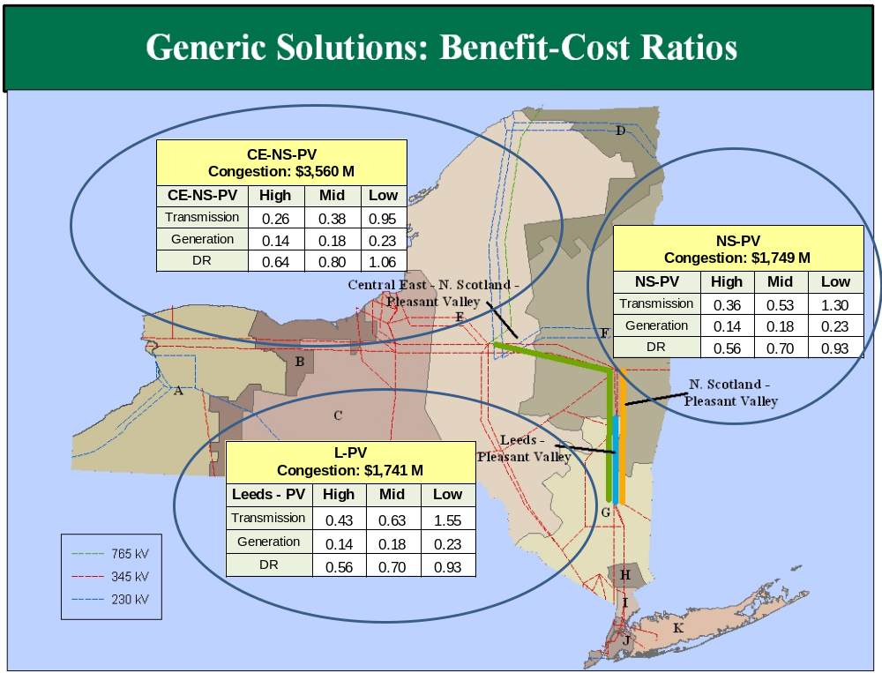
Figure 1: Generic Solutions Benefit/Cost Ratios
2. Summary of Study Process and Results
A. The Three Congestion Studies
Consistent with the CARIS procedures, the NYISO ranked and grouped transmission elements with the largest production cost savings when congestion on that constraint was relieved. The top three groupings selected for the three 2011 CARIS studies are shown in Figure 2 along with the present value of projected congestion. Specifically, the three studies are: Central East - New Scotland - Pleasant Valley (Study 1), New Scotland - Pleasant Valley (Study 2), and Leeds-Pleasant Valley (Study 3) and the annual congestion is shown in Figure 3.
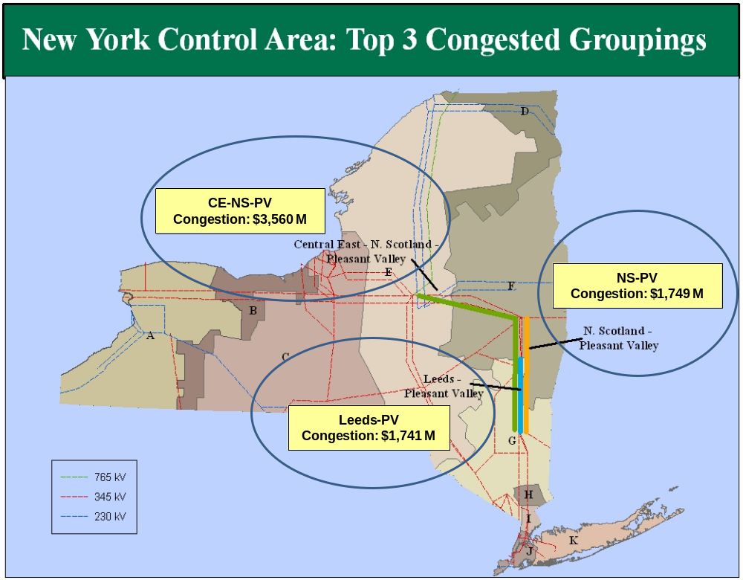
Figure 2: Congestion on the Top Three CARIS Studies (Present Value in 2011 $M)

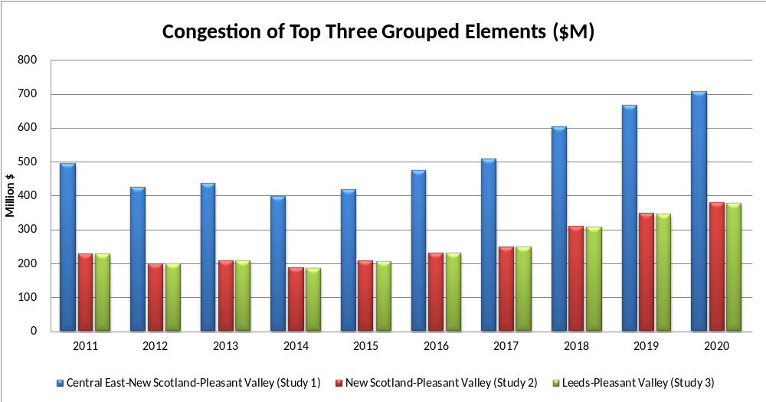
Figure 3: Projected Congestion on the Top Three CARIS Groupings (Nominal $M)

In each of the three studies, the NYISO calculated the present value of projected congestion savings over ten years by independently applying generic transmission, generation, and DR resources. Each generic transmission line solution consists of building a new 345 kV transmission line of approximately 1,000 MVA connecting the buses upstream and downstream of the congested element. The study groups are nested with a southern terminus at Pleasant Valley, therefore the generic generation solution for each study consists of building a new 1000 MW combined cycle plant, connected downstream of the congested elements. Each DR generic solution consists of installing 200 MW of energy efficiency and 200 MW of demand response modeled at 100 peak hours. In study 1, the DR is located in zones F & G and in studies 2 and 3 the DR is located in zones G & I, which are largely located downstream of the congested elements. Although demand response at peak hours provides less reduction in energy consumption than an equal amount of energy efficiency, equal amounts of energy efficiency and demand response were modeled in the 2009 CARIS and this approach was used once again in the 2011 CARIS.

Costs for each type of generic solution were developed through the stakeholder process but no determination was made as to the feasibility of any generic solution. Recognizing that the costs, points of interconnection, timing, and characteristics of actual projects may vary significantly, a range of costs (low, mid and high) was developed for each type of resource.
For purposes of a relative order of magnitude comparison, nominal electric production costs of New York generators over the ten-year study period range between $3.5 billion and $5.8 billion annually. The present value of the estimated carrying costs for each of the generic solutions was compared to the present value of production cost savings for a ten-year period, yielding a benefit/cost ratio for each generic solution.
The benefit/cost ratios displayed in Figure 1 are based on the cumulative present value in 2011 dollars of the NYCA-wide production cost saving over the ten year period (2011 -2020) as shown in Figure 4.

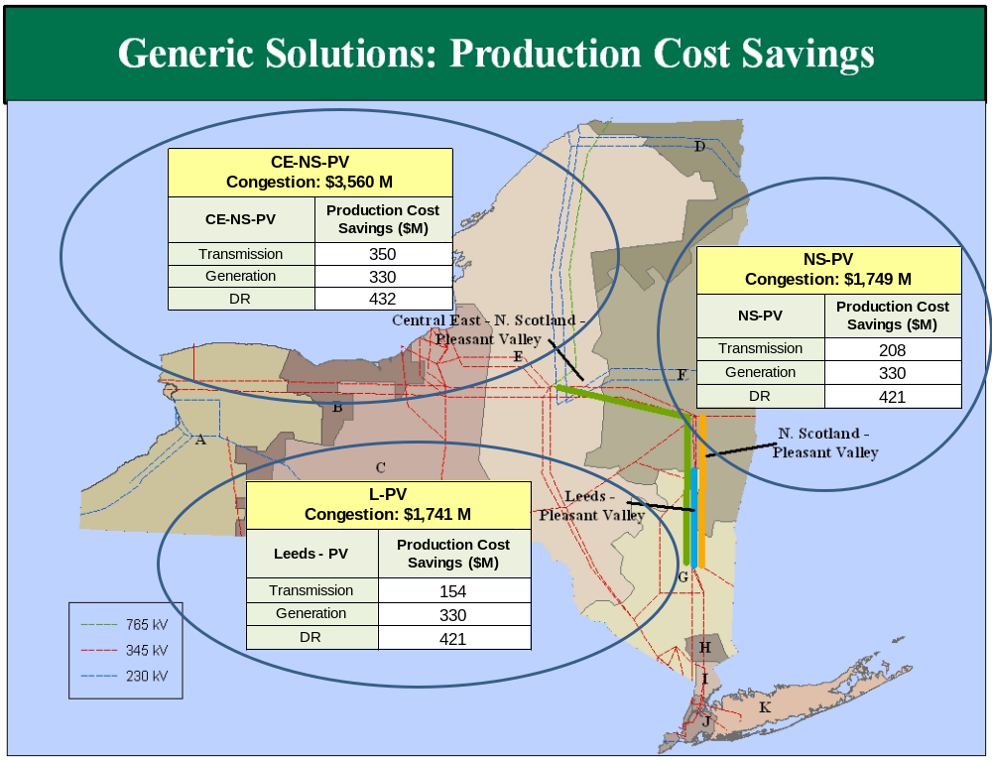Figure 4: NYCA-wide Production Cost Savings (Present Value in 2011 $M)

B. Additional Metrics
In addition to the NYCA-wide production cost savings for each generic solution, the NYISO also has provided, for informational purposes, additional metrics results for each of the three studies and each of the generic solutions in terms of changes in: (a) emission quantities and costs, (b) NYCA generator payments, (c) LBMP load payments, (d) installed capacity (ICAP) costs, (e) loss payments for losses on the transmission system, and (f) congestion rents or transmission congestion contracts (TCCs) values. All but the ICAP metric are results of the production cost simulation program and show either increases or decreases depending primarily on which generic solution is modeled. The ICAP metrics are computed using the latest available information from the installed reserve margin (IRM), locational capacity requirement (LCR), and ICAP Demand Curves and consistently show reduced ICAP costs for each study and for each generic solution.
Figures 5 through 7 below present in graphical form the changes in the additional metric quantities (NYCA generator payments, NYCA load payments, system-wide congestion rents, NYCA losses costs, and NYCA ICAP costs) for each of the three study cases in the ten year (2011-2020) present value amounts in 2011 $M.
The ICAP cost metrics are indicative measures of the additional potential benefits resulting from the implementation of a CARIS solution. For Variant 1, the ISO measured the cost impact of a solution by multiplying the forecast cost per megawatt-year of Installed Capacity (without the solution in place) by the sum of the megawatt impact. For Variant 2, the cost impact of a solution is calculated by forecasting the difference in cost per megawatt-year of Installed Capacity with and without the solution in place and multiplying that difference by fifty percent (50%) of the assumed amount of NYCA Installed Capacity available.
Negative numbers (shown in red and brackets) represent reductions in those metric quantities. Except for congestion costs which are system-wide, these quantities are NYCA-wide, and generator payments do not include changes in external production costs associated with changes in imports.

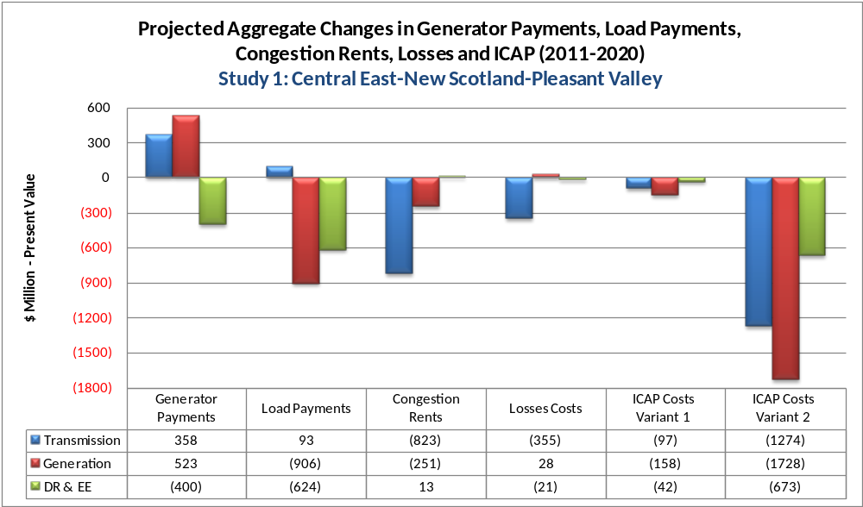
Figure 5: Additional Metrics for Study 1

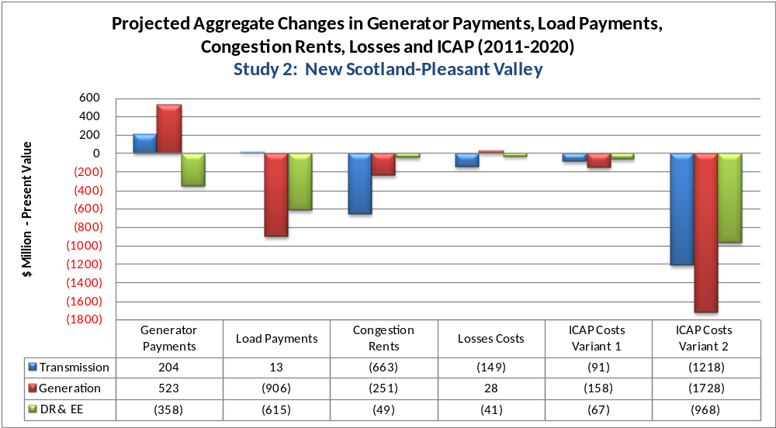
Figure 6: Additional Metrics for Study 2

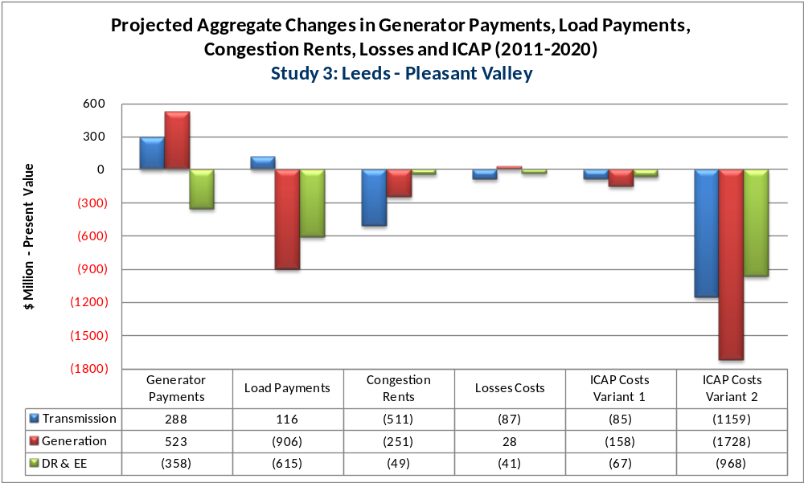
Figure 7: Additional Metrics for Study 3

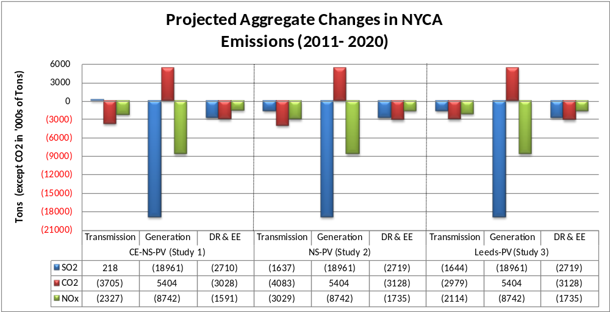
Figure 8: Projected Emissions Changes for Three Studies
C. Scenario Analysis
The NYISO conducted scenario analyses to evaluate the congestion impact of changing variables in the base case assumptions. Scenario analysis provides useful insight on the sensitivity of projected congestion values to differing assumptions included in the base case. Variations in some inputs may provide results that are consistent across NYCA, while other inputs may yield changes that are more localized. The scenarios were selected by the NYISO in collaboration with its stakeholders. They modify the base case to address potential regulatory changes in environmental emission requirements, full achievement of the State Renewable Portfolio Standard and the State Energy Efficiency Portfolio Standard, variations from the forecasted energy consumption and fuel prices, and the continued utilization of the Athens SPS for the ten-year study period. For these scenarios, the NYISO reports the changes to demand dollar congestion for the fifth (2015) and tenth (2020) years.
Table 1 lists major assumptions used for each scenario; and Table 2 shows the impact on congestion for each scenario for the combined years 2015 and 2020. Negative values represent a reduction in congestion impact measured by Demand dollar Congestion, where Demand dollar congestion is a measure of the congestion component in the LBMP and its impact on NYCA loads, as further defined in Section 3.2 of the report.
Table 1: Major Scenario Assumptions
Scenario | Variables
EPA Projected NOx and SO₂ Costs | Increases in SO₂ and Ozone Season NOx costs; decreases in annual NOx cost as projected by EPA
Higher Load Forecast | 6% increase
Lower Load Forecast | 9% decrease
Full RPS and Full EEPS Goals Achievement | Add renewables from Interconnection Queue to achieve 9870 GWh goal and reduce 2015 load to 32147 MW
Athens SPS Continued In Service | 2011-2020
Higher Natural Gas Prices | One standard deviation
Lower Natural Gas Prices | One standard deviation
Lower CO₂ Emission Costs | Flat $5/ton

Table 2: Scenarios Impact on Congestion: 2015 + 2020 ($M nominal)

CONSTRAINTS
EPA
Projected
NOx and
SO2 Costs
Higher
Load
Forecast
Lower
Load
Forecast
Full RPS
and Full
EEPS
Goals
Achieveme
nt
Athens
SPS
Continued
in Service
Higher
Natural
Gas Prices
Lower
Natural
Gas Prices
Lower
Carbon
Emission
Costs
LEEDS-PLSNTVLY
12
103
(175)
38
(199)
58
(72)
(81)
CENTRAL EAST
(22)
(5)
155
839
59
120
(223)
(59)
DUNWOODIE_SHORE RD_345
45
8
(4)
8
8
14
(25)
4
GREENWOOD LINES
0
8
(10)
(3)
1
2
(1)
1
WEST CENTRAL-OP
4
(0)
(0)
(4)
2
4
(2)
(9)
GOTHLS A - GOWANUSS
2
5
(5)
(2)
(2)
0
(2)
(0)
LEEDS3_NEW SCOTLAND_345
2
(2)
1
1
3
0
(0)
(4)
RAINY8W138_VERNW_138
1
0
0
0
1
2
(3)
2
ASTORIAW138_HG5_138
1
0
(0)
0
(1)
(0)
0
(1)
Study 1: Central East-New Scotland-Pleasant Valley
(8)
96
(19)
877
(136)
178
(296)
(144)
Study 2: New Scotland-Pleasant Valley
14
101
(174)
39
(196)
58
(73)
(85)
Study 3:Leeds-Pleasant Valley
12
103
(175)
38
(199)
58
(72)
(81)
2015 + 2020 Scenarios: Change in Demand$ Congestion (Nominal $M)

Table 2 above shows the congestion impact from the scenarios for each of the most congested constraints. It also shows the change in congestion resulting from each scenario for each of the three study groups

3. Other Findings and Observations
- Potential Impacts - This report provides an economic analysis of projected congestion on the New York State bulk power transmission system and the potential costs and benefits of relieving that congestion. The study provides information to interested parties to consider developing transmission, generation or DR projects, as appropriate, to relieve congestion, and to propose transmission projects for economic evaluation and potential recovery of costs through the NYISO’s Tariff. There are other potential benefits to relieving transmission congestion, such as reduced load payments, increased generator payments, reduced losses, ICAP savings, and reduced emissions that may be of interest to parties in making their investment decisions. For CARIS 1, the load payment metric change does not reflect the impact of TCC credit.
- Demand$Congestion – As with the 2009 CARIS Report, the level of congestion projected in this 2011 CARIS Phase l Report varies from historic levels. Several enhancements were implemented for this 2011 CARIS as compared to the 2009 CARIS model, which reduced the disparity between historic and projected congestion. The disparity continues to occur in large part due to certain assumptions, operational parameters and market participant behavior that cannot be fully captured by the production cost simulation model. These disparities include market bidding behavior by both generators and load, virtual transactions that occur in the NYISO Day-Ahead Market, transmission outages, actual commodity price variations and hourly load variations.
- Actual congestion realized in the future years will differ from the projected values because actual system operating conditions, economic conditions, and market behavior will be different from what has been assumed in the study. The purpose of the production simulation model, however, is to help assess the effectiveness of congestion mitigation solutions.

The CARIS base case model projects the demand$congestion values in New York at $709 million in 2011 and $1098 million in 2020. Comparatively, historic demand$congestion values from 2006 to 2010 ranged from a low of $977 million in 2009 to a high of $2,613 million in 2008.
- Changes Since Last CARIS - These include assumption changes, modeling changes, and changes to the methodology to evaluate the primary benefit metric. Examples of base case assumption changes which tend to decrease congestion include lower load forecasts caused by the economic recession, lower natural gas prices, and new generating units and transmission. Major modeling changes for the 2011 study, some of which could increase congestion, include lower Central East interface limits to represent how the limit is impacted by nearby generation, refinement to the representation of the Ramapo PARS to better model how they are used in system operations, utilization of flat hurdle rates to reflect inter-regional energy market transaction costs, and implementation of a weekly fuel forecast to better track seasonal changes.
- Resource Updates - The ten year assessment of future congestion and the potential benefits of relieving some of this congestion is based upon the new and existing NYCA resources that have been included in the base case for the 2010 Comprehensive Reliability Plan (CRP), with one exception. Since the publication of the 2010 CRP, the Hudson Transmission Partners started (in mid 2011) the construction of the transmission intertie between Bergen, NJ and W. 49 Street (“HTP transmission line”). This satisfied NYISO’s base case inclusion criterion. Any additional system resources coming into service, or any changes to the existing resources, during the ten year study period will produce different results when modeled in the base case or coupled with the generic solutions than those presented in this report.
- Scenario Analyses - Scenario analyses were used to provide projected congestion information associated with variations in load, fuel price, available resources, and other assumptions. The scenario analysis shows the impact on congestion for individual constraints as well as the three study groupings.
- Specific Solutions Will Produce Different Results - Projects with characteristics other than the generic projects studied here could also relieve congestion. The generic solutions are representative and for informational purposes only.
- Diversity of NYCA Impacts - This study reports the benefits of relieving congestion both statewide and by zone across New York. All zones do not benefit equally when implementing the generic solutions. For example, load payments decreased in some zones and increased in others.
- Benefit Lifespan - The useful life of actual projects may be longer than the ten-year study period evaluated in this report pursuant to the NYISO tariff. Benefits and costs in later years can be considered in CARIS Phase 2.
- Congestion Pattern Changes - There have been changes in congestion patterns across the New York bulk transmission system over the past several years. As discussed in the 2010 State of the Markets Report by Potomac Economics and the 2009 CARIS Report, lower natural gas prices and new transmission and generation in southeast New York have reduced the projected congestion. Due to the economic downturn and other factors since 2009, lower natural gas prices, lower load forecasts, new transmission, and new generation in southeast New York have been incorporated into the 2011 CARIS model. These changes in assumptions tend to reduce congestion in New York. Other factors, such as increased imports, particularly from Canada, and changes in the projected emission costs associated with new environmental regulations, will tend to increase congestion in upstate New York. The 2011 CARIS results illustrate the combined impact of all these modeling changes.

4. Next Steps
Additional Study Requests
Going forward, any interested party can request, at its own expense, an additional study to assess a specific project and its impact on congestion on the New York bulk power system. The NYISO will conduct the requested studies in the order in which they were accepted and as the NYISO’s resource commitments allow.

Specific Project Analysis
Phase 2 of the CARIS process is expected to begin in March 2012, subject to the approval of this 2011 CARIS Phase 1 report by the NYISO Board of Directors. In Phase 2, developers are encouraged to propose projects to alleviate the identified congestion. The NYISO will evaluate proposed specific economic transmission projects upon a developer’s request to determine the extent such projects alleviate congestion, and whether the projected economic benefits would make the project eligible for cost recovery under the NYISO’s Tariff. While the eligibility criterion is production cost savings, zonal LBMP load savings (net of TCC revenues and bilateral contracts) is the metric used in Phase 2 for the identification of beneficiary savings and the determinant used for cost allocation to beneficiaries for a transmission project. For a transmission project to qualify for cost recovery through the NYISO’s Tariff, the project has to have: (a) a capital cost of at least $25 million, (b) benefits that outweigh costs over the first ten years of operation, and (c) received approval to proceed from 80% or more of the actual votes cast by beneficiaries on a weighted basis. Subsequent to meeting these conditions, the developer will be able to obtain cost recovery of their transmission project through the NYISO’s Tariff, subject to the developer’s filing with the Federal Energy Regulatory Commission (FERC) for approval of the project costs and rate treatment.

Introduction
Pursuant to Attachment Y of its Open Access Transmission Tariff (OATT, or the Tariff), the NYISO performed the first phase of the 2011 Congestion Assessment and Resource Integration Study (CARIS). The study assesses both historic and projected congestion on the New York bulk power system and estimates the economic benefits of relieving congestion. Together with the Local Transmission Planning Process (LTPP) and the Comprehensive Reliability Planning Process (CRPP), the CARIS is the final process in the NYISO’s biennial Comprehensive System Planning Process (CSPP) (see Figure 1-1). The 2011 CARIS completes the CSPP process that began with LTPP inputs for the 2010 Reliability Needs Assessment.
CARIS consists of two phases: Phase 1, the Study Phase, and Phase 2, the Project Phase. Phase 1 is initiated after the NYISO Board of Directors (Board) approves the Comprehensive Reliability Plan (CRP). In Phase 1, the NYISO, in collaboration with its stakeholders and other interested parties, develops a ten-year projection of congestion and together with historic congestion identifies, ranks and groups the most congested elements on the New York bulk power system. For the top three congested elements or groupings, studies are performed which include: (a) the development of three types of generic solutions to mitigate the identified congestion; (b) a benefit/cost assessment of each solution based on projected NYCA-wide production cost savings and estimated project costs; and (c) presentation of additional metrics for informational purposes. The three types of generic solutions are transmission, generation and demand response. Scenario analyses are also performed to help identify factors that increase, decrease or produce congestion in the CARIS base case.
This final report presents the 2011 CARIS Phase 1 study results and provides objective information on the nature of congestion in the New York Control Area (NYCA). Developers can use this information to decide whether to proceed with transmission, generation, or demand response projects. Developers of such projects may choose to pursue them on a merchant basis, or to enter into bi-lateral contracts with LSEs or other parties. This report does not make recommendations for specific projects, and does not advocate any specific type of resource addition or other actions.
Developers may propose economic transmission projects for regulated cost recovery under the NYISO’s Tariff and proceed through the Project Phase, CARIS Phase 2, which will be conducted by the NYISO upon request and payment by a developer. Developers of all other projects can request that the NYISO conduct an additional CARIS analysis at the developer’s cost to be used for the developer’s purposes. For a transmission project, the NYISO will determine whether it qualifies for regulated cost recovery under the Tariff. UnderCARIS, to qualify be eligible for regulated cost recovery, an economic transmission project must have production cost savings greater throject cost (expressed as having a benefit to cost ratio (B/C) greater than1.0), a cost of at least $25 million, and be approved by at least 80% of the weighted vote cast by New York’s Load Serving Entities (LSEs) that serve loads in zones that the NYISO identifies as beneficiaries of the transmission project. The beneficiaries are those load zones that experience net benefits measured over the first ten years from the proposed project commercial operation date. After the necessary approvals, regulated economic transmission projects are eligible to receive cost recovery from these beneficiaries through the NYISO Tariff provisions once they are placed in service.

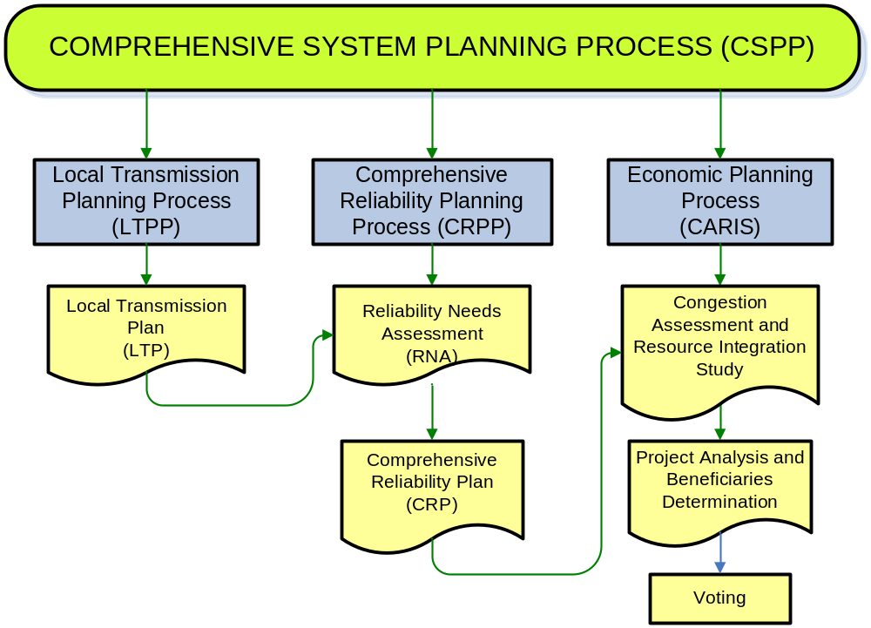

Figure 1-1: NYISO Comprehensive System Planning Process

This 2011 CARIS Phase 1 study includes intended enhancements to the 2009 CARIS Phase 1 study in its assumptions, modeling, and methodology for evaluating benefits which were discussed with ESPWG. Some of these changes reflect actual system changes while others are modeling changes that caused a difference in the study results all else being equal. Examples of base case assumption changes which tend to decrease congestion include lower load forecasts caused by the economic recession, lower natural gas prices, and new generating units and transmission. Notable modeling changes for the 2011 study, some of which might increase congestion, include lower Central East interface limits to represent how the limit is impacted by nearby generation, and refinement to the representation of the operation of the Ramapo PARS to better model how they are used in system operations. Other changes include the utilization of flat hurdle rates to reflect inter-regional energy market transaction costs which directly affected the import levels from each of the NYCA neighbors, and implementation of a weekly fuel forecast to better track the path of seasonal changes. It is also important to note the decision to utilize the MAPS Production Costing software for the 2011 CARIS instead of using the Gridview software for the 2009 CARIS study. The methodology for calculating NYCA-wide production costs was changed in the way that changes in NYCA imports/exports were valued.
The projected congestion in this report will be different than the actual congestion experienced in the future. CARIS simulations are based upon a limited set of long term assumptions for modeling of grid resources throughout the ten-year planning horizon. A range of cost estimates was used to calculate the cost of generic solution projects (transmission, generation, and DR). These costs are intended for illustrative purposes only and are not based on any feasibility analyses. Each of the generic solution costs are utilized in the development of benefit/cost ratios.
The NYISO Staff presented the Phase 1 Study results in a written draft report to the NYISO’s Electric System Planning Working Group (ESPWG) and the Transmission Planning Advisory Subcommittee (TPAS) for review. After that review, the draft report was presented to the NYISO’s Business Issues Committee (BIC) and the Management Committee (MC) for discussion and action before it was submitted to the Board for approval.

- Background

Congestion Assessment and Resource Integration Study (CARIS) Process
The objectives of the CARIS economic planning process are to:
a. Project congestion on the New York State bulk power transmission facilities over the ten-year CSPP planning horizon;
b. Identify, through the development of appropriate scenarios, factors that might affect congestion;
c. Provide information to market participants, stakeholders and other interested parties on solutions to reduce congestion;
d. Provide an opportunity for developers to propose solutions that may reduce the congestion; and
e. Provide a process for the evaluation and approval of regulated economic transmission projects for regulated cost recovery under the NYISO Tariff.

These objectives are achieved through the two phases of the CARIS process which are graphically depicted in Figure 2-1 below.
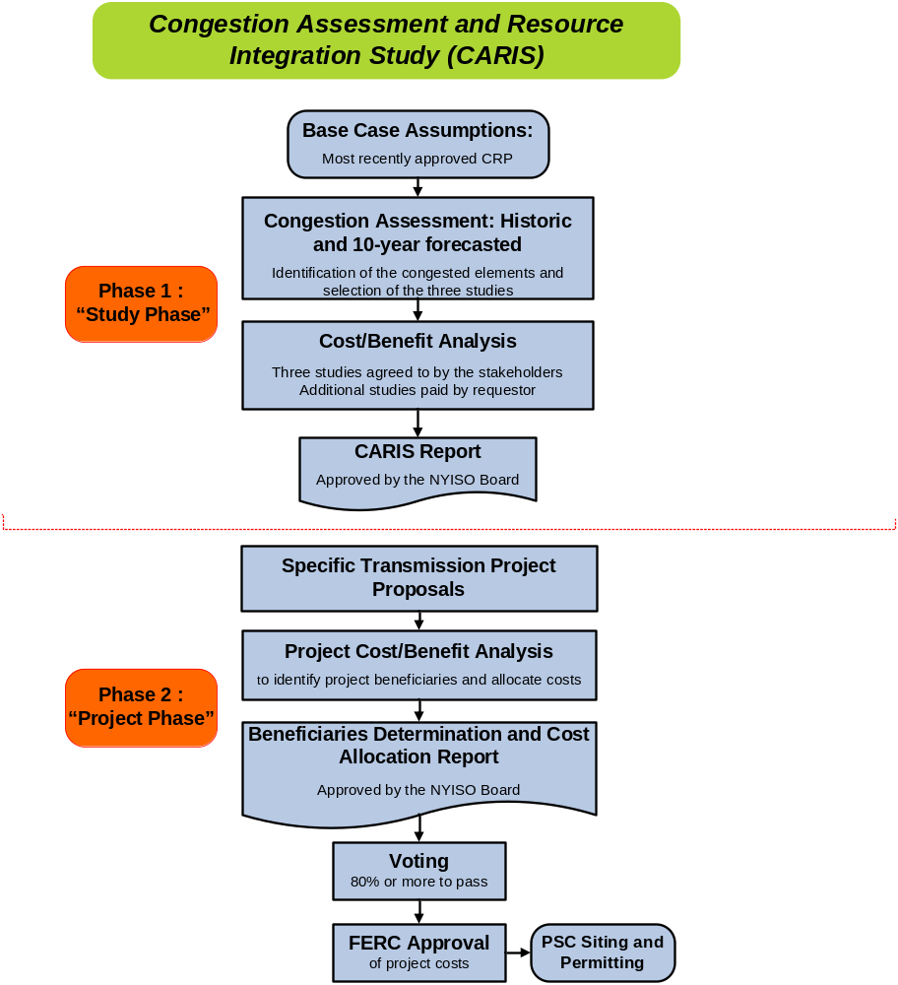
Figure 2-2: Overall CARIS Diagram

Phase 1 - Study Phase
In Phase 1 of the CARIS process, the NYISO, in collaboration with market participants, identifies the most congested elements in the New York bulk power system and conducts three transmission congestion studies based on those elements. In identifying the most congested elements, the NYISO performs both a five-year historic and a ten-year forward-looking congestion assessment to identify the seven most congested elements and, through a relaxation process, develops potential groupings and rankings based on the highest projected production cost savings resulting from the relaxation. The top three ranked elements or groupings become the subjects of the three CARIS studies. For each of these three studies the NYISO conducts a benefit/cost analysis of generic solutions. All resource types - generation, transmission and DR - are considered on a comparable basis as generic solutions to congestion. The solutions analyzed are not specific projects, but rather represent generic transmission, DR and generation resources placed individually in the congested locations on the system to calculate their effects on relieving each of the three most congested elements and the resulting economic benefits.
The principal metric for measuring the economic benefits of each generic solution is the NYCA-wide production cost savings that would result from each generic solution, expressed as the present value over the ten-year planning horizon. The CARIS report also presents data on additional metrics, including estimates of reductions in losses, changes in Locational Based Marginal Pricing (LBMP) load payments, generator payments, changes in installed capacity costs, changes in emissions costs and changes in payments for Transmission Congestion Contracts (TCCs). The TCC payment metric in Phase 1 is simplified to include congestion rent calculations only, and is different from the TCC revenue metric contained in Phase 2. The Installed Capacity (ICAP) metric calculation was changed after the 2009 CARIS Phase 1. CARIS metrics are described in more detail in Section 3.
The NYISO also conducts scenario analyses to assess the congestion impact of various changes to base case assumptions. Scenario results are presented as the change in dollar demand congestion on the three study elements or groupings, as well as other constraints throughout NYCA.

Phase 2 – Project Phase
The Phase 2 model will be developed from the CARIS 1 database using an assumption matrix developed after discussion with ESPWG and will reflect all necessary system modeling changes required for a 10 year extension of the model. Updating and extending the CARIS database for Phase 2 of the CARIS is conducted after the approval of the CARIS Phase 1 report by the NYISO Board.
Potential economic transmission projects that have an estimated capital cost in excess of $25 million may seek regulated cost recovery through the NYISO Tariff. Such developers must submit their projects to the NYISO for a benefit/cost analysis in accordance with the Tariff. The costs for the benefit/cost analysis will be supplied by the developer of the project as required by the Tariff. Projects may be eligible for regulated cost recovery only if the present value of the NYCA wide production cost savings exceeds the present value of the costs over the first ten years of the project life. In addition, the present value over the first ten years of LBMP load savings, net of TCC revenues and bilateral contract quantities, must be greater than the present value of the projected project cost revenue requirements for the first ten years of the amortization period.
Beneficiaries will be LSEs in load zones determined to benefit economically from the project, and cost allocation among load zones will be based upon their relative economic benefit. The beneficiary determination for cost allocation purposes will be based upon each zone’s net LBMP load savings. The net LBMP load savings are determined by adjusting the LBMP load savings to account for TCC revenues and bilateral contract quantities; all LSEs in the zones with positive net LBMP load savings are considered to be beneficiaries. The net LBMP load savings produced by a project over the first ten years of commercial operation will be measured and compared on a net present value basis with the project’s revenue requirements over the same first ten years of a project’s life measured from its expected in-service date. LSE costs within a zone will be allocated according to the ratio of its load to all load in the zone - both expressed in MWh.
In addition to the NYCA-wide production cost savings metric and the net LBMP load savings metric, the NYISO will also provide additional metrics, for information purposes only, to estimate the potential benefits of the proposed project and to allow LSEs to consider other metrics when evaluating or comparing potential projects. These additional metrics will include estimates of reductions in losses, changes in LBMP load payments, changes in generator payments, changes in Installed Capacity (ICAP) costs, changes in emissions costs, and changes in TCC revenues. The TCC revenue metric that will be used in Phase 2 of the CARIS process is different from the TCC payment metric used in Phase 1. In Phase 2, the TCC revenue metric will measure reductions in estimated TCC auction revenues and allocation of congestion rents to the TOs (for more detail on this metric see Section 3.2.2 of this report and the CSPP Manual ).
The NYISO will also analyze and present additional information by conducting scenario analyses, at the request of the developer after discussions with ESPWG, regarding future uncertainties such as possible changes in load forecasts, fuel prices and environmental regulations, as well as other qualitative impacts such as improved system operations, other environmental impacts, and integration of renewable or other resources. Although this data may assist and influence how a benefiting LSE votes on a project, it will not be used for purposes of cost allocation.
The NYISO will provide its benefit/cost analysis and beneficiary determination for particular projects to the ESPWG for comment. Following that review, the NYISO benefit/cost analysis and beneficiary determination will be forwarded to the BIC and MC for discussion and action. Thereafter the benefit/cost analysis and beneficiary determination will be forwarded to the NYISO Board of Directors for review and approval.
After the project benefit/cost and beneficiary determinations are approved by the NYISO Board and posted on the NYISO’s website, the project will be brought to a special meeting of the beneficiary LSEs for an approval vote, utilizing the approved voting procedure (see Section 1.2.5 of the Initial CARIS Manual, Appendix F). The specific provisions for cost allocation are set forth in the Tariff. In order for a project to be approved for regulated cost recovery, the Tariff states that “eighty (80) percent or more of the actual votes cast on a weighted basis must be cast in favor of implementing the project.” If the project meets the required vote in favor of implementing the project, and the project is implemented, all beneficiaries, including those voting “no,” will pay their proportional share of the cost of the project through the NYISO Tariff. This process will not relieve the developer of the responsibility to file with FERC for approval of the project costs which were presented by the developer to the voting beneficiaries and with the appropriate state authorities to obtain siting and permitting approval for the project.

CARIS Methodology and Metrics

CARIS Methodology
For the purposes of conducting the ten-year forward looking CARIS analysis, the NYISO, in conjunction with ESPWG, developed a production costing model database and utilized GE’s Multi-Area Production Simulation (MAPS) software. The details and assumptions in developing this database are summarized in Appendix C.
The Portfolio Ownership and Bid Evaluation (PROBE) production cost simulation tool, developed by PowerGEM LCC, has been used for the last seven years to perform the NYISO historic congestion analysis. PROBE utilizes the actual NYISO Day-Ahead Market (DAM) data to emulate the actual security constrained unit commitment (SCUC) operation. CARIS utilizes the most recent five years of historic data. Unlike MAPS simulation, PROBE simulates virtual bidding and transmission outages and calculates production costs based on generation mitigated bids. While those additional attributes are important in capturing the real congestion costs for the past events, it is nearly impossible to model them with certainty in projecting future transmission congestion. Therefore, these attributes are not accounted for in the ten-year forward looking CARIS analysis. Actual future congestion will vary from projections depending on a number of factors. For more detail see Appendix D.

CARIS Metrics
The principal benefit metric for CARIS analysis is the NYCA-wide production cost savings that would result from each of the generic solutions. Additional benefit metrics were analyzed as well, and the results are presented in this report and accompanying appendices for informational purposes only. All benefit metrics were determined by measuring the difference between the projected CARIS base case value and a projected solution case value when each generic solution was added. The discount rate of 7.36% used for the present value analysis was the current weighted average cost of capital for the NYTOs, weighted by their annual GWh send-out in 2010.
One of the key metrics in the CARIS analysis is termed Demand Dollar congestion (expressed as Demand$ congestion in PROBE). Demand$ congestion represents the congestion component of load payments. For a load zone, the Demand$ congestion of a constraint is the product of the constraint shadow price, the load zone shift factor (SF) on that constraint, and the zonal load.
For NYCA, the Demand$ congestion is the sum of all of the zonal Demand$ congestion.
These definitions are consistent with what has been used for the reporting of historic congestion for the past seven years. Demand$ congestion is used to identify and rank the significant transmission constraints as candidates for grouping and the evaluation of potential generic solutions. It does not equate to payments by load.

Principal Benefit Metric
The principal benefit metric for the CARIS analysis is the present value of the NYCA-wide production cost savings that are projected to result from implementation of each of the generic congestion mitigation solutions. The NYCA-wide production cost savings are calculated as those savings associated with generation resources in the NYCA and the costs of incremental imports/exports priced at external proxy generator buses of the solution case. This was adopted given the acknowledged need to improve the 2009 CARIS methodology where the NYCA-wide production cost savings were calculated as those savings associated with generation resources in the NYCA and the change in the total net interports ed at thective external proxy generator buses with and without the solution.
Specifically, the NYCA-wide production cost savings are calculated using the following formula:
NYCA-wide Production Cost Savings = NYCA Generator Production Cost Savings -
∑ ∑[(Import/Export Flow)_{Solution} – (Import/Export Flow)_{Base}] x ProxyLMP_{Solution}
Where ProxyLMP_{Solution} is the LMP at one of the external proxy buses;
(Import/Export Flow)_{Solution} – (Import/Export Flow)_{Base} represents incremental imports/exports with respect to one of the external systems;
and the summations are made for each external area and all simulated hours.

Additional Benefit Metrics
The additional benefits, which are provided for information purposes only, include estimates of reduction in loss payments, LBMP load costs, generator payments, ICAP costs, emission costs, and TCC payments. All the quantities, except ICAP, will be the result of the forward looking production cost simulation for the ten-year planning period. The NYISO, in collaboration with the ESPWG, determined the additional informational metrics to be defined for this CARIS cycle given existing resources and available data. The collaborative process determined the methodology and models needed to develop and implement these additional metrics requirements, which are described below and detailed in the Initial CARIS Manual. An example illustrating the relationship among some of these metrics is provided in Appendix E.
Reduction in Losses – This metric calculates the change in marginal losses payments. Losses payments are based upon the loss component of the zonal LBMP load payments.
LBMP Load Costs – This metric measures the change in total load payments. Total load payments include the LBMP payments (energy, congestion and losses) paid by electricity demand (load, exports, and wheeling). Exports will be consistent with the input assumptions for each neighboring control area.
Generator Payments – This metric measures the change in generation payments by measuring only the LBMP payments (energy, congestion, losses).). Thus, generator payments are calculated for this information metric as the sum of the LBMP payments to generators and imports. Imports will be consistent with the input assumptions for each neighboring control area.
ICAP Costs –The latest available information from the installed reserve margin (IRM), locational capacity requirement (LCR), and ICAP Demand Curves are used for the calculation. The NYISO first calculates the NYCA MW impact of the generic solution on LOLE. The NYISO then forecasts the installed capacity cost per megawatt-year point on the ICAP demand curves in Rest of State and in each locality for each planning year. There are two variants for calculating this metric, both based on the MW impact. For more detail on this metric see the Section 31.3.1.3.5.6 of the Tariff.
Emission Costs – This metric measures the change in the total cost of emission allowances for CO₂, NO_{X}, and SO₂, emissions on a zonal basis. Total emission costs are reported separately from the production costs. Emission costs are the product of forecasted total emissions and forecasted allowance prices.
TCC Payments – The TCC payment metric is calculated differently for Phase 1 and for Phase 2 of the CARIS process, as described in the NYISO Tariff. In CARIS phase 1,cycle the TCCent metric is simplified to be the calculate chants.

Baseline System Assumptions
The implementation of the CARIS process requires the gathering, assembling, and coordination of a significant amount of data, in addition to that already developed for the reliability planning processes. The 2011 CARIS study process is conducted by updating the base case input assumptions provided in the 2010 CRP and aligns with the ten-year reliability planning horizon for the 2010 CRP.

Notable System Assumptions & Modeling Changes
The base case has been updated as of July 1, 2011 for this CARIS Phase 1 using the assumptions provided below. These assumptions were discussed with the stakeholders at several meetings of the ESPWG. Appendix C includes a detailed description of the assumptions utilized in the CARIS analysis. The key assumptions are presented below:
1. Power flow models – the 2010 CRP power flow base cases were updated for use in the 2011 CARIS study.
2. The load and capacity forecast was updated using the 2011 Gold Book baseline forecast for energy and peak demand by zone for the ten year study period.
3. The transmission and constraint model utilizes a bulk power system representation for most of the Eastern Interconnection as described below. The model uses both the 2010 RNA/CRP transfer limits and actual operating limits.
4. The production cost model performs a security constrained economic dispatch of generation resources to serve the load. The production cost curves, unit heat rates, fuel forecasts and emission costs forecast were developed by the NYISO from multiple data sets including public domain information, proprietary forecasts and confidential market information. The model includes scheduled generation maintenance periods based on a combination of each unit’s planned and forced outage rates. Because of the uncertainty associated with the Cross-State Air Pollution Rule (CSAPR) ruling, this study did not update the emission assumptions in place as of July 1, 2011.

Major Modeling Inputs
Input Parameter | Change from the 2009 CARIS
Load Forecast | Lower by ___ %
Fuel Price Forecast | Lower by ___ %
Carbon Price Forecast | Higher by __ % to __ %
NOx Price Forecast | ( Fill in as above )
SOx Price Forecast | (Fill in as above)
Modeling Changes
Description | Change from the 2009 CARIS
Central East Interface Limit | The starting limit was 200MW less than what was used in 2009 limit to be more representative of the Central East operating limit that take into account the operation of nearby generation
Ramapo PARs | Changed from being automatically optimized during model simulation in 2009 to more closely representing the actual Day Ahead market operations of Ramapo PARs
Con Ed – PSEG Wheel | In 2009, both the A/B/, an J and terfaces were set at 600 MW min, 1200 MW max with imbalance monitored. Now changed to set both A/, B/, C, a J/ d Kto deliv00 MW with a bandwidth of +/- 100 MW, to more closely represent latest agreement conforming the ConEd/ PSEG wheel protocol
 | The use of a more refined fuel price forecast (monthly to weekly)
 | Flat dispatch hurdle rates to better reflect inter-regional energy market transaction costs over the 10 years, and
 | The use of more representative combined cycle and gas turbine models

In addition to the modeling changes listed above that can have significant impacts on the congestion projections, there are known NYCA events that have impacts on the simulation outcome, as summarized in Table 4-1.

Table 4-1: Timeline of NYCA Changes
2011
2012
2013
2014
2015 - 2020
M29 Cable Installed
Bayonne Generator
Installed (500 MW)
-
HTP Installed
Nine Mile Pt2
Uprate (53 MW)
No changes
Athens SPS Removed*
Nine Mile Pt2 Uprate
(115 MW)
- -
Munnsville Wind
Power Uprate (0.6
MW)
Steel Winds II Installed
(1.5 MW)
Ontario Uprate
(5.6 MW)
Astoria Energy II
Installed (576 MW)
Energy Systems North
East Retired (79.4
MW)**
Project Orange 1&2
Retired (40 MW)**
Greenidge 4 Protective LlayupRetired
(106.1 MW)
Westover 8 RetiredProtective Llayup
(81.2 MW)

* The CARIS base case assumes, for study purposes, that the Athens SPS (which remained in service throughout 2011 and is currently in service as of January 2012) is not in service throughout the 2011-2020 study period.
** Units retired in 2010

Load and Capacity Forecast
The load and capacity forecast used in the CARIS base case, provided in Table 4-2, was based on the 2011 Gold Book and accounts for the impact of programs such as the Energy Efficiency Portfolio Standard (EEPS).

Table 4-2: CARIS 1 Base Case Load and Resource Table

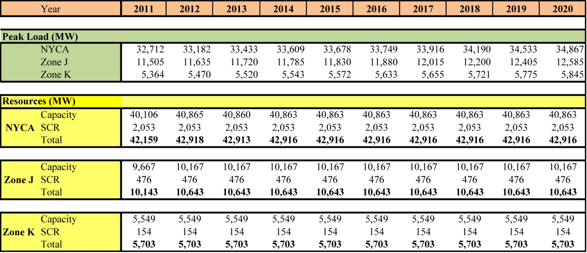
Source: 2011 Gold Book baseline load forecasts from Section I.

Transmission Model
The CARIS production cost analysis utilizes a bulk power system representation for the entire Eastern Interconnection, which is defined roughly as the bulk electric network in the United States and Canadian Provinces East of the Rocky Mountains, excluding WECC, FRCC, SPP, and Texas. Figure 4-1 below illustrates the NERC Regions and Balancing Authorities in the CARIS model. The CARIS model includes a full active representation for the NYCA, ISO-NE, IESO, and PJM.
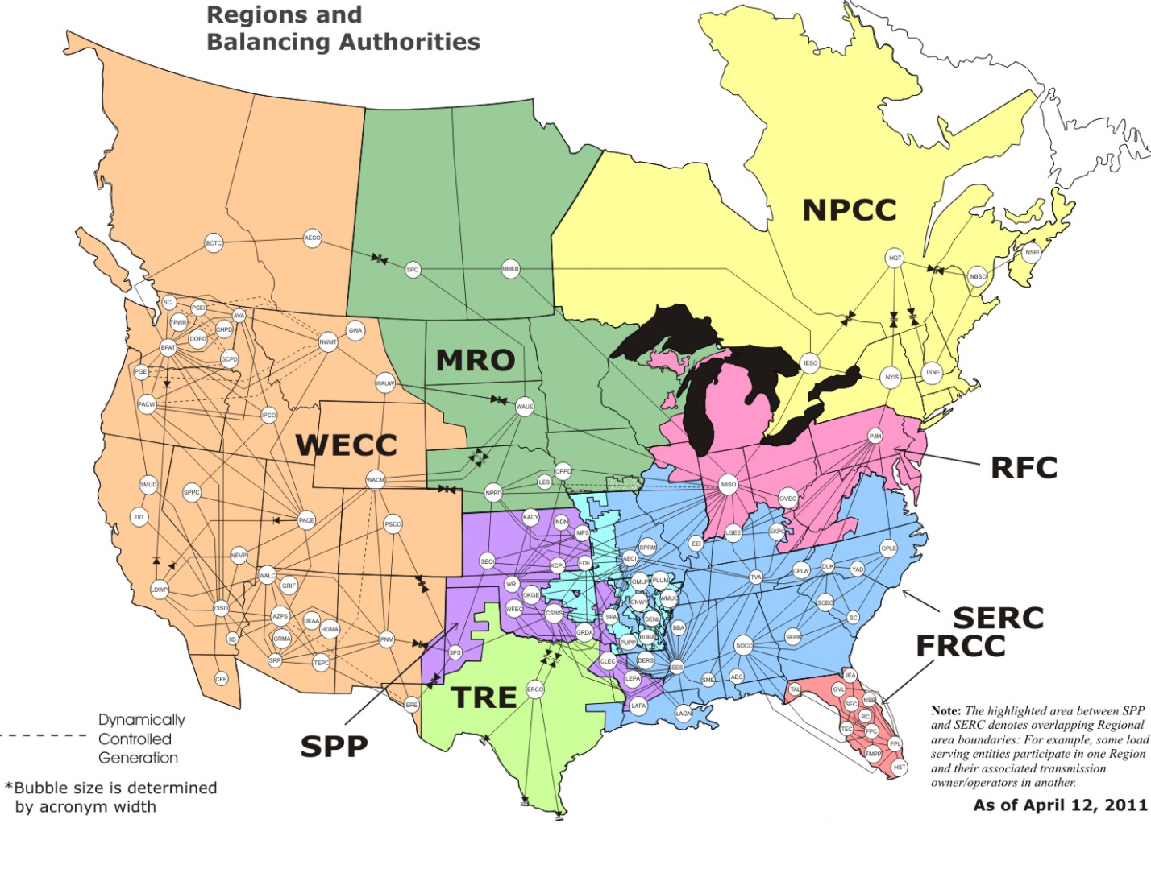
Full Active Representations

Figure 4-3: Areas Modeled in CARIS (Excluding WECC, FRCC, SPP, & TRE)
Source: NERC

New York Control Area Transfer Limits
Unlike the RNA and CRP, which utilize emergency limits, the CARIS utilizes the actual normal facility ratings for the calculation of thermal transfer limits. For voltage and stability based limits, the normal and emergency limits are assumed to be the same. For New York Control Area Interface Transfer limits, the limits are consistent with the SCUC operating limits and operating nomograms with some exceptions as indicated in Table 4-3 below.
Table 4-3: Transmission System Normal Voltage Transfer Limits for
Key Interfaces (in MW)
Interface | 2011 CARIS Study
WEST CENTRAL-Open | 2150
CENTRAL EAST | 2400
ConEd - Long Island | 2166
Dunwoodie (I) to NYCity (J) | 4350
Dunwoodie (I) to Long Island (k) | 1161
Sprainbrook/Dunwoodie South | 5365
Note: Central East was modeled with a unit sensitive nomogram reflective of the operating nomogram.

Normal thermal interface transfer limits for the CARIS study are not directly utilized from the thermal transfer analysis performed using the Power Technologies Inc. Managing and Utilizing System Transmission (MUST) software application. Instead, CARIS uses the most limiting monitored line and contingency sets identified from MUST analysis. The resulting monitored lines and contingency sets used in the CARIS do not include lines that have less than a 5% impact on the NYCA cross-state transmission interfaces, or the lines that only impact local 115-138 kV transmission or sub-transmission constraints.

Fuel Forecasts

CARIS Base Annual Forecast
The fuel price forecasts for CARIS are based on the U.S. Energy Information Administration’s (EIA) current national long-term forecast of delivered fuel prices, which is released each spring as part of the Annual Energy Outlook (AEO). The figures in this forecast are in real dollars (i.e., indexed relative to a base year). Forecasted time-series of the GDP deflator published by EIA, as part of the AEO, were used to inflate the real values to nominal values. This forecast is updated quarterly based on data published in EIA’s periodic Short-Term Energy Outlooks.

New York Fuel Forecast
In developing the New York fuel forecast, adjustments were made to the EIA fuel forecast to reflect bases for fuel prices in New York. Key sources of data for estimating the relative differences or ‘basis’ for fuel prices in New York are the Monthly Utility and non-Utility Fuel Receipts and Fuel Quality Data reports based on the information collected through Form EIA-923. The base annual forecast series from the EIA 2011 annual energy outlook forecast are then subjected to an adjustment to reflect the New York ‘basis’ relative to the national prices as described below.
Natural Gas
Analysis of EIA’s Short-Term Energy Outlooks from the past two years for the national average of delivered price of natural gas for electricity generation suggests that it is, on average, 10% higher than Henry Hub prices. The regional basis is then assessed against 110% of Henry Hub prices. The natural gas price for Downstate (Zones J and K), is the Transco Zone 6 (New York) hub-price and for Upstate (Zones A through I) the proxy-hub is the Tetco-M3. As of September 2011, the forecasted Downstate natural gas price is roughly 17% higher relative to the national average, and the Upstate natural gas price is 10% higher than the national average. Forecasted fuel prices for Upstate and Downstate New York are shown in Figures 4-2 and 4-3.
Fuel Oil
Based on EIA data in Electric Power Monthly, price differentials across states and localities can be explained by a combination of transportation/delivery charges and taxes during the past 24 months. According to Electric Power Monthly, the trend of fuel-oil prices for New York implies that, on average, they are 5% below the national average delivered price. Based on this, the basis for both distillate and residual oils for Downstate are 0.95 (relative to the national average). The Upstate basis is 0.98 to reflect the additional transportation costs. For illustrative purposes, forecasted prices for Distillate Oil (Fuel Oil #2) and for Residual Oil (Fuel Oil #6) are shown in Figures 4-2 and 4-3.
Coal
The data from Electric Power Monthly for the average cost of coal delivered for electricity generation was used to calculate a common basis for all NYCA Zones. Prices in New York are, on average, 40% higher than in the United States as a whole. (The published figures do not make a distinction between the different varieties of coal; i.e., bituminous, sub-bituminous, lignite, etc.), EIA’s 2011 AEO forecast is used for CARIS.

Seasonality and Volatility
All average monthly fuel prices, with the exception of coal and uranium, display somewhat predictable patterns of fluctuations over a given 12-month period. In order to capture such seasonality, NYISO estimated seasonal-factors using standard statistical methods. The multiplicative factors were applied to the annual forecasts to yield forecasts of average monthly prices.
The 2011 data used to estimate the seasonal factors are as follows:
- Natural Gas: Raw daily prices from ICE (Intercontinental Exchange) for the trading hubs Transco Zone 6 (New York) - as a proxy for Downstate (Zones J and K) – Tetco-M3 – as a proxy for Upstate (Zones A to I).
- Fuel Oils #2 and #6: The average daily prices from Argus, Bloomberg, and Platts.
The seasonalized time-series represents the forecasted trend of average monthly prices.
Standard deviation

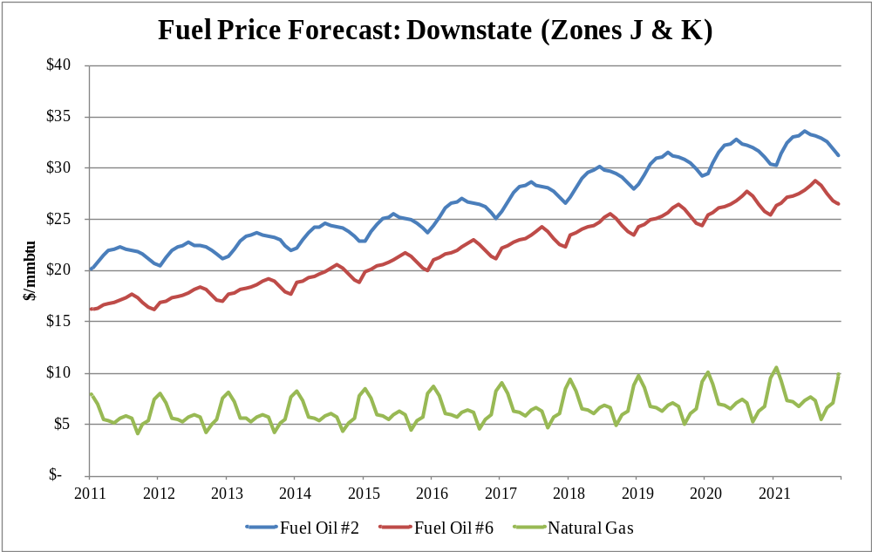
Figure 4-4: Forecasted fuel prices for Zones J & K (nominal $)

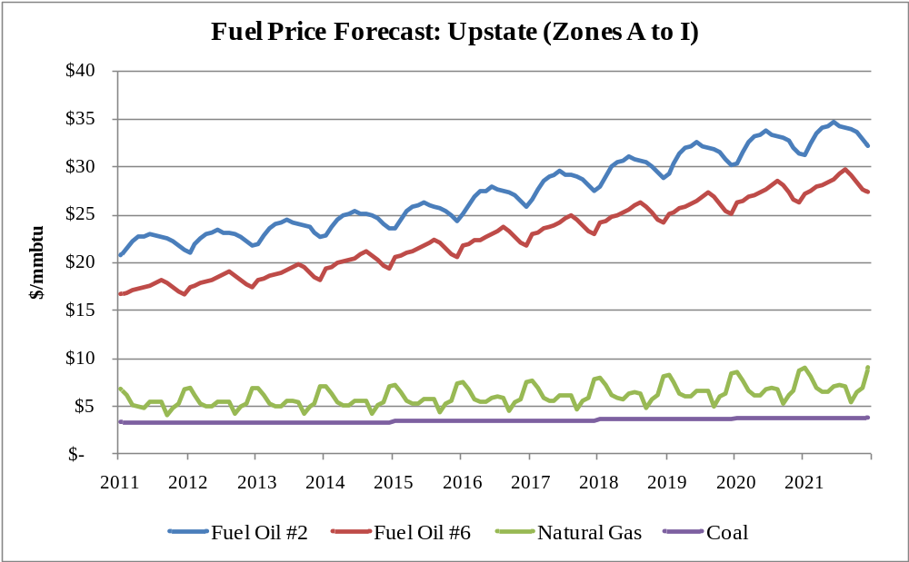
Figure 4-5: Forecasted fuel prices for Zones A-I (nominal $)

External Areas Fuel Forecast
The fuel forecasts for the three external areas, ISO-NE, PJM, and IESO, were also developed. For each of the fuels, the basis for ISO-NE, PJM-East, and PJM-West were based on the state level data published in Electric Power Monthly. With respect to IESO, the relative prices were based on data from a recent publication.

Emission Cost Forecast
The costs of emission allowances are an increasing portion of generator production costs. Currently, all NYCA fossil fueled generators greater than 25 MW and most generators in most surrounding states are required to hold allowances in amounts equal to their emissions of SO₂, NO_{X}, and CO₂. There are exchanges for trading allowances and futures contracts for allowances. The Chicago Climate Futures Exchange (CCFE) offers standardized and cleared futures and options contracts on emission allowances and other environmental products. Until mid 2010, there was a robust market for the exchange of these allowances. When the USEPA proposed the revised Clean Air Interstate Rule (CAIR), called the Clean Air Transport Rule (CATR), the proposal called for the end of the use of the CAIR allowances. The effect of this proposal was to place the holders of these allowances in the position of "use them or lose them”. Generators who had been banking allowances then sought to reclaim the remaining value by seeking buyers at all time minimum prices. As a consequence, the NYISO concluded that market prices were no longer a reliable benchmark for estimating the cost of future SO2 and NOx emissions.
Emission allowance price forecasts for SO₂ and NOx were developed by estimating the cost of removal from operation of existing emission control equipment for 2011.
In July 2011, the USEPA replaced the Clean Air Transport Rule proposal with the finalized Cross-State Air Pollution Rule (CSAPR) that requires significant additional reductions of SO₂ and NOx emissions beyond those previously identified. Due to the timing of this rule and the numerous unanswered questions surrounding it, a decision was made with the support of the ESPWG not to incorporate the rule in the 2011 CARIS 1 study. However, the impact of the CSAPR, together with its technical adjustments proposed by EPA in Oct 2011, is analyzed as a scenario in the report.
The CSAPR establishes a new allowance allocation and trading system for units larger than 25 MW of nameplate capacity. To demonstrate compliance with the rule, affected generators will need one allowance for each ton of designated pollutants emitted in a year. In New York, CSAPR will affect 167 units that represent 23,275 MW of capacity. The first emission reductions are expected to start in 2012 with additional reductions required in 2014. These additional emission reductions are anticipated to apply in 2012 and 2013 and will be accompanied by increased costs from fuel switching and more aggressive operation of existing emission control equipment. In 2014, provided that the technical adjustments become final, additional limitations will become effective for NOx RACT and BART as well as the initiation of the CSAPR Assurance Level provisions. The EPA projects that these limits will increase the cost of removal of NOx.
The RGGI program for capping CO₂ emissions from power plants includes six New England states plus NY, MD, DE, NJ,however NJ was not included in RGGI in the model. Experience to date has shown the program to be oversupplied with CO₂ allowances. The price forecast is near the floor for 2011. The program is currently being evaluated with a possible goal of reducing the cap and thereby increasing the prices. The working assumption for this study was an initiation of a federal CO₂ program in 2016. , It was assumed by the NYISO and discussed with ESPWG that for the purposes of this study that by 2016 the RGGI program would be redesigned to increase CO2 allowance prices to match the federal program when it becomes effective Since federal carbon legislation has been stalled, and the RGGI program has not yet reduced the annual cap on carbon emissions the actual carbon allowance price and associated allowance futures are significantly lower than the assumption used in this 2011 CARIS Phase 1. No CO₂ emissions adder was modeled for Ontario, assuming that IESO (Ontario) would not be affected by either a tightened RGGI program or a federal CO2 program. This resulted in some imports from Ontario becoming more economic in the model as US CO2 allowance costs were increased.
.

Emission costs, which are driven by the fuel burned, the efficiency of the unit and the emission control technology employed, are calculated as the product of emission rate and emission allowance costs. Annual emission rates were used in the simulations. The annual emission rates in terms of Ton/mmBTU are available from the EPA’s Clean Air Markets Division (CAMD). Since the emission rate determined above is an average emission rate, the same rate was used across the operating range.
Figure 4-4 shows the emission allowance forecast by year in $/Ton.
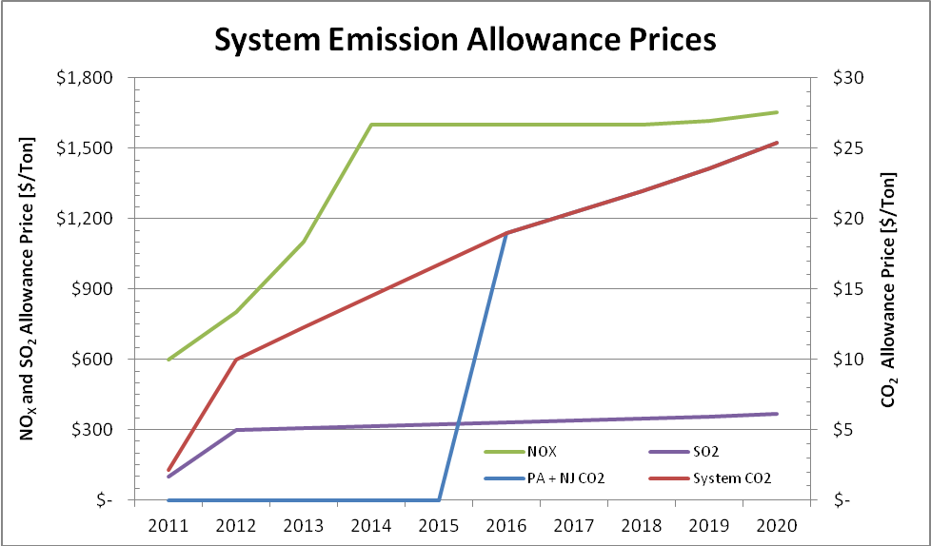
Figure 4-6: Emission Allowance Forecast
With respect to the carbon emission futures under the Regional Greenhouse Gas Initiative (RGGI), the data from the CCFE was available only through 2012. The implied trend was extrapolated to cover the 2013-2020 study period.

Generic Solutions
Generic solutions are evaluated by NYISO for each of the three CARIS studies utilizing each resource type (generation, transmission, and demand response (DR)) as required in Section 31.3.1.3 of the Tariff. The development of the generic solution representative costs was based on available public information with stakeholder input. This methodology utilized typical MW block size generic solutions, a standard set of assumptions without determining actual project feasibility, and order of magnitude costs for each resource type.
The cost estimates for generic solutions only are intended to set forth an order of magnitude of the potential projects’ costs for Benefit/Cost ratio analysis. These estimates should not be assumed as reflective or predictive of actual projects or imply that facilities can necessarily be built for these estimated costs or in the locations assumed.

Resource Block Sizes
Typical resource block sizes are developed for each resource type based on the following guidelines:
- Block size would be reflective of a typical size built for the specific resource type and geographic location;
- Block size is to be small enough to be additive with reasonable step changes; and
- Blocks sizes are in comparable proportions between the resource types.
The block sizes selected for each resource type are presented in Table 4-4 through Table 4-6.
Table 4-4: Transmission Block Sizes
Location | Line System Voltage (kV) | Block Capacity (MVA)
Zone A-J | 345 | 1000
Zone K | 138 | 500
Notes: Block size for Zone J was selected to be 600 MVA. 138 kV was selected for Zone K due to the limited number of 345 kV substations located within this Zone. The block capacity was selected so as to be reflective of the typical line size for this voltage class and location.

Table 4-5: Generation Block Sizes
Plant Location | Plant Block Size Capacity (MW)
Zone A-K | 500

Table 4-6: DR (Each 200 MW Block contains Demand Response +EE)
Location | Demand Response Quantity (MW) | Portfolio Type
Zone A-K | 100 | Energy Efficiency
Zone A-K | 100 | Demand Response

Guidelines and Assumptions for Generic Solutions
Developing cost estimates for these resource types was dependent on many different parameters and assumptions and without consideration of project feasibility or project-specific associated costs of achiev detaptions utilized for each resource is included in the Generic Solution Cost Matrix, in Appendix C.
The following guidelines and assumptions were used to select the generic solution:
Transmission Resource
- The generic transmission solution consists of a new transmission line interconnected to the system upstream and downstream of the grouped congested elements being studied.
- The generic transmission line terminates at the nearest existing substations of the grouped congested elements.
- If there is more than one substation located near the grouped congested elements which meets the required criteria, then the two substations that have the shortest distance between the two are selected. Space availability at substations was not evaluated in this process.
Generation Resource
- The generic generation solution consisted of the construction of a new combined cycle generating plant connecting downstream from the grouped congested elements being studied.
- The generic generation solution terminates at the nearest existing substation of the grouped congested elements.
- If there is more than one substation located near the grouped congested elements which meets the required criteria, the substation that has the highest relative shift factor was selected. Space availability at substations was not evaluated in this process.

Demand Response (DR)
- The generic DR solution was modeled as a reduction in load consisting of energy efficiency and demand response within the zone where the most downstream grouped congested element is terminated.
- The demand response was assumed to be on-peak, concentrated in the top 60-100 highest load hours.
- The DR installed in a zone was limited to less than 10% of the peak zonal load. If the modeled DR exceeds 10% of the peak zonal load, it is prorated based on peak load between the selected zone and the next downstream zone.
- The DR solution was not optimized to give the highest production cost savings per unit of cost, although energy efficiency yields significantly larger production cost savings than demand response

- 4.6.3 Generic Solution Pricing Considerations
Three sets of cost estimates which were designed to be reflective of the differences in labor, land and permitting costs among Upstate, Downstate and Long Island follow below. The considerations used for estimating costs for the three resource types and for each geographical area are listed in Table 4-7.
Table 4-7: Generic Solution Pricing Considerations
Transmission | Generation | DR
Transmission Line Cost per Mile | Plant Costs | Energy Efficiency Programs
Substation Terminal Costs | Generator Lead Cost per Mile | Demand Response Programs
System Upgrade Facilities | Substation Terminal Costs
 | System Upgrade Facilities
 | Gas Line Cost per Mile
 | Gas Regulator Station

Low, mid, and high cost estimates for each element were discussed with stakeholders. This establishes a range of cost estimates to address the variability of generic projects. The resulting order of magnitude unit pricing levels are included in the Generic Solution Cost Matrix in Appendix C.

2011 CARIS Phase 1 Results
This section presents summary level results of six steps of the 2011 CARIS Phase 1. These six steps include: (1) congestion assessment; (2) ranking of congested elements; (3) selection of three studies; (4) generic solution applications; (5) benefit/cost analysis; and (6) scenario analysis. Study results are described in more detail in Appendix E.

Congestion Assessment
The CARIS process begins with the development of a ten-year projection of future Demand$ congestion costs. This projection is combined with the past five years of historic congestion to identify and rank significant and recurring congestion. The results of the historical and future perspective are presented in the following two sections.
In order to assess and identify the most congested elements, both positive and negative congestion on constrained elements are taken into consideration. Whether congestion is positive or negative depends on the choice of the reference point. All metrics are referenced to the Marcy 345 kV bus near Utica, NY. In the absence of losses, any location with LBMP greater than the Marcy LBMP has positive congestion, and any location with LBMP lower than the Marcy LBMP has negative congestion. The negative congestion typically happens due to transmission constraints that prevent lower cost resources from being delivered towards the Marcy bus.

Historic Congestion
Historic congestion assessment has been conducted at the NYISO for the last seven years with metrics and procedures developed with the ESPWG and approved by the NYISO Operating Committee. Four congestion metrics were developed to assess historic congestion: Bid-Production Cost (BPC) as the primary metric, Load Payments metric, Generator Payments metric, and Congestion Payment metric. The results of the historic congestion analysis are posted on the NYISO website quarterly. For more information or source of historical results below see:
http://www.nyiso.com/public/markets_operations/services/planning/documents/index.jsp
Historic congestion costs by zone, expressed as Demand$, are presented in Table 5-1, indicating that the highest congestion is in New York City and Long Island.

Table 5-8: Historic Demand$ Congestion by Zone 2006-2010 (nominal $M)
Zone | 2006 | 2007 | 2008 | 2009 | 2010
West | 1 | (14) | (25) | (14) | (1)
Genesee | 2 | (14) | (9) | 4 | 6
Central | 4 | 9 | 18 | 8 | 11
North | (0) | (0) | (2) | (3) | (1)
Mohawk Valley | 2 | 5 | 10 | 4 | 5
Capital | 27 | 74 | 143 | 53 | 62
Hudson Valley | 54 | 87 | 176 | 57 | 73
Millwood | 27 | 31 | 78 | 16 | 23
Dunwoodie | 44 | 56 | 124 | 41 | 49
NY City | 673 | 700 | 1403 | 503 | 560
Long Island | 708 | 518 | 624 | 274 | 350
NYCA Total | 1,542 | 1,508 | 2,613 | 977 | 1,141
Reported values do not deduct TCCs
NYCA totals represent the sum of absolute values
Athens SPS in service 2008 – 2010 (and 2011)
DAM data include Virtual Bidding & Transmission planned outages

Table 5-2 below lists historic congestion costs, expressed as Demand$, for top NYCA constraints* from 2006 to 2010. The top congested paths are shown below.
Table 5-9: Historic Demand$ Congestion by Constrained Paths 2006-2010 (nominal $M)

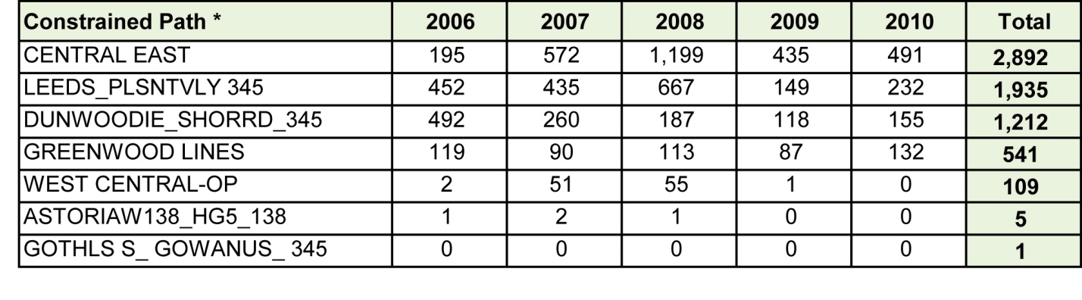
* Ranking is based on absolute values.

Table 5-3 summarizes the annual historic congestion results posted by the NYISO. NYISO reports the summaries of the calculated changes in the four historic congestion metrics: Bid Production Cost (BPC), Generator Payments, Congestion Payments, and Load Payments. The changes in these four historic congestion metrics were calculated using PROBE as the constrained system values minus the unconstrained system values. Positive numbers imply savings while negative numbers imply increases in payments when all constraints are relieved. Unhedged Congestion is calculated as the total congestion represented by Demand$ Congestion minus the TCC hedge payments (TCC auction proceeds). Total payments made by load adjusted for the TCC hedges, TCC shortfalls, and Rate Schedule 1 imbalances comprise the statewide Unhedged Load Payments. These adjusted statewide Unhedged Load Payments equal the total Generator Payments.

Table 5-10: Historic NYCA System Changes – Mitigated Bids 2006-2010 (nominal $M)
Year | Change in BPC | Change in Generator Payments | Change in Unhedged Congestion Payments |  | Change in TCC Payments
2006 | 118 | 59 | 921 |  | 634
2007 | 130 | (107) | 806 |  | 670
2008 | 243 | (417) | 1,525 |  | 1,143
2009 | 82 | (102) | 477 |  | 480
2010 | 94 | (116) | 640 |  | 515
Figure 5-1 below illustrates a cumulative effect of bid production costs savings over the past five years as a result of relieving all NYCA constraints.

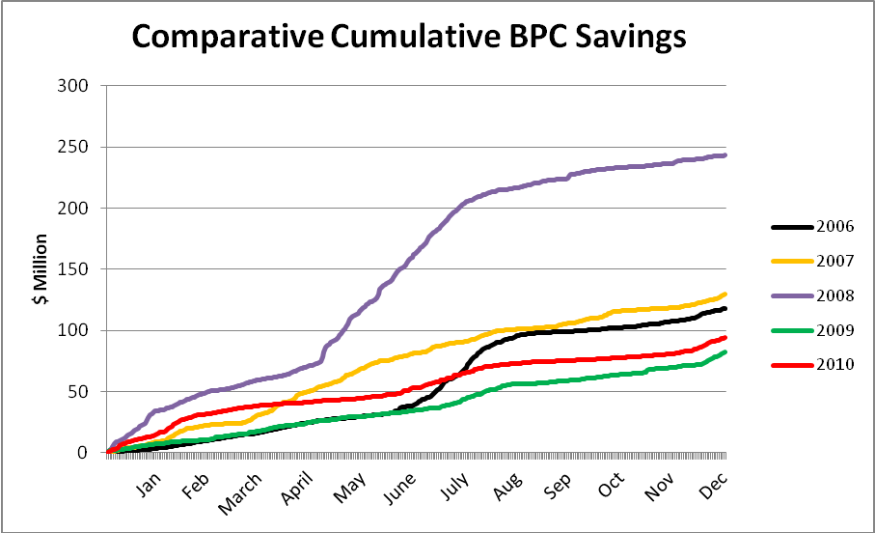
Figure 5-7: Historic Cumulative BPC Savings, 2006-2010 (nominal $M)

Projected Future Congestion
Future congestion for the 10 year study period was determined from a MAPS simulation using a ten year base case developed with the ESPWG. As reported in Section 3.2, congestion is reported as Demand$ congestion. MAPS simulations are highly dependent upon many long-term assumptions, each of which affects the study results. The MAPS model utilizes input assumptions listed in Appendix C.
When comparing historic congestion costs to projected congestion costs, it is important to note that there are significant differences in assumptions used by PROBE and MAPS. MAPS, unlike PROBE, did not simulate the following: (a) virtual bidding; (b) transmission outages; (c) fixed load and price-capped load; (d) generation and demand bid price; (e) Bid Production Cost Guarantee payments (BPCG); and (f) co-optimization with ancillary services.
Discussion
Table 5-4 presents the projected congestion from 2011 through 2020 by zone. The relative costs of congestion shown in this table indicate that the majority of the projected congestion is in the Downstate zones – NY City and Long Island. Year to year changes in congestion reflect changes in the model, which are discussed in Section 4.1.

Table 5-11: Projection of Future Demand$ Congestion 2011-2020 by Zone (nominal $M)

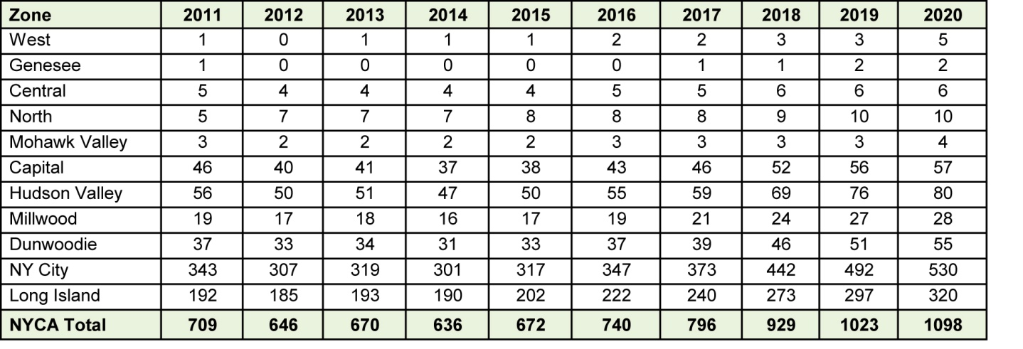
Note: Reported costs have not been reduced to reflect TCC hedges and represent absolute values. Athens SPS was not modeled during years 2011-2020, although it was still in service as of January 2012.
Based on the positive Demand$ congestion costs, the future top congested paths are shown in Table 5-5 below.

Table 5-12: Projection of Future Demand$ Congestion 2011-2020 by Constrained Path (nominal $M)
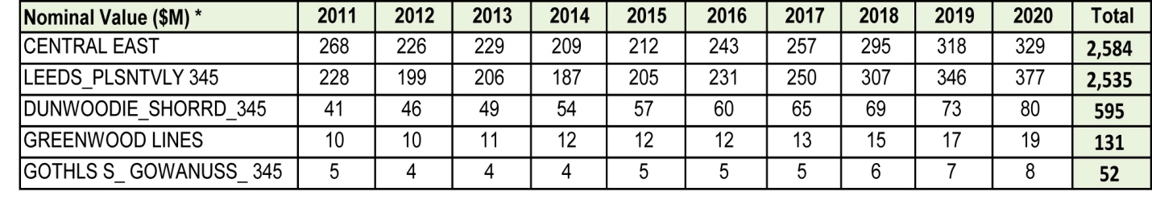* The absolute value of congestion is reported.

Ranking of Congested Elements
The identified congested elements from the ten-year projection of congestion are lined up with the past five years of identified historic congested elements to develop fifteen years of Demand$ congestion statistics for each initially identified top constraint. The fifteen years of statistics are analyzed to determine recurring congestion or the mitigation of congestion from future system changes incorporated into the base CARIS system that may lead to exclusions. Ranking of the identified constraints is initially based on the highest present value of congestion over the fifteen-year period with five years historic and ten years projected.
Table 5-6 lists the ranked elements based on the highest present value of congestion over the fifteen years of the study, including both positive and negative congestion. Central East and Leeds - Pleasant Valley continue to be the paths with the greatest congestion. The level of congestion over the Dunwoodie-Shore Road path diminishes in the future with the recent addition of the Caithness plant. The top seven elements are evaluated in the next step for selection of the three studies.
Table 5-13: Ranked Elements Based on the Highest Present Value of Demand$ Congestion
over the Fifteen Years Aggregate

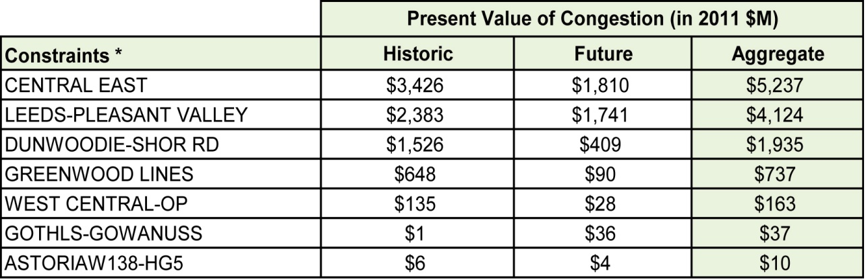
*The absolute value of congestion is reported.
The frequency of actual and projected congestion is shown in Table 5-7 below. The table presents the actual number of congested hours by constraint, from 2007 through 2010, and projected hours of congestion, from 2011 through 2020. The change in the number of projected hours of congestion, by constraint after each generic solution is applied, is shown in Appendix E.

Table 5-14: Number of Congested Hours by Constraint
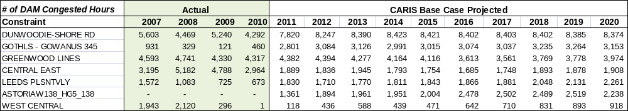

Three CARIS Studies

Selection of the Three Studies
Selection of the three CARIS studies is a two-step process in which the top seven ranked constraints are identified and utilized for further assessment in order to identify potential for grouping of constraints. Resultant grouping of elements for each of the top seven ranked constraints is utilized to determine the three studies.
In Step 1, both historic (5 years) and projected (10 years) congested elements for the fifteen- year period are ranked in ascending order based on the calculated present value of Demand$ Congestion. In Step 2, the top congested elements from Step 1 are relieved independently to determine if any needs to be grouped with other elements that show significant congestion when a primary element is relieved. See Appendix E for more detailed discussion.
For this study, Astoria West-Hellgate was eliminated from consideration before applying the first step because projected congestion was de minimis. In the first step, the remaining six congested elements with the highest present value ranking were utilized for further assessment. In the second step, the assessment was accomplished in multiple iterations to include additional elements that appear as limiting when each of the top six congested elements are relaxed by removing their limits. The assessed element groupings are then ranked based upon the highest change in production cost as shown in Figure 5-2.
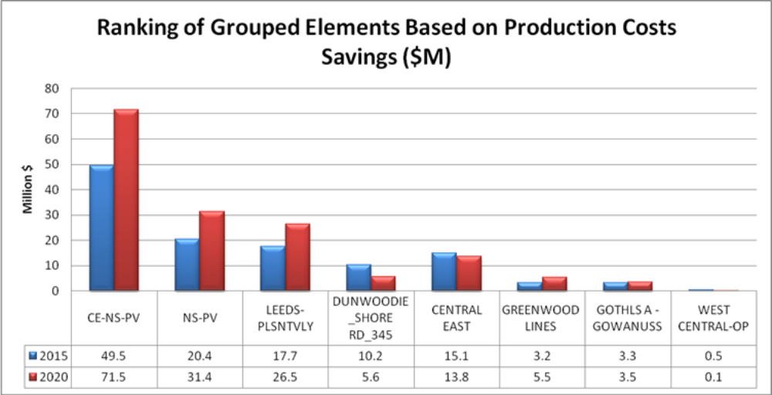

Figure 5-8: Production Costs Savings, 2015 and 2020 (nominal $M)
The three ranked groupings with the largest change in production cost are selected as the three CARIS studies: Central East-New Scotland-Pleasant Valley (CE-NS-PV), New Scotland – Pleasant Valley (NS-PV) and Leeds-Pleasant Valley (L-PV). Table 5-8 has the base case congestion associated with each of the three studies. A detailed discussion on the ranking process is presented in Appendix E.

Table 5-15: Demand$ Congestion of the Top Three CARIS Studies (nominal $M)

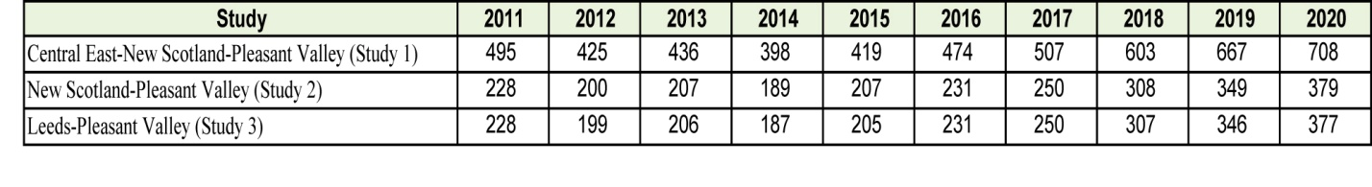

The location of the top three congested groupings, which define the three studies, along with their present value of congestion (in 2011 dollars) is presented in Figure 5-3.
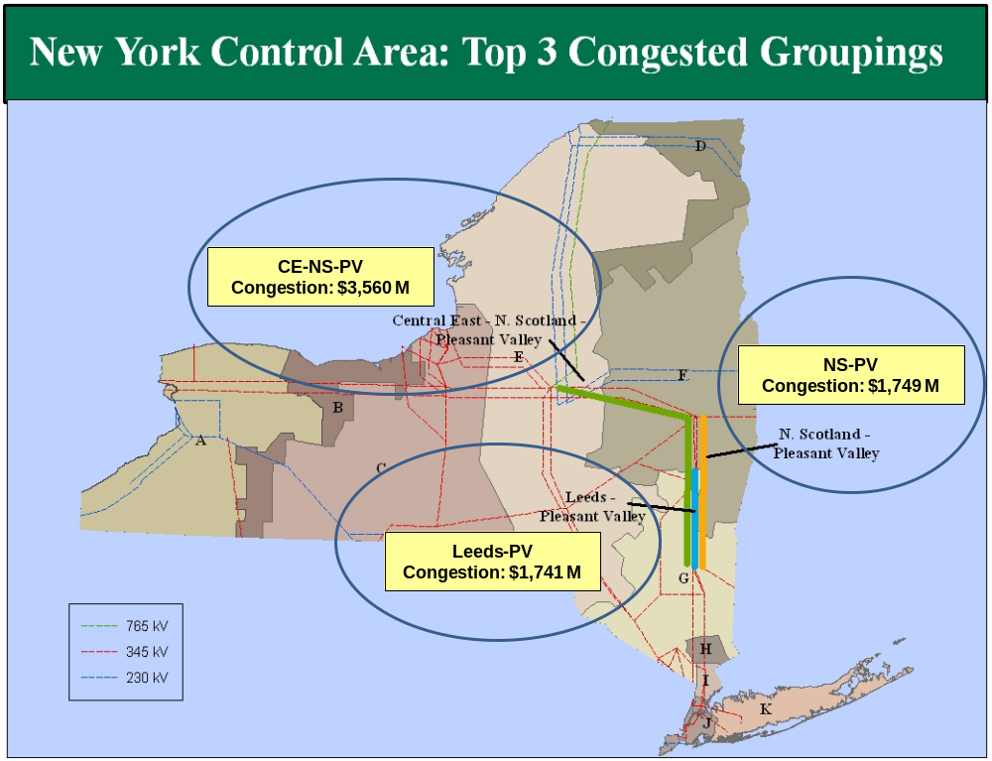
Figure 5-9: Base Case Congestion of Top 3 Congested Groupings, 2011-2020 - Present Value ($M)

Generic Solutions to Congestion
The congestion of each of the three groupings being studied is mitigated by individually applying one of the generic resource types; transmission, generation and DR. The resource type is applied based on the rating and size of the blocks determined in the Generic Solutions Cost Matrix included in Appendix C and is consistent with the methodology explained in Section 4 of this report. Resource blocks were applied to relieve a majority of the congestion. Additional resource blocks were not added if diminishing returns would occur.
In regard to the generic solutions, it is important to note the following:
- Other solutions may exist which will alleviate the congestion on the studied elements.
- No attempt has been made to determine the optimum solution for alleviating the congestion.
- No engineering, physical feasibility study, routing study or siting study has been completed for the generic solutions. Therefore, it is unknown if the generic solutions can be physically constructed as studied.
- Generic solutions are not assessed for impacts on system reliability or feasibility.
- Actual projects will incur different costs.
- The generic solutions differ in the degree to which they relieve the identified congestion.
- For each of the base case and solution cases, HQ imports are held constant.

The discount rate of 7.36% used for the present values analysis is the weighted average of the after-tax Weighted Average Cost of Capital (WACC) for the NYTOs. The weighted average is based on the utilities’ annual GWh sendout of energy for 2010.

Transmission has the greatest impact on reducing Demand$ congestion (55% to 100%) because adding a transmission solution addresses the underlying system constraint that was driving the congestion. The generation solution reduced Demand$ congestion by 48% to 77%. A large portion of the production cost savings resulting from generation can be attributed to the efficiency advantage of the generic generation solution when compared to the system wide heat rate. The demand response solution reduced Demand$ congestion by 2% to 10%, yet shows the largest production cost savings because it directly reduces the energy production requirements
The results of the three generic solutions are provided below with more detail in Appendix E. The following generic solutions were applied for each study:
Study 1: Central East – New Scotland – Pleasant Valley
The following generic solutions were applied for Central East – New Scotland -Pleasant Valley Study:
- Transmission: A new 345 kV line from Edic to New Scotland to Pleasant Valley, 155 Miles. The new line increases the Central East voltage transfer limit by approximately 600 MW and the UPNY-SENY thermal capability by up to 1200 MW.
- Generation: A new 1,000 MW Plant at Pleasant Valley
- Demand Response & Energy Efficiency (DR/EE): 100 MW Demand Response and 100 MW Energy Efficiency for a total of 200MW in Zone F and 200MW in Zone G (200 MW is less than 10% of peak load in each of Zones F & G)

Table 5-9 shows the Demand$ congestion of Central East – New Scotland – Pleasant Valley for 2015 and 2020 before and after each of the generic solutions is applied. The base Case congestion numbers, $419M for 2015 and $708M for 2020, are taken directly from Table 5-8 representing the level of congestion of the Study 1 before the solutions.

Table 5-16: Demand$ Congestion Comparison for Central East – New Scotland – Pleasant Valley Study (nominal $M)
 | 2015 |  |  | 2020
Resource Type | Base Case | Solution | % Change | Base Case | Solution | % Change
Transmission | 419 | 190 | -55% | 708 | 305 | -57%
Generation - 1000 MW | 419 | 96 | -77% | 708 | 195 | -72%
Demand Response - 400 MW | 419 | 405 | -3% | 708 | 696 | -2%

Table 5-10 shows the production cost savings expressed as the present value in 2011 $ from 2011 to 2020 for the Central East – New Scotland – Pleasant Valley study after generic solutions were applied.
Table 5-17: Central East – New Scotland – Pleasant Valley Study: NYCA-wide Production Cost Savings (Present Value in 2011 $M)
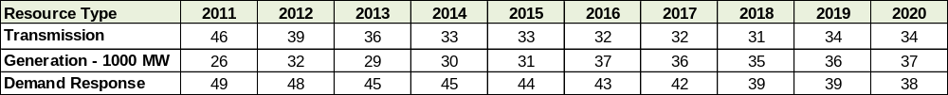
The Central East – New Scotland – Pleasant Valley 345 kV transmission solution is projected to relieve the congestion across existing Central East – New Scotland – Leeds-Pleasant Valley transmission lines by 55% in 2015 and 57% in 2020 respectively, as shown in Table 5-9. In Table 5-10, the annual production cost savings are relatively flat in present value, but increase in nominal value from 2014 to 2020 as fuel prices increase. Total ten year NYCA-wide production cost savings is $350 million (present value) as the result of better utilization of economic generation in the state and economic imports from neighboring regions made available by the large scale transmission upgrades represented by this generic transmission solution.
The generation solution is projected to reduce congestion by 77 % in 2015 and 72% in 2020. The ten-year production cost savings of $330 million (present value) are due to the uncongested location and the assumed better heat rate of the generic generating unit compared to the average system heat rate. Efficient generator solutions reduce imports from neighbors and enable a more efficient and lower cost NYCA generation market. Savings accrue in lower production cost as well as reduced congestion.
The Zones F and G DR/EE solution is projected to reduce congestion by 3% in 2015 and 2% in 2020, while the ten-year total production cost saving is $432 million (present value). The relative large value of production cost saving is largely attributable to the reduction in energy use of the DR/EE solution itself. DR solutions show greater reductions in production cost than the generation and transmission solutions.

Study 2: New Scotland – Pleasant Valley
The following generic solutions were applied for New Scotland – Pleasant Valley study:
- Transmission: A new 345 kV line from New Scotland to Pleasant Valley, 65 Miles. The new line increases the UPNY-SENY transfer capability by up to 1200 MW and the Central East voltage limit by 100 MW.
- Generation: A new 1,000 MW Plant at Pleasant Valley
- Demand Response & Energy Efficiency (DR/EE): 100 MW Demand Response and 100 MW Energy Efficiency for a total of 200MW in Zone G and 200MW in Zone I (200 MW is less than 10% of peak load in each of Zones G & I)
Table 5-11 shows the Demand$ congestion of New Scotland – Pleasant Valley for 2015 and 2020 before and after each of the generic solutions is applied.

Table 5-18: Demand$ Congestion Comparison for New Scotland – Pleasant Valley Study (nominal $M)

 | 2015 |  |  | 2020
Resource Type | Base Case | Solution | % Change | Base Case | Solution | % Change
Transmission | 207 | 14 | -93% | 379 | 44 | -88%
Generation - 1000 MW | 207 | 96 | -54% | 379 | 195 | -49%
Demand Response - 400 MW | 207 | 187 | -10% | 379 | 345 | -9%

Table 5-12 shows the NYCA-wide production cost savings expressed as the present value in 2011 $ from 2011 to 2020 for the New Scotland – Pleasant Valley study after generic solutions were applied.
Table 5-19: New Scotland – Pleasant Valley Study: NYCA-wide Production Cost Savings
(Present Value in 2011 $M)

Resource Type
2011
2012
2013
2014
2015
2016
2017
2018
2019
2020
Transmission
27
23
21
20
20
19
19
18
20
21
Generation - 1000 MW
26
32
29
30
31
37
36
35
36
37
DR
47
48
44
44
43
42
41
38
38
37
The addition of the New Scotland – Pleasant Valley line is projected to relieve the New Scotland – Pleasant Valley congestion by 93% in 2015 and 88% in 2020. The total ten-year production cost savings of $208 million (present value) are again due to increased use of lower cost generation in upstate and increased levels of imports compared to the base case. The Central East congestion increased in this solution.
The generation solution is projected to reduce congestion by 54 % in 2015 and 49% in 2020. The ten-year production cost savings of $330 million (present value) are derived from the heat rate efficiency advantage of the new generic unit compared to the average system heat rate. Imports are significantly reduced in this solution. Efficient generator solutions reduce imports from neighbors and enable a more efficient and lower cost NYCA generation market. Savings accrue in lower production cost as well as reduced congestion.

The Zones G and I DR/EE solution is projected to reduce congestion by 9 – 10%. The ten-year production cost savings of $421 million (present value) are largely related to the reduction in energy use. DR solutions show greater reductions in production cost than the generation and transmission solutions.
Study 3: Leeds – Pleasant Valley
The following generic solutions were applied for the Leeds-Pleasant Valley study, and the results are shown in Table 5-11:
- Transmission: A new 345 kV line from Leeds to Pleasant Valley; 39 Miles. The new line increases the UPNY-SENY thermal capability by up to 1000 MW and Central East voltage limit by 50 MW.
- Generation: Install a new 1000 MW Plant at Pleasant Valley.
- Demand Response & Energy Efficiency (DR/EE): 100 MW demand response and 100 MW Energy Efficiency for a total of 200 MW in Zone G and 200MW in Zone I (200 MW is less than 10% of peak load in each of Zones G & I).
Table 5-13 shows the Demand$ congestion of Leeds-Pleasant Valley for 2015 and 2020 before and after each of the generic solutions is applied. Transmission has the greatest impact in reducing congestion and eliminated the entire congestion for the Leeds-Pleasant Valley path.

Table 5-20: Demand$ Congestion Comparison for Leeds-Pleasant Valley (nominal $M)
 | 2015 |  |  | 2020
Resource Type | Base Case | Solution | % Change | Base Case | Solution | % Change
Transmission | 205 | 0 | -100% | 377 | 0 | -100%
Generation - 1000 MW | 205 | 96 | -53% | 377 | 195 | -48%
Demand Response - 400 MW | 205 | 187 | -9% | 377 | 345 | -8%

Table 5-14 shows the NYCA-wide production cost savings expressed as the present value in 2011 $ from 2011 to 2020 for the Leeds-Pleasant Valley study after the generic solutions were applied.

Table 5-21: Leeds-Pleasant Valley Study: NYCA-wide Production Cost Savings
(Present Value in 2011$M)
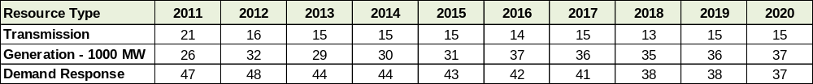

The addition of the Leeds to Pleasant Valley 345 kV transmission line results in a projected total ten-year production cost savings of $154 million (present value). Elimination of the Leeds-Pleasant Valley congestion allows the downstate load better access to upstate generation and economic imports from neighbors. It is also noted that relieving the congestion on the Leeds- Pleasant Valley lines increases the congestion on the other two study groups.
The generation solution is projected to reduce congestion across NYCA for the planning horizon. The ten-year production cost savings of $330 million (present value) are due to the uncongested location and the assumed better heat rate of the generic generating unit compared to the average system heat rate. Efficient generator solutions reduce imports from neighbors and enable a more efficient and lower cost NYCA generation market. Savings accrue in lower production cost as well as reduced congestion.

The Zones G and I DR/EE solution is projected to reduce congestion by 8 – 9%. The ten-year production cost savings of $421 million (present value) are largely related to the reduction in energy use. DR solutions show greater reductions in production cost than the generation and transmission solutions.
The NYCA-wide production cost savings of the three generic solutions for the three studies are summarized and shown in Figure 5-4.

Benefit/Cost Analysis
The NYISO conducted the benefit/cost analysis for each of the three: Central East – New Scotland – Pleasant Valley, New Scotland – Pleasant Valley, and Leeds – Pleasant Valley. The CARIS benefit/cost analysis assumes a levelized generic carrying charge rate of 16% for transmission and generation solutions. Therefore, for a given generic solution pertaining to a constrained element, the carrying charge rate, in conjunction with an appropriate discount rate (see description in Section 5.3.2 above) yields a capital recovery factor, which, in turn, is used to calculate the benefit/cost ratio.
Benefit/Cost ratio = Present Value of Production Cost Savings
Overnight Costs x Capital Recovery Factor
The 16% carrying charge rate used in these CARIS benefit/cost calculations reflects generic figures for a return on investment, federal and state income taxes, property taxes, insurance, fixed O&M, and depreciation (assuming a straight-line 30-year method). The calculation of the appropriate capital recovery factor, and, hence, the B/C ratio, is based on the first ten years of the 30-year period, using a discount rate of 7.36% , and the 16% carrying charge rate, yielding a Capital Recovery Factor equal to 1.145.

Cost Analysis
Table 5-15 includes the total cost estimate for each generic solution based on the unit pricing included in Appendix C. The detailed cost breakdown for each solution is included in Appendix E. These are simplified estimates of overnight installation costs and do not include any of the many complicating factors that could be faced by individual projects. On-going fixed operation and maintenance costs and other fixed costs of operating the facility are captured in the capital recovery factor.

Table 5-22: Generic Solution Costs for Each Study
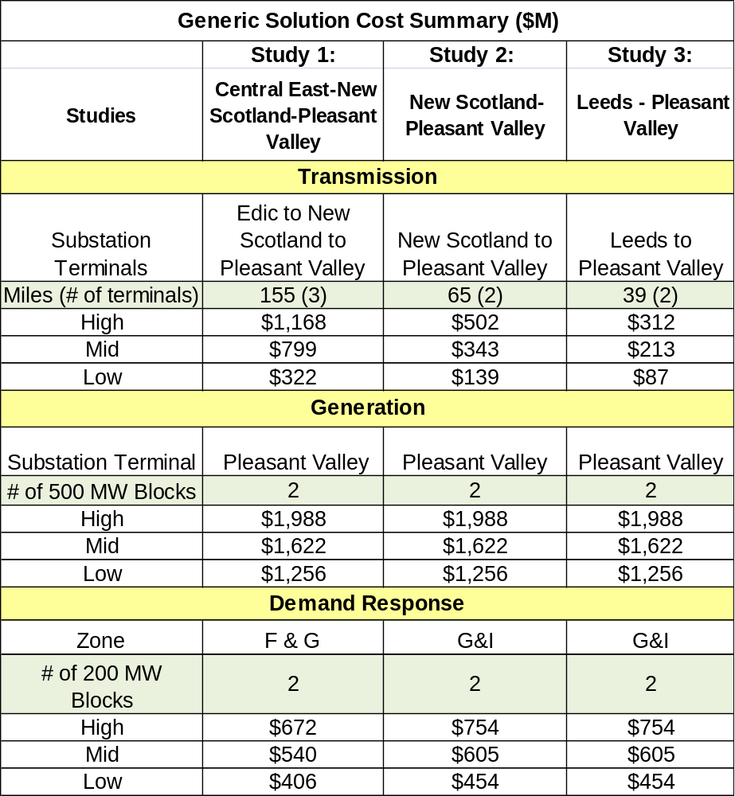

Primary Metric Results
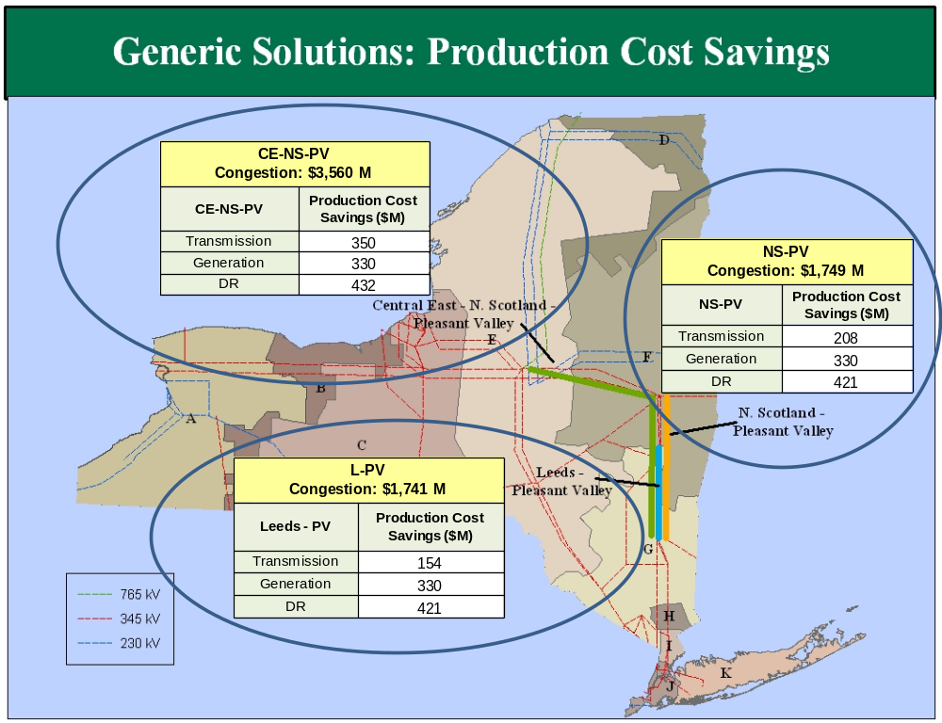
Figure 5-11: Total NYCA-wide Production Cost Savings 2011-2020 (Present Value in 2011 $M)

The primary benefit metric for the three CARIS studies is the reduction in NYCA-wide production costs. Table 5-16 shows the production cost savings used to calculate the benefit/cost ratios for the generic solutions.

Table 5-23: Production Cost Generic Solutions Savings 2011-2020: Present Value in 2011 ($M)
 | Central East to New Scotland to Pleasant Valley | New Scotland to Pleasant Valley | Leeds to Pleasant Valley
Transmission | 350 | 208 | 154
Generation | 330 | 330 | 330
DR/EE | 432 | 421 | 421

Benefit/Cost Ratios
Figure 5-5 shows the benefit/cost ratios for each study and each generic solution. 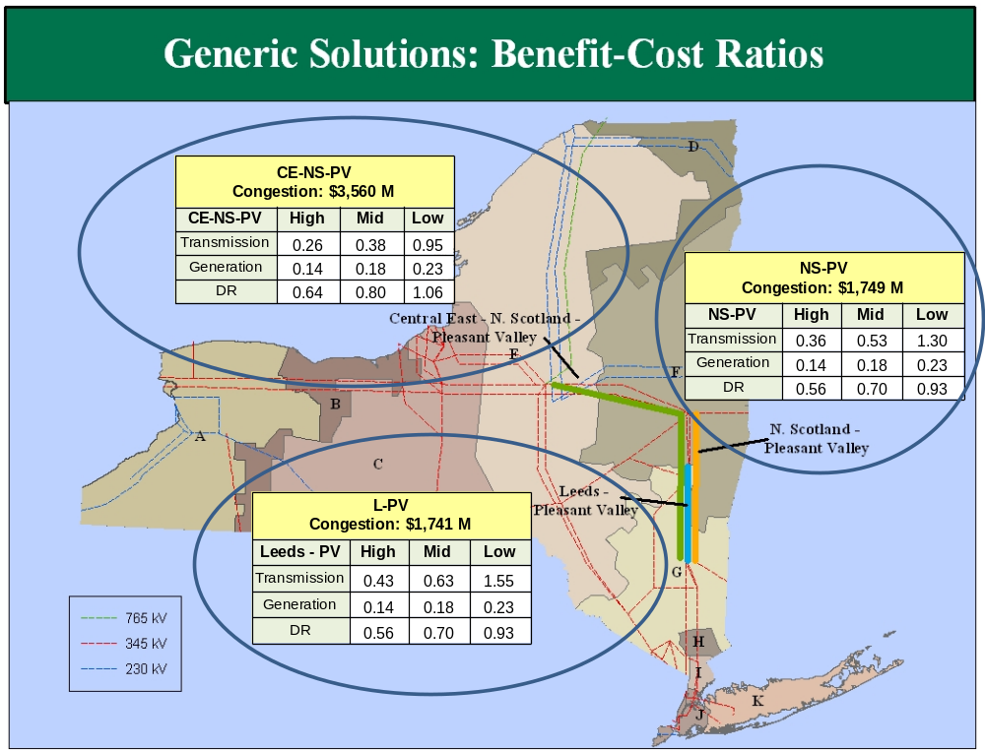
Figure 5-12: B/C Ratio (High, Mid, and Low Cost Estimate Ranges)

Additional Metrics Results
Additional metrics, which are provided for information purposes in Phase 1, are presented in Table 5-17, Table 5-18, and Table 5-19 to show the ten-year total change in: (a) generator payments; (b) LBMP load payments; (c) TCC payments (congestion rents); (d) losses; (e) emission costs/tons; and (f) ICAP MW and cost impact, after the generic solutions are applied. The values represent the generic solution case values less the base case values for all the metrics except for the ICAP metric. Details on the calculations are in Appendix E.

While all but the ICAP metric are from the production cost simulation program, the ICAP metrics are computed using the latest available information from the installed reserve margin (IRM), locational capacity requirement (LCR), and ICAP Demand Curves. Actual calculation consists of two steps. In the first step, the MW impact of a generic solution is determined through Loss of Load Expectation (LOLE) analysis, where LOLE is the resource adequacy criterion. The MW impact is indicative of reduced installed capacity requirement made possible by the congestion mitigation solutions. A transmission solution that enables better utilization of the existing generating resources in the State will allow a lower IRM and lower LCR. Generation solutions, depending on their location in the NYCA, will contribute as an ICAP source and may reduce the IRM and LCR requirements. For DR, the reduced load downstream of congestion will lower both the overall ICAP and the LCR requirements. The ICAP reduction can be larger than the nameplate of the solution in megawatts. Using year 2020 as an example, the ICAP MW impact for each study area resulting from the application of generic solutions is reported in Table 5-18. This represents the potential reduction in ICAP procurement obligations and the associated ICAP costs.

Second, the ICAP cost reduction benefit is translated to a dollar amount through two pricing variations for each of the years of the ten year study period. For Variant 1, the ISO measured the cost impact of a solution for each planning year by: (i) forecasting the cost per megawatt-year of Installed Capacity under the assumption that the solution is not in place, based on the 2011 ICAP Demand Curve for the NYCA and the amount of Installed Capacity available in the NYCA, and (ii) multiplying that forecasted cost per megawatt-year by the sum of the megawatt impact. For Variant 2, the ISO measured the cost impact of a solution for each planning year by: (i) forecasting the cost per megawatt-year of Installed Capacity under the assumption that the solution is in place, based on the latest available ICAP Demand Curve for the NYCA and the amount of Installed Capacity available in the NYCA; (ii) subtracting that forecasted cost per megawatt-year from the forecasted cost per megawatt-year of Installed Capacity calculated in Variant 1 (without the solution in place); and (iii) multiplying that difference by fifty percent (50%) of the assumed amount of NYCA Installed Capacity available. The ICAP cost metrics are indicative measures of the additional potential benefits resulting from the implementation of a CARIS solution. The metrics are not precise determinants of future capacity prices and are calculated for the purpose of providing additional information. Both of the two ICAP cost savings are shown in Table 5-17. For details on all 10 years, see Appendix E.

Table 5-24: Change in NYCA Generator and Load Payments, Losses, and ICAP Costs, and system-wide Congestion Rents

Negative values represent reductions.
*Congestion Rents are the sum of Shadow Prices times Flow across all constraints in the system. (They are not the same as Demand$ Congestion).
[Add Variant 2 number for non-zero floor]

Draft Table 5-17a: Savings in NYCA Load Payments, Congestion Costs, Losses Costs and ICAP Costs (Present Value $M)
 |  | Load Payments | Load  Energy Costs | Load  Congestion Costs * | Load  Losses Costs** | ICAP Costs Variant 1 | ICAP Costs Variant 2
Study | Solution
 | Transmission
Study 1: CE-NS-PV | Edic-New Scotland-Pleasant Valley |  |  |  |  | 57 | 803
Study 2: NS-PV | New Scotland-Pleasant Valley |  |  |  |  | 57 | 803
Study 3: Leeds-PV | Leeds – Pleasant Valley |  |  |  |  | 57 | 803
 | Generation
Study 1: CE-NS-PV | Pleasant Valley |  |  |  |  | 105 | 1174
Study 2: NS-PV | Pleasant Valley |  |  |  |  | 105 | 1174
Study 3: Leeds-PV | Pleasant Valley |  |  |  |  | 105 | 1174
 | DR & EE
Study 1: CE-NS-PV | Zone F&G |  |  |  |  | 28 | 470
Study 2: NS-PV | Zone G & I |  |  |  |  | 44 | 674
Study 3: Leeds-PV | Zone G & I |  |  |  |  | 44 | 674
* Congestion Costs are calculated as Zonal $Demand Congestion for NYCA Zones
** Load Losses cost are the Load x Loss component of LMP or Loss Payment
NOTE: Missing values will be supplied shortly

Table 5-25: ICAP MW Impact

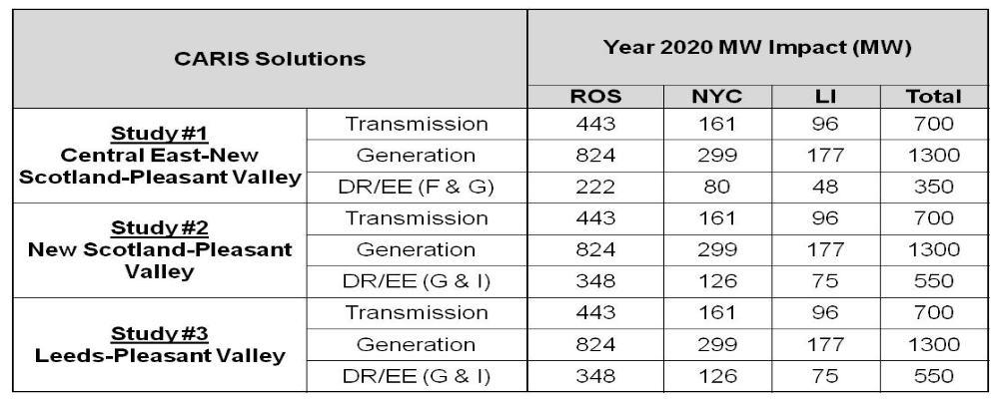

The ten-year changes in total emissions resulting from the application of generic solutions are reported in Table 5-19 below. The base case ten-year emission totals for NYCA are: CO₂ = 401,534 tons, SO₂= 289,765 tons and NOx = 237,134 tons. The study results reveal that most of the generic solutions impact emissions by less than 2%, with the exception of generation solutions impacting SO₂ and NOx emissions up to 7% and 4% respectively. The current installed capacity in NYCA as reported in the 2011 Gold Book is 37,707 MW. The generic generation solution of 1,000 MW represents the equivalent of 2.7 % increase in installed capacity. The generic demand response solution of 200 MW of DR and 200 MW of EE could be considered as an additional resource which would be equivalent to 1.1% of installed capacity. The capability of the generic transmission solution is 1,000 MVA, which would be utilized to shift dispatch patterns of several hundred MW of capacity, or something on the order of 1% of installed capacity. The three generic solutions can be considered to change the fleet emission characteristics on the order of 1-3%. The comparison of the relative emission changes among solution types and across locations provides insight about the relative air related impacts if the emissions assumptions come to fruition. The emissions results include only emissions from NYCA units. and no exrnal emissions impacts associated with changes in NYCA imports are not reported. Both transmission and demand response solutions show improvements by reducing the emissions of all three pollutants up to 1.3%. Generation solutions produce a net reduction in the emissions of SO₂ and NOx, due to the relative low emission rates of a new unit compared to the average emission rates of the existing fleet. The Pleasant Valley location offers the greatest emission reductions in SO2 (7%) and NOx (4%). Generic generation solutions lead to a slight increase in CO₂ emissions when a 1,000 MW generation solution is applied.

Table 5-26: Ten-Year Change in NYCA CO2, SO2 and NOx Emissions (Dollars in Present Value)

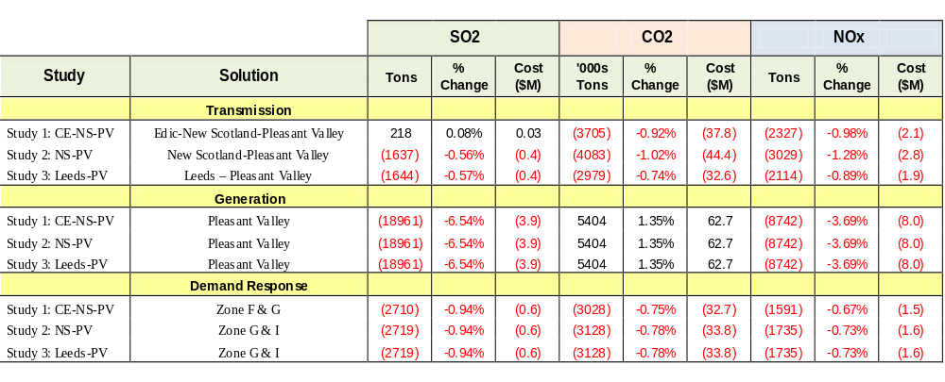

Scenario Analysis
Scenario analysis is performed to explore the impact on congestion associated with variables to the base case. Since this is an economic study and not a reliability analysis, these scenarios focus upon factors that impact the magnitude of congestion across constrained elements.
A forecast of congestion is impacted by many variables for which the future values are uncertain. Scenario analyses are methods of identifying the relative impact of pertinent variables on the magnitude of congestion costs. The CARIS scenarios were presented to ESPWG and modified based upon the input received and the availability of NYISO resources. The focus of these analyses was to examine the impact of the full amount of the resources added through the State Renewable Portfolio Standard (RPS) combined with the full achievement of the State Energy Efficiency Portfolio Standard (EEPS), fuel price and load forecast uncertainties, costs of emissions, and maintaining the Athens SPS in service. The objective of the scenario analysis is to determine the change in the costs of congestion that is caused by variables that differ from their base case values. The simulations were conducted for the mid-period year (2015) and the horizon year (2020).

Scenario Analysis
Table 5-20 summarizes the scenarios studied in CARIS Phase 1. The scenarios consider the effects of changes to the base case model. These changes are described as “Variables” in the table below.

Table 5-27: Scenario Matrix
Scenario | Variables
EPA Projected NOx and SO2 Costs | Increases in SO2 and Ozone Season NOx costs; decreases in annual NOx cost as projected by EPA
Higher Load Forecast | 6% increase
Lower Load Forecast | 9% decrease
Full RPS and Full EEPS Goals Achievement | Add renewables from Interconnection Queue to achieve 9870 GWh goal and reduce 2015 load to 32147 MW
Athens SPS Continued In Service | 2011-2020
Higher Natural Gas Prices | One standard deviation
Lower Natural Gas Prices | One standard deviation
Lower CO2 Emission Costs | Flat $5/ton ceiling

Table 5-21 presents the impact of eight scenarios selected for study. Those impacts are expressed as congestion costs for the scenarios and the base case. Negative numbers represent negative congestion.

Table 5-28: Comparison of Base Case and Scenario Cases, 2015 and 2020 (nominal $M)

CONSTRAINTS
TYPE
BASE
CASE
EPA
Projected
NOx and
SO2 Costs
Higher
Load
Forecast
Lower
Load
Forecast
Full RPS
and Full
EEPS
goals
Achievem
ent
Athens
SPS
Continue
d in
Service
Higher
Natural
Gas
Prices
Lower
Natural
Gas
Prices
Lower
Carbon
Emission
Costs
LEEDS-PLSNTVLY
Contingency
205
177
244
138
221
130
228
173
170
CENTRAL EAST
Interface
212
253
219
268
563
232
272
110
171
DUNWOODIE_SHORE RD_345
Contingency
57
75
61
56
61
61
64
46
58
GREENWOOD LINES
Contingency
12
11
15
8
11
12
13
12
12
WEST CENTRAL-OP
Interface
2
3
2
2
1
3
4
2
0
GOTHLS A - GOWANUSS
Contingency
5
6
6
3
4
4
5
4
4
LEEDS3_NEW SCOTLAND_345
Contingency
2
0
0
3
2
2
2
1
0
RAINY8W138_VERNW_138
Contingency
2
3
2
2
2
2
3
1
3
ASTORIAW138_HG5_138
Contingency
0
0
0
0
1
0
0
0
0
Study 1: Central East-New Scotland-Pleasant Valley
419
430
463
409
787
364
502
284
341
Study 2: New Scotland-Pleasant Valley
207
177
244
141
223
132
229
174
170
Study 3:Leeds-Pleasant Valley
205
177
244
138
221
130
228
173
170
2015 Scenarios: Demand$ Congestion ($M)
Absolute values
CONSTRAINTS
TYPE
BASE
CASE
EPA
Projected
NOx and
SO2 Costs
Higher
Load
Forecast
Lower
Load
Forecast
Full RPS
and Full
EEPS
Goals
Achievem
ent
Athens
SPS
Continue
d in
Service
Higher
Natural
Gas
Prices
Lower
Natural
Gas
Prices
Lower
Carbon
Emission
Costs
LEEDS-PLSNTVLY
Contingency
377
417
440
269
399
253
412
337
330
CENTRAL EAST
Interface
329
266
317
428
817
369
389
207
312
DUNWOODIE_SHORE RD_345
Contingency
80
107
85
76
84
85
87
66
83
GREENWOOD LINES
Contingency
19
20
24
13
17
19
20
18
20
WEST CENTRAL-OP
Interface
9
12
8
9
6
10
11
7
2
GOTHLS A - GOWANUSS
Contingency
8
9
11
5
7
7
8
7
8
LEEDS3_NEW SCOTLAND_345
Contingency
2
6
2
2
3
5
2
3
0
RAINY8W138_VERNW_138
Contingency
2
2
2
2
2
2
3
1
3
ASTORIAW138_HG5_138
Contingency
1
2
1
1
1
0
1
1
0
Study 1: Central East-New Scotland-Pleasant Valley
708
689
760
699
1,218
627
804
547
642
Study 2: New Scotland-Pleasant Valley
379
423
443
271
401
258
415
339
331
Study 3:Leeds-Pleasant Valley
377
417
440
269
399
253
412
337
330
2020 Scenarios: Demand$ Congestion (Nominal $M)
Absolute values
Figures 5-6 through 5-8 show the congestion impact results of eight scenarios performed for the years 2015 and 2020. While the table above shows the congestion impact from the scenarios for each of the most congested constraints, the figures below separately show how each of the three transmission groupings chosen for study are affected by each of the scenarios.

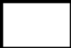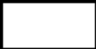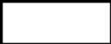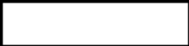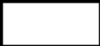
(800)
(600)
(400)
(200)
0
200
400
600
800
EPA Projected NOx and SO2 Costs (
-
0.7%)
Higher Load Forecast (9%)
Lower Load Forecast (
-
2%)
Full RPS and Full EEPS Goals Achievement (78%)
Athens SPS Continued in Service (
-
12%)
Higher Natural Gas Prices (16%)
Lower Natural Gas Prices (
-
26%)
Lower Carbon Emission Costs (
-
13%)
Scenario Impact on Central East
-
-New Scotland
-
-Pleasant Valley
Total Change in Congestion
-
2015 + 2020 (Nominal $M)
Group #1: 2015&2020
Base Case Congestion: $1,127M

Figure 5-6: Scenario Impact on Central East – Pleasant Valley Congestion

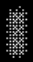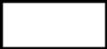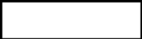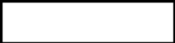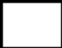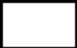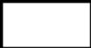
(600)
(400)
(200)
0
200
400
EPA Projected NOx and SO2 Costs (2%)
Higher Load Forecast (17%)
Lower Load Forecast (
-
30%)
Full RPS and Full EEPS Goals Achievement (7%)
Athens SPS Continued in Service (
-
33%)
Higher Natural Gas Prices (10%)
Lower Natural Gas Prices (
-
12%)
Lower Carbon Emission Costs (
-
15%)
Scenario Impact on New Scotland
-
-Pleasant Valley Total Change in Congestion
2015 + 2020 (Nominal $M)
Group #2: 2015&2020 Base Case Congestion: $586
Figure 5-7: Scenario Impact on New Scotland – Pleasant Valley Congestion

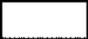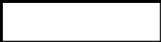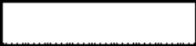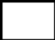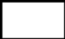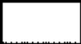
(600)
(400)
(200)
0
200
400
EPA Projected NOx and SO2 Costs (2%)
Higher Load Forecast (18%)
Lower Load Forecast (
-
30%)
Full RPS and Full EEPS Goals Achievement (6%)
Athens SPS Continued in Service (
-
34%)
Higher Natural Gas Prices (10%)
Lower Natural Gas Prices (
-
12%)
Lower Carbon Emission Costs (
-
14%)
Scenario Impact on Leeds
-
-Pleasant Valley Total Change in Congestion
2015 + 2020 (Nominal $M)
Group #3: 2015&2020 Base Case Congestion: $582 M
Figure 5-8: Scenario Impact on Leeds- Pleasant Valley Congestion

Scenario 1: EPA Projected NOx and SO₂ Costs
Emissions of SO₂ and NOx have costs that are determined by various cap and trade programs currently in effect in New York and in most of the surrounding regions. Forecasts used in the base case for these allowance costs were developed using various private and public data such as some proprietary forecasts, EPA’s allowance price, and market prices from the Chicago Climate Futures Exchange. To examine factors that might produce or increase congestion, the forecast costs of NOx and SO₂ emissions were modeled based on EPA projections for 2015 and 2020, resulting from the Cross-State Air Pollution Rule.
Scenario 2: Higher Load Forecast
This scenario examined the impact of the higher load forecast on the cost of congestion. The high load forecast is obtained from the 2011 Gold Book, and is 6% higher than the 2011 Gold Book Baseline load forecast used in the 2011 CARIS base case. The high load forecast is 35,738 MW and 36,988 MW respectively in 2015 and 2020. All other assumptions were kept the same as in the base case.
Scenario 3: Lower Load Forecast
This scenario examined the impact of the lower load forecast on the cost of congestion. The low load forecast is derived from the 2011 Gold Book, and is 9% lower than the 2011 Gold Book Baseline load forecast used in the 2011 CARIS base case. The low load forecast is 30,734 MW and 31,819 MW respectively in 2015 and 2020. All other assumptions were the same as in the base case.
Scenario 4: Full RPS and EEPS Goals Achievement
This scenario adds renewable generation projects from the NYISO Interconnection queue to achieve the renewable goal of 9,870 GWh by 2015, and models load reductions which achieve the goal of 15% load reduction resulting in a peak load projection of 32,147 MW in 2015.
Scenario 5: Athens SPS Continued In Service
This scenario assumed that the Athens SPS is in service throughout the study period from 2011 -2020. The 2011 base case assumed that Athens SPS was not in service. The Athens SPS system impact study in 2006 indicated a 450 MW increase in the UPNY-SENY interface with the SPS in service.
Scenario 6: Higher Natural Gas Prices

This scenario examines congestion costs when natural gas prices are projected to be higher than the base case levels by one standard deviation. The volatility of natural gas prices varies across the year such that it is most volatile in winter months and relatively stable during late spring. Consequently, as compared to the base case, the high price case uses January prices around 22% higher for Downstate and 12% higher for Upstate, while remaining about the same in May-June in both cases.
Scenario 7: Lower Natural Gas Prices
This scenario examines congestion costs when natural gas prices are projected to be lower than the base case levels by one standard deviation. The volatility of natural gas prices varies across the year such that it is most volatile in winter months and relatively stable during late spring. Consequently, as compared to the base case, the low price case uses January prices around 22% lower for Downstate and 12% lower for Upstate, while remaining about the same in May-June in both cases.

Scenario 8: Lower CO₂ Emission Costs

To simulate the potential impact of carbon emission costs lower than those modeled in the base case, this scenario assumed the price of CO₂ allowances to not exceed $5/ton throughout the 2011-2020 study period.

2011 CARIS Findings – Study Phase

The CARIS identified three study areas by considering monitored elements that have historically displayed high levels of congestion after adjusting for the effects of volatile fuel price changes and also considering the installation of new resources and transmission system improvements contained in the 2010 CRP. In order to estimate the economic impact of alleviating the identified congestion, the three generic solutions were applied to each of the three study areas and production costs savings were calculated based on the three different ranges of generic costs.
Table 6-1 shows the projected congestion for each of the three transmission groupings: Central East-New Scotland-Pleasant Valley, New Scotland-Pleasant Valley, and Leeds-Pleasant Valley.
Table 6-29: Base Case Projected Congestion 2011-2020

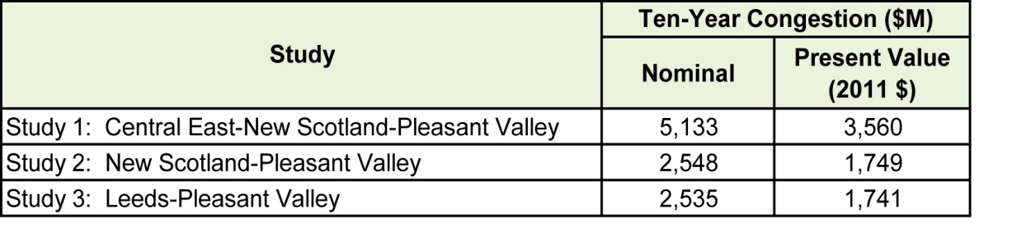
The application of the generic solutions to the three study areas all result in production cost savings expressed in 2011 present values, as shown in Table 6-2.

Table 6-30: Production Cost Savings 2011-2020, Present Value in 2011 $M
 | Ten-Year Production Cost Savings (2011 $M)
Study | Transmission Solution | Generation Solution | DR Solution
Study 1: Central East-New Scotland-Pleasant Valley | 350 | 330 | 432
Study 2: New Scotland to Pleasant Valley | 208 | 330 | 421
Study 3: Leeds - Pleasant Valley | 154 | 330 | 421

In Phase 1, CARIS compares the present value of the production cost savings benefit over the ten-year study period to the present value of fixed costs based on a 16% carrying cost charge, for transmission and generation solutions, to determine a benefit/cost ratio, as presented in Table 6-3. A 16% carrying cost charge does not apply to demand response solutions. See Section 5.5 for a detailed explanation.

Table 6-31: Benefit/Cost Ratios
Study | Cost Ranges | Benefit/Cost Ratios
Study | Cost Ranges | Transmission Solution | Generation Solution | Demand Response Solution
Study 1: Central East-New Scotland-Pleasant Valley | High | 0.26 | 0.14 | 0.64
Study 1: Central East-New Scotland-Pleasant Valley | Mid | 0.38 | 0.18 | 0.80
Study 1: Central East-New Scotland-Pleasant Valley | Low | 0.95 | 0.23 | 1.06
Study 2: New Scotland to Pleasant Valley | High | 0.36 | 0.14 | 0.56
Study 2: New Scotland to Pleasant Valley | Mid | 0.53 | 0.18 | 0.70
Study 2: New Scotland to Pleasant Valley | Low | 1.30 | 0.23 | 0.93
Study 3: Leeds to Pleasant Valley | High | 0.43 | 0.14 | 0.56
Study 3: Leeds to Pleasant Valley | Mid | 0.63 | 0.18 | 0.70
Study 3: Leeds to Pleasant Valley | Low | 1.55 | 0.23 | 0.93

In conclusion, this CARIS Phase 1 study provides: (a) projections of congestion in the NYCA system; (b) present value of ten-year production cost savings ranging from $150M to $430M resulting from the application of various generic transmission, generation and demand response solutions; and (c) the Benefit/Cost ratios as high as 1.55 and as low as 0.14 depending on the high-medium-low generic project cost estimates.
Additionally, the scenario analyses provide information on new or increased projected congestion costs resulting from changes in variables selected for scenario analyses (see Table 5-23 in Section 5).

Next Steps

In addition to the CARIS Phase 1 Study, any interested party can request additional studies or use the CARIS Phase 1 results for guidance in submitting a request for a Phase 2 study.

Additional CARIS Studies
In addition to the three CARIS studies, any interested party may request an additional study of congestion on the NYCA bulk power system. Those studies can analyze the benefits of alleviating congestion with all types of resources, including transmission, generation and demand response, and compare benefits to costs.

Phase 2 – Specific Transmission Project Phase
The NYISO staff will commence Phase 2 – the Project Phase – of the CARIS process following the approval of the Phase 1 report by the NYISO Board. The model for Phase 2 studies would include known changes to the system configuration that meet base case inclusion rules and would be updated with any new load forecasts, fuel costs, and emission costs projections upon review and discussion by stakeholders. Phase 2 will provide a benefit/cost assessment for each specific transmission project that is submitted by developers who seek regulated cost recovery under the NYISO’s Tariff.
Transmission projects seeking regulated cost recovery will be further assessed by NYISO staff to determine whether they qualify for cost allocation and cost recovery under the NYISO Tariff. To qualify, the total capital cost of the project must exceed $25 million, the benefits as measured by the NYCA-wide production cost savings must exceed the project cost measured over the first ten years from the proposed commercial operation date, and a super-majority (> 80%) of the weighted votes cast by the beneficiaries must be in favor of the project. Additional details on the Phase 2 process can be found in Appendix F.

Project Phase Schedule
The NYISO staff will perform benefit/cost analysis for submitted economic transmission project proposals for and, if a developer seeks cost recovery, will determine beneficiaries and conduct cost allocation calculations. The results of the Phase 2 analyses will provide a basis for beneficiary voting on each proposed transmission project.
The next CARIS cycle will begin in 2013, upon the completion of the next CRPP cycle (approval of the 2012 CRP).

Appendix A – Glossary

TERM | DEFINITION
Ancillary Services | Services necessary to support the transmission of Energy from Generators to Loads, while maintaining reliable operation of the NYS Power System in accordance with Good Utility Practice and Reliability Rules. Ancillary Services include Scheduling, System Control and Dispatch Service; Reactive Supply and Voltage Support Service (or Voltage Support Service); Regulation Service; Energy Imbalance Service; Operating Reserve Service (including Spinning Reserve, 10-Minute Non-Synchronized Reserves and 30-Minute Reserves); and Black Start Capability. [FROM SERVICES TARIFF]
Bid Production Cost | Total cost of the Generators required to meet Load and reliability Constraints based upon Bids corresponding to the usual measures of Generator production cost (e.g., running cost, Minimum Generation Bid, and Start Up Bid). [FROM SERVICES TARIFF]
Bulk Power Transmission Facility (BPTF) | Transmission facilities that are system elements of the bulk power system which is the interconnected electrical system within northeastern North America comprised of system elements on which faults or disturbances can have a significant adverse impact outside of the local area.
Business Issues Committee (BIC) | A NYISO committee that is charged with, among other things, the responsibility to establish procedures related to the efficient and non-discriminatory operation of the electricity markets centrally coordinated by the NYISO, including procedures related to bidding, Settlements and the calculation of market prices.
Capacity | The capability to generate or transmit electrical power, or the ability to reduce demand at the direction of the NYISO.
Chicago Climate Futures Exchange (CCFE) | A derivatives exchange that offers standardized and cleared futures and options contracts on emission allowances and other environmental products.
Clean Air Markets Division (CAMD) | A division of the U.S. Environmental Protection Agency responsible for various market-based regulatory programs that are designed to improve air quality by reducing outdoor concentrations of fine particles, sulfur dioxide, nitrogen oxides, and mercury.
Comprehensive Reliability Plan (CRP) | An annual study undertaken by the NYISO that evaluates projects offered to meet New York’s future electric power needs, as identified in the Reliability Needs Assessment (RNA). The CRP may trigger electric utilities to pursue regulated solutions to meet Reliability Needs if market-based solutions will not be available by that point. It is the second step in the Comprehensive Reliability Planning Process (CRPP)
Comprehensive Reliability Planning Process (CRPP) | The annual process that evaluates resource adequacy and transmission system security of the state’s bulk electricity grid over a ten-year period and evaluates solutions to meet those needs. The CRPP consists of two studies: the RNA, which identifies potential problems, and the CRP, which evaluates specific solutions to those problems.
Comprehensive System Planning Process (CSPP) | A transmission system planning process that is comprised of three components: (1) Local transmission planning; (2) Compilation of local plans into the Comprehensive Reliability Planning Process (CRPP), which includes developing a Comprehensive Reliability Plan (CRP); (3) Channeling the CRP data into the Congestion Assessment and Resource Integration Study (CARIS)
Congestion | Congestion on the transmission system results from physical limits on how much power transmission equipment can carry without exceeding thermal, voltage and/or stability limits determined to maintain system reliability. If a lower cost generator cannot transmit its available power to a customer because of a physical transmission constraint, the cost of dispatching a more expensive generator is the congestion cost.
Congestion Rent | The opportunity costs of transmission Constraints on the NYS Bulk Power Transmission System. Congestion Rents are collected by the NYISO from Loads through its facilitation of LBMP Market Transactions and the collection of Transmission Usage Charges from Bilateral Transactions.
Contingencies | Electrical system events (including disturbances and equipment failures) that are likely to happen.
Day Ahead Market (DAM) | A NYISO-administered wholesale electricity market in which capacity, electricity, and/or Ancillary Services are auctioned and scheduled one day prior to use. The DAM sets prices as of 11 a.m. the day before the day these products are bought and sold, based on generation and energy transaction bids offered in advance to the NYISO. More than 90% of energy transactions occur in the DAM.
DC tie-lines | A high voltage transmission line that uses direct current for the bulk transmission of electrical power between two control areas.
Demand Response | A mechanism used to encourage consumers to reduce their electricity use during a specified period, thereby reducing the peak demand for electricity.
Eastern Interconnection Planning Collaborative (EIPC) | A group of planning authorities convened to establish processes for aggregating the modeling and regional transmission plans of the entire Eastern Interconnection and for performing inter-regional analyses to identify potential opportunities for efficiencies between regions in serving the needs of electrical customers.
Economic Dispatch of Generation | The operation of generation facilities to produce energy at the lowest cost to reliably serve consumers.
Electric System Planning Working Group (ESPWG) | A NYISO governance working group for Market Participants designated to fulfill the planning functions assigned to it. The ESPWG is a working group that provides a forum for stakeholders and Market Participants to provide input into the NYISO’s Comprehensive Reliability Planning Process (CRPP), the NYISO’s response to FERC reliability-related Orders and other directives, other system planning activities, policies regarding cost allocation and recovery for reliability projects, and related matters.
Energy Efficiency Portfolio Standard (EEPS) | A statewide program ordered by the NYSPSC in response to the Governor’s call to reduce New Yorkers’ electricity usage by 15% of forecast levels by the year 2015, with comparable results in natural gas conservation. Also known as 15x15.
Exports | A Bilateral Transaction or purchases from the LBMP Market where the Energy is delivered to a NYCA Interconnection with another Control Area. [FROM SERVICES TARIFF]
External Areas | Neighboring Control Areas including HQ, ISO-NE, PJM, IESO
Federal Energy Regulatory Commission (FERC) | The federal energy regulatory agency within the US Department of Energy that approves the NYISO’s tariffs and regulates its operation of the bulk electricity grid, wholesale power markets, and planning and interconnection processes.
FERC Form 715 | An annual transmission planning and evaluation report required by the FERC – filed by the NYISO on behalf of the transmitting utilities in New York State.
FERC Order No. 890 | Adopted by FERC in February 2007, Order 890 is a change to FERC’s 1996 open access regulations (established in Orders 888 and 889). Order 890 is intended to provide for more effective competition, transparency and planning in wholesale electricity markets and transmission grid operations, as well as to strengthen the Open Access Transmission Tariff (OATT) with regard to non-discriminatory transmission service. Order 890 requires Transmission Providers – including the NYISO – have a formal planning process that provides for a coordinated transmission planning process, including reliability and economic planning studies.
Grandfathered Rights | The transmission rights associated with: (1) Modified Wheeling Agreements; (2) Transmission Facility Agreements with transmission wheeling provisions; and (3) Third Party Transmission Wheeling Agreements (TWA) where the party entitled to exercise the transmission rights associated with such Agreements has chosen, as provided in the Tariff, to retain those rights rather than to convert those rights to TCCs. [FROM SERVICES TARIFF]
Grandfathered TCCs | The TCCs associated with: (1) Modified Wheeling Agreements; (2) Transmission Facility Agreements with transmission wheeling provisions; and (3) Third Party TWAs where the party entitled to exercise the transmission rights associated with such Agreements has chosen, as provided by the Tariff, to convert those rights to TCCs. [FROM SERVICES TARIFF]
Heat Rate | A measurement used to calculate how efficiently a generator uses heat energy. It is expressed as the number of BTUs of heat required to produce a kilowatt-hour of energy. Operators of generating facilities can make reasonably accurate estimates of the amount of heat energy a given quantity of any type of fuel, so when this is compared to the actual energy produced by the generator, the resulting figure tells how efficiently the generator converts that fuel into electrical energy.
High Voltage Direct Current (HVDC) | A transmission line that uses direct current for the bulk transmission of electrical power, in contrast with the more common alternating current systems. For long-distance distribution, HVDC systems are less expensive and suffer lower electrical losses.
Investment Hurdle Rate | The minimum acceptable rate of return.
Imports | A Bilateral Transaction or sale to the LBMP Market where Energy is delivered to a NYCA Interconnection from another Control Area.
Independent Market Monitoring Unit | Consulting firm retained by the NYISO Board pursuant to Article 4 of  the NYISO’s Market Monitoring Plan.
Independent System Operator (ISO) | An organization, formed at the direction or recommendation of the Federal Energy Regulatory Commission (FERC), which coordinates, controls and monitors the operation of the electrical power system, usually within a single US State, but sometimes encompassing multiple states.
Installed Capacity (ICAP) | A generator or load facility that complies with the requirements in the Reliability Rules and is capable of supplying and/or reducing the demand for energy in the NYCA for the purpose of ensuring that sufficient energy and capacity are available to meet the Reliability Rules.
Installed Reserve Margin (IRM) | The amount of installed electric generation capacity above 100% of the forecasted peak electric consumption that is required to meet New York State Reliability Council (NYSRC) resource adequacy criteria. Most planners consider a 15-20% reserve margin essential for good reliability.
Load | A term that refers to either a consumer of Energy or the amount of demand (MW) or Energy (MWh) consumed by certain consumers. [FROM SERVICES TARIFF]
Locational Capacity Requirement (LCR) | Locational Capacity Requirement specifies the minimum amount of installed capacity that must be procured from resources situated specifically within a locality (Zone K and Zone J). It considers  resources within the locality as well as the transmission import capability to the locality in order to meet the resource adequacy reliability criteria of the New York State Reliability Council (NYSRC) and the Northeast Power Coordinating Council (NPCC).
Load Serving Entity (LSE) | Any entity, including a municipal electric system and an electric cooperative, authorized or required by law, regulatory authorization or requirement, agreement, or contractual obligation to supply Energy, Capacity and/or Ancillary Services to retail customers located within the NYCA, including an entity that takes service directly from the NYISO to supply its own Load in the NYCA. [FROM SERVICES TARIFF]
Load Zones | The eleven regions in the NYCA connected to each other by identified transmission interfaces. Designated as Load Zones A-K.
Local Transmission Planning Process (LTPP) | The first step in the Comprehensive System Planning Process (CSPP), under which stakeholders in New York’s electricity markets participate in local transmission planning.
Locational Based Marginal Pricing (LBMP) | The price of Energy at each location in the NYS Transmission System.
Market Analysis and Portfolio Simulation (MAPS) Software | An analytic tool for market simulation and asset performance evaluations.
Multi-Area Reliability Simulation (MARS) Software | An analytic tool for market simulation to assess the reliability of a generation system comprised of any number of interconnected areas.
Market Based Solution | Investor-proposed projects that are driven by market needs to meet future reliability requirements of the bulk electricity grid as outlined in the RNA. Those solutions can include generation, transmission and Demand Response Programs.
Market Participant | An entity, excluding the NYISO, that produces, transmits sells, and/or purchases for resale capacity, energy and ancillary services in the wholesale market. Market Participants include: customers under the NYISO tariffs, power exchanges, TOs, primary holders, load serving entities, generating companies and other suppliers, and entities buying or selling transmission congestion contracts.
New York Control Area (NYCA) | The area under the electrical control of the NYISO. It includes the entire state of New York, and is divided into 11 zones.
New York Independent System Operator (NYISO) | Formed in 1997 and commencing operations in 1999, the NYISO is a not-for-profit organization that manages New York’s bulk electricity grid – a 11,009-mile network of high voltage lines that carry electricity throughout the state. The NYISO also oversees the state’s wholesale electricity markets. The organization is governed by an independent Board of Directors and a governance structure made up of committees with Market Participants and stakeholders as members.
New York State Reliability Council (NYSRC) | A not-for-profit entity whose mission is to promote and preserve the reliability of electric service on the New York State Power System by developing, maintaining, and, from time-to-time, updating the Reliability Rules which shall be complied with by the New York Independent System Operator (NYISO) and all entities engaging in electric transmission, ancillary services, energy and power transactions on the New York State Power System.
Nomogram | Nomograms are used to model relationships between system elements. These can include; voltage or stability related to load level or generator status; two interfaces related to each other; generating units whose output is related to each other; and operating procedures.
Northeast Coordinated System Planning Protocol (NCSPP) | ISO New England, PJM and the NYISO work together under the Northeast Coordinated System Planning Protocol (NCSPP), to analyze cross-border issues and produce a regional electric reliability plan for the northeastern United States.
Operating Reserves | Capacity that is available to supply Energy or reduce demand and that meets the requirements of the NYISO. [SERVICES TARIFF TERM]
Overnight Costs | Direct permitting, engineering and construction costs with no allowances for financing costs.
Phase Angle Regulator (PAR) | Device that controls the flow of electric power in order to increase the efficiency of the transmission system.
Proxy Generator Bus | A proxy bus located outside the NYCA that is selected by the NYISO to represent a typical bus in an adjacent Control Area and for which LBMP prices are calculated. The NYISO may establish more than one Proxy Generator Bus at a particular Interface with a neighboring Control Area to enable the NYISO to distinguish the bidding, treatment and pricing of products and services at the Interface.
Regional Greenhouse Gas Initiative (RGGI) | A cooperative effort by ten Northeast and Mid-Atlantic states to limit greenhouse gas emissions using a market-based cap-and-trade approach.
Regulated Backstop Solution | Proposals required of certain TOs to meet Reliability Needs as outlined in the RNA. Those solutions can include generation, transmission or dDemand rResponse. Non-Transmission Owner developers may also submit regulated solutions. The NYISO may call for a Gap solution if neither market-based nor regulated backstop solutions meet Reliability Needs in a timely manner. To the extent possible, the Gap solution should be temporary and strive to ensure that market-based solutions will not be economically harmed. The NYISO is responsible for evaluating all solutions to determine if they will meet identified Reliability Needs in a timely manner.
Regulation Service | An Ancillary Service. See glossary definition for Ancillary Services.
Reliability Need | A condition identified by the NYISO in the RNA as a violation or potential violation of Reliability Criteria. (OATT TERM)
Reliability Needs Assessment (RNA) | An annual report that evaluates resource adequacy and transmission system security over a ten-year planning horizon, and identifies future needs of the New York electric grid. It is the first step in the NYISO’s CRPP.
Security Constrained Unit Commitment (SCUC) | A process developed by the NYISO, which uses a computer algorithm to dispatch sufficient resources, at the lowest possible Bid Production Cost, to maintain safe and reliable operation of the NYS Power System.
Special Case Resource (SCR) | A NYISO demand response Demand Response program designed to reduce power usage by businesses and large power users qualified to participate in the NYISO’s ICAP market. Companies that sign up to serve as SCRs are paid in advance for agreeing to reduce power consumption upon NYISO request.
Stakeholders | A person or group that has an investment or interest in the functionality of New York’s transmission grid and markets.
Thermal transfer limit | The maximum amount of heat a transmission line can withstand. The maximum reliable capacity of each line, due to system stability considerations, may be less than the physical or thermal limit of the line.
Transfer Capability | The amount of electricity that can flow on a transmission line at any given instant, respecting facility rating and reliability rules.
Transmission Congestion Contract (TCC) | The right to collect, or obligation to pay, Congestion Rents in the Day Ahead Market for Energy associated with a single MW of transmission between a specified Point Of Injection and Point Of Withdrawal. TCCs are financial instruments that enable Energy buyers and sellers to hedge fluctuations in the price of transmission. (SERVICES TARIFF TERM)
Transmission Constraint | Limitations on the ability of a transmission facility to transfer electricity during normal or emergency system conditions.
Transmission District | The geographic area served by the Investor Owned Transmission Owners and LIPA, as well as the customers directly interconnected with the transmission facilities of the Power Authority of the State of New York. (SERVICES TARIFF TERM)
Transmission Interface | A defined set of transmission facilities that separate Load Zones and that separate the NYCA from adjacent Control Areas. (SERVICES TARIFF TERM)
Transmission Owner (TO) | A public utility or authority that provides Transmission Service under the Tariff
Transmission Planning Advisory Subcommittee (TPAS) | A group of Market Participants that advises the NYISO Operating Committee and provides support to the NYISO Staff in regard to transmission planning matters including transmission system reliability, expansion, and interconnection.
Unhedged Congestion | Congestion payment (congestion component times load affected) minus the TCC hedge.[Add definition]

NYSPSC CASE 03-E-0188. Order Regarding Retail Renewable Portfolio Standard. September 24, 2004.
NYSPSC CASE 07-M-0548. Order Establishing Energy Efficiency Portfolio Standard And Approving Programs. June 23, 2008. id., Order Authorizing Efficiency Programs, Revising Incentive Mechanism, and Establishing a Surcharge Schedule, October 25, 2011; see also NYPSC Case 10-M00457, In the Matter of the Systems Benefits Charge IV, Order Continuing the System Benefits Charge, October 24, 2011 .
The NYISO began reporting NYISO historic congestion information in 2003.
http://www.nyiso.com/public/webdocs/services/planning/initial_caris_manual_bic_approved/CARISmanual.pdf. The planning Manuals are currently under revision and will be released as a CSPP Manual.
Section 31.3.1.3.4 of the Tariff specifies the principal benefit metric for the CARIS analysis.
Add a footnote linking to presentation
New York Control Area (NYCA) "Capacity" values include resources internal to New York, additions (South Pier generator addition is not included), re-ratings, retirements, purchases and sales, and UDRs with firm capacity. Zones J and K capacity values do not include UDRs with firm capacity.
www.eia.doe.gov
Prior to 2008, this data was submitted via FERC Form 423. 2008 onwards, the same data are collected on Schedule 2 of the new Form EIA-923. See http://www.eia.doe.gov/cneaf/electricity/page/ferc423.html . These figures are published in Electric Power Monthly.
The raw hub-price is ‘burdened’ by an appropriate level of local taxes.
This is a two-step process: First, deviations around a centered 12-month moving average were calculated over the 2005-2010 period; second, the average values of these deviations were normalized to estimate monthly/seasonal factors.
Ontario Wholesale Electricity Market Price Forecast For the Period May 1, 2008 through October 31, 2009, Presented to Ontario Energy Board, April 11, 2008 by Navigant Consulting Inc., Toronto, Ontario.
The D.C. Circuit Court of Appeals granted a stay of the CSAPR pending the court’s review of the various petitions challenging the rule’s validity. The court ordered parties to submit a briefing plan in January that would allow these cases to be heard in April 2012. The court also made clear that it expects the EPA to continue to administer its Clean Air Interstate Rule pending the court’s resolution of these petitions. (See EME Homer City Generation L.P. v. U.S. EPA, D.C. Cir. No. 11-1302 (Dec. 30, 2011))
The carrying charge rate of 16% was based on a 30-year period because the Tariff provisions governing Phase 2 of CARIS refer to calculating costs over 30 years for information purposes. See OATT Attachment Y, Section 31.4.3.3.4.
[Add cite for reference]
Market-based responses to congestion identified in Phase 1 of the CARIS are not eligible for regulated cost recovery, and therefore are not obligated to follow the requirements of Phase 2. Cost recovery of market-based projects shall be the responsibility of the developer.

