

2009 Congestion Assessment and Resource Integration Study (CARIS) – Phase 1

Phase 1 - Study Phase

7th DRAFT Report

December 1, 2009

For Discussion Purposes Only

Caution and Disclaimer
The contents of these materials are for information purposes and are provided “as is” without representation or warranty of any kind, including without limitation, accuracy, completeness or fitness for any particular purposes. The New York Independent System Operator (NYISO) assumes no responsibility to the reader or any other party for the consequences of any errors or omissions. The NYISO may revise these materials at any time in its sole discretion without notice to the reader.

Table of Contents
Executive Summary i
1. Introduction 1
2. Background 3
2.1. The Evolution of Planning Processes at the NYISO 3
2.2. CARIS Process 5
2.2.1. Phase 1 - Study Phase 6
2.2.2. Phase 2 – Project Phase 8
2.3. Other Planning Studies 9
3. CARIS Methodology and Metrics 11
3.1. CARIS Methodology 11
3.2. CARIS Metrics 11
3.2.1. Principal Benefit Metric 12
3.2.2. Additional Benefit Metrics 12
4. Baseline System Assumptions and Methodology 15
4.1. Major System Assumptions 15
4.2. Load and Capacity Forecast 16
4.3. Transmission Model 17
4.3.1. New York Control Area Transfer Limits 18
4.4. Fuel Forecasts 20
4.4.1. CARIS Base Annual Forecast 20
4.4.2. New York Fuel Forecast 20
4.4.3. Seasonality and Volatility 21
4.4.4. External Areas Fuel Forecast 22
4.5. Emission Cost Forecast 23
4.6. Generic Solutions 25
4.6.1. Resource Block Sizes 25
4.6.2. Guidelines and Assumptions for Generic Solutions 26
4.6.3. Order of Magnitude Unit Pricing 28
4.6.4. Application of Order of Magnitude Cost Estimates 29
5. 2009 CARIS Analyses – Study Phase 30
5.1. Congestion Assessment 30
5.1.1. Historic Congestion 30
5.1.2. Projected Congestion 33
5.2. Ranking of Congested Elements 34
5.3. Selection of Three Studies 35
5.4. Generic Solutions 37
5.5. Benefit/Cost Analysis 43
5.5.1. Cost Analysis 44
5.5.2. Primary Metric Results 45
5.5.3. Benefit/Cost Ratios 45
5.5.4. Additional Metrics Results 48
5.6. Scenario and Sensitivity Analysis 53
5.6.1. Variables for Consideration 53
5.6.2. Scenarios 55
6. 2009 CARIS Conclusions – Study Phase 61
7. Next Steps 64
7.1. Additional CARIS Studies 64
7.2. Phase 2 – Specific Transmission Project Phase 64
7.3. Project Phase Schedule 64
Appendix A – Glossary 65

Appendix B - Congestion Assessment and Resource Integration Study Process

Appendix C - Baseline System Assumptions and Methodology

Appendix D - Overview of CARIS Modeling

Appendix E - Detailed Results of 2009 CARIS Phase 1

Appendix F - Initial CARIS Manual

Appendix G – 2009 RNA and 2009 CRP Reports

Appendix H – Generic Solution Results - Additional Details
List of Tables
Table 4—1: Timeline of Major Events 16
Table 4—2: RNA Study Case Load and Resource Table with Updated TO Plans 17
Table 4—3: - Transmission System Normal Voltage Transfer Limits for Key Interfaces (in MW) 19
Table 4—4: ISO-New England Assumptions 23
Table 4—5: PJM-East Assumptions 23
Table 4—6: PJM-West Assumptions 23
Table 4—7: IESO Assumptions 23
Table 4—8: Transmission Block Sizes 26
Table 4—9: Generation Block Sizes 26
Table 4—10: Demand Response Block Sizes 26
Table 4—11: Order of Magnitude Unit Pricing Elements 29
Table 5—1: PROBE NYCA System Changes - Mitigated Bids 2004-2008 (nominal $ m) 31
Table 5—2: Demand $ Congestion by Zone 2004-2008 (nominal $ m) 32
Table 5—3: Historic Congestion by Constraint 2004-2008 (nominal $ m) 33
Table 5—4: Projection of Future Congestion 2009-2018 by Zone (nominal $ m) 34
Table 5—5: Projection of Future Congestion 2009-2018 by Constraint (nominal $ m) 34
Table 5—6: Ranked Elements Based on the Highest Present Value of Congestion over the Fifteen Years Aggregate 35
Table 5—7: Number of Congested Hours by Constraint 35
Table 5—8: Congestion of the Top Three CARIS Studies (nominal $ m) 36
Table 5—9: Demand$ Congestion Comparison for Leeds-Pleasant Valley Study (nominal $ m) 38
Table 5—10: Leeds - Pleasant Valley Study: NYCA Production Cost Savings: Present Value in 2009 $ m 39
Table 5—11: Demand$ Congestion Comparison for Central East Study (nominal $ m) 40
Table 5—12: Central East Study: NYCA Production Cost Savings: Present Value in 2009 $ m 40
Table 5—13: Demand$ Congestion Comparison for West Central (nominal $ m) 41
Table 5—14: West Central Study: NYCA Production Cost Savings: Present Value in 2009 ($ m) 42
Table 5—15: Generic Solution Costs for Each Study Table 44
Table 5—16: Production Cost Generic Solutions Savings 2009-2018: Present Value in 2009 ($ m) 45
Table 5—17: Change in NYCA Generator Payments, Load Payments, Congestion Rents Losses and ICAP (nominal $ m) 49
Table 5—18: Change in NYCA CO₂, SO₂ and NO_{X} Emissions 50
Table 5—19: Ten-Year Regional CO₂ Emissions in Million Tons 51
Table 5—20: Scenario Matrix 55
5—21: Comparison of Base Case and Scenario Cases 56
Table 5—22: Zonal Distribution of Additional Wind Generator Capacity for RPS 57
Table 6—1: Base Case Projected Congestion 2009-2018 61
Table 6—2: Production Cost Savings 2009-2018, Present Value in 2009 $ m 61
Table 6—3: Benefit/Cost Ratios 62

List of Figures
Figure 2-1: NYISO Comprehensive System Planning Process 5
Figure 2-2: Overall CARIS Diagram 6
Figure 4-1: All Areas Modeled in CARIS (Excluding WECC & TRE) 18
Figure 4-2: Historic and forecasted fuel prices for Zones A-H (nominal $) 21
Figure 4-3: Historic and forecasted fuel prices for Zones I-K (nominal $) 22
Figure 4-4: Emission Allowance Forecast 24
Figure 5-1: PROBE Cumulative BPC Savings 32
Figure 5-2: Base Case Congestion of the Top 3 Congested Groupings 37
Figure 5-3: Production Cost Savings 2009-2018, Present Value in 2009 $ m 43
Figure 5-4: B/C Ratio (High, Medium, and Low Cost Estimate Ranges) 46
Figure 5-5: Cumulative Benefits of Generic Generation Solutions: 47
Figure 5-6: Cumulative Benefits of Generic Transmission Solutions: Present Value 48
Figure 5-7: Cumulative Benefits of Generic Demand Response/Energy Efficiency Solutions: Present Value 48
Figure 5-8: 2009 Base Case LBMP $/MWh 52
Figure 5-9: 2018 Base Case LBMP $/MWh 52

Executive Summary
1. NYISO’s Economic Planning Process
The New York Independent System Operator (NYISO) is conducting the first cycle of its new, two-phase, economic planning process – the Congestion Assessment and Resource Integration Study (CARIS) – which augments the NYISO’s traditional role of planning for the reliability of the New York bulk power system. In Phase 1, CARIS begins with an assessment of historic and future congestion on the New York State bulk power transmission system and provides an analysis of the potential costs and benefits of relieving that congestion. In Phase 2, developers can propose transmission projects for evaluation of their potential to relieve congestion and provide economic benefits. The NYISO will analyze such proposals to determine their benefits, identify the beneficiaries, and provide information to aid the beneficiaries in deciding whether the proposed transmission projects should move through the stakeholder voting process and have their costs recovered through the NYISO’s Tariff.
In this Phase 1 study report, the NYISO, in collaboration with its stakeholders and all interested parties, has developed a ten-year projection of transmission congestion from 2009-2018 over transmission paths in the New York bulk power system. Based upon an analysis of historic and projected congestion, the NYISO has identified the three most congested sets of elements on the New York bulk power system. The report provides a comparison of the costs of generic transmission, generation and demand response projects with the benefits of relieving congestion for each of the three sets of congested elements. The benefit of relieving congestion is measured by New York Control Area (NYCA)-wide production cost savings. Additional metrics, such as the impact on emissions, load and generator payments, are also provided for informational purposes. The report also provides an evaluation of the impact on congestion of potential key changes in study assumptions in the modeling base case through a series of ten scenarios.
The Phase 1 study results provide information concerning the potential to reduce congestion and obtain production cost savings in New York and may serve to spur investments in transmission, generation and demand response. The results are reported here to inform developers and policymakers about the potential costs and benefits of relieving transmission congestion to assist in the development of specific projects.
2. Summary of Study Results
Congestion on the transmission system results from physical limits on how much power transmission equipment can carry without exceeding thermal, voltage and/or stability limits determined to maintain system reliability. If a lower cost generator cannot transmit its available power to a customer because of a physical transmission constraint, the cost of dispatching a more expensive generator is the congestion cost. For example, when the price difference between nearby, more expensive generation and more distant, cheaper power resources is sufficiently high for enough time, it may be economically feasible to relieve that congestion by building or upgrading transmission systems, building a cheaper power source in closer proximity to the load, or by reducing the demand for power.
Figure 1 provides some perspective of how historic values (2004 – 2008) of congestion in NYCA compare with the projected values (2009 – 2018) in the CARIS base case. The strong positive correlation between Congestion Payments and fuel prices reflected in the figure underscores the key role played by the latter in determining market payments. With natural gas being the fuel of marginal units in the vast majority of the hours, especially during high-load periods, changes in its price has an obvious impact on the congestion element of zonal LBMPs. Note that in this case the projected congestion is lower than the historic actual congestion, with the reduction in natural gas prices representing one reason for the decline. Demand Dollar (Demand$) congestion between 2004 and 2008 ranged from $833 million to $2,613 million, while projected congestion is $146 million in 2009 increasing to $780 million in 2018. Actual congestion realized in the future years may be higher or lower because actual system operating conditions, economic conditions, and market behavior may be different from what has been assumed in the study. For example, the projected congestion of $146 million for 2009 is lower than the actual congestion of $223 million (absolute value) observed in the first quarter of 2009.

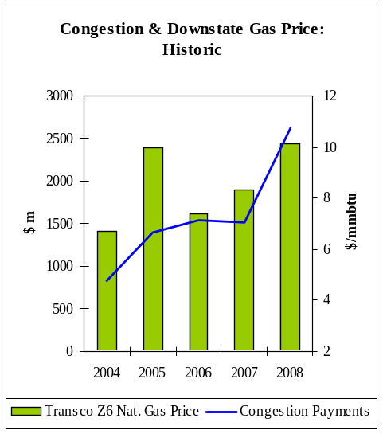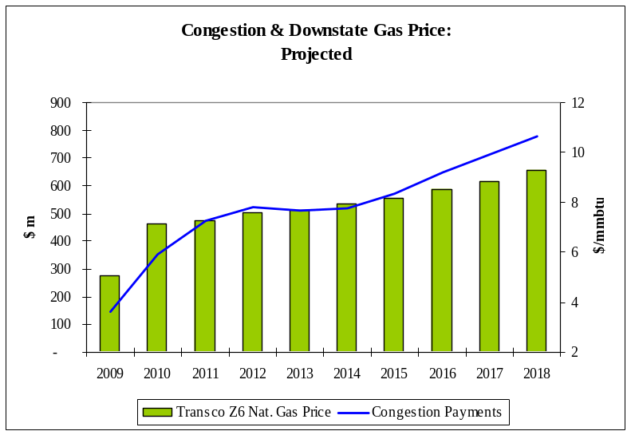
Figure 1: Congestion Payments and Downstate Natural Gas Price: Historic & Projected (nominal $ m)

A. The Three Congestion Studies
The NYISO ranked the five highest congested monitored elements based on Demand$ congestion and selected the three highest ranked groupings of transmission system elements with the largest production cost savings as the three CARIS studies. The three groups of elements that are analyzed in the CARIS studies are located in the upper Hudson Valley (Study 1: Leeds - Pleasant Valley), central New York (Study 2: Central East), and western New York (Study 3: West Central). Figure 2 below indicates the total annual level of congestion projected on these groups of elements between 2009 and 2018.
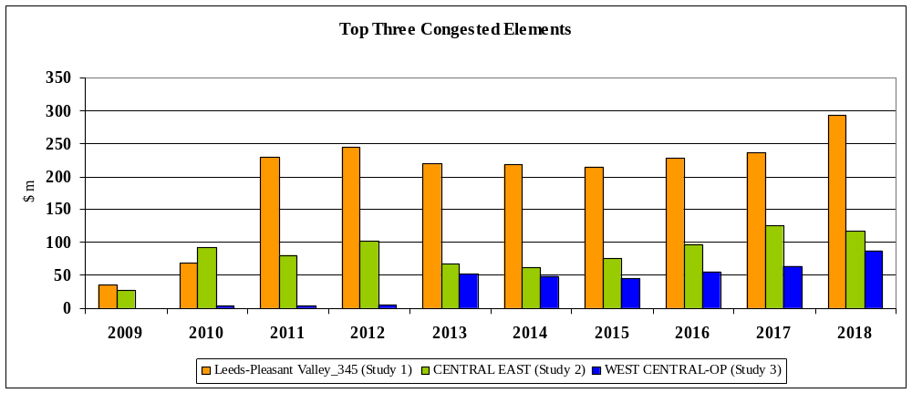
Figure 2: Projected Congestion on the Top Three CARIS Elements (nominal $ m)
The top three sets of congested transmission system elements, or study areas, are shown geographically, along with their ten-year present value of congestion in Figure 3.
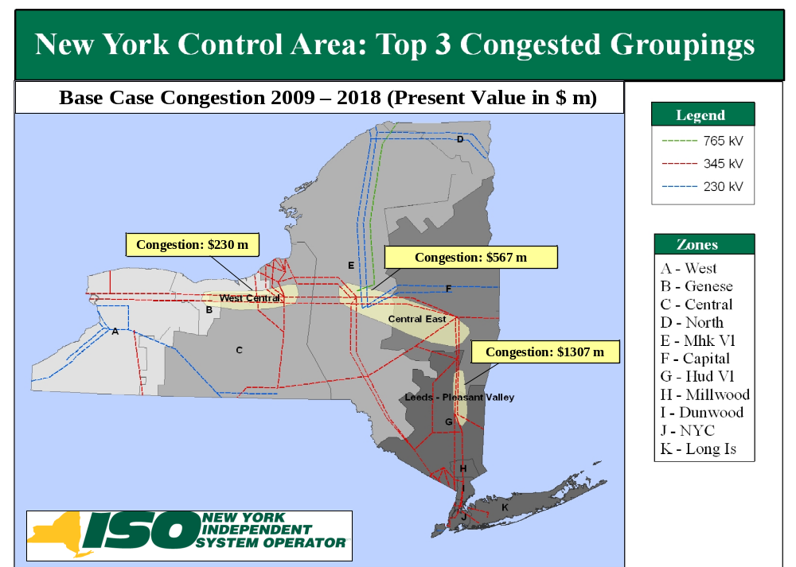

Figure 3: Projected Congestion on the Top Three CARIS Elements, Present Value in 2009 $ m
In each of the three studies, the NYISO calculated the present value of congestion savings over ten years by applying generic transmission, generation and demand response (DR) resources. Each generic transmission line solution consists of building a new 345kV transmission line rated at 1,000 MVA connecting the buses upstream and downstream of the congested element. Each generic generation solution consists of building a new 500 MW combined cycle plant connected downstream of the congested element. Each demand response generic solution consists of installing 100 MW of energy efficiency and 100 MW of demand response in the zone located downstream of the congested element. The generic solutions did not attempt to alleviate all of the congestion or to identify optimum solutions nor was the feasibility of any generic solutions evaluated. Costs for each type of generic solution were developed through the stakeholder process. Recognizing that the costs, points of interconnection, timing, and characteristics of actual projects may vary significantly, a range of costs (low, medium and high) was developed for each type of resource. The estimated cost of each of the generic solutions was compared to the present value of production cost savings for a ten-year period, yielding a benefit/cost ratio for each generic solution.

Figure 4 shows the production cost savings for each generic solution. For purposes of a relative order of magnitude comparison, nominal electric production costs in New York over the ten-year study period ranges between $4.1 billion and $7.5 billion annually.

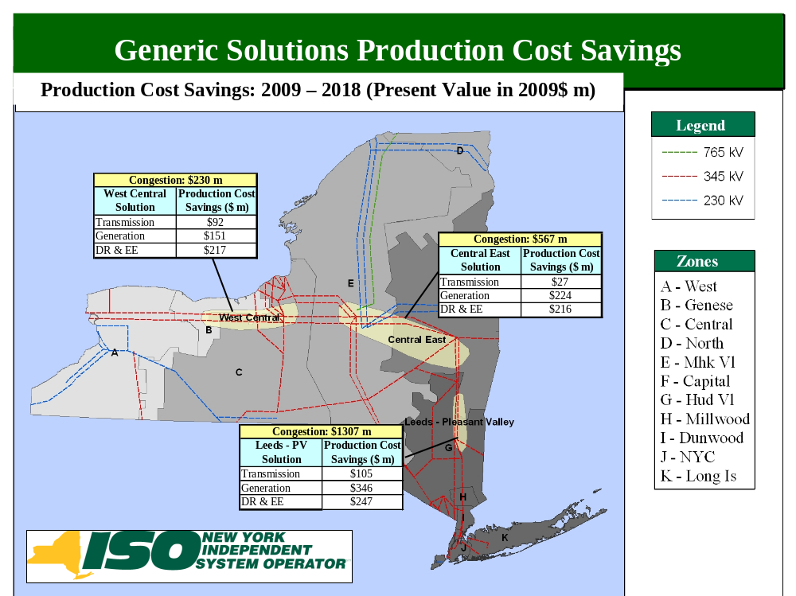

Figure 4: NYCA Generic Solutions Production Cost Savings: Present Value in 2009 $ m
The primary metric used to conduct benefit/cost analysis is the change in NYCA-wide production costs. The benefit/cost ratios displayed in Figure 5 are based on the cumulative present value in 2009 dollars of the production cost benefits for the first ten years of operation with an assumed 16% carrying charge rate applied to the project cost.
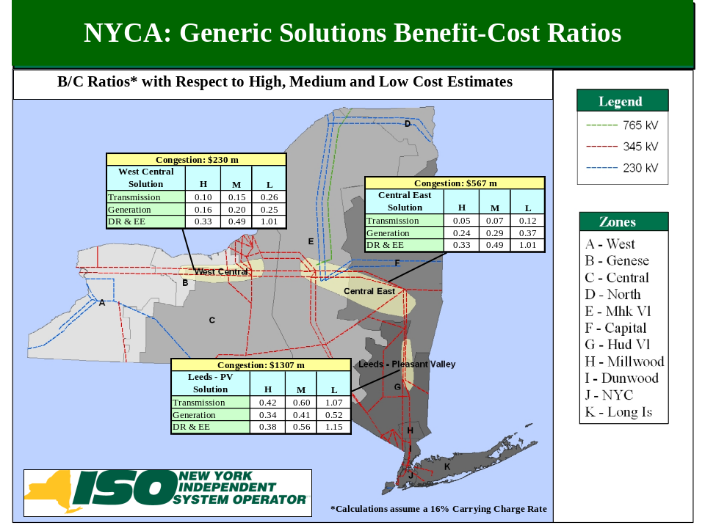
Figure 5: NYCA Generic Solutions Benefit/Cost Ratios
B. Additional Metrics
In addition to the statewide production cost savings for each generic solution, the NYISO has also provided, for informational purposes, an analysis of additional metrics for each study, including (a) emission costs/tons, (b) generator payments, (c) LBMP load payments, (d) installed capacity (ICAP) MW impact, (e) losses on the bulk power transmission system, and (f) transmission congestion contracts (TCCs) or congestion rents. These additional metrics are summarized in Table 1 and Figures 6 and 7.
Table 1 shows the ICAP cost metric based on the simplified MW impact methodology after the generic solutions are applied. Transmission solutions may provide an ICAP value because they enable better utilization of the existing generating resources and therefore enable a reduction in the Installed Reserve Margin (“IRM”). Generation and DR/EE solutions provide some direct ICAP value because the solutions themselves result in ICAP resources. Depending on the location of the solution, it may also provide for a reduction in the IRM and therefore an ICAP value that is greater than the ICAP size of the solution itself, or an increase in the IRM and therefore an ICAP value that is less than the ICAP size of the solution itself. For example, adding 500 MW at Pleasant Valley yields 595 MW less ICAP NYCA-wide than the Base Case but adding 500 MW at New Scotland only yields 255 MW less ICAP NYCA-wide than the Base Case.

Table 1: ICAP Metric – NYCA MW Value in 2018

Study Area | Transmission Solution | Generation Solution  (500 MW) | DR/EE  Solution  (200 MW)
Study #1 - Leeds-Pleasant Valley | 250 | 595 | 225
Study #2 - Central-East | 0 | 255 | 70
Study #3 - West Central | 0 | 220 | 70
Note: These values represent the NYCA-wide MW impact to maintain the base case Loss of Load Expectation (LOLE) after applying the generic solution.

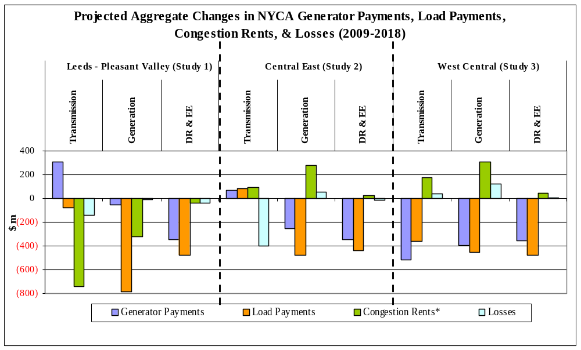

Figure 6: Change in Generator Payments, Load Payments, Congestion Rents, and Losses (nominal $ m)

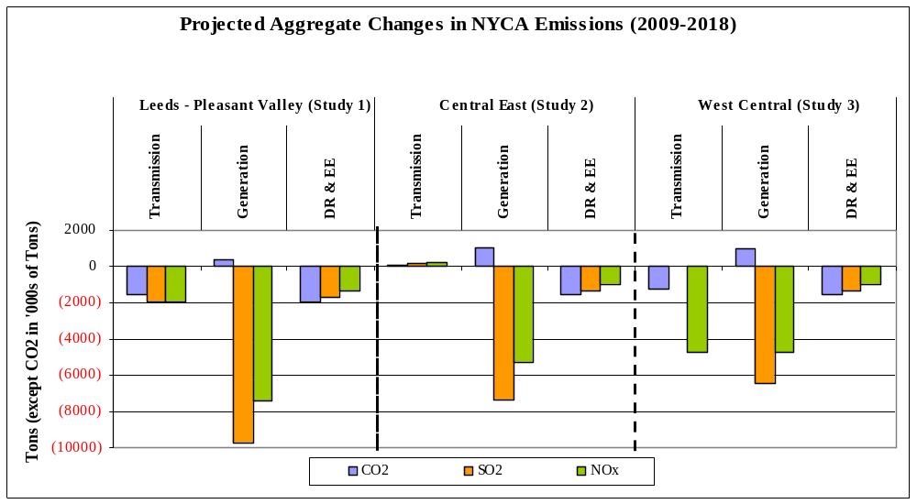
Figure 7: Change in CO₂, SO₂ and NO_{X} Emission
The results depicted in Figure 6 indicate that changes in these additional metrics are below two percent as compared to the CARIS Base Case, with the exception of slightly higher changes in congestion rents. The largest impact on the congestion rent (TCC metric) is shown in the Leeds-Pleasant Valley study, with a decrease of approximately 10%. Overall, of the three studies, Leeds- Pleasant Valley generally shows relatively larger impacts on the additional metrics.
The values shown in Figure 7 indicate that the application of generic solutions tends to reduce emissions. These reductions are small compared to NYCA total electric generation emissions, at most under two percent, compared to the base case emissions. The magnitudes of these reductions are consistent with the nature of the generic solutions compared to the overall NYCA resources.
C. Scenario Analysis
The NYISO also evaluated the impact of factors on congestion in the three study areas by conducting a series of ten scenarios selected by the NYISO and its stakeholders. These scenarios evaluated potential changes in environmental emission requirements, the amount of resources added through the State Renewable Portfolio Standard, savings realized from the State Energy Efficiency Portfolio Standard, generation retirements and additions, and changes in forecasted energy consumption. To illustrate the impact of each of these factors, the NYISO calculated the changes in projected congestion for each study in the fifth (2013) and tenth (2018) years. Figures 8, 9 and 10 below show the impact of each scenario on congestion for 2013 and 2018 combined. Negative values represent a reduction in congestion.
Table 2 lists major assumptions used for each scenario. For detailed descriptions of each of the ten scenario assumptions, refer to Section 5.6.2.
Table 2: Major Scenario Assumptions
Scenario | Case # | Major Assumptions
State Policy | 1 | Governor’s “45x15”, coal retirements,
State Policy | 1 | high emissions cost
NYISO Update | 2 | Updated fuel and load forecasts, resources
High Growth | 3 | 2008 Econometric load forecast
High Fuel | 4 | Higher fuel prices
High Load and Fuel | 5 | Cases 3 & 4
Low Fuel | 6 | Lower fuel prices
1000 MW on HQ Border | 7 | 2 Generic 500 MW on HQ border
Modified State Policy | 8 | Case 1 with lower fuel prices
New 500 MW Astoria 345 kV | 9 | Generic 500 MW on Astoria 345 kV
New 500MW Staten Island | 10 | Generic 500 MW on Staten Island
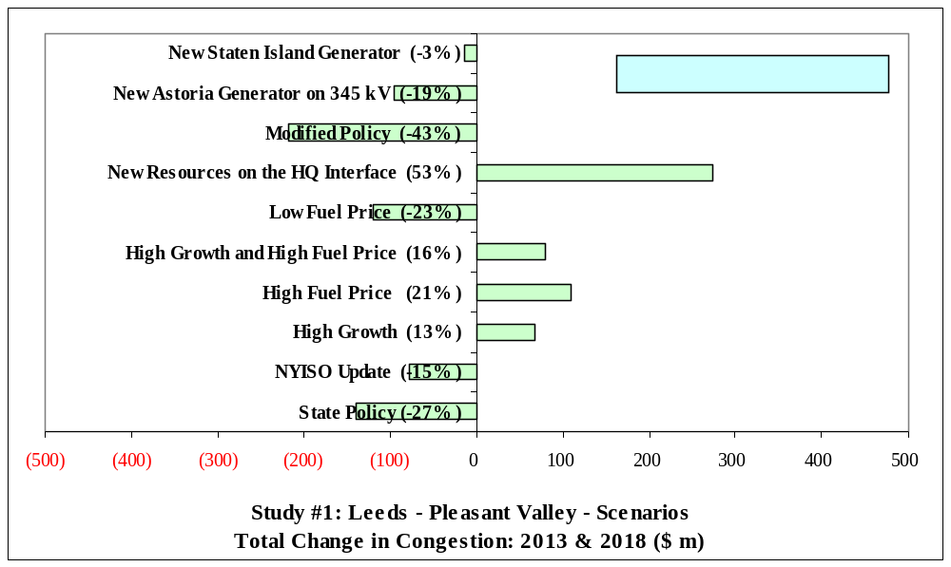

Figure 8: Scenarios Impact on Congestion in Leeds-Pleasant Valley Study (nominal $ m)

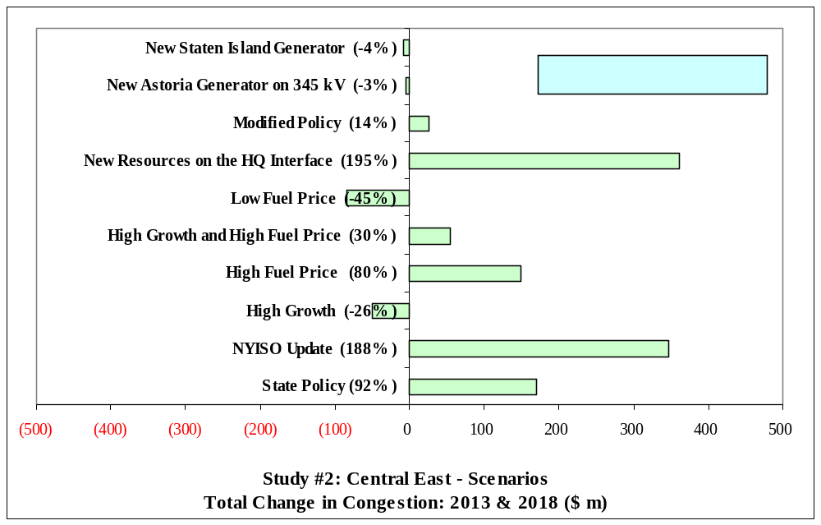
Figure 9: Scenarios Impact on Congestion in Central East Study (nominal $ m)
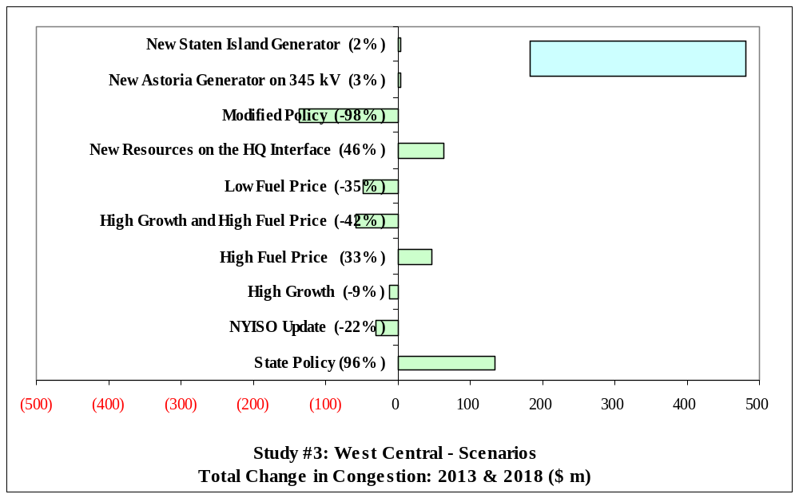

Figure 10: Scenarios Impact on Congestion in West Central Study (nominal $ m)

The scenario analysis provides useful insight on the sensitivity of projected congestion values to differing assumptions. Variations in some inputs provide results that are consistent across NYCA, while other inputs yield changes that are more localized.
3. Key Findings and Observations
- Potential Impacts - This report provides an economic analysis of congestion on the New York State bulk power transmission system and the potential costs and benefits of relieving that congestion. The study serves as an invitation to interested parties to consider developing transmission, generation or demand response projects, as appropriate, to relieve congestion, and to propose transmission projects for economic evaluation and potential recovery of costs through the NYISO’s Tariff. There are other potential benefits to relieving transmission congestion, such as reduced load payments, increased generator payments, reduced losses, ICAP savings, and reduced emissions that may be of interest to parties in making their investment decisions. The additional metrics may also show increased costs to some loads due to reduced credits from TCC payments.

- Basis for Projected Production Cost Savings - The level of congestion projected from the CARIS model varies from historic levels. The difference occurs due to certain input parameters that are not incorporated into the CARIS model, including market bid behavior, virtual transactions, transmission outages, and actual commodity prices/hourly loads. Section 5.1.1 of this report describes the relationship between congestion levels and Bid Production Cost since 2003.
Projected benefits are dependent upon each solution’s project parameters (size, location, type, etc.). The projected benefits also depend upon non-project parameters (fuel price, stream of benefits over the CARIS study period, etc.).
- Congestion Projection - The CARIS production cost model projects a range of annual congestion values in New York ranging from $146 million in 2009 to $780 million in 2018 without generic solutions being applied. Historic congestion range from $833 million in 2004 to $2,613 million in 2008. Actual congestion realized in the future years may differ because actual system operating conditions, economic conditions, and market behavior may be different from what has been assumed in the study (See Appendix E.2. for modeling validation). For example, based upon actual congestion in the first quarter of 2009, the model underestimated congestion for all of 2009 since actual first quarter congestion was $223 million (absolute value) versus the model results of $146 million as presented in Section 5, Table 5-4.

- Study Area Impacts - Among the three constraints studied, none of the benefit/cost ratios that resulted from the high or medium range of generic project cost estimates were greater than 1.0. In the case of the low range cost estimates, each of the constraints studied exhibited benefit/cost ratios slightly above 1.0 with the generic demand response solution. The Leeds-Pleasant Valley study also exhibited a benefit/cost ratio slightly above 1.0 with the transmission solution’s low range cost estimate.
- No New Resources Added - This study is based upon existing NYCA resources. No new resources were added beyond the 2009 CRP base case. Additional resources coupled with the solutions studied will produce different results than those captured here.
- Specific Solutions Will Produce Different Results - Projects with characteristics other than the generic projects studied here could also relieve congestion, but were not analyzed in this study. The generic solutions are for informational purposes only. Also, since the study only analyzed congestion relief for each of the three groups individually, combining the solutions and aggregating the studied transmission facilities may increase production cost savings as well as total project costs.
- Diversity of NYCA Impacts- This study reports the benefits of relieving congestion both statewide and by zone across New York. All zones will not benefit equally. Some zones will see decreased load payments due to a project and others will see increased load payments.

- Benefit Lifespan - The useful life of actual projects may be longer than the ten-year period studied in this report. Due to uncertainty associated with projecting congestion costs and savings, this study did not capture costs and benefits beyond the ten-year study period.
- Broader Regional Markets - New York is not the only beneficiary of relieving congestion. Neighboring electric systems may also experience benefits from congestion relief as power flows more freely across regional markets. Congestion relief is considered an important aspect of broader regional market design.
- Congestion Pattern Changes - There have been changes in congestion patterns across the New York bulk transmission system over the past several years caused by several factors, as discussed in the 2008 State of the Markets Report by Potomac Economics. For example, low natural gas prices adopted in the study may reduce the cost of congestion. Also, system enhancements such as the Neptune HVDC line, the Linden Variable Frequency Transformer (VFT), and the Caithness generator may reduce the congestion projected in New York City and the Empire generator may increase projected congestion in upstate New York.
4. Next Steps
Additional Study Requests
Going forward, any interested party can at any time request an additional study of congestion and the effect of their demand response, generation or transmission project on the New York bulk power system, at their expense. NYISO will study the requests in the order in which they are accepted and as resources will allow.

Specific Project Analysis
Phase 2 of the CARIS process will begin upon approval of this Phase 1 report by the Business Issue Committee, the Management Committee and subsequently the NYISO Board of Directors. In Phase 2, developers are encouraged to propose projects to alleviate the identified congestion. The NYISO will evaluate proposed specific economic transmission projects upon a developer’s request to determine the extent such projects alleviate congestion, and whether the economic benefits would make such project eligible for cost recovery under the NYISO’s Tariff. While the eligibility criterion is production cost savings, zonal LBMP load savings (net of TCC revenues and bilateral contracts) is the metric used for the identification of and cost allocation to beneficiaries for transmission projects in Phase 2. If the project: (a) alleviates congestion, (b) has a capital cost of at least $25 million,(c) has benefits that outweigh costs over the first ten years of operation, and (d) receives approval to proceed from 80 percent or more of the actual votes cast on a weighted basis, the developer will be able to obtain cost recovery of their transmission projects through the NYISO’s Tariff, subject to the developer’s filing with FERC for approval of the project’s costs.

.

Introduction
The NYISO is undertaking a new process pursuant to Attachment Y of its Open Access Transmission Tariff (OATT, or the Tariff) to assess both historic and projected congestion on the New York bulk power system. This new process, known as the Congestion Assessment and Resource Integration Study (CARIS), will estimate the economic benefits of relieving that congestion by studying the effect of integrating potential transmission, generation and demand response resources. CARIS builds on the NYISO’s existing Comprehensive Reliability Planning Process (CRPP). Together with the Local Transmission Planning Process (LTPP) and the CRPP, the CARIS completes the NYISO’s new overall Comprehensive System Planning Process (CSPP). The LTPP is the first step in the CSPP. When the reliability planning process is approved by the NYISO’s Board of Directors (Board), the CARIS begins, starting from a reliable system as described in the approved Comprehensive Reliability Plan (CRP).
CARIS consists of two phases: Phase 1, the Study Phase, and Phase 2, the Project Phase. In Phase 1, the NYISO, in collaboration with its stakeholders and other interested parties, develops a ten-year projection of congestion, identifies, ranks and groups the most congested elements on the New York bulk power system based on the historic and projected congestion, and develops the three CARIS studies. Each of the three studies includes: (a) the development of generic solutions to mitigate the identified congestion; (b) a benefit/cost assessment of each solution based on NYCA-wide production cost savings; (c) presentation of additional information on other related congestion metrics to all stakeholders; and (d) scenario analyses performed on the base case to assess the impact of a range of potential market conditions on congestion associated with the top three groupings. Phase 1 results are presented in a written report to the NYISO’s Electric System Planning Working Group (ESPWG) and the Transmission Planning Advisory Subcommittee (TPAS) for review. After that review, the draft report is presented to the NYISO’s Business Issues Committee (BIC) and the Management Committee (MC) for discussion and action within the NYISO’s governance process before being submitted to the Board for approval.
This document is the NYISO’s first CARIS report. It presents the Phase 1 study results and provides objective information on the nature of congestion in the New York Control Area (NYCA) that developers can use to decide whether to proceed with transmission upgrades or other resource additions (generation or demand response). This report does not make recommendations for specific projects, and does not favor any type of resource addition or other actions. This process was developed to augment the NYISO’s planning processes, and to assist the market by providing information to potential developers to assist them in deciding whether to invest in projects based on the economics of the NYISO’s markets. Developers may also propose economic transmission projects for regulated cost recovery under the NYISO’s Tariff and proceed through Phase 2 of CARIS - the Project Phase - which will be conducted by the NYISO in 2010. For these transmission projects, the NYISO will determine whether they qualify for regulated cost recovery under the Tariff. Eligible economic transmission projects that elect to pursue regulated cost recovery under the NYISO’s Tariff must be approved by at least 80% of the weighted vote of New York’s Load Serving Entities (LSEs) that serve loads in zones that the NYISO identifies as beneficiaries of transmission projects. The beneficiaries are those load zones that experience net benefits measured over the first ten years from the proposed project commercial operation date. Developers of economic generation or demand response projects may choose to pursue such projects on a merchant basis, or to enter into contracts with LSEs or other parties. CARIS provides additional data and tools to assist in the development of policy and to provide information to potential developers on their investment decisions.
CARIS estimates of future congestion are forecasts that may be different than actual congestion experienced in the future. To complete the study, the inputs and assumptions that are used for the CARIS study were frozen at initiation. For this CARIS cycle, the CARIS studies are based upon the 2009 CRP base case which was developed in mid-2008 and includes assumptions about the NYCA system and load growth. As a result, the base case does not include recent developments, such as the load forecast reductions caused by the current economic downturn. Further, CARIS simulations are based upon a limited set of long term assumptions about the utilization of grid resources throughout the ten-year planning horizon which are subject to change. The costs used for the benefit/cost ratios developed for generic projects represent the average cost for a broad range of projects for each type of generic solution, and are intended for illustrative purposes only.

Background

The Evolution of Planning Processes at the NYISO
Since its formation in 1999, the NYISO carried out two primary functions: (1) the reliable operation of New York’s bulk power system and (2) the administration of New York’s competitive wholesale electricity markets. The restructuring of the New York electric industry from vertically-integrated transmission, generation and distribution companies operating under traditional cost of service regulation to wholesale markets was designed to incent private investment in generation, transmission and other resources to foster competition. Additionally, this restructuring provided for the shift of the risk associated with these investments away from ratepayers to investors operating in economically-efficient and transparent wholesale markets. System planning, therefore, was initially restricted to conducting analyses for entities requesting transmission service which would require transmission upgrades and/or additions under Section 19 and 32 of the NYISO’s Open Access Transmission Tariff (OATT) and Market Administration and Control Area Services Tariff (Services Tariff). This system also allowed the New York Public Service Commission (NYSPSC) to request studies of transmission upgrades. In addition, NYISO had the responsibility for conducting analyses of any new generation or transmission facilities proposing to interconnect to the New York Bulk Power System to determine the necessary system upgrades for compliance with applicable reliability standards.
The NYISO, in collaboration with its stakeholders, developed a CRPP in 2003-2004 to identify the Reliability Needs of the bulk power system looking out ten years and seek market-based solutions to the identified Reliability Needs. In December 2004, the Federal Energy Regulatory Commission (FERC) approved the CRPP filing, including the addition of a new Attachment Y to the NYISO’s OATT, and the NYISO immediately began its implementation in early 2005. The CRPP is a long-range assessment of resource adequacy and transmission reliability over a ten-year planning horizon. It includes the development of a Reliability Needs Assessment (“RNA”), an evaluation of proposed solutions, and the development of the CRP to address the identified needs.
For each Reliability Need identified in the RNA, the NYISO contemporaneously requests market-based solutions from the marketplace as well as regulated backstop solutions from the identified Responsible Transmission Owner(s). If no viable market-based solutions are developed in time to satisfy the Reliability Needs, the NYISO will initiate the second step of the solicitation process by requesting alternative regulated responses to Reliability Needs. Solutions may be generation, transmission, or demand response resources. Once it receives the proposed market-based and regulated backstop solutions, the NYISO assesses these solutions and reports in the CRP whether the projects submitted will meet the identified Reliability Needs. If the NYISO deems a Responsible TO’s regulated backstop solution necessary to meet a Reliability Need, the costs incurred by the Responsible Transmission Owners in planning, developing, and implementing the regulated backstop solutions are recoverable, until such time as it is halted, pursuant to the NYISO Tariff. The principal objective of the CRPP is to maintain reliability by providing an opportunity for developers to invest in new, market-based projects before triggering a regulated backstop solution. To date, the NYISO has completed four annual cycles of the CRPP. Most recently, the NYISO staff, in collaboration with its stakeholders, developed the 2009 CRP, which was approved by the NYISO Board in May, 2009. The Plan identified no Reliability Needs through 2018 — provided system conditions do not change — and evaluated the risks that could give rise to Reliability Needs before that time. The 2009 CRP forms the foundation for this first CARIS study.
In Order No. 890, the FERC expanded the planning responsibilities of the NYISO and the New York Transmission Owners (NYTOs) setting forth nine principles that all planning processes are required to meet. The NYISO and the NYTOs submitted a joint compliance filing in December 2007, which proposed Tariff changes creating a three-stage CSPP which will span a two-year cycle. First, each NYTO conducts a LTPP for its respective transmission system and provide the input assumptions and results to interested parties through the NYISO stakeholder process for review and comment. Second, the LTPP provides input into the CRPP, which remains largely unchanged from the process first implemented in 2005. Third, the NYISO conducts the CARIS to: (a) identify the most constraining elements on the New York bulk power system and study the potential benefits and costs associated with relieving that identified congestion; and (b) provide that information to stakeholders in order to facilitate the development of solutions to the identified congestion. Solutions can be developed by both NYTOs and private developers. Transmission project sponsors are eligible for transmission project cost allocation and regulated cost recovery through the Tariff if such project is approved by a supermajority of voting beneficiaries. The NYISO CSPP is illustrated in Figure 2-1 below.
The joint NYISO/NYTO compliance filing was conditionally approved by the FERC on October 18, 2008. The NYISO and the NYTOs made three subsequent compliance filings. On October 15, 2009, the FERC accepted the compliance filings and required a further compliance filing by December 14, 2009 on certain discrete issues. These issues include providing additional detail in the Tariff on how incremental Transmission Congestion Contracts and bilateral contract payments will be handled in Phase 2 of the CARIS, and reporting on voting by project beneficiaries in Phase 2. None of the changes requested by the FERC affect this Phase 1 CARIS report. Based on the FERC’s conditional approval, the NYISO and the NYTOs began implementing CARIS with stakeholders, using the 2009 CRP as the basis for this study.
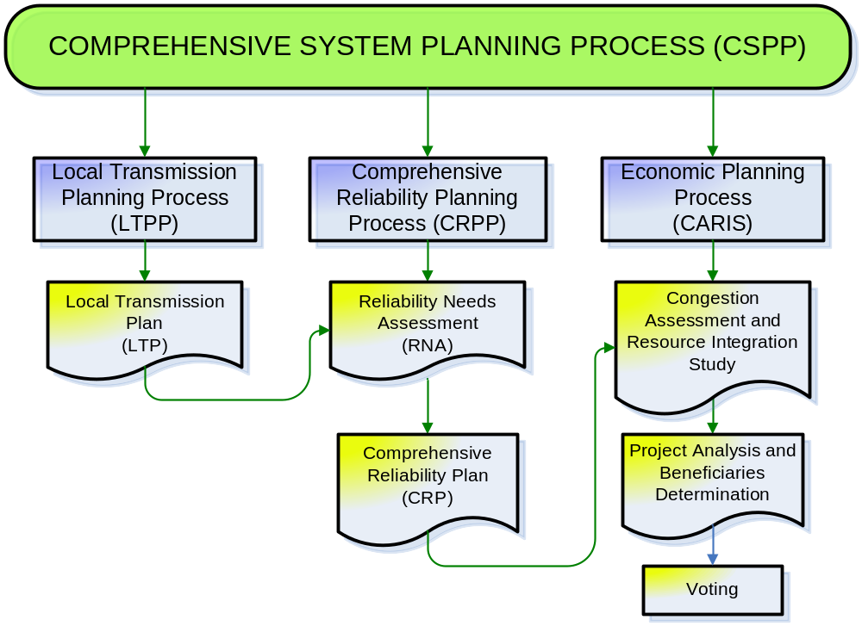
Figure 2-1: NYISO Comprehensive System Planning Process

CARIS Process
As directed by FERC Order 890, the NYISO collaborated with its stakeholders through multiple joint ESPWG and TPAS meetings, soliciting inputs and feedback, while developing CARIS procedures, study modeling and assumptions. Further, the procedures were reviewed with the BIC before implementing Phase 1 of CARIS.
The objectives of the CARIS economic planning process are to:
a. Provide estimates of future congestion on the New York State bulk power transmission facilities over the ten-year CSPP planning horizon;
b. Identify, through the development of appropriate scenarios, factors that might mitigate or increase congestion;
c. Provide information to market participants, stakeholders and other interested parties on generic solutions to reduce congestion;
d. Provide an opportunity for developers to propose solutions that may reduce the congestion; and
e. Provide a process for the evaluation and approval of regulated economic transmission projects for regulated cost recovery under the NYISO Tariff.

The 2009 CARIS builds upon and aligns with the CRPP and assumes a baseline reliable system identified in the 2009 CRP for the ten-year study period from 2009 to 2018. Figure 2-2 below presents a graphical depiction of the CARIS process.

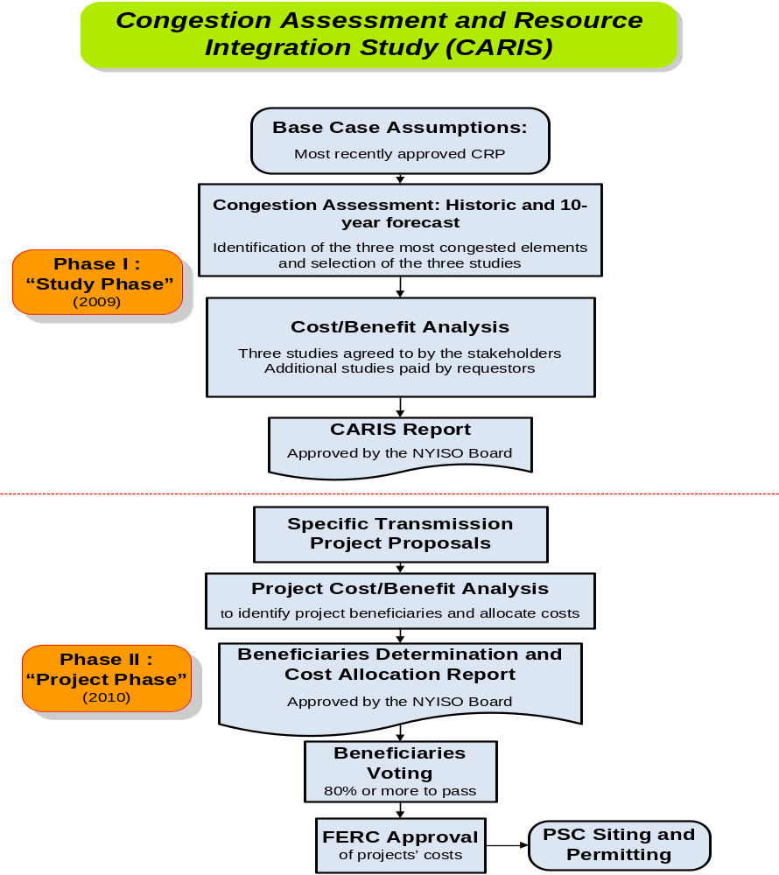
Figure 2-2: Overall CARIS Diagram

Phase 1 - Study Phase
In Phase 1 of the CARIS process, the NYISO, in collaboration with market participants, identifies the three most congested elements in the New York bulk power system, determines the three CARIS studies, applies the generic solutions to the congestion identified, and conducts the benefit/cost analysis of the applied generic solutions. In addition, the NYISO also performs scenario analyses, with scenarios including but not limited to load forecast uncertainty, fuel forecast uncertainty, new resources, retirements, emissions changes, environmental proposals and energy efficiency programs.
In identifying the most congested elements, the NYISO performs both a five-year historic and a ten-year forward-looking congestion assessment to identify the five most congested elements, and through a relaxation process, develops potential groupings and ranks them based on the highest production cost savings resulting from the relaxation. The top three ranked groups become the subjects of the three CARIS studies. For each of these three studies the NYISO conducts a benefit/cost analysis of generic solutions. All resource types, generation, transmission and demand response, are considered on a comparable basis as generic solutions to congestion. The solutions analyzed are not specific projects, but rather represent generic transmission, demand response and generation resources placed individually in key locations on the system to measure their effects on relieving each of the three most congested elements. The principal metric for measuring proposed solution benefits for each generic solution is the NYCA wide production cost savings that would result from each generic solution, expressed as the present value over the ten-year planning horizon. The NYISO also reports data on additional metrics, including estimates of reductions in losses, changes in Locational Based Marginal Prices (LBMP) load payments, changes in installed capacity costs, changes in emissions costs and changes in payments for Transmission Congestion Contracts (TCCs). The TCC payment metric in Phase 1 has been simplified to include congestion rent calculations only and is different from the TCC revenue metric contained in Phase 2. CARIS metrics are described in more detail in Section 3.
Upon completion of the Phase 1 analysis, the results of the analysis are presented to stakeholders in this written report. The report provides interested parties with a wide range of information, including a discussion of its assumptions, inputs, and methodology to assist them in identifying and developing actual solutions to transmission congestion. A draft CARIS report is first submitted to the ESPWG and the TPAS for review and comment. Following completion of that review, the draft CARIS report is sent to the BIC and the MC for discussion and action. Thereafter, the draft CARIS, with BIC and MC input, is forwarded to the NYISO Board for review and action. The draft CARIS is also provided to the Independent Market Advisor for review and consideration. The Board may approve the CARIS report as submitted or propose modifications on its own motion for further consideration. Upon approval by the Board, the NYISO issues the CARIS report and posts it on its website.
In addition to the three CARIS studies, stakeholders may also request additional studies of system congestion at their own expense. Requests may be made at any time, and studies will be conducted to the extent NYISO’s resources allow. The NYISO posts all requests for studies on its website. The specific process for requesting, conducting and paying for additional studies is set forth in Section 1.1.2 of the Initial CARIS Manual. Other information on additional studies, including the form to request additional studies, is posted on the NYISO website. No results of any additional studies are included in this report.

Phase 2 – Project Phase
Phase 2 of the CARIS is conducted after the approval of the Phase 1 report by the NYISO Board. In Phase 2 the developers of potential transmission projects that have an estimated capital cost in excess of $25 million to alleviate congestion may seek regulated cost recovery through the NYISO Tariff. Such developers must submit their projects to the NYISO for analysis of benefits and costs (project’s benefit/cost analysis) at any time prior to the input phase (Phase 1) of the next CARIS cycle, in accordance with the cost allocation principles and methodologies contained in Tariff. Projects are eligible for regulated cost recovery if they would produce net savings based upon a comparison of the NYCA-wide production cost savings with the annual total revenue requirements for the project; both computed over the first ten years following the projected in-service date of the facility. The costs for the benefit/cost analysis will be supplied by the developer of the project using a reasonable amortization period. Specific project cost for the benefit/cost analysis will then be expressed as the net present value of the first ten years of the annual total revenue requirement for the project, starting from the proposed commercial operation date of the project.
Beneficiaries determined by the NYISO will be LSEs in load zones determined to benefit economically from the project, and cost allocation among load zones will be based upon their relative economic benefit. The beneficiary determination for cost allocation purposes will be based upon each LSE’s zonal net LBMP load savings. The net LBMP load savings are determined by adjusting the LBMP load savings to account for TCC revenues and bilateral contract payments; all entities in the zones with positive LBMP load savings are considered to be beneficiaries. The net LBMP load savings produced by a project over the first ten years of commercial operation are measured and compared on a net present value basis with the project’s revenue requirements over the same first ten years of a project’s life measured from its expected in-service date. LBMP load savings are calculated first on a zonal basis and are then allocated to each LSE in a zone according to the ratio of its load to all load in the zone - both expressed in MWh.
In addition to the NYCA-wide production cost savings metric, the NYISO will also provide additional metrics, for information purposes only, to estimate the potential benefits of the proposed project and to allow LSEs to consider other metrics when evaluating or comparing potential projects. These additional metrics will include estimates of reductions in losses, changes in LBMP load payments, changes in generator payments, changes in Installed Capacity (ICAP) costs, changes in emissions costs, and changes in TCC revenues. The TCC revenue metric that will be used in Phase 2 of the CARIS process is different from the TCC payment metric used in Phase 1. In Phase 2, the TCC revenue metric will measure reductions in estimated TCC revenues and allocation of congestion rents to the TOs ( for more detail on this metric see Section 3.3.2 of this report and the Initial CARIS Manual, Section 15.4b).
The NYISO will also analyze and present additional information by conducting scenario analyses, where appropriate, regarding future uncertainties, such as possible changes in load forecasts, fuel prices and environmental regulations, as well as other qualitative impacts, such as improved system operations, other environmental impacts, and integration of renewable or other resources. Although this data may assist and influence how a benefiting LSE votes on a project, they will not be used for purposes of cost allocation.
The NYISO will provide its benefit/cost analysis and beneficiary determination for particular projects to the ESPWG for comment. Following that review, the NYISO benefit/cost analysis and beneficiary determination will be forwarded to the BIC and MC. After the MC vote on the benefit/cost analysis, the benefit/cost analysis and beneficiary determination will be forwarded to the NYISO Board of Directors for review and approval.
After the project benefit/cost and beneficiary determinations are approved by the NYISO Board and posted on the NYISO’s website, the project will be brought to a special BIC meeting for a vote by the identified LSEs, utilizing the economic planning process voting procedure (see the Initial CARIS Manual, Appendix F), on whether the project is approved for cost allocation. The specific provisions for cost allocation are set forth in the Tariff which also calls for the NYISO to establish procedures to determine the specific list of voting entities for each proposed project. That procedure and procedures for conducting a vote on proposed projects in Phase 2 of CARIS are under development at the ESPWG and are not the subject of this report. In order for a project to be approved for regulated cost recovery, the Tariff states that “eighty (80) percent or more of the actual votes cast on a weighted basis must be cast in favor of implementing the project.” If the project meets the required vote in favor of implementing the project, and the project is implemented, all beneficiaries, including those voting “no,” will pay their proportional share of the cost of the project through the NYISO Tariff. This process does not relieve the developer of the responsibility to file with FERC for approval of the project costs and with the appropriate state authorities to obtain siting approval for the project.

Other Planning Studies
Numerous electric system planning processes have taken root at the national, state, and local levels simultaneous to the expansion of the NYISO’s electric system planning functions. In the American Reinvestment and Recovery Act, Congress encouraged broader transmission system planning to upgrade aging facilities and expand transmission capability to move power between regions in the United States and Canada, such as for delivering renewable energy resources from resource rich areas to urban load centers. To implement this initiative, the US Department of Energy (DOE) has made funding available for interconnection-wide planning under a Funding Opportunity Announcement (FOA) issued on June 15, 2009. The NYISO is participating in the formation of the Eastern Interconnection Planning Collaborative (EIPC) to conduct transmission planning studies for the Eastern United States and Canada. On September 14, 2009, the EIPC applied to the DOE for a grant to fund this endeavor.
Regionally, the NYISO continues to participate in the Northeast Coordinated System Planning Protocol (NCSPP). The NYISO, ISO New England (ISO-NE), Independent Electricity System Operator of Ontario (IESO), and PJM Interconnection LLC (PJM) executed the regional planning protocol in December 2004 to provide a vehicle to enhance coordination of planning in the northeastern United States, with the participation of Canadian planning authorities. The collaborative released a Northeast Coordinated System Plan (NCSP) in 2006 and in 2009 to address Reliability Needs among regions and seams issues among ISO and Regional Transmission Organization (RTO) markets. The 2009 NCSP is posted on the NYISO’s website at http://www.nyiso.com/public/webdocs/services/planning/ipsac/NCSP03-27-09.pdf.
At the state level, the Governor of New York re-established a State Energy Planning Board (SEPB) by Executive Order in April 2008. The NYISO has actively participated in the SEPB working group, filing comments, submitting white papers on timely topics, and conducting reliability modeling for a bulk power system assessment. The SEPB released a draft State Energy Plan (SEP) in August 2009, and the NYISO provided further written comments on October 19, 2009. Pending the completion of the State Energy Plan in late 2009, the NYSPSC has held Phase 3 of its Electric Resource Planning (ERP) proceeding in abeyance. The ERP proceeding will expand upon and implement SEPB policy initiatives, such as state support for renewable resources, demand response and energy efficiency.
With input from the NYISO, the NYTOs are conducting the New York State Transmission Assessment and Reliability Study (STARS). STARS is a joint study of the state's bulk power system over a 20-year planning horizon to help meet future electric needs, support the growth of renewable energy sources, and ensure the reliability of the power system. Its aim is to develop a thorough assessment of the transmission system and suggest long-range plans for coordinated infrastructure investment in the state’s power system. Because the bulk power system is owned by separate entities, yet interconnected, the STARS will examine the types of investments, including smart grid applications, needed to meet the long-term needs of the entire control area to complement studies currently being performed by the New York Independent System Operator (NYISO).
Finally, at the municipal level, the City of New York created a City Energy Planning Board (CEPB) as part of Plan NYC. The CEPB is designed to provide a coordinated vision in providing for the future energy needs of New York City considering supply and demand while addressing cost, reliability and environmental impacts. The City retained CRA International to conduct a Master Electrical Transmission Plan for the City, a long-term study of the City’s energy needs and policy initiatives that will affect NYISO’s planning processes. The New York City Economic Development Corporation released the results of this analysis in June 2009.

It is anticipated that specific projects which may result from any of the above initiatives will be analyzed under the NYISO’s interconnection and planning processes, including CARIS, if funding under the NYISO Tariff is requested for an economic transmission project.

CARIS Methodology and Metrics

CARIS Methodology
For the purposes of conducting the ten-year forward looking CARIS analysis, the NYISO, in conjunction with ESPWG, developed a production costing model database. The details and assumptions in developing this database were discussed at various ESPWG meetings and are summarized in Appendix C. The database was used in two production cost simulation software tools: ABB’s GridView and GE’s Market Analysis and Portfolio Simulation (MAPS), which are widely accepted in the industry. For benchmarking purposes, both tools are being utilized, and appear to give comparable results. Independent of this report, the NYISO will issue a separate report to stakeholders detailing the benchmarking of the GridView and MAPS tools and comparing the respective results to make a recommendation on tools to be used in future CARIS cycles. For the purposes of this report, only Grid View results are presented. Moving forward, the NYISO will maintain the common database for both tools.
For historic congestion analysis, the Portfolio Ownership and Bid Evaluation (PROBE) production cost simulation tool, developed by PowerGEM LCC, has been used in the last six years to perform the NYISO historic congestion analysis. PROBE utilizes the actual NYISO Day-Ahead Market (DAM) data to emulate the actual SCUC operation. Unlike the GridView and MAPS simulation, PROBE simulates virtual bidding and transmission outages, and calculates production costs based on generation mitigated bids. While those additional attributes are important in capturing the real congestion values for the past events, it is nearly impossible to model them with certainty in projecting future transmission congestion. Therefore, these attributes are not accounted for in the ten-year forward looking CARIS analysis. For more detail on each simulation tool see Appendix D. For illustrative purposes, a comparison between simulated and actual congestion for first Quarter 2009 is provided in Appendix D. Actual congestion may vary from projections depending on a number of factors.
The methodology for conducting the CARIS was vetted with ESPWG and incorporated in the Initial CARIS Manual.

CARIS Metrics
One of the key metrics in the CARIS analysis is termed Demand Dollar congestion (expressed with variable name Demand$ congestion in PROBE). Demand$ congestion for a constraint is the amount of congestion paid by load (without TCC hedges and bilaterals) throughout NYCA that is a result of that constraint. The Demand$ congestion values are calculated by multiplying zonal load with a transmission constraint’s shadow price and with the zone’s shift factor (SF) on that constraint. This definition is consistent with the definition that has been used for the reporting of historic congestion for the past six years. Demand$ is used to identify significant transmission constraints as candidates for evaluating generic solutions; it does not equate to payments by load.
In conducting Phase 1 of the CARIS process, the NYISO performed an assessment of historic and projected future congestion, identified the top three congested elements, and conducted benefit/cost analysis of each type of generic solution — transmission, generation and demand response/energy efficiency — to the identified congestion. The CARIS analysis reports various metrics that were developed with NYISO stakeholders at the ESPWG to measure the cost impacts of congestion and the benefits of its mitigation. The principal benefit metric for CARIS analysis is NYCA-wide production cost reduction that would result from each of nine generic solutions. Additional benefit metrics were analyzed as well, and the results are presented in this report for information purposes only. All benefit metrics were determined by measuring the difference between the projected CARIS base case system value and a projected system value when each generic solution was added. The discount rate used for the present value analysis was the current weighted average cost of capital for the NYTOs.

Principal Benefit Metric
The principal benefit metric for the CARIS analysis is the present value of the NYCA-wide production cost reduction that would result from implementation of nine generic congestion mitigation solutions. The NYCA-wide production cost savings are calculated as those savings associated with generation in the New York zones offset by the production cost savings attributed to the interchange flows (i.e. imports and exports). The flows related to each interface are valued on the basis of LBMPs at a selected proxy bus. See Table C–4 in Appendix C for a listing of the proxy buses.

Additional Benefit Metrics
The additional benefits, which are provided for information purposes only, include estimates of reduction in losses, LBMP load costs, generator payments, ICAP costs, Ancillary Services costs, emission costs, and TCC payments. All the quantities, except ICAP, will be the result of the forward looking production cost simulation for the ten-year planning period. The NYISO, in collaboration with the ESPWG, determined the methodology and models needed to develop and implement these additional metrics requirements, which are described below and detailed in the Initial CARIS Manual. An example illustrating the relationship among some of these metrics is provided in Appendix E.
Reduction in Losses – This metric calculates the change in marginal losses payments. Losses payments are based upon the loss component of the zonal LBMP load payments.
LBMP Load Costs – This metric measures the change in total load payments. Total load payments include the LBMP payments (energy, congestion and losses) paid by electricity demand (forecasted load, exports, and wheeling). Exports will be consistent with the input assumptions for each neighboring control area. Unhedged load payments represent total load payments minus the TCC payments.
Generator Payments – This metric measures the change in generation payments and includes the LBMP payments (energy, congestion, losses), and ancillary services payments made to electricity suppliers. Ancillary Services costs include payments for regulation services and operating reserves, including 10 minutes synchronous, 10 minutes non-synchronous and 30 minutes non-synchronous. Generator payments are calculated as the sum of the LBMP payments and ancillary services payments to generators and imports. Imports will be consistent with the input assumptions for each neighboring control area.
ICAP Costs – The measurement of this metric is highly dependent on the rules and procedures guiding the calculation of the installed reserve margin (IRM) and locational capacity requirement (LCR), both for the next capability period and future capability periods. Therefore, for the first CARIS cycle only, the NYISO will use the MW impact methodology. For more detail on this metric see the Initial CARIS Manual.
Emission Costs – This metric measures the change in the total cost of emission allowances for CO₂, NO_{X}, and SO₂, emissions on a zonal basis. Total emission costs are reported separately from the production costs.. Emission costs are the product of forecasted total emissions and forecasted allowance prices.
TCC Payments – The TCC payment metric is calculated differently for Phase 1 and for Phase 2 of the CARIS process, as agreed to by the stakeholders’ process at the ESPWG. The Phase 1 TCC payment metric is simplified to calculate congestion rents only:
- For Phase 1, the TCC payment metric measures the change in total congestion rents collected in the day-ahead market. Congestion rents are calculated as the product of the Congestion Component of the Day-Ahead LBMP in each Load Zone or Proxy Generator Bus and the withdrawals scheduled in each hour at that Load Zone or Proxy Generator Bus, minus the product of the Congestion Component of the Day-Ahead LBMP at each Generator Bus or Proxy Generator Bus and the injections scheduled in each hour at that Generator bus or Proxy Generator Bus, summed over all locations and hours.
- For Phase 2, the TCC payment metric referred to as TCC Revenues is used for the regulated economic transmission project cost allocation under Section 15.4 of the Tariff. The TCC revenue metric will measure net reductions in TCC Revenues and will reflect the forecasted impact of the project on TCC auction revenues and day-ahead residual congestion rents allocated to load in each zone, excluding the congestion rents that accrue to any incremental TCCs that may be made feasible as a result of this project. This impact will include forecasts of: (1) the total impact of that project on the Transmission Service Charge offset applicable to loads in each zone (which may vary for loads in a given zone that are in different Transmission Districts); (2) the total impact of that project on the NYPA Transmission Adjustment Charge offset applicable to loads in that zone; and (3) the total impact of that project on payments made to LSEs serving load in that zone that hold Grandfathered Rights or Grandfathered TCCs, to the extent that these have not been taken into account in the calculation of item 1 above. Calculations of net reductions in TCC revenues are detailed in the Initial CARIS Manual.

Baseline System Assumptions and Methodology
The implementation of the CARIS process requires the gathering, assembling, and coordination of a significant amount of data, in addition to that already developed for the reliability planning processes. In accordance with the Tariff, the starting point in conducting CARIS analysis is the NYISO’s most currently approved CRP. The 2009 CARIS analysis begins with the base case input assumptions provided in the 2009 CRP and aligns with the 10-year reliability planning horizon for the 2009 CRP.

Major System Assumptions
It is important to note that there are no substantive changes in base case input assumptions from the 2009 CRP except for those prescribed in section 1.1.3 of the Initial CARIS Manual. This step resulted in no change in the system model from the 2009 CRP. Appendix C includes a detailed description of the assumptions utilized in the CARIS analysis developed in collaboration with stakeholders. The key assumptions are presented below:
1. Power flow models – the CARIS uses the same power flow base cases utilized in the 2009 CRP.
2. The load and capacity forecast was taken from the 2009 RNA/CRP. It represents the 2008 Gold Book econometric forecast adjusted for approximately 30% of the entire Energy Efficiency Portfolio Standard (EEPS) goals. The 2009 load forecast, which reflects impacts from the recession, was not used in the load model.
3. The transmission and constraint model utilizes a bulk power system representation comprising the entire Eastern Interconnection, including the United States and Canadian Provinces east of the Rocky Mountains, excluding Texas. The model uses the 2009 RNA/CRP transfer limits and system upgrades/additions. External transactions between NYCA and its neighboring control areas are modeled as the interchange flow between the load (export) and generator (import) proxy busses. Transmission outages were not modeled. Refer to Appendix D for details.
4. The production cost model utilizes the most economic security constrained dispatch of generation resources to serve the load subject to the constraints given in the model. To develop the production cost curves, unit heat rates, fuel forecasts and emission costs forecast were developed from multiple data sets including public domain information, proprietary forecasts and confidential market information. The CO₂ emission cost forecast does not include Federal CO₂ policy. The model includes the planned and unplanned maintenance generation outages as described more fully in Appendix C. Bilateral transactions are not accounted for in the Phase 1 CARIS study. For the purposes of the CARIS analysis, the energy associated with bilateral transactions is simulated to occur in the DAM and the fuel requirements to support those transactions is priced according to the monthly fuel forecast.
Notwithstanding the other major inputs listed in other sections that can have significant impacts on the congestion projection, there are known events that have impacts on the simulation outcome, as summarized in Table 4-1.
Table 4—1: Timeline of Major Events
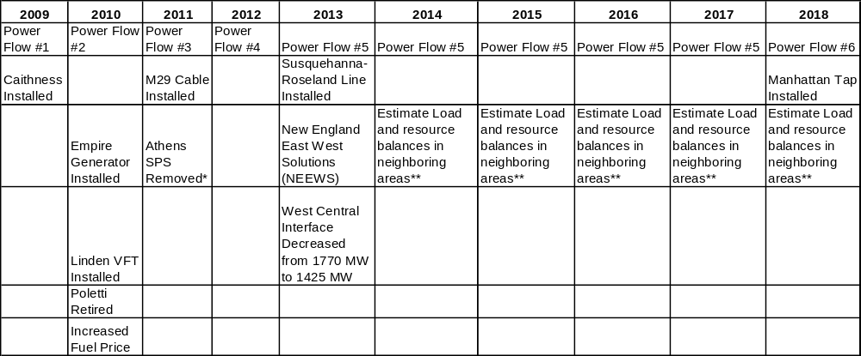
* The CARIS base case assumes that the Athens SPS will no longer be in service starting in January, 2011. The assumption is based on the NYSRC Executive Committee March 9, 2007 meeting minutes on the Athens Special Protection System (SPS).
** As per the RNA/CRP procedures, the load is adjusted in neighboring areas to approximate maintaining design LOLE requirements.

Load and Capacity Forecast
The load and capacity forecast used in the CARIS baseline system, provided in Table 4-2, was taken directly from the 2009 RNA/CRP. There were no changes made to the load forecast or the resource mix in the CARIS as compared to the 2009 CRP.
As reported in the 2009 CRP, the 2008 Gold Book forecasts for peak load and energy demand were modified to account for the impacts of programs such as the Energy Efficiency Portfolio Standard (EEPS) to reflect achievement of approximately 30% of the entire EEPS goal. In addition, Special Case Resources (SCRs) were updated to reflect the increased SCRs level experienced in the market.
Table 4—2: RNA Study Case Load and Resource Table with Updated TO Plans
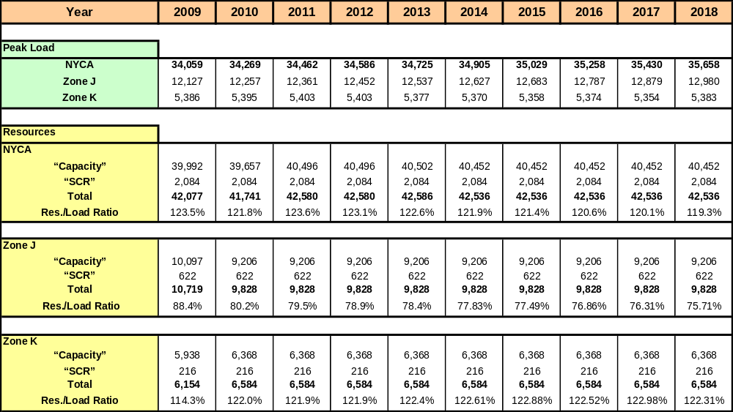

Transmission Model
The CARIS production cost analysis utilizes a bulk power system representation comprising the entire Eastern Interconnection, which is defined roughly as the bulk electric network in the United States and Canadian Provinces East of the Rocky Mountains, excluding WECC and Texas. Figure 4-1 below illustrates the electric grid represented in the CARIS model comprising the Eastern Interconnection regions and Balancing Authorities. The CARIS model includes a full active representation for the NYCA, ISO-NE, IESO, and PJM (PJM Classic, Allegheny Power System (APS), American Electric Power System (AEP), Commonwealth Edison Company (CE), Duquesne Light Company (DLCO), Dayton Power and Light (DAY) and Virginia Power (VP)) for both the network model and the a production cost model. A proxy bus is used to model Hydro Quebec (HQ) to NYISO and ISO-NE. Transmission- only models are represented for Michigan Electric Coordinated Systems (MECS), First Energy Corporation (FE), Southwest Power Pool (SPP), MAR, Northern Indiana Public Service Company (NIPS), Ohio Valley Electric Corporation ( OVEC), Tennessee Valley Authority (TVA), Florida Reliability Coordinating Council (FRCC), SERC Reliability Corporation (SERC), and equivalences for the Electric Reliability Council of Texas (ERCOT), and the WECC. For purposes of the CARIS report, the model is discussed in two parts: the NYCA system representation and the system representations for the external control areas.
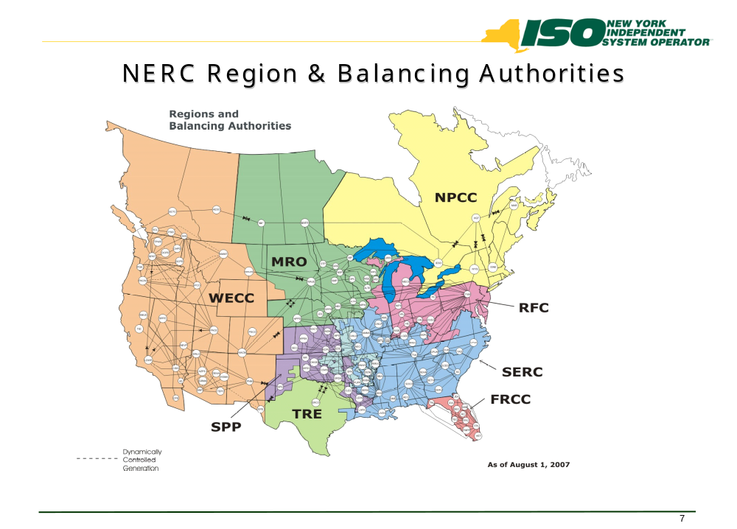

Figure 4-3: All Areas Modeled in CARIS (Excluding WECC & TRE)

New York Control Area Transfer Limits
In the resource adequacy analysis for the 2009 RNA, interface transfer limits were assumed to be constant from the end of the first five years throughout the second five-year period. The assumed interface transfer limits were confirmed during the CRP evaluation of the baseline system. For the resource adequacy analysis of the RNA/CRP, emergency criteria transfer limits are employed in the GE-MARS software model, while the transfer limits for the CARIS study are based upon normal criteria transfer limits. For voltage and stability based limits, the normal and emergency limits are assumed to be the same. The normal voltage transfer limits for critical NYCA transmission interfaces in the CARIS were taken from the RNA and the CRP with some exceptions as indicated in Table 4-3 below.
Table 4—3: - Transmission System Normal Voltage Transfer Limits for
Key Interfaces (in MW)
Interface | 2009 CARIS Study
Interface | 2009 | 2010 | 2011 | 2012 | 2013-2018
WEST CENTRAL-Open | 1770 | 1770 | 1770 | 1770 | 1425
CENTRAL EAST | 2600 | 2600 | 2600 | 2600 | 2600
CONED – LILCO | 2166 | 2166 | 2166 | 2166 | 2166
UPNY-ConEd | 5000 | 5000 | 5000 | 5000 | 5000
Dunwoodie (I) to NYCity (J) | 4000 | 4075 | 4400 | 4400 | 4400
Dunwoodie (I) to Long Island (J) | 1217 | 1265 | 1265 | 1265 | 1265
Spr/Dunwoodie South | 5315 | 5290 | 5365 | 5365 | 5365
Note: Central East and UPNY-ConEd and West Central were modeled differently than the RNA/CRP values
Central East was not modeled explicitly in the RNA/CRP but was modeled with the Fraser - Gilboa circuit. UPNY/ConEd was modeled with a nomogram in the RNA/CRP whereby one of two different 300 MW reductions from the 5,300 MW limit in 2009 and 2010 were applied depending upon the generation availability and load in SENY. This was simplified to one value of 5,000 MW for the CARIS study. Although the RNA analysis indicated an increase in the transfer limit from 5,000 MW to 5,500 MW, the 5,000 MW was held constant in 2011-2018 for CARIS because the interface was not constraining and there was no need to calculate new sensitivity factors for the nomogram at the higher transfer limits. The voltage limit decrease on the West Central interface is a function of widespread degradation in voltage performance throughout the Zone A and B non-bulk and bulk power systems caused by load growth and unit retirements.

Normal thermal interface transfer limits for the CARIS study are not directly utilized from the thermal transfer analysis performed using the Power Technologies Inc. Power System Simulator for Engineering (PSS/E) Managing and Utilizing System Transmission (MUST) software application, which uses the transmission planning set of design criteria contingencies. Instead, CARIS uses the most limiting monitored line and contingency sets which MUST identified as the most limiting constraint to the NYCA cross-state transmission interfaces to determine thermal transfer limits as the load and generation is varied throughout the annual simulations. The resulting monitored lines and contingency sets used in the CARIS do not include lines that have less than a five percent impact on the NYCA cross-state transmission interfaces, or the lines that only impact local 115-138 kV transmission or sub-transmission constraints.

Fuel Forecasts

CARIS Base Annual Forecast
The starting point for preparing the fuel price forecasts for CARIS is the U.S. Energy Information Administration’s (EIA) current national long-term forecast of delivered fuel-prices that is released each spring as part of the Annual Energy Outlook (AEO).
The figures in this forecast are in real dollars (i.e., indexed relative to a base year). Forecasted time-series of the GDP deflator published by EIA, as part of the AEO, is used to inflate the real values to nominal values.

New York Fuel Forecast
In developing the New York’s fuel forecast, adjustments were made to the EIA’s fuel forecast to reflect bases for fuel prices in New York. A key source of data for estimating the relative differences or ‘basis’ for fuel prices in New York are the Monthly Utility and non-Utility Fuel Receipts and Fuel Quality Data reports based on information collected through Form EIA-423 (2000-2007) and EIA-923 (2008 onwards). The base annual forecast series are then subjected to an adjustment to reflect the New York ‘basis’ relative to the national prices as follows:
Natural Gas
A historical analysis of EIA’s national AEO forecasts of delivered fuel-prices suggests that they are around five percent higher than Henry Hub prices. Any basis for New York, then, is assessed against 105% of Henry Hub price forecasts. The natural gas price for Zones I through K, is the Transco Zone 6 (New York) and the proxy for the remainder of NYISO Zones is the Tetco-M3 trading price. Analysis of historical prices reveals that, relative to 105% of Henry Hub prices, on average, the basis for Transco Zone 6 (NY) is around 13% and for Tetco-M3 it is 5.5%. The 7.5 percentage-point differential is consistent with the sum of historical differences between the two prices and the applicable taxes in the New York City area. Historic and forecasted fuel prices for upstate and downstate New York are shown in Figures 4-2 and 4-3.
Fuel Oil

Based on reports drawn from EIA-423 for the years 2002-2007, prices of both distillate and residual oils are about 15% cheaper in New York as compared to the U.S. average price. Since the overwhelming bulk of oil-based generation is situated in Zones J and K, the basis for the downstate Zones is -15%. To allow for additional transportation charges, the basis for the upstate Zones is -10%, For illustrative purposes, historic and forecasted price for Fuel Oil #6 for upstate and downstate New York are shown in Figures 4-2 and 4-3.
Coal
The data for Bituminous Coal in EIA-423 was used to calculate a common basis for all NYISO Zones. Prices in New York are, on average, 15% higher than in the United States as a whole.
Uranium
It is assumed that the same fuel price applies to all nuclear generators in the United States.

Seasonality and Volatility
All average monthly fuel prices, with the exception of uranium, display somewhat predictable patterns of fluctuations over a given 12-month period. In order to capture such seasonality, NYISO estimated seasonal-factors using standard statistical methods. The multiplicative factors were applied to the annual forecasts to yield forecasts of average monthly prices.
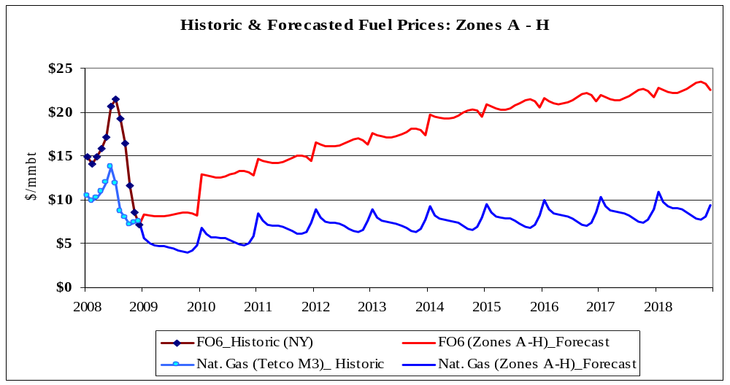

Figure 4-4: Historic and forecasted fuel prices for Zones A-H (nominal $)

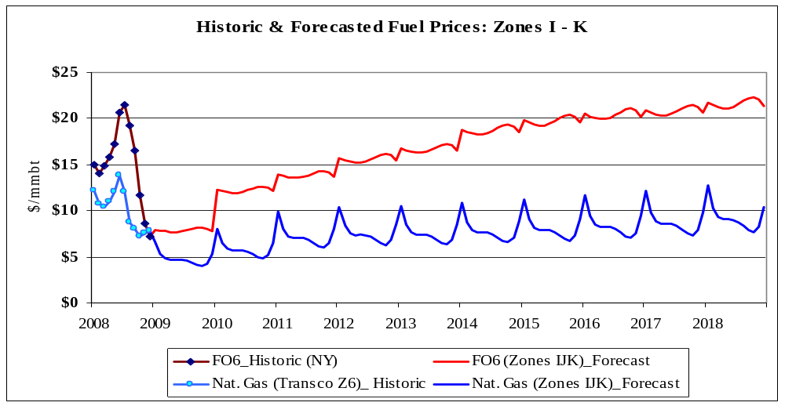

Figure 4-5: Historic and forecasted fuel prices for Zones I-K (nominal $)
The seasonalized time-series represents the forecasted trend of average monthly prices. However, in order to facilitate simulation studies to explore scenarios with higher/lower prices, the NYISO developed volatility-factors to capture typical intra-month variability of prices. These factors were the typical monthly standard deviation of daily prices, based on historical data. For natural gas and fuel oils, this monthly volatility factor equals the average standard deviation of daily prices. In the case of coal, only monthly average prices are available; therefore, the corresponding factor is the standard deviation of average monthly prices. This approximation is reasonable because coal prices exhibit relatively muted volatility, as compared to natural gas, and fuel oils.

External Areas Fuel Forecast
The fuel forecasts for the three external areas, ISO-NE, PJM, and IESO, were also developed. The starting point was the base-line annual forecasts of each fuel for New York. The annual averages and the seasonal factors for each external control area were estimated as follows: for ISO-NE and PJM, information obtained from EIA Form 423 (EIA-423) was used to calculate the basis relative to figures for New York, and for IESO the basis was based on data from a recent publication.
Tables 4-4, 4-5, 4-6 and 4-7 below outline the assumptions that went into the fuel-price forecasts for each external control area.

Table 4—4: ISO-New England Assumptions
 | Annual Average | Monthly Factor
Natural Gas | Same as the price for Zones I – K | Same as the factor for Zones I – K
FO2 | 120% of the price for New York | Same as the factor for New York
FO6 | 115% of the price for New York | Same as the factor for New York
Coal | 125% of the price for New York | Same as the factor for New York

Table 4—5: PJM-East Assumptions
 | Annual Average | Monthly Factor
Natural Gas | Same as the price for Zones A – H | 90% of the factor for Zones A – H in Jan.; 95% in Feb., and 100% for other months
FO2 | 125% of the price for Zones A – H | Same as the factor for New York
FO6 | 113% of the price for Zones A – H | Same as the factor for New York
Coal | 97% of the price for Zones A – H | Same as the factor for New York

Table 4—6: PJM-West Assumptions
 | Annual Average | Monthly Factor
Natural Gas | Same as the price for Zones A – H | 88% of the factor for Zones A – H
FO2 | 125% of the price for Zones A – H | Same as the factor for New York
FO6 | 113% of the price for Zones A – H | Same as the factor for New York
Coal | 82% of the price for Zones A – H | Same as the factor for New York

Table 4—7: IESO Assumptions
 | Annual Average | Monthly Factor
Natural Gas | 84% of the price for Zones A – H; rest of the months the same as the price for Zones A – H | 90% of the factor for Zones A – H
FO2 | Same as the EIA national forecast | Same as the factor for New York
FO6 | Same as the EIA national forecast | Same as the factor for New York
Coal | 120% of the price for New York | Same as the factor for New York

Emission Cost Forecast
The costs of emission allowances are an increasing portion of generators’ production costs. Currently all NYCA fossil fueled generators greater than 25 MW and most generators in most surrounding states are required to hold allowances in amounts equal to their emissions of SO₂, NO_{X}, and CO₂. There are exchanges for trading allowances and futures contracts for allowances. The Chicago Climate Futures Exchange (CCFE) offers standardized and cleared futures and options contracts on emission allowances and other environmental products. The emission allowance price forecasts were created by using future contract values on May 15, 2009. Extrapolations were made for years where futures contracts were not traded. The simulations were based on the assumption that all fossil generators are required to have emission allowances equal to their respective emissions.
Emission costs are the product of emission rate and emission allowance costs. Annual emission rates were used in the simulations. The annual emission rates in terms of #/mmBTU are available from the EPA’s Clean Air Markets Division (CAMD). Since the emission rate determined above is an average emission rate, the same rate was used across the operating range.
Figure 4-4 shows the emission allowance forecast by year in $/Ton.
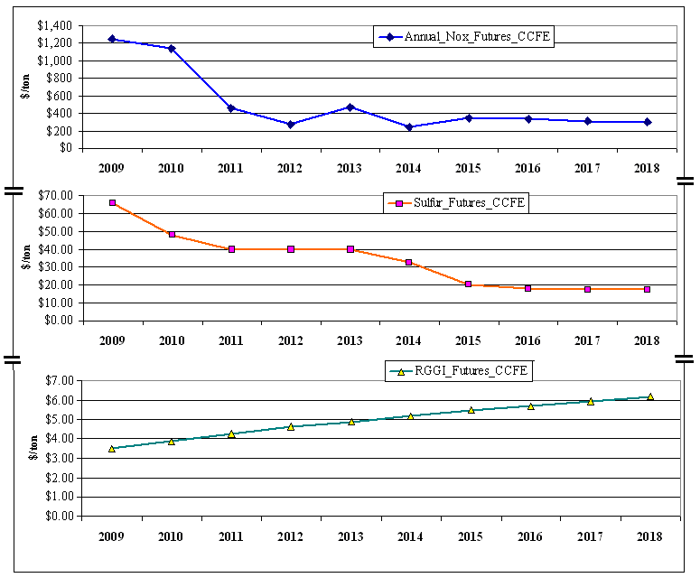
Figure 4-6: Emission Allowance Forecast
With respect to the carbon emission futures under the Regional Greenhouse Gas Initiative (RGGI), the data from the CCFE was available only through 2012. The implied trend was extrapolated to cover the 2013-2018 period.

Generic Solutions
Generic solutions are evaluated by NYISO for each identified congested element or grouping utilizing each resource type – generation, transmission, and demand response – as required in Section 11.3 of the Tariff. The development of the generic solutions representative costs are accomplished by consultants experienced with NYISO’s market and systems and with stakeholder input.. This methodology was based on utilizing typical MW block size generic solutions, a standard set of assumptions without determining actual project feasibility, and an order of magnitude costs for each resource type.
The estimates included in the Generic Solution Cost Matrix should not be utilized for purposes outside of the CARIS process. These estimates should not be assumed as reflective or predictive of actual projects or imply that facilities can necessarily be built for these generic order of magnitude solution estimates.

Resource Block Sizes
Typical resource block sizes are developed for each resource type based on the following guidelines:
- Block size would be reflective of a typical size built for the specific resource type and geographic location;
- Block size is to be small enough to be additive with reasonable step changes; and
- Blocks sizes are in comparable proportions between the resource types.
The block sizes selected for each resource type are presented in Table 4-8 through Table 4-10.

Table 4—8: Transmission Block Sizes
Location | Line System Voltage (kV) | Block Ampacity (Amp) | Block Capacity (MVA)
Zone A-J | 345 | 1673 | 1000
Zone K | 138 | 2092 | 500
Note: 138 kV was selected for Zone K due to the limited number of 345 kV substations located within this Zone. The block capacity was reduced accordingly to be reflective of the typical line size for this voltage class.
Table 4—9: Generation Block Sizes
Plant Location | Plant Block Size Capacity (MW)
Zone A-K | 250

Table 4—10: Demand Response Block Sizes
Location | Block Size (MW) | Portfolio Type
Zone A-K | 100 | Energy Efficiency
Zone A-K | 100 | Demand Response

Guidelines and Assumptions for Generic Solutions
Developing cost estimates for these resource types is very dependent on many different parameters and site specific situations. A detailed list of assumptions utilized for each resource is included in the Generic Solution Cost Matrix, in Appendix C.
The following guidelines and assumptions are used to select the generic solution and determine their cost:
Transmission Resource
- The generic transmission solution consists of a new transmission line interconnected to the system upstream and downstream of the grouped congested elements being studied.
- The generic transmission line terminates at the nearest existing substations of the grouped congested elements.
- If there is more than one substation located near the grouped congested elements which meets the required criteria, then the two substations that have the shortest distance between the two are selected.
- The cost of the Transmission solution would be affected by the following:
1. type of construction (typical conventional overhead or underground)
2. voltage and ampacity capability
3. substation interconnection
4. rights of way
5. permitting
6. system upgrade facilities

Generation Resource
- The generic generation solution consists of the construction of a new combined cycle generating plant connecting downstream from the grouped congested elements being studied.
- The generic generation solution terminates at the nearest existing substation of the grouped congested elements.
- If there is more than one substation located near the grouped congested elements which meets the required criteria, the substation that has the highest relative shift factor is selected.
- The cost of the Generation solution would be affected by the following:
1. type of plant
2. length, type, voltage and ampacity of generator lead
3. substation interconnection
4. length of gas line
5. rights of way
6. permitting
7. system upgrade facilities

Demand Response
- The generic demand response solution is modeled as a reduction in load within the zone where the most downstream grouped congested element is terminated.
- The on-peak demand is assumed to be concentrated in the top 60-100 highest load hours.
- The demand response installed in a zone is limited to less than 10% of the peak zonal load. If the “block” demand response exceeds 10% of the peak zonal load, it is prorated based on peak load between the selected zone and the next downstream zone.
- The cost of the Demand Response solution would be affected by the following:
1. zonal locations
2. energy efficiency (available 8760 hours/year)/ demand response
3. utility demand side management filings

Order of Magnitude Unit Pricing
Order of magnitude unit pricing cost estimates were developed based on the block sizes and assumptions for each resource type. The NYISO utilized engineering consultants to develop order of magnitude cost estimates based on their experience in the industry and similar existing projects or programs currently being considered within New York. The order of magnitude cost estimates took into account the cost differences between geographical areas within New York. Three sets of costs were developed that are reflective of the differences in labor, land and permitting costs between upstate, downstate and Long Island. The order of magnitude unit pricing for the following elements, listed in Table 4-11, were developed for the three resource types and for each geographical area.
Table 4—11: Order of Magnitude Unit Pricing Elements
Transmission | Generation | Demand Response
Transmission Line Cost per Mile | Plant Costs | Energy Efficiency Programs
Substation Terminal Costs | Generator Lead Cost per Mile | Demand Response Programs
System Upgrade Facilities | Substation Terminal Costs
 | System Upgrade Facilities
 | Gas Line Cost per Mile
 | Gas Regulator Station

All costs were reviewed by the Transmission Owners and stakeholders through the stakeholder process. As part of this process, ranges for the cost for each element were developed in order to address the wide variability that can occur in a project due to such items as permitting, right of way constraints, and existing system conditions. The resulting order of magnitude unit pricing levels are included in the Generic Solution Cost Matrix in Appendix C.

Application of Order of Magnitude Cost Estimates
Upon selection of the three congestion areas to be studied and their generic solutions, the order of magnitude unit pricing elements are utilized to develop order of magnitude generic solution costs for inclusion in the benefit/cost ratio analysis. If the location for the generic solution identifies unusual complexities, a contingency factor will be applied to the costs included in the matrix. These complexities may include but are not limited to right of way restrictions, terrain and/or permitting difficulties.

2009 CARIS Analyses – Study Phase
This section presents the results of Phase 1, the Study Phase, of the CARIS process. Specific economic transmission projects are not considered in this phase. They will be studied in Phase 2, the Project Phase, of the CARIS process. The results are presented below and described in more detail in Appendix E. The process steps include: (1) congestion assessment; (2) ranking of congested elements; (3) selection of three studies; (4) generic solutions application; (5) benefit/cost analysis; and (6) scenario analysis.
The Study Phase of the CARIS process begins with the development of a ten-year projection of future congestion costs resulting from NYCA system facilities. This projection is combined with the past five years of historic congestion to identify and rank significant and recurring congestion. Based on this ranking, the top five congested elements are identified, and a grouping process, detailed in section 5.3, is implemented to develop the three studies comprising CARIS. Generic solutions to these most congested groupings are then assessed, and the benefit/cost ratios are presented based on generic solution costs and projected production cost savings. Scenario analyses are also conducted to determine the impact of certain uncertainties on the projection of congestion.

Congestion Assessment
Congestion assessment is performed both from a historical and future perspective and is done separately. The results are presented in the following two sections of this chapter.
In order to assess and identify the most congested elements, both positive and negative congestion on constrained elements is taken into consideration. The concept of positive versus negative congestion is based on how the congestion relates to the reference point. New York uses the Marcy 345 kV bus near Utica as its reference point. For locations downstream of the reference bus, congestion will be positive and for locations upstream of the reference bus congestion will be negative. For example, in the absence of losses, any location with LBMP greater than the Marcy LBMP has positive congestion, and any location with LBMP lower than the Marcy LBMP has negative congestion. The negative congestion typically happens due to transmission constraints preventing lower cost resources from being delivered towards the Marcy Bus.

Historic Congestion
Historic congestion assessment has been conducted at the NYISO for the last five years with metrics and procedures developed with the ESPWG and approved by the NYISO Operating Committee. Four congestion metrics were developed to assess historic congestion: Bid-Production Cost (BPC) as the primary metric, Load Payments metric, Generator Payments metric, and Congestion Payment metric. The results of the historic congestion analysis are posted on the NYISO website quarterly. The NYISO uses PROBE production cost simulation tool to generate historical results, which, unlike the CARIS projected results, include, among other things, the impact of virtual bidding and actual transmission outages on congestion. This is explained in more detail below and in Appendix D.
Table 5-1 summarizes the NYISO posted annual historic congestion data generated by PROBE including zones both internal and external to NYCA. NYISO reports the summaries of the calculated changes in the four historic congestion metrics: BPC, Generator Payments, Congestion Payments, and Load Payments. The change in these four historic congestion metrics is calculated by PROBE as the constrained system values minus the unconstrained system values. Positive numbers imply savings while negative numbers imply increases in payments when all constraints are relieved. Unhedged Congestion is calculated as the total congestion represented by Demand$ Congestion minus the TCC hedge payments. Total payments made by load adjusted for the TCC hedges, TCC shortfalls, and Rate Schedule 1 imbalances comprise the statewide NYCA Unhedged Load Payments. These adjusted statewide Unhedged Load Payments equal the total Generator Payments.

Table 5—12: PROBE NYCA System Changes - Mitigated Bids 20043-2008 (nomnal $ m)
Year | Change in BPC | Change in Generator Payments | Change in Unhedged Congestion Payments |  | TCC Payments
2004 | 72 | (181) | 316 |  | 516
2005 | 113 | (71) | 685 |  | 707
2006 | 118 | 59 | 921 |  | 634
2007 | 130 | (107) | 806 |  | 670
2008 | 243 | (417) | 1,525 |  | 1,147

Figure 5-1 below illustrates a cumulative effect of bid production costs savings over the past six years as a result of relieving all NYCA constraints.
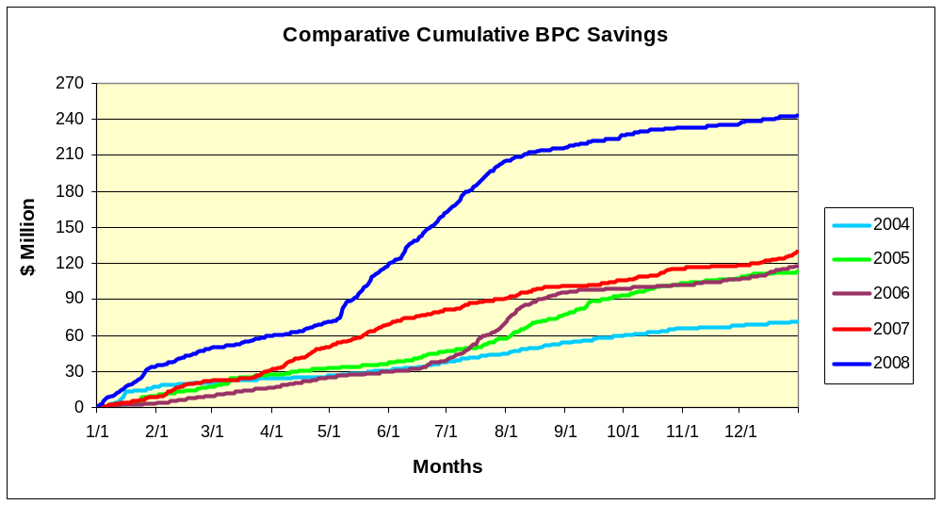
Figure 5-7: PROBE Cumulative BPC Savings (nominal $ m)
Historic congestion values by zone are presented in Table 5-2, indicating the highest congestion in New York City and Long Island. Total NYCA congestion, expressed as Demand$, nearly doubled in 2008 in comparison to 2007, which resulted mostly from high fuel prices in 2008.
Table 5—13: Demand $ Congestion by Zone 2004-2008 (nominal $ m)
Zone | 2004 | 2005 | 2006 |  | 2007 | 2008
West | (1) | (5) | 1 |  | (14) | (25)
Genesee | 1 | (1) | 2 |  | (14) | (9)
Central | 1 | (1) | 4 |  | 9 | 18
North | 0 | (1) | (0) |  | (0) | (2)
Mohawk Valley | 0 | (0) | 2 |  | 5 | 10
Capital | 8 | 19 | 27 |  | 74 | 143
Hudson Valley | 5 | 20 | 54 |  | 87 | 176
Millwood | 3 | 12 | 27 |  | 31 | 78
Dunwoodie | 4 | 24 | 44 |  | 56 | 124
NY City | 582 | 809 | 673 |  | 700 | 1403
Long Island | 230 | 508 | 708 |  | 518 | 624
NYCA Total | 833 | 1400 | 1542 |  | 1508 | 2613
The reported values include TCCs.
NYCA totals represent the sum of absolute values.
Historical Congestion Source: PROBE DAM quarterly reports
DAM data include Virtual Bidding & Transmission planned outages

Table 5-3 below lists historic congestion values for top constraints from 2004 to 2008. Based on the positive congestion values, the top three congested constraints are Central East, Leeds-Pleasant-Valley, and Dunwoodie Shore Road.
Table 5—14: Historic Congestion by Constraint 2004-2008 (nominal $ m)
Constraint | 2004 | 2005 | 2006 | 2007 | 2008 | Total
CENTRAL EAST - VC | 52 | 102 | 187 | 571 | 1,199 | 2,112
PLSNTVLY 345 LEEDS 345 1 | 27 | 182 | 452 | 435 | 667 | 1,763
DUNWODIE 345 SHORE_RD 345 1 | 152 | 348 | 492 | 260 | 187 | 1,439
MOTTHAVN 345 RAINEY 345 2 | 0 | 0 | 0 | 43 | 272 | 315
RAINEY 138 VERNON 138 1 | 5 | 84 | 21 | 19 | 81 | 210
WEST CENTRAL | (0) | (0) | (2) | (51) | (55) | (108)
E179THST 138 HELLTP_W 138 1 | (9) | (18) | (10) | (12) | (34) | (83)

* Ranking is based on absolute values.

Projected Congestion
A projection of future congestion is reported as Demand$ congestion. Congestion projections resulting from the simulation are highly dependent upon many long-term assumptions. The CARIS model utilizes input assumptions listed in Appendix C.
When comparing historical congestion values to projected congestion values, one must bear in mind that there are significant differences in assumptions used by the PROBE and CARIS tools. The CARIS tools did not simulate the following: (a) virtual bidding; (b) transmission outages; (c) fixed load and price-capped load; (d) generation and demand bid price; (e) Bid Production Cost Guarantee payments (BPCG); and (f) co-optimization with ancillary services. Another factor to consider when comparing historic and future congestion values is the fuel prices. Projected fuel prices for 2009 are much lower than 2008 actual fuel prices. This results in projections that are lower than historic values. For instance, the model estimates 2009 congestion of $146 million for the entire year, while first quarter 2009 actual congestion was $223 million(absolute value). A comparison between simulated and actual congestion for first Quarter 2009 is provided in Appendix D. The results will vary depending on a number of factors.
Discussion
Table 5-4 presents the projected congestion from 2009 through 2018 by zone. The relative values of congestion shown in this table indicate that the majority of the projected congestion is in the downstate zones – NY City and Long Island. The step changes in congestion, as shown in Tables 5-4 and 5-5, from 2009 to 2010, is caused by the increase in fuel prices as well as the system changes shown in Table 4-1, timeline of Major Events. One of the causes of the large changes from 2010 to 2011 is due to the study assumption of the removal from service of the Athens SPS and the resultant decrease in the UPNY/SENY transfer capability of approximately 450 MW as determined in the Athens 2006 System Impact Study. System-wide congestion increased by 35% from 2010 to 2011.

Table 5—15: Projection of Future Congestion 2009-2018 by Zone (nominal $ m)
Zone | 2009 | 2010 | 2011 | 2012 | 2013 | 2014 | 2015 | 2016 | 2017 | 2018
West | (5) | (13) | (12) | (14) | (34) | (33) | (36) | (41) | (45) | (57)
Genesee | (3) | (3) | (3) | (4) | (23) | (21) | (22) | (25) | (29) | (37)
Central | 1 | 1 | 1 | 1 | 0 | 0 | (2) | (2) | (1) | 1
North | 0 | 1 | 1 | 1 | 0 | 0 | 0 | 1 | 1 | 1
Mohawk Valley | 1 | 1 | 2 | 2 | 1 | 1 | 1 | 2 | 2 | 2
Capital | 5 | 15 | 14 | 18 | 13 | 13 | 15 | 19 | 23 | 23
Hudson Valley | 8 | 20 | 35 | 38 | 33 | 33 | 35 | 39 | 43 | 50
Millwood | 3 | 6 | 11 | 12 | 11 | 10 | 11 | 12 | 13 | 15
Dunwoodie | 6 | 14 | 26 | 28 | 24 | 24 | 26 | 28 | 30 | 36
NY City | 87 | 209 | 271 | 300 | 278 | 292 | 326 | 375 | 410 | 426
Long Island | 27 | 69 | 98 | 106 | 93 | 91 | 97 | 106 | 116 | 132
NYCA Total | 146 | 352 | 474 | 524 | 510 | 518 | 571 | 650 | 713 | 780
Note: Reported values are without TCCs. NYCA totals represent absolute values
Table 5-5 lists the future top most congested elements: Leeds-Pleasant Valley, Central East, West Central, Astoria West, Mott Haven-Rainy and Dunwoodie Shore Road.
Table 5—16: Projection of Future Congestion 2009-2018 by Constraint (nominal $ m)
Constraints | 2009 | 2010 | 2011 | 2012 | 2013 | 2014 | 2015 | 2016 | 2017 | 2018
Leeds - Pleasant Valley 345 | 35 | 69 | 230 | 245 | 220 | 217 | 215 | 228 | 236 | 293
Central East | 27 | 93 | 80 | 103 | 67 | 62 | 75 | 97 | 126 | 118
Motthaven – Rainey 345 | 1 | 15 | 2 | 4 | 6 | 8 | 10 | 13 | 15 | 24
Dunwoodie - Shore Rd 345 | 4 | 16 | 8 | 7 | 7 | 6 | 6 | 7 | 8 | 8
West Central - OP* | 0 | 3 | 3 | 5 | 53 | 48 | 46 | 54 | 64 | 87
AstoriaW 138 - HG5 138* | 2 | 9 | 12 | 11 | 11 | 12 | 13 | 15 | 15 | 17
* The absolute value of congestion is reported.

Ranking of Congested Elements
The identified congested elements from the ten-year projection of congestion are lined up with the past five years of identified historic congested elements to develop fifteen years of $Demand congestion statistics for each identified constraint. The fifteen years of statistics are analyzed to identify recurring congestion or the mitigation of congestion from future system changes incorporated into the base CARIS system. Ranking of the identified constraints is initially based on the highest present value of congestion over the fifteen-year period – five years historic and ten years projected.
Table 5-6 lists the ranked elements based on the highest present value of congestion over the fifteen years of the study, including both positive and negative congestion. Dunwoodie-Shore Road and Mott Haven-Rainey’s level of congestion diminishes in the future with the addition of the Caithness plant and the installation of the M29 Cable. Dunwoodie-Shore Road congestion declined substantially in 2007 when the Neptune cable came into service. Therefore, allowance for diminishing congestion in the future years in the approved ranking procedure directs the selection of West Central as the third ranked element. The top five elements are evaluated in the next step for selection of the three studies.
Table 5—17: Ranked Elements Based on the Highest Present Value of Congestion
over the Fifteen Years Aggregate
 | Present Value of Congestion in 2009 $ m
Constraints | Historic | Future | Aggregate
LEEDS-PLEASANT VALLEY 345 | $2,063 | $1,307 | $3,370
CENTRAL EAST | $2,442 | $567 | $3,009
WEST CENTRAL-OP | ($120) | ($230) | ($350)
DUNWOODIE-SHORE ROAD 345 | $1,770 | $59 | $1,829
MOTT HAVEN-RAINEY 345 | $341 | $66 | $407
ASTORIA W 138-HELLGATE5_138 | $50 | ($78) | ($28)
Note: Allowance for diminishing congestion in the future years in the approved ranking procedure directs the selection of West Central as the third ranked element.
The frequency of actual and projected congestion is shown in Table 5-7 below. The table presents the actual number of congested hours by constraint, from January 2007 through September 2009, and projected number of congested hours, from 2009 through 2018. Based on the projected values, the most frequently constrained elements are Dunwoodie-Shore Road, followed by Leeds-Pleasant Valley, West Central, Central East, and Mott Haven Rainey respectively. The number of projected congested hours by constraint after each generic solutions is applied as reflected in Appendix E.
Table 5—18: Number of Congested Hours by Constraint
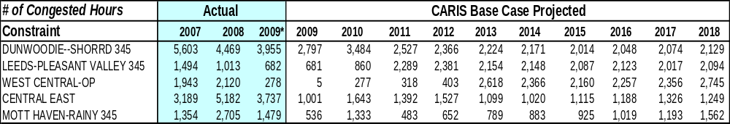

Selection of Three Studies
Selection of the three CARIS studies is a two-step process in which the top five ranked constraints are identified and utilized for further assessment in order to identify potential for grouping of constraints. Resultant grouping of elements for each of the top five ranked constraints is utilized to determine the three studies.
In the first step, the five congested elements with the highest present value ranking are utilized for further assessment under the CARIS process, as explained in the previous step 5.2. In the second step, this assessment is accomplished in multiple iterations to include additional elements that appear as limiting when each of the top five congested elements are relaxed. The assessed element groupings are then ranked based upon the highest change in production cost. The three ranked groupings with the largest change in production cost are selected as the three CARIS studies. The three CARIS studies, as shown in Table 5-8 are Leeds - Pleasant Valley, Central East, and West Central. The detailed discussion on the ranking process is presented in Appendix E.

Table 5—19: Congestion of the Top Three CARIS Studies (nominal $ m)
Study | 2009 | 2010 | 2011 | 2012 | 2013 | 2014 | 2015 | 2016 | 2017 | 2018
LEEDS- PLTVLLEY 345 | $35 | $69 | $230 | $245 | $220 | $217 | $215 | $228 | $236 | $293
CENTRAL EAST | $27 | $93 | $80 | $103 | $67 | $62 | $75 | $97 | $126 | $118
WEST CENTRAL-OP | ($0) | ($3) | ($3) | ($5) | ($53) | ($48) | ($46) | ($54) | ($64) | ($87)

Discussion
One of the causes of the increase in congestion from 2010 to 2011, Table 5-8, is the change from an STE to an LTE post-contingency rating on the Leeds - Pleasant Valley circuits starting in 2011 due to the CARIS study assumption that the Athens SPS will no longer be in service starting in January 2011. This rating change of approximately180 MW has the effect of reducing the effective UPNY-SENY interface capability by approximately 450 MW, as indicated in the Athens 2006 System Impact Study. System-wide congestion increased by 35% from 2010 to 2011.

The location of the top three congested groupings, along with their base present value congestion payment in 2009 $ m, is presented in Figure 5-2.
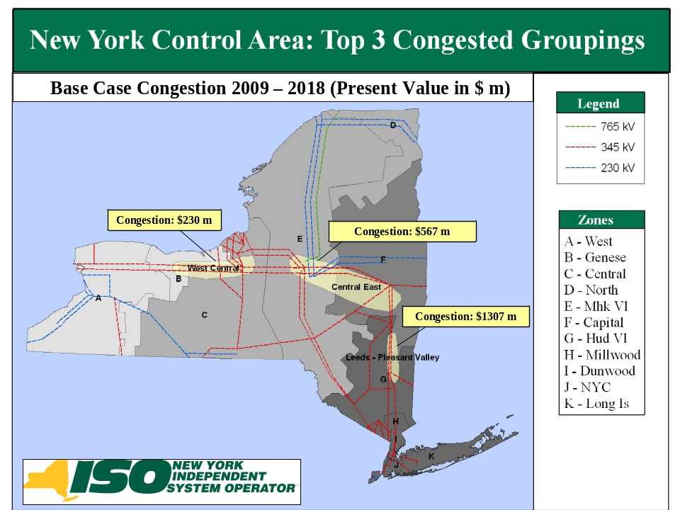

Figure 5-8: Base Case Congestion of the Top 3 Congested Groupings

Generic Solutions
The congestion of each of the three groupings being studied is mitigated by individually applying one of the generic resource types; transmission, generation and demand response. The resource type is applied based on the rating and size of the “blocks” determined in the Generic Solutions Cost Matrix included in Appendix C and is consistent with the methodology explained in Section 4 of this report. Resource “blocks” are applied until a majority of the congestion is relieved. If including an additional resource “block” has a diminishing rate of return, or if it is not feasible, then the additional “block” is not included. In regard to the generic solutions, it is important to note the following:
- Other solutions may exist which will alleviate the congestion on the studied elements.
- No attempt has been made to determine the optimum solution for alleviating the congestion.
- No engineering, physical feasibility study, routing study or siting study has been completed for the generic solutions. Therefore, it is unknown if the generic solutions can be physically constructed as proposed.
- Generic solutions are not assessed for impacts on system reliability.
- Actual projects will incur different costs.
- The generic solutions differ in the degree to which they relieve the identified congestion.

The discount rate used to calculate present values of the benefit stream of a generic transmission solution applied to a given constrained element is the weighted average of the Weighted Average Cost of Capital (WACC) figures submitted to the NYISO by the NYTOs. The weights are the relative mileage ownership shares derived from data reported in the NYISO Gold Book. The applicable discount rates for the generic generation and DR/EE solutions pertaining to the element, is the same as the one used for the transmission solution.
The results of the three generic solutions are to provide indicative information to interested parties. More detailed information on these results are provided in Appendix E. The following generic solutions were applied for each study:
Study #1 – Leeds - Pleasant Valley
The following generic solutions were applied for Leeds-Pleasant Valley Study:
- Transmission: A new 345 kV line from Leeds to Pleasant Valley- 39 Miles. The new line increases the UPNY-SENY thermal limit by approximately 1000 MW and Central East voltage limit by 50 MW.
- Generation: Install a new 500 MW Plant at Pleasant Valley.
- Demand Response: Install 100 MW Demand Response and 100 MW Energy Efficiency in Zone G (200 MW is less than 10% of Zone G’s peak load).
Table 5-9 shows the Demand$ congestion impact on Leeds-Pleasant Valley for 2013 and 2017 when each of the generic solutions are applied.

Table 5—20: Demand$ Congestion Comparison for Leeds-Pleasant Valley Study (nominal $ m)
 | 2013 |  |  | 2017
Resource Type | Solution | Base Case | % Change | Solution | Base Case | % Change
Transmission | 0 | 220 | -100% | 0 | 236 | -100%
Generation – 2 Blocks | 157 | 220 | -28% | 166 | 236 | -30%
Demand Response | 214 | 220 | -3% | 228 | 236 | -4%

Table 5-10 shows the NYCA production cost savings expressed as the present value in 2009 $ from 2009 to 2018 for Leeds-Pleasant Valley study after generic solutions were applied.
Table 5—21: Leeds - Pleasant Valley Study: NYCA Production Cost Savings: Present Value in 2009 $ m
 | 2009 | 2010 | 2011 | 2012 | 2013 | 2014 | 2015 | 2016 | 2017 | 2018
Transmission | 5 | 5 | 14 | 14 | 13 | 10 | 10 | 11 | 11 | 12
Generation-500 | 30 | 36 | 40 | 37 | 33 | 34 | 33 | 34 | 35 | 32
Demand Response | 24 | 29 | 28 | 25 | 24 | 24 | 25 | 24 | 23 | 21

Discussion
The new Leeds-Pleasant Valley 345 kV transmission solution relieves the congestion across existing Leeds-Pleasant Valley transmission lines and the UPNY-SENY transmission interface. The total ten-year production cost savings of $105 million (present value) are equally dependent upon the spread between upstate and downstate fuel costs, and increased imports from PJM, IESO, and ISO-NE. Relieving the congestion on the Leeds-Pleasant Valley lines increases the congestion on the other two study groups: Central East and West Central.
The Pleasant Valley generation solution reduces congestion across NYCA for the planning horizon. The ten-year production cost savings of $346 million (present value) are derived from the efficiency advantage of the new generic unit compared to the system heat rate. Imports are significantly reduced from all surrounding areas except HQ, which is held constant.
The Zone G Demand Response solution reduces congestion across NYCA for the planning horizon with a minor exception downstream for some later years. The ten-year production cost savings of $247 million (present value) are largely related to the reduction in energy use. Imports are reduced from all surrounding areas except HQ which is held constant.
The level of NYCA production cost savings may be dependent on the change from an STE to an LTE post-contingency rating on the Leeds - Pleasant Valley circuits starting in 2011 due to the CARIS study assumption that the Athens SPS will no longer be in service starting in January 2011. This rating change of approximately180 MW has the effect of reducing the effective UPNY-SENY interface capability by approximately 450 MW as indicated in the Athens 2006 System Impact Study.
Study #2 - Central East
The following generic solutions were applied for Central East study:
- Transmission: A new 345 kV line from Edic to New Scotland, 90 Miles. The new line relieves the Central East thermal limit and increases the Central East voltage limit by 400 MW.
- Generation: A new 500 MW Plant at New Scotland
- Demand Response: Install 100 MW Demand Response and 100 MW Energy Efficiency in Zone F (200 MW is less than 10% of Zone F’s peak load)
Table 5-11 shows the Demand$ congestion impact on Central East for 2013 and 2017 when each of the generic solutions are applied.
Table 5—22: Demand$ Congestion Comparison for Central East Study (nominal $ m)
 | 2013 |  |  | 2017
Resource Type | Solution | Base Case | % Change | Solution | Base Case | % Change
Transmission | 19 | 67 | -71% | 50 | 126 | -61%
Generation – 2 Blocks | 40 | 67 | -41% | 86 | 126 | -32%
Demand Response | 57 | 67 | -15% | 115 | 126 | -8%

Table 5-12 shows the NYCA production cost savings expressed as the present value in 2009 $ from 2009 to 2018 for Central East study after generic solutions were applied.

Table 5—23: Central East Study: NYCA Production Cost Savings: Present Value in 2009 $ m
 | 2009 | 2010 | 2011 | 2012 | 2013 | 2014 | 2015 | 2016 | 2017 | 2018
Transmission | 2 | 6 | 3 | 2 | 2 | 1 | 3 | 3 | 3 | 2
Generation | 21 | 25 | 26 | 19 | 18 | 24 | 23 | 22 | 25 | 22
Demand Response | 22 | 27 | 26 | 19 | 22 | 21 | 21 | 21 | 19 | 17

Discussion
The addition of the Edic-New Scotland marginally relieves the Central East congestion but does not have significant impact on production cost because of the Leeds-Pleasant Valley congestion which bottles generation in upstate New York. The ten-year production cost savings of $27 million (present value) are derived approximately equally from increased use of lower cost generation in Upstate and increased imports. The transmission solution increases imports from IESO and PJM, while exports to ISONE increase in an approximately equal amount.
The New Scotland generation solution reduces congestion Upstate for the planning horizon, while the value of congestion increases in SENY. The ten-year production cost savings of $224 million (present value) are derived from the efficiency advantage of the new generic unit compared to the system heat rate. This same phenomenon acts to increase the value of congestion in SENY as the generation remains bottled up. Imports are significantly reduced from all surrounding areas except HQ which is held constant.
The Zone F Demand Response solution reduces congestion across Upstate for the planning horizon, while the value of congestion increases downstream in SENY because generation in that area remains bottled up. The ten-year production cost savings of $216 million (present value) are largely related to the reduction in energy use. Imports are reduced from all surrounding areas except HQ, which is held constant.
Study #3 - West Central
The following generic solutions were applied for the West Central study, and the results are shown in Table 5-11:
- Transmission: a new 345 kV line from Niagara to Pannell to Clay- 149 Miles.
The West Central transmission constraint results from the West Central voltage limit for the loss of the Ginna generator. Initial voltage analysis was performed with the addition of a Pannell Rd-Clay 345 kV transmission line, but the transmission line addition did not improve the voltage performance. Recognizing that the voltage performance may be more a function of local system problems, and that West Central is tightly coupled with the Dysinger East transmission interface, a new circuit from Niagara to Clay was inserted and the voltage limit improved by over 500 MW. Other non-bulk power system solutions to the voltage limit may exist as well.
- Generation: Install a new 500 MW Plant at Clay.
- Demand Response: Install 100 MW Demand Response and 100 MW Energy Efficiency in Zone C (200 MW is less than 10% of Zone C’s peak load).

Table 5-13 shows the Demand$ congestion impact on West Central for 2013 and 2017 when each of the generic solution is applied.

Table 5—24: Demand$ Congestion Comparison for West Central (nominal $ m)
 | 2013 |  |  | 2017
Resource Type | Solution | Base Case | % Change | Solution | Base Case | % Change
Transmission | 10 | 53 | -80% | 14 | 64 | -78%
Generation – 2 Blocks | 40 | 53 | -23% | 47 | 64 | -27%
Demand Response | 50 | 53 | -6% | 59 | 64 | -8%

Table 5-14 shows the NYCA production cost savings expressed as the present value in 2009 $ from 2009 to 2018 for West Central study after the generic solutions were applied.

Table 5—25: West Central Study: NYCA Production Cost Savings: Present Value in 2009 ($ m)
 | 2009 | 2010 | 2011 | 2012 | 2013 | 2014 | 2015 | 2016 | 2017 | 2018
Transmission | 8 | 8 | 8 | 8 | 11 | 10 | 11 | 11 | 8 | 8
Generation-500 | 10 | 13 | 16 | 13 | 13 | 16 | 17 | 16 | 20 | 19
Demand Response | 20 | 25 | 25 | 18 | 21 | 22 | 22 | 23 | 20 | 20
Discussion
The addition of Niagara-Pannell-Clay 345 kV transmission line relieves the West Central congestion, while the value of congestion increases in Zones E through K. The ten-year production cost savings of $92 million (present value) increased with time as fuel prices increase and there is sufficient generation in Ontario and west New York to transfer to the rest of New York. Imports from IESO and PJM increase significantly while exports to ISO-NE also increase.
The Clay generation solution reduces congestion in Zones A and B for the planning horizon, while the value of congestion increases in Zones E through K. The ten-year production cost savings of $151 million (present value) are derived from the efficiency advantage of the new generic unit compared to the average system heat rate. This same phenomenon increases the value of congestion downstream as the generation remains bottled up. Imports decrease from all surrounding areas except HQ, which is held constant.
The Zone C Demand Response solution reduces congestion across the planning horizon except for a minor increase downstream in SENY for some years The ten-year production cost savings of $217 million (present value) are largely related to the reduction in energy use. Imports decrease from all surrounding areas except HQ, which is held constant.
The summation of production cost savings of the three generic solutions for each congestion grouping from 2009 to 2018 is shown in Figure 5-3. The greatest production cost savings for each congestion grouping has resulted from the generic generation solutions. The energy efficiency generic solutions resulted in the second highest production cost savings for each grouping.

Figure 5-9: Production Cost Savings 2009-2018, Present Value in 2009 $ m

Benefit/Cost Analysis
The NYISO conducted the benefit/cost analysis for each of the three studies comprising the CARIS: Leeds - Pleasant Valley, Central East, and West Central. The CARIS benefit/cost analysis assumes a generic carrying charge rate of 16%. Therefore, for a given generic solution pertaining to a constrained element, the carrying charge rate, in conjunction with an appropriate discount rate (see description in Section 5.4 above) yields a capital recovery factor, which, in turn, is used to calculate the benefit/cost ratio.

Benefit/Cost ratio = Present Value of Production Cost Changes
Overnight Costs x Capital Recovery Factor

The 16% Carrying Charge Rate used in the CARIS Benefit/Cost calculations reflects generic figures for a return on investment, federal and state income taxes, property taxes, insurance, fixed O & M, and depreciation (assuming a straight-line 30-year rule). The calculation of the appropriate Capital Recovery Factor, and, hence, the B/C ratio, is based on the first 10 years of the 30-year period, according to the following formula:

Capital Recovery Factor = 0.16 x ( 1 + 1/(1 + r) + 1/(1 + r)² + 1/(1 + r)³ + ….. 1/(1 + r)⁹ ),

where r denotes the discount rate. Therefore, a discount rate of, say, 8.75%, implies that

Capital Recovery Factor = 0.16 x (1 + 1/1.08 + 1/1.08² + 1/1.08³ + ….. 1/1.08⁹) = 1.129.

Cost Analysis
Table 5-15 includes the total order of magnitude cost estimate for each generic solution based on the unit pricing included in Appendix C. The detailed cost breakdown for each solution is included in Appendix E. These are simplified estimates of overnight installation costs and do not include any of the complicating factors that could be faced by individual projects. On going fixed operation and maintenance costs and other fixed costs of operating the facility are captured in the Capital Recovery Factor.
Table 5—26: Generic Solution Costs for Each Study Table
Generic Solution Cost Summary ($ m)
Studies | Study 1: Leeds - Pleasant Valley | Study 2: Central East | Study 3: West Central
Transmission
Substation Terminals | Leeds to Pleasant Valley | Edic to New Scotland | Niagara to Pannell to Clay
Miles | 39 | 90 | 149
High | $222 | $477 | $790
Mid | $155 | $333 | $552
Low | $87 | $189 | $313
Generation
Substation Terminal | Pleasant Valley | New Scotland | Clay
# of 250MW Blocks | 2 | 2 | 2
High | $911 | $831 | $831
Mid | $751 | $681 | $681
Low | $591 | $531 | $531
Demand Response
Zone | G | F | C
# of Blocks | 1 | 1 | 1
High | $580 | $580 | $580
Mid | $390 | $390 | $390
Low | $190 | $190 | $190

Primary Metric Results
The primary metric used to conduct benefit/cost analysis for the three CARIS studies is the change in NYCA-wide production costs. Identified congestion on each of the three congested groupings was mitigated by applying three generic solutions: transmission, generation, and demand response. As Table 5-16 below indicates, the highest savings in production costs would be achieved if the Leeds - Pleasant Valley constraint were to be mitigated. By adding a new 500 MW generator, the production cost would be reduced by $346 million from 2009-2018. If Central East congestion is mitigated, the highest production cost savings of $224 million would be achieved by installing a new 500 MW generator. In mitigating the West Central congestion, the highest production savings of $ 217 million would be achieved if Demand Response/Energy Efficiency project were to be added.
Table 5—27: Production Cost Generic Solutions Savings 2009-2018: Present Value in 2009 ($ m)
 | Leeds to Pleasant Valley | Central East | West Central
Transmission | 105 | 27 | 92
Generation | 346 | 224 | 151
Demand Response & EE | 247 | 216 | 217

Benefit/Cost Ratios
Figure 5-4 shows the benefit/cost ratios when a carrying charge of 16% is applied.

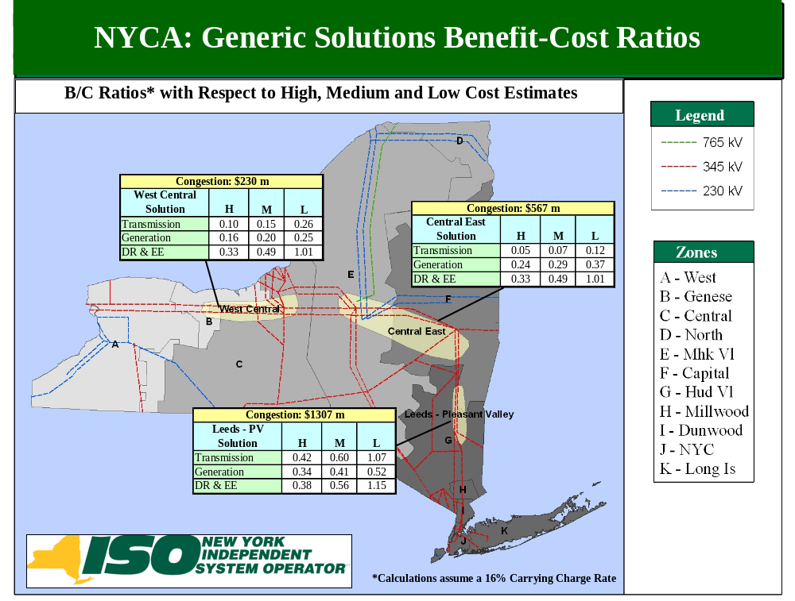
Figure 5-10: B/C Ratio (High, Medium, and Low Cost Estimate Ranges)
Plotted in Figures 5-5, 5-6 and 5-7 are the ten-year cumulative benefits from 2009 to 2018 for each of the three generic solutions. The benefit/cost ratios displayed are based on the present value of the cumulative benefits and an assumed 16% project carrying cost charge. The ratios of the cumulative benefits to project overnight cost, plus a 16% adder for a project carrying cost (“the total cost”), are also shown in the figures. For example, looking at the cumulative graph of the Leads-Pleasant Valley study, the generic generation solution in Figure 5-5 shows that by 2018 41% of the total cost would be recovered by production cost savings. There could be additional benefits continuing beyond the ten-year planning horizon that are not included here.
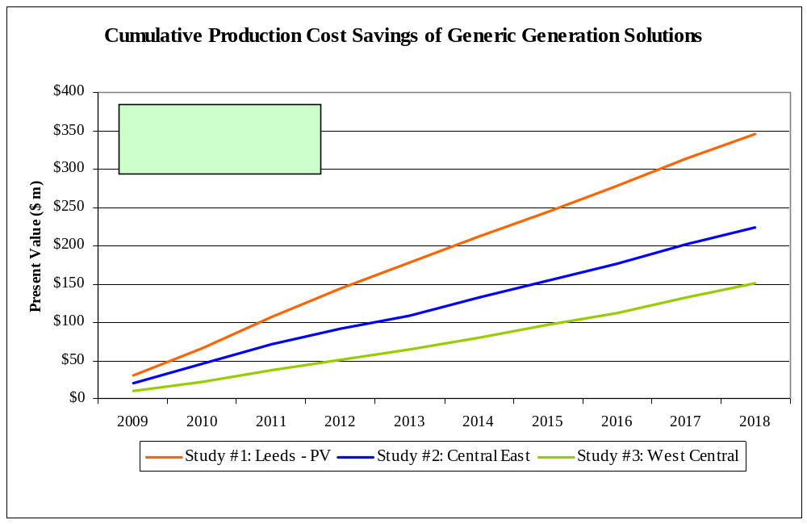
Figure 5-11: Cumulative Benefits of Generic Generation Solutions:
Present Value

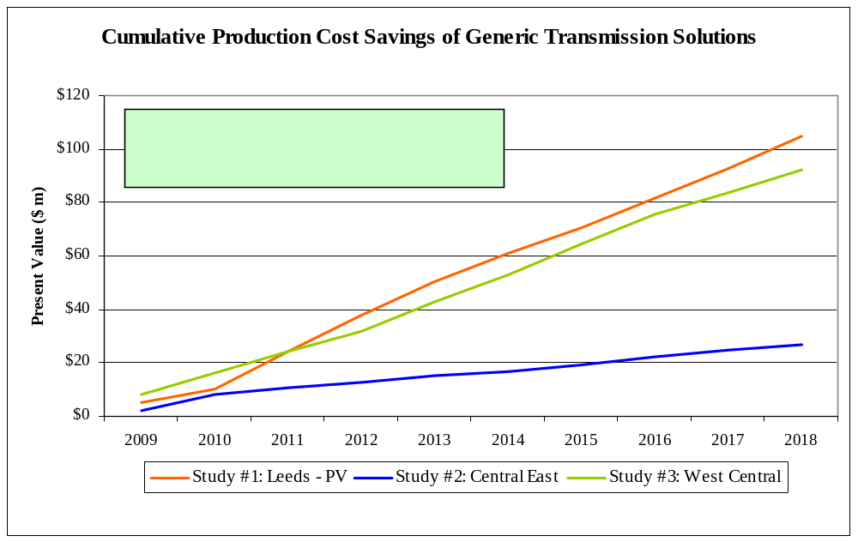
Figure 5-12: Cumulative Benefits of Generic Transmission Solutions: Present Value
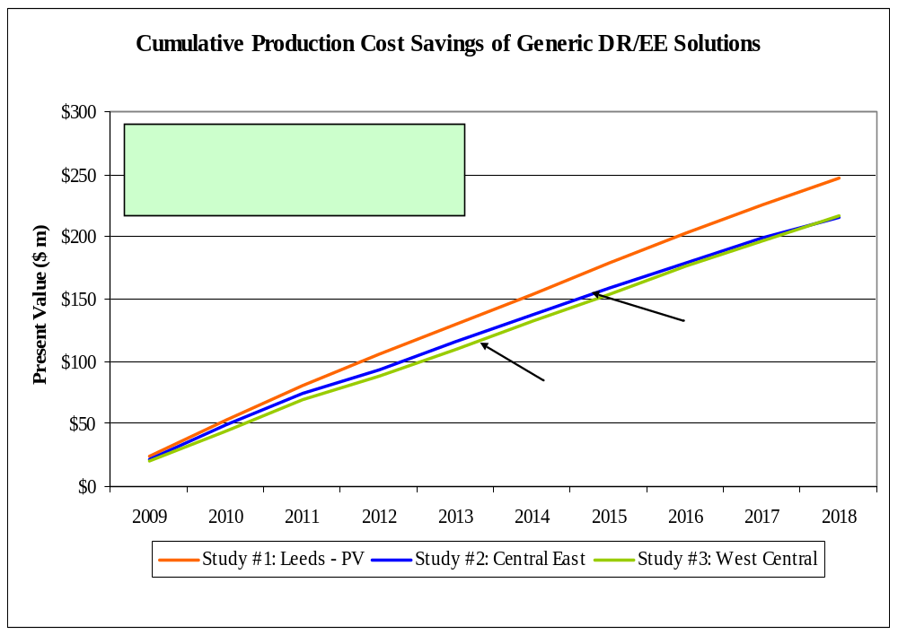
Figure 5-13: Cumulative Benefits of Generic Demand Response/Energy Efficiency Solutions: Present Value

Additional Metrics Results
Additional metrics, which are provided for information purposes in Phase 1, are presented in Table 5-17 and Table 5-18 to show the nominal ten-year total change in: (a) generator payments; (b) LBMP load payments; (c) TCC payments (congestion rents); (d) losses; (e) emission costs/tons; and (f) ICAP MW impact, after the generic solutions are applied. The values represent the difference between the applied generic solutions’ values and the Base Case values for all the metrics except for the ICAP metric. Negative values imply a reduction in costs/tons. The ICAP metric is determined by using the MW impact methodology as described in the CARIS Initial Manual. This methodology determines the capacity that can be removed across NYCA and still meet the Base Case LOLE after the generic solutions are applied. Transmission solutions may provide an ICAP value because they enable better utilization of the existing generating resources and therefore enable a reduction in the Installed Reserve Margin (“IRM”). Generation and DR/EE solutions provide some direct ICAP value because the solutions themselves result in ICAP resources. Depending on the location of the solution, it may also provide for a reduction in the IRM and therefore an ICAP value that is greater than the ICAP size of the solution itself, or an increase in the IRM and therefore an ICAP value that is less than the ICAP size of the solution itself. For example, adding 500 MW at Pleasant Valley yields 595 MW less ICAP NYCA-wide than the Base Case but adding 500 MW at New Scotland only yields 255 MW less ICAP NYCA-wide than the Base Case. For more information on additional metrics’ results, see Appendix E.
Table 5—28: Change in NYCA Generator Payments, Load Payments, Congestion Rents Losses and ICAP (nominal $ m)
 |  | Generator Payments | Load Payments | Congestion Rents* | Losses | ICAP
Study | Solution | ($ m) | ($ m) | ($ m) | ($ m) | (MW)
 | Transmission
#1 - Leeds- Pleasant Valley | Leeds - Pleasant Valley | 306 | (76) | (738) | (139) | 250
#2 - Central East | Edic - New Scotland | 67 | 86 | 94 | (399) | 0
#3 - West Central | Niagara - Clay | (519) | (358) | 176 | 38 | 0
 | Generation
#1 - Leeds- Pleasant Valley | Pleasant Valley | (52) | (784) | (326) | (7) | 595
#2 - Central East | New Scotland | (257) | (479) | 276 | 51 | 255
#3 - West Central | Clay | (389) | (457) | 310 | 125 | 220
 | Dd Response & Energy Eff.
#1 - Leeds- Pleasant Valley | Zone G | (347) | (478) | (36) | (36) | 225
#2 - Central East | Zone F | (343) | (442) | 21 | (16) | 70
#3 - West Central | Zone C | (352) | (480) | 44 | 4 | 70
* Congestion Rents are calculated as Shadow Price times Flow across all constraints in the system.
Note: A negative number implies a reduction.

Discussion
As shown in Table 5-17, relieving the Central East or West Central interfaces with any of the generic solutions increases congestion on the Leeds-Pleasant Valley line. This increase offsets any reduction in congestion achieved on the Central East or West Central interfaces, resulting in an increase of congestion rent on an overall system basis.
The generic solution of installing the Leeds-Pleasant Valley line results in NYCA generator payments increasing while the load payments are decreasing, which appears to be intuitively contradictory. However, further investigation reveals that this transmission solution relieves some pressure at the West Central and Central East interfaces, sharply increasing generation in Zones C and F while generation in Zone G declines substantially. Therefore, upstate generator payments increase while the downstate generator payments decrease. On an overall NYCA basis, the total generator payments increase. Concurrently, the upstate LBMP is increasing while the downstate LBMP is decreasing. However, since downstate load has a dominant share in NYCA load, the downward pressure on load payments more than offsets the upward pressure due to LBMP increases in upstate when measured on a statewide basis. Accordingly, alleviating congestion in Leeds-Pleasant Valley leads to lower load payments statewide as the lower priced upstate generation flows into downstate resulting in a decrease in load payments downstate which is larger than the increase in generator payments in upstate. See Appendix E-4 for further discussion of the inter-relationships among the additional metrics. Not considered here is the impact of the potential TCC revenues may have on the transmission service charge paid by load customers.

Table 5—29: Change in NYCA CO₂, SO₂ and NO_{X} Emissions

Study |  | Solution |  |  |  | CO₂ |  |  |  |  |  | SO₂ |  |  |  |  |  | NOx
 |  |  |  | '000s Tons |  | %Change |  | Cost ($m) |  | Tons |  | %Change |  | Cost ($m) |  | Tons |  | %Change |  | Cost ($m)
 |  | Transmission
1 |  | Leeds - Pleasant Valley |  | (1558) |  | -0.28% |  | (8) |  | (1908) |  | -0.27% |  | (0) |  | (1960) |  | -0.50% |  | (1)
2 |  | Edic - New Scotland |  | 77 |  | 0.01% |  | 0 |  | 178 |  | 0.02% |  | (0) |  | 203 |  | 0.05% |  | 0
3 |  | Niagara - Clay |  | (1255) |  | -0.23% |  | (7) |  | 31 |  | 0.00% |  | (0) |  | (396) |  | -0.10% |  | (0)
 |  | Generation
1 |  | Pleasant Valley |  | 361 |  | 0.07% |  | 2 |  | (9693) |  | -1.35% |  | (0) |  | (7413) |  | -1.89% |  | (4)
2 |  | New Scotland |  | 1040 |  | 0.19% |  | 6 |  | (7359) |  | -1.03% |  | (0) |  | (5266) |  | -1.34% |  | (3)
3 |  | Clay |  | 999 |  | 0.18% |  | 5 |  | (6445) |  | -0.90% |  | (0) |  | (4758) |  | -1.21% |  | (3)
 |  | Dd Response & Energy Eff.
1 |  | Zone G |  | (1942) |  | -0.35% |  | (10) |  | (1715) |  | -0.24% |  | (0) |  | (1333) |  | -0.34% |  | (1)
2 |  | Zone F |  | (1565) |  | -0.28% |  | (8) |  | (1370) |  | -0.19% |  | (0) |  | (959) |  | -0.24% |  | (0)
3 |  | Zone C |  | (1535) |  | -0.28% |  | (8) |  | (1324) |  | -0.19% |  | (0) |  | (992) |  | -0.25% |  | (1)
Note: A negative number implies a reduction.

Discussion
The ten-year changes in total emissions resulting from the application of generic solutions are reported in Table 5-18 above. The Base Case ten-year emission totals for NYCA are: NOx = 392,443 tons. SO₂= 715,502 tons, and CO₂ = 553,292,000 tons. The results reveal that all the generic solutions impact emissions by less than two percent. The current installed capacity in NYCA as reported in the 2009 “Gold Book” is 38,190 MW. The generic generation solution of 500 MW represents the equivalent of 1.3% increase in installed capacity. The generic DR/EE solution of 100 MW of DR and 100 MW of EE could be considered as an additional resource which would equivalent to 0.5% of installed capacity. The capability of the generic transmission solution is 1,000 MVA, which would be utilized to shift dispatch patterns of several hundred MW of capacity, or something on the order of one percent of installed capacity. The three generic solutions can be considered to change the fleet characteristics on the order of one percent, which is consistent with the changes in emission patterns.
The comparison of the relative emission changes among solution types and across locations provides insight about the relative air related impacts. Demand response solutions result in lower overall energy consumption and lower peaks. Accordingly, all locations show improvements in emissions, while the Zone G location shows the greatest reductions.
Transmission and generation solutions yield results that are sensitive to their location. The Edic-New Scotland transmission solution leads to slight increases in the emissions of all three pollutants, which results from the increased use of older generation in central and western New York. The Niagara-Clay transmission solution, which results in both increased generation level in central and western New York and increased imports from PJM and IESO, leads to a mixed pattern of emission changes. The results reveal a reduction in CO₂ and NOx emissions, while SO₂ emissions increased slightly iver the period.
All generic generation solutions lead to an approximately 0.2% increase in CO₂ emissions in NYCA. Table 5-19 shows a net reduction in CO₂ emissions across the region for the ten year study period. This is a result of the relative efficiency of all generic generation solutions as compared to the system average. All generation solutions produce a net reduction in the emissions of SO₂ and NOx between 1% and 2% because of the relative low emission rates of a new unit compared to the average emission rates of the existing fleet. The New Scotland location offers the greatest emission reductions.
Table 5—30: Ten-Year Regional CO₂ Emissions in Million Tons
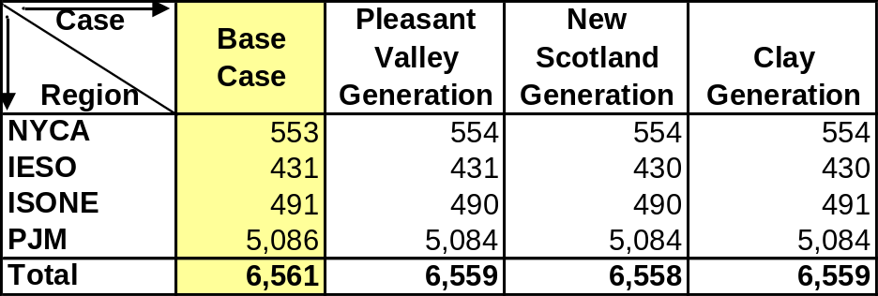

Figures 5-8 and 5-9 below depict the projected base case LBMPs in 2009 and 2018, respectively. The average LBMP in 2009 is $45/MWh, ranging from $41/MWh in the western New York to $48/MWh in New York City and $49/MWh in Long Island. In 2018, an average projected LBMP is $76/MWh, ranging from $64/MWh in the western New York to $84/MWh in New York City and Long Island.
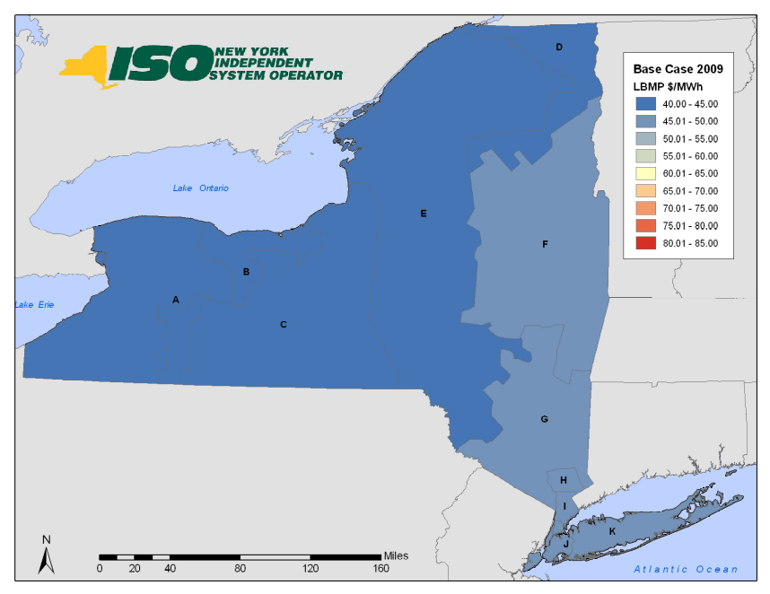
Figure 5-14: 2009 Base Case LBMP $/MWh

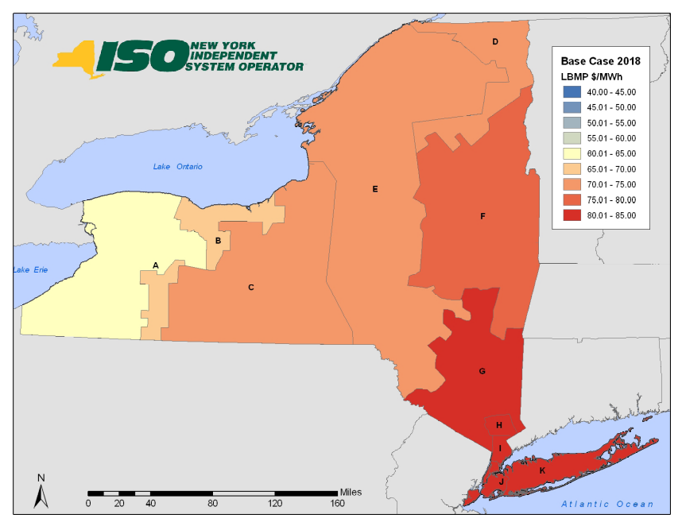
Figure 5-15: 2018 Base Case LBMP $/MWh

Scenario and Sensitivity Analysis
Scenario/sensitivity analysis is performed to explore the impact of uncertainties associated with significant drivers or variables to the base case. Since this is an economic study and not a reliability analysis, these scenarios should focus upon factors that impact the magnitude of congestion across constrained elements. Therefore, the assumptions modeled within these scenarios may not necessarily apply the same criteria as a reliability planning approach.
A forecast of congestion is impacted by many variables for which the future values are uncertain. Scenario and sensitivity analyses are methods of identifying the relative impact of pertinent variables on the cost of congestion. The CARIS scenario studies were presented to ESPWG and modified based upon the input received and the availability of NYISO resources. The focus of these studies was to examine the impact of proposed State policies, fuel price and load forecast uncertainties, costs of emissions, and impacts of various new resources. The objective of the scenario analysis is to determine the change in the costs of congestion on the top three congested paths within NYCA that is caused by variables that differ from the Base Case. The simulations were conducted for the mid-period year (2013) and the horizon year (2018).

Variables for Consideration
Load Forecast Uncertainty

The scenarios evaluated the impact of: (a) a higher forecasted load growth using the high load forecast prepared for the 2009 RNA; (b) a low load growth forecast assuming full implementation of the Energy Efficiency Portfolio Standard (EEPS, or “15 X 15”) as in the 2009 RNA EEPS scenario ; and (c) updated load forecast developed for the 2009 Load and Capacity Data Gold Book.
Fuel Price Uncertainty
The scenarios also evaluated the impact of higher and lower fuel price forecasts. The fuel forecasts utilized in CARIS employed historical price volatility to build a statistical profile around the expected prices that were used in the Base Case. The high fuel price forecast is one standard deviation above the expected price, and the low fuel price forecast is one standard deviation below the expected price. The updated fuel price forecast used the same methodology as the base fuel price forecast applied to updated market information.
New Resources
New resources usually impact the cost of congestion, and can raise or lower it depending on their location and other characteristics. New resources can come from the market, the planning process, government initiatives, and other sources. New York State is currently proposing an expanded Renewable Portfolio Standard. This proposal may require New York to obtain 30% of its electric energy from renewable resources by 2015. The scenarios assumed that incremental renewable energy requirements of this proposed standard would be satisfied through the use of wind energy. The NYISO derived the necessary amount of additional renewable energy to satisfy the targets by selecting projects in the order in which they appeared on the NYISO Interconnection Queue. In 2013, 5,100 GWh of additional renewable energy will be required. The requirement rises to 7,100 GWh in 2015 and is then capped.
The NYISO Update scenario includes the build out at the Astoria Energy facility to the limit of its existing Interconnection Agreement at the 138 kV level. Some additional wind generation facilities have been added that would now meet the criteria for inclusion in an updated RNA base case. These include Wethersfield (132 MW), High Sheldon (112 MW), Canandaigua (125 MW), Clinton (101 MW) and Chateaugay (107 MW).

New resources can have a significant impact on the cost of congestion in New York. Scenarios were constructed to examine the impacts on the cost of congestion when additions are located at or near a border location or in congested areas. One scenario examined the impact of connecting a 500 MW natural gas combined cycle plant to the 345 kV system at the position currently occupied at Astoria . Two other analyses were conducted for a similar facility located on Staten Island, the southern end of the NYCA system and for Massena at the NYCA’s northern border, respectively. The dispatch cost for these facilities was set at 95% of their generic solution running cost to simulate the effects of the new, economically attractive source of energy.
Environmental Mandates and Retirements
The 2009 RNA examined the potential impact of several developing environmental regulations. The first was the implementation of the Regional Greenhouse Gas Initiative, (RGGI), which limits the total CO₂ emissions from power plants across ten state regions. The 2009 RNA scenario analysis concluded that, under some combinations of fuel prices and CO₂ allowance prices, some coal fired power plants would be more likely to retire. The scenario analysis continues to treat coal-fired power plants with capacity factors below 50% as likely candidates for retirement. The State Policy Case incorporated this retirement criterion.
New York State is in the process of revising NOx emission regulations for fossil-fired power plants. The 2009 RNA examined the impact of these regulations on reliability. The State Policy Case uses the same capacity limitations on the High Emitting Combustion Turbines.
Emission Costs
Emissions of SO₂, NOx, and CO₂, all have costs that are determined by various cap and trade programs currently in effect in New York and in most of the surrounding regions. Forecasts used in the base case for these allowance costs were developed using various proprietary forecasts and market prices from the Chicago Climate Futures Exchange. To examine the sensitivity of congestion costs to variations in the prices of these allowances, the forecast prices of SO₂ and NOx were doubled. To simulate the potential impact of a Federal CO₂ limitation, the scenarios assumed the price of CO₂ allowances at $25/ton in 2013 and forecasted prices escalate at CPI plus 5% as prescribed by bills pending in Congress (H.R. 2454 and the Kerry-Boxer Senate proposal).
Energy Efficiency
Energy efficiency acts to reduce the cost of congestion when they are installed downstream of a transmission constraint. They reduce congestion by reducing peak load and altering the load profile. The NYISO examined DR/EE as generic solutions in each of the three studies. Energy Efficiency acts to alter the load forecast and were factored into the Base Case. As in the 2009 RNA, the Base Case assumed that the identified funding will achieve approximately one third of the load reduction necessary to achieve the “15 x15” goal. A low load forecast has been developed to examine the impact of achieving the “15 x 15” goal on the cost of congestion.

Scenarios
The scenarios build upon the Base Case assumptions. Where there were changes in the assumptions, such changes are identified below. Table 5-20 summarizes the scenarios studied in the CARIS Phase 1 report.
Table 5—31: Scenario Matrix
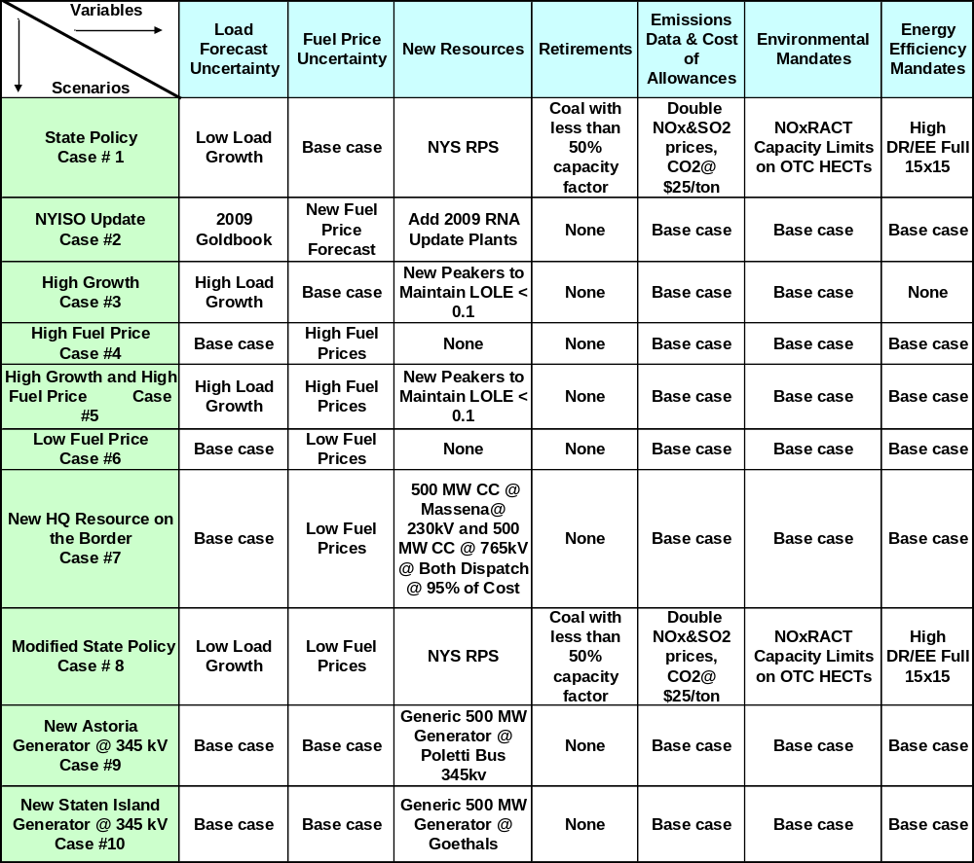
Table 5-21 presents the impact of ten scenarios representing variations in load growth, resource types, resource locations, fuel costs, emission costs and constraints for the mid-year and the horizon year, 2013 and 2018 respectively. Those impacts are expressed as changes in congestion values between the scenarios and the Base Case. Negative numbers represent a reduction in congestion. High fuel prices lead to higher congestion costs at the three study areas and conversely lower fuel prices result in lower congestion. New resources located in load pockets universally reduce the cost of congestion in all three study areas. Other variations generally show that the specific impact of these variables is highly dependent on the location studied.
Table

5—32: Comparison of Base Case and Scenario Cases
 | Change in Congestion – nominal $ m
 | Leeds - PV Study # 1 |  | Central East Study #2 |  | West Central Study #3
Scenario | 2013 | 2018 | 2013 | 2018 | 2013 | 2018
1 – State Policy | (81) | (59) | 21 | 149 | (51) | (83)
2 - NYISO Update | 0 | (46) | 155 | 127 | (22) | (8)
3 - High Growth | 18 | 49 | (11) | (38) | 3 | 9
4 - High Fuel Price | 55 | 55 | 73 | 75 | 23 | 24
5 - High Growth and High Fuel Price | 80 | 116 | 56 | 23 | 28 | 35
6 - Low Fuel Price | (64) | (55) | (34) | (49) | (23) | (26)
7 - New Resources on the HQ Interface | 77 | 118 | 164 | 247 | (28) | (46)
8 - Modified Policy | (122) | (97) | (26) | 52 | (52) | (84)
9 - New Astoria Generator on 345 kV | (46) | (50) | (2) | (4) | (2) | (2)
10 - New Staten Island Generator | (6) | (8) | (3) | (5) | (2) | (1)
Change is calculated as Scenario minus Base

Case #1 – State Policy
The purpose of this scenario is to examine the aggregated impact of new and likely to emerge State and Federal policies on the cost of congestion. In his January 7, 2009 State of the State Address, Governor Paterson announced a “45 x 15” initiative that sets targets for the State to meet 45 percent of its electric energy needs through improved energy efficiency and renewable energy by 2015. The Draft State Energy Plan released on August 10, 2009 provides that the energy efficiency portion of that Governor’s initiative is 15 of the total 45 percent. The 15 percent reduction in forecasted 2015 load represents the EEPS. While the Public Service Commission has yet to directly address the renewable energy portion of the “45 x 15” initiative, this scenario assumes that the State’s current Renewable Portfolio Standard (RPS) (Case 03-E-0188) will be expanded to meet 30 percent of the retail electricity use with renewable energy generation by 2015.
This scenario also used the low load growth forecast which is the equivalent to the full 15 x 15 scenario in the 2009 RNA. Fuel prices are the same as the base case. New wind resources beyond those in the 2009 RNA were added with a simulated additional 5,100 GWh annually in 2013. These new wind resources were selected based on their respective positions in the Interconnection Queue. Similarly, 7,100 GWh annually beyond the 2009 RNA are simulated for 2018. The zonal distribution of this new wind capacity is shown in Table 5-22.
Table 5—33: Zonal Distribution of Additional Wind Generator Capacity for RPS
Zone | 2013 | 2018
Central | 38.4% | 26.3%
Genesee | 0.0% | 3.1%
Mohawk Valley | 40.6% | 35.9%
North | 19.9% | 20.9%
West | 1.1% | 13.8%
To simulate the effects of unit retirements, the model ran in an iterative manner to identify coal fired generators that experience a drop in production to levels below a 50% capacity factor. These units were removed and the models rerun. SO₂ and NOx allowance prices are doubled from the Base Case to simulate continuing evolution of the reductions required through the CAIR program on Ozone SIP calls. CO₂ prices started at $25/ton in 2013 and were assumed to increase consistent with the prescribed requirements of the proposed legislation. The impact of the Ozone Transport Commission (OTC) Reasonably Available Control Technology (RACT) limitation for NOx was simulated through the use of capacity limits on High Emitting Combustion Turbines as examined in the 2009 RNA.
In this scenario, NYCA load is reduced approximately by 7% in 2013 and by 9% in 2018. Despite the load reduction, the sharp increase in emissions costs leads to increases in LBMPs. The effect of the State RPS is to increase generation in the Mohawk Zone by more than 40% in 2013 and more than 60% in 2018. This increase results in an increase in congestion across Central East. The load reduction, coupled with an addition of wind generation leads to a reduction of congestion at Leeds-Pleasant Valley and West Central, and an increase in congestion across Central East.
Case #2 - NYISO Update
This scenario examined the impact of the updated load forecast from the 2009 Gold Book, which is 3.7% lower than the 2009 RNA Base Case load forecast. This scenario also includes an updated fuel price forecast that is about 10% higher for natural gas and about 12% higher for residual oil as compared to the Base Case fuel forecast. In addition, several new generating units that would now meet the criteria for consideration in the RNA, were included.. The additional generation includes the build out at the Astoria Energy facility att he 138kV level and the following wind facilites; Wethersfield (132 MW Zone C), High Sheldon (112 MW Zone C), Canandaigua (125 MW Zone C), Clinton (101 MW Zone D) and Chateaugay (107 MW Zone D). All other variables were the same as in the Base Case.
The reduction in energy consumption coupled with additional production from a new efficient generator in New York City results in a reduction in congestion on Leeds-Pleasant Valley. The reduction in load in the West results in a reduction in congestion across West Central. The additional wind capacity is simulated to produce an additional 1,400 GWH annually. This additional generation in zones that already have a surplus of generation, coupled with the increases in fuel price, yields a significant increase in congestion across Central East.

Case #3 - High Growth
This scenario examined the impact of a higher load growth forecast on the cost of congestion. The case used the 2008 econometric load forecast from the 2009 RNA. All other inputs were the same as in the Base Case.
With an increase in load of 3% in 2013 and 5% in 2018, the congestion across Leeds-Pleasant Valley and West Central is increased. As Leeds-Pleasant Valley becomes more congested, load requirements are met with increased generation in SENY. The combined effect is the decreased congestion across Central-East.
Case #4 - High Fuel Price
This scenario examines the impact of higher fuel prices on the cost of congestion. Compared to the Base Case forecast, natural gas prices average 10% higher in Zones I-K and 7% higher in Upstate. Residual fuel oil prices were assumed to be 2% higher for the period and coal was assumed to cost 2.5% more. All other inputs were the same as in the Base Case.
The higher fuel prices result in higher congestion cost across NYCA with the largest impact on Central East and a slightly smaller impact on Leeds-Pleasant Valley. Generation in Zones J and K decreases in response to higher fuel prices which increases the congestion on Leeds-Pleasant Valley and Central East.
Case #5 - High Growth and High Fuel Price
This scenario examines the impact of the combined changes in Cases #3 and #4. All other inputs were the same as in the Base Case.
The combined impact of high growth and high fuel price scenarios is the largest increase in congestion cost over Leeds- Pleasant Valley, followed by Central East and West Central. As Leeds-Pleasant Valley becomes more congested in 2018, load requirements are met with increased generation in SENY. The observed effect is the decreased congestion in 2018 across Central-East compared to 2013.
Case #6 - Low Fuel Price
This scenario examines the impact of lower fuel prices on the cost of congestion. Compared to the Base Case forecast, natural gas prices average 10% lower in Zones I-K and 7% lower in Upstate. Residual fuel oil prices were 2% lower for the period, and coal is 2.5% lower. All other inputs were the same as in the Base Case.
The lower fuel prices show a decrease in congestion across NYCA. Generation in Zones J & K increases by 5% and 7% respectively in 2013 and 2018.
Case #7 - New Resources on the HQ Interface
This scenario included two new generic 500 MW combined cycle plants that inject energy at Massena. In the simulation the plants were dispatched at 95% of generic solution running cost to capture the maximum impact on congestion. The transmission system, together with other inputs, was the same as the in the Base Case.
The result is a large increase in congestion cost across Central East, followed by the Leeds- Pleasant Valley. The new resources increase the generation north of the Central East by more than 50%. Additional transmission project(s) would be necessary to effectively move this power throughout the State. Congestion across West Central shows a decrease as the resource surplus in those zones would need to compete with the new resources in the North.
Case # 8 - Modified Policy
This scenario is similar to Case # 1, the State Policy Case, with the exception that it uses the low fuel price forecast used in Case #6. All other inputs were the same as in the Base Case. The results show a large decrease in congestion in the Leeds-Pleasant Valley and West Central which can be explained by the reduction in load. The results are mixed for Central East. Initially, in 2013 the congestion costs decrease in this area as both load and generation are reduced, however, congestion costs increase in 2018 when additional wind resources are added.
Case #9 - New Astoria Generator on 345 kV
This scenario examined the impact on the cost of congestion of locating a new generic 500 MW natural gas combined cycle plant connected to the 345 kV system at the location currently occupied by the Poletti Station. In the simulation the plants were dispatched at 95% of generic solution running cost to capture the maximum impact on congestion. No other new generation is assumed in Zone J. All other inputs were the same as in the Base Case.
The results show decreases in congestion for all three study areas, with the Leeds-Pleasant Valley Study showing the largest reduction and the West Central Study showing the least reduction in congestion. As a result of the assumed heat rate of the new generator being significantly below that of the generator fleet in Zone J, the LBMPs and the cost of congestion is reduced. Total generation in Zone J is increased by an amount that is approximately equivalent to 60% of the output of this new resource. Thus, both imports and congestion costs decline.
Case # 10 - New Staten Island Generator
This scenario examined the impact on the cost of congestion of locating a new generic 500 MW natural gas combined cycle plant connected to the 345 kV system at the Goethals bus. In the simulation the plants were dispatched at 95% of generic solution running cost to capture the maximum impact on congestion. All other inputs were the same as in the Base Case.
This new generic generator on the Staten Island resulted in decreases in congestion for all three studies with the largest reduction over Leeds- Pleasant Valley and the least reduction over West Central. As a result of the assumed heat rate of the new generator being significantly below that of the generators in Zone J, the new generator reduces LBMP and the cost of congestion. Total generation in Zone J is increased by an amount that is approximately 8% of the output of this new resource. Thus, the impact on congestion costs of a new resource at this location is less than that in Case # 9. Additional transmission projects would be necessary for this location to fully capture the benefits of the project within NYCA and Zone J.

2009 CARIS Conclusions – Study Phase
The objectives of CARIS Phase 1 are:
1. Develop a forecast of congestion and select three studies with the highest congestion;
2. Develop three generic solutions for each of the three study areas and forecast their respective impacts on congestion; and
3. Analyze the changes in congestion in the three study areas that would arise under differing future states through the use of scenario analysis.
The CARIS study identified three study areas by considering monitored elements that have historically displayed high levels of congestion after adjusting for the effects of volatile fuel price changes and also considering the installation of new resources and transmission system improvements contained in the 2009 CRP.
As shown in Table 6-1, the three transmission groupings studied are: Leeds-Pleasant Valley, Central-East, and West-Central.

Table 6—34: Base Case Projected Congestion 2009-2018
Study | Ten-Year Congestion in $ m
Study | Nominal | Present Value 2009 $
Study #1 -Leeds - Pleasant Valley | 1,987 | 1,307
Study #2 - Central East | 847 | 567
Study #3 - West Central | 362 | 230

The application of the generic solutions to the three study areas all result in production cost savings expressed in 2009 present values, as shown in Table 6-2. The generic solutions did not attempt to alleviate all of the congestion or to identify optimum solutions.

Table 6—35: Production Cost Savings 2009-2018, Present Value in 2009 $ m
 | Ten-Year Production Cost Savings (2009 $ m)
Study | Transmission Solution | Generation Solution | Demand Response Solution
Study #1 - Leeds - Pleasant Valley | 105 | 346 | 247
Study #2 - Central East | 27 | 224 | 216
Study # 3 - West Central | 92 | 151 | 217

For Phase 1, CARIS compares the present value of production cost savings benefit over the ten-year study period to the present value of fixed costs based on a 16% carrying cost charge discounted over the first ten years of a thirty-year horizon to determine a benefit/cost ratio, as presented in Table 6-3. See Section 5.5 for a detailed explanation.

Table 6—36: Benefit/Cost Ratios
Study | Cost Estimate | Benefit/Cost Ratios
Study | Cost Estimate | Transmission Solution | Generation Solution | Demand Response Solution
Study #1 - Leeds - Pleasant Valley | High | 0.42 | 0.34 | 0.38
Study #1 - Leeds - Pleasant Valley | Medium | 0.60 | 0.41 | 0.56
Study #1 - Leeds - Pleasant Valley | Low | 1.07 | 0.52 | 1.15
Study #2 - Central East | High | 0.05 | 0.24 | 0.33
Study #2 - Central East | Medium | 0.07 | 0.29 | 0.49
Study #2 - Central East | Low | 0.12 | 0.37 | 1.01
Study #3 - West Central | High | 0.10 | 0.16 | 0.33
Study #3 - West Central | Medium | 0.15 | 0.20 | 0.49
Study #3 - West Central | Low | 0.26 | 0.25 | 1.01

ICAP Requirements in 2018

The Study #1 - Leeds-Pleasant Valley constraint was found to have the highest projected future congestion at $513m. The generic solutions applied here have the highest benefit/cost ratios of the three studies. Nevertheless, the benefit/cost ratios for the generic solutions assuming medium costs do not exceed 1.0.

The Study #2 - Central-East constraint is projected to have the second highest congestion at $185m. The application of generic solutions here yield lower benefit/cost ratios than the Leeds-Pleasant Valley study. Although more generation is able to pass through this constraint, the simulation shows that it remains bottled up behind Leeds-Pleasant Valley.

The Study #3 - West-Central constraint is projected to have the lowest benefit/cost ratios of the three studies, in general. The reduction in production costs derived from the application of the generic solutions are lower than the other two studies because lower cost resources largely remain bottled up behind both the Central-East and Leeds-Pleasant Valley constraints.

The scenario analysis provides useful insight on the sensitivity of projected congestion values to differing future states. Variations in some inputs provide results that are consistent across NYCA, while other inputs yield results that are more localized, as shown in Figure 6-1.

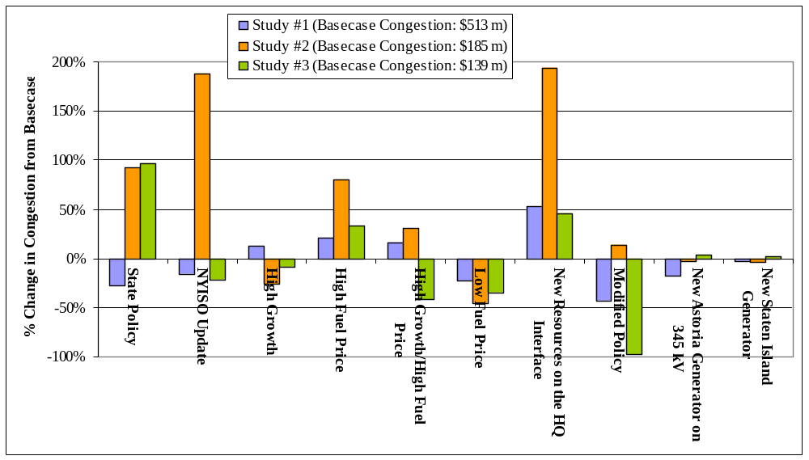
Figure 6-1: Impact of Scenarios on Congestion at Constraints

In conclusion, this CARIS Phase 1 study provides: (a) projections of congestion in the NYCA system; (b) changes in those forecasts resulting from the application of various generic transmission, generation and demand response solutions; and (c) the sensitivity of the identified congestion to changes of inputs representing differing views of future states. The CARIS process is suitable for evaluating projects designed to relieve congestion, for identifying beneficiaries to transmission projects, and for quantifying their respective cost allocations.

Next Steps

Additional CARIS Studies
In addition to the three CARIS studies, any interested party can request an additional study of congestion on the NYCA bulk power system at any time. Those studies can analyze the benefits of alleviating congestion with all types of resources, including transmission, generation and demand response, and compare benefits to costs.

Phase 2 – Specific Transmission Project Phase
Upon the approval of the Phase 1 study results by the Business Issues Committee, Management Committee and the NYISO Board, the NYISO staff will start conducting Phase 2 - the Project Phase - of the CARIS process. Phase 2 deals with any specific transmission project proposals submitted by developer who is seeking regulated cost recovery under the NYISO Tariff.
Transmission projects seeking regulated cost recovery will be further assessed by NYISO staff to determine whether they qualify for cost allocation and cost recovery under the NYISO Tariff. To qualify, the total capital cost of the project must exceed $25 million, the benefits must exceed their cost measured over the first ten years from the proposed commercial operation date, and a super-majority (> 80%) of the weighted votes cast by the beneficiaries must be in favor of the project. Additional details on Phase 2 process can be found in Appendix F and Initial CARIS Manual.

Project Phase Schedule
Phase 2 of the CARIS process will start after the NYISO Board’s approval of the Phase 1 study results, which is anticipated to occur in the beginning of 2010. Throughout 2010, NYISO staff will be evaluating submitted economic transmission project proposals for benefit/cost analysis, and if a developer seeks cost recovery, determining beneficiaries and conducting cost allocation calculations. The results of these analyses will provide a basis for beneficiary voting on each proposed transmission project. Upon the completion of the 2011 CRP, the next CARIS cycle will start.

Appendix A – Glossary

TERM | DEFINITION
Ancillary Services | Services necessary to support the transmission of Energy from Generators to Loads, while maintaining reliable operation of the NYS Power System in accordance with Good Utility Practice and Reliability Rules. Ancillary Services include Scheduling, System Control and Dispatch Service; Reactive Supply and Voltage Support Service (or “Voltage Support Service”); Regulation Service; Energy Imbalance Service; Operating Reserve Service (including Spinning Reserve, 10-Minute Non-Synchronized Reserves and 30-Minute Reserves); and Black Start Capability. [FROM SERVICES TARIFF]
Bid Production Cost | Total cost of the Generators required to meet Load and reliability Constraints based upon Bids corresponding to the usual measures of Generator production cost (e.g., running cost, Minimum Generation Bid, and Start Up Bid). [FROM SERVICES TARIFF]
Bulk Power Transmission Facility (BPTF) | Transmission facilities that are system elements of the bulk power system which is the interconnected electrical system within northeastern North America comprised of system elements on which faults or disturbances can have a significant adverse impact outside of the local area.
Business Issues Committee (BIC) | A NYISO committee that is charged with, among other things, the responsibility to establish procedures related to the efficient and non-discriminatory operation of the electricity markets centrally coordinated by the NYISO, including procedures related to bidding, Settlements and the calculation of market prices.
Capacity | The capability to generate or transmit electrical power, or the ability to reduce demand at the direction of the NYISO.
Chicago Climate Futures Exchange (CCFE) | A derivatives exchange that offers standardized and cleared futures and options contracts on emission allowances and other environmental products.
Clean Air Markets Division (CAMD) | A division of the U.S. Environmental Protection Agency responsible for various market-based regulatory programs that are designed to improve air quality by reducing outdoor concentrations of fine particles, sulfur dioxide, nitrogen oxides, and mercury.
Comprehensive Reliability Plan (CRP) | An annual study undertaken by the NYISO that evaluates projects offered to meet New York’s future electric power needs, as identified in the Reliability Needs Assessment (RNA). The CRP may trigger electric utilities to pursue regulated solutions to meet Reliability Needs if market-based solutions will not be available by that point. It is the second step in the Comprehensive Reliability Planning Process (CRPP)
Comprehensive Reliability Planning Process (CRPP) | The annual process that evaluates resource adequacy and transmission system security of the state’s bulk electricity grid over a 10-year period and evaluates solutions to meet those needs. The CRPP consists of two studies: the RNA, which identifies potential problems, and the CRP, which evaluates specific solutions to those problems.
Comprehensive System Planning Process (CSPP) | A transmission system planning process that is comprised of three components: (1) Local transmission planning; (2) Compilation of local plans into the Comprehensive Reliability Planning Process (CRPP), which includes developing a Comprehensive Reliability Plan (CRP); (3) Channeling the CRP data into the Congestion Assessment and Resource Integration Study (CARIS)
Congestion | Congestion on the transmission system results from physical limits on how much power transmission equipment can carry without exceeding thermal, voltage and/or stability limits determined to maintain system reliability. If a lower cost generator cannot transmit its available power to a customer because of a physical transmission constraint, the cost of dispatching a more expensive generator is the congestion cost.
Congestion Rent | The opportunity costs of transmission Constraints on the NYS Bulk Power Transmission System. Congestion Rents are collected by the NYISO from Loads through its facilitation of LBMP Market Transactions and the collection of Transmission Usage Charges from Bilateral Transactions.
Contingencies | Electrical system events (including disturbances and equipment failures) that are likely to happen.
Day Ahead Market (DAM) | A NYISO-administered wholesale electricity market in which capacity, electricity, and/or Ancillary Services are auctioned and scheduled one day prior to use. The DAM sets prices as of 11 a.m. the day before the day these products are bought and sold, based on generation and energy transaction bids offered in advance to the NYISO. More than 90% of energy transactions occur in the DAM.
DC tie-lines | A high voltage transmission line that uses direct current for the bulk transmission of electrical power between two control areas.
Demand Response | A mechanism used to encourage consumers to reduce their electricity use during a specified period, thereby reducing the peak demand for electricity.
Eastern Interconnection Planning Collaborative (EIPC) | A group of planning authorities convened to establish processes for aggregating the modeling and regional transmission plans of the entire Eastern Interconnection and for performing inter-regional analyses to identify potential opportunities for efficiencies between regions in serving the needs of electrical customers.
Economic Dispatch of Generation | The operation of generation facilities to produce energy at the lowest cost to reliably serve consumers.
Electric System Planning Working Group (ESPWG) | A NYISO governance working group for Market Participants designated to fulfill the planning functions assigned to it. The ESPWG is a working group that provides a forum for stakeholders and Market Participants to provide input into the NYISO’s Comprehensive Reliability Planning Process (CRPP), the NYISO’s response to FERC reliability-related Orders and other directives, other system planning activities, policies regarding cost allocation and recovery for reliability projects, and related matters.
Energy Efficiency Portfolio Standard (EEPS) | A statewide program ordered by the NYSPSC in response to the Governor’s call to reduce New Yorkers' electricity usage by15% of forecast levels by the year 2015, with comparable results in natural gas conservation. Also known as 15x15.
Exports | A Bilateral Transaction or purchases from the LBMP Market where the Energy is delivered to a NYCA Interconnection with another Control Area. [FROM SERVICES TARIFF]
External Areas | Neighboring Control Areas including HQ, ISO-NE, PJM, IESO
Federal Energy Regulatory Commission (FERC) | The federal energy regulatory agency within the US Department of Energy that approves the NYISO’s tariffs and regulates its operation of the bulk electricity grid, wholesale power markets, and planning and interconnection processes.
FERC Form 715 | An annual transmission planning and evaluation report required by the FERC – filed by the NYISO on behalf of the transmitting utilities in New York State.
FERC Order No. 890 | Adopted by FERC in February 2007, Order 890 is a change to FERC’s 1996 open access regulations (established in Orders 888 and 889). Order 890 is intended to provide for more effective competition, transparency and planning in wholesale electricity markets and transmission grid operations, as well as to strengthen the Open Access Transmission Tariff (OATT) with regard to non-discriminatory transmission service. Order 890 requires Transmission Providers – including the NYISO – have a formal planning process that provides for a coordinated transmission planning process, including reliability and economic planning studies.
Grandfathered Rights | The transmission rights associated with: (1) Modified Wheeling Agreements; (2) Transmission Facility Agreements with transmission wheeling provisions; and (3) Third Party Transmission Wheeling Agreements (“TWA”) where the party entitled to exercise the transmission rights associated with such Agreements has chosen, as provided in the Tariff, to retain those rights rather than to convert those rights to TCCs. [FROM SERVICES TARIFF]
Grandfathered TCCs | The TCCs associated with: (1) Modified Wheeling Agreements; (2) Transmission Facility Agreements with transmission wheeling provisions; and (3) Third Party TWAs where the party entitled to exercise the transmission rights associated with such Agreements has chosen, as provided by the Tariff, to convert those rights to TCCs. [FROM SERVICES TARIFF]
Grid View Software | An analytic tool for market simulation and asset performance evaluations.
Heat Rate | A measurement used to calculate how efficiently a generator uses heat energy. It is expressed as the number of BTUs of heat required to produce a kilowatt-hour of energy. Operators of generating facilities can make reasonably accurate estimates of the amount of heat energy a given quantity of any type of fuel, so when this is compared to the actual energy produced by the generator, the resulting figure tells how efficiently the generator converts that fuel into electrical energy.
High Voltage Direct Current (HVDC) | A transmission line that uses direct current for the bulk transmission of electrical power, in contrast with the more common alternating current systems. For long-distance distribution, HVDC systems are less expensive and suffer lower electrical losses.
Hurdle Rate | The minimum acceptable rate of return.
Imports | A Bilateral Transaction or sale to the LBMP Market where Energy is delivered to a NYCA Interconnection from another Control Area.
Independent Market Advisor | Person, persons or consulting firm retained by the NYISO Board pursuant to Article 4 of the NYISO’s Market Monitoring Plan.
Independent System Operator (ISO) | An organization, formed at the direction or recommendation of the Federal Energy Regulatory Commission (FERC), which coordinates, controls and monitors the operation of the electrical power system, usually within a single US State, but sometimes encompassing multiple states.
Installed Capacity (ICAP) | A generator or load facility that complies with the requirements in the Reliability Rules and is capable of supplying and/or reducing the demand for energy in the NYCA for the purpose of ensuring that sufficient energy and capacity are available to meet the Reliability Rules.
Installed Reserve Margin (IRM) | The amount of installed electric generation capacity above 100% of the forecasted peak electric consumption that is required to meet New York State Reliability Council (NYSRC) resource adequacy criteria. Most planners consider a 15-20% reserve margin essential for good reliability.
Load | A term that refers to either a consumer of Energy or the amount of demand (MW) or Energy (MWh) consumed by certain consumers. [FROM SERVICES TARIFF]
Locational Capacity Requirement (LCR) | Locational Capacity Requirement specifies the minimum amount of installed capacity that must be procured from resources situated specifically within a locality (Zone K and Zone J). It considers  resources within the locality as well as the transmission import capability to the locality in order to meet the resource adequacy reliability criteria of the New York State Reliability Council (NYSRC) and the Northeast Power Coordinating Council (NPCC).
Load Serving Entity (LSE) | Any entity, including a municipal electric system and an electric cooperative, authorized or required by law, regulatory authorization or requirement, agreement, or contractual obligation to supply Energy, Capacity and/or Ancillary Services to retail customers located within the NYCA, including an entity that takes service directly from the NYISO to supply its own Load in the NYCA. [FROM SERVICES TARIFF]
Load Zones | The eleven regions in the NYCA connected to each other by identified transmission interfaces. Designated as Load Zones A-K.
Local Transmission Planning Process (LTPP) | The first step in the Comprehensive System Planning Process (CSPP), under which stakeholders in New York’s electricity markets participate in local transmission planning.
Locational Based Marginal Pricing (LBMP) | The price of Energy at each location in the NYS Transmission System.
MAPS Software | An analytic tool for market simulation and asset performance evaluations.
Market Based Solution | Investor-proposed projects that are driven by market needs to meet future reliability requirements of the bulk electricity grid as outlined in the RNA. Those solutions can include generation, transmission and Demand Response Programs.
Market Participant | An entity, excluding the NYISO, that produces, transmits sells, and/or purchases for resale capacity, energy and ancillary services in the wholesale market. Market Participants include: customers under the NYISO’s tariffs, power exchanges, TOs, primary holders, load serving entities, generating companies and other suppliers, and entities buying or selling transmission congestion contracts.
New York Control Area (NYCA) | The area under the electrical control of the NYISO. It includes the entire state of New York, and is divided into 11 zones.
New York Independent System Operator (NYISO) | Formed in 1997 and commencing operations in 1999, the NYISO is a not-for-profit organization that manages New York’s bulk electricity grid – a 10,775-mile network of high voltage lines that carry electricity throughout the state. The NYISO also oversees the state’s wholesale electricity markets. The organization is governed by an independent Board of Directors and a governance structure made up of committees with Market Participants and stakeholders as members.
New York State Energy Planning Board (SEPB) | Established by New York’s Governor in April 2008 to create a state energy plan (SEP) that examines and lays out goals addressing all aspects of New York’s energy use and conservation.
New York State Reliability Council (NYSRC) | A not-for-profit entity whose mission is to promote and preserve the reliability of electric service on the New York State Power System by developing, maintaining, and, from time-to-time, updating the Reliability Rules which shall be complied with by the New York Independent System Operator ("NYISO") and all entities engaging in electric transmission, ancillary services, energy and power transactions on the New York State Power System.
Nomogram | Nomograms are used to model relationships between system elements. These can include; voltage or stability related to load level or generator status; two interfaces related to each other; generating units whose output is related to each other; and operating procedures.
Northeast Coordinated System Planning Protocol (NCSPP) | ISO New England, PJM and the NYISO work together under the Northeast Coordinated System Planning Protocol (NCSPP), to analyze cross-border issues and produce a regional electric reliability plan for the northeastern United States.
NYISO Governance Process | A shared governance process by which representatives from stakeholder groups discuss debate and vote on issues directly affecting the NYISO’s operations, reliability and markets. The three committees – Management, Operating and Business Issues – are supported by several subcommittees, which are made up of individuals from five major sectors of the marketplace: Transmission Owners, Generation Owners, Other Suppliers, End-Use Consumers, and Public Power and Environmental Parties.
Operating Reserves | Capacity that is available to supply Energy or reduce demand and that meets the requirements of the NYISO. [SERVICES TARIFF TERM]
Overnight Costs | Direct permitting, engineering and construction costs with no allowances for financing costs.
Phase Angle Regulator (PAR) | Device that controls the flow of electric power in order to increase the efficiency of the transmission system.
Plan NYC | New York City goal, announced by Mayor Michael R. Bloomberg in 2007, of reducing its citywide carbon emissions by 30% below 2005 levels by 2030.
Proxy Generator Bus | A proxy bus located outside the NYCA that is selected by the NYISO to represent a typical bus in an adjacent Control Area and for which LBMP prices are calculated. The NYISO may establish more than one Proxy Generator Bus at a particular Interface with a neighboring Control Area to enable the NYISO to distinguish the bidding, treatment and pricing of products and services at the Interface.
Regional Greenhouse Gas Initiative (RGGI) | A cooperative effort by ten Northeast and Mid-Atlantic states to limit greenhouse gas emissions using a market-based cap-and-trade approach.
Regional Transmission Operator (RTO) | An organization that is responsible for moving electricity over large interstate areas. They schedule the use of transmission lines; manage the interconnection of new generation and monitor the markets.
Regulated Backstop Solution | Proposals required of certain TOs to meet Reliability Needs as outlined in the RNA. Those solutions can include generation, transmission or Demand Response. Non-Transmission Owner developers may also submit regulated solutions. The NYISO may call for a Gap solution if neither market-based nor regulated backstop solutions meet Reliability Needs in a timely manner. To the extent possible, the Gap solution should be temporary and strive to ensure that market-based solutions will not be economically harmed. The NYISO is responsible for evaluating all solutions to determine if they will meet identified Reliability Needs in a timely manner.
Regulation Service | An Ancillary Service. See glossary definition for Ancillary Services.
Reliability Need | A condition identified by the NYISO in the RNA as a violation or potential violation of Reliability Criteria. (OATT TERM)
Reliability Needs Assessment (RNA) | An annual report that evaluates resource adequacy and transmission system security over a 10-year planning horizon, and identifies future needs of the New York electric grid. It is the first step in the NYISO’s CRPP.
Responsible Transmission Owner (Responsible TO) | The Transmission Owner or TOs designated by the NYISO, pursuant to the NYISO Planning Process, to prepare a proposal for a regulated solution to a Reliability Need or to proceed with a regulated solution to a Reliability Need. The Responsible TO will normally be the Transmission Owner in whose Transmission District the NYISO identifies a Reliability Need.
Security Constrained Unit Commitment (SCUC) | A process developed by the NYISO, which uses a computer algorithm to dispatch sufficient resources, at the lowest possible Bid Production Cost, to maintain safe and reliable operation of the NYS Power System.
Smart Grid | A combination of transmission/distribution and communications technologies that enables the routing of power in optimal ways to respond to a wide range of conditions.
Special Case Resource (SCR) | A NYISO Demand Response program designed to reduce power usage by businesses and large power users qualified to participate in the NYISO’s ICAP market. Companies that sign up to serve as SCRs are paid in advance for agreeing to reduce power consumption upon NYISO request.
Stakeholders | A person or group that has an investment or interest in the functionality of New York’s transmission grid and markets.
Thermal transfer limit | The maximum amount of heat a transmission line can withstand. The maximum reliable capacity of each line, due to system stability considerations, may be less than the physical or thermal limit of the line.
Transfer Capability | The amount of electricity that can flow on a transmission line at any given instant, respecting facility rating and reliability rules.
Transmission Congestion Contract (TCC) | The right to collect, or obligation to pay, Congestion Rents in the Day Ahead Market for Energy associated with a single MW of transmission between a specified Point Of Injection and Point Of Withdrawal. TCCs are financial instruments that enable Energy buyers and sellers to hedge fluctuations in the price of transmission. (SERVICES TARIFF TERM)
Transmission Constraint | Limitations on the ability of a transmission facility to transfer electricity during normal or emergency system conditions.
Transmission District | The geographic area served by the Investor Owned Transmission Owners and LIPA, as well as the customers directly interconnected with the transmission facilities of the Power Authority of the State of New York. (SERVICES TARIFF TERM)
Transmission Interface | A defined set of transmission facilities that separate Load Zones and that separate the NYCA from adjacent Control Areas. (SERVICES TARIFF TERM)
Transmission Line Losses | Power consumed by the delivery system from electric current overcoming the resistance of the wires, transformers and other components of the power system that result in power being converted into heat.
Transmission Owner (TO) | A public utility or authority that provides Transmission Service under the Tariff
Transmission Planning Advisory Subcommittee (TPAS) | A group of Market Participants that advises the NYISO Operating Committee and provides support to the NYISO Staff in regard to transmission planning matters including transmission system reliability, expansion, and interconnection.
Wheels Through | Transmission Service, originating in another Control Area that is wheeled through the NYCA to another Control Area. [SERVICES TARIFF TERM]
Working Groups | Groups comprised of NYISO stakeholders, convened to address transmission system and market issues under the NYISO governance system.

Despite the anomalous fuel-price volatility in the aftermath of Katrina in 2005, the coefficient of correlation between congestion values and natural gas price during the 2004 – 2008 period was 0.71. The corresponding coefficient for the study period of 2009-2018 was 0.98. The exclusion of 2005 data raises the historic correlation to 0.96.
For purpose of representing demand response in the software used, the NYISO modeled demand response resources as consisting of half energy efficiency measures and half demand response.
Decreased congestion rents can reduce credits against the transmission service charge of the loads in certain zones and have an impact on the total benefits received by those loads in those zones.
NYSPSC CASE 03-E-0188. Order Regarding Retail Renewable Portfolio Standard. September 24, 2004.
NYSPSC CASE 07-M-0548. Order Establishing Energy Efficiency Portfolio Standard And Approving Programs. June 23, 2008.
The NYISO began reporting NYISO historic congestion information in 2003.
The NYISO anticipates that any lessons learned from completion of the first CARIS study will be used to refine and improve the economic planning process.
http://www.nyiso.com/public/webdocs/services/planning/initial_caris_manual_bic_approved/CARISmanual.pdf.
The NYISO benefit/cost analysis will be forwarded to the BIC and to the MC for discussion and action. The beneficiary determination and associated voting percentages will be provided to the BIC and the MC for review and comment, but not approval.
Section 11.3.d of the Tariff specifies the principal benefit metric for the CARIS analysis.
Section 11.3.d of the Tariff specifies the additional metrics. The additional metrics allow LSEs to consider other parameters when evaluating or comparing potential projects.
For the future CARIS cycles, the NYISO will develop a methodology to reflect potential changes in ICAP costs separate from this temporary approach which is not meant to set precedence for the more fully developed ICAP cost methodology applicable to future CARIS cycles.
While the system topology and resource additions are the same as in the 2009 CRP, additional data inputs were needed for the CARIS studies since the CRP studies employed transmission and resource adequacy analyses while the CARIS uses production cost analysis requiring additional inputs
The use of the SPS was permitted as an exception to the New York State Reliability Council (NYSRC) reliability rules. See Section 5.3 of this CARIS report.
“SCR” values reflect the August 2008 SCR posting and were held constant over the ten-year Study Period.
New York Control Area (NYCA) "Capacity" values include resources internal to New York, additions, reratings, retirements, purchases and sales, and UDRs with firm capacity. Zone K "Capacity" values include UDRs with firm capacity. Wind generation values include full nameplate capacity.
THIS IN THE BODY BELOW TABLE 4.3
www.eia.doe.gov
Prior to 2008, this data was submitted via FERC Form 423. 2008 onwards, the same data are collected on Schedule 2 of the new Form EIA-923. See http://www.eia.doe.gov/cneaf/electricity/page/ferc423.html
This is a two-step process: First, using multi-year time-series, deviations around a time-varying trend (e.g., a centered 12-month moving average or a Hodrick-Prescott Filtered trend) were calculated; second, a 4-degree polynomial trend was fitted to the estimated seasonal factors.
These forecasts were, in turn, based on EIA’s current national long-term forecast of delivered fuel-prices.
Ontario Wholesale Electricity Market Price Forecast For the Period May 1, 2008 through October 31, 2009, Presented to Ontario Energy Board, April 11, 2008 by Navigant Consulting Inc., Toronto, Ontario.
NERA/Sargent & Lundy, Quanta Services, and Brattle Group were retained to provide the initial cost assessment for the generation, transmission and demand response solutions.
For future CARIS studies, the NYISO will utilize an additional block size of 138kV, 500MVA for Zone J in order to address potential congested load pockets in NYC and at such time develop the respective cost estimates.
For this CARIS cycle Demand Resource costs considered potential market value and not actual costs to build or implement DSM. In the next CARIS cycle the actual cost estimates will be considered for Demand Response solutions.
The Carrying Charge Rate of 16% was applied to a 30-year period because the Tariff provisions governingin Phase 2 of CARIS refers to calculating costs over 30 years for information purposes. See OATT Attachment Y, Section 15.3(d).
See PSC Case 07-M-0548, Order Establishing Energy Efficiency Portfolio Standard and Approving Programs (issued and effective June 23, 2008).
Market-based responses to congestion identified in Phase 1 of the CARIS are not eligible for regulated cost recovery, and therefore are not obligated to follow the requirements of Phase 2. Cost recovery of market-based projects shall be the responsibility of the developer.

