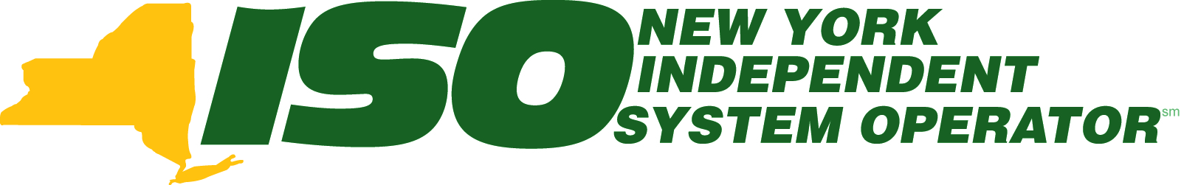

2009 Reliability Needs Assessment

Draft Report

November 5, 2008

4th DRAFT - For Discussion Only
With Stakeholder revisions discussed at ESPWG, November 4, 2008.

Caution and Disclaimer
The contents of these materials are for information purposes and are provided “as is” without representation or warranty of any kind, including without limitation, accuracy, completeness or fitness for any particular purposes. The New York Independent System Operator assumes no responsibility to the reader or any other party for the consequences of any errors or omissions. The NYISO may revise these materials at any time in its sole discretion without notice to the reader.

Table of Contents
1. Introduction 1-1
1.1. Related Planning Activities 1-2
2. CRP Process and Summary of Prior Plans 2-1
2.1. Overview of the CRPP 2-1
2.2. Summary of Prior CRPs 2-5
3. RNA Base Case Assumptions, Drivers and Methodology 3-1
3.1. RNA Base Case Assumptions and Drivers 3-2
3.2. Impact of Energy Efficiency Portfolio Standard on the Load Forecast 3-2
3.3. Forecast of Special Case Resources 3-8
3.4. Resource Additions 3-8
3.5. TO Firm Plans 3-10
3.6. Resource Retirements 3-11
3.7. Base Case Load and Resource Margins 3-11
3.8. Methodology for the Determination of Needs 3-13
4. Reliability Needs Assessment 4-1
4.1. Overview 4-1
4.2. Reliability Needs for Base Case 4-1
4.3. Factors Affecting Reliability Needs for 2009 4-5
4.4. Scenarios 4-6
4.5. Introduction 4-11
4.6. Potential Impact of RGGI and other CO₂ Allowance Programs 4-12
4.7. Potential Impact of Future NOx Emission Limitations 4-14
5. Observations and Recommendations 5-22
5.1. Base Case 5-22
5.2. Scenarios 5-25
6. Historic Congestion 6-1
7. Appendix A - Reliability Needs Assessment Glossary 7-1
8. Appendix B – Load and Energy Forecast, 2008-2018 8-1
9. Appendix C: Transmission System Assessment 9-1
10. Appendix D: Environmental Scenarios 10-1

2-52-5
Assumpti
Assumpti

4-1

4-144-13
5-22
5-225-22
5-25

Table of Tables
Table I-1: Scheduled Unit Retirements * ii
Table 2-1: Current Status of the 2008 CRP Market – Based Solutions and TOs’ Plans 2-7
Table 3-1 - RNA Forecast Scenarios 3-5
Table 3-2: Comparison of Zonal Forecasts - Forecast of Coincident Summer Peak Demand by Zone – MW Before Reductions for Emergency Demand Response Programs 3-7
Table 3-3: Forecast Delta, RNA Year 2009 – RNA Year 2008 3-7
Table 3-2: Unit Additions 3-9
Table 3-4: Scheduled Unit Retirements * 3-11
Table 3-5: NYCA Load and Resource Margins 2009 to 2018 3-12
Table 3-6: 2008 RNA - 2009 RNA Load and Capacity Comparison 3-12
Table 4-1: Transmission System Thermal Transfer Limits for Key Interfaces in MW 4-2
Table 4-2: Transmission System Voltage Transfer Limits for Key Interfaces in MW 4-2
Table 4-3: Transmission System Base Case Transfer Limits for Key Interfaces in MW 4-3
Table 4-4: LOLE for the RNA Study Case Transfer Limits 4-3
Table 4-5: External Tie Line Capability vs Derated Values 4-4
Table 4-6: LOLE for the RNA Base Case Transfer Limits With Derated Tieline Capability 4-4
Table 4-7: Factors Affecting the NYCA LOLE Results 4-6
Table 4-8: RNA Base Case LOLE Econometric Growth Scenario 4-7
Table 4-9: Econometric Growth Scenario 4-7
Table 4-10: “15x15” Energy Efficiency Scenario 1 4-8
Table 4-11: LOLE Results for “15x15” Energy Efficiency Scenario 1 4-9
Table 4-12: “15x15” Energy Efficiency Scenario 2 4-9
Table 4.13: LOLE Results for “15x15” Energy Efficiency Scenario 2 4-9
Table 4-14: High Economic Growth and Extreme Weather Scenario 4-10
Table 4-15: RNA Base Case LOLE High Economic Growth and Extreme Weather Scenario 4-10
Table 4.16: LOLE for RNA Base Case Environmental Retirement Scenario RNA Base Case Load Forecast Scenario 1: OTC – HEDD HECTs 4-15
Table 4.17: LOLE for RNA Base Case Environmental Retirement Scenario RNA Base Case Load Forecast Scenario 2: OTC - HEDD LFBs 4-15
Table 4.17a: LOLE for RNA Base Case Environmental Retirement Scenario RNA Base Case Load Forecast Scenario 3: DEC New NOx RACT 4-16
Table 4-18: NYCA External HQ to Area D Capacity Scenario 4-16
Table 4-19: NYCA Area_F and G External Sale To New England Scenario 4-17
Table 4-20: Indian Point 2 and 3 Nuclear Retirement Scenario 4-17
Table 4-21: Revised Transmission Topology 4-18
Table 4-22 Zones at Risk Results for 2018 4-19
Table 4-23: Wind Penetration Scenario Assumptions 4-20
Table 4-24: LOLE with High Wind Penetration 4-20
Table 4-25: LOLE with SCR Resources Reduced Annually by 7.5% 4-21
Table 4-26: LOLE with SCR Resourced Increased Annually by 7.5% 4-21
Table 4-27: External Areas Adjusted to Achieve 0.10 LOLE 4-22
Table 4-28: External Areas Fixed to IRM 2009 Load and Capacity Values 4-22
Table 6-1: Breakdown of 2007 Total Unhedged Congestion – Top Five Facilities 6-2
Table 6-2: Unhedged Congestion Payments, 2003-2007 6-2
Table B-1: Summary of Econometric Forecasts 8-1
Table B-2: 21-Year Historic Peak and Energy Data and Growth Rates 8-2
Table B-3: Weather Normalized Annual Energy and Seasonal Peak Loads 8-3
Table B-4: Actual and Forecast Annual Energy 8-3
Table B-5: Weather Normalized Summer Peaks and Forecast By Region 8-4
Table B-6: EEPS 2015 Goals by Administration or Jurisdictional Unit 8-6
Table B-7: Confidence Factors and Realization Rates 8-7
Table B-8: Base Case – Achievement Based on $160M/yr Through 2015 8-8
Table B-9: Zonal Energy Forecast Growth Rates - 2008 to 2018 8-9
Table C.1: Area Load plus Losses (MW) 9-1
Table C.2: Generation Dispatched (MW) 9-2
Table C.3: Emergency Thermal Transfer Limits 9-3
Table C.4: Emergency Voltage Transfer Limits 9-5
Table D-1 LOLE for RNA Base Case Environmental Retirement Scenario RNA Base Case Load Forecast Scenario 1: OTC – HEDD HECTs 10-6
Table D-2 LOLE for RNA Base Case Environmental Retirement Scenario RNA Base Case Load Forecast Scenario 2: OTC - HEDD LFBs 10-6
Table D.3 LOLE for RNA Base Case Environmental Retirement Scenario RNA Base Case Load Forecast Scenario 3: DEC New NOx RACT 10-7
Table D-4: September 25, 2008 RGGI Auction 10-9
Table D-5: December 17, 2008 RGGI Auction 10-10
2-72-7

Transfer
Transfer

Transfer

4-154-14
4-154-14
4-164-15
4-164-15
4-174-16
4-174-16
4-184-17
4-194-18
4-204-18
4-204-20
4-214-20
4-214-21
4-224-21
4-224-21
4-224-21

Table of Figures
Figure 2-1: NYISO Reliability Planning Process 2-42-42-3
Figure 2-2: Proposed Economic Planning Process 2-52-52-4
Figure 6-1: Cumulative Unhedged Historic Congestion by Year 2003 to 2007 6-1
Figure C-1: 2009 RNA MARS Topology 9-6
Figure D-1: NOx Emissions vs Gross Generation 10-3
Figure D-2: NYCA NOx Emissions vs Ozone Concentration 10-4
Figure D-3: RGGI program vs. WCI and US program 10-11
Figure D-4: EU ETS 2012 Allowance Price 10-12
Figure D-5: NYISO CO2 Emissions 10-13

- Executive Summary
The 2009 Reliability Needs Assessment (RNA) commences the fourth cycle of the Comprehensive Reliability Planning Process (CRPP) since the New York Independent System Operator’s (NYISO) planning process was initially approved by the Federal Energy Regulatory Commission (FERC) in December 2004. The CRPP is a long-range reliability assessment of both resource adequacy and transmission security of the New York bulk power system conducted over five-year and 10-year planning horizons. The FERC reaffirmed its approval on October 16, 2008, when it approved the NYISO’s Comprehensive System Planning Process (CSPP), which encompasses the existing CRPP as well as the new economic planning process called the Congestion Analysis and Resource Integration Study (CARIS). The CRPP has been highly successful in identifying needs and recruiting market-based solutions to meet those needs, and in lining up both Responsible TO and alternative regulated solutions to be called upon as a backstop only if a regulated reliability solution needs to be triggered.
This 2009 RNA builds upon the results and analyses contained in the NYISO’s first three Comprehensive Reliability Plans (CRP). Those first CRPs responded to the need for significant resource additions identified by reliability needs assessments for the 10-year Study Periods each of them covered. Changes in the public policy context that directly affect forecasted load levels and the addition of sufficient new resource for the New York bulk power system have changed the outlook for the RNA this year. This 2009 RNA indicates that the forecasted baseline system meets applicable reliability criteria for the years 2009 through 2018. There are three primary reasons this year’s RNA does not identify reliability needs for this Study Period.
First, the prior base cases used in the CRPs did not include major market and alternative regulated resource and transmission system additions that now meet criteria (NYISO Manual 26 entitled: “Comprehensive Reliability Planning Process Manual”) for inclusion in the NYISO’s base case for this year’s study , in Zones C through K. Unit additions of approximately 1,714 MW over the 2008 RNA resource assumptions, which include approximately 800 MW of new wind capacity, have been incorporated into the 2009 RNA Base case. Additionally, the plan identifies no planned unit retirements beyond the level already identified in the 2008 RNA. Previous additions from the 2005 CRP include new transmission lines such as M29, reactive power resources, capacity additions totaling 455 MW, and new high voltage direct current (HVDC) ties totaling 990 MW from PJM and ISO-New England into NYCA zone K. The additions from the 2008 CRP also include the addition of capacitor banks at the Millwood Substation that increased transfer capability from the lower Hudson Valley into New York City. Planned unit retirements are also somewhat lower, 156 MW, than in the 2008 RNA. These changes are summarized in the Table I-1 below:
Table I-1: Scheduled Unit Retirements *
Unit/ Year | 2008 | 2010
Russell Station 3** | 41.7
Russell Station 4** | 77.7
Onondaga Cogen | 78.3
Lovett 5** | 182.9
Poletti** |  | 890.7
Total MW | 380.6 | 890.7 | 1271.3
* As specified by the Owner/Operator
** Unit retirements included in 2008 RNA

Second, the 2009 RNA also reflects the results of expected energy efficiency gains pursuant to the New York State Public Service Commission’s (NYSPSC) Energy Efficiency Portfolio Standard Order (EEPS or 15x15), pursuant to which the PSC has taken the initial steps to implement the Governor’s initiative to lower demands on the electric system by 15% of forecasted levels for 2015. The NYSPSC authorized continued spending of $175 million annually on Systems Benefits Charge Programs, and an additional $160 million annually for energy efficiency programs in the June 23rd Order, totaling approximately $335 million per year. These expenditures will supplement other state programs such as improvements in codes and standards. Finally, the NYSPSC stated that it would provide the opportunity for up to an additional $170 million in programs which have not yet been authorized. Using conservative assumptions appropriate to a baseline reliability analysis, the NYISO determined that there should be a reduction of approximately five percent of peak load from the previously forecasted levels by 2015 based upon currently authorized spending levels. This equates to approximately 30% of the identified energy efficiency goals. The resulting 2,100 MW decrease in the peak load forecast largely contributed to the NYISO’s determination that there are no resource adequacy needs in the Base case. That is, the expected reductions in peak load from demand side management measures offset what would otherwise be necessary capacity resource additions. This means that New York will have adequate resources to meet the bulk power system reliability needs from 2009 to 2018, as long as these demand side management programs are successfully implemented at the levels and in the locations assumed in this study. At this time, even in the absence of these programs, the NYISO has determined that resources would be sufficient and that the bulk power system would not experience any reliability needs for the First Five Year Period, from 2009 to 2013.
Third, the NYISO has experienced a significant increase in registration for its Special Case Resource (SCR) programs, which effectively have added capacity resources to the system based on customer pledges to cut energy usage on demand. The NYISO currently has registrations of approximately 2,084 MW of SCRs, an increase of 761 MW of resources over the 2008 RNA.
In sum, based upon the combined effect of lower load forecasts resulting from State public policy programs, transmission system upgrades, generator additions and lower planned retirements, and additional SCR program participation, the NYISO has determined that at this time there are no resource adequacy needs in New York from 2009 to 2018 and, therefore, no need to solicit solutions this year. Nevertheless, the NYISO will issue a 2009 CRP to update the 2008 CRP and to serve as the basis of the NYISO’s recent economic planning process, which was approved by FERC in October 2008.
Most important, the NYISO will vigilantly monitor the progress of market-based solutions, State energy efficiency program implementation, transmission owner projects and other non-participant planned projects on the bulk power system to determine that these projects remain on schedule. This monitoring is key to the NYISO’s determination that there are no reliability needs to maintain system reliability at this time. Should the NYISO determine that conditions have changed, it will determine whether market-based solutions that are currently progressing are sufficient to meet the resource adequacy and system security needs of the New York power grid. If not, the NYISO will have the discretion to issue a request for gap solutions to address the newly identified reliability needs. Many challenges drive the need for vigilance in monitoring the conditions on the bulk power system until the NYISO conducts its next RNA two years from now in 2011. The NYISO has conducted analysis of numerous sensitivities and scenarios to test the robustness of the bulk power system and to bound the conditions under which resource adequacy or transmission security needs may arise. Reliability needs would arise in 2017 in the absence of effective implementation of the EEPS programs. On the other hand, additional energy efficiency penetration would further mitigate the need for resource additions. If extreme weather conditions (2 standard deviations hotter than normal) became the norm within the NYISO and this was combined with high load growth, the New York bulk power grid could need resources as soon as 2010.
Implementation of new programs to control NOx emissions from fossil fueled generators on high electric demand days could render a portion of these units unavailable to meet peak energy needs. If such limitations curtailed the availability of up to 1,231 MW of high emitting combustion turbines and up to 1,739 MW of load following boilers, operational limitations on these peaking units could result in violations of the resource adequacy criterion. Moreover, if implementation of new emission controls as reasonably available control technologies (RACT) meant that 75% of units could retrofit to meet the requirements, but 25% could not, up to 3,125 MW of capacity may no longer be available to meet peak load conditions. If such circumstances arose, the resource adequacy criterion would be violated for all years from 2009 through 2018. With respect to the Regional Greenhouse Gas Initiative (RGGI), the NYISO has conducted analyses which demonstrate that if the new RGGI allowance market operates as expected by the State, (i.e., allowance prices remain low and a substantial spread persists between natural gas and coal pricing), power grid reliability will not be negatively impacted in the near term. Assuming today’s coal and gas fuel price spread and other environmental program compliance costs, if market disruptions occur in the price of allowances which cause high carbon allowance prices of $35 to $50/ton, the availability of high carbon emitting coal fired capacity would be reduced, placing significant strain on these resources. These adverse economic effects on high carbon emitting units could occur with lower carbon allowance prices, if the coal and gas fuel price spread changes, or other environmental compliance costs increase.
Similarly, the unexpected retirement of certain generation could cause immediate resource adequacy violations and the need for new resources in New York. For example, due to its location in a high load, constrained area of the system, retirement of one of the two Indian Point nuclear power plant units, which are due for relicensing before the Nuclear Regulatory Commission, would cause an immediate violation of the resource adequacy criterion in the year of retirement. Retirement of both units would cause a severe shortage in resources needed to maintain bulk power system reliability with the LOLE for the NYCA reaching 4.11 by 2018. Moreover, an increase in load or a reduction in resources in 2018 of 750 MW in the Lower Hudson Valley or a change of between 500 and 750 MW in New York City, in the last year of the Study Period would cause resource adequacy violations and a need for new resources as well.

Introduction
Implemented in 2005 and developed with NYISO stakeholders, the Comprehensive Reliability Planning Process (CRPP) is an annual, ongoing process that combines the expertise of the NYISO and its stakeholders to assess and establish the bulk electricity grid’s reliability needs and solutions to maintain bulk power system reliability. The first step in the CRPP is the Reliability Needs Assessment (RNA), which evaluates the adequacy and security of the bulk power system over a 10-year Study Period. In identifying resource adequacy needs, the NYISO identifies the amount of resources in megawatts (known as “compensatory megawatts”) and the locations in which they are needed to meet those needs. In the second step of the process, the NYISO solicits and evaluates market-based and regulated backstop and alternative solutions to the identified needs, and develops a Comprehensive Reliability Plan (CRP). This document is a report of the RNA findings for the Study Period 2009-2018.
If the RNA identifies a reliability need in the 10-year Study Period, the NYISO will designate one or more Responsible Transmission Owners (Responsible TOs) who are responsible for the development of a regulated backstop solution to address the identified need if the market should fail to respond. In addition, the NYISO will solicit market-based and alternative regulated solutions to address the identified need. Solutions must satisfy reliability criteria, including resource adequacy. Nevertheless, the solutions submitted to the NYISO do not have to be in the same amounts or locations used in the RNA to quantify the reliability needs. There are various combinations of resources and transmission upgrades that could meet the needs identified in the RNA. The reconfiguration of transmission facilities and/or modifications to operating protocols identified in the solution phase could result in changes and/or modifications of the needs identified in the RNA.
The future reliability of the bulk power system depends on a combination of additional resources, provided in response to market forces and by the electric utility companies that continue to deliver electricity to customers and are obligated to provide reliable and adequate service. To maintain the system’s long-term reliability, those resources must be readily available or in development to meet future needs. Just as important as the electric system plan is the process of planning itself. Electric system planning is an ongoing process of evaluating, monitoring and updating as conditions warrant. Along with addressing reliability, the CRPP is also designed to provide information that is both informative and of value to the New York wholesale electricity marketplace.
This report begins with an overview of the CRPP. The 2008 CRP and prior reliability plans are then summarized. The report continues with a summary of the 2009 RNA base case assumptions and methodology. Detailed analyses, data and results underlying the modeling assumptions are contained in the Supporting Document Appendices which are available upon request.
The report then presents the 2009 needs assessment wherein the Base case finds, using base case assumptions, that New York State does not have bulk power system reliability needs during the Study Period from 2009 to 2018. The RNA then analyzes certain sensitivities and scenarios to test the robustness of the system and the conditions under which needs would arise. In this RNA, much attention is given to risks that could give rise to reliability needs, including unusually high loads, unexpected plant retirements, and delay or failure (partial or full) in implementation of state-sponsored energy efficiency programs. Accordingly, the report states that while the NYISO will not need to solicit market-based and regulated backstop solutions this year, it will continue to monitor the bulk power system for risks to this assessment and will indicate the need for a gap solution , as appropriate, if as unexpectedly identified before the next RNA is completed. The NYISO will continue to track Base Case projects, and TO planned project Uupdateds to those TO Ppans. he NYSO will be issuing a 2009 CRP based upon this RNA to update the 2008 CRP.
The document concludes with the latest information available regarding historic congestion, which is provided to the market place for informational purposes. On October 16, 2008, the Federal Energy Regulatory Commission (FERC) accepted the NYISO’s Order 890 planning process tariff changes in Attachment Y to the NYISO’s OATT, upon certain conditions. Accordingly, the NYISO will be undertaking its first forward-looking economic planning in the CARIS process based upon the 2009 CRP.

Related Planning Activities
The public policy context underlying the NYISO’s Comprehensive Reliability Planning Process changed substantially over the last year, at both the federal and state levels. In Order 890, the FERC determined that the Open Access Transmission Tariffs (OATT) of electric transmission service providers nationwide should be reformed to provide for, among other things, an open, transparent and coordinated planning process at both a regional and a local level. Among other things, Order 890 cited the decline in transmission investment since its landmark open access Order 888 was issued in 1996, and the consequent growth in significant transmission constraints. Hence, Order 890 required the NYISO to file an expanded process in conformance with nine planning principals.
On December 7, 2007, the NYISO filed a Comprehensive System Planning Process (CSPP) as an amendment to its OATT Attachment Y that contained three main components. First, the TOs will conduct a Local Transmission Owner Planning Process (LTPP) that will provide the opportunity for stakeholders to participate in the TOs local planning efforts. Second, the outcome of the TOs’ local plans will form an input into the CRPP. The NYISO filed only minor changes to the CRPP to make corrections and conform to the FERC planning principles. After receiving an extension from FERC, the NYISO negotiated and then filed on June 18, 2008 amendments to the CRPP to provide for cost allocation and recovery for transmission reliability backstop solutions through the NYISO’s tariff, and for cost allocation and recovery for generation and demand side management backstop solutions through a state law mechanism that is under development among the New York State Public Service Commission (NYSPSC), the New York Power Authority (NYPA), and the Long Island Power Authority (LIPA). Third, the CRP will form the basis of a new economic planning process, known as the Congestion Assessment and Resource Integration Study (CARIS). The CARIS will consist of a series of three studies of future congestion on the New York bulk power system, including an analysis of the costs and benefits of alternatives to alleviate that congestion. The NYISO proposed that economic transmission upgrades could proceed with cost allocation to all beneficiaries if at least 80% of the designated beneficiaries vote in favor. On October 16, 2008, the FERC conditionally approved the NYISO’s planning compliance filings.
The State of New York has been equally active in the energy planning context over the last two years. The Governor called for reducing retail energy consumption by 15% from forecasted levels by the year 2015 (known as “15 x 15”). Following extensive proceedings during 2007, the PSC issued on June 23, 2008 an Order Establishing an Energy Efficiency Portfolio Standard (EEPS) and Approving Programs. The NYSPSC authorized continued spending of $175 million annually on Systems Benefits Charge Programs, and an additional $160 million annually for energy efficiency programs in the June 23rd Order, totaling approximately $335 million per year. These expenditures will supplement other state programs such as improvements in codes and standards. Finally, the NYSPSC stated that it would provide the opportunity for up to an additional $170 million in programs which have not yet been authorized. Evaluating and factoring in the effect of approved program expenditures in reducing future electric loads and system demands for the 2009-2018 Study Period was a major component of the input phase for this 2009 RNA.
In another important action, the Governor established the New York State Energy Planning Board (SEPB) by Executive Order on April 9, 2008. The SEPB consists of representatives of nine state agencies and authorities, and the Governor’s Deputy Secretary for Environment. It is chaired by the Governor’s Deputy Secretary for Energy. The Final Scope of the 2009 New York State Energy Plan was approved August 7, 2008. A draft State Energy Plan (SEP) is due for public release by March 31, 2009 and a final plan must be approved by June 30, 2009. The Executive Order calls for consultation and “maximum input” from the NYISO in developing the SEP. The NYISO has been providing technical input to the Energy Coordination Working Group that consists of representatives of the state entities. The NYISO will be conducting reliability modeling work to assist with developing the Electric Resource Assessment. The SEP will also include a number of issue briefs on which the NYISO is providing input, including energy infrastructure needs, regional collaboration and the impact of plug-in hybrid electric vehicles on the electric grid. Finally, the City of New York is undertaking its own transmission system assessment, to which the NYISO is also providing technical assistance.
These federal, state and local energy planning processes place a spotlight on this year’s CRPP. The RNA base case assumptions for the Base case, the Base case reliability needs assessment, along with sensitivity and scenario analyses will serve as the foundation for economic planning called for by FERC, local Transmission Owner planning processes, the State Energy Plan assessment and issue briefs, and the City of New York energy planning process. The CRPP is a robust planning process that can provide the basis for these planning efforts, as well as for the market-based reliability planning process the NYISO has been carrying out with its stakeholders for the last four years.

CRP Process and Summary of Prior Plans
This section presents an overview of the CRPP followed by a summary of the 2005, 2007 and 2008 CRPs and their current status. A detailed discussion of the CRPP, including applicable reliability criteria is contained in NYISO Manual 26 entitled: “Comprehensive Reliability Planning Process Manual”, which is posted on the NYISO’s website and can be accessed at the following link: http://www.nyiso.com/public/webdocs/documents/manuals/planning/CRPPManual120707.pdf.”

Overview of the CRPP
The CRPP is a long-range assessment of both resource adequacy and transmission reliability of the New York bulk power system conducted over five-year and 10-year planning horizons. The CRPP is part of the NYISO’s proposed Comprehensive System Planning Process (CSPP), which the FERC conditionally approved on October 16, 2008. The CRPP was largely unchanged in that filing, except for cost allocation and cost recovery provisions for transmission reliability backstop solutions, which was filed on June 18, 2008. The New York Public Service Commission, New York Power Authority and Long Island Power Authority are negotiating cost recovery and cost allocation for non-transmission (demand response and generation) reliability backstop solutions for these TOs that are not subject to the NYSPSC’s jurisdiction.
A new Local Transmission Owner Planning Process (LTPP) will provide opportunities for stakeholders to have input into each Transmission Owner’s system specific plans, which will, in turn, provide input for future CRPs. The FERC conditionally approved the NYISO’s planning compliance filing on October 16, 2008. The 2009 CRPP will form the basis for CARIS, the NYISO’s new economic planning process. That process will examine congestion on the New York bulk power system and the costs and benefits of alternatives to alleviate that congestion. Figures 2-1 and 2-2 below illustrate how the CRPP fits into the NYISO’s proposed CSPP.
In the CRPP, the reliability of the bulk power system is assessed and solutions to reliability needs evaluated in accordance with existing reliability criteria of the North American Electric Reliability Corporation (NERC), the Northeast Power Coordinating Council, Inc. (NPCC), and the New York State Reliability Council (NYSRC) as they may change from time to time. These criteria and a description of the nature of long-term bulk power system planning are described in detail in the CRPP Manual, and are briefly summarized below.
There are two different aspects to analyzing a bulk power system’s reliability: adequacy and security. Adequacy is a planning and probabilistic concept. A system is adequate if the probability of having sufficient transmission and generation to meet expected demand is equal to or less than the system’s standard, which is expressed as a loss of load expectation (LOLE). The New York State bulk power system is planned to meet an LOLE that, at any given point in time, is less than or equal to an involuntary load disconnection that is not more frequent than once in every 10 years, or 0.1 days per year. This requirement forms the basis of New York’s installed capacity (ICAP), or resource adequacy requirement.
Security is an operating and deterministic concept. This means that possible events are identified as having significant adverse reliability consequences, and the system is planned and operated so that the system can continue to serve load even if these events occur. Security requirements are sometimes referred to as N-1, N-1-1 or N-2. N is the number of system components; an N-1 requirement means that the system can withstand single disturbance events (e.g., one component outage) without violating thermal, voltage and stability limits or before affecting service to consumers. N-1-1 means that the reliability criteria apply after any critical element such as a generator, transmission circuit, transformer, series or shunt compensating device, or high voltage direct current (HVDC) pole has already been lost, and after generation and power flows have been adjusted between outages by the use of 10-minute operating reserve and, where available, phase angle regulator control and HVDC control. Each control area usually maintains a list of critical elements and most severe contingencies that need to be assessed.
The CRPP is anchored in the market-based philosophy of the NYISO and its Market Participants, which posits that market solutions should be the preferred choice to meet the identified reliability needs. In the event that market-based solutions do not materialize to meet a reliability need in a timely manner, the NYISO designates the Responsible TO or Responsible TOs to proceed with a regulated backstop solution in order to maintain system reliability. Market Participants can offer and promote alternative regulated solutions which, if determined by NYISO to help satisfy the identified reliability needs and by regulators to be more desirable, may displace some or all of the Responsible TOs’ regulated backstop solutions. Under the CRPP, the NYISO also has an affirmative obligation to report historic congestion on the transmission system and the NYISO, together with its independent Market Advisor must report, whether the market place is responding appropriately to the reliability needs of the bulk power system. If market failure is identified as the reason for the lack of market-based solutions, the NYISO will explore appropriate changes in its market rules with its stakeholders and Independent Market Advisor. The CRPP does not substitute for the planning that each TO conducts to maintain the reliability of its own bulk and non-bulk power systems.
The NYISO does not have the authority to license or construct projects to respond to reliability needs. The ultimate approval of those projects lies with regulatory agencies such as the FERC, the NYSPSC, environmental permitting agencies, and local governments. The NYISO monitors the progress and continued viability of proposed market and regulated projects to meet identified needs, and reports its findings in annual plans. Figure 2-2 below summarizes the existing CRPP process, and Figures 2.2 and 2.3 summarize the new CSPP process:

NYISO Existing Comprehensive Reliability Planning Process
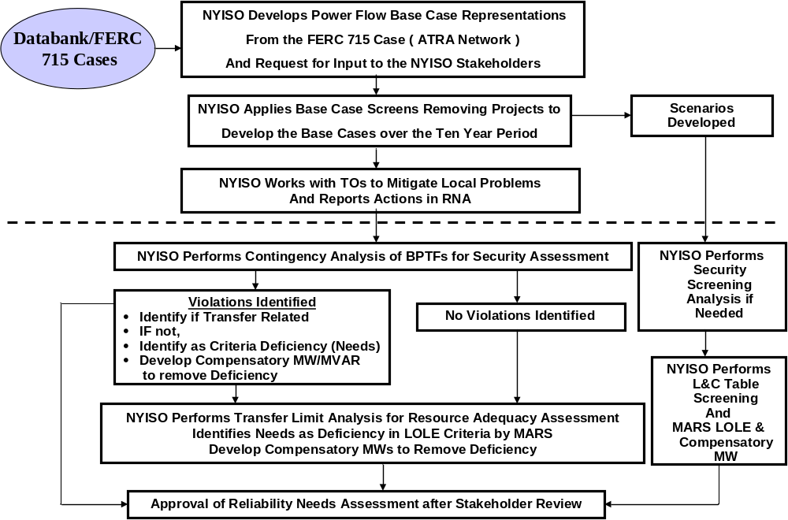
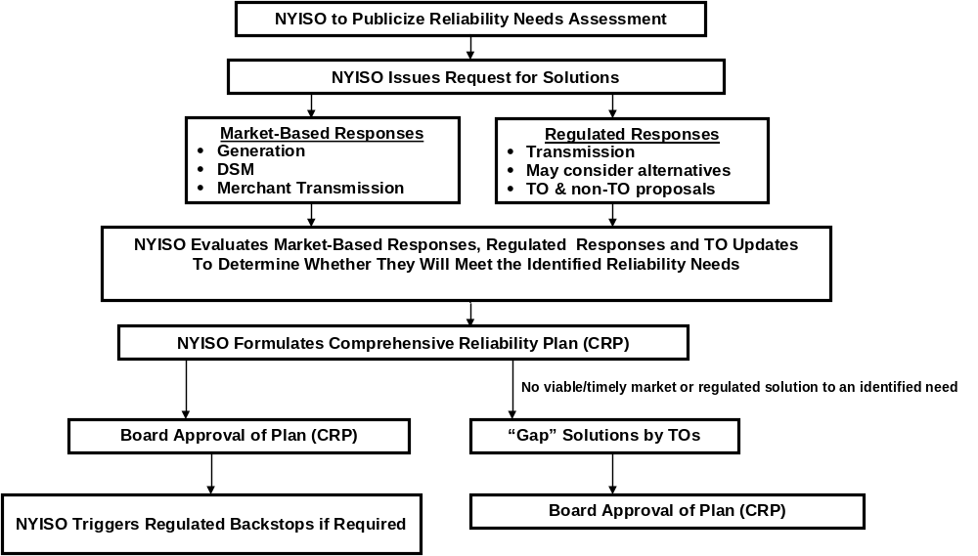
Figure 2-1: NYISO Reliability Planning Process

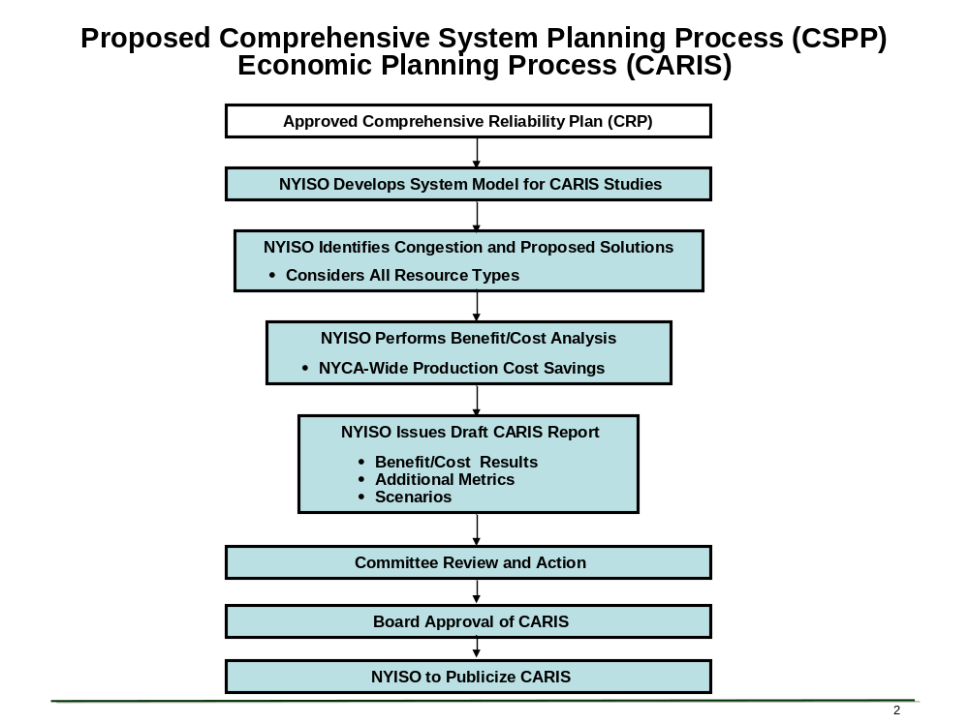
Figure 2-2: Proposed Economic Planning Process

Summary of Prior CRPs
This is the fourth cycle of the CRPP process since the NYISO’s planning process was approved by FERC in December 2004. The first CRP, which was approved by the NYISO Board of Directors in August 2006, identified 3,105 MW of resource additions needed through the 10-year Study Period ending in 2015. Market solutions totaled 1,200 MW, with the balance provided by updated Transmission Owners’ (TOs) plans. The second CRP, which was approved by the NYISO Board of Directors in September 2007, identified 1,800 MW of resource additions needed over the 10-year Study Period ending in 2016. Proposed market solutions totaled 3,007 MW, in addition to updated Transmission Owners’ (TOs) plans. The third CRP, which was approved by the NYISO Board of Directors in July 2008, identified 2,350 MW of resource additions needed through the 10-year Study period ending in 2017. Market solutions totaling 3,380 MW were submitted to meet these needs. As a result of updated TOs’ plans and proposed market based solutions, the NYISO has not had to trigger any regulated backstop solutions to meet reliability needs.
The success of the 2008 CRP is dependent on the market solutions it identifies moving forward. Table 2-1 presents the market solutions and TOs’ plans that were submitted in response to requests for solutions and were included in the 2008 CRP. The table also indicates that 2,672 MW of solutions are still being reported to the NYISO as moving forward with the development of their projects. It should be noted that there are a number of other projects in the NYISO queue that are also moving forward with the interconnection process, but that have not been offered as market solutions in this process.
Table 2-1: Current Status of the 2008 CRP Market – Based Solutions and TOs’ Plans
Project Type |  | Submitted | MW | Zone | In-Service Date |  | Status
Resource Proposals
Gas Turbine  NRG Astoria Re-powering | CRP 2005, CRP 2007, CRP 2008 |  | 412 * | J | Jan - 2011 |  | New Target June 2012 NYISO interconnection queue projects # 201 and # 224
Simple Cycle GT Indian Point | CRP 2007, CRP 2008 |  | 300 | H | May - 2011 |  | New Target May 2012
Cross Hudson Combined Cycle Bergen 2 | CRP 2008 |  | 550 | J | June - 2011 |  | New Target June 2012 NYISO interconnection queue project # 255 withdrawn. Re-submitted as queue #295 for 800 MW.
DSM SCR  EnerNOC | CRP 2008 |  | 125 | G, H, J | 2012 - 2017 |  | Withdrawn
DSM SCR ECS | CRP 2008 |  | 300 | F, G, H, I, J | 2008 - 2012 |  | Withdrawn
Empire Generation Project | CRP 2008 |  | 660 | F | Q1 2010 |  | New Target July 2010 Under Construction NYISO interconnection queue project # 69
Transmission Proposals
Controllable AC Transmission Linden VFT | CRP 2007, CRP 2008 |  | 300  No specific capacity identified) | PJM - J |  | Q4 2009 | Under Construction NYISO interconnection queue project #125
Back-to-Back HVDC, AC Line HTP | CRP 2007, CRP 2008 and was an alternative regulated proposal in CRP 2005 |  | 660 (500 MW specific capacity identified) | PJM - J |  | Q2 2011 | Article VII pending NYISO interconnection queue projects # 206
Back-to-Back HVDC, AC Line Harbor Cable | CRP 2007, CRP 2008 and was an alternative regulated proposal in CRP 2005 |  | 550 (550 MW specific capacity identified) | PJM - J |  | June - 2011 | Withdrawn NYISO interconnection queue projects # 195 and # 253
TOs' Plans
ConEd M29 Project | CRP 2005 |  | N/A | J | Dec - 2009 |  | New Target** May 2011 Under construction NYISO interconnection queue projects # 153
Caithness | CRP 2005 |  | 310 | K | Jan - 2009 |  | New Target June 2009  Under construction  NYISO interconnection queue projects # 107
Millwood Cap Bank | CRP 2007 |  | 240 MVAr | H | Q1 2009 |  | On Target Under construction
* NRG submitted three proposals, one of them was subsequently withdrawn. For the purposes of the Market-Based solutions’ evaluation NYISO assumed the lowest MW proposal. A retirement of approximately 100 MW is reflected in this number.
** The new target is with respect to the target quoted in the 2008 Gold Book dating to the information available in the spring of 2007.

RNA Base Case Assumptions, Drivers and Methodology
The NYISO has established procedures and a schedule for the collection and submission of data and for the preparation of the models used in the RNA. The NYISO’s procedures are designed to allow its planning activities associated with the CRPP to be aligned and coordinated with the related activities of the NERC, NPCC, and NYSRC and to be performed in an open and transparent manner. The assumptions underlying the RNA were reviewed at the Transmission Planning Advisory Subcommittee (TPAS) and the Electric System Planning Working Group (ESPWG). The RNA base case consists of the Five Year Base Case and the second five years of the Study Period. The Study Period analyzed in the 2009 RNA is the 10-year period from 2009 through 2018. The load models developed for the RNA base case were initially based on the econometric load forecast from the 2008 Load and Capacity Data Report, also known as the “Gold Book, as subsequently modified to account for the impact of the EEPS program as described in Section 4.2 below.” Five Year Base Case was developed based on: (1) the most recent Annual Transmission Reliability Assessment (ATRA) base case, (2) input from Market Participants, and (3) the procedures set forth in the CRPP Manual.
The NYISO developed the system representation for the second five years of the Study Period starting with the First Five Year Base Case and using: (1) the most recent Load and Capacity Data Report published by the NYISO on its Web site; (2) the most recent versions of NYISO reliability analyses and assessments provided for or published by NERC, NPCC, NYSRC, and neighboring control areas; (3) information reported by neighboring control areas such as power flow data, forecasted load, significant new or modified generation and transmission facilities, and anticipated system conditions that the NYISO determines may impact the bulk power transmission facilities (BPTF); (4) Market Participant input; and (5) procedures set forth in the CRPP manual. Based on this process, the network model for the second five-year period incorporates TO and neighboring system plans in addition to those incorporated in the Five Year Base Cases. The changes in the MW and MVAr components of the load model were made to maintain a constant power factor with the MW forecast.
The 2009 RNA base case model of the New York system includes the following new and proposed facilities and updates to the forecasts in the Gold Book based on new information developed before the start date of the RNA studies:
- TO projects on non-bulk power facilities
- Facilities that have accepted their Attachment S cost allocations and are in service or under construction as of June 1, 2008
- Transmission upgrades related to any projects and facilities that are included in the RNA base case, as defined above
- TO plans identified in 2008 CRP and the 2008 Gold Book as firm plans
- Facility reratings and uprates
- Scheduled retirements
- Updated forecasts of Special Case Resources (SCR) and the impacts of the NYSPSC EEPS Order, as developed and reviewed at the ESPWG
- External System Modeling.
The RNA Base Ccse does not include all projects currently listed on the NYISO’s interconnection queue or those shown in the 2008 Gold Book. It includes only those which meet the screening requirements for inclusion. Scenarios to include projects not meeting these screening requirements are developed for assessment.

RNA Base Case Assumptions and Drivers
Forecasts for peak load and energy as well as the impacts of programs such as EEPS and SCRs were developed for the 10-year study period. Projections for the installation and retirements of resources and transmission facilities are developed in conjunction with Market Participants and Transmission Owners and included in the base cases. Resources that may choose to participate in markets outside of New York are given zero capacity credits towards meeting resource adequacy requirements in New York.

Impact of Energy Efficiency Portfolio Standard on the Load Forecast
As part of the EEPS Proceeding, the NYSPSC directed a series of working groups composed of all interested parties to the proceeding to obtain information needed to further elaborate the goal. The NYSPSC issued an Order on June 23, 2008, setting short-term goals for programs to be implemented in the 2008-2011 period to begin the process of satisfying the PSC’s goal as applied to the entities over which it has jurisdiction. The NYSPSC also identified goals that it expected would be implemented by LIPA, NYPA and other state agencies, including improvements in building codes and appliance standards.
The NYISO has been a party to the EEPS proceeding from its inception. In conjunction with market participants in the Electric System Planning Working Group, the NYISO developed load forecasts for the potential impact of the EEPS over the 10-year planning period. The following factors were considered in developing the 2009 RNA base case forecast:
- NYSPSC-approved spending levels for the programs under its jurisdiction, including the Systems Benefit Charge and utility-specific programs
- Expectation of increased spending levels after 2011
- Expected realization rates of planned energy efficiency
- Degree to which energy efficiency is already included in the NYISO’s econometric load forecast
- Impacts of new appliance efficiency standards and building codes and standards
- Specific energy efficiency plans proposed by LIPA, NYPA and Consolidated Edison (Con Edison)
The resulting forecast used for the 2009 RNA base case reflects an adjustment to the 2008 Gold Book econometric forecast to reflect achievement of approximately 30% of the entire EEPS goal based on currently approved funding levels. Also produced were two scenarios for the RNA, one in which higher levels of EEPS spending was available increasing the achieved energy efficiency load reductions, and one in which the entire goal was realized, regardless of cost. Once the statewide energy and demand impacts were developed, zonal level forecasts were produced for the econometric forecast, for the base case, and for the two scenarios.
The zonal coincident peak demand forecasts for the RNA were developed in one of two ways. LIPA and Con-Ed provided explicit energy and coincident peak demand forecasts. For all other zones, the NYISO used a constant load factor specific to each zone, based on historic average zonal load factors from recent years. In LIPA's case, the load factor was very nearly constant over the forecast horizon. In Con-Ed's case, the load factor tended to increase over time. The same energy-demand relationship established in the econometric forecast was applied to the RNA Base Case and each of the scenarios. To obtain non-coincident peak forecasts, the NYISO applied a ratio of non-coincident peak to coincident peak to each zone, based on recent historical data.

Table 3-1 below summarizes the 2008 RNA Base Case forecast, the 2008 Gold Book econometric forecast, the 2009 RNA Base Case forecast and two additional scenarios. For comparison purposes, the 2007 econometric forecast is also included. This forecast provided the basis for the 2008 RNA Base Case. As can be seen from the red highlighted numbers in the table, the 2009 RNA base case peak demand forecast for 2018 is 35,658 MW, while the forecast in the 2008 RNA forecast for 2012 is 35,566 MW. This means that the 2009 RNA Base Case forecast for 2018 is within 100 MW of last year’s forecast for 2012, and more than 2,100 MW lower than the current econometric forecast of 37,784 MW for 2018. The impact of the EEPS load reductions is the major factor that drives the 2009 RNA result that there are no bulk power system reliability needs during the Study Period.
Utility-specific energy efficiency programs are also incorporated in the 2009 RNA Base Case. Consolidated Edison Company of New York, Inc (“Con Edison”) has provided the NYISO a schedule of annual Demand-Side Management impacts for the years 2008 through 2016. The cumulative impact of these programs is 510 MW by 2016. These programs have received approval from the NYSPSC in prior rate cases, are expected to receive additional funding from the NYSPSC EEPS authorized funding and will be implemented in the Con Edison local distribution system over the next eight years. The NYISO has reviewed this forecast with Con Edison and incorporated these impacts in the Base Case at the zonal level, together with additional planned energy efficiency impacts from the EEPS initiative.
The Long Island Power Authority has also provided the NYISO with information regarding its energy efficiency programs for the development of the 2009 RNA. The NYISO worked with LIPA staff to develop an annual schedule reflecting implementation of the LIPA program, which has a goal of 500 MW of demand reduction by 2018. There are small annual differences between the schedule in the 2009 RNA Base Case and the final LIPA schedule. After including additional planned conservation impacts from the EEPS initiative, the total annual conservation impacts on Long Island meet or exceed those of the LIPA program. (Changes coming from LIPA)
Figure 3-1 depicts the information presented in Table 3-1. The details of the analysis for the development of the impacts of the EEPS on the forecast can be found in Appendix C.

Table 3-1 - RNA Forecast Scenarios
Annual GWh | 2008 | 2009 | 2010 | 2011 | 2012 | 2013 | 2014 | 2015 | 2016 | 2017 | 2018
2008 RNA Base Case | 167,440 | 169,470 | 171,744 | 174,032 | 176,615 | 178,759 | 181,126 | 183,544 | 186,256 | 188,728
2008 GB Econometric | 166,849 | 169,040 | 171,575 | 173,788 | 176,091 | 178,669 | 181,597 | 184,262 | 187,052 | 188,801 | 190,662
2009 RNA Base Case | 166,677 | 168,127 | 169,747 | 170,953 | 171,926 | 173,158 | 174,799 | 176,176 | 178,250 | 179,283 | 180,427
Scenario 1 | 166,677 | 167,977 | 169,399 | 170,263 | 170,485 | 170,965 | 171,857 | 172,485 | 174,559 | 175,592 | 176,736
Scenario 2 | 166,241 | 166,389 | 165,923 | 164,929 | 162,772 | 160,712 | 159,182 | 157,382 | 159,808 | 161,466 | 163,326
EEPS Energy Impacts
Cumulative GWh | 2008 | 2009 | 2010 | 2011 | 2012 | 2013 | 2014 | 2015 | 2016 | 2017 | 2018
2009 RNA Base Case | 172 | 913 | 1,828 | 2,835 | 4,165 | 5,511 | 6,798 | 8,086 | 8,802 | 9,519 | 10,235
Scenario 1 | 172 | 1,063 | 2,176 | 3,525 | 5,606 | 7,704 | 9,740 | 11,777 | 12,493 | 13,209 | 13,926
Scenario 2 | 608 | 2,651 | 5,652 | 8,859 | 13,319 | 17,957 | 22,414 | 26,880 | 27,244 | 27,335 | 27,335
Annual MW | 2008 | 2009 | 2010 | 2011 | 2012 | 2013 | 2014 | 2015 | 2016 | 2017 | 2018
2008 RNA Base Case | 33,871 | 34,300 | 34,734 | 35,141 | 35,566 | 35,962 | 36,366 | 36,749 | 37,141 | 37,631
2008 GB Econometric | 33,827 | 34,247 | 34,649 | 35,053 | 35,452 | 35,870 | 36,317 | 36,708 | 37,086 | 37,407 | 37,784
2009 RNA Base Case | 33,792 | 34,059 | 34,269 | 34,462 | 34,586 | 34,725 | 34,905 | 35,029 | 35,258 | 35,430 | 35,658
Scenario 1 | 33,792 | 34,029 | 34,199 | 34,324 | 34,298 | 34,288 | 34,320 | 34,298 | 34,526 | 34,698 | 34,926
Scenario 2 | 33,703 | 33,704 | 33,489 | 33,234 | 32,722 | 32,197 | 31,739 | 31,227 | 31,530 | 31,833 | 32,209
EEPS Demand Impacts
Cumulative MW | 2008 | 2009 | 2010 | 2011 | 2012 | 2013 | 2014 | 2015 | 2016 | 2017 | 2018
2009 RNA Base Case | 35 | 188 | 379 | 590 | 867 | 1,145 | 1,412 | 1,678 | 1,828 | 1,977 | 2,126
Scenario 1 | 35 | 218 | 449 | 729 | 1,155 | 1,582 | 1,997 | 2,410 | 2,560 | 2,709 | 2,858
Scenario 2 | 124 | 543 | 1,160 | 1,819 | 2,730 | 3,674 | 4,579 | 5,481 | 5,556 | 5,575 | 5,575

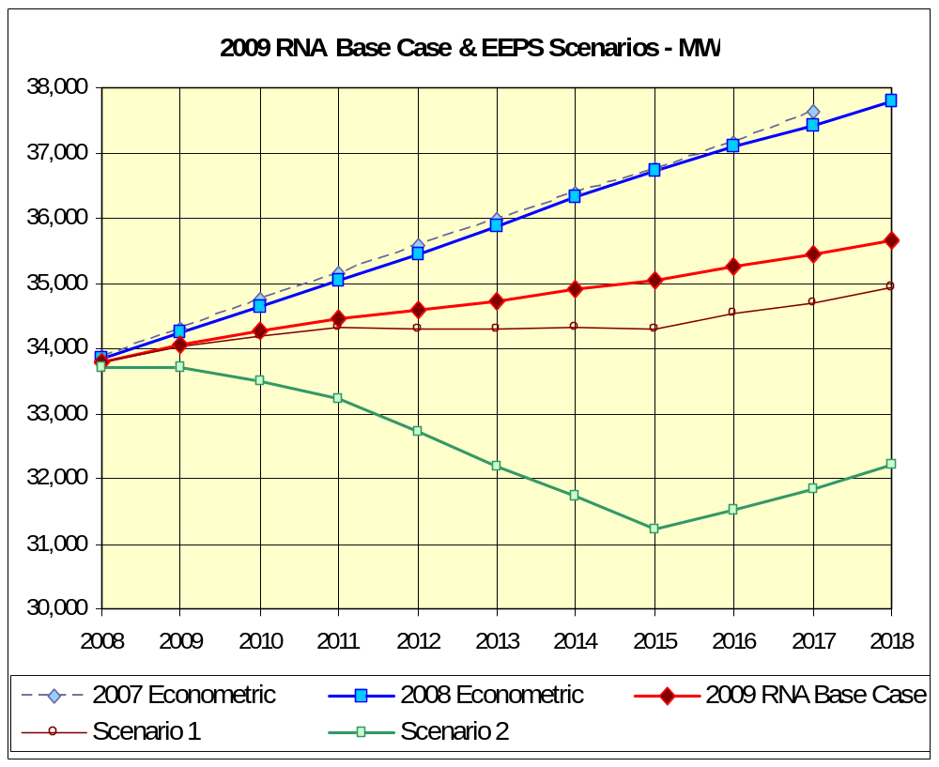
Figure 3-1: 2009 RNA Base Case & EEPS Scenarios – MW

Table 3-2 below presents the 2009 Base Case load forecast and Table 3-3 summarizes the differences between the 2008 and 2009 RNAs in a load forecast by zone.

Table 3-2: Comparison of Zonal Forecasts - Forecast of Coincident Summer Peak Demand by Zone – MW
Before Reductions for Emergency Demand Response Programs
Year | A | B | C | D | E | F | G | H | I | J | K | NYCA
2008 | 2,647 | 1,933 | 2,872 | 824 | 1,382 | 2,298 | 2,341 | 638 | 1,537 | 11,964 | 5,355 | 33,792
2009 | 2,657 | 1,941 | 2,873 | 836 | 1,388 | 2,299 | 2,358 | 644 | 1,550 | 12,127 | 5,386 | 34,059
2010 | 2,666 | 1,949 | 2,873 | 847 | 1,393 | 2,301 | 2,375 | 651 | 1,561 | 12,257 | 5,395 | 34,269
2011 | 2,674 | 1,947 | 2,884 | 853 | 1,401 | 2,314 | 2,400 | 659 | 1,568 | 12,361 | 5,403 | 34,462
2012 | 2,678 | 1,948 | 2,883 | 853 | 1,402 | 2,331 | 2,408 | 662 | 1,566 | 12,452 | 5,403 | 34,586
2013 | 2,690 | 1,958 | 2,894 | 856 | 1,404 | 2,347 | 2,425 | 669 | 1,567 | 12,537 | 5,377 | 34,725
2014 | 2,705 | 1,979 | 2,914 | 858 | 1,412 | 2,366 | 2,450 | 668 | 1,557 | 12,627 | 5,370 | 34,905
2015 | 2,715 | 1,996 | 2,930 | 856 | 1,417 | 2,385 | 2,465 | 671 | 1,554 | 12,683 | 5,358 | 35,029
2016 | 2,731 | 2,017 | 2,948 | 857 | 1,421 | 2,410 | 2,484 | 675 | 1,554 | 12,787 | 5,374 | 35,258
2017 | 2,744 | 2,035 | 2,956 | 855 | 1,423 | 2,436 | 2,505 | 681 | 1,562 | 12,879 | 5,354 | 35,430
2018 | 2,757 | 2,052 | 2,963 | 857 | 1,424 | 2,462 | 2,520 | 688 | 1,571 | 12,980 | 5,383 | 35,658

Table 3-3: Forecast Delta, RNA Year 2009 – RNA Year 2008
Year | A | B | C | D | E | F | G | H | I | J | K | NYCA
2008-07 | 12 | -90 | -68 | -51 | -83 | 72 | 64 | 7 | -52 | 184 | -65 | 347
2009-08 | 7 | -132 | -97 | -67 | -71 | 82 | 52 | 3 | -64 | 152 | -99 | 190
2010-09 | -3 | -168 | -125 | -75 | -70 | 67 | 39 | -2 | -82 | 107 | -146 | -31
2011-10 | -25 | -218 | -133 | -80 | -83 | 73 | 33 | -3 | -98 | 36 | -204 | -269
2012-11 | -60 | -265 | -152 | -87 | -106 | 82 | 10 | -6 | -120 | -28 | -261 | -553
2013-12 | -89 | -300 | -156 | -88 | -141 | 88 | -1 | -1 | -135 | -108 | -353 | -840
2014-13 | -120 | -322 | -156 | -90 | -172 | 96 | -3 | -3 | -160 | -153 | -422 | -1,055
2015-14 | -173 | -348 | -163 | -85 | -220 | 101 | -11 | 6 | -168 | -232 | -497 | -1,333
2016-15 | -224 | -370 | -167 | -76 | -270 | 112 | -15 | 18 | -171 | -243 | -545 | -1,489
2017-16 | -262 | -395 | -179 | -79 | -305 | 124 | -18 | 24 | -178 | -261 | -648 | -1,710
2018-17 | -287 | -425 | -190 | -85 | -334 | 140 | -27 | 26 | -191 | -380 | -693 | -1,974

Forecast of Special Case Resources
The SCR forecast for the 2009 RNA base case was modified from the 2008 Gold Book to reflect the increase in SCR registrations that was experienced this past summer. A new forecast was developed for the first year of the RNA Study Period and this value was held constant over the 10-year study period. The starting point for the update is the addition of 761 MW of SCR, for a total of 2,084 MW, wich is consistent with the 2009 Installed Reserve Margin (IRM) assumptions and details of this forecast can be found in Appendix C of this report and its impact can be seen in the RNA Load and Resource Margin Table (Table 3-4) below. From an ICAP perspective, this represents an approximate increase of 76150 of resource capacity over the 2008 RNA which was included in the 2009 RNA Base Case. A low and high SCR scenario was included for variations in the levels of SCRs over the planning horizon. For the low SCR scenario the initial 2009 IRM SCR level of 2,084 MW of 76150 MW by 7.5% each year from 2010 to 2018. For the high SCR scenario, the initial 2009 IRM SCR level of 2,084 of 76150 MWvincreased by 7.5% each year from 2010 to 2018.

Resource Additions
Table 3-2 below presents the unit additions, which were represented in the RNA base case:
Table 3-2: Unit Additions
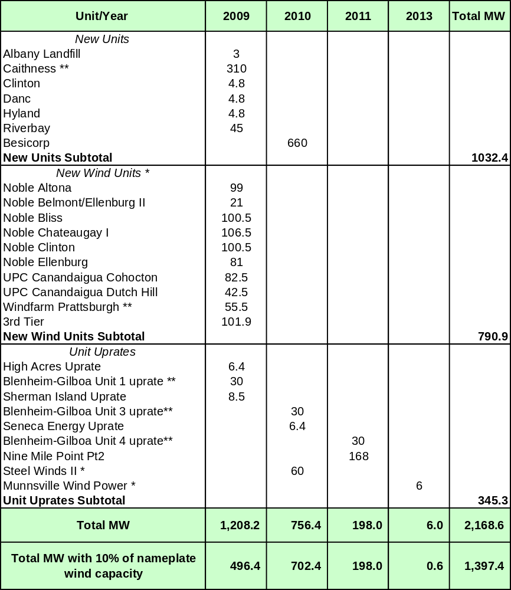
* Wind Units MW represent ICAP values at full nameplate capacity.
** Unit additions included in 2008 RNA

TO Firm Plans
Table 2.1 presents the TO Firm Plans which were included in the 2008 CRP and are moving forward. . Table 3.3 psents all of the firm transmission plans which were included the 2008 Gold Book.

Table 3.3: FirmTransmission Plans (2008 Gold Book)
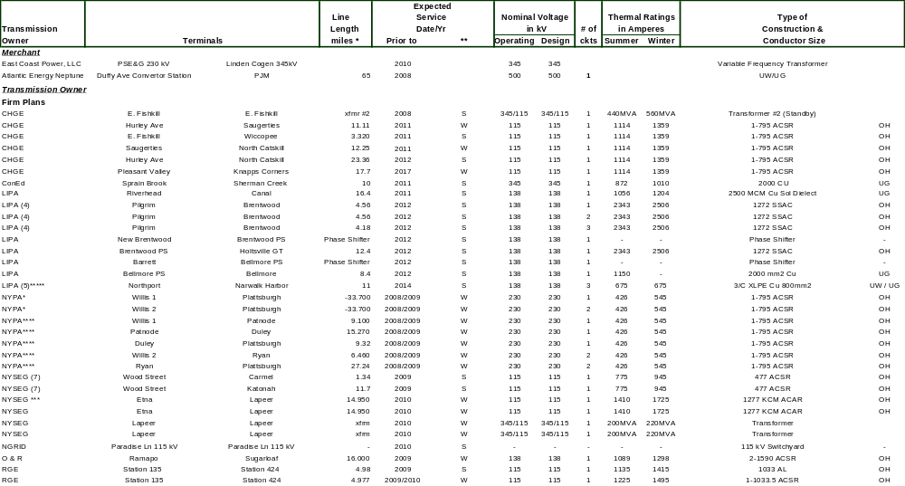

(7) | '115 kv operation as opposed to previous 46 kv operation
(5) | Cable replacement; LIPA owns 50% of the NUSCO cable
(4) | 138 kv operation as opposed to previous 69 kv operation
***** | Partial NUSCO upgrade will be done in 2008 and full NUSCO upgrade is scheduled for 2014 (including Northport-Pilgrim Upgrade)
**** | Lines resulting from tapping of Existing Circuit
*** | Reconductoring of Existing Line
** | S = Summer Peak Period | W = Winter Peak Period
* | Line Length Miles - negative values indicate removal of Existing Circuit being tapped

Resource Retirements
Table 3-4 below presents the unit retirements, which were represented in the RNA base case:
Table 3-4: Scheduled Unit Retirements *
Unit/ Year | 2008 | 2010
Russell Station 3** | 41.7
Russell Station 4** | 77.7
Onondaga Cogen | 78.3
Lovett 5** | 182.9
Poletti** |  | 890.7
Total MW | 380.6 | 890.7 | 1271.3
* As specified by the Owner/Operator
** Unit retirements included in 2008 RNA

Base Case Load and Resource Margins
The unit retirements and additions, when combined with the existing generation as of April 1, 2008 in the Gold Book and other adjustments, resulted in the RNA base case Load and Resource Margins found in Table 3-5 below:
Table 3-5: NYCA Load and Resource Margins 2009 to 2018
Year
2009
2010
2011
2012
2013
2014
2015
2016
2017
2018
Peak Load
NYCA
34,059
34,269
34,462
34,586
34,725
34,905
35,029
35,258
35,430
35,658
Zone J
12,127
12,257
12,361
12,452
12,537
12,627
12,683
12,787
12,879
12,980
Zone K
5,386
5,395
5,403
5,403
5,377
5,370
5,358
5,374
5,354
5,383
Resources
NYCA
Capacity
39,992
39,657
40,496
40,496
40,502
40,452
40,452
40,452
40,452
40,452
SCR
2,084
2,084
2,084
2,084
2,084
2,084
2,084
2,084
2,084
2,084
Total
42,077
41,741
42,580
42,580
42,586
42,536
42,536
42,536
42,536
42,536
Res./Load Ratio
123.5%
121.8%
123.6%
123.1%
122.6%
121.9%
121.4%
120.6%
120.1%
119.3%
Zone J
Capacity
10,097
9,206
9,206
9,206
9,206
9,206
9,206
9,206
9,206
9,206
SCR
622
622
622
622
622
622
622
622
622
622
Total
10,719
9,828
9,828
9,828
9,828
9,828
9,828
9,828
9,828
9,828
Res./Load Ratio
88.4%
80.2%
79.5%
78.9%
78.4%
77.83%
77.49%
76.86%
76.31%
75.71%
Zone K
Capacity
5,938
6,368
6,368
6,368
6,368
6,368
6,368
6,368
6,368
6,368
SCR
216
216
216
216
216
216
216
216
216
216
Total
6,154
6,584
6,584
6,584
6,584
6,584
6,584
6,584
6,584
6,584
Res./Load Ratio
114.3%
122.0%
121.9%
121.9%
122.4%
122.61%
122.88%
122.52%
122.98%
122.31%
New York Control Area (NYCA) "Capacity" values include resources internal to New York, Additions, Reratings, Retirements, Purchases and Sales, and UDRs with firm capacity. Zone K "Capacity" values include UDRs with firm capacity. Wind generation values include full nameplate capacity.
“SCR” values reflect projected August 2009 ICAP capability period values held constant over the 10-year Study Period.
Table 3-6 below presents the comparison between the 2008 RNA and 2009 RNA in load forecast, unit additions, unit retirements, and SCRs. The 2009 RNA load forecast decreased by approximately 2,000 MW, while the unit additions and SCRs increased by approximately 1,700 MW and 760 MW respectively. Drastically reduced load forecast due to the EEPS initiatives coupled with the increase in unit additions and SCRs produced the 2009 RNA findings of no reliability needs for the study period 2009-2018.
Table 3-6: 2008 RNA - 2009 RNA Load and Capacity Comparison
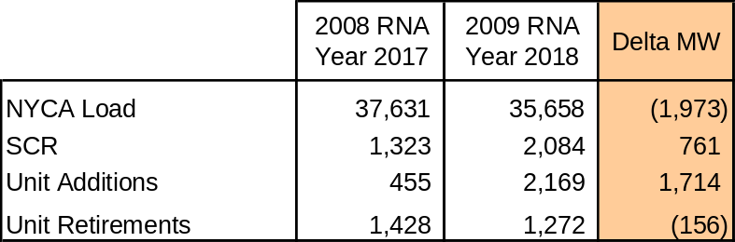
Pursuant to Section 4.5 of Attachment Y of the OATT, the NYISO also develops reliability scenarios for the first five years and second five years of the Study Period considering, among other things, load forecast uncertainty, new resources, retirements, and potential limitations imposed by environmental programs that are currently either pending or under consideration. The NYISO also conducts sensitivity analyses pursuant to Section 4.6 of OATT Attachment Y to test the robustness of the needs assessment studies and identify conditions under which reliability criteria may not be met.

Methodology for the Determination of Needs
Reliability needs are defined in terms of total deficiencies relative to reliability criteria determined from the assessments of the BPTFs performed for this RNA. There are two different steps to analyzing the reliability of the BPTFs. The first is to evaluate the security of the transmission system; the second is to evaluate the adequacy of the system, subject to the security constraints. The NYISO’s existing Planning Process includes both adequacy and security assessments. The NYISO conducts transmission adequacy and resource adequacy assessment jointly.
Adequacy is the ability of the electric systems to supply and deliver the total quantity of electricity demanded at any given time taking into account scheduled and unscheduled outages of system elements. Adequacy considers the transmission systems, generation resources and other capacity resources, such as demand response. Adequacy assessments are performed on a probabilistic basis to capture the randomness of system element outages. A system is adequate if the probability of having sufficient transmission and generation to meet expected demand is equal to or less than the system’s standard, which is expressed as a LOLE. As stated in Section II, the New York State bulk electricity system is planned to meet a LOLE that, at any given point in time, is less than or equal to an involuntary load disconnection that is not more frequent than once in every 10 years, or 0.1 days per year. This requirement forms the basis of New York’s ICAP requirement.
Security is the ability of the power system to withstand sudden disturbances and/or the unanticipated loss of system elements and continue to supply and deliver electricity. Compliance with security criteria is assessed deterministically. Security is a deterministic concept, with potential disturbances being treated with equal likelihood in the assessment. These disturbances are explicitly defined in the reliability rules as design criteria contingencies. The impact of applying these design criteria contingencies is assessed to ensure no criteria violations exist. These design criteria contingencies are sometimes referred to as N-1, N-1-1, or N-2.
As violations are found, compensatory MW needs for the New York Control Area (NYCA) are developed by adding generic 250 MW generating units to zones that are capable of addressing the needs. The compensatory MW amounts and locations are based on a review of binding transmission constraints and zonal LOLE in an iterative process to determine when reliability criteria are satisfied. These additions are used to estimate the amount of resources generally needed to satisfy reliability needs. The compensatory MW additions are not intended to represent specific proposed solutions. Resource needs could potentially be met by other combinations of resources in other areas including generation, transmission and demand response measures. Due to the differing natures of supply and demand-side resources and transmission constraints, the amounts and locations of resources necessary to match the level of compensatory MW needs identified will vary. Resource needs could be met in part by transmission system reconfigurations that increase transfer limits, or by changes in operating protocols. Operating protocols could include such actions as using dynamic ratings for certain facilities, operating exceptions, or special protection systems.
In addition, the NYISO performs a short circuit analysis using ASPEN (Advanced Systems for Power Engineering) OneLiner software to determine the impact of the maximum generation on the bulk power system. The NYISO “Guideline for Fault Current Assessment” was used. Three-phase, single-phase and line-line-ground short-circuit currents were determined for approximately 150 bulk power substations across the NYCA.

Reliability Needs Assessment

Overview
Reliability is defined and measured through the use of the concepts of adequacy and security. The NYISO first performs analysis of Transmission Security criteria violations. Then the NYISO assesses Transmission Adequacy and Resource Adequacy jointly with the use of General Electric’s Multi Area Reliability Simulation (MARS) software package. This is done through the development of interface transfer limits and a Monte Carlo base simulation of the probabilistic outages of capacity and transmission outages.

Reliability Needs for Base Case
Below are the principal findings of the RNA for the 2009-2018 Study Period. Also, the needs assessment evaluated ten scenarios described in Section 4.4 below.

Transmission Security Assessment
The first step in identifying reliability needs is to assess transmission security. The NYISO reviewed many previously completed transmission security assessments and performed an AC contingency analysis for various bulk power system stations. This analysis was performed with PSS/E’s automated Power-Voltage (PV) analysis for fast screening. Based on findings of the review and the screening analysis, more detailed analysis was performed for critical contingency evaluation and transfer limit evaluation using the power-voltage (P-V) curve approach as described in NYISO Transmission Planning Guideline #2-0 and Operating Engineering Voltage Guideline (dated April 11, 2006). The impact of critical generators being out of service was also assessed. Security for the BPTFs is and will be maintained by limiting power transfers.

Short Circuit Assessment
Another important element of performing a transmission security assessment is the calculation of short circuit current to ascertain whether the circuit breakers present in the system would be subject to fault levels in excess of their rated interrupting capability. The analysis was performed for the year 2013 with the latest version of the Class Year 2008 Annual Transmission Baseline Assessment (ATBA), modified to be consistent with the 2009 RNA study conditions. The fault levels were kept constant over the second five years because the methodology for fault duty calculation is not sensitive to load growth. The detailed analysis is presented in Appendix D of this report. The NYISO observed no major changes in fault current from the previous RNAs. Overdutied circuit breakers appear in at least two substations in the analysis, Astoria West and Fitzpatrick. In 2007 an interim operating protocol was developed to limit the number of units connected to the Astoria West bus, thereby preventing the overduty situation. In April 2008 a Memorandum-of-Understanding was signed by Con Edison, NRG, and NYPA, which continues certain provisions of the interim operating protocol until the overdutied breakers can be replaced, with Con Edison committing to replace the breakers by the Summer 2010. Entergy will replace the Fitzpatrick overdutied breaker prior to the end of 2008.

Resource and Transmission Adequacy
The resultant load forecast after EEPS has not resulted in any increased demands on the transmission system to meet capacity and energy needs in the NYCA system. The transfers into and through Southeastern New York (SENY) will continue to be limited by voltage constraints, rather than thermal constraints. As a result of the three prior CRPs, the TOs are upgrading their systems by bypassing series reactors and adding reactive resources where appropriate. These improvements have brought the transmission voltage limit close to the thermal limit for the cable interface into Zone J. For details on these improvements, please refer to Tables 4-1, 4.-2 and 4-3 below.
Table 4-1: Transmission System Thermal Transfer Limits for Key Interfaces in MW
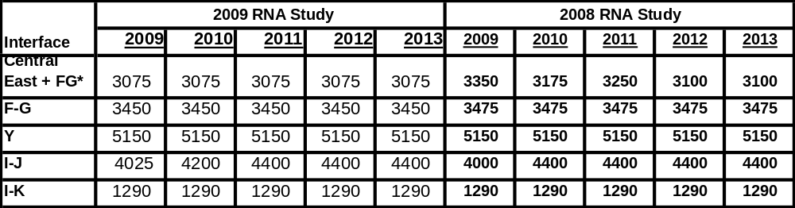
* F-G – Fraser-Gilboa circuit
Table 4-2: Transmission System Voltage Transfer Limits for Key Interfaces in MW
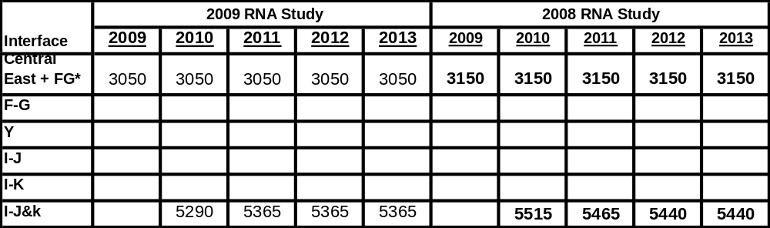
Note: Blank entries indicate that the voltage limits are more than 5% above the thermal limits. The I to J and I to K interfaces were combined into one interface grouping since the limit on one interface is sensitive to the flow on the other.

Table 4-3: Transmission System Base Case Transfer Limits for Key Interfaces in MW
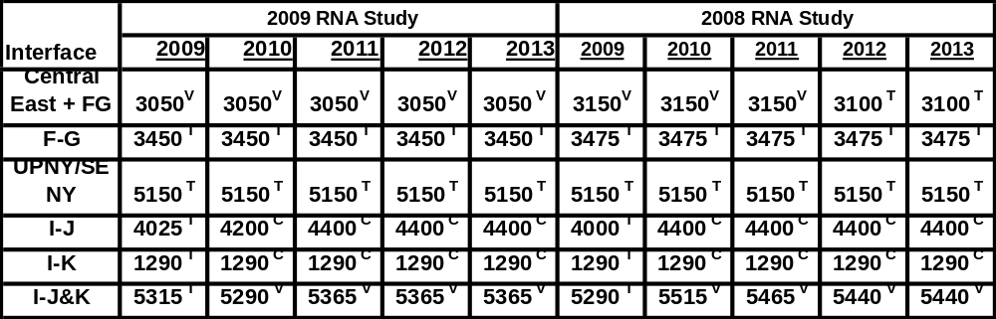
Note: T = Thermal; V = Voltage, C = Combined
Resource and transmission adequacy is evaluated for the entire 10-year Study Period. Resource adequacy is evaluated for the second five year period with transfer limits assumed constant. The analysis encompasses the Five Year Base Case and the second five years. The RNA base case transfer limits under emergency conditions (from the analysis conducted with the updated base cases) were employed to determine resource adequacy needs (defined as a loss-of-load-expectation or LOLE that exceeds 0.1 days per year). The LOLE for the NYCA did not exceed 0.10 days per year in any year through 2018. The LOLE results for the entire 10-year RNA base case are summarized in Table 4.-4.
Table 4-4: LOLE for the RNA Study Case Transfer Limits
Area/Year | 2009 | 2010 | 2011 | 2012 | 2013 | 2014 | 2015 | 2016 | 2017 | 2018
AREA-A
AREA-B
AREA-C
AREA-D
AREA-E
AREA-F
AREA-G
AREA-H
AREA-I |  |  |  |  |  | <0.01 | <0.01 | 0.01 | 0.01 | 0.02
AREA-J |  |  |  |  |  | <0.01 | 0.01 | 0.01 | 0.01 | 0.02
AREA-K
NYCA | <0.01 | <0.01 | <0.01 | <0.01 | <0.01 | <0.01 | 0.01 | 0.01 | 0.01 | 0.02

External Tie Derate Sensitivity
The NYISO performed a sensitivity analysis to test the system by limiting the amount of external assistance which could be provided from neighboring areas. This analysis was conducted by running the MARS model for the base case and derating the tieline capabilities. Table 4-5 lists full and derated tie line capabilities: Table 4-6 summarizes LOLE for the RNA Base Case Transfer Limits With Derated Tieline Capability. The blank entries indicate that LOLE is equivalent to zero.
Table 4-5: External Tie Line Capability vs Derated Values
Tieline | Full Tieline Limit |  | Derated Tieline Limit
Tieline | Positive | Negative | Positive | Negative
F-NE | 800 | 800 | 800 | 771.4
G-NE | 800 | 600 | 800 | 578.6
D-NE | 150 | 0 | 150 | 0
K-NE | 286 | 286 | 286 | 286
A-PJMW | 550 | 550 | 550 | 95.8
C-PJMW | 200 | 800 | 200 | 139.4
C-PJMC | 300 | 200 | 300 | 34.8
G-PJME | 2000 | 500 | 2000 | 500
J-PJME | 0 | 1200 | 0 | 1200
D-HQ | 1000 | 1500 | 1000 | 300
D-Cedars | 1 | 1 | 1 | 1
A-OH | 1550 | 1450 | 1550 | 1132.6
D-OH | 400 | 400 | 400 | 312.4
Total | 8037 | 8287 | 8037 | 5352

Table 4-6: LOLE for the RNA Base Case Transfer Limits With Derated Tieline Capability
Area/Year | 2009 | 2010 | 2011 | 2012 | 2013 | 2014 | 2015 | 2016 | 2017 | 2018
AREA-A
AREA-B
AREA-C
AREA-D
AREA-E
AREA-F
AREA-G
AREA-H
AREA-I |  |  |  |  |  | <0.01 | <0.01 | 0.01 | 0.01 | 0.02
AREA-J |  |  |  |  |  | 0.01 | 0.01 | 0.01 | 0.01 | 0.03
AREA-K
NYCA | <0.01 | <0.01 | <0.01 | <0.01 | <0.01 | 0.01 | 0.01 | 0.01 | 0.01 | 0.03

Reliability Needs Summary
Given that the base case and the external tie derating sensitivity case analysis produced LOLE results that were below 0.1 days per year, for all years in the Study Period, there were no identified transmission security violations for the 10-year Study Period. No additional resources are forecasted to be required to maintain reliability at this time.

Factors Affecting Reliability Needs for 2009
The 2009 RNA indicatesd thatthere were no reliability needs for the 2009 to 2018 Study Pperiod. These results were significantly different from the results determined in the 2008 RNA study. alysis was performed to identify the impact of critical factors affecting the results. The differenc
- Load Forecast - Case #24
The 2009 RNA base case load forecast was lower than in compa RNA base case forecast due to the projected EEPS program penetration levels by approximately 1,973 MW. When the 2008 RNA base case load forecast was substituted in the 2009 RNA base case (Case #2), the NYCA LOLE increased from <0.01 in 2013 and 0.02 in 2017 in the 2009 RNA base case to 0.05 in 2013 and 0.25 in 2017 (Case #24).Load Data (reduced to ref

- SCR Levels -Case #25
The 2009 RNA SCR forcasted level was increased to reflect this past summer’s participation in the market, resulting in an increase of 761 MW from the 2008 RNA base case. When the SCR data used in the 2008 RNA base case was substituted in the 2009 RNA base case with the 2008 RNA load data (Case #24), the NYCA LOLE increased from 0.05 in 2013 and 0.25 in 2017 to 0.14 in 2013 and 0.43 in 2017 (Case #25). )

- 2008 RNA Generation Additions and Retirements - Case #26 2008
The 2009 RNA Generation Additions and Retirements Data increased the NYCA capacity by 1558 MW in comparison to the 2008 RNA base case. When the capacity data in the 2009 RNA base case with the 2008 RNA load and SCR data (Case #25) was modified to be consistent with the 2008 RNA base case, the NYCA LOLE increased from 0.14 in 2013 and 0.43 in 2017 to 0.17 in 2013 and 0.42 in 2017.

- External Area Capacity Changes- Case #27Exter
The external area capacity wasreduced (3000 MWsMn Ontario and 1000 MWsMW PJM East) so that the difference between the External Area Capacity minus Load was similar to the 2008 RNA values. inase#26. In this case the NYCA LOLE increased from 0.17 in 2013 and 0.42 in 2017 to 0.29 in 2013 and 0.69 in 2017.
Table 4.7 illustrates the NYCA LOLE increasing from the 2009 RNA results for the years 2013 (<0.01) and 2017 (.02) as each of the above factors are layered upon each other. In Case 27, which included all four modifications, the NYCA LOLE in 2013 and in 2017 was 0.28 and 0.69, respectively. Although these NYCA LOLE values are not identical to the NYCA LOLE values in the 2008 RNA (0.18 for 2013 and 0.72 for 2017), they do indicate the significant factors affecting results in the 2009 RNA. If the factors were taken individually, the difference between the 2009 and 2008 RNA results would not be as significant. The results are relative and dependent upon the sequencing order.
There were other changes which were made for the 2009 IRM Analysis which has been discussed and documented at the Installed Capacity Subcommittee (ICS) of the NYS Reliability Council.
Table 4-7: Factors Affecting the NYCA LOLE Results
Case # | Based On Case # | Case Description | 2013 | 2017
2 |  | 2009 RNA Base Case | <0.01 | 0.02
24 | 2 | Use 2008 NYCA Load Data | 0.05 | 0.25
25 | 24 | Use 2008 SCR Values | 0.14 | 0.43
26 | 25 | Remove 2009 Generation Additions | 0.17 | 0.42
27 | 26 | External Area Tieline Capacity and LOLE | 0.29 | 0.69
 |  | 2008 RNA Base Case with Neptune UDR | 0.18 | 0.72

Scenarios
Scenarios are variations on key assumptions in the RNA base case to assess the impact of possible changes in circumstances that could impact the RNA. The following scenarios were evaluated as part of the RNA.
- Load Forecast Scenario
  - 2008 Econometric (Load and Capacity Data Report) Forecast
  - “15x15” Energy Efficiency Scenarios ― New York State EEPS initiative of 15% reduction in energy consumption by 2015
- Environmental Scenarios
  - Nitrogen oxides (NOx) Reduction Initiatives, Clean Air Interstate Rule (CAIR), High Electric Demand Days (HEDD), and Reasonably Available Control Technology Standards (RACT) ― Operational limitations for certain units that may result from additional NOx emission reduction requirement)
  - Regional Greenhouse Gas Initiative (RGGI) for carbon dioxide (CO2) emissions environmental program impacts
- External capacity adjustments
- Indian Point 2 and 3 nuclear unit retirements
- Revised Transmission Topology
- Zones at Risk
- High Wind Penetration
- Low and high SCR resources forecast
- External LOLE Representation

Load Forecast Scenarios
Econometric Load Forecast (Gold Book) Scenario
The 2008 Load & Capacity Report contains a base load forecast which was based upon econometric factors and did not include any penetration levels associated with the EEPS proposal. Since the load in the econometric forecast is significantly higher than the base case forecast, the LOLE criterion violation identified in the 2009 RNA would occur by 2017, shown in Table 4-8.

Table 4-8: RNA Base Case LOLE Econometric Growth Scenario
Area/Year | 2009 | 2010 | 2011 | 2012 | 2013 | 2014 | 2015 | 2016 | 2017 | 2018
AREA-A
AREA-B |  |  |  |  |  | 0.00 | 0.00 | 0.00 | 0.01 | 0.03
AREA-C
AREA-D
AREA-E |  |  |  |  |  |  |  | 0.00 | 0.00 | 0.01
AREA-F
AREA-G |  |  |  |  |  | 0.00 |  | 0.00 | 0.00 | 0.00
AREA-H |  |  |  |  |  |  |  | 0.00
AREA-I | 0.00 | 0.00 | 0.01 | 0.01 | 0.02 | 0.04 | 0.05 | 0.08 | 0.12 | 0.18
AREA-J | 0.00 | 0.00 | 0.01 | 0.01 | 0.03 | 0.05 | 0.06 | 0.09 | 0.14 | 0.22
AREA-K |  |  |  |  |  |  | 0.00 | 0.00 | 0.00 | 0.01
NYCA | 0.00 | 0.00 | 0.01 | 0.01 | 0.03 | 0.05 | 0.07 | 0.09 | 0.14 | 0.22
The load in the 2009 RNA’s econometric load forecast for 2015 (36,708 MW) is slightly lower than the 2008 RNA’s base case load forecast for 2015 (36,749 MW). The econometric load growth scenario increases the 2009 RNA’s base case LOLE for 2018 from 0.02 to 0.22. This result reveals the impact of the energy efficiency programs on reliability needs (See Table 4-9).
Table 4-9: Econometric Growth Scenario
Year | 2009 | 2010 | 2011 | 2012 | 2013 | 2014 | 2015 | 2016 | 2017 | 2018
Base Case MW | 34,059 | 34,269 | 34,462 | 34,586 | 34,725 | 34,905 | 35,029 | 35,258 | 35,430 | 35,658
Econometric Case | 34,247 | 34,649 | 35,053 | 35,452 | 35,870 | 36,317 | 36,708 | 37,086 | 37,407 | 37,784
EEPS Impact | 188 | 379 | 590 | 867 | 1,145 | 1,412 | 1,678 | 1,828 | 1,977 | 2,126
“15x15” Energy Efficiency Scenarios
As described above in Section 3.2, the 2009 RNA Base Case forecast includes a portion of the EEPS goal of a 15% reduction in energy usage from forecast levels in 2015. Two additional scenarios related to the EEPS were also prepared. The first scenario includes a higher level of expenditures on energy efficiency. The second scenario achieves the full 15% reduction regardless of cost. Since the Base Case forecast showed no reliability needs, the inclusion of even higher levels of energy efficiency likewise result in no reliability needs through the planning horizon of 2018.
Scenario 1 - Higher Level of Expenditures
The 2009 RNA Base Case schedule for energy efficiency activity associated with the EEPS is based on the spending levels authorized by the June 2008 order (approximately $160 million dollars per year) beginning in October 2008 and extending through 2011. For the Base case, the NYISO assumed that this level of annual spending would extend through 2015. For Scenario 1, NYISO made two additional changes to the schedule of expenditures. First, the NYISO continued the expenditure of $160 million per year from 2012 through 2015. NYISO also modeled an additional level of spending of up to $85 million dollars per year, which was discussed in the EEPS Order but not authorized. The $85 million per year equivalent to half that was ramped up in 25% steps from 2009 through 2011, and then remained at $85 per year from 2012 through 2015. The result is that Scenario 1 meets approximately 40% of the entire EEPS goal. Table 4-10 illustrates the load difference between the Base Case and Scenario 1 case. Table 4-11 illustrates the LOLE results for the Scenario 1 case.
Table 4-10: “15x15” Energy Efficiency Scenario 1
Year | 2009 | 2010 | 2011 | 2012 | 2013 | 2014 | 2015 | 2016 | 2017 | 2018
Base Case MW | 34,059 | 34,269 | 34,462 | 34,586 | 34,725 | 34,905 | 35,029 | 35,258 | 35,430 | 35,658
Scenario 1 MW | 34,029 | 34,199 | 34,324 | 34,298 | 34,288 | 34,320 | 34,298 | 34,526 | 34,698 | 34,926
MW Decrease | -30 | -70 | -138 | -288 | -437 | -585 | -731 | -732 | -732 | -732
Table 4-11: LOLE Results for “15x15” Energy Efficiency Scenario 1
Area/Year | 2009 | 2010 | 2011 | 2012 | 2013 | 2014 | 2015 | 2016 | 2017 | 2018
AREA-A
AREA-B
AREA-C
AREA-D
AREA-E
AREA-F
AREA-G
AREA-H
AREA-I |  |  | <0.01 | <0.01 | <0.01 | <0.01 | <0.01 | <0.01 | <0.01 | <0.01
AREA-J |  |  | <0.01 | <0.01 | <0.01 | <0.01 | <0.01 | <0.01 | <0.01 | <0.01
AREA-K
NYCA |  |  | <0.01 | <0.01 | <0.01 | <0.01 | <0.01 | <0.01 | <0.01 | <0.01
Scenario 2 – Full 15% Reduction
The annual energy efficiency impacts in Scenario 2 were developed at a rate designed to reach 15% energy reduction by 2015, regardless of cost. Annual energy savings were obtained from the schedule of expenditures by applying an assumed cost of $305 per MWh, as referenced in the EEPS order. Table 4-12 illustrates the load difference between the Base Case and Scenario 2 case. Table 4-13 illustrates the LOLE results for the Scenario 2 case.
Table 4-12: “15x15” Energy Efficiency Scenario 2
Year | 2009 | 2010 | 2011 | 2012 | 2013 | 2014 | 2015 | 2016 | 2017 | 2018
Base Case MW | 34,059 | 34,269 | 34,462 | 34,586 | 34,725 | 34,905 | 35,029 | 35,258 | 35,430 | 35,658
Scenario 2 MW | 33,704 | 33,489 | 33,234 | 32,722 | 32,197 | 31,739 | 31,227 | 31,530 | 31,833 | 32,209
MW Decrease | -355 | -780 | -1,228 | -1,864 | -2,528 | -3,166 | -3,802 | -3,728 | -3,597 | -3,449

Table 4.13: LOLE Results for “15x15” Energy Efficiency Scenario 2
Area/Year | 2009 | 2010 | 2011 | 2012 | 2013 | 2014 | 2015 | 2016 | 2017 | 2018
AREA-A
AREA-B
AREA-C
AREA-D
AREA-E
AREA-F
AREA-G
AREA-H
AREA-I |  |  | <0.01 | <0.01 | <0.01 | <0.01 | <0.01 | <0.01 | <0.01 | <0.01
AREA-J |  |  | <0.01 | <0.01 | <0.01 | <0.01 | <0.01 | <0.01 | <0.01 | <0.01
AREA-K
NYCA |  |  | <0.01 | <0.01 | <0.01 | <0.01 | <0.01 | <0.01 | <0.01 | <0.01

High Load Growth and Extreme Weather Forecast Scenario
The 2008 Load & Capacity Report contains a high load forecast (95th percentile) that assumes both extreme weather conditions (high summer temperatures consistent with the 95th percentile of historic weather conditions) and strong economic growth. (See Table 4-14). The annual percentage increases of this forecast over the 2008 econometric forecast were applied to the 2009 RNA base case forecast to obtain a high load forecast that has still adjusted for the impact of the EEPS on the econometric forecast. Since the load is higher than the Base Case forecast, the LOLE criterion violation identified in the 2009 RNA would occur by 2010, shown in Table 4-15. Accordingly, if extreme weather were to become the norm for the NYISO and the NYISO also experienced high load growth and extreme weather simultaneously, the New York Control Area would have a need for resources in 2010 even after taking into account the effect of the EEPS programs. Most of the increase in load and the commensurate increase in LOLE, between this case and the Base Case are driven by the assumption that the NYISO would experience extreme weather conditions 100% of the time rather than the distribution of weather conditions that is included in the Base Case.

Table 4-14: High Economic Growth and Extreme Weather Scenario
Year | 2009 | 2010 | 2011 | 2012 | 2013 | 2014 | 2015 | 2016 | 2017 | 2018
Base Case MW | 34,059 | 34,269 | 34,462 | 34,586 | 34,725 | 34,905 | 35,029 | 35,258 | 35,430 | 35,658
High Growth Case | 36,607 | 36,843 | 37,064 | 37,211 | 37,378 | 37,586 | 37,737 | 37,998 | 38,201 | 38,464
MW Increase | 2,548 | 2,574 | 2,602 | 6,252 | 2,653 | 2,681 | 2,708 | 2,740 | 2,771 | 2,806

Table 4-15: RNA Base Case LOLE High Economic Growth and Extreme Weather Scenario
Area/Year | 2009 | 2010 | 2011 | 2012 | 2013 | 2014 | 2015 | 2016 | 2017 | 2018
AREA-A
AREA-B | 0.01 |  |  |  |  |  |  |  | 0.01 | 0.03
AREA-C
AREA-D
AREA-E |  |  |  |  |  |  |  |  |  | 0.01
AREA-F | 0.01
AREA-G | 0.07 |  |  |  |  |  |  | 0.01 | 0.01 | 0.01
AREA-H
AREA-I | 0.07 | 0.10 | 0.12 | 0.14 | 0.16 | 0.22 | 0.21 | 0.24 | 0.28 | 0.37
AREA-J | 0.08 | 0.12 | 0.12 | 0.15 | 0.17 | 0.26 | 0.24 | 0.27 | 0.33 | 0.45
AREA-K | 0.01 | 0.00 | 0.00 | 0.00 | 0.00 | 0.01 | 0.00 | 0.00 | 0.00 | 0.01
NYCA | 0.09 | 0.13 | 0.13 | 0.16 | 0.18 | 0.27 | 0.26 | 0.29 | 0.34 | 0.47
The high load growth scenario increases the 2009 Base Case LOLE for 2018 from 0.02 to 0.47. The 2009 RNA’s high load forecast for 2010 (36,843 MW) is slightly higher than the 2008 RNA’s Base Case load forecast for 2015 (36,749 MW).

Environmental Scenarios

Introduction
All generators must plan to comply with an increasingly complex and uncertain set of Federal and State environmental regulations. These regulations impact the duration and outcome of permitting processes, the operation of existing plants, and decisions to modify or retire plants. The potential impacts of two of the more significant initiatives in environmental regulation will be analyzed for their respective potential impacts on electric system reliability. This information is intended to assist in determining whether and how the goals of these environmental initiatives can be achieved while maintaining bulk power system reliability.
New York recently promulgated rules to implement the Regional Greenhouse Gas Initiative (RGGI). The RGGI program places a cap on the total emissions of carbon dioxide (CO₂) from affected power plants in the ten participating states in the mid-Atlantic and northeast regions of the United States. Starting in 2015, the cap is reduced by 2.5 percent annually from 2015 through 2018. RGGI may effectively make affected fossil fueled units energy limited units for reliability purposes, to the extent that those units will be limited in their operations to the number of RGGI allowances they are able to obtain. The RGGI program is seen as a possible prototype for other regional state initiatives and for an increasingly-likely Federal program to limit emissions of carbon dioxide (CO₂) from power plants. There appears to be a developing consensus about the regulatory approach to CO₂ control through cap-and-trade markets, and national legislation may be enacted by Congress during the next administration.
The State of New York is required to comply with the National Ambient Air Quality Standards (NAAQS) for criteria pollutants, including ozone, which have been established by the U.S. Environmental Protection Agency (EPA). New York State has not achieved compliance with the NAAQS for ozone. Ground level ozone is the product of hydrocarbons (HC) and NOx emissions, and sunlight. Fossil-powered generating stations are the fourth largest source of NOx emission in New York, behind area sources, non-road sources and on road mobile sources, each of which are responsible for significantly higher NOx emissions.
. The State Implementation Plan (SIP) to achieve compliance with NAAQS is currently being reviewed by EPA. The SIP has three design elements that will affect fossil fueled generators in New York. First is a regional program to budget NOx emissions and provide for tradable NOx Allowances, know as CAIR. This EPA program was overturned in court, and the EPA is currently examining its next steps. The second element is the Ozone Transport Commission (OTC) High Electric Demand Day (HEDD) program to reduce emissions from older peaking units. Third, DEC has recently initiated the process to develop new standards for Reasonable Available Control Technology for the control of NOx from all but the newest fossil fueled generators in New York.
It is reasonable to evaluate the potential impact of significant new NOx emission limitations on the bulk power system. The 2007 RNA analyzed the potential impact of the OTC-HEDD program on the targeted plants for the “design day” and determined that proposed program would lead to exceedances of reliability criteria. This year, the analysis reviewed the impact of the OTC-HEDD emission reductions on targeted units for all high ozone days during the period 2005 to 2007. In addition, potential impacts of DEC’s preliminary proposal to update NOx RACT standards for all units will also be examined.
While the analyses offered below examine the potential reliability impact of each of these regulatory initiatives individually, the owners of the affected facilities will need to consider the cumulative financial impacts of these regulations when making their plans for continued operation and investment. In a similar fashion, developers and owners of low and non-emitting resources may hold an improved outlook for the viability of those resources.

Potential Impact of RGGI and other CO₂ Allowance Programs
If the new RGGI Allowance market operates under unremarkable circumstances, bulk power system reliability is not expected to be negatively impacted in the near term. If, on the other hand, market disruptions occur, the spread between natural gas pricing and coal pricing continues to dissipate or the RGGI market is allowed to converge with the world CO₂ allowance markets undesirable outcomes will quickly occur. For example, convergence with world markets would lead to allowance prices in the range of $35 to $50/ton and the likely exit from the marketplace of the coal capacity in New York, which may place significant strain on other resources.

The recently promulgated rules for the implementation of RGGI call for a cap on emissions starting in 2009 on most fossil fueled units greater than 25 MW. The cap is set at emission levels that have been recently experienced in the ten member states. In 2015 the cap is reduced annually by 2.5% until the end of the Study Period in 2018. RGGI will require most affected generators to own one allowance for each ton of CO₂ emitted. Allowances will be distributed through periodic auctions which are open to generators and other interested parties. The first sub-regional auction was completed on September 25, 2008 and in that auction 6.7% of the 2009 allowances were sold to 59 entities for $3.07 each. The next auction for 16.7% of the 2009 allowances is planned for December 17. Four more auctions are planned for 2009. If fuel supplies remain available and within the range of prices experienced over the past several years and unit operating performance is similar to historical performance, it is reasonable to expect the system to shift to slightly lower emissions without negatively impacting reliability.
Several situations can be postulated that can result in an insufficient supply of allowances after accounting for fuel switching, offsets, and efficiency improvements. For example, a loss of a major nuclear plant would translate into an immediate need for an additional 11.4 million tons per year of CO₂ allowances to operate other facilities to provide the energy currently provided by these largely emissions free, base loaded resources
Emission allowance costs will be one of the factors to be considered by fossil fueled generating plant owners when evaluating the continued viability of a generating unit. Fuel costs will also be of primary importance to that analysis. In particular, fuel costs determine the incremental margin that will be available in the energy markets. Historically, large coal fired base-loaded units have depended upon fuel cost advantage to gain incremental revenues with which to offset some portion of fixed costs not recoverable in the capacity markets. Emission sts over the past several years have become increasingly volatile as seen in Figure 4-1, leading to increasingly varible spreads between coal and gas fuel prices. . The have been periods when coal enjoyed substantial advantage and most recently that advantage has become greatly diminished.
Figure 4-1: Fuel Price History 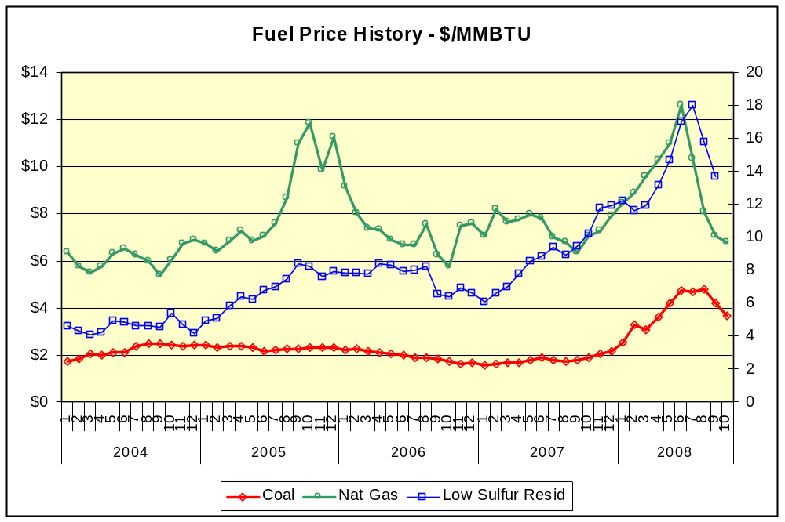
The incremental reduction of CO2 is achieved through a combination of the reduction of the use of electricity and switching from high emitting units to lower emitting units that will be primarily fueled by natural gas. It is expected that the cost of a CO2 allowance will be directly related to the cost of natural gas and will experience similar volatility
The Western Climate Initiative (WCI) is program to cap and then reduce greenhouse gas emissions from seven western states ( CA, OR, WA, AZ, NM, UT, MT) and four Canadian provinces (BC, QUE, ONT, MAN). The equivalent CO2 emissions to be capped are approximately 1,000 million tons as compared the RGGI cap of 188 million tons. The cap begins in 2012 and will be decrease to a level that is 15% below 2005 emissions. The program design and plan have been agreed to by each of the participants. The plan provides for the use of allowances from other greenhouse gas control programs such as RGGI. Up to 49% of the required reductions can be accounted for through the use of such allowances. Given the magnitude of this program, the level of support in participating governments, and the stage of program development it is reasonable to consider the convergence of the RGGI allowance market with the WCI allowance market. The planners of WCI have estimated that allowance costs will range between $22 and $65/ton depending upon the final amounts of offsets that will be allowed. Ihe Whe European system is much larger and continues to grow through the addition of new members and sectors. Throughout 2008 European Union allowances have traded in the range of $35 to $50/ton. At these price levels most, if not all, of the margin available from the electric markets will have disappeared for coal fired generators. Generally coal fired units have been relatively low in the bid stack as baseload units. With increasing allowance prices the units mode of operation would become variable requiring other resources to also change operating modes. One expected change would be an increased use of gas. As allowance prices continue to increase further, it is likely that coal capacity would exit the system. Towards the end of the planning horizon this would impact reliability and place significant new demands on SCR resources. Convergence with other markets can be monitored for and provide signals to adjust plans.
Other events in the allowance markets and related fuel and energy systems could also lead to significant shifts in operating modes that would result in generators being unavailable during peak usage periods, potentially leading to bulk power system reliability risks. Some events to be considered would include a disruption in gas supply similar to the Rita and Katrina storms, which resulted in an increase of emissions of approximately 8 million tons. The loss of a nuclear plant for an extended period would result in an increased demand for allowances of more than 11 million tons.

Potential Impact of Future NOx Emission Limitations
A review of recent generation and air quality data should aid in the understanding of the nature of possible reduction requirements. According to DEC data, throughout the period of 2005-2007 there have been a total of 49 days when New York’s air quality did not meet the existing NAAQS for ozone of 84 ppb. With the new standard of 75 ppb in place, it is reasonable to expect that additional exceedances would have been recorded with the current level of emissions. The NYISO analyzed the same dataset to determine the potential impact of the OTC HEDD program. The analysis was conducted in two parts, looking first at the High Emitting Combustion Turbines (HECT), and then at the Load Following Boilers (LFB). The complete OTC HEDD analysis is the sum of the two analyses. As discussed in last year’s RNA, retrofit emission reduction technologies may not be economically feasible or available at all for many of the HECTs and some of the LFBs. The analysis conducted assumed that the proposed emission reductions are achieved through capacity limitations. The impacts of those capacity limitations result in LOLEs>0.1 as shown in Tables 4.16 and 4.17. This analysis shows a reduction in the magnitude of the LOLEs compared to last year, which can be attributed to the increased use of SCR resources. The analysis shows that these SCR resources will be called upon significantly more than current practice. Programs designed to reduce NOx emissions from the HECT units will require at a minimum, equivalent capacity replacement, to maintain resource adequacy.
Table 4.16: LOLE for RNA Base Case Environmental Retirement Scenario RNA Base Case Load Forecast Scenario 1: OTC – HEDD HECTs
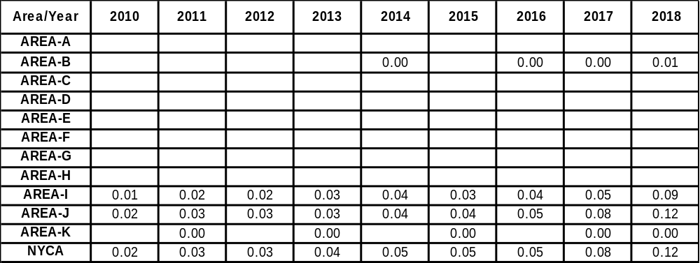

Table 4.17: LOLE for RNA Base Case Environmental Retirement Scenario RNA Base Case Load Forecast Scenario 2: OTC - HEDD LFBs
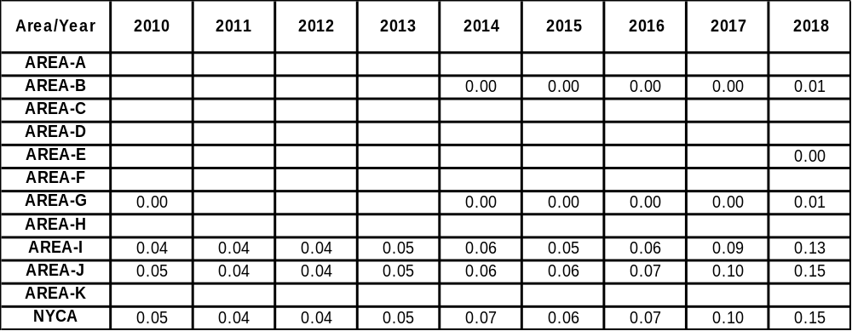

NYSDEC has started the review process for updating Reasonably Available Control Technology Standards for all fossil generating units with the exception of the most recent additions. This proposal could affect approximately 25,000 MW of capacity in New York. The analysis is based on the assumption that 75% of the required reduction can be achieved by the affected units. Further, the remaining affected units are assumed to achieve 50% of the required reductions. The balance of the required reductions is assumed to be achieved through capacity derating. For purposes of this analysis, the derating was assumed to be distributed evenly across all capacity. The results of the analysis, shown in Table 4.17a below, show that resource adequacy criteria were exceeded across the planning period. The results also show significant increased reliance on SCR resources.
Table 4.17a: LOLE for RNA Base Case Environmental Retirement Scenario RNA Base Case Load Forecast Scenario 3: DEC New NOx RACT
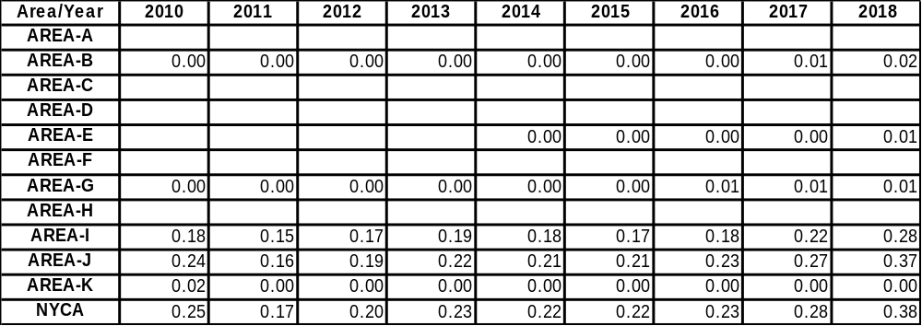

External Capacity Scenario
The New York ICAP market historically has had up to 2,755 MW of external import rights made available for external ICAP suppliers to participate in the New York capacity market. Any capacity available from the external systems is modeled as emergency assistance. However, the RNA modeling reduced external interface capability by 2,755 MW in total. The purpose of this scenario was to assess the impact on resource adequacy of an additional amount of 800 MW of firm external capacity over the 10-year Study Period. The capacity was made available in Upstate New York (UPNY) in Zone D to reflect the most likely delivery point for this capacity upstream of UPNY/SENY and Central East. The LOLE results for this scenario are presented in Table 4-18.
Table 4-18: NYCA External HQ to Area D Capacity Scenario
Area/Year | 2009 | 2010 | 2011 | 2012 | 2013 | 2014 | 2015 | 2016 | 2017 | 2018
AREA-A
AREA-B
AREA-C
AREA-D
AREA-E
AREA-F
AREA-G
AREA-H
AREA-I
AREA-J
AREA-K
NYCA |  | <0.01 | <0.01 | <0.01 | <0.01 | <0.01 | <0.01 | <0.01 | <0.01 | <0.01

This scenario shows that if 800 MW of additional capacity outside the NYCA were to participate in the New York ICAP market for the Study Period, the LOLE levels would improve.
An additional external capacity scenario was performed to assess the impact on resource adequacy of a reduction of 800 MW of capacity due to capacity exports from New York to adjoining areas in each year over the 10-year Study Period. One half of the reduction in capacity (400 MW) was made from Zone F and the other half (400 MW) was made from Zone G. The 800 MW of capacity was delivered to New England. The LOLE results for this scenario are presented in Table 4-19.
Table 4-19: NYCA Area_F and G External Sale To New England Scenario
Area/Year | 2009 | 2010 | 2011 | 2012 | 2013 | 2014 | 2015 | 2016 | 2017 | 2018
AREA-A
AREA-B
AREA-C
AREA-D
AREA-E
AREA-F
AREA-G
AREA-H
AREA-I |  |  |  |  |  |  |  | .01 | .01 | .02
AREA-J |  |  |  |  |  | .01 | .01 | .01 | .01 | .02
AREA-K
NYCA |  | <0.01 | <0.01 | <0.01 | <0.01 | 0.01 | <0.01 | 0.01 | 0.01 | 0.02
This scenario shows that a reduction of 800 MW of capacity in upstate NY would not impact resource adequacy needs significantly.

Nuclear Retirement Scenario
Table 4-20 below illustrates the impact on resource adequacy of the retirement of the Indian Point Unit 2 and Unit 3 nuclear power plants which are both base-loaded units that are located in Southeastern New York, the area of the State where transmission constraints exist and resource adequacy needs have been most prevalent:
Table 4-20: Indian Point 2 and 3 Nuclear Retirement Scenario
Area/Year | 2010 | 2011 | 2012 | 2013 | 2014 | 2015 | 2016 | 2017 | 2018
AREA-A
AREA-B |  |  |  |  |  |  | <0.01 | <0.01 | 0.01
AREA-C
AREA-E
AREA-F
AREA-G |  |  |  |  | <0.01 | <0.01 | 0.05 | 0.06 | 0.10
AREA-H |  |  |  |  | 0.03 | 0.04 | 1.80 | 2.26 | 3.22
AREA-I | <0.01 | <0.01 | 0.01 | 0.01 | 0.19 | 0.23 | 2.26 | 2.85 | 3.90
AREA-J | <0.01 | <0.01 | 0.01 | 0.01 | 0.18 | 0.23 | 1.88 | 2.41 | 3.38
AREA-K
NYCA | <0.01 | <0.01 | 0.01 | 0.01 | 0.20 | 0.25 | 2.41 | 3.02 | 4.11
For the analysis it was assumed that Indian Point 2 ceases operations on its end of current license date in September 2013 and Indian Point 3 ceases operations on its end of current license date in December, 2015 this scenario shows that without the first unit in service in 2013, the reliability criteria would be violated in 2014. Without both units in service, the reliability impacts are even more extreme and effectively translate into an LOLE of two days/year, twenty times higher than mandated by the NERC/NPCC requirements.

Revised Transmission Topology
This scenario illustrates the impact on resource adequacy of revising the transmission topology to change the representation of the transmission path between Area G, PJM East, and Area J. The existing transmission topology is illustrated in Figure 1 in Appendix D. The existing transmission path between Area G and PJM East includes the Branchburg-Ramapo 500 kV and South Mahwah to Waldwick 345 kV transmission lines. The transmission path between PJM East to Area J includes the Hudson to Farragut 345 kV and Linden to Goethals 230 kV transmission lines. The revised transmission topology would separate the Area G to PJM East path into two paths, one representing the Branchburg-Ramapo transmission line controlled by the Ramapo Phase Shifter and the other the South Mahwah to Waldwick 345 kV lines controlled by the Waldwick phase shifters. The PJM East to Area J transmission path would be separated into two paths, one representing the flows scheduled on the Hudson-Farragut and Linden-Goethals phase shifters and the other path representing the flows scheduled on the Linden VFT. The objective of the revised transmission topology is to ensure that the power flows that occur south on the Waldwick phase shifters equal the power flows that occur east on the Farragut and Goethals phase shifters. In effect this scenario reduces the emergency assistance from PJM into NY. Table 4-21 below illustrates LOLE results of the Base Case load forecast with the revised transmission topology:
Table 4-21: Revised Transmission Topology
Area/Year | 2009 | 2010 | 2011 | 2012 | 2013 | 2014 | 2015 | 2016 | 2017 | 2018
AREA-A
AREA-B
AREA-C
AREA-D
AREA-E
AREA-F
AREA-G
AREA-H
AREA-I |  |  |  |  |  | 0.01 | 0.01 | 0.02 | 0.03 | 0.06
AREA-J |  |  |  |  |  | 0.02 | 0.02 | 0.02 | 0.04 | 0.07
AREA-K
NYCA | <0.01 | <0.01 | <0.01 | <0.01 | <0.01 | 0.02 | 0.02 | 0.03 | 0.04 | 0.07

For the year 2018 the revised transmission topology increased the NYCA LOLE from 0.02 to 0.07.

Zones at Risk Scenario
Given that the LOLE of the Base Case conditions did not exceed 0.10 for the 10 year study period, additional analysis was performed to determine the reduction in capacity which would cause the LOLE to exceed 0.10. For each of these Areas, the capacity in the area was derated by increments of 250 MW until the NYCA LOLE exceeded 0.10. The NYISO did not reduce capacity from particular units or model the effect on load pockets within zones of removing specific amounts of capacity from load pockets. The analysis was performed for the 2018 year in Areas B, G, H, and J. The following Table 4-22 summarizes the results:
Table 4-22 Zones at Risk Results for 2018
 | Capacity Derated | NYCA LOLE
Area_B | 500 | 0.13
Area G | 750 | 0.10
Area J | 500  750 | 0.08  0.15
Area_H | 750 | 0.10
The results demonstrate that removing 750 MW from the Lower Hudson Valley (Zone G or H), removing between 500 MW and 750 MW from Zone J, or 500 MW from Zone B in 2018 would cause a violation of the resource adequacy criterion.
An additional scenario was performed which builds on the Zones at Risk Scenario, e he External Capacity Scenario, an resources under development in Northern New York, Western New York, and the Southern Tier, represented in the High Wind Penetration Scenario. To investigate possible reliability impacts from capacity displacement, capacity was removed from Zones G, H, and J. Two sensitivity cases for capacity locations were run, one with removing 1500 MW removed from Zone G other with 500 MW each removed from Zones G, H, and J. Both sensitivity cases revealed LOLE violations of approximately 0.25.

High Wind Penetration Scenario
A high wind penetration scenario was developed by reviewing the proposed wind resources identified in the NYISO generation interconnection queue. Table 4-23 illustrates the assumptions used to develop the additional wind generation capacity assuming a 50% penetration level.

Table 4-23: Wind Penetration Scenario Assumptions
 | Proposed Capacity (MW) | 50% Penetration | Base Case Capacity (MW) | Additional Capacity (MW)
Area A | 2481 | 1241 | 121 | 1120
Area C | 1462 | 731 | 212 | 519
Area D | 916 | 458 | 499 | 0
Area E | 2217 | 1109 | 366 | 743
The following Table 4-24 summarizes the LOLE results for the high wind penetration scenario:
Table 4-24: LOLE with High Wind Penetration
Area/Year | 2009 | 2010 | 2011 | 2012 | 2013 | 2014 | 2015 | 2016 | 2017 | 2018
AREA-A
AREA-B
AREA-C
AREA-D
AREA-E
AREA-F
AREA-G
AREA-H
AREA-I |  |  |  |  |  |  |  | .01 | .01 | .02
AREA-J |  |  |  |  |  |  | .01 | .01 | .01 | .02
AREA-K
NYCA | <0.01 | <0.01 | <0.01 | <0.01 | <0.01 | <0.01 | .01 | .01 | .01 | .02

SCR Penetration Scenarios
A low SCR penetration scenario was developed by reducing the Base Case SCR resources by 7.5% annually starting in 2010. Table 4-25 illustrates the LOLE results with the reduced SCR resources.

Table 4-25: LOLE with SCR Resources Reduced Annually by 7.5%
Area/Year | 2009 | 2010 | 2011 | 2012 | 2013 | 2014 | 2015 | 2016 | 2017 | 2018
AREA-A
AREA-B |  |  |  |  |  |  | <0.01 | <0.01 | <0.01 | 0.02
AREA-C
AREA-D
AREA-E |  |  |  |  |  |  |  |  | <0.01 | <0.01
AREA-F
AREA-G
AREA-H
AREA-I |  | <0.01 | <0.01 | <0.01 | 0.01 | 0.01 | 0.01 | 0.01 | 0.02 | 0.05
AREA-J |  | <0.01 | <0.01 | <0.01 | 0.01 | 0.01 | 0.01 | 0.02 | 0.03 | 0.06
AREA-K
NYCA | <0.01 | <0.01 | <0.01 | <0.01 | 0.01 | 0.01 | 0.01 | 0.02 | 0.03 | 0.06
A high SCR penetration scenario was developed by increasing the Base Case SCR resources by 7.5% annually starting in 2010. Table 4-26 illustrates the LOLE results with the high penetration of SCR resources.

Table 4-26: LOLE with SCR Resourced Increased Annually by 7.5%
Area/Year | 2009 | 2010 | 2011 | 2012 | 2013 | 2014 | 2015 | 2016 | 2017 | 2018
AREA-A
AREA-B
AREA-C
AREA-D
AREA-E
AREA-F
AREA-G
AREA-H
AREA-I
AREA-J
AREA-K
NYCA | <0.01 | <0.01 | <0.01 | <0.01 | <0.01 | <0.01 | <0.01 | <0.01 | <0.01 | <0.01

External LOLE Modeling Scenario
The RNA Base Case results assumed the load and capacity for external control areas represented in the MARS model was fixed to the IRM values for the first five years. For the second five years, the external control area peak load was adjusted so that the LOLE levels in external control areas would be approximately 0.10 for the Base Case assumptions. Table 4-27 illustrates the LOLE results with the external control area loads adjusted to a LOLE value of approximately 0.10. Table 4-28 illustrates the LOLE results for the external control area loads and capacity fixed to the IRM 2009 values.
Table 4-27: External Areas Adjusted to Achieve 0.10 LOLE
Area/Year | 2014 | 2015 | 2016 | 2017 | 2018
NYCA | 0.01 | 0.01 | 0.01 | 0.01 | 0.02
PJM | 0.11 | 0.11 | 0.10 | 0.10 | 0.11
ISONE | 0.10 | 0.15 | 0.09 | 0.07 | 0.08
IESO | 0.12 | 0.13 | 0.12 | 0.12 | 0.13
HQ | 0.11 | 0.12 | 0.09 | 0.10 | 0.09
Table 4-28: External Areas Fixed to IRM 2009 Load and Capacity Values
Area/Year | 2014 | 2015 | 2016 | 2017 | 2018
NYCA | 0.01 | 0.01 | 0.01 | 0.01 | 0.03
PJM | 0.26 | 0.26 | 0.22 | 0.23 | 0.25
ISONE | 0.07 | 0.06 | 0.08 | 0.06 | 0.07
IESO | 0.03 | 0.01 | 0.01 | 0.01 | 0.02
HQ | 0.09 | 0.10 | 0.06 | 0.06 | 0.06

Impact of Shift in NYCA Resources

: 2018 LOLE Impacts of Transmission Reinforcements
for an Expanded Renewable Scenario

Observations and Recommendations

Base Case
This 2009 RNA builds upon the results and analyses contained in the NYISO’s first three CRPs. Those first CRPs responded to the need for significant resource additions identified by its associated Reliability Needs Assessments for the respective 10-year Study Periods that each of them covered. By contrast, this 2009 RNA indicates that the forecasted system does not violate the LOLE resource adequacy criterion for the years 2009 through 2018. There are three primary reasons why this year’s RNA does not identify reliability needs.
First, the prior Base Cases used in the CRPs did not include major resource and alternative regulated resource and transmission system additions that now meet criteria zones C through K. Unit additions of approximately 1,714 MW over 2008 Base Case resource additions have been incorporated into the 2009 RNA Base Case. Additionally, the plan identifies no planned unit retirement. Previous additions from the 2005 CRP include new transmission lines such as M29, reactive power resources, capacity additions totaling 455 MW, and new HVDC ties totaling 990 MW from PJM and ISO-New England into NYCA zone K. The additions from the 2008 CRP also include the addition of capacitor banks at the Millwood Substation that increased transfer capability from the Lower Hudson Valley into New York City. Planned unit retirements are also somewhat lower, 156 MW, than in the 2008 RNA.
Second, the 2009 RNA also reflects the results of expected energy efficiency gains pursuant to the NYSPSC’s Energy Efficiency Portfolio Standard Order, pursuant to which the PSC has taken the initial steps to implement the Governor’s initiative to lower demands on the electric system by 15% of forecasted levels for 2015. The NYSPSC authorized continued spending of $175 million annually on Systems Benefits Charge Programs, and an additional $160 million annually for energy efficiency programs in the June 23rd Order, totaling approximately $335 million per year. These expenditures will supplement other state programs such as improvements in codes and standards. Finally, the NYSPSC stated that it would provide the opportunity for up to an additional $170 million in programs which have not yet been authorized. Using conservative assumptions appropriate to a baseline reliability analysis, the NYISO determined that there should be a reduction of approximately five percent of peak load from previously forecasted levels by 2015 based upon currently authorized spending levels. This equates to approximately 30% of the identified energy efficiency goals. The resulting 2,100 MW decrease in the peak load forecast largely contributed to the NYISO’s determination that there are no resource adequacy needs in the Base Case. That is, the expected reductions in peak load from demand side management measures offset what would otherwise be necessary capacity resource additions. This means that New York will have adequate resources to need bulk power system reliability needs from 2009 to 2018, as long as these demand side management programs are successfully implemented at the levels and in the locations assumed in this study. At this time, even in the absence of these programs, the NYISO has determined that other resources would be sufficient and that the bulk power system would not experience any reliability needs for the First Five Year Period, from 2009 to 2013.
Third, the NYISO has experienced a significant increase in registration for its SCR programs, which have added capacity resources to the system based on customer pledges to cut energy usage on demand. The NYISO currently has registrations of approximately 2,084 MW of SCRs, an increase of 761 MW of resources over the 2008 RNA.
In sum, based upon the combined effect of lower load forecasts resulting from State public policy programs, generator additions and lower planned retirements, and additional SCR program participation, the NYISO has determined that at this time there are no resource adequacy needs in New York from 2009 to 2018 and, therefore, no need to solicit solutions to reliability needs this year. Nevertheless, the NYISO will issue a 2009 CRP to update the 2008 CRP and to serve as the basis of the NYISO’s nascent economic planning process, which was approved by FERC in October 2008.
Most important, the NYISO will vigilantly monitor the progress of market-based solutions, State energy efficiency program implementation, transmission owner projects and other planned projects on the bulk power system to determine that these projects remain on schedule. This monitoring is key to the NYISO’s determination that there are no reliability needs at this time. Should the NYISO determine that conditions have changed, it will determine whether market-based solutions that are currently progressing are sufficient to meet the resource adequacy and system security needs of the New York power grid. If not, the NYISO will have the discretion to issue a request for regulated backstop solutions to address the newly identified reliability needs
Many challenges drive the need for vigilance in monitoring the conditions on the bulk power system until the NYISO conducts its next RNA two years from now in 2011. The NYISO has conducted analysis of numerous sensitivities and scenarios, described below, to test the robustness of the bulk power system and to bound the conditions under which resource adequacy or transmission security needs may arise. Reliability needs would arise in 2017 in the absence of effective implementation of the EEPS programs. On the other hand, additional energy efficiency penetration would further mitigate the need for resource additions. If extreme weather conditions (2 standard deviations hotter than normal) became the norm within the NYISO and this was combined with high load growth, the New York bulk power grid could need resources as soon as 2010.
Implementation of new programs to control NOx emissions from fossil fueled generators on high electric demand days could render a portion of these units unavailable to meet peak energy needs. If such limitations curtailed the availability of up to 1,231 MW of high emitting combustion turbines and up to 1,739 MW of load following boilers, operational limitations on these peaking units could result in violations of the resource adequacy criterion. Moreover, if implementation of new emission controls as reasonably available control technologies meant that 75% of units could retrofit to meet the requirements, but 25% could not, up to 3,125 MW of capacity may no longer be available to meet peak load conditions. If such circumstances arose, the resource adequacy criterion would be violated for all years from 2009 through 2018. With respect to the RGGI, the NYISO had conducted analyses which demonstrate that if the new RGGI allowance market operates as expected by the State (i.e. allowance prices remain low and a substantial spread persists between natural gas and coal pricing), power grid reliability will not be negatively impacted in the near term. However, high carbon allowance price $35 to $50/ton, or a change in the spread between natural gas and coal pricing, could lead to reduced availability of high carbon emitting coal fired capacity, placing significant strain on these resources.
Similarly, the unexpected retirement of certain generation could cause immediate resource adequacy violations and the need for new resources in New York. For example, due to its location in a high load, constrained area of the system, retirement of one of the two Indian Point nuclear power plant units, which are up for relicensing before the Nuclear Regulatory Commission, would cause an immediate violation of the resource adequacy criterion in the year of retirement. Retirement of both units would cause a severe shortage in resources needed to maintain bulk power system reliability with the LOLE for the NYCA reaching 4.11 by 2018. Moreover, an increase in load or a reduction in resources in 2018 of 750 in the Lower Hudson Valley or a change of between 500 and 750 MW in New York City in the last year of the Study Period would cause resource adequacy violations and a need for new resources as well.
Finally, the NYISO has determined that existing transmission system transfer limitations will curb the ability of a significant influx of renewable resource in upstate New York and Canada to significantly add to the reliability of the NYISO. Adding renewable resources such as wind and hydroelectric does not improve resource adequacy without appropriate transmission system reinforcements. However, transmission reinforcements would these resources to reach load center areas in downstate New York, and resource adequacy would improve as long as there is not a loss of other resources. Such transmission reinforcements could also facilitate the State in achieving its Renewable Portfolio Standard goals.

Scenarios
The NYISO conducted analysis of numerous scenarios, more than in any prior year, to determine whether, and under what conditions, shifts in resources, load levels or public policy programs would give rise to reliability needs

Econometric Load Forecast.
The NYISO evaluated resource adequacy needs against the 2008 economic load forecast in the Gold Book, which does not include the effect of the NYSPSC’s Energy Efficiency Portfolio Standard Order. Because the load would be approximately 2,100 MW higher in 2018 than the RNA Base Case forecast, there would be a need for resources in 2017 in the absence of effective implementation of the Energy Efficiency Portfolio Standard. This scenario demonstrates the impact of the EEPS in meeting future resource needs in New York.

Energy Efficiency Portfolio Standard
Due to its nature as a baseline power grid reliability analysis, the NYISO’s Base Case incorporated conservative assumptions regarding the amount of energy efficiency and peak capacity reductions that will result from the NYSPSC’s EEPS Order. The NYISO recognizes that the NYSPSC may well approve additional programs and expenditures to implement the EEPS. Accordingly, the NYISO analyzed two additional scenarios. In the first scenario, the NYISO continued expenditures of $160 million per year from 2012 to 2015, plus additional spending of $85 million per year, equivalent to half that was discussed in the EEPS Order but not yet authorized. This scenario resulted in energy savings that translate into roughly 732 MW of additional load reductions by 2018, and no resource needs throughout the Study Period. In the second scenario, the NYISO modeled achievement of the entire 15 x 15 goal regardless of cost, which produce additional load reductions of 3,449 MW by 2018 compared to the Base Case.
Explain conversion of energy to capacity savings 305/MW. (Arthur)

High Load Growth and Extreme Weather Forecast
For comparison to the prior two forecast scenarios, the NYISO evaluated the combined impacts of EEPS programs, high load growth in the 95th percentile of growth, and extremely warm weather becoming the norm. This scenario, described more fully under section 4.4.1, revealed that such circumstances would lead to resource adequacy needs on the bulk power system beginning in 2010. The majority of this impact results from assuming extremely warm weather rather than a probabilistic distribution of weather based upon historic conditions.

NOx Reduction Programs
The NYISO modeled the potential impact of energy output limitations on generating facilities that could result from new programs the NYSDEC is considering to reduce emissions of nitrogen oxides that cause ozone smog levels to exceed national standards. The HEDD program that would target emissions from peaking generators in New York City on hot high ozone days could lead to those units to be limited in their operations. Such limitations could affect the availability of up to 1,231 MW of high emitting combustion turbines and up to 1,739 MW of load following boilers. Operational limitations on these peaking units would result in violations of the resource adequacy criterion at all times. The owners of these power plants have indicated that adding control technology to them is not economically feasible. Accordingly, if emission reductions are required from these units beyond those that can be tolerated for maintaining power system reliability during peak load conditions, replacement of these units by other resources will be required. The NYSDEC is also examining tightening RACT for all fossil fuel fire generating units, with the exception of the most recent additions. Assuming that 75% of the fossil fleet could be retrofitted, up to 3,125 MW of capacity may no longer be available. If such circumstances arose, the resource adequacy criterion also would be violated for all years from 2009 through 2018.

Regional Greenhouse Gas Initiative
The recently promulgated RGGI regulations implement a regional program through which 10 states have agreed to cap CO2 emissions from power plants larger than 25 MW of capacity beginning in 2009. During the 2015-2018 period, the carbon emissions cap for each state will be reduced by 2.5% annually. The NYISO had conducted analyses which demonstrate that if the new RGGI allowance market operates as expected by the State and does not force the retirement of significant number of units, power grid reliability will not be negatively impacted in the near term. The first round of carbon allowance auctions were conducted without incident, and resulted in a price of $3.07 per ton of carbon. Assuming today’s coal and gas fuel price spread and other environmental program compliance costs, if market disruptions occur in the price of allowances which cause high carbon allowance prices of $35 to $50/ton, the availability of high carbon emitting coal fired capacity would be reduced, placing significant strain on these resources. These adverse economic effects on high carbon emitting units could occur with lower carbon allowance prices, if the coal and gas fuel price spread changes, or other environmental compliance costs increase.

External Capacity Scenario
This scenario assessed the impact on resource adequacy if an additional amount of 800 MW of firm external capacity were added to the New York bulk power grid over the 10-year Study Period. The NYISO determined that such capacity additions from outside of New York would improve resource adequacy, but by a very small amount for the Base Case.

Nuclear Retirement Scenario
This scenario modeled the effect on resource adequacy if the Indian Point Unit 2 retired in 2013 and Unit 3 nuclear power plants retired in 2015. The NYISO determined that, due to their location in a high load, constrained area of the system, such retirements would lead to immediate resource needs in 2014 and severe resource adequacy violations from 2016 through 2018. Specifically, Indian Point 2 and 3 are each 1,000 MW generating facilities. In addition to providing energy and capacity to consumers in the Lower Hudson Valley and New York City, these facilities also are a critical source of voltage support for this area. Due to their location in this high load, constrained area of the State, the LOLE levels are exceeded immediately in Southeastern New York and correspondingly, for the NYCA, without just the first unit in service in 2013. Without the second unit in service two years later in 2016, the impacts are far more severe. Under NERC and NPCC requirements, the LOLE cannot exceed one day in 10 years which is stated as a 0.10 LOLE. Without both units in service, the LOLE jumps to over 1.0 throughout zones in Southeastern New York below the Leeds Pleasant Valley transmission line and correspondingly, for the NYCA. The LOLE then skyrockets in later years without these two units reaching an LOLE of 4.11 by 2018. These LOLE levels were reached as applied against a Base Case that assumes significant load reductions due to the State’s focused energy efficiency efforts. If load reductions are ultimately not achieved or are achieved at lower levels in this area of the State, the LOLE impacts without these two units will become even more pronounced.

Revised Transmission Topology
This scenario illustrates the impact on resource adequacy of revising the transmission topology to change the representation of the transmission paths between Area G, PJM East, and Area J. The objective of the revised transmission topology is to ensure that the power flows that occur south on the Waldwick phase shifters equal the power flows that occur east on the Farragut and Goethals phase shifters. However, the scenario does reduce the capability for emergency assistance that can be received from PJM. For the year 2018, the revised transmission topology increased the NYCA LOLE from 0.02 to 0.07.

Zones at Risk
Given that the LOLE of the Base Case conditions did not exceed 0.10 for the 10 year study period, additional analysis was performed to determine the reduction in capacity which would cause the LOLE to exceed 0.10. The NYISO determined that if 750 MW of capacity were to be removed from the Lower Hudson Valley or between 500 MW and 750 MW of capacity were to be removed for any reason for the New York City area in 2018, the resource adequacy criterion would be violated in that year.
An additional scenario was performed to investigate the possible reliability impacts of shifting capacity from Zones G, H, and J to upstate New York. Two sensitivity cases for capacity relocations were performed, removing 1500 MW from Zone G, and 500 MW each from Zones G, H, and J. Both sensitivity cases revealed LOLE violations of 0.25.

High Wind Penetration
The NYISO analyzed the effect on resource adequacy of 50% of wind resources in the NYISO’s Interconnection Queue coming on line in 2010. The results reveal no improvement in resource adequacy during the Study Period.

Special Case Resource Penetration
This scenario modeled the effect on resource adequacy of, alternatively, reducing and increasing SCRs from the approximately 2,084 MW of resources contained in the NYISO’s Base Case. A low SCR penetration scenario was developed by reducing the Base Case SCR resources annually by 7.5% starting in 2010. The reduction indicated that a resource adequacy need would arise in 2017. A high SCR penetration scenario was developed by increasing the SCR resources annually by 7.5% starting in 2010. Increasing the SCR resources did not change the system resource needs.

    - External Resource Adequacy Modeling
The RNA Base Case results assumed the load and capacity for external control areas represented in the MARS model was fixed to the IRM values for the first five years. In the scenario, the NYISO adjusted the external control area peak load for the second five years so that the LOLE levels in external control areas would be approximately 0.10 for the Base Case assumptions and then fixed at the IRM 2009 load and capacity values. The NYISO determined that no resource adequacy need would arise in New York in either event.

Historic Congestion
Appendix A of Attachment Y of the NYISO OATT states: “As part of its Comprehensive Reliability Planning Process, the NYISO will prepare summaries and detailed analysis of historic congestion across the New York Transmission System. This will include analysis to identify the significant causes of historic congestion in an effort to help Market Participants and other stakeholders distinguish persistent and addressable congestion from congestion that results from one time events or transient adjustments in operating procedures that may or may not recur. This information will assist Market Participants and other stakeholders to make appropriately informed decisions”. The detailed analysis of historic congestion can be found on the NYISO Web site at:
www.nyiso.com/public/services/planning/congestion_cost.jsp
Figure 6-1 below presents the latest available summary of cumulative historical Day Ahead Market (DAM) congestion dollars as determined by the bid-production-cost-savings methodology for the years 2003, 2004, 2005, 2006, and 2007. This information is available on the NYISO web site. The cumulative congestion dollar amounts are affected by fuel pricing and are higher for 2007 than in 2006. Congestion costs are impacted both by the frequency of constraints and the cost of energy on each side of the constraint. The detailed congestion information can be found on the NYISO Web site under Services Planning.
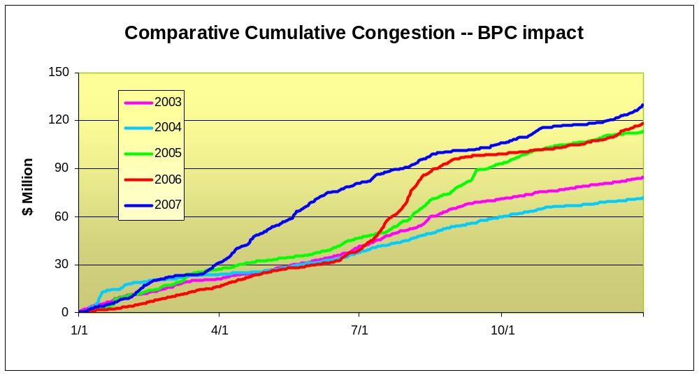
Figure 6-1: Cumulative Unhedged Historic Congestion by Year 2003 to 2007
Table 6-1 below presents the breakdown of unhedged congestion for the top five monitored elements as percentages of the total amount of congestion. The top five accounted for almost 90% of the total congestion.
Table 6-1: Breakdown of 2007 Total Unhedged Congestion – Top Five Facilities
Monitored Facility | % of Annual Total
CENTRAL EAST - VC | 39.0
PLSNTVLY 345 LEEDS 345 1 | 30.4
DUNWOODIE 345 SHORE_RD 345 1 | 17.7
RAINEY 345 DUNWOODIE 345 1 | 1.4
MOTTHAVEN 345 RAINEY 345 2 | 1.3
Other Facilities | 10.2
Total | 100.0
Table 6-2 presents the breakdown of unhedged congestion for the five monitored elements as percentages of the total amount of congestion over the period of five years from 2003 through 2007.
Table 6-2: Unhedged Congestion Payments, 2003-2007
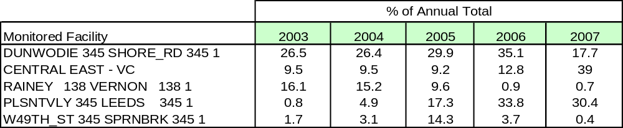

Appendix A - Reliability Needs Assessment Glossary
Term | Definition
10-year Study Period | 10-year period starting with the year the study is dated and projecting forward 10 years. For example, the 2009 RNA covers the 10-year Study Period of 2009 through 2018.
15x15 | See definition for Energy Efficiency Portfolio Standard.
Adequacy: | Encompassing both generation and transmission, adequacy refers to the ability of the bulk power system to supply the aggregate requirements of consumers at all times, accounting for scheduled and unscheduled outages of system components.
Alternative Regulated Solutions: | Submitted by developers if the NYISO determines that it has not received adequate regulated backstop or market-based solutions to satisfy the Reliability Need and, as a result, solicits additional regulated backstop or market-based solutions.
Annual Transmission Reliability Assessment (ATRA): | An assessment, conducted by the NYISO staff in cooperation with Market Participants, to determine the System Upgrade Facilities required for each generation and merchant transmission project included in the Assessment to interconnect to the New York State Transmission System in compliance with Applicable Reliability Requirements and the NYISO Minimum Interconnection Standard.
Bulk Power Transmission Facility (BPTF): | Transmission facilities that are system elements of the bulk power system which is the interconnected electrical system within northeastern North America comprised of system elements on which faults or disturbances can have a significant adverse impact outside of the local area.
Capability Period: | The Summer Capability Period lasts six months, from May 1 through October 31. The Winter Capability Period runs from November 1 through April 30 of the following year.
Capacity: | The capability to generate or transmit electrical power, or the ability to reduce demand at the direction of the NYISO.
Clean Air Interstate Rule (CAIR) | Rule enacted by the U.S. EPA to reduce Interstate Transport of Fine Particulate Matter (PM ) and Ozone. CAIR provides a federal framework to limit the emission of SO₂ and CO₂.
Comprehensive Reliability Plan (CRP): | An annual study undertaken by the NYISO that evaluates projects offered to meet New York’s future electric power needs, as identified in the Reliability Needs Assessment (RNA). The CRP may trigger electric utilities to pursue regulated solutions to meet reliability needs if market-based solutions will not be available by that point. It is the second step in the Comprehensive Reliability Planning Process (CRPP).
Comprehensive Reliability Planning Process (CRPP): | The annual process that evaluates resource adequacy and transmission system security of the state’s bulk electricity grid over a 10-year period and evaluates solutions to meet those needs. The CRPP consists of two studies: the RNA, which identifies potential problems, and the CRP, which evaluates specific solutions to those problems.
Comprehensive System Planning Process (CSPP) | A transmission system planning process that is comprised of three components: 1) Local transmission planning; 2) Compilation of local plans into the Comprehensive Reliability Planning Process (CRPP), which includes developing a Comprehensive Reliability Plan (CRP); 3) Channeling the CRP data into the Congestion Assessment and Resource Integration Study (CARIS)
Congestion Assessment and Resource Integration Study (CARIS) | The third component of the Comprehensive System Planning Process (CSPP). The CARIS is based on the Comprehensive Reliability Plan (CRP).
Congestion: | Transmission paths that are constrained, which may limit power transactions because of insufficient capability.
Contingencies: | Contingencies are electrical system events (including disturbances and equipment failures) that are likely to happen.
Day-Ahead Market (DAM): | A NYISO-administered wholesale electricity market in which capacity, electricity, and/or Ancillary Services are auctioned and scheduled one day prior to use. The DAM sets prices as of 11 a.m. the day before the day these products are bought and sold, based on generation and energy transaction bids offered in advance to the NYISO. More than 90% of energy transactions occur in the DAM.
Electric Reliability Organization (ERO): | Under the Energy Policy Act of 2005, the Federal Energy Regulatory Commission (FERC) is required to identify an ERO to establish, implement and enforce mandatory electric reliability standards that apply to bulk electricity grid operators, generators and TOs in North America. In July 2006, the FERC certified the North American Electric Reliability Corporation (NERC) as America’s ERO.
Electric System Planning Work Group (ESPWG): | A NYISO governance working group for Market Participants designated to fulfill the planning functions assigned to it. The ESPWG is a working group that provides a forum for stakeholders and Market Participants to provide input into the NYISO’s Comprehensive Reliability Planning Process (CRPP), the NYISO’s response to FERC reliability-related Orders and other directives, other system planning activities, policies regarding cost allocation and recovery for reliability projects, and related matters.
Energy Efficiency Portfolio Standard (EEPS) | A statewide program ordered by the NYSPSC in response to the Governor’s call to reduce New Yorkers' electricity usage by15% of forecast levels by the year 2015, with comparable results in natural gas conservation. Also known as 15x15.
Federal Energy Regulatory Commission (FERC): | The federal energy regulatory agency within the U.S. Department of Energy that approves the NYISO’s tariffs and regulates its operation of the bulk electricity grid, wholesale power markets, and planning and interconnection processes.
Five Year Base Case: | The model representing the New York State power system over the first five years of the Study Period.
Forced Outage: | An unanticipated loss of capacity, due to the breakdown of a power plant or transmission line. It can also mean the intentional shutdown of a generating unit or transmission line for emergency reasons.
Gold Book | Annual NYISO publication of its Load and Capacity Data Report.
High Electric Demand Days (HEDD): | Days of high electricity demand, which can dramatically increase ozone-forming air pollution from electric generation, and result in nitrogen oxide (NOx) emissions that can be greater than two times their average levels. Days of high electrical use often coincide with days with high ozone levels.
High Emitting Combustion Turbines (HECT) | Those gas turbine generators with relatively low capacity factors and higher emission rates that tend to be used on days when there is a high electric demand. A specific list of these units that has been identified by the Ozone Transport Commission
Independent Market Advisor | Person, persons or consulting firm retained by the NYISO Board pursuant to Article 4 of the ISO’s Market Monitoring Plan.
Installed Capacity (ICAP): | A generator or load facility that complies with the requirements in the Reliability Rules and is capable of supplying and/or reducing the demand for energy in the NYCA for the purpose of ensuring that sufficient energy and capacity are available to meet the Reliability Rules.
Installed Reserve Margin (IRM): | The amount of installed electric generation capacity above 100% of the forecasted peak electric consumption that is required to meet New York State Reliability Council (NYSRC) resource adequacy criteria. Most planners consider a 15-20% reserve margin essential for good reliability.
Interconnection Queue: | A queue of merchant transmission and generation projects (greater than 20 MW) that have submitted an Interconnection Request to the NYISO to be interconnected to the state’s bulk electricity grid. All projects must undergo three studies – a Feasibility Study (unless parties agree to forgo it), a System Reliability Impact Study (SRIS) and a Facilities Study – before interconnecting to the grid.
Load Following Boilers: | Those steam generators with relatively low capacity factors and higher emission rates that tend to be used on day when there is a high electric demand. A specific list of these units that has been identified by the Ozone Transport Commission
Load Pocket: | Areas that have a limited ability to import generation resources from outside their areas in order to meet reliability requirements.
Local Transmission Owner Planning Process (LTPP) | The first step in the Comprehensive System Planning Process (CSPP), under which stakeholders in New York’s electricity markets participate in local transmission planning.
Loss of load expectation (LOLE): | LOLE establishes the amount of generation and demand-side resources needed - subject to the level of the availability of those resources, load uncertainty, available transmission system transfer capability and emergency operating procedures - to minimize the probability of an involuntary loss of firm electric load on the bulk electricity grid. The state’s bulk electricity grid is designed to meet an LOLE that is not greater than one occurrence of an involuntary load disconnection in 10 years, expressed mathematically as 0.1 days per year.
Lower Hudson Valley: | The southeastern section of New York, comprising New York Control Area Load Zones G, H and I. Greene, Ulster, Orange Dutchess, Putnam, Rockland and Westchester counties are located in those Load Zones.
Market-Based Solutions: | Investor-proposed projects that are driven by market needs to meet future reliability requirements of the bulk electricity grid as outlined in the RNA. Those solutions can include generation, transmission and Demand Response Programs.
Market Participant: | An entity, excluding the NYISO, that produces, transmits sells, and/or purchases for resale capacity, energy and ancillary services in the wholesale market. Market Participants include: customers under the NYISO’s tariffs, power exchanges, TOs, primary holders, load serving entities, generating companies and other suppliers, and entities buying or selling transmission congestion contracts.
National Ambient Air Quality Standards (NAAQS) | Limits, set by the EPA, on pollutants considered harmful to public health and the environment.
New York Control Area (NYCA): | The area under the electrical control of the NYISO. It includes the entire state of New York, and is divided into 11 zones.
New York State Department of Environmental Conservation (NYSDEC) | The agency that implements New York State environmental conservation law, with some programs also governed by federal law.
New York Independent System Operator (NYISO): | Formed in 1997 and commencing operations in 1999, the NYISO is a not-for-profit organization that manages New York’s bulk electricity grid – a 10,775-mile network of high voltage lines that carry electricity throughout the state. The NYISO also oversees the state’s wholesale electricity markets. The organization is governed by an independent Board of Directors and a governance structure made up of committees with Market Participants and stakeholders as members.
New York State Bulk Power Transmission Facility (BPTF): | The facilities identified as the New York State Bulk Power Transmission Facilities in the annual Area Transmission Review submitted to NPCC by the NYISO pursuant to NYSRC requirements.
New York State Department of Public Service (DPS): | The New York State Department of Public Service, as defined in the New York Public Service Law, which serves as the staff for the New York State Public Service Commission.
New York State Energy Planning Board (SEPB) | Established by New York’s governor in April 2008 to create a state energy plan (SEP) that examines and lays out goals addressing all aspects of New York’s energy use and conservation.
New York State Energy Research and Development Authority (NYSERDA) | A corporation created under the New York State Public Authorities law and funded by the System Benefits Charge (SBC). Among other responsibilities, NYSERDA is charged with Conducting a multifaceted energy and environmental research and development program to meet New York State's diverse economic needs.
New York State Public Service Commission (NYSPSC): | The New York State Public Service Commission, as defined in the New York Public Service Law.
Open Access Transmission Tariff (OATT) | Document of guidelines, regulated by the FERC, under which the NYISO provides transmission service. The OATT is a dynamic document to which revisions are made on a collaborative basis by the NYISO, New York’s Electricity Market Stakeholders, and the FERC.
Order 890: | Adopted by FERC in February 2007, Order 890 is a change to FERC’s 1996 open access regulations (established in Orders 888 and 889). Order 890 is intended to provide for more effective competition, transparency and planning in wholesale electricity markets and transmission grid operations, as well as to strengthen the Open Access Transmission Tariff (OATT) with regard to non-discriminatory transmission service. Order 890 requires Transmission Providers – including the NYISO – have a formal planning process that provides for a coordinated transmission planning process, including reliability and economic planning studies.
Outage: | Removal of generating capacity or transmission line from service, either forced or scheduled.
Ozone Transport Commission (OTC) | A multi-state organization created under the Clean Air Act (CAA), responsible for advising the EPA on transport issues and for developing and implementing regional solutions to the ground-level ozone problem in the Northeast and Mid-Atlantic regions.
Peak Demand: | The maximum instantaneous power demand averaged over any designated interval of time, which is measured in megawatt hours (MWh). Peak demand, also known as peak load, is usually measured hourly.
Reasonably Available Control Technologies (RACT) | A process that determines, and then requires the use of reasonable available control requirements to reduce or limit polluting emissions. These requirements identify the lowest emission limit that a source or source category is capable of meeting after considering technological and economic feasibility.
Reactive Power Resources: | Facilities such as generators, high voltage transmission lines, synchronous condensers, capacitor banks, and static VAr compensators that provide reactive power. Reactive power is the portion of electric power that establishes and sustains the electric and magnetic fields of alternating-current equipment. Reactive power is usually expressed as kilovolt-amperes reactive (kVAr) or megavolt-ampere reactive (MVAr).
Regional Greenhouse Gas Initiative (RGGI) | A cooperative effort by ten Northeast and Mid-Atlantic states to limit greenhouse gas emissions using a market-based cap-and-trade approach.
Regulated Backstop Solutions: | Proposals required of certain TOs to meet reliability needs as outlined in the RNA. Those solutions can include generation, transmission or Demand Response. Non-Transmission Owner developers may also submit regulated solutions. The NYISO may call for a Gap solution if neither market-based nor regulated backstop solutions meet reliability needs in a timely manner. To the extent possible, the Gap solution should be temporary and strive to ensure that market-based solutions will not be economically harmed. The NYISO is responsible for evaluating all solutions to determine if they will meet identified reliability needs in a timely manner.
Reliability Criteria: | The electric power system planning and operating policies, standards, criteria, guidelines, procedures, and rules promulgated by the North American Electric Reliability Council (NERC), Northeast Power Coordinating Council (NPCC), and the New York State Reliability Council (NYSRC), as they may be amended from time to time.
Reliability Need: | A condition identified by the NYISO in the RNA as a violation or potential violation of Reliability Criteria.
Reliability Needs Assessment (RNA): | An annual report that evaluates resource adequacy and transmission system security over a 10-year planning horizon, and identifies future needs of the New York electric grid. It is the first step in the NYISO’s CRPP.
Renewable Portfolio Standard (RPS) | Proceeding commenced by order of the NYSPSC in 2004 which established goal to increase renewable energy used in New York State 25% (or approximately 3,700 MW) by 2013.
Responsible Transmission Owner (Responsible TO): | The Transmission Owner or TOs designated by the NYISO, pursuant to the NYISO Planning Process, to prepare a proposal for a regulated solution to a Reliability Need or to proceed with a regulated solution to a Reliability Need. The Responsible TO will normally be the Transmission Owner in whose Transmission District the NYISO identifies a Reliability Need.
Security: | The ability of the power system to withstand the loss of one or more elements without involuntarily disconnecting firm load.
Southeastern New York (SENY) | The NYCA south of the interface between Upstate New York (UPNY) and southeastern New York.
Special Case Resources (SCR): | A NYISO Demand Response program designed to reduce power usage by businesses and large power users qualified to participate in the NYISO’s ICAP market. Companies that sign up as SCRs are paid in advance for agreeing to cut power upon NYISO request.
State Implementation Plan (SIP) | A plan, submitted by each State to the EPA, for meeting specific requirements of the Clean Air Act, including the requirement to attain and maintain the National Ambient Air Quality Standards (NAAQS).
Study Period: | The 10-year time period evaluated in the RNA.
System Benefits Charge (SBC) | An amount of money, charged to ratepayers on their electric bills, which is allocated towards energy-efficiency programs, research and development initiatives, low-income energy programs, and environmental disclosure activities.
Transfer Capability: | The amount of electricity that can flow on a transmission line at any given instant, respecting facility rating and reliability rules.
Transmission Constraints: | Limitations on the ability of a transmission facility to transfer electricity during normal or emergency system conditions.
Transmission Owner (TO) | A public utility or authority that provides Transmission Service under the Tariff
Transmission Planning Advisory Subcommittee (TPAS): | A group of Market Participants that advises the NYISO Operating Committee and provides support to the NYISO Staff in regard to transmission planning matters including transmission system reliability, expansion, and interconnection.
Unforced Capacity Delivery Rights (UDR): | Unforced capacity delivery rights are rights that may be granted to controllable lines to deliver generating capacity from locations outside the NYCA to Localities within NYCA.
Upstate New York (UPNY): | The NYCA north of the interface between Upstate New York (UPNY) and southeastern New York (SENY).
Weather Normalized: | Adjustments made to remove fluctuation due to weather changes when making energy and peak demand forecasts. Using historical weather data, energy analysts can account for the influence of extreme weather conditions and adjust actual energy use and peak demand to estimate what would have happened if the hottest day or the coldest day had been the typical, or “normal,” weather conditions. Normal is usually calculated by taking the average of the previous 30 years of weather data.
Zone: | One of the eleven regions in the NYCA connected to each other by identified transmission interfaces. Designated as Load Zones A-K.

Appendix B – Load and Energy Forecast, 2008-2018
B.1 Introduction
Overview
This section describes the annual energy and seasonal peak demand forecasts for the 10-year period beginning with 2008 and extending through 2018. It begins with this Executive Summary, continues with an overview of historic electricity and economic trends in New York State, and concludes with the ten-year forecasts of summer and winter peak demands and annual energy requirements.
Executive Summary
As part of the CRPP, the NYISO performed a 10-year forecast of summer and winter peak demands and annual energy requirements. The electricity forecast is based on projections of New York’s economy performed by Economy.com in the spring of 2008. The Economy.com forecast includes detailed projections of employment, output, income and other factors for twenty three regions in New York State. A summary of the electricity forecast and the key economic variables that drive it follows.
In June 2008, the Public Service Commission of New York issued its Order regarding the Energy Efficiency Portfolio Standard. This proceeding sets as its goal the reduction of electricity consumption by 15% from 2007 forecasted levels as of 2015. This reduction represents an annual energy reduction of about 26,000 GWh and 5,700 MW of capacity otherwise needed to meet peak demand. Because bulk power system reliability planning is necessarily conservative in its assumptions, the NYISO modified the 2008 econometric forecast to account for that portion of the EEPS goal that was considered sufficiently reliable to include in the 2009 RNA.
Table B-1: Summary of Econometric Forecasts
Economic Indicators | Average Annual Growth
Economic Indicators | 97-02 | 02-07 | 08-13 | 13-18
Total Employment | 0.9% | 0.5% | 0.5% | 0.3%
Gross State Product | 3.4% | 3.0% | 2.3% | 2.4%
Population | 0.5% | 0.2% | 0.0% | -0.1%
Total Real Income | 2.2% | 3.4% | 1.9% | 1.4%
Summer Peak (actual data through 2006) | 1.5% | 1.0% | 0.5% | 0.5%
Annual Energy (actual data through 2006) | 1.5% | 1.1% | 0.8% | 0.8%
Employment Trends | Shares of Total Employment
Employment Trends | 2002 | 2007 | 2013 | 2018
Business, Services & Retail | 52.6% | 53.3% | 53.3% | 53.6%
Health, Education, Government, Agriculture | 34.7% | 35.3% | 36.1% | 36.7%
Manufacturing | 12.7% | 11.4% | 10.6% | 9.7%
B.2 Historical Overview
NYCA System
Table 5.2.1 shows the New York Control Area’s (NYCA) historic peak and energy growth since 1993.
Table B-2: 21-Year Historic Peak and Energy Data and Growth Rates
 |  |  |  |  | Summer |  |  | Winter
 |  |  |  |  | Capability Period |  |  | Capability Period
Year |  | Annual GWh | Percent Growth |  | Summer MW | Percent Growth |  |  | Winter MW | Percent Growth
1993 |  | 146,915 |  |  | 27,139 |  |  | 93-94 | 23809
1994 |  | 147,777 | 0.60% |  | 27,065 | -0.30% |  | 94-95 | 23,345 | -1.90%
1995 |  | 148,429 | 0.40% |  | 27,206 | 0.50% |  | 95-96 | 23,394 | 0.20%
1996 |  | 148,527 | 0.10% |  | 25,585 | -6.00% |  | 96-97 | 22,728 | -2.80%
1997 |  | 147,374 | -0.80% |  | 28,699 | 12.20% |  | 97-98 | 22,445 | -1.20%
1998 |  | 149,855 | 1.70% |  | 28,161 | -1.90% |  | 98-99 | 23,878 | 6.40%
1999 |  | 154,841 | 3.30% |  | 30,311 | 7.60% |  | 99-00 | 24,041 | 0.70%
2000 |  | 155,140 | 0.20% |  | 28,138 | -7.20% |  | 00-01 | 23,774 | -1.10%
2001 |  | 155,240 | 0.10% |  | 30,982 | 10.10% |  | 01-02 | 22,798 | -4.10%
2002 |  | 158,507 | 2.10% |  | 30,664 | -1.00% |  | 02-03 | 24,454 | 7.30%
2003 |  | 158,013 | -0.30% |  | 30,333 | -1.10% |  | 03-04 | 25,262 | 3.30%
2004 |  | 160,211 | 1.40% |  | 28,433 | -6.30% |  | 04-05 | 25,541 | 1.10%
2005 |  | 167,208 | 4.40% |  | 32,075 | 12.80% |  | 05-06 | 24,948 | -2.30%
2006 |  | 162,237 | -3.00% |  | 33,939 | 5.80% |  | 06-07 | 25,057 | 0.40%
2007 |  | 167,341 | +3.15% |  | 32,169 | -5.22% |  | 07-08 | 25,021 | -0.14%
Annual Avg Growth: |  |  | 0.93% |  |  | 1.22% |  |  |  | 0.36%

NYCA is a summer peaking system and its summer peak has grown faster than annual energy and winter peak over this period. Both summer and winter peaks show considerable year-to-year variability due to the influence of extreme weather conditions on the seasonal peaks. Annual energy is influenced by weather conditions over an entire year, which is much less variable.
Table B-3 shows trends in weather-normalized annual energy and seasonal peaks for the NYCA system. The summer peak is the fastest growing and the winter peak is the slowest.
Table B-3: Weather Normalized Annual Energy and Seasonal Peak Loads
Year | Annual GWh | Percent Change | Summer MW | Percent Change | Winter MW | Percent Change
1993 | 144,883 |  | 26,204 |  | 23,685
1994 | 145,674 | 0.50% | 27,161 | 3.70% | 23,654 | -0.10%
1995 | 146,008 | 0.20% | 27,167 | 0.00% | 23,554 | -0.40%
1996 | 148,071 | 1.40% | 27,938 | 2.80% | 22,788 | -3.30%
1997 | 148,465 | 0.30% | 28,488 | 2.00% | 22,762 | -0.10%
1998 | 150,030 | 1.10% | 28,999 | 1.80% | 24,031 | 5.60%
1999 | 153,572 | 2.40% | 28,925 | -0.30% | 23,909 | -0.50%
2000 | 156,779 | 2.10% | 28,974 | 0.20% | 24,218 | 1.30%
2001 | 155,166 | -1.00% | 29,767 | 2.70% | 25,045 | 3.40%
2002 | 157,650 | 1.60% | 30,028 | 0.90% | 24,294 | -3.00%
2003 | 158,673 | 0.60% | 30,450 | 1.40% | 24,849 | 2.30%
2004 | 161,363 | 1.70% | 29,901 | -1.80% | 25,006 | 0.60%
2005 | 164,425 | 1.90% | 31,821 | 6.40% | 24,770 | -0.90%
2006 | 162,853 | -1.00% | 32,992 | 3.70% | 25,618 | 3.40%
2007 | 165,309 | 1.51% | 33,444 | 1.37% | 25,490 | -0.50%
Avg Ann Growth |  | 0.95% |  | 1.76% |  | 0.53%
B.3 Regional Energy and Seasonal Peaks
Table B-4 shows historic and forecast annual energy and growth rates for the different regions in New York The Upstate region is NYCA Zones A – I. Zones J and K, which represent NYCA’s most critical load centers in New York City and Long Island, are shown individually. These groupings are meant to combine Zones that have similar economies. These regions are also separated by the most important electrical interfaces in New York. Upstate-West is separated from Upstate-East by the Central-East interface. Upper Hudson Valley (Zone F) and Lower Hudson Valley (Zones G, H and I) are separated by the UPNY/SENY interface. Lower Hudson Valley and J are separated by Dunwoodie South. J and K are separated by the Con Ed – LIPA interface.
Table B-4: Actual and Forecast Annual Energy
Year | Upstate Regions | New York City | Long Island | NYCA
1998 | 84,923 | 46,076 | 18,856 | 149,855
1999 | 86,888 | 48,281 | 19,671 | 154,841
2000 | 85,885 | 49,183 | 20,072 | 155,140
2001 | 84,290 | 50,227 | 20,723 | 155,240
2002 | 85,607 | 51,356 | 21,544 | 158,507
2003 | 85,224 | 50,829 | 21,960 | 158,013
2004 | 85,935 | 52,073 | 22,203 | 160,211
2005 | 90,253 | 54,007 | 22,948 | 167,208
2006 | 86,956 | 53,096 | 22,185 | 162,237
2007 | 89,843 | 54,750 | 22,748 | 167,341
2008 | 89,445 | 54,272 | 22,960 | 166,677
2009 | 90,132 | 54,987 | 23,008 | 168,127
2010 | 90,840 | 55,905 | 23,002 | 169,747
2011 | 91,277 | 56,661 | 23,015 | 170,953
2012 | 91,443 | 57,503 | 22,981 | 171,926
2013 | 91,911 | 58,358 | 22,888 | 173,158
2014 | 92,503 | 59,430 | 22,866 | 174,799
2015 | 92,952 | 60,353 | 22,870 | 176,176
2016 | 93,560 | 61,628 | 23,062 | 178,250
2017 | 94,073 | 62,083 | 23,127 | 179,283
2018 | 94,580 | 62,569 | 23,278 | 180,427
98-02 | 0.20% | 2.75% | 3.39% | 1.41%
02-07 | 0.97% | 1.29% | 1.09% | 1.09%
08-13 | 0.55% | 1.46% | -0.06% | 0.77%
13-18 | 0.57% | 1.40% | 0.34% | 0.83%
97-08 | 0.63% | 1.94% | 2.11% | 1.23%
08-18 | 0.56% | 1.43% | 0.14% | 0.80%

Table B-5: Weather Normalized Summer Peaks and Forecast By Region
Year | Upstate Regions | New York City | Long Island | NYCA
1998 | 14,184 | 9,581 | 4,396 | 28,161
1999 | 15,086 | 10,467 | 4,758 | 30,311
2000 | 14,237 | 9,771 | 4,130 | 28,138
2001 | 15,480 | 10,602 | 4,900 | 30,982
2002 | 15,271 | 10,321 | 5,072 | 30,664
2003 | 15,100 | 10,240 | 4,993 | 30,333
2004 | 14,271 | 9,742 | 4,420 | 28,433
2005 | 16,029 | 10,810 | 5,236 | 32,075
2006 | 17,054 | 11,300 | 5,585 | 33,939
2007 | 15,824 | 10,970 | 5,375 | 32,169
2008 | 16,473 | 11,964 | 5,355 | 33,792
2009 | 16,546 | 12,127 | 5,386 | 34,059
2010 | 16,617 | 12,257 | 5,395 | 34,269
2011 | 16,699 | 12,361 | 5,403 | 34,462
2012 | 16,731 | 12,452 | 5,403 | 34,586
2013 | 16,811 | 12,537 | 5,377 | 34,725
2014 | 16,909 | 12,627 | 5,370 | 34,905
2015 | 16,988 | 12,683 | 5,358 | 35,029
2016 | 17,097 | 12,787 | 5,374 | 35,258
2017 | 17,198 | 12,879 | 5,354 | 35,430
2018 | 17,296 | 12,980 | 5,383 | 35,658
98-02 | 1.86% | 1.88% | 3.64% | 2.15%
02-07 | 0.71% | 1.23% | 1.17% | 0.96%
08-13 | 0.41% | 0.94% | 0.08% | 0.55%
13-18 | 0.57% | 0.70% | 0.02% | 0.53%
97-08 | 1.22% | 1.52% | 2.26% | 1.49%
08-18 | 0.49% | 0.82% | 0.05% | 0.54%

The historic weather-normalized peaks and forecast peaks are reported in Table B-5. These forecasts are developed using results from some Transmission Owners and/or from the NYISO's own econometric forecasts. TO results are not always available at the zonal level. Due to different methods and levels of aggregation, the historic weather-normalized values may change in future years as we continue to review and refine these weather-normalized peaks. Peak demand growth from 2002 through 2007 has been 1.4% statewide. This rate of growth is expected to decline during the forecast horizon to a rate of 0.55%.
B.4 Forecast Methodology
The NYISO methodology for producing the long term forecasts for the reliability needs Assessment consists of the following steps:
- Econometric forecasts were developed for zonal energy using quarterly data from 1993 through 2007. This differs from past years in which we used annual energy from 1975 to the current year. The benefits of this change are that we have more observations to fit data and we include only the more recent data in our models. While data prior to 1993 still provides useful information on how the state economy reacts to economic cycles, these data may no longer be appropriate in representing the future trends in the state's economy. For each zone, we estimated an ensemble of econometric models using population, households, economic output, employment, cooling degree days and heating degree days and other economic variables. Each member of the ensemble was evaluated and compared to historic data. The zonal model chosen for the forecast was the one which best represented recent history and the regional growth for that zone. We also received and evaluated forecasts from Con Edison and LIPA, which were used for Zones H, I, J and K.
- The summer & winter non-coincident and coincident peak forecasts for Zones H, I, J and K were derived from the forecasts submitted to the NYISO by Con Edison and LIPA. For the remaining zones, we derived the summer and winter coincident peak demands from the zonal energy forecasts by using average zonal weather-normalized load factors from 2001 through 2007. The 2008 summer peak forecast was matched to coincide with the 2008 ICAP forecast. Non-coincident peaks were obtained by developing historic averages of diversity factors for each zone.
B.5 Efficiency Adjustments
The 2008 econometric forecast provided the starting point for the 2009 RNA Base Case forecast. The NYSPSC’s June 2008 EEPS Order has as its goal an energy reduction of approximately 26,885 GWh from the forecast levels by 2015. About two-thirds of the goals was divided among programs administered by several state agencies, while the remainder is expected to be obtained through building codes and improved state and federal appliance energy efficiency standards.
Table B-6: EEPS 2015 Goals by Administration or Jurisdictional Unit
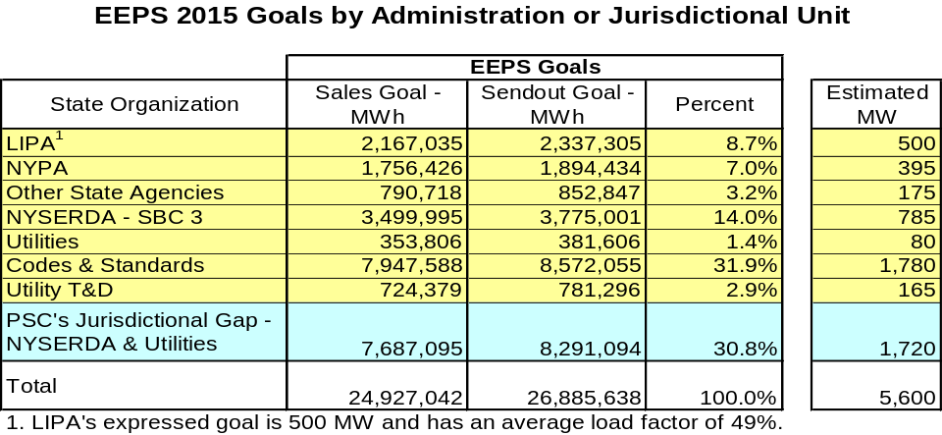
Note: LIPA’s expressed goal is 500 MW and has an average load factor of 49%
The NYISO conducted discussions with all major parties to the EEPS order. The NYISO also reviewed the following studies, reports, and forecasts:
- The EEPS order itself
- American Counsel for Energy Efficient Economy (ACEEE) analyses used to derive the impacts of Codes and Standards
- The 2008 Energy Information Administration Long Term Annual Outlook forecast for the Mid-Atlantic states
- The 2007 Federal legislation on energy efficiency codes & standards
- NYSERDA's impact evaluation reports and annual reports
- The NYSERDA-sponsored 2003 Optimal study of statewide technical conservation potential.
The purpose of the review was to perform an assessment of the degree to which the impacts of the EEPS should be considered sufficiently reliable for inclusion in the 2009 RNA Base Case. As part of this assessment, the NYISO compared its estimates of energy efficiency codes and standards to those of the EIA and ACEEE. The NYISO reported to the Electric System Planning Working group its conclusion that the EIA estimates were more reliable than those of ACEEE.
To obtain a quantitative basis for inclusion of the EEPS goal in the 2009 RNA, the NYISO developed confidence factors and realization rates that were applied to the individual segments of the EEPS order. These are summarized in the table below.
Table B-7: Confidence Factors and Realization Rates
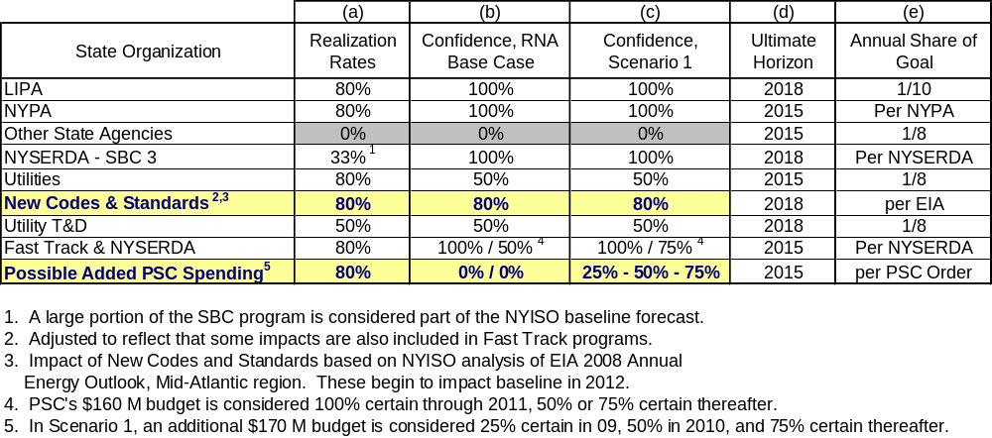
Finally, the NYISO used NYSPSC-approved levels of annual spending to construct a schedule of annual energy savings specific to each element of the EEPS goal. The result was the development of a projection of annual and cumulative EEPS impacts that could be applied zone-by-zone to the NYISO's 2008 econometric forecast. The annual conservation impacts for each element of the EEPS order are shown in the table below.
Two additional scenarios were constructed that assumed higher levels of conservation impacts than in the NYISO's Base Case forecast.

Table B-8: Base Case – Achievement Based on $160M/yr Through 2015
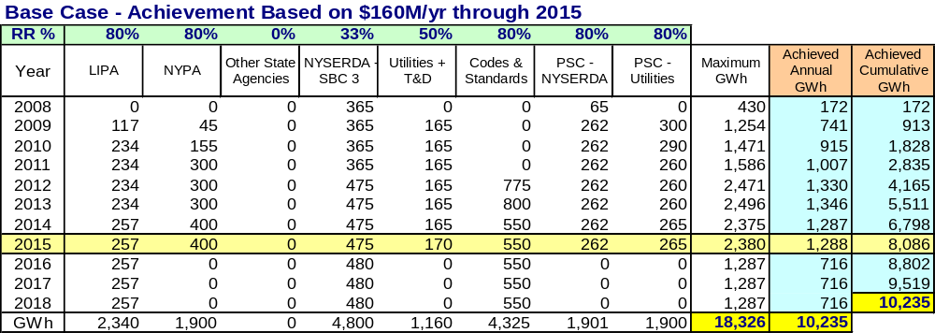

Table B-9: Zonal Energy Forecast Growth Rates - 2008 to 2018

Annual GWh | 2008 | 2009 | 2010 | 2011 | 2012 | 2013 | 2014 | 2015 | 2016 | 2017 | 2018
2007 Econometric | 167,440 | 169,470 | 171,744 | 174,032 | 176,615 | 178,759 | 181,126 | 183,544 | 186,256 | 188,728
2008 Econometric | 166,849 | 169,040 | 171,575 | 173,788 | 176,091 | 178,669 | 181,597 | 184,262 | 187,052 | 188,801 | 190,662
2009 RNA Base Case | 166,677 | 168,127 | 169,747 | 170,953 | 171,926 | 173,158 | 174,799 | 176,176 | 178,250 | 179,283 | 180,427
Scenario 1 | 166,677 | 167,977 | 169,399 | 170,263 | 170,485 | 170,965 | 171,857 | 172,485 | 174,559 | 175,592 | 176,736
Scenario 2 | 166,241 | 166,389 | 165,923 | 164,929 | 162,772 | 160,712 | 159,182 | 157,382 | 159,808 | 161,466 | 163,326
EEPS Energy Impacts
Cumulative GWh | 2008 | 2009 | 2010 | 2011 | 2012 | 2013 | 2014 | 2015 | 2016 | 2017 | 2018
2009 RNA Base Case | 172 | 913 | 1,828 | 2,835 | 4,165 | 5,511 | 6,798 | 8,086 | 8,802 | 9,519 | 10,235
Scenario 1 | 172 | 1,063 | 2,176 | 3,525 | 5,606 | 7,704 | 9,740 | 11,777 | 12,493 | 13,209 | 13,926
Scenario 2 | 608 | 2,651 | 5,652 | 8,859 | 13,319 | 17,957 | 22,414 | 26,880 | 27,244 | 27,335 | 27,335
Annual MW | 2008 | 2009 | 2010 | 2011 | 2012 | 2013 | 2014 | 2015 | 2016 | 2017 | 2018
2007 Econometric | 33,871 | 34,300 | 34,734 | 35,141 | 35,566 | 35,962 | 36,366 | 36,749 | 37,141 | 37,631
2008 Econometric | 33,827 | 34,247 | 34,649 | 35,053 | 35,452 | 35,870 | 36,317 | 36,708 | 37,086 | 37,407 | 37,784
2009 RNA Base Case | 33,792 | 34,059 | 34,269 | 34,462 | 34,586 | 34,725 | 34,905 | 35,029 | 35,258 | 35,430 | 35,658
Scenario 1 | 33,792 | 34,029 | 34,199 | 34,324 | 34,298 | 34,288 | 34,320 | 34,298 | 34,526 | 34,698 | 34,926
Scenario 2 | 33,703 | 33,704 | 33,489 | 33,234 | 32,722 | 32,197 | 31,739 | 31,227 | 31,530 | 31,833 | 32,209
EEPS Demand Impacts
Cumulative MW | 2008 | 2009 | 2010 | 2011 | 2012 | 2013 | 2014 | 2015 | 2016 | 2017 | 2018
2009 RNA Base Case | 35 | 188 | 379 | 590 | 867 | 1,145 | 1,412 | 1,678 | 1,828 | 1,977 | 2,126
Scenario 1 | 35 | 218 | 449 | 729 | 1,155 | 1,582 | 1,997 | 2,410 | 2,560 | 2,709 | 2,858
Scenario 2 | 124 | 543 | 1,160 | 1,819 | 2,730 | 3,674 | 4,579 | 5,481 | 5,556 | 5,575 | 5,575

Appendix C: Transmission System Assessment
A key element underlying the determination of reliability needs is an assessment to determine if the transmission system meets reliability criteria, and to establish the transfer limits to be used in the Multi-Area Reliability Simulation (MARS) model. This assessment is conducted through a series of power flow, stability and short circuit studies.
In general, the RNA analyses indicated that the bulk power transmission system can be secured, but that transfer limits for certain key interfaces must be reduced in order to respect voltage collapse criteria. However, a reduction in transfer limits or a limiting interface can result in higher LOLE findings and/or needs occurring earlier than they otherwise would. As a result, LOLE analysis was conducted for the RNA Base Case, a case with thermal limits, and finally a case with no internal NYCA transmission limits. These cases were conducted to demonstrate the impact that transmission limits have on the LOLE results.
C.1 Development of RNA Base Case System Cases
Table C.1 below summarizes the Area load plus losses.
Table C.1: Area Load plus Losses (MW)

 | 2009 | 2010 | 2011 | 2012 | 2013
LOAD+LOSSES MW
WEST | 2657 | 2666 | 2674 | 2678 | 2690
GENESSEE | 1941 | 1949 | 1947 | 1948 | 1959
CENTRAL | 2873 | 2873 | 2884 | 2884 | 2896
NORTH | 826 | 847 | 853 | 853 | 856
MOHAWK | 1392 | 1394 | 1401 | 1404 | 1410
CAPITAL | 2306 | 2301 | 2300 | 2318 | 2335
HUDSON | 2358 | 2375 | 2401 | 2409 | 2427
MILLWOOD | 646 | 650 | 661 | 659 | 669
DUNWOODIE | 1565 | 1576 | 1581 | 1597 | 1613
NYC | 12073 | 12166 | 12265 | 12402 | 12547
L ISLAND | 5385 | 5395 | 5403 | 5403 | 5377
 | 34022 | 34192 | 34368 | 34555 | 34781
Table C.2 below summarizes the Area generation dispatched for the RNA Base Case system.
Table C.2: Generation Dispatched (MW)

 | 2009 | 2010 | 2011 | 2012 | 2013
GEN DISP MW
WEST | 5002 | 5036 | 5036 | 5037 | 5036
GENESSEE | 667 | 689 | 689 | 689 | 689
CENTRAL | 5803 | 5845 | 5845 | 5923 | 5923
NORTH | 1223 | 1236 | 1236 | 1237 | 1236
MOHAWK | 605 | 643 | 643 | 642 | 642
CAPITAL | 3163 | 3481 | 3481 | 3467 | 3466
HUDSON | 3026 | 2802 | 2917 | 2918 | 2918
MILLWOOD | 2110 | 2169 | 2169 | 2169 | 2169
DUNWOODIE | 0 | 3 | 3 | 3 | 3
NYC | 7292 | 7302 | 7302 | 7477 | 7477
L ISLAND | 3757 | 3832 | 3832 | 3926 | 3927
 | 32648 | 33038 | 33154 | 33486 | 33486

C.2 Emergency Thermal Transfer Limit Analysis
The NYISO performed an analysis of RNA Base Case emergency thermal transfer limits for the key interfaces used in the MARS Resource Adequacy analysis. The definitions of the transmission interfaces are described in Appendix 5.1.
Table C.3 illustrates the emergency thermal transfer limits for the RNA base base system conditions:
Table C.3: Emergency Thermal Transfer Limits

 | 2010 |  | 2011 |  | 2012 |  | 2013
Dysinger East | 3025 | 1 | 3050 | 1 | 2925 | 1 | 3075 | 1
West Central | 1800 | 1 | 1825 | 1 | 1800 | 1 | 1825 | 1
Moses South | 2675 | 7 | 2675 | 7 | 2675 | 7 | 2675 | 7
Volney East | 4400 | 2 | 4400 | 2 | 4425 | 2 | 4375 | 2
Total East | 6500 | 2 | 6500 | 2 | 6550 | 2 | 6625 | 2
Central East | 2675 | 3 | 2675 | 3 | 2700 | 3 | 2700 | 3
Central East+Fras-gilb | 3075 | 3 | 3075 | 2 | 3075 | 2 | 3075 | 2
CE Group | 5175 | 3 | 5150 | 2 | 5175 | 2 | 5150 | 2
F to G | 3425 | 4 | 3475 | 4 | 3475 | 4 | 3450 | 4
UPNY-SENY Open | 5150 | 4 | 5150 | 4 | 5150 | 4 | 5150 | 4
UPNY-ConEd Open | 6300 | 5 | 6300 | 5 | 6325 | 5 | 6350 | 5
Millwood South Closed | 9525 | 8 | 9550 | 8 | 9550 | 8 | 9850 | 8
Dunwoodie-South Plan | 5215 | 9 | 5690 | 6 | 5690 | 6 | 5725 | 6
I to J | 4200 | 9 | 4400 | 6 | 4400 | 6 | 4400 | 6
LI Import | 2090 | 10 | 2090 | 10 | 2090 | 10 | 2090 | 10

 | Limiting Facility | Limiting Rating | Contingency
1 | Stolle-Meyer 230 kV | 1685 | Pre-disturbance
2 | Coopers Corners-Fraser 345 kV | 1207 | Pre-disturbance
3 | New Scotland-Leeds 345 kV | 1724 | L/O New Scotland-Leeds 345 kV
4 | Pleasant Valley-Leeds 345 kV | 1725 | L/O Athens-Pleasant Valley 345 kV
5 | MiddletownTap-Coopers Corners 345 kV | 1793 | L/O RockTavern- Coopers Corners 345 kV
6 | Dunwoodie- Mott Haven 345 kV | 795 | Pre-disturbance
7 | Moses-Adirondack 230 kV | 440 | L/O Massena-Marcy & Massena-Chateaguay 765 kV
8 | Roseton-Fishkill 345 kV | 1936 | Pre-disturbance
9 | Rainey-Mott_H 345 kV | 1196 | L/O Rainey-Mott_H 345 kV
10 | Dunwoodie-Shore Rd 345 kV | 653 | Pre-disturbance

The variations in through-time transfer limits are due to the differences in generation dispatch and other factors.
C.3 Emergency Voltage Transfer Limit Analysis
RNA Base Case system voltage analysis was performed with PSS/E automated using Power-Voltage (PV) analysis for fast screening. Based on findings from this review, a more detailed analysis was performed for key transmission interfaces in order to more accurately represent generation contingencies and perform more detailed analysis of specific transfer cases.
Table C.4 illustrates the initial RNA Base Case system voltage analysis. Appendix 5.3 illustrates the pre-disturbance and post-contingency voltage as a function of transfers.
Table C.4: Emergency Voltage Transfer Limits
 | 2010 |  | 2011 |  | 2012 |  | 2013
Dysinger East | 2600 | 1 | 2600 | 1 | 2600 | 1 | 2550 | 1
West Cent | 1725 | 1 | 1700 | 1 | 1650 | 1 | 1425 | 1
Moses South | 2000 | 2 | 2000 | 2 | 2000 | 2 | 2000 | 2
Volney East | 3500 | 3 | 3500 | 3 | 3750 | 3 | 3750 | 3
Total East | 6675 | 4 | 6575 | 4 | 6550 | 4 | 6425 | 4
Central East | 2850 | 4 | 2600 | 4 | 2825 | 4 | 2800 | 4
Cent East+Fras-gilb | 3050 | 4 | 3050 | 4 | 3050 | 4 | 3050 | 4
CE Group | 4550 | 4 | 4550 | 4 | 4550 | 4 | 4525 | 4
F to G | 3750 | 5 | 3525 | 5 | 3650 | 5 | 3800 | 5
UPNY-SENY Open | 6150 | 5 | 6150 | 5 | 6150 | 5 | 6150 | 5
UPNY-ConEd Open | 5300 | 7 | 5500 | 7 | 5500 | 7 | 5500 | 7
Millwood South Closed | 8450 | 8 | 8450 | 7 | 8450 | 7 | 8450 | 7
I to J + K | 5290 | 8 | 5365 | 8 | 5365 | 8 | 5365 | 8

 | Limiting Facility | Limiting Voltage (kV) | Contingency
1 | Rochester 345 | 328 | L/O Somerset-Rochester 345
2 | Porter 230 | 218 | L/O Marcy-New Scotland 345
3 | Edic 345 | 328 | L/O 9 Mile Point #2
4 | New Scotland 345 | 328 | New Scotland 77 Bus Fault
5 | Pleasant Valley 345 | 328 | L/O Leeds-Pleasant Valley 345
6 | Pleasant Valley 345 | 328 | L/O Millstone #3
7 | Sprain Brook 345 | 328 | L/O Tower 67/68 at Ladentown
8 | Sprain Brook 345 | 328 | L/O W89/W90 Tower at Pleasantville
9 | Voltage Collapse Limit |  | L/O Ravenswood 3

C.4 Development of the MARS Topology
As described earlier, the MARS model was used to determine the NYCA and zonal LOLEs. A key input into the MARS modeling process is the transmission network topology. The starting point for the CRPP is the most recently approved New York State Reliability Council installed reserve margin study topology. Figure 1 below is the most recently approved topology, which is the one that was used for the study entitled: “NEW YORK CONTROL AREA INSTALLED CAPACITY REQUIREMENTS FOR THE PERIOD MAY 2008 THROUGH APRIL 2009”. This topology was the starting point for the RNA but was modified as dictated by assessment of future transmission system conditions, as discussed herein.

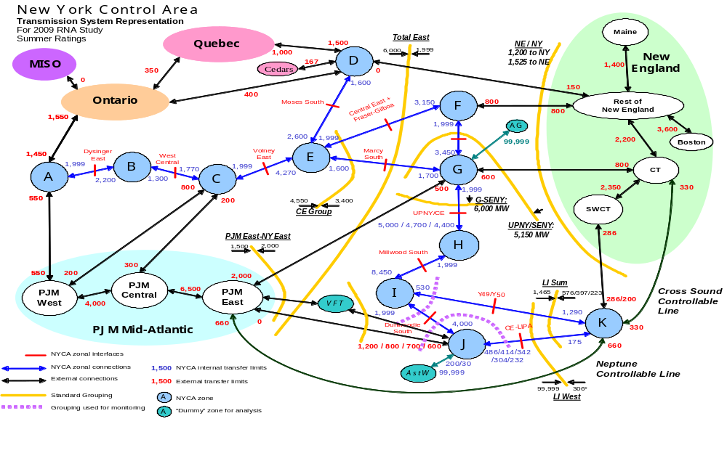
Figure C-1: 2009 RNA MARS Topology

C.5 Short Circuit Assessment
A short circuit analysis was performed using ASPEN OneLiner (Advanced Systems for Power Engineering) to determine the impact of the maximum generation on the bulk power system. The NYISO “Guideline for Fault Current Assessment” was used. Three-phase, single-phase and line-line-ground short-circuit currents were determined for approximately 150 bulk power substations across the NYCA.

Appendix D: Environmental Scenarios
All generators must plan to comply with an increasingly complex and uncertain set of Federal and State environmental regulations. These regulations impact the duration and outcome of permitting processes, the operation of existing plants, and decisions to modify or retire plants. The potential impacts of two of the more significant initiatives in environmental regulation will be analyzed for their respective potential impacts on electric system reliability.
Following the invalidation of the United States Environmental Protection Agency’s (USEPA) Clean Air Interstate Rule (CAIR) by the federal courts, great uncertainty surrounds the direction and timing of the combined Federal and State initiatives to control power plant emissions of nitrogen oxides (NOx) for the purpose of achieving compliance with National Ambient Air Quality Standards (NAAQS) for ozone. Notwithstanding this uncertainty, it is reasonable to expect some emission limitation requirements will emerge from the regulatory process. Accordingly, the NYISO examined the potential impacts on reliability from possible NOx emission limitations over the Study Period.
New York recently promulgated rules to implement the Regional Greenhouse Gas Initiative (RGGI). The RGGI program places a cap on the total emissions of carbon dioxide (CO2) from affected power plants in the ten member states. Starting in 2015, the cap is reduced by 2.5 percent annually from 2015 through 2018. RGGI will effectively make affected fossil fueled units energy limited units for reliability purposes, to the extent that those units will be limited in their operations to the number of RGGI allowances they are able to obtain. The RGGI program is seen as prototype for an increasingly-likely Federal program to limit emissions of carbon dioxide (CO2) from power plants. There appears to be a developing consensus about the regulatory approach to CO2 control, and legislation is likely to be enacted by Congress during the next administration.
The purpose of these analyses is to determine to what extent the potential impact on reliability can be quantified. This information is intended to assist in developing compliance strategies that achieve the goals of these environmental initiatives while maintaining bulk power system reliability.
D.1 NOx Reduction Initiatives, CAIR, HEDD, and RACT
The analysis below makes clear that the path to satisfactory air quality will require significant NOx emission reductions from sectors other than New York generators, will need to recognize the limited set of feasible emission control technologies available for some generators, and plan to make equivalent replacement resources available in congested areas.
Ground level ozone is the product of hydrocarbons (HC) and NOx emissions, and sunlight. Fossil-powered generating stations are the fourth largest source of NOx emission in New York behind area sources, non-road sources and on road mobile sources.
. New York State has not achieved compliance with the NAAQS for ozone. The State of New York is required to comply with the National Ambient Air Quality Standards (NAAQS) for criteria pollutants, including ozone that was established by the U.S. Environmental Protection Agency (EPA) pursuant to the Federal Clean Air Act. On March 12, 2008, the EPA promulgated a new lower standard for ozone. The new standard is 75 ppb, which is below the current standard of 84 ppb. There are a number of regulatory and court challenges underway to lower the standard further to 70 ppb.
New York’s State Implementation Plan (SIP) to achieve compliance with NAAQS was submitted to EPA in August 2007 and is currently under review. The SIP has three design elements. First, the SIP depends upon both in state and upwind reductions to be achieved under CAIR program, which calls for using two allowances for each ton emitted. Second, the New York SIP also commits to achieve an additional reduction in NOx emissions of approximately 50 tons/day on High Electric Demand Days (HEDD) as part of the Ozone Transport Commission (OTC) process agreed to last year. DEC has informed the NYISO that these NOx emission reductions are goals that the OTC states will try to achieve. DEC has also indicated that these commitments are not legally binding upon any state. In the August 31, 2007 State Implementation Plan (SIP) submittal, DEC’s Department of Air Resources stated that it would establish appropriate operating parameters and emission controls for HEDD units. No estimates of the level of the resulting NOx emission reductions were cited in the SIP submittal. Third, NYSDEC has recently begun the process of revising Reasonably Available Control Technology Standards for NOx (NOx RACT) regulations to further reduce emissions of NOx from fossil fuel fired boilers.
On July 11, 2008, the United States Circuit Court of Appeals for the District of Columbia vacated the USEPA’s Clear Air Interstate Rule (CAIR). CAIR had been promulgated in 2005 as a regulatory mechanism to bring large portions of the Eastern US into compliance with National Ambient Air Quality Standards (NAAQS) for ozone and particulate matter (PM 2.5).
Thus, New York finds itself in need of a new plan to meet emission requirements, as the obligation to meet NAAQS is paramount. Although New York has stringent emission limitations and the State Implementation Plan (SIP) calls for significant additional in state emission reductions, it can not achieve compliance with NAAQS without upwind states also making significant emission reductions. Consequently, a regional plan such as CAIR will be a necessary component of New York’s new SIP.
It is reasonable to evaluate the potential impact of significant new NOx emission limitations on the bulk power system. The 2007 RNA analyzed the potential impact of the OTC-HEDD program on the targeted plants for the “design day” and determined that proposed program would lead to exceedances of reliability criteria. This year the analysis review the impact of the OTC-HEDD emission reductions on targeted units for all high ozone days during the period 2005 to 2007. In addition, potential impacts of DEC’s preliminary proposal to update NOx RACT standards for all units will also be examined.
A review of recent generation and air quality data should aid in the understanding of the nature of possible reduction requirements. According to DEC data, throughout the period of 2005-2007 there have been a total of 49 days when New York’s air quality did not meet the existing NAAQS for ozone of 84 ppb. With the new standard of 75 ppb in place, it is reasonable to expect that additional exceedances would have been recorded with the current level of emissions. On these days of high ozone levels, NYCA generation levels varied from a minimum of 387 GWHrs to a maximum of 679 GWHrs. According to EPA data, NYCA NOx emissions varied from a minimum of 93 tons to a maximum of 439 tons. While the data shows a strong correlation between NYCA generation and NYCA NOx emissions, Figure D-1, the correlation between NYCA NOx emissions and ambient ozone concentrations is much weaker, Figure D-2. Following this correlation to its limit, we note that operating NYCA in a zero emissions mode (which is not possible) would still find exceedances of the standard. It should be apparent that fossil generation is not the only contributing source to poor air quality and the problem can only be solved on a regional basis. Thus the first assumption for the analysis is that some form of regulation effectively similar to CAIR will be in place by 2012.
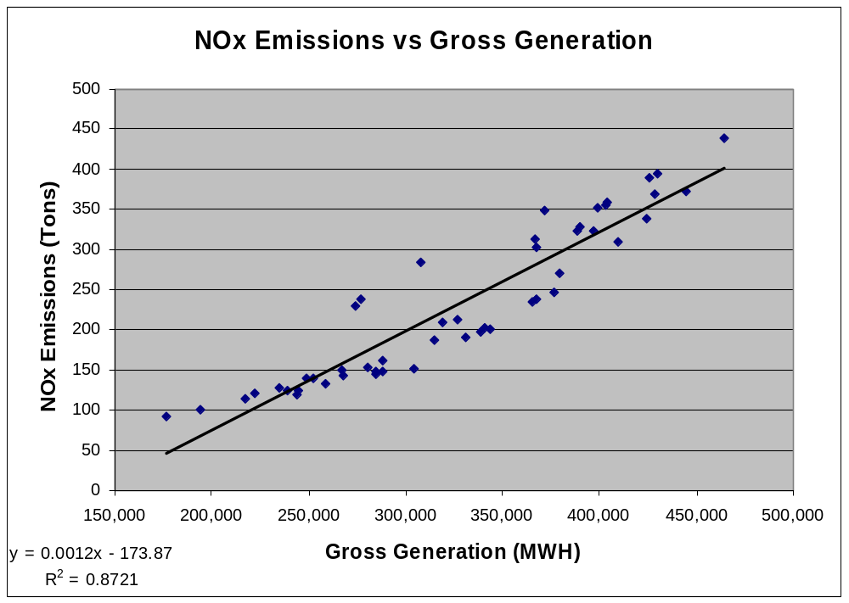
Figure D-1: NOx Emissions vs Gross Generation
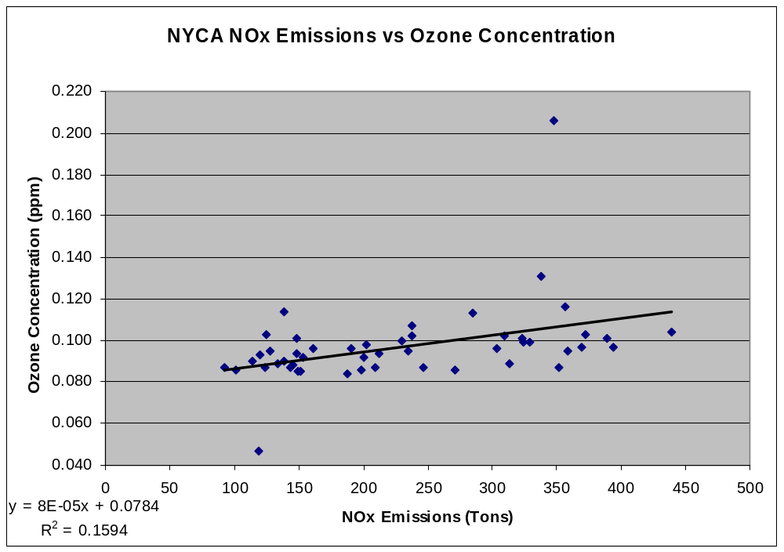
Figure D-2: NYCA NOx Emissions vs Ozone Concentration
The NYISO analyzed the same dataset to determine the potential impact of the OTC HEDD program. The analysis was conducted in two parts, looking first at the High Emitting Combustion Turbines (HECT), and then at the Load Following Boilers (LFB). The complete OTC HEDD analysis is the sum of the two analyses. The HECTs, have provided 2,816 MW of capacity in New York. The NYISO determined that production on high ozone days varies from a minimum of 0.2 GWHrs to a maximum of 35 GWHrs. Reported emissions varied from zero to a maximum of 136 tons of NOx.
The Environmental Energy Alliance (EEA), in speaking for many of the owners of the identified HEDD units, has advised the NYISO that the proposed technology retrofits are not economically feasible. Therefore, the preliminary analysis of the effects of HEDD on reliability was approximated by making a pro rata reduction of DMNC for the Summer Capability Period for units identified by the OTC and DEC as HEDD units based on the targeted reduction for each unit called upon on that day. As a first approximation for the analysis, the following assumptions were made:
The HEDD units will operate for the same number of hours as they did on each of the high ozone days (Scenario 1 and 2)
The HEDD units will operate at a capacity equivalent to its
DMNC *(1-(OTC RACT %)) (Scenario 3).

NOx Emission Rates are assumed to be equal to the reported emission rate. The equivalent capacity reduction required varied from a minimum of zero to a maximum of 1,231 MW, with 610 MW of the derating occurring in load pockets. NOx emission reductions varied from zero to 28 tons. The results of the analysis are given in Table D.1 and show that resource adequacy criteria will be violated at the end of the planning period. This analysis shows a reduction in the magnitude of the LOLEs compared to last year that is a result of the increased use of SCR resources. The analysis shows that these SCR resources will be called upon significantly more than current practice. Given that the owners of these units have indicated that technology retrofits are not economically feasible, programs designed to reduce NOx emissions from the HECT units will require at a minimum, equivalent capacity replacement, to maintain resource adequacy.
A similar analysis is focused on the Load Following Boilers (LFB) identified in the OTC HEDD program. The LFBs have provided 4,051 MW of capacity. The equivalent capacity reduction required varied from a minimum of 1,704 MW to a maximum of 1,739 MW, with 165 MW of the derating occurring in load pockets. NOx emission reductions varied from 10 tons to 75 tons. The results of the analysis are given in Table D.2 and show that resource adequacy criteria will be violated at the end of the planning period. This analysis shows a reduction in the magnitude of the LOLEs compared to last year which is a result of the increased use of SCR resources. The analysis shows that these SCR resources will be called upon significantly more than current practice.
NYSDEC has started the review process for updating Reasonably Available Control Technology Standards for all fossil generating units with the exception of the most recent additions. This proposal could affect approximately 25,000 MW of capacity in New York. For this scenario, it is assumed that 75% of the capacity can be retrofitted to achieve the required emission reductions, and the remaining 25% of the effected capacity can only achieve 50% of the required reduction. The remaining required NOx emission reduction was assumed to be achieved through limitations on output of the units, resulting in an effective capacity derating of 3,125 MW. DEC’s thought process assumes that 50% of units subject to the proposed NOx RACT limits can comply and the remainder can achieve approximately one half of the required reduction. This analysis is based on a higher level of success for technology retrofits that results in a lesser need to limit capacity while still demonstrating LOLEs.0.1. For purposes of this analysis, the derating was assumed to be distributed evenly across all capacity. Resource adequacy criteria were exceeded across the planning period (See Table D.3).

Table D-1 LOLE for RNA Base Case Environmental Retirement Scenario RNA Base Case Load Forecast Scenario 1: OTC – HEDD HECTs

Table D-2 LOLE for RNA Base Case Environmental Retirement Scenario RNA Base Case Load Forecast Scenario 2: OTC - HEDD LFBs

Table D.3 LOLE for RNA Base Case Environmental Retirement Scenario RNA Base Case Load Forecast Scenario 3: DEC New NOx RACT

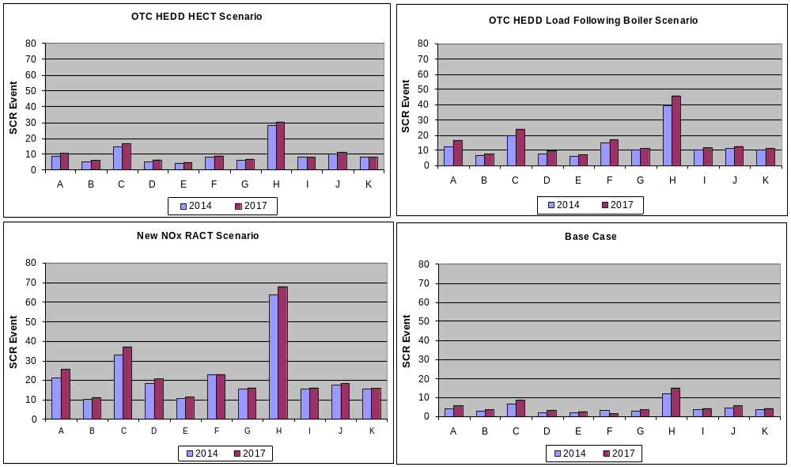

Several observations can be made based upon the NYISO’s analysis of these scenarios. First, New York’s plan to achieve improvements in air quality will need to be regional in nature because New York cannot achieve the NAAQS standards by implementing it SIP without upwind states being part of the solution to improve air quality. Second, although emission technology retrofits can accomplish a great deal, they are not universally applicable. For certain units that are relied upon for peaking capacity to maintain bulk power system reliability, the owners have indicated that emission technology additions are not economic. Accordingly, efforts to curb emission from those units on High Electric Demand Days will need to proceed in phases to provide for equivalent capacity replacement in load pockets.
D.2 CO2 or Regional Greenhouse Gas Initiative (“RGGI”)
As the analysis below demonstrates, if the new RGGI Allowance market operates under unremarkable circumstances, bulk power system reliability will not be negatively impacted in the near term. If on the other hand, market disruptions occur or the RGGI market is allowed to converge with the world CO2 allowance markets undesirable outcomes will quickly occur. Convergence with world markets would lead to Allowance prices in the range of $35 to $50/ton and the likely exit from the marketplace of the coal capacity in New York which may place significant strain on other resources.
The recently promulgated RGGI rules implement a regional program through which 10 states have agreed to cap CO2 emissions from power plants larger than 25 MW of capacity beginning in 2009. RGGI will require most affected generators to purchase emission allowances. RGGI, Inc. will distribute these allowances initially through an auction process that is open to affected generators and others that wish to participate in the allowance market. Once purchased at auction, allowances will be tradable. Under RGGI, generators will need one allowance to emit one ton of CO2. During the 2015-2018 period the carbon emissions cap for each state will be reduced by 2.5% annually. RGGI, Inc.’s published reports of CO2 emissions from affected generators for 2005 show that New York’s carbon emissions were near the cap level of 64 million tons. RGGI, Inc. reports for the year 2006 show that emissions from New York generators are below the state’s cap, at approximately 53.6 million tons/year. In 2007, 53% of the energy generated in the NYCA was produced using fossil fuels, which represents an increase from 2006. Thus when emissions are finally reported, it is expected that CO2 emissions will have increased in 2007. More than 99% of the fossil-fuel generated energy came from units for which carbon emissions will be controlled under RGGI in 2009.
RGGI, Inc. conducted the first carbon allowance auction on September 25. A total of 12,565,387 CO2 Allowances were sold in portfolios from the States of Connecticut, Massachusetts, Maryland, Maine, Rhode Island, and Vermont. This auction represents 6.7% of 2009 allowances as shown in Table D-4. The reported clearing price for the auction was $3.07/ allowance. Potomac Economics has been retained by RGGI, Inc. as a market monitor for the auction. Potomac’s review of the auction concluded in part that “The auction was administered in a fair and transparent manner…” No allowances with later vintages were offered in the first auction.

Table D-4: September 25, 2008 RGGI Auction

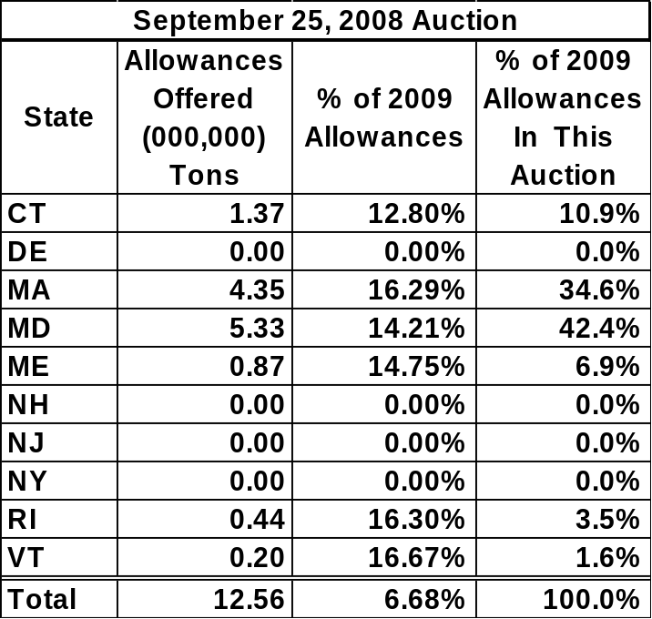

RGGI, Inc. has announced the second auction is scheduled for December 17, 2008 where it is planned that all ten States will participate by offering portfolios 31,505,898 allowances. This amount represents 16.7% of the total 2009 Allowances, as shown in Table D-5.

Table D-5: December 17, 2008 RGGI Auction

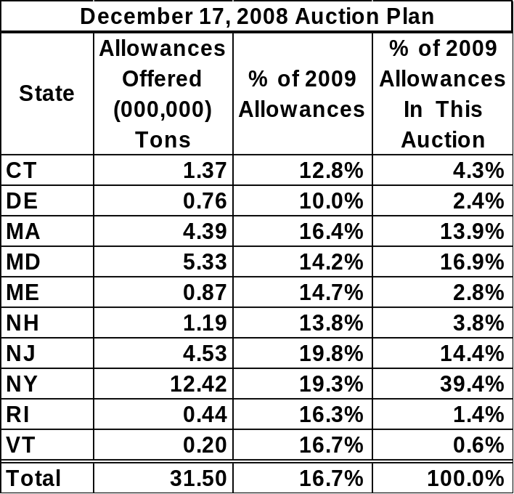

The balance of allowances remaining to be auctioned are planned to be distributed through four auctions in 2009.
Previous RNAs examined the impact on resource adequacy of the hypothetical retirement of varying amounts of coal fired capacity in New York State. It was determined that the LOLE criterion was violated when approximately one half of the coal fired capacity was removed from service. All RGGI-affected generators in New York will require allowances to comply with this program. Several situations can be postulated that can result in an insufficient supply of allowances after accounting for fuel switching, offsets, and efficiency improvements. For example, a loss of a major nuclear unit would translate into a need for an additional 11.4 million tons per year of CO₂ allowances. It is also possible that non-RGGI-affected entities could remove significant quantities of allowances from the New York markets for other purposes.
Two issues arise with respect to RGGI that may affect bulk power system reliability in New York. First, the convergence of CO2 emission allowance prices with world market prices may create carbon emission costs that would render units uneconomic, leading to otherwise unexpected retirements. Second, carbon emission costs could cause coal-fired units to become generators that are on the margin in the energy markets. Coal-fired units have traditionally been operated and bid into the markets as baseload units. This treatment results from the long start-up and shut-down periods for coal-fired units. Should coal-fired units become marginal units, they could be forced to cycle in and out of service. Such circumstances could cause units to endure atypical wear and tear, or to avoid that, make themselves unavailable for operation during peak times when they were formerly at the base of the production stack. The NYISO will monitor the behavior of coal-fired units in New York to determine if this phenomenon arises, and if it does, will engage its stakeholders on how to address it.

If the RGGI Allowance system is constrained to the need of RGGI affected generators only and there are no disruptions to the allowance market and related energy markets, marginal production would shift to units with lower carbon emissions. In such circumstances, there would be no significant impact on reliability. If the RGGI Allowance system is allowed to merge with other regional climate initiatives where the demand for allowances out strips the supply, significant allowance price increases would likely result as well as significant shifts in operating mode of the higher emitters. The Western Climate Initiative (WCI) represents the largest and most developed regional initiative. Figure D-3 below prepared by PointCarbon depicts the relative magnitude of the RGGI program as compared to the WCI or a possible US program.

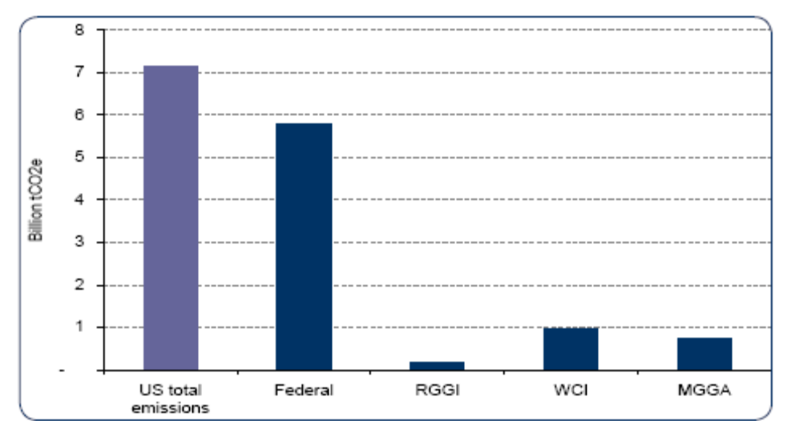
Figure D-3: RGGI program vs. WCI and US program

The WCI estimates CO₂ allowance prices to range between $24/ton up to $71/ton in 2020 largely dependent upon the final decisions on the use of offsets. One of the primary sources of such offsets for WCI is the RGGI system. A merger of these systems will most likely lead to a price convergence. Beyond convergence with the WCI, consideration should also be given to convergence with the European CO2 Allowance market. Throughout 2008 European Union allowances have traded in the range of $35 to $50/ton as shown in Figure D-4.

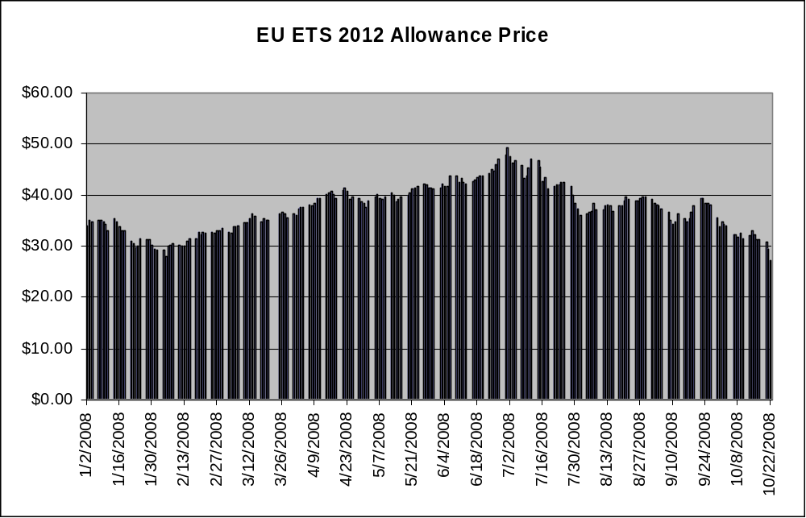
Figure D-4: EU ETS 2012 Allowance Price

Further development of renewable resources and energy efficiency programs can, depending on their location, reduce the minimum number of allowances necessary to meet electric resource requirements in New York. New York State, in its Renewable Portfolio Standard (RPS), has established a target for the purchase of Renewable Energy Credits (RECs) associated with sufficient additional energy intended to increase New York’s proportion of energy produced from renewable resources to 25% by 2013. The NYISO evaluated the impact of this target on the estimated CO₂ emissions. That is, the NYISO examined the amount of CO₂ emissions savings from renewable resources that would offset the need for carbon allowances that would otherwise be necessary to operate fossil fuel generators needed to meet the reliability criteria. The NYISO also evaluated whether these additional resources moved the year of need for new capacity. That analysis indicates that the addition of 610 MW of renewable capacity will reduce CO2 emissions by 3.5 million tons in New York, as depicted in Figure D-5 below. These RPS resources would reduce the minimum tons of CO2 necessary to maintain an acceptable LOLE by a comparable amount in 2010.
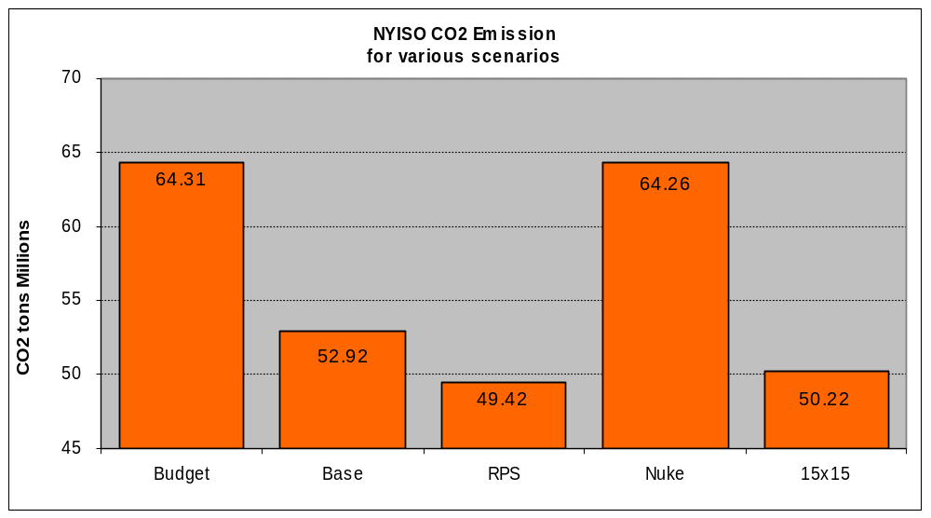

Figure D-5: NYISO CO2 Emissions

The Base Case and the rest of the scenarios use a probabilistic representation for weather. This scenario forces the model to ignore normal and below normal weather conditions and to instead analyze reliability based upon only extreme weather conditions.
If it will not be an annual process from here on, perhaps a footnote here to that effect is in order
The first CRP was entitled the “2005 Comprehensive Reliability Plan,” while the second CRP, released the following year, was entitled the “2007 Comprehensive Reliability Plan.” A year was skipped in the naming convention because the title of the first CRP, which covered the Study Period 2006-2015, designated the year the study assumptions were derived, or 2005, but for the second CRP a different year designation convention was adopted, which identified the first year of the 2007-2016 Study Period. The latter naming convention will continue to be applied to subsequent CRPP documents.
The procedures for reviewing alternative regulated solutions for a reliability need are currently being discussed in NYPSC Case 07-E-1507.
The first CRP was entitled the “2005 Comprehensive Reliability Plan,” while the second CRP, released the following year, was entitled the “2007 Comprehensive Reliability Plan.” A year was skipped in the naming convention because the title of the first CRP, which covered the Study Period 2006-2015, designated the year the study assumptions were derived, or 2005, but for the second CRP a different year designation convention was adopted, which identified the first year of the 2007-2016 Study Period. The latter naming convention will continue to be applied to subsequent CRPP documents.
It should be noted that the LOLE results presented for each load zone are determined based on the assumption that load in a particular load Zone has “first rights” to that capacity in that load Zone even though that capacity could be contractually obligated to load in another load Zone or area. General Electric’s Multi-Area Reliability Simulations (MARS) logic prorates capacity among zones if more than one zone is capacity deficient.
NOTE: Should explain how got to the 30% with the existing funding levels.
The PSC has authorized the collection of $160 million annually. The June 23rd Order also called for the expenditure of an additional $170 million annually through 2011, for a total of $330 million annually during that period.
Because such capacity is not under long term contract to New York, it is not included in the base case for the Study Period.
The Base Case and the rest of the scenarios use a probabilistic representation for weather. This scenario forces the model to ignore normal and below normal weather conditions and to instead analyze reliability based upon only extreme weather conditions.
The 2009 RNA Base Case assumed no new generation resources in Zone J throughout the Study Period.
The 2008 RNA MARS limits were derived from IRM base case.
Id.
Emissions levels are affected by: (i) the cost differential between oil and gas with the cost of gas below the cost of oil in 2006; and (ii) moderate weather conditions.
This is equivalent to the tons of CO2 emitted by generators sufficient to replace the annual production of a nuclear power plant – 9,000,000 MWh.

