2010 Reliability Needs Assessment

Redline against 6/24 pdf

DRAFT 2 Report

Rev.
7
June 25, 2010

Caution and Disclaimer
The contents of these materials are for information purposes and are provided “as is” without representation or warranty of any kind, including without limitation, accuracy, completeness or fitness for any particular purposes. The New York Independent System Operator assumes no responsibility to the reader or any other party for the consequences of any errors or omissions. The NYISO may revise these materials at any time in its sole discretion without notice to the reader.

Table of Contents
Executive Summary i
1. Introduction 1-1
2. Summary of Prior CRPs 2-1
3. RNA Base Case Assumptions, Drivers and Methodology 3-1
3.1. Impact of Energy Efficiency Programs on the Load Forecast 3-2
3.2. Forecast of Special Case Resources 3-5
3.3. Resource Additions 3-5
3.4. TO Firm Plans 3-5
3.5. Resource Retirements 3-8
3.6. Base Case Load and Resource Margins 3-8
3.7. Methodology for the Determination of Needs 3-10
4. Reliability Needs Assessment 4-1
4.1. Overview 4-1
4.2. Reliability Needs for Base Case 4-1
4.3. Scenarios 4-6
5. Other Areas of Interest 5-1
5.1. Environmental Regulations 5-1
5.2. Wind Impact 5-10
6. Observations and Recommendations 6-1
7. Historic Congestion 7-1
Appendices 1
Appendix A – Reliability Needs Assessment Glossary 2
Appendix B- The CSPP’s Reliability Planning Process 3
Appendix C – Load and Energy Forecast 2010-2020 8
Appendix D – Transmission System Assessment 20
Appendix E – Environmental Scenarios 30

Table of Tables

Table of Figures

Executive Summary

Introduction
The Reliability Needs Assessment (RNA), as part of the Comprehensive System Planning Process (CSPP), reports on the NYISO’s assessment of the bulk electric system to identify any Reliability Needs.
This document reports the RNA findings for the Study Period 2011-2020. If the RNA identifies a reliability need in the 10-year Study Period, the NYISO will designate one or more Responsible Transmission Owners (Responsible TOs) who are responsible for the development of a regulated backstop solution to address each identified Reliability Need. In addition, the NYISO will request from any interested party market-based and alternative regulated solutions after the RNA is approved to address the identified need. Solutions must satisfy reliability criteria, including resource adequacy. Nevertheless, the solutions submitted to the NYISO do not have to be in the same amounts or locations used in the RNA to quantify the Reliability Needs. There are various combinations of resources and transmission upgrades that could meet the needs identified in the RNA. The reconfiguration of transmission facilities and/or modifications to operating protocols identified in the solution phase could result in changes and/or modifications of the needs identified in the RNA.
Continued reliability of the bulk power system during the Study Period depends on a combination of additional resources, provided by independent developers in response to market forces and by the electric utility companies who are obligated to provide reliable and adequate service to their customers. To maintain the system’s long-term reliability, those resources must be readily available or in development to meet future needs. Just as important as the electric system plan is the process of planning itself. Electric system planning is an ongoing process of evaluating, monitoring and updating as conditions warrant. Along with addressing reliability, the CSPP is also designed to provide information that is both informative and of value to the New York wholesale electricity marketplace.
This report begins with an overview of the CSPP. The 2009 CRP and prior reliability plans are then summarized. The report continues with a summary of the 2010 RNA Base Case assumptions and methodology. Detailed analyses, data and results underlying the modeling assumptions are contained in the Appendices.
In addition to assessing the base case conditions, the RNA analyzes certain scenarios to test the robustness of the system and the conditions under which needs would arise. Attention is given to risks that may give rise to Reliability Needs, including unusually high loads, unexpected plant retirements, and delay in implementation of state-sponsored energy efficiency programs. Most importantly, the NYISO will continue to monitor the progress of the market-based solutions submitted in earlier CRPs, State energy efficiency program implementation, the ongoing developments in State and Federal environmental regulatory programs, plant re-licensing efforts, transmission owner projects identified in the Local Transmission Plans (LTPs) and other planned projects on the bulk power system to determine that these projects progress as expected and that any delays will not adversely impact system reliability.
Finally, the NYISO will issue a 2010 CRP based upon this RNA report. This RNA report also provides the latest information available regarding the past five years of congestion via a link to the NYISO’s website. This historic congestion information is provided to the market place for informational purposes. The NYISO completed its first forward-looking economic planning assessment of future congestion in the CARIS process in January 2010, which was based upon the 2009 CRP. The 2010 CRP will be the foundation for the next CARIS report.

Summary of Prior CRPs
This is the fifth RNA since the NYISO’s planning process was approved by FERC in December 2004. The 2005 CRP, which was approved by the NYISO Board of Directors in August 2006, identified 3,105 MW of resource additions needed through the 10-year Study Period ending in 2015. Market solutions totaled 1,200 MW, with the balance provided by updated Transmission Owners’ (TOs) plans. The 2007 CRP, which was approved by the NYISO Board of Directors in September 2007, identified 1,800 MW of resource additions needed over the 10-year Study Period ending in 2016. Proposed market solutions totaled 3,007 MW, in addition to updated Transmission Owners’ (TOs) plans. The 2008 CRP, which was approved by the NYISO Board of Directors in July 2008, identified 2,350 MW of resource additions needed through the 10-year Study period ending in 2017. Market solutions totaling 3,380 MW were submitted to meet these needs. The 2009 CRP, which was approved by the NYISO Board of Directors in January 2009, identified that there were no resource addition needs through the 10-year Study period ending in 2018. Therefore, market solutions were not requested. The NYISO has not had to trigger any regulated backstop solutions to meet Reliability Needs.
Table 2-1 presents the market solutions and TOs’ plans that were submitted in response to requests for solutions and were included in the 2008 CRP. The table also indicates that 2,115 MW of solutions are either in-service or are still being reported to the NYISO as moving forward with the development of their projects. Although the 2009 CRP did not identify any needs, as a risk mitigation measure, the NYISO has continued to monitor the market based solutions submitted for the 2008 CRP throughout 2009 and 2010. The primary drivers causing there to be no needs identified in the 2009 RNA as compared to the 2008 RNA are 1) an increase in generation and transmission facilities, 2) a decrease in the load forecast due to Energy Efficiency Portfolio Standard Order (EEPS) and 3) an increase Special Case Resources (SCRs).
It should be noted that there are a number of other projects in the NYISO queue that are also moving forward with the interconnection process, but that have not been offered as market solutions in this process. Some of these additional resources are listed in Table 2-2. These projects have either accepted their cost allocation as part of the Class Year Facilities Study process or are currently included in the 2009 or 2010 Class Year Facilities Studies. Both Tables 2-1 and 2-2 note the projects that meet the RNA Base Case inclusion rules.
Table 2-1: Current Status of Tracked Market – Based Solutions and TOs’ Plans Included in the 2008 CRP
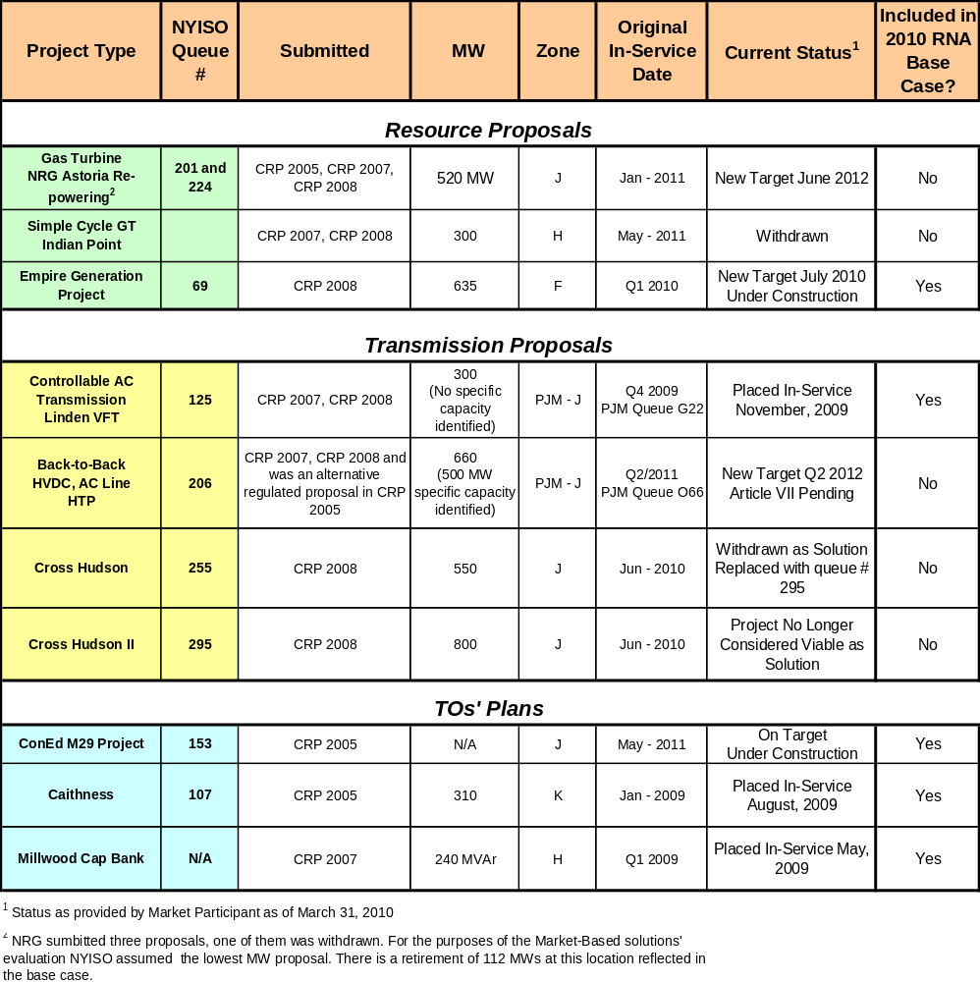

Table 2-2: Proposed Resources per 2010 Gold Book
(updated to reflect most current information as noted)

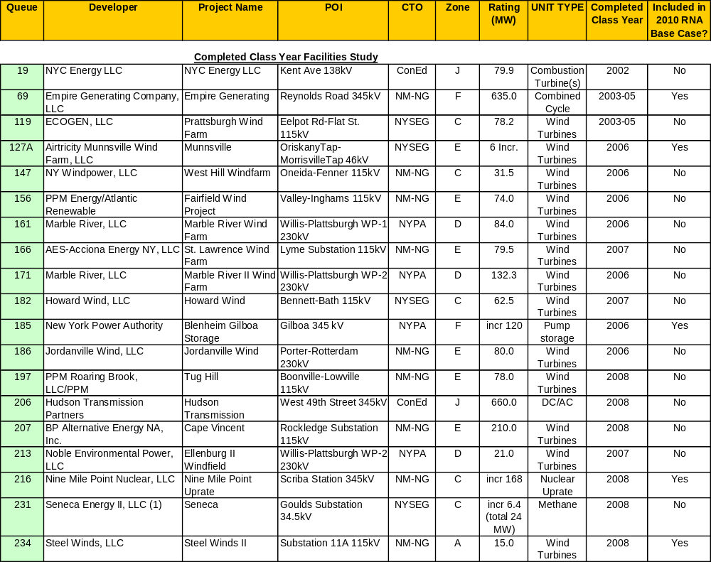
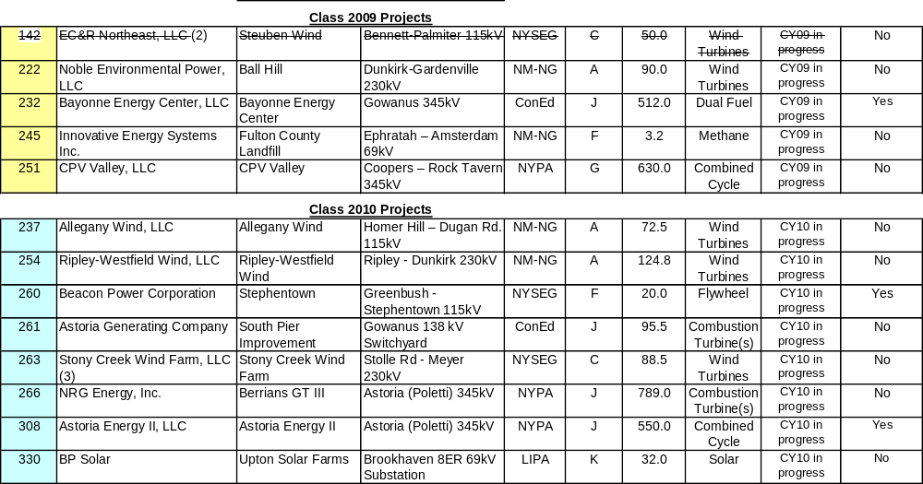

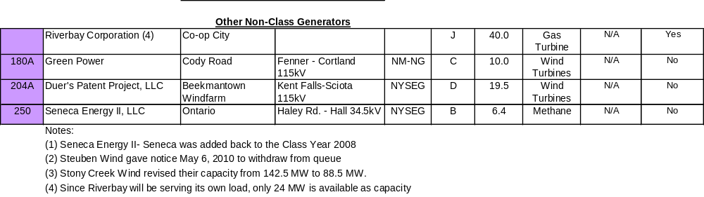

RNA Base Case Assumptions, Drivers and Methodology
The NYISO has established procedures and a schedule for the collection and submission of data and for the preparation of the models used in the RNA. The NYISO’s procedures are designed to allow its planning activities associated with the CSPP to be aligned and coordinated with the related activities of the NERC, NPCC, and NYSRC and to be performed in an open and transparent manner. The assumptions underlying the RNA were reviewed at the Transmission Planning Advisory Subcommittee (TPAS) and the Electric System Planning Working Group (ESPWG). The RNA Base Case consists of the Five Year Base Case and the second five years of the Study Period. The Study Period analyzed in the 2010 RNA is the 10-year period from 2011 through 2020. The load models developed for the RNA Base Case are based on the baseline load forecast from the 2010 Load and Capacity Data report, also known as the “Gold Book”. The Five Year Base Case was developed based on: 1) the most recent Annual Transmission Reliability Assessment (ATRA) Base Case, 2) input from Market Participants, and (3) the procedures set forth in the CRPP Manual.
Forecasts for peak load and energy as well as the impacts of programs such as EEPS and SCRs were developed for the 10-year Study Period. Projections for the installation and retirement of resources and transmission facilities are developed in conjunction with Market Participants and Transmission Owners and included in the Base Case. Resources that may choose to participate in markets outside of New York are modeled as contracts thus removing their available capacity for meeting resource adequacy requirements in New York.
The NYISO developed the system representation for the second five years of the Study Period starting with the First Five Year Base Case and using: 1) the most recent Load and Capacity Data Report published by the NYISO on its Web site; 2) the most recent versions of NYISO reliability analyses and assessments provided for or published by NERC, NPCC, NYSRC, and neighboring control areas; 3) information reported by neighboring control areas such as power flow data, forecasted load, significant new or modified generation and transmission facilities, and anticipated system conditions that the NYISO determines may impact the bulk power transmission facilities (BPTF); 4) Market Participant input; and 5) procedures set forth in the CRPP manual. Based on this process, the network model for the second five-year period incorporates LTPs and neighboring system plans in addition to those incorporated in the Five Year Base Cases. The changes in the MW and MVAr components of the load model were made to maintain a constant power factor.
The 2010 RNA Base Case model of the New York bulk power system includes the following new and proposed facilities and forecasts in the Gold Book:
- TO projects on non-bulk power facilities included in the FERC 715 Cases
- Facilities that have accepted their Attachment S cost allocations and are in service or under construction as of April 1, 2010
- Facilities that have obtained a PSC Certificate (or other regulatory approvals and SEQRA review) and an approved System Reliability Impact Study (“SRIS”) and an executed contract with a credit-worthy entity.
- Transmission upgrades related to any projects and facilities that are included in the RNA Base Case, as defined above
- LTPs identified in the 2010 Gold Book as firm plans
- Facility reratings and uprates
- Scheduled retirements
- Special Case Resources (SCR) and the impacts of the NYSPSC EEPS Order, as developed and reviewed at the ESPWG
- External System Modeling.
The RNA Base Case does not include all projects currently listed on the NYISO’s interconnection queue or those shown in the 2010 Gold Book. It includes only those which meet the screening requirements for inclusion per Table 3-3.

Impact of Energy Efficiency Programs on the Load Forecast
The 2010 Gold Book contains two forecasts. The first is an econometric forecast of annual energy and peak demand that does not include the impacts of the State’s EEPS programs. The second forecast includes an adjustment for the statewide energy efficiency programs described below and is the base case forecast for the 2010 RNA. The energy efficiency impacts reflect an achievement of 51% of the entire EEPS goal by the end of the forecast horizon in 2020.
As part of the EEPS Proceeding, the NYSPSC directed a series of working groups composed of all interested parties to the Proceeding to obtain information needed to further elaborate the goal. The NYSPSC issued an Order on June 23, 2008, setting short-term goals for programs to be implemented in the 2008-2011 period to begin the process of satisfying the NYSPSC’s goal as applied to the entities over which it has jurisdiction. The NYSPSC anticipated that LIPA and NYPA and other state agencies would implement their own programs, including energy efficiency, improvements in building codes and new appliance standards.
The NYISO has been a party to the EEPS proceeding from its inception and is a member of the Evaluation Advisory Group, responsible for advising the DPS on the methods to be used to track program participation and measure the program costs, benefits, and impacts on electric energy usage. In conjunction with market participants in the Electric System Planning Working Group, the NYISO developed load forecasts for the potential impact of the EEPS over the 10-year planning period. The following factors were considered in developing the 2010 RNA Base Case forecast:
- NYSPSC-approved spending levels for the programs under its jurisdiction, including the Systems Benefit Charge and utility-specific programs
- Expectation of increased spending levels after 2011
- Expected realization rates, participation rates and timing of planned energy efficiency programs
- Degree to which energy efficiency is already included in the NYISO’s econometric load forecast
- Impacts of new appliance efficiency standards, and building codes and standards
- Specific energy efficiency plans proposed by LIPA, NYPA and Consolidated Edison Company of New York, Inc. (Con Edison)
- The actual rates of implementation of EEPS, based on data received from Department of Public Service staff.
Table 3-1 below summarizes the 2010 Gold Book econometric forecast, the 2010 RNA Base Case forecast and a 2009 RNA 15x15 forecast. The 2009 RNA15x15 energy forecast for 2015 is 157,380 GWH and represents a 15% reduction from the 2015 econometric forecast expected at that time. Since then, the 2015 forecast has been reduced by almost 9,000 GWh due to the 2009 recession and subsequent lower economic growth projections, as compared to the 2009 RNA.

Table 3-1 - RNA Forecast Scenarios

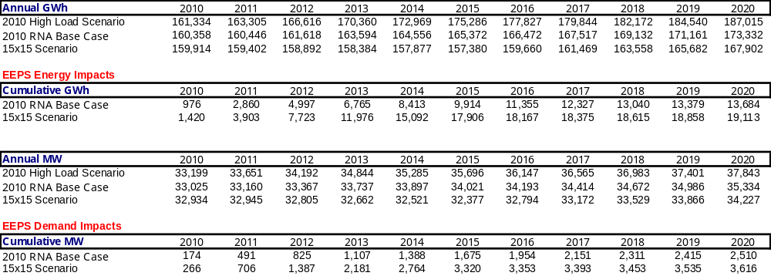
Figure 3-1: 2010 Base Case Forecast and Scenarios 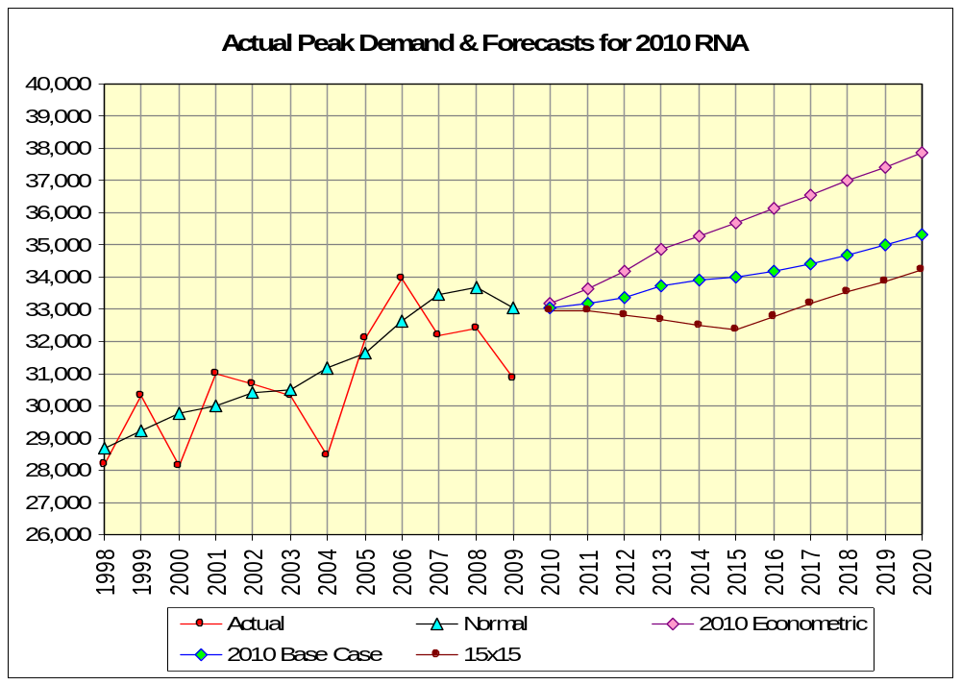

Forecast of Special Case Resources
The SCR forecast for the 2010 RNA Base Case was based on the 2010 Gold Book value of 2251 MW for 2020. An annual profile of SCR data was developed for each area and each month of a year. This annual profile was used for each year, 2011 through 2020. Its impact can be seen in the RNA Load and Resource Margin Table (Table 3-5) below. From an ICAP perspective, this represents an approximate increase of 167 MW of resource capacity over the 2009 RNA.

Resource Additions
Table 3-2 presents the unit additions, which were represented in the RNA Base Case.

TO Firm Plans
Table 3-3 presents all of the firm transmission plans that were included the 2010 Gold Book and were included in the RNA Base Case.
Table 3-2: Unit Additions
 | Queue | Project Name | 2010 | 2011 | 2012 | 2013 | Total MW
New Thermal Units

 | 69 | Empire Generating (July 2010) ⁽³⁾ | 635 |  |  |  | 635
 | 232 | Bayonne Energy (June 2011) |  | 512.5 |  |  | 512.5
 | 308 | Astoria Energy II (June 2011) |  | 550 |  |  | 550
 | 237A | Chautauqua Landfill (Feb 2010) | 6.4 |  |  |  | 6.4
 | N/A⁽¹⁾ | Riverbay (June 2010) ⁽³⁾ | 24 |  |  |  | 24
 |  | New Thermal Units Sub-Total | 665.4 | 1062.5 | 0 | 0 | 1727.9
New Wind

 | 234 | Steel Winds II (Nov 2010) ⁽³⁾ | 15 |  |  |  | 15
 |  | New Wind Sub-Total | 15 | 0 | 0 | 0 | 15
Unit Uprates

 | 185 | Blenheim-Gilboa Unit 4 uprate (June 2010) ⁽³⁾ ⁽⁴⁾ | 30 |  |  |  | 30
 | 216 | Nine Mile Point II (June 2012) ⁽³⁾ |  |  | 168 |  | 168
 | 127A | Munnsville Wind Power (Dec 2013) ⁽³⁾ |  |  |  | 6 | 6
 |  | Unit Uprates Sub-Total | 30 | 0 | 168 | 6 | 204
Other

 | 260 | Stephentown 20 MW Flywheel (Sept. 2010)⁽²⁾
Retired Units

 |  | Retired Units | 0 | 0 | 0 | 0 | 0
 |  | Grand Total | 710.4 | 1062.5 | 168 | 6 | 1946.9
Notes:
(1) Riverbay did not go through the NYISO Interconnection study process since it is connected to a non-FERC jurisdictional line. Only the available capacity is shown.
(2) Stephentown is modeled as a regulation resource.
(3) Included in 2009 RNA
(4) Overall total project uprate is 120 MW. Unit 4 is the last 30 MW uprate to be completed.

.
Table 3-3: Firm Transmission Plans (2010 Gold Book)

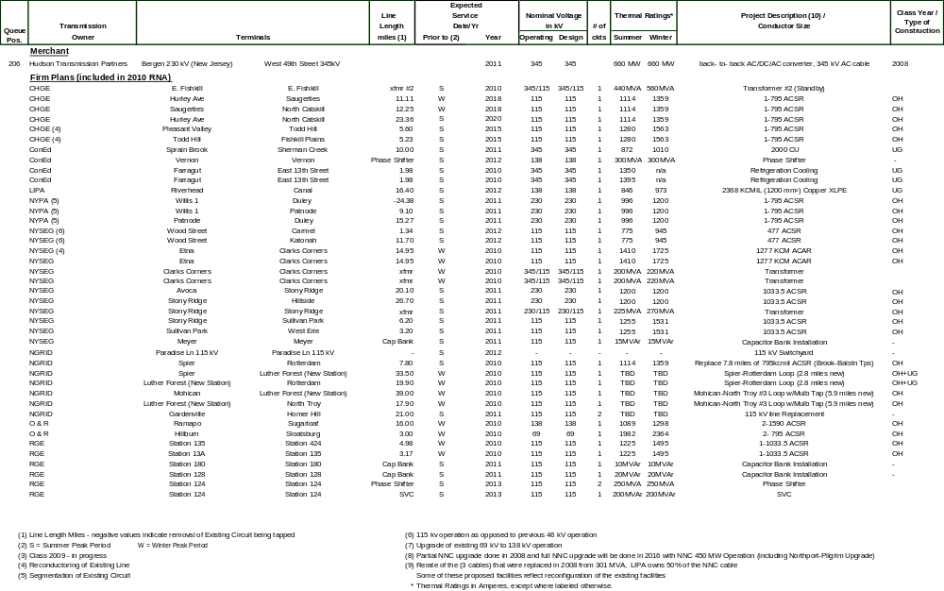

Resource Retirements
Table 3-4 below presents the unit retirements which were represented in the 2010 RNA Base Case:
Table 3-4: Scheduled Unit Retirements *
Unit/ Year | 2009 | 2010
Poletti** |  | 890.7
Greenidge 3 | 52.2
Westover 7 | 40.2
Total MW | 92.4 | 890.7 | 983.1
** Unit retirements included in 2009 RNA

Base Case Load and Resource Margins
The unit retirements and additions, when combined with the existing generation as of April 1, 2010 in the 2010 Gold Book and other adjustments, resulted in the 2010 RNA Base Case Load and Resource Margins found in Table 3-5 below:
Table 3-5: NYCA Load and Resource Margins 2011 through 2020
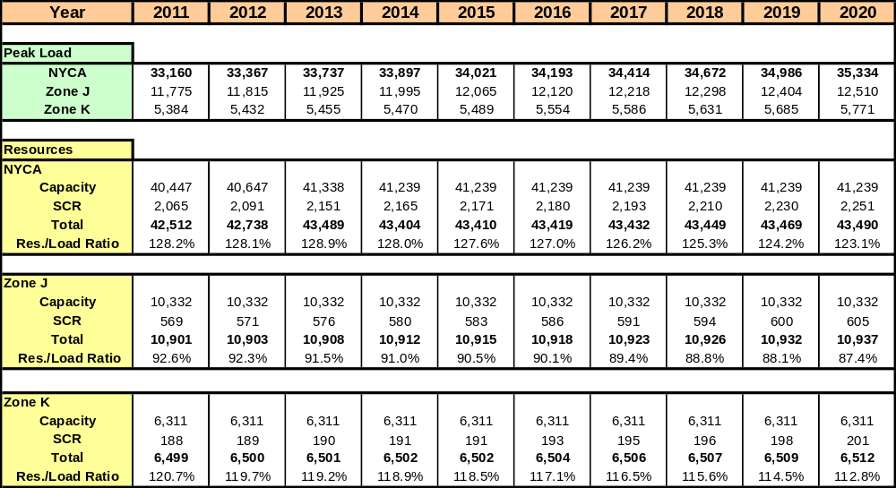
"Capacity" values include resources electrically internal to NY, Additions, Reratings, Retirements, Purchases and Sales, and UDRs with firm capacity. Generation resources are based on Summer Capability and not Nameplate.
SCR values reflect projected August 2010 ICAP capability period values (which are adjusted for the annual growth rate of 8.41%).
Table 3-6 below presents the comparison between the 2009 RNA and 2010 RNA in load forecast, unit additions, unit retirements, and SCRs. The 2010 RNA load forecast decreased by approximately 325 MW, while the overall NYCA capacity increased by approximately 880 MW and SCRs increased by approximately 167 MW. Due to these relatively small incremental changes, the resource adequacy assessment results of the 2010 RNA are similar to those of the 2009 RNA.
Table 3-6: 2009 RNA - 2010 RNA Load and Capacity Comparison
 | 2009 RNA Year 2018 | 2010 RNA Year 2020 | Delta MW
NYCA Load | 35,658 | 35,334 | -324
SCR | 2,084 | 2,251 | 167
Capacity without SCRs | 40,452 | 41,239 | 787
Unit Retirements | 1,272 | 983.1 | -289

Pursuant to Section 4.5 of Attachment Y of the OATT, the NYISO also develops reliability scenarios for the first five years and second five years of the Study Period considering, among other things, load forecast uncertainty, new resources, retirements, and potential limitations imposed by environmental programs that are currently either pending or under consideration. The NYISO also conducts sensitivity analyses pursuant to Section 4.6 of OATT Attachment Y to test the robustness of the needs assessment studies and identify conditions under which reliability criteria may not be met.

Methodology for the Determination of Needs
Reliability Needs are defined by the OATT in terms of total deficiencies relative to reliability criteria determined from the assessments of the BPTFs performed for this RNA. There are two different steps to analyzing the reliability of the BPTFs. The first is to evaluate the security of the transmission system; the second is to evaluate the adequacy of the system, subject to the security constraints. The NYISO’s existing planning procedures include both adequacy and security assessments. The NYISO conducts transmission adequacy and resource adequacy assessment jointly.
Adequacy is the ability of the electric systems to supply and deliver the total quantity of electricity demanded at any given time taking into account scheduled and unscheduled outages of system elements. Adequacy considers the transmission systems, generation resources and other capacity resources, such as demand response. Adequacy assessments are performed on a probabilistic basis to capture the randomness of system element outages. A system is adequate if the probability of having sufficient transmission and generation to meet expected demand is equal to or less than the system’s standard, which is expressed as a LOLE. As stated in Section 2.0, the New York State bulk power system is planned to meet a LOLE that, at any given point in time, is less than or equal to an involuntary load disconnection that is not more frequent than once in every 10 years, or 0.1 days per year. This requirement forms the basis of New York’s ICAP requirement.
Security is the ability of the power system to withstand sudden disturbances and/or the unanticipated loss of system elements and continue to supply and deliver electricity. Compliance with security criteria is assessed deterministically. Security is a deterministic concept, with potential disturbances being treated with equal likelihood in the assessment. These disturbances are explicitly defined in the reliability rules as design criteria contingencies. The impact of applying these design criteria contingencies is assessed to ensure no thermal loading, voltage or stability violations exist. These design criteria contingencies are sometimes referred to as N-1 or N-1-1. In addition, the NYISO performs a short circuit analysis to determine that the system can clear faulted facilities reliably under short circuit conditions. The NYISO “Guideline for Fault Current Assessment” is used.
If Reliability Needs are identified, compensatory MW for the New York Control Area (NYCA) are developed where appropriate by adding generic 250 MW generating units to zones to address the zone-specific needs. The compensatory MW amounts and locations are based on a review of binding transmission constraints and zonal LOLE in an iterative process to determine when reliability criteria are satisfied. These additions are used to estimate the amount of resources generally needed to satisfy Reliability Needs. The compensatory MW additions are not intended to represent specific proposed solutions. Resource needs could potentially be met by other combinations of resources in other areas including generation, transmission and demand response measures. Due to the differing natures of supply and demand-side resources and transmission constraints, the amounts and locations of resources necessary to match the level of compensatory MW needs identified will vary. Resource needs could be met in part by transmission system reconfigurations that increase transfer limits, or by changes in operating protocols. Operating protocols could include such actions as using dynamic ratings for certain facilities, operating exceptions, or special protection systems.

Reliability Needs Assessment

Overview
Reliability is defined and measured through the use of the concepts of adequacy and security. The NYISO first performs analysis of Transmission Security criteria violations. Then the NYISO assesses Transmission Adequacy and Resource Adequacy jointly with the use of General Electric’s Multi Area Reliability Simulation (MARS) software package. This is done through the development of interface transfer limits and a Monte Carlo base simulation of the probabilistic outages of capacity and transmission outages.

Reliability Needs for Base Case
Below are the principal findings of the RNA for the 2011-2020 Study Period. The needs assessment evaluated scenarios which are described in Section 4.4 below.

Transmission Security Assessment
Identifying Reliability Needs requires analysis and assessment of the transmission security of the BPTFs. The NYISO performed AC contingency analysis of the BPTFs to test for thermal and voltage violations using Siemens PTI PSS®MUST program utilizing the AC Contingency Analysis activity. More detailed analysis was performed for critical contingency evaluation and transfer limit evaluation using the power-voltage (P-V) curve approach as described in NYISO Transmission Planning Guideline #2-0 and Operating Engineering Voltage Guideline (dated April 11, 2006) using the Siemens PTI PSS®E (Rev. 30) software package. The impact of the status of critical generators on transfer limits was also quantified. Security for the BPTFs is and will be maintained by limiting power transfers. To assist in its assessment, the NYISO also reviewed many previously completed transmission security assessments.
The NYISO performed the transmission system performance testing required for the RNA. The results of the AC contingency analysis demonstrated that the BPTFs were within the facilities’ thermal and voltage limits. NYISO will conduct a more thorough N-1-1 transmission security analysis in as part of the upcoming Annual Transmission Review (ATR). The NYISO observed that a BPTF double circuit tower contingency outage in Rockland County produced local transmission system line loadings in excess of equipment ratings; however, no violation of Reliability Criteria occurred on the bulk power system. The local TO has operating procedures and plans in place to address the local area non-bulk power system issues.
.

Short Circuit Assessment
Another important element of performing a transmission security assessment is the calculation of short circuit current to ascertain whether the circuit breakers present in the system would be subject to fault levels in excess of their rated interrupting capability. The analysis was performed for the year 2015 reflecting the study conditions outlined in Sections 3.4, 3.5 and 3.6. The calculated fault levels would be constant over the second five years because the methodology for fault duty calculation is not sensitive to load growth. The detailed analysis is presented in Appendix C of this report.
The overdutied circuit breakers at Farragut occur with the addition of two new projects, Bayonne Energy Center (Class Year 2009) and Astoria Energy II (Class Year 2010), connected to the Con Edison and NYPA systems, respectively. Pursuant to Attachment S of the NYISO OATT, the NYISO will identify necessary mitigation solutions for the overdutied breakers and perform cost allocation of any identified upgrades during the applicable Class Year studies.
National Grid’s circuit breaker ratings are currently under review. If breaker duties are found to exceed the ratings based on NYISO’s fault current assessment the local TOs will work with the NYISO to develop mitigation plans.

Resource and Transmission Adequacy
The 2010 RNA base case load forecast, which includes adjustments for the EEPS impact was utilized in the analysis to determine transmission system transfer limits. Tables 4-1, 4-2 and 4-3 below provide the thermal and voltage transfer limits for the major NYCA interfaces.

Table 4-1: Transmission System Thermal Transfer Limits for Key Interfaces in MW
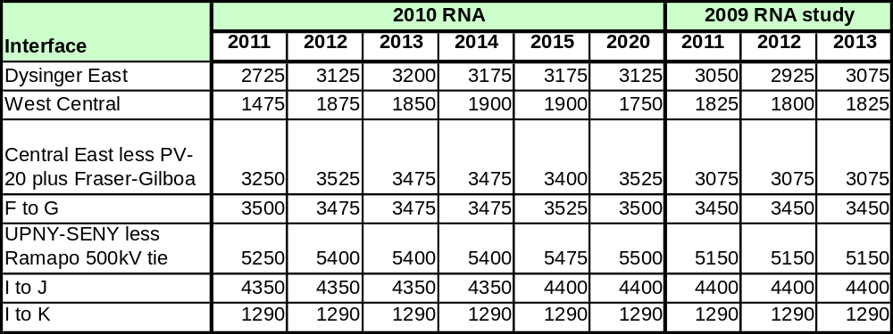

Table 4-2: Transmission System Voltage Transfer Limits for Key Interfaces in MW
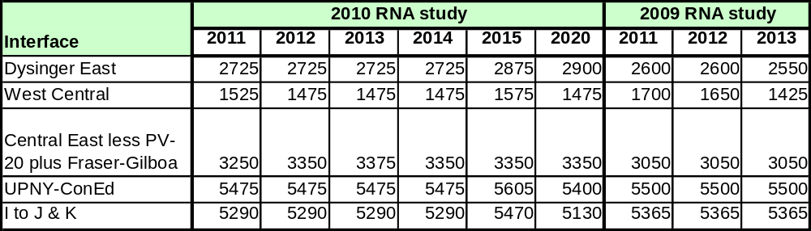
Note: The I to J and I to K interfaces were combined into one interface grouping since the simultaneous limit is less than the sum of each individual limit.

Table 4-3: Transmission System Base Case Transfer Limits for Key Interfaces in MW
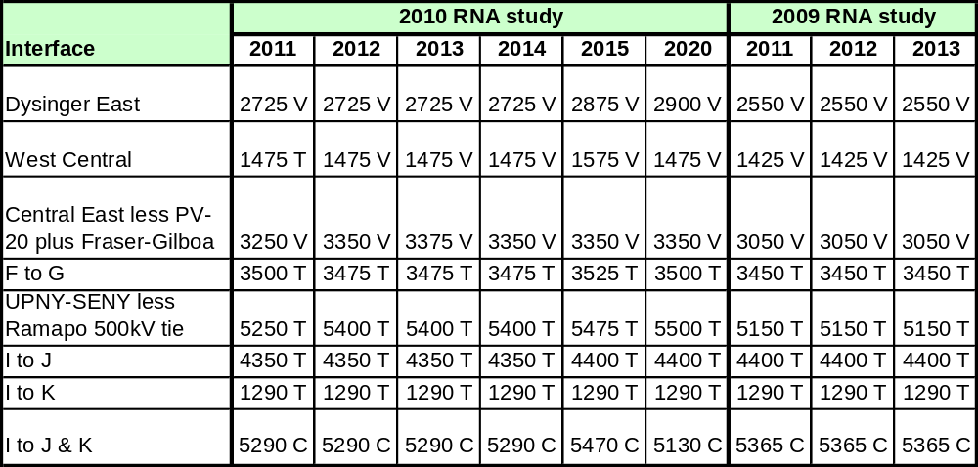
Note: T = Thermal; V = Voltage; C = Combined

When comparing the transfer limits calculated for the 2010 RNA to the transfer limits calculated for the 2009 RNA, increases in the Dysinger East, West Central and UPNY-SENY interfaces are evident. Local transmission system upgrades and the addition of a Static VAr Compensator (SVC) in Zone B contributed to the increases in the Dysinger East and West Central transfer limits. Changes to the 345 kV transmission system and base system conditions in ISO-NE contributed to the increase in the UPNY-SENY transfer limit by impacting the distribution of base flow on the UPNY-SENY circuits. When comparing the transfer limit in 2015 to the limit in 2020 calculated for the 2010 RNA, the I to J & K transfer limit decreased. The change is due primarily to the load growth on the system between study year 2015 and 2020.

Nomograms for the West Central and Central East transmission interfaces to reflect the variation in voltage transfer limits due to load or generation dispatches were developed for the 2010 RNA. For the West Central interface, the limit is a function of load. If the load in Area A is greater than 2529MW and Area B is greater than 1785 MW then the West Central limit would be 1475 MW. If the load in Area A is greater than 2669 MW and Area B is greater than 1884MW then the West Central limit would be 1350 MW. For the Central East (plus Fraser-Gilboa and minus Plattsburgh-Sandbar transmission lines) transmission interface, the transfer limit is a function of the number of generating units available in the Oswego Complex. The following table illustrates the changes in transfer limits as a function of the number of units available in the Oswego Complex:

No. Units In Oswego Complex | Central East Limit (MW)
1 | 2261
2 | 2586
3 | 2693
4 | 2715
5 | 2819
6 | 2976
7 | 2989
8 | 3250
Resource and transmission adequacy is evaluated for the entire 10-year Study Period. The analysis encompasses the Five Year Base Case and the second five years. The RNA Base Case transfer limits under emergency conditions were employed to determine resource adequacy needs (defined as a loss-of-load-expectation or LOLE that exceeds 0.1 days per year).
The transfer limits were calculated for each year of the first five years and for the tenth year of the study period (the end of the second five years). If the transfer limits for the tenth year are significantly lower than fifth year of the study period such that the load flow case cannot solve, and there are Reliability Needs identified in the first five years, NYISO assumes that solutions resulting in the first five years will restore those limits and counter the continued degradation of the transfer limits in the second five years. Therefore, the NYISO holds the transfer limit values in the second five years constant at the fifth year values. The impact on the transfer limits is determined in the evaluation of solutions to validate this assumption. If the assumption is not validated, additional solutions will be developed. For this RNA, since no Reliability Needs were identified in the first five years, NYISO did not assume solutions would develop and so actual transfer limits were calculated for year ten and a linear approximation for the annual reduction in limits was assumed between year five and year ten.
The LOLE for the NYCA did not exceed 0.10 days per year in any year through 2020. The LOLE results for the entire 10-year RNA Base Case are summarized in Table 4-4.
Table 4-4: NYCA LOLE for the 2010 RNA Study Base Case*
Area/Year | 2011 | 2012 | 2013 | 2014 | 2015 | 2016 | 2017 | 2018 | 2019 | 2020
AREA_A
AREA_B
AREA_C
AREA_D
AREA_E
AREA_F
AREA_G |  |  |  |  |  |  |  |  | 0.002 | 0.003
AREA_H
AREA_I |  |  |  |  |  |  |  |  | 0.005 | 0.007
AREA_J |  |  |  |  |  |  |  |  | 0.005 | 0.007
AREA_K
NYCA | 0.00 | 0.00 | 0.00 | 0.00 | 0.00 | 0.00 | 0.00 | 0.00 | 0.006 | 0.008

*Note: An LOLE value of 0.00 represents a rounded value, not a zero probability of loss of load.
For this study, the external systems emergency operating procedure data was removed. Capacity of the external systems was further adjusted so that the LOLE value of the Areas (Ontario, New England, Hydro Quebec, and PJM) was not less than 0.10 and not greater than 0.15. The External Area LOLE values for the base case are illustrated in Table 4-5. The MOD-MW capacity modifications required to establish these LOLE values can be found in Appendix D
Table 4-5: External Area LOLE for the 2010 RNA Study Base Case
Area/Year | 2011 | 2012 | 2013 | 2014 | 2015 | 2016 | 2017 | 2018 | 2019 | 2020
NE | 0.12 | 0.11 | 0.10 | 0.10 | 0.11 | 0.11 | 0.11 | 0.11 | 0.11 | 0.11
ONT | 0.12 | 0.13 | 0.11 | 0.12 | 0.14 | 0.12 | 0.12 | 0.11 | 0.10 | 0.12
HQ | 0.14 | 0.12 | 0.13 | 0.11 | 0.15 | 0.10 | 0.10 | 0.11 | 0.10 | 0.12
PJM | 0.10 | 0.10 | 0.11 | 0.14 | 0.12 | 0.12 | 0.12 | 0.12 | 0.12 | 0.12

These results were similar to the results obtained in the 2009 RNA Study. The following Table 4-6 illustrates the NYCA LOLEs from the 2009 RNA Study.
Table 4-6: LOLE for the 2009 RNA Study Base Case
Area/Year | 2011 | 2012 | 2013 | 2014 | 2015 | 2016 | 2017 | 2018
NYCA | 0.00 | 0.00 | 0.00 | 0.00 | 0.01 | 0.01 | 0.01 | 0.02

Reliability Needs Summary
Given that the Base Case analysis produced LOLE results that were below 0.1 days per year, for all years in the Study Period, there were no identified transmission security violations for the 10-year Study Period. No additional resources are forecasted to be required to maintain reliability at this time. Accordingly, the NYISO did not apply the compensatory MW methodology.

Scenarios
Scenarios are variations on key assumptions in the RNA Base Case to assess the impact of possible changes in circumstances that could impact the RNA. The following scenarios were evaluated as part of the RNA.
- Load Forecast Scenarios
    - 2010 Econometric Forecast (from 2010 Gold Book)
    - 45 x 15 Scenario
- Indian Point 2 and 3 Nuclear Unit Retirements
- Zonal Capacity At Risk
- NYSEG ETCNL
- Wheel Throughs

Load Forecast Scenarios

Econometric Forecast Scenario
The RNA base case includes the projected energy efficiency impacts associated with statewide energy efficiency programs. This scenario removes these impacts from the forecast. Since the load in the econometric forecast is higher than the base case, the probability of violating the LOLE criterion increases. This forecast scenario is shown in Table 4-7.
This scenario increases the 2010 RNA’s Base Case LOLE for 2020 from 0.01 to 0.25. This result reveals the impact of the energy efficiency programs on Reliability Needs (See Table 4-8).
Table 4-7: Econometric Forecast Scenario
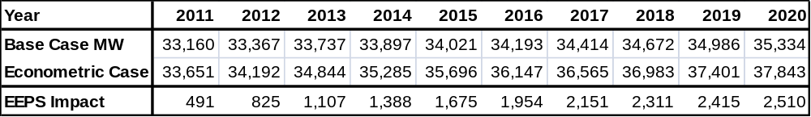

Table 4-8: RNA Base Case LOLE Econometric Forecast Scenario
Area/Year | 2011 | 2012 | 2013 | 2014 | 2015 | 2016 | 2017 | 2018 | 2019 | 2020
AREA_A
AREA_B
AREA_C
AREA_D
AREA_E
AREA_F
AREA_G |  |  | 0.001 | 0.003 | 0.004 | 0.01 | 0.018 | 0.03 | 0.053 | 0.088
AREA_H
AREA_I |  |  | 0.004 | 0.008 | 0.013 | 0.027 | 0.047 | 0.076 | 0.129 | 0.21
AREA_J |  |  | 0.004 | 0.009 | 0.014 | 0.029 | 0.05 | 0.079 | 0.132 | 0.22
AREA_K |  |  |  |  |  | 0.008 | 0.007 | 0.016 | 0.036 | 0.109
NYCA | 0.00 | 0.00 | 0.00 | 0.01 | 0.02 | 0.03 | 0.05 | 0.09 | 0.15 | 0.25

45 x 15 Scenario
The 45 x 15 scenario reflects the State’s clean energy policy goal to have 30% of the State’s energy served by renewable sources and 15% of energy consumption reduction by the year 2015. Approximately 1275 MW of wind projects are already in-service across NY State. Table 4-9 lists all the wind projects that are included in the 2010 RNA base case.

Table 4-9 Wind Projects in 2010 RNA Base Case

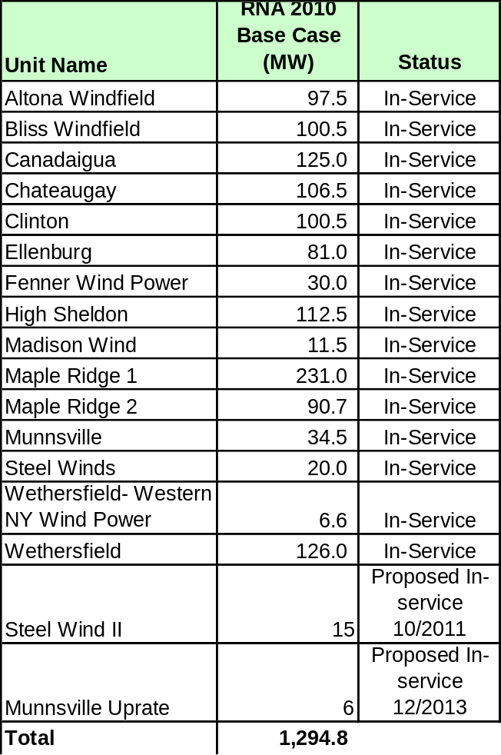

An additional 1368 MW of renewable wind and solar projects are proposed to be built before 2015. Table 4-10 lists the proposed renewable projects that have completed a Facilities Study Class Year and accepted their cost allocation or are currently included in a Facilities Study Class Year. Recognizing that the 1368 MW of additional renewable may not fully achieve the 30% penetration level sought by the state policy this additional capacity has contributed to the LOLE of 0.0.

Table 4-10: Proposed Renewable Projects

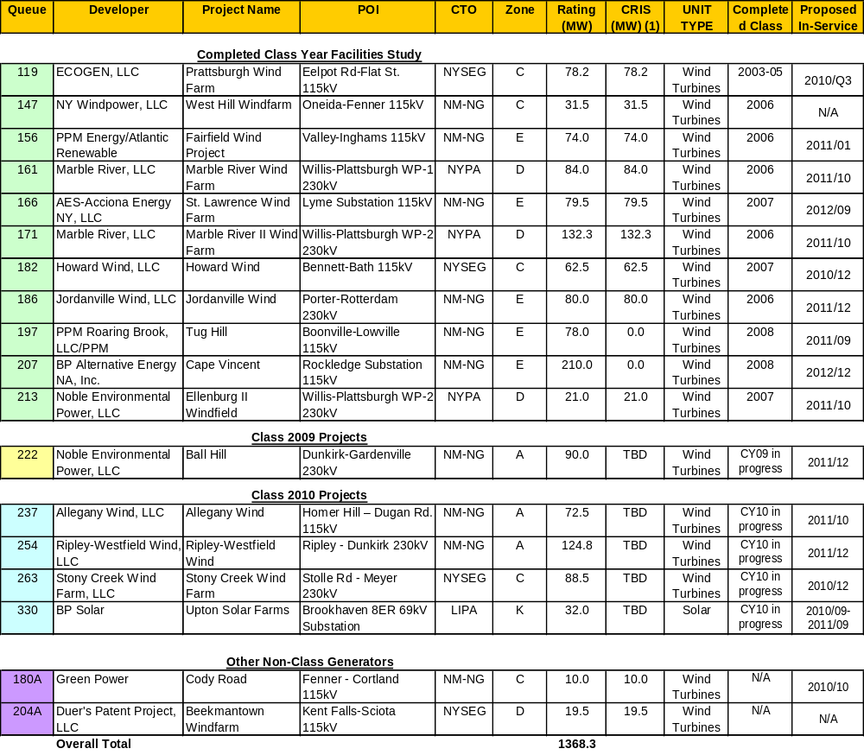

The following load forecast is based on meeting the state energy efficiency goal. This reduced consumption for year 2015 is taken from the 2009 RNA scenario for full achievement of the goal. This forecast is 1107 MW below that included in the 2010 RNA base case for year 2020.
Table 4-11: Energy Efficiency Portfolio Standard Load Forecast

The combined impact of adding 1368 MW of renewable resource capacity and reducing the load forecast by 1107 MW results in an LOLE of less than 0.01 throughout the 10 year Study Period.

Nuclear Retirement Scenario

Table 4-12 below illustrates the impact on resource adequacy of the retirement of the Indian Point nuclear power plant which has two base-loaded units which are located in Southeastern New York, the area of the State where transmission constraints exist and resource adequacy needs have been most prevalent

. For the analysis it was assumed that Indian Point 2 and Indian Point 3 cease operations at the end of their current license dates, September 2013 and December 2015, respectively. Transfer limit analysis was performed on the system model with both Indian Point units out-of-service.

Table 4-12 : Indian Point Plant Nuclear Retirement Scenario

Area/Year | 2016 | 2017 | 2018 | 2019 | 2020
AREA_A
AREA_B
AREA_C
AREA_D
AREA_E
AREA_F
AREA_G | 0.05 | 0.06 | 0.08 | 0.13 | 0.17
AREA_H | 0.12 | 0.15 | 0.20 | 0.29 | 0.38
AREA_I | 0.12 | 0.17 | 0.23 | 0.33 | 0.41
AREA_J | 0.10 | 0.14 | 0.19 | 0.28 | 0.38
AREA_K | 0.01 | 0.00 | 0.00 | 0.00 | 0.01
NYCA | 0.14 | 0.19 | 0.26 | 0.36 | 0.38

The ability to transfer power to Zone J and Zone K will be constrained at the UPNY-SENY interface under peak load conditions well before the downstream interfaces can be stressed as all of the remaining capacity in zone G, H, and I is exhausted. However to determine the transfer limits in the Hudson Valley, the UPNY-ConEd and I to J and K interfaces were loaded ignoring the UPNY-SENY limit. The resulting voltage collapse limits over the UPNY-ConEd and I to J and K interfaces are much higher than the actual transmission system flow due to the upstream thermal constraints. The decrease in voltage collapse limits is approximately 2000 MW because without Indian Point the flows on the I to J and K interface are approximately 2000 MW lower when the UPNY-SENY interface is loaded at the same limit.
With both units out of service in 2016, the reliability criterion is violated with an LOLE of 0.14 days/year. Thereafter, the LOLE continues to escalate for the remainder of the Study Period reaching an LOLE of 0.38 days/year in 2020.
If the projected EEPS savings included in the 2010 base case are not realized, then the reliability need year will be advanced to 2014.
Further transmission analysis also demonstrated local thermal violations per Reliability Criteria. Specifically, under N-1-1 facility outage conditions, generation located below the UPNY-SENY interface will not be sufficient to return the system back to normal transmission ratings, resulting in load relief measures for Zones G, H, I, J or K.

Zonal Capacity at Risk
. Given that the LOLE of the Base Case conditions did not exceed 0.10 for the 10-year study period, additional analysis was performed to determine the reduction in capacity, which would cause the LOLE to exceed 0.10. For the eleven zones comprising the NYCA, the zones were aggregated A-F, G-I, J, and K. The overall capacity in the zones was derated in increments of 250 MW until the NYCA LOLE exceeded 0.10. The NYISO did not reduce capacity from particular units nor model the effect on load pockets within zones. Therefore no internal transmission problems were evaluated. The results do not indicate whether or not the transmission system could support some or all the capacity derates.
The levels of capacity removed in those zones for 2020 without violating NYCA LOLE are: Zone J at 1000 MW, Zone K at 1000 MW, Zones G-I at 1000 MW. Actual levels of removable capacity may be lower as a result of transmission security violations due to specific capacity losses at specific locations.

For Zones A-F, the level of removable capacity is highly dependent on the specific locations in the transmission system. For example the NYISO conducted a limited local transmission security analysis which removed a number of existing units within upstate zones. With the unavailability of those units, certain 115 kV facilities would experience thermal and voltage violations in those zones. Any potential transmission problems would be subject to further transmission owners’ verification and mitigation. Therefore, although the zones at risk analysis shows a maximum level of removable capacity between 1000 and 1750 MW without LOLE violations for Zones J, K, and G-I, in reality much lower amounts of capacity removal may result in reliability issues at specific transmission locations.

The results presented in the zones at risk scenario represent the maximum level of removable capacity without an LOLE violation. Additional transmission security analysis would need to be performed for any contemplated plant retirement in any zone.

NYSEG ETCNL Rights
NYSEG has the grandfathered Deliverability rights to bring in up to 1080 MW of capacity from PJM. This scenario in no way implies that NYSEG should or needs to modify their current agreement. Modeling the 1080 MW as a firm contract on the PJM western NY ties had no impact on the NYCA LOLE.

Wheel Throughs
To determine the impact of capacity wheel throughs, a 300 MW contract through NY was modeled. This results in the NYCA LOLE increasing from 0.006 to 0.008 in year 2020.

Other Areas of Interest

Environmental Regulations
New York has a long history in the active development of environmental policies and regulations that govern the permitting, construction and operation of power generation and transmission facilities. Two noteworthy policy initiatives where New York has preceded national environmental programs include the regulation of power plant emissions to curb acid rain, and the more recently promulgated regional program to limit power plant emissions of carbon dioxide and other greenhouse gases. Currently New York’s standards for permitting new generating facilities are among the most stringent in the nation. The combined result of these strict environmental standards and competitive markets administered by the NYISO since 1999 has been retirement of older plants representing 3000 MW of capacity and the addition of over 7,000 MW of new efficient generating capacity. This has resulted in a marked reduction of power plant emissions and a significant improvement in the efficiency of the generation fleet.

Notwithstanding the remarkable progress towards achieving New York’s clean energy and environmental goals, more remains to be accomplished. While the 2009 New York State Energy Plan (http://www.nysenergyplan.com/stateenergyplan.html) provides a long range vision and framework for New York’s energy. The State’s Department of Environmental Conservation (NYSDEC) annual publication of its regulatory agenda describes the new environmental initiatives that it will focus in the coming year. The 2010 agenda can be found at:

http://www.dos.state.ny.us/info/register/2010/jan6/pdfs/regagenda.pdf.

The U.S. Environmental Protection Agency also publishes a similar report on its regulatory agenda which can be found at:

http://www.reginfo.gov/public/do/eAgendaMain;jsessionid=9f8e890430d77ed37246b4ab417e9961cfca348ec55b.e34ObxiKbN0Sci0RbxaSc3qRc3n0n6jAmljGr5XDqQLvpAe?operation=OPERATION_GET_AGENCY_RULE_LIST&currentPub=true&agencyCd=2000&Image58.x=36&Image58.y=15.

The environmental initiatives that may affect generation resources may be driven by either or both the State or federal programs.

One of the purposes of the RNA is to identify possible future outcomes that could lead to insufficient resources in the NYS Power System to satisfy applicable reliability criteria. For example, such a situation may result from load growth rates exceeding the NYISO’s base case forecast, the failure of new resources to successfully achieve commercial operation as planned, or the unplanned retirement of a significant amount of capacity provided by existing resources. The purpose of the development of this “Environmental Scenario” is to gain insight into population of resources that are likely to be faced with major capital investment decisions in order to achieve compliance with several evolving environmental program initiatives. The premise of this analysis is that the risk of unplanned retirements is directly related to the capital investment decisions resource owners need to make in order to achieve compliance with the new regulatory program requirements. The goal of this scenario analysis is to identify when and where these risks occur on the New York Power System.

This analysis identifies, on a zonal or super zonal basis, the levels of cost impact that will result in an identified risk of unplanned retirements. The identification and timing of these potential risks will inform the NYISO and State policy makers of the potential impacts to system reliability caused by the newly adopted and proposed environmental regulations. Of equal importance, the results will also useful information about future opportunities to developers of new clean efficient generation resources or aggregators of special case resources.

Selection of Major Environmental Program Initiatives
The environmental initiatives reviewed for this study are described below.

Reasonably Available Control Technology for Oxides of Nitrogen (NOxRACT)

NYSDEC has proposed new regulations for the control of emissions of nitrogen oxides (NOx) from fossil fueled power plants. The regulations establish presumptive emission limits for each type of fossil fueled generator and fuel used as an electric generator in NY. NYSDEC is seeking to reduce emissions from the effected generators by 50%, from 58,000 TPY to 29,000 TPY. Compliance options include averaging emissions with lower emitting units, fuel switching, and installing emission reduction equipment such as low NOx burners or combustors, or selective catalytic reduction units.

The NYISO retained GE to conduct a detailed study about the types and costs of control technology necessary to comply with the proposed regulation. The study found that “A total of 72 units or 9515 MW of capacity was identified as needing some type of control mechanism of equipment modification to comply with the proposed standard.” The study concluded that the costs to comply with the NOxRACT regulation would reduce operating margin for affected generators, but would generally not lead to situations where those margins would become negative. In addition the study concluded that the proposed compliance deadline should be extended to July 2014 in order to accommodate the outage schedules necessary to install the required emissions control equipment retrofits.

Best Available Retrofit Technology (BART)

NYSDEC recently promulgated a new regulation Part 249, Requirements for the Applicability, Analysis, and Installation of Best Available Retrofit Technology (BART) Controls. The regulation applies to fossil fueled electric generating units built between August 7, 1962 and August 7, 1977 and is necessary for State to comply with provisions of the federal Clean Air Act that are designed to improve visibility in National Parks. The regulation requires an analysis to determine the impact of an affected unit’s emissions on visibility in region national parks. If the impacts are greater than a prescribed minimum, then emission reductions must be made at the effect unit. Emissions of sulfur dioxide (SO2), nitrogen oxides (NOx) and particulate matter (PM) may be necessary. The compliance deadline has been set as January 2014.

Maximum Achievable Control Technology (MACT)

The USEPA is required by the federal Clean Air Act to develop rules to limit emissions of certain substances classified as toxic. USEPA is scheduled to release a proposed rule March 2011. The rule will establish limits for Particulate Matter (PM), Hydrogen Chloride (HCl), Mercury (Hg), Carbon Monoxide (CO), and Dioxin and Furans. These limits will apply to coal fired generators and may apply to electric generators that are fueled by heavy oil. The anticipated compliance date is November 2014.

In addition, NYSDEC has promulgated Part 246: Mercury Reduction Program for Coal-Fired Electric Utility Steam Generating Units, which establishes emission limitations that are currently in effect in New York to reduce mercury emissions. Phase II of this regulation requires additional reductions from coal fired boilers in 2015. The Phase II emission limitations may be equivalent to the limits USEPA will establish next year.

The USEPA has proposed limitations on mercury emissions from oil fired boilers that supply generators less than 25 MW. Similar limitations for large oil fired boilers are likely.

Best Technology Available (BTA)

NYSDEC is currently seeking comment on it policy documents “Best Technology Available (BTA) for Cooling Water Intake Structures. The proposed policy will apply to plants with design intake capacity greater than 20 million gallons/day and prescribes reductions in fish mortality. The proposed policy establishes performance goals for new and existing cooling water intake structures. The performance goals call for the use of wet, closed-cycle cooling systems at existing generating facilities. The policy does provide some limited relief of plants with historically capacity factors less than 15%.

Once the NYSDEC has made a determination of what constitutes BTA for a facility, the Department will consider the cost of the technology to determine if the costs are “wholly disproportionate” to the environmental benefits to be gained with BTA.

Reliability Impact Assessment Methodology
Several of the evolving environmental initiatives described above have sufficient definition of potential requirements, are generally widespread in effect, and are expected to require compliance actions in the earlier portion of the planning period, and therefore could lead to premature retirements. The programs are estimated to impact 23,957 MW of capacity in the NYCA or 64% of the installed generating capacity NYISO currently relies on.

Each of the four programs has been examined to determine the category of capital cost potentially required of affected units to comply with each program. Three category levels are used to qualify the expected impacts of each program on the existing generation fleet. Category 1 applies for the affected generator that is already in compliance with the proposed requirements, or could be expected to achieve compliance with changes in operating procedures and/or through the use of fuel switching. Thus the capital cost to achieve compliance for Category 1 generators is relatively small. Category 2 applies where the required capital expenditures are of a magnitude that is consistent with other capital expenditure that is necessary to maintain a generator over the planning horizon, e.g. a five year major overhaul of the steam turbine. Category 3 applies where the level of capital expenditure required to comply with the new regulation is above the average level of capital cxpenditures and of a magnitude that is not routine.

While the total population of affected units is represented by the summation of the three impact categories, in each of these analyses the primary concern is with the capital investment decisions represented by Category 2 and 3. With the results of these analyses, the level of impact for each unit is summed across the four programs for Category 2 and 3. Units with the highest cumulative totals of impact are considered to be potentially at risk for premature retirement. (The level of impact for each zone will be compared to the zones at risk analysis to identify where the environmental initiatives may result in an LOLE violation.)

NOxRACT Impact Assessment
The NYISO retained GE to conduct a detailed study about the types and costs of control technology necessary to comply with the proposed regulation. The study found that “[a] total of 72 units or 9515 MW of capacity was identified as needing some type of control mechanism of equipment modification to comply with the proposed standard.” Capital costs of compliance were estimated to be approximately in the range of $100-300 Mil. The study concluded that the costs to comply with this regulation would reduce operating margin for affected generators but would not generally lead to situations where those margins would become negative. In addition the study concluded that the proposed compliance deadline should be extended to July 2014 in order to accommodate the outage schedules necessary to retrofit the required emissions control equipment.

BART Impact Assessment
The impact assessment of the BART program is less certain than the assessment for the NOxRACT program. The results of the visibility analysis are used to determine the emission reductions that may be necessary for SO2, NOx, and PM. For the purposes of this impact assessment, it is assumed that all affected units in New York will need to reduce emissions of these pollutants that cause visibility impairments. Based on this assumption, 8,940 MW of capacity is affected. The majority of these units are large oil fired units that have gas as an alternate fuel. Many of these units do not have state of the art emission control systems. Units that have natural gas capabilities were assigned Category 1. Generators that were designated to fuel switch in the NOxRACT study were assigned Category 2. Facilities that are predominantly coal fired were assumed to need upgraded particulate collection, SCR, and FGD and were assigned Category 3.

The NOx control measures for BART generally were consistent with the results of the NOxRACT study. NYSDEC has established a reasonableness test of $5,000/ton reduced based on the estimated Potential To Emit. Capital expenditures for this program would be of the same order of magnitude as the NOxRACT program.

MACT Impact Assessment
USEPA’s proposal for MACT for fossil fired electric generators is planned to be released next Spring. In the interim we can gain some insight about the scope and the possible limits by reviewing the recently released MACT regulations for units less than 25 MW. The regulations apply to coal and oil fueled electric generators. The proposed emission limits for coal are comparable to the NYSDEC Part 246 Phase 2 regulations. The USEPA proposal for small boilers goes beyond the current version of Part 246 by specifying emission limits that are comparable to those for coal, thus for the purpose of this assessment, we have assumed that units burning heavy oil will need to retrofit mercury sorbent materials and capture them in upgraded particulate collection equipment.

Facilities that are in compliance with the 2015 emission limit are assigned Category 1. Generators that need to add sorbent injection systems are assigned Category 2. Facilities that need to add sorbent injection and improved particulate collection are assigned Category 3.

The 2008 USEPA Toxic Release Inventory reports that approximately 1250 pounds of mercury were released from electric generators. Assuming that the MACT regulation will require a 90% reduction in mercury emissions similar to the NYSDEC Part 246 requirement, then an estimated emission reduction of 1,125 pounds/yr. would be required. The USEIA has estimated the cost of removal to be approximately $20,000/pound. The estimated annual cost for the carrying and operating costs of mercury removal systems would be $ 22.5 Mil/yr.

BTA Impact Assessment
NYSDEC’s BTA policy will require the use of closed cycle cooling systems at plants that currently have open cycle cooling systems with some limited relief for sites that can not physically accommodate cooling towers, generators with current historical capacity factors below 15%, and where the expense of a closed cooling water system is “wholly disproportionate” compared to the environmental benefits to be gained. Several sites have gained limited relief and are assigned Impact Category 1. Sites that may gain approval to use fish protection systems based on specific equipment and past studies are assigned Impact Category 2. The majority of the sites may well need to retrofit closed cycle cooling systems and are assigned to Impact Category 3.

NYSDEC has estimated the capital and operating costs of using closed cycle cooling at electric generators in NY at $8.5 Bil without consideration for cases where limited relief is granted. This program will require capital investments that are one to two orders of magnitude greater than the costs for any of the other environmental initiatives examined.Consequently, the BTA program has the greatest potential to lead to unplanned retirements.

The risk of premature retirement of an individual unit of capacity is represented in this study by the summation of the assigned risk categories. The representation does not imply that the risk associated with each program Category 1, 2, or 3 is equivalent, rather is meant to collect the number of risk events that specific MW of capability are exposed to. The higher the sum of these risk events the greater the likelihood of premature retirement. These sums are presented in Table SS below.

Integration of Environmental Initiative Impact Assessment with Zones At Risk Analysis
The RNA examines levels of removable capacity in the zones at risk while continuing to satisfy the reliability criteria of LOLE < 0.1. The analysis considers the reliability implication of the environmental initiatives described above by matching the quantities of capacity identified n the zones at risk anaylsis If the capacity that can be removed from that zone is more than the capacity represented by the total amount of capacity in Category 2 and 3 for that zone, the reliability impact caused by any retirement resulting from these regulations would need a specific transmission security analysis to determine what upgrades would be necessary on the local transmission system and when that work could be completed.

If the capacity that can be removed from that zone is less than the capacity represented by the total amount of capacity in Category 2 & 3 for that zone, then reliability would be at risk. Transmission security analyses would then need to be conducted to define the extent and magnitude of the problem caused by premature retirements. Solutions to reduce that risk could include: flexibility in the design of the environmental initiative, or regulatory flexibility during the transition period while new generation and/or transmission resources are developed and brought on line to reduce the reliability risk to acceptable levels.

The tables below identify the quantity of capacity that is in Category 2 or Category 3 for each of the environmental programs and therefore are indicative of the relative amount of capacity at risk for premature retirement as a result of these programs.

For the NOxRACT program, Zones A-F have the most capacity affected and would require site specific transmission security analyses. There is 1312 MW of capacity at risk in Zones G-H-I which exceeds threshold for the amount of capacity that can be removed while maintaining reliability criteria. The amount of capacity in Category 2 & 3 for Zones J and K is less than the indentified amount of capacity that can be removed, however, the complexity of the transmission system in those Zones requires that site specific analyses be conducted there

Table 5-1 NOxRACT Program Impact Reliability Threshold

NOxRACT Impact Reliability Threshold
Super Zones | 2 | 3 | Total
A,B,C,D,E,F | 2,672 | 419 | 3,091
G,H,I | 551 | 761 | 1,312
J,K | 673 | 187 | 860
Total | 3,896 | 1,367 | 5,263

For the MACT program, Zones A-F have 2760 MW of capacity affected and would require site specific transmission security analyses. There is 2794 MW of capacity at risk in Zones G-H-I which exceeds threshold for the amount of capacity that can be removed while maintaining LOLE reliability criteria. There is 5537 MW of capacity affected in Zones J and K which also exceeds the threshold for the amount of capacity that can be removed while maintaining LOLE reliability criteria

Table 5-2 MACT Program Impact Reliability Threshold

MACT Impact Reliability Threshold
Super Zones | 2 | 3 | Total
A,B,C,D,E,F | 1,921 | 840 | 2,760
G,H,I | 368 | 2,426 | 2,794
J,K | 1,953 | 3,583 | 5,537
Total | 4,242 | 6,849 | 11,091

For the BART program, Zones A-F have 1686 MW of capacity affected and would require site specific transmission security analyses. There is 1715 MW of capacity at risk in Zones G-H-I which exceeds the threshold for the amount of capacity that can be removed while maintaining LOLE reliability criteria. There is 1652 MW of capacity affected in Zones J and K which also exceeds the threshold for the amount of capacity that can be removed while maintaining LOLE reliability criteria..

Table 5-3 BART Program Impact Reliability Threshold

BART Impact Reliability Threshold
Super Zones | 2 | 3 | Total
A,B,C,D,E,F | 1,686 |  | 1,686
G,H,I | 1,346 | 368 | 1,715
J,K | 1,652 |  | 1,652
Total | 4,684 | 368 | 5,052

The BTA program affects the greatest amount of capacity and therefore is likely to create the greatest risk for premature retirements and for unacceptable reliability risks. For the BTA program Zones A-F have 4,203 MW of capacity affected and would require site specific transmission security analyses. There is 2,063 MW of capacity at risk in Zones G-H-I which exceeds threshold for the amount of capacity that can be removed while maintaining LOLE reliability criteria. There is 6353 MW of capacity affected in Zones J-K which also exceeds the threshold for the amount of capacity that can be removed while maintaining LOLE reliability criteria..

Table 5-4 BTA Program Impact Reliability Threshold

BTA Impact Reliability Threshold
Super Zones | 2 | 3 | Total
A,B,C,D,E,F | 1,211 | 2,992 | 4,203
G,H,I |  | 2,063 | 2,063
J,K | 4,032 | 2,321 | 6,353
Total | 5,243 | 7,376 | 12,619

Table 5-6 Combined Program Impact Reliability Threshold

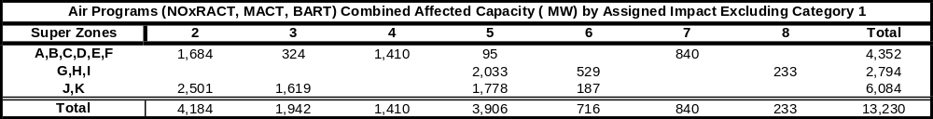

Summary:
All programs will require significant capital investments from some portion of the effected population of units. Previous studies have indicated that the NOxRACT program by itself may be accommodated while maintaining positive net revenues, however in combination with the requirements of the other programs the hurdle to reinvestment is raised along with the potential for premature retirement. MACT, BART, and BTA programs will affect a large portion of the fleet in their respective zones that is significantly greater than the amount of capacity that can be removed as determined by the zones at risk analysis. Except for NOx RACT, LOLE violations are likely to occur for each of the environmental initiatives if plant retirements occur as summarized in Categories 2 & 3, with the possible exceptions of superzone A-F where more focused zonal LOLE and specific transmission security analysis would be required.

Wind Impact
The NYISO conducted a study of the reliability impacts of up to 8 GW of installed nameplate wind for selected years through 2018. A draft of the final report can be found at:
http://www.nyiso.com/public/committees/documents.jsp?com=bic_miwg&directory=2010-06-18
The primary finding of the study is that wind generation can be reliably integrated to supply renewable energy with significant reductions in “greenhouse” gases such as CO₂ and other emissions such as NOx and SO_{2 .} However, because of their intermittent and variable nature, wind plants provide more of a challenge to power system operation than conventional power plants. This study determined that the NYISO’s systems and procedures (which includes the security constrained economic dispatch and the practices that have been adopted to accommodate wind resources) will allow for the integration of up to 8 GW of installed wind plants without any adverse reliability impacts.
This conclusion is predicated on the assumption that a sufficient thermal resource base is maintained to support the wind.. As wind resources increase as an overall percentage of the resource mix, the installed reserve margin will need to increase due to the variability and the lower overall availability.
The intermittent nature of wind generation results in an increase in overall system variability as measured by the net load (load minus wind). In response to these increased operational challenges the NYISO has implemented changes to its operational practices such as being the first ISO to incorporate intermittent resources into security constrained economic dispatch (SCED) and to implement a centralized forecasting process for wind resources. The study concluded that at higher levels of installed wind generation the system will experience higher magnitude ramping events and will require additional regulation resources to respond to increased variability during the five minute dispatch cycle. The analysis determined that the average regulation requirement will need to increases by approximately 9% for every 1,000 MW increase in wind generation between 4,250 MW and 8,000 MW.

Observations and Recommendations
The 2010 RNA has not identified any new Reliability Needs through 2020. The reliability of the NYS Power System is dependent on three key factors; 1) implementation of EEPS to achieve the forecasted goal, 2) the addition of two power plants of over 1000 MW in zone J, 3) continued development of the firm transmission projects as reflected in the LTPs. Delay of these projects would require extending, and possibly expanding the use of operating procedures to maintain system reliability.
The scenario analyses also indicate potential risks to reliability. The scenarios are Indian Point plant retirement, failure to achieve significant energy efficiency goals, significant generation capacity retirement caused by various factors.
The NYISO recommends the continued monitoring and verification of the energy efficiency improvements. The NYISO will continue to track the development and progress of the transmission and generation projects assumed in the base case. The NYISO will continue to monitor the development of State and Federal regulatory programs and licensing proceedings. In addition, the NYISO may provide an assessment of the reliability, economic and emissions impact associated with these regulatory proceedings.

Historic Congestion
Appendix A of Attachment Y of the NYISO OATT states: “As part of its Comprehensive Reliability Planning Process, the NYISO will prepare summaries and detailed analysis of historic congestion across the New York Transmission System. This will include analysis to identify the significant causes of historic congestion in an effort to help Market Participants and other stakeholders distinguish persistent and addressable congestion from congestion that results from one time events or transient adjustments in operating procedures that may or may not recur. This information will assist Market Participants and other stakeholders to make appropriately informed decisions.” The detailed analysis of historic congestion can be found on the NYISO Web site at:
www.nyiso.com/public/services/planning/congestion_cost.jsp

Appendices
Appendix A – Reliability Needs Assessment Glossary

Appendix B- The CSPP’s Reliability Planning Process
This section presents an overview of the CSPP’ Reliability Planning Processes followed by a summary of the 2005, 2007, 2008 and 2009 CRPs and their current status. A detailed discussion of the Reliability Planning Process, including applicable reliability criteria, is contained in NYISO Manual 26 entitled: “Comprehensive Reliability Planning Process Manual,” which is posted on the NYISO’s website and can be accessed at the following link:
http://www.nyiso.com/public/webdocs/documents/manuals/planning/CRPPManual120707.pdf.
Each biennial cycle begins with the Local Transmission Planning Process (LTPP). The LTPP provides inputs for the NYISO’s Reliability Planning Process. The NYISO then conducts the Reliability Needs Assessment (RNA). The RNA evaluates the adequacy and security of the bulk power system over a 10-year Study Period. In identifying resource adequacy needs, the NYISO identifies the amount of resources in megawatts (known as “compensatory megawatts”) and the locations in which they are needed to meet those needs. After the RNA is complete, the NYISO requests and evaluates first market-based solutions, then regulated backstop and alternative regulated solutions that address the identified Reliability Needs. This step results in the development of the NYISO’s Comprehensive Reliability Plan (CRP) for the 10-year Study Period. The next step of the CSPP is the completion of the Congestion Assessment and Resource Integration Study (CARIS) for economic planning. CARIS Phase 1 examines congestion on the New York bulk power system and the costs and benefits of alternatives to alleviate that congestion. During CARIS Phase 2, the NYISO will evaluate specific transmission project proposals for regulated cost recovery.

The NYISO’s Reliability Planning Process is a long-range assessment of both resource adequacy and transmission reliability of the New York bulk power system conducted over five-year and 10-year planning horizons. As an integral part of the CSPP, the Local Transmission Owner Planning Process (LTPP) provides opportunities for stakeholders to have input into each Transmission Owner’s system specific plans, which, in turn, are input used in the RNA. Links to the Transmission Owner’s LTPs can be found on the NYISO’s website at:
NYISO (Markets & Operations - Services - Planning - Long Term Transmission Planning)
There are two different aspects to analyzing the bulk power system’s reliability in the RNA: adequacy and security. Adequacy is a planning and probabilistic concept. A system is adequate if the probability of having sufficient transmission and generation to meet expected demand is equal to or less than the system’s standard, which is expressed as a loss of load expectation (LOLE). The New York State bulk power system is planned to meet an LOLE that, at any given point in time, is less than or equal to an involuntary load disconnection that is not more frequent than once in every 10 years, or 0.1 days per year. This requirement forms the basis of New York’s installed capacity (ICAP), or resource adequacy requirement.
Security is an operating and deterministic concept. This means that possible events are identified as having significant adverse reliability consequences, and the system is planned and operated so that the system can continue to serve load even if these events occur. Security requirements are sometimes referred to as N-1 or N-1-1. N is the number of system components; an N-1 requirement means that the system can withstand single disturbance events (e.g., generator, bus section, transmission circuit, breaker failure, double-circuit tower) without violating thermal, voltage and stability limits or before affecting service to consumers. An N-1-1 requirement means that the reliability criteria apply after any critical element such as a generator, transmission circuit, transformer, series or shunt compensating device, or high voltage direct current (HVDC) pole has already been lost. Generation and power flows can be adjusted by the use of 10-minute operating reserve, phase angle regulator control and HVDC control and a second single disturbance is analyzed..
The CSPP is anchored in the market-based philosophy of the NYISO and its Market Participants, which posits that market solutions should be the preferred choice to meet the identified Reliability Needs reported in the RNA. In the CRP, the reliability of the bulk power system is assessed and solutions to Reliability Needs evaluated in accordance with existing reliability criteria of the North American Electric Reliability Corporation (NERC), the Northeast Power Coordinating Council, Inc. (NPCC), and the New York State Reliability Council (NYSRC) as they may change from time to time. These criteria and a description of the nature of long-term bulk power system planning are described in detail in the CRPP Manual, and are briefly summarized below. In the event that market-based solutions do not materialize to meet a reliability need in a timely manner, the NYISO designates the Responsible TO or Responsible TOs to proceed with a regulated backstop solution in order to maintain system reliability. Market Participants can offer and promote alternative regulated solutions which, if determined by NYISO to help satisfy the identified Reliability Needs and by regulators to be more desirable, may displace some or all of the Responsible TO’s regulated backstop solutions. Under the CSPP, the NYISO also has an affirmative obligation to report historic congestion across the transmission system. In addition, the draft RNA is provided to the Independent Market Advisor for review and consideration of whether the market rules changes are necessary to address an identified failure, if any, in one of the NYISO’s competitive markets. If market failure is identified as the reason for the lack of market-based solutions, the NYISO will explore appropriate changes in its market rules with its stakeholders and Independent Market Advisor. The CSPP does not substitute for the planning that each TO conducts to maintain the reliability of its own bulk and non-bulk power systems.
The NYISO does not have the authority to license or construct projects to respond to identified Reliability Needs reported in the RNA. The ultimate approval of those projects lies with regulatory agencies such as the FERC, the NYSPSC, environmental permitting agencies, and local governments. The NYISO monitors the progress and continued viability of proposed market and regulated projects to meet identified needs, and reports its findings in annual plans. Figure B-1 below summarizes the reliability planning process and Figure B-2 summarizes the economic planning process which collectively comprises the CSPP process.
The 2010 CRP will form the basis for the NYISO’s economic planning process. That process will examine congestion on the New York bulk power system and the costs and benefits of alternatives to alleviate that congestion.

NYISO Reliability Planning Process
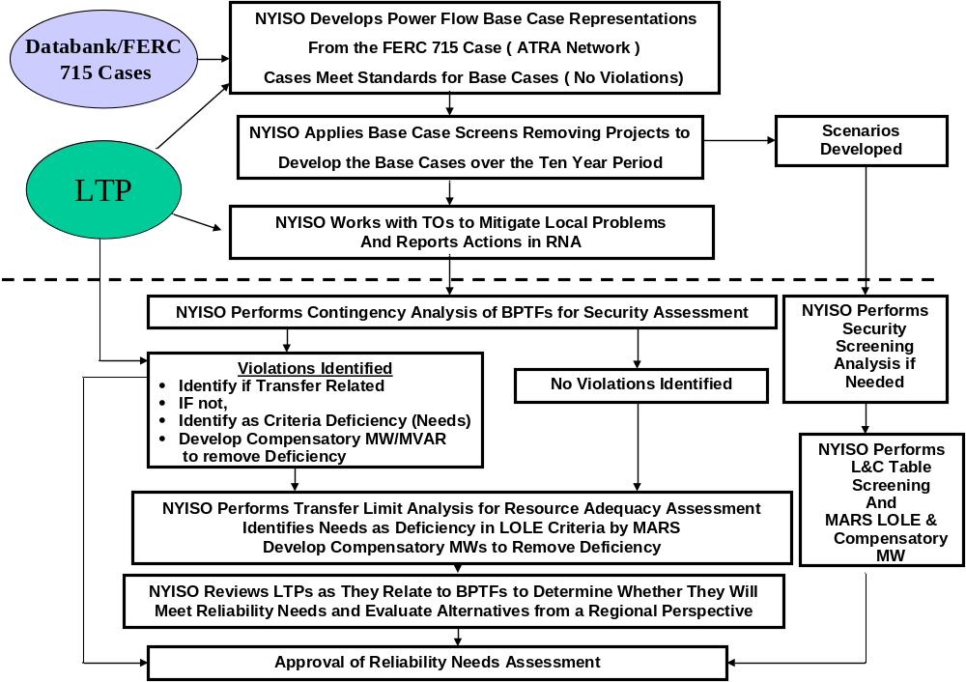
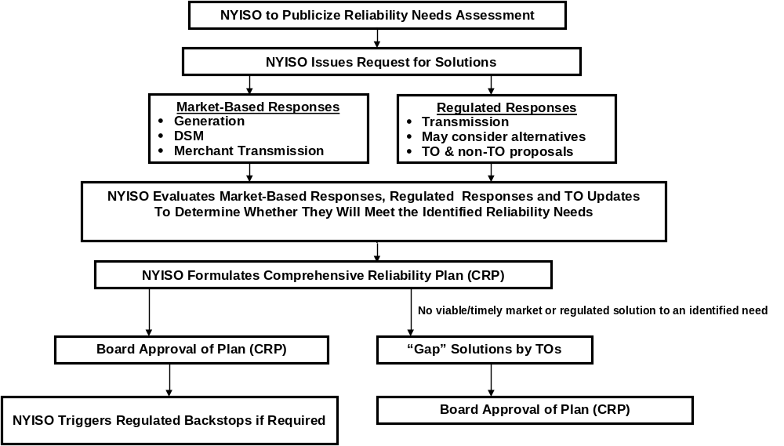
Figure B-1: NYISO Reliability Planning Process

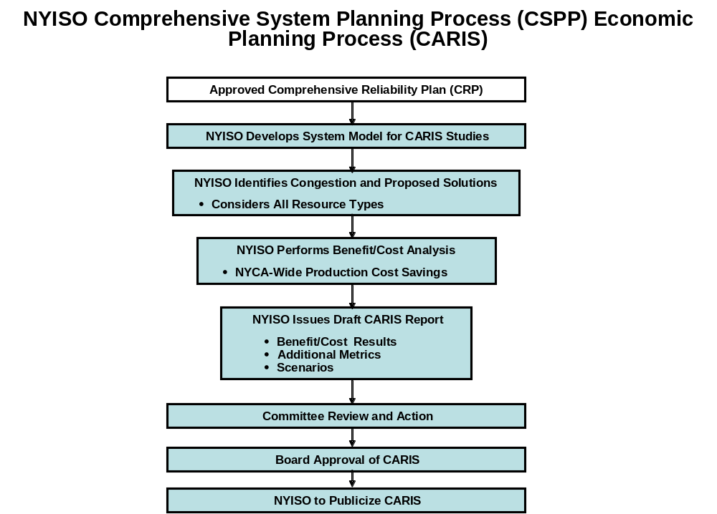
Figure B-2: Economic Planning Process

Appendix C – Load and Energy Forecast 2010-2020

- Introduction
  - Overview
This section describes the annual energy and seasonal peak demand forecasts for the ten year period beginning with 2010 and extending through 2020. It begins with this Executive Summary, continues with an overview of historic electricity and economic trends in New York State, and concludes with the ten-year forecasts of summer and winter peak demands and annual energy requirements.
  - Executive Summary
The NYISO performs the Comprehensive System Planning Process to assess the adequacy of New York’s electricity infrastructure for meeting reliability and market needs over the 2010 – 2020 horizon. As part of this assessment, a ten year forecast of summer and winter peak demands and annual energy requirements was produced.
The electricity forecast is based on projections of New York’s economy performed by Moody's Analytics in January 2010. The forecast includes detailed projections of employment, output, income and other factors for twenty three regions in New York State. A summary of the electricity forecast and the key economic variables that drive it follows.
In June 2008, the Public Service Commission of New York issued its Order regarding the Energy Efficiency Portfolio Standard. This proceeding sets as its goal a cumulative energy reduction of about 26,900 GWh and an estimated 5,500 MW in peak demand. The NYISO included fifty percent of the goal by the year 2020.

Table C-1: Summary of Econometric Forecasts
Economic Indicators | Average Annual Growth
Economic Indicators | 1999-2004 | 2004-2009 | 2010-2015 | 2015-2020
Total Employment | -0.11% | 0.18% | -0.08% | 1.65%
Gross State Product | 2.31% | 2.16% | 0.37% | 3.17%
Population | 0.42% | 0.28% | 0.06% | 0.16%
Total Real Income | 1.58% | 1.29% | 0.51% | 3.27%
Summer Peak (actual data through 2009) | -1.27% | 1.64% | 0.60% | 0.76%
Annual Energy (actual data through 2009) | 0.53% | -0.18% | 0.62% | 0.94%
Employment Trends | Shares of Total Employment
Employment Trends | 2004 | 2010 | 2015 | 2020
Business, Services & Retail | 38.34% | 37.75% | 37.83% | 37.82%
Health, Education, Government, Agriculture | 46.70% | 49.27% | 50.27% | 50.82%
Manufacturing | 14.97% | 12.98% | 11.91% | 11.36%

- Historical Overview
  - NYCA System
Table C-2 shows the New York Control Area’s (NYCA) historic peak and energy growth since 2000.
Table C-2: Historic Peak and Energy Data with Growth Rates
 |  |  |  |  | Summer |  |  | Winter
 |  |  |  |  | Capability Period |  |  | Capability Period
Year |  | Annual GWh | Percent Growth |  | Summer MW | Percent Growth |  | Year | Winter MW | Percent Growth
2000 |  | 156,631 |  |  | 28,138 |  |  | 2000-01 | 23,774
2001 |  | 156,801 | 0.11% |  | 30,982 | 10.11% |  | 2001-02 | 23,713 | -0.26%
2002 |  | 158,752 | 1.24% |  | 30,664 | -1.03% |  | 2002-03 | 24,454 | 3.12%
2003 |  | 158,012 | -0.47% |  | 30,333 | -1.08% |  | 2003-04 | 25,262 | 3.30%
2004 |  | 160,211 | 1.39% |  | 28,433 | -6.26% |  | 2004-05 | 25,541 | 1.10%
2005 |  | 167,208 | 4.37% |  | 32,075 | 12.81% |  | 2005-06 | 25,060 | -1.88%
2006 |  | 162,237 | -2.97% |  | 33,939 | 5.81% |  | 2006-07 | 25,057 | -0.01%
2007 |  | 167,341 | 3.15% |  | 32,169 | -5.21% |  | 2007-08 | 25,021 | -0.14%
2008 |  | 165,613 | -1.03% |  | 32,432 | 0.82% |  | 2008-09 | 24,673 | -1.39%
2009 |  | 158,780 | -4.13% |  | 30,844 | -4.90% |  | 2009-10 | 24,074 | -2.43%
Annual Avg Growth: |  |  | 0.15% |  |  | 1.03% |  |  |  | 0.14%

NYCA is a summer peaking system and its summer peak has grown faster than annual energy and winter peak over this period. Both summer and winter peaks show considerable year-to-year variability due to the influence of extreme weather conditions on the seasonal peaks. Annual energy is influenced by weather conditions over an entire year, which is much less variable.
  - Regional Energy and Seasonal Peaks
Table C-3 shows historic and forecast growth rates of annual energy for the different regions in New York. The Upstate region includes Zones A – I. The NYCA's most critical load centers are Zones J (New York city) and K (Long Island) are shown individually.
Table C-3: Actual and Forecast Annual Energy
Year | Upstate Region | New York City | Long Island | NYCA
2000 | 87,376 | 49,183 | 20,072 | 156,631
2001 | 85,851 | 50,227 | 20,723 | 156,801
2002 | 85,852 | 51,356 | 21,544 | 158,752
2003 | 85,223 | 50,829 | 21,960 | 158,012
2004 | 85,935 | 52,073 | 22,203 | 160,211
2005 | 90,253 | 54,007 | 22,948 | 167,208
2006 | 86,956 | 53,096 | 22,185 | 162,237
2007 | 89,843 | 54,750 | 22,748 | 167,341
2008 | 88,316 | 54,835 | 22,461 | 165,613
2009 | 83,788 | 53,100 | 21,892 | 158,780
2010 | 85,334 | 52,838 | 22,187 | 160,358
2011 | 85,458 | 52,697 | 22,290 | 160,446
2012 | 86,131 | 53,026 | 22,461 | 161,618
2013 | 87,614 | 53,437 | 22,544 | 163,594
2014 | 87,967 | 53,966 | 22,623 | 164,556
2015 | 88,139 | 54,466 | 22,767 | 165,372
2016 | 88,412 | 54,939 | 23,122 | 166,472
2017 | 88,872 | 55,305 | 23,340 | 167,517
2018 | 89,600 | 55,886 | 23,646 | 169,132
2019 | 90,501 | 56,630 | 24,031 | 171,161
2020 | 91,412 | 57,385 | 24,535 | 173,332
2000-09 | -0.5% | 0.9% | 1.0% | 0.2%
2010-20 | 0.7% | 0.8% | 1.0% | 0.8%
2000-04 | -0.4% | 1.4% | 2.6% | 0.6%
2004-09 | -0.5% | 0.4% | -0.3% | -0.2%
2010-15 | 0.6% | 0.6% | 0.5% | 0.6%
2015-20 | 0.7% | 1.0% | 1.5% | 0.9%

- Trends Affecting Electricity in New York
  - 2010 Employment Forecast
The 2010 economic outlook for employment shows a slow recovery from the 2009 recession. Total employment growth does not become positive until 2011. It reaches a rate of 3% by 2013, then slows to a rate of .5% thereafter.

Figure C-1: Annual Employment Growth Rates
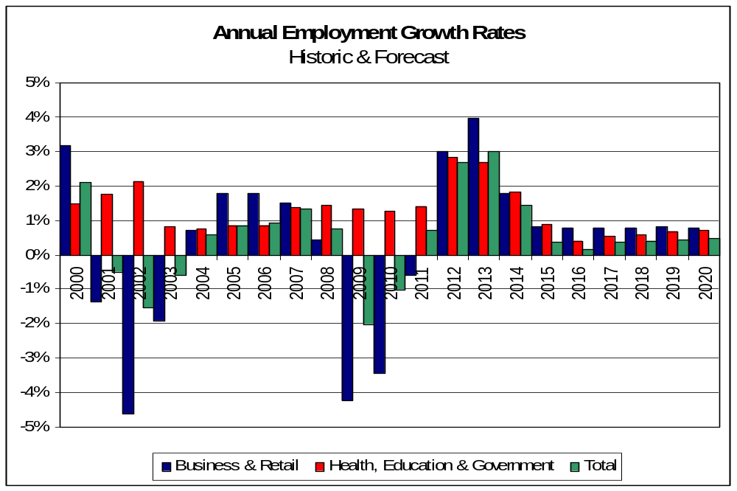

  - 2010 Population Forecast
The 2010 population forecast projects slower population growth in every region of the state. While all growth rates remain positive, we see rates that grow more and more slowly. The largest change in growth is in New York City, where future growth is less than 50% of recent historic growth.
Figure C-2: Annual Change in Population by Region
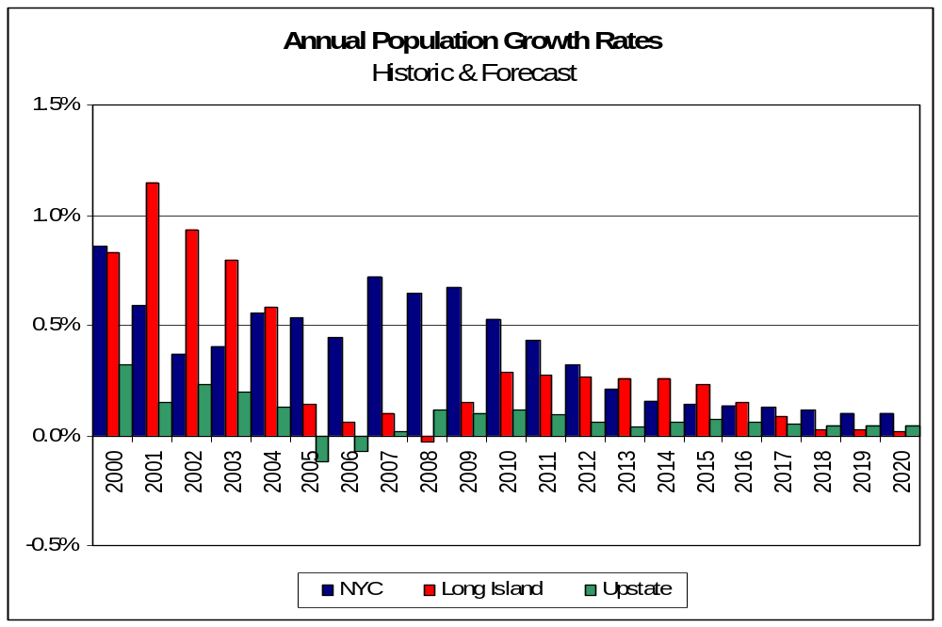

  - 2010 Forecasts of Real Output, Real Income, Employment
Three key economic trends in the state are measured by real gross output, total income, and employment. Real gross output measures the prosperity of business, while real income and employment are indicative of the prosperity of households. The period from 2004 to 2007 showed significant growth in all these metrics. The recession caused them to decline substantially until 2011.
The 2010 forecast projects real economic output growth in the range of 2% through 2020. Real income growth has a similar pattern to output. Employment turns positive but is only growing at a rate of about 0.5%. All indices are characterized by faster growth in the near term followed by slower growth in the long term.

Figure C-3: Annual Growth Rates in Real Output and Income
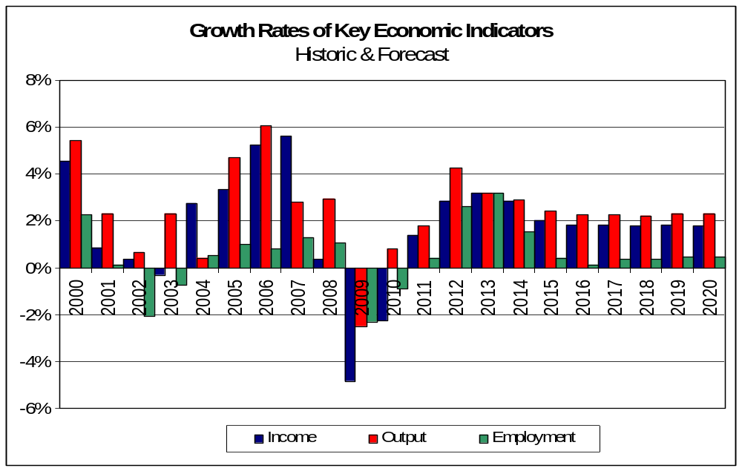

  - Regional Economic Trends
Compared to previous years, there is a greater similarity in economic and electric energy growth throughout the state. The Upstate region (Zones A to I) has slower economic growth and slower energy growth.

Table C-4: Regional Economic Growth Rates of Key Economic Indicators
New York State |  |  |  | New York City
 | Average Annual Growth |  |  |  | Average Annual Growth
Economic Indicators | 1999-2009 | 2010-2020 |  | Economic Indicators | 1999-2009 | 2010-2020
Total Employment | 0.2% | 1.0% |  | Total Employment | 0.3% | 1.1%
Gross Product | 2.5% | 2.6% |  | Gross Product | 3.1% | 3.1%
Population | 0.3% | 0.1% |  | Population | 0.6% | 0.2%
Total Income | 1.6% | 2.1% |  | Total Income | 1.9% | 3.2%
Upstate Regions |  |  |  | Long Island
 | Average Annual Growth |  |  |  | Average Annual Growth
Economic Indicators | 1999-2009 | 2010-2020 |  | Economic Indicators | 1999-2009 | 2010-2020
Total Employment | 0.1% | 0.9% |  | Total Employment | 0.3% | 1.0%
Gross Product | 1.7% | 2.5% |  | Gross Product | 1.9% | 2.1%
Population | 0.1% | 0.1% |  | Population | 0.5% | 0.2%
Total Income | 1.2% | 2.4% |  | Total Income | 1.7% | 2.1%
- Forecast Methodology
The NYISO methodology for producing the long term forecasts for the Reliability Needs Assessment consists of the following steps.
Econometric forecasts were developed for zonal energy using quarterly data from 1993 through 2009. For each zone, we estimated an ensemble of econometric models using population, households, economic output, employment, cooling degree days and heating degree days. Each member of the ensemble was evaluated and compared to historic data. The zonal model chosen for the forecast was the one which best represented recent history and the regional growth for that zone. We also received and evaluated forecasts from Con Edison and LIPA, which were used in combination with the forecasts we developed for Zones H, I, J and K.
The summer & winter non-coincident and coincident peak forecasts for Zones H, I, J and K were derived from the forecasts submitted to the NYISO by Con Edison and LIPA. For the remaining zones, we derived the summer and winter coincident peak demands from the zonal energy forecasts by using average zonal weather-normalized load factors from 2001 through 2009. The 2010 summer peak forecast was matched to coincide with the 2010 ICAP forecast.
- Energy Conservation
The Electric Energy Portfolio Standard (EEPS) is an initiative of the Governor of New York and implemented by the state's Public Service Commission. The goal of the initiative is to reduce electric energy usage by 15 percent from forecasted energy usage levels in the year 2015 (the 15x15 initiative), which translates into a goal of 26,880 GWh by 2015.
The PSC directed a series of working groups composed of all interested parties to the proceeding to obtain information needed to further elaborate the goal. The PSC issued an Order in June 2008, directing NYSERDA and the state's investor owned utilities to develop conservation plans in accordance with the EEPS goal. The PSC also identified goals that it expected would be implemented by LIPA and NYPA.
The NYISO has been a party to the EEPS proceeding from its inception. As part of the development of the 2010 RNA forecast, we developed an adjustment to the 2010 econometric model that incorporated a portion of the EEPS goal. This was based upon discussion with market participants in the Electric System Planning Working Group. We considered the following factors in developing the 2010 RNA base case:
- the approved spending levels of NYPA, LIPA and the PSC,
- the expectation of increased spending levels after 2011,
- the expected realization rates of planned conservation,
- the degree to which energy conservation is already included in the econometric forecast,
- the impacts of new appliance efficiency standards and building codes and standards
- specific conservation plans proposed by LIPA, NYPA and Consolidated -Edison.
- the actual rates of implementation, based on data received from Department of Public Service staff.
The resulting adjusted forecast included approximately 50% of the entire EEPS goal by the year 2020. Once the statewide energy and demand impacts were developed, zonal level forecasts were produced for the econometric forecast and for the base case.

Figure C-5: Zonal Energy Forecast Growth Rates - 2008 to 2018
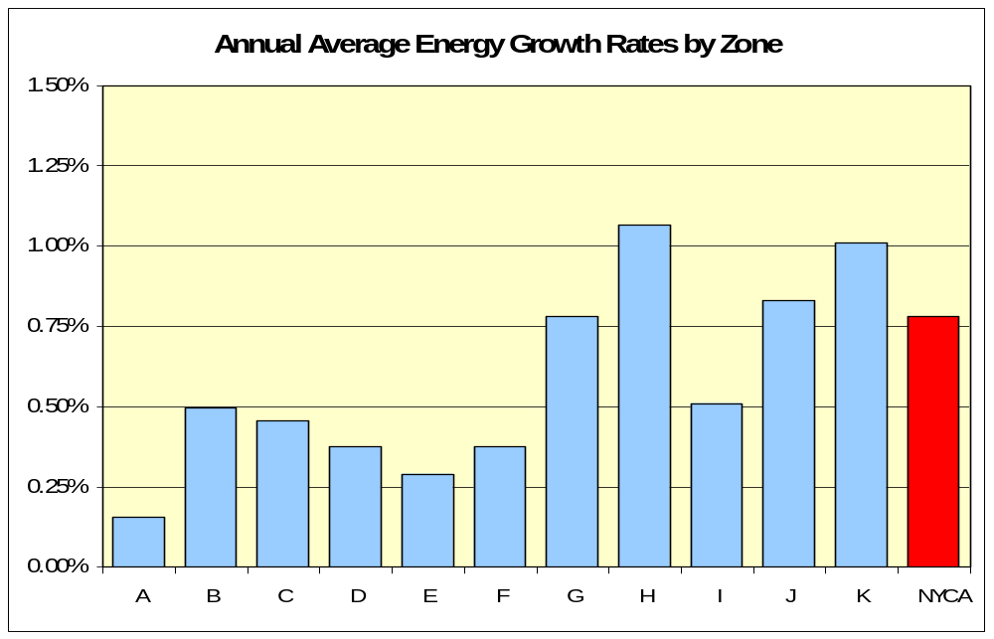

Figure C-6: Zonal Summer Peak Demand Forecast Growth Rates - 2007 to 2017
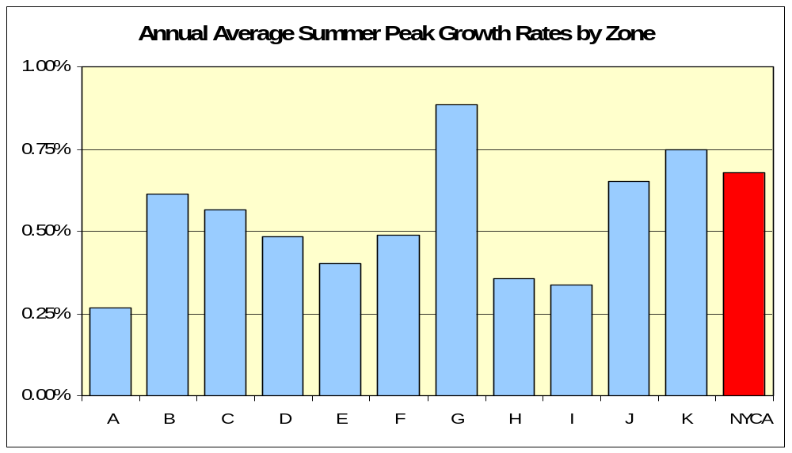
Table C-5: Actual and Forecast Annual Energy by Zone - GWh

Year | A | B | C | D | E | F | G | H | I | J | K | NYCA
2000 | 16,785 | 9,635 | 16,182 | 6,527 | 8,182 | 11,398 | 10,795 | 1,942 | 5,929 | 49,183 | 20,072 | 156,631
2001 | 16,209 | 9,661 | 16,034 | 6,374 | 7,403 | 11,429 | 10,957 | 2,003 | 5,782 | 50,227 | 20,723 | 156,801
2002 | 16,355 | 9,935 | 16,356 | 6,450 | 7,116 | 11,302 | 10,215 | 2,162 | 5,962 | 51,356 | 21,544 | 158,752
2003 | 15,942 | 9,719 | 16,794 | 5,912 | 6,950 | 11,115 | 10,451 | 2,219 | 6,121 | 50,829 | 21,960 | 158,012
2004 | 16,102 | 9,888 | 16,825 | 5,758 | 7,101 | 11,161 | 10,696 | 2,188 | 6,216 | 52,073 | 22,203 | 160,211
2005 | 16,498 | 10,227 | 17,568 | 6,593 | 7,594 | 11,789 | 10,924 | 2,625 | 6,435 | 54,007 | 22,948 | 167,208
2006 | 15,998 | 10,003 | 16,839 | 6,289 | 7,339 | 11,337 | 10,417 | 2,461 | 6,274 | 53,096 | 22,185 | 162,237
2007 | 16,258 | 10,207 | 17,028 | 6,641 | 7,837 | 11,917 | 10,909 | 2,702 | 6,344 | 54,750 | 22,748 | 167,341
2008 | 15,835 | 10,089 | 16,721 | 6,734 | 7,856 | 11,595 | 10,607 | 2,935 | 5,944 | 54,835 | 22,461 | 165,613
2009 | 15,149 | 9,860 | 15,949 | 5,140 | 7,893 | 10,991 | 10,189 | 2,917 | 5,700 | 53,100 | 21,892 | 158,780
2010 | 15,364 | 9,990 | 16,245 | 4,236 | 8,011 | 11,383 | 10,448 | 2,997 | 6,658 | 52,838 | 22,187 | 160,358
2011 | 15,301 | 9,967 | 16,297 | 4,365 | 8,012 | 11,422 | 10,469 | 3,010 | 6,614 | 52,697 | 22,290 | 160,446
2012 | 15,211 | 9,972 | 16,343 | 4,920 | 7,989 | 11,436 | 10,554 | 2,992 | 6,714 | 53,026 | 22,461 | 161,618
2013 | 15,150 | 10,013 | 16,403 | 6,230 | 7,977 | 11,437 | 10,634 | 2,991 | 6,778 | 53,437 | 22,544 | 163,594
2014 | 15,194 | 10,058 | 16,429 | 6,358 | 7,959 | 11,439 | 10,669 | 3,037 | 6,823 | 53,966 | 22,623 | 164,556
2015 | 15,189 | 10,068 | 16,462 | 6,385 | 7,945 | 11,443 | 10,707 | 3,083 | 6,856 | 54,466 | 22,767 | 165,372
2016 | 15,202 | 10,103 | 16,494 | 6,397 | 7,970 | 11,464 | 10,754 | 3,131 | 6,896 | 54,939 | 23,122 | 166,472
2017 | 15,263 | 10,174 | 16,578 | 6,431 | 8,021 | 11,522 | 10,830 | 3,165 | 6,890 | 55,305 | 23,340 | 167,517
2018 | 15,352 | 10,262 | 16,692 | 6,489 | 8,084 | 11,601 | 10,952 | 3,216 | 6,952 | 55,886 | 23,646 | 169,132
2019 | 15,476 | 10,377 | 16,846 | 6,559 | 8,167 | 11,708 | 11,119 | 3,271 | 6,978 | 56,630 | 24,031 | 171,161
2020 | 15,602 | 10,494 | 17,001 | 6,625 | 8,249 | 11,815 | 11,289 | 3,332 | 7,004 | 57,385 | 24,535 | 173,332

Table C-6: Actual and Forecast Summer Coincident Peak Demand - MW

Year | A | B | C | D | E | F | G | H | I | J | K | NYCA
2000 | 2,462 | 1,644 | 2,459 | 757 | 1,185 | 1,872 | 2,176 | 417 | 1,265 | 9,771 | 4,130 | 28,138
2001 | 2,519 | 1,889 | 2,719 | 780 | 1,260 | 2,068 | 2,361 | 537 | 1,347 | 10,602 | 4,900 | 30,982
2002 | 2,631 | 1,842 | 2,787 | 777 | 1,252 | 2,073 | 2,076 | 498 | 1,335 | 10,321 | 5,072 | 30,664
2003 | 2,510 | 1,782 | 2,727 | 671 | 1,208 | 2,163 | 2,146 | 498 | 1,395 | 10,240 | 4,993 | 30,333
2004 | 2,493 | 1,743 | 2,585 | 644 | 1,057 | 1,953 | 2,041 | 475 | 1,280 | 9,742 | 4,420 | 28,433
2005 | 2,726 | 1,923 | 2,897 | 768 | 1,314 | 2,164 | 2,236 | 592 | 1,409 | 10,810 | 5,236 | 32,075
2006 | 2,735 | 2,110 | 3,128 | 767 | 1,435 | 2,380 | 2,436 | 596 | 1,467 | 11,300 | 5,585 | 33,939
2007 | 2,592 | 1,860 | 2,786 | 795 | 1,257 | 2,185 | 2,316 | 595 | 1,438 | 10,970 | 5,375 | 32,169
2008 | 2,611 | 2,001 | 2,939 | 801 | 1,268 | 2,270 | 2,277 | 657 | 1,399 | 10,979 | 5,231 | 32,432
2009 | 2,608 | 1,939 | 2,780 | 721 | 1,420 | 2,188 | 2,178 | 600 | 1,323 | 10,661 | 5,194 | 30,844
2010 | 2,609 | 1,969 | 2,829 | 520 | 1,423 | 2,260 | 2,288 | 623 | 1,494 | 11,725 | 5,286 | 33,025
2011 | 2,605 | 1,970 | 2,844 | 537 | 1,426 | 2,274 | 2,297 | 624 | 1,494 | 11,775 | 5,314 | 33,160
2012 | 2,595 | 1,975 | 2,858 | 607 | 1,425 | 2,282 | 2,321 | 627 | 1,503 | 11,815 | 5,360 | 33,367
2013 | 2,591 | 1,988 | 2,875 | 768 | 1,427 | 2,287 | 2,344 | 633 | 1,515 | 11,925 | 5,383 | 33,737
2014 | 2,603 | 2,001 | 2,885 | 786 | 1,426 | 2,292 | 2,356 | 635 | 1,519 | 11,995 | 5,398 | 33,897
2015 | 2,604 | 2,005 | 2,894 | 790 | 1,425 | 2,294 | 2,367 | 636 | 1,524 | 12,065 | 5,417 | 34,021
2016 | 2,609 | 2,013 | 2,902 | 792 | 1,431 | 2,301 | 2,379 | 638 | 1,528 | 12,120 | 5,481 | 34,193
2017 | 2,621 | 2,028 | 2,918 | 796 | 1,440 | 2,313 | 2,397 | 640 | 1,531 | 12,218 | 5,513 | 34,414
2018 | 2,637 | 2,046 | 2,939 | 804 | 1,452 | 2,331 | 2,425 | 644 | 1,540 | 12,298 | 5,557 | 34,672
2019 | 2,658 | 2,069 | 2,966 | 813 | 1,466 | 2,351 | 2,461 | 645 | 1,543 | 12,404 | 5,611 | 34,986
2020 | 2,680 | 2,093 | 2,993 | 821 | 1,481 | 2,372 | 2,498 | 646 | 1,546 | 12,510 | 5,695 | 35,334

Table C-7: Actual and Forecast Winter Coincident Peak Demand

Year | A | B | C | D | E | F | G | H | I | J | K | NYCA
2000-01 | 2,489 | 1,510 | 2,506 | 880 | 1,263 | 1,798 | 1,690 | 366 | 877 | 7,206 | 3,188 | 23,773
2001-02 | 2,248 | 1,455 | 2,340 | 843 | 1,129 | 1,742 | 1,626 | 344 | 860 | 7,013 | 3,198 | 22,798
2002-03 | 2,418 | 1,507 | 2,679 | 925 | 1,223 | 1,903 | 1,590 | 437 | 927 | 7,373 | 3,472 | 24,454
2003-04 | 2,433 | 1,576 | 2,755 | 857 | 1,344 | 1,944 | 1,720 | 478 | 981 | 7,527 | 3,647 | 25,262
2004-05 | 2,446 | 1,609 | 2,747 | 918 | 1,281 | 1,937 | 1,766 | 474 | 939 | 7,695 | 3,729 | 25,541
2005-06 | 2,450 | 1,544 | 2,700 | 890 | 1,266 | 1,886 | 1,663 | 515 | 955 | 7,497 | 3,581 | 24,947
2006-07 | 2,382 | 1,566 | 2,755 | 921 | 1,274 | 1,888 | 1,638 | 504 | 944 | 7,680 | 3,505 | 25,057
2007-08 | 2,336 | 1,536 | 2,621 | 936 | 1,312 | 1,886 | 1,727 | 524 | 904 | 7,643 | 3,596 | 25,021
2008-09 | 2,274 | 1,567 | 2,533 | 930 | 1,289 | 1,771 | 1,634 | 529 | 884 | 7,692 | 3,570 | 24,673
2009-10 | 2,330 | 1,555 | 2,558 | 648 | 1,289 | 1,788 | 1,527 | 561 | 813 | 7,562 | 3,443 | 24,074
2010-11 | 2,234 | 1,521 | 2,523 | 590 | 1,345 | 1,792 | 1,638 | 580 | 956 | 7,587 | 3,523 | 24,289
2011-12 | 2,225 | 1,517 | 2,531 | 608 | 1,345 | 1,799 | 1,642 | 582 | 950 | 7,567 | 3,539 | 24,304
2012-13 | 2,212 | 1,518 | 2,538 | 685 | 1,341 | 1,801 | 1,655 | 579 | 964 | 7,614 | 3,566 | 24,473
2013-14 | 2,203 | 1,524 | 2,548 | 867 | 1,339 | 1,801 | 1,668 | 579 | 973 | 7,673 | 3,579 | 24,754
2014-15 | 2,210 | 1,531 | 2,552 | 885 | 1,336 | 1,801 | 1,673 | 588 | 980 | 7,749 | 3,592 | 24,896
2015-16 | 2,209 | 1,532 | 2,557 | 889 | 1,334 | 1,802 | 1,679 | 597 | 984 | 7,821 | 3,615 | 25,018
2016-17 | 2,211 | 1,538 | 2,562 | 891 | 1,338 | 1,805 | 1,686 | 606 | 990 | 7,889 | 3,671 | 25,186
2017-18 | 2,220 | 1,549 | 2,575 | 895 | 1,346 | 1,814 | 1,698 | 612 | 989 | 7,941 | 3,706 | 25,346
2018-19 | 2,232 | 1,562 | 2,593 | 903 | 1,357 | 1,827 | 1,717 | 622 | 998 | 8,025 | 3,754 | 25,591
2019-20 | 2,251 | 1,579 | 2,616 | 913 | 1,371 | 1,843 | 1,744 | 633 | 1,002 | 8,132 | 3,815 | 25,899
2020-21 | 2,269 | 1,597 | 2,640 | 922 | 1,385 | 1,860 | 1,770 | 645 | 1,006 | 8,240 | 3,895 | 26,230

Appendix D – Transmission System Assessment
A key element underlying the determination of Reliability Needs is an assessment to determine if the transmission system meets reliability criteria, and to establish the transfer limits to be used in the Multi-Area Reliability Simulation (MARS) model. This assessment is conducted through a series of power flow, stability and short circuit studies.
In general, the RNA analyses indicated that the bulk power transmission system can be secured, but that transfer limits for certain key interfaces must be reduced in order to respect voltage collapse criteria. However, a reduction in transfer limits or a limiting interface can result in higher LOLE findings and/or needs occurring earlier than they otherwise would. As a result, LOLE analysis was conducted for the RNA Base Case, a case with thermal limits, and finally a case with no internal NYCA transmission limits. These cases were conducted to demonstrate the impact that transmission limits have on the LOLE results.
D-1 Development of RNA Base Case System Cases
The NYISO developed the system representation for the second five years of the Study Period starting with the NPCC CP-8 2010 Summer Assessment Base Case and using: 1) the most recent Load and Capacity Data Report published by the NYISO on its Web site; 2) the most recent versions of NYISO reliability analyses and assessments provided for or published by NERC, NPCC, NYSRC, and neighboring control areas; 3) information reported by neighboring control areas such as power flow data, forecasted load, significant new or modified generation and transmission facilities, and anticipated system conditions that the NYISO determines may impact the bulk power transmission facilities (BPTF); 4) Market Participant input; and 5) procedures set forth in the CRPP manual. Based on this process, the network model for the second five-year period incorporates TO and neighboring system plans in addition to those incorporated in the Five Year Base Cases. The changes in the MW and MVAr components of the load model were made to maintain a constant power factor.
The 2010 RNA Base Case model of the New York bulk power system includes the following new and proposed facilities and forecasts in the Gold Book:
- TO projects on non-bulk power facilities included in the FERC 715 Cases
- Facilities that have accepted their Attachment S cost allocations and are in service or under construction as of April 1, 2010
- Facilities that have obtained a PSC Certificate (or other regulatory approvals and SEQRA review) and an approved System Reliability Impact Study (“SRIS”) and an executed contract with a credit-worthy entity.
- Transmission upgrades related to any projects and facilities that are included in the RNA Base Case, as defined above
- TO plans identified in the 2010 Gold Book as firm plans
- Facility reratings and uprates
- Scheduled retirements
- Special Case Resources (SCR) and the impacts of the NYSPSC EEPS Order, as developed and reviewed at the ESPWG
- External System Modeling.
The RNA Base Case does not include all projects currently listed on the NYISO’s interconnection queue or those shown in the 2010 Gold Book. It includes only those which meet the screening requirements for inclusion.

The RNA Base Case was developed from the NPCC CP-8 2010 summer assessment system representation for Ontario, New England, and Hydro Quebec. The PJM representation was based upon the NPCC CP-8 2009 summer assessment data. These data bases included load forecasts for each of the Areas 2010 through 2013 and a New England load forecast from 2014 to 2019. The PJM load forecast for 2014 to 2019 was developed by applying the growth rate (ratio of load for each year between 2014-2019) indicated in the PJM 2010 Load Forecast Report Data. The Ontario and Hydro Quebec load for 2014-2019 was derived from the most recent NPCC Load, Capacity, Energy, Fuel, and Transmission Report.

In order to avoid overdependence from emergency assistance from Outside World Areas, the Outside World Area’s emergency operating procedure data was removed. Capacity of the Outside World areas was further modified so that the LOLE value of the Areas (Ontario, New England, Hydro Quebec, and PJM) was not less than 0.10 and not greater than 0.15. Table D-1 illustrates the MOD-MW data.

Table D-1
MOD-MW Data To Avoid Overdependence From
Emergency Assistance From Outside World Areas

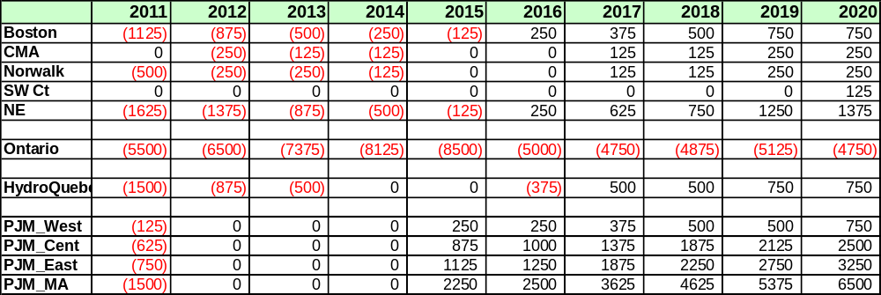

D-2 Emergency Thermal Transfer Limit Analysis
The NYISO performed an analysis of RNA Base Case emergency thermal transfer limits for the key interfaces used in the MARS Resource Adequacy analysis. Table D-2 illustrates the emergency thermal transfer limits for the RNA base system conditions:
Table D-2: Emergency Thermal Transfer Limits
 | 2011 |  | 2012 |  | 2013 |  | 2014 |  | 2015
Dysinger East | 1 | 2725 | 1 | 3125 |  | 3200 | 1 | 3175 | 1 | 3175
West Central | 1 | 1475 | 1 | 1875 |  | 1850 | 1 | 1900 | 1 | 1900
Moses South | 2 | 2475 | 3 | 2650 | 3 | 2650 | 3 | 2650 | 3 | 2650
Volney East | 4 | 5675 | 4 | 5700 | 4 | 5800 | 4 | 5775 | 4 | 5750
Total East | 5 | 5929 | 6 | 6066 | 6 | 6009 | 6 | 5977 | 6 | 5880
Central East less PV-20  plus Fraser-Gilboa | 5 | 3250 | 5 | 3525 | 5 | 3475 | 5 | 3475 | 5 | 3400
F to G | 7 | 3500 | 7 | 3475 | 7 | 3475 | 7 | 3475 | 7 | 3525
UPNY-SENY less Ramapo 500kV tie | 7 | 5250 | 7 | 5400 | 7 | 5400 | 7 | 5400 | 7 | 5475
I to J | 8 | 4350 | 8 | 4350 | 8 | 4350 | 8 | 4350 | 8 | 4400
I to K | 9 | 1290 | 9 | 1290 | 9 | 1290 | 9 | 1290 | 9 | 1290

 | Limiting Facility | Limiting Rating | Contingency
1 | Wethersfield-Meyer 230 kV | 430 | Pre-disturbance
2 | Browns Falls-Taylorville 115 kV | 134 | Chateaguay-Massena and  Massena-Marcy 765 kV
3 | Marcy 765/345 T2 transformer | 1971 | Marcy 765/345 T1 transformer
4 | Oakdale-Fraser 345kV | 1380 | Edic-Fraser 345kV
5 | New Scotland-Leeds 345kV | 1724 | New Scotland-Leeds 345kV
6 | Fraser-Coopers Corners 345 kV | 1207 | Pre-disturbance
7 | Leeds-Pleasant Valley 345 kV | 1725 | Athens-Pleasant Valley 345 kV
8 | Mott Haven-Rainey 345 kV | 1196 | Mott Haven-Rainey 345 kV
9 | Dunwoodie-Shore Rd 345 kV | 653 | Pre-disturbance

The variations in through-time transfer limits are due to the differences in generation dispatch and other factors.

D-3 Development of the MARS Topology
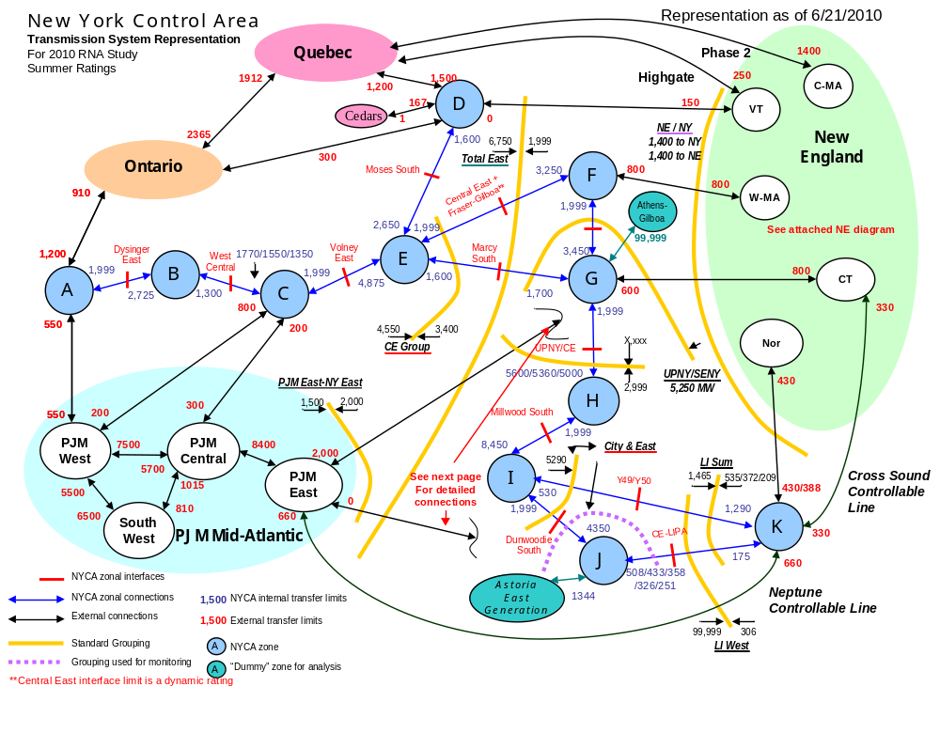
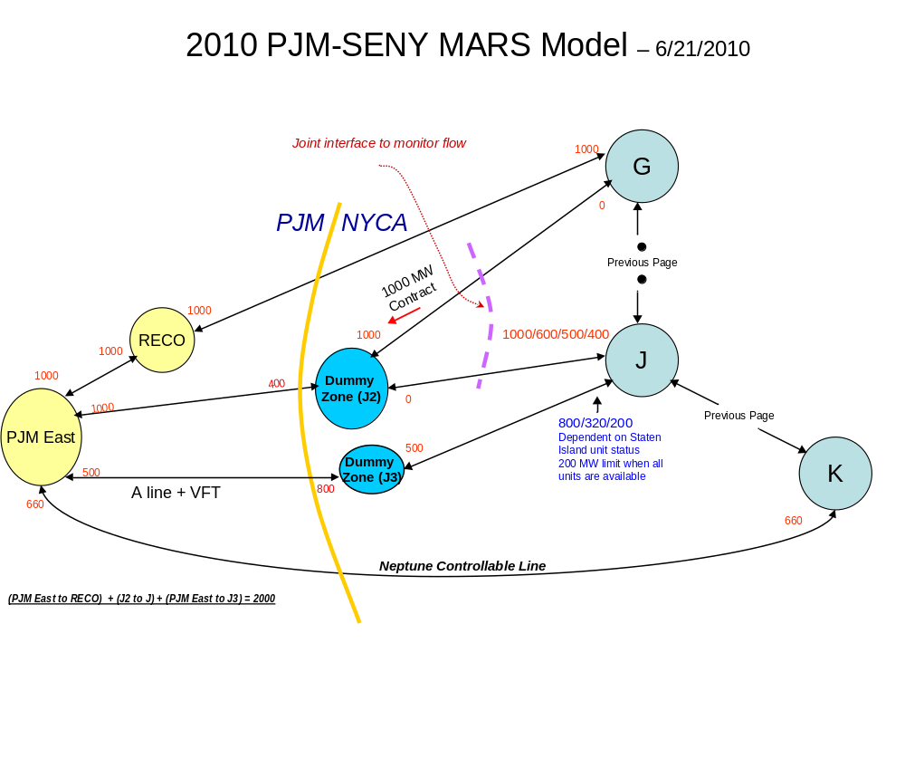
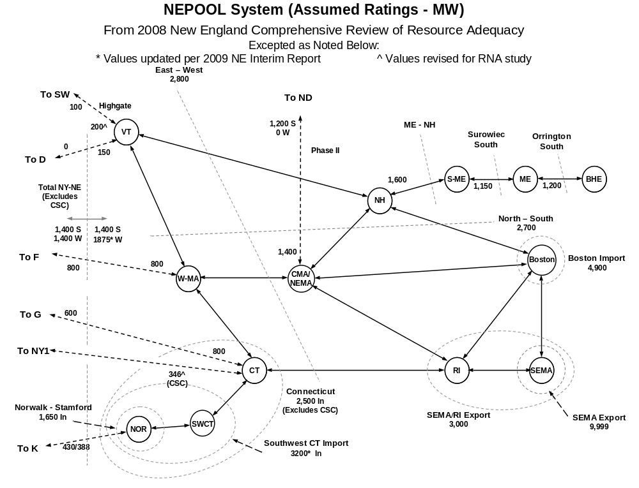
D-4 Short Circuit Assessment
Table D-3 provides the results of NYISO’s short circuit screening test. Individual breaker assessment (IBA) is required for any breakers whose rating is exceeded by the maximum fault current. Either NYISO or the Transmission Owner may complete the IBA.

Table D- 3: 2010 RNA Fault Current Analysis Summary Table
 |  | Maximum | Lowest | IBA Needed
BUS | KV | Phase Current | Rated CB | Y/N
MARCY 765 | 765 | 9.7 | 63 | N
MASSENA 765 | 765 | 7.9 | 63 | N
RAMAPO | 500 | 15.1 | none | n/a
AES SOMERSET | 345 | 17.9 | 32 | N
ALPS | 345 | 17.8 | 40 | N
ATHENS | 345 | 34 | 50 | N
BOWLINE 2 | 345 | 27.1 | 40 | N
BOWLINE1 | 345 | 27.1 | 40 | N
BUCHAN N | 345 | 29.5 | 63 | N
BUCHAN S | 345 | 39.3 | 40 | N
CLAY | 345 | 34 | 50 | N
COOPERS CRN | 345 | 15.4 | 32 | N
DEWITT | 345 | 19.3 | 40 | N
DUNWOODIE | 345 | 52 | 63 | N
E FISHKILL | 345 | 39.7 | 63 | N
E15ST 45 | 345 | 58.2 | none | n/a
EDIC | 345 | 32.5 | 40 | N
EGC PAR | 345 | 25.8 | 63 | N
ELBRIDGE | 345 | 16.4 | 40 | N
EV 56-2 | 345 | 35 | none | n/a
FARRAGUT | 345 | 64.9 | 63 | Y
FITZPATRICK | 345 | 42.9 | 37 | Y
FR KILLS | 345 | 41.7 | 63 | N
FRASER | 345 | 17.5 | 29.6 | N
GILBOA 345 | 345 | 25.4 | 40 | N
GOETHL N | 345 | 47.1 | 63 | N
GOETHL S | 345 | 47.1 | 63 | N
GOW N | 345 | 53.2 | 63 | N
GOW S | 345 | 52.3 | 63 | N
HURLEY | 345 | 17.3 | 40 | N
INDEPENDENCE | 345 | 39.6 | 50 | N
LADENTOWN | 345 | 39.5 | 63 | N
LAFAYETTE | 345 | 18.3 | 40 | N
LEEDS | 345 | 34.6 | 40 | N
MARCY 345 | 345 | 31.7 | 63 | N
MIDDLETN TAP | 345 | 16 | 63 | N
MILLWOOD | 345 | 45.6 | 63 | N
MOTT HAVEN | 345 | 52.6 | 63 | N
NIAGARA 345 | 345 | 33.7 | 63 | N
NMP#1 | 345 | 45.3 | 50 | N
NSCOT 99B | 345 | 31.6 | 32 | N
OAKDALE 345 | 345 | 12.7 | 29.6 | N
OSWEGO | 345 | 32.7 | 50 | N
PLEASANT VAL | 345 | 41.3 | 63 | N
POLETTI | 345 | 48.6 | 63 | N
PVILLE-1 | 345 | 22 | 63 | N
RAINEY | 345 | 60 | 63 | N
RAMAPO | 345 | 43.7 | 63 | N
REYNOLDS | 345 | 14.8 | none | n/a
ROCK TAVERN | 345 | 26.3 | 38 | N
Roseton | 345 | 34.9 | 38 | N
S.MAH-A | 345 | 34.2 | 40 | N
S.MAH-B | 345 | 33.9 | 40 | N
S080 345kV | 345 | 17.1 | 32 | N
S122 | 345 | 17 | 32 | N
SCRIBA | 345 | 48.9 | 50 | N
SHORE RD | 345 | 28.3 | 63 | N
SPRN BRK | 345 | 53.4 | 63 | N
STOLLE ROAD | 345 | 4 | 32 | N
TREMONT | 345 | 33.5 | none | n/a
VOLNEY | 345 | 37.4 | 40 | N
W 49 ST | 345 | 54.6 | 63 | N
W.HAV345 | 345 | 28.5 | none | n/a
WATERCURE345 | 345 | 7.9 | 29.6 | N
WOOD ST A | 345 | 22.1 | none | n/a
WOOD ST B | 345 | 25.4 | none | n/a
ADIRONDACK | 230 | 9.7 | 25 | N
DUNKIRK | 230 | 15.5 | 26 | N
GARDENVILLE1 | 230 | 23.4 | 30 | N
HILLSIDE 230 | 230 | 11.8 | 28.6 | N
HUNTLEY | 230 | 27.1 | 27 | Y
MEYER | 230 | 6.6 | 28.6 | N
NIAGRA E 230 | 230 | 56.9 | 63 | N
OAKDALE | 230 | 6.4 | none | n/a
PACKARD | 230 | 43.7 | 50 | N
PORTER | 230 | 19.6 | 25 | N
ROBINSON RD. | 230 | 14.5 | 34.4 | N
ROTTERDAM66H | 230 | 12.6 | 20 | N
S RIPLEY | 230 | 9.1 | 40 | N
ST LAWRN 230 | 230 | 33.6 | 37 | N
STOLLE ROAD | 230 | 14 | 28.6 | N
WATERCURE230 | 230 | 11.7 | 26.4 | N
WILLIS 230 | 230 | 11.8 | 37 | N
AST-EAST-E | 138 | 57.2 | 63 | N
AST-WEST-N | 138 | 46.7 | 45 | Y
BARRETT1 | 138 | 49.3 | 59.2 | N
BRKHAVEN | 138 | 26.6 | 35.4 | N
BUCHANAN | 138 | 15.9 | 40 | N
CORONA N. | 138 | 55.3 | 63 | N
DUN NO | 138 | 34.2 | 40 | N
DUN SO | 138 | 30.9 | 40 | N
E 13 ST | 138 | 48.6 | 63 | N
E 179 ST | 138 | 49.4 | 63 | N
EASTVIEW | 138 | 37.2 | 63 | N
EGC-1 | 138 | 72.8 | 80 | N
FOXHLS 1 | 138 | 34.5 | 63 | N
FOXHLS 2 | 138 | 34.9 | 40 | N
FR KILLS | 138 | 38 | 40 | N
FREEPORT | 138 | 36.3 | 63 | N
GRENWOOD | 138 | 51.5 | 63 | N
HOLBROOK | 138 | 47.9 | 52.2 | N
JAMAICA | 138 | 48.4 | 45 | Y
LKE SCSS1 | 138 | 39.7 | 57.8 | N
MILLWOOD | 138 | 19.5 | 20 | N
NEWBRID | 138 | 73.7 | 80 | N
NRTHPRT1 | 138 | 60.4 | 56.2 | Y
NRTHPRT2 | 138 | 60.4 | 56.2 | Y
PILGRIM | 138 | 59.9 | 63 | N
PT JEFF | 138 | 32.2 | 63 | N
QUEENSBG | 138 | 44.8 | 63 | N
RIVERHD | 138 | 18.7 | 63 | N
RULND RD | 138 | 46 | 63 | N
SHM CRK | 138 | 46.1 | 63 | N
SHORE RD1 | 138 | 49.5 | 57.8 | N
SHOREHAM1 | 138 | 25.2 | 52.2 | N
TREMNT11 | 138 | 43.3 | 63 | N
VERNON E | 138 | 43.1 | 40 | Y
VERNON W | 138 | 34.8 | 40 | N
VLY STRM2 | 138 | 53.5 | 57.8 | N
CLAY | 115 | 38 | 60 | N
PORTER | 115 | 41.5 | 43 | N
Tables D-4 provides the results of NYISO’s IBA for Farragut 345kV, Fitzpatrick 345kV, Astoria West 138kV, Jamacia 138kV and Northport 138 kV. Table D-4 provides the results of National Grid’s IBA for Clay 115kV, Leeds 345 kV, New Scotland 345kV, Porter 115 kV and 230kV, Scriba 345 kV and Volney 345 kV.
Table D-4: NYISO IBA for 2010 RNA Study
 | FARRAGUT 345 KV
Breaker ID | Rating (kA) | 1LG (kA) | 2LG (kA) | 3LG (kA) | Overduty
1E | 63 | 63.885 | 64.917 | 60.567 | Y
2E | 63 | 63.885 | 64.917 | 60.567 | Y
3E | 63 | 63.540 | 64.595 | 60.261 | Y
4E | 63 | 63.467 | 64.612 | 60.289 | Y
5E | 63 | 63.885 | 64.917 | 60.567 | Y
6E | 63 | 63.885 | 64.917 | 60.567 | Y
7E | 63 | 63.195 | 64.561 | 60.283 | Y
8E | 63 | 63.195 | 64.561 | 60.283 | Y
9E | 63 | 63.885 | 64.917 | 60.567 | Y
10E | 63 | 63.885 | 64.917 | 60.567 | Y
11E | 63 | 53.281 | 55.841 | 52.622 | N
1W | 63 | 63.885 | 64.917 | 60.567 | Y
2W | 63 | 63.885 | 64.917 | 60.567 | Y
3W | 63 | 63.885 | 64.917 | 60.567 | Y
4W | 63 | 63.885 | 64.917 | 60.567 | Y
5W | 63 | 62.803 | 64.196 | 60.009 | Y
6W | 63 | 63.143 | 64.152 | 59.818 | Y
7W | 63 | 63.143 | 64.153 | 59.818 | Y
8W | 63 | 63.491 | 64.612 | 60.293 | Y
9W | 63 | 63.885 | 64.917 | 60.567 | Y
10W | 63 | 63.885 | 64.917 | 60.567 | Y
11W | 63 | 54.482 | 56.462 | 51.378 | N
 | FITZPATRICK 345 KV
Breaker ID | Rating (kA) | 1LG (kA) | 2LG (kA) | 3LG (kA) | Overduty
10042 | 37 | 35.663 | 36.923 | 33.423 | N
 | AST-WEST 138kV
Breaker ID | Rating (kA) | 1LG (kA) | 2LG (kA) | 3LG (kA) | Overduty
G1N | 45 | 44.156 | 42.406 | 38.984 | N
G2N | 45 | 44.156 | 42.406 | 38.984 | N
 | JAMAICA 138 KV
Breaker ID | Rating (kA) | 1LG (kA) | 2LG (kA) | 3LG (kA) | Overduty
1 | 45 | 36.614 | 40.301 | 39.05 | N
 | NORTHPORT 138 KV
Breaker ID | Rating (kA) | 1LG (kA) | 2LG (kA) | 3LG (kA) | Overduty
1310 | 56.2 | 50.247 | 51.733 | 52.232 | N
1320 | 56.2 | 50.22 | 51.772 | 52.249 | N
1450 | 56.2 | 51.339 | 50.469 | 49.14 | N
1460 | 56.2 | 27.255 | 29.617 | 31.112 | N
1470 | 56.2 | 32.206 | 32.637 | 32.822 | N

Appendix E – Environmental Scenarios

Background
  - New York has a long history in the active development of environmental policies and regulations that govern the permitting, construction and operation of power generation and transmission facilities. Two noteworthy policy initiatives where New York has preceded national environmental programs include the regulation of power plant emissions to curb acid rain, and the more recently promulgated regional program to limit power plant emissions of carbon dioxide and other greenhouse gases. Such initiatives along with other environmental regulatory programs have led to significant investments in emission control equipment for many generating plants in New York, while other older less efficient and higher emitting facilities have been retired. Currently New York’s standards for permitting new generating facilities are among the most stringent in the nation.

  - The combined result of these strict environmental standards and competitive markets administered by the NYISO since 1999 has been retirement of older plants representing 3000 MW of capacity and the addition of over 7,000 MW of new efficient generating capacity. This has resulted in a marked reduction of power plant emissions and a significant improvement in the efficiency of the generation fleet as shown in Figures E-1 through E-3 below.

Figure E-1 New York State Power Plant Emissions Rates

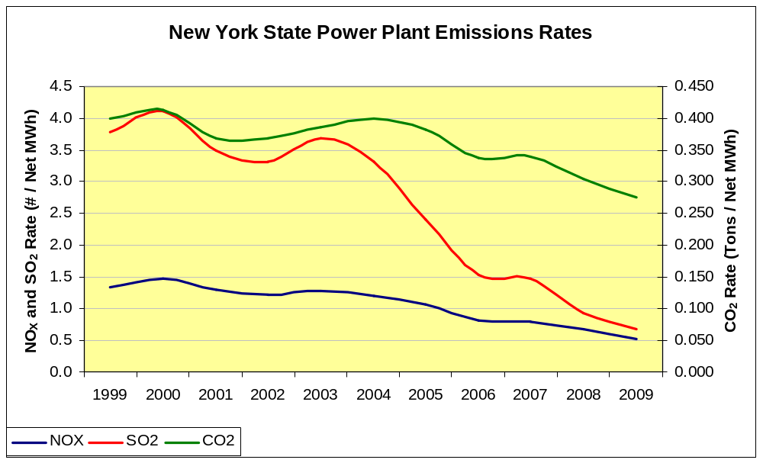

Figure E-2 New York State Power Plant Emissions
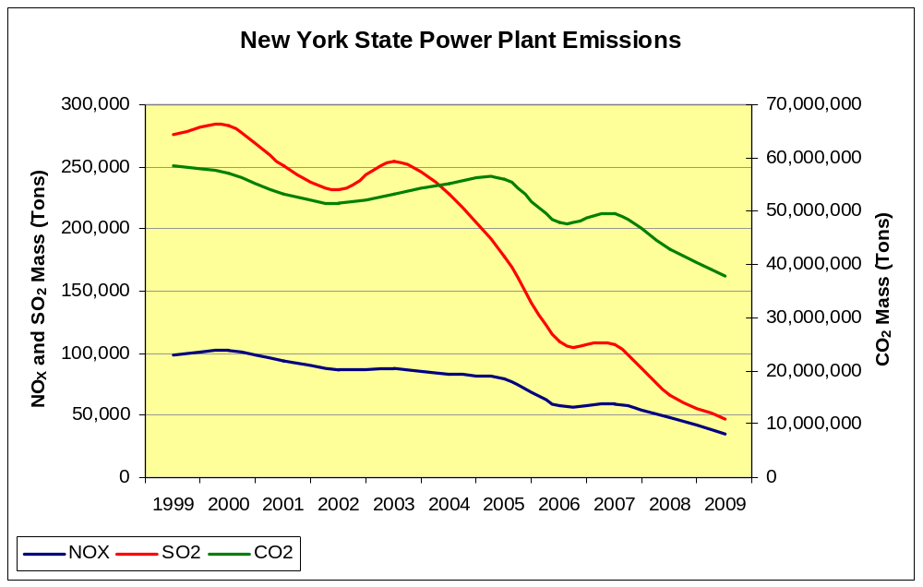

Figure E-3 New York State Power Plant Heat Rates
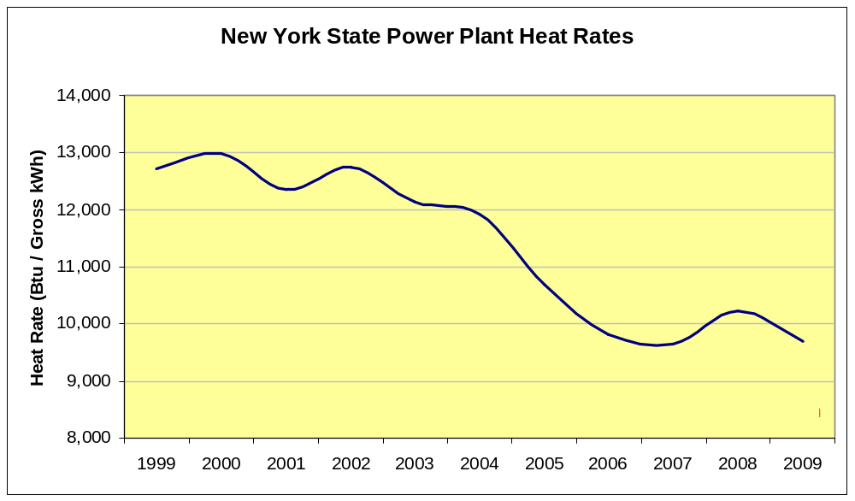

  - Notwithstanding the remarkable progress towards achieving New York’s clean energy and environmental goals, more remains to be accomplished. While the 2009 New York State Energy Plan (http://www.nysenergyplan.com/stateenergyplan.html) provides a long range vision and framework for New York’s clean energy economy and provides guidelines for New York State policymakers, much of the immediate environmental objectives and regulatory developments that are impacting New York’s energy markets now and in the near-term are mapped out by the State’s Department of Environmental Conservation (NYSDEC) in the annual publication of its regulatory agenda. This agenda describes the new environmental initiatives that it will focus in the coming year. The 2010 agenda can be found at http://www.dos.state.ny.us/info/register/2010/jan6/pdfs/regagenda.pdf. The U.S. Environmental Protection Agency also publishes a similar report on its regulatory agenda which can be found at http://www.reginfo.gov/public/do/eAgendaMain;jsessionid=9f8e890430d77ed37246b4ab417e9961cfca348ec55b.e34ObxiKbN0Sci0RbxaSc3qRc3n0n6jAmljGr5XDqQLvpAe?operation=OPERATION_GET_AGENCY_RULE_LIST&currentPub=true&agencyCd=2000&Image58.x=36&Image58.y=15. The environmental initiatives that may affect generation resources may be driven by either or both the State or federal programs.

  - One of the purposes of the RNA is to identify possible future outcomes that could lead to insufficient resources in the NYS Power System to satisfy applicable reliability criteria. For example, such a situation may result from load growth rates exceeding the NYISO’s base case forecast, the failure of new resources to successfully achieve commercial operation as planned, or the unplanned retirement of a significant amount of capacity provided by existing resources. The purpose of the development of this “Environmental Scenario” is to gain insight into population of resources that are likely to be faced with major capital investment decisions in order to achieve compliance with several evolving environmental program initiatives. The premise of this analysis is that the risk of unplanned retirements is directly related to the capital investment decisions resources need to make in order to achieve compliance with the new regulatory program requirements. The goal of this scenario analysis is to identify when and where these risks occur on the New York Power System.

  - The objectives of this study include:
    - Selection of major environmental program initiatives that may require significant capital investments to achieve compliance with the new environmental regulations within the 10 year planning horizon.
    - Identification of the set of existing generation resources that will be subject to each of the regulations studied.
    - Assessment of current environmental control technologies that are in place and related environmental performance for the potentially affected units of each regulatory program.
    - Identification of the possible control technologies that may be required for each regulatory program selected.
    - Risk characterization resulting from the level of retrofit cost impact for each regulatory program selected.
    - Identification of the timeframe for investment decisions required for affected units to achieve compliance.
    - Summation of the cost impact categories that each affected unit could be expected to be exposed to in the planning horizon
    - Comparison of the cumulative cost impacts for the effected resources on a zonal basis to the standard zones at risk analysis.

This analysis identifies, on a zonal or super zonal basis, the levels of cost impact that will result in an identified risk of unplanned retirements. The identification and timing of these potential risks will inform the NYISO and State policy makers of the potential impacts to potential LOLE violations caused by the newly adopted and proposed environmental regulations. Of equal importance, the results will also provide useful information about future opportunities to developers of new clean efficient generation resources or aggregators of special case resources.

Selection of Major Environmental Program Initiatives
The environmental initiatives reviewed for this study are described below.

Reasonably Available Control Technology for Oxides of Nitrogen (NOxRACT)

    - NYSDEC has proposed new regulations for the control of emissions of nitrogen oxides (NOx) from fossil fueled power plants. The regulations establish presumptive emission limits for each type of fossil fueled generator and fuel used as an electric generator in NY. The NOxRACT limits are part of the State Implementation Plan for achieving compliance with the National Ambient Air Quality Standard (NAAQS) for ozone. NOx in the presence of hydrocarbons and sunlight forms ozone. Reducing NOx emissions usually but not always leads to reductions in the ambient concentrations of ozone. Hydrocarbon emissions are largely controlled through automotive tailpipe standards. Fossil fueled power plants are the fourth largest source of NOx emissions in NY. NYSDEC is seeking to reduce emissions from the affected generators by 50%, from 58,000 TPY to 29,000 TPY. Compliance options include averaging emissions with lower emitting units, fuel switching, and installing emission reduction equipment such as low NOx burners or combustors, or selective catalytic reduction units.

    - The NYISO retained GE to conduct a detailed study about the types and costs of control technology necessary to comply with the proposed regulation. The study found that “A total of 72 units or 9515 MW of capacity was identified as needing some type of control mechanism of equipment modification to comply with the proposed standard.” The study concluded that the costs to comply with the NOxRACT regulation would reduce operating margin for affected generators, but would generally not lead to situations where those margins would become negative. In addition the study concluded that the proposed compliance deadline should be extended to July 2014 in order to accommodate the outage schedules necessary to install the required emissions control equipment retrofits.

Best Available Retrofit Technology (BART)

NYSDEC recently promulgated a new regulation Part 249, Requirements for the Applicability, Analysis, and Installation of Best Available Retrofit Technology (BART) Controls. The regulation applies to fossil fueled electric generating units built between August 7, 1962 and August 7, 1977 and is necessary for State to comply with provisions of the federal Clean Air Act that are designed to improve visibility in National Parks. The regulation requires an analysis to determine the impact of an affected unit’s emissions on visibility in region national parks. If the impacts are greater than a prescribed minimum, then emission reductions must be made at the effect unit. Emissions of sulfur dioxide (SO2), nitrogen oxides (NOx) and particulate matter (PM) may be necessary. The compliance deadline has been set as January 2014.

Maximum Achievable Control Technology (MACT)

The USEPA is required by the federal Clean Air Act to develop rules to limit emissions of certain substances classified as toxic. USEPA is scheduled to release a proposed rule March 2011. The rule will establish limits for Particulate Matter (PM), Hydrogen Chloride (HCl), Mercury (Hg), Carbon Monoxide (CO), and Dioxin and Furans. These limits will apply to coal fired generators and may apply to electric generators that are fueled by heavy oil. The emission limits are being determined through emissions testing of generators that are representative of the existing fleet of affected units. The limit will be established at the average emission rate of the best performing 12% of the test fleet. This implies that approximately 94% of generators will be determined to be in need of additional emission reductions. The anticipated compliance date is November 2014.

In addition, NYSDEC has promulgated Part 246: Mercury Reduction Program for Coal-Fired Electric Utility Steam Generating Units, which establishes emission limitations that are currently in effect in New York to reduce mercury emissions. Phase II of this regulation requires additional reductions from coal fired boilers in 2015. The Phase II emission limitations may be equivalent to the limits USEPA will establish next year.

The USEPA has proposed limitations on mercury emissions from oil fired boilers that supply generators less than 25 MW. Similar limitations for large oil fired boilers are likely.

Best Available Technology (BTA)

NYSDEC is currently seeking comment on it policy documents “Best Technology Available (BTA) for Cooling Water Intake Structures. The proposed policy will apply to plants with design intake capacity greater than 20 million gallons/day and prescribes reductions in fish mortality. The proposed policy establishes performance goals for new and existing cooling water intake structures. The performance goals call for the use of wet, closed-cycle cooling systems at existing generating facilities.

The policy does provide some limited relief of plants with historical capacity factors less than 15%.

For existing facilities, the proposed BTA requirements will typically be implemented when the existing facilities SPDES permit is renewed (every five years). As such, the NYSDEC will be required to make a determination of BTA for the particular facility intake structures before granting a renewed SPDES permit. Once the NYSDEC has made a determination of what constitutes BTA for a facility, the Department will consider the cost of the technology to determine if the costs are “wholly disproportionate” to the environmental benefits to be gained with BTA.

  - Clean Air Interstate Rule (CAIR)

The USEPA promulgated CAIR which established caps for emissions of SO2 and NOx and a system for allocating and trading allowances. The rule was subject to litigation and the US Supreme Court order the rule to be redesigned. USEPA has reported that it plans to release the revised rule within several months. There are no reliable public reports on how the rule will be designed.

Ozone National Ambient Air Quality Standard (Ozone NAAQS)

In January of this year, USEPA proposed lowering the primary 8-hour NAAQS for ground-level ozone to the range of 60 to 70 ppb from the current effective standard of 84 ppb. The final standard determinations are expected to be issued by August 31, 2010. NYSDEC has provided Figure D-4 that identifies counties that may exceed the primary 8-hour standard based on currently available monitoring data if the final standard falls below 65 ppb.

Figure E-4: 2010 Proposed Primary Ozone NAAQS
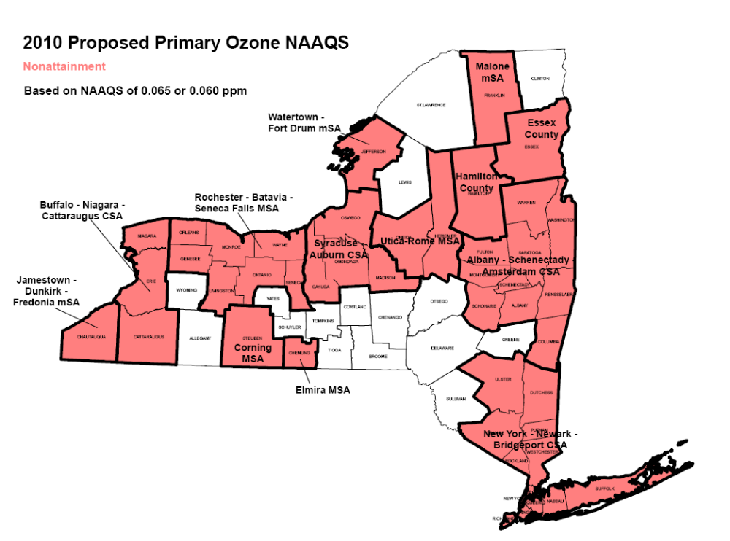

NYSDEC will have a one year monitoring period to prepare a recommended determination of attainment/non-attainment status for the revised 8-hour standard, and a three year period to develop a State Implementation Plan that will bring the State into compliance with the NAAQS. Actions required to reduce emissions from existing fossil fuel generating plants are anticipated to be necessary by 2017 for identified non-attainment areas.

Distributed Generation (DG Rule)

NYSDEC is preparing a rule to limit emissions from small diesel generators that participate in the NYISO’s Installed Capacity/Special Case Resource programs (ICAP/SCR) or Emergency Demand Response Providers (EDRP). Some of the older generators that participate in these programs may emit pollutants at rates that are two to three orders of magnitude greater than new gas-fired turbines that have recently interconnected to the bulk power system. There are approximately 218 MW of generating capacity in the ICAP/SCR program and approximately 87 MW of generating capacity in the EDRP program that would be effected by this regulation. Diesel generators built since 2000, however, are generally expected to comply with the new emission limits expected to be proposed by NYSDEC..

USEPA Regulation of Coal Combustion Byproducts

The USEPA has proposed to create a new regulatory program under the Resource Conservation and Recovery Act (RCRA) for the management of coal combustion byproducts A final rule is expected to be issued by the USEPA this year. If the decision is to regulate coal combustion byproducts under Subtitle D of RCRA, the approach will be somewhat analogous to existing NYSDEC’s regulations under Part 360 which have been in effect for a number of years. If the final rule seeks to regulate the material under Subtitle C of RCRA, the additional resources required for doing so are significant and could lead to the premature retirement of some or all of the coal fired generation in New York. New York currently has 2700 MW of coal fired generation.

Reliability Impact Assessment Methodology
Several of the evolving environmental initiatives described above have sufficient definition of potential requirements, are generally widespread in effect, and are expected to require compliance actions in the earlier portion of the planning period, and therefore could lead to premature retirements. This study will focus on NOxRACT, BART, MACT, and BTA. The programs are estimated to impact 23,957 MW of capacity in the NYCA or 64% of the installed generating capacity NYISO currently relies on.

Each of the four programs has been examined to determine the category of capital cost potentially required of affected units to comply with each program. Three category levels are used to qualify the expected impacts of each program on the existing generation fleet. Category 1 applies for the affected generator that is already in compliance with the proposed requirements, or could be expected to achieve compliance with changes in operating procedures and/or through the use of fuel switching. Thus the capital cost to achieve compliance for Category 1 generators is relatively small. Category 2 applies where the required capital expenditures are of a magnitude that is consistent with other capital expenditures that are necessary to maintain a generator over the planning horizon, e.g. a five year major overhaul of the steam turbine. Category 3 applies where the level of capital expenditure required to comply with the new regulation is above the average level of Cap EX and of a magnitude that is not routine.

While the total population of affected units is represented by the summation of the three impact categories, in each of these analyses the primary concern is with the capital investment decisions represented by Category 2 and 3. With the results of these analyses, the level of impact for each unit is summed across the four programs for Category 2 and 3. Units with the highest cumulative totals of impact are considered to be potentially at risk for premature retirement. The level of impact for each zone will be compared to the zones at risk analysis to identify where and when a reliability risk could arrive on the system.

NOxRACT Impact Assessment

The NYISO retained GE to conduct a detailed study about the types and costs of control technology necessary to comply with the proposed regulation. The study found that “[a] total of 72 units or 9515 MW of capacity was identified as needing some type of control mechanism of equipment modification to comply with the proposed standard.” Capital costs of compliance were estimated to be approximately in the range of $100-200 Mil. The study concluded that the costs to comply with this regulation would reduce operating margin for effected generators but would not generally lead to a situations where those margins would become negative. In addition the study concluded that the proposed compliance deadline should be extended to July 2014 in order to accommodate the outage schedules necessary to retrofit the required emissions control equipment.

Generators that already achieve the presumptive limits, or would likely do so with combustion tuning or fuel switching were assigned Category 1, Facilities that needed to install low NOx combustors, Selective Non Catalytic Reduction systems, or expand existing Selective Catalytic Reduction Systems were assigned Category 2. Generators that needed to install complete SCR systems were assigned Category 3. Table E-1 reports the amount of capacity impacted by superzone.

Figure E-1 Zonal Distribution of Capacity Affected by NOxRACT

NOx RACT Affected Capacity (MW) by Assigned Impact Category
Super Zones | 1 | 2 | 3 | Total
A,B,C,D,E,F | 1,933 | 2,672 | 419 | 5,024
G,H,I | 39 | 551 | 761 | 1,351
J,K | 2,237 | 673 | 187 | 3,096
Total | 4,209 | 3,896 | 1,367 | 9,471

BART Impact Assessment

The impact assessment of the BART program is less certain than the assessment for the NOxRACT program. This uncertainty is found in the need to conduct visibility impairment analysis . This is a relatively new analysis method for the owners of existing generation in the New York. The results of this analysis are used to determine the emission reductions that may be necessary for SO2, NOx, and PM. For the purposes of this impact assessment, it is assumed that all effected units in New York will need to reduce emissions of these pollutants that cause visibility impairments. Based on this assumption, 8,940 MW of capacity is effected. The majority of these units are large oil fired units that have gas as an alternate fuel. Many of these units do not have state of the art emission control systems. Units that have natural gas capabilities were assigned Category 1. Generators that were designated to fuel switch in the NOxRACT study were assigned Category 2. Facilities that are predominantly coal fired were assumed to need upgraded particulate collection, SCR, and FGD and were assigned Category 3.

The NOx control measures for BART generally were consistent with the results of the NOxRACT study.

NYSDEC has established a reasonableness test of $5,000/ton reduced based on the estimated Potential To Emit. Capital expenditures for this program would be of the same order of magnitude as the NOxRACT program.

Table E-2 Zonal Distribution of Capacity Affected by BART

BART Affected Capacity (MW) by Assigned Impact Category
Super Zones | 1 | 2 | 3 | Total
A,B,C,D,E,F |  | 1,686 |  | 1,686
G,H,I | 1,080 | 1,346 | 368 | 2,794
J,K | 2,807 | 1,652 |  | 4,460
Total | 3,887 | 4,684 | 368 | 8,940

MACT Impact Assessment

USEPA’s proposal for MACT for fossil fired electric generators is planned to be released next Spring. In the interim we can gain some insight about the scope and the possible limits by reviewing the recently released MACT regulations for units less 25 MW. The regulations apply to coal and oil fueled electric generators. The proposed emission limits for coal are comparable to the NYSDEC Part 246 Phase 2 regulations. The USEPA proposal for small boilers goes beyond the current version of Part 246 by specifying emission limits that are comparable to those for coal, thus for the purpose of this assessment, we have assumed that units burning heavy oil will need to retrofit mercury sorbent materials and capture them in upgraded particulate collection equipment.

Facilities that are in compliance with the 2015 emission limit are assigned Category 1. Generators that need to add sorbent injection systems are assigned Category 2. Facilities that need to add sorbent injection and improved particulate collection are assigned Category 3.

The 2008 USEPA Toxic Release Inventory reports that approximately 1250 pounds of mercury were released from electric generators. Assuming that the MACT regulation will require a 90% reduction in mercury emissions similar to the NYSDEC Part 246 requirement, then an estimated emission reduction of 1,125 pounds/yr. would be required. The USEIA has estimated the cost of removal to be approximately $20,000/pound. The estimated annual cost for the carrying and operating costs of mercury removal systems would be $ 22.5 Mil/yr.

Table E-3 Zonal Distribution of Capacity Affected by MACT

MACT Affected Capacity (MW) by Assigned Impact Category
Super Zones | 1 | 2 | 3 | Total
A,B,C,D,E,F | 1,177 | 1,921 | 840 | 3,937
G,H,I |  | 368 | 2,426 | 2,794
J,K |  | 1,953 | 3,583 | 5,537
Total | 1,177 | 4,242 | 6,849 | 12,268

Table E-4 Combined Zonal Distribution of Capacity Affected by Air Programs

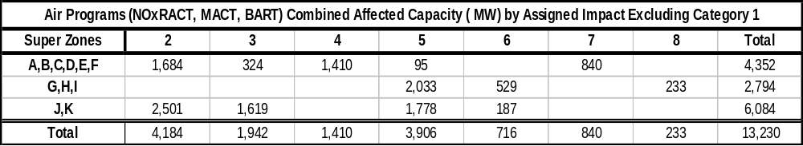

BTA Impact Assessment
NYSDEC’s BTA policy will require the use of closed cycle cooling systems at plants that currently have open cycle cooling systems with some limited relief for; sites that can not physically accommodate cooling towers, generators with current historical capacity factors below 15%, and where the expense of a closed cooling water system is “wholly disproportionate” compared to the environmental benefits to be gained. Several sites have gained limited relief and are assigned Impact Category 1. Sites that may gain approval to use fish protection systems based on specific equipment and past studies are assigned Impact Category 2. The majority of the sites may well need to retrofit closed cycle cooling systems and are to Impact Category 3.

NYSDEC has estimated the capital and operating costs of using closed cycle cooling at electric generators in NY at $8.5 Bil without consideration for cases where limited relief is granted. This program will require capital investments that are one to two orders of magnitude greater than the costs for any of the other environmental initiatives examined.

Consequently, the BTA program has the greatest potential to lead to unplanned retirements.

Table E-5 Zonal Distribution of Capacity Affected by BTA

BTA Affected Capacity (MW) by Assigned Impact Category
Super Zones | 1 | 2 | 3 | Total
A,B,C,D,E,F | 2,819 | 1,211 | 2,992 | 7,022
G,H,I | 2,794 |  | 2,063 | 4,857
J,K | 692 | 4,032 | 2,321 | 7,044
Total | 6,305 | 5,243 | 7,376 | 18,923

The risk of premature retirement of an individual unit of capacity is represented in this study by the summation of the assigned risk categories. The representation does not imply that the risk associated with each program Category, 1, 2, or 3 is equivalent, rather is meant to collect the number of risk events that specific MW of capability is exposed to. The higher the sum of these risk events the greater the likelihood of premature retirement. These sums are presented in Table E-6 below.

Table E-6 Summarized Zonal Distribution of Capacity Impact Assessment

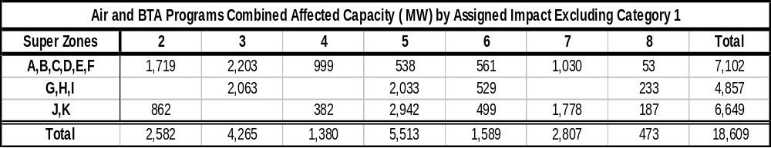

It should be noted that the LOLE results presented for each load zone are determined based on two key assumptions: the first is that load in a particular load Zone is first served by the capacity in that load Zone unless modeled as contractually obligated to load in another load Zone or area, and second, excess capacity is prorated among deficient zones simultaneously within a pool first. .
The same scenario studied in the 2009 RNA with a lower load level and new generation additions in Zones J push the Reliability Needs from 2014 to 2016
The first CRP was entitled the “2005 Comprehensive Reliability Plan,” while the second CRP, released the following year, was entitled the “2007 Comprehensive Reliability Plan.” A year was skipped in the naming convention because the title of the first CRP, which covered the Study Period 2006-2015, designated the year the study assumptions were derived, or 2005, but for the second CRP a different year designation convention was adopted, which identified the first year of the Study Period. The latter naming convention continue to be applied to for the 2008 and 2009 CRP documents. However, the original naming convention is used for the 2010 CRP and subsequent CRP documents.
The procedures for reviewing alternative regulated solutions for a reliability need are currently being discussed in NYPSC Case 07-E-1507.

