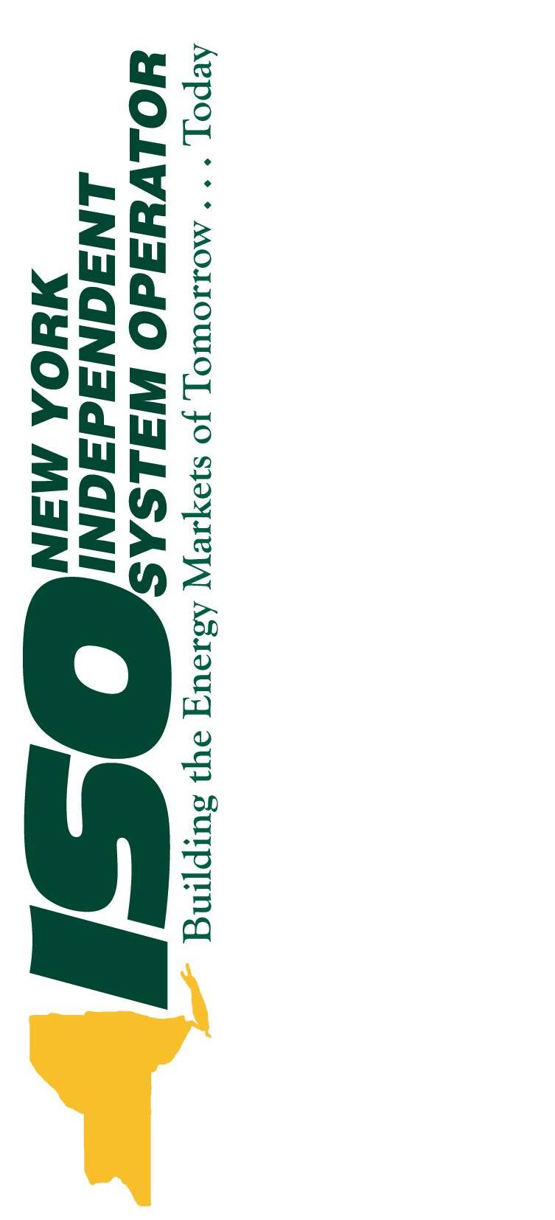 | The Comprehensive Reliability Plan 2008  A Long-Term Reliability Assessment  of  New York’s Bulk Power System  Draft Report 3  May 20, 2008  With ESPWG May 20th edits  0000.doc

Caution and Disclaimer
The contents of these materials are for information purposes and are provided “as is” without representation or warranty of any kind, including without limitation, accuracy, completeness or fitness for any particular purposes. The New York Independent System Operator (NYISO) assumes no responsibility to the reader or any other party for the consequences of any errors or omissions. The NYISO may revise these materials at any time in its sole discretion without notice to the reader.

Executive Summary
New York’s citizens and the State’s economy are dependent on the reliability and continuity of the supply of electricity. The New York Independent System Operator (NYISO) plays a key role in maintaining that reliability. The NYISO’s role requires a system planning process to identify future needs and means of meeting those needs. Because the facilities required to maintain adequate electric service can require many years from conception to operation, and typically require substantial capital investments, the planning process must look into the future using the best available forecasting techniques.
The reliability of New York’s bulk power transmission facilities depends on a combination of adequate resources, provided both in response to market incentives and by regulated electric utility companies in conformity with their statutory obligations to deliver safe and adequate service to retail customers. In order to maintain the system’s long-term reliability, those resources must be readily available or in development to meet future needs. After the electric industry was restructured in the 1990s to provide transmission open access and to introduce competition into New York’s wholesale electricity markets, stakeholders in New York and the public welfare required a mechanism to identify long term bulk power system needs and to facilitate the development of projects to meet those needs.
With these objectives in mind, the NYISO and its stakeholders developed and implemented the Comprehensive Reliability Planning Process (CRPP). The Federal Energy Regulatory Commission (FERC) approved the CRPP in December 2004; the NYISO undertook its first ten-year planning process in 2005-2006, and completed its second process in 2007.
Conceptually, the CRPP is divided into two parts. The first part is the Reliability Needs Assessment (RNA), which determines the reliability needs over the ten year planning period based on the forecast of the demand for electricity and the projected system conditions. Compensatory MW examples are developed to demonstrate the amounts and locations of resources that could meet those needs. Following the approval of the RNA, the second part begins with the request for solutions, with the expectation that market-based solutions will come forward to meet the identified needs. In the event that Market-Based Solutions are not sufficient, the process provides for the identification of Regulated Backstop Solutions by the NYTOs, and of Alternative Regulated Solutions by market participants. The NYISO then evaluates all proposed solutions to determine whether they will meet the identified reliability needs. Finally, the Comprehensive Reliability Plan (CRP) is developed, setting forth the facilities and schedule that are expected to be implemented to meet those needs.
The New York State Public Service Commission (PSC) has commenced a three-phase Energy Resource Planning (ERP) proceeding to examine long-term energy planning in New York. In the first phase, the PSC examined how to undertake cost allocation and cost recovery of non-transmission regulated solutions to reliability needs, specifically generation and demand response projects. In the second phase (currently under way), the PSC is evaluating the process to determine the regulated solutions that should be permitted and built to meet reliability needs if Market-Based Solutions are not sufficient. In the third phase, the PSC will determine how to establish a state resource planning process that takes public policy considerations into account. In addition, the Governor of New York State recently announced the establishment of a new State Energy Planning Board (SEPB). Because the NYISO is not part of government, its authority is limited to the responsibilities contained in its federally approved tariff and its formation agreements. The New York State energy policy initiatives should complement the planning already being conducted by the NYISO, and should be undertaken in concert with the NYISO’s existing and developing processes. The NYISO has and will participate in every phase of the PSC’s ERP proceeding to: (i) maintain an all-resource planning process that provides equal consideration to and treatment of transmission, generation and demand response resources; (ii) guide the PSC’s selection of regulated solutions consistent with the NYISO’s tariffs; and (iii) carry out planning for New York’s bulk power system consistent with the NYISO’s competitive markets. Finally, the NYISO will offer full technical assistance and support to the SEPB for its deliberations.
This 2008 CRP is the third CRP to address the long-term reliability of New York’s bulk power transmission system. In fulfilling its mission to serve as the authoritative source on bulk power system operations and reliability planning, the NYISO offers this Comprehensive Reliability Plan for its federal planning process and to inform the initiatives of the PSC, the New York State Department of Environmental Conservation, and the SEPB.

The 2008 Comprehensive Reliability Plan
The 2008 RNA determined that additional resources would be needed over the ten-year Study Period 2008-2017 in order for the New York Control Area (NYCA) to comply with applicable reliability criteria. As a result, the NYISO requested Market-Based, Regulated Backstop, and Alternative Regulated Solutions to the identified reliability needs. The CRPP prefers Market-Based Solutions to meet the future needs, with regulated backstop and Alternative Regulated Solutions available, if needed.
The NYISO designated certain Transmission Owners (TOs) responsible for developing Regulated Backstop Solutions to address the reliability needs identified in the RNA. In accordance with their ongoing planning responsibilities, the TOs updated their plans, which had the effect of moving the first year of need from 2012 to 2013, thus meeting the needs in the first five year period of the ten-year Study Period (2008-2012). They also submitted Regulated Backstop Solutions to meet the identified reliability needs over the second five-year period (2013-2017).
Simultaneously, developers submitted a broad range of Market-Based Solutions and alternative regulated responses to the NYISO. Based upon its evaluation of the market-based proposals and updated plans from the TOs, the NYISO has concluded that there are sufficient resource additions to the NYCA planned or under development to meet the reliability needs for the next ten years. Accordingly, the NYISO has determined that no action needs to be taken at this time to implement any Regulated Backstop Solution or an Alternative Regulated Solution to address the reliability needs identified in the 2008 RNA. The NYISO will continue to monitor the progress of Market-Based Solutions and TO plans through its quarterly monitoring program, and may make a determination that a regulated solution should proceed to seek regulatory approval if future conditions indicate that reliability criteria will be violated.
The 2008 Comprehensive Reliability Plan, as presented in Section 6 of this document, contains the following four actions:
1. Developing at least 2,350 MW of market-based resources from the 3,380 MW of the merchant generation, transmission and demand response projects that have been proposed for New York. Approximately 1,000 MW of these resources should be located in Zone J or be provided through UDRs into Zone J; 1,050 MW of resources in the lower Hudson Valley; and the remaining 300 MW of additional resources anywhere in the NYCA. The NYISO has received more market-based proposals than the minimum resources needed to meet resource adequacy criteria and transmission security criteria. The NYISO does not choose which of the submitted market-based projects will be built. Rather, it is up to the proponents to proceed with, and the relevant state and federal siting and permitting agencies to approve, the specific projects. The NYISO will continue to monitor and track, on a quarterly basis, the viability of these projects in accordance with established procedures and will report on its evaluation on a regular basis.

2. Maintaining the in-service date for the Con Edison M29 transmission project. The date has changed since the start of the 2008 CRP. For the 2008 RNA, this project was assumed to be in service for the summer of 2010. The most recent in service date is now planned to be before summer of 2011. Given the close proximity to 2010, the NYISO evaluated the impact of this delay with the RNA assumptions constant, and determined that there would be no reliability need for 2010. However, if the M29 facility will not be in service for the summer of 2011, the NYISO will re-evaluate whether the delay will give rise to a reliability need. Other changes in assumptions and project development status would need to be incorporated at that time.

3. Implementing the identified Responsible TO plans, which include transmission upgrades, such as the addition of capacitor banks at the Millwood substation, firm capacity in conjunction with granted unforced capacity delivery rights (UDRs), and planned non-bulk power system projects.

4. The continued review of the North American Electric Reliability Corporation (NERC) Blackout Recommendation 7a, to the extent applicable, including a review of NERC’s other blackout recommendations and developing procedures related to voltage (such as load modeling and generator performance) to identify additional factors not already implemented that could enhance or improve reliability through managing the voltage performance of New York’s bulk power system.

Summary of Findings
The CRP reports two primary findings, summarized here and discussed in more detail in Section 7.
Finding Number One – Transmission Security and Adequacy
As determined in the two prior CRPs approved by the NYISO Board of Directors, it is necessary to reduce transfer limits for key NYCA transmission interfaces during the 10-year Study Period in order to maintain the security of the transmission system. The lower transfer limits are associated with the UPNY/SENY, Dysinger East, West Central, together with the persistent Central East voltage/stability interface. They reduce the ability of the New York bulk power system to deliver capacity downstream of the constraints as well as into the local area of the interfaces between the NYCA Zones. The result is an increase in the loss of load expectation (LOLE), which translates into increased resource requirements. The major factor driving the reduction in transfer limits is the voltage performance of the New York bulk power system, which is being adversely impacted by load growth and generator retirements. However, the required transfer limit reductions identified in the 2008 RNA are not as severe as in the prior studies because system improvements incorporated into the base case enhance the voltage performance of the system.

Finding Number Two – Plan Risk Factors
Although the planned system meets reliability criteria based on the conditions studied, the NYISO has identified seven risk factors that could adversely affect the plan. The seven risk factors, which require ongoing review and assessment, follow:
- The construction of planned resources and transmission upgrades should move forward on the schedules provided so that at least 2,350 MW of market-based resources from the 3,380 MW of the merchant generation, transmission, and demand response projects that have been proposed for New York are in service when needed. Approximately 1,000 MW of these resources should be located in Zone J or have UDRs into Zone J; 1,050 MW of resources should be located in the Lower Hudson Valley; and the remaining 300 MW of resources should be located anywhere in NYCA. In accordance with the criteria adopted by the NYISO Operating Committee, the NYISO will continue to monitor the progress of market-based transmission, capacity and demand response resource projects to determine their ongoing viability, and to determine whether Regulated Backstop Solutions need to be triggered. If solutions are not implemented on a timely basis, electric system reliability could be put at risk. The absence of a “one-stop” siting process could impede the construction and operation of new generating facilities to meet reliability needs. New York State once had a streamlined siting process for large power plants, but that law (Article X of the New York Public Service Law) expired at the end of 2002. The NYISO’s evaluation of the viability of project timelines will reflect the absence of an Article X process. The New York State Legislature should reenact a comprehensive siting process for major electric generating facilities in Article X of the New York Public Service Law.
- Con Edison should continue with the development of the M29 facility and immediately inform the NYISO of any further delays. The NYISO will continue to monitor the progress of the M29 facility in its quarterly monitoring of the progress of TO plans. If a delay occurs such that the facility will not be in service for the summer of 2011, the NYISO will revaluate the impact of the delay at that time, considering all other appropriate system changes, to determine whether a reliability need will arise.
- The planned generator additions in this plan will be natural gas fired units with Number 2 fuel oil or kerosene as the back up fuel. The fuel diversity of the power supply system and its overall impact on fuel availability, reliability and prices needs to be monitored on a continuous basis. The NYISO will also monitor changes to the fuel supply infrastructure, such as new fuel gas pipelines and liquefied natural gas facilities.
- The plan depends increasingly on the availability of capacity resources in neighboring control areas delivered through UDRs for New York to maintain its compliance with reliability criteria. The Northeast Coordinated System Plan, which is specified in the Northeastern ISO/RTO Planning Coordination Protocol,, will need to assess whether sufficient resources are being developed on a regional basis to maintain resource adequacy in all areas. As capacity markets become increasingly more regional in nature, New York will monitor its capacity markets to ensure that they remain competitive and attract sufficient investment to maintain reliability. The NYISO’s neighboring control areas, ISO-New England and PJM, have implemented multi-year forward capacity markets. The development of forward capacity markets is under discussion at the NYISO’s Installed Capacity (ICAP) Working Group.
- The proponents of market-based generation and transmission solutions have stated that the viability of their projects may depend upon long-term price certainty, which may take the form of long-term contracts, forward capacity markets, and/or new capacity zones. The Independent Market Advisor will continue to evaluate whether market rule changes are necessary to identify and address failure in one or more of the NYISO’s competitive markets. The NYISO will continue monitoring and participating in the PSC’s ERP proceeding.
- Retirement of additional generating units beyond those already contemplated in the 2008 RNA for either economic and/or environmental factors, or continued degradation of the voltage performance would adversely affect the reliability of the NYCA bulk power system beyond what has been identified in this CRP. The next round of the CRPP should progress on schedule. A draft 2009 RNA Assessment is due to be completed in September 2008. Just as important as the plan is the process of planning and the ongoing monitoring it provides. Emphasis should be placed on thoroughly identifying and addressing environmental factors that may lead to additional generating unit retirements. In addition to continuing to analyze the reliability impacts of these regulatory initiatives, the NYISO will undertake the following actions as well:
- The NYISO will support the development of a broader range of regulatory initiatives in order to achieve compliance with the ozone standard through the reduction of NOx emissions from power plants.. The United States Environmental Protection Agency recently established a new standard for ozone at 75 ppb, which will significantly increase the magnitude of the challenge ahead.
- The NYISO will continue to monitor the development of the RGGI program with particular focus on allowance auction design and implementation and development of an effective allowance market monitoring program. The NYISO will also need to incorporate allowance prices in its planning and market monitoring processes.
- New York has taken the initiative to reduce energy consumption by 15 percent of forecasted levels by 2015. In response, the PSC commenced a proceeding to examine implementation of an Energy Efficiency Portfolio Standard (EEPS) to achieve these reductions in energy usage. Implementation of this initiative would affect the state’s future capacity needs. Also, the impact of the New York State Energy Research and Development Authority (NYSERDA) sponsored programs on load demand and resource additions needs to be monitored and factored into the reliability assessments. The PSC proceeding should continue to be undertaken in coordination with the NYISO’s planning processes and be based upon consistent data inputs and analytical models and methodologies. The NYISO has and will continue to actively participate in the PSC’s EEPS proceeding by providing technical expertise on load forecasting, offering opinions on establishing energy savings goals, and offering measurement and verification of energy and related demand savings. Further, the NYISO will work with NYSERDA to establish a mechanism by which NYSERDA reports, and NYISO accounts for, NYSERDA’s actual and forecasted demand side management programs and zonal load reductions.

Recommendation
This 2008 CRP determines that, under the conditions studied, the Market-Based Solutions submitted and the Responsible TO updated plans, the proposed system upgrades will maintain the reliability of the New York bulk power system without the need for regulated backstop or Alternative Regulated Solutions at this time. Therefore, the NYISO Staff recommends that the Operating Committee and the Management Committee recommend that the Board of Directors approve the 2008 CRP.

Table of Contents
Executive Summary 3
A. The 2008 Comprehensive Reliability Plan 4
B. Summary of Findings 6
C. Recommendation 8
1. Introduction 1.1
2. The Comprehensive Reliability Planning Process 2.1
2.1 Summary of the CRPP 2.1
2.2 Governance Process 2.4
2.3 Summary of Reliability Policies and Criteria Applicable to the NYISO 2.5
2.3.1 Basic Reliability Concepts 2.5
2.3.2 Organizational Structure 2.6
2.3.3 Reliability Policies and Criteria 2.7
3. Reliability Needs Assessment Summary 3.1
4. The Development of Solutions to Reliability Needs 4.1
4.1 Responsible Transmission Owner Solutions 4.1
4.1.1 Individual TO Updated Plan Submittal 4.1
4.1.2 Responsible TO Joint Submittal 4.1
4.1.3 Additional TO Regulated Backstop Solutions 4.3
4.2 Market-Based Solutions 4.4
4.3 Alternative Regulated Solutions 4.8
5. Evaluation of Solutions 5.1
5.1 Adequacy and Transmission Security 5.1
5.2 Responsible Transmission Owners Submitted Plans and Regulated Backstop Solutions 5.2
5.2.1 First Five Year Base Case: 5.2
5.2.2 Second Five Years 5.5
5.2.3 Assessment of Responsible TO Updated Plans and Regulated Backstop Solutions 5.11
5.2.4 Market-based Solutions 5.12
5.2.5 First Five Year Base Case 5.13
5.2.6 Second Five Years 5.14
5.2.7 Assessment of the Market Proposals 5.16
5.2.8 Alternative Regulated Responses 5.19
5.2.9 Alternative Regulated Generation Response 5.19
5.2.10 Alternative Regulated Transmission Response 5.20
5.2.11 Assessment of the Alternative Regulated Responses 5.21
5.3 Summary of Evaluation of Proposed Solutions 5.21
5.4 Transmission System Short Circuit Assessment 5.21
6. The 2008 Reliability Plan 6.1
7. Findings, Actions, and Recommendation 7.1
7.1 Findings, Actions Taken and Actions Required 7.1
7.1.1 Finding Number One – Transmission Security and Adequacy 7.1
7.1.2 Prior CRP Recommended Actions 7.1
7.1.3 Finding Number Two – Plan Risk Factors 7.3
7.2 Recommendation 7.6
Appendix A – Summary of Market-Based Solutions and TOs’ Updated Plans A-1
Appendix B – Glossaries B-1
Appendix C – Supporting Documentation C-1
Appendix D – Detail Technical Data D-1

Table of Tables

Table 4.2.1: Summary of Proposed Market-Based Solutions 4.5
Table 5.2.1: Thermal Transfer Limits for Key Interfaces in MW 5.2
Table 5.2.2: Transmission System Voltage Transfer Limits for Key Interfaces in MW 5.3
Table 5.2.3: Transmission System Transfer Limits for Key Interfaces in MW 5.3
Table 5.2.4: RNA Study Case Load and Resource Table with Updated TO Plans and Joint TO Submittal (First Five Year Base Case) 5.4
Table 5.2.5; NYCA LOLE for the First Five Year Base Case with TO Updated Plan (First Five Year Base Case) 5.5
Table 5.2.6: Joint Transmission Owner Submittal of Proposed Additions by Year and Zone with Sensitivities of Transmission Inclusion and Relocation 5.7
Table 5.2.7: Transfer Limits for Transmission Alternatives (in MW) 5.8
Table 5.2.8: RNA Study Case Load and Resource Table with TO Updated Plans (TO Joint Submittal with 2,100 MW of Resources and Transmission Upgrade, Second Five Years) 5.9
Table 5.2.9: RNA Study Case Load and Resource Table with TO Updated Plans (Without Transmission Upgrade and 250 MW Compensatory MW for Second Five Years) 5.10
Table 5.2.10 below presents the Load and Resource table with the Five Year Base Case with the LIPA TO updated plan of the Neptune transmission project, and the market proposals for the first Five Year Base Case. The Market-Based Solutions improve the LOLE results for 2009 through 2010 when compared to the first Five Year Base Case. Table 5.2.10: Base Case Load and Resource with Updated Neptune and Market-Based Solutions 5.13
Table 5.2.11: Base Case Load and Resource with Updated Neptune and Market-Based Solutions – Second Five Years 5.15
Table 5.2.12: NYCA LOLE for the Second Five Years with Both LIPA and Con Edison Updated TO Plans and Market-Based Solutions (probability of occurrences in days per year) 5.16
Table 5.2.13: Impact of New Lovett 540 MW Combined Cycle on NYCA LOLE 5.20
Table 5.2.14: Impact NYRI Transmission Proposal on NYCA LOLE 5.21

Table of Figures

Figure 2.1.1: CRPP Flow Chart 2.4
Figure 2.2.1: NYISO Governance Process 2.5
Figure 4.2.1 : Cumulative Needs Compared to Market-Based Solutions in MW 4.5
Figure 5.1.1: NYISO 230 kV and above Transmission Map 5.1
Figure 5.2.1: TO Regulated Backstop Solutions – 2,100 MW 5.12
Figure 5.2.2: CRP 2007 NYCA Resources as Percent of NYCA Peak Load with Neptune and Market-Based Solutions 5.17
Figure 5.2.3: CRP 2007 Zone J Resources as Percent of Zone J Peak Load with Neptune and Market-Based Solutions 5.18
Figure 5.2.4: CRP 2007 Zone K Resources as Percent of Zone K Peak Load with Neptune and Market-Based Solutions 5.19

Introduction
When the electric industry restructured in the United States in the 1990s, new market mechanisms approved by the FERC stressed competition among suppliers to meet the reliability and economic needs of consumers and the economy. Because strong reliance was placed upon open access to transmission and the markets to send the correct economic signals to add needed resources in response to demand, the New York Independent System Operator, Inc. (NYISO), formed in 1999, undertook two essential functions through its tariffs: (1) the reliable operation of the bulk power system and, (2) the accurate operation of economically competitive markets for capacity, energy and ancillary services. Resource additions and transmission expansions were planned primarily by market participants who were willing to pay for them to support their market-based projects. Bulk power markets for capacity, energy and ancillary services were formed at the same time as state and federal policy makers recognized that the discipline and efficiency of market forces in providing these commodities would promote the public good through cost savings. Under this market-based philosophy, bulk power system needs should be provided for through markets that send economically efficient price signals for investment in needed resources.
Over time, it became increasingly clear that some mechanism was desirable to facilitate the identification by market participants of longer-term bulk power system resource additions beyond the projects identified by individual market participants primarily based on short-term needs. Emphasis remained upon the marketplace, however, to identify and build specific projects to meet transmission security and resource adequacy needs. With these goals in mind, the NYISO, in conjunction with its stakeholders, developed and implemented in 2005 its Comprehensive Reliability Planning Process (CRPP), codified in Attachment Y of the NYISO’s Open Access Transmission Tariff (OATT). Upon FERC’s acceptance of the CRPP, the NYISO expanded its third essential role; that of bulk power system planner for the New York Control Area (NYCA). Over 7,000 MW of new power plants and merchant transmission projects with unforced capacity delivery rights (UDRs) have come into operation in New York since the formation of competitive wholesale markets. Most of these have been located in the downstate region where both the price signals and reliability needs are the greatest. Electric system needs are increasingly met by projects developed in response to market forces.
While the NYISO’s markets and long-term planning processes have been maturing, the federal and state governments have placed a renewed emphasis on planning for the energy needs of the United States and New York, respectively. At the federal level, the FERC issued its final rule in its Open Access Transmission Tariff (OATT) reform proceeding. Following on FERC’s Orders 888, and 889, which first established transmission open access, and Order 2000, which initiated competitive market mechanisms for the wholesale electric industry, Order 890 directed improvements to the OATTs of all Transmission Providers, including the Independent System Operators (ISOs) and Regional Transmission Organizations (RTOs). Among other things, Order 890 listed nine principles that all Transmission Providers should adhere to in conducting their planning processes. In accordance with this Order, the NYISO made a compliance filing at the FERC in December 2007 demonstrating how it plans to comply with these nine principles.
The NYISO’s expanded planning roles enable it to serve as the authoritative source for bulk power system planning in New York and to provide the underpinnings to numerous initiatives being designed and implemented by the State of New York. Descriptions of three of those initiatives follow: First, the New York State Public Service Commission (PSC) is continuing to implement the Renewable Portfolio Standard (RPS) in New York that calls for 25 percent of all electricity consumption in New York to come from renewable resources, such as wind energy, by 2013. Second, the PSC is in the midst of a proceeding that is examining how an Energy Efficiency Portfolio Standard (EEPS) can be implemented in New York. The goal of the EEPS is to reduce resource needs and environmental impacts, such as global climate change, from the electric industry by reducing forecasted electric energy consumption levels by 15 percent by 2015 (15 x 15). Third, the PSC has commenced a proceeding to create an Energy Resource Planning process (ERP) that seeks: (1) to resolve cost allocation and cost recovery issues for generation and demand response projects built under the CRPP to meet bulk power system reliability needs; (2) to develop a process by which the PSC will select the project or projects that should proceed with regulatory approvals to meet reliability needs under the CRPP (transmission, generation and demand response) in the event that the markets do not provide adequate solutions; and (3) to establish an energy resource planning process for the electric and natural gas systems in New York.
Concurrently, the New York State Department of Environmental Conservation (DEC) is considering several important initiatives of its own that could significantly affect the reliability and operation of the bulk power system. Descriptions of three of those initiatives follow: First, the DEC is implementing the multi-state Regional Greenhouse Gas Initiative (RGGI) to establish a cap and trade system for greenhouse gas emissions, including carbon dioxide, from power plants. Second, the DEC has adjusted its approach for the reduction of nitrogen dioxide emissions that lead to ozone smog on High Electric Demand Days (HEDD). The DEC is now considering a broader program that will establish new Reasonably Available Control Technology (RACT) standards. Third, the DEC has ongoing proceedings examining the water withdrawal and discharge permits of power plants that could affect their future operations and viability.
Finally, the Governor of New York State issued an Executive Order on April 9, 2008 to form once again a State Energy Planning Board (SEPB). The SEPB will consist of representatives from state agencies, including the PSC, DEC, Health, Economic Development, New York State Energy Research and Development Authority (NYSERDA), Transportation, Budget and Urban Development. Led by the Governor’s Deputy Secretary for Energy, with input from the Deputy Secretary for Environment, the SEPB is to create a state energy plan for all energy sectors in New York, including the electric industry. The Executive Order calls upon the SEPB to issue a draft State Energy Plan by March 31, 2009 and to complete a final plan in June 2009. The Executive Order calls upon maximum input from stakeholders including, among others, the NYISO. In fulfilling its mission to serve as the authoritative source on bulk power system operations and reliability planning, the NYISO offers this Comprehensive Reliability Plan (CRP), built upon the foundation of NYISO’s competitive markets, to inform the SEPB as well as the other PSC and DEC initiatives outlined above.
This 2008 CRP describes the 2008-2017 reliability plan for the New York bulk power systems. Section 2 of this CRP outlines the CRPP; Section 3 summarizes the 2008 RNA; Section 4 describes the offered solutions to reliability needs; Section 5 discusses the results of the evaluation of solutions; Section 6 presents the reliability plan itself, and Section 7 discusses the findings, actions and recommendations along with an analysis of the potential risks and mitigating factors that could affect the plan.

The Comprehensive Reliability Planning Process
Electric system planning is a continuous process of evaluating, monitoring and updating, which makes the regular publication of the CRP an invaluable resource. In addition to addressing reliability issues, the CRP offers valuable information to the state’s wholesale electricity marketplace.
As set forth in NYISO OATT, Attachment Y, the five objectives of the CRPP are as follows:
- Evaluate the reliability needs of the bulk power transmission facilities (BPTF);
2. Identify factors and issues that could adversely impact the reliability of the BPTF;
3. Provide an opportunity and a process whereby solutions to identified needs are proposed, evaluated, and enacted in a timely manner to maintain the reliability of the system;
4. Provide for the development of Market-Based Solutions, while maintaining the reliability of the BPTF through Regulated Backstop Solutions as needed;
5. Coordinate the NYISO’s reliability assessments with those undertaken by neighboring control areas.
The CRPP is an ongoing process that produces two annual reports. The first is the Reliability Needs Assessment (RNA), which evaluates generation adequacy and transmission reliability over a 10-year span, and identifies future needs that should be addressed to maintain reliability. Identifying potential and existing reliability issues concerning the New York bulk power system is the first step necessary to maintain the system’s integrity for today and the future. The 2008 RNA was issued in December 2007. As the NYISO completes this third cycle of the CRPP, a draft of the 2009 RNA is simultaneously underway.
The second step is the development of the CRP, which identifies and evaluates proposed solutions to maintain power system reliability. Those solutions may include market-based, regulated backstop and/or Alternative Regulated Solutions that may result in new generation additions, transmission upgrades and additions, and/or expanded demand response programs.
The following presents an overview and summary of the CRPP, the CRPP stakeholder process, and the reliability policies and criteria that are the foundation of the CRPP. A detailed description of the CRPP is contained in the CRPP Manual, which is posted on the NYISO’s website, http://www.nyiso.com/public/documents/manuals/planning.

Summary of the CRPP
The CRPP is an assessment, over a 10-year planning horizon, to determine if the bulk power system can adequately supply the aggregate electric power and energy requirements of electricity consumers at all times, taking into account planned and unplanned outages of system components and sudden disturbances such as electric short circuits or unanticipated loss of system components. The North American Electric Reliability Corporation (NERC) definition of an “adequate level of reliability” states that an adequate level of reliability of the bulk power system has been achieved when it is planned and operated such that:
- The bulk power system remains within acceptable limits;
- The System performs acceptably after credible contingencies;
- The System limits instability and cascading outages;
- The System’s facilities are protected from severe damage;
- The System’s integrity can be restored if it is lost.
The CRPP is conducted in accordance with the existing reliability criteria of the NERC, the Northeast Power Coordinating Council, Inc. (NPCC), and the New York State Reliability Council (NYSRC). This process is anchored in the NYISO’s philosophy that Market-Based Solutions are the first choice to meet identified reliability needs. However, in the event that Market-Based Solutions do not appear to meet a reliability need in a timely manner, the NYISO will designate the Responsible Transmission Owner (TO) to proceed with a Regulated Backstop Solution in order to maintain reliability. Under the CRPP, the NYISO also investigates whether market failure is the reason for the lack of a Market-Based Solution, and explores changes in its market rules if that is found to be the case.
As the first step in the CRPP, the NYISO conducts an assessment of the state’s reliability needs to determine whether there are any violations of existing reliability rules governing resource adequacy and transmission security. Following the review of the RNA by the NYISO committees and final approval by the NYISO Board of Directors, the NYISO will request solutions to the identified reliability needs from the marketplace. At the same time, the Responsible TOs are obligated to prepare Regulated Backstop Solutions for each identified need over the planning horizon, which will serve as the benchmark to establish the time by which a Market-Based Solution must appear. Both market-based and regulated solutions are open to all types of resources: transmission, generation, and demand response. Non-TO developers also have the ability to submit proposals for Alternative Regulated Solutions. The NYISO evaluates all proposed solutions to determine whether they are viable. The NYISO does not conduct an economic evaluation of the proposed solutions under the current tariff.
Following its analysis of all proposed solutions, the NYISO prepares the CRP. The CRP identifies all proposed solutions that the NYISO determines are capable of meeting the identified reliability needs. If a viable market-based project or projects can satisfy the identified needs in a timely manner, the CRP will so state. If developers do not present viable market-based proposals and the NYISO determines that a Regulated Backstop Solution must be implemented, the CRP will so state, and the NYISO will request the appropriate Responsible TO(s) to proceed with regulatory approval and development of the backstop solution. The NYISO also monitors the continued viability of proposed projects to meet identified needs and reports its findings in subsequent CRPs. The planning process is illustrated in Figure 2.1.
The CRPP also allows the NYISO Board of Directors to address the appearance of a reliability need on an emergency basis, whether during or in-between the normal CRPP cycle. In the event that there is an immediate threat to reliability, the NYISO will request the appropriate Responsible TO(s) to develop a “gap solution” and to pursue its regulatory approval and completion in conjunction with the PSC. Gap solutions are intended to be temporary and not to interfere with pending market-based projects.
The Tariff contains a set of principles for cost allocation and cost recovery based upon the principle that beneficiaries should pay. The NYISO continues to be engaged in a stakeholder process to develop procedures for cost allocation. As Attachment Y is currently written, cost recovery for regulated transmission solutions will be addressed through a separate rate schedule in the NYISO’s Services Tariff, while cost recovery for non-transmission solutions will be handled under state law.
The CRPP also addresses the respective roles of the NYISO, the FERC and the PSC with regard to the NYISO planning process. In the event of a dispute regarding the NYISO’s findings in the RNA or the CRP that cannot be resolved through the normal NYISO governance procedures, the Tariff provides for disputes to be brought to either the FERC or the PSC, depending upon the nature of the dispute. In the event that a Responsible TO is unable to license or complete a Regulated Backstop Solution that has been found necessary by the NYISO during the course of the CRPP, the NYISO is required to report this to the FERC. Transmission Owners and other developers may submit proposed regulated solutions to the New York State Department of Public Service for review at any time prior to their submission to the NYISO.
A separate, FERC-approved agreement between the NYISO and the New York Transmission Owners addresses the Transmission Owner’s rights and obligations for performance under the CRPP. The process flow diagram below summarizes the CRPP Stakeholder Process.

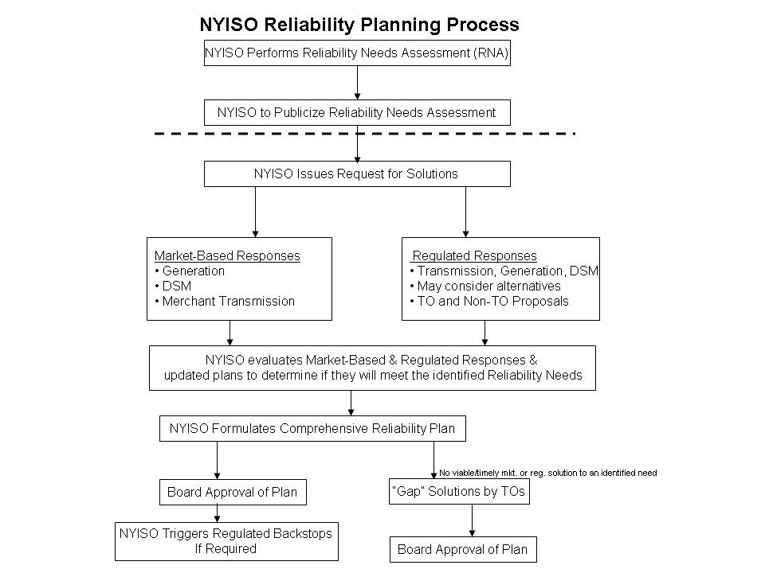
Figure 2.1.1: CRPP Flow Chart

Governance Process
Given that the CRPP addresses both reliability and business issues, both the Transmission Planning Advisory Subcommittee (TPAS) and the Electric System Planning Working Group (ESPWG) participate in the implementation process. This participation consists of parallel input and review stages as shown in Figure 2.2.2 below.
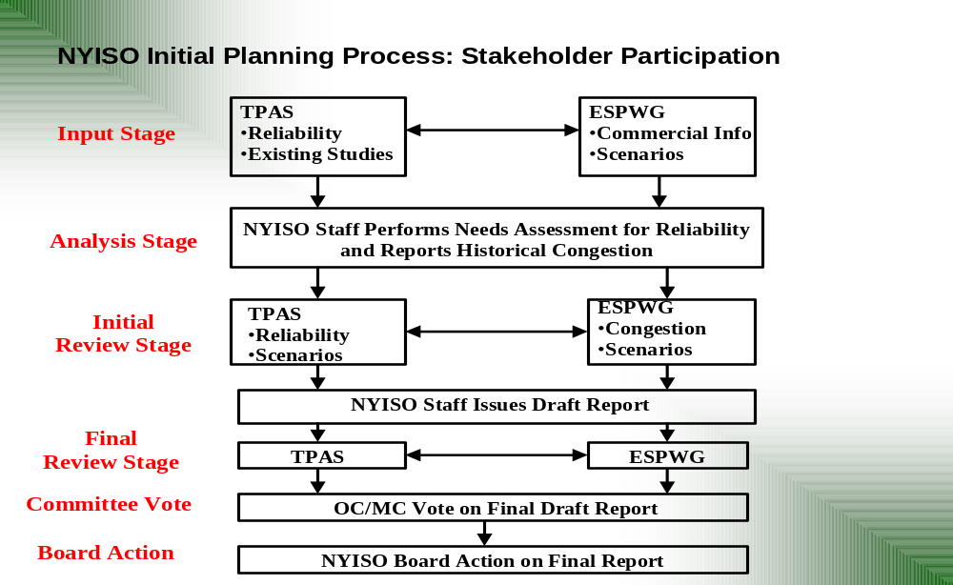
Figure 2.2.2: NYISO Governance Process

TPAS has primary responsibility for the reliability analyses, while the ESPWG has primary responsibility for providing commercial input and assumptions utilized in the development of reliability assessment scenarios and the reporting and analysis of historic congestion costs. Coordination between these two groups and NYISO staff was established during each stage of the initial planning process.
The intent of this process is to achieve consensus at both TPAS and the ESPWG. While no formal voting process is established at this level, as is typical for NYISO working groups, an opportunity for reporting majority and minority views to the NYISO’s governance committees is provided in the absence of a consensus.
Following the TPAS and ESPWG review, the draft RNA and CRP reports are forwarded to the Operating Committee for discussion and action, and subsequently to the Management Committee for discussion and action. Finally, the NYISO’s Board of Directors reviews and approves the RNA and the CRP.

Summary of Reliability Policies and Criteria Applicable to the NYISO
The foundation of the CRPP is the reliability policies and criteria applicable to the NYISO. The phrase “reliability policy and criteria” is used broadly to include standards, requirements, guidelines, practices, and compliance. The following presents an overview of these policies and criteria in the context of basic reliability concepts and the organizations that develop, promulgate, implement, and enforce the related policies and criteria.

Basic Reliability Concepts
The standard industry definition of bulk power system reliability is the degree to which the performance of the elements of that system (i.e., generation and transmission) results in power being delivered to consumers within accepted standards and in the amount desired. It may be measured by the frequency, duration, and magnitude of adverse effects on consumer service.
Reliability consists of adequacy and security. Adequacy, which encompasses both generation and transmission adequacy, refers to the ability of the bulk power system to supply the aggregate requirements of consumers at all times, accounting for scheduled and unscheduled outages of system components. Security refers to the ability of the bulk power system to withstand disturbances such as electric short circuits or unanticipated loss of system components.
There are two different approaches to analyzing a bulk power system’s security and adequacy. Adequacy is a planning and probability concept. A system is adequate if the probability of not having sufficient transmission and generation to meet expected demand is equal to or less than the system’s standard, which is expressed as a loss of load expectation (LOLE). The New York bulk power system is planned to meet a LOLE representative of an involuntary load disconnection event not more than once in every 10 years, or 0.1 days per year. This requirement forms the basis of New York’s resource adequacy and installed capacity (ICAP) requirements.
Security is an operating and deterministic concept. This means that possible events are identified as having significant adverse reliability consequences and the bulk power system is planned and operated so that the system can continue to serve load even if these events occur. Security requirements are sometimes referred to as “N minus 1” (N-1), “N minus 1 and minus 1” (N-1-1), or “N minus 2” (N-2). In this definition, “N” is the number of system components. An N-1 requirement means that the system can withstand the loss of any one component without affecting service to consumers. N-1-1 means that the reliability criteria apply after any critical element such as a generator, transmission circuit, transformer, series or shunt compensating device, or high voltage direct current (HVDC) pole has already been lost, and after generation and power flows have been adjusted between outages by the use of 10-minute operating reserve and, where available, phase angle regulator control and HVDC control. Each control area usually maintains a list of critical elements and most severe contingencies that need to be assessed.

Organizational Structure
Reliability policies are developed, promulgated, implemented, and enforced by various organizations at different levels. These include federal and state regulators, industry-created organizations such as the NERC and its member organizations, transmission owners, and energy market participants.
The NERC was formed as a voluntary, not-for-profit organization in 1968 in response to the blackout of 1965. A ten-member Board of Trustees governs the NERC with input from an industry stakeholder committee. The NERC has formulated planning standards and operating policies. Pursuant to the Energy Policy Act of 2005, the FERC approved the NERC as the Electric Reliability Organization for North America in 2006. The FERC has approved many NERC standards as enforceable as of June 18, 2007, and the NERC and the FERC are in the process of approving additional standards that carry the weight of federal law.
Eight regional reliability councils currently comprise the NERC’s membership; and members of these councils come from all segments of the industry. New York State is an area within the NPCC, which also includes New England and northeastern Canada. The NPCC implements broad-based, industry-wide reliability standards tailored to its region. The NERC and the NPCC have received the FERC’s approval of a delegation agreement by which the NPCC oversees and enforces compliance with NERC and NPCC standards in the northeastern regions of the United States and Canada.
New York State also has its own electric reliability organization, which is the NYSRC. The NYSRC is a not-for-profit organization that promulgates reliability rules and monitors compliance on the New York bulk power system. The NYISO, and all organizations engaging in electric transactions on the state’s power system must comply with these rules. Thirteen members from different segments of the electric power industry govern the NYSRC. New York-specific reliability rules may be more detailed or stringent than NERC Standards and Policies and NPCC Criteria. Local reliability rules that apply to certain zones within New York may be even more stringent than statewide reliability rules.

Reliability Policies and Criteria
Similar to the national, regional and state levels of reliability organizations, there are national, regional and state levels of documents comprising the reliability standards, policies and criteria that govern the New York bulk power system. Presently, the NERC has two major types of standards: Operating Standards and Planning Standards.
Planning Standards provide the fundamental planning requirements. The interconnected bulk electric system must be planned so that the aggregate electrical demand and energy requirements of customers are satisfied, taking into account scheduled and reasonably expected unscheduled outages of system elements, and capable of withstanding sudden disturbances. Regional Councils may develop planning criteria that are consistent with those of the NERC.
Operating Standards provide the fundamental operating requirements. The interconnected bulk electric system must be operated in secure state such that the aggregate electrical demand and energy requirements of customers are satisfied in real time. Responsibility for reliable operation is vested primarily with the NYISO. The objective of these Operating Standards is to promote reliable interconnection operations within each of the three interconnections in North America without burdening other entities within the interconnection. The NYISO is within the Eastern Interconnection.
NPCC has three basic categories of documents: Criteria, Guidelines, and Procedures, respectively referred to as Type A, B, and C documents. The foundational NPCC document is A-2, Basic Criteria for Design and Operation of Interconnected Power Systems, which establishes the principles of interconnected planning and operations.
The NYSRC Reliability Rules for Planning and Operating the New York bulk power system include the required rules and define the performance that constitutes compliance. These rules include NERC Planning Standards and Operating Policies; NPCC Criteria, Guidelines and Procedures; New York-specific reliability rules; and local transmission owner reliability rules. The NYISO’s implementation and compliance with NYSRC Reliability Rules are codified in its Operations, Planning, and Administrative manuals and other written procedures.
The NYSRC establishes the annual statewide installed capacity requirement (ICR) to maintain resource adequacy. The ICR is expressed as an Installed Reserve Margin (IRM), which is the percentage of capacity above 100 percent that is required. Factors that are considered in establishing the ICR include the characteristics of loads, uncertainty in load forecast, outages and deratings of generation units, the effects of interconnections on other control areas, and transfer capabilities of the New York bulk power system. The NYISO determines ICAP requirements for load serving entities (LSEs), including locational ICAP requirements for New York City and Long Island.

Reliability Needs Assessment Summary
The 2008 RNA indicated that the forecasted system first exceeds the LOLE criterion in the year 2012. The need in 2012 results from a statewide capacity deficiency as well as a zonal deficiency resulting from transmission constraints.. Therefore the need could be resolved by adding capacity resources downstream of the transmission constraints or by adding resources upstream of transmission constraints in conjunction with transmission reinforcement. Accordingly, the RNA designated all TOs, except for the New York Power Authority (NYPA), as the Responsible TOs required to identify a Regulated Backstop Solution to the reliability need, which may be called upon by the NYISO should no timely Market-Based Solution be available. NYPA was not identified as a Responsible TO because it serves its government, authority and private sector customers by contractual agreement rather than as the utility provider of last resort, which would be required to serve those customers should they refuse service from NYPA. Nevertheless, the NYISO expects that NYPA will work cooperatively with the Responsible TOs to identify Regulated Backstop Solutions to the reliability needs identified in the RNA.
Based upon continuing load growth throughout the NYCA from 2013 to 2017, and assuming no additional resources in the second five years of the Study Period, the RNA determined that the LOLE criterion will be violated in these years as well. The RNA characterized the reliability needs for 2013-2017 as statewide resource adequacy needs. That is, there are multiple combinations of generation, transmission and demand-side resources that could satisfy those needs during this period. Consequently, the RNA identified all of the TOs, except for NYPA, as Responsible TOs to identify Regulated Backstop Solutions for the reliability needs in 2013 to 2017.
The RNA reported the results of two sensitivity analyses, with the following results:
- The reliability need in 2012 could be deferred to 2013 if the Neptune project was modeled as firm capacity in Zone K;
- Assuming unlimited transmission system capability would also defer the first year of reliability need from 2012 to 2013.
The reliability needs can be satisfied through the addition of compensatory MW statewide as well as in Zones G through K below the UPNY/SENY interface. The RNA also examined the reliability needs under a number of alternative scenarios, with the following results for those scenarios that resulted in a change in the need date:
- If the high load forecast were to occur, the reliability need in 2012 would advance to 2010, and local needs would emerge in western New York;
- If increasingly stringent environmental controls were to force the imminent retirement of all of the coal-based generation in New York except for the two most modern units, the reliability needs in some zones in New York would advance to 2009 or 2010;
- If NYPA proceeds with one of its two proposals to purchase 500 MW of new capacity in Zone J by 2011 to serve its customers in New York City, the first year of need would be 2014;
- If energy savings consistent with those in the 15 x 15 initiative are achieved (through the EEPS proceeding), which would be equivalent to approximately 5,700 MW of peak demand reduction, the identified reliability needs over the ten year planning period would not occur.
Finally, the RNA conducted a short-circuit analysis and informed the market about historic congestion costs.
Dr. David Patton, the NYISO’s Independent Market Advisor, reviewed the RNA. With regard to the locational needs identified in the RNA, Dr. Patton indicated that the ongoing work of the NYISO and its Market Participants to identify when new capacity zones and associated local capacity requirements are appropriate should improve the economic signals needed to allow the market to resolve these needs.
On December 10, 2007, the NYISO Board of Directors approved the 2008 RNA. Because the OATT calls for the NYISO to encourage Market-Based Solutions to identified reliability needs, the NYISO issued its initial request for those solutions on December 12, 2007. The NYISO requested that developers submit Market-Based Solutions and that the Responsible TOs submit Regulated Backstop Solutions to the identified reliability needs by March 1, 2008. The NYISO also stated that developers could submit Alternative Regulated Solutions if they chose to. Due to uncertainty as to the viability of generation solutions as of April 4, the NYISO issued a letter that day soliciting any remaining Alternative Regulated Solutions to be submitted by April 21, 2008. Like Market-Based Solutions and Regulated Backstop Solutions, these proposals may consist of transmission, generation or demand response projects.
Two significant changes since the approval of the 2008 RNA are a reduced load forecast and the change in status of a proposed Market-Based Solution to “under construction.” In addition, the amount of SCRs most recently registered has increased. The NYISO’s planning process continuously evaluates changing system conditions, monitors factors that impact the forecasts used in the assessments, and updates the assumptions and results of the assessments. Changes to these parameters will be incorporated in the next cycle of CRPP. Accordingly, this CRP evaluates solutions received in response to the NYISO’s solicitations to determine if they meet the reliability needs identified in the 2008 RNA.

The Development of Solutions to Reliability Needs
Following the issuance of the RNA, the CRPP enters a solutions phase, in which the NYISO requests and evaluates solutions submitted in response to the identified reliability needs, and then prepares the CRP. TO updated plans may also be submitted by the TOs for inclusion by the NYISO. This section summarizes the proposed solutions and TO updated plans received by the NYISO.
The NYISO received nine Market-Based Solutions totaling a potential of 3,380 MW of resources, an individually submitted TO updated plan from LIPA regarding UDRs with firm capacity treatment for the PJM to Long Island HVDC tie, and joint TO submittal with an updated TO plan of 500 MW of demand side management (DSM) in Zone J and proposed Regulated Backstop Solutions totaling 1,600 MW of resources and one transmission proposal. The NYISO also received two individual TO proposals for Regulated Backstop Solutions, and two Alternative Regulated Solutions. The details of the proposals are presented below. The NYISO evaluated the various solutions and updated plans it received according to the CRPP Manual. The NYISO conducted an iterative process with the project proponents, and is reporting the results of its evaluation in this CRP.

Responsible Transmission Owner Solutions
The Responsible TOs jointly submitted proposed Regulated Backstop Solutions and updated TO plans. Some TOs also submitted individual Regulated Backstop Solutions and updated TO plans in their own separate submittals.

Individual TO Updated Plan Submittal
- LIPA provided an update regarding the Neptune Project HVDC Tie from PJM to Long Island exercising some UDR rights as firm capacity. This RNA sensitivity case indicated that this potentially could satisfy the reliability needs identified for the first five year period. This was confirmed in the development of solutions phase as well as the evaluation of solutions. This outcome was assumed in the final joint Responsible TO submittal.

Responsible TO Joint Submittal
The Responsible TOs identified to provide solutions to meet the needs for the second five year period of the 2008 RNA are:
- Central Hudson Gas and Electric Corporation (Central Hudson)
- Consolidated Edison Company of New York, Inc. (Con Edison)
- Long Island Power Authority (LIPA)
- New York State Electric & Gas Corporation (NYSEG)
- Niagara Mohawk Power Corporation d/b/a National Grid (National Grid)
- Orange & Rockland Utilities, Inc. (O&R),
- Rochester Gas and Electric Corporation (RG&E).
The proposed solutions are comprised of the following Regulated Backstop Solutions and TO updates:
TO Updates:
- 500 MW of DSM as a TO update in Zone J phased in by 2017. This represents demand reduction commitments made by Con Edison and is included in its most recent load forecast. This resource was submitted as an updated TO plan. Pursuant to Section 4.4(b) of Attachment Y, the NYISO has reviewed this project and there is some uncertainty with respect to including it as an updated plan at this time. Con Edison’s proposed plan was not approved or funded as part of Con Edison’s recently concluded electric rate case and has not, to date, been accepted or considered as part of the EEPS proceeding. The uncertainty simply may be a question of timing. There is some evidence that the PSC will approve some level of DSM programs for Con Edison as the PSC has authorized the use of some ratepayer funds for Con Edison to hire additional staff for this purpose. Moreover, Con Edison has publicly announced its 500 MW DSM program and indicated its commitment as a company to carrying out the program. At this time, the NYISO will not reasonably determine the size and scope of the Con Edison DSM program. Given that: (i) the absence of the 500 MW DSM resource would leave a resource adequacy need unfulfilled only in 2017, (ii) the PSC is expected to rule on additional DSM programs in the EEPS proceeding this year; and (iii) there is sufficient time to implement DSM or other resources for 2017 following a PSC decision, and the NYISO does not need to make a determination of necessity for an additional Regulated Backstop Solution at this time. The NYISO will continue to work with Con Edison and the PSC staff on this issue, particularly in the context of establishing whether the resource can be included in the base case for the NYISO’s 2009 RNA. The NYISO will also monitor the Con Edison proposed plan in its quarterly monitoring program once the plan is reflected in the RNA base case.
Regulated Backstop Solutions:
- 500 MW of new clean efficient generation/DSM in Zone J to be phased in during the 2013-2017 period as the CRP indicates this capacity would be needed. This assumes a start date 3-4 years prior to the date when the CRP indicates this capacity would be needed.
- 300 MW of new generation/DSM in Zone K to be phased in during the 2013-2017 period with a start date 3-4 years prior to the date when the NYISO would expect the resource to be in service.
- 300 MW of new generation/DSM in Zone B to be phased in during the 2013-2017 period as the CRP indicates this capacity would be needed. This assumes a start date 3-4 years prior to the date when the CRP indicates this capacity would be needed.
- 500 MW of new generation/DSM in Zone G to be phased in during the 2016-2017 period as the CRP indicates this capacity would be needed. This assumes a start date 3-4 years prior to the date when the CRP indicates this capacity would be needed.
- A 345 kV transmission line between Zones F and G. The start date of this potential option is 5-7 years prior to the date when the CRP indicates that this facility would be needed.

Additional TO Regulated Backstop Solutions
In addition to the Responsible TOs’ joint submittal, the following individual TO Regulated Backstop Solutions were submitted:
- RG&E submitted a 300 MW generation resource in Zone B. Its submittal included conceptual design information, licensing, and a construction schedule for a 300 MW natural gas combined cycle plant. RG&E stated that completion of this project would take 5-7 years.
- National Grid submitted two options for a transmission line between zones F and G to address constraints on the UPNY/SENY interface. They are:
A1: a 44 mile 345 kV line between Leeds and Pleasant Valley, or
A2: a 64 mile 345 kV line between a new substation in Schodack, NY (at a point on the existing 345 kV New Scotland/Alps line approximately 13 miles from the New Scotland station) and Pleasant Valley.
- National Grid submitted a transmission project consisting of local transmission reinforcements to the underlying 115 kV system between Packard and Gardenville by constructing a new 115 kV line. The proposal also adds three 75 MVAr 115 kV capacitor banks at Gardenville. This was submitted in response to the potential (N-1)-1 issues within Zone A under a high load forecast scenario in the RNA. National Grid requested that the NYISO determine the impact of the proposed local facilities on transfer limits in the Zone A area.

Market-Based Solutions
The NYISO reviewed solutions that were submitted in response to its request and concluded that the following are viable Market-Based Solutions based upon the information received to date. Five of the solutions were included in the 2007 CRP and re-submitted for the 2008 CRP. Four of the solutions are new They include:
1. 520 MW of generation in Zone J,
2. 300 MW of generation in Zone H ,
3. 550 MW of identified generation in PJM to be delivered via a radial AC transmission project into Zone J.
4, 5. 425 MW comprised of two DSM/special case resource (SCR) projects in Zones F, G, H, I, and J, as required to meet needs,
6. 635 MW of generation in Zone F, which is under construction,
7. 300 MW controllable AC line between PJM and Zone J, which is under construction,
8. 500 MW of identified generation in PJM to be delivered to Zone J via a 660 MW back-to-back HVDC transmission project,
9. 550 MW of identified capacity associated with two controllable transmission projects into Zone J with potential UDRs totaling 550 MW.
In total, the NYISO received Market-Based Solutions with an equivalent capacity of 3,380 MW.
Table 4.2.1 below is a summary of the Market-Based Solutions that have been submitted. Figure 4.2.3 presents the cumulative MW by in-service dates for the Market-Based Solutions versus the cumulative MW need by year of need:
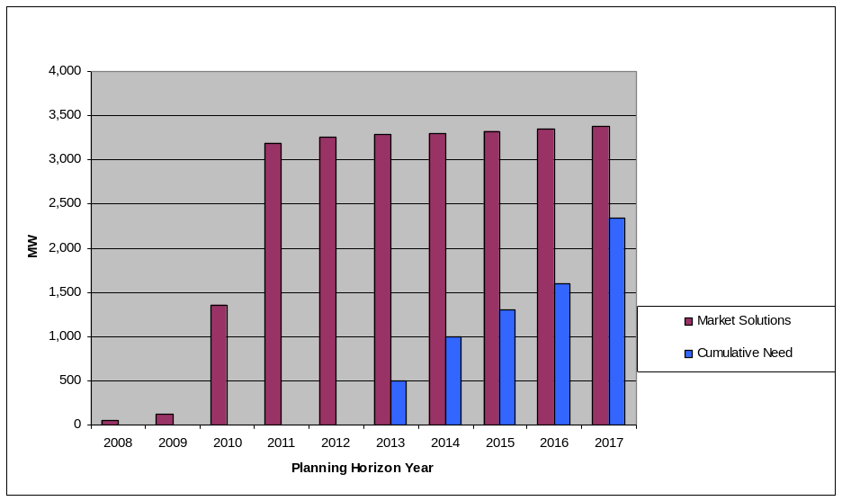
Figure 4.2.3 : Cumulative Needs Compared to Market-Based Solutions in MW

Table 4.2.1: Summary of Proposed Market-Based Solutions
Project Type | Size of Resource(MW) | Zone | In-service Date
Resource Proposals
Gas Turbine  NRG Astoria Re-powering | 520 MW | J | 1/2011
Simple Cycle GT  Indian Point | 300 | H | 5/2011
Combined Cycle  Bergen | 550 | J | 6/2010
DSM SCR | 125 | G,H, and J | 2012-2017
DSM SCR | 300 | F,G,H,I, and J | Ramps up from 2008 through 2012
Empire Generation Project | 635 | F | Q1/2010
Transmission Proposals
Controllable AC Transmission –VFT  Linden VFT | 300  (No specific capacity identified) | PJM-J | Q4 2009  PJM Queue G22
Back-to-Back  HVDC, AC Line  HTP | 660  (500 MW specific capacity identified) | PJM-J | Q2 2011  PJM Queue O66
Back-to-Back HVDC, AC Line  Harbor Cable | 550  (550 MW specific capacity identified) | PJM-J | 6/2011

More specifically, the NYISO received the following projects:
The NRG Submittal of Additional Capacity Resources
NRG submitted three distinct proposals for new generating capacity in Zone J:
1. The construction of two Siemens fast-start combined cycle units totaling 520 MW of ICAP at its Astoria facility in Queens to be connected to the 138 kV Astoria West substation. There is a retirement of 112 MW at this location reflected in the base case. This project would require the retirements in the base case at Astoria to proceed. The project is listed as a No. 201 and No. 224 in the NYISO interconnection queue. The anticipated in-service date is January 2011.
2. The construction of three Siemens fast-start combined cycle units totaling 789 MW of ICAP at its Astoria facility in Queens to be connected to the Astoria 345 kV substation. This project would require the retirements in the base case at Astoria to proceed. The project is listed as a No. 266 in the NYISO interconnection queue.
3. The construction of a three-on-one combined cycle plant totaling 800 MW at its Arthur Kill facility. The proposed facility would have a radial interconnection into the Gowanus 345 kV substation in Brooklyn. This project is listed as a No. 268 in the NYISO interconnection queue. The anticipated in-service date is Summer 2012.
NRG intends to proceed to completion with only one of these proposals. For purposes of the evaluation of this proposal, and to be conservative, the NYISO assumed the lowest MW proposal in the evaluation of Market-Based Solutions.
The 660 MW Hudson Transmission Project (HTP) with 500 MW Firm Capacity
This solution has been submitted by Hudson Transmission Partners. The HTP is an HVDC project that will provide a new controllable transmission line into Zone J that is rated at 660 MW. This is Project No. 206 in the NYISO interconnection queue. The HTP consists of a back-to-back HVDC system (“converter-circuit-converter”) in a single building (the Converter Station) located in Ridgefield, New Jersey near the PSEG Bergen substation, which is part of the PJM transmission system. A 345 kV AC transmission line will connect the Converter Station to Con Edison’s transmission system at the West 49th St. substation. The HTP is being developed in response to the Request for Proposals, “Long-Term Supply of In-City Unforced Capacity and Optional Energy” issued by NYPA dated March 11, 2005 (the 2005 NYPA RFP). The project was selected by NYPA’s Board of Trustees in November 2006 for further negotiation and review. This project is linked with the Red Oak Project described below. The project is to be in-service in second quarter, 2011. The System Impact Study in the PJM interconnection process has been posted. The project would be used to transmit capacity from the Red Oak, NJ Combined Cycle Generating Unit, described below.
The Red Oak project is an existing 817 MW three on one (3x1) combined cycle, natural gas fired power generation project, located in Sayreville, New Jersey. Red Oak began commercial operation in 2002. Red Oak’s major equipment includes three Westinghouse 501F combustion turbines, one Toshiba steam turbine, and three Foster Wheeler heat recovery steam generators, each with selective catalytic reduction. FPL Energy proposed the Red Oak project to NYPA as a supplement to Hudson’s response to the 2005 NYPA RFP. The Red Oak project could provide reliable capacity to NYPA’s New York City customers via the HTP. The project was selected by NYPA’s Board of Trustees for further negotiation and review of a 500 MW capacity contract.
The 550 MW Bergen 2 Combined Cycle Project
This solution was submitted by Cavallo Energy LLC. The developer, In-City LLC proposes to radially connect the output of the existing Bergen No. 2 generating plant at the Bergen Station in Ridgefield, New Jersey into the 345 kV system at Consolidated Edison’s West 49th Street substation, via a dedicated eight mile, 345 kV underground cable. The project is expected to deliver 550 MW commencing in June 2010. This project is in position No. 255 on the NYISO interconnection queue.
The 550 MW Harbor Cable Project (HCP) and Generating Portfolio
This solution was submitted by Brookfield Energy Marketing. The HCP will provide a 550 MW fully controllable electric transmission pathway from generation sources located in New Jersey to Zone J. The HCP will consist of a back-to-back HVDC converter station located in Linden, New Jersey with 200 MW going to the Goethals substation on Staten Island via a single circuit 345 kV AC transmission cable and 350 MW going to Manhattan near the new World Trade Center substation via double-circuit 138 kV AC transmission cables. This project is listed as No. 195 and No. 252 in the NYISO interconnection queue. The developer proposes to bundle the transmission project with up to 550 MW of capacity and energy from existing and/or new capacity located in New Jersey to be available in June 2011. To date, the developer has not applied for interconnection in PJM.
The 300 MW Linden Variable Frequency Transformers (VFT)
This solution was submitted by GE Energy Financial Services. The Project is a 300 MW bi-directional controllable AC transmission tie between the PJM and NYISO systems. It will be physically located adjacent to Linden Cogen plant. Three 100 MW Variable Frequency Transformer “channels” will tie an existing PJM 230 kV transmission line to existing 345 kV cables connecting Linden Cogen into Con Edison’s Goethals substation. This will result in a continuously variable 300 MW tie between the northern New Jersey PJM system and Zone J. This proposal does not contain any associated capacity identified to the NYISO at this time, but would rely on existing resources in PJM. This project is No. 125 on the NYISO’s interconnection queue and is scheduled to be in-service in late 2009. The developer has entered into an Interconnection Services Agreement and a Construction Services Agreement in PJM, and the project is under construction. It is expected that UDRs will be awarded for the full capacity of this project.
The 300 MW Indian Point Peaking Facility
This solution was submitted by Entergy Nuclear Power Marketing. The Entergy Buchanan Generation Project will consist of 300 to 330 MW of simple cycle gas turbine peaking capacity to be located on the site of the Indian Point Energy Center in Zone H. The facility will be interconnected to Con Edison’s existing Buchanan substation at 138 kV. This project is scheduled to be in-service in mid-2011. This project has not yet submitted a request for interconnection to the NYISO.
The 635 MW Empire Generating Project
This solution was submitted by Empire Generating Co. LLC, under First Light Energy (previously known as the Besicorp Project) for a 635 MW combined cycle plant that is presently under construction in Zone F. The anticipated in service date is on/before the first quarter of 2010. This project is in position No. 69 on the NYISO interconnection queue.
EnerNOC Demand Response
EnerNOC, Inc. offers 125 MW of additional demand response resources to the NYISO for Zones G, H, and J, specifically, and/or for any other zones as needed to meet identified reliability needs. The anticipated in service date is during the period 2012 to 2017.
Energy Curtailment Specialists, Inc. Demand Response
Energy Curtailment Specialists (ECS) offers up to 300 MW of additional demand response ramping up starting in 2008 and completed by 2012, with 25 MW each in Zones F, G, and H, 75 MW in Zone I, and 150 MW in Zone J. ECS anticipates to further develop and increase MW participation through 2017.

Alternative Regulated Solutions
Two Alternative Regulated Solutions were submitted. One consists of new generation at an existing site, and the second consists of a new transmission facility located wholly within New York. They are:
Mirant Lovett – Mirant New York proposes to construct a new 540 MW combined cycle facility located at its Lovett site by the year 2012.
New York Regional Interconnect – This Alternative Regulated Solution was previously submitted by the New York Regional Interconnect (NYRI) in response to the NYISO’s 2005 and 2007 RNAs. The NYRI transmission proposal is to construct a new HVDC transmission line between the Edic substation in the Town of Marcy, Oneida County, and the Rock Tavern substation in the Town of New Windsor, Orange County. It is Project No. 96 in the NYISO interconnection queue. The HVDC transmission line would function as a bipolar, bi-directional facility operated at a rated power flow of 1,200 MW at a nominal voltage of ± 400 kV DC. The developer plans to place the project in commercial operation in 2012.

Evaluation of Solutions
Evaluation of solutions is covered by Section 7 of the NYISO CRPP Manual. Section 7.1 describes the process for the evaluation of the Regulated Backstop Solutions submitted by the Responsible TOs. Section 7.2 states how Market-Based Solutions are evaluated. Section 7.3 lays out the process for the evaluation of Alternative Regulated Solutions.

Adequacy and Transmission Security
Figure 5.1.4 below displays the bulk power system for NYCA, which is generally facilities 230 kV and above, but does include certain 138 kV facilities and a very small number of 115 kV facilities. The balance of the facilities 138 kV and lower are considered non-bulk or sub-transmission facilities. The figure also displays key transmission interfaces for New York.

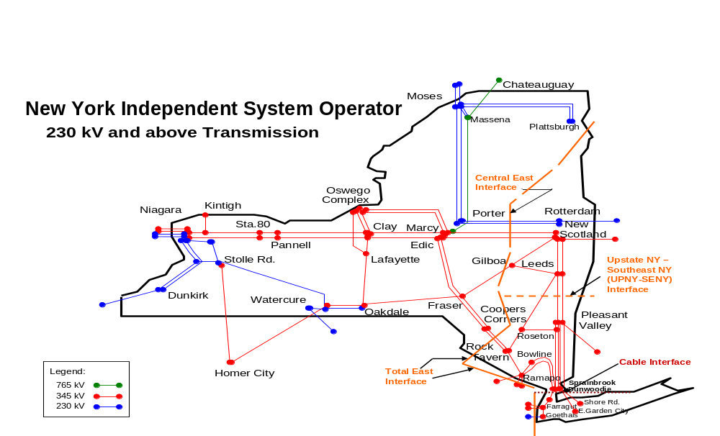
Figure 5.1.4: NYISO 230 kV and above Transmission Map

In the RNA, transfer limits were assumed to be constant from the end of the first five years throughout the second five year period. The assumed transmission transfer limits were confirmed during the evaluation of the solutions. The staging of the proposed Regulated Backstop Solutions at their proposed locations maintains or significantly improves the transmission transfer limit assumptions.. The solutions in Zone G were assessed on the 138 kV system. The generation solution in Zone J was assumed to be connected to the 345 kV system, and the DSM was assumed to be dispersed throughout Zone J.

Responsible Transmission Owners Submitted Plans and Regulated Backstop Solutions
From the Responsible TO joint submittal, the Neptune HVDC project exercising its UDR rights with some level of firm capacity was included in the evaluation of the first Five Year Base Case. For the second five year period, the joint submittal by the Responsible TOs was evaluated. Individually submitted TO Regulated Backstop Solutions were also evaluated.

First Five Year Base Case:
As identified in the 2008 RNA and discussed in the transmission security and adequacy section, load growth in southeastern New York, planned generator retirements, changes to neighboring systems, and the resulting impacts on the voltage performance of the transmission system, resulted in a significant reduction in the transfer capability of the New York bulk power system to reliably deliver power into and through the lower Hudson Valley. This impact manifested itself as increased resource needs in Zones G through J.
The TO updated plan submitted by LIPA included a level of firm capacity treatment in Zone K associated with the Zone K UDRs. Incorporating this change into the first Five Year Base Case period did not change the transmission interface limits but deferred the first year of reliability need from 2012 to 2013 because of the change from emergency assistance treatment to a level of firm capacity.Table 5.2.2 below presents the key transmission interface transfer limits based on thermal limits, Table 5.2.3 below presents the key transmission interface transfer limits based on voltage limits, and Table 5.2.4 presents the transfer limits employed in the Multi-Area Reliability Simulation (MARS) analysis.

Table 5.2.2: Thermal Transfer Limits for Key Interfaces in MW
Interface | Year
Interface | 2008 | 2009 | 2010 | 2011 | 2012
Central East +FG* | 3375 | 3350 | 3175 | 3250 | 3100
Zones F-G | 3475 | 3475 | 3475 | 3475 | 3475
UPNY/SENY | 5150 | 5150 | 5150 | 5150 | 5150
Zones I-J** | 3925 | 4000 | 4400 | 4400 | 4400
Zones I-K | 1290 | 1290 | 1290 | 1290 | 1290
*FG – Fraser-Gilboa circuit; for the MARS interface, Fraser-Gilboa is added to the Central East operating interface definition.
**Delay of M29 beyond summer 2010 is not reflected in the 2010 limit.

Table 5.2.3: Transmission System Voltage Transfer Limits for Key Interfaces in MW
Interface | Year
Interface | 2008 | 2009 | 2010 | 2011 | 2012
Central East + FG | 3,150 | 3,150 | 3,150 | 3,150 | 3,150
Zones F-G
UPNY/SENY
Zones I-J |  |  | 4,225 | 4,175 | 4,150
Zones I-K
Note: Blank entries indicate that the voltage limits are more than five percent above the thermal limits.

Table 5.2.4: Transmission System Transfer Limits for Key Interfaces in MW
Interface | Year
Interface | 2008 | 2009 | 2010 | 2011 | 2012
Central East + FG | 3,150^{V} | 3,150^{V} | 3,150^{V} | 3,150^{V} | 3,100 ^{T}
Zones F-G | 3,475 ^{T} | 3,475 ^{T} | 3,475 ^{T} | 3,475 ^{T} | 3,475 ^{T}
UPNY/SENY | 5,150 ^{T} | 5,150 ^{T} | 5,150 ^{T} | 5,150 ^{T} | 5,150 ^{T}
Zones I-J | 3,925 ^{T} | 4,000 ^{T} | 4,400 ^{C} | 4,400 ^{C} | 4,400 ^{C}
Zones I-K | 1,290 ^{T} | 1,290 ^{T} | 1,290 ^{C} | 1,290 ^{C} | 1,290 ^{C}
Zones I-J&K | 5,215 ^{T} | 5,290 ^{T} | 5,515 ^{V} | 5,465 ^{V} | 5,440 ^{V}
Note: T = Thermal; V = Voltage, C = Combined

These transfer limits were incorporated into the MARS model along with the LIPA TO updated plan. The LOLE results are presented in the Table 5.2.5 entitled: “RNA Study Case Load and Resource Table with TO Submitted Plans”. The table shows that with LIPA’s TO updated plan, the NYCA system meets resource adequacy requirement through 2012 and that the first year of need is 2013. Table 5.2.6 presents the LOLE results by zone and for the NYCA.

Table 5.2.5: RNA Study Case Load and Resource Table with Updated TO Plans and Joint TO Submittal
(First Five Year Base Case)

Year
2008
2009
2010
2011
2012
Peak Load
NYCA
33,871
34,300
34,734
35,141
35,566
Zone J
11,975
12,150
12,325
12,480
12,645
Zone K
5,485
5,541
5,607
5,664
5,730
Resources
NYCA
“-Capacity”
39,247
39,247
39,987
39,987
39,987
“-SCR”³
1323
1323
1323
1323
1323
Total
40,570
40,570
41,310
41,310
41,310
Zone J
“-Capacity”
10,019
10,019
9,128
9,128
9,128
“-SCR”
468.7
468.7
468.7
468.7
468.7
Total
10,487
10,487
9,596
9,596
9,596
Zone K
“-Capacity”
5,612
5,612
6,352
6,352
6,352
“-SCR”
159.5
159.5
159.5
159.5
159.5
Total
5,772
5,772
6,512
6,512
6,512
NYCA Resource to Load Ratio [1]
119.78%
118.28%
118.93%
117.55%
116.15%
Zone J Res./Load Ratio [2]
87.57%
86.31%
77.86%
76.89%
75.89%
Zone K Res./Load Ratio
105.22%
104.16%
116.13%
114.96%
113.64%
NYCA LOLE (day/year)
0.00
0.00
0.03
0.05
0.10
[1] The statewide and local resource to load ratios result from the existing system under the conditions studied and should not be interpreted as the IRM or locational capacity requirements (LCR) that would be established for the NYCA capacity markets.
[2] A ratio less than the current locational capacity requirement is the result of the “as found system” being at a point on the LCR/IRM curve that meets reliability criteria with LCRs different from current requirements.
[3] SCRs were modeled in the RNA at the level of ICAP that was registered in the New York market as of July 1, 2007. This level has increased since that time.

Table 5.2.6; NYCA LOLE for the First Five Year Base Case with TO Updated Plan (First Five Year Base Case)
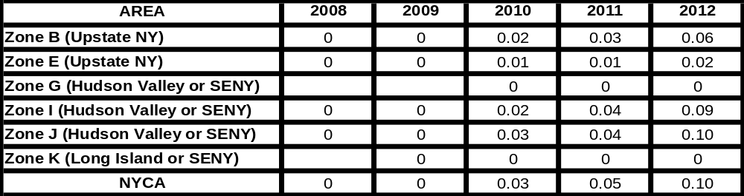

Second Five Years
As discussed in Section 4, the Responsible TOs offered a joint submittal with proposals to satisfy the reliability needs. They consisted of 2,100 MW of new resources by 2017 and a new transmission line. The new resources include 300 MW of new generation or DSM in Zone B, a commitment to 500 MW of DSM as a TO updated plan in addition to another 500 MW of DSM or clean generation in Zone J, 300 MW of new generation or DSM in Zone K, as well as another 500 MW of new generation or DSM in Zone G. As a Regulated Backstop Solution, the 2,100 MW of additional resources satisfies the identified reliability needs when considered together with LIPA’s TO updated plan for a level of firm capacity delivered to New York over the Neptune Cable, and the addition of a new transmission line between Zones F and G.
The new transmission between Zones F and G would increase the transfer capability of the UPNY/SENY interface, allowing for better utilization of existing upstate resources, including the newly proposed resource in Zone B, for as long as there is surplus generation upstream of this interface. Sensitivities regarding the treatment of this transmission line were run for informational purposes. If the transmission line is not added, and given the same location of the 2,100 MW resource additions, the LOLE criterion would still be satisfied.
Another sensitivity shows that an additional 250 MW of compensatory MW added to the joint TO submittal downstream of UPNY/SENY would greatly improve meeting the identified reliability needs in the second five years because of the large 250 MW block size. A final sensitivity shows that relocation with a slight reduction of the compensatory MW also satisfies the LOLE criterion and meets the reliability needs in the second five years, indicating that there is not a lot of excess resource capacity available for more efficient transmission utilization above Zone G for the modeling assumptions in this CRP. The 2,050 MW of resources is equal to the level of compensatory MW from the free flow sensitivity in the RNA. Table 5.2.7 illustrates the compensatory MW locations associated with this additional informative analysis of the joint TO submittal both with and without the potential transmission line.
RG&E has also proposed a generation option consisting of the repowering of the Russell plant that could serve as the solution for the local needs identified in Zone B. Analysis was done treating the backstop solution as both DSM and Generation.
Both of National Grid’s specific transmission line options between Zones F and G were evaluated. These two options, which essentially provide the equivalent reliability benefit given the existing and proposed resource locations, enable more resources upstate to be effective in satisfying needs in the Lower Hudson Valley, as well as to improve the operational reliability of the transmission grid.
Additionally, National Grid proposed to reinforce the 115 kV transmission system between Packard and Gardenville by constructing a new 115 kV line. The proposal also adds three 75 MVAr 115 kV capacitor banks at Gardenville. Evaluated initially with the jointly submitted TO Regulated Backstop Solution, this proposal addresses the issue identified in the RNA under the high load forecast scenario on the local system within Zone A around the Gardenville substation, does not address bulk power system needs at this time, and does not appreciably increase the transfer limits of the Dysinger East and West Central interfaces after the addition of the Zone B Regulated Backstop Solution. The final joint TO proposal did not include this project.
Table 5.2.7 presents the phase in of the Responsible TOs’ joint submittal by year and zone, with and without the new transmission line in-service by 2017, and with the relocation of resources from Zone B to Zone G. The additional 250 MW is shown as a change in Zone J capacity in 2017.

Table 5.2.7: Joint Transmission Owner Submittal of Proposed Additions by Year and Zone with Sensitivities of Transmission Inclusion and Relocation
MW level | 2,100 with transmission |  | 2,100 without transmission |  | 2,350 without transmission |  | 2,050 without transmission w/Relocation
Year | MW | Zone | MW | Zone | MW | Zone | MW | Zone
2013 | 300 | B | 300 | B | 300 | B | 250 | G
 | 190 | J | 190 | J | 190 | J | 190 | J
 | 121 | K | 121 | K | 121 | K | 121 | K
2014 | 315 | J | 315 | J | 315 | J | 315 | J
 | 40 | K | 40 | K | 40 | K | 40 | K
2015 | 270 | J | 270 | J | 270 | J | 270 | J
2015 | 44 | K | 44 | K | 44 | K | 44 | K
2016 | 250 | G | 250 | G | 250 | G | 250 | G
 | 40 | J | 40 | J | 40 | J | 40 | J
 | 44 | K | 44 | K | 44 | K | 44 | K
2017 | 250 | G | 250 | G | 250 | G | 250 | G
 | 185 | J | 185 | J | 435 | J | 185 | J
 | 47 | K | 47 | K | 47 | K | 47 | K
Total | 2096 |  | 2096 |  | 2346 |  | 2046
2017 LOLE | 0.1 |  | 0.1 |  | 0.07 |  | 0.1

The impacts of individual TO submittals by National Grid regarding the UPNY/SENY options were evaluated by conducting power flow analysis to determine their impacts on thermal and voltage limits. Both the Leeds/PV and Schodack/PV options result in approximately the same increase in the UPNY/SENY interface of approximately 875 MW. However, the New Scotland to Leeds circuit becomes more limiting for the third Leeds to Pleasant Valley circuit. This impact is reflected on the transfer limit for the Zone F to Zone G interface. Alternatively, the Schodack to Pleasant Valley circuit mitigates the New Scotland to Leeds transfer limit regardless of dispatch. More generation upstream of these interfaces would be able to supply downstream areas, subject to the Central East interface limit. Voltage limit impacts in the Hudson Valley were approximately the same for both options, but to achieve the same level increase as the thermal limit, additional reactive compensation in the Hudson Valley would be required. Such enhancement could take the form of transmission improvements (capacitor banks, static VAR compensators, etc.) or generation solutions in Zone G. Table 5.2.8 summarizes the transfer limits used in the LOLE analysis for the two UPNY/SENY transmission options. Individual assessments were performed for the generation/DSM addition in Zone B, one with all generation and one with all DSM. While both were effective in satisfying the identified reliability needs, overall system performance and transfer limits were better for the generation alternative.

Table 5.2.8: Transfer Limits for Transmission Alternatives (in MW)
Interface | Existing System | Leeds-PV | Schodack-PV
F-G | 3,475 | 3,475 | 4,350
UPNY/SENY | 5,150 | 6,025 | 6,025

Table 5.2.9 below presents the total level of MW needed to maintain compliance with the resource adequacy criterion for the joint TO submittal. The proposed Regulated Backstop Solution of 500 MW DSM and clean generation was modeled as a 500 MW generation resource connecting to the in-city 345 kV network. This analysis was done to maintain transfer limits needed to achieve resource adequacy given the set of proposed solutions. The table should not be interpreted as requiring 250 MW of generation in 2014; some of that need could be met with DSM while maintaining resource adequacy. The NYISO notes that there may be a difference in emergency transfer limits when considering non-bulk power system DSM, which reduces loadings, as opposed to generation, on the 345 kV network, which provides an additional reactive resource.
Table 5.2.9: RNA Study Case Load and Resource Table with TO Updated Plans
(TO Joint Submittal with 2,100 MW of Resources and Transmission Upgrade, Second Five Years)

Year | 2013 | 2014 | 2015 | 2016 | 2017
Peak Load
NYCA | 35,651 | 35,950 | 36,269 | 36,577 | 36,835
Zone J | 12,590 | 12,660 | 12,755 | 12,825 | 12,860
Zone K | 5,670 | 5,694 | 5,714 | 5,753 | 5,780
Resources
NYCA
“Capacity” | 39,126 | 39,376 | 39,626 | 39,876 | 40,126
“SCR” | 1323 | 1323 | 1323 | 1323 | 1323
Total | 40,459 | 40,709 | 40,959 | 41,209 | 41,459
Zone J
“Capacity” | 9,015 | 9,265 | 9,515 | 9,515 | 9,515
“SCR” | 468.7 | 468.7 | 468.7 | 468.7 | 468.7
Total | 9,483 | 9,733 | 9,983 | 9,983 | 9,983
Zone K
“Capacity” | 6,352 | 6,352 | 6,352 | 6,352 | 6,352
“SCR” | 159.5 | 159.5 | 159.5 | 159.5 | 159.5
Total | 6,512 | 6,512 | 6,512 | 6,512 | 6,522
NYCA Resource to Load Ratio | 113.5% | 113.2% | 112.9% | 112.7% | 112.3%
Zone J Resource to Load Ratio | 75.3% | 76.9% | 78.3% | 77.8% | 77.0%
Zone K Resource to Load Ratio | 114.8% | 114.4% | 114.0% | 113.2% | 112.7%
NYCA LOLE (day/year) | 0.10 | 0.08 | 0.08 | 0.09 | 0.1

Table 5.2.10: RNA Study Case Load and Resource Table with TO Updated Plans
(Without Transmission Upgrade and 250 MW Compensatory MW for Second Five Years)

Year | 2013 | 2014 | 2015 | 2016 | 2017
Peak Load
NYCA | 35,651 | 35,950 | 36,269 | 36,577 | 36,930
Zone J | 12,590 | 12,660 | 12,755 | 12,825 | 12,965
Zone K | 5,670 | 5,694 | 5,714 | 5,753 | 5,780
Resources
NYCA
“Capacity” | 39,136 | 39,386 | 39,636 | 39,886 | 40,386
“SCR” | 1323 | 1323 | 1323 | 1323 | 1323
Total | 40,459 | 40,709 | 40,959 | 41,209 | 41,709
Zone J
“Capacity” | 9,015 | 9,265 | 9,515 | 9,515 | 9,765
“SCR” | 468.7 | 468.7 | 468.7 | 468.7 | 468.7
Total | 9,483 | 9,733 | 9,983 | 9,983 | 10,233
Zone K
“Capacity” | 6,352 | 6,352 | 6,352 | 6,352 | 6,352
“SCR” | 159.5 | 159.5 | 159.5 | 159.5 | 159.5
Total | 6,512 | 6,512 | 6,512 | 6,512 | 6,512
NYCA Resource to Load Ratio | 113.5% | 113.2% | 112.9% | 112.7% | 112.9%
Zone J Resource to Load Ratio | 75.3% | 76.9% | 78.3% | 77.8% | 78.9%
Zone K Resource to Load Ratio | 114.8% | 114.4% | 114.0% | 113.2% | 112.7%
NYCA LOLE (day/year) | 0.10 | 0.08 | 0.08 | 0.09 | 0.09

Assessment of Responsible TO Updated Plans and Regulated Backstop Solutions
The evaluation of the joint Responsible TO submittal of a TO updated plan and Regulated Backstop Solutions indicates that the system as modeled will meet the needs through 2017. Figure 5.2.5 below presents the resource mixes that result from the TOs’ submittal for the 2,100 MW resource proposal that also includes a transmission upgrade between Zone F and Zone G. NYCA resources are presented as the percentage of the forecasted annual peak load. The sum of the resources stated as a percentage of the forecasted peak load equals the IRM, which is a generally accepted measure of the level of resources needed to maintain reliability. Expressed as the percentage of annual peak load, the resources are divided into five categories:
1. In-NYCA generating capacity,
2. UDRs, which are supported by external capacity,
3. DSM/SCR,
4. Regulated backstop resources needed to maintain the 0.1 days per year criterion,
5. External capacity of 3,280 MW currently eligible to participate in the NYISO markets. The amount of eligible capacity can change annually and is used in the chart for illustrative purposes only.
For reference, the statewide ICR is currently 115 percent. It is updated annually.

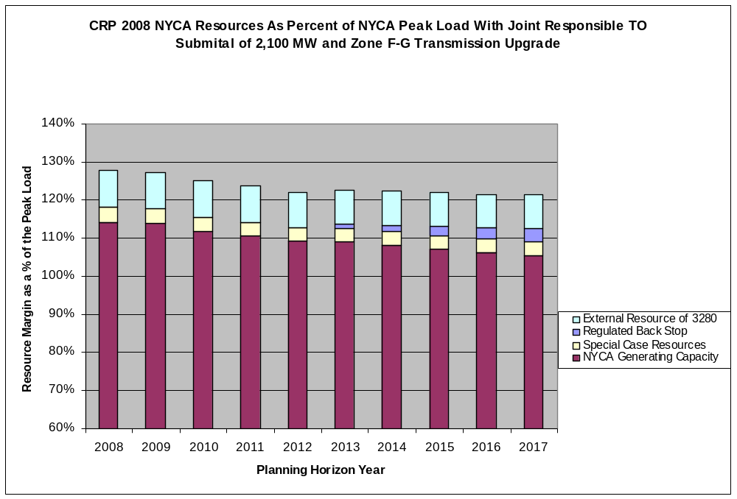
Figure 5.2.5: TO Regulated Backstop Solutions – 2,100 MW

Market-based Solutions
As previously discussed, the NYISO received nine market-based proposals in response to its request for Market-Based Solutions. Because the HVDC proposals provided evidence of the availability or potential availability of capacity and energy, the HVDC projects from PJM to Zone J were modeled as UDRs or equivalent to generators located in Zone J. The transfer limits used to evaluate the market-based proposals are the same as those used to evaluate the updated TO plans from the first five years. Since the proposed Market-Based Solutions provide for generation additions in excess of the Regulated Backstop Solutions, as well as additional transmission capability, for the second five years, it was assumed that at least the same level of reactive support would be available as for the Regulated Backstop Solutions. Therefore, the transfer limits would be at least those used for the evaluation of the backstop solutions. Recognizing that many of the proposed Market-Based Solutions were DC and AC ties from PJM, additional zones and interfaces were added to the transmission topology used for the MARS resource adequacy analysis. This topology change was employed to capture potential internal PJM or Zone J constraints not otherwise specifically modeled when there is only one transmission interface modeled for the PJM to Zone J interface.

First Five Year Base Case
Table 5.2.11 below presents the Load and Resource table with the Five Year Base Case with the LIPA TO updated plan of the Neptune transmission project, and the market proposals for the first Five Year Base Case. The Market-Based Solutions improve the LOLE results for 2009 through 2010 when compared to the first Five Year Base Case.
Table 5.2.11: Base Case Load and Resource with Updated Neptune and Market-Based Solutions
Year | 2008 | 2009 | 2010 | 2011 | 2012
Peak Load
NYCA | 33,871 | 34,300 | 34,734 | 35,141 | 35,566
Zone J | 11,975 | 12,150 | 12,325 | 12,480 | 12,645
Zone K | 5,485 | 5,541 | 5,607 | 5,664 | 5,730
Resources
NYCA
“-Capacity” | 38,697 | 39,037 | 40,021 | 41,871 | 41,871
“-SCR” | 1323 | 1323 | 1323 | 1323 | 1323
Total | 40,020 | 40,360 | 41,344 | 43,194 | 43,194
Zone J
“-Capacity” | 10,019 | 10,019 | 9,678 | 11,228 | 11,228
“-SCR” | 468.7 | 468.7 | 468.7 | 468.7 | 468.7
Total | 10,487 | 10,487 | 10,146 | 11,696 | 11,696
Zone K
“-Capacity” | 5,612 | 5,612 | 6,352 | 6,352 | 6,352
“-SCR” | 159.5 | 159.5 | 159.5 | 159.5 | 159.5
Total | 5,772 | 5,772 | 6,512 | 6,512 | 6,512
NYCA Resource to Load Ratio | 118.15% | 117.67% | 119.03% | 122.92% | 121.45%
Zone J Resource to Load Ratio | 87.57% | 86.31% | 82.32% | 93.72% | 92.49%
Zone K Resource to Load Ratio | 105.22% | 104.16% | 116.13% | 114.96% | 113.64%
NYCA LOLE (day/year) | 0.00 | 0.00 | 0.00 | 0.00 | 0.00

Second Five Years
Table 5.2.12 presents the Load and Resource table that incorporates only LIPA’s TO updated plan (Neptune) and the market proposals for the second five years. Table 5.2.13 presents the zonal and NYCA LOLE results for the second five years with the market proposals in-service and includes both the LIPA TO updated plan (Neptune) and the Con Edison updated TO plan (500 MW DSM program).
Table 5.2.12: Base Case Load and Resource with Updated Neptune and Market-Based Solutions – Second Five Years

Year | 2013 | 2014 | 2015 | 2016 | 2017
Peak Load
NYCA | 35,962 | 36,366 | 36,749 | 37,141 | 37,631
Zone J | 12,780 | 12,915 | 13,030 | 13,140 | 13,360
Zone K | 5,791 | 5,855 | 5,919 | 6,002 | 6,076
Resources
NYCA
“-Capacity” | 41,871 | 41,871 | 41,871 | 41,871 | 41,871
“-SCR” | 1323 | 1323 | 1323 | 1323 | 1323
Total | 43,194 | 43,194 | 43,194 | 43,194 | 43,194
Zone J
“-Capacity” | 11,228 | 11,228 | 11,228 | 11,228 | 11,228
“-SCR” | 468.7 | 468.7 | 468.7 | 468.7 | 468.7
Total | 11,696 | 11,696 | 11,696 | 11,696 | 11,696
Zone K
“-Capacity” | 6,352 | 6,352 | 6,352 | 6,352 | 6,352
“-SCR” | 159.5 | 159.5 | 159.5 | 159.5 | 159.5
Total | 6,512 | 6,512 | 6,512 | 6,512 | 6,512
NYCA Resource to Load Ratio | 120.1% | 118.8% | 117.5% | 116.3% | 114.8%
Zone J Resource to Load Ratio | 91.5% | 90.6% | 89.8% | 89.0% | 87.5%
Zone K Resource to Load Ratio | 112.4% | 111.2% | 110.0% | 108.5% | 107.2%
NYCA LOLE (day/year) | 0.00 | 0.00 | 0.01 | 0.02 | 0.04

Table 5.2.13: NYCA LOLE for the Second Five Years with Both LIPA and Con Edison Updated TO Plans and Market-Based Solutions (probability of occurrences in days per year)
AREA | 2013 | 2014 | 2015 | 2016 | 2017
Zone B (Upstate NY) | 0.00 | 0.00 | 0.00 | 0.00 | 0.01
Zone E (Upstate NY) | 0.00 | 0.00 | 0.00 | 0.00 | 0.00
Zone G (Hudson Valley or SENY) | 0.00 | 0.00 | 0.00 | 0.00 | 0.00
Zone I (Hudson Valley or SENY) | 0.00 | 0.00 | 0.00 | 0.00 | 0.01
Zone J (NYC or SENY) | 0.00 | 0.00 | 0.00 | 0.00 | 0.01
Zone K (Long Island or SENY) | 0.00 | 0.00 | 0.00 | 0.00 | 0.00
NYCA | 0.00 | 0.00 | 0.00 | 0.00 | 0.01
As can be seen from these LOLE results, the impact of including both submitted TO updated plans is to improve adequacy from the RNA to a reliable LOLE of 0.01 days per year. With or without the 500 MW of additional DSM in Zone J, there are sufficient market resource additions to meet resource adequacy requirements.

Assessment of the Market Proposals
With the updated Neptune HVDC project, the market proposals are not needed to meet the identified reliability needs for the first Five Year Base Case. Moreover, if they are constructed, the market proposals are sufficient to maintain the LOLE criteria for the second five year period. Because of planning uncertainties and the identified needs in the second five years, sufficient projects should proceed to meet resource adequacy requirements. At least 500 MW of resources should be added by 2013. A total of at least 2,350 MW of resources should be added statewide by 2017. Projects in the quantities and locations noted in Table 4.2.1: Summary of Proposed Market-Based Solutions will need to maintain their schedules for permitting, construction, and entering into service.
In evaluating the viability of the market proposals, the NYISO has identified an issue with respect to these projects going forward and their potential overall reliability benefits being realized. Although each of these developers have significant financial resources available to them, the proponents of market-based generation and transmission solutions stated that their viability may depend upon entry into long-term contracts for the sale of at least a portion of their output or use of their transmission facilities. Some of the developers asserted that the current NYISO-administered markets do not provide sufficient revenue certainty to fully support the investment these products will require. Accordingly, while the NYISO has determined that these projects appear viable at this time to meet their projected in-service dates, there is at least some level of uncertainty as to whether these projects will proceed.
Figure 5.2.6 below presents the IRM that results from the Neptune TO plan for the first Five Year Base Case and the market proposals for the full 10-year Study Period. The resources are presented as a percentage of the annual peak load. The sum of the resources equal the IRM.
Expressed as a percentage of the annual peak, the resources are divided into four categories: (1) in-NYCA existing generating capacity, (2) DSM/SCR, (3) market proposals that are additions to NYCA generating capacity, and (4) external capacity of 3,280 MW currently eligible to participate in the NYISO markets. and Figure 5.2.8 below present the resources for New York City and Long Island as a percentage of their respective peak loads. The sum of the resources is equal to the amount of installed zonal resources expressed as a percentage of the forecasted zonal peak load. Because New York City and Long Island are defined as localities in the NYISO Tariff, they have minimum locational capacity requirements (LCRs). The current minimum LCRs are 80 percent for New York City and 94 percent for Long Island, respectively.

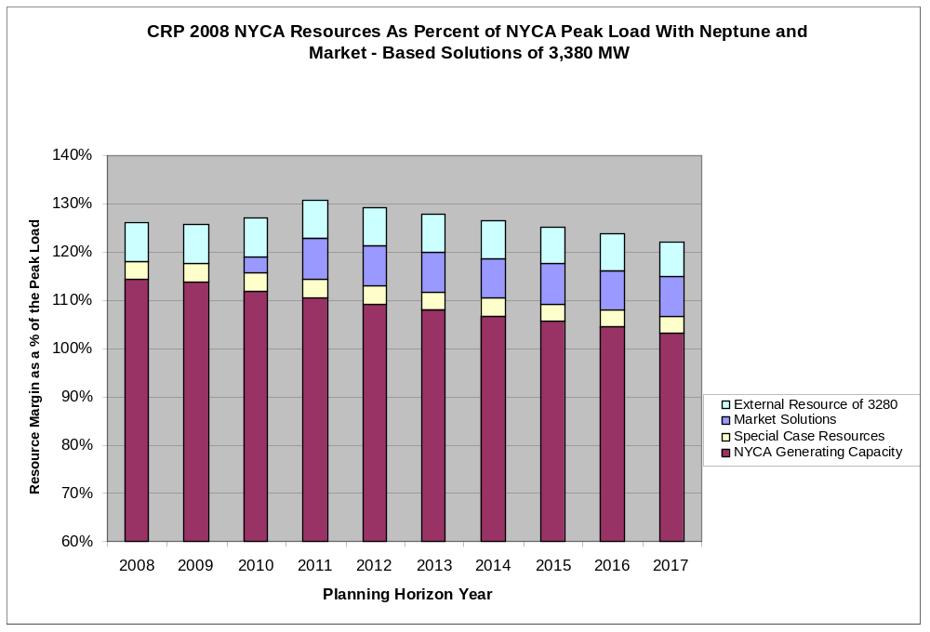
Figure 5.2.6: CRP 2007 NYCA Resources as Percent of NYCA Peak Load with Neptune and Market-Based Solutions

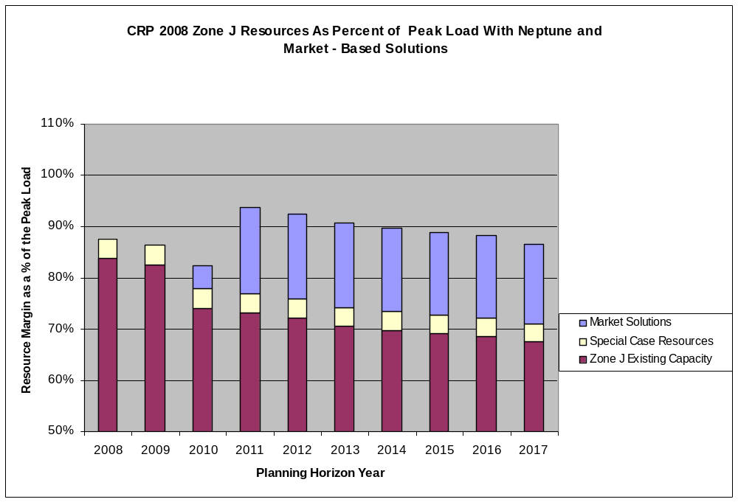

Figure 5.2.7: CRP 2007 Zone J Resources as Percent of Zone J Peak Load with Neptune and Market-Based Solutions

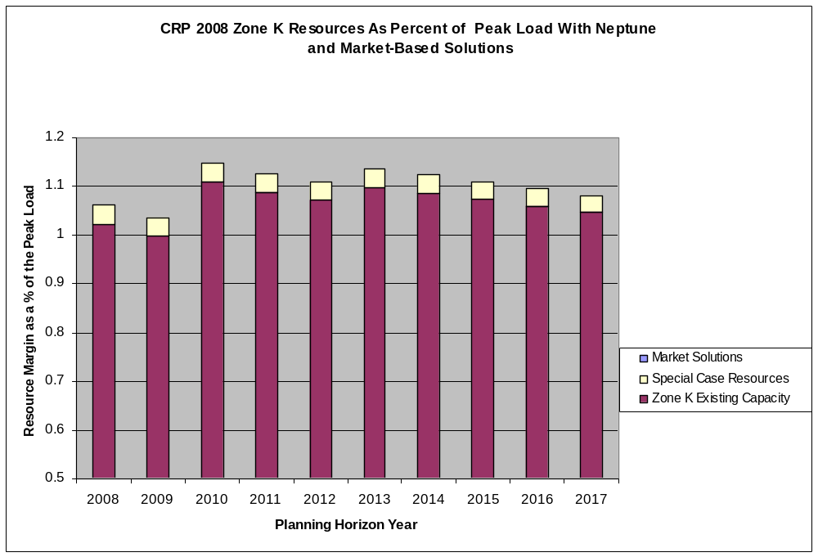

Figure 5.2.8: CRP 2007 Zone K Resources as Percent of Zone K Peak Load with Neptune and Market-Based Solutions

Alternative Regulated Responses
The NYISO solicited requests for alternative regulated responses to meet the identified reliability needs. As discussed previously, two alternative regulated responses were submitted. The responses consisted of one generation proposal and one transmission proposal. An in-depth review of each of the proposals was not undertaken at this time because, as noted earlier, the NYISO determined that regulated alternatives are not required as there are sufficient Market-Based Solutions.

Alternative Regulated Generation Response
Mirant New York proposes to construct a new 540 MW combined cycle facility located at the Lovett site by the year 2012. This addition of MW improves the system performance in the local area as well as bulk power system transfer limits.

Table 5.2.14: Impact of New Lovett 540 MW Combined Cycle on NYCA LOLE
 | 2013 | 2014 | 2015 | 2016 | 2017
Zone B (Upstate NY) | 0.06 | 0.09 | 0.15 | 0.22 | 0.31
Zone E (Upstate NY) | 0.02 | 0.03 | 0.06 | 0.10 | 0.15
Zone G (Hudson Valley or SENY) | 0.00 | 0.00 | 0.00 | 0.00 | 0.00
Zone I (Hudson Valley or SENY) | 0.08 | 0.12 | 0.20 | 0.31 | 0.41
Zone J (Hudson Valley or SENY) | 0.09 | 0.14 | 0.22 | 0.34 | 0.44
Zone K (Long Island or SENY) | 0.00 | 0.00 | 0.01 | 0.02 | 0.04
NYCA | 0.10 | 0.14 | 0.23 | 0.36 | 0.46
NYCA Differences (W and W/O ARR) | -0.07 | -0.13 | -0.19 | -0.24 | -0.26

Alternative Regulated Transmission Response
This Alternative Regulated Solution was submitted by the NYRI, which proposes to construct a new HVDC transmission line between the Edic substation in the Town of Marcy, Oneida County and the Rock Tavern substation in the Town of New Windsor, Orange County. It is project No. 96 in the NYISO interconnection queue.
Based on updated information and modeling, the NYISO had determined that there is no need to require a Regulated Backstop Solution at this time. As a result, the alternative regulated transmission proposal was not evaluated as a specific alternative to Regulated Backstop Solutions. Rather, this proposal was evaluated as a generic increase to transfer capability.
To evaluate the benefits of increased transfer capability associated with this transmission proposal, selected interfaces in the MARS model were increased to simulate the potential benefits of additional transmission capability.
Although this proposal would potentially increase the Zones E to G interface by 1,200 MW, there are simultaneous constraints that need to be recognized. To capture these simultaneous constraints, this project was evaluated using a lower interface limit increase of 1,000 MW for UPNY/SENY. The impact of this proposal on LOLE is presented in Table 5.2.15.
Table 5.2.15: Impact NYRI Transmission Proposal on NYCA LOLE
 | 2013 | 2014 | 2015 | 2016 | 2017
Zone B (Upstate NY) | 0.11 | 0.17 | 0.27 | 0.40 | 0.49
Zone E (Upstate NY) | 0.04 | 0.07 | 0.12 | 0.20 | 0.24
Zone G (Hudson Valley or SENY) | 0.01 | 0.01 | 0.01 | 0.02 | 0.02
Zone I (Hudson Valley or SENY) | 0.12 | 0.18 | 0.29 | 0.42 | 0.53
Zone J (Hudson Valley or SENY) | 0.13 | 0.21 | 0.33 | 0.48 | 0.58
Zone K (Long Island or SENY) | 0.00 | 0.01 | 0.01 | 0.03 | 0.05
NYCA | 0.13 | 0.21 | 0.34 | 0.49 | 0.61
NYCA Differences (W and W/O ARR) | -0.04 | -0.06 | -0.08 | -0.10 | -0.12

Assessment of the Alternative Regulated Responses
The above analysis indicates that all of the alternative regulated responses would improve reliability and satisfy some portion of the need.
The transmission Alternative Regulated Solution would benefit resource adequacy only if there is additional capacity available to be delivered, but it does provide the flexibility to site additional resources away from load centers. The impacts of this transmission project are being studied in the System Reliability Impact Study (SRIS). The SRIS indicates that there are positive and negative impacts to the bulk power system associated with the project.

Summary of Evaluation of Proposed Solutions
In summary, the updated TO plan provided by LIPA together with existing system resources will satisfy New York’s bulk power system reliability needs for the first five years of the Study Period. If the market responses remain on schedule as proposed, the NYCA would more than comply with the LOLE criterion throughout the 10-year Study Period. Given that the total capacity of the Market-Based Solutions are nearly 1,000 MW in excess of resource requirements, and the planned in-service dates are well in advance of need, reliability needs will still be met if a portion of the Market-Based Solutions come into service later than presently planned. Consequently, neither a Regulated Backstop Solution nor an Alternative Regulated Solution needs to be implemented at this time. Going forward, the NYISO will monitor the progress of the proposed solutions on a quarterly basis to determine that these planned resources will be available in a timely manner.

Transmission System Short Circuit Assessment
The NYISO updated the short circuit assessment in the 2008 RNA to include all the TO solutions that were evaluated for this CRP. The methodology employed was the same as used for the RNA. It is described in the “NYISO Guideline for Fault Current Assessment,” contained in Appendix B of the RNA supporting document. The fault current levels arising from the implementation of the updated TO plans were assessed and compared against the most recent Annual Transmission Reliability Assessment 2007 (ATRA) fault levels to determine if breakers would become over-dutied. The Market-Based Solutions were evaluated in aggregate. Assumptions were made as to the exact locations for the solutions in the second five years of the Study Period. The exact location of solutions can greatly impact the fault levels calculated. Based on the locations assumed for the solutions, fault duties did not indicate over-dutied breakers in addition to those identified in the 2007 ATRA.

The 2008 Reliability Plan
The NYISO OATT Attachment Y in Section 8 states that:
Following the NYISO’s evaluation of the proposed Market-Based and Regulated solutions to Reliability Needs, the NYISO will prepare a draft Comprehensive Reliability Plan (“CRP”). The draft CRP shall set forth the NYISO’s findings and recommendations; including any determination, that implementation of a Regulated Solution (which may be a Gap Solution) is necessary to maintain system reliability.
After Committee review and vote as described in Attachment Y of the OATT, the draft CRP will become final once approved by the NYISO Board of Directors.
The 2008 RNA determined that additional resources would be needed over the 10-year Study Period in order for the NYCA to comply with applicable reliability criteria. As a result, the NYISO requested market-based, regulated backstop, and Alternative Regulated Solutions to the reliability needs. The preference is to provide an opportunity for Market-Based Solutions to meet the future needs with regulated backstops and Alternative Regulated Solutions available, if needed.
The NYISO designated the TOs responsible for developing Regulated Backstop Solutions to address the reliability needs identified in the RNA. The Responsible TOs submitted two updated TO plans, one of which had the effect of meeting needs in the first five year period. They also submitted Regulated Backstop Solutions which were sufficient to meet the identified reliability needs over the second five year period in conjunction with the updated TO plans. In addition, a broad range of solutions, including market-based proposals, and alternative regulated responses were submitted. Based upon its evaluation of the market-based proposals and updated TO plans, the NYISO has concluded that there are sufficient resource additions to the NYCA planned or under development to meet the identified reliability needs for the next 10 years. Accordingly, the NYISO has determined that no action needs to be taken at this time to implement any proposed Regulated Backstop Solution or an Alternative Regulated Solution.
The plan contains the following four actions:
1. Developing at least 2,350 MW of market-based resources from the 3,380 MW of the merchant generation, transmission and demand response projects that have been proposed for New York. Approximately 1,000 MW of these resources should be located in Zone J or delivered through UDRs into Zone J; 1,050 MW of resources in the lower Hudson Valley; and the remaining 300 MW of additional resources anywhere in the NYCA. The NYISO has received more market-based proposals than the minimum resources needed to meet resource adequacy criteria and transmission security criteria. The NYISO does not choose which of the submitted market-based projects will be built. Rather, it is up to the proponents to proceed with, and the relevant state and federal siting and permitting agencies to approve, the specific projects. The NYISO will continue to monitor and track on a quarterly basis the viability of these projects in accordance with established procedures and will report on its evaluation on a regular basis. There are other combinations of resources that would meet resource adequacy criteria on a statewide basis.
2. The in service date for the Con Edison M29 transmission project has changed since the start of the 2008 CRP. For the 2008 RNA, this project was assumed to be in service for the summer of 2010. The most recent in service date is now beyond summer of 2010. Given the close proximity of 2010, the NYISO evaluated the impact of this delay with the RNA assumptions constant and determined that there would be no reliability need for 2010. However, if the M29 facility will not be in service for the summer of 2011, the NYISO will re-evaluate whether the delay will give rise to a reliability need. Other changes in assumptions, project development status, and system topology would need to be incorporated at that time.
3. Implementing certain Responsible TO plans, which include transmission upgrades, such as the addition of capacitor banks at the Millwood substation, firm capacity in conjunction with granted UDRs, and the implementation of any planned non-bulk power system projects.
4. The NERC Blackout Recommendation 7a, to the extent applicable, including a review of the NERC’s other blackout recommendations related to voltage (such as load modeling and generator performance), should be reviewed to identify additional factors not already implemented that could enhance or improve reliability through managing the voltage performance of New York’s bulk power system – see 7.1.2 item 2 below.

Findings, Actions, and Recommendation
This section will present the findings and recommendations of the NYISO in conducting the 2008 RNA and this CRP.

Findings, Actions Taken and Actions Required

Finding Number One – Transmission Security and Adequacy
As determined in the two prior CRPs approved by the NYISO Board of Directors, it is necessary to reduce transfer limits for key NYCA transmission interfaces during the 10-year Study Period in order to maintain the security of the transmission system. The lower transfer limits are associated with the UPNY/SENY, Dysinger East, West Central, together with the persistent Central East voltage/stability interface. They reduce the ability of the New York bulk power system to deliver capacity downstream of the constraints as well as into the local area of the interfaces between the NYCA zones. The result is an increase in the LOLE, which translates into increased resource requirements. The major factor driving the reduction in transfer limits is the voltage performance of the New York bulk power system, which is being adversely impacted by load growth and generator retirements. However, the required transfer limit reductions identified in the 2008 RNA are not as severe as in the prior studies because of system improvements incorporated into the baseline that are designed to improve the voltage performance of the system.
The prior CRPs identified actions required to address transmission security and adequacy concerns. These concerns are still relevant to the 2008 CRP, and are reiterated herein along with a summary of the steps that have already been taken to address the required actions.

Prior CRP Recommended Actions
The prior CRPs identified and recommended two actions that are needed in order to mitigate the impact of the expected degradation in the voltage performance of the New York bulk power system. They are:
Recommendation 1
The determination of reliability needs for resource adequacy deficiencies should differentiate between the needs that are solely attributable to transmission system performance in the form of thermal, voltage, or stability constraints versus those that are attributable to an overall NYCA resource adequacy deficiency.
Recommendation 2
Continued progress on the part of a number of NYISO-related initiatives to address issues and concerns with the voltage performance of the bulk power system. They include:
- Continuation of the initiative to complete a comprehensive reliability analysis of reactive power demand and resources in the NYCA.
- Development of a work plan and time table for the Reactive Power Working Group (RPWG) to complete its initiative to improve modeling of reactive power sinks and sources in the NYCA power system model.
- A benchmarking of New York’s reactive power planning and voltage control practices to the “best practices” identified in NERC Blackout Recommendation 7a, to the extent applicable. A review of NERC’s other blackout recommendations related to voltage, such as load modeling and generator performance, is recommended to identify additional factors that could enhance or improve reliability through managing the voltage performance of New York’s bulk power system.
Actions Taken
Since the approval of the first CRP, the NYISO has taken the following two actions:
Action 1
In order to address Recommendation 1 above, the resource adequacy needs for the 2007 RNA were evaluated to determine if they were solely attributable to transmission constraint(s) and/or attributable to an overall NYCA system wide resource adequacy deficiency. Based on this evaluation, the Responsible TOs were identified.
Action 2
To address Recommendation 2, above, the NYISO RPWG has several initiatives underway. They include, but are not limited to, the following:
- A review of the NYISO Voltage Guidelines such as the adequacy of the five percent margin used to determine interface transfer limits above which voltage collapse potentially would occur.
- A review of a number of the factors that impact the voltage performance of the power system. They include the load forecast, the modeling of system loads, and the testing of generator reactive capability, metering, load power factor, and a review of the tools that are used for power system simulation.
These efforts are ongoing and the RPWG has been providing monthly reports to the Operating Committee regarding their progress. The reports have covered such topics as complex load modeling, survey of reactive power resources, metering needs, and power factor sensitivity testing. The NYISO urges the TOs to work with the stakeholders to create a reactive power standard for the bulk power system in the NYCA. .

Finding Number Two – Plan Risk Factors
Although the planned system meets reliability criteria based on the conditions studied, the NYISO has identified seven risk factors that could adversely affect the plan. The seven risk factors, which require ongoing review and assessment, follow.
            - First and foremost, construction of planned resources and transmission upgrades should move forward on the schedules provided so that at least 2,350 MW of market-based resources from the 3,380 MW of the merchant generation, transmission, and demand response projects that have been proposed for New York are in service when needed. Approximately 1,000 MW of these resources should be located in Zone J or have UDRs into Zone J; 1,050 MW of resources should be located in the lower Hudson Valley; and the remaining 300 MW of resources should be located in NYCA, generally. In accordance with the criteria adopted by the NYISO Operating Committee, the NYISO will continue to monitor the progress of CRP projects, which consist of transmission, generation and demand response projects, to determine their ongoing viability, and to determine whether Regulated Backstop Solutions need to be triggered. If solutions are not implemented on a timely basis, electric system reliability could be put at risk. Also, the absence of a “one-stop” siting process could impede the construction and operation of new generating facilities to meet reliability needs. New York State once had a streamlined siting process for large power plants, but that law (Article X of the New York Public Service Law) expired at the end of 2002. The NYISO will consider the absence of an Article X process when evaluating the viability of project timelines.
Action Required
The Operating Committee has approved in the CRPP Manual the criteria and process for monitoring all planned system additions that are identified as necessary to maintain reliability. The NYISO, as the responsible party for assessing the continued viability of solutions to meet the reliability needs in a timely manner, has established a comprehensive solution monitoring process. Technical Bulletin 171 augments the monitoring criteria in the CRPP Manual i) to include a more complete representative list of tracking metrics, ii) to require solution updates on a quarterly basis, iii) to restrict the allowed grace period for overdue update responses from proposers of solutions, and iv) to include independent status verifications on critical path activities by the NYISO through office and site visits. In accordance with the provisions of Attachment Y and the CRPP Manual, the NYISO process also includes an independent analysis of project schedules submitted by the TOs in determination of the benchmark trigger dates associated with their proposed Regulated Backstop Solutions.

Finally, The New York State Legislature should reenact a comprehensive siting process for major electric generating facilities in Article X of the Public Service Law.
            - Further delay in the implementation of the Con Edison M29 facility for the summer of 2011, could cause reliability concerns in New York City for 2011 absent any improvements or additions.
Action Required
Con Edison should continue with the development of the M29 facility on schedule and immediately inform the NYISO of any further delays. The NYISO will continue to monitor the progress of the M29 facility in its quarterly monitoring of the progress of TO plans. If a delay occurs, the NYISO will revaluate the impact of the delay at that time, considering all of the appropriate system and project development status changes.
            - The planned generator additions in this plan will be natural gas fired units with Number 2 fuel oil or kerosene as the back up fuel.
Action Required
The fuel diversity of the power supply system and its overall impact on fuel availability, reliability and prices needs to be monitored on a continuous basis. The NYISO will also monitor changes to the fuel supply infrastructure, such as new fuel gas pipelines and liquefied natural gas facilities.
            - The plan depends increasingly on the availability of capacity resources in neighboring control areas delivered as UDRs for New York to maintain its compliance with reliability criteria.
Action Required
The Northeast Coordinated System Plan, which is specified in the Northeastern ISO/RTO Planning Coordination Protocol, will need to assess whether sufficient resources are being developed on a regional basis to maintain resource adequacy in all areas. As capacity markets become increasingly more regional in nature, New York will need to monitor its capacity markets to ensure that they remain competitive and attract sufficient investment to maintain reliability. The NYISO’s neighboring control areas, ISO-New England and PJM, have implemented multi-year forward capacity markets. The development of forward capacity markets is under discussion at the NYISO’s ICAP Working Group.
            - The proponents of some market-based generation and transmission solutions have stated that the viability of their projects may depend upon long-term price certainty, which may take the form of long-term contracts, forward capacity markets, and/or new capacity zones. .
Action Required
Section 8.2 of Attachment Y of the OATT states that, concurrently with submission for Board Review, “the draft CRP will also be provided to the Independent Market Advisor for review.” The Independent Market Advisor will review whether market rule changes are necessary to address and identify failure in one or more of the NYISO competitive markets. (OATT Attachment Y, Section 5.2). Issues regarding forward capacity markets are under discussion at the NYISO’s ICAP Working Group. In addition, the NYISO will continue monitoring and participating in the PSC’s ERP proceeding.
            - Retirement of additional generating units beyond those already contemplated in the 2008 RNA for either economic and/or environmental factors, or continued degradation of voltage performance would adversely affect the reliability of the NYCA bulk power system beyond what has been identified in this CRP.
Action Required
The next round of the CRPP should progress on schedule. A draft 2009 RNA Assessment is due to be completed in September 2008. Just as important as the plan is the process of planning and the ongoing monitoring it provides. Emphasis should be placed on thoroughly identifying and addressing environmental factors that may lead to additional generating unit retirements.
The two environmental initiatives, one of which is designed to reduce ozone precursor emissions of NOx and the other designed to reduce CO₂ emissions, are currently being considered by environmental regulators in New York and the Northeast. Both of these initiatives have been planned to be implemented in 2009. The NYISO analysis of impacts of the New York DEC’s initial proposal to regulate NOx emissions from low capacity factor units, known as HEDD units, shows that reliability criteria would be violated in 2009. There are indications that the DEC will not seek targeted reductions from specified HEDD units, but will seek to promulgate additional NOx RACT requirements. The NYISO will evaluate the proposal, when made, to determine its impact on this plan and bulk power system reliability generally. Additional time and a broader range of approaches will be required to develop a regulatory strategy that simultaneously achieves the necessary NOx reductions while satisfying reliability criteria. The NYISO analysis of the implementation of RGGI identified the need for a minimum number of CO₂ Allowances to be available to New York generators in order to satisfy reliability criteria. If regulatory actions or allowance market activity restrict the liquid supply of allowances to below the identified minimum, reliability criteria may be violated.
In addition to continuing to analyze the reliability impacts of these regulatory initiatives, the NYISO will undertake the following actions as well:
- The NYISO will support the development of a broader range of regulatory initiatives in order to achieve compliance with the ozone standard through the reduction of NOx emissions from power plants. The United States Environmental Protection Agency recently established a new standard for ozone at 75 ppb, which will significantly increase the magnitude of the challenge ahead.
- The NYISO will continue to monitor the development of the RGGI program with particular focus on allowance auction design and implementation and development of an effective allowance market monitoring program. The NYISO will also need to incorporate allowance prices in its planning and market monitoring processes.
            - New York has taken the initiative to reduce New York’s energy consumption by 15 percent of forecasted levels by 2015. In response, the New York PSC commenced a proceeding to examine implementation of the EEPS to achieve these reductions in energy usage. Implementation of this initiative would affect the state’s future capacity needs. Also, the impact of NYSERDA sponsored programs on load demand and resource additions needs to be monitored and factored into the reliability assessments.
Action Required
The PSC EEPS proceeding should continue to be undertaken in coordination with the NYISO’s planning processes and be based upon consistent data inputs and analytical models and methodologies. The NYISO has participated and will continue to actively participate in the EEPS proceeding by providing technical expertise on load forecasting, offering opinions on establishing energy savings goals, and measurement and verification of energy and related demand savings. Further, NYISO will work with NYSERDA to establish a mechanism by which NYSERDA reports and NYISO accounts for their actual and forecasted demand side management programs zonal load reductions.

Recommendation
This 2008 CRP determines that, under the conditions studied, the Market-Based Solutions submitted and the Responsible TO updated plans, the proposed system upgrades will maintain the reliability of the New York bulk power system without the need for Regulated Backstop or Alternative Regulated Solutions at this time. Therefore, the NYISO Staff recommends that the Operating Committee and the Management Committee recommend that the Board of Directors approve the 2008 CRP.

Appendix A – Summary of Market-Based Solutions and TOs’ Updated Plans
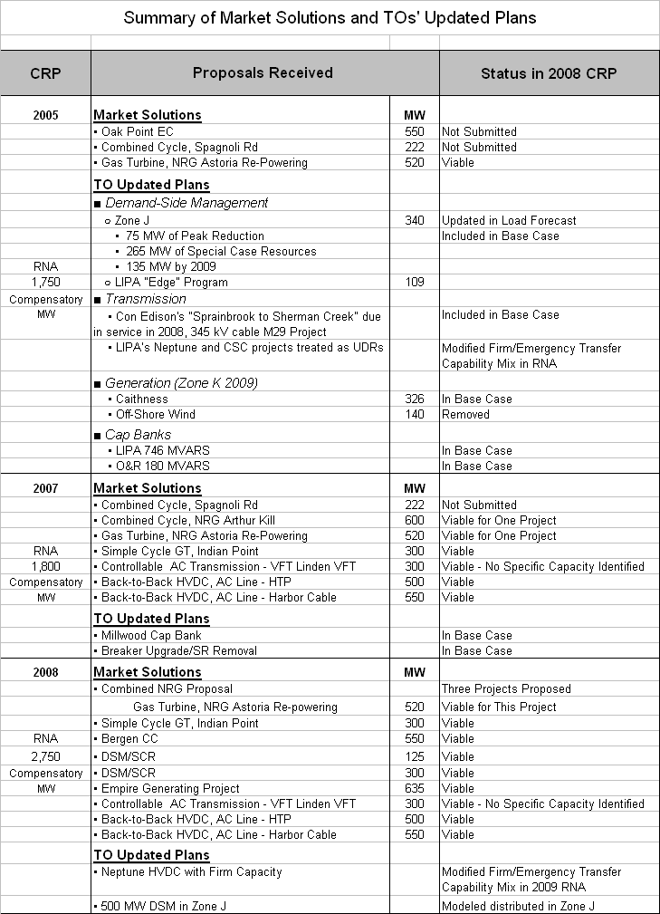

Appendix B – Glossaries

Appendix C – Supporting Documentation

Appendix D – Detail Technical Data
(To be provided upon request)

See NYISO Technical Bulletin 171, Subject: Monitoring Viability of Solutions to Meet Reliability Needs – NYISO Process.
Reference to the NYISO’s FERC Order 890 compliance filing.
In the context of the CRPP, the terms “viable” and “viability” shall mean that there is a reasonable likelihood that the market-based solution will effectively address the identified reliability needs in a timely manner. Reference the CRPP Manual and NYISO Technical Bulletin 171.
Pursuant to its December 2007 filing in compliance with FERC Order 890, the NYISO will perform economic studies to determine the ability and the costs and benefits of projects to alleviate congestion on the New York bulk power system. The NYISO’s compliance filing is still pending approval by the Commission.
NYISO’s supplemental compliance filing on June 4, 2008, will propose cost allocation and cost recovery mechanisms for regulated reliability solutions.
This agreement also envisions the establishment of a separate rate recovery mechanism, to be approved by FERC, for the recovery of costs associated with the development and construction of a regulated transmission backstop solution required by the CRP.
The RNA assumes no imports of external resources other than those that are tied to long-term contracts Historically, several thousand MW of external resources have sold capacity into the New York market on a short-term basis.
The NYISO’s determination that a solution is viable under the approved criteria does not predict the outcome of regulatory approval processes, or the application of governmental policies. The NYISO does not itself select specific projects to meet reliability needs, nor does it construct any projects.
This commitment is conditioned on the receipt of approval from the PSC to recover the program costs from Con Edison’s ratepayers.
As stated previously, the NYISO does not need to trigger a Regulated Backstop Solution at this time.
On April 29, 2008, the Board of Trustees of NYPA authorized negotiations of a contract for the purchase of 500 MW of capacity from Astoria Energy, in response to NYPA’s second 500 MW 2007 RFP for new capacity in New York City. Because this determination was made late in the process of NYISO’s crafting of the 2008 CRP and no contract has been concluded, the NYISO will consider the appropriate treatment of the Astoria Energy project in its 2009 CRPP cycle.
There is a retirement of 112 MWs at this location reflected in the base case.
All supporting databases and analysis utilized in developing this plan are available for inspection subject to confidentiality and critical energy infrastructure information requirements.
Probability of occurrences in days per year.
A 500 MW DSM in Zone J was submitted as an TO updated TO plan. Pursuant to Section 4.4(b) of Attachment Y, the NYISO is not in agreement at this time with this resource as it has reviewed this project and found some uncertainty with respect to including it as a TO updated plan to meet bulk power system reliability needs at this time. Without this project, the remaining resources in the joint TO submittal would not fully satisfy the identified reliability needs. However, the shortfall would not occur until 2017, which provides ample time to resolve this issue.
Of the three proposed transmission solutions, one has not initiated the Interconnection Process with PJM, one has completed its impact study, and one has proceeded to construction with an Interconnection Service Agreement and Construction Service Agreement. Since these projects would have significant impacts on both the PJM and New York systems, their status will be closely monitored in Interconnection Processes, the CRPP and the Regional Planning Process through the Northeast Coordinated System Plan.
Includes updated TO plans.
ibid
Reliability needs are identified with respect to approved reliability criteria, including through MARS LOLE studies. These studies reflect capabilities of the NYCA transmission system with appropriate interface limits in the presence of thermal, voltage or stability constraints.
See NYISO Technical Bulletin 171, Subject: Monitoring Viability of Solutions to Meet Reliability Needs – NYISO Process.
National Ambient Air Quality Standards for Ozone: Final Rule, 73 Fed. Reg. 16436 [March 27, 2008].

