

2009 Congestion Assessment and Resource Integration Study (CARIS) – Phase 1

Appendices B-G

4th DRAFT REPORT

October 27, 2009

For Discussion Purposes Only

Appendix B –Congestion Assessment and Resource Integration Study (CARIS) Process

Phase 1 – Study Phase
The purpose of Phase 1 or the Study Phase, Figure B-1 is to gather, organize, and develop information related to congestion as it impacts the NYCA for stakeholders. More specifically:
a. Post historic congestion and identify significant causes of historic congestion;
b. Project congestion on the New York State BPTFs over the ten-year planning period;
c. Identify the most congested elements or contingency pairs of elements;
d. Identify, through the development of appropriate scenarios, factors that might mitigate or increase congestion;
e. Provide information regarding generic projects to reduce congestion;
The Study Phase starts with the gathering of historic and the projection of future congestion information. That information is used to identify significant and reoccurring congestion. The historic congestion information is a compilation of the last six years of congestion data which is posted quarterly and the projected congestion is simulated from security-constrained unit commitment and economic dispatch software and posted once per CARIS cycle. A CARIS cycle is a two-year cycle.
Based upon the combination of historic and projected congestion metrics, each congested element or contingency pairs of elements are ranked by the following formula developed in conjunction with the ESPWG:
Present Value in Year 1 = [(Sum of the Future Value of Congestion from the Prior 5 Historic 12-Month Periods) + (Sum of the Present Value of Congestion from the Future 10 years)]
The rankings are posted for stakeholder review. The rankings are finalized after the stakeholder review and from this final ranking the top three congested elements/contingency pairs of elements are selected and posted for study. Additional information can be found in Initial CARIS Manual – Criteria for the Selection of CARIS Studies, Appendix F.
During this process, requests for additional studies from stakeholders are posted by the NYISO. These studies are in addition to the three identified studies noted above. Any stakeholder is eligible to request an additional study. All requests will be posted on the NYISO website. Additional details can be found in Initial CARIS Manual – Process for Additional Studies, Appendix F.
Once the three studies are selected, benefit/cost analysis is performed. To perform the benefit analysis assumptions for the baseline system are developed in conjunction with the ESPWG. Based on Attachment Y of the Tariff, the baseline system for the CARIS simulations assumes a reliable system throughout the Study Period, based upon the solutions identified in the most recently completed and approved CRP. The baseline system for the CARIS incorporates sufficient viable market-based solutions to meet the identified Reliability Needs as well as any regulated backstop solutions triggered in prior or current CRPs. If more market based solutions have been proposed than the minimum needed to meet the identified Reliability Needs, the NYISO, in conjunction with the ESPWG, has developed methodologies to scale back market-based solutions to the minimum needed to meet the identified Reliability Needs. Regulated backstop solutions that have been proposed but not triggered in the most recent CRP will also be used if there are insufficient market-based solutions for the ten-year study period. Additional information can be found in Initial CARIS Manual – Procedure for Inclusion of Market Based Solutions & Regulated Backstop Solutions in CARIS Base Case, and Procedure to Scale Back Market Based Solutions, Appendix F.
In conducting the CARIS, the NYISO conducts benefit/cost analysis of each generic solution to the congestion identified. One generic solution is determined by NYISO for each resource type (generation, transmission, and demand response) for each of the three congestion studies. During each cycle, NYISO will develop with ESPWG specific project criteria for each resource type (generation, transmission, and demand response) including block size and construction assumptions. Following the identification of the three studies, each resource type shall be applied in year one of the planning horizon, in sufficient quantities of generic block sizes associated with each resource type and specific locations to alleviate a substantial and comparable portion of the identified congestion over the planning horizon. Additional details can be found in Initial CARIS Manual –Generic Solutions, Appendix F.
The principal benefit metric for the CARIS analysis will be expressed as the present value of the NYCA wide production cost reduction that would result from each generic solution. Additional benefit metrics calculated include estimates of reduction in losses, changes in LBMP load payments, changes in generator payments, changes in ICAP costs, changes in emission costs, and changes in TCC payments. Additional details can be found in Initial CARIS Manual – Additional Benefit Metrics for CARIS Studies Methodology and Models to Develop and Implement Additional Metrics, Appendix F.
The costs of generic solutions utilized in the benefit/cost analysis are order of magnitude estimates developed for each resource type. The costs will be developed for relevant geographic locations during each CARIS cycle. The order of magnitude costs will be provided to the ESPWG for their review and acceptance during each CARIS cycle as part of the Assumption Matrix approval process. If a cursory review of the location for the generic solution identifies unusual complexities, a contingency factor will be applied to the costs.
To add information to the benefit/cost analysis, scenario analysis is performed. The scenarios are developed in conjunction with the ESPWG. Variables for consideration in the development of these scenarios include but are not limited to: load forecast uncertainty, fuel price uncertainty, new resources, retirements, emission data, the cost of allowances and potential requirements imposed by proposed environmental and energy efficiency mandates, as well as overall NYISO resource requirements.
The NYISO will prepare a draft of the Study Phase report including a discussion of assumptions, inputs, methodology, and results of the analyses. The draft report shall be submitted to both TPAS and the ESPWG for review and comment. Following completion of that review, the draft report shall be sent to the Business Issues Committee and the Management Committee for discussion and action. Following the Management Committee vote, the draft report, with Business Issues Committee and Management Committee input, will be forwarded to the NYISO Board for review and action. Concurrently, the draft report will be provided to the Independent Market Monitor Adviser for his review and consideration. Upon approval by the Board, the NYISO shall issue the Study Phase of the CARIS report to the marketplace by posting it on its website.
In order to provide ample exposure for the market place to understand the content of the Study Phase of the CARIS, the NYISO will provide various opportunities for Market Participants and other potentially interested parties to discuss final CARIS. Such opportunities may include presentations at various NYISO Market Participant committees, focused discussions with various industry sectors, and /or presentations in public venues.

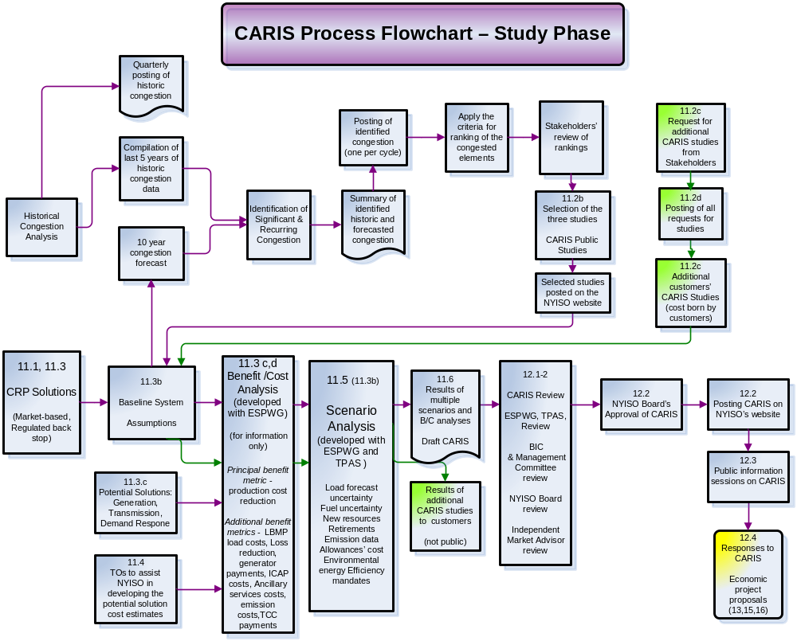
Figure B- – Phase 1 or Study Phase of the CARIS Process

Phase 2 – Projects Phase
The results of the Phase 1- Study Phase will provide information to stakeholders who are interested in proposing an actual project to address specific congestion identified in the CARIS Study Phase report. Any interested developer can propose any type of project, such as a generator or demand response, to specific congestion identified in the Study Phase. However, Phase 2 – Specific Project Phase, applies only to regulated economic transmission projects proposed in response to congestion identified in the CARIS and regulated backstop solutions when the implementation of the regulated backstop solution is accelerated solely to reduce congestion in earlier years of the study period.
Market-based responses to congestion identified in the Study Phase of the CARIS are not eligible for regulated return and therefore are not obligated to follow the requirements of Phase 2. The cost of a market-based project shall be the responsibility of the developer of the market based proposal.
To be eligible for cost recovery in Phase 2, the benefit of the proposed project must exceed its cost measured over the first ten years from the proposed commercial operation date for the project, the total capital cost of the project must exceed $25 million, and a super-majority of the beneficiaries must vote in favor of the project.
Phase 2, Figure B-2 starts with the NYISO evaluating proposed project to determine if the proposed project is an economic transmission project. If the proposed project is an economic transmission project, the NYISO will perform a ten-year Benefit/Cost (B/C) analysis from the proposed in-service date, which is paid for by the developer. The benefit metric will be expressed as the present value of the annual NYCA-wide production cost savings that would result from the implementation of the proposed project, measured for the first ten years from the proposed commercial operation date of the project. The estimated cost of each economic transmission project will be supplied by the developer and the cost metric will be the present value of the annual total revenue requirement for the project, reasonably allocated over the first ten years from the proposed commercial operation date of the project.
As stated above, if the proposed economic transmission project has a B/C ratio >1 over the first ten years from the proposed commercial operation date of the project and the total capital cost of the proposed project is greater than $25 million, then the proposed project will be eligible to proceed to the next steps.
In addition to the metrics used in the B/C analysis, for informational purposes only, the NYISO will also calculate the present value and annual total revenue requirement for the project over a 30 year period commencing with the proposed commercial operation date of the project. Also, the NYISO will work with the ESPWG to consider the development of additional metrics for informational purposes only. These additional metrics shall include those that measure changes in: LBMP load costs, generator payments, ICAP costs, emissions costs, losses and TCC revenues. Consideration of these additional metrics will take into account the overall resource commitments of the NYISO.
In addition to the B/C analysis, the NYISO will work with the ESPWG to consider the development and implementation of scenario analyses, for information only, which shed additional light on the cost and benefit of a proposed project.
Additional details can be found in Initial CARIS Manual– NYISO Cost Allocation Procedures for Regulated Economic Transmission Projects, Appendix F.
The results of the B/C analysis, additional metrics and the scenario analysis, along with the determination of the beneficiaries, will be documented and submitted to the ESPWG for review and comment. Following completion of that review, the NYISO’s analysis shall be forwarded to the Business Issues Committee and Management Committee. Following the Management Committee vote, the NYISO’s project B/C analysis and beneficiary determination will be forwarded, with the input of the Business Issues Committee and Management Committee, to the NYISO Board for review and action. Upon final approval of the Board, project B/C analysis and beneficiary designations shall be posted by the NYISO on its website.

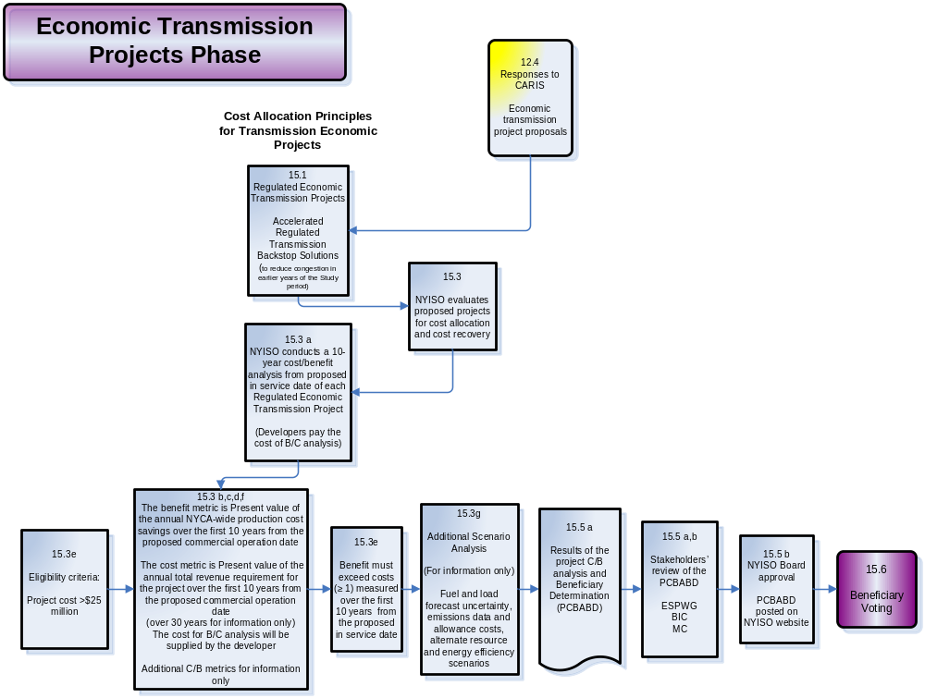
Figure B- – Phase 2 – Project Phase of the CARIS process

Voting, Cost Allocation, and Cost Recovery
The CARIS process requires the determination of beneficiaries for voting and cost allocation, Figure B-3. The cost of a regulated economic transmission project will be allocated to those load serving entities that would economically benefit from implementation of the proposed project. The NYISO will identify the beneficiaries of the proposed project over a ten-year time period commencing with the proposed commercial operation date for the project.
The NYISO will measure the present value of annual zonal LBMP load savings for all load zones which would have a load savings, net of reductions in TCC payments, and bilateral contracts (based on available information) as a result of the implementation of the proposed project. Additional information can be found in CARIS Procedure - Procedure to Estimate the TCC Revenues, Appendix F. The beneficiaries will be those load zones who experience net benefits measured over the first ten years from the proposed commercial operation date for the project. For each load zone that would benefit from a proposed project, the NYISO will allocate the cost of the project to load based on share of total savings. Within zones, costs will be allocated to Load Serving Entities based on MWhs. Load zones not benefiting from a proposed project will not be allocated any of the costs of the project. There will be no “make whole” payments to non-beneficiaries.
Only Load Serving Entities defined as beneficiaries of a proposed project shall be eligible to vote on a proposed project. The voting share of each Load Serving Entity shall be weighted in accordance with its share of the total project benefits. For the proposed project to proceed, eighty (80) percent or more of the actual votes cast on a weighted basis must be cast in favor of implementing the project. If the project meets the required vote in favor of implementing the project, and the project is implemented, all beneficiaries, including those voting “no,” will pay their proportional share of the cost of the project. Additional information can be found in the Initial CARIS Manual - Voting Procedures (to be finalized), Appendix F.
If the proposed economic transmission project has a B/C ratio >1 over the first ten years from the proposed commercial operation date of the project, the total capital cost of the proposed project is greater than $25 million, and it receives a super-majority (>=80%) of the beneficiaries vote in favor of the project, then the Developer shall have the right to make a filing with FERC, under Section 205 of the Federal Power Act, for approval of its costs associated with implementation of the project. Also, upon request by NYPA, the NYISO will make a filing on behalf of NYPA. FERC must approve the cost of a proposed economic transmission project for that cost to be recovered through the NYISO tariff.
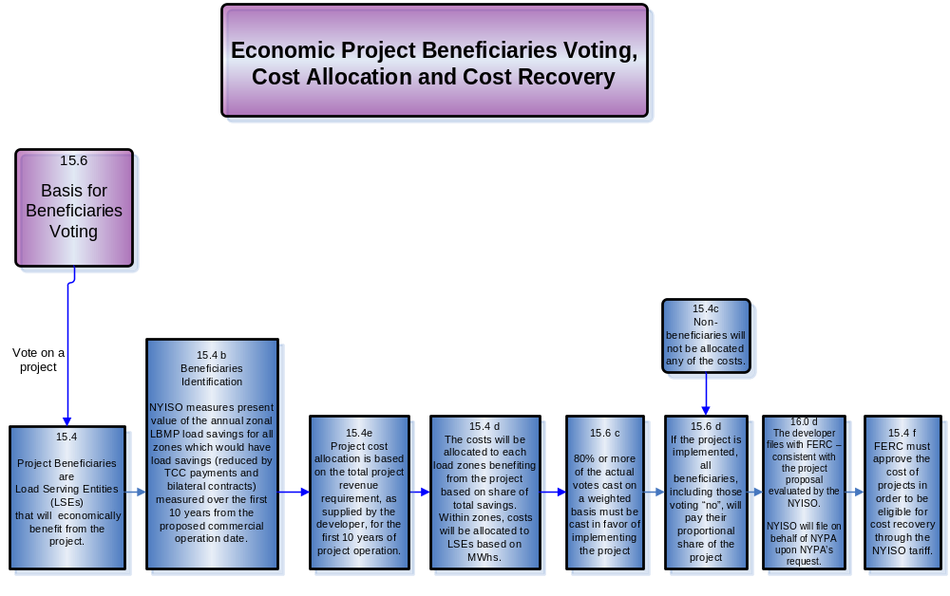
Figure B- –Voting, Cost Allocation, and Cost Recovery of the CARIS process
The CARIS procedure to identify beneficiaries of each proposed projects is currently under development. Other Phase 2 procedure under development include: Methodology to extend database beyond the study period (15.3.a); Acceleration of regulated backstop solutions for economic reasons (15.1); and process for specific regulated economic transmission projects proposals (15.3).

Appendix C – Baseline System Assumptions and Methodology

CARIS Model - Base Case Modeling Assumptions for 2009-2018

CARIS Study Phase
Implementing CARIS requires the understanding of a significant amount of data. Taken from Section 11 of Schedule Y of the Tariff, “The CARIS for economic planning will align with the reliability planning process. Each CARIS will use a ten-year planning horizon consistent with the reliability planning horizon. Each CARIS will be based on the most recently concluded and approved CRP. The base case for each CARIS will assume a reliable system for the ten-year planning horizon based upon the CRP.”
The data utilized in the base case simulations for CARIS is based on 2009 CRP/RNA and CARIS Assumption Matrix, Table C-1, shown below. Major components of data includes base load flow data, unit heat rates, unit capacities, fuel prices, transmission constraint modeling, load growth and shape representation, both simulated and actual and scheduled interchange values, O&M cost, and environmental cost components. The assumption matrix was developed with the ESPWG.
Table C - : CARIS Assumption Matrix

Parameter | Modeling for CARIS Base Cases | Basis for Recommended Assumptions for CARIS
Peak Load | Forecast as per 2009 RNA Base. Scenarios for other forecasts. | Based on CRP Peak Forecast  Use 2009 Base Case Energy Forecast
Load Shape Model  Energy Forecast | 2002 Load Shape, constant over ten year period.  2009 RNA Base Case Forecast | 2002 load shape is an appropriate representation for this analysis. For base year, use 2002 Load Shape, Adjusted for Energy Forecast if needed , Evaluate alternative in future
Load Uncertainty Model | Statewide and zonal model updated to reflect current data., constant over ten year period | Base Level Forecast will be used. Other load uncertainty levels not evaluated.
Generating Unit Capacities | Same as CRP - Per 2009 CRP, updated DMNC test values plus units | Any changes in CRP capacities through time to be represented in CARIS.
New Units | As per the CRP and scaled back according to procedure (Tariff Attachment Y: Section 11.3.b) | N/A
Wind Resource Modeling | Existing units derived from hourly wind data with average Summer Peak Hour capacity factor of approximately 11 %. New units from wind shapes from wind study. | Typical shape for location as per MARS and wind studies.
Non-NYPA Hydro Capacity Modeling | Pondage  Run of River(Hourly) | N/A
Special Case Resources | Those sold for the program, discounted to historic availability and distributed according to zonal performance.  Assume 15% growth rate for all zones. Modify load SCR/EOP to proportion available SCR by load amount by zone. See SCR determinations in Attachment G. | N/A
EDRP Resources | Those registered for the program, discounted to historic availability (45 % overall). July & August values calculated from 2008 July and August registrations. | Need to define costs associated, firm modifiers vs. price responsive.
External Capacity – Purchases | Based on NYISO forecast. Sensitivity performed to remove contracts and see the effect on LCR-IRM curve. Results should not impinge on IRM. Sensitivity with 20 MW MISO wheel through Ontario to Zone A). | N/A
Retirements | 2008 Gold Book over ten year period | As per the CRP
Planned Outages | Per 2009 CRP, based on schedules received by NYISO & adjusted for history., constant over ten year period | As per the CRP
Outage Scheduling  Planned | Continue with approximately 150 MW after reviewing last year’s data. | As per the maintenance schedules in long term adequacy studies
Gas Turbines Ambient Derate | Continue with approximately 150 MW after reviewing last year’s data, constant over ten year period | Reflected only in summer/winter ratings
Environmental Modeling  Adders  Externalities  Allowances | Studied as scenarios.  Built into the development of cost curves of resources. Optimization is cost driven. | Any impacts assumed in CRP carried forward.  Limits on emissions done through allowances, not hard limits  Allowance cost from Chicago Climate Futures Exchange
Commitment and Dispatch Options  Operating Reserves | Each Balancing Authority Commits separately  Hurdle Rates are employed for commitment and dispatch  Operating Reserves as per NYCA requirements | N/A
Fuel Price Forecast | EIA data obtained quarterly, adjusted for seasonality on monthly basis, monthly volatility based on historical patterns | NYISO to calibrate forecast based on public information and historical data
Cost Curve Development | Developed from Heat Rate Curve, Fuel Price forecast, environmental adders, penalty factors | Allowances from Chicago Climate Futures Exchange,  Heat Rate development under discussion, confidential issues
Heat Rates  NYCA  External Systems | Developed from vendor supplied data and fuel input data matched with MWhr data for NYCA
Local Reliability Rules | List and develop appropriate nomograms | Fuel burn restrictions, operating restrictions and exceptions, commitment/dispatch limits
Energy Storage  Gilboa PSH  Lewiston PSH | Gilboa and Lewiston scheduled against NYCA | N/A
Transmission System Model
Power Flow Cases | As per CRP | N/A
Interface Limits  Monitored/contingency pairs  Nomograms  Joint, Grouping  Unit Sensitive Voltage | Transfer limit analysis done in RNA/CRP for critical interfaces. External system limits from input from neighboring systems. | Based on historical congestion, planning study results, NERC book of flowgates, PROBE/SCUC list of active/potential constraints, Special Protections Systems including Athens SPS in 2009 and 2010.
New Transmission Capability | As per CRP | N/A
Internal Controllable Lines (PARs,DC,VFT) | Optimized in simulation | N/A
Neighboring Systems
Outside World Area Models  Fuel Forecast | Power flow data from CRP, “production” data developed by NYISO with vendor and neighbor input  Linked with NYCA forecast | N/A
External Capacity  Load Forecast | Firm and grandfathered are included.  Neighboring systems data reviewed and held at required reserve margin | Neighboring systems modeled consistent with reserve margins in the RNA/CRP analysis
System representation in Simulation | HQ modeled as load/gen pair  Full Representation/Participation  - NYISO  - NE-ISO  - IESO  - PJM Classic &  Full Representation: NYISO,NEISO,IESO,PJM (PJM Classic, AP,AEP,CE,DLCO,DAY,VP)  Proxy Bus:  HQ-NYISO, HQ-NEISO  Transmission Only/Zeroed Out:  MECS,FE,SPP, MAR, NIPS,OVEC,TVA, FRCC,SERC,ERCOT,WECC | N/A
External Controllable Lines (PARs,DC,VFT, Radial lines) | A,B,C and J,K “wheel”  Both sets set at 600 min, 1200 max, imbalance monitored  Ramapo +/- 1000 MW  Norwalk +/- 100 MW  L33,34 - +/- 300 MW  PV20 – 130, 0 MW  Neptune and CSC as per CRP firm X 24 hrs, economy remainder | N/A

Below are descriptions of key data in more detail. The data was developed based on the Tariff and in collaboration with stakeholders.

Power Flow Data
CARIS uses the network topology, system impedance and transmission line ratings that were developed from the 2009 CRP power flows. The following power flow cases were developed for the CARIS from the 2008 FERC Form 715 filing base cases:
- Summer 2009 Peak Load
- Summer 2013 Peak Load
- Winter 2013/2014 Peak Load
- Summer 2018 Peak Load
For the intermediate years between 2010 and 2017, the power flow cases were based on data provided in the FERC Form 715 2013 Summer Peak Load case. PJM system changes modeled in PJM’s 2012 Regional Transmission Expansion Plan (RTEP) Study and NYISO system changes described in the 2009 CRP Study required changes to these power flow cases, such as additional generators and transmission lines, to capture the sequencing of these additional resources. The FERC Form 715 2018 Summer Peak Load case and NYISO system changes described in the 2009 CRP Study were used to develop the 2018 power flow case. The winter transmission line ratings from the FERC Form 715 Winter 2013/2014 Peak Load case were used for all years assessed in the CARIS.

Transmission Model
New York Control Area Model
Figure C-1 below displays the bulk power system for NYCA, which is generally facilities 230 kV and above, but also includes certain 138 kV facilities and a small number of 115 kV facilities. The balance of the facilities 138 kV and lower are considered non-bulk or sub-transmission facilities for purposes of this study. The figure also displays key transmission interfaces for New York.
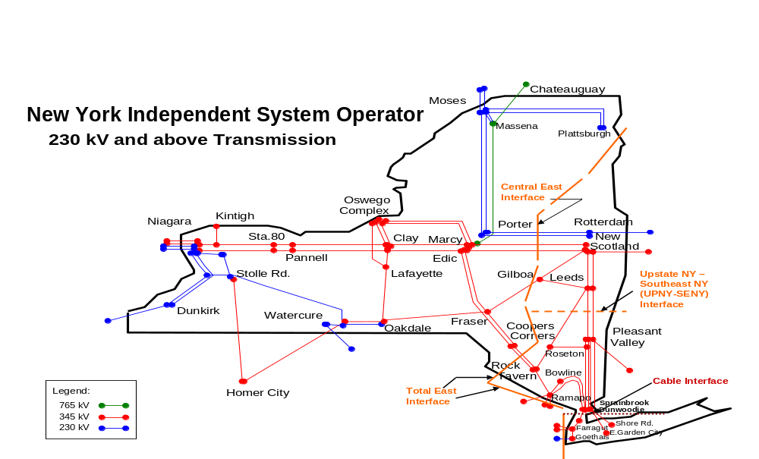
Figure C-1: NYISO 230 kV and above Transmission Map

New York Control Area Changes, Upgrades and Resource Additions
The highlights of year on year model changes are as follows:
a. Caithness Long Island – new 320 MW, Combined Cycle, LIPA, Suffolk, NY, Commercial Operation – 4/2009;
b. BesiCorp – new 660 MW, Combined Cycle, National Grid, Rensselear, NY, proposed Commercial Operation 2/2010;
c. Polleti – 890.7 MW, retirement expected 2/2010;
d. M29 – 345 kV transmission line from an existing station in Yonkers, NY to a new substation in NYC, expected in-service date Summer 2011;
e. Athens Special Protection System (SPS) is scheduled to expire in 2010
f. Linden VFT – proposed commercial operation date December 2009.
External Area Model
The external areas immediately adjacent to the NYCA are also modeled at full representation except for Hydro Quebec (HQ). Those areas include ISO-NE, IESO, and PJM (PJM Classic, AP, AEP, CE, DLCO, DAY and VP). Since HQ is asynchronously tied to the bulk system, proxy buses representing the direct ties from HQ to NYISO and HQ to ISO-NE are modeled. External areas surrounding the above areas are only modeled to capture the impact of loop flows.
Table C-2 illustrates the external transmission limits used in the CARIS Study.
Table C-2: External Area Transmission Transfer Limits
Area | Interface | 2009 | 2010 | 2011 | 2012 | 2013 | 2014
IESO | IMO EXPORT | 2500 | 2500 | 2500 | 2500 | 2500 | 2500
IESO | IMO-MISO | 1 | 1 | 1 | 1 | 1 | 1
IESO | IMO-NYISO | 2000 | 2000 | 2000 | 2000 | 2000 | 2000
ISO-NE | Boston | 4900 | 4900 | 4900 | 4900 | 4900 | 4900
ISO-NE | Connecticut-Export | 2200 | 2200 | 2200 | 2200 | 2200 | 3600
ISO-NE | East-West (NE-NY) | 2100 | 2100 | 2100 | 2100 | 2100 | 2100
ISO-NE | ISO-NE EXPORT | 4000 | 4000 | 4000 | 4000 | 4000 | 4000
ISO-NE | ISO-NE-NYISO | 1400 | 1400 | 1400 | 1400 | 1400 | 1400
ISO-NE | LI – ISO-NE | 450 | 450 | 450 | 450 | 450 | 450
ISO-NE | ME – NH | 1400 | 1400 | 1400 | 1400 | 1400 | 1500
ISO-NE | NB – NEPOOL | 500 | 500 | 500 | 500 | 500 | 500
ISO-NE | North – South | 2700 | 2700 | 2700 | 2700 | 2700 | 2700
ISO-NE | Norwalk-Stamford | 1300 | 1300 | 1300 | 1300 | 1300 | 1300
ISO-NE | Orrington South | 1050 | 1050 | 1050 | 1050 | 1050 | 1050
ISO-NE | SEMA | 1450 | 1450 | 1450 | 1450 | 1450 | 1450
ISO-NE | SEMA/RI | 2200 | 2200 | 2200 | 2200 | 2200 | 2200
ISO-NE | South West CT | 2350 | 2350 | 2350 | 2350 | 2350 | 3650
ISO-NE | Surowiec South | 1150 | 1150 | 1150 | 1150 | 1150 | 1150
NYISO | NYISO-HQ | 1050 | 1050 | 1050 | 1050 | 1050 | 1050
NYISO | NYISO-IESO | 2500 | 2500 | 2500 | 2500 | 2500 | 2500
NYISO | NYISO-PJM | 2500 | 2500 | 2500 | 2500 | 2500 | 2500
PJM | APSOUTH | 3250 | 3250 | 3250 | 3250 | 3250 | 3250
PJM | Central Interface | 5200 | 5200 | 5200 | 5200 | 5200 | 5200
PJM | Eastern Interface | 7000 | 7000 | 7000 | 7000 | 7000 | 7000
PJM | PJM East – NYISO | 2500 | 2500 | 2500 | 2500 | 2500 | 2500
PJM | PJM EXPORT | 6000 | 6000 | 6000 | 6000 | 6000 | 6000
PJM | PJM West – NYISO | 2000 | 2000 | 2000 | 2000 | 2000 | 2000
PJM | PJM_Extension Export | 1500 | 1500 | 1500 | 1500 | 1500 | 1500
PJM | PJM_HomerCty | 531 | 531 | 531 | 531 | 531 | 531
PJM | PJM-VAP | 500 | 500 | 500 | 500 | 500 | 500
PJM | Western Interface | 6250 | 6250 | 6250 | 6250 | 6250 | 6250

Two major transmission additions in the PJM area are included in the base cases. The first addition is the TrAIL Line, which is located in PJM and is scheduled to enter commercial operation in 2010. The second addition is the Susquehanna-Roseland 500 kV addition, which is located in PJM and is scheduled to enter commercial operation in 2013.
Hurdle Rates and Interchange Models
Hurdle rates set the conditions in which economy interchange can be transacted between neighboring markets/control areas. It represents a minimum savings level that needs to be achieved before energy will flow across the interchange. Hurdle rates serve two purposes in the CARIS model. First, they are used when preparing the Base Case to help calibrate the production-cost simulation so that it replicates a historical pattern of generation dispatch. Second, they are used to find a different (and usually lower-cost) combination of generation resources to meet loads aggregated from the base case.
Two independent hurdle rates are used in the CARIS base case, one for the commitment and a separate one for the dispatch. The commitment hurdle rate sets the level that a unit commitment change will be made and the dispatch hurdle rate sets a level that will allow economic dispatch to be changed to allow scheduled energy to flow between market areas. Hurdle rates are held constant throughout the 2009-2018 study period. Hurdle rates on several closed and open interfaces were used to model regional power imports, exports and wheel-through transactions. These hurdle rates are frequently used in conducting multi-pool production cost simulations and they are used to represent several phenomena such as complex market pricing at the boundary busses, cost mark-ups and market inefficiency. The hurdle rate values in the CARIS databases are consistent with previous NYISO and consultant studies, and are considered standard industry practice. In addition, the annual NYISO imports are consistent with historic import levels, confirming that NYISO’s hurdle rate assumptions are reasonable.
Only energy transactions associated with Unforced Capacity Delivery Rights (UDRs) granted on controllable tie lines were specifically modeled, namely on the NYISO DC tie-lines (Neptune and Cross Sound Cable (CSC)). Flows on those facilities were not subject to hurdle rates and the required firm commitment was modeled in the associated neighboring system. It should be noted that the flow on the CSC line was allowed to reverse direction (i.e., flow toward ISO-NE) but the Neptune flows was restricted to no more than 660 MW in one direction into Long Island. The reverse flow toward PJM was not allowed to occur in the simulation because exports from NYCA to PJM are not presently allowed on Neptune line.
In regard to Interchange, the hourly interchange flow for each interface connecting the NYISO with neighboring control areas, was priced at the LBMP of its corresponding proxy-bus. The summation of all 8760 hours determined the annual cost of the energy for each interface. Table C-3 lists the proxy bus location for each interface.
Table C-3: Interchange LBMP Proxy Bus
Interface | Proxy-Bus
PJM | Keystone
Ontario | Beck
Quebec | Chateauguay
Neptune | Atlantic 230 kV
New England | Sandy Pd
Cross Sound Cable | New Haven Harbor

Production Cost Model
Production costing models require input data to develop cost curves for the resources that the model will commit and dispatch to serve the load subject to the constraints given in the model. This section will discuss how the “production cost data” for these resources were identified and quantified. The model simulations are driven by incremental production costs of generators. The incremental cost of generation is the product of the incremental heat rate multiplied by the sum of fuel cost, emissions cost, and variable operation and maintenance expenses
Heat Rates
Fuel costs represent the largest incremental expense for fossil fueled generating units. Fuel costs are the product of fuel prices and incremental heat rates. Thus it is critically important to the quality of the results of CARIS that individual generating unit heat rates used in the simulations be an accurate representation of reality. Individual unit heat rates are important competitive information and thus are not widely available from generator owners. Both of the simulation models have databases that represent the model providers’ best estimates of heat rates. When the heat rates from the two models were compared, it was apparent that significant differences existed.
In order to gain additional insight as to which, if either, dataset was an accurate representation of actual unit performance, publicly available information reporting heat input was matched with net generator production from NYISO market data to calculate hourly heat rates for 2008. One vendor has substituted a dataset for which the NYISO did not have a direct license agreement, thus removing that data set from further consideration. Unit heat input data is available from the US Environmental Protection Agency’s (EPA) Clean Air Market Data. Accordingly, this data set was used to calculate unit heat rates and incremental heat rates across each unit’s operating range through the use of regression analysis techniques. First, second, and third order polynomials were developed. Generally, third order polynomials resulted in the best fit. A small number of data points were eliminated for a few units to improve curve fit. The eliminated data could be the result of errors in reporting or represent limited operation within a specific hour. These calculated heat rates were then compared to the remaining simulation model data for each fossil fueled unit in the NYCA and one heat rate curve was selected for each unit.
Consideration was given to using this approach across all of the units in the simulation, however, the relative smaller impact of heat rate inaccuracies for non-NYCA units and the magnitude of the effort to correct heat rates for all units in the simulation lead to the conclusion that vendor-supplied heat rate information should be used for all non-NYCA units.
CARIS simulation models employ power points which are points in each unit’s operating range where specific data such as heat rate is tied to the power point. In general there are minimum and maximum points where the unit can be simulated to operate on a sustained basis. There may also be additional intermediary points. Each of these points was tied to a point on the heat rate curve and the incremental heat rate was determined for each unit.
A review of the actual operating performance of NYCA units revealed that the vendor supplied data sets did not accurately capture the point of minimum operation for units that have emission control systems that are sensitive to flue gas exit temperatures for the control of NO_{X} emissions. The minimum operating points for units with these permit conditions were increased to reflect these operating limits.
Heat Rates of marginal units in all zones display the expected seasonal patterns with summer months having the highest values. Also, there is a progression by which the monthly averages are the lowest in Zone A. The further east a zone is located, the higher the implied heat rate is. The relative magnitudes of differences across zones are consistent with the differences in the generation fuel-mixes as depicted in Figure C-3.
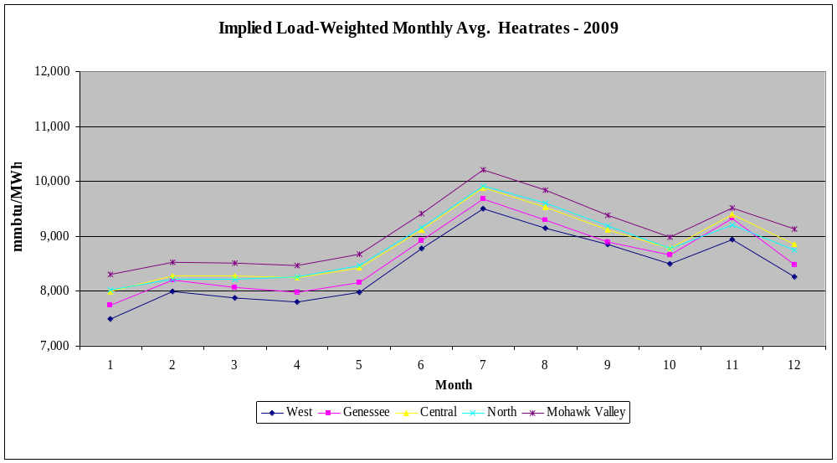
Figure C-3: Implied load-weighted monthly average heat rates for Upstate NY
The implied heat rates for all downstate zones, Figure C-4, display the expected seasonal patterns. The heat rates of marginal units are highest for Millwood (Zone H), Hudson Valley (Zone G), and Long Island (Zone K). With respect to Zones G and J, the difference in assumed gas prices explains the relative heat rate parity during non-winter months, and the divergence during the winter months.
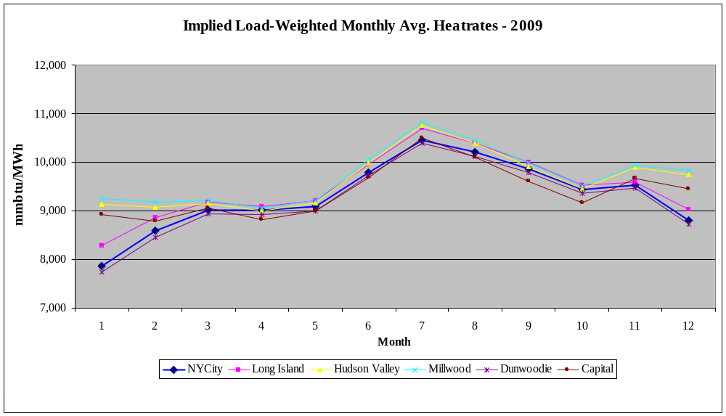
Figure C-4: Implied load-weighted monthly average heat rates for Downstate NY
Fuel forecast
Figures C-5 and C-6 illustrate forecasted oil and natural gas fuel prices for external areas.
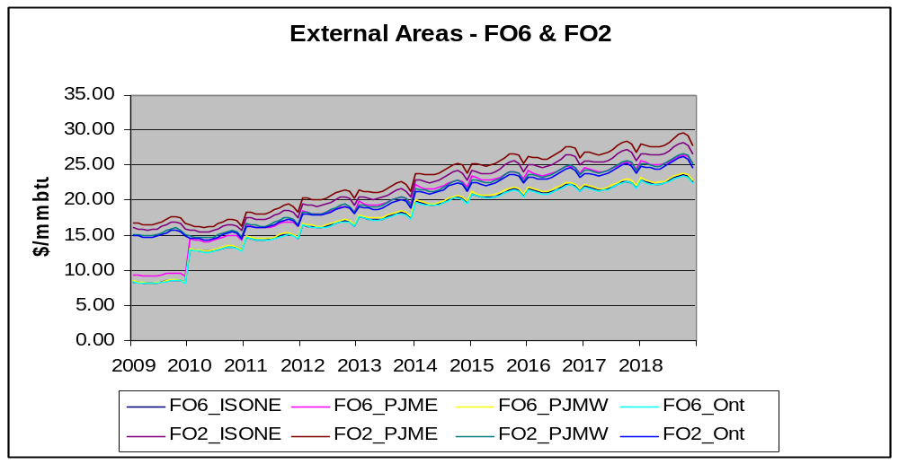
Figure C-5: Forecasted oil fuel prices for ISO-NE, PJM, & Ontario

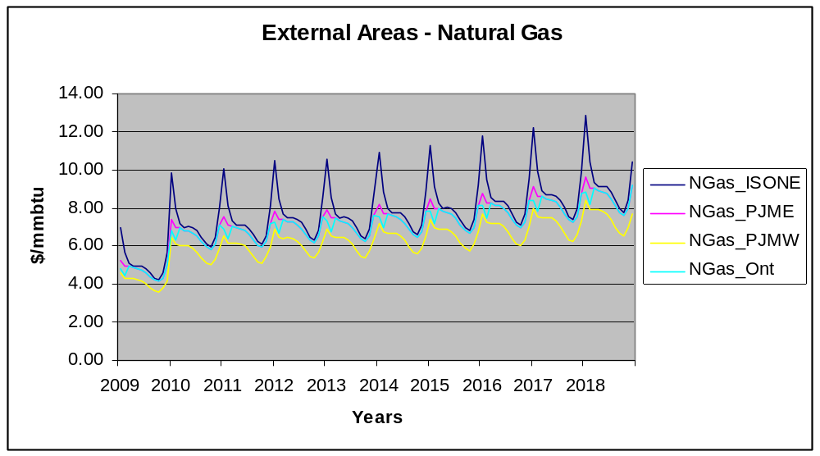
Figure C-6: Forecasted natural gas prices for ISO-NE, PJM, & Ontario

Fuel Switching
Fuel switching capability is widespread within NYCA. In the NYCA, 37% of the 2009 generating capacity, or 14,470 MW, has the ability to burn either oil or gas. There are three- reasons that generating facilities would exercise the capability to burn oil: the first reason is that oil would be the economic fuel of choice, the second reason would be to satisfy reliability rules, and the third reason would be and interruption of the gas supply. Historically, significant quantities of oil have been used at the prices illustrated in Figure C-7.

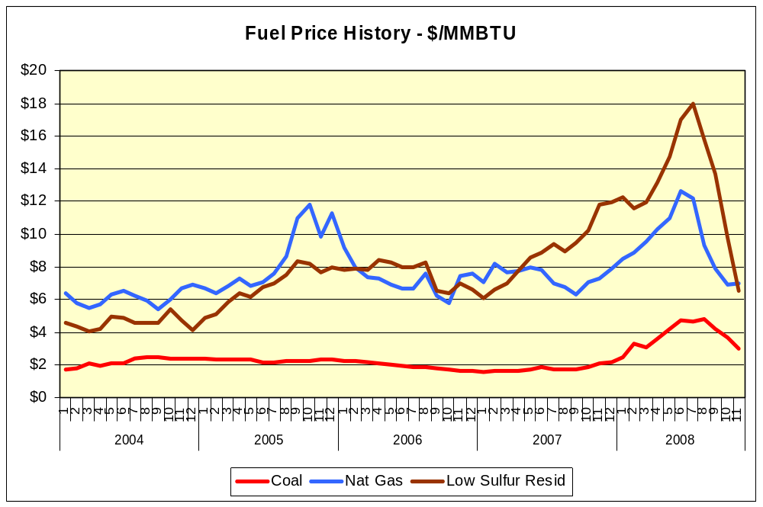
Figure C-7: Historical fuel prices of coal, natural gas, and low sulfur coal
Both simulation models can select the economic fuel based on monthly production costs for units with duel fuel capability. For the planning horizon, the fuel price forecast does not show that low sulfur residual fuel oil will be an economic choice on a monthly basis.
The New York State Reliability Council (NYSRC) has established rules for the reliable operation of the New York bulk power system. Two of those rules guard against the loss of electric load because of the loss of gas supply. Rule I-R3 states “The New York State bulk power system shall be operated so that the loss of a single gas facility does not result in the loss of electric load within the New York City zone.” Rule I-R5 similarly states “The New York State bulk power system shall be operated so that the loss of a single gas facility will not result in the uncontrolled loss of electricity within the Long Island zone.” To satisfy these criteria, annual studies are performed that update the configurations of the electricity and gas systems and simulate the loss of a various gas supply facilities. The loss of these gas facilities leads to the loss of some generating units. This loss becomes critical because it may result in voltage collapse when load levels are high enough. Therefore, criteria are established whereby certain units that are capable of doing so are required to switch to minimum oil burn levels so that in the event of the worst gas system contingency these units stay on-line at minimum generation levels and support system voltage. This MW deficiency must be made up first through the increased use of imports until oil burning units are able to ramp up their output over a longer timeframe. Some new combined cycle gas turbine units in these zones have the ability to “switch-on-the-fly” from gas-burn to oil-burn with a limited loss of output that can be quickly recovered. However, there is the risk that this live switching may not be successful and the unit may trip. Therefore, in many cases, such units are required to switch to burning oil at lower load levels so there is the ability of recovering from an unsuccessful switching. As the generator fleet in these zones has experienced a shift to increased use of combined cycle units with switch-on-the-fly capability, the amount of oil used in steam units to satisfy minimum oil burn criteria has decreased. In order to simulate the use of oil in steam units to satisfy these reliability criteria, Northport #4 is forced to use oil operation only in summer, and Ravenswood #3 is up to its minimum load levels. For operation at higher load levels, the models simulate these units as dual fuel units that selected the economic fuel.
Generation Maintenance
Planned maintenance outages duration was developed based upon historic 2007 and 2008 maintenance schedules – FERC Form 714, 2007-2008. The planned outage schedules were initially specified by the program and manually modified so that the total capacity outage for each month and zone is consistent with historic levels.
The unforced outage duration was based upon the data specified in the 2009 CRP. The unforced outage duration was then added to the planned outage schedule, which was modified to include the unforced outage duration.

Generic Solution Cost Matrix
A generic solution was determined by NYISO utilizing each resource type (generation, transmission, and demand response) as required in Tariff attachment Y Section 11.3c. The development of the generic solutions and their costs were accomplished by using a cost matrix methodology. This methodology was based on utilizing typical MW block size generic solutions, a standard set of assumptions and an order of magnitude costs for each resource type. The block sizes, assumptions and cost estimates were vetted through the stakeholder process at the ESPWG.
Order of magnitude unit pricing cost estimates were developed based on the block sizes and assumptions for each resource type. The NYISO utilized engineering consultants to develop order of magnitude cost estimates based on their experience in the industry and similar existing projects or programs currently being considered within New York. The order of magnitude cost estimates took into account the cost differences between geographical areas within New York. Three sets of costs were developed that are reflective of the differences in labor, land and permitting costs between Upstate, Downstate and Long Island.
All costs were reviewed by the Transmission Owners and Market Participants through the stakeholder process. As part of this process, ranges for the cost for each element were developed in order to address the wide variability that can occur in a project due to such items as permitting, right of way constraints and existing system conditions.
During the stakeholder review process, it was noted that the cost for new generation in Zone G may be more closely matched to the costs seen Downstate in (Zones H-I) versus costs seen in Upstate (Zones A-F). In reviewing the generation costs for various Zones that were prepared for the ICAP Demand Curve study reported in the Independent Study to Establish Parameters of the ICAP Demand Curve for the New York Independent System Operator report with respect to peaking units, the costs for new generation in Zone G falls half way between the costs for Zone F and Zone J. Therefore, the combined cycle generator plant costs for Zone G (exclusive of interconnection costs) are estimated to be the average of the costs for Upstate and Downstate.
The Demand Response resource type costs were based on New York utility EEPS filings for their Demand Side Management programs which consider the potential market value and not actual costs to build or implement DSM. The NYISO will consider developing a customer installed cost approach in future CARIS analysis so that cost estimates for all resource types will be predicting actual cost to implement such a project.
Estimates included in the Generic Solution Cost Matrix should not be utilized for purposes outside of the CARIS process. Also, these estimates should not be assumed as reflective or predictive of actual projects or imply that facilities can necessarily be built for these generic solution order of magnitude estimates.
Generic Solutions Cost Matrix
Generic solutions cost matrix and assumptions for all three types of solutions are presented in Table C-4 through Table C-7 below.
Table C - 4: Transmission Cost Matrix
Base Case Modeling Assumptions for 2009-2018 CARIS Study Phase
Attachment 1
Generic Solution
Transmission Cost Matrix
Order of Magnitude Unit Prices
(Estimates should not be assumed reflective or predictive of actual project costs)
 |  | Transmission |  |  |  |  | Substation
Item # | Location | Line System Voltage (kV) | Block Ampacity (Amp) | Block Capacity (MVA) | Construction Type | Transmission Cost ($M/Mile) | Line Terminal Addition per Substation ($M) | System Upgrade Facilities ($M)
T-1 High | Zone A-G | 345 | 1673 | 1000 | Overhead | $5.0 | $9.0 | $9.0
T-1 Mid | Zone A-G | 345 | 1673 | 1000 | Overhead | $3.5 | $6.0 | $6.0
T-1 Low | Zone A-G | 345 | 1673 | 1000 | Overhead | $2.0 | $3.0 | $3.0
T-2 High | Zone H-J | 345 | 1673 | 1000 | Undergrd | $25.0 | $40.0 | $50.0
T-2 Mid | Zone H-J | 345 | 1673 | 1000 | Undergrd | $20.0 | $25.0 | $30.0
T-2 Low | Zone H-J | 345 | 1673 | 1000 | Undergrd | $15.0 | $10.0 | $10.0
T-3 High | Zone K | 138 | 2092 | 500 | Undergrd | $20.0 | $20.0 | $25.0
T-3 Mid | Zone K | 138 | 2092 | 500 | Undergrd | $15.0 | $12.0 | $15.0
T-3 Low | Zone K | 138 | 2092 | 500 | Undergrd | $10.0 | $4.0 | $5.0
Assumptions:
1. Estimates herein should not be utilized for purposes outside of the CARIS process. Also, these estimates should not be assumed as reflective or predictive of actual projects or imply that facilities can necessarily be built for these generic solution order of magnitude estimates. Estimate ranges were identified after Transmission Owner input, a review of recent proposed transmission projects in NY, and reaching consensus at the ESPWG.
2. Lines constructed within Zones A through G will be comprised of single circuit AC overhead construction.
3. Lines constructed within Zones H through K will be comprised of AC underground cable construction.
4. The transmission line will be interconnected into an existing 345kV substation for Zones A-J and 138kV for Zone K.
5. The cost for lines that cross between Zones G and Zones H or I will be pro-rated as overhead or underground based on the mileage of the line included within each Zone.
6. The line can be permitted and constructed utilizing the shortest distance between the two selected substations.
7. The existing substation selected as the interconnection point consists of open air construction and has sufficient space within the fenced yard for adding a new breaker and a half bay for the new line terminal. If the selected substation is Gas-Insulated, a factor of 4 times will be applied to the base substation terminal costs.
8. The control house at the existing substations selected as the interconnection point has sufficient space for installing the new protection and communication equipment for the new line terminal.
9. Estimates include costs for material, construction labor, engineering labor, permits, testing and commissioning. The estimates do not include Allowance of Funds During Construction (AFDC)
10. The cost per mile includes a range to account for the variable land and permitting costs associated with a project such as utilizing an existing ROW, expanding an existing ROW or obtaining new ROW.
11. The substation line terminal costs include a range to account for necessary protection and communication equipment.
12. System Upgrade Facilities costs include a range to account for line terminal relay upgrades and replacement of overdutied breakers.
13. If upon a cursory review of the location for the generic solution identifies unusual complexities, a contingency factor will be applied to the costs included in the matrix. These complexities may include but are not limited to right of way restrictions, terrain and/or permitting difficulties, etc. Field inspections will not be completed as part of the cursory review.
Note: For future CARIS studies, the NYISO will utilize an additional block size of 138kV, 500MVA for Zone J in order to address potential congested load pockets in NYC and at such time develop the respective cost estimates.

Table C -5: Generation Cost Matrix
Base Case Modeling Assumptions for 2009-2018 CARIS Study Phase
Attachment 1
Generic Solution
Generation Cost Matrix
Order of Magnitude Unit Costs
(Estimates should not be assumed reflective or predictive of actual project costs)
Item # | Plant Location | Plant Block Size Capacity (MW) | Plant Cost per Block Size ($M) | Electric Unit Transmission Cost ($M/Mile) | Substation Terminal Cost ($M) | System Upgrade Facilities ($M) | Gas Unit Transmission Cost ($M/Mile) | Gas Regulator Station Cost ($M)
G-1 High | Zone A-F | 250 | $400.0 | $5.0 | $9.0 | $9.0 | $5.0 | $3.0
G-1 Mid | Zone A-F | 250 | $330.0 | $3.5 | $6.0 | $6.0 | $3.5 | $2.0
G-1 Low | Zone A-F | 250 | $260.0 | $2.0 | $3.0 | $3.0 | $2.0 | $1.0
G-1 High | Zone G | 250 | $440.0 | $5.0 | $9.0 | $9.0 | $5.0 | $3.0
G-1 Mid | Zone G | 250 | $365.0 | $3.5 | $6.0 | $6.0 | $3.5 | $2.0
G-1 Low | Zone G | 250 | $290.0 | $2.0 | $3.0 | $3.0 | $2.0 | $1.0
G-2 High | Zone H-J | 250 | $480.0 | $25.0 | $40.0 | $50.0 | $20.0 | $3.0
G-2 Mid | Zone H-J | 250 | $400.0 | $20.0 | $25.0 | $30.0 | $15.0 | $2.0
G-2 Low | Zone H-J | 250 | $320.0 | $15.0 | $10.0 | $10.0 | $10.0 | $1.0
G-3 High | Zone K | 250 | $470.0 | $20.0 | $20.0 | $25.0 | $5.0 | $3.0
G-3 Mid | Zone K | 250 | $390.0 | $15.0 | $12.0 | $15.0 | $3.5 | $2.0
G-3 Low | Zone K | 250 | $310.0 | $10.0 | $4.0 | $5.0 | $2.0 | $1.0
Assumptions
1. Estimates herein should not be utilized for purposes outside of the CARIS process. Also, these estimates should not be assumed as reflective or predictive of actual projects or imply that facilities can necessarily be built for these generic solution order of magnitude estimates. Estimate ranges were identified after Transmission Owner input, a review of recent proposed generation projects in NY, and reaching consensus at the ESPWG.
2. It is assumed that the plant will be gas combined cycle type. Configured as a 2 x 1 7EA block with selective catalytic reduction (SCRs), total generation 250MW.
3. The plant cost includes real estate and permitting.
4. The plant cost includes generator step-up transformer and generator substation yard including associated protection and communication equipment.
5. The plant will be interconnected into an existing 345kV substation for Zones A-J and 138kV for Zone K.
6. The generator lead will be rated 345kV, 1673A, 1000MVA for Zones A-J and 138kV, 2092A, 500MVA for Long Island. The generator lead will be built with overhead construction for Zones A-G and underground construction for Zones H-K.
7. It is assumed that the existing substation selected as the interconnection point consists of open-air construction and has sufficient space within the fenced yard for adding a new breaker and a half bay for the new line terminal. If the selected substation is gas-insulated, a factor of 4 times will be applied to the base substation terminal costs.
8. It is assumed that the plant will require a 10in dia. gas line extension to bring a 450 psig gas supply to the plant and a single gas regulator station per block along with gas conditioning, startup gas heaters and metering. It is assumed that an adequate gas supply is available.
9. It is assumed that the existing substation selected as the interconnection point and outgoing transmission lines has adequate rating to interconnect new generation.
10. It is assumed that the control house at the existing substation selected as the interconnection point has sufficient space for installing the new protection and communication equipment for the new line terminal.
11. It is assumed that the generator lead and gas line can be permitted and constructed utilizing the shortest distance.
12. It is assumed that the ROW is generally unobstructed and significant relocation of underground interferences is not required and that rock excavation is not required.
13. It is assumed that the ROW does not require mitigation of environmentally sensitive areas.
14. Estimates include costs for material, construction labor, engineering labor, permits, testing and commissioning. The estimates do not include Allowance of Funds During Construction (AFDC)
15. The plant cost includes a range to account for the variable land and permitting costs associate a project.
16. The cost per mile includes a range to account for the variable land and permitting costs associated with a project such as utilizing an existing ROW, expanding an existing ROW or obtaining new ROW.
17. The substation line terminal costs include a range to account for necessary protection and communication equipment.
18. System Upgrade Facilities costs include a range to account for line terminal relay upgrades and replacement of overdutied breakers.
19. The transmission and gas transmission unit cost will be applied during the study as necessary dependent on the location of the congestion location to be studied.
20. If upon a cursory review of the location for the generic solution identifies unusual complexities, a contingency factor will be applied to the costs included in the matrix. These complexities may include but are not limited to right of way restrictions, terrain and/or permitting difficulties, etc. Field inspections will not be completed as part of the cursory review.
Note: For future CARIS studies, the NYISO will utilize an additional block size of 138kV, 500MVA for Zone J in order to address potential congested load pockets in NYC and at such time develop the respective cost estimates.

Table C -6: Generator Cost per Unit - 2009 Price Level
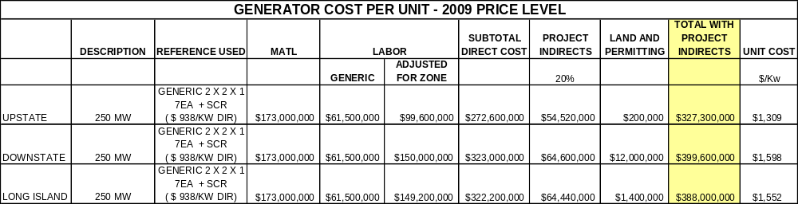

Table C - 7: Demand Response Cost Matrix
Base Case Modeling Assumptions for 2009-2018 CARIS Study Phase
Attachment 1
Generic Solution
Demand Response
Order of Magnitude Unit Costs
(Estimates should not be assumed reflective or predictive of actual project costs)
Item # | Demand Response Block Size (MW) | Portfolio Type | Location | Unit Cost ($M/MW) | Total Portfolio Cost ($M)
D-1 High | 100 | Energy Efficiency | Zone A-G | $4.2 | $420
D-1 Mid | 100 | Energy Efficiency | Zone A-G | $2.8 | $280
D-1 Low | 100 | Energy Efficiency | Zone A-G | $1.4 | $140
D-2 High | 100 | Demand Response | Zone A-G | $1.6 | $158
D-2 Mid | 100 | Demand Response | Zone A-G | $1.1 | $105
D-2 Low | 100 | Demand Response | Zone A-G | $0.5 | $53
D-3 High | 100 | Energy Efficiency | Zone H-J | $5.7 | $570
D-3 Mid | 100 | Energy Efficiency | Zone H-J | $3.8 | $380
D-3 Low | 100 | Energy Efficiency | Zone H-J | $1.9 | $190
D-4 High | 100 | Demand Response | Zone H-J | $2.1 | $210
D-4 Mid | 100 | Demand Response | Zone H-J | $1.4 | $140
D-4 Low | 100 | Demand Response | Zone H-J | $0.7 | $70
D-5 High | 100 | Energy Efficiency | Zone K | $3.9 | $390
D-5 Mid | 100 | Energy Efficiency | Zone K | $2.6 | $260
D-5 Low | 100 | Energy Efficiency | Zone K | $1.3 | $130
D-6 High | 100 | Demand Response | Zone K | $2.7 | $270
D-6 Mid | 100 | Demand Response | Zone K | $1.8 | $180
D-6 Low | 100 | Demand Response | Zone K | $0.9 | $90
Assumptions
1. Estimates herein should not be utilized for purposes outside of the CARIS process. Also, these estimates should not be assumed as reflective or predictive of actual projects or imply that facilities can necessarily be built for these generic solution order of magnitude estimates. Estimate ranges were identified after Transmission Owner input and reaching consensus at the ESPWG.
2. Costs are based on representative NY utilities' Demand Side Management filings.
3. Expected peak demand impact was used to scale the present value of the total portfolio budget to produce 100MW peak reduction.
4. Costs from each portfolio are based on 10 years of peak demand reduction.
5. Cost estimation is developed by dividing each year's cost by the peak demand reduction for that year and then calculating the present value of the $/MW over a 10 year period.
6. The range is derived from the utility filings as the "Low" and the "Mid" and "High" represents 2 and 3 times the "Low", respectively.
7. Due to a lack of Demand Response filing data for Upstate, it is assumed that the Upstate costs will be 75% of the Downstate costs. This is representative of the cost difference between to the Energy Efficiency programs for the two areas.

Appendix D – Overview of CARIS Modeling

Model Overview (GridView/MAPS, PROBE)
Production cost simulation software is the primary analytical tool utilized in the CARIS process. Production cost simulation tools seek to minimize the cost of dispatching a static fleet of generation assets to serve a deterministic forecast of (typically hourly) loads. In general terms, production cost simulations calculate the hourly production cost of supply resources under security- constrained transmission network and area market conditions.
To estimate the cost of transmission congestion, procedures and protocols were developed by the NYISO. The fundamental idea is to calculate, using the same data and calculation approach as the NYISO’s Security Constrained Unit Commitment software (SCUC), what the day-ahead hourly clearing prices would be if there were no transmission constraints, using the same data and calculation approach as the NYISO’s Security Constrained Unit Commitment software (SCUC). The congestion cost is then calculated as the difference between the constrained transmission system and the unconstrained transmission system. Annual congestion cost is the sum of daily costs.
Grid View and MAPS
In conducting the CARIS analysis the NYISO utilized both GridView and MAPS as the production cost simulation software. Both GridView and MAPS software tools mimic the operation of the NYISO day ahead electricity market by simulating security constrained unit commitment (SCUC) and economic dispatch of the generation and by monitoring transmission system flows under both normal and contingency conditions. This enables calculation of hourly production costs in light of the constraints imposed by the transmission system on the economic dispatch of generation. Both programs feature the following:
- Detailed representation of the large scale transmission network. The transmission system is modeled in terms of individual transmission lines, interfaces (group of lines), phase-angle regulators (PARs), and high voltage direct current (HVDC) lines. Both GridView and MAPS software model voltage and stability considerations through operating nomograms that define how voltage and stability these limits can change hourly as a function of loads, generation, and flows elsewhere on the system.
- Detailed generation modeling for thermal, hydro, pumped storage, wind, solar etc. Generation system data capabilities include multi-step cost curves based on heat rates, emission costs, fuel costs, and unit cycling capabilities. The generation units, along with chronological hourly load profiles, are assigned to individual buses on the system. Hourly load profiles are adjusted to meet peak and energy forecasts, which are input entered into the model on a monthly or annual basis. Information on hourly loads at each bus in the system is required to calculate electrical flows on the transmission system. This is specified by assigning one or a combination of several hourly load profiles to each load bus.
- Co-optimization of energy and ancillary services
- Post- contingency analysis for any given hourly dispatch

PROBE -– PoRtfolio Ownership and Bid Evaluation
PROBE software, developed by PowerGEM LLC LLC, is the day-ahead market simulation tool which has been utilized used by the NYISO as an analysis tool to conduct the NYISO’s historic congestion analysis. The results of this historic congestion analysis, expressed as a change in production costs, generator payments, load payments and congestion, have been reported on a quarterly basis on the NYISO’s website since 2003. The results of PROBE analysis were also used in the benchmarking process of GridView and MAPS.
PROBE software provides market simulation by using uses a Linear Programming-based Security Constrained Economic Dispatch (SCED) and Security Constrained Unit Commitment (SCUC) engine. PROBE uses actual submitted generator parameters, hourly bids and network status (including transmission outages) used by the NYISO to clear the day-ahead market. It performs a simulation for the market “as it was,” and then removes all transmission constraints (other constraints such as generator ramp rates and minimum run times are still enforced). Unit commitment and dispatch are then recalculated for this unconstrained scenario with no changes in bids from those actually submitted. The constrained and unconstrained results are compared to derive the change in bid production costs, load payments and generation payments. All calculations represent all market segments such as energy, start-up, and ancillary services bids for generators, import/export bids, virtual bids (virtuals), and fixed and price-capped demand bids.
In contrast to other planning-type software products, PROBE is designed to reproduce the day-ahead market clearing calculation as closely as possible. To accomplish this, PROBE was customized to model the NYISO’s market rules, including rules regarding co-optimization of energy and ancillary services, mitigation, marginal losses, and other custom market rules.
The major difference between the GridView/MAPS results and PROBE results is that GridView/MAPS did not simulate in this CARIS cycle the following: a) virtual bidding; b) transmission outages; c) fixed load and price-capped load; d) production costs based on mitigated bids; e) Bid Production Cost Guarantee (BPCG) payments; f) co-optimization with ancillary services; g) and externals.

Modeling Validation
Database Verification
To help ensure that the CARIS analyses produced accurate results, the NYISO conducted a two-stage data and modeling verification process. This involved a review of all input data and many of the program parameters on two separate occasions prior to the development of the base case analyses. The verification process was conducted by a NYISO System and Resource Planning team that was not involved in database modeling.
The following topics were examined as part of data verification:
- Forecasts of hourly load data for NYISO zones and external areas (externals);
- Hourly import and export schedules;
- Transmission system losses;
- Transmission interface transfer limits, contingencies & and nomograms;
- Generator incremental heat rates and emissions rates;
- Modeling of combined cycle units;
- Fuel price forecasts;
- Modeling of pumped storage & and hydro units; and
- Geographical location of generators by size and type.
The verification process involved a direct comparison of data contained in the GridView and MAPS models with the primary data sources from which those inputs were derived. Where modeling choices were made, as in the case of incremental heat rates and combined cycle units, parameters were selected that most closely represented actual unit characteristics.
In several cases, discrepancies were noted by the data verification team. A log of discrepancies was kept, and after the first stage of data verification, the log was presented for review and discussion with the CARIS team. The CARIS team was then directed to remedy the discrepancies in data or modeling choices made. These changes were accomplished before the development of the base case scenarios. Once the base case scenarios were developed, reviewed, and confirmed, the GridView and MAPS input files used to generate those results were saved as reference cases and used to develop scenarios. This was done to ensure that all subsequent scenarios were all performed from the same set of standard conditions.
After the development of the base case scenarios, a second stage of data verification, similar to the first, was performed. This was to confirm that no significant elements of the data inputs or modeling assumptions had been made subsequent to the development of the base case analyses.
2009 Quarter 1 Results
To be provided in the meeting.
XX Congestion on the Central East interface is within 8% ($106m vs. $98m). The actual congestion in the DAM is 20% higher and this is mainly caused by congestion of $45m on the Dunwoodie - Mt Haven 345kV contingency constraint (71 on 72 line and vice versa), which was not congested in the CARIS model. This congestion could be caused by lower line ratings (in DAM) on these facilities (needs to be checked), a higher load forecast and unavailability of critical generation in the area (due to economics or maintenance).

Database Conversion Certification
The NYISO, in conjunction with the ESPWG, decided that the first CARIS cycle analysis would be performed using both GridView and MAPS simulation tools. To compare the results between the two tools, the NYISO undertook a process of converting the NYISO ABB-GridView database to the NYISO GE-MAPS database. In order to guarantee a correct data conversion, the NYISO developed a converter capable of creating the MAPS input files from the GridView database. In order to guarantee model logic and features consistency, the NYISO worked with GE and ABB to decide which model logic and features to use. The following data was validated: Load annual peaks and energies; installed capacity; the unit full-load costs; and other data, such as minimum up and down time, start-up costs, spinning reserve allocation, and outages. In order to check the quality of the conversion, many random checks were manually made, including interface limits, monitored elements and contingencies. Moreover, the generator shift factor (GSF) matrix was compared to verify that the same load flow was used. Finally, GE provided NYISO with the information to balance the initial condition of the MAPS Generation and Transmission (GT) program. In conclusion, validation of conversion process worked well as all the tests mentioned above passed and the conversion process was deemed successful.
Appendix E –Detailed Results of 2009 CARIS Phase 1

Congestion Assessment – Historic and Projected
One of the features of a Locational Based Marginal Price (LBMP) based market is the ability to identify grid locations that are difficult to serve with economic generation due to transmission bottlenecks (constraints) and quantify the cost of this congestion. The NYISO calculates and publishes LBMP’s with three components:
- Energy component – Marginal electricity cost without the adjusted cost of congestion and losses.
- Congestion component – Cost of out-of merit generation dispatch relative to an assumed unconstrained reference point at Marcy substation.
- Losses component – Cost for supplying the losses from the accessible marginal generators to the grid point in question.

Historic Congestion Assessment
The NYISO reports historic congestion results on its website on a quarterly basis. The cost of congestion commonly reported is the simple sum of the day ahead market LBMP congestion component times the amount of load being affected (positively or negatively) by congestion (later referred to as “congestion payments”). While this congestion cost is relatively simple to calculate, this value is generally felt to be an over-simplified and deceiving congestion impact metric because:
  - This calculation does not incorporate the effect of supply and demand response when congestion is removed.
  - The congestion cost is relative to an assumed uncongested reference point. If this reference point is moved, the congestion cost is shifted to the LBMP energy component. The congestion versus energy cost calculation becomes arbitrary depending on the reference point chosen.
To better measure the true cost of transmission congestion, analysis tools and protocols were developed by the NYISO. The fundamental idea is to calculate what the day-ahead hourly clearing prices would be if there were no transmission constraints, using the same data and calculation approach as the NYISO Security Constrained Unit Commitment software (SCUC). The congestion cost is the difference between the actual SCUC transmission constrained LBMP’s, loads, and bids, and the same calculation with all transmission constraints ignored. Annual cost is the sum of daily costs.
The reported numbers are the result of a simulation of the NYCA market using the hourly bids and network status actually used by NYISO to clear the day-ahead market. The simulation performs a security constrained unit commitment for the market “as it was”, then removes all transmission constraints (other constraints such as desired net interchange (DNI), generator ramp rates and minimum run times are still enforced). Unit commitment and dispatch are then recalculated for this unconstrained scenario with no changes in bids from those actually submitted. The constrained and unconstrained results are compared to derive the cost of congestion. All calculations represent all market segments (e.g., fixed load, virtual load and generation, imports and exports), and actual hour-by-hour network status. The unconstrained scenario fixes the amount of virtual load and generation at their original MW levels.
Historic Congestion Metrics
To suit various needs for viewing the impact of congestion, four congestion metrics were developed: Bid Production Cost metric; Congestion Payment metric; Generator Payment metric; and Load Payment metric. All metrics report the difference between a constrained and an unconstrained value.
1. Change in Bid Production Cost (BPC) – This is the primary congestion impact metric chosen for use by the NYISO Operating Committee. The calculation compares the total production cost, based on mitigated bids, with and without transmission constraints limiting the unit commitment and dispatch. This measures the economic inefficiency introduced by the existence of transmission bottlenecks. In a sense, this is the societal cost of transmission congestion. A positive number means that transmission congestion increased electricity production cost.

An advantage of this metric is that production cost will always decrease when constraints are removed. The direct objective of SCUC is to minimize bid production cost; LBMPs are the result of the commitment and dispatch that result from achieving this objective under generating unit and transmission constrained conditions. Since SCUC does not directly attempt to minimize LBMPs, relieving all or some of the constraints may or may not decrease the market based electricity cost to load. In LBMP markets, the load in a location pays the marginal price of the supply at that location, not the bid price. The result of constraint relief in an LBMP market depends on how much load is affected, where the load is, and the response of supply and demand as constraints are relieved.

2. Change in Congestion Payments – This calculation, the sum of the LBMP congestion component times the load affected, ignores the energy cost change as constraints are removed. With no simulation truly required to arrive at this congestion impact metric (the congestion cost in an unconstrained market is 0), this is the accounting cost of congestion.

Congestion payments can be hedged with transmission congestion contracts (TCC’s) resulting in the unhedged congestion numbers reported. For this analysis, it was assumed that all TCC’s are owned by load and are available for hedging congestion payments. A positive number means congestion increases load cost.

3. Change in Generation Payments –In addition to the LBMP payments to generation (or other supply sources such as virtual generation, or imports), generators are also paid a Bid Production Cost Guarantee (BPCG) and for Ancillary Services. BPCG compensates generators that are committed for reliability despite the fact their bids are greater than the LBMP at the generator location. This can happen if ramp rates, minimum run times or other limits force unit operation, which minimizes overall production cost, even including BPCG payments. A positive number means generation payments went up due to congestion.

4. Change in Load Payments – This metric is the opposite side of the generation payments calculation. The calculation uses simulation to include the local energy cost response when transmission constraints are removed. Where the first congestion metric measures efficiency, this metric determines how much more New York load actually pays due to congestion and the market design; that is, the bills impact. The load payments congestion impact includes the effect of all market segments that can change when transmission constraints are relieved. These segments are:
- LBMP Components: While the LBMP congestion component will be pushed to zero when no transmission constraints exist, the unbottled generation will sell more energy at a slightly higher price (in accordance with the bid curves), albeit at a lower bid than the units put on out-of-merit in the transmission limited case. This results in a likely increase in the LBMP energy component as the LBMP congestion component decreases. The LBMP loss component will also change depending on the location and prices of the generation unbottled when constraints are relieved. Ancillary service costs (e.g., reserves) also affect LBMPs, as generators trade-off between selling ancillary services or energy.
- Load payments due to congestion are hedged with TCCs, leading to the reported unhedged load payment. In this analysis, it was assumed that all TCCs were credited to load. The TCC auction cost is ignored, as it is part of the Transmission Service Charge (TSC).
- TCC shortfall – In the event of a TCC shortfall (or surplus), the load pays for the imbalance. As transmission constraints are relieved or removed the imbalance changes. While the shortfall may be compensated for elsewhere in the TSC, from a congestion impact perspective this is considered a load cost. Although the NYISO OATT describes details of the allocation of shortfall by transmission owner, for this analysis shortfall is stated for the NYCA only.
- Schedule 1 imbalances – In accordance with the NYISO OATT, imbalances of energy and loss payments are a component of the OATT defined Schedule 1 payments. Relieving or eliminating transmission constraints affects these payments, and is thus considered a congestion impact in this analysis. Like shortfall, this analysis states the Schedule 1 effect for the NYCA only. A positive number means congestion increases load payments.

Tables E-1 through E-3 present historic Base Case metrics’ results.

Table E - 1: Historic Congestion $Demand Payment (2004-2008) by Zone
Congestion $Demand Payment (m$)
 |  | Historical
Area |  | 2004 | 2005 | 2006 | 2007 | 2008
West |  | (0.66) | (4.93) | 0.90 | (14.10) | (25.15)
Genesse |  | 0.52 | (1.33) | 1.62 | (14.01) | (9.42)
Central |  | 0.49 | (1.18) | 3.46 | 9.41 | 18.42
North |  | (0.03) | (1.12) | (0.15) | (0.25) | (1.75)
Mohawk Valley |  | 0.10 | (0.34) | 2.14 | 4.57 | 9.84
Capital |  | 7.48 | 19.31 | 27.20 | 73.75 | 143.40
Hudson Valley |  | 4.87 | 19.94 | 54.40 | 86.86 | 175.45
Millwood |  | 2.74 | 11.81 | 26.73 | 30.78 | 78.02
Dunwoodie |  | 4.39 | 23.56 | 44.11 | 56.12 | 124.41
NYCity |  | 581.84 | 808.65 | 672.90 | 700.03 | 1402.66
Long Island |  | 229.47 | 507.96 | 708.16 | 517.93 | 624.44
Total |  | 831.2 | 1,382.3 | 1,541.5 | 1,451.1 | 2,540.3
Historical Congestion Source: PROBE DAM quarterly reports
DAM data include Virtual bidding & Transmission planned outages

Table E -2: Historical Generator Payment (2004-2008)
Generator Payment m$
 |  | Historical
Area |  | 2004 | 2005 | 2006 | 2007 | 2008
West |  | 1,356 | 1,971 | 1,530 | 1,630 | 1,701
Genesse |  | 314 | 435 | 418 | 491 | 476
Central |  | 1,493 | 2,282 | 1,612 | 1,753 | 1,825
North |  | 543 | 760 | 633 | 659 | 779
Mohawk Valley |  | 150 | 336 | 230 | 206 | 234
Capital |  | 415 | 747 | 704 | 883 | 1,175
Hudson Valley |  | 1,093 | 1,174 | 533 | 571 | 532
Millwood |  | 900 | 1,371 | 1,145 | 1,252 | 1,725
Dunwoodie |  | 22 | 88 | 56 | 39 | 39
NYCity |  | 1,291 | 2,308 | 1,895 | 2,072 | 2,405
Long Island |  | 1,036 | 1,682 | 1,485 | 1,282 | 1,286
Total |  | 8,615 | 13,153 | 10,241 | 10,840 | 12,178
Historical Generator Payment Source: PROBE DAM quarterly reports
DAM data include Virtual bidding & Transmission planned outages

Table E -3: Historical Load Payment (2004-2008) by Zone
Load Payment m$
 |  |  | Historical
Area |  |  | 2004 | 2005 | 2006 | 2007 | 2008
West |  |  | 855 | 1,196 | 868 | 983 | 1,061
Genesse |  |  | 741 | 874 | 649 | 668 | 754
Central |  |  | 717 | 1,097 | 779 | 928 | 1,060
North |  |  | 288 | 473 | 351 | 413 | 474
Mohawk Valley |  |  | 359 | 551 | 400 | 443 | 469
Capital |  |  | 735 | 1,022 | 720 | 818 | 1,008
Hudson Valley |  |  | 498 | 883 | 761 | 864 | 1,114
Millwood |  |  | 207 | 344 | 252 | 263 | 385
Dunwoodie |  |  | 452 | 544 | 442 | 494 | 706
NYCity |  |  | 3,665 | 5,739 | 4,394 | 4,696 | 5,919
Long Island |  |  | 1,540 | 2,591 | 2,353 | 2,261 | 2,535
Total |  |  | 10,059 | 15,314 | 11,969 | 12,831 | 15,485
Historical Load Payment Source: PROBE DAM quarterly reports
DAM data include Virtual bidding & Transmission planned outages

Projected Congestion Assessment

CARIS Metrics

In conducting CARIS analysis, seven metrics are used. The primary metric is the production cost metric and the other six additional metrics are load payments, generator payments, emissions, TCCs, losses, and ICAP metric. All benefit metrics are determined by measuring the difference between the CARIS Base Case system value and a system value when the generic solution is added. The discount rate used for the present value analysis is the current weighted average cost of capital for the NYTOs.

1. NYCA Production Cost Metric

NYCA production cost is the total generation cost of producing power to serve NYCA load. The total cost includes the following components:

- Fuel cost (fuel consumption MBtu multiplied by fuel cost $ /MBtu)
- Variable O&M cost (VOM adder $/MWh)
- Emission cost (emission allowance price multiplied by total allowance)
- Start-up Costs (number of starts multiplied by start-up cost)
- NYCA Imports and Exports evaluated at the proxy busses LBMP values

2. Demand$_Congestion Payment

The congestion values (Demand$_Congestion Payments) are calculated as the congestion component of the LBMP paid by NYCA load. It is defined as the shadow price of each constrained elements multiplied by the load affected and calculated as follows:

Demand$_Congestion by constraint for all areas and all hours_ = (ShadowPrice x Zone GSF x Zone Load))

Total Demand$_Congestion = Sum of all constraints’ Demand$_Congestion

3. Generator Payment Metric

Generator payment is also referred to as generator revenues. It represents zonal LBMP based revenues or payment to generators located in a zone. The hourly revenue or payment to each generator is the determined as the hourly generator MW dispatch multiplied by the generator’s LBMP or spot price. The annual generator payment is then the sum of all 8,760 hourly generator payments.

Annual generator LBMP payment = sum of all hours (generator LBMP x generator MW dispatch)

Zonal generator payment = sum of generator payment located in a zone

4. LBMP Load Payment Metric

The LBMP Load Payment metric is the , or LBMP load payment, is the total energy cost to consumers. It is a zonal LBMP based consumer payment. h Hourly load-weighted average LBMP price for each zone is calculated and multiplied by with the zonal load to determine the hourly zonal load payment. The annual load payment is then the sum of all 8,760 hourly load payments.

Annual Zonal LBMP payment = sum of all hours (zonal LBMP x zonal load)

Zonal LBMP = zonal average load-weighted LMP

Note: actual consumer payments will be net of any TCC hedges or bilateral contracts.

5. TCC metric (Congestion Rent)

The TCC payment metric is determined by calculating congestion rents. Congestion hourly congestion rent for a constrained facility is defined as the active power flow (MW) on the constrained facility multiplied by its shadow price. Shadow price is defined as the incremental production cost saving if the constrained element flow limit is increased by 1MW. Shadow prices on constrained elements are non-zero during hours of congestion (or constrained element MW flow is equal to constrained element limit).

Congested rent value by constraint = sum of all hours (constrained element MW x Shadow Price $/MW)

Total congestion rent = Sum of all constraints congestion rent

6. ICAP Metric

The MW impact methodology is used in this first CARIS cycle to calculate the ICAP metric. GE’s Multi-Area Reliability Simulation program (MARS) was used to determine the impact of each generic solution on the Loss of Load Expectation (LOLE) and the amount of capacity required to bee removed to bring the LOLE back in line with the base case. The generation solutions were modeled by creating a new 500MW combined cycle plant located in the appropriate zone using a two state model and typical NERC eFORD values for its transition rates. The demand response solutions were modeled by reducing the peak for the appropriate zone and increasing the emergency response value. The transmission solutions were modeled by modifying the transfer limits, as noted in Table E-4.

Table E- 4 - MARS Interface Modifications for ICAP Calculations
Central East Transmission Generic Solution | Leeds-Pleasant Valley Transmission Generic Solution | West Central Transmission Generic Solution
Central East-Fraser-Gilboa Interface increased by 400 MW | Central East-Fraser-Gilboa Interface increased by 50 MW | West Central Interface Increased by 500 MW
Total East Group Increased by 400 MW | Total East Group Increased by 50 MW | Dysinger East Interface Increased by 500 MW
Central East Group Increased by 400 MW | Central East Group Increased by 50 MW
 | Zone F to Zone G Increased by 800 MW
 | UPNY-SENY Interface Increased by 350 MW

When comparing historical values to projected values, one must bear in mind that there are significant differences in assumptions used by the PROBE and CARIS tools. The CARIS tools did not simulate the following: a) virtual bidding; b) transmission outages; c) fixed load and price-capped load; d) production costs based on mitigated bids; e) Bid Production Cost Guarantee (BPCG) payments; f) co-optimization with ancillary services; g) and externals.

Table E-5 below presents the summation of the CARIS metrics base case values over the ten-year study period in nominal $.

Table E-5: Projected CARIS Base Case Metrics

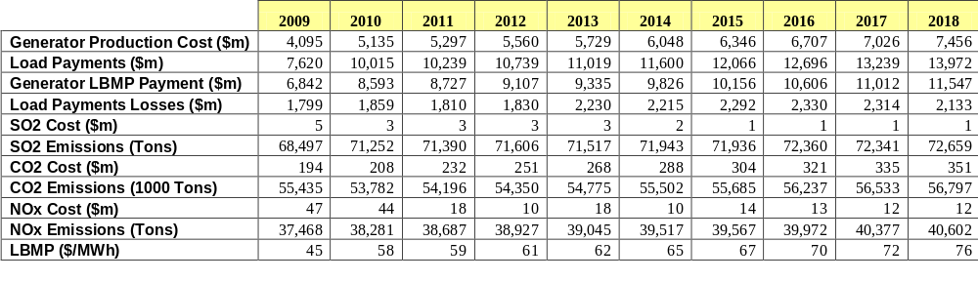

The projected Base Case congestion metrics in nominal $ are shown in Error: Reference source not foundTables E-6 through E-16.

Table E - 6: Projected Production Costs (2004-2008) by Zone
Generator Production Cost m$
 | 2009 | 2010 | 2011 | 2012 | 2013 | 2014 | 2015 | 2016 | 2017 | 2018
West | 311 | 327 | 334 | 346 | 354 | 369 | 382 | 390 | 411 | 415
Genesse | 56 | 56 | 56 | 57 | 59 | 61 | 66 | 68 | 69 | 74
Central | 674 | 733 | 734 | 759 | 785 | 817 | 858 | 887 | 915 | 959
North | 88 | 118 | 121 | 128 | 130 | 136 | 141 | 148 | 155 | 164
Mohawk Valley | 22 | 27 | 30 | 32 | 34 | 37 | 40 | 43 | 42 | 51
Capital | 597 | 1,018 | 1,032 | 1,088 | 1,108 | 1,156 | 1,200 | 1,257 | 1,303 | 1,387
Hudson Valley | 114 | 149 | 157 | 172 | 173 | 187 | 194 | 205 | 216 | 233
Millwood | 205 | 201 | 199 | 205 | 210 | 215 | 230 | 236 | 241 | 249
Dunwoodie | 0 | 0 | 0 | 0 | 0 | 0 | 0 | 0 | 0 | 0
NYCity | 1,344 | 1,479 | 1,543 | 1,609 | 1,658 | 1,770 | 1,858 | 1,977 | 2,082 | 2,171
Long Island | 483 | 611 | 648 | 680 | 696 | 741 | 764 | 806 | 846 | 902
NYISO Total | 3,895 | 4,718 | 4,855 | 5,075 | 5,208 | 5,489 | 5,732 | 6,017 | 6,279 | 6,607
Interchange Flow Value | 200 | 417 | 441 | 485 | 520 | 559 | 615 | 690 | 748 | 849
Aggregate NYISO | 4,095 | 5,135 | 5,297 | 5,560 | 5,729 | 6,048 | 6,346 | 6,707 | 7,026 | 7,456

Table E - 7: Projected Load Payments (2009-2018) by Zone
Load Payments - m$
 | 2009 | 2010 | 2011 | 2012 | 2013 | 2014 | 2015 | 2016 | 2017 | 2018
West | 645 | 800 | 806 | 836 | 852 | 898 | 929 | 963 | 998 | 1050
Genesse | 416 | 531 | 532 | 553 | 555 | 589 | 613 | 639 | 666 | 695
Central | 695 | 890 | 898 | 933 | 965 | 1014 | 1049 | 1094 | 1136 | 1202
North | 288 | 369 | 374 | 389 | 402 | 421 | 433 | 448 | 463 | 491
Mohawk Valley | 317 | 413 | 417 | 435 | 448 | 470 | 486 | 505 | 524 | 541
Capital | 515 | 672 | 677 | 713 | 733 | 770 | 801 | 842 | 884 | 935
Hudson Valley | 504 | 669 | 692 | 725 | 743 | 781 | 810 | 849 | 888 | 940
Millwood | 126 | 168 | 175 | 184 | 189 | 198 | 205 | 215 | 225 | 240
Dunwoodie | 305 | 405 | 419 | 437 | 446 | 464 | 478 | 498 | 519 | 552
NYCity | 2692 | 3627 | 3744 | 3966 | 4100 | 4350 | 4565 | 4864 | 5088 | 5377
Long Island | 1117 | 1473 | 1505 | 1569 | 1585 | 1645 | 1696 | 1779 | 1849 | 1950
NYISO Total | 7,620 | 10,015 | 10,239 | 10,739 | 11,019 | 11,600 | 12,066 | 12,696 | 13,239 | 13,972

Table E - 8: Projected Generator Payment (2009-2018) by Zone
Generator LBMP Payment - m$
 | 2009 | 2010 | 2011 | 2012 | 2013 | 2014 | 2015 | 2016 | 2017 | 2018
West | 1083 | 1369 | 1374 | 1425 | 1440 | 1516 | 1565 | 1615 | 1666 | 1733
Genesse | 193 | 243 | 244 | 254 | 253 | 266 | 275 | 285 | 291 | 290
Central | 1357 | 1705 | 1710 | 1782 | 1842 | 1928 | 1985 | 2062 | 2129 | 2247
North | 395 | 511 | 514 | 536 | 553 | 580 | 598 | 621 | 644 | 664
Mohawk Valley | 141 | 182 | 183 | 191 | 198 | 209 | 216 | 225 | 231 | 248
Capital | 780 | 1189 | 1177 | 1236 | 1274 | 1337 | 1385 | 1447 | 1501 | 1585
Hudson Valley | 191 | 265 | 279 | 299 | 303 | 322 | 331 | 349 | 369 | 394
Millwood | 796 | 1037 | 1065 | 1115 | 1131 | 1176 | 1212 | 1263 | 1306 | 1380
Dunwoodie | 0 | 0 | 0 | 0 | 0 | 0 | 0 | 0 | 0 | 1
NYCity | 1374 | 1436 | 1484 | 1541 | 1594 | 1698 | 1773 | 1882 | 1975 | 2055
Long Island | 533 | 656 | 695 | 726 | 747 | 794 | 815 | 855 | 899 | 950
NYISO Total | 6,842 | 8,593 | 8,727 | 9,107 | 9,335 | 9,826 | 10,156 | 10,606 | 11,012 | 11,547

Table E - 9: Projected Losses Payment (2009-2018) by Zone
Load Payments Losses (M$)
Zone | 2009 | 2010 | 2011 | 2012 | 2013 | 2014 | 2015 | 2016 | 2017 | 2018
West | (18.54) | (43.45) | (44.73) | (47.85) | (43.97) | (45.35) | (44.81) | (47.67) | (50.84) | (56.71)
Genesse | (4.20) | (8.75) | (9.15) | (10.00) | (8.82) | (8.39) | (7.63) | (8.04) | (8.22) | (9.81)
Central | 3.42 | 1.30 | 1.22 | 0.93 | 2.86 | 3.03 | 3.62 | 3.86 | 4.05 | 5.71
North | (2.29) | (4.62) | (4.67) | (5.08) | (4.82) | (4.37) | (4.29) | (4.79) | (5.17) | (3.48)
Mohawk Valley | 10.70 | 12.28 | 12.39 | 12.88 | 13.39 | 14.15 | 14.70 | 15.25 | 15.98 | 16.15
Capital | 27.96 | 36.08 | 36.69 | 38.90 | 39.22 | 40.66 | 41.83 | 44.14 | 46.62 | 50.82
Hudson Valley | 41.49 | 57.72 | 58.43 | 61.45 | 62.03 | 64.40 | 65.73 | 69.16 | 72.14 | 75.80
Millwood | 11.29 | 15.97 | 16.15 | 17.00 | 17.34 | 17.91 | 18.29 | 19.24 | 20.09 | 21.57
Dunwoodie | 28.64 | 40.27 | 40.32 | 42.21 | 42.59 | 43.71 | 44.44 | 46.47 | 48.24 | 51.12
NYCity | 272.32 | 387.30 | 389.95 | 415.07 | 425.07 | 445.60 | 459.90 | 490.24 | 510.89 | 540.20
Long Island | 123.47 | 173.62 | 171.74 | 179.40 | 178.46 | 182.61 | 185.77 | 195.38 | 201.80 | 205.35
NYISO Total | 494.27 | 667.71 | 668.35 | 704.90 | 723.36 | 753.97 | 777.56 | 823.24 | 855.57 | 896.72
IESO Total | (58.73) | (244.93) | (257.91) | (286.66) | (244.11) | (218.21) | (194.66) | (225.69) | (249.78) | (274.17)
PJM Total | 935.50 | 786.68 | 747.23 | 725.89 | 1,074.96 | 985.83 | 1,012.61 | 1,024.61 | 982.96 | 708.36
NEISO | 427.70 | 649.46 | 651.87 | 685.52 | 675.74 | 693.03 | 696.23 | 708.33 | 725.19 | 802.48
Total | 1,798.73 | 1,858.92 | 1,809.55 | 1,829.65 | 2,229.94 | 2,214.62 | 2,291.74 | 2,330.49 | 2,313.94 | 2,133.39

Table E - 10: Projected SO2 Emission Costs (2009-2018) by Zone
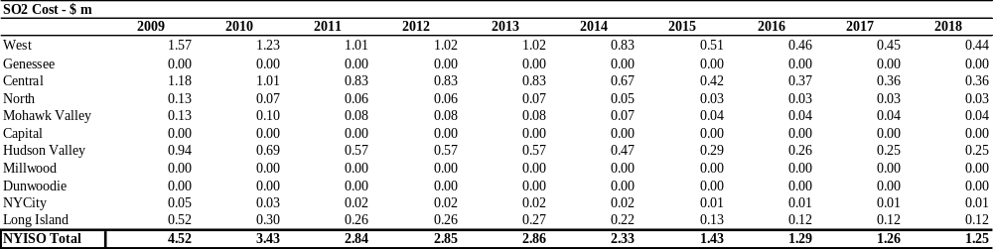

Table E - 11: Projected SO2 Emission Tons (2009-2018) by Zone
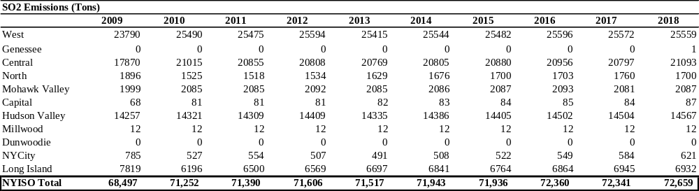

Table E - 12: Projected CO2 Emission Costs (2009-2018) by Zone
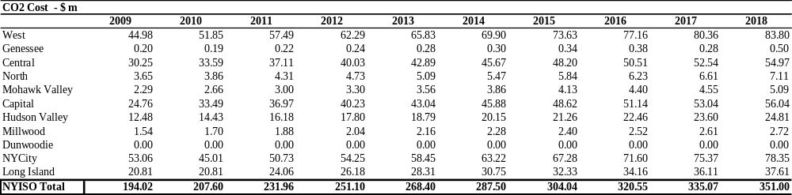

Table E - 13: Projected CO2 Emission Tons (2009-2018) by Zone
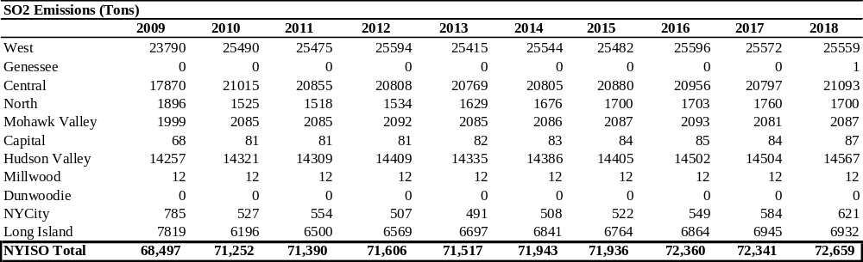

Table E - 14: Projected NOx Emission Costs (2009-2018) by Zone
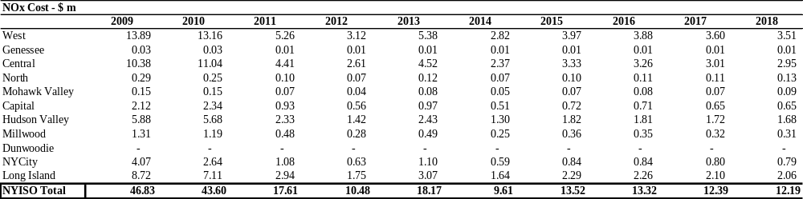

Table E - 15: Projected NOx Tons (2009-2018) by Zone
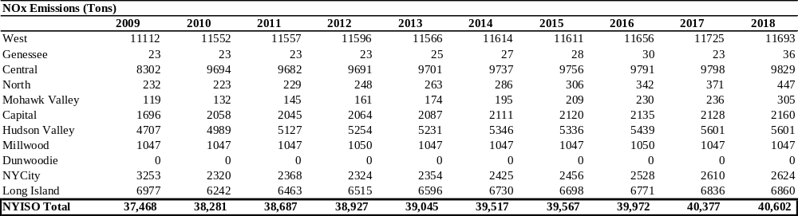

Table E - 16: Projected Zonal LBMP (2009-2018) by Zone
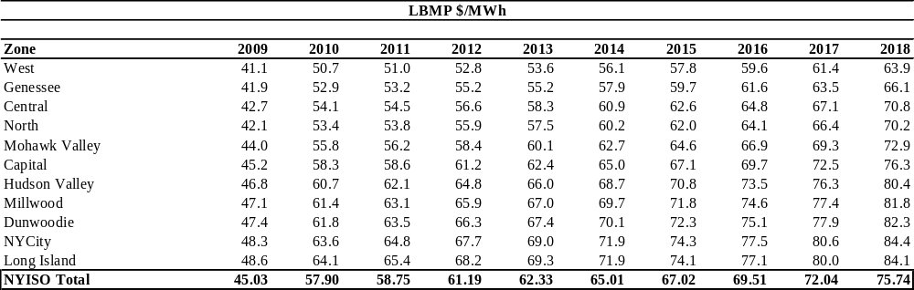

Selection of Three Studies

The selection of the three CARIS studies is a two-step process as described below.

In Step 1, both historic and projected congestion elements for a fifteen year period are ranked in ascending order based on the calculated present value of Demand$ Congestion. Initially the top five positive and top two negative congested elements are identified for further consideration. This initial list is then revised to include any orphaned elements if their projected congestion is higher than other elements’ project congestion. The elements are removed from the list which shows a significant decline thus indicating a diminishing return. The remaining top five congested elements are then further considered for inclusion in Step 2.

In Step 2, the top five congested elements from Step 1 are relieved independently to identify the grouped elements and to calculate the production cost savings for each group. The top congested elements are relieved by increasing their limit to 9999 for a mid and horizon year. The primary constraint will be assessed for grouping with a new element if the new element is electrically adjacent to the primary element and in the top five of congested elements based on Demand$ Congestion. If the new element meets these criteria, then process will be repeated again with the new element’s limit also increased to 9999 to identify any additional electrically adjacent elements that become significantly congested. The elements are grouped if the production cost savings are increased by 50% or more. If after the initial grouping the production cost savings is not more than $3 Million, then the primary element is eliminated from the list. If more than three grouped elements meet all the criteria, then the three with the most production cost savings are selected as the three studies. The production cost savings based on modifying an existing element’s limit will be different than that achieved when applying a transmission solution since an impedance value for a line is not being introduced..

Table E-17 shows the Dollar Demand Congestion for the Base Case and the relaxation cases for year 2013 and 2017. None of the relaxation tests resulted in an increase in congestion on an electrically adjacent line except for Leeds-Pleasant Valley. The relaxation of the Leeds-Pleasant Valley line did result in an increase in congestion on the Leeds-New Scotland line. However, the increased congestion is not enough to place it in the top five congested elements. Therefore, it is not grouped with the Leeds-Pleasant Valley line for the study.

Table E-17: Dollar Demand Congestion Results for Relaxation of Top Congested Elements
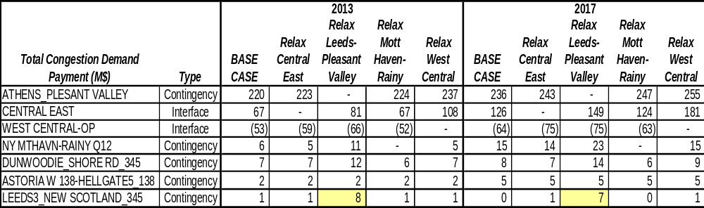

Table E-18 shows the change in production cost when the top elements are relieved. Leeds to Pleasant Valley, Central East and West Central have the highest production cost savings and are therefore selected as the three studies.

Table E-18: Production Cost Changed Due to Relaxation of Primary Element

 | 2013 | 2017
ATHENS_PLEASANT VALLEY | 13.1 | 14.8
CENTRAL EAST | 3.3 | 5.3
WEST CENTRAL-OP | 9.1 | 9.7
NY MRHAVN-RAINY Q12 | -0.08 | 6.4

E.3. Generic Solutions

Modeling Modifications
Upon selection of the generic solutions for each resource type for each grouped elements studied, the generic solutions are individually modeled in the base case in order to determine its impact on congestion of the grouped elements. It is assumed that the generic solution is installed in the first study year. This allows for the calculation of the full ten-year production cost and additional metrics resulting from the generic solution.

The base case transfer limits for the appropriate interfaces are recalculated for the mid-year and horizon year with all facilities in-service.

Initially, one single “block” size for each resource type is modeled. If a majority of the congestion of the grouped elements being studied is not relieved, then the installation of an additional block is considered. However, if adding the additional block results in a diminishing rate of return, or is not feasible, then it is not included.

Disclaimers:
- Other solutions may exist which will alleviate the congestion on the studied elements.
- No attempt has been made to determine the optimum solution for alleviating the congestion.
- No engineering, physical feasibility study, routing study or siting study has been completed for the generic solutions. Therefore, it is unknown if the generic solutions can be physically constructed as proposed.
- The costs of the System Upgrade Facilities to maintain reliability are not included in the cost /benefit analysis.
Grouped Congested Elements Solutions

One block of each resource type was applied to each congested grouping. It was determined that installation of one block of transmission solution for each congested grouping studied relieved the majority of the congestion. Installing one block of generation did not result in a significant reduction of congestion for all of congested elements being studied. Therefore, a second block of generation was installed for each. Installing the second block of generation still did not result in a majority of the congestion being relieved. However, a third block was not installed due to a diminishing rate of return. Installing one block of demand respond response resulted in minimal congested relief on the congested grouping being studied and even increased the congestion for the Central East interface. This is due to the demand response solution being applied through out the Zonal area and not to the bus located downstream of the congestion. However, the implementation of demand response will result in a reduction in production cost. Adding a second block of demand response was not installed since this would exceed 10% of the zonal load and thus would unlikely be achievable. The following sections outline the specific solutions developed for each congested grouping being studied.

Study#1 - Pleasant Valley – Leeds

Since the Pleasant Valley - Leeds line terminates at substations that meet the guidelines, the initial generic solution for relieving the Leeds to Pleasant Valley congestion for each resource types are as follows:

- Transmission : A new 345 kV line from Leeds to Pleasant Valley- 39 Miles

- Generation: Install a new 500 MW Plant at Pleasant Valley

- Demand Response: Install 100 MW Demand Response and 100 MW Energy Efficiency in Zone G (200 MW is less than 10% of Zone G’s peak load)

Table E-197shows the comparison of the resulting dollar demand congestion between the base case and generic polution for years 2013 and 2017.

Table E-197 Dollar Demand Congestion Comparison for Leeds – Pleasant Valley for Block Size Determination

Leeds Pleasant Valley- Congestion $ Demand
 | 2013 |  |  | 2017
 | Base Case | Solution Case | % Change | Base Case | Solution Case | % Change
Transmission | 220.0 | 0.0 | 100% | 236.0 | 0.0 | 100%
Generation- 1 Block | 220.0 | 191.0 | 13% | 236.0 | 204.0 | 14%
Generation – 2 Blocks | 220.0 | 157.4 | 28% | 236.0 | 165.8 | 30%
Demand Response | 220.0 | 213.5 | 3% | 236.0 | 227.7 | 4%

Table E-20 presents the change in the number of congested hours by constraints after each of the three generic solutions has been applied. Negative values imply a reduction in congested hours.

Table E-20: Change in Number of Congested Hours
Study #1 – Leeds - Pleasant Valley
 | Change in # of Congested Hours: Transmission Solution
 | 2009 | 2010 | 2011 | 2012 | 2013 | 2014 | 2015 | 2016 | 2017 | 2018
CENTRAL EAST | 198 | 65 | 365 | 372 | 202 | 208 | 167 | 171 | 174 | 121
ATHENS_PLTVLLEY | (681) | (860) | (2289) | (2381) | (2154) | (2148) | (2087) | (2123) | (2017) | (2094)
NY MOTTHAVEN-RAINEY | 124 | 140 | 322 | 362 | 300 | 312 | 275 | 304 | 256 | 336
DUNWOODIE_SHORE RD | 232 | 84 | 607 | 694 | 614 | 549 | 506 | 516 | 518 | 474
WEST CENTRAL-OP | (1) | 32 | 36 | 59 | 412 | 354 | 278 | 306 | 326 | 342
 | Change in # of Congested Hours: Generation Solution
 | 2009 | 2010 | 2011 | 2012 | 2013 | 2014 | 2015 | 2016 | 2017 | 2018
CENTRAL EAST | (196) | (120) | (21) | 23 | 2 | (16) | (21) | (17) | (43) | (45)
ATHENS_PLTVLLEY | (197) | (342) | (482) | (535) | (440) | (494) | (517) | (503) | (475) | (466)
NY MOTTHAVEN-RAINEY | 386 | 535 | 396 | 491 | 439 | 494 | 521 | 531 | 541 | 590
DUNWOODIE_SHORE RD | 698 | 635 | 707 | 830 | 752 | 830 | 805 | 817 | 727 | 770
WEST CENTRAL-OP | 0 | (4) | 5 | 19 | 10 | 32 | (33) | (23) | (27) | (7)
 | Change in # of Congested Hours: DR & EE Solution
 | 2009 | 2010 | 2011 | 2012 | 2013 | 2014 | 2015 | 2016 | 2017 | 2018
CENTRAL EAST | (19) | (1) | 0 | (9) | 0 | (6) | 4 | (5) | 4 | (13)
ATHENS_PLTVLLEY | (19) | (6) | 7 | (20) | (21) | (30) | (14) | (25) | (16) | (7)
NY MOTTHAVEN-RAINEY | 49 | 46 | 44 | 80 | 59 | 60 | 55 | 50 | 44 | 82
DUNWOODIE_SHORE RD | 128 | 53 | 89 | 98 | 97 | 74 | 105 | 99 | 83 | 88
WEST CENTRAL-OP | (1) | 2 | 7 | 4 | (16) | 2 | (39) | (18) | (11) | (18)
Note: Negative values imply a reduction.

Study #2 - Central East
In order to determine the upstream and downstream locations needed for the solutions for relieving the congestion on the Central East Interface, all the elements that comprise this interface were examined as shown in Table E-21. Two lines of this interface met the guideline of tying into an existing 345 kV substation: Edic to New Scotland and Marcy to New Scotland. Edic to New Scotland line was chosen based on shorter mileage.

Table E-21 Elements which Comprise the Central East Interface

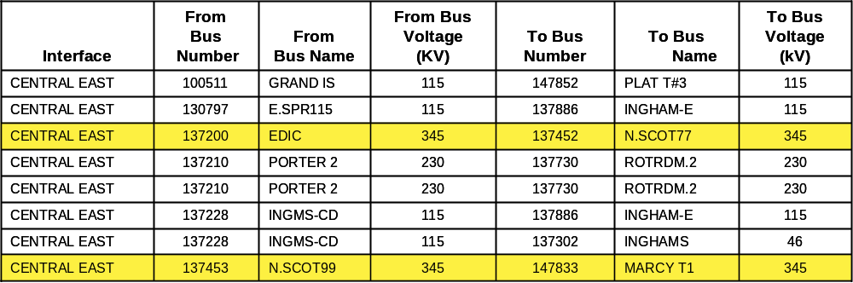

Generic solutions for relieving the Central East Interface for each resource types are as follows:
- Transmission: A new 345 kV line from Edic to New Scotland, 90 Miles

- Generation: Install a new 500 MW Plant at New Scotland

- Demand Response: Install 100 MW Demand Response and 100 MW Energy Efficiency in Zone F (200 MW is less than 10% of Zone F’s peak load)

Table E-22 shows the comparison of the resulting dollar demand congestion between the Base Case and generic solution for years 2013 and 2017.

Table E-22: Dollar Demand Congestion Comparison for Central East for Block Size Determination

Central East- Congestion $ Demand
 | 2013 |  |  | 2017
 | Base Case | Solution Case | % Change | Base Case | Solution Case | % Change
Transmission | 67.0 | 19.2 | 71% | 125.6 | 49.5 | 61%
Generation- 1 Block | 67.0 | 53.0 | 21% | 125.6 | 108.0 | 14%
Generation – 2 Blocks | 67.0 | 39.6 | 41% | 125.6 | 85.8 | 32%
Demand Response | 67.0 | 57.1 | 15% | 125.6 | 115.2 | 8%

Table E-23 presents the change in the number of congested hours by constraints after each of the three generic solutions has been applied. Negative values imply a reduction in congested hours.
Table E-23: Change in Number of Congested Hours
Study #2 - Central East
 | Change in # of Congested Hours: Transmission Solution
 | 2009 | 2010 | 2011 | 2012 | 2013 | 2014 | 2015 | 2016 | 2017 | 2018
CENTRAL EAST | (647) | (799) | (721) | (753) | (680) | (667) | (696) | (686) | (679) | (753)
ATHENS_PLTVLLEY | 245 | 390 | 476 | 414 | 387 | 375 | 431 | 402 | 396 | 441
NY MOTTHAVEN-RAINEY | 12 | (30) | (4) | 6 | (5) | (47) | (44) | (25) | (46) | (20)
DUNWOODIE_SHORE RD | (41) | (76) | (119) | (138) | (99) | (136) | (57) | (74) | (161) | (118)
WEST CENTRAL-OP | (2) | 95 | 96 | 103 | 135 | 126 | 144 | 195 | 171 | 119
 | Change in # of Congested Hours: Generation Solution
 | 2009 | 2010 | 2011 | 2012 | 2013 | 2014 | 2015 | 2016 | 2017 | 2018
CENTRAL EAST | (469) | (373) | (384) | (362) | (320) | (342) | (376) | (348) | (343) | (328)
ATHENS_PLTVLLEY | 418 | 437 | 616 | 612 | 638 | 663 | 661 | 671 | 728 | 728
NY MOTTHAVEN-RAINEY | 211 | 213 | 137 | 141 | 155 | 148 | 151 | 145 | 200 | 265
DUNWOODIE_SHORE RD | 347 | 257 | 116 | 206 | 172 | 211 | 202 | 231 | 156 | 221
WEST CENTRAL-OP | 0 | 6 | 3 | (23) | (194) | (160) | (164) | (161) | (159) | (186)
 | Change in # of Congested Hours: DR & EE Solution
 | 2009 | 2010 | 2011 | 2012 | 2013 | 2014 | 2015 | 2016 | 2017 | 2018
CENTRAL EAST | (94) | (82) | (83) | (89) | (73) | (71) | (88) | (90) | (87) | (82)
ATHENS_PLTVLLEY | 34 | 62 | 101 | 75 | 85 | 76 | 104 | 109 | 86 | 93
NY MOTTHAVEN-RAINEY | 16 | 34 | 26 | 34 | 18 | 29 | 21 | 34 | 26 | 35
DUNWOODIE_SHORE RD | 53 | 40 | 46 | 94 | 37 | 31 | 59 | 103 | 40 | 42
WEST CENTRAL-OP | (2) | 4 | 2 | (2) | (26) | (2) | (39) | (29) | (40) | (45)
Note: Negative values imply a reduction.

Study #3 - West Central
In order to determine the upstream and downstream locations needed to develop the solutions for relieving the congestion on the West Central Interface, the elements that make up this interface were examined, Table E-24. This interface includes two lines which meet the guideline of tying into an existing 345 kV substation, namely the Pannell to Clay 345 kV lines. However, upon testing the impact of a new generic line between Pannell and Clay, no improvement in voltage performance was observed. Recognizing that the voltage problem may be more a function of local system problems and that West Central is tightly coupled with the Dysenger East interface, a new circuit from Niagara to Clay was inserted and the voltage limit improved by over 500 MW. This was chosen to stay within the procedures for generics, although it is recognized that other bulk power system solutions may exist as well.

Table E-24: Elements which Comprise the West Central Interface

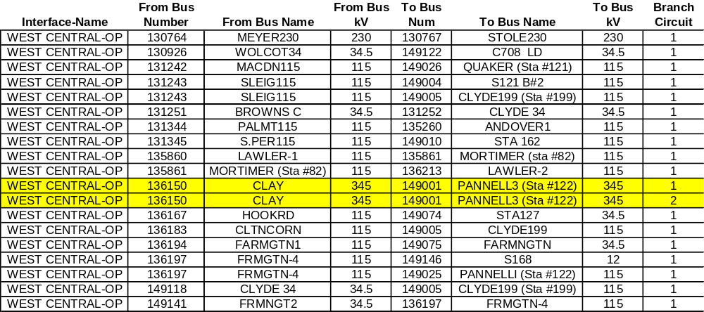

This interface includes only one line which meets the guideline of tying into an existing 345kV substation. This is the Pannell to Clay 345kV line. Therefore, the generic solutions for relieving the West Central Interface for each resource types are as follows:

- Transmission: A new 345kV line from Niagara to Pannell to Clay: 149 Miles

- Generation: Install a new 5000 MW Plant at Clay

- Demand Response: Install 100 MW Demand Response and 100 MW Energy Efficiency in Zone C (200 MW is less than 10% of Zone C’s peak load)

Table E-240 hows the comparison of the resulting dollar demand congestion between the base case and generic polution for years 2013 and 2017.
Table E-240:Dollar Demand Congestion Comparison for West Central for Block Size Determination
West Central- Congestion $ Demand
 |  | 2013 |  |  |  |  |  | 2017
 |  | Base Case |  | Solution Case |  | % Change |  | Base Case |  | Solution Case |  | % Change
Transmission |  | 52.6 |  | 10.4 |  | 80% |  | 63.6 |  | 13.7 |  | 78%
Generation- 1 Block |  | 52.6 |  | 47.0 |  | 11% |  | 63.6 |  | 56.0 |  | 12%
Generation – 2 Blocks |  | 52.6 |  | 40.3 |  | 23% |  | 63.6 |  | 46.7 |  | 27%
Demand Response |  | 52.6 |  | 49.5 |  | 6% |  | 63.6 |  | 58.6 |  | 8%

Table E-26 presents the change in the number of congested hours by constraints after each of the three generic solutions has been applied. Negative values imply a reduction in congested hours.

Table E-26: Change in Number of Congested Hours
Study #3 - West Central
 | Change in # of Congested Hours: Transmission Solution
 | 2009 | 2010 | 2011 | 2012 | 2013 | 2014 | 2015 | 2016 | 2017 | 2018
CENTRAL EAST | 164 | 431 | 361 | 415 | 665 | 625 | 559 | 583 | 560 | 657
ATHENS_PLTVLLEY | 37 | 56 | 114 | 102 | 269 | 238 | 204 | 239 | 211 | 235
NY MOTTHAVEN-RAINEY | 71 | 46 | 10 | 80 | 47 | 31 | 49 | 34 | 47 | 109
DUNWOODIE_SHORE RD | (33) | 19 | (10) | 37 | 70 | 104 | 59 | 86 | 76 | 172
WEST CENTRAL-OP | (5) | (266) | (312) | (387) | (1800) | (1718) | (1577) | (1613) | (1568) | (1840)
 | Change in # of Congested Hours: Generation Solution
 | 2009 | 2010 | 2011 | 2012 | 2013 | 2014 | 2015 | 2016 | 2017 | 2018
CENTRAL EAST | 514 | 448 | 343 | 369 | 436 | 475 | 474 | 451 | 387 | 457
ATHENS_PLTVLLEY | 102 | 88 | 201 | 169 | 221 | 239 | 283 | 273 | 279 | 268
NY MOTTHAVEN-RAINEY | 102 | 142 | 94 | 144 | 115 | 106 | 146 | 155 | 176 | 221
DUNWOODIE_SHORE RD | 274 | 214 | 104 | 162 | 154 | 209 | 187 | 199 | 169 | 224
WEST CENTRAL-OP | (4) | (97) | (107) | (138) | (398) | (286) | (326) | (368) | (354) | (370)
 | Change in # of Congested Hours: DR & EE Solution
 | 2009 | 2010 | 2011 | 2012 | 2013 | 2014 | 2015 | 2016 | 2017 | 2018
CENTRAL EAST | 85 | 113 | 69 | 80 | 107 | 106 | 123 | 95 | 100 | 106
ATHENS_PLTVLLEY | 13 | 27 | 59 | 22 | 53 | 38 | 72 | 67 | 59 | 50
NY MOTTHAVEN-RAINEY | (7) | 24 | 28 | 32 | 18 | 35 | 36 | 25 | 31 | 35
DUNWOODIE_SHORE RD | 54 | 20 | 38 | 45 | 53 | 27 | 55 | 63 | 29 | 51
WEST CENTRAL-OP | (1) | (30) | (20) | (31) | (86) | (68) | (104) | (86) | (114) | (82)
Note: Negative values imply a reduction.

E.4. Benefit/Cost Analysis (including additional metrics)
Disclaimers
- No verification has been completed to determine if the generic solution can be built within the generic cost estimate ranges.

- The generic solutions analysis is performed to provide a rough estimate of the benefit to cost opportunity based upon the assumptions contained in this report.

- The NYISO makes no representations regarding the adequacy or accuracy of the benefit/cost ratios.

Tables E-26 through E-2493prsent potentc solutions overnight installation costs costs ated with each study. On-going operation and maintenance costs are not included.

Table E-26: Poneric Solution Costs for Each Study
Generic Solution Cost Summary ($M)
Congested Groups | Central East | Leads - Pleasant Valley | West Central
Transmission
Substation Terminals | Edic to New Scotland | Leeds to Pleasant Valley | Niagara to Pannell to Clay
Miles | 90 | 39 | 149
High | $477 | $222 | $790
Mid | $333 | $155 | $552
Low | $189 | $87 | $313
Generation
Substation Terminal | New Scotland | Pleasant Valley | Clay
# of 250MW Blocks | 2 | 2 | 2
High | $831 | $911 | $831
Mid | $681 | $751 | $681
Low | $531 | $591 | $531
Demand Response
Zone | F | G | C
# of Blocks | 1 | 1 | 1
High | $580 | $580 | $580
Mid | $390 | $390 | $390
Low | $190 | $190 | $190

Table E-27: Poneric Solutions for Study #1 - Leeds to Pleasant Valley

Generic Solution for
Study #1 - Leeds to Pleasant Valley
(Estimates should not be assumed reflective or predictive of actual project costs)
Transmission Solution: Leeds to Pleasant Valley
Item # | Quantity | Unit Pricing ($M) | Total ($M)
T-1 High
Transmission Line (Miles) | 39 | $5.0 | $195.0
Substation Line Terminal | 2 | $9.0 | $18.0
System Upgrade | 1 | $9.0 | $9.0
Total High Transmission Solution Cost |  |  | $222.0
T-1 Mid
Transmission Line (Miles) | 39 | $3.5 | $136.5
Substation Line Terminal | 2 | $6.0 | $12.0
System Upgrade | 1 | $6.0 | $6.0
Total Mid Transmission Solution Cost |  |  | $154.5
T-1 Low
Transmission Line (Miles) | 39 | $2.0 | $78.0
Substation Line Terminal | 2 | $3.0 | $6.0
System Upgrade | 1 | $3.0 | $3.0
Total Low Transmission Solution Cost |  |  | $87.0
Generation Solution: Pleasant Valley
Item # | Quantity | Unit Pricing ($M) | Total ($M)
G-1 High
Plant (250 MW Blocks) | 2 | $440.0 | $880.0
Electric Transmission Line (Miles) | 1 | $5.0 | $5.0
Substation Terminal | 1 | $9.0 | $9.0
System Upgrade Facilities | 1 | $9.0 | $9.0
Gas Transmission Line (Miles) | 1 | $5.0 | $5.0
Gas Regulator Station | 1 | $3.0 | $3.0
Total High Generation Solution Cost |  |  | $911.0
G-1 Mid
Plant (250 MW Blocks) | 2 | $365.0 | $730.0
Electric Transmission Line (Miles) | 1 | $3.5 | $3.5
Substation Terminal | 1 | $6.0 | $6.0
System Upgrade Facilities | 1 | $6.0 | $6.0
Gas Transmission Line (Miles) | 1 | $3.5 | $3.5
Gas Regulator Station | 1 | $2.0 | $2.0
Total Mid Generation Solution Cost |  |  | $751.0
G-1 Low
Plant (250 MW Blocks) | 2 | $290.0 | $580.0
Electric Transmission Line (Miles) | 1 | $2.0 | $2.0
Substation Terminal | 1 | $3.0 | $3.0
System Upgrade Facilities | 1 | $3.0 | $3.0
Gas Transmission Line (Miles) | 1 | $2.0 | $2.0
Gas Regulator Station | 1 | $1.0 | $1.0
Total Low Generation Solution Cost |  |  | $591.0
Demanda Réponse Solution: Zone G
Item # | Quantity | Unit Pricing ($M) | Total ($M)
D-1 High
Energy Efficiency (100 MW Blocks) | 1 | $420.0 | $420.0
D-2 High
Demand Response (100 MW Blocks) | 1 | $160.0 | $160.0
Total High Demand Response Solution Costs |  |  | $580.0
D-1 Mid
Energy Efficiency (100 MW Blocks) | 1 | $280.0 | $280.0
D-2 Mid
Demand Response (100 MW Blocks) | 1 | $110.0 | $110.0
Total Mid Demand Response Solution Costs |  |  | $390.0
D-1 Low
Energy Efficiency (100 MW Blocks) | 1 | $140.0 | $140.0
D-2 Low
Demand Response (100 MW Blocks) | 1 | $50.0 | $50.0
Total Low Demand Response Solution Costs |  |  | $190.0

Table E-28: Poneric Solutions for Study #2 – Central East

Generic Solution
Central East
(Estimates should not be assumed reflective or predictive of actual project costs)
Transmission Solution: Edic to New Scotland
Item # | Quantity | Unit Pricing ($M) | Total ($M)
T-1 High
Transmission Line (Miles) | 90 | $5.0 | $450.0
Substation Line Terminal | 2 | $9.0 | $18.0
System Upgrade | 1 | $9.0 | $9.0
Total High Transmission Solution Cost |  |  | $477.0
T-1 Mid
Transmission Line (Miles) | 90 | $3.5 | $315.0
Substation Line Terminal | 2 | $6.0 | $12.0
System Upgrade | 1 | $6.0 | $6.0
Total Mid Transmission Solution Cost |  |  | $333.0
T-1 Low
Transmission Line (Miles) | 90 | $2.0 | $180.0
Substation Line Terminal | 2 | $3.0 | $6.0
System Upgrade | 1 | $3.0 | $3.0
Total Low Transmission Solution Cost |  |  | $189.0
Generation Solution: New Scotland
Item # | Quantity | Unit Pricing ($M) | Total ($M)
G-1 High
Plant (250 MW Blocks) | 2 | $400.0 | $800.0
Electric Transmission Line (Miles) | 1 | $5.0 | $5.0
Substation Terminal | 1 | $9.0 | $9.0
System Upgrade Facilities | 1 | $9.0 | $9.0
Gas Transmission Line (Miles) | 1 | $5.0 | $5.0
Gas Regulator Station | 1 | $3.0 | $3.0
Total High Generation Solution Cost |  |  | $831.0
G-1 Mid
Plant (250 MW Blocks) | 2 | $330.0 | $660.0
Electric Transmission Line (Miles) | 1 | $3.5 | $3.5
Substation Terminal | 1 | $6.0 | $6.0
System Upgrade Facilities | 1 | $6.0 | $6.0
Gas Transmission Line (Miles) | 1 | $3.5 | $3.5
Gas Regulator Station | 1 | $2.0 | $2.0
Total Mid Generation Solution Cost |  |  | $681.0
G-1 Low
Plant (250 MW Blocks) | 2 | $260.0 | $520.0
Electric Transmission Line (Miles) | 1 | $2.0 | $2.0
Substation Terminal | 1 | $3.0 | $3.0
System Upgrade Facilities | 1 | $3.0 | $3.0
Gas Transmission Line (Miles) | 1 | $2.0 | $2.0
Gas Regulator Station | 1 | $1.0 | $1.0
Total Low Generation Solution Cost |  |  | $531.0
Demand Response Solution: Zone F
Item # | Quantity | Unit Pricing ($M) | Total ($M)
D-1 High
Energy Efficiency (100 MW Blocks) | 1 | $420.0 | $420.0
D-2 High
Demand Response (100 MW Blocks) | 1 | $160.0 | $160.0
Total High Demand Response Solution Costs |  |  | $580.0
D-1 Mid
Energy Efficiency (100 MW Blocks) | 1 | $280.0 | $280.0
D-2 Mid
Demand Response (100 MW Blocks) | 1 | $110.0 | $110.0
Total Mid Demand Response Solution Costs |  |  | $390.0
D-1 Low
Energy Efficiency (100 MW Blocks) | 1 | $140.0 | $140.0
D-2 Low
Demand Response (100 MW Blocks) | 1 | $50.0 | $50.0
Total Low Demand Response Solution Costs |  |  | $190.0

Table E-93: Poteric Solutions for Study #3 – West Central
Generic Solution
West Central
(Estimates should not be assumed reflective or predictive of actual project costs)
Transmission Solution: Niagara to Pannell to Clay
Item # | Quantity | Unit Pricing ($M) | Total ($M)
T-1 High
Transmission Line (Miles) | 149 | $5.0 | $745.0
Substation Line Terminal | 4 | $9.0 | $36.0
System Upgrade | 1 | $9.0 | $9.0
Total High Transmission Solution Cost |  |  | $790.0
T-1 Mid
Transmission Line (Miles) | 149 | $3.5 | $521.5
Substation Line Terminal | 4 | $6.0 | $24.0
System Upgrade | 1 | $6.0 | $6.0
Total Mid Transmission Solution Cost |  |  | $551.5
T-1 Low
Transmission Line (Miles) | 149 | $2.0 | $298.0
Substation Line Terminal | 4 | $3.0 | $12.0
System Upgrade | 1 | $3.0 | $3.0
Total Low Transmission Solution Cost |  |  | $313.0
Generation Solution: Clay
Item # | Quantity | Unit Pricing ($M) | Total ($M)
G-1 High
Plant (250 MW Blocks) | 2 | $400.0 | $800.0
Electric Transmission Line (Miles) | 1 | $5.0 | $5.0
Substation Terminal | 1 | $9.0 | $9.0
System Upgrade Facilities | 1 | $9.0 | $9.0
Gas Transmission Line (Miles) | 1 | $5.0 | $5.0
Gas Regulator Station | 1 | $3.0 | $3.0
Total High Generation Solution Cost |  |  | $831.0
G-1 Mid
Plant (250 MW Blocks) | 2 | $330.0 | $660.0
Electric Transmission Line (Miles) | 1 | $3.5 | $3.5
Substation Terminal | 1 | $6.0 | $6.0
System Upgrade Facilities | 1 | $6.0 | $6.0
Gas Transmission Line (Miles) | 1 | $3.5 | $3.5
Gas Regulator Station | 1 | $2.0 | $2.0
Total Mid Generation Solution Cost |  |  | $681.0
G-1 Low
Plant (250 MW Blocks) | 2 | $260.0 | $520.0
Electric Transmission Line (Miles) | 1 | $2.0 | $2.0
Substation Terminal | 1 | $3.0 | $3.0
System Upgrade Facilities | 1 | $3.0 | $3.0
Gas Transmission Line (Miles) | 1 | $2.0 | $2.0
Gas Regulator Station | 1 | $1.0 | $1.0
Total Low Generation Solution Cost |  |  | $531.0
Demand Response Solution: Zone C
Item # | Quantity | Unit Pricing ($M) | Total ($M)
D-1 High
Energy Efficiency (100 MW Blocks) | 1 | $420.0 | $420.0
D-2 High
Demand Response (100 MW Blocks) | 1 | $160.0 | $160.0
Total High Demand Response Solution Costs |  |  | $580.0
D-1 Mid
Energy Efficiency (100 MW Blocks) | 1 | $280.0 | $280.0
D-2 Mid
Demand Response (100 MW Blocks) | 1 | $110.0 | $110.0
Total Mid Demand Response Solution Costs |  |  | $390.0
D-1 Low
Energy Efficiency (100 MW Blocks) | 1 | $140.0 | $140.0
D-2 Low
Demand Response (100 MW Blocks) | 1 | $50.0 | $50.0
Total Low Demand Response Solution Costs |  |  | $190.0

E.4. Additional Metrics

The write-up below attempts to bring the additional metrics numbers together for the reader. The relationship between the metrics is explained. In addition the calculation of change in the values of the additional metrics is also demonstrated and a reference is included to where these meatrics are discussed.

The equation below describes the relationship between the additional metrics:

Load Payment = Generation Payment + Congestion Rent + Residual Losses

The Load and Generation Payment and the congestion Rent values above are the global or system values from the simulation model. For the CARIS model the system include PJM, IESO-Ontario, NYISO and ISO-NE. In the Day-Ahead-Market, interchange with the neighboring markets is modeled at a simple PROXY bus and many of the interchange or PROXY metrics cannot be easily determined.

Load Payment as calculated in CARIS models represents the total annual amount collected by an ISO from the load. These annual values cover the three types of charges passed on to the load, i.e. energy, congestion and losses

A similar breakdown also applies to the Generator LBMP Payments (or Generator Revenues) and, accordingly, equal the annual amount paid to generators for providing electricity for energy, congestion and losses. However, in CARIS the generator payments do not include Bid Production Cost Guarantees (BPCG) and other payments as per NYISO tariff as is the case in DAM settlements.

The calculations of the change in additional metrics reported in this report for the Base Case and the Leeds-Pleasant Valley transmission solution are shown in Table E-31. The values in the third table represent the change in these values. The reader is directed to follow the notes in each table below to the pages where these results are referred to in the report.

The load payment is consistently higher than the generator payments every year. The remainder is a payment due to Residual Losses, which is then returned to the loads and/or transmission owners depending on the market settlements structure. Also, the values in the “Load Congestion Pay” and the “Load Losses Pay” columns are both components of the value listed in the “Load Pay” column. They are shown separately because one of two is identified in the TARIFF as an additional metric “Load Losses Pay” and the other “Load Congestion Pay” value was used to identify the highest ranked congestion elements. For this reason the change in the “Load congestion Pay” is not reported in any of the CARIS results table except in this section.

The congestion rent values are also listed for the base case and the Leeds-Pleasant Valley solution case and the change in this value is also listed in the third table. The change in the congestion rent values substituted the TCC metric called for in the TARIFF for CARIS phase 1.

Table E-31: Base Case Additional Metrics (in nominal $ Millions)
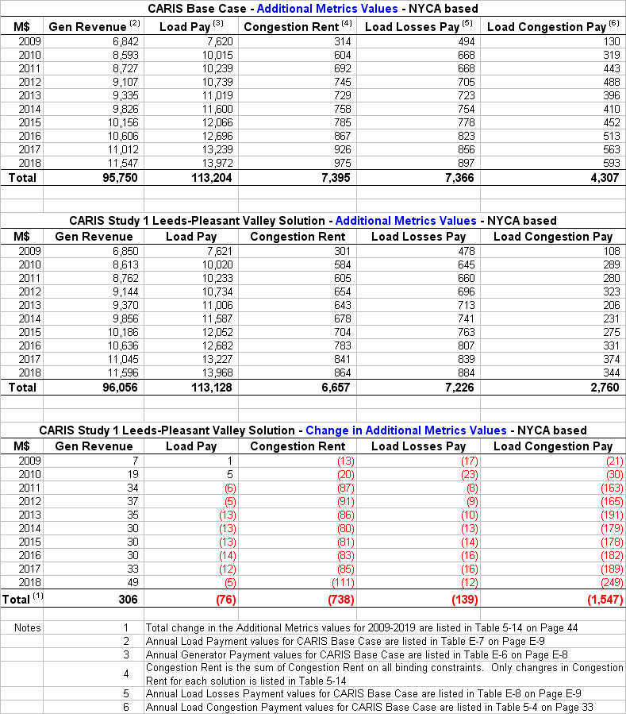

Appendix F – Initial CARIS Manual (link)

http://www.nyiso.com/public/webdocs/services/planning/initial_caris_manual_bic_approved/CARISmanual.pdf

Appendix G - 2009 RNA and CRP Reports (link)
The 2009 RNA and CRP reports can be found through the following links:

http://www.nyiso.com/public/webdocs/services/planning/reliability_assessments/RNA_2009_Final_1_13_09.pdf

http://www.nyiso.com/public/webdocs/services/planning/reliability_assessments/CRP__FINAL_5-19-09.pdf

A procedure on the acceleration of regulated backstop solutions is still under the development
The NYISO benefit/cost analysis will be forwarded to the BIC and to the MC for discussion and action. The beneficiary determination and associated voting percentages will be provided to the BIC and the MC for review and comment, but not approval.
The actual cost estimates for Demand Response solutions will be considered in the next CARIS cycle.

