

2009 Congestion Assessment and Resource Integration Study (CARIS) – Phase 1

Phase 1 - Study Phase

4th DRAFT Report

October 27, 2009

For Discussion Purposes Only

Caution and Disclaimer
The contents of these materials are for information purposes and are provided “as is” without representation or warranty of any kind, including without limitation, accuracy, completeness or fitness for any particular purposes. The New York Independent System Operator (NYISO) assumes no responsibility to the reader or any other party for the consequences of any errors or omissions. The NYISO may revise these materials at any time in its sole discretion without notice to the reader.

Table of Contents
Executive Summary i
1. Introduction 1
2. Background 3
2.1. The Evolution of Planning Processes at the NYISO 3
2.2. CARIS Process 5
2.2.1. Phase 1 - Study Phase 6
2.2.2. Phase 2 – Project Phase 8
2.3. Relationship of CARIS to other Planning Processes 9
3. CARIS Methodology and Metrics 11
3.1. CARIS Methodology 11
3.2. CARIS Metrics 11
3.2.1. Principal Benefit Metric 12
3.2.2. Additional Benefit Metrics 12
4. Baseline System Assumptions and Methodology 15
4.1. Major System Assumptions 15
4.2. Load and Capacity Forecast 16
4.3. Transmission Model 17
4.3.1. New York Control Area Transfer Limits 18
4.4. Fuel Forecasts 20
4.4.1. CARIS Base Annual Forecast 20
4.4.2. New York Fuel Forecast 20
4.4.3. Seasonality and Volatility 21
4.4.4. External Areas Fuel Forecast 22
4.5. Emission Cost Forecast 24
4.6. Generic Solutions 25
4.6.1. Resource Block Sizes 26
4.6.2. Guidelines and Assumptions for Generic Solutions 27
4.6.3. Order of Magnitude Unit Pricing 28
4.6.4. Application of Order of Magnitude Cost Estimates 29
5. 2009 CARIS Analyses – Study Phase 30
5.1. Congestion Assessment 30
5.1.1. Historic Congestion 30
5.1.2. Projected Congestion 33
5.2. Ranking of Congested Elements 34
5.3. Selection of Three Studies 35
5.4. Generic Solutions 36
5.5. Benefit/Cost Analysis 41
5.5.1. Cost Analysis 42
5.5.2. Primary Metric Results 42
5.5.3. Benefit/Cost Ratios 43
5.5.4. Additional Metrics Results 46
5.6. Scenario and Sensitivity Analysis 50
5.6.1. Variables for Consideration 50
5.6.2. Scenarios 52
6. 2009 CARIS Conclusions – Study Phase 56
7. Next Steps 59
7.1. Additional CARIS Studies 59
7.2. Phase 2 – Specific Transmission Project Phase 59
7.3. Project Phase Schedule 59
Appendix A – Glossary 60

Appendix B - Congestion Assessment and Resource Integration Study Process
Appendix C - Baseline System Assumptions and Methodology
Appendix D - Overview of CARIS Modeling
Appendix E - Detailed Results of 2009 CARIS Phase 1
Appendix F - Initial CARIS Manual
Appendix G – 2009 RNA and 2009 CRP Reports
List of Tables
Table 1: Projected Congestion on the Top Three CARIS Elements (nominal $ in Millions) ii
Table 2: Reduction in ICAP Requirements vi
Table 3: Scenario impact x
Table 4: Timeline of Major Events 16
Table 5: RNA Study Case Load and Resource Table with Updated TO Plans 17
Table 6: - Transmission System Normal Voltage Transfer Limits for Key Interfaces (in MW) 19
Table 7: ISO-New England Assumptions 23
Table 8: PJM-East Assumptions 23
Table 9: PJM-West Assumptions 23
Table 10: IESO Assumptions 24
Table 11: Transmission Block Sizes 26
Table 12: Generation Block Sizes 26
Table 13: Demand Response Block Sizes 27
Table 14: Order of Magnitude Unit Pricing Elements 29
Table 15: PROBE NYCA System Congestion Impact - Mitigated Bids ($ in Millions), 2003-2008 31
Table 16: Historic Congestion by Zone 2004-2008 32
Table 17: Historic Congestion by Constraint ($ in Millions) 2004-2008 32
Table 18: Projection of Future Congestion 2009-2018 by Zone (nominal $ in Millions) 33
Table 19: Projection of Future Congestion 2009-2018 (nominal $ in Millions) by Constraint 34
Table 20: Ranked Elements Based on the Highest Present Value of Congestion over the Fifteen Years Aggregate 34
Table 21: Number of Congested Hours by Constraint 35
Table 22: Top Three CARIS Studies (nominal $ in Millions) 35
Table 23: Leeds - Pleasant Valley: NYCA Production Cost Savings (Present Value in 2009 $ Millions) 37
Table 24: Central East: NYCA Production Cost Savings (Present Value in 2009 $ Millions) 38
Table 25: West Central: NYCA Production Cost Savings (Present Value in 2009 $ Millions) 39
Table 26: Generic Solution Costs for Each Study Table 42
Table 27: NYCA Production Cost Generic Solutions Savings 2009-2018 (Present Value in 2009 $ Millions) 43
Table 28: Change in NYCA Generator Payments, Load Payments, Congestion Rents, Losses and ICAP (in nominal $ Millions) 46
Table 29: Change in NYCA CO₂, SO₂ and NO_{X} Emissions 47
Table 30: Scenario Matrix 52
Table 29: Comparison of Base Case and Scenario Cases 55

List of Figures
Figure 1: Projected Congestion on the Top Three CARIS Elements (present value in 2009 $ in Millions) iii
Figure 2: NYCA Generic Solutions Production Cost Savings iv
Figure 3: NYCA Generic Solutions Benefit/Cost Ratios v
Figure 4: Change in Generator Payments, Load Payments, Congestion Rents, and Losses vi
Figure 5: Change in CO₂, SO₂ and NO_{X} Emissions vii
Figure 6: Scenarios Impact on Congestion in Leeds-Pleasant Valley Study viii
Figure 7: Scenarios Impact on Congestion in Central East Study ix
Figure 8: Scenarios Impact on Congestion in West Central Study ix
Figure 10: NYISO Comprehensive System Planning Process 5
Figure 11: Overall CARIS Diagram 6
Figure 12: All Areas Modeled in CARIS (Excluding WECC & TRE) 18
Figure 13: Historic and forecasted fuel prices for Zones A-H (nominal $) 21
Figure 14: Historic and forecasted fuel prices for Zones I-K (nominal $) 22
Figure 15: Emission Allowance Forecast 25
Figure 16: PROBE Cumulative BPC Savings 31
Figure 17: Base Case Congestion Payment of the Top 3 Congested Groupings 36
Figure 18: Production Cost Savings 2009-2018 41
Figure 19: B/C Ratio (High, Medium, and Low Cost Estimate Ranges) 43
Figure 20: Cumulative Benefits of Generic Generation Solutions of Each Study (Present Value in 2009 $ in Millions) 44
Figure 21: Cumulative Benefits of Generic Transmission Solutions of Each Study (Present Value in 2009 $ in Millions) 45
Figure 22: Cumulative Benefits of Generic Demand Response/Energy Efficiency Solutions of Each Study (Present Value in 2009 $ in Millions) 45
Figure 23: 2009 Base Case LBMP $/MWh 48
Figure 24: 2018 Base Case LBMP $/MWh 49

Executive Summary

1. NYISO’s Economic Planning Process

The NYISO is conducting the first cycle of its new, two-phase, biennial economic planning process – the Congestion Assessment and Resource Integration Study (CARIS) – which augments its traditional role of planning for the reliability of the New York bulk power system. In Phase 1, CARIS begins with an assessment of historic and future congestion on the New York State bulk power transmission system and provides an analysis of the potential costs and benefits of relieving that congestion. In Phase II, developers can propose transmission projects for evaluation on their potential to relieve congestion and provide economic benefits. The NYISO will analyze such proposals to determine their benefits, identify the beneficiaries, and provide a mechanism to aid the beneficiaries in deciding whether the transmission projects should move through the voting process and have their costs recovered through the NYISO’s tariff.

In this Phase I study report, the NYISO, in collaboration with its stakeholders and all interested parties, has developed study methodologies and input assumptions that yielded a ten-year projection of transmission congestion from 2009-2018 over transmission paths in the New York bulk power system. Based upon an analysis of historic and projected congestion, the NYISO has identified the three most congested sets of elements on the New York bulk power system. The report provides a comparison of the costs of generic transmission, generation and demand response projects with the benefits of relieving congestion for each of the three sets of congested elements. The benefit of the congestion relief is measured by New York Control Area (NYCA)-wide production cost savings. Additional metrics, such as the impact on emissions and load and generator payments are also provided for information. The report also evaluated the impact on congestion of potential key changes in study assumptions in the modeling base case through a series of ten scenarios.
These Phase 1 study results suggest that sufficient potential may exist to reduce congestion and obtain production cost savings in New York to spur investments in transmission, generation and demand response. The results are reported here to inform developers and policymakers about the potential costs and benefits of relieving transmission congestion to assist in the development of specific projects.

2. Summary of Study Results
Congestion on the transmission system results from physical limits on how much power transmission equipment can carry without exceeding thermal, voltage and/or stability limits determined to maintain system reliability. If lower cost generator cannot transmit its available power to a customer because of a physical transmission constraint, the cost of calling a more expensive generator out-of-merit order is the congestion cost. For example, when the price difference between nearby, more expensive generation and more distant, cheaper power resources is sufficiently high for enough time, it may be economically feasible to relieve that congestion by building or upgrading transmission lines, building a cheaper power source nearby the load, or by reducing the demand for power.

A. The Three Congestion Studies
The NYISO selected the three highest ranked groupings of transmission system elements with the largest production cost savings as the three CARIS studies. The three groups of elements that are analyzed in the CARIS studies are located in the upper Hudson Valley (Leeds - Pleasant Valley), central New York (Central East), and western New York (West Central). The chart below indicates the total annual level of congestion projected on these groups of elements between 2009 and 2018.
Table 1: Projected Congestion on the Top Three CARIS Elements (nominal $ in Millions)
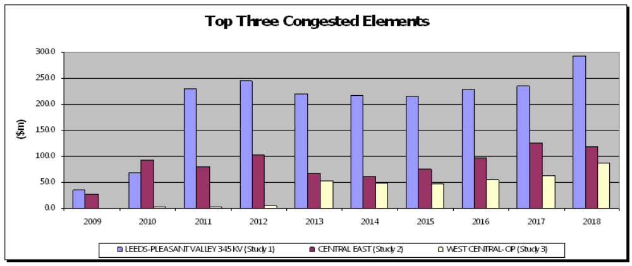
The top three sets of congested transmission system elements are shown geographically, along with their ten-year present value of congestion in Figure 1.

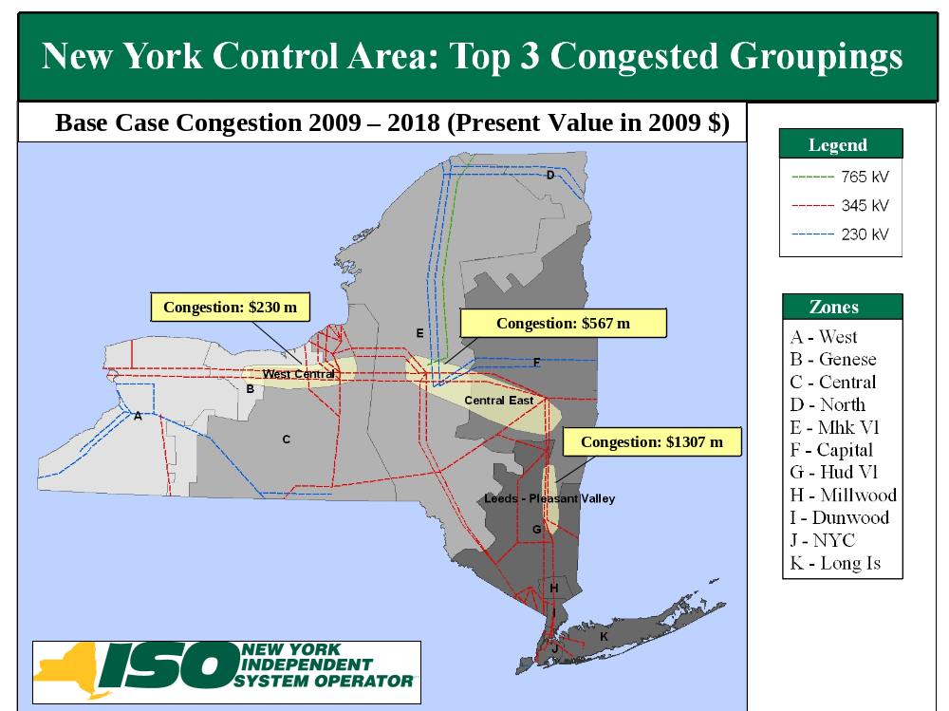
Figure 1: Projected Congestion on the Top Three CARIS Elements (present value in 2009 $ in Millions)

In each of the three studies, the NYISO calculated the present value of relieving congestion over ten years by applying generic transmission, generation and demand response (DR) resources. Costs for each type of generic solution were developed through the stakeholder process. Recognizing that the costs, points of interconnection, timing, and characteristics of actual projects may vary significantly, a range of costs was developed for each type of resource. The annual revenue requirements for each of the generic solutions were compared to the total production cost savings for a ten-year period, yielding a benefit-cost ratio for each generic solution. Figure 2 shows the production cost savings for each generic solution. For purposes of a relative order of magnitude comparison, nominal electric production costs in New York for the 10 year study period ranges between $4.1 billion and $7.5 billion annually.

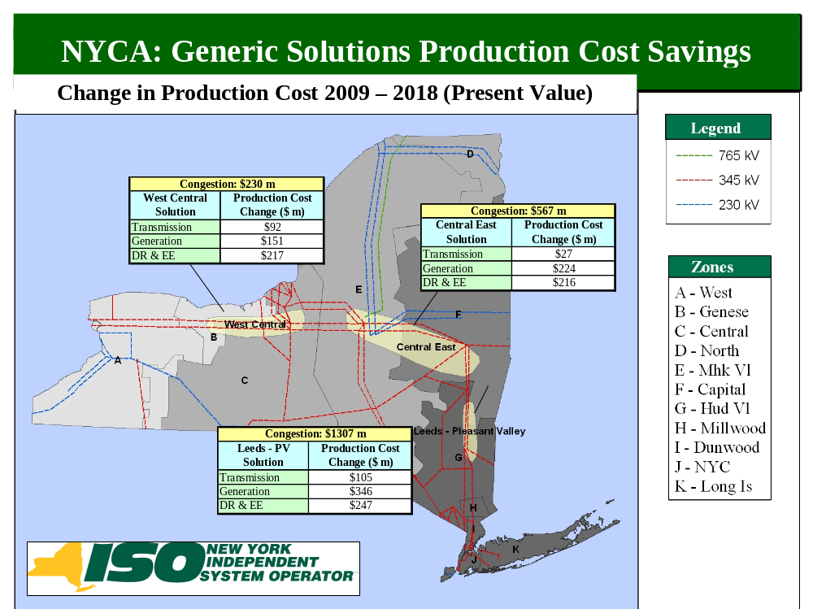
Figure 2: NYCA Generic Solutions Production Cost Savings

The primary metric used to conduct benefit/cost analysis is the change in NYCA-wide production costs. The Benefit-Cost ratios displayed in Figure 3 are based on the cumulative present value of the production cost benefits and an assumed 16% carrying charge rate applied to the project cost over a ten year period.
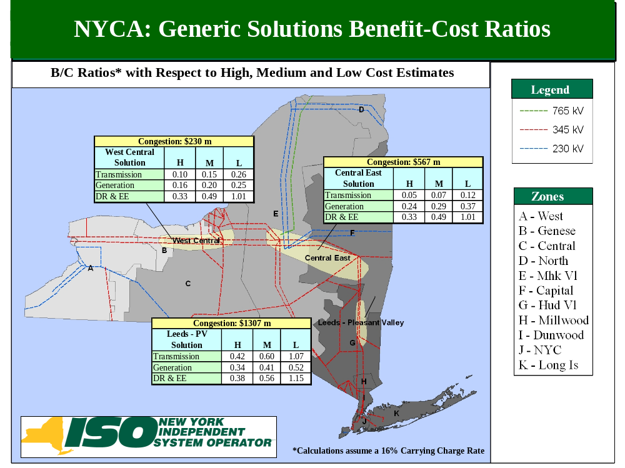
Figure 3: NYCA Generic Solutions Benefit/Cost Ratios

B. Additional Metrics

In addition to the statewide production cost savings for each generic solution, for informational purposes the NYISO has also provided an analysis of additional metrics for each case including changes in air emissions, payments to generators, payments by customers (loads), ICAP requirements, and losses on the bulk power transmission system. These additional metrics are summarized in Figures 4, 5, and 6. Note that relieving congestion may have additional, non-quantifiable impacts that are not reflected in this report.

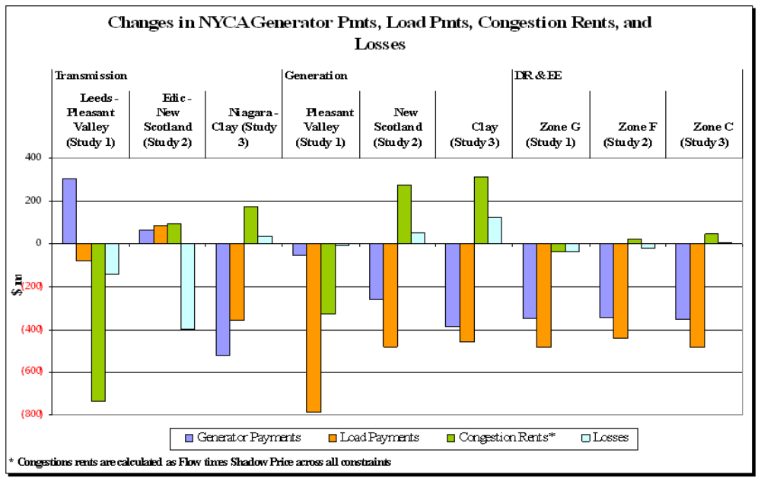
Figure 4: Change in Generator Payments, Load Payments, Congestion Rents, and Losses

 | ICAP Benefit MW
Study Area | Transmission Solution | Generation Solution | DR/EE Solution
Leeds-Pleasant Valley | 250 | 595 | 225
Central-East | 0 | 255 | 70
West Central | 0 | 220 | 70

Table 2: Reduction in ICAP Requirements

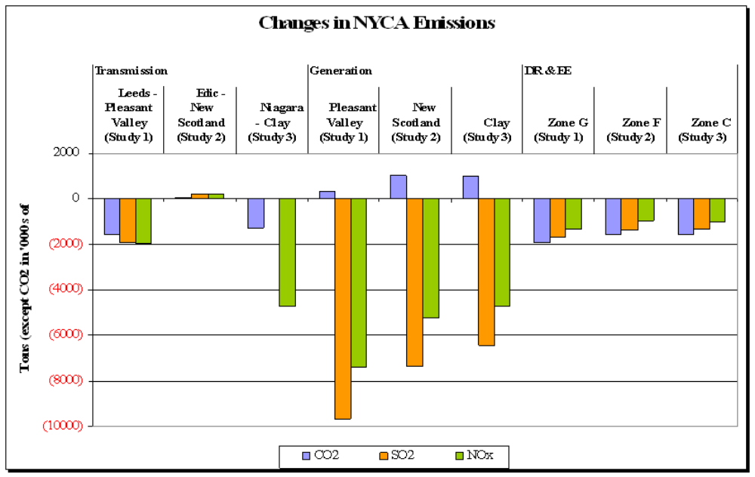
Figure 5: Change in CO₂, SO₂ and NO_{X} Emissions

Results from the generic solutions, Figure 4, show a range of impact on the additional metrics with those addressing the Leeds-Pleasant Valley study area (Study #1) the most favorable. Figure 5 shows the potential reduction in NYCA-wide ICAP requirements with the Leeds-Pleasant study area the greatest.

Emission results are generally reduced by the application of generic solutions. The Leeds- Pleasant Valley generic solutions most favorably impact emissions whereas the results in the Central East and West-Central study areas are mixed due to the diversity of fuels available in these zones. DR application results in emission reductions in all study areas. Generation solutions yield the greatest reductions in SO₂ and NO_{x} emission because of the very low emission rates required for new generators. New generation results in a slight increase in CO₂ emissions within New York, however, these emissions are offset by reductions in lower imports from PJM and Ontario where coal is on the margin. Emission changes resulting from the application of transmission solutions is location dependent.
.

C. Scenario Analysis

Other factors were also evaluated for their impact on congestion for each of the three sets of elements through a series of 10 scenarios selected for this study by the NYISO and its stakeholders. These scenarios evaluated potential changes in environmental emission requirements, the amount of resources added through the State Renewable Portfolio Standard, savings realized from the State Energy Efficiency Portfolio Standard, generation retirements and additions, and changes in forecasted energy consumption. To illustrate the impact of each of these external factors, the NYISO has reported the changes in forecasted congestion for each of the three groupings of system elements in the fifth (2013) and tenth (2018) years for each scenario respectively. The charts below for the three study areas show the impact of each scenario on congestion and report the change in congestion values between the scenario’s congestion values and the base case congestion values. For specific descriptions of each of the 10 scenario assumptions, refer to Section 5.6.2.

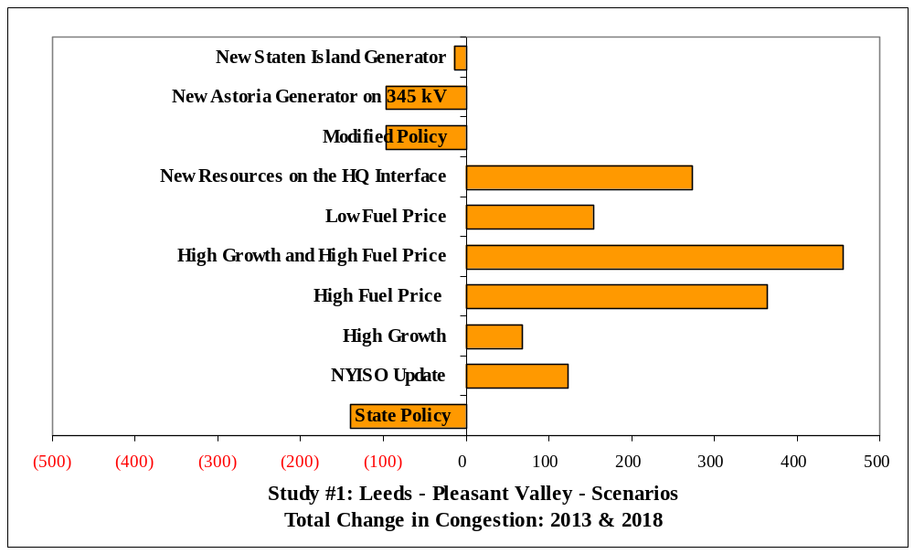
Figure 6: Scenarios Impact on Congestion in Leeds-Pleasant Valley Study
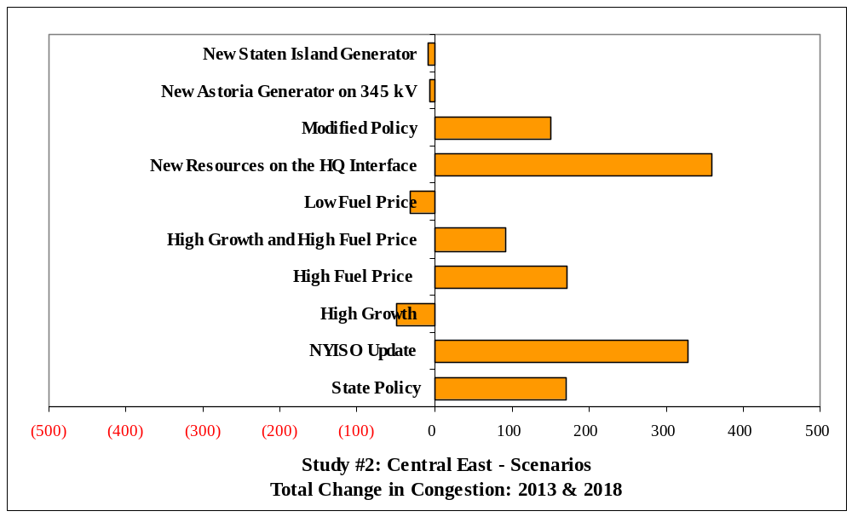
Figure 7: Scenarios Impact on Congestion in Central East Study

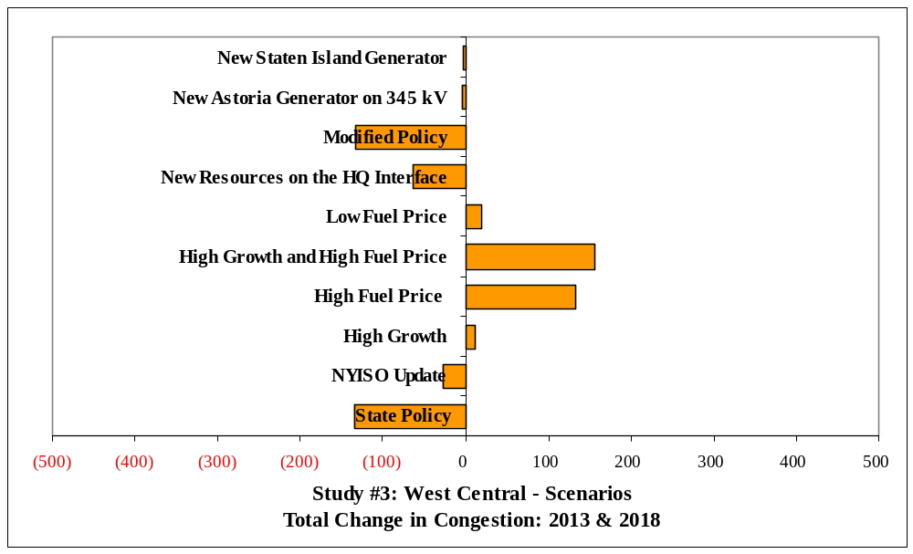
Figure 8: Scenarios Impact on Congestion in West Central Study

The scenario analysis provided useful insight on the sensitivity of projected congestion values to differing assumptions. Variations in some inputs provide results that are consistent across NYCA while other inputs yield results that are specific to each zone.

3. Key Findings and Observations

- Potential Benefits Exist. This report provides an economic analysis of congestion on the New York State bulk power transmission system and the potential costs and benefits of relieving that congestion, and serves as an invitation to interested parties to develop transmission, generation or demand response projects to relieve congestion and to propose transmission projects for economic evaluation and potential recovery of costs through the NYISO’s tariff. The results suggest that sufficient potential may exist to reduce congestion and obtain production cost savings in New York. In addition, there are other impact such as reduced load payments, increased generator payments, reduced losses, ICAP savings, and reduced emissions are also provided that may be of interest to parties in their investment decisions.
- Congestion Projection. The CARIS production cost model projects a range of annual total congestion values in New York from $130 million in 2009 to $593 million in 2018 for the system “as projected” in New York, with no generic solutions applied. Actual congestion realized in the future years will differ because actual system operating conditions, economic conditions, and market behavior will be different from what has been assumed in the study.

- Study Area Impacts. Among the three studies, the Leeds-Pleasant Valley study revealed that both the demand response and transmission projects had the highest benefit-cost ratios among the three generic solutions, with both slightly above 1.0 for the low cost estimates. Neither generation nor transmission generic solutions have shown break even benefit-cost ratios for the Central East or West Central studies, except for the demand response which is approximately 1.0 at the low cost estimate.

- No New Resources Added. This study is based upon existing NYCA resources. No resources were added beyond the 2009 CRP base case. Additional resources coupled with the solutions studied will produce benefits beyond those captured here.

- Specific Solutions Will Produce Different Results. Projects with different characteristics than the generic projects studied here could also relieve congestion, but were not analyzed in this study. The generic solutions are for informational purposes. Also, since the study only analyzes the congestion relief for each of the three groups individually, combining the solutions for more than one group may increase production cost savings.
- Regional Diversity of Benefits. This study reports the many benefits of relieving congestion both statewide and by zone across New York. All regions will not benefit equally.
- Benefit Lifespan. The useful life of actual projects will be several times longer than the 10 years that are studied in this report. Due to uncertainty associated with projecting congestion and project savings beyond ten years, those costs and benefits are not captured in this study.

- Broader Regional Markets. New York is not the only beneficiary of relieving congestion. Neighboring electric systems may also experience benefits from congestion relief as resources flow more freely across regional markets. Congestion relief is, therefore, an important aspect of broader regional market design.

- Congestion Pattern Changes. There have been changes in congestion patterns across the New York bulk transmission system over the past several years caused by several factors as discussed in the 2008 State of the Markets Report by Potomac Economics. For example, low natural gas prices adopted in the study tends to reduce energy prices southeast of the Leeds – Pleasant Valley and Central East transmission constraints that separate the lower cost upstate generation from the more expensive downstate generation resources and load centers. Also, system enhancements such as the Neptune HVDC line, the Linden VFT, the future Caithness and Empire generation, lower fuel prices, etc. will tend to reduce the forecasted congestion in New York City and increase forecasted congestion in upstate New York.

4. Next Steps

Additional Study Requests. Going forward, any interested party can at any time request an additional study of congestion and the effect of their demand response, generation or transmission project on the New York bulk power system, at their expense.

Specific Project Analysis. Phase 2 will begin upon approval of this Phase 1 report by the NYISO Board of Directors. In Phase 2, developers are encouraged to propose transmission projects to alleviate congestion. The NYISO will evaluate proposed specific economic transmission projects upon a developer’s request to determine the extent such projects alleviate congestion, and whether the economic benefits would make such project eligible for cost recovery under the NYISO’s Tariff. It is important to note that, while the eligibility metric is production cost savings, zonal LMP load savings (net of TCCs and bilaterals) is the metric used for the identification of and cost allocation to beneficiaries for transmission projects in Phase 2. If the project alleviates congestion, has a capital cost of at least $25 million, has benefits that outweigh costs over the first ten years of operation, and receives approval to proceed from 80 percent of identified beneficiaries, the developer will be able to obtain cost recovery of their transmission projects through the NYISO’s tariff subject to the developer’s filing with FERC for approval of the project’s costs.

.

Intentionally left blank

Introduction
The New York Independent System Operator (NYISO) is undertaking a new process pursuant to its Attachment Y of the OATT (Open Access Transmission Tariff, or the Tariff from hereon, to assess both historic and projected congestion on the New York bulk power system and to estimate the economic benefits of relieving that congestion by integrating potential projects comprising transmission, generation or demand resources. This new process is entitled the Congestion Assessment and Resource Integration Study (CARIS). CARIS builds on the NYISO’s existing reliability planning process previously known as the Comprehensive Reliability Planning Process (CRPP), and together with the Local Transmission Planning Process (LTPP), completes the NYISO’s new overall Comprehensive System Planning Process (CSPP). The LTPP was developed to be the first step in the CSPP. When the reliability planning process of the CSPP is completed and approved by the NYISO board, the CARIS begins, starting from a reliable system as described in the approved Comprehensive Reliability Plan (CRP).
CARIS consists of two phases: Phase 1, the Study Phase, and Phase 2, the Project Phase. In Phase 1, the NYISO, in collaboration with its stakeholders and other interested parties, develops a ten-year projection of congestion, identifies, ranks and groups the most congested elements on the New York bulk power system based on the historic and forecasted congestion, and develops the three CARIS studies. Each of the three studies includes: i) the development of generic solutions to mitigate the identified congestion; ii) a benefit/cost assessment of each solution based on NYCA wide production cost savings; iii) presentation of additional information on other related congestion metrics to all stakeholders; iv) and scenario analyses performed on the base case to assess the impact of potential factors to the congestion associated with the top three groupings. Phase 1 results are presented in a written report to the NYISO’s Electric System Planning Working Group (ESPWG) and the Transmission Planning Advisory Subcommittee (TPAS) for review. After that review, the draft report is presented to the NYISO’s Business Issues Committee (BIC) and the Management Committee (MC) for discussion and action within the NYISO’s Governance process before being submitted to the NYISO Board of Directors (NYISO Board) for approval.
This document is the NYISO’s first CARIS report. It presents the Phase 1 study results and serves the crucial function of providing objective information on the nature of congestion in the New York Control Area (NYCA) that developers can use to decide whether to proceed with transmission upgrades or other resource additions (generation or demand response). This report does not make any recommendations of any kind and does not favor any type of resource addition or other actions. This process was developed to augment the NYISO’s planning processes and to assist the market by providing information to potential developers to assist them in deciding to invest in their own, based on the economics of those projects in the NYISO’s markets. Developers may also propose economic transmission projects for cost recovery under the NYISO’s Tariff and proceed through Phase 2 of CARIS, the Project Phase, which will be conducted by NYISO staff in 2010. For these transmission projects, the NYISO will determine if they qualify as economic projects eligible for cost recovery, as defined by the Tariff. Eligible economic transmission projects that elect to pursue cost recovery under the NYISO’s CARIS tariff provisions must be approved by at least 80% of the weighted vote of New York’s Load Serving Entities (LSEs) that serve loads in those zones that the NYISO identifies as beneficiaries of transmission projects. The beneficiaries of the projects will be those load zones that experience net benefits measured over the first ten years from the proposed commercial operation for the project. Developers of economic generation or demand response projects may choose to pursue such projects on a merchant basis or to enter into contracts with LSEs or other parties. CARIS provides additional data and tools to assist in the development of policy and to provide information to potential developers in their investment decisions.
CARIS estimates of future congestion are forecasts and may be different than actual future congestion. To allow completion of the study, the inputs and assumptions that are used for the CARIS study must be frozen at the time the study was initiated. For this CARIS cycle, the CARIS studies are based upon the 2009 CRP base case which was developed in mid 2008 and includes assumptions about the NYCA system and load growth. As a result, the base case does not include recent developments such as the load forecast reductions caused by the current economic downturn. Further, CARIS simulations are based upon a limited set of long term assumptions about the utilization of grid resources throughout the ten-year planning horizon which are subject to change. The costs used for the benefit/cost ratios developed for generic projects are representative of the average cost for a broad range of projects representative of the generic solution type and are intended for illustrative purposes within the CARIS Phase 1 only.

Background

The Evolution of Planning Processes at the NYISO
Since its formation in 1999, the NYISO has carried out two primary functions: (1) the reliable operation of New York’s bulk power system and (2) the administration of New York’s competitive wholesale electricity markets. The restructuring of the New York electric industry from vertically-integrated transmission, generation and distribution companies operating under traditional cost of service regulation to wholesale markets was designed to incent private investment in generation, transmission and other resources to foster competition. Additionally, this restructuring provided for the shift of the risk associated with these investments away from ratepayers to investors operating in economically-efficient and transparent wholesale markets. System planning, therefore, was initially restricted to conducting analyses for entities requesting transmission service which would require transmission upgrades and/or additions under Section 19 and 32 of the NYISO’s Open Access Transmission Tariff (OATT). This system also allowed the New York Public Service Commission (NYSPSC) to request studies of transmission upgrades. In addition, NYISO had the responsibility for conducting analyses of any new generation or transmission facilities proposing to interconnect to the New York Bulk Power System to determine the necessary system upgrades for compliance with applicable reliability standards.
The NYISO, in collaboration with its stakeholders, developed a CRPP in 2003-2004 to identify the Reliability Needs of the bulk power system looking out ten years and seek market-based solutions to the identified Reliability Needs. In December 2004, the Federal Energy Regulatory Commission (FERC) approved the CRPP filing, including the addition of a new Attachment Y to the NYISO’s OATT, and the NYISO immediately began its implementation in early 2005. The CRPP is a long-range assessment of resource adequacy and transmission reliability over a ten-year planning horizon. It includes the development of a Reliability Needs Assessment (“RNA”), an evaluation of proposed solutions, and the development of the CRP to address the identified needs. For each Reliability Need identified in the RNA, the NYISO contemporaneously requests market-based solutions from the marketplace as well as regulated backstop solutions from the identified Responsible Transmission Owner(s). If no viable market-based solutions are developed in time to satisfy the Reliability Needs, the NYISO will initiate the second step of the solicitation process by requesting alternative regulated responses to Reliability Needs All types of solutions may include generation, transmission, or demand response resources. Once it receives the proposed market-based and regulated backstop solutions, the NYISO assesses these solutions and reports in the CRP whether the projects submitted will meet the identified Reliability Needs. If the NYISO deems a Responsible TO’s regulated backstop solution necessary to meet the Reliability Needs, then the costs incurred by the Responsible Transmission Owners in planning, developing, and implementing the regulated backstop solutions are recoverable under the NYISO Tariff. The principal objective of the CRPP is to maintain reliability by providing an opportunity for developers to invest in new, market-based projects before triggering a regulated backstop solution. To date, the NYISO has completed four annual cycles of the CRPP. Most recently, the NYISO staff, in collaboration with its stakeholders, developed the 2009 CRP which was approved by the NYISO Board in May, 2009. The Plan identified no Reliability Needs through 2018 — provided system conditions do not change — and evaluated the risks that could give rise to Reliability Needs before that time. The 2009 CRP forms the foundation for this first CARIS study.
In Order No. 890 (Order 890), the FERC expanded the planning responsibilities of the NYISO and the New York Transmission Owners (NYTOs) setting forth nine principles that all planning processes are required to meet. The NYISO and the NYTOs submitted a joint compliance filing in December 2007, which proposed tariff changes creating a three-stage CSPP which will span a two-year cycle. First, each NYTO conducts a LTPP for its respective transmission system and provide the input assumptions and results to interested parties through the NYISO stakeholder process for review and comment. Second, the LTPP provides input into the CRPP, which remains largely unchanged from the process first implemented in 2005. Third, the NYISO conducts the CARIS to a) identify the most constraining elements on the New York bulk power system and study the potential benefits and costs associated with relieving that identified congestion, and b) provide that information to stakeholders in order to facilitate the development of solutions to the identified congestion from private developers who, as an alternative to recovering transmission projects costs through contractual obligations/arrangements, can now be eligible for transmission project cost allocation and regulated cost recovery through the Tariff if such project is approved by a supermajority of voting beneficiaries. The NYISO CSPP is illustrated in Figure 2-1 below.
The joint NYISO/NYTO compliance filing was conditionally approved by the FERC on October 18, 2008. The NYISO and the NYTOs have made three subsequent compliance filings, and final approval of the CSPP remains pending at the FERC (Placeholder - FERC Order Carl). Based on the FERC’s conditional approval and the expectation that economic planning proceeds as filed with the FERC, the NYISO and the NYTOs commenced implementation of CARIS with its stakeholders using the 2009 CRP as the basis.
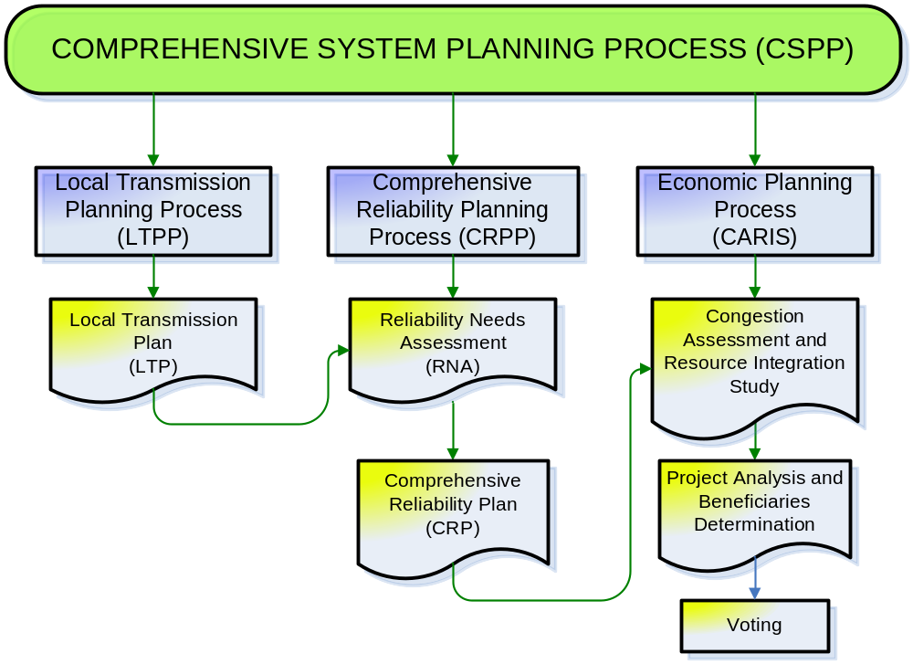
Figure 9: NYISO Comprehensive System Planning Process

CARIS Process
As directed by FERC Order 890, the NYISO collaborated with its stakeholders through multiple joint ESPWG and TPAS meetings, soliciting inputs and feedback, while developing CARIS procedures, study modeling and assumptions. Further, the procedures were reviewed with the BIC before implementing Phase 1 of CARIS.
The objectives of the CARIS economic planning process are to:
a. Provide estimates of future congestion on the New York State bulk power transmission facilities over the ten-year CSPP planning horizon;
b. Identify, through the development of appropriate scenarios, factors that might mitigate or increase congestion;
c. Provide information to market participants, stakeholders and other interested parties on generic solutions to reduce congestion;
d. Provide an opportunity for developers to propose solutions that may reduce the congestion; and
e. Provide a process for the evaluation and approval of regulated economic transmission projects for cost recovery under the NYISO Tariff.
The 2009 CARIS builds upon and aligns with the CRPP and assumes a baseline reliable system identified in the 2009 CRP for the ten-year study period from 2009 to 2018. Figure 2-2 below presents a graphical depiction of the CARIS process.

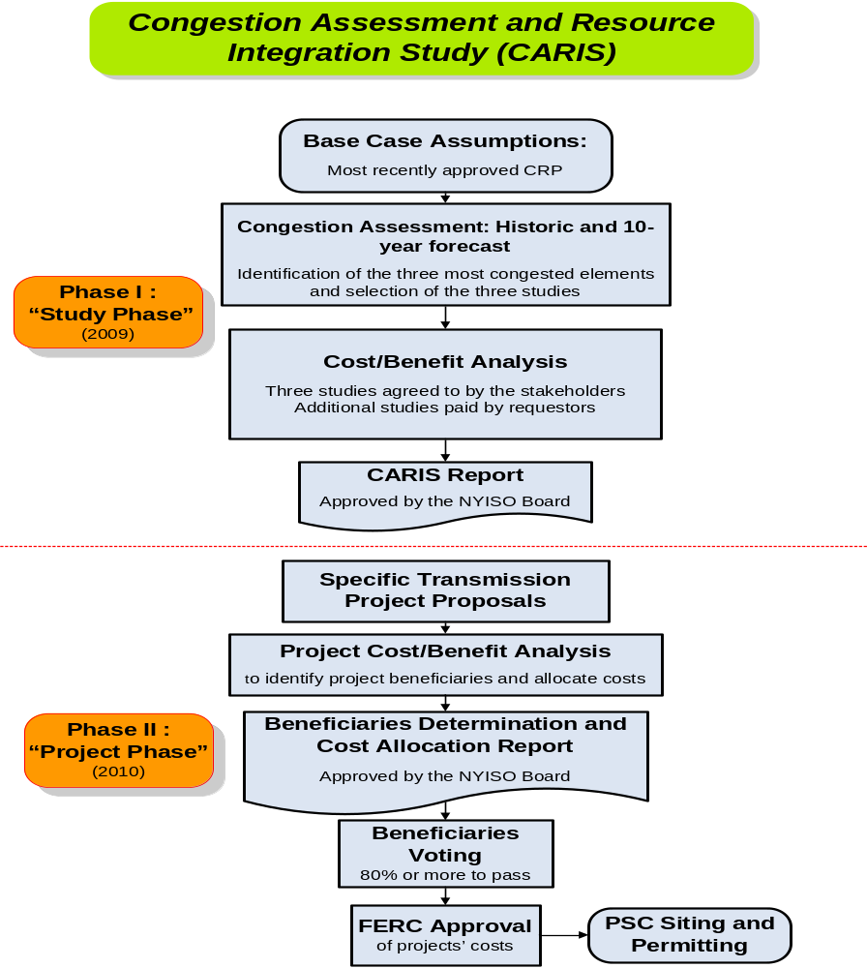
Figure 10: Overall CARIS Diagram

Phase 1 - Study Phase
In Phase 1 of the CARIS process, the NYISO, in collaboration with market participants, identifies the three most congested elements in the New York bulk power system, determines the three CARIS studies, applies the generic solutions to the congestion identified and conducts the benefit/cost analysis of the applied generic solutions. In addition, the NYISO also performs scenario analyses, with scenarios including but not limited to load forecast uncertainty, fuel forecast uncertainty, new resources, retirements, emissions changes, environmental proposals and energy efficiency programs.
In identifying the most congested elements, the NYISO performs both a five-year historic and a ten-year forward-looking congestion assessment to identify the five most congested elements, and through a relaxation process, develops potential groupings and ranks them based on the highest production cost savings resulting from the relaxation. The top three ranked groups become the subjects of the three CARIS studies. For each of these three studies the NYISO conducts a benefit/cost analysis of generic solutions. All resource types, generation, transmission and demand response, are considered on a comparable basis as generic solutions to congestion. The solutions analyzed are not specific projects, but rather represent generic transmission, demand response and/or generation resources placed in key locations on the system to measure their effects on relieving each of the three most congested elements. The principal metric for measuring proposed solution benefits for each generic solution is the change in NYCA wide production costs that would result from each generic solution, expressed as the present value over the ten-year planning horizon. The NYISO also reports data on additional metrics, including estimates of reductions in losses, changes in Locational Based Marginal Prices (LBMP) load payments, changes in installed capacity costs, changes in emissions costs and changes in payments for Transmission Congestion Contracts (TCCs). The TCC payment metric in Phase 1 has been simplified to include congestion rent calculations only and is different from the TCC revenue metric contained in Phase 2. CARIS metrics are described in more detail in Section 3.
Upon completion of the Phase 1 analysis, the results of the analysis are presented to stakeholders in this written report. The report provides interested parties with a wide range of information, including a discussion of its assumptions, inputs, and methodology to assist them in identifying and developing actual solutions to transmission congestion. A draft CARIS report is first submitted to the ESPWG and the TPAS for review and comment. Following completion of that review, the draft CARIS report is sent to the BIC and the MC for discussion and action. Thereafter, the draft CARIS, with BIC and MC input, is forwarded to the NYISO Board for review and action. The draft CARIS is also provided to the Independent Market Advisor for review and consideration. The Board may approve the CARIS report as submitted or propose modifications on its own motion for further consideration. Upon approval by the Board, the NYISO issues the CARIS report and posts it on its website.
In addition to the three CARIS studies, stakeholders may also request additional studies of system congestion at their own expense. Requests may be made at any time, and studies will be conducted to the extent NYISO’s resources allow. The NYISO posts all requests for studies on its website. The specific process for requesting, conducting and paying for additional studies is set forth in Section 1.1.2 of the Initial CARIS Manual. Other information on additional studies, including the form to request additional studies, is posted on the NYISO website. No results of any additional studies are included in this report.

Phase 2 – Project Phase
Phase 2 of the CARIS is conducted after the approval of the Phase 1 report by the NYISO Board. In Phase 2 the developers of potential transmission projects that have an estimated capital cost in excess of $25 million to alleviate congestion may seek regulated cost recovery through the NYISO Tariff. Such developers must submit their projects to the NYISO for analysis of benefits and costs (project’s benefit/cost analysis) at any time prior to the input phase (Phase 1) of the next CARIS cycle, in accordance with the cost allocation principles and methodologies contained in Tariff. Projects are eligible for cost recovery if they would produce net savings based upon a comparison of the NYCA-wide production cost savings with the annual total revenue requirements for the project; both computed over the first ten years following the projected in-service date of the facility. The costs for the benefit/cost analysis will be supplied by the developer of the project using a reasonable amortization period. Specific project cost for the benefit cost analysis will then be expressed as the net present value of the first ten years of the annual total revenue requirement for the project, starting from the proposed commercial operation date of the project.
Beneficiaries determined by the NYISO will be LSEs in load zones that economically benefit from the project, and cost allocation among them will be based upon their relative economic benefit. The beneficiary determination for cost allocation purposes will be based upon LSEs’ relative net LBMP load savings. The net LBMP load savings are determined by adjusting the LBMP load savings to account for TCC and bilateral contract payments; all entities in the zones with positive LBMP load savings are considered to be beneficiaries. The LBMP load savings are measured and compared on a net present value basis with the project’s revenue requirements over the first ten years of a project’s life measured from its expected in-service date. LBMP load savings are calculated first on a zonal basis and are then allocated to each LSE in a zone according to the ratio of its load to all load in the zone - both expressed in MWh.
In addition to the NYCA-wide production cost savings metric, the NYISO will also provide additional metrics, for information purposes only, to estimate the potential benefits of the proposed project and to allow LSEs to consider other metrics when evaluating or comparing potential projects. These additional metrics will include estimates of reductions in losses, changes in LBMP load payments, changes in generator payments, changes in Installed Capacity (ICAP) costs, changes in emissions costs, and changes in TCC revenues. The TCC revenue metric that will be used in Phase 2 of the CARIS process is different from the TCC payment metric used in Phase 1. In Phase 2, the TCC revenue metric will measure reductions in estimated TCC revenues and allocation of congestion rents to the TOs ( for more detail on this metric see Section 3.3.2 of this report and the Initial CARIS Manual, Section 15.4b).
The NYISO will also analyze and present additional information by conducting scenario analyses, where appropriate, regarding future uncertainties, such as possible changes in load forecasts, fuel prices and environmental regulations, as well as other qualitative impacts, such as improved system operations, other environmental impacts, and integration of renewable resources. Although this data may assist and influence how a benefiting LSE votes on a project, they will not be used for purposes of cost allocation.
The NYISO will provide its benefit/cost analysis and beneficiary determination for particular projects to the ESPWG for comment. Following that review, the NYISO benefit/cost analysis and beneficiary determination will be forwarded to the BIC and MC. After the MC vote, the benefit/cost analysis and beneficiary determination will be forwarded to the NYISO Board of Directors for review and approval.
After the project benefit/cost and beneficiary determinations are approved by the NYISO Board and posted on the NYISO’s website, the project will be brought to a special BIC meeting for a vote by the identified LSEs, utilizing the economic planning process voting procedure (see the Initial CARIS Manual, Appendix F), on whether the project is approved for cost allocation. The specific provisions for cost allocation are set forth in the Tariff which also calls for the NYISO to establish procedures to determine the specific list of voting entities for each proposed project. That procedure and procedures for conducting a vote for projects in Phase 2 of CARIS are under development at the ESPWG and are not the subject of this report. In order for a project to be approved for cost recovery, the Tariff states that “eighty (80) percent or more of the actual votes cast on a weighted basis must be cast in favor of implementing the project.” If the project meets the required vote in favor of implementing the project, and the project is implemented, all beneficiaries, including those voting “no,” will pay their proportional share of the cost of the project through the NYISO Tariff. This process does not relieve the developer of the responsibility to file with FERC for approval of the project costs and with the appropriate state authorities to obtain siting approval for the project.

ft

Relationship of CARIS to other Planning Processes
Numerous electric system planning processes have taken root at the national, state, and local level simultaneous to the expansion of the NYISO’s electric system planning functions. In the American Reinvestment and Recovery Act, Congress encouraged broader transmission system planning to upgrade aging facilities and expand transmission capability to move power between regions in the United States and Canada, such as for delivering renewable energy resources from resource rich areas to urban load centers. To implement this initiative, the US Department of Energy (DOE) has made funding available for interconnection-wide planning under a Funding Opportunity Announcement (FOA) issued on June 15, 2009. The NYISO is participating in the formation of the Eastern Interconnection Planning Collaborative (EIPC) to conduct transmission planning studies for the Eastern United States and Canada. On September 14, 2009, the EIPC applied to the DOE for a grant to fund this endeavor. (Placeholder for what will happen before we post the final report
Regionally, the NYISO continues to participate in the Northeast Coordinated System Planning Protocol (NCSPP). The NYISO, ISO New England (ISO-NE), Independent Electricity System Operator of Ontario (IESO), and PJM Interconnection LLC (PJM) executed the regional planning protocol in December 2004 to provide a vehicle to enhance coordination of planning in the northeastern United States, with the participation of Canadian planning authorities. The collaborative released a Northeast Coordinated System Plan (NCSP) in 2006 and in 2009 to address Reliability Needs among regions and seams issues among ISO and Regional Transmission Organization (RTO) markets. The 2009 NCSP is posted on the NYISO’s website at http://www.nyiso.com/public/webdocs/services/planning/ipsac/NCSP03-27-09.pdf.
At the state level, the Governor of New York re-established a State Energy Planning Board (SEPB) by Executive Order in April 2008. The NYISO has actively participated in the SEPB working group, filing comments, submitting white papers on timely topics, and conducting reliability modeling for a bulk power system assessment. The SEPB released a draft State Energy Plan (SEP) in August 2009, and the NYISO will submit further input during the 60-day public comment period. Pending the completion of the SEP in the fall of 2009, the NYSPSC has held Phase 3 of its Electric Resource Planning (ERP) proceeding in abeyance. The ERP proceeding will expand upon and implement SEPB policy initiatives, such as state support for renewable resources, demand response and energy efficiency.
With input from the NYISO, the NYTOs are conducting the New York State Transmission Assessment and Reliability Study (STARS). STARS is a joint study of the state's bulk power system over a 20-year planning horizon to help meet future electric needs, support the growth of renewable energy sources, and ensure the reliability of the power system. Its aim is to develop a thorough assessment of the transmission system and suggest long-range plans for coordinated infrastructure investment in the state’s power system. Because the bulk power system is owned by separate entities, yet interconnected, the STARS will examine the types of investments, including smart grid applications, needed to meet the long-term needs of the entire control area to complement studies currently being performed by the New York Independent System Operator (NYISO).
Finally, at the municipal level, the City of New York created a City Energy Planning Board (CEPB) as part of Plan NYC. The CEPB is designed to provide a coordinated vision in providing for the future energy needs of New York City considering supply and demand while addressing cost, reliability and environmental impacts. The City has retained CRA International to conduct a Master Electrical Transmission Plan for the City, a long-term study of the City’s energy needs and policy initiatives that will affect NYISO’s planning processes. The New York City Economic Development Corporation released the results of this analysis in June 2009.
It is anticipated that specific projects which may result from any of the above initiatives will be analyzed under the NYISO’s interconnection and planning processes, including CARIS, if funding under the NYISO Tariff is requested for an economic transmission project.

CARIS Methodology and Metrics

CARIS Methodology
For the purposes of conducting the ten-year forward looking CARIS analysis, the NYISO, in conjunction with ESPWG, developed a production costing model database. The details and assumptions in developing this database were discussed at various ESPWG meetings and are summarized in Appendix C. The database was used in two production cost simulation software tools: ABB’s GridView and GE’s Market Analysis and Portfolio Simulation (MAPS), which are widely accepted in the industry. For benchmarking purposes, both tools are being utilized, and appear to give comparable results. Independent of this report, the NYISO will issue a separate report to stakeholders detailing the benchmarking of the GridView and MAPS tools and comparing the respective results to make a recommendation on tools to be used in future CARIS cycles. For the purposes of this report, only Grid View results are presented. Moving forward, the NYISO will maintain the common database for both tools.
For historic congestion analysis, the Portfolio Ownership and Bid Evaluation (PROBE) production cost simulation tool, developed by PowerGEM LCC, has been used in the last six years to perform the NYISO historic congestion analysis. PROBE utilizes the actual NYISO Day-Ahead Market (DAM) data to emulate the actual SCUC operation. Unlike the GridView and MAPS simulation, PROBE simulates virtual bidding and transmission outages, and calculates production costs based on generation mitigated bids. While those additional attributes are important in capturing the real congestion values for the past events, it is nearly impossible to model them with certainty in projecting future transmission congestion. Therefore, it has been decided that these attributes are not accounted for in the ten-year forward looking CARIS analysis. For more detail on each simulation tool see Appendix D. For illustrative purposes, a comparison between simulated and actual congestion for first Quarter 2009 is provided in Appendix D.
The methodology for conducting the CARIS was vetted with ESPWG and incorporated in the Initial CARIS Manual.

CARIS Metrics
One of the key metrics in the CARIS analysis is termed Demand Dollar congestion (expressed with variable name Demand$ congestion in PROBE). Demand$ congestion for a constraint is the amount of congestion paid by load (without TCC hedges and bilaterals) throughout NYCA that is a result of that constraint. The Demand$ congestion values are calculated by multiplying zonal load with a transmission constraint’s shadow price with the zone’s shift factor (SF) on that constraint. This definition is consistent with the definition that has been used for the reporting of historic congestion for the past six years. Demand$ is used to identify significant transmission constraints which serve as candidates for evaluating generic solutions; it does not equate to payments by load.
In conducting Phase 1 of the CARIS process, the NYISO performed an assessment of historic and projected future congestion, identified the top three congested elements, and conducted benefit/cost analysis of each type of generic solution — transmission, generation and demand response/energy efficiency — to the identified congestion. The CARIS analysis reports various metrics that were developed with NYISO stakeholders at the ESPWG to measure the cost impacts of congestion and the benefits of its mitigation. The principal benefit metric for CARIS analysis is NYCA-wide production cost reduction that would result from each of nine generic solutions. Additional benefit metrics were analyzed as well and the results are presented in this report for information purposes only. All benefit metrics were determined by measuring the difference between the forecasted CARIS base case system value and a forecasted system value when each generic solution was added. The discount rate used for the present value analysis was the current weighted average cost of capital for the NYTOs.

Principal Benefit Metric
The principal benefit metric for the CARIS analysis is the present value of the NYCA-wide production cost reduction that would result from implementation of nine generic congestion mitigation solutions.

Additional Benefit Metrics
The additional benefits, which are provided for information purposes only, include estimates of reduction in losses, LBMP load costs, generator payments, ICAP costs, Ancillary Services costs, emission costs, and TCC payments. All the quantities, except ICAP, will be the result of the forward looking production cost simulation for the ten-year planning period. The NYISO, in collaboration with the ESPWG, determined the methodology and models needed to develop and implement these additional metrics requirements, which are described below and detailed in the Initial CARIS Manual. An example illustrating the relationship among some of these metrics is provided in Appendix E.
Reduction in Losses – This metric calculates the change in marginal losses payments. Losses payments are based upon the loss component of the zonal LBMP load payments.
LBMP Load Costs – This metric measures the change in total load payments and unhedged load payments. Total load payments include the LBMP payments (energy, congestion and losses) paid by electricity demand (forecasted load, exports, and wheeling). Exports will be consistent with the input assumptions for each neighboring control area. Unhedged load payments represent total load payments minus the TCC payments.
Generator Payments – This metric measures the change in generation payments and includes the LBMP payments (energy, congestion, losses), and ancillary services payments made to electricity suppliers. Ancillary Services costs include payments for regulation services and operating reserves, including 10 minutes synchronous, 10 minutes non-synchronous and 30 minutes non-synchronous. Generator payments are calculated as the sum of the LBMP payments and ancillary services payments to generators and imports. Imports will be consistent with the input assumptions for each neighboring control area.
ICAP Costs – The measurement of this metric is highly dependent on the rules and procedures guiding the calculation of the installed reserve margin (IRM) and locational capacity requirement (LCR), both for the next capability period and future capability periods. Therefore, for the first CARIS cycle only, the NYISO will use the MW impact methodology. For more detail on this metric see the Initial CARIS Manual.
Emission Costs – This metric measures the change in the total cost of emission allowances for CO₂, NO_{X}, and SO₂, emissions on a zonal basis. Total emission costs are a component of the production cost curve. Emission costs are the product of forecasted total emissions and forecasted allowance prices.
TCC Payments – The TCC payment metric is calculated differently for Phase 1 and for Phase 2 of the CARIS process:

- For Phase 1, the TCC payment metric measures the change in total congestion rents collected in the day-ahead market. Congestion rents are calculated as the product of the Congestion Component of the Day-Ahead LBMP in each Load Zone or Proxy Generator Bus and the withdrawals scheduled in each hour at that Load Zone or Proxy Generator Bus, minus the product of the Congestion Component of the Day-Ahead LBMP at each Generator Bus or Proxy Generator Bus and the injections scheduled in each hour at that Generator bus or Proxy Generator Bus, summed over all locations and hours.
- For Phase 2, the TCC payment metric referred to as TCC Revenues is used for the regulated economic transmission project cost allocation under Section 15.4 of the Tariff. The TCC revenue metric will measure net reductions in TCC Revenues and will reflect the forecasted impact of the project on TCC auction revenues and day-ahead residual congestion rents allocated to load in each zone, excluding the congestion rents that accrue to any incremental TCCs that may be made feasible as a result of this project. This impact will include forecasts of: 1) the total impact of that project on the Transmission Service Charge offset applicable to loads in each zone (which may vary for loads in a given zone that are in different Transmission Districts); 2) the total impact of that project on the NYPA Transmission Adjustment Charge offset applicable to loads in that zone; and 3) the total impact of that project on payments made to LSEs serving load in that zone that hold Grandfathered Rights or Grandfathered TCCs, to the extent that these have not been taken into account in the calculation of item 1 above. Calculations of net reductions in TCC revenues are detailed in the Initial CARIS Manual.

Baseline System Assumptions and Methodology
The implementation of the CARIS process requires the gathering, assembling, and coordination of a significant amount of data, in addition to that already developed for the reliability planning processes. In accordance with the Tariff, the starting point in conducting CARIS analysis is the NYISO’s most currently approved CRP. The 2009 CARIS analysis begins with the base case input assumptions provided in the 2009 CRP and aligns with the 10-year reliability planning horizon for the 2009 CRP.

Major System Assumptions
It is important to note that there are no substantive changes in base case input assumptions from the 2009 CRP except for those prescribed in section 1.1.3 of the Initial CARIS Manual. This step resulted in no change in the system model from the 2009 CRP. Appendix C includes a detailed description of the assumptions utilized in the CARIS analysis developed in collaboration with stakeholders. The key assumptions are presented below:
- Power flow models - CARIS uses the same power flow base cases utilized in the 2009 CRP.
- Load and capacity forecast was taken from the 2009 RNA/CRP. It represents the 2008 Gold Book econometric forecast adjusted for approximately 30% of the entire Energy Efficiency Portfolio Standard (EEPS) goals. The 2009 load forecast impacted by the recession was not used in the load model.
- Transmission and constraint model utilizes a bulk power system representation comprising the entire Eastern Interconnection, including the United States and Canadian Provinces east of the Rocky Mountains, excluding Texas. The model uses the 2009 RNA/CRP transfer limits and system upgrades/additions. External transactions between NYCA and its neighboring control areas are modeled as the interchange flow between the load (export) and generator (import) proxy busses. Transmission outages were not modeled. Refer to Appendix D for details.
- Production cost model utilizes the most economic security constrained dispatch of generation resources to serve the load subject to the constraints given in the model. To develop the production cost curves, unit heat rates, fuel forecasts and emission costs forecast were developed from multiple data sets including public domain information, proprietary forecasts and confidential market information. The CO2 emission cost forecast does not include Federal CO2 policy. The model includes the planned maintenance generation outages that have been lengthened to reflect the expected duration of forced outages. Bilateral transactions are not simulated in the CARIS model since the terms of bilateral transactions are confidential information, and therefore can not be accurately simulated. For the purposes of the CARIS analysis, the energy associated with bilateral transactions is simulated to occur in the DAM and the fuel requirements to support those transactions is priced according to the monthly fuel forecast.

Notwithstanding the other major inputs listed in other sections that can have significant impact on the congestion projection, are the known events that have impacts on the simulation outcome, as summarized in Table 4-1.
Table 3: Timeline of Major Events
2009 | 2010 | 2011 | 2012 | 2013 | 2014 | 2015 | 2016 | 2017 | 2018
Power Flow #1 | Power Flow #2 | Power Flow #3 | Power Flow #4 | Power Flow #5 | Power Flow #5 | Power Flow #5 | Power Flow #5 | Power Flow #5 | Power Flow #6
Caithness Installed |  | M29 Cable Installed |  | Susquehanna-Roseland Line Installed |  |  |  |  | Manhattan Tap Installed
 | Empire Generator Installed | Athens SPS Removed |  | New England East West Solutions (NEEWS) | Estimate Load and resource balances in neighboring areas | Estimate Load and resource balances in neighboring areas | Estimate Load and resource balances in neighboring areas | Estimate Load and resource balances in neighboring areas | Estimate Load and resource balances in neighboring areas
 | Linden VFT Installed |  |  | West Central Interface Decreased from 1770 MW to 1425 MW
 | Poletti Retired
 | Increased Fuel Price

Note: The CARIS base case assumes that the Athens SPS will no longer be in service starting in January, 2011. This is consistent with the current agreement in place between the involved parties.

Load and Capacity Forecast
The load and capacity forecast used in the CARIS baseline system, provided in Table 4-2, was taken directly from the 2009 RNA/CRP. There were no changes made to the load forecast or the resource mix in the CARIS as compared to the 2009 CRP.
As reported in the CRP, the 2008 Gold Book forecasts for peak load and energy demand were modified to account for the impacts of programs such as the Energy Efficiency Portfolio Standard (EEPS) and Special Case Resources (SCRs) to reflect achievement of approximately 30% of the entire EEPS goal and increased SCR levels experienced in the market.
Table 4: RNA Study Case Load and Resource Table with Updated TO Plans
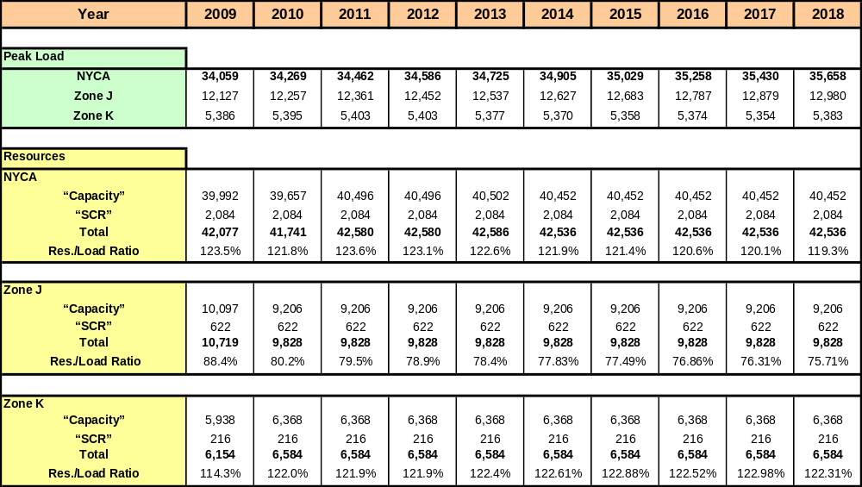

Transmission Model
The CARIS production cost analysis utilizes a bulk power system representation comprising the entire Eastern Interconnection, which is defined roughly as the bulk electric network in the United States and Canadian Provinces East of the Rocky Mountains, excluding WECC and Texas. Figure 4-1 below illustrates the electric grid represented in the CARIS model comprising the Eastern Interconnection regions and Balancing Authorities. The CARIS model includes a full active representation for the NYCA, ISO-NE, IESO, and PJM (PJM Classic, Allegheny Power System (APS), American Electric Power System (AEP), Commonwealth Edison Company (CE), Duquesne Light Company (DLCO), Dayton Power and Light (DAY) and Virginia Power (VP)) for both the network model and the a production cost model. A proxy bus is used to model Hydro Quebec (HQ) to NYISO and ISO-NE. Transmission- only models are represented for Michigan Electric Coordinated Systems (MECS), First Energy Corporation (FE), Southwest Power Pool (SPP), MAR, Northern Indiana Public Service Company (NIPS), Ohio Valley Electric Corporation ( OVEC), Tennessee Valley Authority (TVA), Florida Reliability Coordinating Council (FRCC), SERC Reliability Corporation (SERC), and equivalences for the Electric Reliability Council of Texas (ERCOT), and the WECC. For purposes of the CARIS report, the model is discussed in two parts: the NYCA system representation and the system representations for the external control areas.
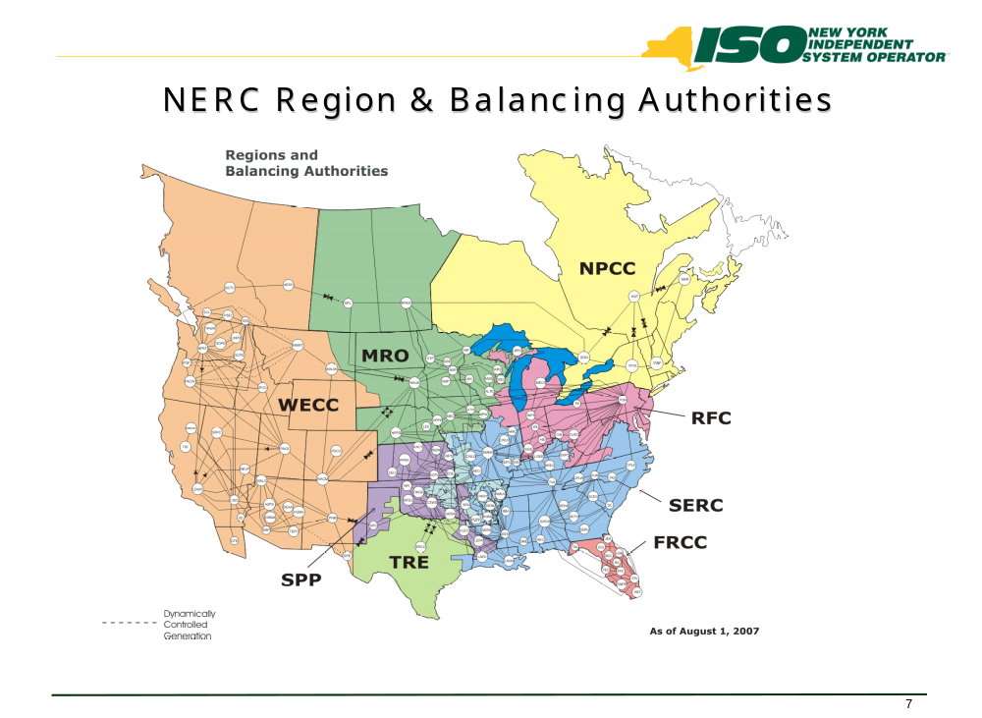
Figure 11: All Areas Modeled in CARIS (Excluding WECC & TRE)

New York Control Area Transfer Limits
In the resource adequacy analysis for the 2009 RNA, interface transfer limits were assumed to be constant from the end of the first five years throughout the second five-year period. The assumed interface transfer limits were confirmed during the CRP evaluation of the baseline system. For the resource adequacy analysis of the RNA/CRP, emergency criteria transfer limits are employed in the GE-MARS software model, while the transfer limits for the CARIS study are based upon normal criteria transfer limits. For voltage and stability based limits, the normal and emergency limits are assumed to be the same. The normal voltage transfer limits for critical NYCA transmission interfaces in the CARIS were taken from the RNA and the CRP with some exceptions as indicated in Table 4-3 below.
Table 5: - Transmission System Normal Voltage Transfer Limits for
Key Interfaces (in MW)
Interface | 2009 CARIS Study
Interface | 2009 | 2010 | 2011 | 2012 | 2013
WEST CENTRAL-Open | 1770 | 1770 | 1770 | 1770 | 1425
CENTRAL EAST | 2600 | 2600 | 2600 | 2600 | 2600
CONED – LILCO | 2166 | 2166 | 2166 | 2166 | 2166
UPNY-ConEd | 5000 | 5000 | 5000 | 5000 | 5000
Dunwoodie (I) to NYCity (J) | 4000 | 4075 | 4400 | 4400 | 4400
Dunwoodie (I) to Long Island (J) | 1217 | 1265 | 1265 | 1265 | 1265
Spr/Dunwoodie South | 5315 | 5290 | 5365 | 5365 | 5365
Note: Central East and UPNY-ConEd were modeled differently than the RNA/CRP values
Normal thermal interface transfer limits for the CARIS study are not directly utilized from the thermal transfer analysis performed using the Power Technologies Inc. Power System Simulator for Engineering (PSS/E) Managing and Utilizing System Transmission (MUST) software application which uses the transmission planning set of design criteria contingencies. Instead, CARIS uses the most limiting monitored line and contingency sets which MUST identified as the most limiting constraint to the NYCA cross-state transmission interfaces to determine thermal transfer limits as the load and generation is varied throughout the annual simulations. The resulting monitored lines and contingency sets used in the CARIS do not include lines which have less than a five 5 percent impact on the NYCA cross-state transmission interfaces, or the lines that only impact local 115-138 kV transmission or sub-transmission constraints.

Fuel Forecasts

CARIS Base Annual Forecast
The starting point for preparing the fuel price forecasts for CARIS is the US Energy Information Administration’s (EIA) current national long-term forecast of delivered fuel-prices that is released each spring as part of the Annual Energy Outlook (AEO).
The figures in this forecast are in real dollars (i.e., indexed relative to a base year). Forecasted time-series of the GDP deflator published by EIA, as part of the AEO, is used to inflate the real values to nominal values.

New York Fuel Forecast
In developing the New York’s fuel forecast, adjustments were made to the EIA’s fuel forecast to reflect bases for fuel prices in New York. A key source of data for estimating the relative differences or ‘basis’ for fuel prices in New York are the Monthly Utility and non-Utility Fuel Receipts and Fuel Quality Data reports based on information collected through Form EIA-423 (2000-2007) and EIA-923 (2008 onwards). The base annual forecast series are then subjected to an adjustment to reflect the New York ‘basis’ relative to the national prices as follows:
Natural Gas (Figures 4-2 and 4-3):
A historical analysis of EIA’s national AEO forecasts of delivered fuel-prices suggests that they are around 5% higher than Henry Hub prices. Any basis for New York, then, is assessed against 105% of Henry Hub price forecasts. The natural gas price for zones I through K is the Transco Zone 6 (NY) and the proxy for the remainder of NYISO zones is the Tetco-M3 trading price. Analysis of historical prices reveals that, relative to 105% of Henry Hub prices, on average, the basis for Transco Zone 6 (NY) is around 13% and for Tetco-M3 it is 5.5%. (The 7.5 percentage-point differential is consistent with the sum of historical difference between the two prices and the applicable taxes in the New York City area.)
Fuel Oils (Figures 4-2 and 4-3):
Based on reports drawn from EIA-423 for the years 2002-2007, prices of both distillate and residual oils are about 15% cheaper in New York as compared to the US average price. Since the overwhelming bulk of oil-based generation is situated in Zones J and K, the basis for the Downstate zones is -15%. To allow for additional transportation charges, the basis for the Upstate zones is -10%.
Coal (Figures 4-2 and 4-3):
The data for Bituminous Coal in EIA-423 was used to calculate a common basis for all NYISO zones. Prices in New York are, on average, 15% higher than in the United States as a whole.
Uranium (Figures 4-2 and 4-3):
It is assumed that the same fuel price applies to all nuclear generators in the United States.

Seasonality and Volatility
All average monthly fuel prices, with the exception of uranium, display somewhat predictable patterns of fluctuations over a given 12-month period. In order to capture such seasonality, NYISO estimated seasonal-factors using standard statistical methods. The multiplicative factors were applied to the annual forecasts to yield forecasts of average monthly prices.
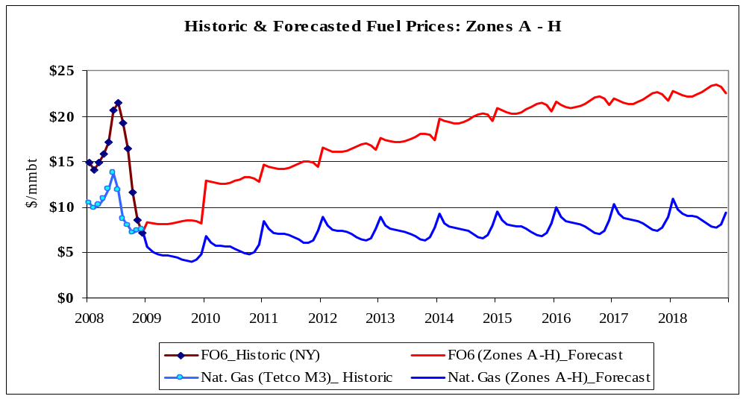
Figure 12: Historic and forecasted fuel prices for Zones A-H (nominal $)

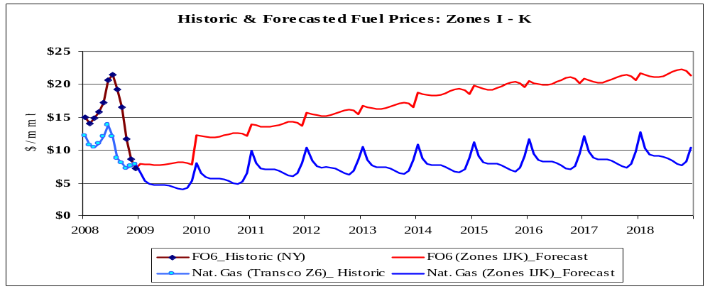
Figure 13: Historic and forecasted fuel prices for Zones I-K (nominal $)
The seasonalized time-series represents the forecasted trend of average monthly prices (i.e., a trend). However, in order to facilitate simulation studies to explore scenarios with higher/lower prices, the NYISO developed volatility-factors to capture typical intra-month variability of prices. These factors were the typical monthly standard deviation of daily prices, based on historical data. For natural gas and fuel oils, this monthly volatility factor equals the average standard deviation of daily prices. In the case of coal, only monthly average prices are available; therefore, the corresponding factor is the standard deviation of average monthly prices. This approximation is reasonable because coal prices exhibit relatively muted volatility, as compared to natural gas, and fuel oils.

External Areas Fuel Forecast
The fuel forecasts for the three external areas, ISO-NE, PJM, and IESO, were also developed. The starting point was the base-line annual forecasts of each fuel for New York. The annual averages and the seasonal factors for each external control area were estimated as follows: For ISO-NE and PJM, information obtained from EIA Form 423 (EIA-423) was used to calculate the basis relative to figures for New York, and for IESO the basis was based on data from a recent publication.
Tables 4-5, 4-6, 4-7 and 4-8 below outline the assumptions that went into the fuel-price forecasts for each external control area.

Table 6: ISO-New England Assumptions
 | Annual Average | Monthly Factor
Natural Gas | Same as the price for Zones I – K | Same as the factor for Zones I – K
FO2 | 120% of the price for New York | Same as the factor for New York
FO6 | 115% of the price for New York | Same as the factor for New York
Coal | 125% of the price for New York | Same as the factor for New York

Table 7: PJM-East Assumptions
 | Annual Average | Monthly Factor
Natural Gas | Same as the price for Zones A – H | 90% of the factor for Zones A – H in Jan.; 95% in Feb., and 100% for other months
FO2 | 125% of the price for Zones A – H | Same as the factor for New York
FO6 | 113% of the price for Zones A – H | Same as the factor for New York
Coal | 97% of the price for Zones A – H | Same as the factor for New York

Table 8: PJM-West Assumptions
 | Annual Average | Monthly Factor
Natural Gas | Same as the price for Zones A – H | 88% of the factor for Zones A – H
FO2 | 125% of the price for Zones A – H | Same as the factor for New York
FO6 | 113% of the price for Zones A – H | Same as the factor for New York
Coal | 82% of the price for Zones A – H | Same as the factor for New York
Table 9: IESO Assumptions
 | Annual Average | Monthly Factor
Natural Gas | 84% of the price for Zones A – H; rest of the months the same as the price for Zones A – H | 90% of the factor for Zones A – H
FO2 | Same as the EIA national forecast | Same as the factor for New York
FO6 | Same as the EIA national forecast | Same as the factor for New York
Coal | 120% of the price for New York | Same as the factor for New York

Emission Cost Forecast
The costs of emission allowances are an increasing portion of generators’ production costs. Currently all NYCA fossil fueled generators greater than 25 MW and most generators in most surrounding states are required to hold allowances in amounts equal to their emissions of SO₂, NO_{X}, and CO₂. There are exchanges for trading allowances and futures contracts for allowances. The Chicago Climate Futures Exchange (CCFE) offers standardized and cleared futures and options contracts on emission allowances and other environmental products. The emission allowance price forecasts were created by using future contract values on May 15, 2009. Extrapolations were made for years where futures contracts were not traded. The simulations were based on the assumption that all fossil generators are required to have emission allowances equal to their respective emissions.
Emission costs are the product of emission rate and emission allowance costs. Annual emission rates were used in the simulations. The annual emission rates in terms of #/mmBTU are available from the EPA’s Clean Air Markets Division (CAMD). Since the emission rate determined above is an average emission rate, the same rate was used across the operating range.

Figure 4-4 shows the emission allowance forecast by year in $/Ton.
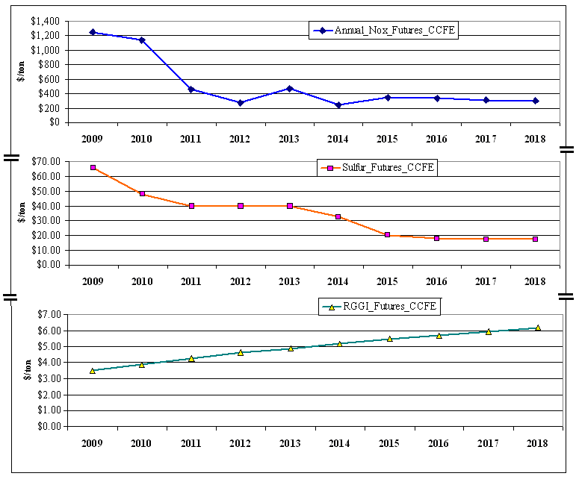
Figure 14: Emission Allowance Forecast
With respect to the carbon emission futures under the Regional Greenhouse Gas Initiative (RGGI), the data from the CCFE was available only through 2012. The implied trend was extrapolated to cover the 2013-2018 period.

Generic Solutions
Generic solutions are evaluated by NYISO for each identified congested element or grouping utilizing each resource type – generation, transmission, and demand response – as required in Section 11.3 of the Tariff. The development of the generic solutions representative costs are accomplished by consultants experienced with NYISO’s market and systems and with stakeholder input.. This methodology was based on utilizing typical MW block size generic solutions, a standard set of assumptions, and an order of magnitude costs for each resource type.
It should be noted that the estimates included in the Generic Solution Cost Matrix should not be utilized for purposes outside of the CARIS process. These estimates should not be assumed as reflective or predictive of actual projects or imply that facilities can necessarily be built for these generic order of magnitude solution estimates.

Resource Block Sizes
Typical resource block sizes are developed for each resource type based on the following guidelines:
- Block size would be reflective of a typical size built for the specific resource type and geographic location
- Block size is to be small enough to be additive with reasonable step changes
- Blocks sizes are in comparable proportions between the resource types
The block sizes selected for each resource type are presented in Table 4-9 through Table 4-11.
Table 10: Transmission Block Sizes
Location | Line System Voltage (kV) | Block Ampacity (Amp) | Block Capacity (MVA)
Zone A-J | 345 | 1673 | 1000
Zone K | 138 | 2092 | 500
Note: 138 kV was selected for Zone K due to the limited number of 345 kV substations located within this Zone. The block capacity was reduced accordingly to be reflective of the typical line size for this voltage class.
Table 11: Generation Block Sizes
Plant Location | Plant Block Size Capacity (MW)
Zone A-K | 250

Table 12: Demand Response Block Sizes
Location | Demand Response Block Size (MW) | Portfolio Type
Zone A-K | 100 | Energy Efficiency
Zone A-K | 100 | Demand Response

Guidelines and Assumptions for Generic Solutions
Developing cost estimates for these resource types is very dependent on many different parameters and site specific situations. A detailed list of assumptions utilized for each resource is included in the Generic Solution Cost Matrix, in Appendix C.
The following guidelines and assumptions are used to select the generic solution and determine their cost:
Transmission Resource
- The generic transmission solution consists of a new transmission line interconnected to the system upstream and downstream of the grouped congested elements being studied.
- The generic transmission line terminates at the nearest existing substations of the grouped congested elements.
- If there is more than one substation located near the grouped congested elements which meets the required criteria, then the two substations that have the shortest distance between the two are selected.
- The cost of the Transmission solution would be affected by the following:
1. type of construction (typical conventional overhead or underground)
2. voltage and ampacity capability
3. substation interconnection
4. rights of way
5. permitting
6. system upgrade facilities
7. order of magnitude cost estimate

Generation Resource
- The generic generation solution consists of the construction of a new combined cycle generating plant connecting downstream from the grouped congested elements being studied.
- The generic generation solution terminates at the nearest existing substation of the grouped congested elements.
- If there is more than one substation located near the grouped congested elements which meets the required criteria, the substation that has the highest relative shift factor is selected.
- The cost of the Generation solution would be affected by the following:
1. type of plant
2. length, type, voltage and ampacity of generator lead
3. substation interconnection
4. length of gas line
5. rights of way
6. permitting
7. system upgrade facilities
8. order of magnitude cost estimate

Demand Response
- The generic demand response solution is modeled as a reduction in load within the zone where the most downstream grouped congested element is terminated.
- The on-peak demand is assumed to be concentrated in the top 60-100 highest load hours.
- The demand response installed in a zone is limited to less than 10% of the peak zonal load. If the “block” demand response exceeds 10% of the peak zonal load, it is prorated based on peak load between the selected zone and the next downstream zone.
- The cost of the Demand Response solution would be affected by the following:
1. zonal locations
2. energy efficiency (available 8760 hours/year)/ demand response
3. utility demand side management filings
4. order of magnitude cost estimate

Order of Magnitude Unit Pricing
Order of magnitude unit pricing cost estimates were developed based on the block sizes and assumptions for each resource type. The NYISO utilized engineering consultants to develop order of magnitude cost estimates based on their experience in the industry and similar existing projects or programs currently being considered within New York. The order of magnitude cost estimates took into account the cost differences between geographical areas within New York. Three sets of costs were developed that are reflective of the differences in labor, land and permitting costs between Upstate, Downstate and Long Island. The order of magnitude unit pricing for the following elements, listed in Table 4-11, were developed for the three resource types and for each geographical area.
Table 13: Order of Magnitude Unit Pricing Elements
Transmission | Generation | Demand Response
Transmission Line Cost per Mile | Plant Costs | Energy Efficiency Programs
Substation Terminal Costs | Generator Lead Cost per Mile | Demand Response Programs
System Upgrade Facilities | Substation Terminal Costs
 | System Upgrade Facilities
 | Gas Line Cost per Mile
 | Gas Regulator Station

All costs were reviewed by the Transmission Owners and stakeholders through the stakeholder process. As part of this process, ranges for the cost for each element were developed in order to address the wide variability that can occur in a project due to such items as permitting, right of way constraints, and existing system conditions. The resulting order of magnitude unit pricing levels are included in the Generic Solution Cost Matrix in Appendix C.

Application of Order of Magnitude Cost Estimates
Upon selection of the three congestion areas to be studied and their generic solutions, the order of magnitude unit pricing element are utilized to develop order of magnitude generic solution costs for inclusion in the benefit to cost ratio analysis. If the location for the generic solution identifies unusual complexities, a contingency factor will be applied to the costs included in the matrix. These complexities may include but are not limited to right of way restrictions, terrain and/or permitting difficulties.

2009 CARIS Analyses – Study Phase
This section presents the results of Phase 1, the Study Phase, of the CARIS process. Specific economic projects are not considered in this phase. They will be subsequently studied in Phase 2, the Project Phase, of the CARIS process. The results are presented below and described in more detail in Appendix E. The process steps include:1) congestion assessment; 2) ranking of congested elements; 3) selection of three studies; 4) generic solutions application; 5) benefit/cost analysis; and 6) scenario analysis.
The Study Phase of the CARIS process begins with the development of a ten-year projection of future congestion costs resulting from NYCA system facilities. This projection is combined with the past five years of historic congestion to identify and rank significant and recurring congestion. Based on this ranking, the top five congested elements are identified, and a grouping process, detailed in section 5.3, is implemented to develop the three studies comprising CARIS. Generic solutions to these most congested groupings are then assessed, and the benefit/cost ratios are presented based on generic solution costs and forecasted production cost savings. Scenario analyses are also conducted to determine the impact of uncertainties on the projection of congestion.

Congestion Assessment
Congestion assessment is performed both from a historical and future perspective and is done separately. The results are presented in the following two sections of this chapter.
In order to assess and identify the most congested elements, both positive and negative congestion on constrained elements is taken into consideration. The concept of positive versus negative congestion is based on how the congestion relates to the reference point. New York uses the Marcy 345 kV bus near Utica as its reference point. For locations downstream of the reference bus, congestion will be positive and for locations upstream of the reference bus congestion will be negative. For example, in the absence of losses, any location with LBMP greater than the Marcy LBMP has positive congestion, and any location with LBMP below the Marcy LBMP has negative congestion. The negative congestion typically happens due to transmission constraints preventing lower cost generation from being delivered in full to the New York grid, or when all available relatively inexpensive imports cannot be fully delivered.

Historic Congestion
Historic congestion assessment has been conducted at the NYISO for the last six years with metrics and procedures developed with the ESPWG and approved by the NYISO Operating Committee. Four congestion metrics were developed to assess historic congestion: Bid-Production Cost (BPC) as the primary metric, Load Payments metric, Generator Payments metric, and Congestion Payment metric. The results of the historic congestion analysis are posted on the NYISO website quarterly. The NYISO uses PROBE production cost simulation tool to generate historical results, which, unlike the CARIS forecasted results, include, among other things, the impact of virtual bidding and actual transmission outages on congestion. This is explained in more detail further in the text and in Appendix D.
Table 5-1 below summarizes the impact of historic congestion on BPC, unhedged congestion payments, generator payments, and load payments over the past six years, including zones both internal and external to NYCA. The results represent the change in metrics’ values between a constrained system and a system in which all constraints are relieved. When all the constraints were relieved, BPC and congestion payments resulted in positive savings, while generator payments and load payments resulted in negative savings for the majority of studied historic years. More information on historic congestion metrics and how they are calculated is included in Appendix E.
Table 14: PROBE NYCA System Congestion Impact - Mitigated Bids ($ in Millions), 2003-2008
Year | BPC ($mil.) (mitigated) | Unhedged Congestion Payments* ($ mil.) | Generator Payments ($ mil.) | Unhedged Load Payments* ($mil.)
2003 | 85 | 293 | (136) | (136)
2004 | 72 | 316 | (181) | (181)
2005 | 113 | 685 | (71) | (71)
2006 | 118 | 921 | 59 | 59
2007 | 130 | 806 | (107) | (107)
2008 | 243 | 1,525 | (417) | (417)
* Values are adjusted for TCCs.

Figure 5-1 below illustrates a cumulative effect of bid production costs savings over the past six years as a result of relieving all NYCA constraints.
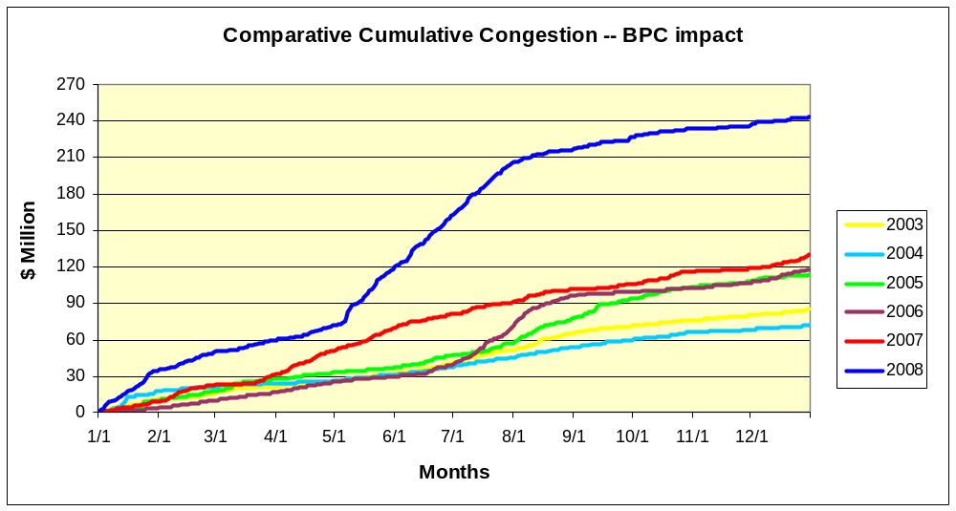
Figure 15: PROBE Cumulative BPC Savings
Historic congestion values by zone are presented in Table 5-2 indicating the highest congestion in New York City and Long Island. Total NYCA congestion, expressed as Demand$, nearly doubled in 2008 in comparison to 2007, mostly due to high fuel prices in 2008
Table 15: Historic Congestion by Zone 2004-2008
 | Historic NYCA Congestion $Demand ($ in Millions)
Zone | 2004 | 2005 | 2006 | 2007 | 2008
West | (0.7) | (4.9) | 0.9 | (14.1) | (25.1)
Genesse | 0.5 | (1.3) | 1.6 | (14.0) | (9.4)
Central | 0.5 | (1.2) | 3.5 | 9.4 | 18.4
North | (0.0) | (1.1) | (0.2) | (0.3) | (1.8)
Mohawk Valley | 0.1 | (0.3) | 2.1 | 4.6 | 9.8
Capital | 7.5 | 19.3 | 27.2 | 73.7 | 143.4
Hudson Valley | 4.9 | 19.9 | 54.4 | 86.9 | 175.5
Millwood | 2.7 | 11.8 | 26.7 | 30.8 | 78.0
Dunwoodie | 4.4 | 23.6 | 44.1 | 56.1 | 124.4
NYCity | 581.8 | 808.7 | 672.9 | 700.0 | 1,402.7
Long Island | 229.5 | 508.0 | 708.2 | 517.9 | 624.4
The values are not adjusted for TCCs
Historical Congestion Source: PROBE DAM quarterly reports
DAM data include Virtual bidding & Transmission planned outages

Table 5-3 below lists historic congestion values for top constraints from 2004 to 2008. Based on the positive congestion values, the top three congested constraints are Central East, Leeds-Pleasant-Valley, and Dunwoodie Shore Road.
Table 16: Historic Congestion by Constraint ($ in Millions) 2004-2008
Constraint | 2004 | 2005 | 2006 | 2007 | 2008 | Total
CENTRAL EAST - VC | 52 | 102 | 187 | 571 | 1,199 | 2,112
PLSNTVLY 345 LEEDS 345 1 | 27 | 182 | 452 | 435 | 667 | 1,763
DUNWODIE 345 SHORE_RD 345 1 | 152 | 348 | 492 | 260 | 187 | 1,439
MOTTHAVN 345 RAINEY 345 2 | 0 | 0 | 0 | 43 | 272 | 315
RAINEY 138 VERNON 138 1 | 5 | 84 | 21 | 19 | 81 | 210
WEST CENTRAL | (0) | (0) | (2) | (51) | (55) | (108)
E179THST 138 HELLTP_W 138 1 | (9) | (18) | (10) | (12) | (34) | (83)

* Ranking is based on absolute values.

Projected Congestion
A projection of future congestion is reported as demand dollar (Demand$) congestion. Congestion forecasts resulting from the simulation are highly dependent upon many long-term assumptions. The CARIS model utilizes input assumptions listed in Appendix C.
When comparing historical congestion values to projected congestion values, one must bear in mind that there are significant differences in assumptions used by the PROBE and CARIS tools. The CARIS tools did not simulate the following: a) virtual bidding; b) transmission outages; c) fixed load and price-capped load; d) generation and demand bid price; e) Bid Production Cost Guarantee payments (BPCG); and f) co-optimization with ancillary services. Another factor to consider when comparing historic and future congestion values is the fuel prices. Projected fuel prices for 2009 are much lower than 2008 actual fuel prices. For illustrative purposes, a comparison between simulated and actual congestion for first Quarter 2009 is provided in Appendix D.
Table 5-4 presents the projected congestion from 2009 through 2018 by zone. The relative values of congestion shown in this table indicate that the majority of the projected congestion is in the downstate zones – NY City and Long Island. The step changes in congestion, as shown in Tables 5-4 and 5-5, from 2009 to 2010, is caused by the increase in fuel prices and a change in fuel price spreads as well as the changes shown in Table 4-1, timeline of Major Events. The major causes of the large changes from 2010 to 2011 are due to the insertion of the M29 cable and the study assumption of the removal from service of the Athens SPS and the resultant decrease in the UPNY/SENY transfer capability of approximately 450 MW.
Table 17: Projection of Future Congestion 2009-2018 by Zone (nominal $ in Millions)
Zone | 2009 | 2010 | 2011 | 2012 | 2013 | 2014 | 2015 | 2016 | 2017 | 2018
West | (5) | (13) | (12) | (14) | (34) | (33) | (36) | (41) | (45) | (57)
Genesse | (3) | (3) | (3) | (4) | (23) | (21) | (22) | (25) | (29) | (37)
Central | 1 | 1 | 1 | 1 | (0) | (0) | (2) | (2) | (1) | 1
North | 0 | 1 | 1 | 1 | 0 | 0 | 0 | 1 | 1 | 1
Mohawk Valley | 1 | 1 | 2 | 2 | 1 | 1 | 1 | 2 | 2 | 2
Capital | 5 | 15 | 14 | 18 | 13 | 13 | 15 | 19 | 23 | 23
Hudson Valley | 8 | 20 | 35 | 38 | 33 | 33 | 35 | 39 | 43 | 50
Millwood | 3 | 6 | 11 | 12 | 11 | 10 | 11 | 12 | 13 | 15
Dunwoodie | 6 | 14 | 26 | 28 | 24 | 24 | 26 | 28 | 30 | 36
NYCity | 87 | 209 | 271 | 300 | 278 | 292 | 326 | 375 | 410 | 426
Long Island | 27 | 69 | 98 | 106 | 93 | 91 | 97 | 106 | 116 | 132

Table 5-5 lists the future top most congested elements: Leeds-Pleasant Valley, Central East, West Central, Astoria West, Mott Haven-Rainy and Dunwoodie Shore Road.

Table 18: Projection of Future Congestion 2009-2018 (nominal $ in Millions) by Constraint
Constraints | 2009 | 2010 | 2011 | 2012 | 2013 | 2014 | 2015 | 2016 | 2017 | 2018 | Total
LEEDS - PLEASANT VALLEY 345 | 35.1 | 68.9 | 229.8 | 245.0 | 220.0 | 217.1 | 214.8 | 227.8 | 235.8 | 292.8 | 1987.0
CENTRAL EAST | 26.8 | 92.6 | 79.9 | 102.7 | 67.0 | 62.3 | 74.7 | 97.0 | 125.6 | 117.9 | 846.5
MOTT HAVNEN-RAINEY 345 | 1.4 | 15.4 | 2.0 | 3.5 | 5.5 | 8.0 | 9.7 | 12.9 | 15.0 | 23.5 | 96.9
DUNWOODIE-SHORRD 345 | 4.3 | 15.7 | 7.6 | 7.2 | 6.7 | 6.3 | 6.4 | 7.0 | 8.1 | 8.5 | 77.9
WEST CENTRAL-OP | (0.0) | (2.8) | (3.3) | (4.5) | (52.6) | (48.1) | (46.0) | (54.5) | (63.6) | (86.5) | (362.0)
ASTORIAW138 - HG5 138 | (2.4) | (9.3) | (12.0) | (10.5) | (11.3) | (12.5) | (13.2) | (14.7) | (14.5) | (16.9) | (117.3)

Ranking of Congested Elements
The identified congested elements from the ten-year projection of congestion are lined up with the past five years of identified historic congested elements to develop fifteen years of $Demand congestion statistics for each identified constraint. The fifteen years of statistics are analyzed to identify recurring congestion or the mitigation of congestion from future system changes incorporated into the base CARIS system. Ranking of the identified constraints is initially based on the highest present value of congestion over the fifteen-year eriod – 5 years historic and ten years forecasted. s
Table 5-6 lists the ranked elements based on the highest present value of congestion over the fifteen years of the study, including both positive and negative congestion. Dunwoodie-Shore Road and Mott Haven-Rainey’s historic congestion diminishes in the future with the addition of the Caithness plant and the ongoing construction of the M29 Cable. Dunwoodie-Shore Road congestion declined substantially in 2007 when the Neptune cable came into service. The top five elements are evaluated in the next step for selection of the three studies.
Table 19: Ranked Elements Based on the Highest Present Value of Congestion
over the Fifteen Years Aggregate
 | Present Value of Congestion in 2009 $ Millions
Constraints | Historic | Future | Aggregate
LEEDS-PLEASANT VALLEY 345 | $2,063 | $1,307 | $3,370
CENTRAL EAST | $2,442 | $567 | $3,009
WEST CENTRAL-OP | ($120) | ($230) | ($350)
DUNWOODIE-SHORE ROAD 345 | $1,770 | $59 | $1,829
MOTT HAVEN-RAINEY 345 | $341 | $66 | $407
ASTORIA W 138-HELLGATE5_138 | $50 | ($78) | ($28)
Note: Allowance for diminishing congestion in the future years in the approved ranking procedure directs the selection of West Central as the third ranked element.
The frequency of actual and projected congestion is shown in Table 5-7 below. The table presents the actual number of congested hours by constraint, from January 2007 through September 2009, and projected number of congested hours, from 2009 through 2018. Based on the projected values, the most congested constraint in terms of frequency is Dunwoodie-Shore Road, followed by Athens Pleasant Valley, West Central, Central East, and Mott Haven Rainey respectively.

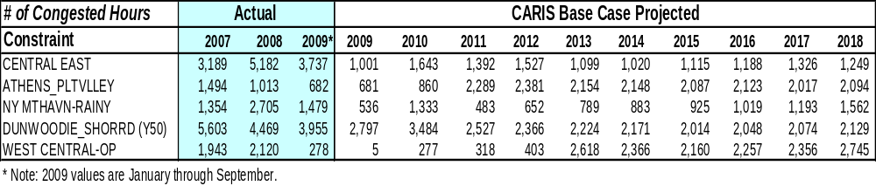

Selection of Three Studies
Selection of the three CARIS studies is a two-step process in which the top five ranked constraints are identified and utilized for further assessment in order to identify potential for grouping of constraints. Resultant grouping of elements for each of the top five ranked constraints is utilized to determine the three studies.
In the first step, the five congested elements with the highest present value ranking are utilized for further assessment under the CARIS process, as explained in the previous step 5.2. In the second step, this assessment is accomplished in multiple iterations to include additional elements that appear as limiting when each of the top five congested elements are relaxed. The assessed element groupings are then ranked based upon the highest change in production cost. The three ranked groupings with the largest change in production cost are selected as the three CARIS studies. The three CARIS studies, as shown in Table 21: include Leeds - Pleasant Valley, Central East, and West Central. The detailed discussion on the ranking process is presented in Appendix E.
Table 21: Top Three CARIS Studies (congestion in nominal $ in Millions)
Element | 2009 | 2010 | 2011 | 2012 | 2013 | 2014 | 2015 | 2016 | 2017 | 2018
LEEDS- PLTVLLEY_345 | $35 | $69 | $230 | $245 | $220 | $217 | $215 | $228 | $236 | $293
CENTRAL EAST | $27 | $93 | $80 | $103 | $67 | $62 | $75 | $97 | $126 | $118
WEST CENTRAL-OP | ($0) | ($3) | ($3) | ($5) | ($53) | ($48) | ($46) | ($54) | ($64) | ($87)

Note: The increase in congestion from 2010 to 2011 is primarily caused by the change from an STE to an LTE post-contingency rating on the Leeds - Pleasant Valley circuits starting in 2011 due to the CARIS study assumption that the Athens SPS will no longer be in service starting in January, 2011. This rating change of approximately180 MW has the effect of reducing the effective UPNY-SENY interface capability by approximately 450 MW as indicated in the Athens System Impact Study.

The location of the top three congested groupings, along with their base present value congestion payment, is presented in Figure 5-2.
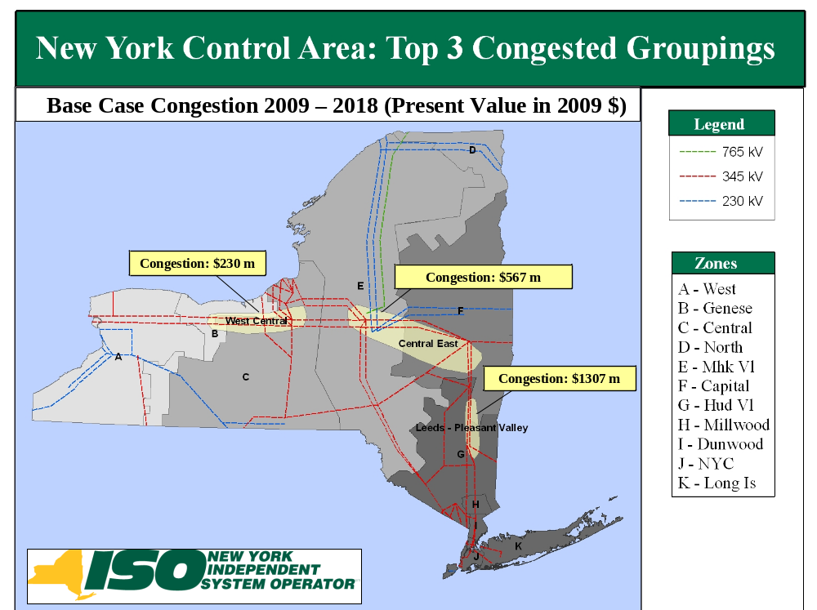

Figure 16: Base Case Congestion of the Top 3 Congested Groupings

Generic Solutions
The congestion of each of the three groupings being studied is mitigated by individually applying one of the generic resource types; transmission, generation and demand response. The resource type is applied based on the rating and size of the “blocks” determined in the Generic Solutions Cost Matrix included in Appendix C and is consistent with the methodology explained in Section 4 of this report.. In regard to the generic solutions, it is important to note the following:
- Other solutions may exist which will alleviate the congestion on the studied elements.
- No attempt has been made to determine the optimum solution for alleviating the congestion.
- No engineering, physical feasibility study, routing study or siting study has been completed for the generic solutions. Therefore, it is unknown if the generic solutions can be physically constructed as proposed.
- Generic solutions are not assessed for impacts on system reliability.

The discount rate used to calculate present values of the benefit stream of a generic transmission solution applied to a given constrained element is the weighted average of the Weighted Average Cost of Capital (WACC) figures submitted to the NYISO by the NYTOs, associated with the constrained element. The weights are the relative mileage ownership shares derived from data reported in the NYISO Gold Book. The applicable discount rates for the generic generation and DR/EE solutions pertaining to the element, is the same as the one used for the transmission solution.
The results of the three generic solutions are to provide indicative information to interested parties. More detailed information on these results are provided in Appendix E. The following generic solutions were applied for each study:
Study #1 – Leeds - Pleasant Valley
The following generic solutions were applied for Leeds-Pleasant Valley Study:
- Transmission: A new 345 kV line from Leeds to Pleasant Valley- 39 Miles. The new line increases the UPNY-SENY thermal limit by approximately 1000 MW and Central East voltage limit by 50 MW.
- Generation: Install a new 500 MW Plant at Pleasant Valley
- Demand Response: Install 100 MW Demand Response and 100 MW Energy Efficiency in Zone G (200 MW is less than 10% of Zone G’s peak load)
Table 5-9 shows the NYCA production cost savings expressed as the present value in 2009 $ from2009 to 2018 for Leeds-Pleasant Valley study after potenti solutions were applied.
Table 22: Leeds - Pleasant Valley: NYCA Production Cost Savings (Present Value in 2009 $ Millions)
 | 2009 | 2010 | 2011 | 2012 | 2013 | 2014 | 2015 | 2016 | 2017 | 2018
Transmission | 4.8 | 5.3 | 14.0 | 13.9 | 12.6 | 10.4 | 9.6 | 10.9 | 11.0 | 12.4
Generation-500 | 29.9 | 36.4 | 40.5 | 37.2 | 33.4 | 34.2 | 33.3 | 33.8 | 35.3 | 31.8
Demand Response | 24.1 | 28.9 | 27.6 | 25.2 | 24.2 | 24.2 | 24.6 | 23.9 | 22.9 | 20.9

Discussion

The new Leeds-Pleasant Valley 345 kV transmission solution relieves the congestion across existing Leeds-Pleasant Valley transmission lines and the UPNY SENY transmission interface. The total ten-year production cost savings of $104.9 million are equally dependent upon the spread between upstate and downstate fuel costs, and increased imports from PJM, IESO, and ISONE. Relieving the congestion on the Leeds-Pleasant Valley lines increases the congestion on the other two study groups: Central East and West Central.
The Pleasant Valley generation solution reduces congestion across NYCA for the planning horizon. The ten-year production cost savings of $345.7XXX lion are derived from the efficiency advantage of the new generic unit compared to the system heat rate. Impots are significantly reduced from all surrounding areas except HQ which is held constant.
The Zone G Demand Response solution reduces congestion across NYCA for the planning horizon with a minor exception downstream for some later years. The ten-year production cost savings of $XX6.6 million are largely related to the reduction in energy use. Imports are reduced from all surrounding areas except HQ which is held constant.

Study #2 - Central East
The following generic solutions were applied for Central East study:
- Transmission: A new 345 kV line from Edic to New Scotland, 90 Miles. The new line relieves the Central East thermal limit and increases the Central East voltage limit by 400 MW.
- Generation: A new 500 MW Plant at New Scotland
- Demand Response: Install 100 MW Demand Response and 100 MW Energy Efficiency in Zone F (200 MW is less than 10% of Zone F’s peak load)
Table 5-10 shows the NYCA production cost savings expressed as the present value in 2009 $ from 2009 to 2018 for Central East study after potentiasolutions were applied.
Table 23: Central East: NYCA Production Cost Savings (Present Value in 2009 $ Millions)
 | 2009 | 2010 | 2011 | 2012 | 2013 | 2014 | 2015 | 2016 | 2017 | 2018
Transmission | 1.8 | 6.1 | 2.8 | 2.0 | 2.5 | 1.4 | 2.7 | 2.6 | 2.9 | 1.7
Generation | 21.0 | 25.2 | 25.7 | 18.8 | 17.5 | 23.8 | 23.0 | 21.6 | 24.9 | 22.4
Demand Response | 22.0 | 26.6 | 26.2 | 19.1 | 22.0 | 21.4 | 20.9 | 21.4 | 19.4 | 16.9

Discussion
The addition of the Edic-New Scotland marginally relieves the Central East congestion but does not have significant impact on production cost because of the Leeds-Pleasant Valley congestion which bottles generation in upstate New York. The ten-year production cost savings of $26.7 million are derived approximately equally from increased use of lower cost generation in Upstate and increased imports. The transmission solution increases imports from IESO and PJM while exports to ISONE increase in an approximately equal amount.
The New Scotland generation solution reduces congestion Upstate for the planning horizon, while the value of congestion increases in SENY. The ten-year production cost savings of $XXX29 million are derived from the efficiency advantage of the new generic unit compared to the system heat rate. This same phenomena acts to increase the value of congestion in SENY as the generation remains bottled up. Imports are significantly reduced from all surrounding areas except HQ which is held constant.
The Zone F DR solution reduces congestion across Upstate for the planning horizon while the value of congestion increases downstream in SENY as the generation remains bottled up. The ten-year production cost savings of $215.9 million are largely related to the reduction in energy use. Imports are reduced from all surrounding areas except HQ which is held constant

Study #3 - West Central
The following generic solutions were applied for the West Central study and the results are shown in Table 5-11:
- Transmission: A new 345 kV line from Niagara to Pannell to Clay- 149 Miles.
The West Central transmission constraint is due to the West Central voltage limit for the loss of Ginna generator. Initial voltage analysis was performed with the addition of a Pannell Rd-Clay 345 kV transmission line but the transmission line did not result in any improvement in the voltage performance. Recognizing the voltage performance may be more a function of local system problems and that West Central is tightly coupled with the Dysinger East transmission interface, a new circuit from Niagara to Clay was inserted and the voltage limit improved by over 500 MW. This was chosen to stay within the procedures for the development of generic solutions, although it is recognized that other non-bulk power system solutions may exist as well.
- Generation: Install a new 500 MW Plant at Clay
- Demand Response: Install 100 MW Demand Response and 100 MW Energy Efficiency in Zone C (200 MW is less than 10% of Zone C’s peak load)
Table 5-11 shows the NYCA production cost savings expressed as the present value in 2009 $ from 2009 to 2018 for West Central study after potentiasolutions were applied.
Table 24: West Central: NYCA Production Cost Savings (Present Value in 2009 $ Millions)
 | 2009 | 2010 | 2011 | 2012 | 2013 | 2014 | 2015 | 2016 | 2017 | 2018
Transmission | 8.0 | 7.9 | 8.1 | 7.7 | 11.4 | 10.0 | 11.2 | 11.2 | 8.3 | 8.2
Generation-500 | 9.5 | 12.5 | 16.1 | 13.4 | 12.6 | 15.5 | 16.7 | 16.0 | 20.0 | 19.0
Demand Response | 19.6 | 25.1 | 25.1 | 18.4 | 21.5 | 22.3 | 21.7 | 22.7 | 20.2 | 20.1
Discussion
The addition of Niagara-Pannell-Clay 345 kV transmission line relieves the West Central congestion while the value of congestion increases in zones E through K. The ten-year production cost savings of $92 million increase with time as the fuel prices increase and there is sufficient generation in Ontario and West New York to transfer to the rest of New York. Imports from IESO and PJM increase significantly while exports to ISONE also increase.
The Clay generation solution reduces congestion in zones A and B for the planning horizon, while the value of congestion increases in zones E through K. The ten-year production cost savings af $XXX15 million are derved from the efficiency advantage of the new generic unit compared to the system heat rate. This sae phenomena acts to increase the value of congestion downstream as the generation remains bottled up. Imports ae significantly reduced from all surrounding areas except HQ, which is held constant.
The zone C Demand Response Rolution reduces congestion across the planning horizon with the exception of a minor increase downstream in SENY for some years The ten-year production cost savings of $XXX.6 million are largely related to the reduction in energy use. Imports are reduced from all surrounding areas except HQ, whichis held constant.

The summation of production cost savings, from 2009 to 2018, of the three generic solutions for each congestion grouping, is shown in Figure 5-3. The greatest production cost savings for each congestion grouping has resulted from the generic generation solutions. It is worth noting that the energy efficiency generic solutions resulted in the second highest production cost savings for each grouping.
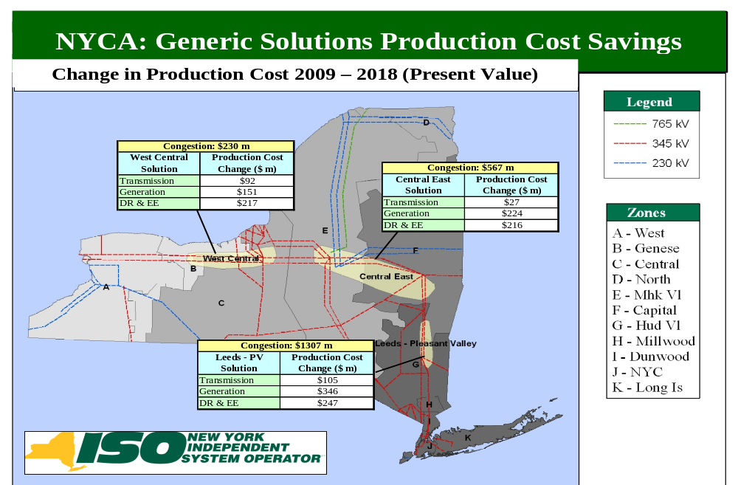
Figure 17: Production Cost Savings 2009-2018

Benefit/Cost Analysis
The NYISO conducted the benefit/cost analysis for each of the three studies comprising the CARIS: Leeds - Pleasant Valley, Central East, and West Central. The CARIS benefit/cost analysis assumes a generic carrying charge rate of 16%. Therefore, for a given generic solution pertaining to a constrained element, the carrying charge rate, in conjunction with an appropriate discount rate (see description in Section 5.4 above) yields a capital recovery factor, which, in turn, is used to calculate the benefit/cost ratio.

Benefit/Cost ratio = Present Value of Production Cost Changes
Overnight Costs x Capital Recovery Factor

These benefit/cost ratios are used to give a relative indication of the project’s economic merit. The costs used are overnight costs that were translated into an annual revenue requirement by assuming a16% carrying charge. The annual revenue requirements are highly dependent on the assumed life of the project and many factors associated with the specific location, developer and the project itself.

Cost Analysis
Table 5-12 includes the total order of magnitude cost estimate for each generic solution based on the unit pricing included in Appendix C. The detailed cost breakdown for each solution is included in Appendix E. These are overnight installation costs. On-going operation and maintenance costs are not included.

Table 25: Generic Solution Costs for Each Study Table
Generic Solution Cost Summary ($M)
Congested Groups | Central East | Leads - Pleasant Valley | West Central
Transmission
Substation Terminals | Edic to New Scotalnd | Leeds to Pleasant Valley | Niagara to Pannell to Clay
Miles | 90 | 39 | 149
High | $477 | $222 | $790
Mid | $333 | $155 | $552
Low | $189 | $87 | $313
Generation
Substation Terminal | New Scotland | Pleasant Valley | Clay
# of 250MW Blocks | 2 | 2 | 2
High | $831 | $911 | $831
Mid | $681 | $751 | $681
Low | $531 | $591 | $531
Demand Response
Zone | F | G | C
# of Blocks | 1 | 1 | 1
High | $580 | $580 | $580
Mid | $390 | $390 | $390
Low | $190 | $190 | $190

Primary Metric Results
The primary metric used to conduct benefit/cost analysis for the three CARIS studies is the change in NYCA-wide production costs. Identified congestion on each of the three congested groupings was mitigated by applying three generic solutions, including transmission, generation, and demand response. As Table 5-13 below indicates that the highest savings in production costs would be achieved if Leeds - Pleasant Valley constraint is mitigated. By adding a new 500 MW generation, the production cost would be reduced by $345.7 million from 2009-2018.

Table 26: NYCA Production Cost Generic Solutions Savings 2009-2018 (Present Value in 2009 $ Millions)
 | Leeds to Pleasant Valley | Central East | West Central
Transmission | 104.9 | 26.7 | 92
Generation | 345.7 | 223.9 | 151.4
Demand Response & EE | 246.6 | 215.9 | 216.6

Benefit/Cost Ratios
Figure 5-4 shows the benefit/cost ratios when a carrying charge of 16% is applied for illustrative purposes.
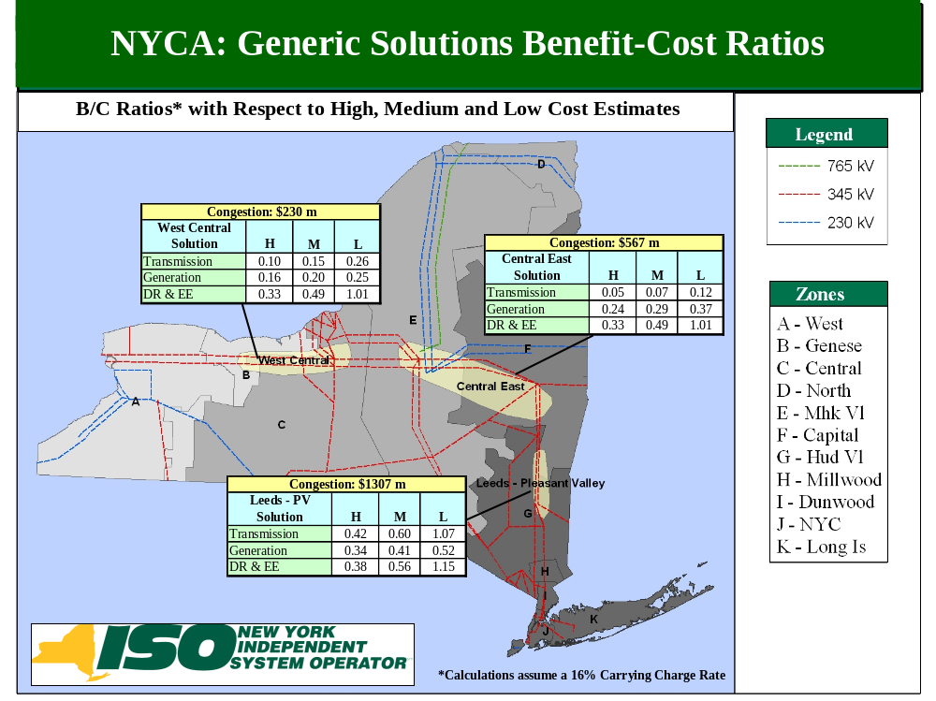
Figure 18: B/C Ratio (High, Medium, and Low Cost Estimate Ranges)
Plotted in Figures 5-5, 5-6 and 5-7 are the ten-1ear cumulative benefits from 2009 to 2018 for each of the three generic solutions. The Benefit-Cost ratios displayed are based on the cresent value of the cumulative benefits and an assumed 16% project carrying cost charge. The ratios of the cumulative benefits to an overnight cost, plus a 16% adder for a project carrying cost (“the total cost”), are also shown in the figures. For example, looking at the cumulative graph of the Leads-Pleasant Valley study Ceneric generation solution in Figure 5-5, by 2018, 41% of the total cost would be recovered by production cost savings. There could be additional benefits continuing beyond the ten-year planning horizon that are not included here.
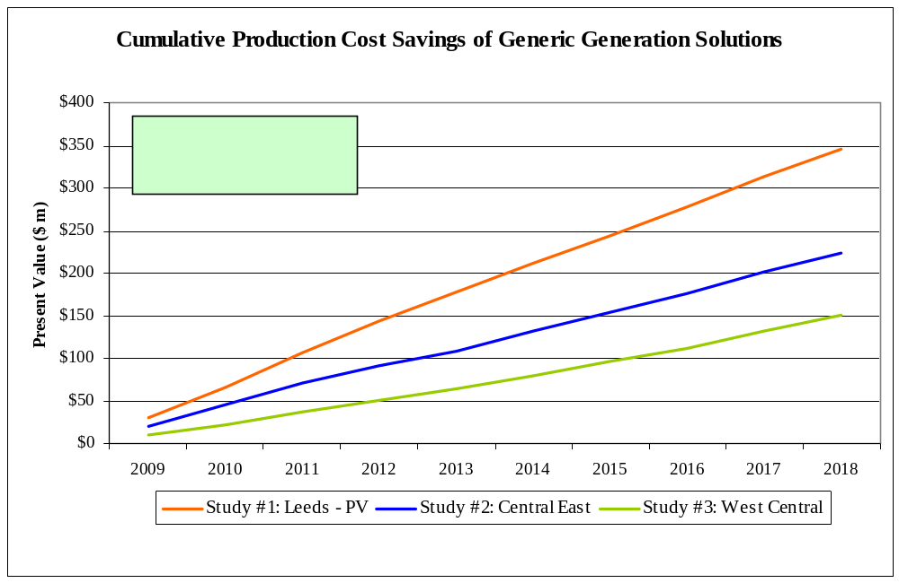
Figure 19: Cumulative Benefits of Generic Generation Solutions of Each Study (Present Value in 2009 $ in Millions)
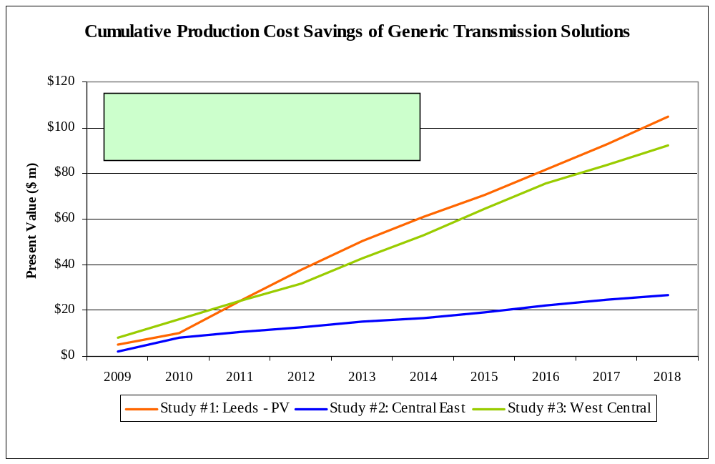
Figure 20: Cumulative Benefits of Generic Transmission Solutions of Each Study (Present Value in 2009 $ in Millions)
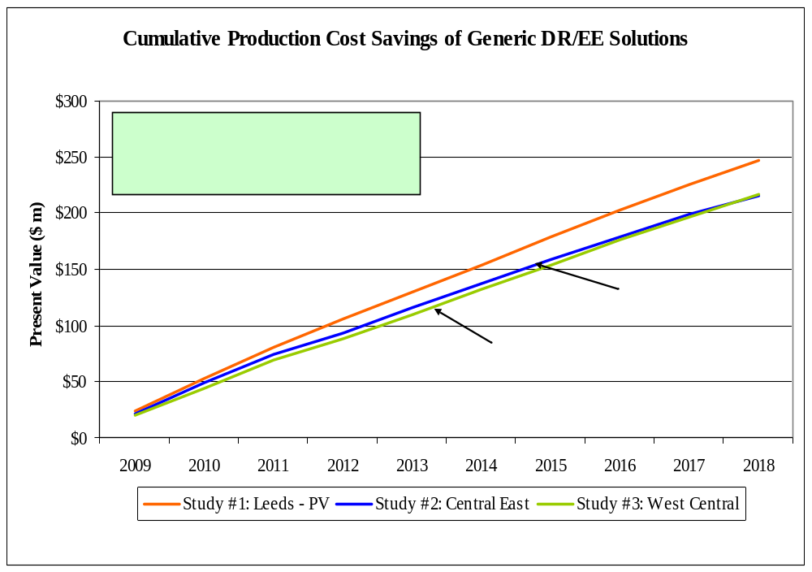
Figure 21: Cumulative Benefits of Generic Demand Response/Energy Efficiency Solutions of Each Study (Present Value in 2009 $ in Millions)

Additional Metrics Results
Additional metrics, which are provided for information purposes in Phase 1, are presented in Table 5-14 and Table 5-15 to show the nominal ten-year total change in: generator payments; LBMP-based load payments; TCC payments (congestion rents); marginal load payment losses; emission costs/tons; and ICAP MW impact, after the generic solutions are applied. The values represent the difference between the applied generic solutions’ values and the base case values for all the metrics except for the ICAP metric. Negative values imply a reduction in costs/tons. The ICAP numbers represent the amount of capacity that can be removed across NYCA and still meet the base LOLE requirement after the generic solutions are applied. For more information on additional metrics’ results, see Appendix E.

Table 27: Change in NYCA Generator Payments, Load Payments, Congestion Rents, Losses and ICAP (in nominal $ Millions)
 |  | Generator Payments | Load Payments | Congestion Rents* | Losses | ICAP
Study | Solution | ($ m) | ($ m) | ($ m) | ($ m) | (MW)
 | Transmission
1 | Leeds - Pleasant Valley | 306 | (76) | (738) | (139) | 250
2 | Edic - New Scotland | 67 | 86 | 94 | (399) | 0
3 | Niagara - Clay | (519) | (358) | 176 | 38 | 0
 | Generation
1 | Pleasant Valley | (52) | (784) | (326) | (7) | 595
2 | New Scotland | (257) | (479) | 276 | 51 | 255
3 | Clay | (389) | (457) | 310 | 125 | 220
 | Dd Response & Energy Eff.
1 | Zone G | (347) | (478) | (36) | (36) | 225
2 | Zone F | (343) | (442) | 21 | (16) | 70
3 | Zone C | (352) | (480) | 44 | 4 | 70
* Congestion Rents are calculated as Shadow Price times Flow across all constraints in the system.
Note: A negative number implies a reduction.)

Relieving the Central East or West Central interfaces with any of the generic solutions results in an increase of congestion on Leeds-Pleasant Valley line. The increase in congestion on the Leeds-Pleasant Valley line offsets any reduction in congestion achieved on the Central East or West Central interfaces resulting in an increase of Congestion Rent on an overall system basis.

The generic solution of installing the Leeds-Pleasant Valley line results in NYCA Generator Payments increasing while the Load Payments are decreasing which may be intuitively contradictory. However, further investigation reveals that this transmission solution relieves some pressure at West Central and Central East interfaces which leads to sharp rises in generation in Zones C and F while generation in Zone G declines substantially. Therefore, Upstate generator payments increase while the Downstate generator payments decrease. On an overall NYCA basis, the resultant Generator Payments are increasing. Concurrently, the Upstate LBMP is increasing while the Downstate LBMP is decreasing. However, since Downstate load has a dominant share in NYCA load, the downward pressure on Load Payments more than offsets the upward pressure due to LBMP increases in Upstate. So alleviation of congestion in Leeds-Pleasant Valley leads to lower Load Payments statewide as the lower price generation that flows into Downstate more than offsets the upward pressure due to increases in LBMPs Upstate. Higher generation Upstate now can be attributed to the substitution of higher prices generation downstate and in CT.

Table 28: Change in NYCA CO₂, SO₂ and NO_{X} Emissions

 |  | Emissions
Study | Solution | CO2 |  | SO2 |  | NOx
 |  | '000s Tons | Cost ($m) | Tons | Cost ($m) | Tons | Cost ($m)
 | Transmission
1 | Leeds - Pleasant Valley | (1558) | (8) | (1908) | (0) | (1960) | (1)
2 | Edic - New Scotland | 77 | 0 | 178 | (0) | 203 | 0
3 | Niagara - Clay | (1255) | (7) | 31 | (0) | (4758) | (0)
 | Generation
1 | Pleasant Valley | 361 | 2 | (9693) | (0) | (7413) | (4)
2 | New Scotland | 1040 | 6 | (7359) | (0) | (5266) | (3)
3 | Clay | 999 | 5 | (6445) | (0) | (4758) | (3)
 | Dd Response & Energy Eff.
1 | Zone G | (1942) | (10) | (1715) | (0) | (1333) | (1)
2 | Zone F | (1565) | (8) | (1370) | (0) | (959) | (0)
3 | Zone C | (1535) | (8) | (1324) | (0) | (992) | (1)
Note: A negative number implies a reduction.

The ten year total emission changes resulting from the application of generic solutions are reported in Table 5-15 above. The comparison of the relative emission changes among solution types and across locations provides insight about the relative air related impacts. DR solutions result in lower overall energy consumption and lower peaks thus all locations show improvements in emissions, while the zZone G location is shown to be most favorable.
Transmission and generation solutions yield results that are sensitive to their location. The Edic-New Scotland transmission solution leads to slight increases in the emissions of all three pollutants which results from the increased use of older generation in central and western New York. The Niagara-Clay transmission solution which results in both increased generation level in central and western NY nd increased imports from PJM and IESO, leads to a mixed pattern of emission changes, a reduction in CO2 and NOx emissions is shown, while SO2 emissions are shown to slightly increase over the period. The Leeds-Pleasant Valley transmission solution yields across the board emission reductions.
All generation solutions lead to increased CO2 emissions in NYCA, although emissions changes across the study area would be expected to yield net reductions because of the relative efficiency of the generic solution compared to the system average. All generation solutions produce net reduction in the emissions of SO2 and NOx because of the relative low emission rates of a new unit compared to the average emission rates of the existing fleet. The Pleasant Valley location would be preferred from the perspective of net emission changes.
To place these ten year emission changes in perspective, the base case ten year emission totals for NYCA are NOx = 392,443 tons. SO2= 715,502 tons, and CO2 = 553,292,000 tons. Thus, the generic solutions would be seen to impact this emission by one to two percent or less.

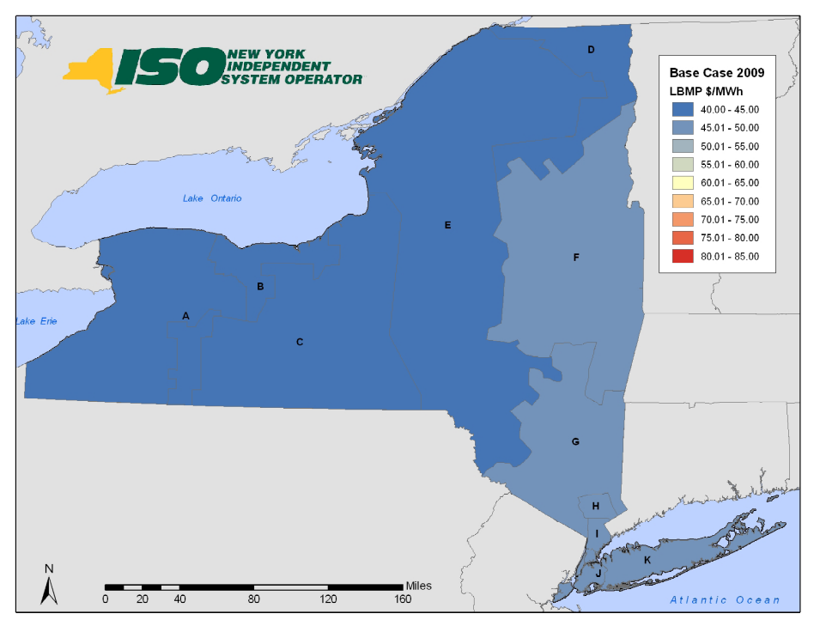
Figure 22: 2009 Base Case LBMP $/MWh

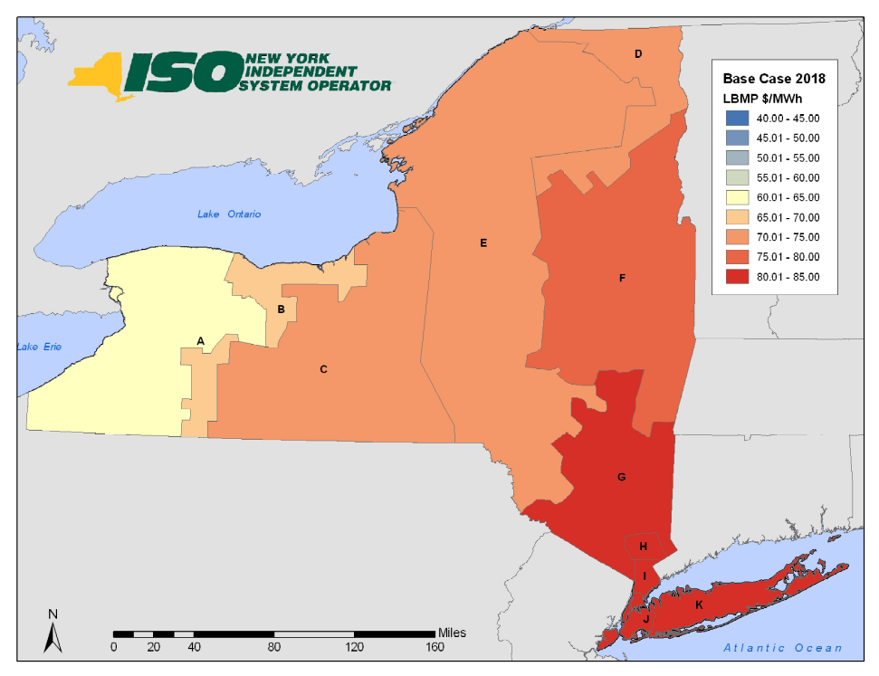
Figure 23: 2018 Base Case LBMP $/MWh

Scenario and Sensitivity Analysis
Scenario/sensitivity analysis is performed to explore the impact of uncertainties associated with significant drivers or variables to the base case. Since this is an economic study and not a reliability analysis these scenarios should particularly explore factors that impact the magnitude of congestion across constrained elements. Therefore, the assumptions modeled within these scenarios may not necessarily apply the same criteria as a reliability planning approach.
A forecast of congestion is impacted by many variables for which the future values are uncertain. Scenario and sensitivity analyses are methods of identifying the relative impact of pertinent variables on the cost of congestion. The CARIS Scenario studies were presented to ESPWG and modified based upon the input received and the availability of NYISO resources. The focus of these studies was to examine the impact of proposed State policies, fuel price and load forecast uncertainties, costs of emissions, and impacts of various new resources. The objective of the scenario study is to determine change in the costs of congestion on the top three congested paths within in NYCA, resulting from assumptions that differ from the base case. The simulations were conducted for the mid period year 2013, and 2018.

Variables for Consideration
Load Growth
The impact of a higher forecast of load growth was evaluated by using the high load forecast prepared for the 2009 RNA... The impact of a low load growth forecast utilized the full “15 X 15” forecast from the 2009 RNA. The updated load forecasts for the 2009 RNA was developed from the 2008 Load and Capacity Data “Gold Book”.
Fuel Price Uncertainty
The impact of a higher and lower fuel price forecast was also evaluated. The fuel forecasts utilized in CARIS employed historical price volatility to build a statistical profile around the expected prices that were used in the base case. The high fuel price forecast is one standard deviation above the expected price and the low fuel price forecast is on standard deviation below the expected price. The updated fuel price forecast used the same methodology as the base fuel price forecast applied to slightly more current market data.
New Resources
New resources usually impact the cost of congestion and can raise or lower it. New resources can come from the market, the planning process, government initiatives, as well as other sources. New York State is currently proposing an expanded Renewable Portfolio Standard. This proposal will require New York to obtain 30% of its electricity from certain types of new renewable resources by 2015. The study assumed that incremental renewable energy requirements of this proposed standard would be satisfied through the use of wind energy. The contemporaneous work of the NYISO on its wind study provided the location, project size, and production profiles examined in this study. In 2013, 5,100 GWH of additional renewable energy will be required. The requirement rises to 7,100 GWH in 2015 and is then capped.
The NYISO update scenario also includes the build out at the Astoria Energy facility to the limit of its existing Interconnection Agreement. Some additional wind generation facilities have been added since the work done for the 2009 RNA. These include Wethersfield, High Sheldon, and Canandaigua.
New resources can have a significant impact on the cost of congestion in New York. Scenarios were constructed to examine the impacts on the cost of congestion when additions are located at or near a border location or in congested areas. One scenario examined the impact of connecting a 500 MW natural gas combined cycle plant to the 345 kV system at the position currently occupied by the Poletti Station. Two other analyses were conducted for a similar facility located on Staten Island, the southern end of the NYCA system and for Massena at the NYCA’s northern boarder, respectively. The dispatch cost for these facilities was set at 95% of its running cost to simulate the effects of the new, economically attractive source of energy.
Environmental Mandates and Retirements
The 2009 RNA examined the impact of several developing environmental regulations. The first was the implementation of the Regional Greenhouse Gas Initiative, (RGGI) which limits the total CO2 emissions from power plants across a ten state region. The 2009 RNA scenario analysis concluded that under some combinations of fuel prices and CO2 Allowance prices that some coal fired power plants would be more likely to retire. The CARIS analysis continues to treat coal fired power plants with capacity factors below 50% as likely candidates for retirement. In the State Policy Case this retirement criteria was applied.
New York State is in the process of revising NOx emission regulations for fossil fired power plants. The 2009 RNA examined the impact of these regulations on reliability. The State Policy Case uses the same capacity limitations on the High Emitting Combustion Turbines.
Emission Costs
Emissions of SO2, NOx, and CO2, all have costs that are determined by various cap and trade programs currently in effect in New York and in most of the surrounding regions. Forecasts used in the base case for these allowance costs were developed using various proprietary forecasts and market prices from the Chicago Climate Futures Exchange. To examine the sensitivity of congestion costs to variations in the prices of these allowances, the forecast prices of SO2 and NOx were doubled. The price of CO2 allowances was established at $25/ton in 2013 and forecasted to escalate at CPI plus 5% as prescribed HR 2454 and the Kerry-Boxer Senate proposal.
Energy Efficiency
Energy efficiency and demand response act to reduce the cost of congestion when they are installed downstream of a transmission constraint. EE and DR reduce congestion by reducing peak load and altering the load profile. EE and DR are examined as generic solutions in the studies of each of the three congested interfaces. EE and DR act to alter the load forecast and have been factored into the base case. The working assumption for the base case was that the identified funding will achieve approximately one third of the load reduction necessary to achieve the “15 x15” goal. A low load forecast has been developed to examine the impact of the “15 x 15” goal on the cost of congestion.

Scenarios
Table 5-16 summarizes the scenarios studied in the CARIS Phase 1 report. More specific description on each scenario is presented as follows.
Table 29: Scenario Matrix
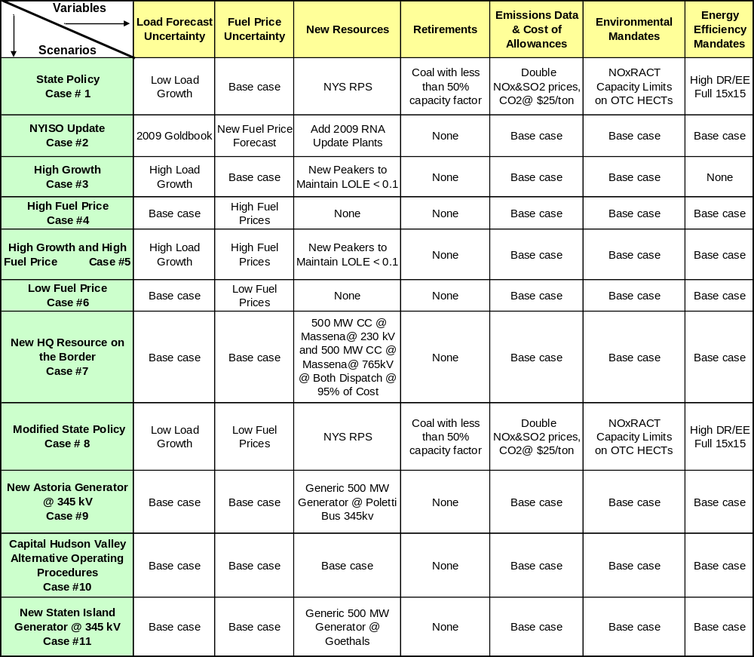

Case #1 – State Policy
The purpose of this case is to examine the aggregated impact of new and likely to emerge State and Federal policies on the cost of congestion. In his January 7, 2009 State of the State Address, Governor Paterson announced a “45 x 15” initiative that sets targets for the State to meet 45 percent of its electricity needs through improved energy efficiency and renewable energy by 2015. The Draft State Energy Plan released on August 10, 2009 provides that the energy efficiency portion of that Governor’s initiative is 15 of the total 45 percent. (This is also known as the “15 x 15” Energy Efficiency Portfolio Standard recently implemented by the Public Service Commission’s June 23, 2008 “Order Establishing Energy Efficiency Portfolio Standard and Approving Programs” (Case 07-M-0548).) While the Public Service Commission has yet to directly address the renewable portion of the “45 x 15” initiative, this scenario assumes that the State’s current Renewable Portfolio Standard (RPS) (Case 03-E-0188) will be expanded to meet 30 percent of the retail electricity use with renewable energy generation by 2015.
This case uses the low load growth forecast which is the equivalent of the full 15 x 15 from the 2009 RNA. Fuel prices are the same as the base case. New wind resources beyond those in the 2009 RNA are added with a simulated additional 5,100 GWh annually in 2013. These new wind resources are selected based on their respective positions in the Interconnection Queue. Similarly, 7,100 GWh annually beyond the 2009 RNA are simulated for 2017. To simulate the effects of unit retirements, the model is run in an iterative manner to identify coal fired generators which experience a drop in production to levels below a 50% capacity factor. These units are removed and the models rerun. SO2 and NOx allowance prices are doubled from the base case to simulate continuing evolution of the reductions required through the CAIR program on Ozone SIP calls. CO2 prices will start at $25/ton in 2013 and increase consistent with the prescribed requirements of the proposed legislation. The impact of OTC NOxRACT limitations is simulated through the use of capacity limits on High Emitting Combustion Turbines as examined in the 2009 RNA.
Case #2 - NYISO Update
This case examines the impact of updated load forecast from the 2009 Gold Book which is by 3.7% lower than the 2009 RNA base case load forecast, and updated fuel price forecastswhich is about 20% higher for aatural gas about 20% 2% higher for residual oil compared to the base case fuel forecast,. fuel oil increased about 2% during the periodn, of no criteria consideration in the RNA have been included. All other variables are the same as in the base case.

Case #3 - High Growth
This scenario examines the impact on the cost of congestion that results from a higher load growth forecast. The 2008 econometric load forecast from the 2009 RNA is used All other inputs are as they are in the base case.
Case #4 - High Fuel Price
This case examines the impact of higher fuel prices on the cost of congestion. Compared to the base case forecast, natural gas prices average 10% higher in zones I-K and 7% higher in Upstate. R,sidual fuel oil prices are 2% higher for the period and coal is 2.5% higher. All other inputs are as they are in the base case.
Case #5 - High Growth and High Fuel Price
This scenario examines the impact of the combined changes from Cases #3 and #4. All other inputs are as they are in the base case.
Case #6 - Low Fuel Price
This case examines the impact of lower fuel prices on the cost of congestion. Compared to the base case forecast, natural gas prices average 10% lower in zones I-K and 7% lower in Upstate. R,sidual fuel oil prices are 2% lower for the period and coal is 2.5% lower. All other inputs are as they are in the base case.
Case #7 - New Resources on the HQ Interface
This analysis will include two new generic 500 MW combined cycle plants that inject energy at Massena. The plants are simulated to dispatch at 95% of running cost to simulate the maximum impact on congestion. The transmission system, together with other inputs is as it is in the base case.
Case # 8 - Modified Policy
This case is designed to similar to Case # 1, however, the low load growth, and low fuel prices as described above are utilized. All other inputs remain the same as in the base case.
Case #9 - New Astoria Generator on 345 kV
This scenario examined the impact on the cost of congestion of locating a new generic 500 MW natural gas combined cycle plant connected to the 345 kV system at the position currently occupied by the Poletti Station. The plant is simulated to dispatch at 95% of running cost to simulate the maximum impact on congestion. All other inputs are as they are in the base case.
Case # 10 - New Staten Island Generator
This scenario examined the impact on the cost of congestion of locating a new generic 500 MW natural gas combined cycle plant connected to the 345 kV system at Goethals. The plant is simulated to dispatch at 95% of running cost to simulate the maximum impact on congestion. All other inputs are as they are in the base case.

Table 5-17 represents the impact of each scenario on congestion and reports the change in congestion values between the scenario’s congestion values and the base case congestion values. Negative numbers represent a reduction in congestion.

Table 31: Comparison of Base Case and Scenario Cases
 | Change in Congestion - $ m
 | Central East |  | Leeds - Plsnt. Valley |  | West Central
Scenario | 2013 | 2018 | 2013 | 2018 | 2013 | 2018
1 – State Policy | 21 | 149 | (81) | (59) | (51) | (83)
2 - NYISO Update | 151 | 177 | 94 | 29 | (19) | (9)
3 - High Growth | (11) | (38) | 18 | 49 | 3 | 9
4 - High Fuel Price | 87 | 85 | 177 | 188 | 66 | 66
5 - High Growth and High Fuel Price | 65 | 27 | 201 | 254 | 75 | 81
6 - Low Fuel Price | (5) | (26) | 68 | 86 | 10 | 9
7 - New Resources on the HQ Interface | 164 | 196 | 77 | 197 | (28) | (36)
8 - Modified Policy | 1 | 149 | (38) | (59) | (50) | (83)
9 - New Astoria Generator on 345 kV | (2) | (4) | (46) | (50) | (2) | (2)
10 - New Staten Island Generator | (3) | (5) | (6) | (8) | (2) | (1)
Change is calculated as Scenarios minus Base

The CARIS process calls for evaluating the sensitivity of congestion values to differing future states through the use of scenario analysis. Ten scenarios were developed in conjunction with the ESPWG that included variations in growth rates, resource types, resource locations, fuel costs, and emission costs and constraints. The scenario analyses were conducted for a mid-range and the study horizon year. High fuel prices and high growth rates universally lead to higher congestion costs at the three study areas. New resources located in load pockets universally reduce the cost of congestion, Other variations generally show that the specific impact of these variables is highly dependent on the location studied.
Some aspects of State Policy act to reduce the cost of congestion in some areas through decreasing load forecasts. The New York Renewable Portfolio Standard encourages the development of renewable resources. The majority of these resources are proposed for areas which would lead to increases in congestion.
Updating the NYISO forecast yields an increase in congestion in Central East and Leeds Pleasant Valley resulting from higher fuel costs in those areas and lower production costs in the West due to the increasing amount of renewable generation.

2009 CARIS Conclusions – Study Phase

CARIS has accomplished the objectives are: established at the outset;
1. Devngestion and select three studies wit
2. Develop three generic solutions for each of the three study areas and forecast their respective impacts on congestion.
3. Analyze the changes in congestion in the three study areas that would arise under differing future states through the use of scenario analysis.
CARIS has identified three study areas that are consistent with the groups historically displaying the highest levels of congestion after adjusting for the effects of volatile fuel price changes and the installation of new resources and transmission system improvements.

The three study areas are: Leeds-Pleasant Valley, Central-East, and Leeds-Pleasal.

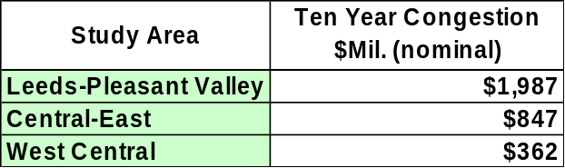

The application of the generic solutions to the three study areas all result in production cost savings:
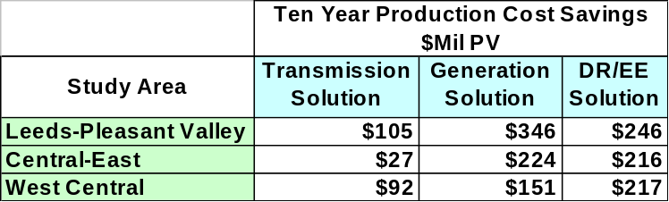

CARIS uses the comparison of the present value of the production cost savings benefit to construction and fixed carrying costs for Phase 1 to set a Benefit/Cost Ratio.

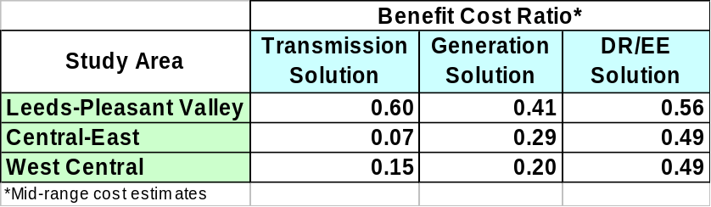

The studies have also identified potential improvements to the ICAP supply available to support NYCA’s reliability requirements.

 | ICAP Benefit MW
Study Area | Transmission Solution | Generation Solution | DR/EE Solution
Leeds-Pleasant Valley | 250 | 595 | 225
Central-East | 0 | 255 | 70
West Central | 0 | 220 | 70

Care should be taken in the interpretation and use of these B/C ratios as there are likely to be benefits beyond the ten year period that are not taken into consideration here.
The Leeds-Pleasant Valley constraint was found to have the highest forecast for congestion. The generic solutions applied here provide the greatest benefit and have the highest B/C ratios. Emission changes related to the use of the generic solutions also fit the pattern.

The Central-East constraint is forecast to have the second highest congestion. The application of generic solutions here yield less attractive results because the value of relieving this congestion remains largely bottled up behind Leeds-Pleasant Valley.

The West-Central constraint is forecasted to have the third ranked congestion value. The value of the benefits derived from the application of the generic solutions are less here because they largely remain bottled up behind both Central-East and Leeds-Pleasant Valley.

The scenario analysis provided useful insight on the sensitivity of forecasted congest values to differing future states. Variations in some inputs provide results that are consistent across NYCA while other inputs yield results that are specific to each zone.

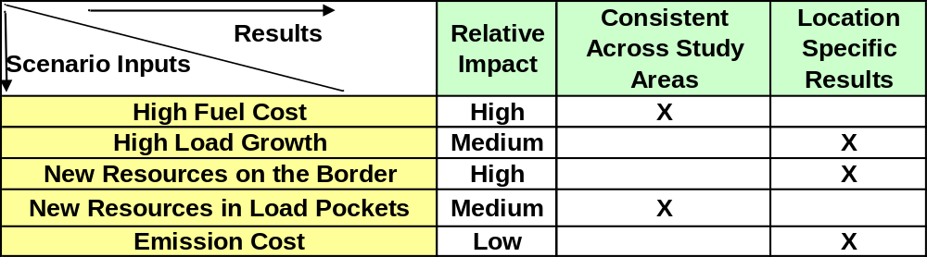

In conclusion, CARIS provides forecasts of; congestion in the NYCA system, the changes in those forecasts resulting from the application of a various generic solutions, and the sensitivity of the identified congestion to changes of inputs representing differing views of future states. The CARIS process is suitable for evaluating transmission projects designed to relieve congestion, for identifying beneficiaries and for quantifying their respective cost allocations.

- Next Steps

Additional CARIS Studies
In addition to the three CARIS studies, any interested party can request an additional study of congestion on the NYCA bulk power system at any time. Those studies can analyze the benefits of alleviating congestion with all types of resources, including transmission, generation and demand response, and compare benefits to costs.

Phase 2 – Specific Transmission Project Phase
Upon the approval of the Phase 1 study results by the NYISO Board, the NYISO staff will start conducting Phase 2 - the Project Phase - of the CARIS process. Phase 2 deals with the specific project proposals seeking cost recovery submitted by the developers to mitigate congestion identified in Phase 1. Regulated economic transmission project proposals addressing the congestion identified in Phase 1 will be considered by the NYISO in Phase 2.
Transmission projects seeking cost recovery will be further assessed by NYISO staff to determine whether they qualify for cost allocation and cost recovery under the NYISO Tariff. To qualify, the total capital cost of the project must exceed $25 million, the benefits must exceed their cost measured over the first ten years from the proposed commercial operation date, and a super-majority (> 80%) of the weighted vote cast must be in favor of the project. Additional details on Phase 2 process can be found in Appendix F and Initial CARIS Manual.

Project Phase Schedule
Phase 2 of the CARIS process will start after the NYISO Board’s approval of the Phase 1 study results, which is anticipated to occur in the beginning of 2010. Throughout the 2010, NYISO staff will be evaluating submitted regulated economic transmission proposals for benefit/cost analysis, and if a developer seeks cost recovery, determining beneficiaries. The results of these analyses will provide a basis for beneficiary voting on each proposed transmission project. Upon the completion of the 2011 CRP, the next CARIS cycle will start.

Appendix A – Glossary

TERM | DEFINITION
Ancillary Services | Services necessary to support the transmission of Energy from Generators to Loads, while maintaining reliable operation of the NYS Power System in accordance with Good Utility Practice and Reliability Rules. Ancillary Services include Scheduling, System Control and Dispatch Service; Reactive Supply and Voltage Support Service (or “Voltage Support Service”); Regulation Service; Energy Imbalance Service; Operating Reserve Service (including Spinning Reserve, 10-Minute Non-Synchronized Reserves and 30-Minute Reserves); and Black Start Capability. [FROM SERVICES TARIFF]
Bid Production Cost | Total cost of the Generators required to meet Load and reliability Constraints based upon Bids corresponding to the usual measures of Generator production cost (e.g., running cost, Minimum Generation Bid, and Start Up Bid). [FROM SERVICES TARIFF]
Bulk Power Transmission Facility (BPTF) | Transmission facilities that are system elements of the bulk power system which is the interconnected electrical system within northeastern North America comprised of system elements on which faults or disturbances can have a significant adverse impact outside of the local area.
Business Issues Committee (BIC) | A NYISO committee that is charged with, among other things, the responsibility to establish procedures related to the efficient and non-discriminatory operation of the electricity markets centrally coordinated by the NYISO, including procedures related to bidding, Settlements and the calculation of market prices.
Capacity | The capability to generate or transmit electrical power, or the ability to reduce demand at the direction of the NYISO.
Chicago Climate Futures Exchange (CCFE) | A landmark derivatives exchange that offers standardized and cleared futures and options contracts on emission allowances and other environmental products.
Clean Air Markets Division (CAMD) | A division of the US Environmental Protection Agency responsible for various market-based regulatory programs that are designed to improve air quality by reducing outdoor concentrations of fine particles, sulfur dioxide, nitrogen oxides, and mercury.
Comprehensive Reliability Plan (CRP) | An annual study undertaken by the NYISO that evaluates projects offered to meet New York’s future electric power needs, as identified in the Reliability Needs Assessment (RNA). The CRP may trigger electric utilities to pursue regulated solutions to meet Reliability Needs if market-based solutions will not be available by that point. It is the second step in the Comprehensive Reliability Planning Process (CRPP)
Comprehensive Reliability Planning Process (CRPP) | The annual process that evaluates resource adequacy and transmission system security of the state’s bulk electricity grid over a 10-year period and evaluates solutions to meet those needs. The CRPP consists of two studies: the RNA, which identifies potential problems, and the CRP, which evaluates specific solutions to those problems.
Comprehensive System Planning Process (CSPP) | A transmission system planning process that is comprised of three components: 1) Local transmission planning; 2) Compilation of local plans into the Comprehensive Reliability Planning Process (CRPP), which includes developing a Comprehensive Reliability Plan (CRP); 3) Channeling the CRP data into the Congestion Assessment and Resource Integration Study (CARIS)
Congestion | Transmission paths that are constrained, which may limit power transactions because of insufficient capability.
Congestion Rent | The opportunity costs of transmission Constraints on the NYS Transmission System. Congestion Rents are collected by the NYISO from Loads through its facilitation of LBMP Market Transactions and the collection of Transmission Usage Charges from Bilateral Transactions.
Contingencies | Electrical system events (including disturbances and equipment failures) that are likely to happen.
Day Ahead Market (DAM) | A NYISO-administered wholesale electricity market in which capacity, electricity, and/or Ancillary Services are auctioned and scheduled one day prior to use. The DAM sets prices as of 11 a.m. the day before the day these products are bought and sold, based on generation and energy transaction bids offered in advance to the NYISO. More than 90% of energy transactions occur in the DAM.
DC tie-lines | A high voltage transmission line that uses direct current for the bulk transmission of electrical power between two control areas. [?]
Demand Response | A mechanism used to encourage consumers to reduce their electricity use during a specified period, thereby reducing the peak demand for electricity.
Eastern Interconnection Planning Collaborative (EIPC) | A group of planning authorities convened to establish processes for aggregating the modeling and regional transmission plans of the entire Eastern Interconnection and for performing inter-regional analyses to identify potential opportunities for efficiencies between regions in serving the needs of electrical customers.
Economic Dispatch of Generation | The operation of generation facilities to produce energy at the lowest cost to reliably serve consumers.
Electric System Planning Working Group (ESPWG) | A NYISO governance working group for Market Participants designated to fulfill the planning functions assigned to it. The ESPWG is a working group that provides a forum for stakeholders and Market Participants to provide input into the NYISO’s Comprehensive Reliability Planning Process (CRPP), the NYISO’s response to FERC reliability-related Orders and other directives, other system planning activities, policies regarding cost allocation and recovery for reliability projects, and related matters.
Energy Efficiency Portfolio Standard (EEPS) | A statewide program ordered by the NYSPSC in response to the Governor’s call to reduce New Yorkers' electricity usage by15% of forecast levels by the year 2015, with comparable results in natural gas conservation. Also known as 15x15.
Exports | A Bilateral Transaction or purchases from the LBMP Market where the Energy is delivered to a NYCA Interconnection with another Control Area. [FROM SERVICES TARIFF]
External Areas | Neighboring Control Areas including HQ, ISO-NE, PJM, IESO
Federal Energy Regulatory Commission (FERC) | The federal energy regulatory agency within the US Department of Energy that approves the NYISO’s tariffs and regulates its operation of the bulk electricity grid, wholesale power markets, and planning and interconnection processes.
FERC Form 715 | An annual transmission planning and evaluation report required by the FERC – filed by the NYISO on behalf of the transmitting utilities in New York State.
FERC Order No. 890 | Adopted by FERC in February 2007, Order 890 is a change to FERC’s 1996 open access regulations (established in Orders 888 and 889). Order 890 is intended to provide for more effective competition, transparency and planning in wholesale electricity markets and transmission grid operations, as well as to strengthen the Open Access Transmission Tariff (OATT) with regard to non-discriminatory transmission service. Order 890 requires Transmission Providers – including the NYISO – have a formal planning process that provides for a coordinated transmission planning process, including reliability and economic planning studies.
Grandfathered Rights | The transmission rights associated with: (1) Modified Wheeling Agreements; (2) Transmission Facility Agreements with transmission wheeling provisions; and (3) Third Party Transmission Wheeling Agreements (“TWA”) where the party entitled to exercise the transmission rights associated with such Agreements has chosen, as provided in the Tariff, to retain those rights rather than to convert those rights to TCCs. [FROM SERVICES TARIFF]
Grandfathered TCCs | The TCCs associated with: (1) Modified Wheeling Agreements; (2) Transmission Facility Agreements with transmission wheeling provisions; and (3) Third Party TWAs where the party entitled to exercise the transmission rights associated with such Agreements has chosen, as provided by the Tariff, to convert those rights to TCCs. [FROM SERVICES TARIFF]
Grid View Software | An analytic tool for market simulation and asset performance evaluations.
Heat Rate | A measurement used to calculate how efficiently a generator uses heat energy. It is expressed as the number of BTUs of heat required to produce a kilowatt-hour of energy. Operators of generating facilities can make reasonably accurate estimates of the amount of heat energy a given quantity of any type of fuel, so when this is compared to the actual energy produced by the generator, the resulting figure tells how efficiently the generator converts that fuel into electrical energy.
High Voltage Direct Current (HVDC) | A transmission line that uses direct current for the bulk transmission of electrical power, in contrast with the more common alternating current systems. For long-distance distribution, HVDC systems are less expensive and suffer lower electrical losses.
Hurdle Rate | The minimum acceptable rate of return.
Imports | A Bilateral Transaction or sale to the LBMP Market where Energy is delivered to a NYCA Interconnection from another Control Area.
Independent Market Advisor | Person, persons or consulting firm retained by the NYISO Board pursuant to Article 4 of the NYISO’s Market Monitoring Plan.
Independent System Operator (ISO) | An organization, formed at the direction or recommendation of the Federal Energy Regulatory Commission (FERC), which coordinates, controls and monitors the operation of the electrical power system, usually within a single US State, but sometimes encompassing multiple states.
Installed Capacity (ICAP) | A generator or load facility that complies with the requirements in the Reliability Rules and is capable of supplying and/or reducing the demand for energy in the NYCA for the purpose of ensuring that sufficient energy and capacity are available to meet the Reliability Rules.
Installed Reserve Margin (IRM) | The amount of installed electric generation capacity above 100% of the forecasted peak electric consumption that is required to meet New York State Reliability Council (NYSRC) resource adequacy criteria. Most planners consider a 15-20% reserve margin essential for good reliability.
Load | A term that refers to either a consumer of Energy or the amount of demand (MW) or Energy (MWh) consumed by certain consumers. [FROM SERVICES TARIFF]
Locational Capacity Requirement (LCR) | Zone K and Zone J
Load Serving Entity (LSE) | Any entity, including a municipal electric system and an electric cooperative, authorized or required by law, regulatory authorization or requirement, agreement, or contractual obligation to supply Energy, Capacity and/or Ancillary Services to retail customers located within the NYCA, including an entity that takes service directly from the NYISO to supply its own Load in the NYCA. [FROM SERVICES TARIFF]
Load Zones | The eleven regions in the NYCA connected to each other by identified transmission interfaces. Designated as Load Zones A-K.
Local Transmission Planning Process (LTPP) | The first step in the Comprehensive System Planning Process (CSPP), under which stakeholders in New York’s electricity markets participate in local transmission planning.
Locational Based Marginal Pricing (LBMP) | The price of Energy at each location in the NYS Transmission System.
MAPS Software | An analytic tool for market simulation and asset performance evaluations.
Market Based Solution | Investor-proposed projects that are driven by market needs to meet future reliability requirements of the bulk electricity grid as outlined in the RNA. Those solutions can include generation, transmission and Demand Response Programs.
Market Participant | An entity, excluding the NYISO, that produces, transmits sells, and/or purchases for resale capacity, energy and ancillary services in the wholesale market. Market Participants include: customers under the NYISO’s tariffs, power exchanges, TOs, primary holders, load serving entities, generating companies and other suppliers, and entities buying or selling transmission congestion contracts.
New York Control Area (NYCA) | The area under the electrical control of the NYISO. It includes the entire state of New York, and is divided into 11 zones.
New York Independent System Operator (NYISO) | Formed in 1997 and commencing operations in 1999, the NYISO is a not-for-profit organization that manages New York’s bulk electricity grid – a 10,775-mile network of high voltage lines that carry electricity throughout the state. The NYISO also oversees the state’s wholesale electricity markets. The organization is governed by an independent Board of Directors and a governance structure made up of committees with Market Participants and stakeholders as members.
New York State Energy Planning Board (SEPB) | Established by New York’s governor in April 2008 to create a state energy plan (SEP) that examines and lays out goals addressing all aspects of New York’s energy use and conservation.
New York State Reliability Council (NYSRC) | A not-for-profit entity whose mission is to promote and preserve the reliability of electric service on the New York State Power System by developing, maintaining, and, from time-to-time, updating the Reliability Rules which shall be complied with by the New York Independent System Operator ("NYISO") and all entities engaging in electric transmission, ancillary services, energy and power transactions on the New York State Power System.
Nomogram | Nomograms are used to model relationships between system elements. These can include; voltage or stability related to load level or generator status; two interfaces related to each other; generating units whose output is related to each other; and operating procedures.
Northeast Coordinated System Planning Protocol (NCSPP) | ISO New England, PJM and the NYISO work together under the Northeast Coordinated System Planning Protocol (NCSPP), to analyze cross-border issues and produce a regional electric reliability plan for the northeastern United States.
NYISO Governance Process | A shared governance process by which representatives from stakeholder groups discuss debate and vote on issues directly affecting the NYISO’s operations, reliability and markets. The three committees – Management, Operating and Business Issues – are supported by several subcommittees, which are made up of individuals from five major sectors of the marketplace: Transmission Owners, Generation Owners, Other Suppliers, End-Use Consumers, and Public Power and Environmental Parties.
Operating Reserves | Capacity that is available to supply Energy or reduce demand and that meets the requirements of the NYISO. [SERVICES TARIFF TERM]
Overnight Costs | Direct permitting, engineering and construction costs with no allowances for financing costs.
Phase Angle Regulator (PAR) | Device that controls the flow of electric power in order to increase the efficiency of the transmission system.
Plan NYC | New York City goal, announced by Mayor Michael R. Bloomberg in 2007, of reducing its citywide carbon emissions by 30% below 2005 levels by 2030.
Proxy Generator Bus | A proxy bus located outside the NYCA that is selected by the NYISO to represent a typical bus in an adjacent Control Area and for which LBMP prices are calculated. The NYISO may establish more than one Proxy Generator Bus at a particular Interface with a neighboring Control Area to enable the NYISO to distinguish the bidding, treatment and pricing of products and services at the Interface.
Regional Greenhouse Gas Initiative (RGGI) | A cooperative effort by ten Northeast and Mid-Atlantic states to limit greenhouse gas emissions using a market-based cap-and-trade approach.
Regional Transmission Operator (RTO) | An organization that is responsible for moving electricity over large interstate areas. They schedule the use of transmission lines; manage the interconnection of new generation and monitor the markets
Regulated Backstop Solution | Proposals required of certain TOs to meet Reliability Needs as outlined in the RNA. Those solutions can include generation, transmission or Demand Response. Non-Transmission Owner developers may also submit regulated solutions. The NYISO may call for a Gap solution if neither market-based nor regulated backstop solutions meet Reliability Needs in a timely manner. To the extent possible, the Gap solution should be temporary and strive to ensure that market-based solutions will not be economically harmed. The NYISO is responsible for evaluating all solutions to determine if they will meet identified Reliability Needs in a timely manner.
Regulation Service | An Ancillary Service. See glossary definition for Ancillary Services.
Reliability Need | A condition identified by the NYISO in the RNA as a violation or potential violation of Reliability Criteria. (OATT TERM)
Reliability Needs Assessment (RNA) | An annual report that evaluates resource adequacy and transmission system security over a 10-year planning horizon, and identifies future needs of the New York electric grid. It is the first step in the NYISO’s CRPP.
Responsible Transmission Owner (Responsible TO) | The Transmission Owner or TOs designated by the NYISO, pursuant to the NYISO Planning Process, to prepare a proposal for a regulated solution to a Reliability Need or to proceed with a regulated solution to a Reliability Need. The Responsible TO will normally be the Transmission Owner in whose Transmission District the NYISO identifies a Reliability Need.
Security Constrained Unit Commitment (SCUC) | A process developed by the NYISO, which uses a computer algorithm to dispatch sufficient resources, at the lowest possible Bid Production Cost, to maintain safe and reliable operation of the NYS Power System.
Smart Grid | A combination of transmission/distribution and communications technologies that enables the routing of power in optimal ways to respond to a wide range of conditions
Special Case Resource (SCR) | A NYISO Demand Response program designed to reduce power usage by businesses and large power users qualified to participate in the NYISO’s ICAP market. Companies that sign up as SCRs are paid in advance for agreeing to cut power upon NYISO request.
Stakeholders | A person or group that has an investment or interest in the functionality of New York’s transmission grid and markets.
Thermal transfer limit | The maximum amount of heat a transmission line can withstand. The maximum reliable capacity of each line, due to system stability considerations, may be less than the physical or thermal limit of the line.
Transfer Capability | The amount of electricity that can flow on a transmission line at any given instant, respecting facility rating and reliability rules.
Transmission Congestion Contract (TCC) | The right to collect, or obligation to pay, Congestion Rents in the Day Ahead Market for Energy associated with a single MW of transmission between a specified Point Of Injection and Point Of Withdrawal. TCCs are financial instruments that enable Energy buyers and sellers to hedge fluctuations in the price of transmission. (SERVICES TARIFF TERM)
Transmission Constraint | Limitations on the ability of a transmission facility to transfer electricity during normal or emergency system conditions.
Transmission District | The geographic area served by the Investor Owned Transmission Owners and LIPA, as well as the customers directly interconnected with the transmission facilities of the Power Authority of the State of New York. (SERVICES TARIFF TERM)
Transmission Interface | A defined set of transmission facilities that separate Load Zones and that separate the NYCA from adjacent Control Areas. (SERVICES TARIFF TERM)
Transmission Line Losses | Power consumed by the delivery system from electric current overcoming the resistance of the wires, transformers and other components of the power system that result in power being converted into heat.
Transmission Owner (TO) | A public utility or authority that provides Transmission Service under the Tariff
Transmission Planning Advisory Subcommittee (TPAS) | A group of Market Participants that advises the NYISO Operating Committee and provides support to the NYISO Staff in regard to transmission planning matters including transmission system reliability, expansion, and interconnection.
Wheels Through | Transmission Service, originating in another Control Area that is wheeled through the NYCA to another Control Area. [SERVICES TARIFF TERM]
Working Groups | Groups comprised of NYISO stakeholders, convened to address transmission system and market issues under the NYISO governance system.

For purpose of representing demand response in the software used, the NYISO modeled demand response resources as consisting of half energy efficiency measures and half demand response.
The NYISO reports historic congestion analysis since 2003.
The NYISO anticipates that any lessons learned from completion of the first CARIS study will be used to refine and improve the economic planning process.
http://www.nyiso.com/public/webdocs/services/planning/initial_caris_manual_bic_approved/CARISmanual.pdf.
The NYISO benefit/cost analysis will be forwarded to the BIC and to the MC for discussion and action. The beneficiary determination and associated voting percentages will be provided to the BIC and the MC for review and comment, but not approval.
Section 11.3.d of the Tariff specifies that the principal benefit metric for the CARIS analysis.
Section 11.3.d of the Tariff specifies the additional metrics. The additional metrics allow LSEs to consider other parameters when evaluating or comparing potential projects.
For the future CARIS cycles, the NYISO will develop a methodology to reflect potential changes in ICAP costs separate from this temporary approach which is not meant to set precedence for the more fully developed ICAP cost methodology applicable to future CARIS cycles.
While the system topology and resource additions are the same as in the 2009 CRP, additional data inputs were needed for the CARIS studies since the CRP studies employed transmission and resource adequacy analyses while the CARIS uses production cost analysis requiring additional inputs
“SCR” values reflect projected August 2009 ICAP capability period values held constant over the ten-year Study Period.
New York Control Area (NYCA) "Capacity" values include resources internal to New York, additions, reratings, retirements, purchases and sales, and UDRs with firm capacity. Zone K "Capacity" values include UDRs with firm capacity. Wind generation values include full nameplate capacity.
Central East was not modeled explicitly in the RNA/CRP but was modeled with the Fraser - Gilboa circuit. UPNY/ConEd was modeled with a nomogram in the RNA/CRP whereby one of two different 300 MW reductions from the 5300 MW limit in 2009 and 2010 nre applied depending upon the generation availability and load in SENY. This was simplified to one value of 5000 MW for CARIS study. Although the RNA analysis indicated an increase to from 5000 MW to 5500 MW, in 2011, 2012, 2013, the 5000 MW was held constant fohe in 2011-2018 forfor CARIe was not constraining and there was no need to calew sensiivity factors the nomogram at the higher transfer.limits.
www.eia.doe.gov
Prior to 2008, this data was submitted via FERC Form 423. 2008 onwards, the same data are collected on Schedule 2 of the new Form EIA-923. See http://www.eia.doe.gov/cneaf/electricity/page/ferc423.html
This is a two-step process: First, using multi-year time-series, deviations around a time-varying trend (e.g. a centered 12-month moving average or a Hodrick-Prescott Filtered trend) were calculated; second, a 4-degree polynomial trend was fitted to the estimated seasonal factors.
These forecasts were, in turn, based on EIA’s current national long-term forecast of delivered fuel-prices.
Ontario Wholesale Electricity Market Price Forecast For the Period May 1, 2008 through October 31, 2009, Presented to Ontario Energy Board, April 11, 2008 by Navigant Consulting Inc., Toronto, Ontario.
NERA/Sargent & Landy, Quanta Services, and Brattle Group were retained to provide the initial cost assessment for the generation, transmission and demand response solutions.
For future CARIS studies, the NYISO will utilize an additional block size of 138kV, 500MVA for Zone J in order to address potential congested load pockets in NYC and at such time develop the respective cost estimates. kV, 500 MVA for Zone J in order to address potential congested load pockets in Y
For this CARIS cycle Demand Resource costs considered potential market value and not actual costs to build or implement DSM. In the next CARIS cycle the actual cost estimates will be considered for Demand Response solutions.
The Capital Recovery Factor is calculated over the 10-year period.
Market-based responses to congestion identified in Phase 1 of the CARIS are not eligible for regulated return and therefore are not obligated to follow the requirements of Phase 2. The cost of a market-based project shall be the responsibility of the developer.

