2020 RNA

Reliability Needs Assessment

Comprehensive System Planning Process

------------------

A Report by the

New York Independent

System Operator

------------------

DRAFT Report

For August 20, 2020 ESPWG/TPAS

Table of Contents

Executive Summary 1

1. Introduction 2

2. Overview of Reliability Planning Process Changes 6

3. Summary of Prior Comprehensive Reliability Plans 8

4. Regulatory Policy Activities 10

Climate Leadership and Community Protection Act (CLCPA) 12

Indian Point Deactivation 12

Peaker Rule: Ozone Season Oxides of Nitrogen (NOx) Emission Limits for Simple Cycle and Regenerative Combustion Turbines 13

New York City Residual Oil Elimination 14

Carbon Dioxide Performance Standards for Major Electric Generating Facilities 14

Regional Greenhouse Gas Initiative (RGGI) 14

NYS Accelerated Renewable Energy Growth and Community Benefit Act 15

5. Base Case Assumptions 16

Annual Energy and Summer Peak Demand Forecasts 17

Forecast of Special Case Resources 24

2020 RNA Resource Additions and Removals 24

Additional Proposed Projects from the Interconnection Queue 29

Local Transmission Plans 33

Bulk Transmission Projects 34

Base Case Peak Load and Resources Summaries 34

6. Base Case Reliability Needs Assessments 38

Overview 38

Methodology for the Determination of Needs 38

Resource Adequacy Base Case Assessments 40

Resource Adequacy Simulations Conclusions 52

Transmission Security Base Case Assessments 52

Steady-State Assessments 52

System Stability Assessments 54

Short Circuit Assessments 58

Transmission Owner Local Criteria Violations 58

7. Base Case Variation Scenarios 63

High Load Forecast Scenario 64

Zonal Resource Adequacy Margin (ZRAM) 65

Status-Quo Scenario 66

8. “70x30” Scenario – [IN PROGRESS] 69

Scope 69

Assumptions 69

Resource Adequacy Methodology and Results 69

Transmission Security Methodology and Results 69

Key Findings of the “70x30” Scenario 69

9. Reliability Compliance Obligations and Activities 70

NPCC/NYSRC Area Transmission Reviews (ATRs) 72

NERC Planning Assessments (TPL-001) 73

Resource Adequacy Compliance Efforts 74

10. A Grid In Transition: Reliability Gap Analysis 76

11. Observations and Recommendations 77

List of Figures

Figure 3: The NYISO’s Comprehensive System Planning Process (CSPP) 2

Figure 4: NYISO RPP 5

Figure 5: Current Status of Tracked Market-Based Solutions and TOs’ Plans 9

Figure 54: Summary Table of Key Environmental Regulations and Energy Policies 11

Figure 6: 2020 RNA Load and Energy Forecast: Baseline Forecast, and Baseline with BtM Solar PV Forecasts Added Back In 19

Figure 7: 2020 RNA Load and Energy for High Load Scenario: High Load Scenario Forecast, and High Load Scenario Forecast with BtM Solar PV Added Back In 20

Figure 8: Comparison of 2018 RNA & 2020 Baseline Forecasts 21

Figure 9: 2020 Baseline and High Load Scenario Energy Forecasts with Solar PV Added Back 22

Figure 10: 2020 Baseline and High Load Energy Scenario Summer Peak Demand Forecasts with Solar PV Added Back 22

Figure 11: 2020 Baseline Annual Energy Forecast Impacts 23

Figure 12: 2020 Baseline Summer Peak Demand Forecast Impacts 23

Figure 13: Forecast of BTM Solar PV Coincident Summer Peak Demand Reductions (MW) 24

Figure 14: Proposed Projects Included in the 2020 RNA Base Case 26

Figure 15: 2020 RNA Generation Deactivations Assumptions 27

Figure 16: Existing Plants Impacted by DEC’s Peaker Rule (additional details on peakers status by ozone season are in Appendix D) 28

Figure 17: Additional Proposed Generation Projects from the 2020 Gold Book 30

Figure 18: Additional Proposed Transmission Projects from the 2020 Gold Book 33

Figure 19: NYCA Peak Load and Resources 2024 through 2030 35

Figure 19a: ICAP vs UCAP for 2030 36

Figure 20: NYCA Load and Resources Comparison with the 2019 - 2028 CRP 37

Figure 21: 2020 RNA Zone J Load and Capacity Comparison with the 2019 - 2028 CRP 37

Figure 22: Transmission System Thermal Emergency Transfer Limits 43

Figure 23: Transmission System Voltage Emergency Transfer Limits 43

Figure 24: Transmission System Base Case Emergency Transfer Limits 43

Figure 25: 2020 RNA Topology Year 4 -10 (2024 -2030) 45

Figure 26: Topology Year 1 (2021) 46

Figure 27: Topology Year 2- 3 (2022- 2023) 47

Figure 28: NYCA Resource Adequacy Results 48

Figure 29: 2020 RNA Zone J Load and Capacity Comparison with the 2019 – 2028 CRP 49

Figure 30: Compensatory MW Additions for Resource Adequacy Violations 50

Figure 31: NYCA Free Flow Simulation Results 51

Figure 32: Steady State Transmission Security N-1-1 Violations 53

Figure 33: Steady State Transmission Security N-1-1-0 Violations 53

Figure 34: Dynamic Stability Criteria N-1 Violations (placeholder) 54

Figure 35: Dynamic Stability Criteria N-1-1 Violations (L/O Ravenswood 3 as First Level Event) (placeholder) 54

Figure 36: New York City (NYC) 345 kV Bus Voltage Recovery 55

Figure 37: High Side of GSU Voltage 56

Figure 38: Generator Synchronism 57

Figure 39: Description of Dynamic MVA Added to System (Placeholder) 58

Figure 40: Description of Static and Dynamic MVA Added to System (Placeholder) 58

Figure 41: Astoria East/ Corona 138 kV TLA 59

Figure 42: Astoria East/ Corona 138 kV TLA Deficiency 59

Figure 43: Astoria East/Corona 138 kV Load Duration Curve for 2023 60

Figure 44: Astoria East/Corona 138 kV Load Duration Curve for 2030 60

Figure 45: Greenwood/ Fox Hills 138 kV TLA 61

Figure 46: Greenwood/ Fox Hills 138 kV TLA Deficiency 61

Figure 47: Greenwood/ Fox Hills 138 kV TLA Load Duration Curve for 2025 62

Figure 48: 2020 Gold Book NYCA High Load vs. Baseline Summer Peak Forecast 64

Figure 49: 2020 Gold Book Zone J High Load vs. Non-coincident Summer Peak Forecast 65

Figure 50: 2020 RNA Resource Adequacy High Load Scenario NYCA LOLE Results 65

Figure 51: Zonal Resource Adequacy Margin (MW) 66

Figure 52: 2020 RNA Resource Adequacy Status-quo Scenario NYCA LOLE Results 67

Figure 53: 2020 RNA Transmission Security Status-quo Scenario Results 68

Figure 55: List of NERC Standards for Planning Coordinators and Transmission Planners 71

Figure 56: Description of NERC TPL-001 Planning Assessment Study Cases 74

# Executive Summary

***[TO BE ADDED AT A LATER DATE]***

# Introduction

This report sets forth the NYISO’s 2020 Reliability Needs Assessment (RNA) and scenario findings for the newly redefined Study Period of years 4 through 10 (*i.e.,* years 2024 through 2030). The RNA is the first of two main components of the Reliability Planning Process (RPP), which is one of the three processes that comprise the NYISO’s Comprehensive System Planning Process (see Figure 3). The RNA is performed to evaluate electric system reliability according to resource adequacy and transmission security criteria over the Study Period.

Figure 3: The NYISO’s Comprehensive System Planning Process (CSPP)

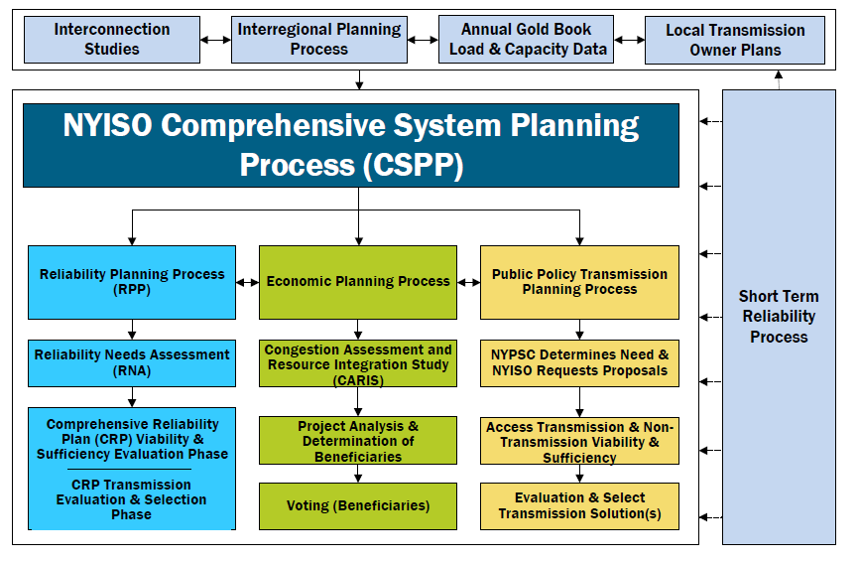

The RNA is developed by the NYISO in conjunction with stakeholders and all interested parties as the first step in the RPP. The RNA assesses the reliability of the New York Bulk Power Transmission Facilities (BPTFs) as the foundation study used in the development of the NYISO Comprehensive Reliability Plan (CRP). Two major study types are performed: resource adequacy and transmission security, over the RNA Study Period (*i.e.,* year 4 through year 10, 2024-2030). If the RNA identifies any violation of Reliability Criteria[1] for BPTFs, the NYISO will report a Reliability Need quantified by an amount of compensatory megawatts (MW) in a location that would resolve that need. After NYISO’s Board approval of the RNA and if any Reliability Needs are left after the post-RNA Base Case updates process, the NYISO will solicit market‐based solutions, designate one or more Responsible Transmission Owners to develop regulated backstop solutions to address each identified Reliability Need, and solicit alternative regulated solutions from interested parties.

The CRP details the NYISO plan for continued reliability of the BPTFs during the Study Period and identifies additional resources, or combinations of resources, that resolve any identified criteria violations in the RNA. New or proposed resources included in the CRP may be provided by market‐based solutions developed in response to market forces, and by the request for solutions. If the market does not adequately respond, reliability will be maintained by either regulated backstop solutions developed by the Responsible TOs, which are obligated to provide reliable service to their customers, or alternative regulated solutions being developed by Other Developers. To maintain the long‐term reliability of the BPTFs, these additional resources must be readily available or in development at the appropriate time to address the identified need.

Proposed solutions that are submitted in response to an identified Reliability Need are evaluated in the development of the CRP and must satisfy Reliability Criteria. However, the solutions submitted to the NYISO for evaluation in the CRP do not have to be in the same amounts of MW or locations as the compensatory MW reported in the RNA. There are various combinations of resources and transmission upgrades that could meet the needs identified in the RNA. The reconfiguration of transmission facilities and/or modifications to operating protocols identified in the solution phase could result in changes and/or modifications of the needs identified in the RNA.

This report begins by highlighting the changes to the RPP recently implemented in the NYISO’s tariffs and procedures. Next, this report summarizes the prior RPP findings and reliability plans. The report continues with a summary of the load and resource forecast for the RNA Study Period, the RNA Base Case assumptions and methodology, and the RNA findings. Detailed analyses, data and results, and the underlying modeling assumptions are contained in the appendices.

Along with addressing reliability, the RPP is also designed to provide information that is both informative and of value to the New York wholesale electricity marketplace and federal and state policy makers.

For informational purposes, this RNA report reviews activities related to environmental regulatory programs and other relevant developments. Also for informational purposes, this RNA report also provides the latest historical information and is available for the past five years of congestion on the NYISO’s website.

The 2020 RPP will serve as the foundation for the 2021 Congestion Assessment and Resource Integration Study (CARIS), which will present more detailed evaluation of system congestion. Just as important as the electric system plan is the process of planning itself. Electric system planning is an ongoing process of evaluating, monitoring, and updating as conditions warrant.

An overview of the RPP is illustrated in Figure 4 and is described in the RPP Manual.

Figure 4: NYISO RPP



# Overview of Reliability Planning Process Changes

The current RPP was approved by the Federal Energy Regulatory Commission (FERC) and its requirements are contained in Attachment Y of the NYISO’s Open Access Transmission Tariff (OATT). The detailed process of the RPP is contained in the RPP Manual.

In 2019, a major planning process was carved out of the RPP and defined as the Short-Term Reliability Process (STRP). This process was approved by the FERC and its requirements are contained in [Attachments Y and FF of the NYISO’s OATT](http://www.nyiso.com/public/webdocs/documents/tariffs/oatt/att_y.pdf). With this process in place, the RPP’s Study Period changes from a year 1 to year 10 analysis, into a year 4 to year 10 look ahead. At the same time, the STRP evaluates year 1 through year 5 from the Short Term Assessment of Reliability (STAR) Start Date, with a focus on Short-Term Reliability Needs arising in years 1 through 3 of the Study Period. Each quarterly STRP concludes if the STAR or Generator Deactivation Assessment does not identify a STRP Need, and states whether a STRP Need will be addressed in the RPP or in the STRP.

Short-Term Reliability Process Needs that arise in the Near Term (within three years) will be addressed using the Short-Term Reliability Process (STRP).  Short-Term Reliability Process Needs that are not Near-Term needs on the BPTF will only be addressed using the STRP if an identified Reliability Need cannot timely be addressed through the ISO’s Reliability Planning Process.  If the Reliability Need is handled through the STRP, the NYISO will solicit market-based solutions of all types, a regulated transmission solution(s), and service offers from Generators, as appropriate.  The NYISO will select a solution(s) consistent with the STRP process which may include selecting Generators to remain in service under temporary Reliability Must Run (RMR) agreements until the transmission solution is complete.

One of the changes to the RPP, which was first implemented in the 2016 RNA, is providing initial (“1st pass”) RNA results to stakeholders, usually in June of the first year of the biennial planning process. The stakeholders can provide project updates focused on reducing or eliminating the initial Reliability Needs, if any are identified, such as:

* Updated LTPs
* Changes in BPTFs
* Changes in available resources such as generating unit status or authority to operate in current equipment configuration past a date certain (*e.g.*, due to a new or amended environmental laws or regulations) [2]
* Changes in load forecast or demand response resources.

If the NYISO determines that an update does not meet the inclusion rules and/or does not impact the preliminary Reliability Need, then the NYISO will not incorporate the change into the final RNA Base Case.

After the NYISO Board of Directors approves the RNA Report, and before NYISO issues a solicitation for regulated backstop, market-based, and alternative regulated solutions, the NYISO will request updated LTPs, NYPA transmission plans, and other[3] status updates relevant to reducing, or eliminating, the Reliability Needs, as timely received from Market Participants, Developers, TOs, and other parties. Changes that would tend to increase the scope of Reliability Needs after the RNA lockdown date will be handled in the Short-Term Reliability Process or a future RNA, as appropriate. The NYISO will then request solutions for the remaining Reliability Needs, if any.

The 2018 version of the RPP Manual reflects a change in the “RNA Base Case Development Process” section, mainly related to the Base Case inclusion rules applicable to proposed projects, and also to the treatment of generation deactivations in the RNA Base Case. Specifically, additional considerations were added in 2019 to reflect situations in which a Generator Owner lacks authority to operate in its current equipment configuration past a date certain (*e.g.,* due to a new or amended environmental law or regulation).

Further details of the RPP and STRP are contained in **Appendix B** of this report, and also in the [RPP Manual](https://www.nyiso.com/documents/20142/2924447/rpp_mnl.pdf) located on the NYISO website. An overview of the RPP, including the updated RNA process, is illustrated in Figure 4 above, and is also described in the RPP Manual.

# Summary of Prior Comprehensive Reliability Plans

This RNA is the tenth RNA the NYISO is conducting since the reliability planning process was initially approved by FERC in December 2004. The first three RNA reports identified Reliability Needs and the first three CRPs (2005-2007) evaluated the market-based and regulated backstop solutions submitted in response to those identified needs. The 2009 RNA and the 2010 RNA indicated that the system did not exhibit any violations of applicable Reliability Criteria. Accordingly, the NYISO did not solicit solutions under the Comprehensive Reliability Plan (CRP) process. The 2012 RNA identified Reliability Needs, and the 2012 CRP evaluated market-based and regulated solutions in response to those needs.

The 2014 RNA identified both resource adequacy and transmission security related Reliability Needs, which were subsequently eliminated by the system updates received during the 2014 CRP process.

The 2016 RNA identified two transmission security Reliability Needs beginning in 2017: the New York State Electric & Gas Corp. (NYSEG) Oakdale 345/115 kV transformer, and the Long Island Power Authority (LIPA) East Garden City to Valley Stream 138 kV line. Subsequent to the October 2016 approval of the RNA, and prior to the start of the CRP (as described in the RPP Manual), NYSEG and LIPA provided updates to their LTPs. With these updates the two identified Reliability Needs were resolved, and there was no solicitation of solutions under the 2016 RPP cycle.

The 2018 RNA concluded that the New York State Bulk Power Transmission Facilities will meet all applicable Reliability Criteria over the 2019 through 2028 study period.

The NYISO has not previously triggered any regulated backstop solutions to meet previously-identified Reliability Needs due to changes in system conditions and the sufficiency of market solutions coming into service.

Figure 5 below presents the market solutions and TOs’ plans that were submitted in response to previous requests for solutions.

Figure 5: Current Status of Tracked Market-Based Solutions and TOs’ Plans



# Regulatory Policy Activities

The Climate Leadership and Community Protection Act (CLCPA) is the public policy initiative shaping how energy will be supplied in New York State. The New York State Department of Environmental Conservation (NYSDEC) “Peaker Rule” requires significant emission reductions from older high emitting gas turbines, which will result in some decisions to deactivate affected units in 2023 and 2025. These two initiative will lead to large changes in the type of resources available to serve the demand in NY.

To support the development of clean energy in this competitive environment, contracts for Renewable Energy Credits (RECs) between the state and developers were established. The CLCPA calls for growing the portion of load served by renewable resources to 70% by 2030. Looking beyond 2030, the CLCPA requires a zero-emission grid by 2040. The RNA 70x30 Scenario in conjunction with other studies being performed by the NYISO, such as the Climate Change Impact & Resilience Study, takes an initial review of the reliability implications of the CLCPA targets.

At the federal, state, and local levels, public policy initiatives are shaping the grid of the future. How the grid is operated to maintain reliability and economic efficiency while achieving these policies requires careful and informed operations, market design, and planning. From this perspective, the NYISO is examining a number of public policy initiatives, and engaging stakeholders and policymakers to identify the challenges and opportunities these initiatives may present to bulk power system reliability and efficiency.

Figure 54: Summary Table of Key Environmental Regulations and Energy Policies

|  |  |  |  |
| --- | --- | --- | --- |
| PUBLIC POLICY INITIATIVE | POLICYMAKING ENTITIES | PUBLIC POLICY GOALS | PUBLIC POLICY IMPLICATIONS |
| Climate Leadership and Community Protection Act | New York State Public Service Commission, New York State Energy Research and Development Authority,  New York State Department of Environmental Conservation, Climate Action Council | **6,000 MW** of distributed solar installed by 2025, **185 trillion** BTU reduction in total  energy consumption, including electrification to reduce fossil fuel use in buildings by 2025, **3,000 MW** of storage installed by 2030, **70%** of load supplied by renewable resources by 2030, **9,000 MW** of Offshore Wind Installed by 2035, **100%** of load supplied by zero- emissions resources by 2040 | **Transformation of the power grid,** necessitating examination of market structures, planning processes, flexible load, and investment in bulk power system infrastructure |
| Indian Point Deactivation | Agreement between  New York State and Entergy | Deactivate Indian Point units 2 and 3 by **2020** and **2021**, respectively | The NYISO issued a deactivation assessment finding no reliability need associated with loss of Indian Point’s **2,311 MW** assuming the addition of certain expected resources. Subsequently, unit 2 deactivated on April 30, 2020.  Unit 3 is scheduled to deactivate in **April 2021** |
| New York City Residual Oil Elimination | City of New York | Eliminate combustion of fuel oil numbers 6 and 4 in New York City by **2020** and **2025,** respectively | **2,946 MW** of installed capacity affected by rule |
| CO2 Performance Standards  for Major Electric Generating Facilities | New York State Department of Environmental Conservation (DEC) | Establish restrictions on carbon dioxide emissions for fossil fuel- fired facilities in New York by **2020** | As of **April 2020,** all coal-fired generation facilities supplying the bulk power system deactivated. NYISO generator deactivation assessments found no reliability needs associated with these deactivations |
| Regional Greenhouse Gas Initiative (RGGI) | New York and other RGGI states | Reduce carbon dioxide emissions cap by 30% from 2020 to 2030 and expand applicability to currently exempt “peaking units” below current 25 MW threshold | The NYS DEC proposed to expand applicability in NYS to generators of **15 MW** or greater, whereas current rules do not apply to generators **less than 25 MW** |
| “Peaker Rule”  Ozone Season Oxides of Nitrogen (NOx) Emissions Limits for simple cycle and regenerative combustion turbines | New York State Department of Environmental Conservation (DEC) | Reduce ozone-contributing pollutants associated with New York State-based peaking unit generation. Compliance obligations phased in between **2023** and **2025** | DEC rule impacts approximately **3,300 MWs** of peaking unit capacity in New York State. The NYISO is analyzing compliance plans through its Reliability Needs Assessment (RNA) to determine whether they give rise to reliability needs |
| NYS Accelerated Renewable Energy Growth and Community Benefit Act | Office of Renewable Energy Siting (ORES) within the NYS Department of State, New York State Public Service Commission, New York State Energy Research and Development Authority (NYSERDA) | Provides for an accelerated path for the permitting and construction of renewable energy projects instead of through the Article 10 power plant  siting law. Requires a comprehensive study to identify cost-effective distribution, local and bulk electric system upgrades to support the state's climate goals, and filing of  the study with the New York State  Public Service Commission. | Intended to help **accelerate siting of eligible renewable resources** in support of state policy goals. Intended to establish new transmission investment priorities to facilitate the achievement of state policies |

## Climate Leadership and Community Protection Act (CLCPA)

On July 18, 2019, the Climate Leadership and Community Protection Act (CLCPA) was signed into law, codifying the following measures:

* 70% of electricity delivered in New York State must be derived from renewable resources by 2030;
* 100% of the electricity consumed in New York State must be derived from zero-emissions resources by 2040;
* 9,000 MW of offshore wind installed by 2035;
* 6,000 MW of distributed solar energy resources installed by 2025; and
* 3,000 MW of energy storage installed by 2030.

The CLCPA created a 22-member Climate Action Council (CAC) to establish a roadmap for how the state will work towards these goals. The CAC will develop many of the implementation details of the CLCPA. The CLCPA establishes that the CAC should develop a draft scoping plan by the end of 2022 and deliver a final plan to the Governor and the Legislature by the end of 2023.

## Indian Point Deactivation

On January 9, 2017, Entergy and New York State announced an agreement to close Indian Point units 2 and 3 in 2020 and 2021, respectively. Following receipt of a deactivation notice from Entergy on November 13, 2017, the NYISO evaluated the proposed deactivation as part of the required generator deactivation assessments it performs for proposed generator retirements. In its analysis, the NYISO assumed that certain power plants then under construction would enter into service. Based on the study’s assumptions, the NYISO concluded that the proposed Indian Point deactivation did not result in a Reliability Need. Subsequent reliability planning studies have not altered this outlook. Additional resources identified in the assessment have entered into service and, on April 30, 2020, Indian Point unit 2 deactivated. The NYISO anticipates that Indian Point unit 3 will deactivate by April 30, 2021 without causing a Reliability Need.

## Peaker Rule: Ozone Season Oxides of Nitrogen (NOx) Emission Limits for Simple Cycle and Regenerative Combustion Turbines

In December 2019, the DEC issued requirements to reduce emissions of smog-forming pollutants from peaking generation units.

Combustion turbines known as “peakers” typically operate to maintain bulk power system reliability during the most stressful operating conditions, such as periods of peak electricity demand. Many of these units also maintain transmission security by supplying energy within certain areas of New York City and Long Island — known as load pockets. Load pockets represent transmission-constrained geographic areas where electrical demand can only be served by local generators due to transmission limitations during certain operational conditions.

The Peaker Rule[4], which phases in compliance obligations between 2023 and 2025, will impact approximately 3,300 MW of simple-cycle turbines located mainly in the lower Hudson Valley, New York City and Long Island. The rule required peaking unit owners to submit compliance plans to the DEC in March 2020. These generator compliance plans informed the NYISO’s *2020 Reliability Needs Assessment* (RNA) base case assumptions for years 2024-2030. The proposed plans are also being examined in the NYISO Short-Term Reliability Process for the years 2021-2025. The rule provides a phased reduction in emission limits, in 2023 and 2025, during the ozone season (May 1-September 30) and allows several options for achieving compliance with the new lower limits applicable during the ozone season. Compliance plans submitted to the NYSDEC were provided to the NYISO for assessment and inclusion in the base case. Review of the plans indicated approximately 1,800 MW had proposed to modify their availability to comply with the emissions standards through various approaches over a phased timeline. Remaining units stated either that they comply with the emission limits as currently operated, or proposed equipment upgrades to achieve the emissions limits. The figure below shows the resulting availability pattern modeled in the RNA Base Case incorporating the information contained within the submitted compliance plans for the units that submitted compliance plans resulting in a change in their availability to operate.

The regulations include a provision to allow an affected generator to continue to operate up to two years, with a possible further two-year extension, after the compliance deadline if the generator is designated by the NYISO or the local transmission owner as needed to resolve a reliability need until a permanent solution is in place.

## New York City Residual Oil Elimination

New York City passed legislation in December 2017 to prohibit the combustion of fuel oil Numbers 6 and 4 within utility boilers in New York City by 2020 and 2025, respectively.The rule is expected to impact 2,946 MW Nameplate of generation in New York City. Many Generators in New York City that are connected to the local gas distribution network are required to maintain alternative fuel combustion capabilities and storage capacity.

In addition, the New York State Reliability Council (NYSRC) has a minimum oil-burn requirement rule that is intended to maintain electric system reliability in the event of gas supply interruptions.

Generators have taken steps to convert their facilities to comply with the law. While oil accounts for a relatively small percentage of the total energy production in New York State, it is often called upon to fuel generation during critical periods, such as when severe cold weather limits access to or increases the price of natural gas. Dual-fuel capability serves as both an important tool in meeting reliability and an effective economic hedge against high natural gas prices during periods of high demand for natural gas.

## Carbon Dioxide Performance Standards for Major Electric Generating Facilities

The DEC adopted regulations that limit carbon dioxide emissions from existing fossil fuel-fired generators beginning in 2021**.** As a result, approximately 860 MW of coal-fired generation exited the market by April 2020, eliminating coal-fired generation as a supply resource on the bulk power system in the state. New York’s coal-fired generation accounted for less than 1% of the total energy produced in the state in 2019. The NYISO assessed these deactivations and concluded[5] that they would not result in reliability needs.

## Regional Greenhouse Gas Initiative (RGGI)

RGGI is a multi-state carbon dioxide emissions cap-and-trade initiative requiring affected fossil fuel generators to procure carbon dioxide emissions allowances. The costs for these allowances are factored into the costs of operating fossil fuel-fired generators. Suppliers seek to recover these costs through competitive offers in the wholesale electricity markets. Through this initiative, each participating state determines a set number of allowances, the majority of which are collectively auctioned to generators or other stakeholders. The level of available allowances is established in advance and lowered over time to encourage generators to invest in emissions reduction strategies.

The New York State DEC issued proposed RGGI regulations that would cap New York’s carbon dioxide emissions at approximately 21 million tons by 2030.[6] In 2019, New York generators emitted approximately 24.6 million tons of carbon dioxide. The proposed rule seeks to expand applicability to certain generators of 15 MW or greater, whereas currently RGGI rules do not apply to generators less than 25 MW nameplate. New Jersey re-joined the initiative in 2020,Virginia will be joining in 2021, and Pennsylvania has pending legislation to join RGGI . The expansion of the RGGI region and anticipated changes to program design features may affect the dynamics of CO2 emission allowance costs and availability going forward. Tighter requirements through RGGI, however, are not likely to trigger reliability concerns because of program design features such as the Cost Containment Reserve and multi-year compliance periods.

## NYS Accelerated Renewable Energy Growth and Community Benefit Act

In an effort to speed up the siting and construction of large-scale clean energy projects, the state approved the Accelerated Renewable Energy Growth and Community Benefit Act in April 2020. The act provides an accelerated path for permitting and constructing renewable energy projects by establishing a new Office of Renewable Energy Siting (ORES) within the New York State Department of State.

The act also directs the New York State Department of Public Service, in consultation with NYSERDA, the New York Power Authority (NYPA), the Long Island Power Authority, the investor-owned utilities, and the NYISO, to conduct a comprehensive study to identify cost-effective distribution, local and bulk electric system upgrades to support the state’s climate and clean energy policies. This study is targeted to be completed by end of 2020. The PSC has commenced a proceeding leading to a transmission investment plan utilizing the NYISO’s Public Policy Process to select projects, while enabling the PSC to designate NYPA, either on its own or with others, to carry out projects needed expeditiously to achieve CLCPA goals.[7] NYPA and DPS Staff have petitioned the PSC proposing criteria for ranking transmission needs to qualify as Priority Projects and proposing the “Northern NY Project” and the “Western NY Energy Link” as meeting these criteria.[8] It is not expected that the new Renewable Energy Law will have an impact for the next several years.

# Base Case Assumptions

The NYISO has established procedures and a schedule for the collection and submission of data and for the preparation of the models used in the RNA. The RPP procedures are designed to allow planning activities to be performed in an open and transparent manner. The RPP is conducted under a defined set of rules that are aligned and coordinated with the related planning activities of the North American Electric Reliability Council (NERC), the Northeast Power Coordinating Council (NPCC), and the New York State Reliability Council (NYSRC). The assumptions underlying the RNA were reviewed at the ESPWG and TPAS and are shown in **Appendix D** of this report.

This section highlights the key assumptions and modeling data updates for the RNA. These include the load forecast model, the forecasted level of Special Case Resources, the change in generation resource status, LTPs, and Bulk Power Transmission Projects. As described above, the newly defined RNA Study Period is from year 2024 (year 4) through 2030 (year 10).

Both the transmission security and resource adequacy studies in the RNA Base Case use a peak demand and energy forecast originating from the baseline forecast reported in the 2020 Gold Book. The baseline forecast from the 2020 Gold Book is derived from energy and peak models that are built based on projections of end-use intensities and economic variables. End-use intensities modeled include those for lighting, refrigeration, cooking, heating, cooling, and other plug loads. The baseline forecast includes the projected impacts of energy efficiency programs, building codes and standards, distributed energy resources, behind-the-meter energy storage, behind-the-meter solar photovoltaic power, electric vehicle usage, and electrification of heating and other end uses. Economic variables considered include gross domestic product (“GDP”), households, population, and commercial and industrial employment. The baseline forecast also considers the near-term economic impacts of reduced energy consumption resulting from the state’s response to COVID-19. For the resource adequacy study, the baseline load forecast was modified by removing the behind-the-meter solar PV impacts in order to model the solar PV explicitly as a generation resource to account for the intermittent nature of its availability.

The RNA Base Cases were developed in accordance with NYISO procedures using projections for the installation and deactivation of generation resources and transmission facilities that were developed in conjunction with Market Participants and TOs:

* For the transmission security evaluations, the power flow RNA Base Case uses the NYISO 2020 FERC 715 filing as a starting point, adding and removing resources consistent with the base case inclusion screening process provided in Section 3 of the RPP Manual. Representations of neighboring systems are derived from interregional transmission planning coordination conducted under the NPCC and ERAG MMWG processes, and pursuant to the Northeast ISO/RTO Planning Coordination Protocol.
* For the resource adequacy evaluations, the models are developed starting with prior resource adequacy models, and are updated with information from the 2020 Gold Book and historical data, with the application of the inclusion rules. Information on modeling of neighboring systems is based on the input received from the NPCC CP-8 working group.

## Annual Energy and Summer Peak Demand Forecasts

This section reports the baseline forecast, the high load scenario forecast, the behind-the-meter solar PV forecast, and the baseline forecast with projected behind-the-meter solar PV added back. These forecasts are fully detailed in the 2020 Gold Book. The baseline forecast reflects the expected impacts of energy efficiency, distributed energy resources, and behind-the-meter solar PV on annual energy use and peak loads. The high load scenario forecast reflects faster adoption of electric vehicles and other electrification, and slower adoption of behind-the-meter solar PV and energy efficiency measures. The baseline energy forecast reflects a moderate recession due to COVID-19 impacts, and assumes typical economic growth in the year 2022 and beyond. The high load scenario energy forecast reflects a slight recession and assumes somewhat higher than typical economic growth in the year 2022 and beyond. The baseline and high load scenario peak forecasts do not account for any potential economic impacts associated with COVID-19. The baseline forecast, which already reflects the solar PV behind-the-meter reductions, was modified to add back those impacts. The modified baseline forecast is used for the resource adequacy study to model behind-the-meter solar PV as a generating resource.

The demand-side management impacts included or accounted for in the 2020 Base Case forecast derive from actual and projected spending levels and realization rates for state-sponsored programs such as the Climate Leadership and Community Protection Act (“CLCPA”), Clean Energy Standard (“CES”), the Clean Energy Fund (“CEF”), the NY-SUN initiative, the energy storage initiative, and other programs developed as part of the Reforming the Energy Vision (“REV”) proceedings. The NYISO reviewed and discussed with Market Participants, during meetings of the ESPWG and TPAS, projections for the potential impact of energy efficiency, solar PV, electric vehicles, and other demand-side management impacts over the Study Period. The factors considered in developing the 2020 RNA Base Case forecast are included in **Appendix C** of this report.

The assumptions for the 2020 economic growth, energy efficiency program impacts, and behind-the-meter solar PV impacts were also discussed with Market Participants during meetings of the ESPWG and TPAS in March and April of 2020. The ESPWG and TPAS reviewed and discussed the assumptions used in the 2020 RNA Base Case forecast in accordance with procedures established for the RNA.

The baseline energy forecast for the 2020 RNA is lower than the 2018 RNA baseline forecast, including a 4.2% decline in 2020 and 1.7% decline in 2028. The baseline peak forecast for the 2020 RNA is also lower than the 2018 RNA baseline forecast, including a 1.4% decline in 2020 and 1.1% decline in 2028. The lower energy forecasts are attributed to both economic factors and the continued impact of energy efficiency and behind-the-meter solar PV.

Figure 6 on the next page summarizes the three forecasts used in the 2020 RNA. Figure 8 shows a comparison of the baseline forecasts and energy efficiency program impacts contained in the 2018 RNA and the 2020 RNA. Figure 6 and Figure 7 present actual, weather-normalized forecasts of annual energy and summer peak demand for the 2020 RNA. Figure 11 and Figure 12 present the NYISO’s projections of annual energy and summer peak demand in the 2020 RNA for energy efficiency, distributed generation, and behind-the-meter solar PV.

Figure 6: 2020 RNA Load and Energy Forecast: Baseline Forecast, and Baseline with BtM Solar PV Forecasts Added Back In



**1** For the resource adequacy study, the Gold Book baseline load forecast was modified by removing the behind-the-meter solar PV impacts in order to model the solar PV explicitly as a generation resource to account for the intermittent nature of its availability.

**2** The transmission security power flow RNA base cases use this Gold Book baseline forecast.

Figure 7: 2020 RNA Load and Energy for High Load Scenario: High Load Scenario Forecast, and High Load Scenario Forecast with BtM Solar PV Added Back In



**3** The high load scenario forecast will be used for the high load resource adequacy scenario.

Figure 8: Comparison of 2018 RNA & 2020 Baseline Forecasts

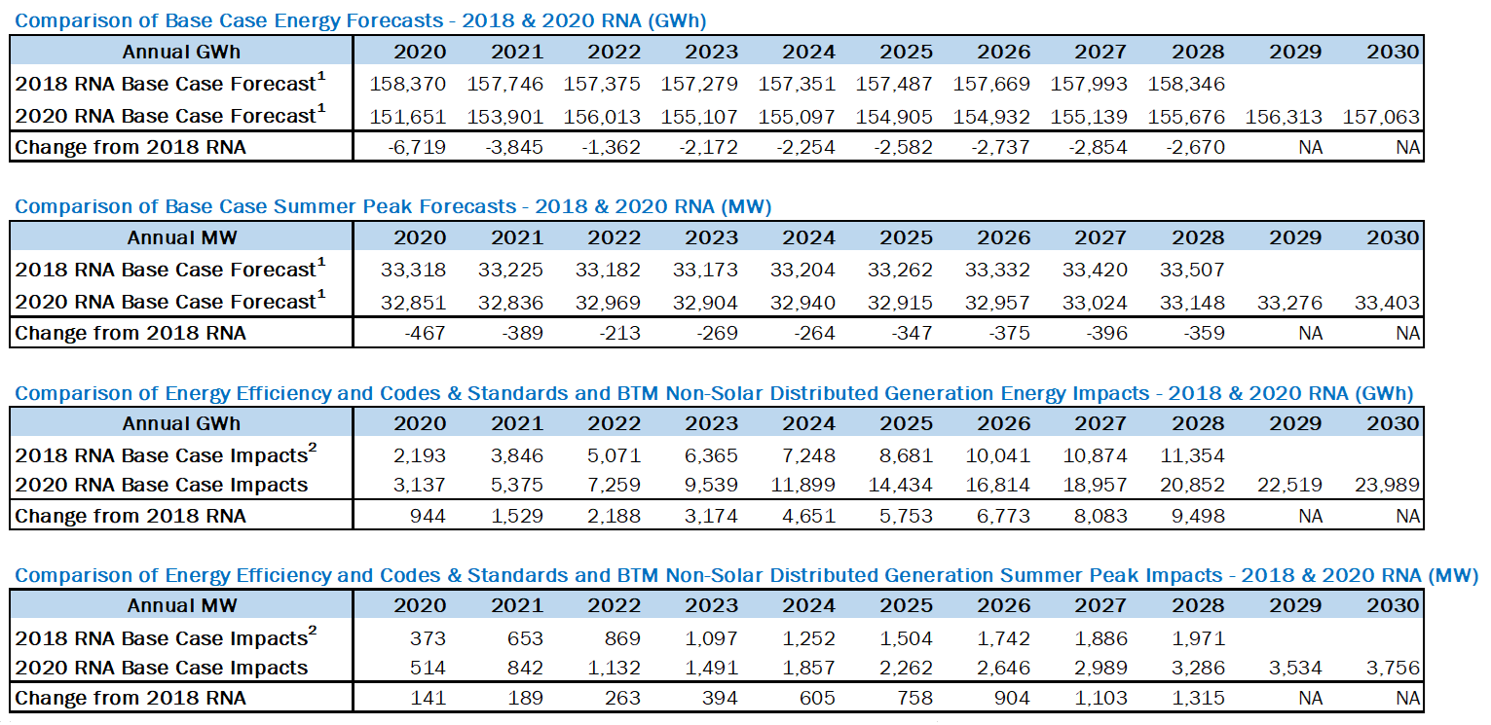

**1** For the resource adequacy study, the Gold Book baseline load forecast was modified by removing the behind-the-meter solar PV impacts in order to model the solar PV explicitly as a generation resource to account for the intermittent nature of its availability.

**2** 2016 Gold Book values have been adjusted to include only those impacts from 2018 forward, so as to compare directly to the 2018 Gold Book values.

Figure 9: 2020 Baseline and High Load Scenario Energy Forecasts with Solar PV Added Back



Figure 10: 2020 Baseline and High Load Energy Scenario Summer Peak Demand Forecasts with Solar PV Added Back



Figure 11: 2020 Baseline Annual Energy Forecast Impacts

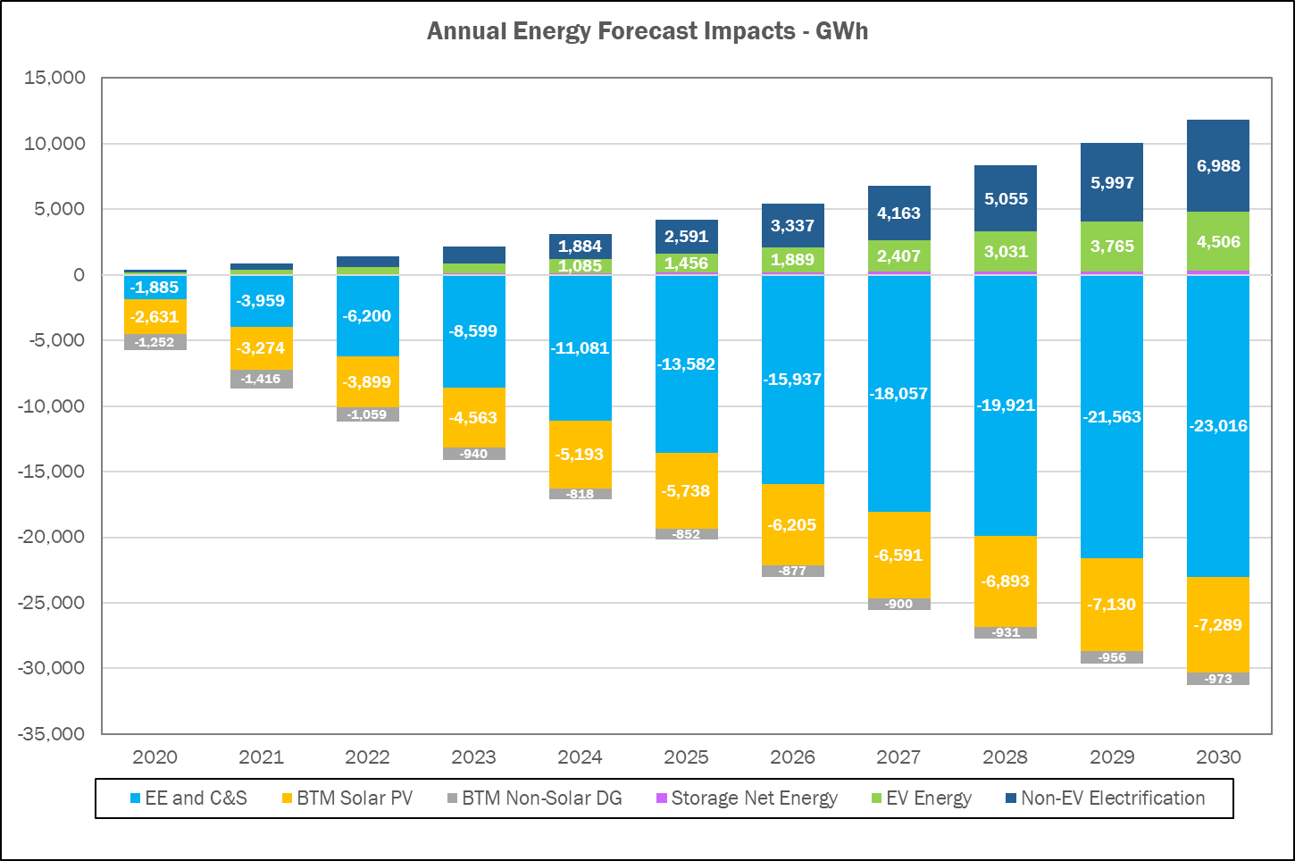

Figure 12: 2020 Baseline Summer Peak Demand Forecast Impacts

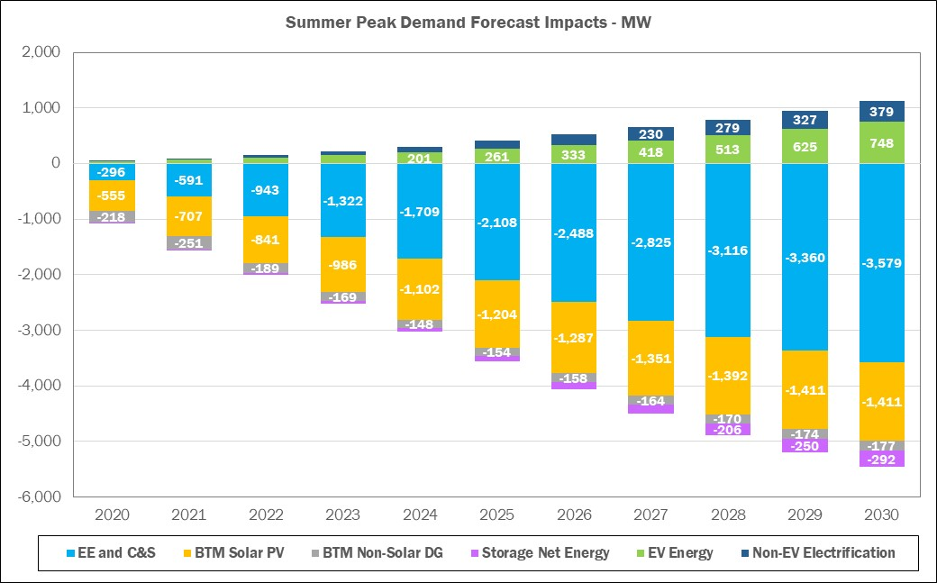

For the 2020 RNA resource adequacy assessments, the NYISO uses behind-the meter (BtM) solar PV production data. For General Electric’s Multi Area Reliability Simulations (GE-MARS) modeling, the BtM solar PV component is added back in the baseline forecast in order to discretely model the BtM solar PV. The load shapes used in the study were adjusted from the historic shapes to a shape that meets the forecasted zonal peak, NYCA peak, Zones G through J Locality peak, and NYCA Energy Forecast. The combination of the load shapes with the solar shapes results in a set of net load shapes that, at time of NYCA peak, meets the baseline forecast. Discretely modeling BtM solar PV as a resource provides for flexibility to adjust the amount of resource available across the system.

Figure 13: Forecast of BTM Solar PV Coincident Summer Peak Demand Reductions (MW)

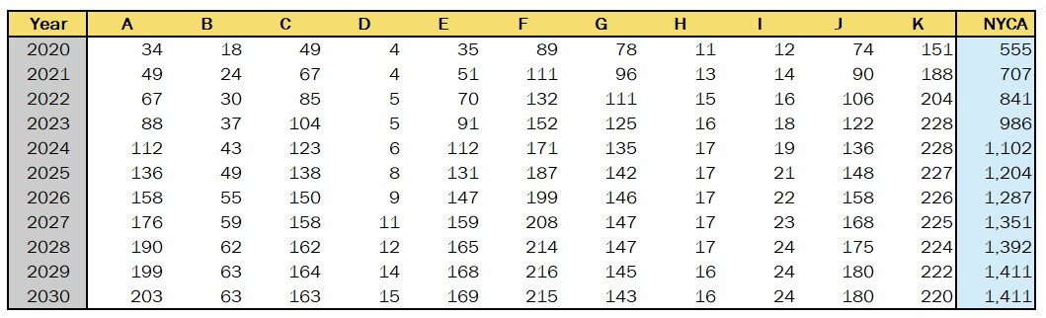

## Forecast of Special Case Resources

The 2020 RNA Special Case Resource[9] (SCR) MW levels are based on the 2020 Gold Book value of 1,282 MW, adjusted for their performance for the resource adequacy evaluations. Transmission security analysis, which evaluates normal transfer criteria, does not consider SCRs.

## 2020 RNA Resource Additions and Removals

Since the 2019 - 2028 CRP assumptions, resources have been added to the system, some deactivation notices have been withdrawn and the associated facilities have returned to the system, and some resources have been removed from the 2020 RNA Base Case:

* A total of approximately 543 MW of proposed generation (wind and solar) has been added to the 2020 RNA Base Case as compared with the 2019 - 2028 CRP.
* A total of approximately 2,582 MW of generation have been removed as compared with the 2019 – 2028 CRP Base Case either due to being in a deactivated state (*e.g.,* retired, mothballed, or in an ICAP-Ineligible Forced Outage (IIFO), or proposed to retire or mothball), or as operationally impacted by the DEC Peaker Rule.

The comparison of generation status between the 2019 – 2028 CRP and 2020 RNA is detailed in Figure 14, Figure 15 and Figure 16. The MW values represent the Capacity Resources Interconnection Service (CRIS) MW values from the 2020 Gold Book.

Figure 14: Proposed Projects Included in the 2020 RNA Base Case



Figure 15: 2020 RNA Generation Deactivations Assumptions



Figure 16: Existing Plants Impacted by DEC’s Peaker Rule (additional details on peakers status by ozone season are in Appendix D)



**Note**: NYSDEC’s Part 227-3 applies to all simple cycle gas turbines with nameplates equal to or greater than 15 MW.  Thus, all simple cycle generators are subject to the rule and all owners of these machines were required to submit compliance plans to the NYSDEC.  The compliance plans consist of statements that the generator; already complies with the new NOx limits, will retire, will limit operation during the ozone season, and/or will retrofit emission control technology to meet the emission limits of the new rule.  If the plant owners submitted compliance plans that state that the generator will able to operate within the new NOx limits during the ozone season, these generators remain in service in the 2020 RNA base case.

## Additional Proposed Projects from the Interconnection Queue

In addition to the projects that met the 2020 RNA inclusion rules (listed in Figure 14), a number of other projects are progressing through the NYISO’s interconnection process. Some of these additional generation resources either have accepted their cost allocation as part of a prior Class Year Facilities Study process, or are included in the Class Year 2019 Facilities Study, or are candidates for future interconnection facilities studies. These projects are listed in the 2020 Gold Book and also in Figure 17 and Figure 18.

Figure 17: Additional Proposed Generation Projects from the 2020 Gold Book







* Generation projects that met 2020 RNA Inclusion Rule are assumed to be in-service one year later than 2020 GB Proposed Date to reflect the potential impact of Covid-19 on construction and completion.

Figure 18: Additional Proposed Transmission Projects from the 2020 Gold Book



## Local Transmission Plans

As part of the NYISO’s Local Transmission Planning Process, the New York TOs present their Local Transmission Owner Plans (LTPs) to the NYISO and stakeholders during ESPWG and TPAS meetings. The firm transmission plans presented in the LTPs and reported as firm in the 2020 Gold Book are included in the 2020 RNA Base Case, with consideration for their in-service dates. A summary of these projects is reported in **Appendix D** of this report.

## Bulk Transmission Projects

The notable bulk transmission projects that met the inclusion rules and are modeled in the 2020 RNA Base Case are:

* The NextEra Empire State Line Project that was selected by the NYISO Board of Directors in October 2017 to address the Western New York Public Policy Transmission Need. This project includes a new 345 kV circuit and phase angle regulator (PAR) that will alleviate constraints in the Niagara area. The planned in-service date for this project is June 2022.
* The Segment A AC Transmission joint project by LS Power and New York Power Authority (NYPA) that was selected by the NYISO Board of Directors in April 2019. The project includes a new double-circuit 345 kV line between Edic and New Scotland substations, two new 345 kV substations at Princetown and Rotterdam, two new 345 kV lines between Princetown to Rotterdam substations, and retirement of the existing Porter to Rotterdam 230 kV lines. The planned in-service date is December 2023.
* The New York Transco Segment B AC Transmission project that also was selected by the NYISO Board of Directors in April 2019. The project includes a new double-circuit 345/115 kV line from a new Knickerbocker 345 kV switching station to the existing Pleasant Valley substation, 50% series compensation on the Knickerbocker to Pleasant Valley 345 kV line, and retirement of 115 kV lines between Greenbush and Pleasant Valley substations. The planned in-service date is December 2023.

## Base Case Peak Load and Resources Summaries

The 2020 RNA Base Case models the existing generation as adjusted for the unit deactivations listed in the 2020 Gold Book, and along with the new resource additions that met the base case inclusion rules set forth in Section 3 of the RPP Manual. This capacity is summarized in Figure 19 on the next page, along with the baseline peak load, capacity net purchases and the SCRs.

Figure 19: NYCA Peak Load and Resources 2024 through 2030





**Notes**:

\***NYCA** load values represent baseline coincident summer peak demand. **Zones J and K load** values represent non-coincident summer peak demand. **Aggregate Zones G-J values** represent G-J peak.

**NYCA Capacity values include resources electrically internal to NYCA, additions, reratings, and retirements (including proposed retirements and mothballs). Capacity values reflect the lesser of CRIS and DMNC values. NYCA resources include the net purchases and sales as per the Gold Book. Zonal totals include the full Unforced Capacity Deliverability Rights (UDRs) for those capacity zones.

* SCR: forecasted MW ICAP value from the 2020 Gold Book.
* Wind, solar, run-of river and landfill gas summer capacity is counted as 100% of nameplate rating.

*** For UCAP calculation, EFORd from GE-MARS output file are used for thermal units. For renewables, installed capacity intermittent resources derating factors (received from IMO team) are used.

Figure 19a: ICAP vs UCAP for 2030



Notes:

Total Capacity = Capacity* + full UDR + SCR

*Capacity = lesser of (CRIS, DMNC). NYCA resources include the net purchases and sales as per the Gold Book.

ICAP = Installed Capacity

UCAP = Unforced Capacity (takes into consideration generation unavailability)

UCAP calculation:

* + For thermal units, average capacity derating factors from the MARS output are used
  + For renewables, installed capacity intermittent resources derating factors are used

As shown in the Figure 19, the total NYCA capacity margin (defined as capacity above the baseline load forecast) varies between 24% and 27%. Figure 19a shows a comparison between the total ICAP and total UCAP for 2030; the difference reflects generation unavailability for the resource mix assumed in the RNA Base Case for year 2030.

Figure 20 below shows the relative decrease in the capacity margin, by comparing the details of the capacity margins for year 10 between the 2020 RNA (2030) and the 2019-2028 CRP (2028). The analysis reveals two observations:

* Negative net margin shows deterioration in the relative capability to serve load, when comparing the two studies assumptions; and
* Compared to the 2019 CRP, the system has less overall net resources.

Figure 20: NYCA Load and Resources Comparison with the 2019 - 2028 CRP



Notes:

1. Includes the reductions due to projected energy efficiency programs, building codes and standards, distributed energy resources and behind-the-meter solar photovoltaic resources; it also reflects expected impacts (increases) from projected electric vehicle usage.
2. Includes the total SCRs, and net capacity purchases and sales from the applicable Gold Book.

Figure 21: 2020 RNA Zone J Load and Capacity Comparison with the 2019 - 2028 CRP



Notes:

1. Includes the reductions due to projected energy efficiency programs, building codes and standards, distribution energy resources and behind-the-meter solar photovoltaic power; it also reflects expected impacts (increases) from projected electric vehicle usage.
2. Does not include the total SCRs, and UDRs from the Gold Book 2020.

# Base Case Reliability Needs Assessments

## Overview

This section provides the methodology and results for the resource adequacy and transmission system adequacy and security of the New York BPTF over the RNA Study Period. If any Reliability Criteria violations are identified, the NYISO identifies Reliability Needs. Violations of the criteria are translated into MW or MVAr amounts to provide a relative quantification of the Reliability Needs, and to support the development of solutions in the CRP.

## Methodology for the Determination of Needs

The OATT defines Reliability Needs in terms of total deficiencies relative to Reliability Criteria determined from the assessments of the BPTF performed in the RNA. There are two steps to analyzing the reliability of the BPTF. The first is to evaluate the security of the transmission system. The second is to evaluate the adequacy of the system, subject to the security constraints. The transmission adequacy and the resource adequacy assessments are performed together.

Transmission security is the ability of the power system to withstand disturbances, such as electric short circuits or unanticipated loss of system elements, and continue to supply and deliver electricity. Transmission security is assessed deterministically with potential disturbances being applied without concern for the likelihood of the disturbance in the assessment. These disturbances (single-element and multiple-element contingencies) are categorized as the design criteria contingencies, explicitly defined in the Reliability Criteria. The impacts resulting from applying these design criteria contingencies are assessed to determine whether thermal loading, voltage, or stability violations will occur. In addition, the NYISO performs a short circuit analysis to determine if the system can clear faulted facilities reliably under short circuit conditions. The NYISO’s “Guideline for Fault Current Assessment[10]” describes the methodology for that analysis.

The analysis for the transmission security assessment is conducted in accordance with NERC Reliability Standards, NPCC Transmission Design Criteria, and the NYSRC Reliability Rules. Contingency analysis is performed on the BPTF to evaluate thermal and voltage performance under design contingency conditions using the Siemens PTI PSS®E and PowerGEM TARA programs. Generation is dispatched to match load plus system losses, while respecting transmission security. Scheduled inter-area transfers modeled in the base case between the NYCA and neighboring systems are held constant.

For the RNA, over 1,000 design criteria contingencies are evaluated under N‑1, N‑1‑0, and N‑1‑1 normal transfer criteria conditions to provide that the system is planned to meet all applicable reliability criteria. To evaluate the impact of a single event from the normal system condition (N‑1), all design criteria contingencies are evaluated including: single element, common structure, stuck breaker, generator, bus, and HVDC facilities contingencies. An N‑1 violation occurs when the power flow on the monitored facility is greater than the applicable post-contingency rating. N‑1‑0 and N‑1‑1 analyses evaluate the ability of the system to meet design criteria after a critical element has already been lost. For N‑1‑0 and N‑1‑1 analysis, single element contingencies are evaluated as the first contingency. The second contingency (N‑1‑1) includes all applicable design criteria contingencies evaluated under N-1 conditions. Certain areas of the Con Edison system are designed and operated for the occurrence of a second contingency. This type of combination can be described as N-1-1-0. For N-1-1-0 analysis, after the second contingency occurs, systems adjustments are allowed to secure the system back to normal ratings. The Con Edison planning criteria are contained in the [NYSRC Reliability Rules](http://www.nysrc.org/NYSRCReliabilityRulesComplianceMonitoring.html), rule G.1. Accordingly, a violation of the N-1-1-0 criterion on the BPTFs in Con Edison district will be identified as Reliability Need in the NYISO’s Reliability Needs Assessment.

The process of successive contingency testing (such as N-1-1) allows for corrective actions including generator re-dispatch, PAR adjustments, and HVDC adjustments between the contingencies. For example, for N-1-1 analysis allowable system adjustments occur between the first (N-1-0) and second (N-1-1) contingencies. These corrective actions prepare the system for the next contingency by reducing the flow to normal rating after the first contingency. An N‑1‑0 violation occurs when the flow cannot be reduced to below the normal rating following the first contingency. An N‑1‑1 violation occurs when the facility is reduced to below the normal rating following the first contingency, but the power flow following the second contingency exceeds the applicable post-contingency rating.

Resource adequacy is the ability of the electric systems to supply the aggregate electrical demand and energy requirements of the customers at all times, taking into account scheduled and reasonably expected unscheduled outages of system elements. Resource adequacy considers the transmission systems, generation resources, and other capacity resources, such as demand response. The NYISO performs resource adequacy assessments on a probabilistic basis to capture the random natures of system element outages. If a system has sufficient transmission and generation, the probability of an unplanned disconnection of firm load is equal to or less than the system’s standard, which is expressed as a loss of load expectation (LOLE). The New York State bulk power system is planned to meet an LOLE that, at any given point in time, is less than or equal to an involuntary firm load disconnection that is not more frequent than once in every 10 years, or 0.1 events per year. This requirement forms the basis of New York’s Installed Reserve Margin (IRM) requirement and is analyzed on a statewide basis.

If Reliability Needs are identified, various amounts and locations of compensatory MW required for the NYCA to satisfy those needs are determined to translate the criteria violations to understandable quantities. Compensatory MW amounts are determined by adding generic capacity resources to NYISO Zones to effectively satisfy the needs. The compensatory MW amounts and locations are based on a review of binding transmission constraints and zonal LOLE determinations in an iterative process to determine various combinations that will result in Reliability Criteria being met. These additions are used to estimate the amount of resources generally needed to satisfy Reliability Needs. The compensatory MW additions are not intended to represent specific proposed solutions. Resource needs could potentially be met by other combinations of resources in other areas including generation, transmission and demand response measures.

Due to the different types of supply and demand-side resources, and also due to transmission constraints, the amounts and locations of resources necessary to match the level of compensatory MW needs identified will vary. Reliability Needs could be met in part by transmission system reconfigurations that increase transfer limits, or by changes in operating protocols. Operating protocols could include such actions as using dynamic ratings for certain facilities, invoking operating exceptions, or establishing special protection systems.

The procedure to quantify compensatory MW for BPTF transmission security violations is a separate process from calculating compensatory MW for resource adequacy violations. This quantification is performed by first calculating transfer distribution factors on the overloaded facilities. The power transfer used for this calculation is created by injecting power at existing buses within the Zone where the violation occurs, and reducing power at an aggregate of existing generators outside of the area.

## Resource Adequacy Base Case Assessments

The NYISO conducts its resource adequacy analysis using the GE-MARS software package, which performs probabilistic simulations of outages of capacity and select transmission resources. The program employs a sequential Monte Carlo simulation method and calculates expected values of reliability indices such as LOLE (days/year) and includes load, generation, and transmission representation. Additional modeling details and links to various stakeholders’ presentations are in the assumptions matrix, Appendix D. The four external Control Areas interconnected to the NYCA (ISO-New England, PJM, Ontario and Quebec) are also modeled. In determining the reliability of a system, there are several types of randomly occurring events that are taken into consideration. Among these are the forced outages of generating units, the forced outages of transmission capacity, and deviations from in the forecasted loads.

#### Generation Model

The NYISO models the generation system in GE-MARS using several types of units. Thermal units considerations include: random forced outages as determined by Generator Availability Data System (GADS) -calculated EFORd and the Monte Carlo draw, scheduled and unplanned maintenance, and thermal derates. Renewable resource units (*i.e.* solar PV, wind, run-of-river hydro and landfill gas) are modeled using five years of historical production data. Co-generation units are also modeled using a capacity and load profile for each unit.

#### Load Model

The load model in the NYISO GE-MARS model consists of historical load shapes and load forecast uncertainty (LFU). The NYISO uses three historical load shapes in the GE-MARS model (2002, 2006 and 2007) in seven different load levels using a normal distribution. LFU is applied to every hour of these historical shapes and each of the seven load levels are run through the GE-MARS model.

#### MARS Topology

The NYISO models the amount of power that could be transferred across the system in GE-MARS using interface transfer limits applied to the connections between the GE-MARS areas[11] (“bubble-and-pipe” model).

Summary of major GE-MARS topology changes[12] (as compared with the 2019-2028 CRP):

* Marion-Farragut 345kV cables (B and C) assumed out-of-service
* 71, 72, M51, M52 series reactors assumed bypassed after deactivation of Indian Point Unit Nos. 2 and 3
* Rainey – Corona transmission project in-service impacting J to K limits
* AC Transmission Public Policy Segment A and B Projects added starting January 2024
* Removal of Cedars bubble/tie to Zone D model; adding the MW from the bubble to the tie HQ to D tie limit.
* Updates to Zone K Imports/Exports
* Somerset retirement impacts
* The external areas model for PJM and ISO-NE were [simplified](https://www.nyiso.com/documents/20142/11350020/07%202020RNA_MARS-ExternalAreasSimplification.pdf) by consolidating the five PJM areas (bubbles) into one, and the eight ISO-NE areas into one.

The emergency transfer criteria limits used in the GE-MARS model were developed from an assessment of analysis of the 2020 RNA power flow base cases, and analysis performed for other studies. Figure 22, Figure 23 and Figure 24 provide the thermal and voltage emergency transfer limits for the major NYCA interfaces. The 2018 RNA transfer limits are presented for comparison purposes.

Figure 22: Transmission System Thermal Emergency Transfer Limits



**Notes**:

Grey italic font: Limit was not calculated

*change in limit between 2018 RNA and 2020 RNA is due to different modeling method used in GE-MARS. Additional topology changes details are in Appendix D.

Figure 23: Transmission System Voltage Emergency Transfer Limits



Note: Grey italic font: Limit was not calculated

Figure 24: Transmission System Base Case Emergency Transfer Limits



Notes:

T - Thermal, V - Voltage, C – Combined

There are large increases in transfer capability modeled starting in year 2024 in the 2020 RNA. The increases reflect the impact of including the AC Transmission Public Policy projects. Comparing limits in year 2023 to year 2024 increases are represented to the thermal limits of 550 MW for the E to G interface, 1,925 MW for the F to G interface, and 1,900 MW for the UPNY-SENY MARS interface. There are also increases to the voltage limits of 825 MW for the Central East MARS interface, 650 MW for the Central East Group interface, and 375 MW for the UPNY-Con Ed interface.

A decrease in the thermal transfer limit for Dysinger East of 100 MW was modeled in the 2020 RNA. The primary cause for the change was the retirement of the Somerset generation unit in Zone A.

Comparing the transfer limits reported for year 2021 through 2023 to the previous RNA, there is an increase of 750 MW on the UPNY-Con Ed voltage limit for the 2020 RNA. The primary cause for this increase is a change in the study assumption for the operation of the series reactors on the Dunwoodie – Mott Haven 345 kV cables (71, 72) and the Sprain Brook – W. 49th Street cables (M51, M52). For the 2020 RNA, these series reactors were modeled as bypassed. This study assumption also resulted in a decrease of 50 MW in the I to J interface thermal limit.

The E to G interface thermal limit was modeled using a dynamic limit table in the 2020 RNA MARS topology. The interface limit ranged from 1750 MW to a maximum of 2250 MW based on the availability of the CPV Valley generation units. Starting in year 2024 the dynamic limit table was replaced with a single interface limit of 2300 MW. The increase in the limit is the result of transmission facility upgrades included in the AC Transmission Public Policy projects. Similarly, the UPNY-SENY MARS interface was modeled using a dynamic limit table ranging from 5100 MW to a maximum of 5350 MW. With the large increase in transfer capability when including the AC Transmission projects in 2024, the model was simplified by using a single limit of 7150 MW, and does not constrain the flow of power in the GE-MARS simulation.

The topology used in the GE-MARS model for the 2020 RNA Base Case is represented in Figure 25.

Figure 25: 2020 RNA Topology Year 4 -10 (2024 -2030)



Additionally, for information only, Figure 26 and Figure 27 represent the initial three years preceding the newly-defined RNA Study Period.

Figure 26: Topology Year 1 (2021)



Figure 27: Topology Year 2- 3 (2022- 2023)



#### Resource Adequacy Base Case Results

The results of the 2020 RNA Base Case resource adequacy studies show that the LOLE for the NYCA is at or above the criterion of 0.1 days/year, starting 2026. The NYCA LOLE results are presented in Figure 28 below.

Figure 28: NYCA Resource Adequacy Results



**Note**: NYCA load values represent baseline coincident summer peak demand. Zones J and K load values represent non-coincident summer peak demand. Aggregate Zones G-J values represent the G-J peak demand.

The LOLE is at or above NYSRC’s and NPCC’s criterion of one day in 10 years, or 0.1 days per year, starting year 6 (2026) of the RNA Study Period, and increases through year 10 (2030). Therefore, the NYISO identifies resource adequacy Reliability Needs starting 2027 (with 2026 being at the 0.10 days/year criterion).

The deficiencies identified in this 2020 RNA are driven by the compound effect of increasing load forecast (*e.g.,* +495 MW in 2030) and loss of generation in Zone J (*e.g*., –1372 MW in 2030) see Figure 29 below. Compared to the 2019 - 2028 CRP, the system has less overall net resources. The 2020 RNA Base Cases models reflect the application of the generator compliance plans for the DEC’s Peaker Rule to affected plants in New York City (Zone J), Long Island (Zone K), and Hudson Valley (Zone G). In Figure 29 below, the negative net margin shows deterioration in the relative capability to serve load, when comparing the assumptions in the two studies.

Figure 29: 2020 RNA Zone J Load and Capacity Comparison with the 2019 – 2028 CRP



Notes:

1. Includes the reductions due to projected energy efficiency programs, building codes and standards, distribution energy resources and behind-the-meter solar photovoltaic power; it also reflects expected impacts (increases) from projected electric vehicle usage.
2. Does not includes the total SCRs, and UDRs from the Gold Book

#### Resource Adequacy Compensatory MW

Resource adequacy compensatory MW amounts are determined by adding generic “perfect capacity” resources to each Zone individually, or in combinations of Zones, to address the shortfall.

“Perfect capacity” is capacity that is not derated (*e.g.,* due to ambient temperature or unit unavailability), not subject to energy duration limitations, and not tested for transmission security or interface impacts. Actual resources would need to be larger in order to achieve the same impact as perfect-capacity resources.

The compensatory MW additions are not intended to represent specific solutions, as the impact of specific solutions can depend on the type of the solution and its location on the grid. Rather, the compensatory MW levels provide a generic order-of-magnitude measure to guide solutions. Resource needs could potentially be met by combinations of solutions including generation, transmission, energy efficiency, and demand response measures.

Figure 30: Compensatory MW Additions for Resource Adequacy Violations



Observations:

* Adequate compensatory MW must be located within, or injected into, Zone J because of transmission constraints into Zone J observed starting in 2029. This result is exemplified by the fact that no compensatory MW in any of the other NYCA Zones will help bring the LOLE back below 0.1 days/year.
* Potential solutions to address the 350 compensatory MW resource adequacy deficiency in Zone J by 2030 (100 MW in 2027) could include a combination of additional transfer capability into Zone J and/or resources located within Zone J, and/or demand-side solutions. However, solutions would also need to address the Zone J local[13] transmission load area deficiencies identified in the transmission security evaluations.

#### Topology Limits Variations *(e.g.*, NYCA Free Flow) Simulations Results

To determine if transmission reinforcements would be beneficial, a “NYCA free flow” test was executed. A free flow simulation is one in which NYCA LOLEs are determined without considering any transmission transfer limitations within the NYCA system.  This provides an indication of whether any LOLE violations identified are purely resource related or if they are caused by limitations in the transmission system.

Following removal of the NYCA internal limits, the NYCA LOLE decreased to well below the criterion throughout the Study Period, indicating that there is no statewide resource deficiency and that transmission reinforcement that would inject resources into Zone J where the deficiency is located, is a potential option to resolve the identified resource adequacy Reliability Need.

The results are in Figure 31 below, and indicate that transmission improvements can also eliminate the LOLE violations.

Figure 31: NYCA Free Flow Simulation Results



Additional topology limits variations were performed to identify which specific interfaces help the most, and provide additional insights to support solutions development:

* Increasing the transfer limits on the interface between Zones I and J only (I_to_J or Dunwoodie South interface): An increase of 450 MW resolved the needs in 2030. This value is larger than the identified Compensatory MW value of 350 MW because the I_to_J interface is not always fully available due to partial outage states.
* Modeling the I_to_J (Dunwoodie South) interface with no limit: The NYCA LOLE decreased to 0.05 days/year in 2030, which is close to the 0.04 days/year NYCA free flow result. This result confirms that Zone J is the critical area in the GE-MARS analysis RNA Base Case, and that any injection from any interface into Zone J would mitigate the resource adequacy zonal deficiency.
* Additional free flow variations results are in Appendix D.

Free flow simulations conclusion: Beyond adding capacity or decreasing load in Zone J, increasing the interface limits into Zone J would mitigate or fully address the resource adequacy deficiency. However, solutions would also need to address the Zone J local[14] transmission load area deficiencies identified in the transmission security evaluations.

### Resource Adequacy Simulations Conclusions

* The Loss of Load Expectation (LOLE) is at or above NYSRC’s and NPCC’s criterion of one day in 10 years, or 0.1 days per year, starting year 6 (2026) of the RNA Study Period, and increasing through year 10 (2030). Therefore, the NYISO identifies resource adequacy Reliability Needs starting 2027 (with 2026 being at the 0.10 days/year criterion).
* The deficiencies identified in this 2020 RNA are driven by the compound effect of the increasing load forecast (*i.e.,* +495 MW in 2030) and loss of generation in Zone J (*i.e*., –1,372 MW in 2030).
* Potential solutions to address the 350 compensatory MW resource adequacy deficiency in Zone J by 2030 (100 MW in 2027) could include a combination of increased transfer capability into Zone J and/or resources located within Zone J, and/or demand-side solutions. However, solutions would also need to address the Zone J local[15] transmission load area deficiencies identified in the transmission security evaluations.

## Transmission Security Base Case Assessments

The following discussion reviews the main findings of the 2020 RNA transmission security assessments (steady state, stability and short circuit assessments) applicable to the Base Case conditions for the Study Period.

### Steady-State Assessments

The RNA requires analysis of the security of the BPTF throughout the Study Period. The BPTF, as defined in this assessment, include all of the facilities designated by the NYISO as a Bulk Power System (BPS) element as defined by the NYSRC and NPCC, as well as other transmission facilities that are relevant to planning the New York State transmission system. To assist in the assessment, the NYISO reviewed previously completed transmission security assessments and used the most recent FERC Form No. 715 power flow cases. The NYISO filed those cases with FERC on April 1, 2020 with updates to the models as described in earlier sections of this report.

For the 2020 RNA transmission security assessment, several transmission security violations (*i.e.,* Reliability Needs) were identified for the Study period. The transmission security Reliability Needs include both thermal loading criteria violations on the BPTF. For the thermal loading violations, several 345 kV circuits in the Con Edison service territory are overloaded under N-1-1 conditions beginning in year 2025 and increasing through 2030. Additionally, the Con Edison 345 kV system has 345 kV circuit overloads under N-1-1-0 conditions beginning in 2025 and increasing through 2030. Figure 32 summarizes of the worst overload for each BPTF element with a thermal criteria violation under N-1-1 conditions. Appendix D provides the details of additional contingency combinations that also result in thermal criteria violations for these BPTFs. Figure 33 provides a summary of the BPTF thermal criteria violations under N-1-1-0 conditions. No BPTF voltage violations are observed for this assessment.

Figure 32: Steady State Transmission Security N-1-1 Violations



Figure 33: Steady State Transmission Security N-1-1-0 Violations



#### Steady State Compensatory MW

Transmission security compensatory MW amounts are determined by adding generic resources to locations of need (or combinations of locations). The compensatory MW additions are not intended to represent specific solutions, as the impact of specific solutions can depend on the type of the solution and its location on the grid. Rather, the compensatory MW provide a generic order-of-magnitude measure to guide the formulation of solutions. Transmission security needs could potentially be met by combinations of solutions including generation, transmission, energy efficiency, and demand response measures.

The BPTF transmission security violations begin at 700 MW in year 2025 and increase in magnitude through year 2030. The maximum observed compensatory MW amount needed to address the BPTF thermal issues described above is 1,075 MW in 2030.

### System Stability Assessments

The dynamic stability criteria Reliability Needs are observed for the entire study period. The criteria violations include transient voltage response violations and loss of generator synchronism. The transient voltage response violations are primarily in the Con Edison area but extending into areas adjacent to their service territory. The loss of generator synchronism is observed in generators within or near the Astoria and Greenwood load pockets, and is primarily driven by the transient voltage response in the local area. Figure 34 provides a summary of the dynamic stability criteria Reliability Needs under N-1 and Figure 35 provides a summary for N-1-1.

Figure 34: Dynamic Stability Criteria N-1 Violations (placeholder)

Figure 35: Dynamic Stability Criteria N-1-1 Violations (L/O Ravenswood 3 as First Level Event) (placeholder)

Figure 36 shows the transient voltage response for a 345 kV bus in the Con Edison service territory that passes the stated criteria as observed in assessments that have the peaker units in-service, as compared to the response observed with the peakers out-of-service. To pass the transient voltage response criteria, the post-fault value must settle to at least 0.9 p.u. voltage five seconds after the fault has cleared. When the transient voltage response fails the stated criteria (as shown in Figure 36) this is referred to as fault induced delayed voltage recovery (FIDVR). FIDVR events are driven by end-use load behavior and load composition, primarily the induction motor loads. When an induction motor stalls, the motors draws excessive reactive power from the grid and require five to six times their typical steady-state running current in this locked-rotor condition[16] which can eventually lead to a significant loss of generation and load.

Figure 36: New York City (NYC) 345 kV Bus Voltage Recovery

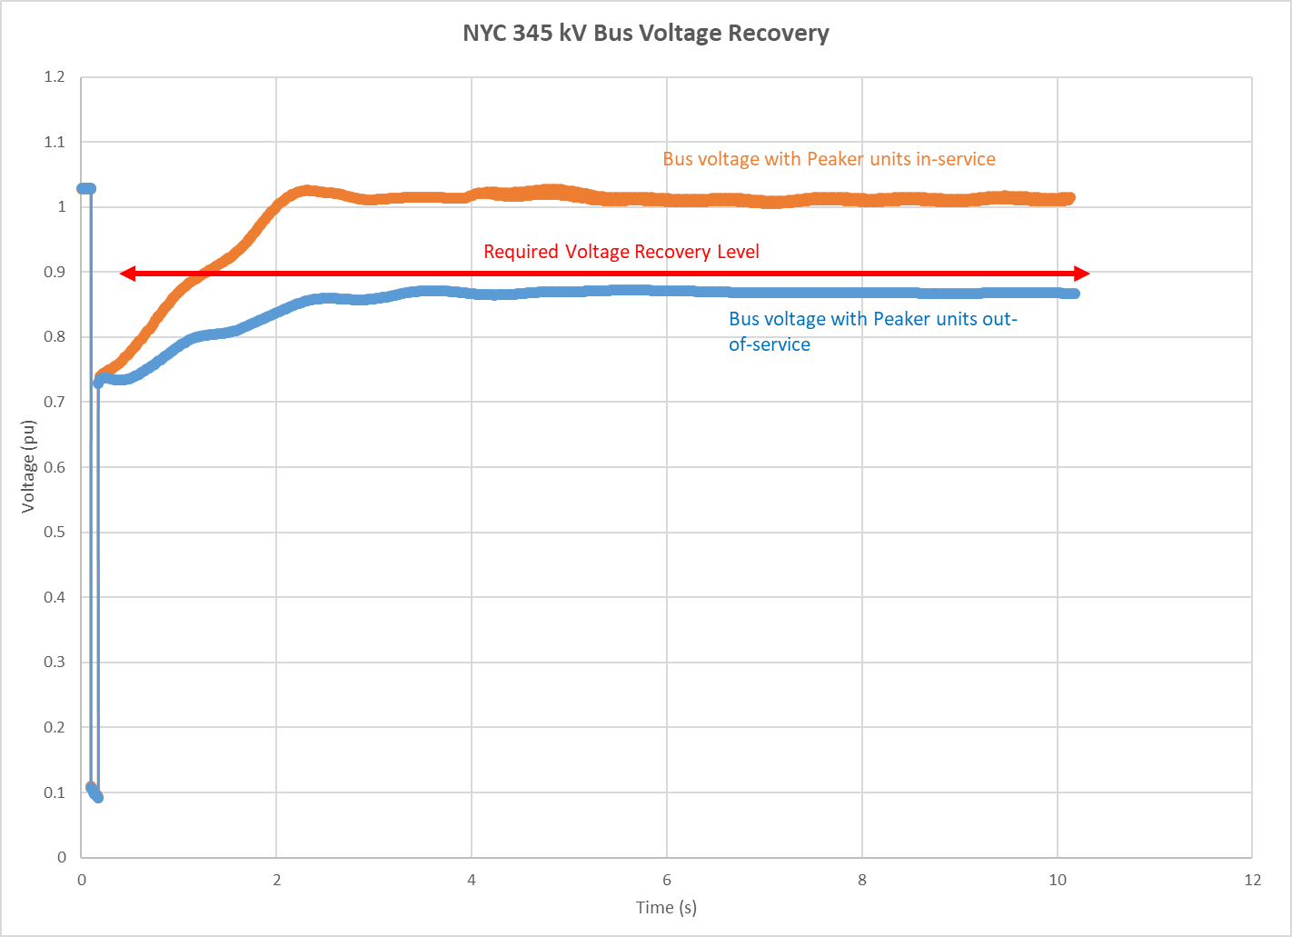

During a fault, the observed voltage drop at a bus depends on the location of the fault on the system relative to the bus and the amount of time the fault remains on the system before it is cleared by protective relaying actions. Following the clearing of a fault on the system by protection system actions, the bus voltage and generator rotor usually enter an oscillatory period. The generator excitation system controls the generator terminal voltage to improve and stabilize the voltages; however, depending on the severity of voltages and generator size, the voltages may or may not stabilize. Generator rotor swings after a fault are caused by the accumulation of energy (*i.e.* an imbalance between electrical power and mechanical power) during the fault. After the clearing of the fault, the generator rotor swings (or oscillations) dissipate that accumulated energy over time. For a stable system response, these oscillations damps out over time to an acceptable post-fault value. For an unstable system response, the system may observe unacceptable damping, system separation, cascading, and generating units losing synchronism with the system.

As shown in Figure 34 and Figure 35, several contingencies result in loss of generator synchronism with the transmission system. A primary driver to the loss of synchronism for these machines is the sustained low voltages following the clearing of the fault. Examples of low voltages as observed from the high-side of the generator step-up (GSU) transformer are shown in Figure 37 in response to a contingency. As can be seen in Figure 37, the sustained low voltages are also observed at the high side of the GSU and remain in the NERC PRC-024 “may trip” zone. In this example, due to the sustained low voltages an equilibrium point for the generators is not reached and the generators lose synchronism with the system. As shown in Figure 38, Generator 1 loses synchronism and trips off line at about 3.5 seconds and Generator 2 goes out of synchronism and trips off line at about 10 seconds. The rotor angles plotted in Figure 38 are relative to the system average rotor angle.

Figure 37: High Side of GSU Voltage

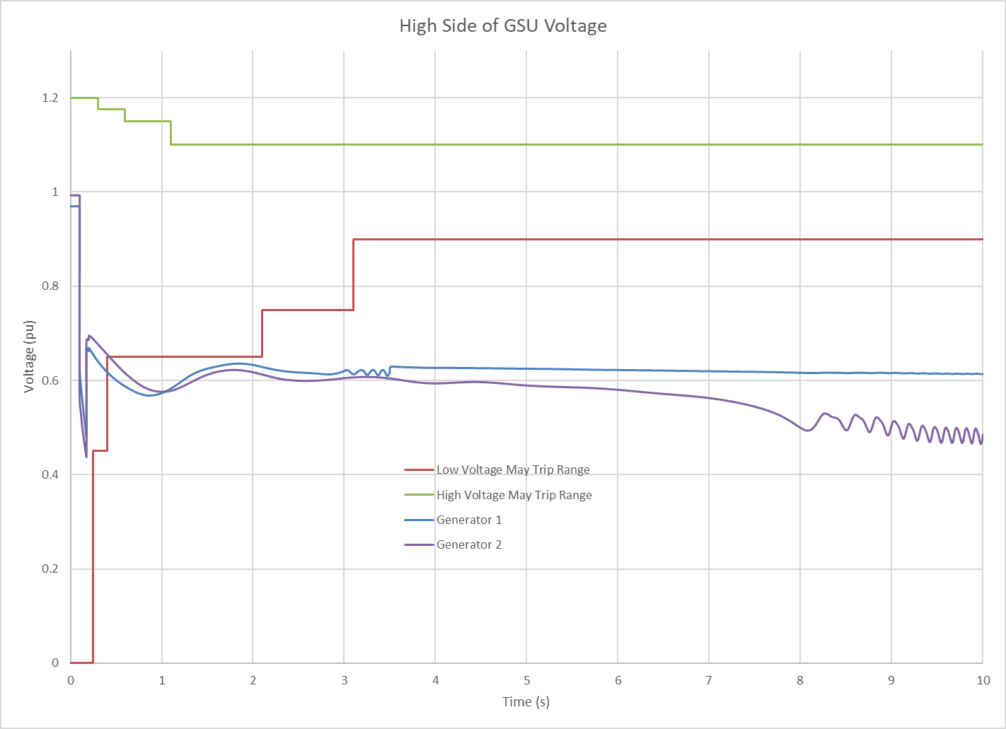

Figure 38: Generator Synchronism

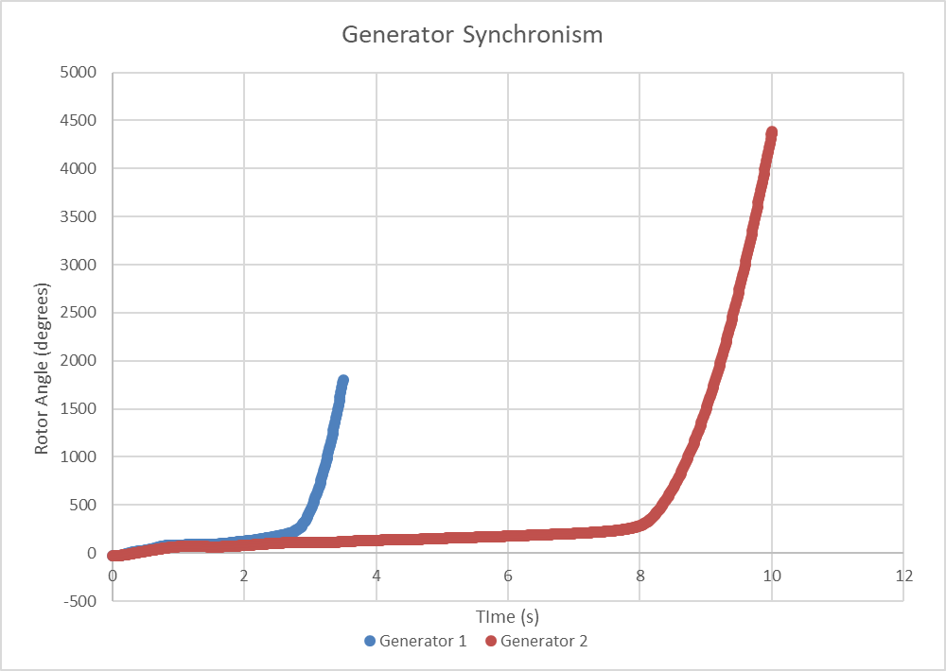

#### Stability Compensation

In the pre-fault (N-0) system condition, voltages are maintained with various static (*e.g.* fixed and switched shunt devices, transmission circuits) and dynamic (*e.g.* generators, FACTS devices, STATCOMS) reactive resources maintaining voltages within prescribed ranges. Manual adjustments to these devices occur as load and other system conditions change in order to maintain the required voltage level.

During the dynamic simulation timeframe, sufficient dynamic reactive resources to sustain transient voltage support during the natural swings of the system are crucial. Generally, the system response to these swings to maintain voltage comes from generator excitation system response, STATCOMs, Static Var Compensators (SVCs), wind and solar plant voltage controls, and other fast-acting resources. [17] While pre-contingency voltages can be maintained using static reactive resources, the dynamic system response timeframe focuses primarily on dynamic reactive capability due to the transient nature of large power and voltage swings and the short response time required.

Add description of stability compensatory MVAR testing (Placeholder )

Figure 39: Description of Dynamic MVA Added to System (Placeholder)

Figure 40: Description of Static and Dynamic MVA Added to System (Placeholder)

### Short Circuit Assessments

The required short circuit assessment in the RNA includes the calculation of symmetrical short circuit current to ascertain whether the circuit breakers at stations connecting the BPTF could be subject to fault current levels in excess of their rated interrupting capability. The analysis was performed for 2025 (year 5), reflecting the study conditions outlined in this “RNA Base Case Assumptions, Drivers, and Methodology” section. The calculated fault levels will not change significantly after year 5 in the Study Period as no new generation or transmission changes are modeled in the RNA, and the methodology for fault duty calculation is not sensitive to load growth. For this assessment no over-dutied circuit breakers were identified. The detailed results of the short circuit assessment are provided in Appendix D of this report.

### Transmission Owner Local Criteria Violations

As described in the following sections, Con Edison and Central Hudson each identified transmission security issues in their service territory on their non-BPTF system. The local non-BPTF criteria violations identified below are provided for information only, as the RNA identifies only BPTF Reliability Needs.

#### Central Hudson Assessment

Central Hudson currently owns and operates two 25 MVA (nameplate) combustion turbines that are subject to the DEC Peaker Rule, namely the Coxsackie and South Cairo generators. Both of these generators provide local substation reserve capacity for transformer outages and post-contingency voltage support for the Westerlo transmission loop. Without these generators, there is no reserve capability for local transformer outages and the Westerlo loop is voltage constrained. These transmission security issues would begin in 2023 and continue through the study period.

#### Con Edison Assessment

The transmission security criteria violations observed in the Con Edison service territory are primarily due to deficiencies that are observed in the Astoria East/Corona 138 kV Transmission Load Area (TLA) and the Greenwood/Fox Hills 138 kV TLA.

#### Astoria East/Corona 138 kV TLA

Figure 41 shows the high-level topology of the Astoria East/Corona 138 kV TLA. The boundary feeders for this TLA include the feeders from the Hell Gate, Astoria Annex, Rainey, and Jamaica substations.

Figure 41: Astoria East/ Corona 138 kV TLA

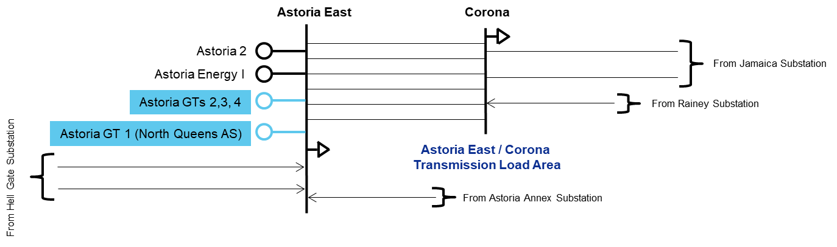

In 2023, thermal overloads are observed on the Astoria East/Corona 138 kV TLA boundary feeders, which are designed to a second contingency (N-1-1-0) based on the applicable Con Edison local design criteria.

Considering the utilization of all available phase angle regulator (PAR) controls, the maximum observed deficiency (*i.e.,* compensatory MW) within this TLA ranges from 110 MW in 2023 to 180 MW in 2030 as shown in Figure 42. As shown in Figure 43 and Figure 44, the Astoria East/Corona 138 kV TLA does not peak with the coincident system peak. Based on the load duration curves shown in Figure 43 and Figure 44, the TLA may be deficient over 10 hours (659 MWh) on a peak day in 2023, increasing to 13 hours (1,461 MWh) on a peak day in 2030.

Figure 42: Astoria East/ Corona 138 kV TLA Deficiency



Figure 43: Astoria East/Corona 138 kV Load Duration Curve for 2023

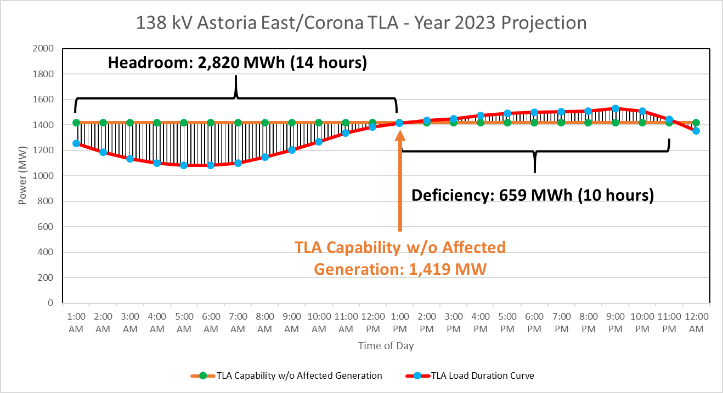

Figure 44: Astoria East/Corona 138 kV Load Duration Curve for 2030

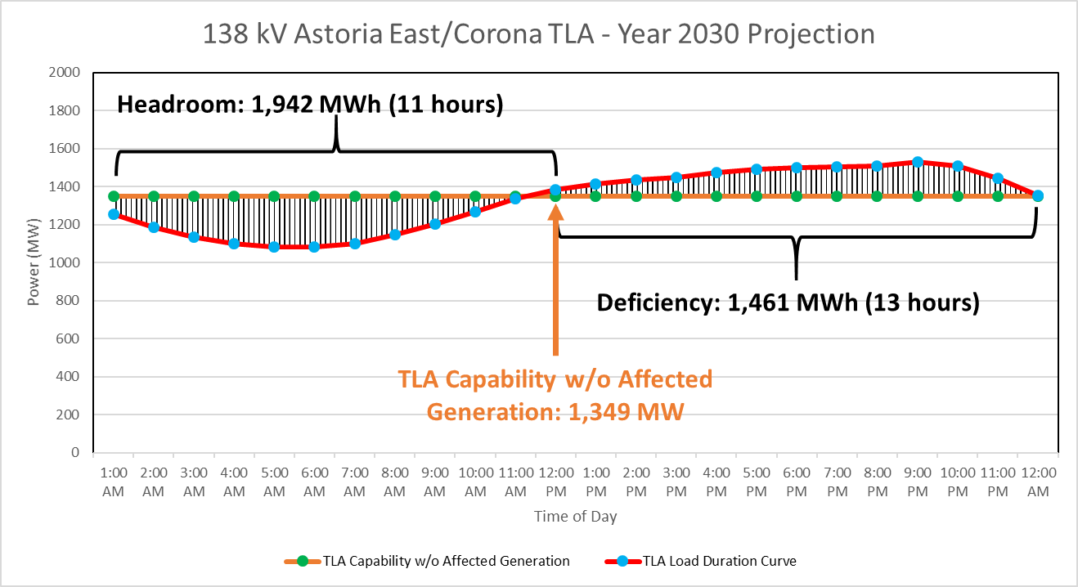

#### Greenwood/Fox Hills 138 kV TLA

Figure 45 shows the high-level topology of the Greenwood/Fox Hills 138 kV TLA. The boundary feeders for this TLA include the feeders from the Vernon, Gowanus, and Fresh Kills substations.

Figure 45: Greenwood/ Fox Hills 138 kV TLA

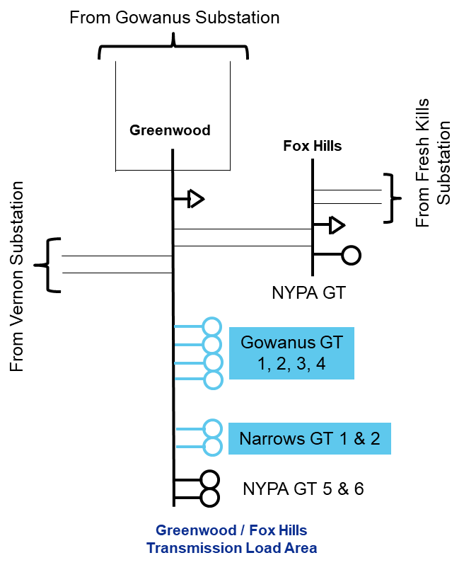

In 2025, thermal overloads and voltage violations are observed on the Greenwood/Fox Hills 138 kV TLA boundary feeders in the steady state (N-0) condition, which are exacerbated under N-1 and N-1-1 conditions.

Considering the utilization of all available PAR controls, the maximum observed deficiency (*i.e.,* compensatory MW) within this TLA of 360 MW in 2025 to 370 MW in 2030 as shown in Figure 46. Based on the load duration curve shown in Figure 47, the TLA may be deficient over 14 hours (3,571 MWh) over a 14 hour period on a peak day in 2025. As there is little change in the peak deficiency (± 10 MW - as shown in Figure 46) the deficiency shown in Figure 47 would not have much variance from 2025 to 2030.

Figure 46: Greenwood/ Fox Hills 138 kV TLA Deficiency



Figure 47: Greenwood/ Fox Hills 138 kV TLA Load Duration Curve for 2025

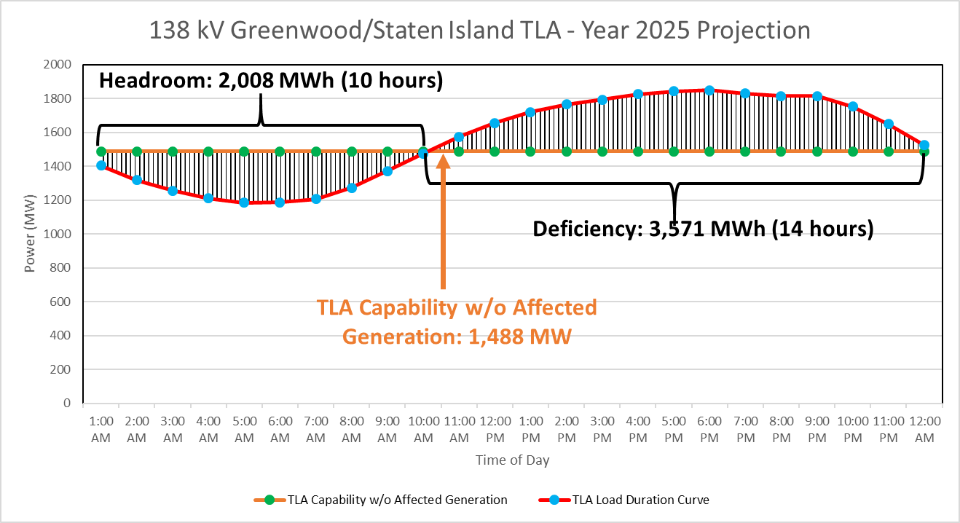

# Base Case Variation Scenarios

The NYISO, in conjunction with stakeholders and Market Participants, developed reliability scenarios pursuant to Section 31.2.2.5 of Attachment Y of the OATT. Scenarios are variations on the preliminary (1st pass) RNA Base Case to assess the impact of possible changes in key study assumptions which, if they occurred, could change the timing, location, or degree of violations of Reliability Criteria on the NYCA system during the Study Period, and are presented for information only. There were no changes between the preliminary RNA Base Case and the final Base Case. The NYISO evaluated the following scenarios as part of this RNA, with an identification of the type of assessment performed:

1. High Load Forecast Scenario – Resource Adequacy

* The 2020 Gold Book High Load forecast were used for the resource adequacy analysis.

1. Zonal Resource Adequacy Margins (ZRAM) - Resource Adequacy

* Identification of the maximum level of zonal MW capacity that can be removed without either causing NYCA LOLE violations, or exceeding the zonal capacity.

1. “Status-quo” Scenario - Transmission Security and Resource Adequacy

* Removal of proposed major transmission and generation projects assumed in the RNA Base Case.

Additionally, the NYISO proposed to perform two exploratory scenarios, further detailed in **Appendix E**:

1. Further[18] Simplified External Areas Model - Resource Adequacy

* Starting with the simplified external model described in footnote 8 and also in the assumptions matrix in Appendix D, removing all load and generation from external areas along with removing interfaces between external areas, followed by inserting fixed amounts of capacity in each external area.

1. Different Load Shape - Resource Adequacy
   * The resource adequacy RNA Base Case uses historical shapes from 2002, 2006, and 2007. Phase 1 of the [Climate Change Impact & Resilience Study](https://www.nyiso.com/documents/20142/10773574/NYISO-Climate-Impact-Study-Phase1-Report.pdf) developed hourly load shapes (*i.e.,* labeled “the reference case” in the study) that were used for this scenario.

The results of the scenarios are summarized in the following sections.

## High Load Forecast Scenario

The RNA Base Case forecast includes impacts associated with projected energy reductions coming from statewide energy efficiency and BtM solar PV programs. The High Load Forecast scenario excludes these energy efficiency program impacts from the peak forecast, resulting in the higher forecast levels. The comparison of the High and Baseline forecasted loads is provided in the Figure 49: there is an increase of 2,388 MW in the peak load in 2030, as compared to the Base Case forecast. Given that the peak load in the High Load forecast is higher than in the Base Case, the probability of violating the LOLE criterion increases, and violations would occur starting in 2025. The NYCA LOLE results are in Figure 50**.**

Figure 48: 2020 Gold Book NYCA High Load vs. Baseline Summer Peak Forecast



Figure 49: 2020 Gold Book Zone J High Load vs. Non-coincident Summer Peak Forecast



Figure 50: 2020 RNA Resource Adequacy High Load Scenario NYCA LOLE Results



This scenario indicates that if expected energy efficiency and peak load reduction programs do not materialize at expected levels, the criterion violations would be observed two years earlier, starting in 2025.

## Zonal Resource Adequacy Margin (ZRAM)

The RNA Base Case results show that the LOLE is at the resource adequacy criterion in 2026 and exceeds 0.10 days/year starting in 2027.

Scenario analyses were performed to determine the amount of capacity in each Zone that could be removed before the NYCA LOLE reaches 0.10 days/year, and offers another relative measure of how close the system is from violating reliability criteria. This simulation is applicable to any RNA Study Years that have LOLE levels that are below criterion, *i.e*., from 2024 through 2026. The NYISO reduced capacity one Zone at a time to determine when violations occur, in the same manner as the compensatory “perfect” MW are added to mitigate resource adequacy violations, but with the opposite impact.  The zonal resource margin analysis is summarized in Figure 51.

Figure 51: Zonal Resource Adequacy Margin (MW)



Note: EZR - exceeds zonal resources (*i.e.,* all generation can be removed without causing a violation)

The ZRAM assessment identifies a maximum level of capacity that can be removed from each zone without causing NYCA LOLE criterion violations. However, the impacts of removing capacity on the reliability of the transmission system and on transfer capability are highly location dependent. Thus, in reality, lower amounts of capacity removal are likely to result in reliability issues at specific transmission locations. The NYISO did not attempt to assess a comprehensive set of potential scenarios that might arise from specific unit retirements. Therefore, actual proposed capacity removal from any of these Zones would need to be further studied in light of the specific capacity locations in the transmission network to determine whether any additional violations of reliability criteria would result. Additional transmission security analysis, such as N-1-1 analysis, would need to be performed for any contemplated plant retirement in any Zone.

## Status-Quo Scenario

This scenario evaluates the reliability of the system under the assumption that no major transmission or generation projects come to fruition within the RNA Study Period. This includes the removal of all proposed transmission and generation projects that have met 2020 RNA Base Case inclusion rules and removal of generators that require modifications to comply with the DEC’s Peaker Rule.

The results of this scenario are in theFigure 52**:**

Figure 52: 2020 RNA Resource Adequacy Status-quo Scenario NYCA LOLE Results



From a resource adequacy perspective, this scenario indicates that if expected generation and transmission projects are not built, the criterion violation advances by two years to 2025.

The steady state transmission security results show no steady state voltage Reliability Criteria violations on the BPTF for N-1 or N-1-1 events. Additionally, no thermal Reliability Criteria violations are observed for N-1 events. However, as compared to the RNA base case, under N-1-1 conditions additional overloads are observed in the Orange and Rockland as well as the Con Edison service territories. The results of the steady state transmission security N-1-1 evaluation of the BPTF for this scenario are shown in Figure 53.

Figure 53: 2020 RNA Transmission Security Status-quo Scenario Results



# “70x30” Scenario – [IN PROGRESS]

The Climate Leadership and Community Protection Act (CLCPA) mandates that New York consumers be served by 70% renewable energy by 2030 (“70x30”). The CLCPA includes specific technology based targets for distributed solar (6,000 MW by 2025), storage (3,000 MW by 2030), and offshore wind (9,000 MW by 2035), and ultimately establishes that the electric sector will be emissions free by 2040. Significant shifts are expected in both the demand and supply sides of the electric grid, and these changes will affect how the power system is currently planned and operated. To assist the evaluation of these impacts, the [2019 CARIS “70x30”](https://www.nyiso.com/documents/20142/2226108/2019-CARIS-Phase1-Report-Final.pdf/bcf0ab1a-eac2-0cc3-a2d6-6f374309e961) scenario kicked-off the assessment using production cost simulation tools to provide a “first look.” Focusing on the impact to energy flows, the NYISO modeled these policy targets for the year 2030 in order to examine potential system constraints, generator curtailments, and other operational limitations.

Subsequent studies, such as this 2020 RNA scenario, as well as the Climate Change Impact and Resilience Study, build upon the findings of the 2019 CARIS scenarios and provide further insight focusing on system reliability aspects such as transmission security and resource adequacy.

As policymakers advance the implementation plan of the CLCPA, the NYISO assessments are intended to complement their efforts, and are not intended to define the specific steps that must be taken to achieve the policy goals. Additional refinements in assumptions, models, and methods in the following years will be necessary as more information becomes available from policy implementation perspectives and simulation methods and models perspectives.

## Scope

[PLACEHOLDER]

## Assumptions

[PLACEHOLDER]

## Resource Adequacy Methodology and Results

[PLACEHOLDER]

## Transmission Security Methodology and Results

[PLACEHOLDER]

## Key Findings of the “70x30” Scenario

[PLACEHOLDER]

# Reliability Compliance Obligations and Activities

The purpose of this section is to discuss the NERC Planning Coordinator and Transmission Planner obligations fulfilled by the NYISO as well as the other NPCC and NYSRC planning compliance obligations. The NYISO has various compliance obligations under NERC, NPCC, and the NYSRC. The periodicity of these requirements varies amongst the standards and requirements. While achieving compliance with all NERC, NPCC, and NYSRC obligations is critical to ensuring the continued reliability of the transmission system, this section primarily discusses in some detail the planning compliance requirements that closely align with this Reliability Needs Assessment. The full details of the compliance obligations are found within the reliability standards and requirements themselves.

The purpose of the NERC Reliability Standards is to “define the reliability requirements for planning and operating the North American bulk power system and are developed using a results-based approach that focuses on performance, risk management, and entity capabilities.” The objective of NPCC Directory #1 and the NYSRC Reliability Rules and Compliance Manual are to provide a “design-based approach” to design and operate the bulk power system to a level of reliability that will not result in the loss or unintentional separation of a major portion of the system from any of the planning and operations contingencies with the intent of avoiding instability, voltage collapse and widespread cascading outages. Figure 55 shows the various NERC Standards with requirements applicable to the NYISO as a NERC registered Planning Coordinator and/or Transmission Planner. The NPCC planning compliance obligations are primarily located in NPCC Regional Reliability Reference Directory #1 Design and Operation of the Bulk Power System. The NYSRC planning compliance obligations are located in the Reliability Rules and Compliance Manual.

Fundamental to any reliability study is the accuracy modeling data provided by the entities responsible for providing the data. The data requirements for the development of the steady state, dynamics, and short circuit models is provided in the NYISO Reliability Analysis Data Manual (RAD Manual).[19] This data primarily comes from compliance with NERC MOD standards. Much of this data is collected through the annual database update process outlined in the RAD Manual and the annual FERC Form 715 filing to which the transmitting utilities certify, to the best of their knowledge, the accuracy of the data. Additional compliance obligations provide for the accuracy of the modeling data through comparison to actual system events (*e.g.,* MOD-026, MOD-026, and MOD-033).

Following the completion of the annual database update, these databases are used for study work such as the Reliability Planning Process, and for many other compliance obligations such as those listed in Figure 55. Planning studies similar to the Reliability Planning Process include the NPCC/NYSRC Area Transmission Reviews (ATRs) and the NERC TPL-001 assessments.

Figure 55: List of NERC Standards for Planning Coordinators and Transmission Planners

| Standard Name | Title | Purpose |
| --- | --- | --- |
| FAC-002 | Facility Interconnection Studies | To study the impact of interconnecting new or materially modified Facilities to the Bulk Electric System. |
| FAC-010 | System Operating Limits Methodology for the Planning Horizon | To ensure that System Operating Limits (SOLs) used in the reliable planning of the Bulk Electric System (BES) are determined based on an established methodology or methodologies. |
| FAC-013 | Assessment of Transfer Capability for the Near-Term Transmission Planning Horizon | To ensure that Planning Coordinators have a methodology for, and perform an annual assessment to identify potential future Transmission System weaknesses and limiting Facilities that could impact the Bulk Electric System's (BES) ability to reliably transfer energy in the Near-Term Transmission Planning Horizon. |
| FAC-014 | Establish and Communicate System Operating Limits | To ensure that System Operating Limits (SOLs) used in the reliable planning and operation of the Bulk Electric System (BES) are determined based on an established methodology or methodologies. |
| IRO-017 | Outage Coordination | To ensure that outages are properly coordinated in the Operations Planning time horizon and Near-Term Transmission Planning Horizon. |
| MOD-020 | Providing Interruptible Demands and Direct Control Load Management Data to System Operators and Reliability Coordinators | To ensure that assessments and validation of past events and databases can be performed, reporting of actual demand data is needed. Forecast demand data is needed to perform future system assessments to identify the need for system reinforcement for continued reliability. In addition to assist a proper real-time operating, load information related to controllable Demand-Side Management programs is needed. |
| MOD-026 | Verification of Models and Data for Generator Excitation Control System or Plant Volt/VAR Control Functions | To verify that the generator excitation control system or plant volt/var control function model (including the power system stabilizer model and the impedance compensator model) and the model parameters used in dynamic simulations accurately represent the generator excitation control system or plant volt/var control function behavior when assessing Bulk Electric System (BES) reliability. |
| MOD-027 | Verification of Models and Data for Turbine/Governor and Load Control or Active Power/Frequency Control Functions | To verify that the turbine/governor and load control or active power/frequency control model and the model parameters, used in dynamic simulations that assess Bulk Electric System (BES) reliability, accurately represent generator unit real power response to system frequency variations. |
| MOD-031 | Demand and Energy Data | To provide authority for applicable entities to collect Data, energy and related data to support reliability studies and assessments to enumerate the responsibilities and obligations of requestors and respondents of that data. |
| MOD-032 | Data for Power System Modeling and Analysis | To establish consistent modeling data requirements and reporting procedures for development of planning horizon cases necessary to support analysis of the reliability of the interconnected transmission system. |
| MOD-033 | Steady State and Dynamic System Model Validation | To establish consistent validation requirements to facilitate the collection of accurate data and building of planning models to analyze the reliability of the interconnected transmission system. |
| PRC-002 | Disturbance Monitoring and Reporting Requirements | To have adequate data available to facilitate analysis of Bulk Electric System (BES) Disturbances |
| PRC-006 | Automatic Underfrequency Load Shedding | To establish design and documentation requirements for automatic underfrequency load shedding (UFLS) programs to arrest declining frequency, assist recovery of frequency following underfrequency events and provide last resort system preservation measures. |
| PRC-006-NPCC | Automatic Underfrequency Load Shedding | The NPCC Automatic Underfrequency Load Shedding (UFLS) regional Reliability Standard establishes more stringent and specific NPCC UFLS program requirements than the NERC continent-wide PRC-006 standard. The program is designed such that declining frequency is arrested and recovered in accordance with established NPCC performance requirements stipulated in this document. |
| PRC-010 | Undervoltage Load Shedding | To establish an integrated and coordinated approach to the design, evaluation, and reliable operation of Undervoltage Load Shedding Programs (UVLS Programs). |
| PRC-023 | Transmission Relay Loadability | Protective relay settings shall not limit transmission loadability; not interfere with system operators' ability to take remedial action to protect system reliability and; be set to reliably detect all fault conditions and protect the electrical network from these faults. |
| PRC-026 | Relay Performance During Stable Power Swings | To ensure that load-responsible protective relays are expected to not trip in response to stable power swings during non-Fault conditions. |
| TPL-001 | Transmission System Planning Performance Requirements | Establish Transmission system planning performance requirements within the planning horizon to develop a Bulk Electric System (BES) that will operate reliably over a broad spectrum of System conditions and following a wide range of probable Contingencies. |
| TPL-007 | Transmission System Planned Performance for Geomagnetic Disturbance Events | Establish requirements for Transmission system planned performance during geomagnetic disturbance (GMD) events. |

## NPCC/NYSRC Area Transmission Reviews (ATRs)

The NPCC/NYSRC ATRs are performed on an annual basis to demonstrate that conformance with the performance criteria specified in NPCC Directory #1 and the NYSRC Reliability Rules. In the ATRs, the NYISO assesses the BPTF for a period four to six years in the future (the NYISO evaluates year 5 of the Study Period). Seven assessments are required as part of each ATR.

The first assessment evaluates the steady state and dynamics transmission security. For instances where the transmission security assessments results indicate that the planned system does not meet the specified criteria, a corrective action plan is incorporated to achieve conformance. As part of the ATRs, and also for compliance with NERC FAC-013, thermal, voltage, and stability transfer limits are performed to identify the limiting constraints for power transfers.

For the second assessment, steady state and dynamics analysis are conducted to evaluate the performance of the system for low probability extreme contingencies. The purpose of the extreme contingency analysis is to examine the post contingency steady state conditions, as well as stability, overload, cascading outages, and voltage collapse, to obtain an indication of system robustness and to determine the extent of any potential widespread system disturbance. In instances where the extreme contingency assessment concludes there are serious consequences, the NYISO evaluates implementing a change to design or operating practices to address the issues.

The third assessment evaluates extreme system conditions that have a low probability of occurrence such as high peak load conditions (*e.g*., 90th percentile load) resulting from extreme weather or the loss of fuel supply from a given resource (*e.g.,* loss of all gas units under winter peak load). The extreme system conditions evaluate various design criteria contingencies to evaluate the post contingency steady state conditions, as well as stability, overload, cascading outages and voltage collapse. The evaluation of extreme contingencies indicate system robustness and determine the extent of any potential widespread system disturbance. In instances where the extreme contingency assessment concludes that there are serious consequences, the NYISO evaluates implementing a change to design or operating practices to address the issues.

The fourth assessment evaluates the breaker fault duty at BPTF buses.

The fifth assessment evaluates other requirements specific to the NYSRC Reliability Rules including an evaluation of the impacts of planned system expansion or configuration facilities on the NYCA System Restoration Plan and Local Area Operation Rules for New York City Operations, loss of gas supply – New York City, and loss of gas supply – Long Island.

The sixth assessment is a review of Special Protection Systems (SPSs). This review evaluates the designed operation and possible consequences of failure to operate or mis-operation of the SPS within the NYCA.

The seventh assessment is a review of requested exclusions to the NPCC Directory #1 criteria.

## NERC Planning Assessments (TPL-001)

The NERC TPL-001 assessment (“Planning Assessment”) is performed annually. The purpose of the Planning Assessment is to demonstrate conformance with the applicable NERC transmission system planning performance requirements for the NYCA BES. The Planning Assessment is a coordinated study between the NYISO and New York Transmission Owners.

The required system conditions to evaluate for this assessment include planned system representations over a 10-year study period for a variety of system conditions. Figure 56 provides a description of the steady state, dynamics, and short circuit cases required to be evaluated in the Planning Assessment.

Figure 56: Description of NERC TPL-001 Planning Assessment Study Cases



Notes:

1. Only required to be assessed to address the impact of proposed material generation additions or changes in that timeframe

The steady state and dynamics transmission security analyses evaluate the New York State BES to meet the applicable criteria. As part of this assessment, the unavailability of major transmission equipment with a lead time of more than a year is also assessed. The fault duty at BES buses are evaluated in the short-circuit representation. When the steady state, dynamics, or short circuit analysis indicates an inability of the system to meet the performance requirements in the standard, a corrective action plan is developed addressing how the performance requirements will be met. Corrective action plans are reviewed in subsequent Planning Assessments for continued validity and implementation status.

For each steady state and dynamics case, the Planning Assessment evaluates the system response to extreme contingencies. Similar to the ATR, when the Planning Assessment extreme contingency analysis concludes there is cascading caused by an extreme contingency, the NYISO evaluates possible actions designed to reduce the likelihood or mitigate the consequences and adverse impacts.

## Resource Adequacy Compliance Efforts

NPCC’s [Directory 1](https://www.npcc.org/Standards/Directories/Forms/Public%20List.aspx) defines a compliance obligation for the NYISO, as Resource Planner and Planning Coordinator, to perform a resource adequacy study evaluating a five-year planning horizon. The NYISO delivers a report every year under this study process to verify the system against the one-day-in-ten-years loss of load expectation (LOLE) criterion, usually based on the latest available RNA/CRP results and assumptions.

NYSRC [Reliability Rules](http://www.nysrc.org/NYSRCReliabilityRulesComplianceMonitoring.html) have recently included a requirement A3.R3 defining the NYISO’s obligation to deliver a Long Term Resource Adequacy Assessment report every RNA year, and an annual update in the non-RNA years. The NYISO will first implement of this requirement after finalizing the 2020 RNA.

The NYISO is also actively involved in other activities such as the NERC’s annual Long Term Reliability Assessment (LTRA), along with its biennial Probabilistic Assessment (ProbA), performed by NERC with the input from all the NERC Regions and Areas, as well as NPCC’s Long Range Adequacy Overview (LROA).

# A Grid In Transition: Reliability Gap Analysis

In 2019, the NYISO published the [*Reliability and Market Considerations For A Grid In Transition*](https://www.nyiso.com/documents/20142/2224547/Reliability-and-Market-Considerations-for-a-Grid-in-Transition-20191220%20Final.pdf/61a69b2e-0ca3-f18c-cc39-88a793469d50) white paper to facilitate a review of how market signals are aligned with system reliability needs in order to attract investment and retain competitive suppliers through the transition to 70% renewable energy by 2030. As part of that white paper, the NYISO conducted a reliability gap analysis to identify ways in which the transition towards intermittent resources could lead to operational circumstances that may violate system reliability requirements. The analysis included potential areas that the NYISO must be prepared to address in order to continue to meet mandatory reliability standards, such as:

* **Maintaining ability to balance load and generation:** Balancing high levels of intermittent generation with system demand that may be difficult to forecast in   
  real-time operations.
* **Maintaining 10-minute operating reserves:** High levels of intermittent resources may result in challenges to maintaining sufficient 10-minute operating reserves and disturbance-control performance requirements.
* **Maintaining total 30-minute operating reserves:** High levels of intermittent resources may lead to challenges in meeting operating reserve requirements in response to longer-term variations in generation levels from intermittent generation.
* **Maintaining ability to meet daily energy requirements:** Reliance on high levels of intermittent resources and limited energy storage resources may present challenges to meeting control-performance requirements and daily energy requirements in real-time operations.
* **Maintaining reliable transmission operations:** It may become difficult to forecast system and locational demand requirements in real time when operating under high levels of intermittent generation.
* **Maintaining black start capability:** The NYISO may be challenged to effectively restore the system within expected timeframes following a blackout given a system with high levels of intermittent generation.
* **Maintaining voltage support capability:** The NYISO may be challenged to meet voltage performance requirements with high levels of intermittent generation.
* **Maintaining frequency response capability:** The NYISO may be challenged to meet frequency performance requirements for a power system with high levels of intermittent generation.
* **Maintaining resource adequacy:** The NYISO may be challenged to maintain acceptable levels of resource adequacy.
* **Maintaining the ability to manage supply resource outage schedules:** The NYISO may be challenged to manage supply resource maintenance outage scheduling.

These concepts will continued to be explored in the 2021-2030 Comprehensive Reliability Plan and numerous other reliability studies in the near future. None of the identified potential reliability gaps relative to intermittent resources represent near-term concerns. However, the challenge for the NYISO is to design and implement a portfolio of market products, reliability planning, and operational enhancements that facilitate achievement of clean energy policies while maintaining system reliability through the competitive wholesale electricity markets. There may also be a need for review of established reliability criteria to address reliability gaps that may arise due to the changing system operating characteristics as New York transitions to a zero emission resource mix.

# Observations and Recommendations

[PLACEHOLDER]

1. A condition identified by the NYISO in the RNA as a violation or potential violation of Reliability Criteria.
2. This change was implemented in the RPP Manual in 2019.
3. This change was implemented in the RPP Manual in 2019.
4. <https://www.dec.ny.gov/regulations/116131.html>
5. See ‘Generator Deactivation Assessments’ at <https://www.nyiso.com/cspp>:

   [Cayuga 1 and 2 Generator Deactivation Assessment (Retirement)](https://www.nyiso.com/documents/20142/1396324/Cayuga1and2-Generation-Deactivation-Assessment-vFinal.pdf/9328ed90-41aa-da58-354f-d02fa755f260)

   [Somerset Generator Deactivation Assessment](https://www.nyiso.com/documents/20142/1396324/Somerset-Generator-Deactivation-Assessment-vFinal.pdf/f1fcf261-3d85-9f96-ef8f-70bdd1586505)

   [Cayuga 1 Generator Deactivation Assessment](https://www.nyiso.com/documents/20142/1396324/Cayuga1-Mothball.pdf/3cb586c3-4cb1-7fde-1a8e-f9a0a0e12d38)
6. https://www.dec.ny.gov/regulations/120061.html
7. <http://documents.dps.ny.gov/public/MatterManagement/CaseMaster.aspx?MatterCaseNo=20-E-0197&submit=Search>
8. See [http://documents.dps.ny.gov/public/Common/ViewDoc.aspx?DocRefId={DEEEB5EF-4676-49AD-B8E7-C72681D99C49}](http://documents.dps.ny.gov/public/Common/ViewDoc.aspx?DocRefId=%7bDEEEB5EF-4676-49AD-B8E7-C72681D99C49%7d) and [http://documents.dps.ny.gov/public/Common/ViewDoc.aspx?DocRefId={C36465AD-E0AE-4823-86B4-183810F247B2}](http://documents.dps.ny.gov/public/Common/ViewDoc.aspx?DocRefId=%7bC36465AD-E0AE-4823-86B4-183810F247B2%7d)
9. The term “Special Case Resource” is defined in Section 2.19 of Market Services Tariff and also in the Appendix A of this report (Glossary)
10. Attachment I of Transmission, Expansion and Interconnection Manual.
11. No generation pockets in Zone J and Zone K are modeled in detail in MARS.
12. Links to related stakeholders’ presentations are in the Appendix D, assumptions matrix.
13. No local transmission load area limits are modeled for the resource adequacy assessment – deficiencies at this local level are identified in the transmission security assessments.
14. No local transmission load area limits are modeled for the resource adequacy assessment – deficiencies at this local level are identified in the transmission security assessments.
15. No local transmission load area limits are modeled for the resource adequacy assessment – deficiencies at this local level are identified in the transmission security assessments.
16. <https://www.nerc.com/docs/pc/tis/FIDVR_Tech_Ref%20V1-2_PC_Approved.pdf>
17. <https://www.nerc.com/comm/PC_Reliability_Guidelines_DL/Reliability%20Guideline%20-%20Reactive%20Power%20Planning.pdf>
18. During the 2020 RNA, the External Areas Model for the RNA Base Case was simplified to consolidate five PJM (mid-Atlantic) areas into a single area and eight ISO-NE areas into a single area.
19. <https://www.nyiso.com/documents/20142/2924447/rel-anl-data-mnl.pdf/2d42445e-317d-b7e9-24b8-c983ae6518ec>