**2020 RNA**

**Reliability Needs Assessment**

**Comprehensive System Planning Process**

**A Report by the  
New York Independent System Operator**

**DRAFT Report**

**For September 10, 2020   
ESPWG/TPAS**

Table of Contents

Executive Summary [NEW SECTION] 1

Summary of Resource Adequacy Results 2

Summary of Transmission Security Results 3

Summary of Compensatory MW 4

Summary of Base Case Based Scenario Results 5

Summary of 70x30 Scenarios Results 7

Resource Adequacy 7

Transmission Security 8

Developments and Initiatives 8

1. Introduction 11

2. Overview of Reliability Planning Process Changes 14

3. Summary of Prior Comprehensive Reliability Plans 16

4. Regulatory Policy Activities 18

Climate Leadership and Community Protection Act (CLCPA) 19

Indian Point Deactivation 20

Peaker Rule: Ozone Season Oxides of Nitrogen (NOx) Emission Limits for Simple Cycle and Regenerative Combustion Turbines 20

New York City Residual Oil Elimination 21

Carbon Dioxide Performance Standards for Major Electric Generating Facilities 22

Regional Greenhouse Gas Initiative (RGGI) 22

NYS Accelerated Renewable Energy Growth and Community Benefit Act 23

5. Base Case Assumptions 24

Annual Energy and Summer Peak Demand Forecasts 25

Forecast of Special Case Resources 32

2020 RNA Resource Additions and Removals 32

Additional Proposed Projects from the Interconnection Queue 36

Local Transmission Plans 40

Bulk Transmission Projects 41

Base Case Peak Load and Resources Summaries 41

6. Base Case Reliability Needs Assessments 45

Overview 45

Methodology for the Determination of Needs 45

Resource Adequacy Base Case Assessments 47

Resource Adequacy Simulations Conclusions 59

Transmission Security Base Case Assessments 59

Steady-State Assessments 59

System Stability Assessments 61

Short Circuit Assessments 65

Transmission Owner Local Criteria Violations 65

7. Base Case Variation Scenarios 70

High Load Forecast Scenario 71

Zonal Resource Adequacy Margin (ZRAM) 72

Status-Quo Scenario 73

8. “70x30” Scenario – [New Section] 75

Scope 75

Resource Adequacy Assumptions 77

Resource Adequacy Methodology and Results 81

Step 1: Renewable Mix on Two Load Levels 82

Step 2: Capacity Removal 83

Step 2 Sensitivity Analysis: Nuclear Units Unavailability 89

Step 3: Addition of Energy Storage Resources 91

Transmission Security Methodology and Results 93

Key Findings of the “70x30” Scenarios 95

Resource Adequacy Key Findings 96

Transmission Security Key Findings 96

9. Reliability Compliance Obligations and Activities 98

NPCC/NYSRC Area Transmission Reviews (ATRs) 100

NERC Planning Assessments (TPL-001) 102

Resource Adequacy Compliance Efforts 103

10. A Grid In Transition: Reliability Gap Analysis 104

11. Observations and Recommendations 106

List of Figures

Figure 1: NYCA Resource Adequacy Results 2

Figure 2: 2020 RNA Zone J Load and Capacity Comparison with the 2019-2028 CRP 3

Figure 3: Summary of Minimum Compensatory MW 4

Figure 4: The NYISO’s Comprehensive System Planning Process (CSPP) 11

Figure 5: Current Status of Tracked Market-Based Solutions and TOs’ Plans 17

Figure 6: Summary Table of Key Environmental Regulations and Energy Policies 18

Figure 7: 2020 RNA Load and Energy Forecast: Baseline Forecast, and Baseline with BtM Solar PV Forecasts Added Back In 27

Figure 8: 2020 RNA Load and Energy for High Load Scenario: High Load Scenario Forecast, and High Load Scenario Forecast with BtM Solar PV Added Back In 28

Figure 9: Comparison of 2018 RNA & 2020 Baseline Forecasts 29

Figure 10: 2020 Baseline and High Load Scenario Energy Forecasts with Solar PV Added Back 30

Figure 11: 2020 Baseline and High Load Energy Scenario Summer Peak Demand Forecasts with Solar PV Added Back 30

Figure 12: 2020 Baseline Annual Energy Forecast Impacts 31

Figure 13: 2020 Baseline Summer Peak Demand Forecast Impacts 31

Figure 14: Forecast of BtM Solar PV Coincident Summer Peak Demand Reductions (MW) 32

Figure 15: Proposed Projects Included in the 2020 RNA Base Case 33

Figure 16: 2020 RNA Generation Deactivations Assumptions 34

Figure 17: Existing Plants Impacted by DEC’s Peaker Rule (Additional Details on Peakers Status by Ozone Season are in Appendix D) 35

Figure 18: Additional Proposed Generation Projects from the 2020 Gold Book 37

Figure 19: Additional Proposed Transmission Projects from the 2020 Gold Book 40

Figure 20: NYCA Peak Load and Resources 2024 through 2030 42

Figure 21: Total Capacity/ Load Ratios (%) ICAP vs UCAP for 2030 43

Figure 22: NYCA Load and Resources Comparison with the 2019 - 2028 CRP 44

Figure 23: 2020 RNA Zone J Load and Capacity Comparison with the 2019 - 2028 CRP 44

Figure 24: Transmission System Thermal Emergency Transfer Limits 49

Figure 25: Transmission System Voltage Emergency Transfer Limits 49

Figure 26: Transmission System Base Case Emergency Transfer Limits 50

Figure 27: 2020 RNA Topology Years 4-10 (2024 -2030) 52

Figure 28: Topology Year 1 (2021) 53

Figure 29: Topology Year 2- 3 (2022- 2023) 54

Figure 30: NYCA Resource Adequacy Results 55

Figure 31: 2020 RNA Zone J Load and Capacity Comparison with the 2019 – 2028 CRP 56

Figure 32: Compensatory MW Additions for Resource Adequacy Violations 57

Figure 33: NYCA Free Flow Simulation Results 58

Figure 34: Steady State Transmission Security N-1-1 Violations 60

Figure 35: Steady State Transmission Security N-1-1-0 Violations 61

Figure 36: NYC 345/138 kV TLA – Approximate Projection for Year 2025 (new) 61

Figure 37: NYC 345/138 kV TLA – Approximate Projection for Year 2030 (placeholder) 61

Figure 38: Dynamic Stability Criteria N-1 Violations (new) 63

Figure 39: Dynamic Stability Criteria N-1-1 Violations (L/O Ravenswood 3 as First Level Event) (new) 64

Figure 40: New York City (NYC) 345 kV Bus Voltage Recovery 67

Figure 41: High Side of GSU Voltage 69

Figure 42: Generator Synchronism 70

Figure 43: Description of Dynamic MVA Added to System (new) 71

Figure 44: Astoria East/ Corona 138 kV TLA 72

Figure 45: Astoria East/ Corona 138 kV TLA Deficiency 73

Figure 46: Astoria East/Corona 138 kV Load Duration Curve for 2023 73

Figure 47: Astoria East/Corona 138 kV Load Duration Curve for 2030 74

Figure 48: Greenwood/Fox Hills 138 kV TLA 75

Figure 49: Greenwood/Fox Hills 138 kV TLA Deficiency 75

Figure 50: Greenwood/Fox Hills 138 kV TLA Load Duration Curve for 2025 76

Figure 51: 2020 Gold Book NYCA High Load vs. Baseline Summer Peak Forecast 78

Figure 52: 2020 Gold Book Zone J High Load vs. Non-coincident Summer Peak Forecast 79

Figure 53: 2020 RNA Resource Adequacy High Load Scenario NYCA LOLE Results 79

Figure 54: Zonal Resource Adequacy Margin (MW) 80

Figure 55: 2020 RNA Resource Adequacy Status-quo Scenario NYCA LOLE Results 81

Figure 56: 2020 RNA Transmission Security Status-quo Scenario Results 81

Figure 57: Summer Energy and Peak Demand Forecast Zonal Distribution 86

Figure 58: Load and Energy Comparison between the 2019 and 2020 Gold Book Forecasts 86

Figure 59: Renewable Mix Assumptions for each Load Level 87

Figure 60: Storage Zonal MW Distribution 88

Figure 61: Resource Mix in the 70x30 ‘Base Load’ Scenario Case before Capacity Removal 89

Figure 62: Resource Mix in the 70x30 ‘Scenario Load’ Scenario Case before Capacity Removal 89

Figure 63: ZRAM Results on the Initial 70x30 Cases 90

Figure 64: Fossil Removal Based on 70x30 ‘Base Load’ Scenario Cases 91

Figure 65: NYCA Resource Mix in 70x30 ‘Base Load’ Scenario Case at Criterion 92

Figure 66: Zone J Resource Mix in 70x30 ‘Base Load’ Scenario Case at Criterion 92

Figure 67: Zone K Resource Mix in 70x30 ‘Base Load’ Scenario Case at Criterion 92

Figure 68: 70x30 ‘Base Load’ Load and Capacity Totals, ICAP vs UCAP 93

Figure 69: Fossil Removal Based on 70x30 ‘Scenario Load’ 94

Figure 70: NYCA Resource Mix in 70x30 ‘Scenario Load’ Scenario Case at Criterion 94

Figure 71: Zone J Resource Mix in 70x30 ‘Scenario Load’ Scenario Case at Criterion 95

Figure 72: Zone K Resource Mix in 70x30 ‘Scenario Load’ Scenario Case at Criterion 95

Figure 73: 70x30 ‘Scenario Load’ Load and Capacity Totals, ICAP vs UCAP 96

Figure 74: Nuclear Retirement Sensitivity based on 70x30 2019 CARIS “Base Load” Scenario 97

Figure 75: Nuclear Retirement Sensitivity based on 70x30 2019 CARIS “Scenario Load” Scenario 98

Figure 76: Fossil MW Removed by Age to Reach LOLE Violation, with and without Storage, and with/without Nuclear Units 99

Figure 77: Fossil MW Removed by Age to Reach LOLE Violation, with and without Storage, and Using 4h vs 8h Storage 100

Figure 78: Case Assumptions 101

Figure 79: N-1-1 Thermal Load Criteria Violations 102

Figure 80: List of NERC Standards for Planning Coordinators and Transmission Planners 106

Figure 81: Description of NERC TPL-001 Planning Assessment Study Cases 109

# Executive Summary [NEW SECTION]

This 2020 Reliability Needs Assessment (RNA) assesses the resource adequacy and transmission security of the New York Control Area (NYCA) Bulk Power Transmission Facilities (BPTF) from study year[1] 4 (i.e., 2024) through year 10 (i.e., 2030), which constitute the Study Period of this RNA.

This 2020 Reliability Needs Assessment finds that there are Reliability Needs on the Bulk Power Transmission Facilities during the Study Period due to both resource adequacy and transmission security Reliability Criteria violations. The deficiencies identified are mainly due to the compound effect of load forecast increases and the assumed generation loss in Zone J (New York City), as affected by the Department of Environmental Conservation’s (DEC’s) Peaker Rule:

* In 2020, the New York State Department of Environmental Conservation adopted a regulation to limit nitrogen oxides (NOx) emissions from simple-cycle combustion turbines (“Peaking Units”) (referred to as the “Peaker Rule”). The Peaker Rule required all impacted plant owners to file compliance plans by March 2, 2020. NYISO considered the affected Generators’ compliance plans in the development of the 2020 Reliability Needs Assessment Base Case.

The 2020 Reliability Need Assessment also contains the results of several scenarios, provided for information. These include a 70x30 scenario, a high load scenario, a status-quo scenario, and several others.

The Reliability Needs Assessment is the first step of the NYISO Reliability Planning Process. As a product of this step, the NYISO documents the Reliability Needs in the Reliability Needs Assessment report, which ultimately is presented to the NYISO Board of Directors for approval.

Following NYISO Board approval, additional steps are taken, as necessary, to mitigate the identified Reliability Needs, if any. These steps are undertaken to minimize unnecessary solicitations. Under this process, the NYISO requests updates to the status of proposed projects such as Local Transmission Owner Plans (LTPs), proposed generation and transmission, and demand response. As part of this step, the NYISO would consider those updates that met the inclusion rules, and if necessary, will solicit market-based solutions, regulated backstop solutions, and alternative regulated solutions to the remaining Reliability Needs. The NYISO would then proceed to assess the viability and sufficiency of each of the solutions, as well as to evaluate and select the more efficient and cost effective transmission solution(s) to satisfy the needs, leading to the development of the Comprehensive Reliability Plan (CRP).

The Comprehensive Reliability Plan provides the plan to maintain system reliability and documents the solutions determined to be viable and sufficient to meet any identified Reliability Needs. If applicable, the Comprehensive Reliability Plan ranks any regulated transmission solutions submitted for the Board to consider for selection of the more efficient or cost effective transmission project. If built, the selected transmission project is eligible for cost allocation and recovery under the NYISO’s tariff; while other non-transmission solutions, if built, will recover their cost under state law, such as through retail tariffs established by the New York State Public Service Commission (PSC) and the rates established by the New York Power Authority and the Long Island Power Authority.

## Summary of Resource Adequacy Results

The Loss of Load Expectation (LOLE) is at or above New York State Reliability Council’s (NYSRC’s) and Northeast Power Coordinating Council’s (NPCC’s) criterion of one day in 10 years, or 0.1 days per year, starting in year 6 (2026) of the RNA Study Period, and increasing through year 10 (2030). Therefore, the NYISO identifies resource adequacy Reliability Needs starting in 2027, with the year 2026 being at the resource adequacy criterion with an LOLE of 0.10 days/year.

Figure 1: NYCA Resource Adequacy Results



Note: *NYCA load values represent baseline coincident summer peak demand. Zones J load value represent non-coincident summer peak demand.

The deficiencies identified in this 2020 RNA are driven by the compound effect of an increasing load forecast (e.g., +495 MW in 2030 in Zone J) and losses of generation in Zone J (*e.g.,* – 1372 MW in 2030). Figure 2 below, indicates that the system, compared to the 2019 - 2028 CRP assumptions, has lower net resources overall.

The 2020 RNA Base Cases models reflect the application of the Department of Environmental Conservation’s (DEC’s) Peaker Rule on combustion turbine power plants in Zone J (New York City), Zone K (Long Island), and Zone G (Central Hudson). In Figure 2 below, negative net margin shows deterioration in the relative margin of resources to serve load, when comparing the two studies assumptions.

The minimum compensatory[2] MW in Zone J that can bring the NYCA LOLE to below the criterion is 100 MW in 2027, increasing to 350 MW in year 2030.

Figure 2: 2020 RNA Zone J Load and Capacity Comparison with the 2019-2028 CRP



Notes:

1. Includes the reductions due to projected energy efficiency programs, building codes and standards, distribution energy resources and behind-the-meter solar photovoltaic power; it also reflects expected impacts (increases) from projected electric vehicle usage.
2. Does not includes the total Special Case Resources (SCR), and Unforced Capacity Deliverability Rights (UDRs) from the Gold Book 2020

## Summary of Transmission Security Results

The NYISO identifies Reliability Needs resulting from the transmission security evaluations. The transmission security Reliability Needs include both thermal loading criteria violations on the BPTF as well as dynamic stability criteria violations. For thermal loading, several 345 kV circuits in the Con Edison service territory are overloaded under N-1-1 conditions beginning in year 2025 and increasing through 2030. Additionally, the Con Edison 345 kV system has violations of a NYSRC local reliability rule to design and operate 345 kV transmission system for the occurrence of a second contingency (N-1-1-0). The 345 kV circuit overloads under N-1-1-0 conditions in Zone J begin in 2025 (with a deficiency of 700 MW) and increasing through 2030 (with a deficiency of 1,075 MW).

The dynamic stability criteria Reliability Needs are observed for the entire Study Period. The criteria violations include violations of transient voltage response, loss of generator synchronism, and undamped voltage oscillations. The transient voltage response violations are primarily in the Con Edison area but extending into areas adjacent to their service territory. The loss of generator synchronism is observed in generators within or near the Astoria and Greenwood load pockets and is primarily driven by the transient voltage response violations in the local area.

Throughout the RNA Study Period, non-BPTF criteria violations are also observed in the Con Edison and Central Hudson service territories. In the Con Edison service territory, the Astoria East / Corona Transmission Load Area 138 kV (TLA) has an observed deficiency of 110 MW in 2023, growing to 180 MW in 2030. The duration of the deficiency ranges from 10 hours in 2023 to 13 hours in 2030 (659 MWh in 2023 and 1,4651 MWh in 2030). The Greenwood / Fox Hills 138 kV TLA has an observed deficiency of 360 MW in 2025, growing to 370 MW in 2030. The duration of the deficiency is 14 hours (3,571 MWh). In the Central Hudson service territory, various voltage constraints and concerns related to reserve capability for local transfer outages are observed as early as 2023.

## Summary of Compensatory MW

Figure 3 below summarizes the minimum compensatory MW identified as needed to the Reliability Criteria violations.

Figure 3: Summary of Minimum Compensatory MW



Notes:

1. The duration of the deficiency ranges from 10 hours in 2023 to 13 hours in 2030 (659 MWh in 2023 and 1,4651 MWh in 2030)
2. The duration of the deficiency is 14 hours (3,571 MWh)

The BPTF dynamic stability criteria violations compensatory values are measured by adding dummy generators at the Farragut 345 kV, Astoria East 138 kV, and Greenwood North 138 kV buses. For each of these generators MW values are added to address the minimum compensatory MW value needed. The total MVA needed in 2024 to address the stability criteria violations in 2024 is 490 MVA. This value increases to 1,020 MVA in 2025 and 1,390 MVA in 2030.

Actual resources would need to be larger in order to achieve the same impact as perfect-capacity resources. The compensatory MW/MVA additions are not intended to represent specific solutions, as the impact of specific solutions can depend on the type of the solution and its location on the grid. Resource needs could potentially be met by combinations of solutions including generation, transmission, energy efficiency, and demand response measures.

The Responsible Transmission Owner is Consolidated Edison for BPTF Reliability Needs identified in Zone J.

## Summary of Base Case Based Scenario Results

The 2020 Reliability Need Assessment analyzes risks to the BPTF under certain scenarios to inform NYISO stakeholders when developing projects, as well as policy makers when formulating state policy.

Scenarios are variations on the Reliability Need Assessment Base Case that the NYISO reports for information purposes to assess the impact of possible changes in key study assumptions, such as higher load forecast, capacity removal, and additional transmission build-outs (e.g., transmission projects built in response to Public Policy Transmission Needs). If they occurred, the events analyzed in the scenarios could change the timing, location, or degree of violations of applicable Reliability Criteria on the New York Control Area (NYCA) system during the Study Period.

The results of the 2020 Reliability Need Assessment scenarios indicate that a higher load level, or proposed projects assumed in service in the Reliability Need Assessment Base Case not materializing, or additional removal of capacity, could cause additional Reliability Needs, or Reliability Needs that occur earlier.

The scenarios evaluated as part of this Reliability Need Assessment are described below, including an identification of the type of assessment performed:

1. High Load Forecast Scenario – Resource Adequacy Only

* The 2020 Gold Book High Load forecast will be used for resource adequacy

1. Zonal Resource Adequacy Margins (ZRAM) - Resource Adequacy only

* Identification of the maximum level of zonal MW capacity that can be removed without either causing New York Control Area LOLE violations, or exceeding the total zonal capacity.

1. “Status-quo” scenario - Transmission Security and Resource Adequacy

* Removal of proposed major transmission and generation projects assumed to be in service in the RNA Base Case.

Additionally, the NYISO proposed to perform two exploratory scenarios, further detailed in **Appendix E**:

1. Further[3] Simplified External Areas Model - Resource Adequacy only

* Starting with the simplified external model described in footnote 3, and also in the assumptions matrix in **Appendix D**, removing all load and generation from external areas along with removing interfaces between external areas, followed by inserting fixed amounts of capacity in each external area.

1. Different Load Shape - Resource Adequacy only

* The Resource Adequacy Base Cases use historical shapes from 2002, 2006, and 2007. The Climate Change Phase 1 study developed forward-looking hourly load shapes. This exploratory scenario identified that additional collaboration with the Load Forecast Task Force and other stakeholders will be initiated, to identify if and how future-looking load shapes would better represent an ever-changing system.

Also, “70 by 30” Climate Leadership and Community Protection Act (CLCPA) scenarios were performed to determine system reliability impacts based on the 2019 Congestion Assessment and Resource Integration Study (CARIS) 70x30 scenarios assumptions, as detailed in **Section 8** below. This effort models the 2030 CLCPA policy targets consistent with the CARIS “70 by 30” scenario from the [CARIS Phase I](https://www.nyiso.com/documents/20142/13410189/02%202019_CARIS_Report.pdf) study developed earlier this year, to continue the effort by adding reliability perspectives.

The results of the scenarios are summarized in the following sections, as well as in the **Appendix E**.

In addition to the above-referenced scenarios, the NYISO also discusses the reliability risks associated with the cumulative impact of environmental laws and regulations, which may affect the flexibility in plant operation and may make fossil-fueled plants energy-limited resources.

A number of recent state policies and initiatives, along with various Department of Environmental Conservation rulemakings are underway that have the potential to significantly change the resource mix in the New York Control Area. These include the CLCPA, the Clean Energy Standard, the Offshore Wind Master Plan, the Large-Scale Renewable Program, the Zero Emission Credits Program for the James A. FitzPatrick, R.E Ginna and Nine Mile Point nuclear power plants, and the DEC Peaker Rule (as reflected in the 2020 RNA Base Case assumptions), etc. The NYISO will continue to monitor these and other developments to determine whether changing system resources and conditions could impact the reliability of the Bulk Power Transmission Facilities.

As part of its ongoing Reliability Planning Process, the NYISO monitors and tracks the progress of market-based projects and regulated backstop solutions, together with other resource additions and retirements, consistent with its obligation to protect confidential information under its Code of Conduct. Among other things, the NYISO closely follows: 1. units interconnecting through the NYISO’s interconnection processes; 2. the development and installation of local transmission facilities; 3. additions, mothballs or retirements of generators; 4. the status of mothballed/retired facilities; 5. the continued implementation of New York State energy efficiency programs, solar PV installations, new wind facilities, new storage facilities, and other additions due to the Clean Energy Standard and the CLCPA; 6. participation in the NYISO demand response programs; and 7. the implementation of the Peaker Rule and other new and proposed environmental regulations that affect the existing generation fleet.

## Summary of 70x30 Scenarios Results

### Resource Adequacy

1. **Adding renewables:** The NYCA system represented in the Step 1 scenarios, (*i.e.,* with the renewable mix added and no fossil removed other than what is in the initial cases assumptions), is reliable, however it becomes unreliable as existing fossil generators are removed from service.
2. **Removing fossil:** The age-based approach results in concentrating the removal of fossil in zones that had the least amount of generation surplus. This causes reaching the LOLE criterion violation at a smaller total MW value of removal compared to if the generation was more spread out. The total fossil removal also depends on other factors such as unit unavailability, maintenance, location, etc.
3. **Nuclear sensitivity:** Retirement of nuclear units may require additional (or removal of less) fossil fuel generation in order to have a reliable system.
4. **Energy Storage Resources:** provide a benefit to the system by allowing for additional fossil units to be retired, subject to limitations identified in this report. Batteries with longer than 4h duration would provide additional benefit to the system.
5. **Curtailments due to Local Constraints**: Alleviating the local transmission constraints that cause renewable curtailments, while beneficial from an annual energy production perspective as shown in CARIS, does not offset the need for dispatchable generation to meet reliability requirements at peak load.
6. **Additional Considerations**: The resource adequacy simulations did not consider potential reliability impacts due to:
   * Intra-zonal constraints on the transmission system;
   * Changes on the transmission system as a result of the resource additions or subtractions;
   * Unit Commitment, ramp rate constraints, and other production cost modeling techniques.

### Transmission Security

1. As the thermal loading issues are observed in a peak load case with a high penetration of land-based wind, off-shore wind, and solar, as well as in a peak case without these resources, additional dispatchable resources would be needed in the area to address thermal reliability criteria violations.
2. The amount of necessary additional dispatchable resources varies from approximately 650 MW in Case 1 to 750 MW in Case 2, determined by adding generic resources to deficient locations. Note: These MW additions are not intended to represent specific solutions, as the impact of specific solutions can depend on the type of solution and its location on the grid.

The NYISO will continue to monitor and track system changes. Subsequent studies, such as the CRP, the next RPP and CARIS cycles, and the Climate Change Impact and Resilience Study, will build upon the findings of these 70x30 Scenarios. To inform policymakers, investors and other stakeholders as implementation unfolds, these forward-looking studies will provide further assessment of the CLCPA, and have the opportunity to use the updated information at the time.

## Developments and Initiatives

Clean energy policies are reshaping the grid in unprecedented ways. New York’s electric industry is transforming from a grid that is powered by traditional synchronous, controllable generation to more non-emitting, weather-dependent intermittent resources and distributed generation. The increase in the intermittent and distributed generation, along with the related penetration of inverter-based technology, creates new challenges. The wholesale markets in New York are continuing to evolve to provide the price and investment signals necessary to reflect system needs and to incent resources capable of resolving those needs.

As discussed above, the New York State Department of Environmental Conservation adopted a regulation to limit nitrogen oxides (NOx) emissions from simple-cycle combustion turbines (Peaking Units) (referred to as the “Peaker Rule”). The Peaker Rule required all impacted plant owners to file compliance plans by March 2, 2020. The Reliability Needs Assessment Base Case reflects generators’ compliance plans in the development of the 2020 Reliability Needs Assessment Base Case.

The NYISO is forecasting higher growth in energy usage, which can be attributed in part to the increasing impact of electric vehicle usage and other electrification (i.e., conversion of home heating, cooking, water heating, and other end-uses from fossil-fuel based systems to electric systems) especially in the later years of the Study Period. Significant load-reducing impacts occur due to energy efficiency initiatives and the growth of distributed behind-the-meter energy resources, such as solar PV. The relative BtM solar impact on peak declines over time as the New York Balancing Area (NYBA) summer peak is expected to shift slightly further into the evening.

The NYISO has a number of initiatives at this time, to assess the impacts of various policies, such as:

* *2019 Congestion Assessment and Resource Integration Study (“*[*CARIS*](https://www.nyiso.com/documents/20142/2226108/2019-CARIS-Phase1-Report-Final.pdf)*”), Phase I* – The NYISO performed congestion assessment under the Economic Planning Process. The study also contains several 70x30 CLCPA scenarios; one of the key findings is that renewable generation pockets are likely to develop throughout the state as the existing transmission grid would be overwhelmed by the significant renewable capacity additions. The results support the conclusion that additional transmission expansion, at both bulk and local levels, will be necessary to efficiently deliver renewable power to New York consumers.
* *Climate Change Study* [*Phase I*](https://www.nyiso.com/documents/20142/10773574/NYISO-Climate-Impact-Study-Phase1-Report.pdf)*: Long Term Load Impacts* – This study was performed by the NYISO in collaboration with Itron, and its core finding is that temperatures are rising across New York and will have a significant impact on summer peak demand.
* *Climate Change Study Phase II: Reliability and Resiliency* - The NYISO retained the Analysis Group (AG) to develop/analyze resource mixes to serve load under the CLCPA 2040 state goals and then to layer on top of this analysis various climate change-type scenarios that could impact the electric system. One reasoned approach to gain an understanding of the challenges that may be faced was to develop book-end type resource mixes where one of the key variables is increasing the major interface capability versus the status quo. Using these bookend resource mixes, analysis can be performed and conclusions developed that can then be interpolated for mixes between the bookends. As the major interface capability is increased, the levels of land-based wind and upstate solar resources that can be incorporated into the system will increase. This increase in the capability of the transmission system from upstate to downstate will allow the output from significant increases in those renewable resources located upstate to serve load downstate. The Analysis Group then layered on scenarios such as heat waves, cold spells, droughts, and severe storms. One of the conclusions of the AG work will be the need for significant amounts of a dispatchable emission-free resource in the downstate area. A key driving factor in terms of the amount of generation resource buildout needed is the CLCPA 2040 forecast from the Climate Change Phase 1 study. This showed a significantly higher winter peaking load level when compared to the summer peak and therefore the resource mix needed to meet.
* *Climate Change Study Phase III: Markets* – to be initiated in 2021
* *Grid in Transition* [Phase I, II](https://www.nyiso.com/documents/20142/2224547/Grid-in-Transition-Executive-Summary.pdf)*, and* [III](https://www.nyiso.com/documents/20142/2224547/Grid-in-Transition-Executive-Summary.pdf)*:* These studies were performed by the NYISO in collaboration with The Brattle Group. The NYISO supports reliability through three complementary markets: energy, ancillary services, and capacity. Each market addresses distinct reliability needs through competitive market pricing that benefits New York consumers while reducing costs. Together, energy, ancillary services, and capacity market revenues provide economic signals for new investment, retirement decisions, and participation by demand response providers. The *Grid in Transition* looked into how the wholesale markets in New York can continue to provide the pricing and investment signals necessary to reflect system needs and to incent resources capable of resolving those needs. Prior to the *Grid in Transition* initiative, the NYISO had already identified areas of market design opportunities across three main points of focus, which are recommended for implementation in the next five years, through 2024: 1. Aligning Competitive Markets and New York State Clean Energy Objectives; 2. Valuing Resource & Grid Flexibility; and 3. Improving Capacity Market Valuation.

# Introduction

This report sets forth the NYISO’s 2020 RNA and scenario findings for the newly redefined Study Period of years 4 through 10 (i.e., years 2024 through 2030). The RNA is the first of two main components of the Reliability Planning Process (RPP), which is one of the three processes that comprise the NYISO’s Comprehensive System Planning Process (see Figure 4). The RNA is performed to evaluate electric system reliability according to resource adequacy and transmission security criteria over the Study Period.

Figure 4: The NYISO’s Comprehensive System Planning Process (CSPP)

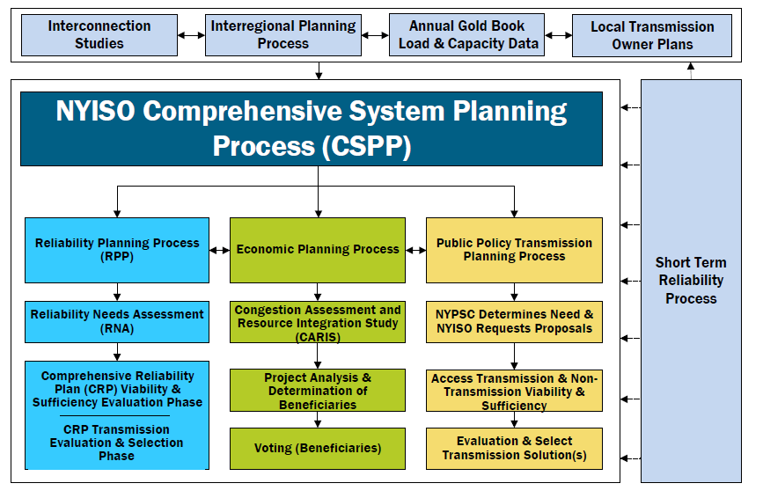

The RNA is developed by the NYISO in conjunction with stakeholders and all interested parties as the first step in the RPP. The RNA assesses the reliability of the New York Bulk Power Transmission Facilities (BPTFs) as the foundation study used in the development of the NYISO Comprehensive Reliability Plan (CRP). Two major study types are performed: resource adequacy and transmission security, over the RNA Study Period (*i.e.,* year 4 through year 10, 2024-2030). If the RNA identifies any violation of Reliability Criteria[4] for BPTFs, the NYISO will report a Reliability Need quantified by an amount of compensatory megawatts (MW) in a location that would resolve that need. After the NYISO’s Board approval of the RNA and if any Reliability Needs are left after the post-RNA Base Case updates process, the NYISO will solicit market‐based solutions, designate one or more Responsible Transmission Owners (TOs) to develop regulated backstop solutions to address each identified Reliability Need, and solicit alternative regulated solutions from interested parties.

The CRP details the NYISO’s plan for continued reliability of the BPTFs during the Study Period and identifies additional resources, or combinations of resources, that resolve any identified criteria violations in the RNA. New or proposed resources included in the CRP may be provided by market‐based solutions developed in response to market forces, and by the request for solutions. If the market does not adequately respond, reliability will be maintained by either regulated backstop solutions developed by the Responsible TOs, which are obligated to provide reliable service to their customers, or alternative regulated solutions being developed by Other Developers. To maintain the long‐term reliability of the BPTFs, these additional resources must be readily available or in development at the appropriate time to address the identified need.

Proposed solutions that are submitted in response to an identified Reliability Need are evaluated in the development of the CRP and must satisfy Reliability Criteria. However, the solutions submitted to the NYISO for evaluation in the CRP do not have to be in the same amounts of MW or locations as the compensatory MW reported in the RNA. There are various combinations of resources and transmission upgrades that could meet the needs identified in the RNA. The reconfiguration of transmission facilities and/or modifications to operating protocols identified in the solution phase could result in changes and/or modifications of the needs identified in the RNA.

This report begins by highlighting the changes to the RPP recently implemented in the NYISO’s tariffs and procedures. Next, this report summarizes the prior RPP findings and reliability plans. The report continues with a summary of the load and resource forecast for the RNA Study Period, the RNA Base Case assumptions and methodology, and the RNA findings. Detailed analyses, data and results, and the underlying modeling assumptions are contained in the appendices.

Along with addressing reliability, the RPP is also designed to provide information that is both informative and of value to the New York wholesale electricity marketplace and federal and state   
policymakers.

For informational purposes, this RNA report reviews activities related to environmental regulatory programs and other relevant developments. For informational purposes, this RNA report also provides the latest historical information and is available for the past five years of congestion on the NYISO’s website.

The *2020 RPP* will serve as the foundation for the *2021 CARIS,* which will present more detailed evaluation of system congestion. Just as important as the electric system plan is the process of planning itself. Electric system planning is an ongoing process of evaluating, monitoring, and updating as conditions warrant.

An overview of the RPP is illustrated in Figure 2 in **Appendix B** and is described in the RPP Manual.

# Overview of Reliability Planning Process Changes

The current RPP was approved by the Federal Energy Regulatory Commission (FERC) and its requirements are contained in Attachment Y of the NYISO’s Open Access Transmission Tariff (OATT). The detailed process of the RPP is contained in the RPP Manual.

In 2019, a major planning process was carved out of the RPP and defined as the Short-Term Reliability Process (STRP). This process was approved by the FERC and its requirements are contained in [Attachments Y and FF of the NYISO’s OATT](http://www.nyiso.com/public/webdocs/documents/tariffs/oatt/att_y.pdf). With this process in place, the RPP’s Study Period changes from a year 1 to year 10 analysis, into a year 4 to year 10 look ahead. At the same time, the STRP evaluates year 1 through year 5 from the Short Term Assessment of Reliability (STAR) Start Date, with a focus on Short-Term Reliability Needs arising in years 1 through 3 of the Study Period. Each quarterly STRP concludes if the STAR or Generator Deactivation Assessment does not identify a STRP Need, and states whether a STRP Need will be addressed in the RPP or in the STRP.

Short-Term Reliability Process Needs that arise in the Near Term (within three years) will be addressed using the Short-Term Reliability Process (STRP). Short-Term Reliability Process Needs that are not Near-Term needs on the BPTF will only be addressed using the STRP if an identified Reliability Need cannot timely be addressed through the ISO’s RPP. If the Reliability Need is handled through the STRP, the NYISO will solicit market-based solutions of all types, a regulated transmission solution(s), and service offers from Generators, as appropriate. The NYISO will select a solution(s) consistent with the STRP process which may include selecting Generators to remain in service under temporary Reliability Must Run (RMR) agreements until the transmission solution is complete.

One of the changes to the RPP, which was first implemented in the *2016 RNA*, is providing initial (“1st pass”) RNA results to stakeholders, usually in June of the first year of the biennial planning process. The stakeholders can provide project updates focused on reducing or eliminating the initial Reliability Needs,   
if any are identified, such as:

* Updated LTPs
* Changes in BPTFs
* Changes in available resources such as generating unit status or authority to operate  
  in current equipment configuration past a date certain (*e.g.*, due to a new or amended environmental laws or regulations) [5]
* Changes in load forecast or demand response resources.

If the NYISO determines that an update does not meet the inclusion rules and/or does not impact the preliminary Reliability Need, then the NYISO will not incorporate the change into the final RNA Base Case.

After the NYISO Board of Directors approves the RNA Report, and before NYISO issues a solicitation for regulated backstop, market-based, and alternative regulated solutions, the NYISO will request updated LTPs, NYPA transmission plans, and other[6] status updates relevant to reducing, or eliminating, the Reliability Needs, as timely received from Market Participants, Developers, TOs, and other parties. Changes that would tend to increase the scope of Reliability Needs after the RNA lockdown date will be handled in the STRP or a future RNA, as appropriate. The NYISO will then request solutions for the remaining Reliability Needs, if any.

The 2018 version of the RPP Manual reflects a change in the “RNA Base Case Development Process” section, mainly related to the Base Case inclusion rules applicable to proposed projects, and also to the treatment of generation deactivations in the RNA Base Case. Specifically, additional considerations were added in 2019 to reflect situations in which a Generator Owner lacks authority to operate in its current equipment configuration past a date certain (e.g., due to a new or amended environmental law or regulation).

Further details of the RPP and STRP are contained in **Appendix B** of this report, and also in the [RPP Manual](https://www.nyiso.com/documents/20142/2924447/rpp_mnl.pdf) located on the NYISO website.

# Summary of Prior Comprehensive Reliability Plans

This RNA is the tenth RNA the NYISO has conducted since the reliability planning process was initially approved by FERC in December 2004. The first three RNA reports identified Reliability Needs and the first three CRPs (2005-2007) evaluated the market-based and regulated backstop solutions submitted in response to those identified needs. The *2009 RNA* and the *2010 RNA* indicated that the system did not exhibit any violations of applicable Reliability Criteria. Accordingly, the NYISO did not solicit solutions under the Comprehensive Reliability Plan (CRP) process. The *2012 RNA* identified Reliability Needs, and the *2012 CRP* evaluated market-based and regulated solutions in response to those needs.

The *2014 RNA* identified both resource adequacy and transmission security related Reliability Needs, which were subsequently eliminated by the system updates received during the 2014 CRP process.

The *2016 RNA* identified two transmission security Reliability Needs beginning in 2017: the New York State Electric & Gas Corp. (NYSEG) Oakdale 345/115 kV transformer, and the Long Island Power Authority (LIPA) East Garden City to Valley Stream 138 kV line. Subsequent to the October 2016 approval of the RNA, and prior to the start of the CRP (as described in the RPP Manual), NYSEG and LIPA provided updates to their LTPs. With these updates the two identified Reliability Needs were resolved, and there was no solicitation of solutions under the 2016 RPP cycle.

The *2018 RN*A concluded that the New York State Bulk Power Transmission Facilities will meet all applicable Reliability Criteria over the 2019 through 2028 study period.

The NYISO has not previously triggered any regulated backstop solutions to meet previously-identified Reliability Needs due to changes in system conditions and the sufficiency of market solutions coming into service.

Figure 5, below, presents the market solutions and TOs’ plans that were submitted in response to previous requests for solutions.

Figure 5: Current Status of Tracked Market-Based Solutions and TOs’ Plans



# Regulatory Policy Activities

The Climate Leadership and Community Protection Act (CLCPA) is the public policy initiative shaping how energy will be supplied in New York State. The New York State Department of Environmental Conservation (NYSDEC) “Peaker Rule” requires significant emission reductions from older high-emitting gas turbines, which will result in some decisions to deactivate affected units in 2023 and 2025. These two initiative will lead to large changes in the type of resources available to serve the demand in New York.

To support the development of clean energy in this competitive environment, contracts for Renewable Energy Credits (RECs) between the state and developers were established. The CLCPA calls for growing the portion of load served by renewable resources to 70% by 2030. Looking beyond 2030, the CLCPA requires a zero-emission grid by 2040. The RNA 70x30 Scenario in conjunction with other studies being performed by the NYISO, such as the *Climate Change Impact & Resilience Study*, takes an initial review of the reliability implications of the CLCPA targets.

At the federal, state, and local levels, public policy initiatives are shaping the grid of the future. How the grid is operated to maintain reliability and economic efficiency while achieving these policies requires careful and informed operations, market design, and planning. From this perspective, the NYISO is examining a number of public policy initiatives, and engaging stakeholders and policymakers to identify the challenges and opportunities these initiatives may present to bulk power system reliability and efficiency.

Figure 6: Summary Table of Key Environmental Regulations and Energy Policies

|  |  |  |  |
| --- | --- | --- | --- |
| PUBLIC POLICY INITIATIVE | POLICYMAKING ENTITIES | PUBLIC POLICY GOALS | PUBLIC POLICY IMPLICATIONS |
| Climate Leadership and Community Protection Act | New York State Public Service Commission, New York State Energy Research and Development Authority,  New York State Department of Environmental Conservation, Climate Action Council | 6,000 MWof distributed solar installed by 2025, 185 trillionBTU reduction in total energy consumption, including electrification to reduce fossil fuel use in buildings by 2025, 3,000 MWof storage installed by 2030, 70%of load supplied by renewable resources by 2030, 9,000 MWof Offshore Wind Installed by 2035, 100% of load supplied by zero-emissions resources by 2040 | Transformation of the power grid, necessitating examination of market structures, planning processes, flexible load, and investment in bulk power system infrastructure |
| Indian Point Deactivation | Agreement between  New York State and Entergy | Deactivate Indian Point units 2 and 3 by 2020 and **2021**, respectively | The NYISO issued a deactivation assessment finding no reliability need associated with loss of Indian Point’s 2,311 MW assuming the addition of certain expected resources.Subsequently, unit 2 deactivated on April 30, 2020.  Unit 3 is scheduled to deactivate  in April 2021 |
| New York City Residual Oil Elimination | City of New York | Eliminate combustion of fuel oil numbers 6 and 4 in New York City by **2020** and 2025**,** respectively | 2,946 MWof installed capacity affected by rule |
| CO2 Performance Standards  for Major Electric Generating Facilities | New York State Department of Environmental Conservation (DEC) | Establish restrictions on carbon dioxide emissions for fossil fuel- fired facilities in New York by **2020** | As of April 2020,all coal-fired generation facilities supplying the bulk power system deactivated. NYISO generator deactivation assessments found no reliability needs associated with these deactivations |
| Regional Greenhouse Gas Initiative (RGGI) | New York and other RGGI states | Reduce carbon dioxide emissions cap by 30% from 2020 to 2030 and expand applicability to currently exempt “peaking units” below current 25 MW threshold | The NYS DEC proposed to expand applicability in NYS to generators  of 15 MWor greater, whereas current rules do not apply to generators less than 25 MW |
| “Peaker Rule”  Ozone Season Oxides of Nitrogen (NOx) Emissions Limits for simple cycle and regenerative combustion turbines | New York State Department of Environmental Conservation (DEC) | Reduce ozone-contributing pollutants associated with New York State-based peaking unit generation. Compliance obligations phased in between **2023** and **2025** | DEC rule impacts approximately 3,300 MWs of peaking unit capacity in New York State. The NYISO is analyzing compliance plans through its Reliability Needs Assessment (RNA) to determine whether they give rise to reliability needs |
| NYS Accelerated Renewable Energy Growth and Community Benefit Act | Office of Renewable Energy Siting (ORES) within the NYS Department of State, New York State Public Service Commission, New York State Energy Research and Development Authority (NYSERDA) | Provides for an accelerated path for the permitting and construction of renewable energy projects instead of through the Article 10 power plant  siting law. Requires a comprehensive study to identify cost-effective distribution, local and bulk electric system upgrades to support the state's climate goals, and filing of  the study with the New York State  Public Service Commission. | Intended to help accelerate siting of eligible renewable resourcesin support of state policy goals. Intended to establish new transmission investment priorities to facilitate the achievement of state policies |

## Climate Leadership and Community Protection Act (CLCPA)

On July 18, 2019, the CLCPA was signed into law, codifying the following measures:

* 70% of electricity delivered in New York State must be derived from renewable resources by 2030;
* 100% of the electricity consumed in New York State must be derived from zero-emissions resources by 2040;
* 9,000 MW of offshore wind installed by 2035;
* 6,000 MW of distributed solar energy resources installed by 2025; and
* 3,000 MW of energy storage installed by 2030.

The CLCPA created a 22-member Climate Action Council (CAC) to establish a roadmap for how the state will work towards these goals. The CAC will develop many of the implementation details of the CLCPA. The CLCPA establishes that the CAC should develop a draft scoping plan by the end of 2022 and deliver a final plan to the Governor and the Legislature by the end of 2023.

## Indian Point Deactivation

On January 9, 2017, Entergy and New York State announced an agreement to close Indian Point units 2 and 3 in 2020 and 2021, respectively. Following receipt of a deactivation notice from Entergy on November 13, 2017, the NYISO evaluated the proposed deactivation as part of the required generator deactivation assessments it performs for proposed generator retirements. In its analysis, the NYISO assumed that certain power plants then under construction would enter into service. Based on the study’s assumptions, the NYISO concluded that the proposed Indian Point deactivation did not result in a Reliability Need. Subsequent reliability planning studies have not altered this outlook. Additional resources identified in the assessment have entered into service and, on April 30, 2020, Indian Point unit 2 deactivated. The NYISO anticipates that Indian Point unit 3 will deactivate by April 30, 2021 without causing a Reliability Need.

## Peaker Rule: Ozone Season Oxides of Nitrogen (NOx) Emission Limits for Simple Cycle and Regenerative Combustion Turbines

In December 2019, the DEC issued requirements to reduce emissions of smog-forming pollutants from peaking generation units.

Combustion turbines known as “peakers” typically operate to maintain bulk power system reliability during the most stressful operating conditions, such as periods of peak electricity demand. Many of these units also maintain transmission security by supplying energy within certain areas of New York City and Long Island — known as load pockets. Load pockets represent transmission-constrained geographic areas where electrical demand can only be served by local generators due to transmission limitations during certain operational conditions.

The Peaker Rule[7], which phases in compliance obligations between 2023 and 2025, will impact approximately 3,300 MW of simple-cycle turbines located mainly in the lower Hudson Valley, New York City and Long Island. The rule required peaking unit owners to submit compliance plans to the DEC in March 2020. These generator compliance plans informed the NYISO’s *2020 Reliability Needs Assessment* (RNA) base case assumptions for years 2024-2030. The proposed plans are also being examined in the NYISO Short-Term Reliability Process for the years 2021-2025. The rule provides a phased reduction in emission limits, in 2023 and 2025, during the ozone season (May 1-September 30) and allows several options for achieving compliance with the new lower limits applicable during the ozone season. Compliance plans submitted to the NYSDEC were provided to the NYISO for assessment and inclusion in the base case. Review of the plans indicated approximately 1,800 MW had proposed to modify their availability to comply with the emissions standards through various approaches over a phased timeline. Remaining units stated either that they comply with the emission limits as currently operated, or proposed equipment upgrades to achieve the emissions limits.

The regulations include a provision to allow an affected generator to continue to operate up to two years, with a possible further two-year extension, after the compliance deadline if the generator is designated by the NYISO or the local transmission owner as needed to resolve a reliability need until a permanent solution is in place.

## New York City Residual Oil Elimination

New York City passed legislation in December 2017 to prohibit the combustion of fuel oil Numbers 6 and 4 within utility boilers in New York City by 2020 and 2025, respectively. The rule is expected to impact 2,946 MW nameplate of generation in New York City. Many Generators in New York City that are connected to the local gas distribution network are required to maintain alternative fuel combustion capabilities and storage capacity.

In addition, the New York State Reliability Council (NYSRC) has a minimum oil-burn requirement rule that is intended to maintain electric system reliability in the event of gas supply interruptions.

Generators have taken steps to convert their facilities to comply with the law. While oil accounts for a relatively small percentage of the total energy production in New York State, it is often called upon to fuel generation during critical periods, such as when severe cold weather limits access to or increases the price of natural gas. Dual-fuel capability serves as both an important tool in meeting reliability and an effective economic hedge against high natural gas prices during periods of high demand for natural gas.

## Carbon Dioxide Performance Standards for Major Electric Generating Facilities

The DEC adopted regulations that limit carbon dioxide emissions from existing fossil fuel-fired generators beginning in 2021**.** As a result, approximately 860 MW of coal-fired generation exited the market by April 2020, eliminating coal-fired generation as a supply resource on the bulk power system in the state. New York’s coal-fired generation accounted for less than 1% of the total energy produced in the state in 2019. The NYISO assessed these deactivations and concluded[8] that they would not result in reliability needs.

## Regional Greenhouse Gas Initiative (RGGI)

RGGI is a multi-state carbon dioxide emissions cap-and-trade initiative requiring affected fossil fuel generators to procure carbon dioxide emissions allowances. The costs for these allowances are factored into the costs of operating fossil fuel-fired generators. Suppliers seek to recover these costs through competitive offers in the wholesale electricity markets. Through this initiative, each participating state determines a set number of allowances, the majority of which are collectively auctioned to generators or other stakeholders. The level of available allowances is established in advance and lowered over time to encourage generators to invest in emissions reduction strategies.

The New York State DEC issued proposed RGGI regulations that would cap New York’s carbon dioxide emissions at approximately 21 million tons by 2030.[9] In 2019, New York generators emitted approximately 24.6 million tons of carbon dioxide. The proposed rule seeks to expand applicability to certain generators of 15 MW or greater, whereas currently RGGI rules do not apply to generators less than 25 MW nameplate. New Jersey re-joined the initiative in 2020, Virginia will be joining in 2021, and Pennsylvania has pending legislation to join RGGI. The expansion of the RGGI region and anticipated changes to program design features may affect the dynamics of CO2 emission allowance costs and availability going forward. Tighter requirements through RGGI, however, are not likely to trigger reliability concerns because of program design features such as the Cost Containment Reserve and multi-year compliance periods.

## NYS Accelerated Renewable Energy Growth and Community Benefit Act

In an effort to speed up the siting and construction of large-scale clean energy projects, the state approved the Accelerated Renewable Energy Growth and Community Benefit Act in April 2020. The act provides an accelerated path for permitting and constructing renewable energy projects by establishing a new Office of Renewable Energy Siting (ORES) within the New York State Department of State.

The act also directs the New York State Department of Public Service, in consultation with NYSERDA, the New York Power Authority (NYPA), the Long Island Power Authority, the investor-owned utilities, and the NYISO, to conduct a comprehensive study to identify cost-effective distribution, local and bulk electric system upgrades to support the state’s climate and clean energy policies. This study is targeted to be completed by end of 2020. The PSC has commenced a proceeding leading to a transmission investment plan utilizing the NYISO’s Public Policy Process to select projects, while enabling the PSC to designate NYPA, either on its own or with others, to carry out projects needed expeditiously to achieve CLCPA goals.[10] NYPA and DPS Staff have petitioned the PSC proposing criteria for ranking transmission needs to qualify as Priority Projects and proposing the “Northern NY Project” and the “Western NY Energy Link” as meeting these criteria.[11]

# Base Case Assumptions

The NYISO has established procedures and a schedule for the collection and submission of data and for the preparation of the models used in the RNA. The RPP procedures are designed to allow planning activities to be performed in an open and transparent manner. The RPP is conducted under a defined set of rules that are aligned and coordinated with the related planning activities of the North American Electric Reliability Council (NERC), the Northeast Power Coordinating Council (NPCC), and the New York State Reliability Council (NYSRC). The assumptions underlying the RNA were reviewed at the ESPWG and TPAS and are shown in **Appendix D** of this report.

This section highlights the key assumptions and modeling data updates for the RNA. These include the load forecast model, the forecasted level of Special Case Resources, the change in generation resource status, LTPs, and Bulk Power Transmission Projects. As described above, the newly defined RNA Study Period is from year 2024 (year 4) through 2030 (year 10).

Both the transmission security and resource adequacy studies in the RNA Base Case use a peak demand and energy forecast originating from the baseline forecast reported in the *2020 Gold Book*. The baseline forecast from the *2020 Gold Book* is derived from energy and peak models that are built based on projections of end-use intensities and economic variables. End-use intensities modeled include those for lighting, refrigeration, cooking, heating, cooling, and other plug loads. The baseline forecast includes the projected impacts of energy efficiency programs, building codes and standards, distributed energy resources, behind-the-meter energy storage, behind-the-meter solar photovoltaic power, electric vehicle usage, and electrification of heating and other end uses. Economic variables considered include gross domestic product (GDP), households, population, and commercial and industrial employment. The baseline forecast also considers the near-term economic impacts of reduced energy consumption resulting from the state’s response to COVID-19. For the resource adequacy study, the baseline load forecast was modified by removing the behind-the-meter solar PV impacts in order to model the solar PV explicitly as a generation resource to account for the intermittent nature of its availability.

The RNA Base Cases were developed in accordance with NYISO procedures using projections for the installation and deactivation of generation resources and transmission facilities that were developed in conjunction with Market Participants and TOs:

* For the transmission security evaluations, the power flow RNA Base Case uses the NYISO 2020 FERC 715 filing as a starting point, adding and removing resources consistent with the base case inclusion screening process provided in Section 3 of the RPP Manual. Representations of neighboring systems are derived from interregional transmission planning coordination conducted under the Northeast Power Coordinating Council (NPCC) and the Eastern Interconnection Reliability Assessment Group (ERAG) Multiregional Modeling Working Group (MMWG) processes, and pursuant to the Northeast ISO/RTO Planning Coordination Protocol.
* For the resource adequacy evaluations, the models are developed starting with prior resource adequacy models, and are updated with information from the *2020 Gold Book* and historical data, with the application of the inclusion rules. Information on modeling of neighboring systems is based on the input received from the NPCC CP-8 working group.

## Annual Energy and Summer Peak Demand Forecasts

This section reports the baseline forecast, the high load scenario forecast, the behind-the-meter solar PV forecast, and the baseline forecast with projected behind-the-meter solar PV added back. These forecasts are fully detailed in the *2020 Gold Book*. The baseline forecast reflects the expected impacts of energy efficiency, distributed energy resources, and behind-the-meter solar PV on annual energy use and peak loads. The high load scenario forecast reflects faster adoption of electric vehicles and other electrification, and slower adoption of behind-the-meter solar PV and energy efficiency measures. The baseline energy forecast reflects a moderate recession due to COVID-19 impacts, and assumes typical economic growth in the year 2022 and beyond. The high load scenario energy forecast reflects a slight recession and assumes somewhat higher than typical economic growth in the year 2022 and beyond. The baseline and high load scenario peak forecasts do not account for any potential economic impacts associated with COVID-19. The baseline forecast, which already reflects the solar PV behind-the-meter reductions, was modified to add back those impacts. The modified baseline forecast is used for the resource adequacy study to model behind-the-meter solar PV as a generating resource.

The demand-side management impacts included or accounted for in the 2020 Base Case forecast derive from actual and projected spending levels and realization rates for state-sponsored programs such as the Climate Leadership and Community Protection Act (CLCPA), Clean Energy Standard (CES), the Clean Energy Fund (CEF), the NY-SUN initiative, the energy storage initiative, and earlierprograms developed as part of the Reforming the Energy Vision (REV) proceedings. The NYISO reviewed and discussed with Market Participants, during meetings of the ESPWG and TPAS, projections for the potential impact of energy efficiency, solar PV, electric vehicles, and other demand-side management impacts over the Study Period. The factors considered in developing the 2020 RNA Base Case forecast are included in **Appendix C** of this report.

The assumptions for the 2020 economic growth, energy efficiency program impacts, and behind-the-meter solar PV impacts were also discussed with Market Participants during meetings of the ESPWG and TPAS in March and April of 2020. The ESPWG and TPAS reviewed and discussed the assumptions used in the 2020 RNA Base Case forecast in accordance with procedures established for the RNA.

The baseline energy forecast for the *2020 RNA* is lower than the *2018 RNA* baseline forecast, including a 4.2% decline in 2020 and 1.7% decline in 2028. The baseline peak forecast for the *2020 RNA* is also lower than the *2018 RNA* baseline forecast, including a 1.4% decline in 2020 and 1.1% decline in 2028. The lower energy forecasts are attributed to both economic factors and the continued impact of energy efficiency and behind-the-meter solar PV.

Figure 7 on the next page summarizes the three forecasts used in the *2020 RNA*. Figure 9 shows a comparison of the baseline forecasts and energy efficiency program impacts contained in the *2018 RNA* and the *2020 RNA*. Figure 10 and Figure 11 present actual, weather-normalized forecasts of annual energy and summer peak demand for the 2020 RN*A*. Figure 12 and Figure 13 present the NYISO’s projections of annual energy and summer peak demand in the *2020 RNA* for energy efficiency, distributed generation, and behind-the-meter solar PV.

Figure 7: 2020 RNA Load and Energy Forecast: Baseline Forecast, and Baseline with BtM Solar PV Forecasts Added Back In



**1** For the resource adequacy study, the Gold Book baseline load forecast was modified by removing the behind-the-meter solar PV impacts in order to model the solar PV explicitly as a generation resource to account for the intermittent nature of its availability.

**2** The transmission security power flow RNA base cases use this Gold Book baseline forecast.

Figure 8: 2020 RNA Load and Energy for High Load Scenario: High Load Scenario Forecast, and High Load Scenario Forecast with BtM Solar PV Added Back In



**3** The high load scenario forecast will be used for the high load resource adequacy scenario.

Figure 9: Comparison of 2018 RNA & 2020 Baseline Forecasts

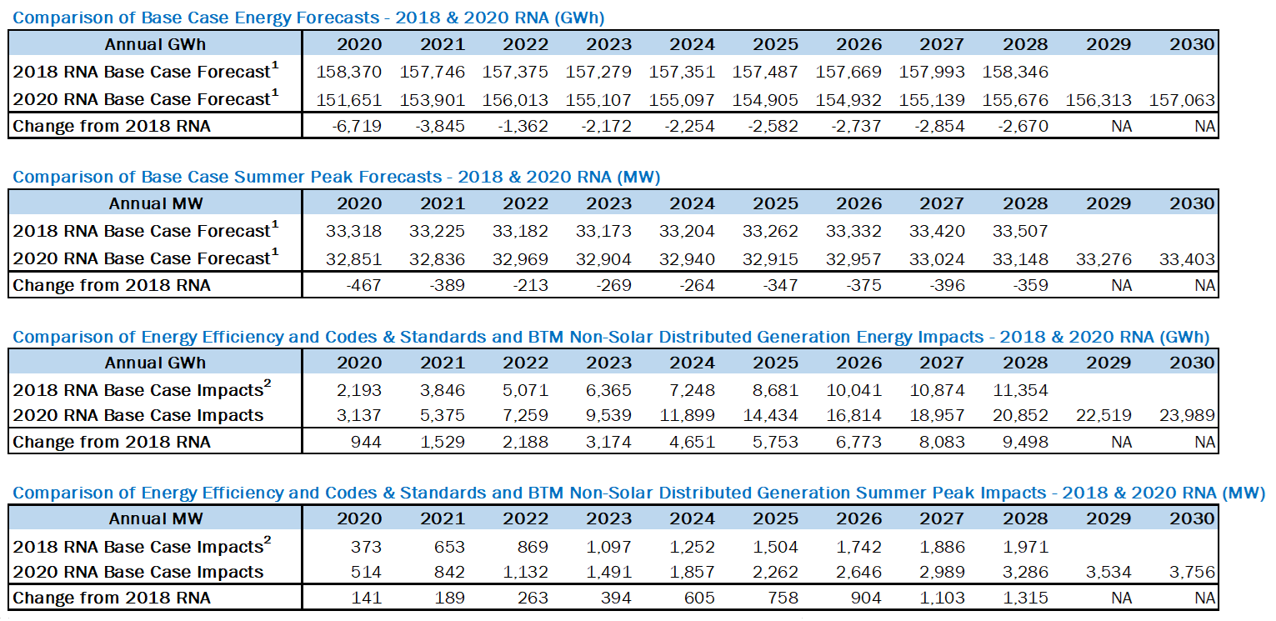

**1** For the resource adequacy study, the Gold Book baseline load forecast was modified by removing the behind-the-meter solar PV impacts in order to model the solar PV explicitly as a generation resource to account for the intermittent nature of its availability.

**2** 2016 Gold Book values have been adjusted to include only those impacts from 2018 forward, so as to compare directly to the 2018 Gold Book values.

Figure 10: 2020 Baseline and High Load Scenario Energy Forecasts with Solar PV Added Back



Figure 11: 2020 Baseline and High Load Energy Scenario Summer Peak Demand Forecasts with Solar PV Added Back



Figure 12: 2020 Baseline Annual Energy Forecast Impacts

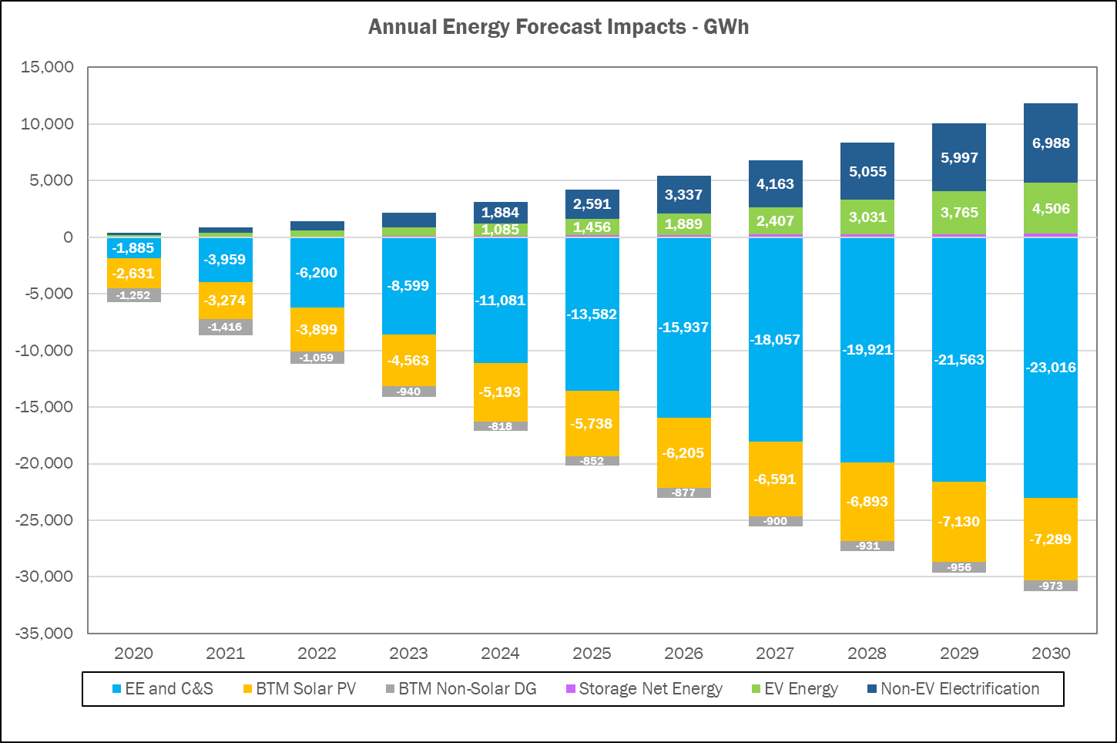

Figure 13: 2020 Baseline Summer Peak Demand Forecast Impacts

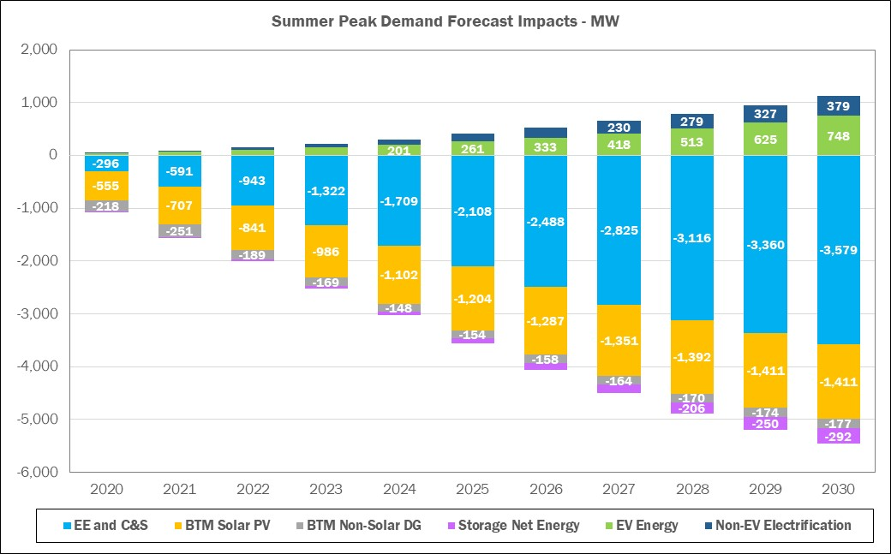

For the *2020 RNA* resource adequacy assessments, the NYISO uses behind-the meter (BtM) solar PV production data. For General Electric’s Multi Area Reliability Simulations (GE-MARS) modeling, the BtM solar PV component is added back in the baseline forecast in order to discretely model the BtM solar PV. The load shapes used in the study were adjusted from the historic shapes to a shape that meets the forecasted zonal peak, NYCA peak, Zones G through J Locality peak, and NYCA Energy Forecast. The combination of the load shapes with the solar shapes results in a set of net load shapes that, at time of NYCA peak, meets the baseline forecast. Discretely modeling BtM solar PV as a resource provides for flexibility to adjust the amount of resource available across the system.

Figure 14: Forecast of BtM Solar PV Coincident Summer Peak Demand Reductions (MW)

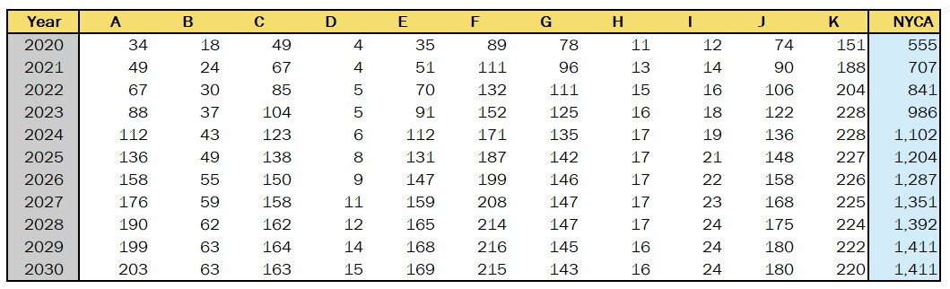

## Forecast of Special Case Resources

The 2020 RNA Special Case Resource[12] (SCR) MW levels are based on the *2020 Gold Book* value of 1,282 MW, adjusted for their performance for the resource adequacy evaluations. Transmission security analysis, which evaluates normal transfer criteria, does not consider SCRs.

## 2020 RNA Resource Additions and Removals

Since the 2019-2028 CRP assumptions were finalized, new resources have been added to the system, some deactivation notices have been withdrawn and the associated facilities have returned to the system, and some other resources have been removed from the 2020 RNA Base Case:

* A total of approximately 543 MW of proposed generation (wind and solar) has been added to the 2020 RNA Base Case as compared with the 2019 - 2028 CRP.
* A total of approximately 2,582 MW of generation have been removed as compared with the 2019 – 2028 CRP Base Case either due to being in a deactivated state (*e.g.,* retired, mothballed, or in an ICAP-Ineligible Forced Outage (IIFO), or proposed to retire or mothball), or as operationally impacted by the DEC Peaker Rule.

The comparison of generation status between the 2019 – 2028 CRP and 2020 RNA is detailed in Figure 15, Figure 16 and Figure 17. The MW values represent the Capacity Resources Interconnection Service (CRIS) MW values from the 2020 Gold Book.

Figure 15: Proposed Projects Included in the 2020 RNA Base Case



Figure 16: 2020 RNA Generation Deactivations Assumptions



Figure 17: Existing Plants Impacted by DEC’s Peaker Rule (Additional Details on Peakers Status by Ozone Season are in Appendix D)



**Note**: NYSDEC’s Part 227-3 applies to all simple cycle gas turbines with nameplates equal to or greater than 15 MW. Thus, all simple cycle generators are subject to the rule and all owners of these machines were required to submit compliance plans to the NYSDEC. The compliance plans consist of statements that the generator; already complies with the new NOx limits, will retire, will limit operation during the ozone season, and/or will retrofit emission control technology to meet the emission limits of the new rule. If the plant owners submitted compliance plans that state that the generator will able to operate within the new NOx limits during the ozone season, these generators remain in service in the 2020 RNA base case.

## Additional Proposed Projects from the Interconnection Queue

In addition to the projects that met the 2020 RNA inclusion rules (listed in Figure 15), a number of other projects are progressing through the NYISO’s interconnection process. Some of these additional generation resources either have accepted their cost allocation as part of a prior Class Year Facilities Study process, or are included in the *Class Year 2019 Facilities Study*, or are candidates for future interconnection facilities studies. These projects are listed in the *2020 Gold Book* and also in Figure 18 and Figure 19.

Figure 18: Additional Proposed Generation Projects from the 2020 Gold Book







* Generation projects that met 2020 RNA Inclusion Rule are assumed to be in-service one year later than 2020 GB Proposed Date to reflect the potential impact of Covid-19 on construction and completion.

Figure 19: Additional Proposed Transmission Projects from the 2020 Gold Book



## Local Transmission Plans

As part of the NYISO’s Local Transmission Planning Process, the New York TOs present their Local Transmission Owner Plans (LTPs) to the NYISO and stakeholders during ESPWG and TPAS meetings. The firm transmission plans presented in the LTPs and reported as firm in the *2020 Gold Book* are included in the 2020 RNA Base Case, with consideration for their in-service dates. A summary of these projects is reported in **Appendix D** of this report.

## Bulk Transmission Projects

The notable bulk transmission projects that met the inclusion rules and are modeled in the *2020 RNA* Base Case are:

* The NextEra Empire State Line Project that was selected by the NYISO Board of Directors in October 2017 to address the Western New York Public Policy Transmission Need. This project includes a new 345 kV circuit and phase angle regulator (PAR) that will alleviate constraints in the Niagara area. The planned in-service date for this project is June 2022.
* The Segment A, AC Transmission joint project, by LS Power and New York Power Authority (NYPA) that was selected by the NYISO Board of Directors in April 2019. The project includes a new double-circuit 345 kV line between Edic and New Scotland substations, two new 345 kV substations at Princetown and Rotterdam, two new 345 kV lines between Princetown to Rotterdam substations, and retirement of the existing Porter to Rotterdam 230 kV lines. The planned in-service date is December 2023.
* The New York Transco Segment B, AC Transmission project, also was selected by the NYISO Board of Directors in April 2019. The project includes a new double-circuit 345/115 kV line from a new Knickerbocker 345 kV switching station to the existing Pleasant Valley substation, 50% series compensation on the Knickerbocker to Pleasant Valley 345 kV line, and retirement of 115 kV lines between Greenbush and Pleasant Valley substations. The planned in-service date is December 2023.

## Base Case Peak Load and Resources Summaries

The 2020 RNA Base Case models the existing generation as adjusted for the unit deactivations listed in the *2020 Gold Book*, and along with the new resource additions that met the base case inclusion rules set forth in Section 3 of the RPP Manual. This capacity is summarized in Figure 20 on the next page, along with the baseline peak load, capacity net purchases and the Special Case Resources (SCRs).

Figure 20: NYCA Peak Load and Resources 2024 through 2030





**Notes**:

\***NYCA** load values represent baseline coincident summer peak demand. **Zones J and K load** values represent non-coincident summer peak demand. **Aggregate Zones G-J values** represent G-J peak.

**NYCA Capacity values include resources electrically internal to NYCA, additions, reratings, and retirements (including proposed retirements and mothballs). Capacity values reflect the lesser of CRIS and DMNC values. NYCA resources include the net purchases and sales as per the Gold Book. Zonal totals include the full Unforced Capacity Deliverability Rights (UDRs) for those capacity zones.

* SCR: forecasted MW ICAP value from the 2020 Gold Book.
* Wind, solar, run-of river and landfill gas summer capacity is counted as 100% of nameplate rating.

*** For UCAP calculation, EFORd from GE-MARS output file are used for thermal units. For renewables, installed capacity intermittent resources derating factors (received from IMO team) are used.

Figure 21: Total Capacity/ Load Ratios (%) ICAP vs UCAP for 2030



Notes:

1. Total Capacity = Capacity* + full UDR + SCR

2. *Capacity = lesser of (CRIS, DMNC). NYCA resources include the net purchases and sales as per the Gold Book.

3. ICAP = Installed Capacity

4. UCAP = Unforced Capacity (takes into consideration generation unavailability)

5. UCAP calculation:

* For thermal units, average capacity derating factors from the MARS output are used
* For renewables, installed capacity intermittent resources derating factors are used

As shown in the Figure 20, the total NYCA capacity margin, which is defined as capacity above the baseline load forecast, varies between 24% and 27%. Figure 21 shows a comparison between the total ICAP and total UCAP for 2030; the difference reflects generation unavailability for the resource mix assumed in the RNA Base Case for year 2030.

Figure 22 below shows the relative decrease in the capacity margin, by comparing the details of the capacity margins for year 10 between the 2020 RNA (2030) and the 2019-2028 CRP (2028). The analysis reveals two observations:

* Negative net margin shows deterioration in the relative capability to serve load, when comparing the two studies assumptions; and
* Compared to the *2019 CRP*, the system has less overall net resources.

Figure 22: NYCA Load and Resources Comparison with the 2019 - 2028 CRP



Notes:

1. Includes the reductions due to projected energy efficiency programs, building codes and standards, distributed energy resources and behind-the-meter solar photovoltaic resources; it also reflects expected impacts (increases) from projected electric vehicle usage.
2. Includes the total SCRs, and net capacity purchases and sales from the applicable Gold Book.

Figure 23: 2020 RNA Zone J Load and Capacity Comparison with the 2019 - 2028 CRP



Notes:

1. Includes the reductions due to projected energy efficiency programs, building codes and standards, distribution energy resources and behind-the-meter solar photovoltaic power; it also reflects expected impacts (increases) from projected electric vehicle usage.
2. Does not include the total SCRs, and UDRs from the applicable *Gold Book*.

# Base Case Reliability Needs Assessments

## Overview

This section provides the methodology and results for the resource adequacy and transmission system adequacy and security of the New York BPTF over the RNA Study Period. If any Reliability Criteria violations are identified, the NYISO identifies Reliability Needs. Violations of the criteria are translated into MW or MVAr amounts to provide a relative quantification of the Reliability Needs, and to support the development of solutions in the CRP.

## Methodology for the Determination of Needs

The OATT defines Reliability Needs in terms of total deficiencies relative to Reliability Criteria determined from the assessments of the BPTF performed in the RNA. There are two steps to analyzing the reliability of the BPTF. The first is to evaluate the security of the transmission system. The second is to evaluate the adequacy of the system, subject to the security constraints. The transmission adequacy and the resource adequacy assessments are performed together.

Transmission security is the ability of the power system to withstand disturbances, such as electric short circuits or unanticipated loss of system elements, and continue to supply and deliver electricity. Transmission security is assessed deterministically with potential disturbances being applied without concern for the likelihood of the disturbance in the assessment. These disturbances (single-element and multiple-element contingencies) are categorized as the design criteria contingencies, which are explicitly defined in the Reliability Criteria. The impacts resulting from applying these design criteria contingencies are assessed to determine whether thermal loading, voltage, or stability violations will occur. In addition, the NYISO performs a short circuit analysis to determine if the system can clear faulted facilities reliably under short circuit conditions. The NYISO’s “Guideline for Fault Current Assessment[13]” describes the methodology for that analysis.

The analysis for the transmission security assessment is conducted in accordance with NERC Reliability Standards, NPCC Transmission Design Criteria, and the NYSRC Reliability Rules. Contingency analysis is performed on the BPTF to evaluate thermal and voltage performance under design contingency conditions using the Siemens PTI PSS®E and PowerGEM TARA programs. Generation is dispatched to match load plus system losses, while respecting transmission security. Scheduled inter-area transfers modeled in the base case between the NYCA and neighboring systems are held constant.

For the RNA, over 1,000 design criteria contingencies are evaluated under N‑1, N‑1‑0, and N‑1‑1 normal transfer criteria conditions to provide that the system is planned to meet all applicable reliability criteria. To evaluate the impact of a single event from the normal system condition (N‑1), all design criteria contingencies are evaluated including: single element, common structure, stuck breaker, generator, bus, and HVDC facilities contingencies. An N‑1 violation occurs when the power flow on the monitored facility is greater than the applicable post-contingency rating. N‑1‑0 and N‑1‑1 analyses evaluate the ability of the system to meet design criteria after a critical element has already been lost. For N‑1‑0 and N‑1‑1 analysis, single element contingencies are evaluated as the first contingency. The second contingency (N‑1‑1) includes all applicable design criteria contingencies evaluated under N-1 conditions. Certain areas of the Con Edison system are designed and operated for the occurrence of a second contingency. This type of combination can be described as N-1-1-0. For N-1-1-0 analysis, after the second contingency occurs, systems adjustments are allowed to secure the system back to normal ratings. The Con Edison planning criteria are contained in the [NYSRC Reliability Rules](http://www.nysrc.org/NYSRCReliabilityRulesComplianceMonitoring.html), rule G.1. Accordingly, a violation of the N-1-1-0 criterion on the BPTFs in Con Edison district will be identified as Reliability Need in the NYISO’s Reliability Needs Assessment.

The process of successive contingency testing (such as N-1-1) allows for corrective actions including generator re-dispatch, PAR adjustments, and HVDC adjustments between the contingencies. For example, for N-1-1 analysis allowable system adjustments occur between the first (N-1-0) and second (N-1-1) contingencies. These corrective actions prepare the system for the next contingency by reducing the flow to normal rating after the first contingency. An N‑1‑0 violation occurs when the flow cannot be reduced to below the normal rating following the first contingency. An N‑1‑1 violation occurs when the facility is reduced to below the normal rating following the first contingency, but the power flow following the second contingency exceeds the applicable post-contingency rating.

Resource adequacy is the ability of the electric systems to supply the aggregate electrical demand and energy requirements of the customers at all times, taking into account scheduled and reasonably expected unscheduled outages of system elements. Resource adequacy considers the transmission systems, generation resources, and other capacity resources, such as demand response. The NYISO performs resource adequacy assessments on a probabilistic basis to capture the random natures of system element outages. If a system has sufficient transmission and generation, the probability of an unplanned disconnection of firm load is equal to or less than the system’s standard, which is expressed as a loss of load expectation (LOLE). The New York State bulk power system is planned to meet an LOLE that, at any given point in time, is less than or equal to an involuntary firm load disconnection that is not more frequent than once in every 10 years, or 0.1 events per year. This requirement forms the basis of New York’s Installed Reserve Margin (IRM) requirement and is analyzed on a statewide basis.

If Reliability Needs are identified, various amounts and locations of compensatory MW required for the NYCA to satisfy those needs are determined to translate the criteria violations to understandable quantities. Compensatory MW amounts are determined by adding generic capacity resources to NYISO Zones to effectively satisfy the needs. The compensatory MW amounts and locations are based on a review of binding transmission constraints and zonal LOLE determinations in an iterative process to determine various combinations that will result in Reliability Criteria being met. These additions are used to estimate the amount of resources generally needed to satisfy Reliability Needs. The compensatory MW additions are not intended to represent specific proposed solutions. Resource needs could potentially be met by other combinations of resources in other areas including generation, transmission and demand response measures.

Due to the different types of supply and demand-side resources, and also due to transmission constraints, the amounts and locations of resources necessary to match the level of compensatory MW needs identified will vary. Reliability Needs could be met in part by transmission system reconfigurations that increase transfer limits, or by changes in operating protocols. Operating protocols could include such actions as using dynamic ratings for certain facilities, invoking operating exceptions, or establishing special protection systems.

The procedure to quantify compensatory MW for BPTF transmission security violations is a separate process from calculating compensatory MW for resource adequacy violations. This quantification is performed by first calculating transfer distribution factors on the overloaded facilities. The power transfer used for this calculation is created by injecting power at existing buses within the Zone where the violation occurs, and reducing power at an aggregate of existing generators outside of the area.

## Resource Adequacy Base Case Assessments

The NYISO conducts its resource adequacy analysis using the GE-MARS software package, which performs probabilistic simulations of outages of capacity and select transmission resources. The program employs a sequential Monte Carlo simulation method and calculates expected values of reliability indices such as LOLE (days/year) and includes load, generation, and transmission representation. Additional modeling details and links to various stakeholders’ presentations are in the assumptions matrix, **Appendix D**. The four external Control Areas interconnected to the NYCA (ISO-New England, PJM, Ontario and Quebec) are also modeled. In determining the reliability of a system, there are several types of randomly occurring events that are taken into consideration. Among these are the forced outages of generating units, the forced outages of transmission capacity, and deviations from in the forecasted loads.

#### Generation Model

The NYISO models the generation system in GE-MARS using several types of units. Thermal units considerations include: random forced outages as determined by Generator Availability Data System (GADS) — calculated EFORd and the Monte Carlo draw, scheduled and unplanned maintenance, and thermal derates. Renewable resource units (*i.e.* solar PV, wind, run-of-river hydro and landfill gas) are modeled using five years of historical production data. Co-generation units are also modeled using a capacity and load profile for each unit.

#### Load Model

The load model in the NYISO GE-MARS model consists of historical load shapes and load forecast uncertainty (LFU). The NYISO uses three historical load shapes in the GE-MARS model (2002, 2006 and 2007) in seven different load levels using a normal distribution. LFU is applied to every hour of these historical shapes and each of the seven load levels are run through the GE-MARS model.

#### MARS Topology

The NYISO models the amount of power that could be transferred across the system in GE-MARS using interface transfer limits applied to the connections between the GE-MARS areas[14] (“bubble-and-pipe” model).

Summary of major GE-MARS topology changes[15] (as compared with the 2019-2028 CRP):

* Marion-Farragut 345kV cables (B and C) assumed out-of-service
* 71, 72, M51, M52 series reactors assumed bypassed after deactivation of Indian Point Unit Nos. 2 and 3
* Rainey – Corona transmission project in-service impacting J to K limits
* AC Transmission Public Policy Segment A and B Projects added starting January 2024
* Removal of Cedars bubble/tie to Zone D model; adding the MW from the bubble to the tie HQ to D tie limit.
* Updates to Zone K Imports/Exports
* Somerset retirement impacts
* The external areas model for PJM and ISO-NE were [simplified](https://www.nyiso.com/documents/20142/11350020/07%202020RNA_MARS-ExternalAreasSimplification.pdf) by consolidating the five PJM areas (bubbles) into one, and the eight ISO-NE areas into one.

The emergency transfer criteria limits used in the GE-MARS model were developed from an assessment of analysis of the *2020 RNA* power flow base cases, and analysis performed for other studies. Figure 24, Figure 25 and Figure 26 provide the thermal and voltage emergency transfer limits for the major NYCA interfaces. The *2018 RNA* transfer limits are presented for comparison purposes.

Figure 24: Transmission System Thermal Emergency Transfer Limits



**Notes**:

Grey italic font: Limit was not calculated

*change in limit between 2018 RNA and 2020 RNA is due to different modeling method used in GE-MARS. Additional topology changes details are in Appendix D.

Figure 25: Transmission System Voltage Emergency Transfer Limits



Note: Grey italic font: Limit was not calculated

Figure 26: Transmission System Base Case Emergency Transfer Limits



Notes:

T - Thermal, V - Voltage, C – Combined

There are large increases in transfer capability modeled starting in year 2024 in the 2020 RNA. The increases reflect the impact of including the AC Transmission Public Policy projects. Comparing limits in year 2023 to year 2024 increases are represented to the thermal limits of 550 MW for the E to G interface, 1,925 MW for the F to G interface, and 1,900 MW for the UPNY-SENY MARS interface. There are also increases to the voltage limits of 825 MW for the Central East MARS interface, 650 MW for the Central East Group interface, and 375 MW for the UPNY-Con Ed interface.

A decrease in the thermal transfer limit for Dysinger East of 100 MW was modeled in the *2020 RNA*. The primary cause for the change was the retirement of the Somerset generation unit in Zone A.

Comparing the transfer limits reported for year 2021 through 2023 to the previous RNA, there is an increase of 750 MW on the UPNY-Con Ed voltage limit for the 2020 RNA. The primary cause for this increase is a change in the study assumption for the operation of the series reactors on the Dunwoodie – Mott Haven 345 kV cables (71, 72) and the Sprain Brook – W. 49th Street cables (M51, M52). For the *2020 RNA*, these series reactors were modeled as bypassed. This study assumption also resulted in a decrease of 50 MW in the I to J interface thermal limit.

The E to G interface thermal limit was modeled using a dynamic limit table in the 2020 RNA MARS topology. The interface limit ranged from 1750 MW to a maximum of 2250 MW based on the availability of the CPV Valley generation units. Starting in year 2024 the dynamic limit table was replaced with a single interface limit of 2300 MW. The increase in the limit is the result of transmission facility upgrades included in the AC Transmission Public Policy projects. Similarly, the UPNY-SENY MARS interface was modeled using a dynamic limit table ranging from 5100 MW to a maximum of 5350 MW. With the large increase in transfer capability when including the AC Transmission projects in 2024, the model was simplified by using a single limit of 7150 MW, and does not constrain the flow of power in the GE-MARS simulation.

The topology used in the GE-MARS model for the 2020 RNA Base Case is represented in Figure 27.

Figure 27: 2020 RNA Topology Years 4-10 (2024 -2030)



Additionally, for information only, Figure 28 and Figure 29 represent the initial three years preceding the newly-defined RNA Study Period.

Figure 28: Topology Year 1 (2021)



Figure 29: Topology Year 2- 3 (2022- 2023)



#### Resource Adequacy Base Case Results

The results of the 2020 RNA Base Case resource adequacy studies show that the LOLE for the NYCA is at or above the criterion of 0.1 days/year, starting 2026. The NYCA LOLE results are presented in Figure 30 below.

Figure 30: NYCA Resource Adequacy Results



**Note**: NYCA load values represent baseline coincident summer peak demand.   
Zones J and K load values represent non-coincident summer peak demand.   
Aggregate Zones G-J values represent the G-J peak demand.

The LOLE is at or above NYSRC’s and NPCC’s criterion of one day in 10 years, or 0.1 days per year, starting year 6 (2026) of the RNA Study Period, and increases through year 10 (2030). Therefore, the NYISO identifies resource adequacy Reliability Needs starting 2027 (with 2026 being at the 0.10 days/year criterion).

The deficiencies identified in this *2020 RNA* are driven by the compound effect of increasing load forecast (*e.g.,* +495 MW in 2030) and loss of generation in Zone J (*e.g*., –1372 MW in 2030) see Figure 31. Compared to the 2019 - 2028 CRP, the system has less overall net resources. The 2020 RNA Base Cases models reflect the application of the generator compliance plans for the DEC’s Peaker Rule to affected plants in New York City (Zone J), Long Island (Zone K), and Hudson Valley (Zone G). In Figure 31, below, the negative net margin shows deterioration in the relative capability to serve load, when comparing the assumptions in the two studies.

Figure 31: 2020 RNA Zone J Load and Capacity Comparison with the 2019 – 2028 CRP



Notes:

1. Includes the reductions due to projected energy efficiency programs, building codes and standards, distribution energy resources and behind-the-meter solar photovoltaic power; it also reflects expected impacts (increases) from projected electric vehicle usage.
2. Does not includes the total SCRs, and UDRs from the Gold Book.

#### Resource Adequacy Compensatory MW

Resource adequacy compensatory MW amounts are determined by adding generic “perfect capacity” resources to each zone individually, or in combinations of Zones, to address the shortfall.

“Perfect capacity” is capacity that is not derated (*e.g.,* due to ambient temperature or unit unavailability), not subject to energy duration limitations, and not tested for transmission security or interface impacts. Actual resources would need to be larger in order to achieve the same impact as perfect-capacity resources.

The compensatory MW additions are not intended to represent specific solutions, as the impact of specific solutions can depend on the type of the solution and its location on the grid. Rather, the compensatory MW levels provide a generic order-of-magnitude measure to guide solutions. Resource needs could potentially be met by combinations of solutions including generation, transmission, energy efficiency, and demand response measures.

Figure 32: Compensatory MW Additions for Resource Adequacy Violations



**Observations:**

* Adequate compensatory MW must be located within, or injected into, Zone J because of transmission constraints into Zone J observed starting in 2029. This result is exemplified by the fact that no compensatory MW in any of the other NYCA Zones will help bring the LOLE back below 0.1 days/year.
* Potential solutions to address the 350 compensatory MW resource adequacy deficiency in Zone J by 2030 (100 MW in 2027) could include a combination of additional transfer capability into Zone J and/or resources located within Zone J, and/or demand-side solutions. However, solutions would also need to address the Zone J local[16] transmission load area deficiencies identified in the transmission security evaluations.

#### Topology Limits Variations *(e.g.*, NYCA Free Flow) Simulations Results

To determine if transmission reinforcements would be beneficial, a “NYCA free flow” test was executed. A free flow simulation is one in which NYCA LOLEs are determined without considering any transmission transfer limitations within the NYCA system. This provides an indication of whether any LOLE violations identified are purely resource related or if they are caused by limitations in the transmission system.

Following removal of the NYCA internal limits, the NYCA LOLE decreased to well below the criterion throughout the Study Period, indicating that there is no statewide resource deficiency and that transmission reinforcement that would inject resources into Zone J where the deficiency is located, is a potential option to resolve the identified resource adequacy Reliability Need.

The results are in Figure 33 below, and indicate that transmission improvements can also eliminate the LOLE violations.

Figure 33: NYCA Free Flow Simulation Results



Additional topology limits variations were performed to identify which specific interfaces help the most, and provide additional insights to support solutions development:

* Increasing the transfer limits on the interface between Zones I and J only (I_to_J or Dunwoodie South interface): An increase of 450 MW resolved the needs in 2030. This value is larger than the identified Compensatory MW value of 350 MW because the I_to_J interface is not always fully available due to partial outage states.
* Modeling the I_to_J (Dunwoodie South) interface with no limit: The NYCA LOLE decreased to 0.05 days/year in 2030, which is close to the 0.04 days/year NYCA free flow result. This result confirms that Zone J is the critical area in the GE-MARS analysis RNA Base Case, and that any injection from any interface into Zone J would mitigate the resource adequacy zonal deficiency.

Additional free flow variations results are in **Appendix D**.

**Free flow simulations conclusion:**

Beyond adding capacity or decreasing load in Zone J, increasing the interface limits into Zone J would mitigate or fully address the resource adequacy deficiency. However, solutions would also need to address the Zone J local[17] transmission load area deficiencies identified in the transmission security evaluations.

### Resource Adequacy Simulations Conclusions

* The Loss of Load Expectation (LOLE) is at or above NYSRC’s and NPCC’s criterion of one day in 10 years, or 0.1 days per year, starting year 6 (2026) of the RNA Study Period, and increasing through year 10 (2030). Therefore, the NYISO identifies resource adequacy Reliability Needs starting 2027 (with 2026 being at the 0.10 days/year criterion).
* The deficiencies identified in this *2020 RNA* are driven by the compound effect of the increasing load forecast (*i.e.,* +495 MW in 2030) and loss of generation in Zone J (*i.e*., –1,372 MW in 2030).
* Potential solutions to address the 350 compensatory MW resource adequacy deficiency in Zone J by 2030 (100 MW in 2027) could include a combination of increased transfer capability into Zone J and/or resources located within Zone J, and/or demand-side solutions. However, solutions would also need to address the Zone J local[18] transmission load area deficiencies identified in the transmission security evaluations.

## Transmission Security Base Case Assessments

The following discussion reviews the main findings of the *2020 RNA* transmission security assessments (steady state, stability and short circuit assessments) applicable to the Base Case conditions for the Study Period.

### Steady-State Assessments

The RNA requires analysis of the security of the BPTF throughout the Study Period. The BPTF, as defined in this assessment, include all of the facilities designated by the NYISO as a Bulk Power System (BPS) element as defined by the NYSRC and NPCC, as well as other transmission facilities that are relevant to planning the New York State transmission system. To assist in the assessment, the NYISO reviewed previously completed transmission security assessments and used the most recent FERC Form No. 715 power flow cases. The NYISO filed those cases with FERC on April 1, 2020 with updates to the models as described in earlier sections of this report.

For the 2020 RNA transmission security assessment, several transmission security violations (*i.e.,* Reliability Needs) were identified for the Study Period. The transmission security Reliability Needs include both thermal loading criteria violations on the BPTF. For the thermal loading violations, several 345 kV circuits in the Con Edison service territory are overloaded under N-1-1 conditions beginning in year 2025 and increasing through 2030. Additionally, the Con Edison 345 kV system has 345 kV circuit overloads under N-1-1-0 conditions beginning in 2025 and increasing through 2030. Figure 34 summarizes of the worst overload for each BPTF element with a thermal criteria violation under N-1-1 conditions. **Appendix D** provides the details of additional contingency combinations that also result in thermal criteria violations for these BPTFs. Figure 35 provides a summary of the BPTF thermal criteria violations under N-1-1-0 conditions. No BPTF steady state voltage violations are observed for this assessment.

Figure 34: Steady State Transmission Security N-1-1 Violations



Figure 35: Steady State Transmission Security N-1-1-0 Violations



Considering the utilization of all available PAR controls, the observed maximum deficiency (*i.e.,* compensatory MW) for the New York City 345/138 kV Transmission Load Area (TLA) in 2025 is 700 MW. Based on the load duration curve shown in Figure 36 the deficiency in 2025 may be observed for approximately nine hours (3,853 MWh). This deficiency increases to 1,075 MW in 2030 and may be observed for approximately TBD hours (TBD MWh) as shown in Figure 37.

Figure 36: NYC 345/138 kV TLA – Approximate Projection for Year 2025 (new)



Figure 37: NYC 345/138 kV TLA – Approximate Projection for Year 2030 (placeholder)

#### Steady State Compensatory MW

Transmission security compensatory MW amounts are determined by adding generic resources to locations of need (or combinations of locations). The compensatory MW additions are not intended to represent specific solutions, as the impact of specific solutions can depend on the type of the solution and its location on the grid. Rather, the compensatory MW provide a generic order-of-magnitude measure to guide the formulation of solutions. Transmission security needs could potentially be met by combinations of solutions including generation, transmission, energy efficiency, and demand response measures.

The BPTF transmission security violations begin at 700 MW in year 2025 and increase in magnitude through year 2030. The maximum observed compensatory MW amount needed to address the BPTF thermal issues described above is 1,075 MW in 2030.

### System Stability Assessments

The dynamic stability criteria Reliability Needs are observed for the entire study period. The criteria violations include transient voltage response violations, loss of generator synchronism, and undamped voltage oscillations. The undamped voltage oscillations are also primarily in the Con Edison area and are primarily driven by the reduction in dynamic reactive capability and MW to serve the load. The reduction in system inertia may also play a role in the undamped voltage oscillations. For a few N-1-1 events observed system collapse occurs due to the low voltages. The transient voltage response violations are primarily in the Con Edison area but extending into areas adjacent to their service territory. The loss of generator synchronism is observed in generators within or near the Astoria and Greenwood load pockets, and is primarily driven by the transient voltage response in the local area. Figure 38 provides a summary of the generator synchronism and transient voltage response dynamic stability criteria Reliability Needs under N-1 and Figure 39 provides a summary for N-1-1 violations.

Figure 38: Dynamic Stability Criteria N-1 Violations (new)



Notes:

(1). Non-BPTF issues are reported for information only.

(2). BPTF dynamic issues observed prior to 2024 will be evaluated in the Short-Term Reliability Process.

Figure 39: Dynamic Stability Criteria N-1-1 Violations (L/O Ravenswood 3 as First Level Event) (new)

| Dynamic Stability Criteria N-1-1 Violations (L/O Ravenswood 3 as First Level Event) (1), (2) | | | | | | | |
| --- | --- | --- | --- | --- | --- | --- | --- |
| Contingency Name | Contingency Description | 2024 | | 2025 | | 2030 | |
| Generator Synchronism | Transient Voltage Response | Generator Synchronism | Transient Voltage Response | Generator Synchronism | Transient Voltage Response |
| ConEd01 | Fault at Astoria East 138 kV with stuck breaker 3E |  |  |  |  |  | non-BPTF |
| ConEd02 | Fault at Astoria West 138 kV and L/O Astoria CC1 and CC2 |  |  |  |  |  | non-BPTF |
| ConEd03 | Fault at Astoria West 138 kV with stuck breaker 2N |  |  |  |  |  | non-BPTF |
| ConEd08 | Fault at E. 13th St. 138 kV with stuck breaker 4E |  | non-BPTF |  | non-BPTF |  | non-BPTF |
| ConEd12 | Fault at Freshkills 138 kV with L/O Arthur Kill 2 |  |  |  | non-BPTF | x | non-BPTF |
| ConEd13 | Fault at Freshkills 138 kV with stuck breaker BT1-2 |  |  |  |  | x | non-BPTF |
| ConEd14 | Fault at Greenwood 138 kV with L/O Gowanus 345/138 (T2) 345 kV and PAR |  |  |  | non-BPTF | x | non-BPTF |
| ConEd15 | Fault at Greenwood 138 kV with stuck breaker 7S |  | non-BPTF | x | non-BPTF | x | non-BPTF |
| ConEd16 | Fault at Hellgate 138 kV with stuck breaker 5 |  |  |  | non-BPTF | x | BPTF & non-BPTF |
| ConEd20 | Fault at Queensbridge 138 kV with stuck breaker 7E |  |  |  |  |  | non-BPTF |
| ConEd23_Q510 | Fault at Farragut 345 kV with L/O bus tie |  |  |  |  | x | BPTF & non-BPTF |
| ConEd25-Q461-Q462 | Fault at E. 13th St. 138 kV with stuck breaker |  | non-BPTF |  | non-BPTF |  | non-BPTF |
| TE02-UC02 | Fault at E. Fishkill 345 kV with L/O E. Fishkill - Pleasantville 345 kV and Dunwoodie - Pleasantville 345 kV lines |  |  |  |  |  | BPTF |
| TE03-UC03 | Fault at Sprainbrook 345 kV and L/O Sprainbrook - Millwood (W64/W99, W79/W93) 345 kV |  |  |  | BPTF & non-BPTF | x | BPTF & non-BPTF |
| TE20-UC20 | Fault at Dunwoodie 345 kV and L/O Dunwoodie - Pleasantville (W89 and W90) 345 kV |  |  |  | BPTF & non-BPTF | x | BPTF & non-BPTF |
| UC11 | Fault at Sprainbrook 345 kV and L/O Sprainbrook - Tremont (X28) 345 kV and Buchanan - Sprainbrook (W93/W79) 345 kV |  | BPTF & non-BPTF | x | BPTF & non-BPTF |  | System Collapse |
| UC19 | Fault at Millwood 345 kV and L/O Millwood - Sprainbrook (W82/W65 and W85/W78) 345 kV |  |  |  | non-BPTF |  | BPTF & non-BPTF |
| UC25A | Fault at Ravenswood 3 345 kV and L/O Ravenswood 3 |  |  | x | BPTF & non-BPTF |  | System Collapse |
| UC25B | Fault at Rainey 345 kV and L/O 60L 345 kV circuit |  | non-BPTF | x | BPTF & non-BPTF |  | System Collapse |
| UC32_Q510 | Fault at Farragut 345 kV and L/O Farragut - Rainey (61) 345 kV |  |  |  |  | x | BPTF & non-BPTF |
| UC33_Q510 | Fault at Farragut 345 kV and L/O Farragut - Rainey (62) 345 kV |  |  |  |  | x | BPTF & non-BPTF |
| UC34_Q510 | Fault at Farragut 345 kV and L/O Farragut - Rainey (63) 345 kV |  |  |  |  | x | BPTF & non-BPTF |
| UC35_Q510 | Fault at Farragut 345 kV and L/O Farragut - E. 13th St. (45) 345 kV |  |  |  |  | x | BPTF & non-BPTF |
| UC36_Q510 | Fault at Farragut 345 kV and L/O Farragut - E. 13th St. (46) 345 kV |  |  |  |  | x | BPTF & non-BPTF |
| UC37_Q510 | Fault at Farragut 345 kV and L/O Farragut - E. 13th St. (47) 345 kV |  |  |  |  | x |  |
| UC38_Q510 | Fault at Farragut 345 kV and L/O Farragut - E. 13th St. (48) 345 kV |  |  |  |  | x | BPTF & non-BPTF |
| UC39_Q510 | Fault at Farragut 345 kV and L/O B3402 (modeled out-of-service in base case) |  |  |  |  | x | BPTF & non-BPTF |
| UC048A_Q510 | Fault at Gowanus 345 kV and L/O Gowanus 345/138 kV 14TR |  | non-BPTF | x | non-BPTF | x | BPTF & non-BPTF |
| UC049_Q510 | Fault at Gowanus 345 kV with stuck breaker 14 |  |  | x | non-BPTF | x | non-BPTF |
| UC57_Q510 | Fault at Farragut 345 kV (near 63 line) with stuck breaker 11W |  |  |  |  | x | BPTF & non-BPTF |
| UC5_Q510 | Fault at Farragut 345 kV (near B44 line) with stuck breaker 11W |  | non-BPTF | x | BPTF & non-BPTF | x | BPTF & non-BPTF |

Notes:

(1). Non-BPTF issues are reported for information only.

(2). BPTF dynamic issues observed prior to 2024 will be evaluated in the Short-Term Reliability Process

Figure 40 shows the transient voltage response for a 345 kV bus in the Con Edison service territory that passes the stated criteria as observed in assessments that have the peaker units in-service, as compared to the response observed with the peakers out-of-service. To pass the transient voltage response criteria, the post-fault value must settle to at least 0.9 p.u. voltage five seconds after the fault has cleared. When the transient voltage response fails the stated criteria (as shown in Figure 40) this is referred to as fault induced delayed voltage recovery (FIDVR). FIDVR events are driven by end-use load behavior and load composition, primarily the induction motor loads. One of the causes of FIDVR is the stalling of induction motors due to low voltages. When an induction motor stalls, the motors draws excessive reactive power from the grid and require five to six times their typical steady-state running current in this locked-rotor condition,[19] which can eventually lead to a significant loss of generation and load.

Figure 40: New York City (NYC) 345 kV Bus Voltage Recovery

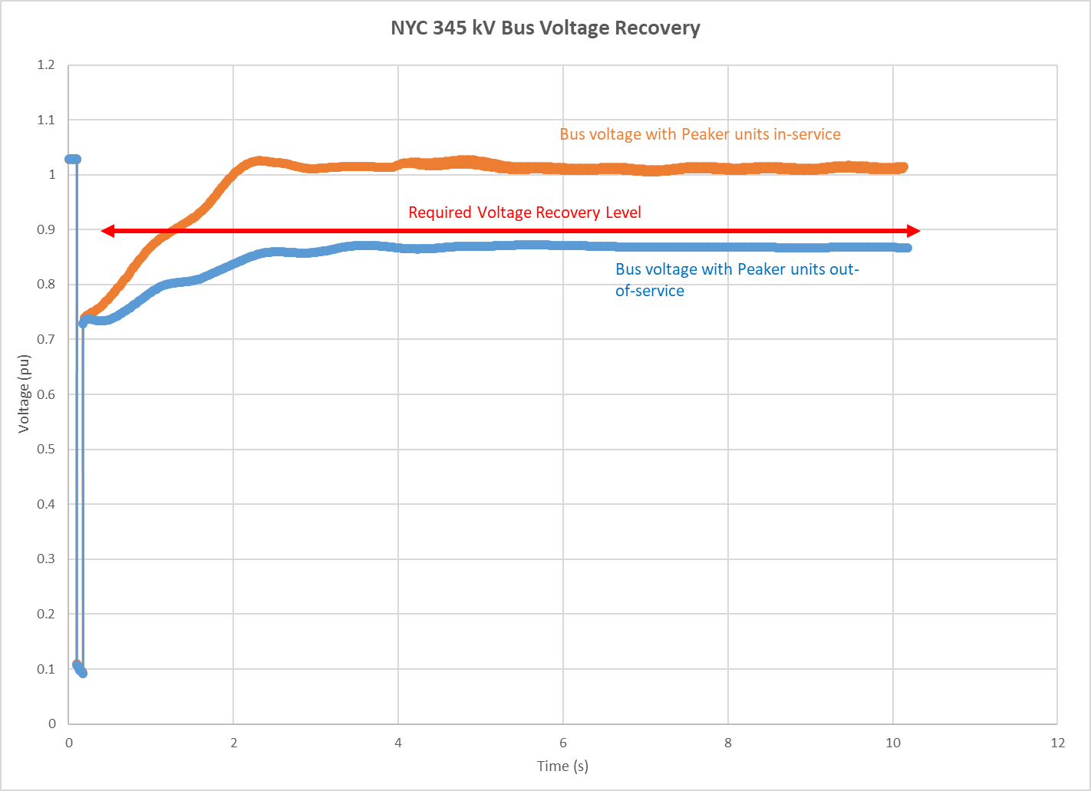

During a fault, the observed voltage drop at a bus depends on the location of the fault on the system relative to the bus and the amount of time the fault remains on the system before it is cleared by protective relaying actions. Following the clearing of a fault on the system by protection system actions, the bus voltage and generator rotor usually enter an oscillatory period. The generator excitation system controls the generator terminal voltage to improve and stabilize the voltages; however, depending on the severity of voltages and generator size, the voltages may or may not stabilize. Generator rotor swings after a fault are caused by the accumulation of energy, *i.e.* an imbalance between electrical power and mechanical power, during the fault. After the clearing of the fault, the generator rotor swings (or oscillations) dissipate that accumulated energy over time. For a stable system response, these oscillations damps out over time to an acceptable post-fault value. For an unstable system response, the system may observe unacceptable damping, system separation, cascading, and generating units losing synchronism with the system.

As shown in Figure 38 and Figure 39, several contingencies result in loss of generator synchronism with the transmission system. A primary driver to the loss of synchronism for these machines is the sustained low voltages following the clearing of the fault. Examples of low voltages as observed from the high-side of the generator step-up (GSU) transformer are shown in Figure 41 in response to a contingency. As can be seen in Figure 41, the sustained low voltages are also observed at the high side of the GSU and remain in the NERC PRC-024 “may trip” zone. In this example, due to the sustained low voltages an equilibrium point for the generators is not reached and the generators lose synchronism with the system. As shown in Figure 42, Generator 1 loses synchronism and trips off line at about 3.5 seconds and Generator 2 goes out of synchronism and trips off line at about 10 seconds. The rotor angles plotted in Figure 42 are relative to the system average rotor angle.

Figure 41: High Side of GSU Voltage

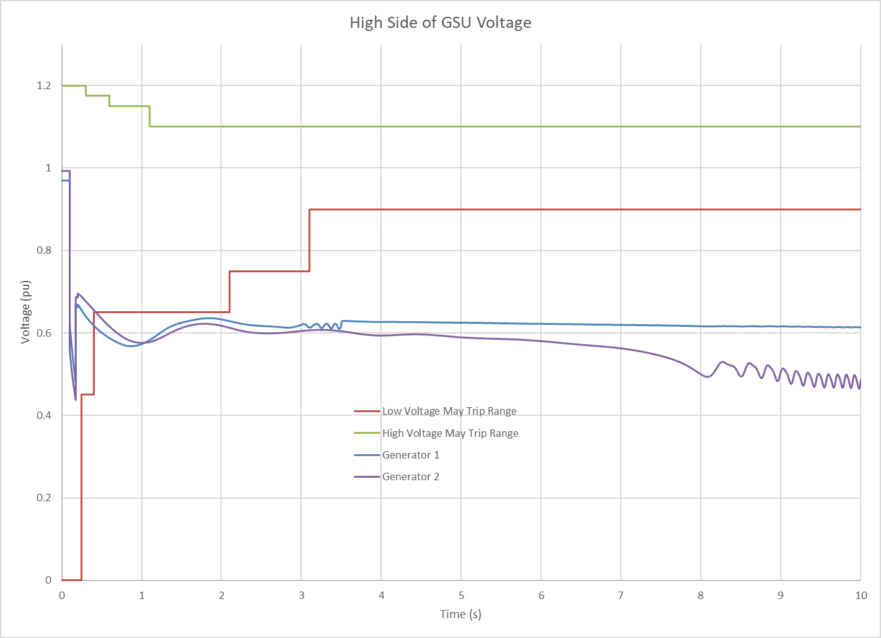

Figure 42: Generator Synchronism

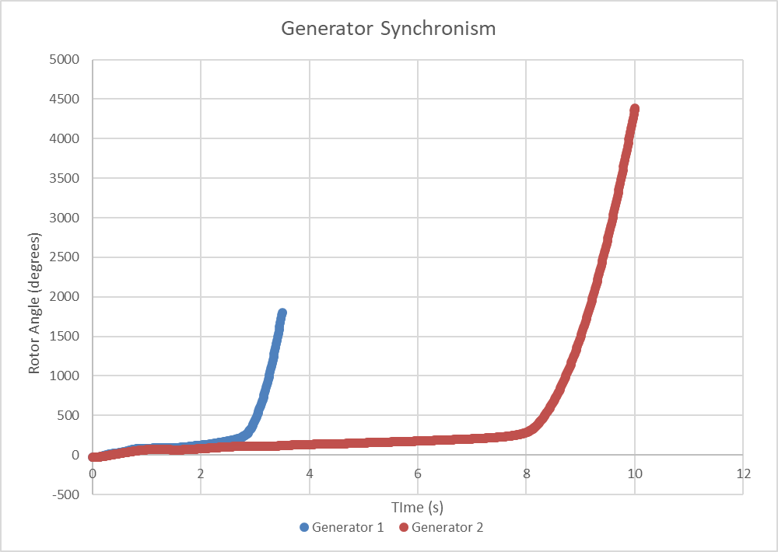

#### Stability Compensation

In the pre-fault (N-0) system condition, voltages are maintained with various static (*e.g.* fixed and switched shunt devices, transmission circuits) and dynamic (*e.g.* Generators, FACTS devices, STATCOMS) reactive resources maintaining voltages within prescribed ranges. Manual adjustments to these devices occur as load and other system conditions change in order to maintain the required voltage level.

During the dynamic simulation timeframe, sufficient dynamic reactive resources to sustain transient voltage support during the natural swings of the system are crucial. Generally, the system response to these swings to maintain voltage comes from generator excitation system response, STATCOMs, Static Var Compensators (SVCs), wind and solar plant voltage controls, and other fast-acting resources.[20] While pre-contingency voltages can be maintained using static reactive resources, the dynamic system response timeframe focuses primarily on dynamic reactive capability due to the transient nature of large power and voltage swings and the short response time required.

The BPTF dynamic stability criteria violations compensatory values are measured by adding dummy generators at the Farragut 345 kV, Astoria East 138 kV, and Greenwood North 138 kV buses with a MW size determined by the compensatory MW for thermal violations. Focusing on the event combination of the loss of Ravenswood 3 followed by event UC11 (as one of the more severe events), reactive capability was added to the dummy generators to the point where the BPTF transient voltage violations, sustained oscillations, and generator synchronism criteria violations are no longer observed. Figure 43 provides a description of dynamic compensation needed to address the event combination of the loss of Ravenswood 3 followed by event UC11. The impact of the added dynamic reactive capability is highly non-linear and other event combinations and the location of the dummy generators may cause significant variance to the values stated in Figure 43.

Figure 43: Description of Dynamic MVA Added to System (new)



Notes:

(1). BPTF dynamic issues observed prior to 2024 will be evaluated in the Short-Term Reliability Process

### Short Circuit Assessments

The required short circuit assessment in the RNA includes the calculation of symmetrical short circuit current to ascertain whether the circuit breakers at stations connecting the BPTF could be subject to fault current levels in excess of their rated interrupting capability. The analysis was performed for 2025 (year 5), reflecting the study conditions outlined in the **Section 5**. The calculated fault levels will not change significantly after year 5 in the Study Period as no new generation or transmission changes are modeled in the RNA, and the methodology for fault duty calculation is not sensitive to load growth. For this assessment no over-dutied circuit breakers were identified. The detailed results of the short circuit assessment are provided in **Appendix D** of this report.

### Transmission Owner Local Criteria Violations

As described in the following sections, Con Edison and Central Hudson each identified transmission security issues in their service territory on their non-BPTF system. The local non-BPTF criteria violations identified below are provided for information only, as the RNA identifies only BPTF Reliability Needs.

#### Central Hudson Assessment

Central Hudson currently owns and operates two 25 MVA (nameplate) combustion turbines that are subject to the DEC Peaker Rule, namely the Coxsackie and South Cairo generators. Both of these generators provide local substation reserve capacity for transformer outages and post-contingency voltage support for the Westerlo transmission loop. Without these generators, there is no reserve capability for local transformer outages and the Westerlo loop is voltage constrained. These transmission security issues would begin in 2023 and continue through the study period.

#### Con Edison Assessment

The transmission security criteria violations observed in the Con Edison service territory are primarily due to deficiencies that are observed in the Astoria East/Corona 138 kV Transmission Load Area (TLA) and the Greenwood/Fox Hills 138 kV TLA.

#### Astoria East/Corona 138 kV TLA

Figure 44 shows the high-level topology of the Astoria East/Corona 138 kV TLA. The boundary feeders for this TLA include the feeders from the Hell Gate, Astoria Annex, Rainey, and Jamaica substations.

Figure 44: Astoria East/ Corona 138 kV TLA

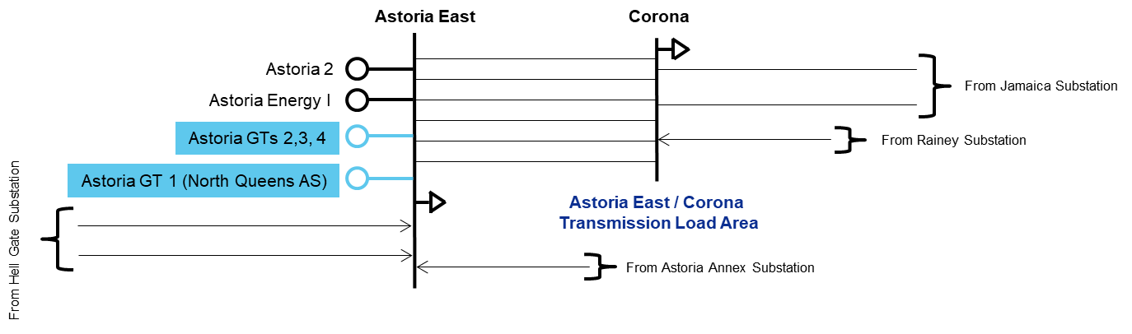

In 2023, thermal overloads are observed on the Astoria East/Corona 138 kV TLA boundary feeders, which are designed to a second contingency (N-1-1-0) based on the applicable Con Edison local design criteria.

Considering the utilization of all available phase angle regulator (PAR) controls, the maximum observed deficiency (*i.e.,* compensatory MW) within this TLA ranges from 110 MW in 2023 to 180 MW in 2030 as shown in Figure 45. As shown in Figure 46 and Figure 47, the Astoria East/Corona 138 kV TLA does not peak with the coincident system peak. Based on the load duration curves shown in Figure 46 and Figure 47, the TLA may be deficient over 10 hours (659 MWh) on a peak day in 2023, increasing to 13 hours (1,461 MWh) on a peak day in 2030.

Figure 45: Astoria East/ Corona 138 kV TLA Deficiency



Figure 46: Astoria East/Corona 138 kV Load Duration Curve for 2023

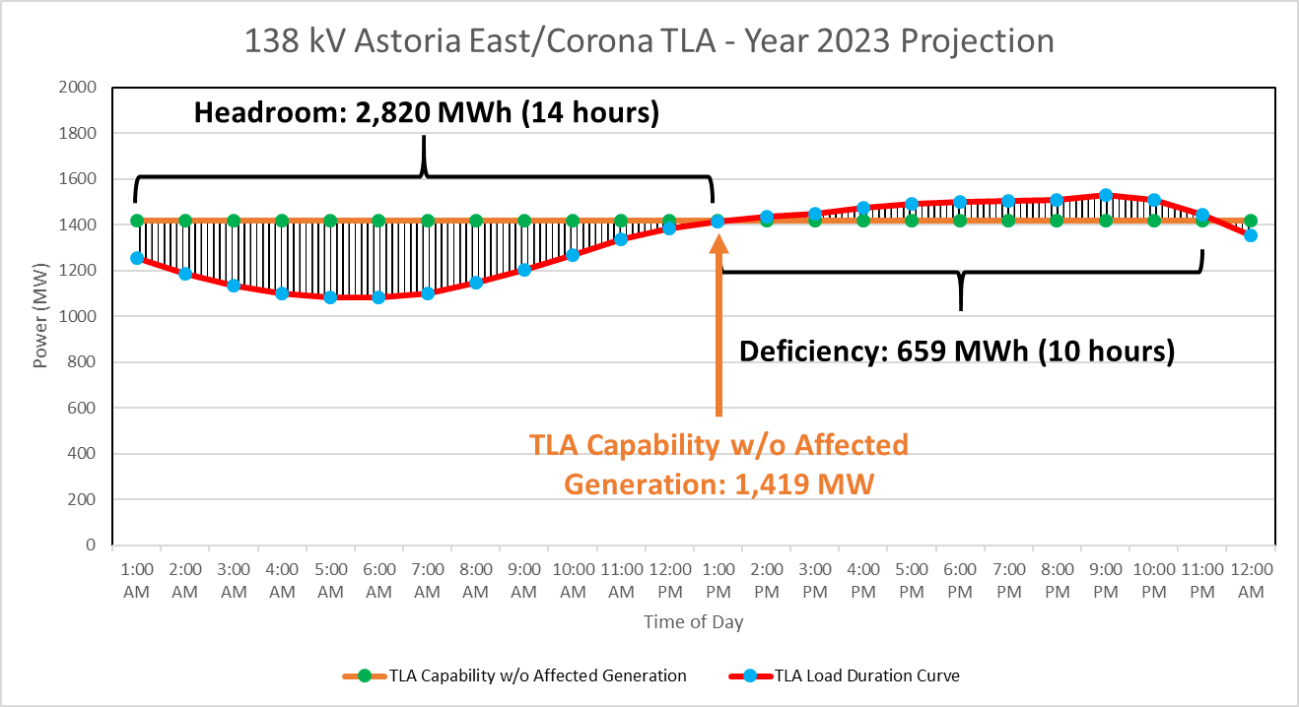

Figure 47: Astoria East/Corona 138 kV Load Duration Curve for 2030

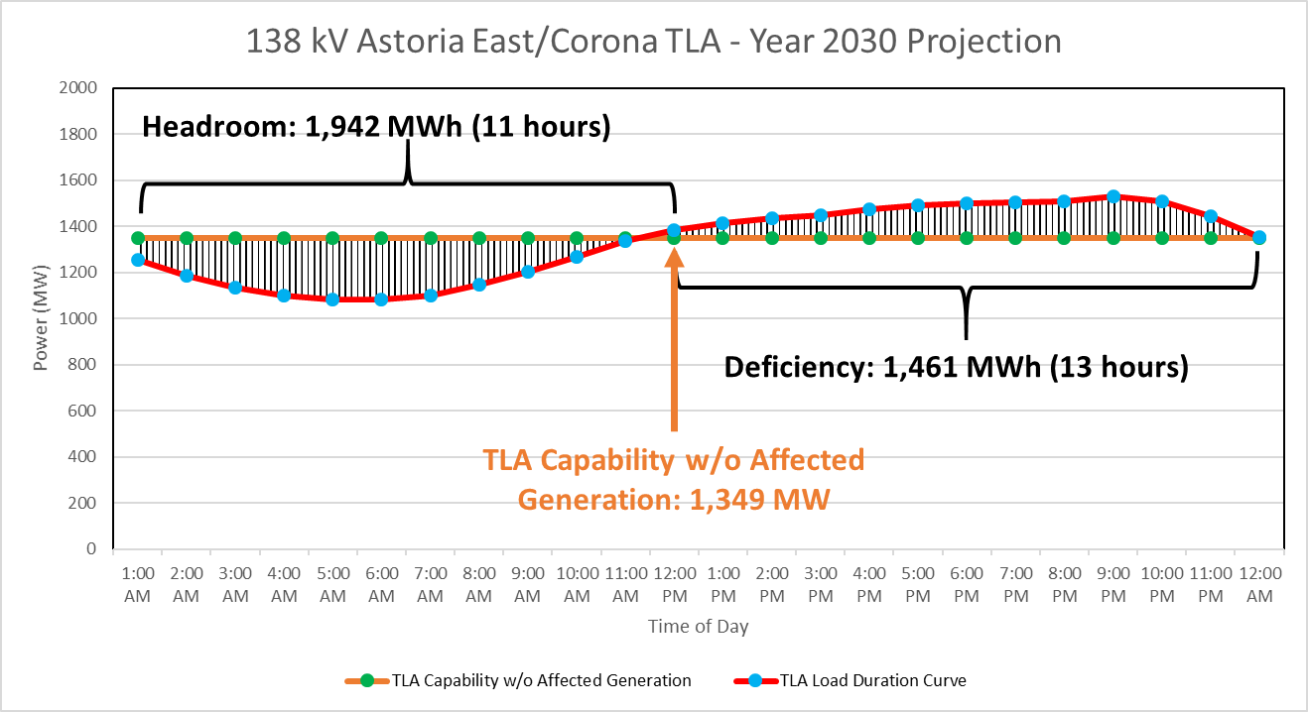

#### Greenwood/Fox Hills 138 kV TLA

Figure 48 shows the high-level topology of the Greenwood/Fox Hills 138 kV TLA. The boundary feeders for this TLA include the feeders from the Vernon, Gowanus, and Fresh Kills substations.

Figure 48: Greenwood/Fox Hills 138 kV TLA

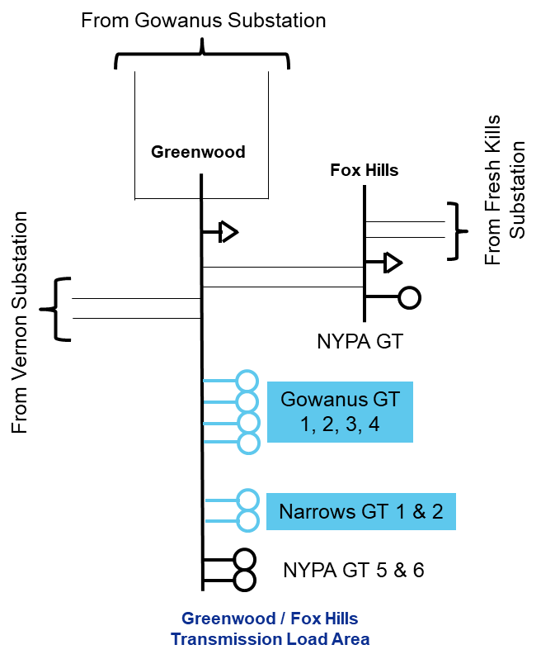

In 2025, thermal overloads and voltage violations are observed on the Greenwood/Fox Hills 138 kV TLA boundary feeders in the steady state (N-0) condition, which are exacerbated under N-1 and N-1-1 conditions.

Considering the utilization of all available PAR controls, the maximum observed deficiency (*i.e.,* compensatory MW) within this TLA of 360 MW in 2025 to 370 MW in 2030 as shown in Figure 49. Based on the load duration curve shown in Figure 50, the TLA may be deficient over 14 hours (3,571 MWh) over a 14 hour period on a peak day in 2025. As there is little change in the peak deficiency (± 10 MW - as shown in Figure 46) the deficiency shown in Figure 47 would not have much variance from 2025 to 2030.

Figure 49: Greenwood/Fox Hills 138 kV TLA Deficiency



Figure 50: Greenwood/Fox Hills 138 kV TLA Load Duration Curve for 2025

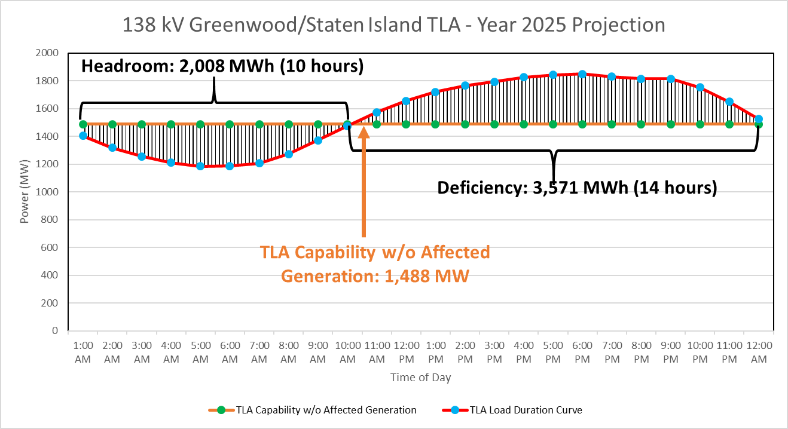

# Base Case Variation Scenarios

The NYISO, in conjunction with stakeholders and Market Participants, developed reliability scenarios pursuant to Section 31.2.2.5 of Attachment Y of the OATT. Scenarios are variations on the preliminary (1st pass) RNA Base Case to assess the impact of possible changes in key study assumptions which, if they occurred, could change the timing, location, or degree of violations of Reliability Criteria on the NYCA system during the Study Period, and are presented for information only. There were no changes between the preliminary RNA Base Case and the final Base Case. The NYISO evaluated the following scenarios as part of this RNA, with an identification of the type of assessment performed:

1. High Load Forecast Scenario – Resource Adequacy

* The 2020 Gold Book High Load forecast were used for the resource adequacy analysis.

1. Zonal Resource Adequacy Margins (ZRAM) - Resource Adequacy

* Identification of the maximum level of zonal MW capacity that can be removed without either causing NYCA LOLE violations, or exceeding the zonal capacity.

1. “Status-quo” Scenario - Transmission Security and Resource Adequacy

* Removal of proposed major transmission and generation projects assumed in the RNA Base Case.

Additionally, the NYISO proposed to perform two exploratory scenarios, further detailed in **Appendix E**:

1. Further[21] Simplified External Areas Model - Resource Adequacy

* Starting with the simplified external model described in footnote 8 and also in the assumptions matrix in Appendix D, removing all load and generation from external areas along with removing interfaces between external areas, followed by inserting fixed amounts of capacity in each external area.

1. Different Load Shape - Resource Adequacy

* The Resource Adequacy Base Cases use historical load shapes from 2002, 2006, and 2007. The Climate Change Phase 1 study developed forward-looking hourly load shapes. This exploratory scenario identified that additional collaboration with the Load Forecast Task Force and other stakeholders will be initiated, to identify if and how future-looking load shapes would better represent an ever-changing system.

The results of the scenarios 1-3 are summarized in the following sections; the exploratory scenarios 4 and 5 are in the **Appendix E**; the 70x30 scenarios are in **Section 8** below

## High Load Forecast Scenario

The RNA Base Case forecast includes impacts associated with projected energy reductions coming from statewide energy efficiency and BtM solar PV programs. The High Load Forecast scenario excludes these energy efficiency program impacts from the peak forecast, resulting in the higher forecast levels. The comparison of the High and Baseline forecasted loads is provided in the Figure 51 below: there is an increase of 2,388 MW in the peak load in 2030, as compared to the Base Case forecast. Given that the peak load in the High Load forecast is higher than in the Base Case, the probability of violating the LOLE criterion increases, and violations would occur starting in 2025. The NYCA LOLE results are in Figure 53**.**

Figure 51: 2020 Gold Book NYCA High Load vs. Baseline Summer Peak Forecast



Figure 52: 2020 Gold Book Zone J High Load vs. Non-coincident Summer Peak Forecast



Figure 53: 2020 RNA Resource Adequacy High Load Scenario NYCA LOLE Results



This scenario indicates that if expected energy efficiency and peak load reduction programs do not materialize at expected levels, the criterion violations would be observed two years earlier, starting in 2025.

## Zonal Resource Adequacy Margin (ZRAM)

The RNA Base Case results show that the LOLE is at the resource adequacy criterion in 2026 and exceeds 0.10 days/year starting in 2027.

Scenario analyses were performed to determine the amount of capacity in each Zone that could be removed before the NYCA LOLE reaches 0.10 days/year, and offers another relative measure of how close the system is from violating reliability criteria. This simulation is applicable to any RNA Study Years that have LOLE levels that are below criterion, *i.e*., from 2024 through 2026. The NYISO reduced capacity one Zone at a time to determine when violations occur, in the same manner as the compensatory “perfect” MW are added to mitigate resource adequacy violations, but with the opposite impact. The zonal resource margin analysis is summarized in Figure 54.

Figure 54: Zonal Resource Adequacy Margin (MW)



Note: EZR - exceeds zonal resources (*i.e.,* all generation can be removed without causing a violation)

The ZRAM assessment identifies a maximum level of capacity that can be removed from each zone without causing NYCA LOLE criterion violations. However, the impacts of removing capacity on the reliability of the transmission system and on transfer capability are highly location dependent. Thus, in reality, lower amounts of capacity removal are likely to result in reliability issues at specific transmission locations. The NYISO did not attempt to assess a comprehensive set of potential scenarios that might arise from specific unit retirements. Therefore, actual proposed capacity removal from any of these zones would need to be further studied in light of the specific capacity locations in the transmission network to determine whether any additional violations of reliability criteria would result. Additional transmission security analysis, such as N-1-1 analysis, would need to be performed for any contemplated plant retirement in any zone.

## Status-Quo Scenario

This scenario evaluates the reliability of the system under the assumption that no major transmission or generation projects come to fruition within the RNA Study Period. This includes the removal of all proposed transmission and generation projects that have met 2020 RNA Base Case inclusion rules and removal of generators that require modifications to comply with the DEC’s Peaker Rule.

The results of this scenario are in theFigure 55**:**

Figure 55: 2020 RNA Resource Adequacy Status-quo Scenario NYCA LOLE Results



From a resource adequacy perspective, this scenario indicates that if expected generation and transmission projects are not built, the criterion violation advances by two years to 2025.

The steady state transmission security results show no steady state voltage Reliability Criteria violations on the BPTF for N-1 or N-1-1 events. Additionally, no thermal Reliability Criteria violations are observed for N-1 events. However, as compared to the RNA base case, under N-1-1 conditions additional overloads are observed in the Orange and Rockland as well as the Con Edison service territories. The results of the steady state transmission security N-1-1 evaluation of the BPTF for this scenario are shown in Figure 56.

Figure 56: 2020 RNA Transmission Security Status-quo Scenario Results



# “70x30” Scenario – [New Section]

The Climate Leadership and Community Protection Act (CLCPA) mandates that New York consumers be served by 70% renewable energy by 2030 (“70x30”). The CLCPA includes specific technology based targets for distributed solar (6,000 MW by 2025), storage (3,000 MW by 2030), and offshore wind (9,000 MW by 2035), and ultimately establishes that the electric sector will be emissions free by 2040. Significant shifts are expected in both the demand and supply sides of the electric grid, and these changes will affect how the power system is currently planned and operated. To assist the evaluation of these impacts, the [2019 CARIS “70x30”](https://www.nyiso.com/documents/20142/2226108/2019-CARIS-Phase1-Report-Final.pdf/bcf0ab1a-eac2-0cc3-a2d6-6f374309e961) scenario kicked-off the assessment using production cost simulation tools to provide a “first look.” Focusing on the impact to energy flows, the NYISO modeled these policy targets for the year 2030 in order to examine potential system constraints, generator curtailments, and other operational limitations.

Subsequent studies, such as this *2020 RNA* scenario, as well as the *Climate Change Impact and Resilience Study*, build upon the findings of the *2019 CARIS* scenarios, and provide further insight focusing on system reliability aspects such as transmission security and resource adequacy.

As policymakers advance the implementation plan of the CLCPA, the NYISO assessments are intended to complement their efforts, and are not intended to define the specific steps that must be taken to achieve the policy goals. Additional refinements in assumptions, models, and methods in the following years will be necessary as more information becomes available from policy implementation perspectives and simulation methods and models perspectives.

RNA scenarios are provided for information only, and do not lead to Reliability Needs identification or mitigation.

## Scope

The 70x30 RNA scenarios consists of a series of cases to study the reliability impact of several 70% renewable energy mix and load levels assumptions. This study does not define the formula to calculate the percentage of renewable energy relative to end-use energy, (*i.e.,* how to account for 70% renewable energy for the “70 by 30” target). As policymakers advance on the implementation plan of CLCPA, this NYISO assessment is intended to complement their efforts, and is not intended to define the specific steps that must be taken to achieve the policy goals. Instead, the findings are intended to provide insight into the resource adequacy and transmission security reliability impacts of two load levels and their corresponding renewable resources mix evaluated in the 2019 CARIS Phase I study. The goal of the analysis is to augment the CARIS congestion and curtailments insights with reliability perspectives.

The 70x30 RNA scenarios examine two potential renewable build-out levels for one assumed distribution pattern across the state, as well as multiple sensitivities to gauge the impact of specific drivers.

A number of key modeling assumptions and approaches may have major impact on the results. To help readers understand the scope of this assessment, considerations that are outside of the scope of this analysis are described below:

1. **Percentage of renewable energy relative to end-use energy:** This study does not define the formula to calculate the percentage of renewable energy relative to end-use energy, (*i.e.,* how to account for 70% renewable energy for the “70 by 30” or “70x30” target). Rather, two potential renewable build-out levels were defined and modeled in the 2019 CARIS study, (and used in this study), for corresponding load levels to approximate the potential future resource mix in 2030.
2. **Renewable mix modeling** 
   1. **Siting and sizing**: New renewable generators are modeled as interconnecting to 115 kV or greater bus voltage levels, guided by the NYISO Interconnection Queue. There are many alternative possible interconnection points, but this assessment assumes a single approach for sizing and siting of renewable generation. Impacts of siting generators at lower voltage buses are outside the scope of this study. Nevertheless, the NYISO recognizes that constraints at the distribution level will affect the downstream constraints, which may change the energy flows at the higher voltage level.
   2. **Operational constraints:**  Renewable resources are modeled as 8,760 hourly resource shapes for the resource adequacy MARS simulations. These generation profiles are synthetically generated resource shapes constructed using publicly available data and tools. This deterministic modeling approach will not capture the uncertainty involved with particular renewable resources.

Also, this analysis does not consider potential reliability impacts due to:

* Changes on the transmission system as a result of the resource additions or subtractions;
* Unit commitment, ramp rate constraints, and other production cost modeling techniques;
* Sub-hourly variation in renewable generation.

1. **Transmission system modeling:** These scenarios are not an interconnection level assessment of the renewable buildouts, and do not review detailed engineering requirements, capacity deliverability, or impact to the New York system reserve margin. Also, for the resource adequacy evaluations, the MARS topology was only slightly changed to restrict flows from Zone K to Zone J, due to DEC Peaker Rule related unit retirement assumptions. No other change was implemented to reflect the impacts of any modification simulated in the scenarios, such as the addition of renewable resources, and the removal of fossil-fueled units.
2. **External area representation:** As the neighboring regions develop their own plans to achieve higher renewable generation penetration, those regions’ demand, generation supply, and transmission system may change. At the time of this report, the plans for NYISO’s neighboring regions are taking shape. The external area representation remains consistent with the RNA Base Case. An, exception is the HQ’s model, where import from Hydro Quebec (HQ) to Zone D is modeled as a unit in MARS with hourly MW shape from the CARIS output into Zone D along with the addition of a 1,310 MW proxy tie from Hydro Quebec (HQ) to Zone J. If the neighboring areas increase their renewable generation, it is possible that the renewable curtailment amounts assumed in the New York system from this analysis are underestimated.
3. **COVID-19 impacts:** Due to the rapidly evolving nature of the pandemic, the impacts to the load forecast and other economic indicators are difficult to predict, and are not included in these scenarios.

## Resource Adequacy[22] Assumptions

The RNA 70x30 scenarios assumptions are based on the [2019 CARIS 70x30](https://www.nyiso.com/documents/20142/2226108/2019-CARIS-Phase1-Report-Final.pdf/bcf0ab1a-eac2-0cc3-a2d6-6f374309e961) renewable resource mix and associated load forecasts. The *2019 CARIS* assumptions were based on the *2019 Gold Book*, and used GE MAPS for production cost simulations, and its findings are intended to provide insight of the extent to which transmission constraints may prevent the delivery of renewable energy to New York consumers. These RNA scenarios are intended to supplement the 2019 CARIS 70x30 analysis of congestion and resource curtailment by providing insights from the reliability simulation perspective.

The 2019 70x30 CARIS accessed two load levels labeled as ‘Base Load’ and ‘Scenario Load’ (described below). The simulation output for each load level provided the 8,760 hourly loads and renewable resources mix as input into the RNA resource adequacy scenarios using GE MARS.

The scenario cases also reflect removal of all of the peaker units, including those which subsequently provided compliance plans, affected by the DEC Peaker Rule in 2023 and 2025, to further align with the CARIS assumptions. Therefore, the scenario cases remove includes removal of those peakers kept in service in the RNA Base Case due to their compliance plans, mainly in Zone K.

The following describes the major simulation steps employed for the resource adequacy 70x30 scenario simulations and results:

**Step 1: Renewable Mix on Two Load Levels -** Model the CARIS 70x30 ‘Base Load’ and ‘Scenario Load’ along with their corresponding renewable resources mix output and calculate NYCA LOLE;

**Step 2:** **Capacity Removal** - For each of the two CARIS load models, remove fossil plants based on age, until NYCA LOLE>0.1 days/year (“model at criterion”).

* Additionally, perform a Zonal Resource Adequacy Margin (ZRAM) analysis as an alternative method of MW removal; and
* Perform sensitivities on nuclear MW removal

**Step 3: Add Storage** - For each of the two CARIS load models, with the model at the LOLE criterion, add storage based on the CARIS-assumed zonal distribution of storage resources, and recalculate the NYCA LOLE to determine their impact on resource adequacy.

**Load Assumptions**

Two load models from the 2019 CARIS 70x30 scenarios are used for the RNA 70x30 resource adequacy scenarios:

1. ‘Base Load’, representing a higher energy shape (153 TWh): the 2002 load shape (8,760 hours) was scaled up to 2028 energy forecast from the 2019 Gold Book. The same load shape was used for all MARS load levels; and
2. ‘Scenario Load’, representing lower energy shape (136 TWh): the CARIS-developed load shape was scaled to match CARIS 70x30 ‘Scenario Load’ energy and peak demand forecast. The same load shape was used for all MARS load levels.

Figure 57: Summer Energy and Peak Demand Forecast Zonal Distribution



*Non-coincident zonal peak

Because the 2019 CARIS assumptions are based on the 2019 Gold Book, Figure 58 is a comparison of the 2019 and 2020 Gold Book loads, for information.

Figure 58: Load and Energy Comparison between the 2019 and 2020 Gold Book Forecasts[23]



**Renewable Mix Assumptions**

The NYISO used the hourly MAPS resources mix output that resulted from the 2019 CARIS Phase I study and corresponding to the two load levels modeled in the 2019 70x30 CARIS. The nameplate capacity of the renewable resource mix is provided in Figure 59 below.

Figure 59: Renewable Mix Assumptions for each Load Level



Additional modeling details, by type:

* + **Land-based wind:**
    - Hourly MW (shapes) are from CARIS simulation output, including curtailments observed in the production simulation, for each of the two load shapes. CARIS used the 2009 National Renewable Energy Laboratory (NREL) hourly data as input.
  + **Off-shore wind**
    - Hourly MW (shapes) are from the CARIS simulation output, including curtailments observed in the production simulation, for each of the two load shapes. CARIS used the 2009 NREL hourly MW data as input.
  + **Utility-scale PV**
    - Hourly MW (shapes) are from CARIS simulation output, including curtailments observed in the production simulation, for each of the two load shapes. CARIS used the 2017 production data used for existing plants (hourly MW) and the 2006 NREL hourly data for new plants as input.

**Storage Assumptions**

A 4-hour battery storage is modeled in each NYISO Zone, using the newly developed GE MARS Energy Limited Resource Type 4 (EL4) model.[24] The scenario assumes the same zonal MW distribution modeled in the 2019 [CARIS](https://www.nyiso.com/documents/20142/8530408/04%20CARIS1%2070x30Scenario%20ESRModeling.pdf) 70x30 scenario, as shown in the Figure 60 below. In these simulations, the EL4 units discharge their MW when the system is deficient, and recharge their energy when the system has an excess of capacity. Units are modeled with a maximum energy discharge per day of four times their maximum hourly discharge value. This paradigm allows the unit to discharge fully in 4 hours, or for longer if not at full discharge. Also, at this time, only 100% roundtrip efficiency can be modeled in MARS, which does not account for losses in charge/discharge cycle.

Figure 60: Storage Zonal MW Distribution



**External area**s

PJM, Ontario and ISO-NE are modeled using same method as 2020 RNA Base Case.

Imports from Hydro Quebec (HQ) to Zone D are modeled as a unit in MARS with hourly MW shape from the CARIS output into Zone D. An additional 1,310 MW HQ to Zone J HVDC tie is assumed, consistent with CARIS. The HQ to J proxy is modeled as a unit in MARS with hourly MW shape from the CARIS output into Zone J.

## Resource Adequacy Methodology and Results

The GE’s MARS program is used for the 70x30 scenarios. The GE MARS tool employs a sequential Monte Carlo simulation method, and calculates, on an area and system basis, standard reliability indices such as daily and hourly LOLE (days/year and hours/year). New MARS cases were developed based on the assumptions described above, and sensitivities were performed to better understand the impact of various factors. The three steps described above are detailed in the following pages.

### Step 1: Renewable Mix on Two Load Levels

Model the CARIS 70x30 ‘Base Load’ and ‘Scenario Load’ along with their corresponding renewable resources mix output and calculate NYCA LOLE;

These initial resource adequacy simulations did not identify a measurable LOLE in either the ‘Base Load’ or ‘Scenario Load’ 70x30 cases. This result occurs because large amounts of additional renewable generation were modeled to meet the 70% energy goal, while retaining in the models the existing fossil fuel generators; which in turn lead to an increase in the available generation. In addition, the transmission system (MARS topology) was not updated to reflect the potential impacts of increasing the penetration of renewable resources.

Figure 61 and Figure 62 below show the resource mix for the two load levels with the renewables added and no fossil removal.

Figure 61: Resource Mix in the 70x30 ‘Base Load’ Scenario Case before Capacity Removal



Figure 62: Resource Mix in the 70x30 ‘Scenario Load’ Scenario Case before Capacity Removal

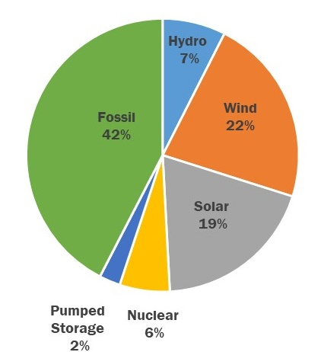

### Step 2: Capacity Removal

Additional simulation are performed to gauge the sensitivity of the system to capacity removal. Two types of removals are simulated, with results in the figures below:

* A Zonal Resource Adequacy Margin (ZRAM) analysis: ZRAM analysis identifies the amounts of generic “perfect capacity” resources that can be removed from a zone while still meeting the LOLE criterion. “Perfect capacity” is capacity that is not derated (*e.g.,* due to ambient temperature or unit unavailability), not subject to energy duration limitations, and not tested for transmission security or interface impacts. Actual resources would need to be larger in order to achieve the same impact as perfect-capacity resources.
* An age-based retirement analysis, where fossil units are removed from service started with the oldest. These removals are performed on the ‘Base Load’ and ‘Scenario Load’ scenario cases.

Figure 63: ZRAM Results on the Initial 70x30 Cases



Notes:

* Negative numbers indicate the amount of MW that can be removed from a zone (one zone at a time in this case) without causing a violation. For instance, NYCA LOLE reaches 0.1 days/year when 1,500 MW of “perfect capacity” is removed from Zone J in the ‘Base Load’ Case.
* EZR - exceeds zonal resources: *i.e.,* all generation from the respective zone can be removed without causing a NYCA LOLE violation
* The generation pockets in Zone J and Zone K are not modeled in detail in MARS and the values identified here may be larger as a result

The ZRAM analysis results show that many of the zones in the NYCA can have all internal resources removed without causing a violation of the LOLE criterion (*i.e.*, those labeled ‘EZR’), a result pointing to the large renewable additions upstate.

Figure 64: Fossil Removal Based on 70x30 ‘Base Load’ Scenario Cases



Notes:

* Case 67: most, but not all units 67 and older were retired in this case
* Case 67*: a special evaluation of Case 67 where the marginal unit was derated, instead of fully removed, to obtain an LOLE closer to 0.1 days/year

The age-based analysis for the ‘Base Load’ scenario identifies that removing units in-service on or before February 1, 1963 (*i.e.*, Case 67 at 2,951 MW total, of which 1,954 MW in Zone J) will cause NYCA to violate the LOLE criterion. An additional analysis was performed to bring the LOLE closer to the 0.1 days/year criterion by derating the capacity of the marginal unit (Case 67*), which identifies that the NYCA will violate the LOLE criterion once 2,801 MW have been removed from the system, of which 1,804 MW in Zone J. The age-based fossil removal method has the effect to primarily remove the units from Zones J and K, accelerating the rate of LOLE reaching its criterion violation. Because Zone J is driving the LOLE at criterion, and not upstate MW, additional fossil MW can be removed from the upstate Zones without affecting the LOLE at criterion.

It should be noted that units are not typically retired solely based on their age, but a host of other factors, and these are just simulation methods to stress the system.

Figure 65, Figure 66 and Figure 67 below show the resources mix for NYCA, Zone J and Zone K respectively, with the renewables added and fossil removal to reach LOLE criterion violation for 70x30 ‘Base Load’ scenario. Fossil MW percentage are calculated based on minimum between CRIS and DMNC while solar and wind MW are based on nameplate rating.

Figure 65: NYCA Resource Mix in 70x30 ‘Base Load’ Scenario Case at Criterion



Note: Fossil MW represents minimum between CRIS and DMNC; solar and wind MW represent nameplate

Figure 66: Zone J Resource Mix in 70x30 ‘Base Load’ Scenario Case at Criterion

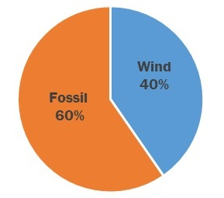

Figure 67: Zone K Resource Mix in 70x30 ‘Base Load’ Scenario Case at Criterion



Figure 68: 70x30 ‘Base Load’ Load and Capacity Totals, ICAP vs UCAP



Notes

1. UCAP calculation:

* For thermal units, MARS EFORd data is used.
* For renewables, UCAP is calculated based on the average output during peak hours

2. Reflects additional peaker removal in Zone K

3. Calculated based on 70x30 ‘Base Load’ Case 67*

Figure 69: Fossil Removal Based on 70x30 ‘Scenario Load’



The age-based analysis for the “Scenario Load” shows that removing units in-service on or before May 1, 1992 (Case 38) will cause NYCA to violate the LOLE criterion. This equates to a removal of 12,341 MW from the system, with the zonal distribution shown in Figure 69 above. The age-based fossil removal method has the effect to primarily remove the units from Zones J and K, accelerating the rate of LOLE reaching its criterion violation. Because mainly Zone K deficiencies are driving the LOLE at criterion in this scenario, additional fossil MW can be removed from the upstate zones without affecting the LOLE at criterion. Figure 70, Figure 71 and Figure 72 below show the resources mix for NYCA, Zone J and Zone K respectively, with the renewables added and fossil removal to reach LOLE criterion violation for 70x30 ‘Scenario Load’ scenario. Fossil MW percentage are calculated based on minimum between CRIS and DMNC while solar and wind MW are based on nameplate rating.

Figure 70: NYCA Resource Mix in 70x30 ‘Scenario Load’ Scenario Case at Criterion



Figure 71: Zone J Resource Mix in 70x30 ‘Scenario Load’ Scenario Case at Criterion



Figure 72: Zone K Resource Mix in 70x30 ‘Scenario Load’ Scenario Case at Criterion



Figure 73: 70x30 ‘Scenario Load’ Load and Capacity Totals, ICAP vs UCAP



Notes

1. UCAP calculation:

* For thermal units, MARS EFORd data is used.
* For renewables, UCAP is calculated based on the average output during peak hours

2. Reflects additional peaker removal in Zone K

3. Calculated based on 70x30 ‘Scenario Load’ Case 38

### Step 2 Sensitivity Analysis: Nuclear Units Unavailability

The remaining nuclear units are removed from the system, which equates to the removal of 3,343 MW summer capacity of nuclear units, all located upstate. In this analysis, first the nuclear MW are removed, followed by the fossil plants removal by age until the LOLE criterion is violated. This exercise identifies how much fossil MW can be removed before reaching criterion violation. It is important to note these units may continue in operation beyond 2029 and this sensitivity analysis should not be interpreted as forecasting any deactivation.

Figure 74: Nuclear Retirement Sensitivity based on 70x30 2019 CARIS “Base Load” Scenario



Notes:

* Case 67: most, but not all units 67 and older were retired in this case
* Case 67*: a special evaluation of Case 67 where the marginal unit was derated instead of fully removed to obtain an LOLE closer to 0.1 days/year
* **3,343: the amount of nuclear MW removed in the sensitivity

Observations:

* The removal of the nuclear units did not significantly affect the LOLE results on the case before the age-based fossil removals, because the addition of upstate renewable resources outweigh the loss of nuclear capacity.
* The results previously identified in the age-based retirement analysis on the ‘Base Load’ case were effectively unchanged by the removal of the nuclear units: *i.e.,* 3,343 MW of retirement of the upstate nuclear units does not significantly impact the NYCA LOLE results because the needs are driven by downstate capacity deficiencies. It is important to note that other benefits of existing generation, such as voltage and stability support, were not captured in this resource adequacy simulation.
* NYCA meets the LOLE criterion with 5,918 MW removed, of which 2,575MW fossil (5,918 - 3,343 = 2,575).
* NYCA exceeds the LOLE criterion when 6,144 MW are removed (at 67*), of which 3,343 MW are nuclear units, and 2,801 MW are fossil-fueled units.

Figure 75: Nuclear Retirement Sensitivity based on 70x30 2019 CARIS “Scenario Load” Scenario



Observations:

* NYCA meets the LOLE criterion in 2030 with 14,282 MW of existing generation removed
  + 14,282 – 3,343 nuclear = 11,170 MW fossil removed with nuclear units out of service, versus 11,264 MW fossil removed when nuclear units are modeled in service.
* As a result of the removal of nuclear units, the identified target date for a criterion violation occurred two years earlier, *i.e.*, on May 1, 1990. This corresponds to 14,513 MW being removed from the system. Of that amount, 11,170 MW is from fossil fuel generators.

### Step 3: Addition of Energy Storage Resources

One of the New York’s CLCPA goals is to add 3,000 MW of energy storage resources by 2030. In this sensitivity the storage resources are distributed across the NY system, and the age-based removal is simulated on both the initial 70x30 analysis from Step 1, and on the nuclear retirement sensitivity. 4-hour duration storage resources are assumed, using the MARS EL4 model.

For each of the two CARIS load models, with the model at the LOLE criterion, the NYISO added storage based on the CARIS-assumed zonal distribution, and recalculated the NYCA LOLE to determine impact on resource adequacy.

Figure 76 identifies the amount of fossil fuel generation that is removed from the system to cause a criterion violation.

Figure 76: Fossil MW Removed by Age to Reach LOLE Violation, with and without Storage, and with/without Nuclear Units



Note: the values in this table should not be used to approximate the Effective Load Carrying Capability (ELCC) of storage resources because the analysis was not conditioned to perform this type of analysis.

On the ‘Base Load’ scenario case, the benefit of the energy storage resources is limited to around 250 MW (*i.e.*, with additional storage, and with or without the existing nuclear units, around 260 MW of additional fossil can be removed to reach NYCA LOLE violation). These effects occur mainly because of the location of the capacity shortfalls (in Zones J and K), and also due to the storage resource allocation (1,320 MW in Zone J and 480MW in Zone K), as well as due to the duration of the events, with many longer than four hours.

For the Scenario Load cases, the energy storage resources have additional benefits. Specifically, with existing nuclear units in-service, and the additional storage resources in service, approximately 900 MW of additional fossil can be removed to reach LOLE violation. With existing nuclear units out of service, and the additional storage resources in service, approximately 380 MW of additional fossil can be removed to reach LOLE violation.

An additional simulation is performed to gauge the impact of using an 8-hour EL4 model on the ‘Base Load’ scenario. When comparing with the 4-hour model, a lot more (*e.g*. approximately 1,450 MW for this specific simulation) fossil MW can removed in order to reach the LOLE violation. Results are shown in the Figure 77 below.

Figure 77: Fossil MW Removed by Age to Reach LOLE Violation, with and without Storage, and Using 4h vs 8h Storage



#### Resolve Economic Curtailments

The production cost analysis performed in CARIS showed that renewable resources were curtailed due to local transmission bottlenecks. As part of the resource adequacy analysis, the NYISO modeled the output renewable shapes, including the CARIS-simulated curtailments, in the initial analysis. This sensitivity analyzes the impact of modeling the input renewables shapes with no curtailment reflected.

The use of non-curtailed renewables does not significantly affect the resource adequacy results. This output demonstrates that alleviating the local constraints that caused the curtailments, while beneficial from an annual energy production perspective as shown in CARIS, does not offset the need for dispatchable generation to meet reliability requirements at peak load.

## Transmission Security Methodology and Results

The purpose of this assessment is to identify reliability risks focusing on the steady-state thermal loading on the BPTF for N-1 and N-1-1 conditions. The transmission security assessment for 70x30 models six different penetrations of renewable resources and load levels. Figure 78 shows the load level for each case along with the assumption for land-based wind, off-shore wind, and solar. For the solar dispatch, both the behind-the-meter and in front of the meter solar are dispatched to the same percentage. For all cases except case 2, the starting dispatch identified in Figure 78 reflects similar conditions observed in the CARIS 70x30 simulations. Case 2 reflects the potential for an evening peak load assuming no MW output from the wind and solar resources. The evening peak load reflects approximately 93% of the peak load observed during the day peak with no output from the behind-the-meter solar.

Figure 78: Case Assumptions



The age-based fossil removals for the Base Load resource adequacy scenario, with no energy storage resources (ESR), are also modeled in this assessment, including the removal of units that were in service prior to January 1, 1963. This removal amounts to a total of 2,586 MW summer capability. The 2,586 MW removal is utilized in the transmission security analysis as it is the last point of generation removal prior to observing resource adequacy LOLE violations.

Case 1 and Case 2 result in N-1 thermal loading criteria violations. These violations are observed on the Rainey 345/138 kV (8W) (both Case 1 and Case 2) and the Rainey 345/138 kV (8E) (Case 1 only) transformers. These violations are primarily driven by local load pocket deficiencies created by the age-based generation removals. No N-1 thermal loading criteria violations are observed in Cases 3, 4, 5, or 6.

Case 1 and Case 2 have N-1-1 thermal loading criteria violations. These violations are summarized in Figure 79. In addition to the transmission security issues observed in the RNA Base Case, additional overloads are observed in the O&R and PSEG-LI service territories.

As the thermal loading issues are observed in a peak load case with a high penetration of land-based wind, off-shore wind, and solar as well as a peak load case without these resources, additional dispatchable resources would be needed to address the thermal reliability criteria violations. The amount of additional dispatchable resources varies from approximately 650 MW in Case 1 to 750 MW in Case 2. This assessment did not consider the potential duration of the deficiencies.

Figure 79: N-1-1 Thermal Load Criteria Violations



## Key Findings of the “70x30” Scenarios

As policymakers advance an implementation plan for the CLCPA, this assessment is intended to complement their efforts and provide information about possible challenges. The “70x30” RNA scenarios build on the 2019 CARIS 70x30 scenarios to model state-mandated policy goals, and supplements the 2019 CARIS Key Findings.

This “first look” at the CLCPA target of 70% renewable energy by 2030, identifies the following key findings.

### Resource Adequacy Key Findings

1. **Adding renewables:** The NYCA system represented in the Step 1 scenarios, (*i.e.,* with the renewable mix added and no fossil removed other than what is in the initial cases assumptions), is reliable, however it becomes unreliable as existing fossil generators are removed from service.
2. **Removing fossil:** The age-based approach results in concentrating the removal of fossil in zones that had the least amount of generation surplus. This causes reaching the LOLE criterion violation at a smaller total MW value of removal compared to if the generation was more spread out. The total fossil removal also depends on other factors such as unit unavailability, maintenance, location, etc.
3. **Nuclear sensitivity:** Retirement of nuclear units may require additional (or removal of less) fossil-fueled generation in order to maintain a reliable system.
4. **Energy Storage Resources:** provide a benefit to the system by allowing for additional fossil units to be retired, subject to limitations identified in this report. Resources with longer than four hours duration would provide additional benefit to the system.
5. **Curtailments due to Local Constraints**: Alleviating the local transmission constraints identified in CARIS that cause renewable curtailments, while beneficial from an annual energy production perspective as shown in CARIS, do not significantly benefit resource adequacy.
6. **Dispatchable Generation**: Even with significant intermittent renewable penetration, there is still a need for significant amounts of dispatchable generation to meet reliability requirements at peak load.
7. **Additional Considerations**: The resource adequacy simulations did not consider potential reliability impacts due to:
   * Intra-zonal constraints on the transmission system;
   * Changes on the transmission system as a result of the resource additions or subtractions;
   * Unit Commitment, ramp rate constraints, and other production cost modeling techniques.

### Transmission Security Key Findings

1. Thermal loading issues are observed in the peak load case with a high penetration of land-based wind, off-shore wind, and solar, as well as in a peak case without these resources. Dispatchable resources beyond those identified in resource adequacy would be needed in the downstate area to address thermal reliability criteria violations.
2. The amount of necessary additional dispatchable resources varies from approximately 650 MW in Case 1 to 750 MW in Case 2, determined by adding generic resources to deficient locations. Note that these MW additions are not intended to represent specific solutions, as the impact of specific solutions can depend on the type of solution and its location on the grid.

The NYISO will continue to monitor and track system changes. Subsequent studies, such as the CRP, the next RPP and CARIS cycles, and the Climate Change Impact and Resilience Study, will build upon the findings of these 70x30 Scenarios. To inform policymakers, investors and other stakeholders as implementation unfolds, these forward-looking studies will provide further assessment of the CLCPA.

# Reliability Compliance Obligations and Activities

The purpose of this section is to discuss the NERC Planning Coordinator and Transmission Planner obligations fulfilled by the NYISO as well as the other NPCC and NYSRC planning compliance obligations. The NYISO has various compliance obligations under NERC, NPCC, and the NYSRC. The periodicity of these requirements varies amongst the standards and requirements. While achieving compliance with all NERC, NPCC, and NYSRC obligations is critical to ensuring the continued reliability of the transmission system, this section primarily discusses in some detail the planning compliance requirements that closely align with this Reliability Needs Assessment. The full details of the compliance obligations are found within the reliability standards and requirements themselves. Publically available results for the compliance activities listed below are found on the NYISO website under Planning – Reliability Compliance[25].

The purpose of the NERC Reliability Standards is to “define the reliability requirements for planning and operating the North American bulk power system and are developed using a results-based approach that focuses on performance, risk management, and entity capabilities.” The objective of NPCC Directory #1 and the NYSRC Reliability Rules and Compliance Manual are to provide a “design-based approach” to design and operate the bulk power system to a level of reliability that will not result in the loss or unintentional separation of a major portion of the system from any of the planning and operations contingencies with the intent of avoiding instability, voltage collapse and widespread cascading outages. Figure 80 shows the various NERC Standards with requirements applicable to the NYISO as a NERC registered Planning Coordinator and/or Transmission Planner. The NPCC planning compliance obligations are primarily located in NPCC Regional Reliability Reference Directory #1 Design and Operation of the Bulk Power System. The NYSRC planning compliance obligations are located in the Reliability Rules and Compliance Manual.

Fundamental to any reliability study is the accuracy modeling data provided by the entities responsible for providing the data. The data requirements for the development of the steady state, dynamics, and short circuit models is provided in the NYISO Reliability Analysis Data Manual (RAD Manual).[26] This data primarily comes from compliance with NERC MOD standards. Much of this data is collected through the annual database update process outlined in the RAD Manual and the annual FERC Form 715 filing to which the transmitting utilities certify, to the best of their knowledge, the accuracy of the data. Additional compliance obligations provide for the accuracy of the modeling data through comparison to actual system events (*e.g.,* MOD-026, MOD-026, and MOD-033).

Following the completion of the annual database update, these databases are used for study work such as the Reliability Planning Process, and for many other compliance obligations such as those listed in Figure 80. Planning studies similar to the Reliability Planning Process include the NPCC/NYSRC Area Transmission Reviews (ATRs) and the NERC TPL-001 assessments.

Figure 80: List of NERC Standards for Planning Coordinators and Transmission Planners

| Standard Name | Title | Purpose |
| --- | --- | --- |
| FAC-002 | Facility Interconnection Studies | To study the impact of interconnecting new or materially modified Facilities to the Bulk Electric System. |
| FAC-010 | System Operating Limits Methodology for the Planning Horizon | To ensure that System Operating Limits (SOLs) used in the reliable planning of the Bulk Electric System (BES) are determined based on an established methodology or methodologies. |
| FAC-013 | Assessment of Transfer Capability for the Near-Term Transmission Planning Horizon | To ensure that Planning Coordinators have a methodology for, and perform an annual assessment to identify potential future Transmission System weaknesses and limiting Facilities that could impact the Bulk Electric System's (BES) ability to reliably transfer energy in the Near-Term Transmission Planning Horizon. |
| FAC-014 | Establish and Communicate System Operating Limits | To ensure that System Operating Limits (SOLs) used in the reliable planning and operation of the Bulk Electric System (BES) are determined based on an established methodology or methodologies. |
| IRO-017 | Outage Coordination | To ensure that outages are properly coordinated in the Operations Planning time horizon and Near-Term Transmission Planning Horizon. |
| MOD-020 | Providing Interruptible Demands and Direct Control Load Management Data to System Operators and Reliability Coordinators | To ensure that assessments and validation of past events and databases can be performed, reporting of actual demand data is needed. Forecast demand data is needed to perform future system assessments to identify the need for system reinforcement for continued reliability. In addition to assist a proper real-time operating, load information related to controllable Demand-Side Management programs is needed. |
| MOD-026 | Verification of Models and Data for Generator Excitation Control System or Plant Volt/VAR Control Functions | To verify that the generator excitation control system or plant volt/var control function model (including the power system stabilizer model and the impedance compensator model) and the model parameters used in dynamic simulations accurately represent the generator excitation control system or plant volt/var control function behavior when assessing Bulk Electric System (BES) reliability. |
| MOD-027 | Verification of Models and Data for Turbine/Governor and Load Control or Active Power/Frequency Control Functions | To verify that the turbine/governor and load control or active power/frequency control model and the model parameters, used in dynamic simulations that assess Bulk Electric System (BES) reliability, accurately represent generator unit real power response to system frequency variations. |
| MOD-031 | Demand and Energy Data | To provide authority for applicable entities to collect Data, energy and related data to support reliability studies and assessments to enumerate the responsibilities and obligations of requestors and respondents of that data. |
| MOD-032 | Data for Power System Modeling and Analysis | To establish consistent modeling data requirements and reporting procedures for development of planning horizon cases necessary to support analysis of the reliability of the interconnected transmission system. |
| MOD-033 | Steady State and Dynamic System Model Validation | To establish consistent validation requirements to facilitate the collection of accurate data and building of planning models to analyze the reliability of the interconnected transmission system. |
| PRC-002 | Disturbance Monitoring and Reporting Requirements | To have adequate data available to facilitate analysis of Bulk Electric System (BES) Disturbances |
| PRC-006 | Automatic Underfrequency Load Shedding | To establish design and documentation requirements for automatic underfrequency load shedding (UFLS) programs to arrest declining frequency, assist recovery of frequency following underfrequency events and provide last resort system preservation measures. |
| PRC-006-NPCC | Automatic Underfrequency Load Shedding | The NPCC Automatic Underfrequency Load Shedding (UFLS) regional Reliability Standard establishes more stringent and specific NPCC UFLS program requirements than the NERC continent-wide PRC-006 standard. The program is designed such that declining frequency is arrested and recovered in accordance with established NPCC performance requirements stipulated in this document. |
| PRC-010 | Undervoltage Load Shedding | To establish an integrated and coordinated approach to the design, evaluation, and reliable operation of Undervoltage Load Shedding Programs (UVLS Programs). |
| PRC-023 | Transmission Relay Loadability | Protective relay settings shall not limit transmission loadability; not interfere with system operators' ability to take remedial action to protect system reliability and; be set to reliably detect all fault conditions and protect the electrical network from these faults. |
| PRC-026 | Relay Performance During Stable Power Swings | To ensure that load-responsible protective relays are expected to not trip in response to stable power swings during non-Fault conditions. |
| TPL-001 | Transmission System Planning Performance Requirements | Establish Transmission system planning performance requirements within the planning horizon to develop a Bulk Electric System (BES) that will operate reliably over a broad spectrum of System conditions and following a wide range of probable Contingencies. |
| TPL-007 | Transmission System Planned Performance for Geomagnetic Disturbance Events | Establish requirements for Transmission system planned performance during geomagnetic disturbance (GMD) events. |

## NPCC/NYSRC Area Transmission Reviews (ATRs)

The NPCC/NYSRC ATRs are performed on an annual basis to demonstrate that conformance with the performance criteria specified in NPCC Directory #1 and the NYSRC Reliability Rules. In the ATRs, the NYISO assesses the BPTF for a period four to six years in the future (the NYISO evaluates year 5 of the Study Period). Seven assessments are required as part of each ATR.

The first assessment evaluates the steady state and dynamics transmission security. For instances where the transmission security assessments results indicate that the planned system does not meet the specified criteria, a corrective action plan is incorporated to achieve conformance. As part of the ATRs, and also for compliance with NERC FAC-013, thermal, voltage, and stability transfer limits are performed to identify the limiting constraints for power transfers.

For the second assessment, steady state and dynamics analysis are conducted to evaluate the performance of the system for low probability extreme contingencies. The purpose of the extreme contingency analysis is to examine the post contingency steady state conditions, as well as stability, overload, cascading outages, and voltage collapse, to obtain an indication of system robustness and to determine the extent of any potential widespread system disturbance. In instances where the extreme contingency assessment concludes there are serious consequences, the NYISO evaluates implementing a change to design or operating practices to address the issues.

The third assessment evaluates extreme system conditions that have a low probability of occurrence such as high peak load conditions (*e.g*., 90th percentile load) resulting from extreme weather or the loss of fuel supply from a given resource (*e.g.,* loss of all gas units under winter peak load). The extreme system conditions evaluate various design criteria contingencies to evaluate the post contingency steady state conditions, as well as stability, overload, cascading outages and voltage collapse. The evaluation of extreme contingencies indicate system robustness and determine the extent of any potential widespread system disturbance. In instances where the extreme contingency assessment concludes that there are serious consequences, the NYISO evaluates implementing a change to design or operating practices to address the issues.

The fourth assessment evaluates the breaker fault duty at BPTF buses.

The fifth assessment evaluates other requirements specific to the NYSRC Reliability Rules including an evaluation of the impacts of planned system expansion or configuration facilities on the NYCA System Restoration Plan and Local Area Operation Rules for New York City Operations, loss of gas supply – New York City, and loss of gas supply – Long Island.

The sixth assessment is a review of Special Protection Systems (SPSs). This review evaluates the designed operation and possible consequences of failure to operate or mis-operation of the SPS within the NYCA.

The seventh assessment is a review of requested exclusions to the NPCC Directory #1 criteria.

## NERC Planning Assessments (TPL-001)

The NERC TPL-001 assessment (Planning Assessment) is performed annually. The purpose of the Planning Assessment is to demonstrate conformance with the applicable NERC transmission system planning performance requirements for the NYCA BES. The Planning Assessment is a coordinated study between the NYISO and New York Transmission Owners.

The required system conditions to evaluate for this assessment include planned system representations over a 10-year study period for a variety of system conditions. Figure 81 provides a description of the steady state, dynamics, and short circuit cases required to be evaluated in the Planning Assessment.

Figure 81: Description of NERC TPL-001 Planning Assessment Study Cases



Notes:

1. Only required to be assessed to address the impact of proposed material generation additions or changes in that timeframe

The steady state and dynamics transmission security analyses evaluate the New York State BES to meet the applicable criteria. As part of this assessment, the unavailability of major transmission equipment with a lead time of more than a year is also assessed. The fault duty at BES buses are evaluated in the short-circuit representation. When the steady state, dynamics, or short circuit analysis indicates an inability of the system to meet the performance requirements in the standard, a corrective action plan is developed addressing how the performance requirements will be met. Corrective action plans are reviewed in subsequent Planning Assessments for continued validity and implementation status.

For each steady state and dynamics case, the Planning Assessment evaluates the system response to extreme contingencies. Similar to the ATR, when the Planning Assessment extreme contingency analysis concludes there is cascading caused by an extreme contingency, the NYISO evaluates possible actions designed to reduce the likelihood or mitigate the consequences and adverse impacts.

## Resource Adequacy Compliance Efforts

NPCC’s [Directory 1](https://www.npcc.org/Standards/Directories/Forms/Public%20List.aspx) defines a compliance obligation for the NYISO, as Resource Planner and Planning Coordinator, to perform a resource adequacy study evaluating a five-year planning horizon. The NYISO delivers a report every year under this study process to verify the system against the one-day-in-ten-years loss of load expectation (LOLE) criterion, usually based on the latest available RNA/CRP results and assumptions. The NY Area Review of Resource Adequacy completed reports are saved here: <https://www.nyiso.com/planning-reliability-compliance> and here: <https://www.npcc.org/library/resource-adequacy>

NYSRC [Reliability Rules](http://www.nysrc.org/NYSRCReliabilityRulesComplianceMonitoring.html) have recently included a requirement A3.R3 defining the NYISO’s obligation to deliver a Long Term Resource Adequacy Assessment report every RNA year, and an annual update in the non-RNA years. The NYISO will first implement of this requirement after finalizing the *2020 RNA.*

The NYISO is also actively involved in other activities such as the NERC’s annual Long Term Reliability Assessment ([LTRA](https://www.nerc.com/pa/RAPA/ra/Pages/default.aspx)), along with its biennial Probabilistic Assessment (ProbA), performed by NERC with the input from all the NERC Regions and Areas, as well as NPCC’s Long Range Adequacy Overview ([LROA](https://www.npcc.org/library/resource-adequacy)).

# A Grid In Transition: Reliability Gap Analysis

In 2019, the NYISO published the [*Reliability and Market Considerations For A Grid In Transition*](https://www.nyiso.com/documents/20142/2224547/Reliability-and-Market-Considerations-for-a-Grid-in-Transition-20191220%20Final.pdf/61a69b2e-0ca3-f18c-cc39-88a793469d50) whitepaper to facilitate a review of how market signals are aligned with system reliability needs in order to attract investment and retain competitive suppliers through the transition to 70% renewable energy by 2030. As part of that white paper, the NYISO conducted a reliability gap analysis to identify ways in which the transition towards intermittent resources could lead to operational circumstances that may violate system reliability requirements. The analysis included potential areas that the NYISO must be prepared to address in order to continue to meet mandatory reliability standards, such as:

* **Maintaining ability to balance load and generation:** Balancing high levels of intermittent generation with system demand that may be difficult to forecast in   
  real-time operations.
* **Maintaining 10-minute operating reserves:** High levels of intermittent resources may result in challenges to maintaining sufficient 10-minute operating reserves and disturbance-control performance requirements.
* **Maintaining total 30-minute operating reserves:** High levels of intermittent resources may lead to challenges in meeting operating reserve requirements in response to longer-term variations in generation levels from intermittent generation.
* **Maintaining ability to meet daily energy requirements:** Reliance on high levels of intermittent resources and limited energy storage resources may present challenges to meeting control-performance requirements and daily energy requirements in real-time operations.
* **Maintaining reliable transmission operations:** It may become difficult to forecast system and locational demand requirements in real time when operating under high levels of intermittent generation.
* **Maintaining black start capability:** The NYISO may be challenged to effectively restore the system within expected timeframes following a blackout given a system with high levels of intermittent generation.
* **Maintaining voltage support capability:** The NYISO may be challenged to meet voltage performance requirements with high levels of intermittent generation.
* **Maintaining frequency response capability:** The NYISO may be challenged to meet frequency performance requirements for a power system with high levels of intermittent generation.
* **Maintaining resource adequacy:** The NYISO may be challenged to maintain acceptable levels of resource adequacy.
* **Maintaining the ability to manage supply resource outage schedules:** The NYISO may be challenged to manage supply resource maintenance outage scheduling.

These concepts will continued to be explored in the *2021-2030 Comprehensive Reliability Plan* and numerous other reliability studies in the near future. None of the identified potential reliability gaps relative to intermittent resources represent near-term concerns. However, the challenge for the NYISO is to design and implement a portfolio of market products, reliability planning, and operational enhancements that facilitate achievement of clean energy policies while maintaining system reliability through the competitive wholesale electricity markets. There may also be a need for review of established reliability criteria to address reliability gaps that may arise due to the changing system operating characteristics as New York transitions to a zero emission resource mix.

# Observations and Recommendations

[PLACEHOLDER]

1. In 2019 the NYISO proposed to stakeholders creating a Short-Term Reliability Process (“STRP”) to evaluate and address reliability impacts resulting from both Generator deactivations and other drivers of Reliability Needs hat are identified in a quarterly Short-Term Assessment of Reliability study. The NYISO made a tariff filing at FERC to create the STRP in February 2020, requesting a May 1, 2020 effective date. The FERC accepted the NYISO filing on April 30, 2020, and the first quarterly STAR commenced on July 15, 2020. The 2020 RNA also incorporates the effects of these tariff changes by assessing Reliability Needs in years 4-10 of the Study Period, while the STRP assesses five years from its start date, with a focus on addressing needs in years 1-3 of the Study Period.
2. Resource adequacy compensatory megawatt amounts are determined by adding generic “perfect capacity” resources to zones (or combination of zones) to address the shortfall. “Perfect capacity” is capacity that is not derated (*e.g.,* due to ambient temperature or unit unavailability), not subject to energy duration limitations, and not tested for transmission security or interface impacts. Actual resources would need to be larger in order to achieve the same impact as perfect-capacity resources. The compensatory MW additions are not intended to represent specific solutions, as the impact of specific solutions can depend on the type of the solution and its location on the grid. Resource needs could potentially be met by combinations of solutions including generation, transmission, energy efficiency, and demand response measures.
3. During the 2020 RNA, the External Areas Model for the RNA Base Case was also simplified to consolidate five PJM (mid-Atlantic) areas into a single area and eight ISO-NE areas into a single area.
4. A condition identified by the NYISO in the RNA as a violation or potential violation of Reliability Criteria.
5. This change was implemented in the RPP Manual in 2019.
6. This change was implemented in the RPP Manual in 2019.
7. <https://www.dec.ny.gov/regulations/116131.html>
8. See ‘Generator Deactivation Assessments’ at <https://www.nyiso.com/cspp>:

   [Cayuga 1 and 2 Generator Deactivation Assessment (Retirement)](https://www.nyiso.com/documents/20142/1396324/Cayuga1and2-Generation-Deactivation-Assessment-vFinal.pdf/9328ed90-41aa-da58-354f-d02fa755f260)

   [Somerset Generator Deactivation Assessment](https://www.nyiso.com/documents/20142/1396324/Somerset-Generator-Deactivation-Assessment-vFinal.pdf/f1fcf261-3d85-9f96-ef8f-70bdd1586505)

   [Cayuga 1 Generator Deactivation Assessment](https://www.nyiso.com/documents/20142/1396324/Cayuga1-Mothball.pdf/3cb586c3-4cb1-7fde-1a8e-f9a0a0e12d38)
9. <https://www.dec.ny.gov/regulations/120061.html>
10. <http://documents.dps.ny.gov/public/MatterManagement/CaseMaster.aspx?MatterCaseNo=20-E-0197&submit=Search>
11. See [http://documents.dps.ny.gov/public/Common/ViewDoc.aspx?DocRefId={DEEEB5EF-4676-49AD-B8E7-C72681D99C49}](http://documents.dps.ny.gov/public/Common/ViewDoc.aspx?DocRefId=%7bDEEEB5EF-4676-49AD-B8E7-C72681D99C49%7d) and [http://documents.dps.ny.gov/public/Common/ViewDoc.aspx?DocRefId={C36465AD-E0AE-4823-86B4-183810F247B2}](http://documents.dps.ny.gov/public/Common/ViewDoc.aspx?DocRefId=%7bC36465AD-E0AE-4823-86B4-183810F247B2%7d)
12. The term “Special Case Resource” is defined in Section 2.19 of Market Services Tariff and also in the Appendix A of this report (Glossary)
13. Attachment I of Transmission, Expansion and Interconnection Manual.
14. No generation pockets in Zone J and Zone K are modeled in detail in MARS.
15. Links to related stakeholders’ presentations are in the Appendix D, assumptions matrix.
16. No local transmission load area limits are modeled for the resource adequacy assessment – deficiencies at this local level are identified in the transmission security assessments.
17. No local transmission load area limits are modeled for the resource adequacy assessment – deficiencies at this local level are identified in the transmission security assessments.
18. No local transmission load area limits are modeled for the resource adequacy assessment – deficiencies at this local level are identified in the transmission security assessments.
19. <https://www.nerc.com/docs/pc/tis/FIDVR_Tech_Ref%20V1-2_PC_Approved.pdf>
20. <https://www.nerc.com/comm/PC_Reliability_Guidelines_DL/Reliability%20Guideline%20-%20Reactive%20Power%20Planning.pdf>
21. During the 2020 RNA, the External Areas Model for the RNA Base Case was simplified to consolidate five PJM (mid-Atlantic) areas into a single area and eight ISO-NE areas into a single area.
22. The transmission security simulations assumptions are defined under the Transmission **Security Methodology and Results Section** below.
23. The term “NC” means “non-coincident” peak load, while the term “CP” mean the “coincident peak” load.
24. The MARS Energy Limited Resource type 4 (EL4) unit was introduced in the GE MARS version 3.29.1499 to better reflect battery behavior.
25. <https://www.nyiso.com/planning-reliability-compliance>
26. <https://www.nyiso.com/documents/20142/2924447/rel-anl-data-mnl.pdf>